Medical Care Advisory Committee (MCAC) and Payment Policy Advisory Board (PPAB) Meeting
  - Executive Office of Health and Human Services
  - February 5, 2024

Table of Contents
- MassHealth’s 1115 Waiver: Update
- MassHealth - Members experiencing homelessness
- MassHealth - Justice Involvement

MassHealth’s 1115 Waiver: Update

Implementation: during 2023, MassHealth made important strides in advancing 1115 demonstration objectives:

  - Health Quality and Equity Initiative: 60 hospitals and 20 MCEs are participating. 2023 deliverables and milestones were met for all participating entities, including new requirements for hospital TJC accreditation, all-entity reporting on demographic and HRSN data, all-entity reporting on disparities assessments, language and disability access, PIPs, etc. Work on 2024 strategy and deliverables underway.
  - Primary Care Capitation and Investment: ~1,000 primary care practices successfully transitioned to capitated payments moving the delivery system away from the FFS model and expanding investment in primary care.
  - HRSN updates: MA’s advocacy led to federal policy changes expanding access to nutrition services.* Work is ongoing to transition all Flexible Services into managed care by 2025.
  - Continuous eligibility: 12m for justice-involved, 24m for members experiencing homelessness (<65)

1115 Amendment Updates: in October 2023, MassHealth submitted an 1115 Demonstration amendment request, with strong local and national stakeholder support. Key provisions include:

- Temporary housing and supports for families / pregnant members in Emergency Assistance program
- Short-term post-hospitalization housing (aka “medical respite”)
- Expand authority for ConnectorCare subsidies from 300% FPL to 500% FPL
- Provide Medicaid services for eligible justice-involved individuals 90 days pre-release
- Continuous eligibility for 12 months all adults (children have 12m CE as of January 1st, 2024)
* Further information available at: https://www.medicaid.gov/sites/default/files/2023-11/hrsn-coverage-table.pdf

MassHealth – Members Experiencing Homelessness

  - MassHealth interventions addressing the needs of members experiencing homelessness
Challenges | MassHealth Initiatives
People experiencing homelessness have lapses in MassHealth coverage | Providing continuous eligibility for 24-months to homeless individuals under age 65 and conducting onsite redetermination events in shelters
Large number of members experiencing homelessness are not enrolled in managed care, and therefore do not have access to Specialized CSP housing supports | Expanded CSP eligibility to fee-for-service (FFS) population, including CSP housing-related services
Many members experiencing homelessness do not meet “chronically” homeless criteria, but would benefit from CSP-HI like services | Expanded target population for successful CSP for Homeless Individuals services to include additional members experiencing homelessness who are high utilizers of health care services
Medical costs increase dramatically if members are evicted and become homeless | Launched new CSP-TPP service for members in Housing Court facing eviction, based on proven Tenancy Preservation Program
Hospitals are unable to discharge members experiencing homelessness because they do not have a safe place to recuperate and recover from an acute physical ailment | Launched new Medical Respite grant program (40 beds) and requested authority from CMS to make Medical Respite a covered service for all managed care and FFS
Members experiencing homelessness need assistance with move-in costs, furnishings, and furniture | Launched new $13m ARPA-funded program to provide up to $5500 for each member to cover costs related to moving into housing from institutional settings or homelessness.
MassHealth has difficulty identifying which members are experiencing homelessness | Established new data sharing agreement with statewide homeless data warehouse that provides weekly data identifying members experiencing homelessness

Overview: Rehousing Data Collective (RDC)
- Rehousing Data Collective (RDC) is statewide data warehouse that aggregates and deduplicates data collected by homeless providers
  - 12 separate Homeless Management Information Systems (HMIS) operated by local Continuum of Care homeless planning group
  - Data from the Emergency Assistance (EA) family shelter system operated by the Executive Office of Housing and Livable Communities (HLC)*
- Beginning in June 2023, MassHealth began receiving weekly updates of the MassHealth IDs for those members experiencing homelessness based on the RDC data
  - “Experiencing Homelessness” = receiving services from homeless outreach, day programs, shelters, safe haven or transitional housing
  - Does not include members “at risk of homelessness”
- June-December 2023 – pilot phase to work out any data flow issues; January 2024 – data live within the MassHealth Data Warehouse
*Does not include data about families/pregnant individuals staying in temporary shelters

Breakdown of individuals experiencing homelessness with MassHealth IDs, as of 7/30/23
- Weekly data feeds indicate approximately 83% of people experiencing homelessness at a given time have a MassHealth ID
- Analysis of data from 7/30/2023:
  - Active Coverage:
    - 95% active MassHealth members experiencing homelessness
    - 5% individuals experiencing homelessness with MassHealth IDs, but no active MassHealth coverage
  - Male and female members experienced homelessness at almost equal levels
  - Age breakdown:
    - Youth under 21 made up over 35% of the total
    - 50% of members experiencing homelessness were between 21 and 54
    - Older adults 55+ represented ~10% of the total
    - Older adults 65+ represented ~3% of the total
  - Managed care enrollment
    - The majority of members experiencing homelessness (86%) were enrolled in managed care
      - ACOA/ACOB: 76%
      - MCO/PCC: 7%
      - One Care/SCO/PACE: 3%
      - 14% of members experiencing homelessness were in Fee For Service

Homeless Indicator – Z Codes
Z codes are a set of ICD-10-CM used to report social, economic, and environmental determinants known to affect health and health-related outcomes. They are used as a secondary diagnosis code, when applicable

Z59.0X Homeless codes
Z59.00 – homelessness unspecified
Z59.01 – sheltered homelessness (living in a shelter such as motel, scattered site housing, temporary or transitional living situation)
Z59.02 – unsheltered homelessness (Residing in place not meant for human habitation such as: abandoned buildings, cars, parks, sidewalk/street)
The majority of members experiencing homelessness (60%) did NOT have a Z59.0x homeless code
13% of members experiencing homelessness did not have any claims in FY2023 and therefore had no opportunity to input a Z code
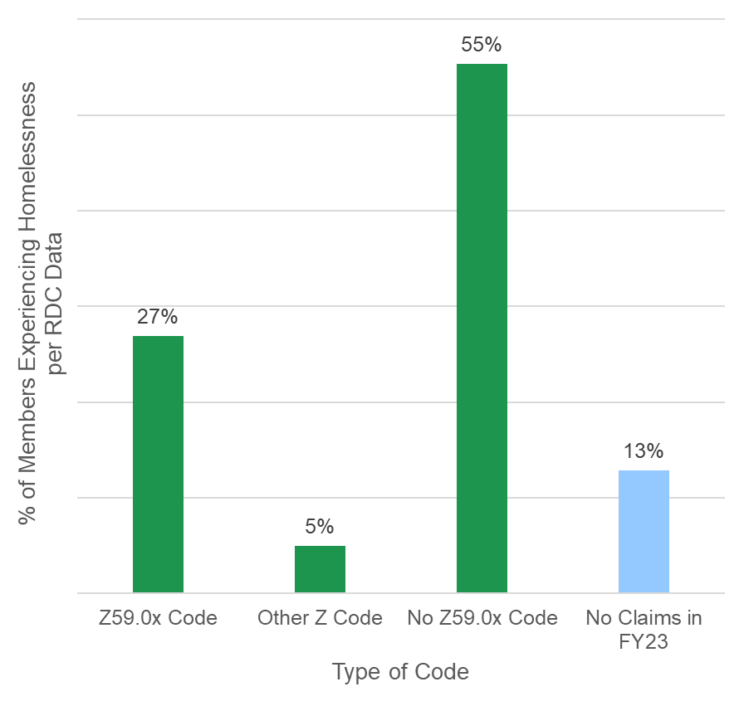

MassHealth – Justice Involvement

The Medicaid Inmate Exclusion Policy (MIEP) waiver proposal presents an opportunity for the
state to draw down federal dollars for medical services and improve care continuity

  - Meeting Objective: To share background/context and discuss opportunities related to MIEP
- Background: In 2022, the Centers for Medicaid and Medicare Services (CMS) tabled MassHealth’s initial MIEP proposal while they further developed policy on this topic, spurring a new proposal and amendment submission by MA in 2023
- Proposal: CMS is currently considering the new proposal, which would enable MassHealth to cover 90 days of pre-release coverage for all Medicaid-eligible adults and youth (increase from 30 days)
- Next Steps: While CMS review and negotiations continue in 2024, MassHealth is working closely with stakeholders to determine how this policy will be operationalized in correctional facilities across the state in the coming years

MIEP presents an opportunity for the state to receive funding for incarcerated individuals’ health care and social needs, which will be reinvested to further improve care

MIEP Overview
- The Medicaid Inmate Exclusion Policy (MIEP) refers to Title XIX of the Social Security Act; this provision excludes federal match dollars from state Medicaid programs for incarcerated individuals
- In October 2018, Congress passed the SUPPORT Act; this law directed CMS to develop guidelines encouraging state Medicaid programs to request flexibility of MIEP
- States can request flexibility of MIEP by submitting a demonstration waiver, also called an 1115 waiver; the waiver allows state Medicaid programs to waive certain federal Medicaid requirements
- As of January 2024, 18 states have submitted 1115 waivers to CMS; 2 states (California and Washington) have received approval, and 16 states (including Massachusetts) have submitted waivers that are pending review from CMS

MassHealth MIEP Background
- In 2022, CMS tabled the initial MIEP proposal submitted by MassHealth in the 1115 waiver submission; however, CMS encouraged MassHealth to resubmit a new MIEP proposal, pending release of broader federal guidance on MIEP waivers nationally
- In 2023, MassHealth submitted a revised MIEP proposal in an 1115 waiver amendment; this is currently pending CMS review
- As part of the updated proposal, MassHealth requested authority to:
  - Provide coverage for all eligible adults and youth for their last 90 days in a correctional setting pre-release
  - Cover all allowable Medicaid services
  - Provide infrastructure funding to correctional facilities for start-up costs

The MIEP proposal requests federal funding for services provided during the 90-day
pre-release period for all Medicaid-eligible adults and youth in correctional facilities

  - Covered Services
- Case management*
- Physical and behavioral health consults*
- Lab and radiology services
- Medication & medication administration
- Medication Assisted Treatment (MAT)
- Community health workers and navigators (such as CSP)
- Min. 30-day supply of meds upon release
- DME upon release

Start-up Infrastructure Funds
- Telehealth capacity building
- Electronic health records investment
- Medicaid billing staff and systems support
- Health care provision capital investments
- Staffing support in correctional settings, probation offices, courts, community justice support centers, etc.
*Care management and clinical service details are in development
Note: 90-day pre-release coverage of all Medicaid-eligible adults includes about ~35K adults/year and ~1K youth/year.

Opportunity to participate in MassHealth’s Community Feedback Forum for Health & Justice

Overview
The Massachusetts Executive Office of Health and Human Services (EOHHS), the state agency responsible for administering MassHealth, is seeking members to serve on a new stakeholder advisory council.
EOHHS seeks to select individuals who have lived experience with incarceration in Massachusetts, family members or guardians of those with lived experience, as well as representatives from community-based organizations, advocacy organizations, and direct service organizations who have experience working with individuals who have been incarcerated.

Details
The Forum will meet virtually
The Forum will meet quarterly through April 2026
Each meeting will last approximately 1-2 hours
It is anticipated that members will commit approximately 4 hours per quarterly meeting
Stipends will be available for members with lived incarceration experience and family members or guardians of individuals with such lived experience who are not paid by another organization
To apply, follow this link: 1115 MassHealth Demonstration ("Waiver") | Mass.gov

Behavioral Health Supports for Justice Involved Individuals (BH-JI) and Community Support Program for individuals with Justice Involvement (CSP-JI) overview

Goals
Develop a reach-in, re-entry model for engaging Justice Involved Individuals with mental health and addiction needs
Demonstrate improved health outcomes, decreased fatal overdoses, and effective, efficient healthcare utilization for Justice Involved Individuals enrolled in the BH-JI program
Connect and transition eligible Enrolled Individuals to appropriate health care services and Community Services, using Navigator model
Expand BH-JI program statewide

Process
Developed following the Council of State Government Justice Reinvestment recommendation in 2017
BH-JI Demonstration began in 2019 with Advocates and Open Sky, in partnership with Probation, Parole, DOC, Sheriff’s Offices, and others
BH-JI launched statewide in February 2022, and services now focus on:
In-Reach/Re-entry supports
Regional coordination activities
CSP-JI authorized for managed care members in August 2022 and remaining MassHealth members in July 2023
CSP-JI are exclusively community/post-release services
BH-JI/CSP-JI efforts and partnerships informed the MIEP proposal

