INDOOR AIR QUALITY ASSESSMENT
Sewage Backup Investigation

MassHealth
45 Spruce Street
Chelsea, Massachusetts

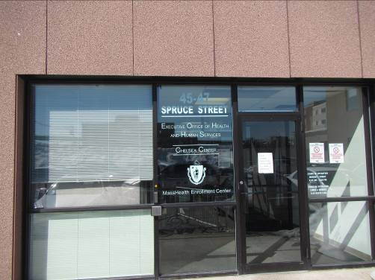

Prepared by:
Massachusetts Department of Public Health
Bureau of Environmental Health
Indoor Air Quality Program
September 2023

BACKGROUND
Building: | MassHealth
Address: | 45 Spruce Street, Chelsea, Massachusetts
Assessment Contact: | Pedro Batista, Field Operations Manager, Executive Office of Health and Human Services
Reason for Request: | Sewage backup and general IAQ
Date of Assessment: | September 1, 2023
Massachusetts Department of Public Health/Bureau of Environmental Health (MDPH/BEH) Staff Conducting Assessment: | Michael Feeney, Director, Indoor Air  Quality (IAQ) Program
Date of Building Construction: | 1970’s
Building Description: | The water damage occurred on the first floor of the MassHealth office located in Chelsea, MA. The building has a flat roof and appears to be clad in Exterior Foam Insulation System (EFIS) panels. Floors are covered with carpet squares.
Windows: | Not openable

METHODS
Please refer to the IAQ Manual and appendices for methods, sampling procedures, and interpretation of results (MDPH, 2015). A full assessment of these offices was conducted in 2015 and the report from that visit can be found here: https://www.mass.gov/info-details/indoor-air-quality-reports-cities-and-towns-c#chelsea-.

IAQ TESTING RESULTS
The following is a summary of indoor air testing results (Table 1). Only a limited area of the building near where the flooding/water damage occurred was tested.
- Temperature was within the recommended range of 70°F to 78°F in all areas on the day of assessment.
- Relative humidity was within the recommended range of 40 to 60% in the areas.

DISCUSSION
IAQ staff visited the site to assess the conditions and extent of a sewage backup that was reported to have occured on August 29, 2023. According to MassHealth staff, a toilet overflowed to wet bathroom walls and the adjacent walls and carpet tiles in the Assistant Director’s (AD) office, the hallway outside the AD office (Picture 1), a door alcove for the entrance into MassHealth Office space, as well as a hallway wall adjacent to the restroom inside the MassHealth office space (Picture 2).
A picture shown to IAQ staff showed toilet overflow water puddled along the wall of the restroom despite the presence of a floor drain (Picture 3) in the restroom floor. IAQ staff observed an access door (Picture 4) located at floor level next to the toilet. It is likely the toilet overflow entered the shared wall through this door to wet the shared wall cavity, gypsum wallboard (GW), and the carpet tile. Extensive staining of carpet tile in the AD office, AD hallway, and restroom hallway was seen on other pictures of the incident shown to IAQ staff during the visit.
IAQ staff noted that the plastic coving installed along the bottom of the hallway wall had not been removed as a part of the remediation activities (Pictures 1 and 2). Plastic coving can prevent the underlying wallboard from drying. IAQ staff used a moisture meter to determine if the gypsum wallboard below the plastic coving had dried. Gypsum wallboard in the AD office and hallway was measurably wet (Table 1) nearly ~72 hours after the reported incident.
It is important to note that porous materials (e.g., GW, carpet, cardboard) that have been in contact with blackwater cannot be effectively cleaned/sanitized or dried and must be disposed of properly. In general, the affected GW walls also need to be cut out at least 12 inches above the highest affected area and disposed of properly. It is recommended that the tile walls in the restroom be cut at least one foot above the high-water mark if the backerboard behind the tile wall is GW. Typically, the blackwater permeates the grout between the tiles and may impact any GW behind the nonporous tile.

CONCLUSIONS/RECOMMENDATIONS
In view of the findings at the time of the visit, the following recommendations are made:
- Follow EPA and industry guidelines concerning methods used to remediate buildings that are impacted by sewage (i.e., blackwater). Some of these guideline links include:
  - USEPA’s Flood Cleanup: Protecting Indoor Air Quality https://www.epa.gov/sites/production/files/2015-09/documents/floods.pdf and
  - ANSI/IICRC S500 - Standard and Reference Guide for Professional Water Damage Restoration. https://webstore.ansi.org/standards/iicrc/ansiiicrcs5002021
- Ensure that all porous items and building materials (e.g., carpet tiles, GW) that were damaged by the backup of blackwater are removed and discarded. This would include wallboard behind tiles in restrooms if it is deemed porous (GW) and not able to be properly sanitized.
- Ensure proper containment strategies are being utilized while work is being performed (e.g., sealed return ducts, depressurization methods) to avoid further contamination.
- Ensure that all nonporous building materials, items, and surfaces impacted are properly disinfected prior to replacing building materials/furnishings.
- Prevent future flooding by:
  - Considering installing electric hand dryers in restrooms and removing the paper towels/wipes.
  - Install signs that explicitly prohibit items such as wipes and paper from being flushed down the toilets.
- Refer to resource manual and other related indoor air quality documents located on the MDPH’s website for further building-wide evaluations and advice on maintaining public buildings. These documents are available at http://mass.gov/dph/iaq.

REFERENCES
MDPH. 2015. Massachusetts Department of Public Health. Massachusetts Department of Public Health Indoor Air Quality Manual: Chapters I-III. Available at: http://www.mass.gov/eohhs/gov/departments/dph/programs/environmental-health/exposure-topics/iaq/iaq-manual/.
Picture 1
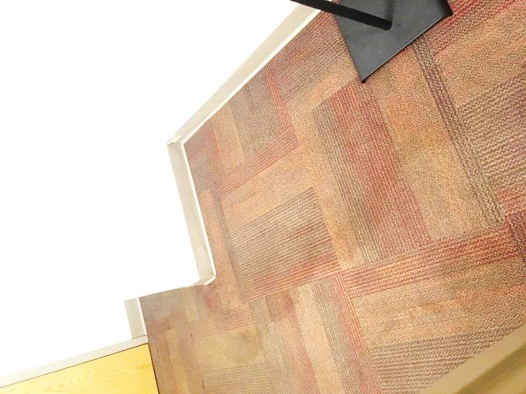
Water stain on carpet outside AD Office, note grey plastic coving at base of wall within carpet stain
Picture 2
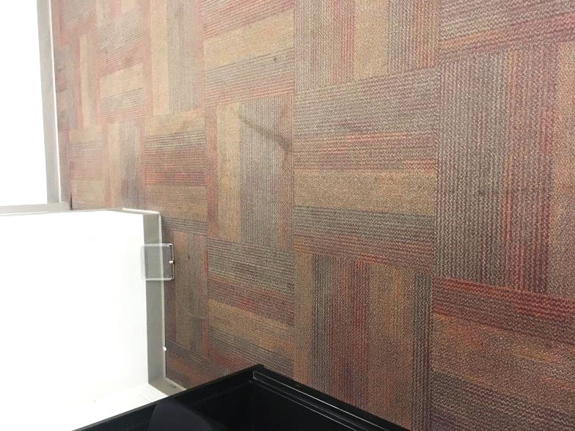
Water stain on carpet outside AD Office, note grey plastic coving at base of wall within carpet stain

Picture 3
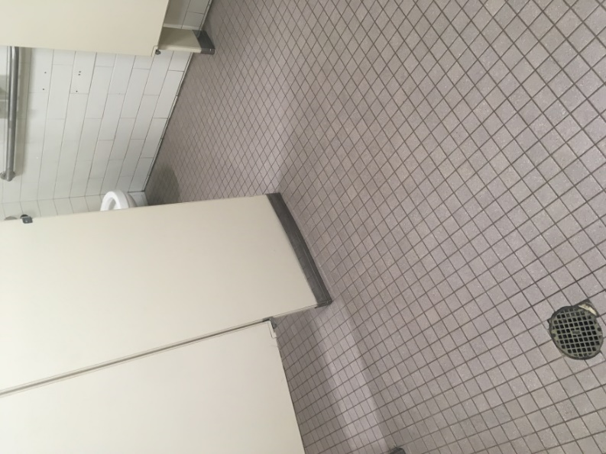
Toilet which overflowed, note floor drain in foreground
Picture 4
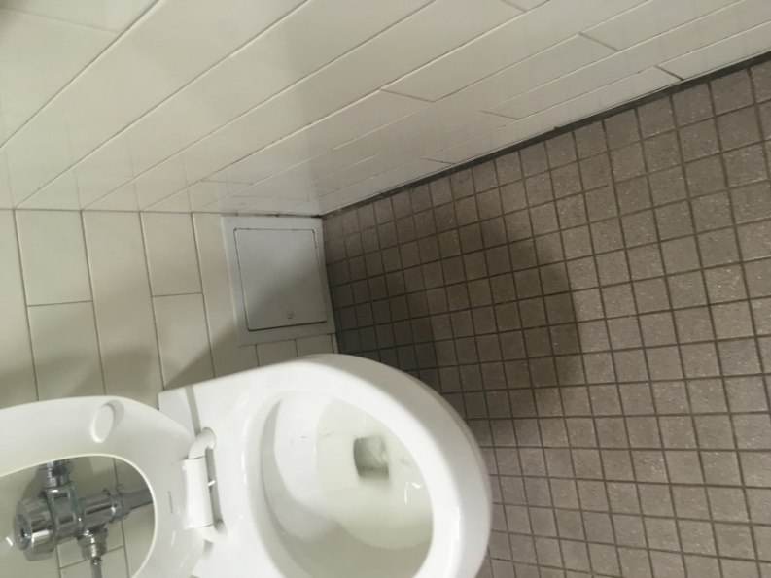
Access door below overflowed toilet, note bottom of frame of access door is at floor level

Table 1
Chelsea MassHealth
45 Spruce Street, Chelsea, MA
Moisture Sampling Results

Location | Temp  (°F) | Relative  Humidity  (%) | Dew Point*  (°F) | Wall Moisture measurement  (%) | Remarks
Lobby, wall opposite public restrooms | 73 | 52 | 54 | Non-detect (dry) | Gypsum wallboard not involved with overflow
Restroom where overflow occurred | 71 | 56 | 54 |  | Access door in toilet wall
Restroom hallway | 71 | 54 | 53 | Non-detect (dry)
Assistant director office | 71 | 54 | 48 | 9-28
Assistant director Hallway | 71 | 54 | 48 | 18-38
- These dew points indicate that moisture measurements in building materials are not due to relative humidity >70% or building components moistened by condensation

