WATER DAMAGE/MOLD INVESTIGATION

MassHire Career Center
618 Acushnet Avenue
New Bedford, Massachusetts

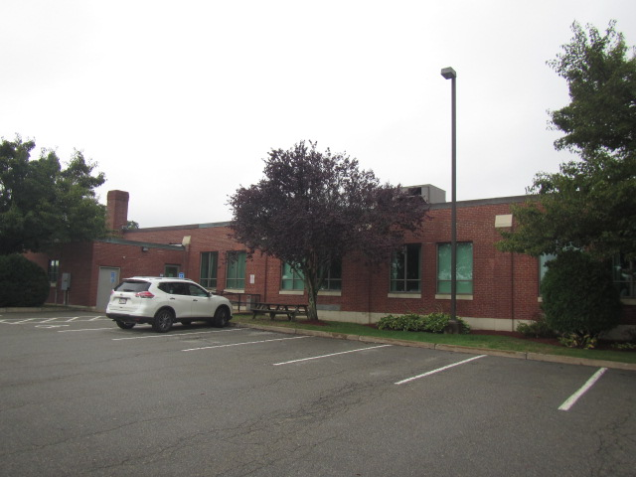

Prepared by:
Massachusetts Department of Public Health
Bureau of Environmental Health
Indoor Air Quality Program
October 2022

BACKGROUND
Building: | MassHire Career Center
Address: | 618 Acushnet Avenue  New Bedford, Massachusetts
Assessment Requested by: | A. Harris Magloire,  Construction Manager, Facilities/Operations Management,  Executive Office of Labor and Workforce Development
Reason for Request: | Mold/water damage concerns after several weeks of roof leaks
Date of Assessment: | September 13 & 22, 2022
Massachusetts Department of Public Health/Bureau of Environmental Health (MDPH/BEH) Staff Conducting Assessment: | Cory Holmes, Assistant Director,  Bureau of Environmental Health  (BEH), Indoor Air Quality (IAQ)  Program

INTRODUCTION
The BEH/IAQ Program was asked to examine the New Bedford MassHire Career Center for the presence of water damage/mold growth, with a focus on areas that were damaged by roof leaks during rainstorms in the northeast corner of the building (Whale Room B conference room and workstations 30-34). Verbal recommendations were made during the visit on September 13, 2022, and a follow-up visit was made on September 22, 2022.

IAQ TESTING RESULTS
Please refer to the IAQ Manual for methods, sampling procedures, and interpretation of results (MDPH, 2015). The testing conducted on September 13, 2022 is summarized below, and the testing results from September 22, 2022 are presented in Table 1.
- Moisture Measurements of walls/floors in the area of roof leaks were above normal parameters at the time of assessment, indicating that porous building materials [e.g., carpeting and gypsum wallboard (GW)] were not properly dried.
- Relative Humidity Measurements indoors ranged from 87 to 90%, which were above the recommended range of 40% to 60% in all areas assessed, indicating a source of water vapor in the building.

Table 1. Air Testing Results for September 22, 2022
Media sampled |  | MDPH Guideline/  Comparison Value |  | Measured Range |  |  | Comments
 |  |  |  | Outdoors/  Background |  | Indoors
Total Volatile Organic Compounds (TVOCs) |  | Non-detectable (ND) or equal to or below background level measured |  | ND |  | ND
Carbon Monoxide (CO) |  | Non-detectable (ND) or equal to or below background level measured |  | ND |  | ND
Particulate Matter 2.5 (PM2.5) |  | US EPA National Ambient Air Quality Standards (NAAQS) 35 μg/m³ or less |  | 14 μg/m³ |  | 4 to 8 μg/m³ | Levels were all below 35 μg/m³
Temperature |  | 70 to 78 ºF |  | 73 ºF |  | 68 to 69 ºF | All readings were close to the MDPH recommended comfort guidelines.
Relative Humidity (RH) |  | 40% to 60% |  | 83-100% |  | 80 to 86% | All readings were above the MDPH recommended comfort guidelines.
Moisture Measurements |  | Porous building materials should have low (i.e., normal moisture content) |  |  |  | Carpeting was dry (i.e., normal) | Water-damaged gypsum wallboard had been removed and replaced.
ppm = parts per million | µg/m³ = microgram per cubic meter |  | ND = non-detectable

DISCUSSION
Prior to the initial DPH IAQ visit, the roof was reportedly repaired, and fans and wet vacs were used to dry wet building materials (e.g., carpet squares and GW). However, as mentioned, carpeting and GW remained wet several days after these repairs/remediation efforts were made (Pictures 1 through 4). In addition, several ceiling tiles were water-damaged (Picture 5), which occupants report occurred after roof repairs were made. While on site, DPH IAQ staff contacted Mr. Magloire and recommended that a professional flooding and restoration firm perform remediation efforts.
In general, the US Environmental Protection Agency (US EPA) and the American Conference of Governmental Industrial Hygienists (ACGIH) recommends that porous materials (e.g., wallboard, carpeting) be dried with fans and heating within 24 to 48 hours of becoming wet (US EPA, 2008; ACGIH, 1989). If porous materials are not dried within this time frame, mold growth may occur.
Following the initial DPH IAQ visit, a flooding restoration/carpet cleaning firm was contacted to perform remediation activities. These included:
- Use of fans and dehumidifiers to accelerate drying of carpeting.
- Removal of coving from impacted walls; and
- Removal and replacement of water-damaged GW (Pictures 6 and 7).
At the time of the follow up DPH IAQ visit on September 22, 2022, all water-damaged materials had been either removed or dried and no visible mold/associated odors were observed/detected. However, it is important to note that relative humidity measurements indoors ranged from 80 to 86%, which was above the MDPH recommended comfort range of 40 to 60% in all areas assessed and was reflective of outdoor conditions (83 to 100%). These elevated relative humidity measurements may be due to the percentage of outdoor air being introduced into the heating, ventilation, and air-conditioning (HVAC) system.

CONCLUSIONS/RECOMMENDATIONS
Based on observations and moisture testing, it appears that by September 23, 2022, all affected water-damaged materials were thoroughly dried or removed. The following additional recommendations were made at the time of assessment and are reiterated below:
- Continue with restoration/reconstruction plans including finishing replacement of GW.
- Once remediation activities are concluded, clean all items and surfaces with a high efficiency particulate arrestance (HEPA) filter equipped vacuum cleaner combined with wet wiping.
- Consider working with a heating, ventilation, and air conditioning (HVAC) engineering firm to:
- Evaluate the ability of the HVAC system to maintain temperature and relative humidity.
  - Determine if air handling units can be adjusted to properly maintain temperature and relative humidity by reducing outside air percentage during outside elevated humidity conditions.
- For more information on mold refer to the US EPA’s “Mold Remediation in Schools and Commercial Buildings”. Available at: http://www.epa.gov/mold/mold-remediation-schools-and-commercial-buildings-guide.
- Refer to resource manuals and other related IAQ documents for further building-wide evaluations and advice on maintaining public buildings. Copies of these materials are located on the MDPH’s website: http://mass.gov/dph/iaq.

REFERENCES
ACGIH. 1989. Guidelines for the Assessment of Bioaerosols in the Indoor Environment. American Conference of Governmental Industrial Hygienists, Cincinnati, OH.
MDPH. 2015. Massachusetts Department of Public Health. “Indoor Air Quality Manual: Chapters I-III”. Available at: Indoor air quality - manual and appendices | Mass.gov
US EPA. 2008. Mold Remediation in Schools and Commercial Buildings. US Environmental Protection Agency, Office of Air and Radiation, Indoor Environments Division, Washington, D.C. EPA 402-K-01-001. http://www.epa.gov/mold/mold-remediation-s-and-commercial-buildings-guide.
Picture 1
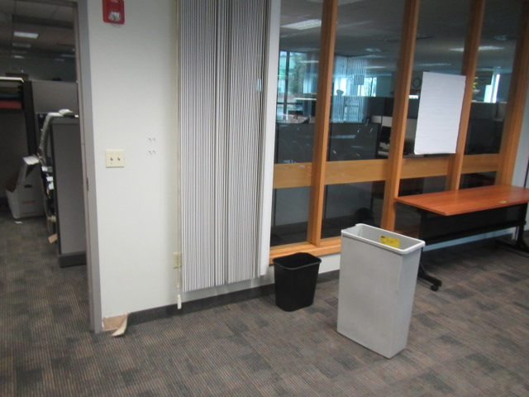
Whale Room B Conference room where leak occurred wetting carpet squares and gypsum wallboard
Picture 2
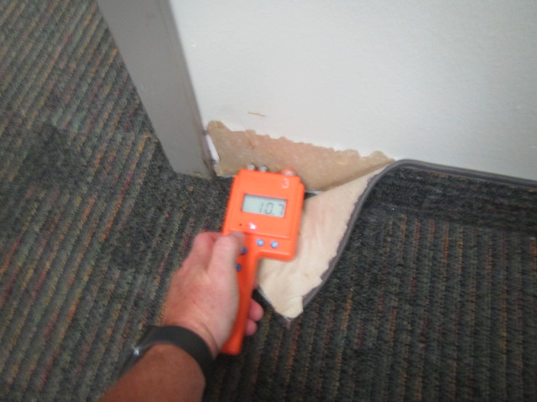
Wet gypsum wallboard inside Whale Room B
Picture 3
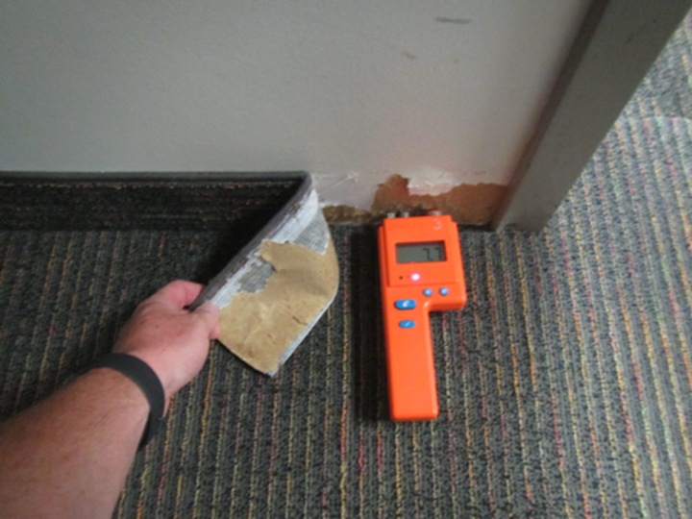
Wet gypsum wallboard directly outside Whale Room B
Picture 4
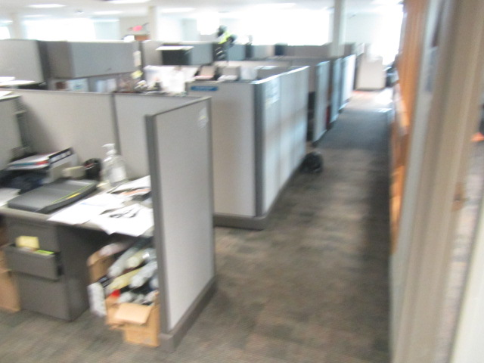
Workstations 30-34 directly outside Whale Room B with wet carpeting
Picture 5
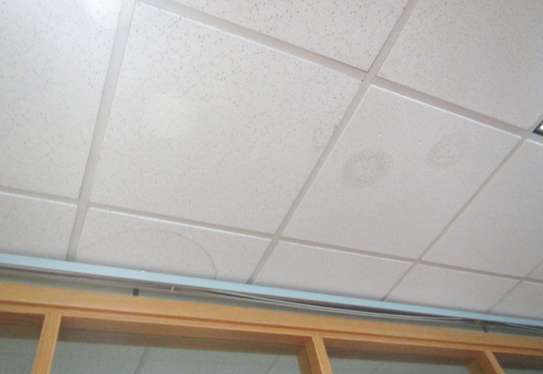
Water-damaged ceiling tiles, note tiles were reportedly stained after roof repairs were made
Picture 6
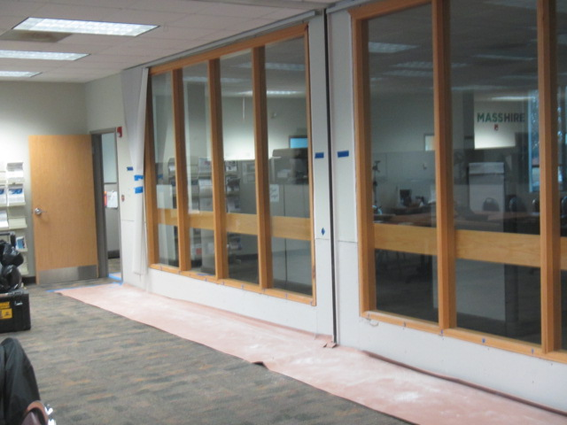
Gypsum wallboard replaced in Whale Room B

Picture 7
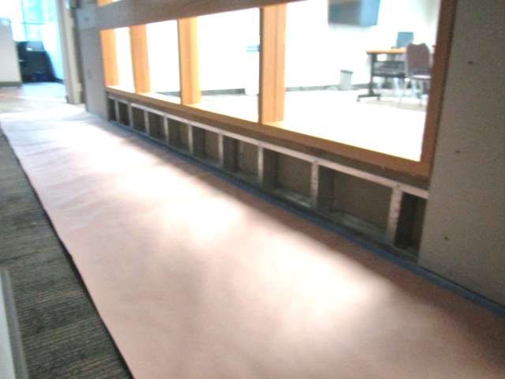
Gypsum wallboard removed directly outside Whale Room B, indicating wall cavity clean and dry

