**MassHire Greater New Bedford Workforce Board**

**Local WIOA 4-Year Plan**

**2025-2029**

**Prepared by:**  
MassHire Greater New Bedford Workforce Board

**Date:** August 2025

**Submitted to:**  
The Honorable Mayor  
City of New Bedford  
Commonwealth of Massachusetts

*Strengthening workforce pipelines, expanding access to training, and supporting sustainable economic growth throughout the Greater New Bedford region.*

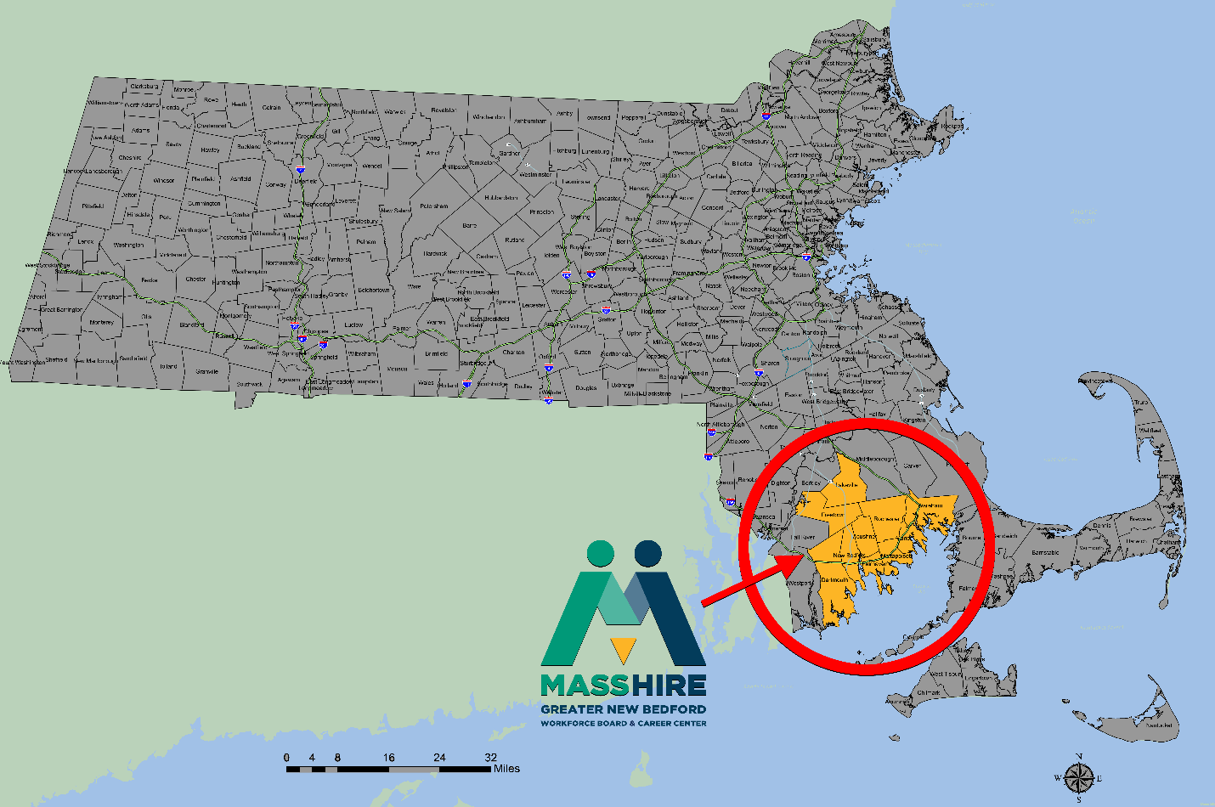

**Table of Contents**

**Executive Summary** ..................................... 3

**Section I: Regional Economic and Workforce Analysis** ............... 4

**Section II: Strategic Alignment and Partnership Coordination** ....... 19

**Section III: Service Delivery and Performance Standards** ........... 29

**Section IV: Governance and Continuous Improvement** ................ 40

**Appendices** ........................................... 46

**Executive Summary**

MassHire Greater New Bedford Workforce Board – FY2025–2029 Local WIOA Plan

The MassHire Greater New Bedford Workforce Board (MHGNBWB) is pleased to present its 2025–2029 Local Workforce Innovation and Opportunity Act (WIOA) Plan. This plan reflects a bold, forward-looking strategy to strengthen workforce pipelines, expand training opportunities, and align with the economic development priorities of the City of New Bedford and the Commonwealth of Massachusetts.

**Regional Workforce Priorities**

• Priority Industries: Offshore Wind, Advanced Manufacturing, Healthcare, IT, and Construction are identified as the key growth sectors driving the region’s economic transformation.  
• Training and Upskilling: Expanded access to Individual Training Accounts, apprenticeships, and sector-based credentialing programs ensure residents gain the skills employers demand.  
• Digital Equity and Accessibility: Enhanced virtual service delivery and digital literacy support are central to increasing opportunity for all residents.  
• Youth Pathways: YouthWorks, Connecting Activities, internships, and school-to-career programming prepare the next generation for sustainable careers.  
• Inclusive Access: Targeted strategies serve veterans, immigrants, individuals with disabilities, and residents with limited English proficiency, ensuring equitable workforce participation.

**Economic and Workforce Alignment**

• Regional Labor Market Data: Projections through 2029 highlight strong growth in healthcare and renewable energy, coupled with persistent demand in advanced manufacturing and technical services.  
• Education & Employer Collaboration: Deep partnerships with Bristol Community College, UMass Dartmouth, technical high schools, and local employers drive curriculum alignment and training innovation.  
• Economic Development Integration: The Board works closely with the City of New Bedford, Port Authority, and regional planning councils to ensure workforce development aligns with business attraction and retention strategies.

**Service Delivery & Accountability**

• Career Center Modernization: Updated workshops, digital platforms, and resource tools improve job readiness and access to high-demand opportunities.  
• Performance Standards: Local targets align with state and federal benchmarks, focusing on employment retention, credential attainment, and measurable skill gains.  
• Continuous Improvement: Regular partner coordination, customer feedback, and data-driven strategies ensure ongoing system effectiveness and responsiveness.

**Commitment to the Region**

The MassHire Greater New Bedford Workforce Board remains steadfast in its mission: to build a resilient, inclusive workforce system that meets the evolving needs of employers while expanding opportunity for every resident. By aligning workforce, education, and economic development efforts, this plan lays the foundation for sustained economic growth and stronger communities across Greater New Bedford**.**

**Section I: Regional Economic and Workforce Analysis**

**1. Strategic Planning Elements**

**(a) Regional Economic Overview**

The Greater New Bedford Workforce Board serves southeastern Massachusetts, a region characterized by both historical economic strengths and emerging transformation opportunities. This diverse economic landscape encompasses Gateway Cities, suburban communities, and rural towns stretching from Norfolk County through Plymouth and Bristol Counties to the Rhode Island border.

The regional economy reflects a strategic transition from traditional maritime and manufacturing foundations toward emerging high-growth sectors. While preserving competitive advantages in established industries, the region is positioning itself as a national leader in offshore wind energy development, advanced manufacturing modernization, and healthcare expansion driven by demographic shifts.

Economic development coordination occurs through systematic partnerships with municipal economic development agencies, regional planning organizations, and state-level initiatives. These collaborations ensure workforce development programming aligns with business attraction and retention strategies while supporting existing employer expansion and modernization efforts.

Priority industry sectors demonstrate both current employment strength and projected growth potential. Maritime and offshore wind industries leverage the region's coastal advantages and maritime expertise while creating pathways for workforce transition from traditional fishing and shipping into renewable energy careers. Advanced manufacturing builds established industrial infrastructure while incorporating contemporary technology and precision production methods that require upgraded workforce capabilities.

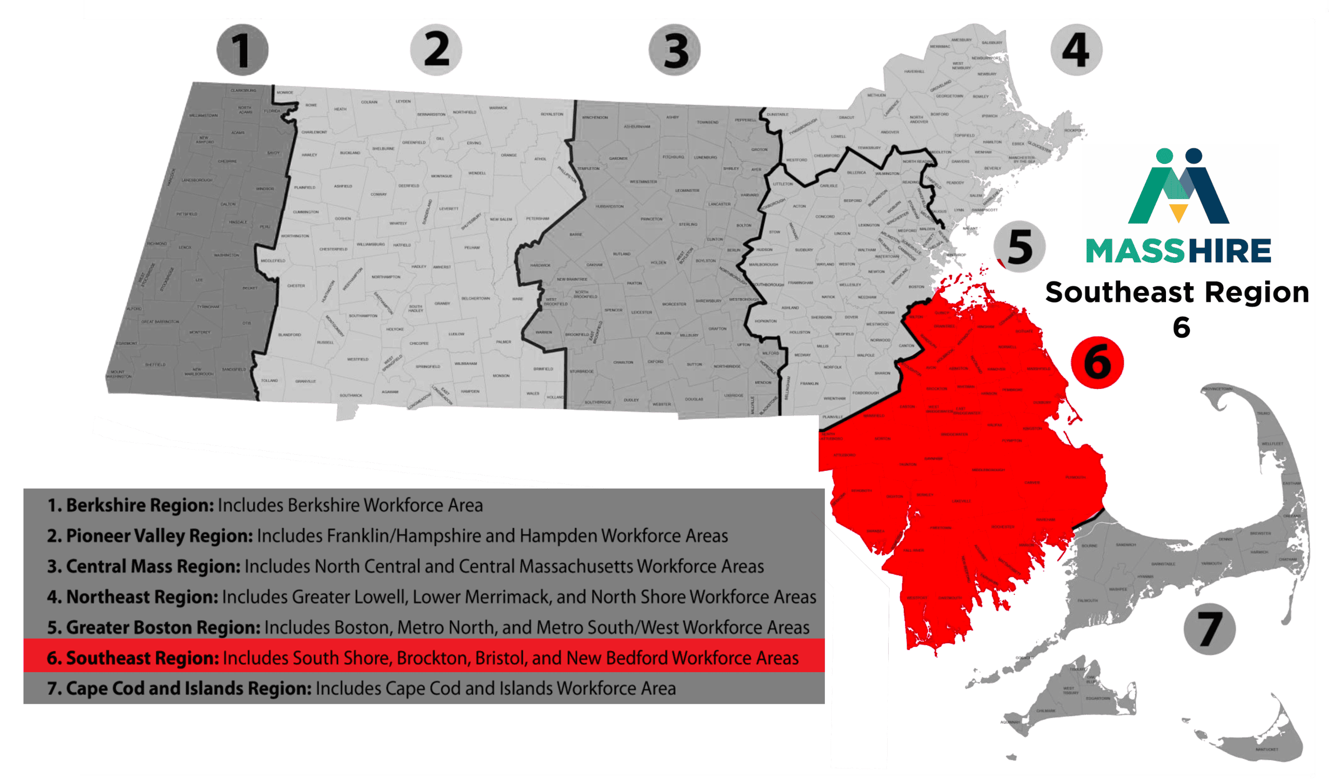

**Regional Economic Data Summary**

| **Metric** | **Region** | **State** |
| --- | --- | --- |
| Population | 235,150 | 7,037,782 |
| Labor Force | 96,150 | 3,948,251 |
| Jobs | 78,104 | 4,068,167 |
| Unemployment Rate | 5.5% | 4.8% |

*Source:* [*https://analyst.lightcast.io/analyst*](https://analyst.lightcast.io/analyst)

<https://www.bls.gov/emp/documentation/projections-methods.htm>

**1(1) Industry Sector Analysis**

ll **Employment Needs**

**Healthcare and Life Sciences** represents the region's largest and fastest-growing employment sector, driven by aging population demographics and expanding medical services throughout southeastern Massachusetts. Employment growth projections indicate 18-22% expansion through 2029, with demand for home health aides, medical assistants, certified nursing assistants, and specialized clinical support roles.

Healthcare workforce development challenges include recruitment of qualified candidates for direct care positions, retention of trained workers in competitive labor markets, and ongoing skills upgrading to accommodate technological advancement in patient care delivery. Educational pathway development requires coordination between workforce programs, community colleges, and healthcare employers to ensure training aligns with both immediate employment needs and career advancement opportunities.

**Advanced Manufacturing** demonstrates moderate overall growth while creating substantially higher-wage opportunities requiring technical expertise and continuous learning capabilities. Regional manufacturers report critical shortages in computer numerical control (CNC) machining, welding, industrial maintenance, and quality control positions that combine technical proficiency with problem-solving skills and adaptability to evolving production methods.

Manufacturing workforce development emphasizes modernization of worker capabilities to accommodate Industry 4.0 technologies including automation, data analytics, and precision manufacturing systems. Training programs must address both technical competencies and workplace readiness skills that enable workers to contribute effectively in contemporary manufacturing environments emphasizing continuous improvement and team-based problem-solving.

**Offshore Wind Energy** presents transformative economic opportunities that leverage regional maritime expertise while creating entirely new career pathways in renewable energy development, installation, and maintenance. Industry development includes turbine manufacturing, port facility development, specialized vessel operations, and long-term maintenance services requiring maritime safety certification combined with renewable energy technical knowledge.

Workforce development for offshore wind requires innovative approaches that combine traditional maritime skills with emerging renewable energy competencies, safety protocols specific to offshore operations, and career pathways that enable workforce transition from traditional maritime industries into renewable energy careers offering comparable or enhanced wages and advancement opportunities.

**Professional and Technical Services** expansion reflects regional economic diversification into data-driven fields, engineering services, financial services, and business consulting that support both regional employers and external clients. Growth sectors include information technology services, architectural and engineering consulting, financial planning and analysis, and specialized business services that leverage regional educational assets and proximity to major metropolitan areas.

**1 (1)** **lll Description of Regional Economy**

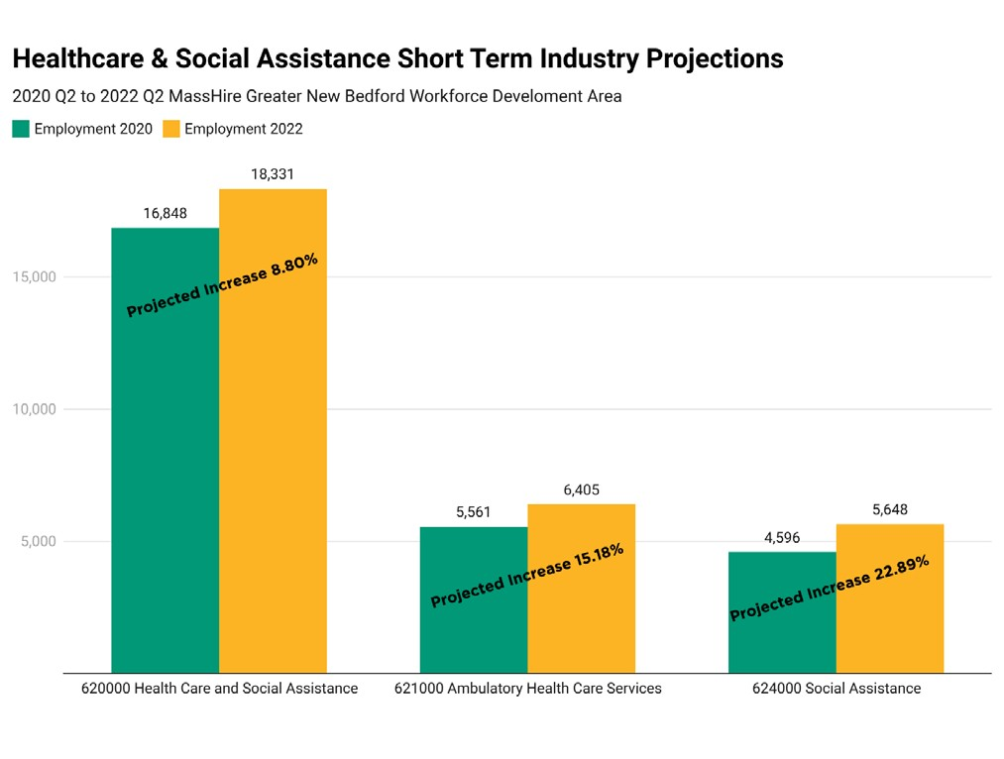

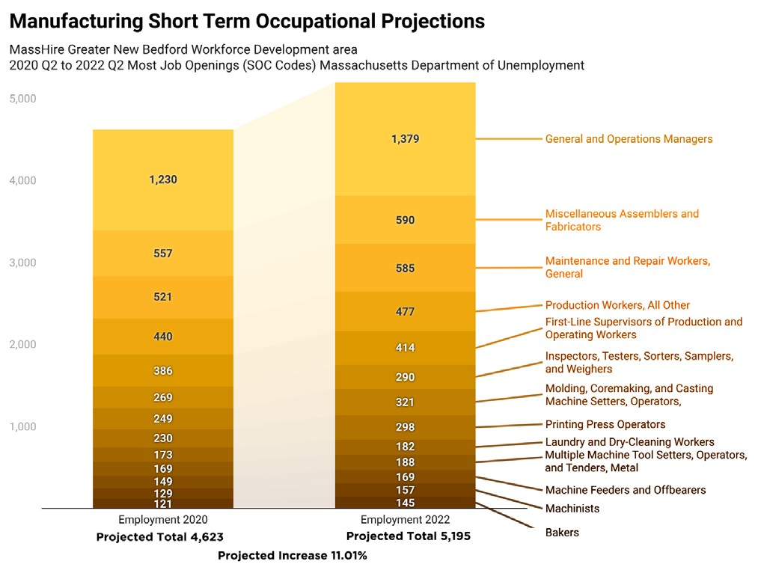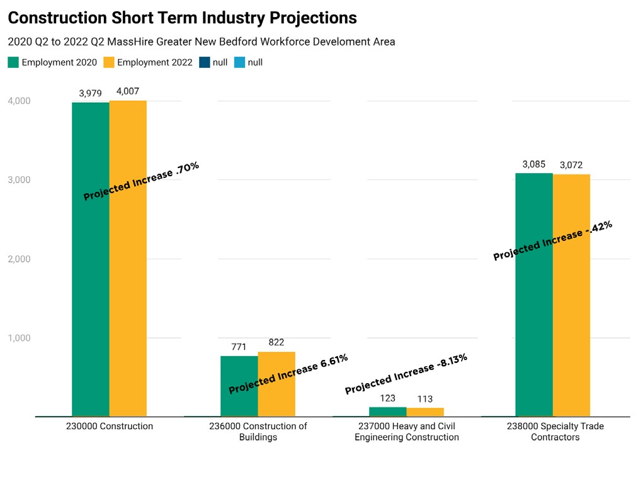

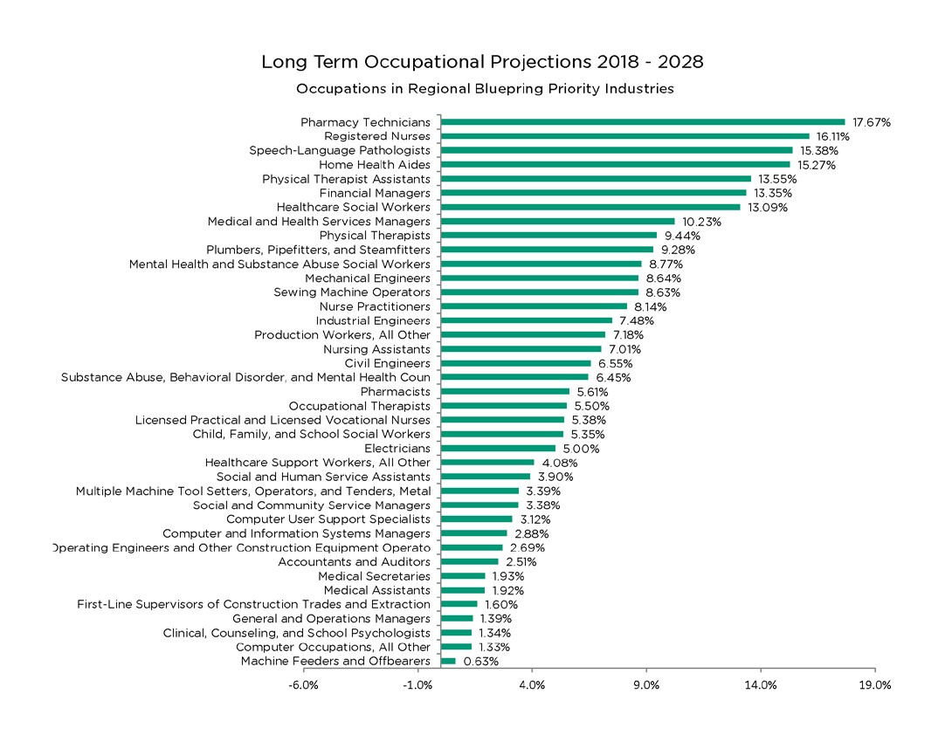

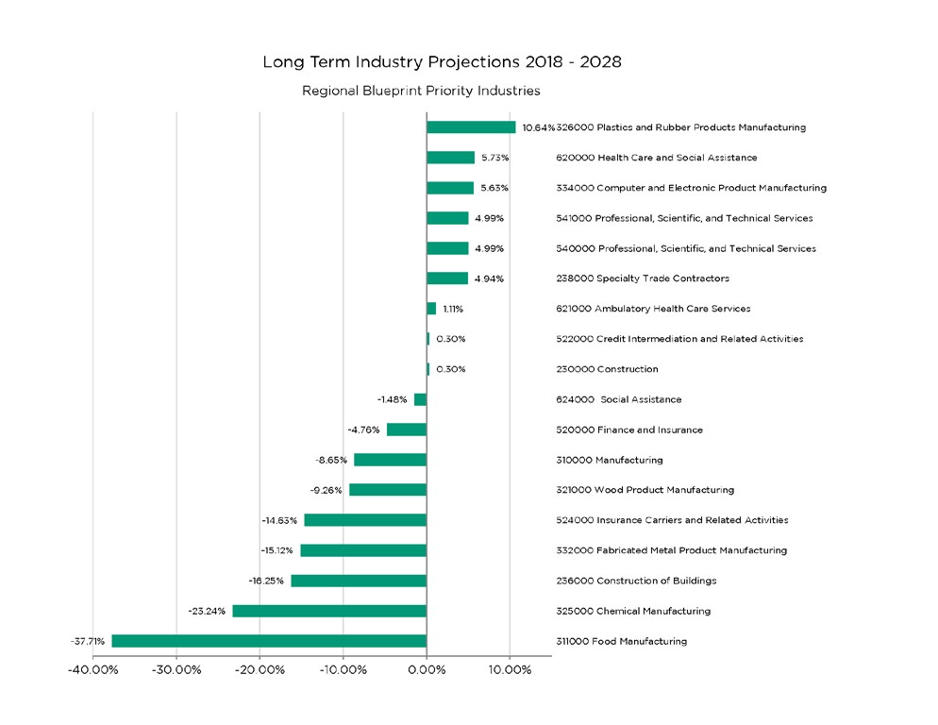

**1(2) Knowledge and Skills For Regional Employment Needs**

To meet employer needs for specific skills and knowledge from their employees, the workforce board:

* Performs real time analyses of the economic conditions in the region to learn the needed knowledge and skills of the region
* Conducts research, data collection, surveys and analysis related to the workforce needs of the regional economy after receiving input from a wide array of stakeholders and then determines training necessary to carry out these functions
* Conducts continued analysis on new industries such as offshore wind and marine trades where growth within the next 3-5 years will heavily impact employment in the Southeast Region

Past employer feedback indicate a convergence of common industry skill factors that contribute to the staffing challenges employers are facing when hiring and retaining qualified labor. Employers need job seekers to have soft skills, critical thinking skills, and ability to keep composure in the workplace (leave personal at home). Other common employer required and needed skill examples include:

* Job seekers need experience with the Microsoft suite
* Many employers require job seekers to have good driving records, valid driver license, and able to pass a CORI
* Employers need job seekers to have financial literacy and able to pass a financial background check
* Job seekers should have good customer service skills and know how to work in teams

Contemporary employment across all priority industries demonstrates increasing convergence around transferable skills that enable worker adaptability and career advancement throughout economic changes. Employers consistently identify problem-solving capabilities, digital literacy, communication effectiveness, and customer service excellence as fundamental requirements that transcend specific occupational boundaries.

The following chart details skills employers need job applicants to possess. When we develop training plans from grants awarded to us, we make conscious decisions to also include as essential skill training components as the funding allows.

**Industry-Specific Technical Requirements**

**Healthcare Technical Competencies** include clinical skills specific to direct patient care, regulatory compliance knowledge for healthcare settings, electronic health records proficiency, and specialized equipment operation that varies by healthcare setting and occupational role. Advanced positions require understanding of medical terminology, patient safety protocols, infection control procedures, and interdisciplinary communication methods.

Training program development must address both entry-level competencies that enable immediate employment and advancement pathways that support career progression through additional education and specialized certification. Healthcare career ladders require coordination between workforce programs, educational institutions, and employer partners to ensure training investments support both individual advancement and employer workforce development needs.

**Manufacturing Technical Skills** encompass precision measurement and quality control, computer-controlled equipment operation, blueprint reading and technical documentation interpretation, workplace safety and regulatory compliance, and lean manufacturing principles that optimize production efficiency while maintaining quality standards.

Contemporary manufacturing requires workers capable of operating sophisticated equipment while contributing to continuous improvement initiatives, quality management systems, and workplace safety programs. Training approaches must combine hands-on technical skill development with broader understanding of manufacturing processes, business operations, and customer requirements that drive production decisions.

**Renewable Energy Competencies** combine traditional maritime skills with specialized renewable energy knowledge including turbine technology, electrical systems, safety protocols for offshore operations, and environmental compliance specific to marine renewable energy development. Career pathway development requires systematic progression from entry-level positions through specialized technical roles requiring advanced certification and experience.

**1(3) Regional Workforce Analysis**

**3.1 Demographic and Educational Characteristics**

The Greater New Bedford region's workforce characteristics reflect both assets and challenges that influence workforce development programming and economic development potential. Educational attainment varies significantly across municipalities, with some communities demonstrating high school completion rates below state averages while others exceed regional and state benchmarks.

Language diversity represents both an asset and a challenge, with substantial populations of Spanish, Portuguese, and other language speakers who contribute valuable cultural competencies and international business capabilities while potentially requiring language support services to access career advancement opportunities. English as a Second Language (ESOL) programming integration with workforce development creates pathways for immigrant workers to utilize their skills and experience while developing English proficiency for career advancement.

Age distribution shows both opportunities and concerns, with younger populations providing workforce pipeline potential while aging demographics create replacement needs across multiple industries. Workforce development programming must address both youth career pathway development and older worker retraining and upgrading skills to maintain regional workforce capability and economic competitiveness.

Geographic distribution across urban, suburban, and rural communities creates transportation and service access challenges that require innovative service delivery approaches including mobile services, technology-enhanced remote participation, and coordination with transportation providers to ensure all residents can access workforce development opportunities regardless of location.

**1(3)(a) Workforce Development Activities: Strengths and Weaknesses**

**STRENGTHS:**

The MassHire Greater New Bedford Workforce Board (MHGNBWB) operates a well-integrated network of workforce development partners, including the Career Center, local community colleges, high schools, state agencies, and community organizations.

Training programs target both entry-level and incumbent workers in sectors such as CNA/healthcare, manufacturing (MACWIC Level 1 & 2), CDL licensing, banking/finance.

Significant collaboration with colleges such as Bristol Community College (BCC) and UMass Dartmouth and Career Technical Initiatives (CTI) has increased training options, career ladder access, and alignment with employer needs.

JOB QUEST is an excellent resource for job seekers and employers.

MHGNBCC Counselors share and customize relevant Labor Market Information (LMI) with each job seeker.

Advisory boards that exist at community colleges and vocational schools for the sectors of healthcare, manufacturing, and marine/maritime do a good job in providing direction for training programs.

We have strong Veterans Services with our local DVOP who has important ties to the community, training programs specific to Veterans.

We have engaged workforce board members who offer suggestions for training programs that benefit our local region.

Our job seekers have access to many other resources like the MA Career Information System (MassCIS), Transferrable Occupational Relationship Quotient (TORQ), Career Ready 101 all geared to exploring and filtering through career pathways and sustainable employment and wages.

**WEAKNESSES:**

Employers report challenges in finding workers with adequate technical and soft skills. CNC machining and the technical capacity to provide this training remain limited in our region and hinders expansion and competitiveness in healthcare and advanced manufacturing.

Small businesses often lack the capacity to invest in employee training due to resource limitations, available training capacity, and low awareness of available workforce funding and support.

Work readiness and foundational skills (e.g., English proficiency, digital literacy, customer service, punctuality) are lacking among some jobseekers, including those with barriers such as limited English proficiency (17.5% of adults), disabilities, and limited formal education.

Demand for ABE services outweigh available resources (wait lists).

Training tends to be grant driven vs. systematic training.

Four-year public institutions to develop courses and programs that create pathways for incumbent worker to transition to management positions.

**1(3)(b) Capacity to Serve Workforce Needs**

**i. Education and Skill Needs of the Workforce**

MHGNBWB has directed trainings to eligible individuals through federal and state grants with Individual Training Accounts focusing on employer requested sector specific needs in Healthcare, Manufacturing and Transportation certification.

**ii. Individuals with Barriers to Employment**

The region supports individuals facing barriers including people with disabilities, limited English proficiency, veterans, and youth through coordinated partnerships including but not limited to:

* Massachusetts Commission for the Blind (MCB)
* MassAbility
* Department of Transitional Assistance (DTA)
* New Bedford Adult Learning Center
* Youthbuild
* JobCorps
* Southeastern Regional Planning and Economic Development District (SRPEDD)
* Jobs for Veterans State Grants Program
* Senior Community Service Employment Program
* Other community-based education providers

MHGNBWB maintains Memorandum of Understanding (MOU) with partners that enables cross-referral, shared case management, and co-enrollment to better support those with challenges such as homelessness, reentry, or long-term unemployment.

**iii. Employment Needs of Businesses**

Businesses in priority sectors such as healthcare, advanced manufacturing, construction, transportation, and finance require job-ready, credentialed candidates. The MassHire Business Services Team and BizWorks programs provide employer support in job development, incumbent worker training, layoff aversion, and hiring assistance.

Manufacturers engage through the Southeast Advanced Manufacturing Consortium (SAMC) and our four SEMA Regional Work Board partners to provide input and create programming.

Construction, manufacturing, and culinary employers work with the CTI programming to provide hands-on training opportunities.

**1(3)(c) Coordination with Local Educational Partners**

The region has a robust network of support in promoting CTIs and partnering with Old Colony Regional Professional Technical School (STI), South Shore Technical Institute and other training providers to train and upskill participants of the region. These collaborations support dual enrollment, stackable credential pathways, and training for in-demand careers.

The MHGBWB and its regional partners are dedicated to building a stronger workforce development system through data-informed planning, equitable access to training, and active employer engagement. As the economy continues to shift, our regional strategies will prioritize aligning education, skill-building, and business needs to foster lasting economic opportunity and resilience across all communities we serve.

In southeastern Massachusetts, we met with employers in direct care, behavioral health, home health care, manufacturing, technology, financial services, and emerging industries to identify career pathways, assess training capacity, and align curriculum. These conversations also addressed industry regulations that shape workforce and education strategies.

Employment needs in our region span a broad range of skills and credentials. In healthcare and social assistance, positions range from certification-based roles to those requiring advanced degrees. Other high-demand industries focus on workplace-specific credentials such as:

* Home Health Aide (HHA)
* Commercial Driver's License (CDL)
* CNC Machining
* Welding

Across industries, customer service remains the top skill in demand, from entry level to senior management. Oral and written communication skills follow closely, along with English language proficiency for non-native speakers.

**Demand BY EDUCATIONAL ATTAINMENT FOR SE MA**

lmi.dua.eol.mass.gov/LMI/OccupationalEmploymentAndWageAllIndustries

**1(4) Strategic Vision for Advancing Regional Economic Growth and Workforce Self-Sufficiency**

The MHGNBWB advances regional economic growth and self-sufficiency through a strategic vision aligned with the Massachusetts Workforce Agenda's Focus Area II: Talent Development, as outlined in the Commonwealth's WIOA Combined Plan (2024–2028). This vision centers on developing a workforce that meets employer needs while ensuring equitable access to employment opportunities for all residents—particularly those facing barriers to work. It reflects the broader state strategy to strengthen competitiveness, enhance affordability, and promote equity across all regions.

**KEY COMPONENTS INCLUDE:**

Building a collaborative workforce system that aligns training and education with industry demands.

Promoting equitable and inclusive economic participation, particularly for youth, UI claimants, individuals with disabilities, veterans, and others with barriers to employment.

Supporting high-demand, high-growth industries, including healthcare, advanced manufacturing, clean energy, construction, and logistics.

**GOALS FOR PREPARING AN EDUCATED AND SKILLED WORKFORCE**

MHGNBWB implements workforce strategies that mirror the state's priorities by focusing on:

**Youth:** Programs such as YouthWorks (year-round and summer), and Connecting Activities that support youth career readiness, credential attainment, and work experience.

**UI Claimants:** Approximately 70% of the job seekers served at the Greater New Bedford Career Center are UI recipients. Services include retraining and individualized career counseling.

**Individuals with Barriers:** Includes veterans, individuals with disabilities, and limited English speakers. Resources such as adaptive technology, accessible facilities, and targeted partner programs (e.g., MCB, DTA) help mitigate employment barriers.

Training efforts include ITAs for industry-aligned credentials including sector-based group training in healthcare, and manufacturing with apprenticeship and credential-based programs (e.g., CDL licensing, and CNA/HHA certifications) in response to regional industry needs.

**LOCAL PERFORMANCE OUTCOMES**

The outcomes below demonstrate the region's commitment to helping participants attain and retain employment, increase earnings, and achieve industry-recognized credentials.

The MGBWB supports the state's strategic vision by fostering a responsive, inclusive, and performance-driven workforce system. It prioritizes alignment with high-demand sectors, targeted training for vulnerable populations, and accountability to federal performance standards.

* **Employment Rate Second Quarter After Exit:** The percentage of participants who are in unsubsidized employment during the second quarter after exit from the program.
  + Youth – 46.7%; Adult – 68.4%; DW – 75.4%
* **Employment Rate Fourth Quarter After Exit:** The percentage of participants who are in unsubsidized employment during the fourth quarter after exit from the program.
  + Youth – 37.5%; Adult – 66.7%; DW – 70.8%
* **Median Earnings Second Quarter After Exit:** Median earnings of participants who are in unsubsidized employment during the second quarter after exit from the program.
  + Youth - $2,356; Adult - $8,353,621; DW - $12,692
* **Credential Attainment:** The percentage of those participants enrolled in an education or training program (excluding those in on-the-job training (OJT) and customized training) who attained a recognized postsecondary credential or a secondary school diploma, or its recognized equivalent, during participation in or within 1 year after exit from the program.
  + Youth – 27.3%; Adult – 72.4%; DW – 67.9%
* **Measurable Skill Gain:** The percentage of participants who, during a Program Year, are in education or training, and who achieve academic, technical, occupational, or other forms of progress towards such a credential or employment.
  + Youth – 48.4%; Adult – 35.6%; DW – 50.9%

**Section II: Strategic Alignment and Partnership Coordination**

**(5) Strategy for Aligning Core Programs and Workforce Partnerships**

The MHGNBWB, in partnership with our One-Stop Career Center, will continue to collaborate with our core WIOA partners across the Greater New Bedford region to align WIOA programs with workforce partners. A shared vision and common goals that reflect the Massachusetts WIOA Combined State Plan, commitment to joint performance targets and coordinated service to shared customers will be aligned by a Memorandum of Understanding (MOU) outlining roles, responsibilities, and referral processes.

Integrated service delivery is achieved through a unified customer flow, seamless intake and referral, and co-enrollment strategies that braid funding for maximum impact. Coordinated business and community engagement ensures a single point of contact for employers, joint sector strategies, and shared outreach efforts, while linked technology and secure data-sharing agreements enable real-time tracking of referrals and outcomes.

Governance is maintained through regular partner meetings and business services reviews, and staff capacity is strengthened through cross-training on programs, eligibility, and labor market trends. Continuous improvement is supported by quarterly analysis of performance data and customer feedback to refine service delivery, close gaps, and adapt to evolving workforce needs, ensuring partners share customers, resources, and responsibility for results.

**2(1)(a) Local Workforce System Components and Program Listings**

The MGBWB offers a diverse array of programs as part of the local workforce development system, including but not limited to:

* WIOA Adult
* WIOA Dislocated Worker
* WIOA Youth
* Wagner Peyser
* One-Stop Career Center Service Provider
* One Stop Career Center Operator
* Connecting Activities
* Regional Planning
* Department of Transitional Assistance
* Mass Commission for the Blind
* MassAbility
* Adult and Community Learning Services (including but not limited to DESE funded ESOL and ABE programs as well as others in the community involved in the Community Partnership for Adult Education)
* Workforce Competitive Trust Fund (WCTF)
* WCTF Commercial Driver's License Program
* MA Tech Collaborative Center for Advanced Mfg. Region 6 Southeastern MA Manufacturing Program
* Region 6 Southeastern MA Healthcare/Behavioral Health HUB Grant Programs
* DHCD
* YouthWorks Summer
* YouthWorks Year Round
* MA Clean Energy Center - New Bedford Career Awareness and Capacity Building Program
* Early Childcare Apprenticeship
* South Shore Vocational School Career Technical Initiative Programs
* Old Colony Vocational School
* Apprenticeship

**2(1)(b) Board Alignment with the MA Workforce Agenda and Core Programs**

The MassHire Greater New Bedford Career Center applies a continually updated Career Center Customer Flow model to improve service accessibility, integrate partner referrals, and promote resource sharing across programs. In alignment with Focus Area IV of the Massachusetts Workforce Agenda, we enhance system infrastructure through integrated technologies, stronger partner communication, and shared data to assess performance and customer experience.

Offering adaptive technologies, remote workshops, and a full range of services, we ensure equitable access for individuals with disabilities and underserved populations. Through close collaboration with education and training providers, including Perkins-funded programs, Connecting Activities, vocational schools, and community colleges, we align career pathways and post-secondary credentials with high-priority industries identified in the Regional Planning Blueprint.

We continuously engage with existing and new partners across southeastern Massachusetts, reflecting the state's priorities around: talent attraction, retention, development, leadership and workforce infrastructure. By maintaining a strong focus on alignment, collaboration, skill development, and customer success, MHGNBWB ensures that all individuals, particularly underserved populations, have access to the tools, resources, and opportunities needed to thrive in a rapidly changing labor market.

**2(2)(a) Expanding Access to Workforce Services for Individuals with Barriers to Employment**

The customers of all partnering agencies who become Career Center members may enjoy the full use of MassHire Greater New Bedford Area's resources. This includes the use of MassHire Greater New Bedford Career Center's state of the art Resource Room.

Resources available through the room include:

* State-of-the-art computers
* Internet Access
* Company information
* High-quality laser printers
* Community resources
* High-capacity copy machine
* Adaptive equipment for the disabled
* Faxing services
* On-site employer recruitment
* Local "hot jobs" listings
* Brochures
* Links to many on-line job hunting sites
* Calendar of events
* Local labor market information
* Dialogue III TTY Text Telephone
* Mass Relay Phone Service
* Zoom Text
* JAWS for Windows
* Microsoft Accessibility Features
* CCTV
* Large print format versions of presentations and materials as requested

**2(2)(b) Co-Enrollment and Career Pathways in Core Programs**

MasshireGNBWB will ensure customers are provided with human-centered wrap around services that will ultimately place clients in Career Pathways to high-growth industries. It is our intent to work with core programs to ensure services are streamlined, and we have continuity of services with all activities for young people. We will prioritize core program referrals and ask the right questions during the comprehensive assessment to ensure connectivity across programs are happening.

MassHire Greater New Bedford Workforce Board (MasshireGNBWB) actively aligns our career pathway development and co-enrollment strategies with the Southeast Regional Workforce Blueprint. This blueprint sets clear regional priorities including healthcare, advanced manufacturing, professional & technical services, construction, clean energy, and CDL/diesel programs highlighting the need to close talent gaps in these sectors.

By leveraging our Local MOU and Career Center Customer Flow model, we coordinate intake and assessment across core partners and Perkins Career & Technical Education providers, ensuring participants are triaged early into aligned pathway programs including WIOA Adult, Youth, and Dislocated Worker programs. This co-enrollment model removes barriers to entry, accelerates progress by bundling services (e.g., wraparound supports, soft-skills training, credential funding), and supports transitions into high-demand occupations prioritized in the regional blueprint.

MasshireGNBWB ensures that high-school and adult learners are seamlessly linked to industry-recognized credentials that are portable and stackable. This integrated system supports durable career ladders matching Southeast Blueprint objectives to expand labor supply in critical regional industries.

As part of SEMA regional planning and to leverage funding streams to support career pathways in our regional blueprint industries, we have been focused on sharing information, strategizing, and supporting Workforce Competitiveness Trust Fund and Career Technical Initiative applications with training and education partners. The Board continues its collaboration with the three other SEMA Workforce Boards on a Healthcare Hub grant from Commonwealth Corporation and Advanced Manufacturing grant from MA Tech Collaborative's Center for Advanced Manufacturing, which provide training opportunities in healthcare and manufacturing, both priority industries in the region.

In addition, since 2023, MassHireGNBWB has been working with the New Bedford Public Schools, exchanging labor market information and discussing the needs and existing efforts and initiatives underway in New Bedford related to the bilingual educator pipeline, to identify any common interests and related areas for collaboration.

**2(2)(c) Improving Access to Recognized Postsecondary and Industry-Recognized Credentials**

MassHire GNBWB partners with educational entities to offer integrated training prioritized for occupations identified by the Regional Planning Blueprint. Staff take a structured approach for outreach to post-secondary training providers and institutions that offer courses specifically in those high priority areas identified in the most recent of the Blueprint. Additionally, MassHireGNBWB with the other southeastern MA workforce boards, meets regularly with the vocational schools to support and apply for funding to create, expand and align programs that meet the needs of local employers. Job seekers will have access to these opportunities through Individual Training Accounts and group training funded through MasshireGNBWB Title I funding and other grants.

**2(3)(a) Employer Engagement Strategies to Support Talent Development and Improve Access to Workforce Services**

In our local area, MassHire Greater New Bedford Workforce Board will continue to facilitate engagement of businesses in our region through engaging partnerships, outreach and networking. We will continue our work with the City of New Bedford, New Bedford Port Authority Commission along with other economic development agencies to promote the services and programs of the Career Center and the Board to small businesses and high demand industries.

Re-engaging our economic and workforce development team, which is comprised of professionals from economic development, workforce development, financial institutions, chambers of commerce and other business partners within the region to visit with employers as a collaborative effort. Conduct an overview of the region with an employer to talk specifically about their individual circumstances and how we can best be of assistance.

**2(3)(b) Improving Workforce Services and Engagement with Agricultural Businesses**

The New Bedford area has a relatively small MSFW population, and the Career Center is fully compliant with federal MSFW service requirements.

**2(3)(c) Support A Local Workforce Development System That Meets Business Needs**

a. Working with Advisory Boards and CEO Roundtables to ascertain immediate and future needs.

b. Providing training for an incumbent workforce in priority industries

c. Serving as an Ambassador for the Massachusetts Workforce Training Fund program and conducting workshops for prospective applicants.

d. Providing opportunities through state and federal grant programs for capital expenditures along with technical assistance

e. Presenting opportunities for businesses to develop partnerships through networking with other professionals in regional industries.

**2(3)(d) Coordination of Workforce Development with Economic Development for Regional Growth**

MasshireGNBWB will coordinate and align our efforts to contribute to the ongoing economic health and vibrancy of the region by preparing the workforce to meet the evolving skill set demands of area employers. We will continue our work with the City of New Bedford with our regional economic development agencies to promote the services and programs of the Career Center and the Board to small businesses and high demand industries.

Re-engaging our economic and workforce development team, which is comprised of professionals from economic development, workforce development, financial institutions, chambers of commerce and other business partners within the region to visit with employers as a collaborative effort. MasshireGNBWB coordinates workforce development programs and economic development by sharing workforce data and projections, industry demands, and expanding upon the following strategies with our workforce, education and economic development partners and stakeholders across the region:

* All partners will support demand driven education and training strategies across K-12, secondary and postsecondary education that directly address the workforce needs of the region's priority and critical industries.
* Our education partners will work to expand education programming in each of the identified priority and critical industries in our Regional Blueprint to support increased capacity for area job seekers including efforts to expand the availability of stackable credits.
* All partners will focus efforts on aligning and expanding work readiness and career exploration activities with the education and workforce development systems in the region.
* Our partners will promote the progression of the region's workforce along career pathways with credentialing and lifelong learning strategies.

MasshireGNBWB, Southeast Regional Planning Council, MassHire South Shore Workforce Board, MassHire Greater Brockton and other municipal economic development, education and employer partners across the region, will work together to develop a strategic plan that will:

* Identify and assess regional assets, industry strengths, and innovation opportunities.
* Guide future investments in infrastructure, workforce training, and business growth.
* Strengthen collaboration between industry, academia, and government to position the region for long-term success in the innovative economy.

**2(3)(e) Strengthen Linkages Between Unemployment Insurance and Reemployment Services**

The New Bedford area utilizes the RESEA program as our main connection between reemployment assistance and Unemployment Insurance. Each year the RESEA program provides services to over 2500 UI recipients. The RESEA program requires that all selected UI recipients attend a Career Center Seminar and complete specific goals in order to remain eligible for benefits.

During the seminar customers receive a full explanation of WIOA programs as well as other re-employment services offered by the career center including job placement assistance through our resource room, job postings, employer recruitment and job fairs. The Career Center's RESEA team have all received level II UI training and are available to assist UI customers with certain issues with their claim and to review work search logs. The resource room coordinator also has Level II UI clearance.

**2(3)(f) Aligning Local Workforce Strategies with Statewide Rapid Response Initiatives**

New Bedford has always had a close working relationship with the Rapid Response team. The New Bedford Area Workforce Board has designated the Career Center as the main point of contact with the state's Rapid Response team. The center has developed a bilateral notification system for plant closings and mass layoffs, and the Rapid Response team shares WARN notices when appropriate.

At the discretion of the Rapid Response team, the Workforce Board Director or Career Center Director may attend initial Rapid Response company meetings to determine how services will be delivered pre-layoff. A member from the career center's business services unit regularly attends employee meetings onsite with Rapid Response to explain career center services. If appropriate, the business services unit will assist the company by contacting similar companies in the area to set up on-site job fairs prior to closing. The Career Center has a Business Services Rep attend regional meetings hosted by Rapid Response.

**2(3)(g) Offering MassHire Career Center Business Services to Local Businesses**

The MassHire Greater New Bedford Business Services Team provides a comprehensive set of services to area employers. Regardless of where they are in the business cycle, the team offers a wide array of programs, grants, and services that are available, free of charge. Whether an employer is trying to hire new employees or is dealing with impending layoffs, services are available to assist them.

MasshireGNBWB also employs an Employer Services Manager who functions as a conduit to local business and works with regional business networks, trade associations, and community stakeholders to network and promote services available to local business. This role also works in conjunction with the Career Center Business Service Representative to promote Career Center services, conducting an overview of the region with an employer to talk specifically about their individual circumstances and how we can best be of assistance. If a referral is warranted, we work with the Career Center to make the connection to BizWorks for the employer's current service need.

**2(4)(a) Coordination of Local Workforce Investment Activities with Regional Economic Development Activities**

Regional engagement ensures that local workforce development programming contributes to broader economic development and community improvement goals while leveraging resources and expertise available throughout southeastern Massachusetts. Economic development partnerships include Greater New Bedford Economic Development Council collaboration that coordinates workforce development with business attraction and retention activities, One SouthCoast Chamber partnership that provides business engagement and employer outreach, Port Authority partnership that coordinates maritime industry workforce development, and municipal economic development partnerships that align workforce development with local business development and community development priorities.

MassHire Region 6 coordination includes regular meetings with workforce board leaders from Bristol, Brockton, and South Shore areas that coordinate programming and resource utilization, joint planning activities that address regional workforce challenges and opportunities, collaborative grant applications that leverage collective capacity and expertise, and shared best practice development that improves service delivery throughout the region.

Economic development coordination includes participation in regional economic development planning activities, coordination with business attraction and retention efforts that require workforce development support, collaboration with transportation and infrastructure planning that affects workforce access and mobility, and partnership with tourism and cultural development initiatives that create employment opportunities and enhance regional competitiveness

**2 (4) (b) Promotion of Entrepreneurial Skills Training and Micro-Enterprise Services**

Coordination with regional innovation and entrepreneurship initiatives creates pathways for residents to develop businesses while providing support for existing entrepreneurs who need workforce development assistance to grow their enterprises.

Entrepreneurship for All (EforAll) partnership includes participation in entrepreneur selection and support processes, workforce development services for entrepreneurs who need staff recruitment and training assistance, skills training for individuals interested in entrepreneurship as a career pathway, and ongoing support for business development and growth that creates employment opportunities for regional residents.

Community Economic Development Center partnership includes coordination of entrepreneurship training with workforce development programming, support for individuals who choose self-employment as an alternative to traditional employment, coordination of microenterprise development with broader economic development initiatives, and ongoing support for small business development that creates employment and economic opportunity.

Innovation support includes workforce development services for technology businesses and startups that require specialized skills, coordination with educational institutions for technology training and professional development, partnership with innovation centers and business incubators that support entrepreneurship, and ongoing support for innovation-based economic development that creates high-wage employment opportunities.

Small business development includes specialized services for businesses with fewer than 50 employees who may lack internal capacity for workforce development, coordination of training programs that address small business needs and constraints, assistance with apprenticeship development and work-based learning programs, and ongoing support that helps small businesses compete effectively for skilled workers.

**2(5)(a) Training Provider Quality Assurance and Performance Monitoring**

Continuous improvement ensures that workforce development programming remains effective and responsive to changing economic conditions, technological advancement, and needs of both employers and participants.

Training provider oversight ensures that participants receive high-quality training that effectively prepares them for employment while maintaining accountability for performance outcomes, cost-effectiveness, and participant satisfaction across all approved training programs. The Eligible Training Provider List (ETPL) management system is used for ongoing recruitment of training providers in priority occupational areas where training options are limited. Training provider applications are reviewed for program quality and performance standards that include minimum requirements for employment placement rates, wage levels, and credential attainment that training providers must achieve to maintain ETPL eligibility.

Quality assurance activities include periodic site visits and program observation to verify training quality and participant preparation, review of curricula and instructional materials to ensure industry relevance and currency, evaluation of equipment and facilities to ensure adequate preparation for workplace requirements, and assessment of instructor qualifications and professional development to ensure effective instruction and current industry knowledge.

**2(5)(b) Provision of Remote Services**

Satellite service locations include partnerships with local organizations that provide space for regular workforce development services in communities throughout our region. Current satellite operations include services at Wareham Public Library, Wareham High School, and housing authority locations that bring services closer to residents while maintaining service quality and comprehensive support.

Virtual service delivery includes video conferencing capabilities for individual and group counseling, online workshop delivery that eliminates transportation barriers while maintaining interactive learning opportunities, remote assessment and service planning that accommodates participant schedules and circumstances, and digital resource access that provides 24-hour availability of career exploration and job search tools.

**2(5)(c) Americans with Disabilities Act Compliance**

Comprehensive accessibility is ensured for all that individuals with disabilities can participate fully in all workforce development programming. The MHGNBCC is fully ADA compliant and provides physical accessibility which includes, assistive technology and adaptive equipment including JAWS (Job Access with Speech) software for vision-impaired participants, ergonomic equipment and workspace modifications, sign language interpretation services for deaf and hard-of-hearing participants, document conversion services that provide materials in accessible formats including large print and electronic formats, communication assistance that addresses various disability-related communication needs and transportation assistance that addresses mobility challenges and enables program participation and employment access.

Massachusetts Rehabilitation Commission and Massachusetts Commission for the Blind share specialized services and expertise in disability awareness and inclusive service delivery and train provide MHGNBCC staff training in topics such as assistive technology utilization, disability awareness and service delivery approaches. Trainings are shared with core system partners to increase awareness and understanding of needs of individuals with disabilities.

**2(5)(d) Partnership Development and Maintenance**

MHGNBWB’s comprehensive Memorandum of Understanding (MOU) system provides a formal framework for partner coordination while defining roles, responsibilities, and expectations that ensure accountability and effectiveness of integrated service delivery. Agreements within the MOU specify:

Service delivery -services provided by each partner organization, identification of target populations served, coordination procedures that ensure seamless referral and service delivery, and performance expectations that ensure accountability and quality service delivery across all partner organizations.

Resource sharing - ensure appropriate funding source utilization that maximize resource utilization while maintaining program accountability, enhance service integration and efficiency, and technology sharing that enables coordinated data management and reporting. This includes facility and equipment sharing arrangements, staff coordination and cross-training activities.

Communication and coordination protocols - agreement which commits partners to quarterly meetings for service coordination, problem-solving, shared planning and evaluation processes, and help maintain relationships that ensure sustained collaboration and mutual support.

**Section III: Service Delivery and Performance Standards**

The MassHire Greater New Bedford Career Center acts as the hub for training activities in the Greater New Bedford area for participants in the Adult and Dislocated Worker programs, which includes co-enrolled SBE Veterans. The Career Center provides these job seekers with the following categories of service:

**Basic Career Services**

Basic career services are made available to all individuals seeking services served in the one-stop delivery system, and include:

* Determinations of whether the individual is eligible to receive assistance from the adult, dislocated worker, or youth programs;
* Outreach, intake (including identification through the state's Worker Profiling and Reemployment Services system of unemployment insurance (UI) claimants likely to exhaust benefits), and orientation to information and other services available through the one-stop delivery system;
* Initial assessment of skill levels including literacy, numeracy, and English language proficiency, as well as aptitudes, abilities (including skills gaps), and supportive service needs;
* Labor exchange services, including: a. Job search and placement assistance, and, when needed by an individual, career counseling, including b. Provision of information on in-demand industry sectors and occupations (as defined in sec. 3(23) of WIOA); and, c. Provision of information on nontraditional employment (as defined in sec. 3(37) of WIOA); d. Provision of referrals to and coordination of activities with other programs and services, including those within the one-stop delivery system and, when appropriate, other workforce development programs. e. Provision of workforce and labor market employment statistics information, including the provision of accurate information relating to local, regional, and national labor market areas, including: i. Job vacancy listings in labor market areas. ii. Information on job skills necessary to obtain the vacant jobs listed; and iii. Information relating to local occupations in demand and the earnings, skill requirements, and opportunities for advancement for those jobs;
* Provision of performance information and program cost information on eligible providers of training services by program and type of providers;
* Provision of information about how the local area is performing on local performance accountability measures, as well as any additional performance information relating to the area's one-stop delivery system;
* Provision of information relating to the availability of supportive services or assistance, and appropriate referrals to those services and assistance, including: child care; child support; medical or child health assistance;
* Assistance in establishing eligibility for programs of financial aid assistance for training and education programs not provided under WIOA; and provision of information and assistance regarding filing claims under UI programs, including meaningful assistance to individuals seeking assistance in filing a claim including meaningful assistance through on-site using staff who are properly trained in UI claims, filing, and/or the acceptance of information necessary to file a claim.

**Individualized Services**

When Career Center staff determine that individualized career services are appropriate for an individual to obtain or retain employment, these services must be made available to the individual. Career Center staff may use recent previous assessments by partner programs to determine if individualized career services are appropriate.

These services include:

* Comprehensive and specialized assessments of the skill levels and service needs of adults and dislocated workers, which may include: a. Diagnostic testing and use of other assessment tools; and b. In-depth interviewing and evaluation to identify employment barriers and appropriate employment goals;
* Development of an individual employment plan, to identify the employment goals, appropriate achievement objectives, and appropriate combination of services for the participant to achieve his or her employment goals, including the list of, and information about, eligible training providers;
* Group and/or individual counseling and mentoring;
* Career planning (e.g. case management);
* Short-term pre-vocational services, including developmental learning skills, communication skills, interviewing skills, punctuality, personal maintenance skills, and professional conduct to prepare individuals for unsubsidized employment or training, in some instances pre-apprenticeship programs may be considered as short-term pre-vocational services;
* Internships and work experiences that are linked to careers;
* Workforce preparation activities that help an individual acquire a combination of basic academic skills, critical thinking skills, digital literacy skills, and self-management skills, including competencies in utilizing resources, using information, working with others, understanding systems, and obtaining skills necessary for successful transition into and completion of postsecondary education, or training, or employment;
* Financial literacy services;
* Out-of-area job search assistance and relocation assistance; and
* English language acquisition and integrated education and training programs.

**Follow Up Services**

Follow-up services are provided as appropriate for participants who are placed in unsubsidized employment, for up to 12 months after the first day of employment. Counseling in the workplace is an appropriate type of follow-up service. Follow-up services do not extend the date of exit in performance reporting Transitioning to Career Services.

**Workshops**

MassHire Greater New Bedford Career Center continues to update the content of our current workshop library offerings, as well as adding new workshops this year.

**Resume 1** - Learn the fundamentals of creating a strong resume that gets noticed by employers. This workshop covers resume formats, how to highlight your skills and experience, and tips for tailoring your resume to specific job opportunities. Participants will leave with the tools to create a professional resume that makes a strong first impression.

**Resume 2** - Build on the basics by refining and strengthening your resume with personalized guidance. In this workshop, participants receive one-on-one feedback from career center staff to polish their resume, highlight accomplishments, and ensure it is targeted to specific job opportunities. By the end, you'll be able to create a tailored resume that better showcases your skills and maximizes your chances with employers.

**Career Compass** - Designed to guide customers through the wide range of services and resources available at the Career Center. Participants will learn about the benefits of the WIOA program, explore career center tools, and learn about our training and job search services. This workshop provides customers with the foundation to help them navigate the path toward employment and long-term career goals.

**Basic Computers** - This workshop introduces participants to the basics of computer use through the EssentialEd platform. Customers will learn foundational skills such as using a mouse and keyboard, navigating the internet, managing email, and working with simple applications. The session is designed for beginners and provides step-by-step instruction to build confidence and prepare participants for more advanced computer and job readiness training.

**Interview Workshop** - This workshop helps participants prepare for interviews by practicing common questions, learning effective response strategies, and improving communication skills. Participants will also receive tips on body language, professionalism, and follow-up techniques to boost confidence and increase success in the hiring process.

**Mock Interviews** - Practice your interview skills in a supportive environment using MyInterview, an interactive video-based tool. Participants will complete a mock interview, receive feedback on their responses, and gain insight into how they present themselves to employers. This workshop helps build confidence, improve communication, and strengthen interview techniques to better prepare for real job opportunities.

**Intro to Word** - This workshop introduces participants to Microsoft Word using the Metrix Learning platform. Customers will learn the basics of creating, formatting, and editing documents, as well as practical tips for producing professional resumes, cover letters, and other job-related materials. The session provides step-by-step instruction and access to self-paced online learning for continued practice beyond the workshop.

**Intro to Excel** - This workshop provides an introduction to Microsoft Excel through the Metrix Learning platform. Participants will learn how to navigate spreadsheets, enter and organize data, use basic formulas, and create simple charts. The session is designed to build foundational skills that are valuable in many workplace settings, with access to self-paced online training for continued learning after the workshop.

All workshops are offered in-person and are made available virtually upon request. Multi-lingual captioning is available.

**Training - Individual Training Accounts**

Using federally funded Individual Training Accounts (ITAs), MassHire Greater New Bedford Career Center retrains a portion of the Adult and Dislocated Worker population to make them more employable. ITAs are available to job seekers to acquire new skills and an industry-required certificate to secure employment. MassHire Greater New Bedford Career Center staff assists job seekers in researching the best training option which will provide an individualized opportunity for self-sufficiency and sustainable employment.

The following table summarizes the occupational categories of the training we have provided in FY25. This training provided certificates for in-demand occupations across the regional industry sectors supported.

| **Occupation** | **Number** |
| --- | --- |
| Transportation & Maritime | 30 |
| Healthcare & Allied Health | 15 |
| Business & Administration | 5 |
| Technology & Data | 4 |
| Specialized Technical /Other | 2 |
| **Grand Total** | **55** |

**Additional Training Programs**

**Career Technical Initiative (CTI)**

The Career Technical Initiative (CTI) is a program of the Workforce Skills Cabinet (WSC). It addresses the persistent demand for workers in manufacturing and construction/trades by expanding training capacity for Massachusetts residents. On behalf of the WSC, Commonwealth Corporation administers CTI, building capacity at high schools with designated aligned Chapter 74 vocational programs. Using existing facilities and equipment, the schools provide training during evenings and weekends to un/underemployed individuals. The schools collaborate with MassHire Career Centers to engage employers and ensure programs meet local workforce demand, recruit students, and place them in jobs once they have graduated. The Career Center continued its collaboration with partner schools to support culinary arts training and welding cohorts.

All of these training opportunities, which often involve enrollment in the Title I WIOA program, are overseen by our Upskilling Navigator, who continues to be funded through state funds. Our Navigator has developed an expertise on training providers in our region, including key programs, their prerequisites and training cycles. The Navigator connects existing MassHire customers to training opportunities and builds marketing campaigns for the training success. They work closely with customers, ensuring enrollment readiness and training fit. The Navigator provides enrollment in Title I whenever possible and provides case management services in these cases. Our Navigator also engages with internal stakeholders for technical assistance and for sharing best practices.

**Promoting Other Training Opportunities**

The Career Center continued to work with the New Bedford Workforce Board on trainings for CDL Class A & B Drivers (WCTF). The target population for this effort includes underemployed and unemployed individuals who are seeking employment in the Transportation Industry and who reside in the Southeast Region of Massachusetts. The Career Center provides recruitment, assessment and selection services which include participation in a CCS and assignment to a Career Specialist, who will complete an initial assessment. The assessment consists of reviewing work history, labor market information, working conditions, and a brief discussion regarding driving history.

Successful completion of the program is determined by completion of the CDL A, or CDL B license exam, which indicates that the customer is ready to enter the job search/placement portion of the program. Job search, job matching, and job placement are part of the services provided.

**Weekly "Hot Jobs Live"**

MHGBCC continued to implement the "Hot Jobs Live" program to connect its job seeker customers with employment opportunities. This program is offered through a Zoom session, and its purpose is to connect the most recent employer job opportunities with job seekers looking to be hired. This event is offered weekly, and 931 job seeker customers participated during FY 25. Just as important, the opportunity provides mini-recruitment events.

**Services to Veterans**

The Career Center is deeply committed to serving Veterans, especially in their return to meaningful employment in the workforce. There are long-standing systems in-place for providing priority of service to Veterans. Job seekers who are Veterans can designate themselves as such either through the DUA database or through registration on the state's Career Center system job portal website, called "JobQuest." In addition, Career Center staff identify Veterans with Significant Barriers to Employment (SBE), so they can be subsequently referred to the Center's Disabled Veterans' Outreach Program (DVOP) specialist.

Involved staff include the Front Desk staff, the administrative staff who oversee the data entry for the Career Center Seminar (CCS) orientation, the facilitators of the CCS and RESEA staff. RESEA staff routinely interact with Veterans with SBEs, ensuring their successful completion of the requirements of the RESEA program and ensuring they are connected with American Job Center (AJC) and DVOP services.

Other SBE Veterans utilized services offered by the Career Center, including participation in the Center's CCS, job fairs, recruitment opportunities, workshops, the Resource Room and assistance with Unemployment Insurance (UI).

**Veterans/Spouses Transitional Assistance Grant (VSTAG)**

MassHire Greater New Bedford Workforce Development Board has received a $350,000 Veterans/Spouses Transitional Assistance Grant (VSTAG) from the U.S. Department of Veterans Affairs, beginning in 2025. This comprehensive program provides transitional support to veterans and their spouses, enhancing access to tools and resources necessary for successful civilian life transitions.

**Program Overview**

The VSTAG initiative expands existing services at the MassHire Greater New Bedford Career Center for veterans and their families. This program complements the current Disabled Veterans' Outreach Program (DVOP) available through Veterans Employment Representative Matt Sutton, providing enhanced support to all former service members and their spouses in securing sustainable employment.

**Community Need**

Greater New Bedford serves approximately 22,722 veterans who face significant employment barriers. Nearly half report service-related disabilities, and 5% experience poverty. Veterans and their spouses often encounter role adjustments, social isolation, and employment difficulties due to frequent relocations and gaps in civilian work experience.

**Services Provided**

The program offers essential services including resume writing workshops, interviewing skills development, career readiness training, and access to occupational training in high-demand fields such as healthcare, manufacturing, IT, and renewable energy. These services focus on empowering participants to build financial independence and meaningful careers.

**Program Administration**

The MassHire Greater New Bedford Career Center administers the project, handling referrals, intake, case management, and job search assistance. A dedicated Case Manager conducts individualized employment assessments and helps participants develop personalized employment plans. The Career Center's Business Services Unit assists with job placement through partnerships with local employers.

**Focus on Underserved Populations**

The initiative emphasizes supporting underserved veteran populations, including women veterans, veterans with disabilities, and minority veterans. Case managers provide post-placement tracking to ensure long-term employment success, aligned with Workforce Innovation and Opportunity Act (WIOA) performance standards.

**Assessment of Veterans Programming**

Some highlights of the Career Center's involvement with Veterans' services this past year were:

The MassHire Greater New Bedford Career Center is proud to highlight a year of meaningful progress in serving Veterans and their families. In recognition of these efforts, the Career Center received the 2025 Jobs for Veterans State Grant (JVSG) "Silver Award" from the Massachusetts Department of Career Services (MDCS), along with incentive funding to further strengthen services for local Veterans. This award honors Career Centers across the Commonwealth that go above and beyond in delivering employment, training, and job placement services, recognizing the dedication of the entire Career Center team—not just individual staff—working together to prioritize Veterans and achieve measurable outcomes.

This past year, our team, in collaboration with community partners and local organizations, connected Veterans with critical resources including career counseling, training programs, and job placement assistance. A key milestone was the launch of our first-ever grant-funded Veteran and Spouse Transitional Assistance Program, which empowers both Veterans and their spouses to secure sustainable employment with real opportunities for advancement. This unified approach reflects our belief that when we support the entire family unit, we strengthen the Veteran community as a whole.

Looking ahead, we remain committed to expanding these efforts. We are preparing to host a Veterans Job Fair on October 29, 2025, bringing together employers and service providers to create direct pathways to employment. These initiatives represent just a glimpse of our ongoing commitment, gratitude, and dedication to the Veterans who have served our nation.

**2(7) Youth Workforce Investment Activities: Availability, Accessibility, and Strategic Coordination**

MassHire Greater New Bedford Workforce Board's youth initiatives offer young people universal access to a comprehensive system of year-round workforce development programs in our region. The site functions as a hub of high-quality employment, training, and supportive services for 14-25 year-olds residing in the Greater New Bedford Service Delivery Area (SDA). MassHire GNBWB collaborates with Core Program partners, social service agencies, and private employer partners to ensure positive, measurable outcomes.

On a year-round basis, youth are connected to private employer partners based on availability and suitability. MassHire GNBWB staff help young people achieve their career goals by providing career awareness services, workshops, internships, access to post-secondary training, and job placement assistance. Additionally, staff offer targeted pre-employment transition services for students with disabilities. Individuals with disabilities receive ongoing employment support services to maintain and advance in employment, including job coaching and counseling support.

Workshop topics include resume writing, interviewing skills, career assessment and exploration, and job search techniques. Service activities include HiSET preparation referrals, college transition advising, financial assistance, skills training, and paid internships for youth experiencing multiple barriers to employment. Upon intake, staff informally identify suitability and eligibility for specific programs and make appropriate referrals to the following activities and services.

**Training Programs**

* **Individual Training Accounts:** Provides funding for youth to complete short-term career training programs.
* **Employment Program:** Offers one-on-one coaching and job placement support for long-term employment.
* **CNA Program:** Prepares youth for Certified Nursing Assistant credentials and employment.
* **Banking & Finance Program:** Introduces financial literacy and career pathways in banking. Participants are given the opportunity to apply the knowledge they learned to real life experience by completing a 100-hour internship with a bank institution or financial agency.
* **Google IT Program:** Training for IT support and certifications using the Google curriculum.
* **School to Career Connecting Activities**: Statewide programming that exposes students to career opportunities, career skills development, career counseling, and work-based learning. An annual regional conference provides regional school and district staff with updated regional workforce data, reflection on regional work-based learning opportunities, opportunity to learn of resources and best practices related to providing high quality career immersion activities.
* **Youthworks Summer Program:** YouthWorks provides subsidized summer employment opportunities for eligible teens and young adults. It focuses on career readiness, work experience, and developing soft skills during the summer months. Participants enter internships where they gain firsthand experience in team collaboration, leadership development, working with the public, and a working knowledge of different career paths that they may be interested in pursuing.
* **Youthworks Year-Round Training:** An extended offering career pathway training, work readiness workshops, and targeted skill-building for young people who need additional support throughout the year.
* **WIOA Out of School programming:** Funded through the federal **WIOA Youth stream**, this program serves young people ages 16–24 who are not in school. It emphasizes education (HiSET/GED), occupational training, career pathways, and support services to help participants gain employment and long-term self-sufficiency.
* **UMASS/NBPS:** HiSET programming done in a supportive college setting. The program provides instruction, tutoring, and test preparation to help participants earn their HiSET credential while also exploring pathways to college and career opportunities
* **Resume Workshops/Job Search Assistance**: Hands-on sessions that help youth build strong, professional resumes highlighting their skills, experiences, and career goals. One-on-one support to help youth explore opportunities, complete applications, and prepare for interviews. Group sessions are done at vendor programs as requested.
* **Meeting Street:** community organization that helps build academic skills, career readiness, and personal growth, including services for youth with disabilities, helping every young person reach their full potential.
* **CPR/OSHA:** Youth gain essential workplace safety knowledge and practical life-saving skills through CPR and First Aid training. Earning an OSHA credential demonstrates an understanding of health and safety standards, which is highly valued by employers across industries, especially in construction, manufacturing, and labor fields.

**Coordination with the Department of Transitional Assistance, MassAbility, & Mass Commission for the Blind**

MasshireGNBWB meets with representation from DTA, MassAbility, MCB and the other core programs (usually weekly or monthly) at the minimum on a quarterly basis with other required workforce partners. During these meetings staff will coordinate and share information regarding programming.

**Alignment of Secondary and Postsecondary Education with Workforce Development Strategies**

MasshireGNBWB maintains a Youth Council. It is the role of the MassHire Greater New Bedford Workforce Board and its Youth Council to provide leadership for the coordination of a comprehensive youth-serving system for the region and to make youth policy recommendations to the Workforce Board and build community awareness and demonstrate leadership in addressing key development, education, and employment issues affecting youth. Facilitate coordination of youth activities in the community. Influence and leverage other community youth funds and services, while addressing the specific needs of youth in the community.

**Coordinating Workforce Investment Activities with Supportive Services and Transportation**

The Workforce Board coordinates programs and services with numerous community partners to provide a holistic approach for customers. Through mutual support and collaboration, services are enhanced through additional case management and expanded resources.

**Partnership Benefits**

This coordinated approach recognizes that successful workforce development requires addressing multiple barriers that participants may face, including transportation challenges, childcare needs, housing stability, and other supportive service requirements. By working closely with community partners, MassHire Greater New Bedford ensures that customers receive comprehensive support that addresses both employment goals and underlying challenges that may impact their success.

**Service Integration**

The Board's collaborative framework enables seamless referrals between partner organizations, reducing duplication of services while maximizing resource efficiency. This coordination ensures that participants receive appropriate supportive services alongside workforce development activities, creating a more effective pathway to sustainable employment and career advancement.

**Maximizing Coordination and Service Delivery in Wagner-Peyser and Career Center Programs**

In order to ensure the MassHire Greater New Bedford Workforce Board is delivering holistic services and not duplicative services, we are utilizing the state information system MOSES. By entering all information for all individuals served within our system we are able to better track which program/grant that the customer is being served and funded under.

**2(11) Providing Career Services to Migrant Seasonal Farm Workers (MSFWs)**

**Service Delivery Process**

Service provision for Migrant Seasonal Farm Workers at the MassHire Greater New Bedford Career Center begins at the reception desk, where required MSFW informational posters are prominently displayed. MSFW status is determined through the intake triage process or through self-identification during JobQuest registration.

**Registration and Orientation**

Customers complete JobQuest registration with staff assistance available in the Resource Room as needed. All participants are scheduled to attend a Career Center Seminar where the MSFW program is discussed. Eligible customers who identify themselves as MSFWs are assigned to a WIOA career specialist for specialized services.

**Equitable Service Provision**

MSFWs receive services on an equitable basis comparable to services provided to non-MSFWs. Staff offer MSFWs the complete range of career and supportive services, benefits, protections, and job and training referral services available to all participants.

**Individualized Employment Services**

Employment Services are delivered in a manner that accounts for individual MSFW preferences, needs, skills, and availability of job and training opportunities, ensuring MSFWs can reasonably participate in all employment services. Job order information is conspicuously posted and readily accessible to MSFW participants.

**Service Standards**

All services maintain the same quality standards and accessibility requirements, ensuring MSFWs receive comprehensive workforce development support that addresses their unique circumstances while providing equal access to opportunities and resources.

**Services Provided to MSFWs:**

* Job listings/Postings
* Recruitments and job fairs
* Workshops on a variety of job search topics
* Resource room with computers (Microsoft office and internet access), printer, fax machine, telephones, newspapers, career resource library
* Career Decision-Making Assessment
* Labor Market Information
* Employment and career counselors
* Veterans employment counseling
* On-the-job training
* Workshops and seminars

**Employer Services Provided**

All business services are extended to agricultural employers

* Agricultural employers can benefit from WOTC, trade, veterans, bonding programs, job order / recruitment services, etc.
* The MassHire Greater New Bedford Career Center Business Services SOP is followed.
* When posting Agricultural job orders, there is a five-day follow-up with employers and customers.
* Business service representatives contacts the employer if an agricultural applicant is rejected.

**Agricultural Jobs - LEP Applicants**

When servicing LEP MSFWs; job order information is translated in Spanish and or other language as needed.

Agricultural Job Orders include the following:

* Job Orders with NAICS farm work industries codes include specific working hours i.e. Start and end time, rate of pay, etc.
* If payment is made in piece rate, the job summary includes: a. The amount to be paid; b. The unit of measurement
* If the employer is a farm labor contractor (FLC) or farm labor contractor employee (FLCE), the job order includes the federal and / or state registration number.
* Use job titles that match the O*NET Codes; if possible.
* If 1-150 days of duration are indicated, a specific estimated number of days or months are shown.
* A wage rates are specific; "depending on experience (DOE)" is not acceptable. Employers covered by FLSA must adhere to minimum wage laws.

The New Bedford area has a relatively small MSFW population, and the Career Center remains fully compliant with federal MSFW service requirements.

**2(12) Title I and II Coordination and Application Review**

MassHire Greater New Bedford Workforce Board works with our partners in the Department of Elementary and Secondary Education in participating in the reading of grant applications as well as participating in the annual "Program Quality Reviews" for each of our area's programs. During the process of the application review the board will ensure that the connection is made to the workforce system. While in the process of program quality reviews we are ensuring that the programs have systems in place to refer and share customers to the Career Center.

**Section IV: Governance and Continuous Improvement**

**(13) Fiscal Agent**

City of New Bedford

Ann-Margaret Jerome, CPA, MSA  
Financial Controller  
Greater New Bedford Workforce Board  
anni@mhgnb.com  
508-759-6999

**2(14) Competitive Process**

MassHire Greater New Bedford Workforce Board procures services for WIOA Title I through an RFP process. Based on the financial threshold, procurement can range from a written bid to a formal application. Responses to inquiries and bids, along with supporting documentation, references and cost are all considered as part of the process to award subcontracts and grants. Procurements are advertised on the MassHire website for easy public access.

**2(15) WIOA Title Levels of Performance Negotiated**

| **WIOA Performance Measures** | **Massachusetts Final Negotiated Goals PY24 / FY 25** |
| --- | --- |
| **WIOA Adults** |  |
| Employment (Second Quarter after Exit) | 69.7% |
| Employment (Fourth Quarter after Exit) | 68.3% |
| Median Earnings | $8364.00 |
| Credential Attainment Rate | 71.3% |
| Measurable Skill Gains | 41.5% |
| **WIOA Dislocated Workers** |  |
| Employment (Second Quarter after Exit) | 81.3% |
| Employment (Fourth Quarter after Exit) | 77% |
| Median Earnings | $12,370.00 |
| Credential Attainment Rate | 66.8% |
| Measurable Skill Gains | 53.9% |
| **WIOA Youth** |  |
| Employment (Second Quarter after Exit) | 63.10% |
| Employment (Fourth Quarter after Exit) | 54.80% |
| Median Earnings | $4357.00 |
| Credential Attainment Rate | 60.00% |
| Measurable Skill Gains | 45.00% |

**2(16) Sustaining A High-Performing Board Through Training, Business Engagement, and Collaboration**

**2(16)(a) What training is provided to Board members?**

Board members complete Conflict of Interest training immediately following their orientation to ensure full compliance with state and organizational standards. In addition, Board-focused training sessions are provided annually during the Board retreat, with an emphasis on strategic planning and governance. Members are also connected to training resources for their own staff, including guidance accessing the Massachusetts Workforce Training Fund and other grant opportunities. To further support engagement, all newly appointed Board members participate in a formal office orientation and tour to become familiar with operations and staff.

**2(16)(b) How do Board Members Contribute to Workforce Development in Your Region**

The Board members of MHGNBWB are very engaged in the work that we do in the region. Members advertise their job openings with the Career Center, demonstrate confidence in their services, participate in sector based Advisory Boards, provide expertise in their subject matter at career fairs, hire graduates of our training programs and serve as Advisors to the Executive Director.

**2(16)(c) How does your Board Support Business Services at the Career Centers**

The Greater New Bedford Workforce Board has consistently championed the demand-driven approach to Career Center activity, ensuring that the needs of employers guide our strategies, programming, and investments. Our Board plays a critical role in advancing business services by aligning workforce initiatives with the regional economy and by fostering strong partnerships across industries.

MHGNBWB has supported the development of a Business Services Unit within the Career Center that is grounded in employer engagement, sector-based strategies, and customer-centered design. This approach allows us to provide businesses with tailored support—ranging from recruitment assistance and customized training to labor market insights—while ensuring that our job seekers are connected to career pathways that meet real-time employer needs.

Our Board members are leaders from key regional industries, and they provide ongoing expertise and direct input that strengthens Career Center business services. Board members also serve as ambassadors within their sectors, helping Career Center staff understand industry-specific demands and testing the responsiveness of our service delivery. This collaboration supports the creation of industry-focused teams within the Career Center, where staff can develop and maintain specialized knowledge to better serve employers.

In addition, MHGNBWB supports the use of career coaching as a complement to business services. This model ensures that job seekers are not only connected to employment opportunities but are also supported through skills development, training, and coaching that align with the needs of regional employers. By strengthening both the demand and supply sides of the labor market, the Board ensures a balanced system that delivers value to businesses while advancing career opportunities for residents of Greater New Bedford.

**2(16)(d) To what extent does inter-intra Board collaboration result in positive outcomes for job seekers and businesses**

The regional planning process undertaken in the development of the Labor Market Blueprint has highlighted that the three Skills Cabinet sectors—Workforce Development, Education, and Economic Development—share many aligned goals and objectives. Within the Greater New Bedford area, strong partnerships already exist, yet there remains significant opportunity to build deeper coordination among these sectors and expand collaboration beyond workforce area boundaries.

The size and diversity of Greater New Bedford present both opportunities and challenges, with a mix of urban and suburban communities, a large immigrant population, and an economy tied to both traditional industries such as fishing and manufacturing, as well as emerging sectors including offshore wind and healthcare. Despite these variations, stakeholders recognize a shared need to create meaningful impact through stronger partnerships and sustained collaboration.

While translating broad regional goals into specific measures (such as common performance metrics) can be challenging, the Greater New Bedford region has the institutions, leadership, and commitment necessary to establish a comprehensive strategy that addresses the demands of a dynamic and evolving economy.

As the partnership works to leverage existing assets and resources, it is understood that progress toward both short- and long-term goals will require steady and deliberate effort. Greater New Bedford is a historic, authentic, and vibrant region, offering unique cultural and natural resources that make it an excellent place to live, work, and thrive. Through collective and coordinated action, MHGNBWB and its partners are confident that the expansion of programs and strategies identified in this Blueprint will foster economic growth, strengthen sustainable career pathways, and create lasting benefits for both the regional workforce and the business community.

**2(17) Training Service Delivery and Customer Choice Under WIOA**

MassHire GNBWB provides Individual Training Account (ITA) funding for occupational skills training programs that lead to nationally or industry-recognized degrees, certificates, or licenses. Eligible youth under Title I Services who require occupational training to successfully enter a career pathway can select from a pre-approved list of courses in the state-sponsored Training Pro system.

MassHire GNBWB approves ITA-eligible courses for the local service delivery area based on locally established criteria. Training services are procured through an open and competitive process, with applications accepted on a rolling basis. Both private and public providers submit their training programs via Training Pro, the Massachusetts Department of Career Services' database, along with required performance data. All vendors and courses must comply with federal and state regulations and result in a recognized certificate, associate or baccalaureate degree, or competency/skill valued by employers.

Once a course meets all requirements, it is listed in Training Pro for potential trainees to review. Courses selected by individuals undergo local review against established criteria. Upon MassHire GNBWB's approval, the course is listed as approved in the New Bedford Service Delivery Area for one year.

**2(17)(a) Ensuring Informed Customer Choice in Training Services**

**Customer Enrollment Process**

All customers interested in receiving services through MassHire Greater New Bedford Workforce Board must participate in a mandatory Information Session. During this session, staff present all available program offerings and services. Following the presentation, young people and staff collaborate to determine the most suitable program based on eligibility requirements and individual interests.

**WIOA Title I Enrollment**

When a young person is certified as eligible for WIOA Title I services, staff initiate the enrollment process. For those interested in the ITA program, staff review the Youth Training enrollment packet and complete available information sections. Participants must complete and document several key components including an Individual Service Strategy (ISS), skills assessments, interest assessments, labor market research, and training program research.

**Training Program Research**

Staff assist participants in researching a minimum of three comparable training programs or schools. This research utilizes multiple resources including online searches, program catalogues, and the ITA Approved Schools list. Staff and youth use Job Quest and MOSES databases to identify current programs eligible for ITA funding. Participants work with YouthWorks staff to thoroughly research their three chosen schools and complete the required information on worksheets included in the youth training proposal packet. Following this comprehensive research process, participants make their final training program decision.

The MassHire Greater New Bedford Workforce Area also utilizes a strategy for the use of various work-based learning models includes a multi-faceted approach. In the workforce area, there are a wide variety of job seeker needs, skills, and abilities. Differing long-term goals, short-term needs, and training deficits are most appropriately addressed by having a multitude of "tools in the workforce development toolbox." These options include:

| **Work-Based Learning Model** | **Population Served** | **Core Purpose** |
| --- | --- | --- |
| **On The Job Training** - employees who lack the knowledge for performing core elements of a job but would otherwise be a good fit are provided with initial training by the employer after hire. | Job seekers who would be a good fit for a job but are lacking in one or more skills that would allow the employer to hire them. Dislocated workers and low-skilled adults. May be incorporated into individual service plans for youth. | Development of career-track skills. Obtain permanent employment. |
| **Apprenticeship** - through a formal combination of paid on-the-job learning and classroom instruction workers master the knowledge, skills, and competencies needed for career success. | Job seekers entering a new career field. Youth interested in an industry. Incumbent workers seeking advancement. | Provides an academic base to supplement work-based learning. Develops focused career-track skills. Provides instruction while earning a living wage. |
| **Incumbent Worker Training** - Employers provide training to existing employees to give them additional or updated skills to make them more competitive or efficient. | Appropriate for low-skilled adults or adults in need of skill modernization. Service provided to employers who have workers who need additional skills. May be appropriate for youth. | Allows training workforce instead of layoffs and hiring more skillful employees. Allows standardization of employee training for employers. Allows training to occur without tasking existing staff to do it. |

**Local Plan Input and Public Comment Process**

MHGNBWB distributes the Strategic Plan throughout our networks in the following manner; placement on website, emailing list to community partners, nonprofits & business leaders, local legislators and available operational business hours for direct input. Following the solicitation of input from the general public, comments that are aligned with the existing plan will be implemented, and those not directly aligned will enter discussion and negotiation if necessary.

**Technology for WIOA Partner Shared Customers**

MHGNBWB and CC support the state level work that has begun to establish and implement an integrated technology-based intake and case management information system among the WIOA partners in the Commonwealth as well as our local area. A virtual file platform is being formulated at the local level and will pilot a shared-customer referral portal upon review. The purpose of the referral portal is to provide an online mechanism that supports the collection of WIOA documentation and when viable maybe shared with customers and WIOA Partner agencies. This is a first step in sharing information for the benefit of the client/customer and their ultimate success in the labor market.

**Ensuring Priority Access to Workforce Services for Target Populations**

In the WIOA Adult and Dislocated Workers Program, the current law requires that first priority for individualized career services and training services be given to public assistance recipients and low-income individuals when adult funds allocated to a local area are limited. In regard to covered persons, the priority of provision of services would be established as follows: Available funds would not change. First to be served would be public assistance recipients and low-income individuals who are also covered persons. The second group to be served would be public assistance recipients and low-income non-veterans. Among participants who are not public assistance recipients or low-income individuals, covered persons will receive priority over non-Veterans.

**Wagner-Peyser Employment Services**

Wagner-Peyser program providers (in their capacity as part of the United States Employment Service - USES) have historically provided Veterans' priority of service in the public labor exchange system. This priority includes, but is not limited to: registration, counseling, and job development.

**Priority of Service for Veterans**

Veterans and eligible spouses receive priority service for all DOL-funded job training programs, including WIOA programs. Priority of service is discussed in Training and Employment Guidance Letter (TEGL) 10-09. This priority of service is not absolute and is provided within the context of the priority of service list, below.

Priority of Service will be applied in the order of the below list for all services:

* Veterans and eligible spouses (who also are included in the groups given statutory priority or WIOA adult formula funds). This means that veterans and eligible spouses who also are recipients of public assistance, other low-income individuals, or individuals who are basic skills deficient would receive priority for services provided with WIOA adult formula funds.
* Non-veterans or eligible spouses who are included in the groups are given priority for WIOA adult formula funds.
* Veterans and eligible spouses who are not included in WIOA's priority groups.
* Any other populations identified by the Governor or MassHire Greater New Bedford Workforce Board for priority.
* Last, non-covered persons outside the groups given priority under WIOA.

The MassHire Greater New Bedford Career Center reviews each customer's background for Veteran status and applies the above hierarchy for all WIOA and Wagner Peyser services.

**Appendices**

**Appendix A: Massachusetts Workforce Agenda Focus Areas**

Building on the MassHire State Workforce Board's vision and mission, the Healey-Driscoll Administration's Workforce Agenda and WIOA State Plan include four focus areas:

**Focus Area I: Talent Attraction and Retention**

For the Commonwealth to be a leader in attracting and retaining talent, Massachusetts must reduce barriers to employment as a critical strategy that will increase labor market participation, especially among underrepresented and underserved populations, and foster a more equitable workforce.

**Focus Area II: Talent Development**

As Massachusetts invests in talent pipelines and career pathways for residents, it is imperative that workforce strategies align with industry hiring demands expressed by employers today and projected by employers for future in-demand occupations across the state.

With the goal of strengthening Massachusetts' talent pipelines, a collaborative workforce system needs to prepare future talent and create upskilling pathways for workers through effective education and training models that will fuel priority industries and occupation.

**Focus Area III: Leadership by Example**

Massachusetts has a tremendous opportunity to strengthen and scale effective strategies, programming, and resources to develop untapped talent especially with the Governor and Executive Branch leading by example, and the Commonwealth as the largest employer in Massachusetts.

**Focus Area IV: Workforce System Infrastructure**

Massachusetts needs to modernize and strengthen the infrastructure and coordination across the MassHire public workforce system to improve support for jobseekers and employers.

Additionally, as the MassHire State Workforce Board serves as a convening body to influence and support Massachusetts' Workforce Agenda, the Board should also ensure alignment as a resource for the Executive Office of Labor and Workforce Development to engage Board members, regional workforce partners, and more.

**Appendix B: Work-Based Learning Models**

The MassHire Greater New Bedford Workforce Area utilizes various work-based learning models to address diverse job seeker needs, skills, and abilities. The following table provides a comprehensive overview of available options:

| **Work-Based Learning Model** | **Population Served** | **Core Purpose** |
| --- | --- | --- |
| **Work Experiences** (Paid and unpaid) - These very short-term experiences consist of initial job experiences and are synonymous with "Internships." They are often tied to secondary or post-secondary programs of study. | Secondary and postsecondary students. Opportunity youth. Recent college graduates. Working-age adults needing exposure or initial experience in a field and who are unable to do so through normal employment. | Exposure to a career field and/or the world of work. Development of professional skills. Academic learning. Job (temporary). |
| **Transitional Jobs** - Time-limited employment combined with a range of supportive services through which participants gain employability skills, become familiar with the world of work, and begin to establish successful work histories. | Individuals with significant barriers to employment. Youth need work experience to develop both hard- and soft skills. Allows job seekers who have significant deficits in job-skills to have experiences to establish base-line levels of competency. | Exposure to the world of work. Development of professional skills. Temporary employment. |
| **Online remediation tools for OJT/apprenticeship screening** in support of cultivating and demonstrating workplace competencies. - This includes both providing assessments and screening as well as online remediation tools for OJT's and apprenticeships. | Service provided to employers and apprenticeship sponsors to determine eligibility and fit of candidates. Provides an opportunity for skills remediation for OJT / apprenticeship candidates who would otherwise not be eligible due to a skills deficit. Appropriate for screening any OJT / apprenticeship candidate and for skills remediation of any who are low skilled, including both adults and youth. | Allows the workforce development system to leverage technology to provide this service at no-cost to employers. Allows these services to be provided in a computer-based environment with minimal investment of time by workforce development staff. Allows for high-quality, focused skills remediation for low-skills workers. Online format provides definitive and measurable outcomes. |

**Appendix C: Contact Information**

**MassHire Greater New Bedford Workforce Board**  
25 Elm Suite 203  
New Bedford, MA 02740  
Phone: (508) 999-0231  
Website: www.masshiregnb.com

**Executive Director:**  
Michael W Santos  
michael@mhgnb.com  
774-263-7326

**Career Center Director:**  
Rodney Solomon  
RSolomon@masshiregnbcc.com  
774-762-5078

**Fiscal Agent:**  
City of New Bedford  
Ann-Margaret Jerome, CPA, MSA  
Financial Controller  
Greater New Bedford Workforce Board  
anni@mhgnb.com  
508-759-6999

**This document represents the collaborative effort of the MassHire Greater New Bedford Workforce Board, community partners, employers, and stakeholders committed to building a stronger, more inclusive workforce development system that serves the needs of both job seekers and businesses in the Greater New Bedford region.**

*Document prepared: August 2025*  
*Next review scheduled: August 2026*  
*For questions or additional information, please contact the MassHire Greater New Bedford Workforce Board.*

**Click to download full Mass Workforce Agenda** <https://www.mass.gov/massachusetts-workforce-agenda>