**INDOOR AIR QUALITY ASSESSMENT**

**MassHire Office**

**39 Grant Street**

**Framingham**

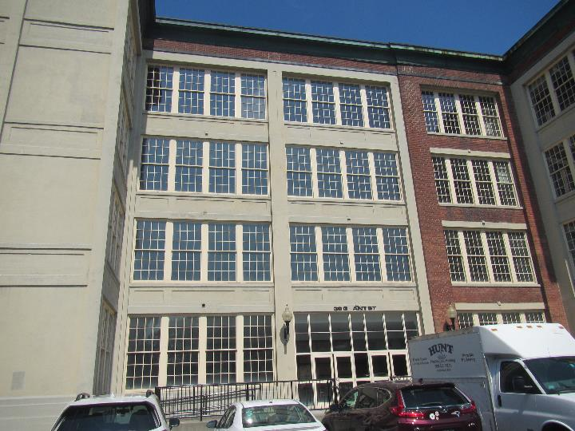

Prepared by:

Massachusetts Department of Public Health

Bureau of Climate and Environmental Health

Division of Environmental Health Regulations and Standards

March 2025

# BACKGROUND

|  |  |
| --- | --- |
| Building: | MassHire Offices |
| Address: | 39 Grant Street, first floor, Framingham |
| Assessment Requested by: | Jack McKenna, Career Center Manager, Norwood Career Center, Norwood |
| Reason for Request: | General concerns about indoor air quality (IAQ) |
| Date of Assessment: | February 25, 2025 |
| Massachusetts Department of Public Health/Bureau of Climate and Environmental Health (MDPH/BCEH) Staff Conducting Assessment: | Ruth Alfasso, Environmental  Engineer, Division of Environmental Health Regulations and Standards (EHRS) |
| Building Description: | The building at 39 Grant Street was originally part of the Dennison Manufacturing plant built in 1840. The building was vacant from 1990 to the early 2000s. The MassHire offices were built out prior to their move-in in 2022. Since 2022, two more spaces on the first floor have been occupied by MassHire – a training room and a youth services area. |
| Windows: | Not openable |

The previous report on this building is available at: <https://www.mass.gov/info-details/indoor-air-quality-reports-cities-and-towns-f#framingham->.

# METHODS

Please refer to the IAQ Manual for methods, sampling procedures, and interpretation of results (MDPH, 2015).

# RESULTS AND DISCUSSION

Measurements for IAQ parameters are shown in Table 1 and summarized below:

* ***Carbon dioxide*** measurements were slightly above the MDPH guideline of 800 ppm in most areas, indicating that most rooms could use more fresh air.
* ***Temperature*** was within the recommended range of 70°F to 78°F in all areas tested.
* ***Relative humidity*** was below the recommended range of 40% to 60% in all areas tested, which is common during the heating season.
* ***Carbon monoxide*** levels were non-detectable (ND) in all areas tested.
* ***Fine particulate matter (PM2.5)*** concentrations were below the National Ambient Air Quality Standard (NAAQS) level of 35 μg/m3 in all areas tested.

## Ventilation

A heating, ventilating, and air conditioning (HVAC) system has several functions. First, it provides heating and, if equipped, cooling. Second, it is a source of fresh air. Finally, an HVAC system will dilute and remove normally occurring indoor environmental pollutants by not only introducing fresh air, but also filtering the airstream and ejecting stale air outdoors via exhaust ventilation. Even if an HVAC system is operating as designed, point sources of respiratory irritation may exist and affect symptoms in sensitive individuals. The following analysis examines and identifies components of the HVAC system and likely sources of respiratory irritant/allergen exposure due to water damage, aerosolized dust, and/or chemicals found in the indoor environment.

The HVAC system consists of an air handling unit (AHU) located on the roof, which draws in outside air and heats/cools it. Conditioned air is ducted to the top of each room or area (Picture 1), and other ducts return air back to the AHU. Note that some rooms had only one vent which might be a supply or a return vent; ideally, each closed room should have one of each.

The HVAC system is controlled by digital thermostats (Picture 2). Thermostats examined were all set to the “fan auto” setting which will only call for air circulation when the temperature needs adjusting. The MDPH BCEH recommends that the fan be set to the “on” setting to provide continuous circulation/filtration during occupied hours. Thermostats can be adjusted by staff who have keys to the lockboxes, but these staff reported that the building owner discourages this.

Table 1 shows that measurements of carbon dioxide in the newer “youth services” office were lower than the ones in the main office. While this might be related to occupancy levels, it also may indicate that the ventilation systems were not balanced once the new office areas were added to the same HVAC circuit. To have proper ventilation with a mechanical ventilation system, the systems must be balanced after installation to provide an adequate amount of fresh air to the interior of a room while removing stale air from the room. It is recommended that HVAC systems be re-balanced every five years to ensure adequate air systems function (SMACNA, 1994). Balancing should also be done when major changes to layout or occupancy are planned or take place.

## Microbial/Moisture Concerns

No water-damaged materials or musty odors were noted in the office. The ceilings in the space are concrete, without any ceiling tiles, and floors are mostly not carpeted, which limits the materials that can become damaged by water.

Plants were observed in many areas (Pictures 3 and 4; Table 1). Plants can be a source of pollen and mold, which can be respiratory irritants to some individuals. Plants should be properly maintained and equipped with drip pans to prevent water damage to porous materials.

There is a refrigerator, a dishwasher, and other food preparation equipment in a break room; they need to be kept clean to prevent microbial growth and odors. All food should be enclosed in pest-proof containers. Refrigerators were noted to be clean during the site visit, and the breakroom floor was water-resistant material. Note that there were items stored under the sink, including porous items (Picture 5). The area under the sink can be a moist environment. Porous items can become water-damaged, and an excess of items can make detecting leaks more difficult.

## Other IAQ Concerns

An examination was conducted for products that may be a source of VOCs in indoor air. Products such as dry erase markers, hand sanitizers, and other cleaners were found in many areas (Table 1). In the absence of adequate fresh air and exhaust ventilation, VOCs from these products can build up and lead to irritation of the mucous membranes or irritating odors.

There were several cloth-covered baffles installed hanging from the ceiling to reduce noise (Picture 6). These items will need to be cleaned periodically to remove dust.

A few areas were carpeted. Carpets should be cleaned regularly in accordance with Institute of Inspection, Cleaning and Restoration Certification (IICRC) recommendations (IICRC, 2012).

# CONCLUSIONS/RECOMMENDATIONS

The following are recommendations made to improve IAQ:

## Ventilation recommendations

1. Operate supply and exhaust ventilation in all areas during occupied periods. Ensure that all control systems allow for the fan to be on when the office is occupied.
2. Have the HVAC system balanced if it has not been since the occupancy of the youth services area and the training room. Balance HVAC systems every 5 years in accordance with SMACNA recommendations (SMACNA, 1994).
3. Ensure filters are replaced on HVAC units at least twice a year. If feasible, use filters with a minimum efficiency rating value (MERV) of 8 or better.

## Water damage recommendations

1. Keep indoor plants in good condition and avoid overwatering. Ensure any plants are placed on water-resistant drip pans to prevent water damage to materials like windowsills.
2. Keep refrigerators and other food-preparation appliances clean and in good condition.
3. Consider keeping fewer items under the sink.

## Other recommendations

1. Use VOC-containing products in areas with good ventilation and keep tightly closed when not in use.
2. Periodically clean dust from supply and return vents and fans.
3. Periodically clean the sound baffles.
4. Clean carpeting in accordance with IICRC recommendations (IICRC, 2012).
5. For buildings in New England, periods of low relative humidity during the winter are often unavoidable. Therefore, scrupulous cleaning practices should be adopted to minimize common indoor air contaminants whose irritant effects can be enhanced when the relative humidity is low. To control for dusts, a high efficiency particulate arrestance (HEPA) filter equipped vacuum cleaner in conjunction with wet wiping of all surfaces is recommended.
6. Refer to resource manual and other related IAQ documents located on the MDPH’s website for further building-wide evaluations and advice on maintaining public buildings. These documents are available at: <http://mass.gov/dph/iaq>.

# REFERENCES

IICRC. 2012. Institute of Inspection, Cleaning and Restoration Certification. Carpet Cleaning: FAQ.

MDPH. 2015. Massachusetts Department of Public Health. Indoor Air Quality Manual: Chapters I-III. Available at: <https://www.mass.gov/lists/indoor-air-quality-manual-and-appendices>.

SMACNA. 1994. HVAC Systems Commissioning Manual. 1st ed. Sheet Metal and Air Conditioning Contractors’ National Association, Inc., Chantilly, VA.

**Picture 1**

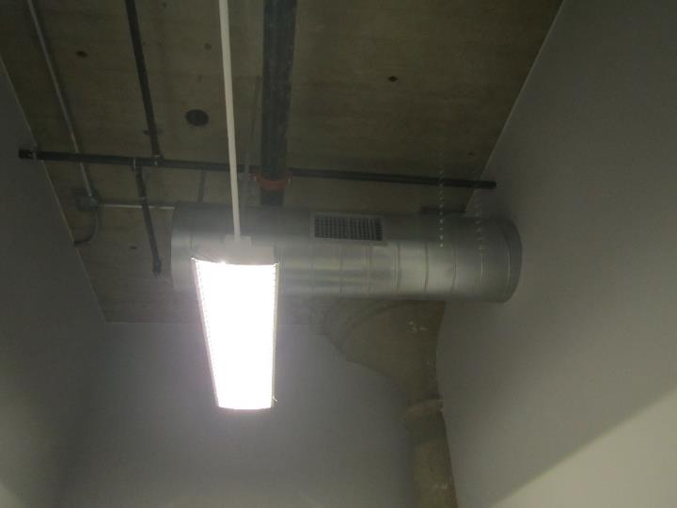

**Supply or return vent in a visible duct; note cement ceiling above**

**Picture 2**

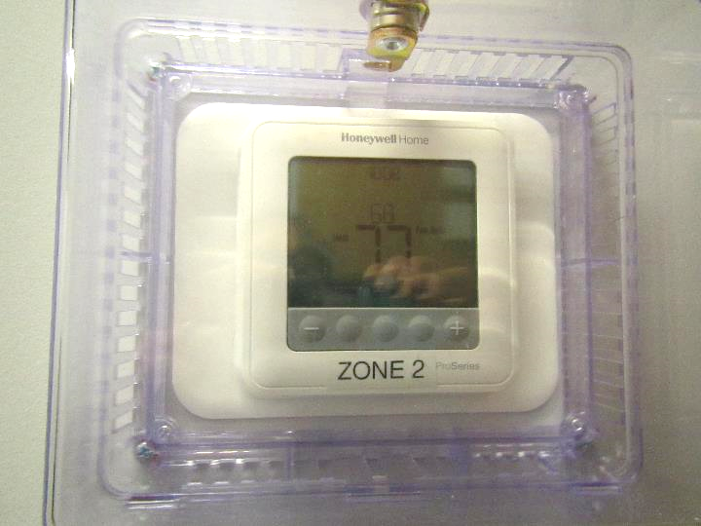

**Digital thermostat in locked box, note “fan auto” setting (arrow)**

**Picture 3**

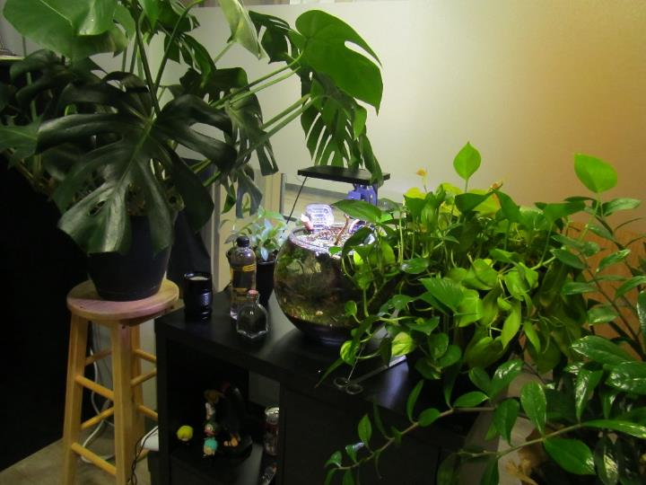

**Plants and a terrarium/aquarium in an office**

**Picture 4**

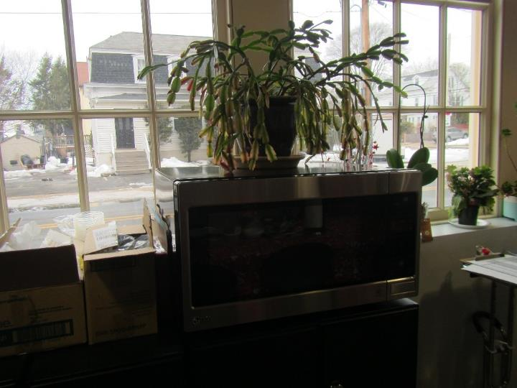

**Plants in the kitchen area**

**Picture 5**

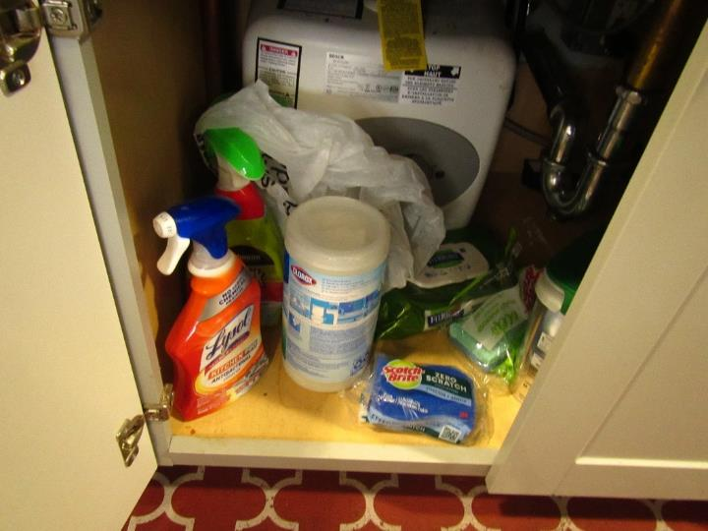

**Items under a sink**

**Picture 6**

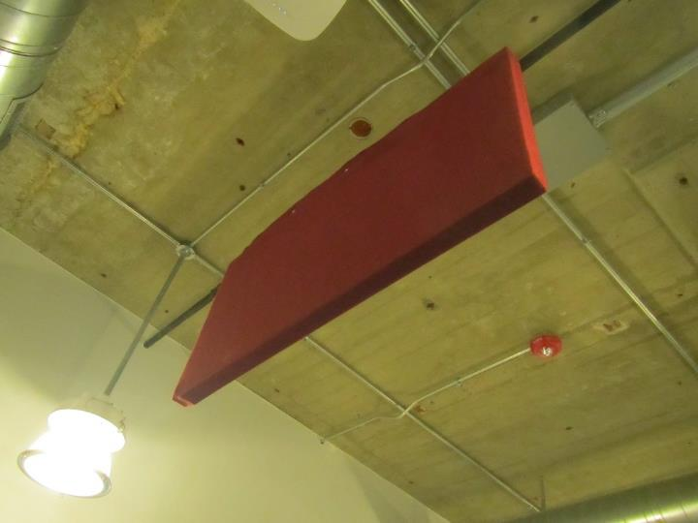

**Cloth-covered sound baffle hung from the ceiling**

| **Location** | **Carbon**  **Dioxide**  **(ppm)** | **Carbon Monoxide**  **(ppm)** | **Temp**  **(°F)** | **Relative**  **Humidity**  **(%)** | **PM2.5**  **(µg/m3)** | **Occupants**  **in Room** | **Windows**  **Openable** | **Ventilation** | | **Remarks** |
| --- | --- | --- | --- | --- | --- | --- | --- | --- | --- | --- |
| **Supply** | **Exhaust** |
| Background | 444 | ND | 51 | 39 | 9 |  |  |  |  | Parking lot |
| IT room (unoccupied) | 896 | ND | 71 | 21 | 2 | 0 | N |  |  |  |
| McKenna | 860 | ND | 74 | 23 | 2 | 1 | N |  |  | Fan |
| Ferrandino | 907 | ND | 74 | 23 | 2 | 1 | N |  |  |  |
| Surin | 866 | ND | 73 | 23 | 2 | 1 | N |  |  | Plant, DEM |
| Bradshaw | 974 | ND | 74 | 25 | 1 | 1 | N | Y | Y | PF |
| End office | 786 | ND | 74 | 23 | 2 | 1 | N | Y | Y |  |
| Jaklitsch | 831 | ND | 73 | 24 | 2 | 1 | N | Y | Y | PF, Plant |
| Pressey | 866 | ND | 73 | 24 | 2 | 1 | N | Y | Y | Plants |
| Diaz | 882 | ND | 73 | 24 | 2 | 1 | N | Y | Y | Plants, heater |
| Cooley (cube) | 921 | ND | 74 | 24 | 3 | 1 | N | Y | Y |  |
| Upson | 907 | ND | 73 | 25 | 3 | 1 | N | Y | Y | Plant |
| Bertrand (cube) | 848 | ND | 73 | 24 | 2 | 0 | N | Y | Y | Plant |
| Peng | 880 | ND | 73 | 24 | 1 | 1 | N | Y | Y | Plant |
| Conference | 871 | ND | 73 | 24 | 1 | - | N | Y | Y |  |
| Rosen | 918 | ND | 73 | 25 | 5 | 1 | N | Y | Y | Heater, food |
| Public cubes, central | 885 | ND | 73 | 24 | 8 | 3 | N | Y | Y | HS, photocopiers |
| Public cubes near door | 842 | ND | 73 | 23 | 2 | 0 | N | Y | Y |  |
| O’Hara cube | 872 | ND | 73 | 24 | 2 | 1 | N | Y | Y | Many plants, food |
| Kitchen | 807 | ND | 71 | 25 | 2 | 0 | N | Y | Y | Fridge, microwave, sink, dishwasher, toaster |
| Jackson | 888 | ND | 72 | 24 | ND | 1 | N | Y | Y |  |
| Youth services main area | 801 | ND | 71 | 25 | 2 | 0 | N | Y | Y |  |
| * Kitchen | 786 | ND | 72 | 25 | 2 | 2 | N | Y | Y | Fridge and microwave and sink |
| * Office 1 | 777 | ND | 71 | 25 | 2 | 0 | N | Y | Y |  |
| * Office 2 | 789 | ND | 71 | 25 | 1 | 2 | N | Y | Y | Plants |
| * Office 3 | 766 | ND | 71 | 25 | 1 | 2 | N | Y | Y |  |
| * Room next to main area | 781 | ND | 70 | 25 | 2 | 1 | N | Y | Y | HS |
| Building lobby | 760 | ND | 71 | 25 | 3 | 0 | N | Y | Y | Area rug (built in) |
| Waiting area | 738 | ND | 71 | 25 | 3 | 2 | N | Y | Y | Area rug |
| Classroom | 973 | ND | 72 | 26 | 1 | 5 | N | Y | Y | Carpeted |
| IT (occupied) | 925 | ND | 73 | 24 | 1 | 1 | N |  |  |  |