**POST-OCCUPANCY**

**INDOOR AIR QUALITY ASSESSMENT**

**MassHire Office**

**554 Main Street**

**Worcester, MA**

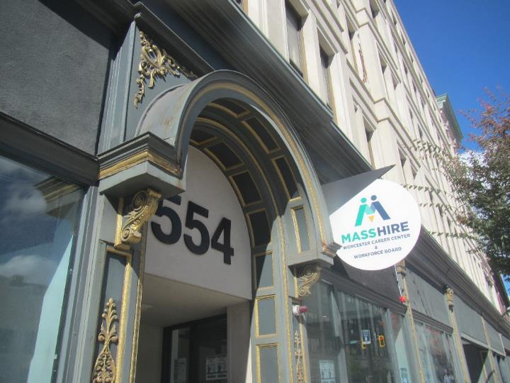

Prepared by:

Massachusetts Department of Public Health

Bureau of Climate and Environmental Health

Indoor Air Quality Program

November 2023

# BACKGROUND

|  |  |
| --- | --- |
| Building: | MassHire Career Center (MassHire) |
| Address: | 554 Main Street, Worcester, MA |
| Assessment Requested by: | Janice Weekes, Executive Director  554 Main Street, Suite 300  Worcester, MA 01608 |
| Reason for Request: | Post-occupancy indoor air quality (IAQ) assessment of newly leased space |
| Date of Assessment: | October 19, 2023 |
| Massachusetts Department of Public Health/Bureau of Climate and Environmental Health (MDPH/BCEH) Staff Conducting Assessment: | Ruth Alfasso, Environmental  Engineer/Inspector, IAQ Program |
| Building Description: | The new MassHire offices occupy the entire third floor and an office suite on the fourth floor of 554 Main Street. The building was originally built in the late 1800s and has five stories. |
| Windows: | Some windows are openable |

# METHODS

Please refer to the IAQ Manual for methods, sampling procedures, and interpretation of results (MDPH, 2015).

# RESULTS AND DISCUSSION

The following is a summary of indoor air testing results (Table 1).

* ***Carbon dioxide*** measurements were below the MDPH guideline of 800 parts per million (ppm) indicating adequate fresh air in the space.
* ***Temperature*** was within the recommended range of 70°F to 78°F in all but one area tested, which was close.
* ***Relative humidity*** was within the recommended range of 40% to 60% in all areas tested.
* ***Carbon monoxide*** levels were non-detectable (ND) in all areas tested.
* ***Fine particulate matter (PM2.5)*** concentrations were below the National Ambient Air Quality Standard (NAAQS) level of 35 μg/m3 in all areas tested.
* ***Total Volatile Organic Compounds (TVOC)*** were non-detectable (ND).

## Ventilation

A heating, ventilating, and air conditioning (HVAC) system has several functions. First, it provides heating and, if equipped, cooling. Second, it is a source of fresh air. Finally, an HVAC system will dilute and remove normally occurring indoor environmental pollutants by not only introducing fresh air, but also filtering the airstream and ejecting stale air to the outdoors via exhaust ventilation. Even if an HVAC system is operating as designed, point sources of respiratory irritation may exist and affect symptoms in sensitive individuals.

The HVAC system for one side of the building uses a rooftop AHU. This unit draws in fresh air and delivers filtered/conditioned air via a ducted supply system, through grills in the ceiling (Picture 1) or vents in the side of visible ducts (Picture 2). Some portions of the return system use ducts, and others the ceiling plenum. Return vents return air to the AHUs (Picture 1).

The other side of the building is supplied with fresh air through energy recovery ventilators (ERVs) located above the ceiling tiles. The ERVs are supplied with fresh air through vents in the side of the building. It was noted during the pre-occupancy visit that these vents are near the fire escape walkways. Therefore, it is important that people do not smoke on the fire escape where smoke could be drawn into the ERVs. Additional heating is provided by hot-water radiators along the exterior walls (Picture 3).

Thermostats were noted in various locations in the office, however the LCDs on the display were very difficult to read, and some appeared to be unset or not connected. Thermostatic controls should be set for the proper system time and occupied/unoccupied settings. Note that MDPH recommends that thermostats be set to have the fan *on* to provide continuous air filtration and circulation throughout the space when the building is occupied, rather than only providing fresh air when a change in temperature is required.

Of note is that the staff-side restrooms on the 3rd floor do not have any ventilation, with no supply or exhaust vent, and no window. It is important that restrooms have exhaust vents or openable windows to remove odors, other pollutants, and moisture that is generated by use of restrooms. Retrofitting exhaust ventilation that can remove these pollutants to the outside should be a priority. Currently the restrooms are equipped with air purifiers, and scented products (reed diffusers and candles), to help deal with unwanted odors. The use of scented products, however, may cause allergic or other reactions in sensitive people and is not a good solution to bathroom odors.

It is recommended that HVAC systems be re-balanced every five years to ensure adequate air systems function (SMACNA, 1994). The system was likely balanced during the remodeling prior to occupancy.

## Microbial/Moisture Concerns

Water damage was noted in on ceiling tiles on the 4th floor (Picture 4). These may be from roof leaks, which were repaired since the office was occupied. Once leaks are repaired, the water-damaged ceiling tiles should be replaced.

Plants were noted in a few areas (Picture 5; Table 1). Plants should be well maintained and placed on waterproof drip pans to prevent water damage to building materials.

Water dispensers, including both wall-mounted plumbed fixtures and freestanding water coolers, were found in carpeted areas (Pictures 6 and 7). Water dispensers can spill or leak and moisten carpeting. Use of a waterproof mat underneath the dispensers can help prevent water damage.

The staff lounge has all new appliances which appeared to be clean and in good condition. Food preparation equipment should be kept clean to prevent odors, water damage, and pests. Food was noted in a few offices (Picture 8; Table 1). Food can be attractive to pests and should be stored in pest-proof containers.

## Other IAQ Concerns

Sampling for total volatile organic compounds (TVOC) was conducted, with all readings being non-detect (ND). An examination was conducted for products that may be a source of VOCs in indoor air. Products such as dry erase markers, hand sanitizers, and other cleaners were found in offices and common areas (Table 1). In the absence of adequate fresh air and exhaust ventilation, VOCs from these products can build up and lead to irritation of the mucous membranes or irritating odors.

Air purifiers were noted in many offices and meeting/classrooms (Picture 9). These units appear to have both HEPA (high-efficiency particulate air) filters and carbon filters. These are useful in removing odors, and particulates, including biological particulates, from the indoor air. The units need to be cleaned and filters need to be replaced in accordance with manufacturer’s instructions (e.g., when the indicator lights go on). These units work best when placed in the breathing zone of occupants to capture and filter breathed air. Some of the units appear to have a setting that ionizes and therefore may produce ozone (e.g., “PlasmaTrue”). This setting should be kept off, as ozone is a respiratory irritant and should not be produced in occupied spaces (EPA 2003).

Personal and stand fans were also noted in the office (Table 1). Some of these had accumulated dust on the blades, which can be aerosolized during use. Fans should be cleaned periodically to remove dust.

Most of this office is carpeted. Carpets should be cleaned regularly in accordance with Institute of Inspection, Cleaning and Restoration Certification (IICRC) recommendations (IICRC, 2012). Upholstered furniture was also noted in some rooms. These should also be cleaned regularly to remove dust and debris.

As noted during the pre-occupancy assessment, exposed brick is present in a few areas (Picture 10). Old brick may release dust and debris. While brick dust is typically of too large a size to impact IAQ, it can be a nuisance and accumulate on flat surfaces over time. If this occurs, cleaning in these areas using methods that do not aerosolize dust (e.g. use of a HEPA-filter-equipped vacuum or wet wiping) should be enhanced.

Portions of the 4th floor of this building have not yet been finished for other tenants. As other areas in the building are being renovated, care should be taken to avoid impacts of construction on occupants of the MassHire suite. Use the guidance in the document “[Construction and renovation generated pollutants in occupied buildings](https://www.mass.gov/service-details/construction-and-renovation-generated-pollutants-in-occupied-buildings)” to minimize impacts of construction in adjacent areas. This also applies to activities on the exterior of the building, such as roof work, that may impact the fresh air supply or create noise and dust in occupied areas. Occupants report that roof work was conducted which led to noise and fumes in the office, and that communication and coordination could have reduced or eliminated issues resulting from this work.

# CONCLUSIONS/RECOMMENDATIONS

The following are recommendations made to maintain IAQ:

## Ventilation recommendations

1. Operate supply and exhaust ventilation in all areas during occupied periods.
2. Ensure thermostats are set and operational, including system time.
3. Work with building management to add exhaust ventilation to the staff-side restrooms on the 3rd floor.
4. Ensure filters are replaced on HVAC units at least twice a year. Use filters with a minimum efficiency rating value (MERV) of 8 or better.
5. It is recommended that HVAC systems be re-balanced every five years to ensure adequate air systems function (SMACNA, 1994).

## Water damage recommendations

1. Investigate and remediate the source of water damage to fourth floor office ceiling.
2. Consider placing a waterproof mat underneath water dispensers to protect carpet from leaks.
3. Keep plants well-maintained and place on waterproof drip pans.
4. Keep refrigerators and other food-preparation appliances clean.

## Other recommendations

1. Store food in pest proof containers.
2. Use VOC-containing products in areas with good ventilation and keep tightly closed when not in use. Avoid products with strong scents and avoid mixing incompatible products.
3. Maintain air purifiers in accordance with manufacturer’s instructions including filter changes. Do not turn on any setting that may produce ozone.
4. Periodically dust the blades of stand and floor fans.
5. Keep items in offices neat and off floors for ease of cleaning. Store excess items elsewhere.
6. Clean carpeting in accordance with IICRC recommendations (IICRC, 2012). Clean upholstered furniture regularly as well.
7. Clean any brick dust using a method that does not aerosolize dust, such as wet wiping or a HEPA-equipped vacuum.
8. For buildings in New England, periods of low relative humidity during the winter are often unavoidable. Therefore, scrupulous cleaning practices should be adopted to minimize common indoor air contaminants whose irritant effects can be enhanced when the relative humidity is low. To control dust, a high efficiency particulate arrestance (HEPA) filter equipped vacuum cleaner in conjunction with wet wiping of all surfaces is recommended. Avoid the use of feather dusters. Drinking water during the day can help ease some symptoms associated with a dry environment (throat and sinus irritations).
9. Use the guidance in the document “[Construction and renovation generated pollutants in occupied buildings](https://www.mass.gov/service-details/construction-and-renovation-generated-pollutants-in-occupied-buildings)” to minimize impacts of construction in adjacent areas or outside the building.
10. Refer to resource manual and other related IAQ documents located on the MDPH’s website for further building-wide evaluations and advice on maintaining public buildings. These documents are available at: <http://mass.gov/dph/iaq>.

# REFERENCES

ICRC. 2012. Institute of Inspection, Cleaning and Restoration Certification. Carpet Cleaning: FAQ.

MDPH. 2015. Massachusetts Department of Public Health. Indoor Air Quality Manual: Chapters I-III. Available at: <https://www.mass.gov/lists/indoor-air-quality-manual-and-appendices>.

SMACNA. 1994. HVAC Systems Commissioning Manual. 1st ed. Sheet Metal and Air Conditioning Contractors’ National Association, Inc., Chantilly, VA.

US EPA. 2003. “Ozone Generators that are Sold as Air Cleaners: An Assessment of Effectiveness and Health Consequences”. United States Environmental Protection Agency, Office of Air and Radiation, Indoor Environments Division, Washington, DC. Last updated September, 2018. <https://www.epa.gov/indoor-air-quality-iaq/ozone-generators-are-sold-air-cleaners>

**Picture 1**

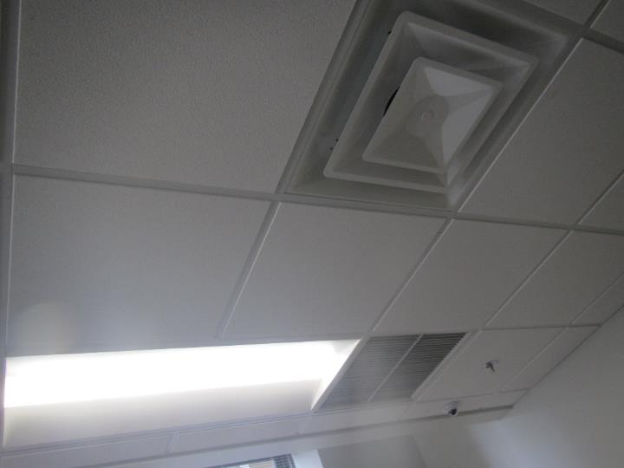

**Ceiling-mounted supply and return vent**

**Picture 2**

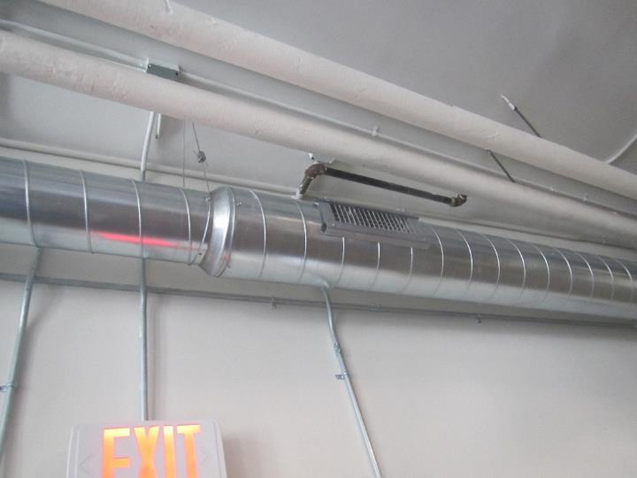

**Supply vent on the side of a visible duct**

**Picture 3**

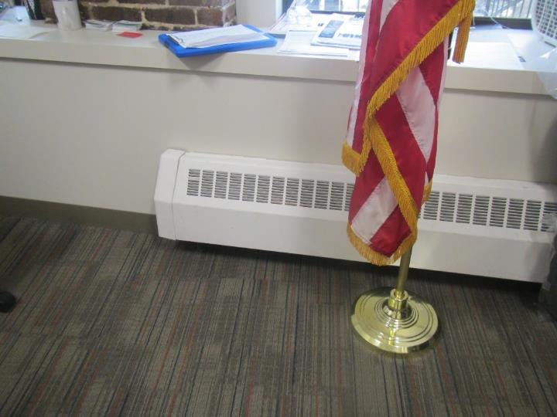

**Radiator in an office**

**Picture 4**

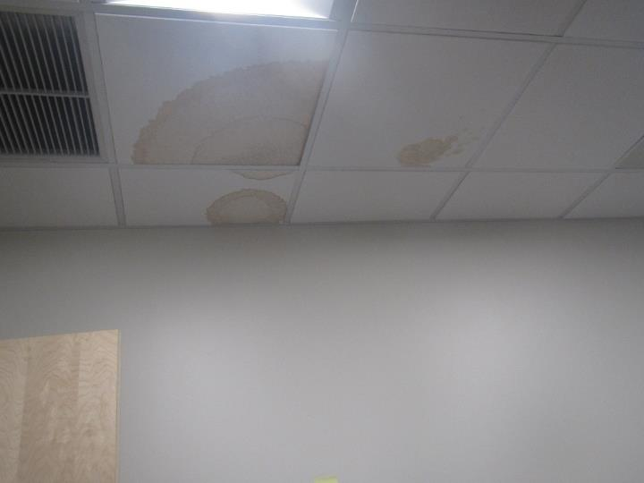

**Water-damaged ceiling tiles in room 404**

**Picture 5**

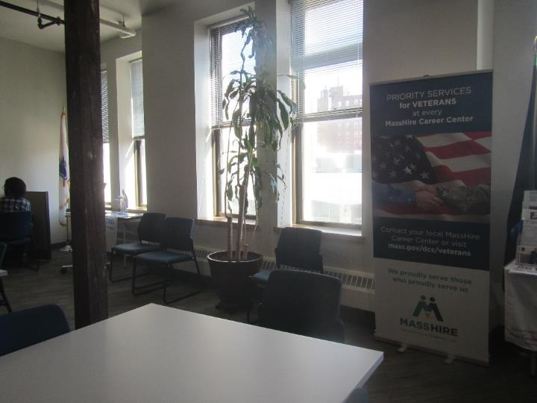

**Plant in the main area of the 3rd floor**

**Picture 6**

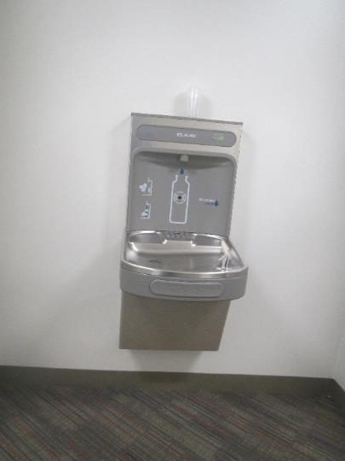

**Bottle filler over carpet**

**Picture 7**

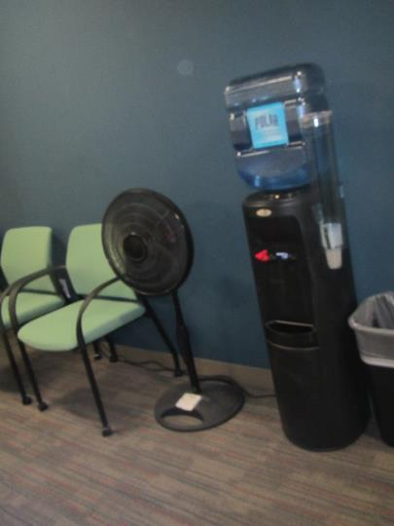

**Water cooler on carpet, also note stand fan**

**Picture 8**

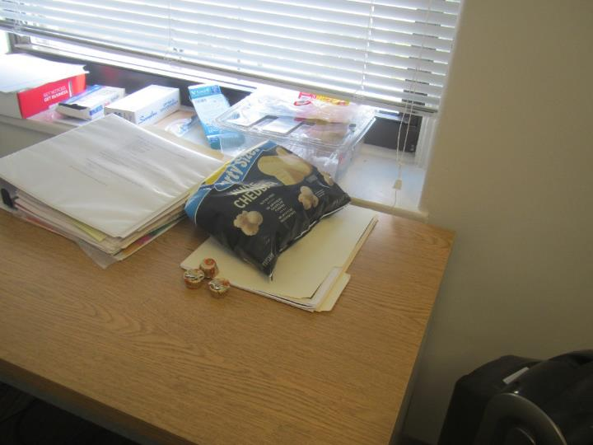

**Food in an office**

**Picture 9**

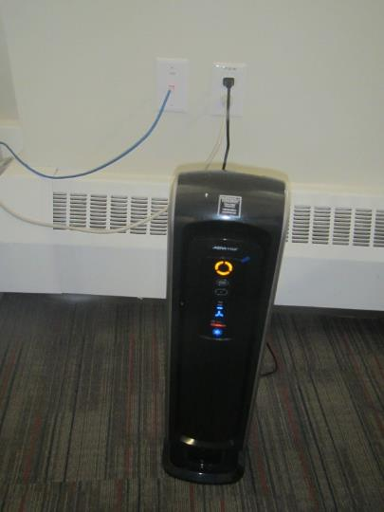

**air purifier**

**Picture 10**

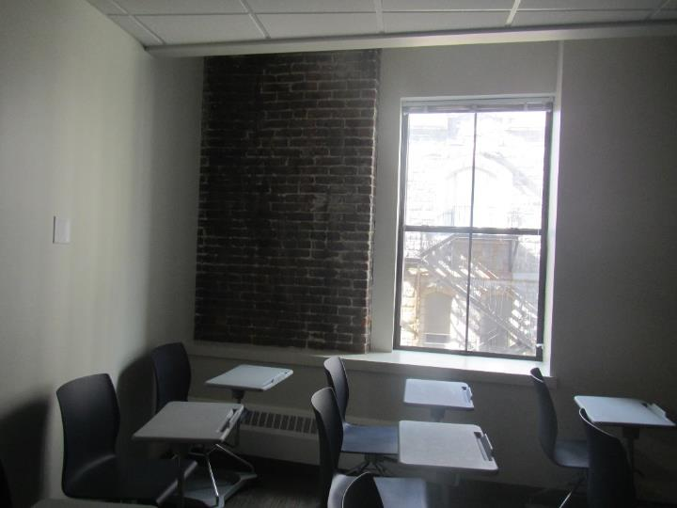

**Exposed brickwork**

| **Location** | **Carbon**  **Dioxide**  **(ppm)** | **Carbon Monoxide**  **(ppm)** | **Temp**  **(°F)** | **Relative**  **Humidity**  **(%)** | **PM2.5**  **(µg/m3)** | **TVOC**  **(ppm)** | **Occupants**  **in Room** | **Windows**  **Openable** | **Ventilation** | | **Remarks** |
| --- | --- | --- | --- | --- | --- | --- | --- | --- | --- | --- | --- |
| **Supply** | **Exhaust** |
| Background | 381 | ND | 68 | 46 | 11-18 | ND |  |  |  |  | Sunny and breezy, heavy traffic |
| Third Floor | | | | | | | | | | | |
| 310 | 546 | ND | 72 | 53 | ND | ND | 0 | N | Y | Y | 2 offices in area, AP |
| Main open area | 560 | ND | 72 | 52 | ND | ND | 5 | Y | Y | Y |  |
| 303 resource room | 502 | ND | 72 | 51 | ND | ND | 2 |  | Y | Y |  |
| On-line learning | 474 | ND | 73 | 50 | ND | ND | 0 |  | Y | Y | AP |
| 304 computer lab | 470 | ND | 72 | 51 | ND | ND | 0 |  | Y | Y | HS, cleaners, AP |
| 305 classroom | 474 | ND | 71 | 52 | ND | ND | 0 |  | Y | Y |  |
| 306 classroom | 478 | ND | 70 | 54 | ND | ND | 0 |  | Y | Y | AP |
| 307 office | 497 | ND | 69 | 54 | ND | ND | 0 |  | Y | Y | Fan – dusty |
| 308 classroom | 549 | ND | 70 | 53 | ND | ND | 0 |  | Y | Y | Exposed brick |
| Public-side Women’s restroom |  |  |  |  |  |  | 0 | N |  | Y |  |
| Public-side all-gender ADA restroom |  |  |  |  |  |  | 0 | N |  | Y |  |
| Cubes outside 311 | 594 | ND | 73 | 52 | ND | ND | 0 |  | Y | Y | Sunlight |
| 311 wellness | 562 | ND | 75 | 49 | ND | ND | 0 |  | Y | Y | AP, sunlight, throws/plush items |
| Cubes near 311 | 567 | ND | 75 | 49 | ND | ND | 2 | N | Y | Y |  |
| 321 office | 516 | ND | 74 | 50 | ND | ND | 1 | Y | Y | Y | Plants, AP, sunlight |
| Cubes outside 321 | 545 | ND | 74 | 50 | ND | ND | 2 | N | Y | Y | PFs, plant |
| Cubes between 321 and 322 | 517 | ND | 73 | 51 | ND | ND | 1 | N | Y | Y | Exposed brick, food, AP |
| Cubes outside 322 | 512 | ND | 72 | 52 | ND | ND | 3 | N | Y | Y | Plants, CP |
| 322 office | 530 | ND | 71 | 53 | ND | ND | 1 |  | Y | N | Exposed brick |
| Main area outside 315-317 | 578 | ND | 72 | 53 | ND | ND | 0 | N | Y | N | Plant, PC, hand sanitizer, CP |
| 315 | 601 | ND | 74 | 51 | ND | ND | 9 | N | Y | Y | PF, food, AP |
| Cubes | 570 | ND | 74 | 51 | ND | ND | 1 | N | Y | Y |  |
| 318 small room | 585 | ND | 73 | 51 | ND | ND | 0 | N | Y | N | Water cooler on carpet |
| Cubes next to 318 | 910 | ND | 73 | 52 | ND | ND | 3 | N | Y | Y |  |
| 319 | 677 |  |  |  |  |  | 1 | N | Y | Y |  |
| 314 staff lounge | 571 | ND | 72 | 52 | ND | ND | 0 |  | Y | Y | NC, 2 fridges, microwave, toaster and toaster oven |
| Cubes near 314 | 570 | ND | 72 | 53 | ND | ND | 1 | N | Y | Y |  |
| Staff-side restroom 1 |  |  |  |  |  |  |  |  | N | N | AP, reed diffuser, candle |
| Staff-side restroom 2 |  |  |  |  |  |  |  |  | N | N | AP, reed diffuser, candle |
| 4th floor | | | | | | | | | | | |
| 401 office | 471 | ND | 72 | 51 | ND | ND | 0 |  | Y | Y | CP, items |
| 402 | 466 | ND | 72 | 51 | ND | ND | 0 |  | Y | Y |  |
| Admission | 481 | ND | 72 | 51 | ND | ND | 0 | N | Y | Y |  |
| 406 | 511 | ND | 71 | 52 | ND | ND | 0 |  | Y | Y | Plant |
| 405 | 486 | ND | 72 | 52 | ND | ND | 0 |  | Y | Y | Items |
| 404 | 492 | ND | 71 | 52 | ND | ND | 0 |  | Y | Y | PF, boxes, 3 water-damaged ceiling tiles |
| Cubes | 488 | ND | 71 | 52 | ND | ND | 1 | N | Y | Y |  |
| Reception | 480 | ND | 71 | 52 | ND | ND | 1 | N | Y | Y | Water cooler on carpet |
| 407 | 481 | ND | 71 | 51 | ND | ND | 0 |  | Y | Y |  |
| Core restroom |  |  |  |  |  |  |  |  | Y | Y |  |