BACKGROUND

INDOOR AIR QUALITY
POST-OCCUPANCY ASSESSMENT

MassHire Norwood Career Center
128 Carnegie Row
Norwood, MA

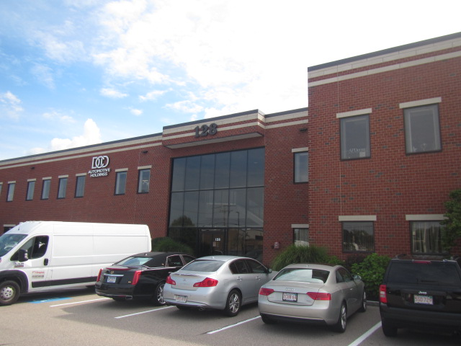

Prepared by:
Massachusetts Department of Public Health
Bureau of Environmental Health
Indoor Air Quality Program
November 2022
Building: | MassHire Norwood Career Center
Address: | 128 Carnegie Row, Suite 109, Norwood, MA
Assessment Requested by: | Antoine Jones, Career Center Operations Manager, MassHire Norwood
Date of Post-Occupancy Assessment: | August 17, 2022
Massachusetts Department of Public Health/Bureau of Environmental Health (MDPH/BEH) Staff Conducting Assessment: | Cory Holmes, Assistant Director, Indoor Air  Quality (IAQ) Program
Building Description: | This office suite is located on the first floor of a two-story office building constructed in 1979 located in a small office park in Norwood. The building has a brick façade and a flat roof. The space has suspended ceiling tiles, carpet squares and gypsum wallboard. The perimeter of the space contains small offices, conference rooms, storage areas and a breakroom with cubicle/workstations in the center of the space.
Windows: | Not openable

METHODS
Please refer to the IAQ Manual for methods, sampling procedures, and interpretation of results (MDPH, 2015).

RESULTS AND DISCUSSION
The following is a summary of indoor air testing results (Table 1).
- Carbon dioxide levels were below the MDPH guideline of 800 parts per million (ppm) in the areas surveyed indicating adequate air exchange, however one of the air handling units was deactivated. This is discussed further under the Ventilation section of this report.
- Temperature was within the MDPH recommended range of 70°F to 78°F in all areas tested.
- Relative humidity was within the MDPH recommended range of 40 to 60% in all areas tested.
- Carbon monoxide levels were non-detectable (ND) in all areas tested.
- Fine particulate matter (PM2.5) concentrations measured were below the National Ambient Air Quality Standard (NAAQS) limit of 35 μg/m³ in all areas tested.
- Total volatile organic compounds (TVOCs) were ND in all areas tested.

Ventilation
A heating, ventilating, and air conditioning (HVAC) system has several functions. First it provides heating and, if equipped, cooling. Second, it is a source of fresh air. Finally, an HVAC system will dilute and remove normally occurring indoor environmental pollutants by not only introducing fresh air, but by filtering the airstream and ejecting stale air to the outdoors via exhaust ventilation. Even if an HVAC system is operating as designed, point sources of respiratory irritation may exist and cause symptoms in sensitive individuals.
The HVAC system consists of air handling units (AHUs) located on the roof, which draw in outside air and heat/cool it. Conditioned air is ducted to ceiling-mounted supply vents and returned via ceiling mounted grates allowing air to migrate into the ceiling plenum back to the AHUs (Picture 1).
The HVAC system is controlled by digital thermostats. The MDPH IAQ Program recommends that the fan be set to the “on” setting to provide continuous circulation/filtration during occupied hours. At the time of assessment, the thermostat controlling the front half of the space was off (Picture 2) and no airflow was occurring. It was not known how long the AHU was deactivated. Mr. Jones reactivated the thermostat upon discovery, restoring proper airflow and temperature control to that portion of the building.
To have proper ventilation with a mechanical ventilation system, the systems must be balanced after installation to provide an adequate amount of fresh air to the interior of a room while removing stale air from the room. It is recommended that HVAC systems be re-balanced every five years to ensure adequate air systems function (SMACNA, 1994). These systems should have been balanced prior to occupancy.

Microbial/Moisture Concerns
No water-damaged materials, water stains or musty odors were observed during the visit.

Other Concerns
Most of the office floors are covered with carpet squares apart from the break room. Carpets should be vacuumed regularly with a high efficiency particulate arrestance (HEPA) filter-equipped vacuum cleaner and cleaned annually (or semi-annually in soiled/high traffic areas) in accordance with Institute of Inspection, Cleaning and Restoration Certification (IICRC) recommendations, (IICRC, 2012).
AHUs have filters, which are reportedly changed 4 times a year. During filter changes, AHU cabinets should be cleaned/vacuumed out to remove debris that may be a source of particulates and odors to the indoor air. Filters should be at least a Minimum Efficiency Rating Value (MERV) of 8, or higher if they fit and the equipment can handle the pressure reductions caused by more restrictive filters.

RECOMMENDATIONS
In view of the findings at the time of assessment, the following recommendations are made:
- Ensure thermostats are activated. Set thermostat timers to the fan “on” setting to provide continuous filtration and ventilation during occupied hours.
- Continue with regular filter changes for HVAC equipment using the best quality/highest MERV rated filters that can be used with current equipment. During filter changes, vacuum debris from AHU cabinets.
- If the HVAC system has not been balanced prior to this assessment, consider balancing the system and every five years (SMACNA, 1994).
- Refer to the resource manual and other related indoor air quality documents located on the MDPH’s website for further building-wide evaluations and advice on maintaining public buildings. These documents are available at http://mass.gov/dph/iaq.

REFERENCES
IICRC. 2012. Institute of Inspection, Cleaning and Restoration Certification. Carpet Cleaning: FAQ.
MDPH. 2015. Massachusetts Department of Public Health. “Indoor Air Quality Manual: Chapters I-III”. Available at: Indoor air quality - manual and appendices | Mass.gov
SMACNA. 1994. HVAC Systems Commissioning Manual. 1st ed. Sheet Metal and Air Conditioning Contractors’ National Association, Inc., Chantilly, VA.
Picture 1
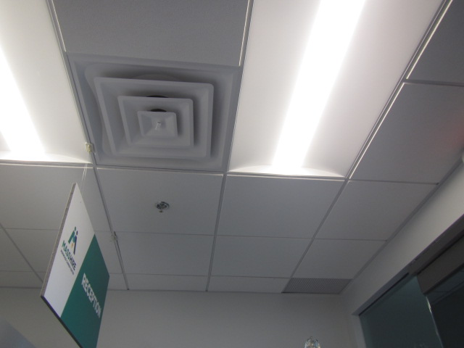
Supply diffuser and return grill (in corner)

Picture 2
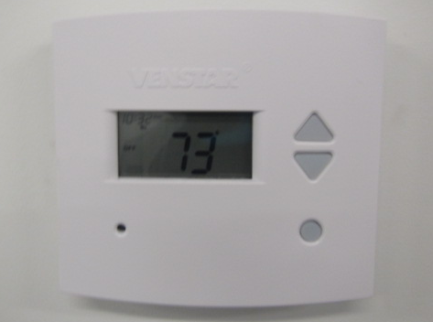
Digital thermostat for front half of space, note unit is in “off” position
Location | Carbon  Dioxide  (ppm) | Carbon Monoxide  (ppm) | Temp  (°F) | Relative  Humidity  (%) | PM2.5  (µg/m³) | TVOC  (ppm) | Occupants  in Room | Windows  Openable | Ventilation |  | Remarks
 |  |  |  |  |  |  |  |  | Supply | Exhaust
Background | 425 | ND | 84 | 50 | 11 | ND |  |  |  |  | Warm, mostly sunny, light breeze
Managers Office | 735 | ND | 76 | 47 | 2 | ND | 2 | N | Y | Y
Welcoming/  Lobby Area | 749 | ND | 76 | 60 | 3 | ND | 1 | N | Y | Y
Resource/  Unemployment Area | 676 | ND | 75 | 49 | 3 | ND | 1 | N | Y | Y | Thermostat “off”- no airflow
Conference Room | 614 | ND | 71 | 52 | 3 | ND | 0 | N | Y | Y
Career Advisor Office | 653 | ND | 74 | 49 | 4 | ND | 1 | N | Y | Y
Veterans Rep Office | 616 | ND | 74 | 48 | 3 | ND | 0 | N | Y | Y
Breakroom | 603 | ND | 75 | 46 | 5 | ND | 0 | N | Y | Y | Tile floor
RESEA | 649 | ND | 74 | 49 | 4 | ND | 1 | N | Y | Y

