INDOOR AIR QUALITY
PRE-OCCUPANCY ASSESSMENT

MassHire Framingham Career Center
39 Grant Street, Suite 150
Framingham, MA

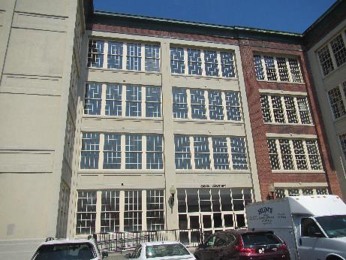

Prepared by:
Massachusetts Department of Public Health
Bureau of Environmental Health
Indoor Air Quality Program
July 2022

BACKGROUND
Building: | New office for Framingham MassHire Career Center (MassHire)
Address: | 39 Grant Street, Framingham, MA
Assessment Requested by: | Angie Grant, Career Center Operations Manager
Date of Pre-Occupancy Assessment: | July 21, 2022
Massachusetts Department of Public Health/Bureau of Environmental Health (MDPH/BEH) Staff Conducting Assessment: | Ruth Alfasso, Environmental Engineer/Inspector,  Indoor Air Quality (IAQ) Program
Date of Building Construction/Renovation | The building at 39 Grant Street was originally part of the Dennison Manufacturing plant built in 1840. The building was vacant from 1990 to the early 2000s when the city of Framingham began working with developers to redevelop the site. The MassHire space has undergone a complete gut renovation.
This new MassHire location is on the first floor of a four-story brick building that was originally built for manufacturing (The Dennison Manufactory). The MassHire suite has office space, open work areas, conference rooms, storage and a small break room. New heating, ventilating and air conditioning systems (HVAC) have been installed in the space. The windows were also replaced. Restrooms will be core facilities shared with other tenants. Building materials consist of laminate flooring, gypsum wallboard, and various glass, cloth, and metal partitions. At the time of the assessment, the windows had been completely installed, and the air conditioning/HVAC system was operating. Staff were on site performing installation work for workstations, phone/internet, and unpacking boxes of materials brought from the old office, however the office was not at full capacity and is not yet open to the public.

Surrounding Businesses/Activities:
Adjacent portions of the original manufacturing site are in use as apartment residences, and there are retail businesses and residential housing nearby. Construction work is currently going on in several adjacent spaces on the first floor of 39 Grant Street to accommodate other tenants which may include lab space and offices. It appears as though upper floors are not yet occupied or under construction.

Previous Relevant Environmental History:
No current/active or historic Massachusetts Contingency Plan projects for this building or property were found in the Massachusetts Department of Environmental Protection database.

METHODS
Air tests for carbon dioxide, carbon monoxide, temperature, relative humidity and airborne particle matter with a diameter less than 2.5 micrometers were taken with the TSI 7585 Q-Trak™ XP Indoor Air Quality Monitor Screening for volatile organic compounds (VOCs) was conducted using a MiniRAE Lite Photo Ionization Detector. BEH/IAQ staff also performed visual inspection of building materials for water damage and/or microbial growth and examined the space for the presence of odors or other environmental concerns.

Air Testing Results
Media sampled |  | MDPH Guideline/  Comparison Value |  | Measured Range |  |  | Comments
 |  |  |  | Outdoors/  Background |  | Indoors
Total Volatile Organic Compounds (TVOCs) |  | Equal to or below background level measured |  | ND |  | ND-1 ppm | New furnishings, packing materials
Carbon Dioxide |  | Below 800 ppm |  | 402 ppm |  | 432-462 ppm | HVAC system operating, lightly occupied
Carbon Monoxide (CO) |  | Non-detectable (ND) or equal to or below background level measured |  | 0.7 ppm |  | ND | Outdoor measurement taken in parking area
Particulate Matter 2.5 (PM2.5) |  | US EPA National Ambient Air Quality Standards (NAAQS) 35 μg/m³ or less |  | 22-56 |  | 23-29 | Various construction activities taking place indoors and outdoors
Temperature |  | 70 to 78ºF |  | 89 |  | 70-72 | HVAC operating
Relative Humidity (RH) |  | 40% to 60% |  | 57 |  | 68-72 | HVAC may not be fully configured, and doors to the exterior were propped open
ppm = parts per million | µg/m³ = microgram per cubic meter |  | ND = non-detectable |  | HVAC = heating, ventilation and air-conditioning

DISCUSSION AND VISUAL OBSERVATIONS

Ventilation
The HVAC systems consist of rooftop air handling units (AHUs) that could not be accessed on the day of the visit. These units draw in fresh air and deliver filtered/conditioned air via a visible ducted supply and return system (Pictures 1 and 2). At the time of the visit, it was not possible to determine which of the vents provide supply air and which are returns. Every office should be equipped with both supply and exhaust ventilation. In addition, some of the vents were incomplete (Picture 3), lacking end caps on ducts, or louvered covers on vents. These should be finished prior to occupancy.
While the HVAC system was operating at the time of the assessment, thermostats did not appear to be configured. Prior to occupancy, all thermostatic controls should be set for the proper system time and occupied/unoccupied settings. Note that MDPH recommends that thermostats be set to have the fan on to provide continuous air filtration and circulation throughout the space when the building is occupied, rather than only providing fresh air when a change in temperature is required.

Microbial/Moisture Concerns
No water-damaged materials including stains, leaks, or odors were detected at the time of the assessment. Plants were observed in a few areas (Picture 4). Indoor plants should be well maintained and not overwatered to prevent leaks and microbial growth.
Note that humidity in the suite was above the MDPH comfort range at the time of the assessment. In addition, when relative humidity is above 70% indoors for a long period of time, mold growth can occur on porous materials even in the absence of liquid water (ASHRAE, 2019). The high relative humidity indoors is related to outdoor conditions which were very hot and somewhat humid on the day of the assessment. Windows had only recently been installed, and some doors to the exterior were propped open. Once construction is complete, doors should be kept closed when the air conditioning is operating. If, at that point, humidity inside continues to be higher than the MDPH comfort limit of 40-60%, the operation of the HVAC system should be adjusted.

Other Conditions
Note that floors inside the MassHire office suite are not carpeted. Floors should be cleaned regularly using a method (e.g. damp wiping or a HEPA-filtered vacuum cleaner) that does not aerosolize dust.
The configuration of the workstation walls in some areas creates a hidden channel behind furniture (Picture 5). Items and debris can be dropped into these areas out of sight, where it can be difficult to clean. A regular program of cleaning these areas will eliminate debris which can become a source of odors or harborage for pests.
As other areas in the building are being renovated for other tenants, care should be taken to avoid impacts of construction on occupants of the MassHire suite. Use the guidance in the document “Construction and renovation generated pollutants in occupied buildings” to minimize impacts of construction in adjacent areas.

RECOMMENDATIONS
In view of the findings at the time of the assessment, the following recommendations are made to improve IAQ prior to occupancy:

Ventilation
- Ensure every office is equipped with both supply and return ventilation,
- Complete installation of all louvered vents and caps on ductwork,
- Ensure all thermostats are properly set for system time, setback times, and to provide continuous ventilation during occupied periods.
- Change filters for HVAC equipment prior to occupancy, and additionally 2-4 times a year using the highest Minimum Efficiency Reporting Value (MERV) rating the building’s ventilation system can accommodate to improve air filtration as much as possible without significantly reducing airflow. Clean out the interiors of AHUs of accumulated dust/debris during filter changes.
- Prior to occupancy, consider having the mechanical ventilation systems balanced by an HVAC engineer. MDPH recommends adopting a balancing schedule of every 5 years for all mechanical ventilation systems, as recommended by ventilation industrial standards (SMACNA, 1994).

Water Damage/Moisture Issues
- Ensure all plants are properly maintained.
- Keep doors closed when the air conditioning is operating. Adjust the HVAC system settings if humidity remains elevated (i.e. > 60%).

Other Recommendations
- Perform a thorough cleaning/wet wiping of all surfaces and high efficiency particulate arrestance (HEPA) vacuuming of all items/flat surfaces throughout the suite prior to occupancy.
- Clean supply, exhaust and return vents of accumulated dust/debris.
- Have a regular schedule of cleaning areas hidden behind workstation walls. Avoid using these areas for storage.
- Follow guidance in the document “Construction and renovation generated pollutants in occupied buildings” to minimize impacts of construction as other spaces in the building get built out.
- In accordance with previously established protocol, once the space has been occupied for a minimum of three weeks, contact the IAQ Program to conduct a follow-up assessment of the space.

REFERENCES
ASHRAE, 2019. American Society of Heating, Refrigeration and Air Conditioning Engineers (ASHRAE) Ventilation for Acceptable Indoor Air Quality. ANSI/ASHRAE Standard 62.1-2019. Atlanta, GA.
SMACNA. 1994. HVAC Systems Commissioning Manual. 1st ed. Sheet Metal and Air Conditioning Contractors’ National Association, Inc., Chantilly, VA.

Picture 1
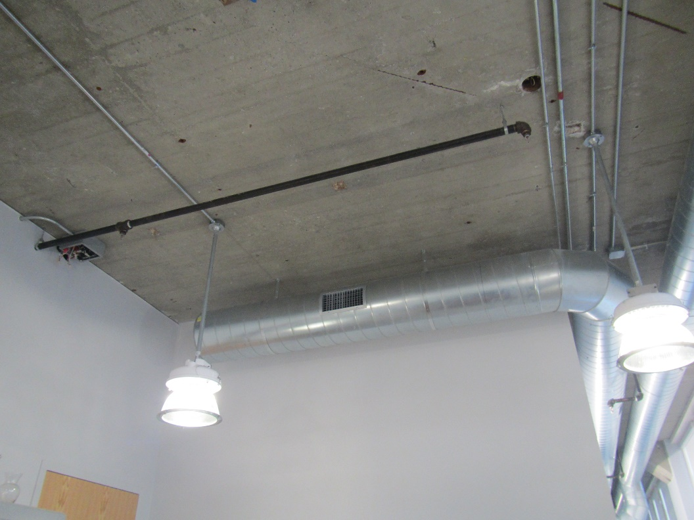
Ductwork with a supply or return vent
Picture 2
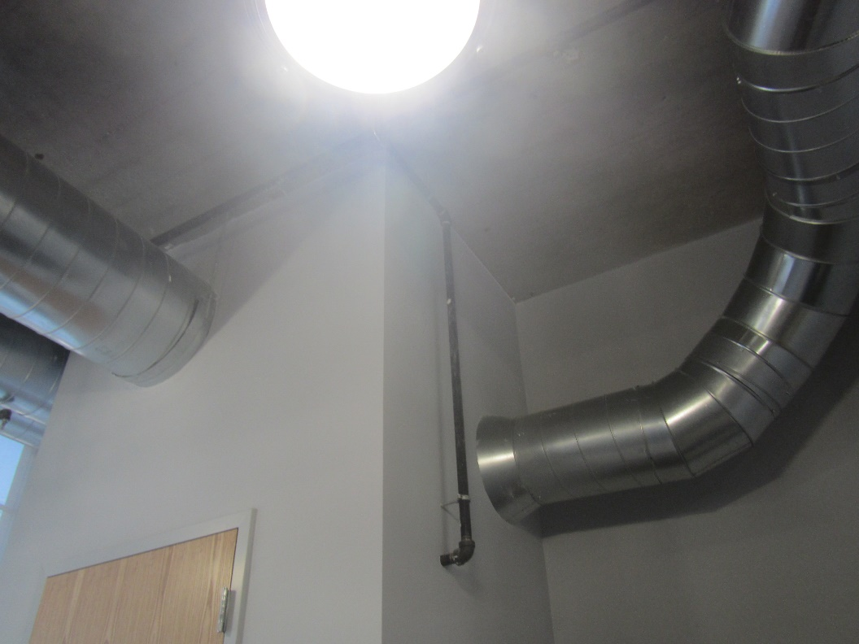
Ductwork
Picture 3
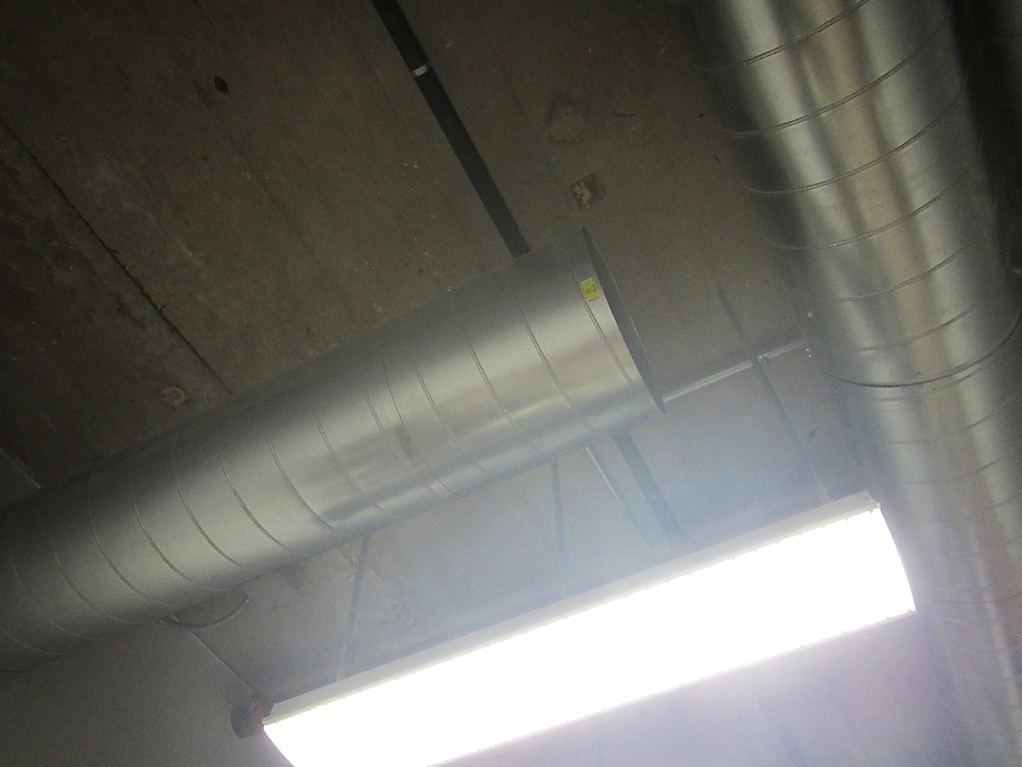
Duct with missing end cap
Picture 4
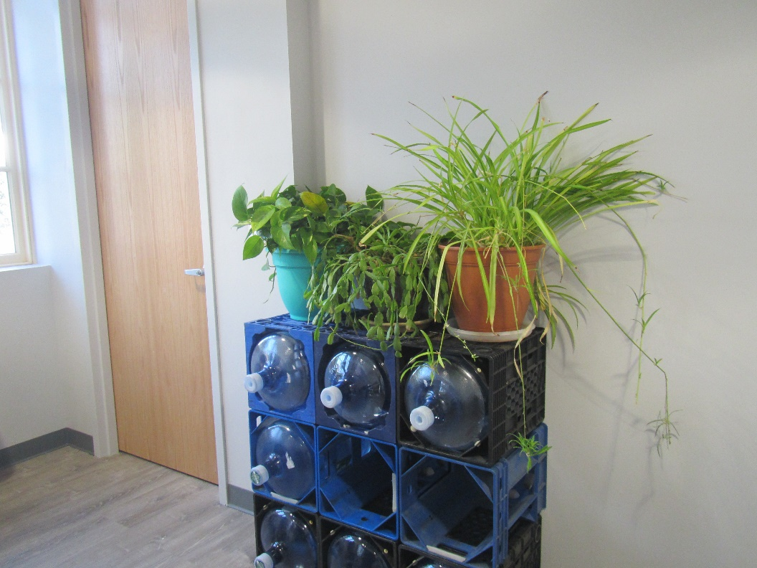
Plants in the breakroom
Picture 5
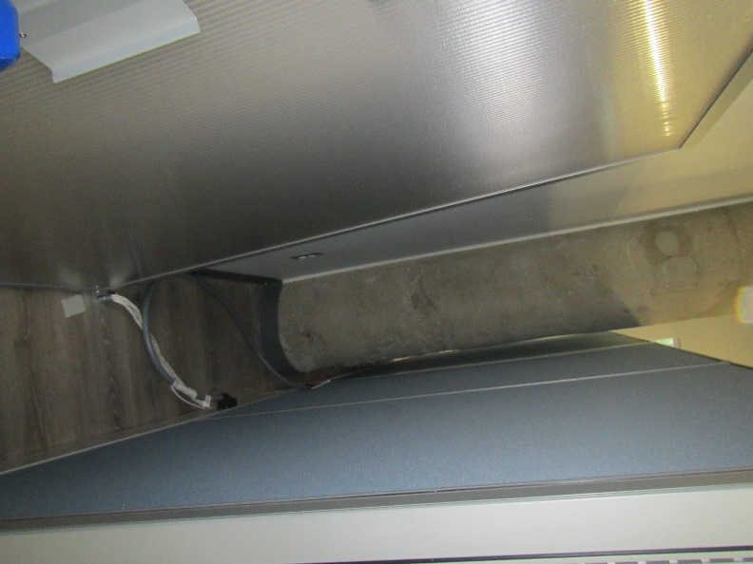
Channel behind workstation walls

