BACKGROUND

INDOOR AIR QUALITY
PRE-OCCUPANCY ASSESSMENT

MassHire Norwood Career Center
128 Carnegie Row
Norwood, MA

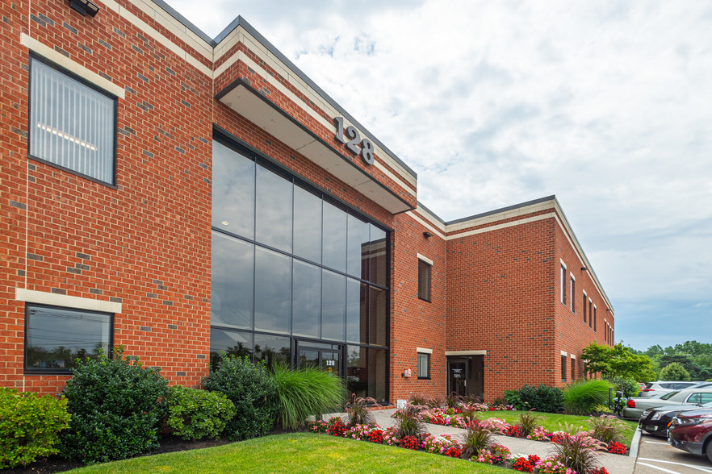

Prepared by:
Massachusetts Department of Public Health
Bureau of Environmental Health
Indoor Air Quality Program
June 2022
Building: | MassHire Norwood Career Center
Address: | 128 Carnegie Row, Norwood, MA
Assessment Requested by: | Antoine Jones, Career Center Operations Manager, MassHire Norwood
Date of Pre-Occupancy Assessment: | June 1, 2022
Massachusetts Department of Public Health/Bureau of Environmental Health (MDPH/BEH) Staff Conducting Assessment: | Cory Holmes, Assistant Director, Indoor Air Quality (IAQ) Program
Building/Ventilation:
This office suite is located on the first floor of a two-story office building constructed in 1979. The building has a brick façade and a flat roof located in small office park in Norwood. Other office tenants occupy spaces in this building. Note that the space is also being advertised for use in Research and Development, so laboratory or light manufacturing activities may also be present.
A full interior renovation was conducted prior to tenancy including heating, ventilation, and air conditioning systems (HVAC). Fresh air is supplied by an air handling units (AHUs) located on the roof. The building uses ducted supply vents and a plenum return system. Centralized restrooms, which will be shared with other office tenants have direct-vented exhaust.

Previous Relevant Environmental History:
No current/active Massachusetts Contingency Plan projects for this building or property were found in the Massachusetts Department of Environmental Protection database.

METHODS
Please refer to the IAQ Manual for methods, sampling procedures, and interpretation of results (MDPH, 2015). The following is a summary of indoor air testing results. BEH/IAQ staff also performed visual inspection of building materials for water damage and/or microbial growth and examined the space for the presence of odors or other environmental concerns.

Air Testing Results
Media sampled |  | MDPH Guideline/  Comparison Value |  | Measured Range |  |  | Comments
 |  |  |  | Outdoors/  Background |  | Indoors
Carbon Dioxide (CO₂) |  | < 800 parts per million (ppm) is preferred |  | 438 |  | 583-620 | HVAC operating, unoccupied
Total Volatile Organic Compounds (TVOCs) |  | Equal to or below background level measured |  | ND |  | ND | New carpeting and painting, no odors detected
Carbon Monoxide (CO) |  | Non-detectable (ND) or equal to or below background level measured |  | ND |  | ND
Particulate Matter 2.5 (PM2.5) |  | US EPA National Ambient Air Quality Standards (NAAQS) 35 μg/m³ or less |  | 1 |  | 1 | Areas were clean and free of dust and debris
Temperature |  | 70 to 78ºF |  | 66 |  | 70-71 | Within MDPH comfort guidelines
Relative Humidity (RH) |  | 40% to 60% |  | 61 |  | 53-54 | Within MDPH comfort guidelines
ppm = parts per million | µg/m³ = microgram per cubic meter |  | ND = non-detectable

DISCUSSION AND VISUAL OBSERVATIONS
At the time of assessment, interior renovations were mostly complete, with the exception of some punch-list items. New lighting, ceiling tiles, carpet squares, and vinyl flooring had been installed during the remodel. No office furniture had been installed yet.
Very little dust or debris was observed, indicating that a thorough cleaning had been performed prior to the move-in date. The MDPH typically recommends wet-wiping surfaces and high-efficiency particulate arrestance (HEPA) vacuuming multiple times prior to occupancy. Additional cleaning once files, materials and furniture have been transported into the building will help remove any dust, debris and moisture brought in from outside during the move.
No water-damaged or moist materials were observed during the assessment, including ceiling tiles and materials near windows. Sinks in the breakroom and the restroom facilities also appeared to be free of leaks or odors.

RECOMMENDATIONS
In view of the findings at the time of assessment, the following recommendations are made:
- Set thermostat timers to the fan “on” setting (not “auto”), throughout the space to provide continuous filtration and ventilation during occupied hours.
- Change filters for HVAC equipment prior to occupancy, and additionally 2-4 times a year using the highest Minimum Efficiency Reporting Value (MERV) rating the building’s ventilation system can accommodate to improve air filtration as much as possible without significantly reducing airflow.
- If the HVAC system has not been balanced prior to this assessment, consider balancing the system after move-in and every five years (SMACNA, 1994).
- Upon completion of renovations and moving, perform a final, thorough cleaning of the office space including wet wiping of all surfaces and use of a HEPA vacuum of all carpeting prior to staff moving into the space.
- Consistent with previously established protocol, once the space has been occupied for a minimum of three weeks, contact the BEH/IAQ Program to conduct a follow-up assessment of the space.

References
SMACNA. 1994. HVAC Systems Commissioning Manual. 1st ed. Sheet Metal and Air Conditioning Contractors’ National Association, Inc., Chantilly, VA.
MDPH. 2015. Massachusetts Department of Public Health. “Indoor Air Quality Manual: Chapters I-III”. Available at: Indoor air quality - manual and appendices | Mass.gov

