INDOOR AIR QUALITY ASSESSMENT

MassHire Metro Southwest Workforce
420 Lakeside Ave
3rd Fl. Suite 301
Marlborough, MA 01752

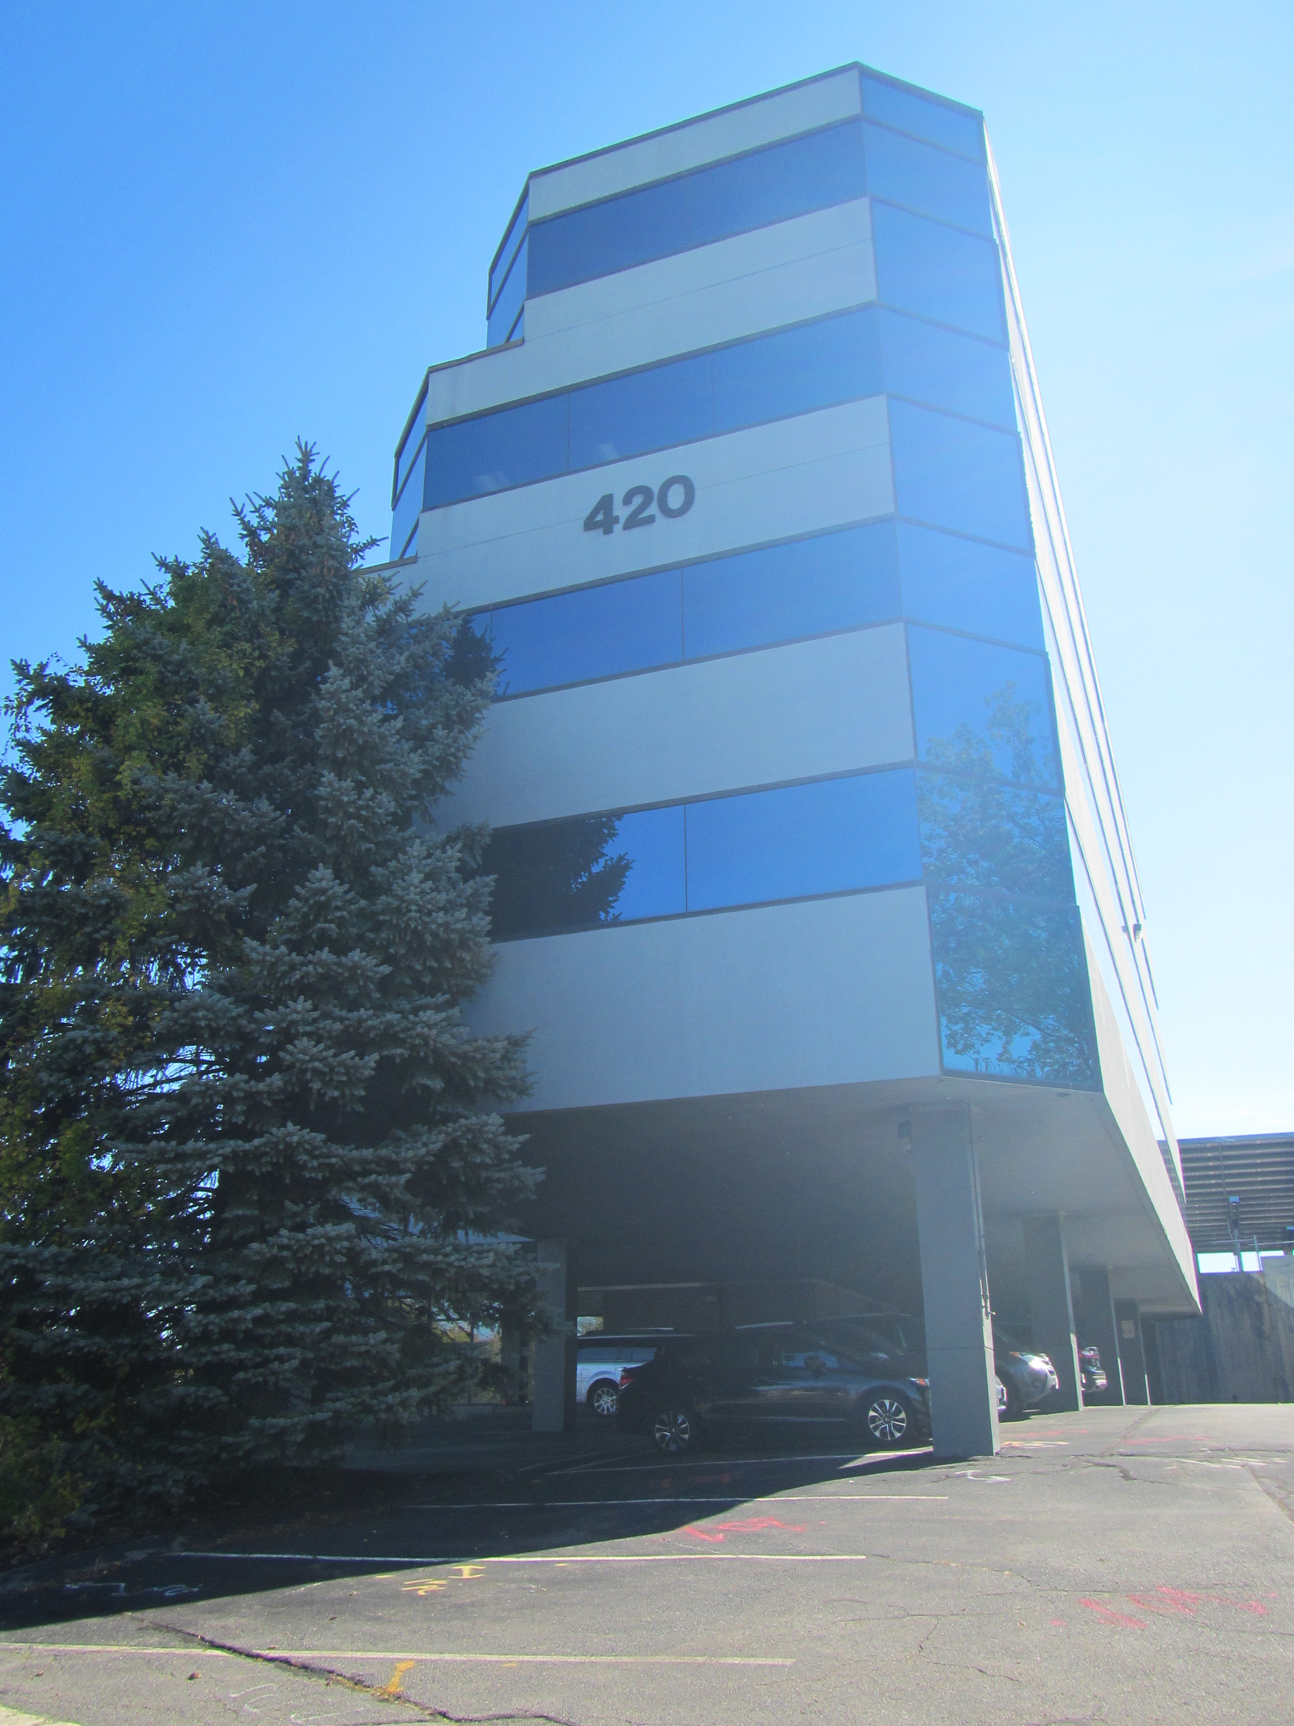

Prepared by:
Massachusetts Department of Public Health
Bureau of Environmental Health
Indoor Air Quality Program
November 2021

BACKGROUND
Building: | MassHire Metro Southwest Workforce Offices (MassHire)
Address: | 420 Lakeside Ave, 3rd Floor, Suite 301  Marlborough, MA 01752
Assessment Requested by: | Henry Bryceson, Deputy Director
Reason for Request: | Water damage and general indoor air quality (IAQ)
Date of Assessment: | October 8, 2021
Massachusetts Department of Public Health/Bureau of Environmental Health (MDPH/BEH) Staff Conducting Assessment: | Ruth Alfasso Environmental  Engineer/Inspector, IAQ
Building Description: | This MassHire office is located on the third floor of a multi-story tiered-shaped office building constructed of steel, concrete, and glass in the mid-1980s. The office suite contains offices, a break room, and other work areas.
Windows: | Not openable

METHODS
Please refer to the IAQ Manual for methods, sampling procedures, and interpretation of results (MDPH, 2015).

RESULTS AND DISCUSSION
The following is a summary of indoor air testing results (Table 1):
- Carbon dioxide levels were below the MDPH recommended level of 800 parts per million (ppm) in all areas surveyed. Note that most areas of the office were not occupied at the time of the assessment.
- Temperature was within the MDPH recommended range of 70°F to 78°F in areas tested.
- Relative humidity was within the MDPH recommended range of 40 to 60% in all areas.
- Carbon monoxide levels were non-detectable (ND) in all areas tested.
- Particulate matter (PM2.5) concentrations measured were below the National Ambient Air Quality (NAAQS) level of 35 μg/m³ in all areas tested

Ventilation
A heating, ventilating and air conditioning (HVAC) system has several functions. First it provides heating and, if equipped, cooling. Second, it is a source of fresh air. Finally, an HVAC system will dilute and remove normally occurring indoor environmental pollutants by not only introducing fresh air, but by filtering the airstream and ejecting stale air to the outdoors via exhaust ventilation. Even if an HVAC system is operating as designed, point sources of respiratory irritation may exist and cause symptoms in sensitive individuals.
Conditioned air is supplied to most rooms from air handling units (AHU) located in the ceiling of the office suite through ceiling-mounted supply vents. Ceiling mounted return vents are located in the ceilings of most rooms (Table 1). In some locations, supply and return vents are directly adjacent to one another (Picture 1), which can limit the supply of fresh air into a room when supply air is immediately drawn into the return vent.
The carbon dioxide results indicate that sufficient fresh air is being supplied for the occupancy of the office suite at the time of the assessment, however most areas of the office were not occupied at the time of the assessment. Carbon dioxide levels may increase with higher occupancy.
To maximize air exchange, the MDPH recommends that both supply and exhaust ventilation operate continuously during periods of occupancy. In order to have proper ventilation with a mechanical supply and exhaust system, the systems must be balanced to provide an adequate amount of fresh air to the interior of a room while removing stale air from the room. It is recommended that HVAC systems be re-balanced every five years to ensure adequate air systems function (SMACNA, 1994). It is unknown when the last time these systems were balanced.

Microbial Concerns
The reason for this visit to the MassHire office was concerns regarding water penetration and water damage. Concerns were expressed regarding water damage mostly on the north side of the building.
The building at 420 Lakeside Avenue has an unusual, tiered, construction, where much of the first floor is supported by stilts above a parking area, and higher floors are set back from the floor below on the north-facing side of the office. This means that there are areas of the MassHire suite that have small sections of roof directly above, despite the building having additional floors above this level. Although the roof above these areas of the MassHire suite could not be examined, the similar roof segments on the floor below could be viewed from the office (Picture 2). These segments appeared to be in poor condition with cracking and sagging of the roof membrane. It seems likely that water pools on the roof segments above the windows in the MassHire suite, and infiltrates through into the ceiling of the office, leading to stained ceiling tiles in these areas (Pictures 3 and 4). During heavy or extended rain, as has occurred over this past summer, water could also penetrate further, dripping down windows and on walls on both the interior-facing side and possibly between the wall and the exterior of the building. This would account for stains and streaks on exterior walls (Picture 5), water-damaged peeling plaster (Pictures 5 and 6), and elevated levels of moisture in walls and carpeting in some areas (Table 1). In one room, the coving at the base of the wall under the window area was loose enough to be pried up by hand (Picture 7), which is a sign of extended water exposure. Wallboard underneath it appeared to be colonized by mold. Some of the ceiling tiles near the windows also had dark staining that may indicate mold colonization (Picture 4).
Note that it is recommended that porous material be dried with fans and heating within 24 to 48 hours of becoming wet (US EPA, 2008, ACGIH, 1989). After this time, mold colonization becomes increasingly likely. It is not possible to clean moldy porous items such as wallboard, the material needs to be removed and replaced. Given the conditions seen during the visit, it is also possible that materials that are not visible, such as the exterior-facing side of the wallboard, has become chronically moistened or colonized with mold. Care should be taken during remediation to contain any mold-colonized material and avoid aerosolizing mold spores and other particulates. Remediation should be conducted in accordance with US EPA guidance (US EPA, 2008).
Other areas away from the windows on the north side of the office suite also had water-damaged ceiling tiles (Picture 8, Table 1). Some of these are reportedly due to previous issues with the HVAC system which have since been repaired. Water-damaged ceiling tiles in the kitchen area may have been due to plumbing or roof drain issues. In one office on the south side of the building, it appeared that stained ceiling tiles had been painted over rather than being replaced (Table 1). Water-damaged ceiling tiles should be removed and replaced when the leaks have been repaired. During replacement of tiles, the area above the ceiling should be examined for further water-damaged materials and cleaned or remediated as needed. This not only removes a potential source of mold and odors, but it allows for more rapid detection of new leaks so they can be addressed promptly.
Although the pattern of leakage suggests that the roof segments and plumbing/HVAC have been the sources of leaks in this building, the exterior siding of the building may also contribute to water infiltration. It appears that the building may have an Exterior Insulation and Finish Systems (EIFS), which is a type of exterior cladding with multiple layers. Older forms of EIFS, such as those used in the 1980s, were designed to repel water, but often lacked a means to drain or evaporate water that had penetrated through the exterior layers. If not properly installed and meticulously maintained, such systems can allow rainwater to penetrate into the interior of a building. (Lstiburek, 2007).
In many areas in the MassHire suite, there were boxes and other porous items on the floor (Picture 9), including near windows that have been impacted by water penetration. Porous items should not be stored in areas where they may become moistened. In addition, furniture and other items should be kept away from walls that have a history of water penetration to allow for detection of leaks and drying of moistened materials.

Other Conditions
Air purifiers were noted in an office. These need to be maintained in accordance with manufacturer’s instructions, including cleaning and filter changes. Note that these units will be more effective if the filtered airstream is in the breathing zone of the occupants rather than on the floor.
Most areas in the MassHire suite were carpeted. Carpets should be cleaned annually (or semi-annually in soiled/high traffic areas) in accordance with Institute of Inspection, Cleaning and Restoration Certification (IICRC) recommendations, (IICRC, 2012).

CONCLUSIONS AND RECOMMENDATIONS
In view of the findings at the time of the visit, the following recommendations are made:

Ventilation Recommendations
- Assess whether the HVAC system brings in fresh air. If it does not, consider if future upgrades can be made to supply fresh air through the HVAC system.
- Operate the HVAC system to provide for continuous ventilation during occupied hours.
- Ensure all exhaust vents are drawing air during occupied periods to remove stale air, odors, moisture, and irritants.
- Consider moving supply and return vents to be away from one another to prevent short-circuiting.
- Change filters in HVAC units at least twice a year. Use MERV 8 or higher filters to the greatest extent that the equipment can handle.
- Consider adopting a balancing schedule of every 5 years for all mechanical ventilation systems, as recommended by ventilation industrial standards (SMACNA, 1994).

Water Damage Recommendations:
- Determine if roof segments above the MassHire suite are failing and have them repaired or replaced.
- Have the condition of the exterior cladding of the building assessed in the vicinity of leaks and repair where possible.
- Remove and replace water-damaged wallboard along the north side of the building. During remediation, plan for additional water-damaged materials to be discovered when walls are opened.
- Replace water-damaged ceiling tiles once leaks have been repaired. During ceiling tile replacement, inspect the area above the ceiling tiles for additional water damage and clean/remediate as needed.
- All water-damaged material should be removed in a manner consistent with recommendations listed in the US EPA’s “Mold Remediation in Schools and Commercial Buildings” (US EPA, 2008).
- It is preferable that remediation of water-damaged material be conducted while the building is unoccupied. If that is infeasible, the strategies outlined in “Construction and renovation generated pollutants in occupied buildings” should be used to minimize impacts on occupants (https://www.mass.gov/service-details/construction-and-renovation-generated-pollutants-in-occupied-buildings).
- Avoid storing porous items on floors or near windows in areas with a history of leaks. Keep furniture away from the most impacted walls to facilitate drying and enable monitoring of water damage.

Other Recommendations
- Clean carpeting in accordance with IICRC recommendations.
- Refer to the resource manual and other related indoor air quality documents located on the MDPH’s website for further building-wide evaluations and advice on maintaining public buildings. These documents are available at http://mass.gov/dph/iaq.

REFERENCES
ACGIH. 1989. Guidelines for the Assessment of Bioaerosols in the Indoor Environment. American Conference of Governmental Industrial Hygienists, Cincinnati, OH.
IICRC. 2012. Institute of Inspection, Cleaning and Restoration Certification. Carpet Cleaning: FAQ.
Lstiburek, Joseph. 2007. “BSD-146: EIFS – Problems and Solutions”. Building Science Corporation. July 11, 2007. Available at: https://www.buildingscience.com/documents/digests/bsd-146-eifs-problems-and-solutions
MDPH. 2015. Massachusetts Department of Public Health. Indoor Air Quality Manual: Chapters I-III. Available at: https://www.mass.gov/lists/indoor-air-quality-manual-and-appendices#indoor-air-quality-manual-
SMACNA. 1994. HVAC Systems Commissioning Manual. 1st ed. Sheet Metal and Air Conditioning Contractors’ National Association, Inc., Chantilly, VA.
US EPA. 2008. “Mold Remediation in Schools and Commercial Buildings”. Office of Air and Radiation, Indoor Environments Division, Washington, DC. EPA 402-K-01-001. September 2008. Available at: http://www.epa.gov/mold/mold-remediation-schools-and-commercial-buildings-guide

Picture 1
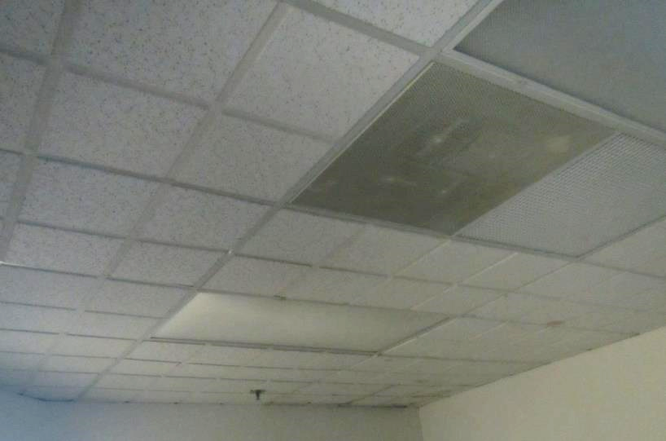
Ceiling-mounted supply and return vents directly adjacent to one another
Picture 2
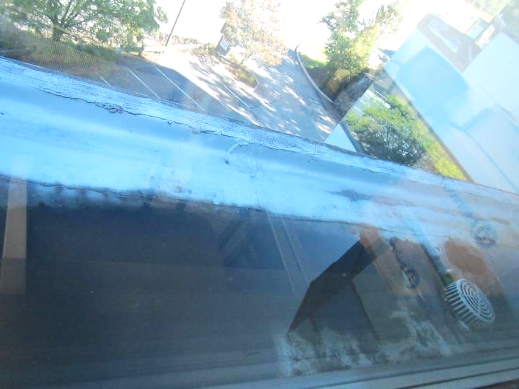
Roof segment over second floor seen from third floor window
Picture 3
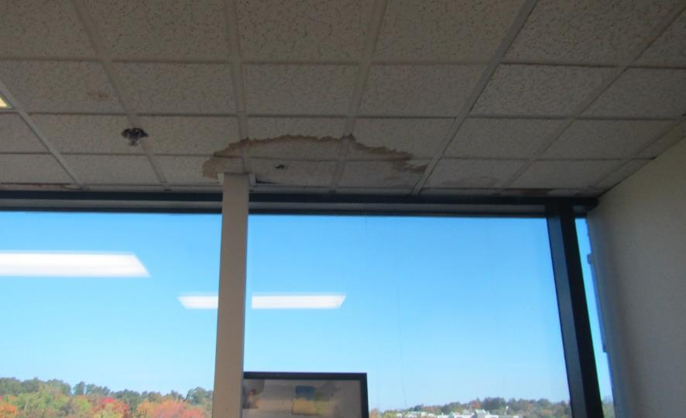
Water-damaged ceiling tiles above windows
Picture 4
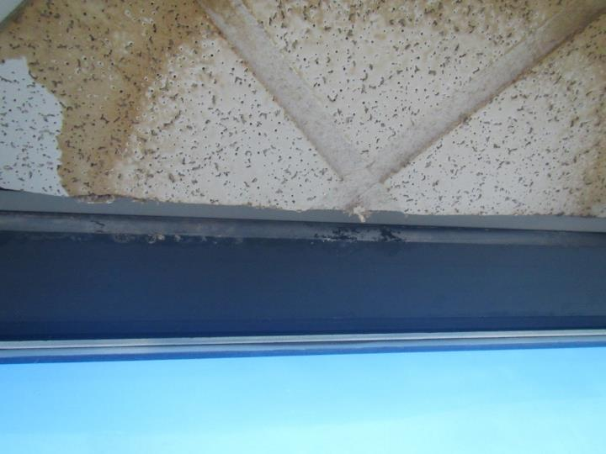
Water-damaged ceiling tile with dark staining that may indicate mold growth
Picture 5
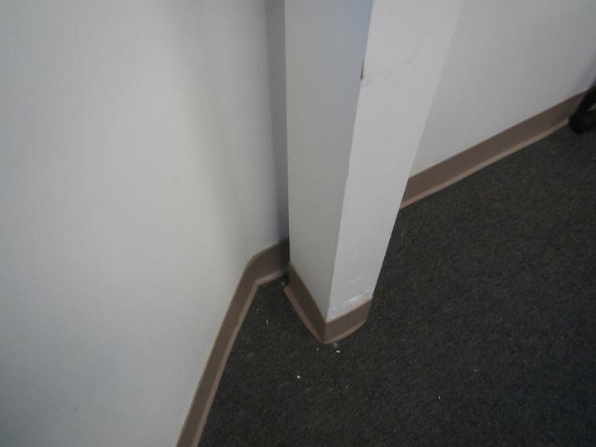
Stains and flaking plaster on interior column and wall
Picture 6
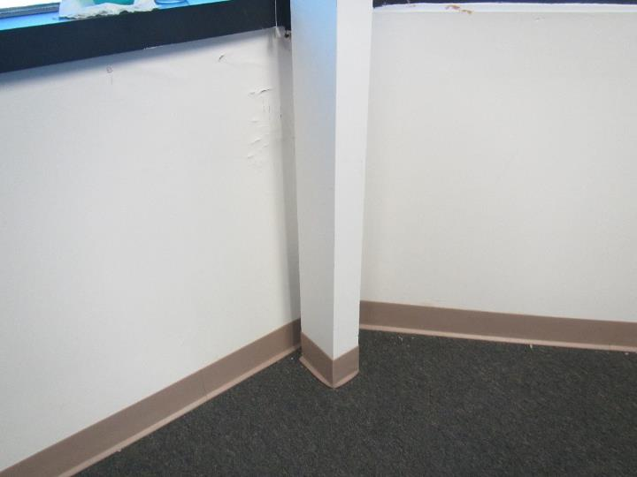
Water-damaged, flaking plaster on wall on north side of building
Picture 7
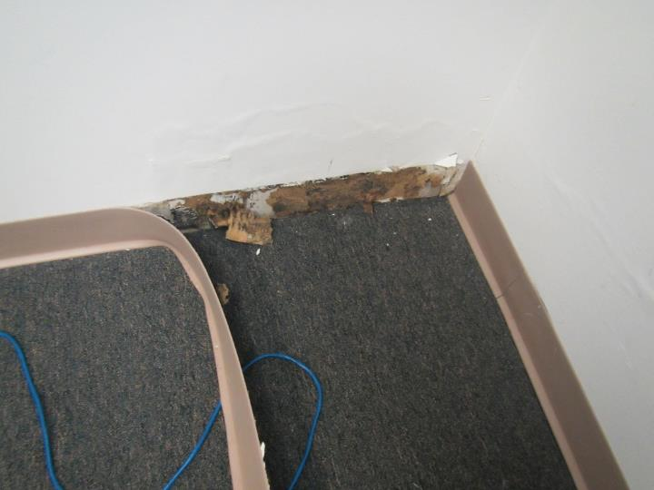
Loose coving with likely mold growth on wallboard underneath
Picture 8
Water-damaged ceiling tiles away from windows
Picture 9
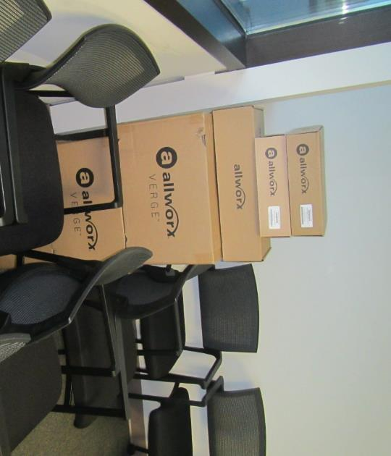
Boxes on floor next to window
Location | Carbon Dioxide  (ppm) | Carbon Monoxide (ppm) | Temp  (°F) | Relative  Humidity  (%) | PM2.5  (µg/m³) | Occupants | Window  Openable | Ventilation |  | Remarks
 |  |  |  |  |  |  |  | Supply | Exhaust
Background (outside) | 403 | < 1 | 71 | 60 | 5 |  |  |  |  | Sunny
Conference room | 554 | ND | 73 | 57 | 3 | 0 | N | Y | Y | 3 WD CT, WD wall plaster, wall measured wet near exterior corner, plaster flaking, coving not loose
2 | 575 | ND | 73 | 55 | 2 | 0 | N | Y | Y
1 | 553 | ND | 73 | 55 | 2 | 0 | N | N | Y | Possibly painted over CT, vent grill is ajar
3 (bullpen) | 581 | ND | 73 | 56 | 2 | 0 | N | N | Y | Plants, photocopier
Kitchen | 579 | ND | 74 | 56 | 2 | 0 | N | Y | Y | WD-CT (from roof drain or plumbing), sink, NC, refrigerator
4 | 571 | ND | 73 | 56 | 1 | 0 | N | N | N | No water damage
5 | 573 | ND | 73 | 55 | 2 | 0 | N | Y | Y | PF, AP, pillow on floor, DEM, plants
6 | 566 | ND | 73 | 56 | 1 | 0 | N | Y | Y | Upholstered chair
7 | 580 | ND | 73 | 56 | 2 | 1 | N | Y | Y | 3 WD CT, possible mold on CT, WD plaster, wall measured as dry, coving not loose
8 | 559 | ND | 72 | 56 | 2 | 0 | N | Y | Y | 6 WD CT, water stains and streaks on wall, DEM, segment of exterior wall measured as wet. Coving not loose.
9 | 579 | ND | 72 | 58 | 2 | 0 | N | Y | Y | Coving can be pulled loose from wall, likely mold on wall behind it, 1 WD CT, carpet measured as slightly wet, exterior wall wet in some areas
10 | 543 | ND | 73 | 57 | 2 | 0 | N | Y | Y | 1 WD CT near window, 3 WD CT near hallway, carpet slightly wet near wall (HVAC leak, since repaired), wall dirty

