Charles D. Baker  Governor  Karyn E. Polito  Lieutenant Governor  Terrence Reidy  Secretary of Public Safety and Security |  |  | Robert J. Ferullo, Jr.  Executive Director

 | Commonwealth of Massachusetts  Municipal Police Training Committee  “Training for Today, Planning for the Future” | 42 Thomas Patten Dr.  Randolph, MA 02368  Phone: (781) 437-0300  Fax: (781) 963-0235 | 
MassHR Employee Self Service

MassHR is designed to provide employees access to their electronic pay advice. In addition, employees are able to view and edit their profile, direct deposit data, W4 information and much more! The link to the website is provided below as well as instructions on how to log into the system.

  - Web Address: http://www.mass.gov/masshr

  - Click on blue rectangle labeled Employee Self Service
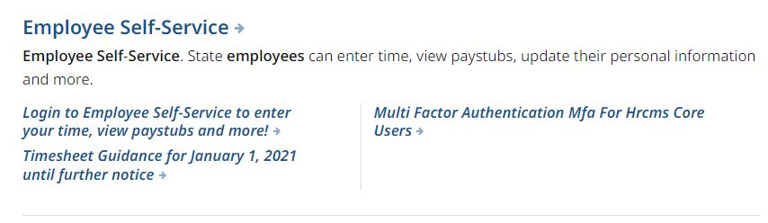

  - User ID = Six Digit Employee ID#
Password = Employee ID# followed by last four digits of SS# (this is the default password. The system will prompt you to change it immediately as well as set up security questions once you have successfully logged in)

  - Self Service: eProfile, ePay, View Paycheck, Edit Direct Deposit data, W4 Updates, W-2 Processing – Consent to suppress, Ethnic Group Updates

Should you require a password reset or experience difficulty accessing the web site, contact the Employee Service Center at (617) 979-8500.

