INDOOR AIR QUALITY ASSESSMENT

Massachusetts Office of Information Technology
One Ashburton Place, 8th floor
Boston, MA

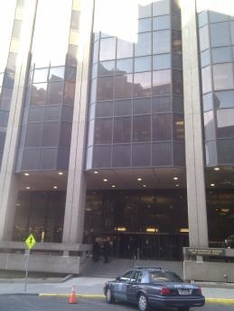

Prepared by:
Massachusetts Department of Public Health
Bureau of Environmental Health
Indoor Air Quality Program
February 2017

Background
Building: | MA Office of Information Technology (MassIT)
Address: | One Ashburton Place, 8th floor
Assessment Requested by: | Chris N. Benanti, IT Facilities Manager, MA Office of Information Technology
Reason for Request: | General indoor air quality (IAQ) concerns
Date of Assessment: | February 13, 2017
Massachusetts Department of Public Health/Bureau of Environmental Health (MDPH/BEH) Staff Conducting Assessment: | Ruth Alfasso, Environmental Engineer, indoor air quality Program
Building Description: | One Ashburton Place, also known as the McCormack Building, is a large state office building built in the 1970s.
Windows: | Not openable

Methods
Please refer to the IAQ Manual for methods, sampling procedures, and interpretation of results (MDPH, 2015).

IAQ Testing Results
The following is a summary of indoor air testing results (Table 1).
- Carbon dioxide levels were below 800 parts per million (ppm) in all areas surveyed, indicating adequate air exchange.
- Temperature was within the recommended range of 70°F to 78°F in all but one area tested.
- Relative humidity was below the recommended range of 40 to 60% in all areas tested, which is typical in New England during winter months.
- Carbon monoxide levels were non-detectable (ND) in all areas tested.
- Fine particulate matter (PM2.5) concentrations measured were below the NAAQS limit of 35 μg/m³ in all areas tested.

Ventilation
A heating, ventilating and air conditioning (HVAC) system has several functions. First it provides heating and, if equipped, cooling. Second, it is a source of fresh air. Finally, an HVAC system will dilute and remove normally-occurring indoor environmental pollutants by not only introducing fresh air, but by filtering the airstream and ejecting stale air to the outdoors via exhaust ventilation. Even if an HVAC system is operating as designed, point sources of respiratory irritation may exist and cause symptoms in sensitive individuals.
Fresh air is supplied by induction units located along the outer edges of the building (Pictures 1 through 3). Return air is drawn through grates or around light fixtures using ducted returns. As shown in Pictures 2 and 3, some induction units had items on top of them, which can obstruct the flow of fresh air. In addition, some of the items on/near the vents of the induction units can be a source of dusts, odors and, in the case of plants, pollen and other potential allergens. Induction unit vents should be kept free of items and kept clean.
It is important to note that relative humidity levels in the building would be expected to be low during the winter months due to atmospheric conditions and heating. Low relative humidity can lead to common symptoms such as: dry skin, lips, and scalp; dry/scratchy throats and noses (nose bleeds); exacerbation of asthma, eczema, or allergies; dry/irritated eyes; and irritation of respiratory tract.

Microbial/Moisture Concerns
A few water-damaged ceiling tiles were observed in offices with windows (Pictures 4 and 5). These indicate past leaks through the building envelope. Water-damaged tiles should be replaced once they are detected. In two offices, new/different wall paneling was observed (Picture 5), which was reportedly installed following more significant leaks more than a year prior to this visit. No musty/moldy odors were observed in these areas.
Due to the age and condition of the building, it is possible that leaks in the vicinity of windows will continue to occur occasionally during wind-driven rain events. To minimize the damage due to such events, a process should be set up to report any leaks or signs of water damage promptly so drying can begin immediately. Staff should avoid storing porous items (e.g., paper, boxes) in areas where leaks have occurred in the past. The United States Environmental Protection Agency (US EPA) and the American Conference of Governmental Industrial Hygienists (ACGIH) recommend that porous materials be dried with fans and heating within 24 to 48 hours of becoming wet (US EPA, 2008; ACGIH, 1989). If porous materials are not dried within this time frame, mold growth may occur. Once mold has colonized porous materials, they are difficult to clean and should be removed and discarded.
Plants were noted in a few areas (Table 1; Picture 3). Plants can be a source of pollen and mold, which can be respiratory irritants to some individuals. Plants should be properly maintained and equipped with drip pans and should be located away from induction units to prevent the aerosolization of dirt, pollen and mold.

Other Concerns
Exposure to low levels of TVOCs may produce eye, nose, throat, and/or respiratory irritation in some sensitive individuals. In addition to testing, BEH/IAQ staff examined spaces for products containing VOCs. BEH/IAQ staff noted air fresheners, deodorizers, hand sanitizers, cleaning products, compressed air canister, and dry erase materials in a number of areas throughout the office space (Table 1; Picture 6). All of these products have the potential to be irritants to the eyes, nose, throat, and respiratory system of sensitive individuals.
MassIT staff reported that musty odors occur in offices when the HVAC system switches between heating and cooling. No odors were detected by BEH staff on the day of the visit. Building staff should keep a record of when odors occur in the building to assist in determining a source. Induction units should be cleaned, inside and outside, periodically to remove dust and debris that may lead to odors when heated. If units are equipped with filters, these should be changed in accordance with manufacturer’s instructions. Also, the temperature of the supply coil fluid should be maintained above the dew point temperature of the office areas to prevent any condensation at or inside the units.
A ceiling tile was ajar/bowed in the conference room. The ceiling tile system should be intact to prevent dust and debris from above the system from infiltrating into occupied areas.
Personal fans observed in some offices appeared dusty. Dust collected on fan blades can be aerosolized. Dust is a respiratory and eye irritant. Fans should be cleaned periodically to prevent aerosolization of dust when the units are activated.
Items were observed on a number of flat surfaces, such as windowsills, tabletops, counters, bookcases, and desks. The large number of items stored in offices provides a source for dusts to accumulate. These items (e.g. papers, folders, boxes) also make it difficult for custodial staff to clean. Items should be relocated and/or be cleaned periodically to avoid excessive dust build up.
Some of the fluorescent light fixtures had debris visible inside them (Picture 7). These fixtures should be cleaned periodically, and care should be taken to avoid distributing the debris when the fixtures are opened. In addition, any debris dislodged during cleaning should be vacuumed using a HEPA-equipped vacuum afterward. This activity should be conducted outside of normal working hours.

Conclusions/Recommendations
Based on observations at the time of assessment, the following is recommended:
- Operate supply and exhaust ventilation continuously in all areas during occupied periods. Ensure all HVAC equipment is cleaned/maintained in accordance with manufacturer’s instructions.
- Regularly clean induction unit coils/fins to reduce any accumulated debris. Also ensure that during cooling season, the temperature of the supply coil fluid above the dew point of the office areas to avoid any condensation at/inside the unit.
- Have the HVAC system balanced every 5 years in accordance with SMACNA recommendations (SMACNA, 1994).
- Replace water-damaged ceiling tiles once the source of the leak is repaired. Ensure that any leaks are reported to building management promptly so drying and other remediation can take place.
- Keep plants in good condition, avoid overwatering, and remove from the airstream of heating and ventilation equipment.
- Reduce the use of cleaning products, sanitizers, and other items that contain VOCs.
- Monitor for odors in areas where previously reported and keep a record, including building activities and weather conditions, when odors are noted. Contact BEH/IAQ staff if odors reoccur.
- Clean blades of personal fans to prevent aerosolization of dust.
- Reduce the amount of items stored on flat surfaces to allow regular cleaning.
- Ensure all ceiling tiles are intact and installed flush in the ceiling tile system. Missing/ajar tiles should be replaced to prevent movement of dust and debris from plenum into occupied areas.
- Clean the light fixtures of debris and ensure that debris is properly contained and cleaned up to prevent aerosolization.
- Refer to resource manual and other related IAQ documents located on the MDPH’s website for further building-wide evaluations and advice on maintaining public buildings. These documents are available at: http://mass.gov/dph/iaq.

References
ACGIH. 1989. Guidelines for the Assessment of Bioaerosols in the Indoor Environment. American Conference of Governmental Industrial Hygienists, Cincinnati, OH.
MDPH. 2015. Massachusetts Department of Public Health. Indoor Air Quality Manual: Chapters I-III. Available at: http://www.mass.gov/eohhs/gov/departments/dph/programs/environmental-health/exposure-topics/iaq/iaq-manual/.
SMACNA. 1994. HVAC Systems Commissioning Manual. 1st ed. Sheet Metal and Air Conditioning Contractors’ National Association, Inc., Chantilly, VA.
US EPA. 2008. Mold Remediation in Schools and Commercial Buildings. US Environmental Protection Agency, Office of Air and Radiation, Indoor Environments Division, Washington, D.C. EPA 402-K-01-001. http://www.epa.gov/mold/mold-remediation-schools-and-commercial-buildings-guide.
Picture 1
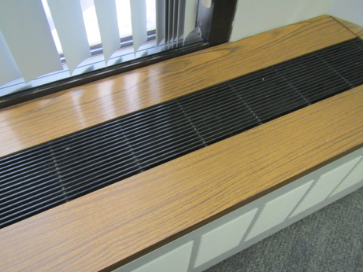
Induction unit
Picture 2
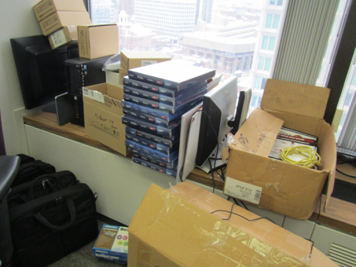
Induction unit with items on top and in front
Picture 3
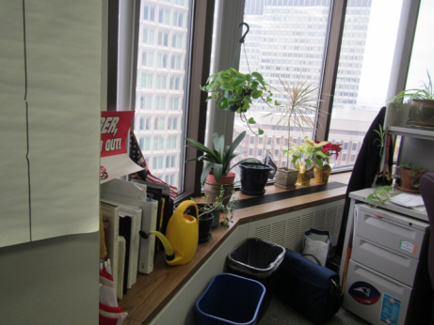
Induction unit with plants
Picture 4
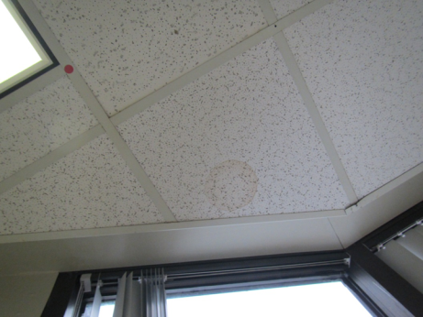
Water-damaged ceiling tile
Picture 5
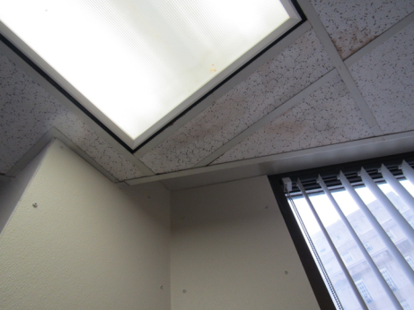
Water-damaged ceiling tiles and new wall paneling (note screws attaching to wall)
Picture 6
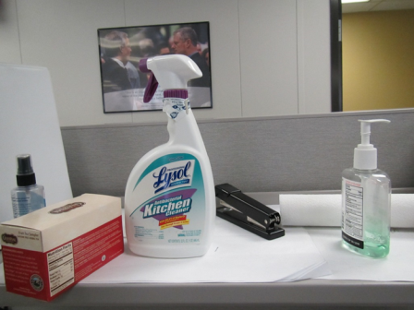
Cleaning product and hand sanitizer
Picture 7
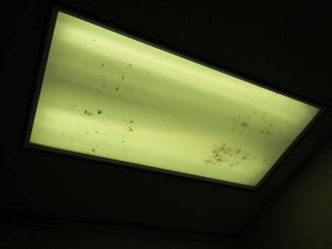
Debris in light fixture

Location | Carbon  Dioxide  (ppm) | Carbon Monoxide  (ppm) | Temp  (°F) | Relative  Humidity  (%) | PM2.5  (µg/m³) | Occupants  in Room | Windows  Openable | Ventilation |  | Remarks
 |  |  |  |  |  |  |  | Supply | Exhaust
Background | NA | NA | NA | NA | NA |  |  |  |  | Windy and cold, recent snow
Conference room | 613 | ND | 69 | 22 | 4 | 0 | N | Y | Y | DEM, ajar tile
Velluto (cubes) | 588 | ND | 71 | 20 | 4 | 0 | N | Y | Y | DEM, items on unit, PF
Sanborn (cubes) | 664 | ND | 72 | 20 | 5 | 2 | N | Y | Y | DEM
Prefontaine (cubes) | 613 | ND | 72 | 20 | 5 | 2 | N | Y | Y | Plants, food, PF
Melhorn (cubes) | 564 | ND | 72 | 19 | 5 | 1 | N | Y | Y | Plants including on unit, HS
Bourne (cubes) | 557 | ND | 73 | 19 | 5 | 1 | N | Y | Y | PF, coffee, plants
Ferreria (office) | 598 | ND | 72 | 18 | 5 | 1 | N | Y | Y | WD CT, stains and new wall surfacing, DEM, PF
Rooney (office) | 597 | ND | 70 | 20 | 4 | 0 | N | Y | Y | PF, DEM
Ditzion (office) | 512 | ND | 70 | 19 | 4 | 0 | N | Y | Y | Plant, DEM
Zarotta-Kene (office) | 556 | ND | 70 | 19 | 4 | 0 | N | Y | Y | DEM, HS, stain on unit
Hamel (office) | 585 | ND | 70 | 20 | 4 | 3 | N | Y | Y | Plant, DEM
Kitchen area | 682 | ND | 72 | 27 | 4 | 0 | N | Y | Y | uncarpeted, fridge and microwave
Cubes near front | 613 | ND | 73 | 19 | 6 | 2 | N | Y | Y | CP

