INDOOR AIR QUALITY REASSESSMENT
Massachusetts Office of Information Technology
One Ashburton Place, 8th floor
Boston, MA
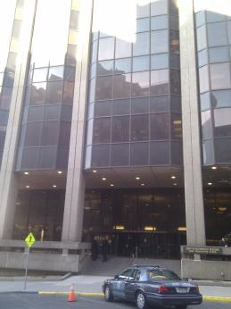
Prepared by:
Massachusetts Department of Public Health
Bureau of Environmental Health
Indoor Air Quality Program
June 2017

Background
Building: | MA Office of Information Technology (MassIT)
Address: | One Ashburton Place, 8th floor
Assessment Requested by: | Chris N. Benanti, IT Facilities Manager, MassIT
Reason for Request: | Reassessment of general indoor air quality (IAQ) concerns including odors
Date of Assessment: | June 16, 2017
Massachusetts Department of Public Health/Bureau of Environmental Health (MDPH/BEH) Staff Conducting Assessment: | Ruth Alfasso, Environmental Engineer, IAQ Program
Building Description: | One Ashburton Place, also known as the McCormack Building, is a large state office building constructed in the 1970s.
Windows: | Not openable

Methods
Please refer to the IAQ Manual for methods, sampling procedures, and interpretation of results (MDPH, 2015).

IAQ Testing Results
The following is a summary of indoor air testing results (Table 1).
- Carbon dioxide levels were below 800 parts per million (ppm) in all areas surveyed, indicating adequate air exchange.
- Temperature was within the recommended range of 70°F to 78°F in all areas tested.
- Relative humidity was within the recommended range of 40 to 60% in all areas tested.
- Carbon monoxide levels were non-detectable (ND) in all areas tested.
- Fine particulate matter (PM2.5) concentrations measured were below the NAAQS limit of 35 μg/m³ in all areas tested.

This building was previously assessed on February 13, 2017 because of concerns regarding odors and respiratory irritation; a report on that visit can be found at http://www.mass.gov/eohhs/gov/departments/dph/programs/environmental-health/exposure-topics/iaq/iaq-rpts/cities-and-towns-b.html. At that time, it was indicated by building staff that odors tended to be worse when the HVAC system switched (from heating to cooling) for the change of seasons; therefore building staff asked the MDPH/IAQ Program to revisit the site.

Ventilation
A heating, ventilating, and air conditioning (HVAC) system has several functions. First it provides heating and, if equipped, cooling. Second, it is a source of fresh air. Finally, an HVAC system will dilute and remove normally-occurring indoor environmental pollutants by not only introducing fresh air, but by filtering the airstream and ejecting stale air to the outdoors via exhaust ventilation. Even if an HVAC system is operating as designed, point sources of respiratory irritation may exist and cause symptoms in sensitive individuals.
Fresh air is supplied by induction units located along the outer edges of the building (Pictures 1 and 2). Return air is drawn through grates or around light fixtures using ducted returns. As shown in Picture 2, some induction units had items on top of them, which can obstruct the flow of fresh air. In addition, some of the items on/near the vents of the induction units can be a source of dusts, odors and, in the case of plants, pollen, and other potential allergens. Induction unit vents should be kept free of items and kept clean.

Microbial/Moisture Concerns
During the previous visit, a few water-damaged ceiling tiles were observed in offices with windows. These appeared to have been replaced as no water-damaged tiles were observed during this visit. However, due to the age and condition of the building, it is possible that leaks in the vicinity of windows will continue to occur occasionally during wind-driven rain events. Staff should avoid storing porous items (e.g., paper, boxes) in areas where leaks have occurred in the past.
Plants were noted in a few areas (Table 1; Picture 2). Plants can be a source of pollen and mold, which can be respiratory irritants to some individuals. Plants should be properly maintained and equipped with drip pans and should be located away from induction units to prevent the aerosolization of dirt, pollen, and mold.

Other Concerns
Exposure to low levels of TVOCs may produce eye, nose, throat, and/or respiratory irritation in some sensitive individuals. In addition to testing, BEH/IAQ staff examined spaces for products containing VOCs. BEH/IAQ staff noted air fresheners, deodorizers, hand sanitizers, cleaning products, compressed air canister, and dry erase materials in a number of areas throughout the office space (Table 1; Picture 3). All of these products have the potential to be irritants to the eyes, nose, throat, and respiratory system of sensitive individuals.
MassIT staff reported that musty odors occur in offices when the HVAC system switches between heating and cooling. A slight musty odor was detected in a few offices. Several of the induction units were opened for examination. Debris was observed inside the cabinets (Pictures 4 and 5), including dust on the fins and debris inside the condensation collection pans. Some collection pans also had small tablets, which are designed to reduce the build-up of microbial growth and clogs. Some of these treatments have components that may be irritating to the skin or respiratory system. The inside of the induction units, including the condensation pans, should be cleaned periodically to prevent odors and dusts from becoming aerosolized during unit use.
The office suites investigated are partially built on a raised floor, because area once served as a mainframe computer room. The area underneath the floor was found to contain significant amounts of debris (Picture 6) likely present since this office space was renovated. As shown in Pictures 4 and 5, this space is directly connected to the induction units, creating a pathway for dust, odors, and pests into occupied space. This space should be thoroughly cleaned.
Items were observed on a number of flat surfaces, such as windowsills, tabletops, counters, bookcases, and desks (Picture 7). Items stored in offices provides a source for dusts to accumulate. These items (e.g. papers, folders, boxes) also make it difficult for custodial staff to clean. Items should be relocated and/or be cleaned periodically to avoid excessive dust build up.
The offices were mostly carpeted. Carpets should be cleaned annually (or semi-annually in soiled/high traffic areas) in accordance with Institute of Inspection, Cleaning and Restoration Certification (IICRC) recommendations, (IICRC, 2012). Some upholstered items in a conference room appeared to be slightly dusty/soiled. These items should also be cleaned regularly.
Some of the fluorescent light fixtures had debris visible inside them (Picture 8), a condition also observed during the previous visit. These fixtures should be cleaned periodically, and care should be taken to avoid aerosolizing the debris when the fixtures are opened. Any debris dislodged during cleaning should be vacuumed using a high efficiency particle arrestance (HEPA) filtered vacuum. This activity should be conducted outside of normal working hours.

Conclusions/Recommendations
Based on observations at the time of assessment, the following is recommended:
- Regularly clean induction unit fins and condensation pans to reduce accumulated debris. Ensure tablets used in condensation pans to control microbial growth do not contain irritating substances or create odors.
- Thoroughly clean the space underneath the raised floor.
- Ensure that during cooling season, the temperature of the supply coil is above the dew point of the office areas to avoid any condensation at/inside the unit.
- Operate supply and exhaust ventilation continuously in all areas during occupied periods. Ensure all HVAC equipment is cleaned/maintained in accordance with manufacturer’s instructions.
- Balance the HVAC system every 5 years in accordance with Sheet Metal and Air Conditioning Contractors’ National Association (SMACNA) recommendations (SMACNA, 1994).
- Keep plants in good condition, avoid overwatering, and remove from the airstream of heating and ventilation equipment.
- Reduce the use of cleaning products, sanitizers, and other items that contain VOCs.
- Reduce the amount of items stored on flat surfaces to allow regular cleaning.
- Clean carpeting in accordance with IICRC recommendations (IICRC, 2012).
- Clean light fixtures of debris; ensure debris is properly contained and cleaned up to prevent aerosolization.
- Refer to resource manual and other related IAQ documents located on the MDPH’s website for further building-wide evaluations and advice on maintaining public buildings. These documents are available at: http://mass.gov/dph/iaq.

References
IICRC. 2012. Institute of Inspection, Cleaning and Restoration Certification. Carpet Cleaning: FAQ. Retrieved from http://www.iicrc.org/consumers/care/carpet-cleaning.
MDPH. 2015. Massachusetts Department of Public Health. Indoor Air Quality Manual: Chapters I-III. Available at: http://www.mass.gov/eohhs/gov/departments/dph/programs/environmental-health/exposure-topics/iaq/iaq-manual/.
SMACNA. 1994. HVAC Systems Commissioning Manual. 1st ed. Sheet Metal and Air Conditioning Contractors’ National Association, Inc., Chantilly, VA.
Picture 1
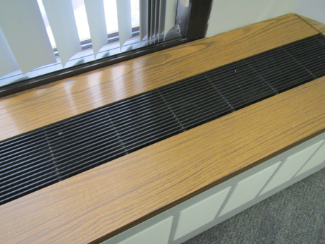
Induction unit
Picture 2
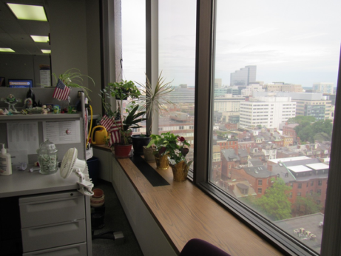
Induction unit with plants on it
Picture 3
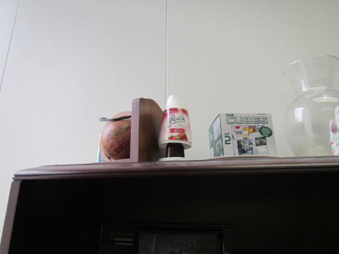
Air freshener
Picture 4
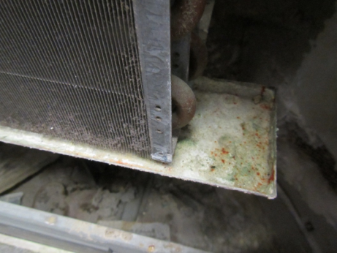
Inside induction unit, note dusty fins, debris in condensation tray and space underneath
Picture 5
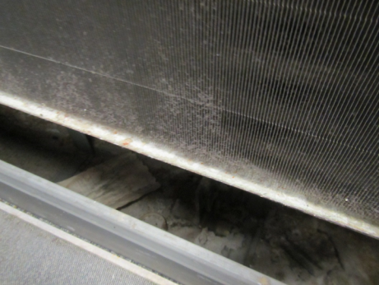
View inside induction unit showing dusty fins and debris in space below
Picture 6
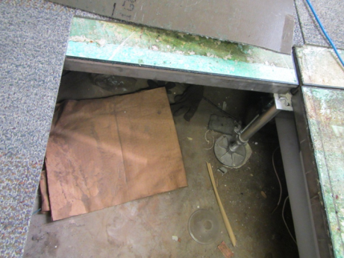
View under raised floor showing significant debris
Picture 7
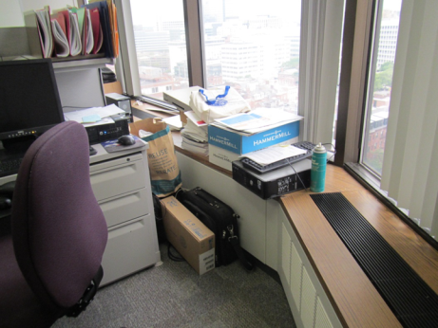
Items on surfaces next to windows
Picture 8
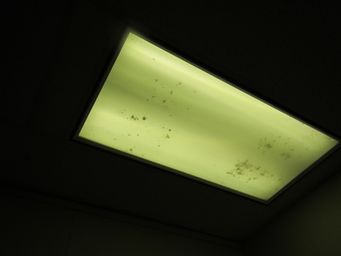
Debris inside light fixture
Location | Carbon Dioxide (ppm) | Carbon Monoxide (ppm) | Temp (°F) | Relative Humidity (%) | PM2.5 (µg/m³) | Occupants in Room | Windows Openable | Ventilation | Remarks
 |  |  |  |  |  |  |  | Intake | Exhaust
Background | 358 | 0.1 | 74 | 47 | 5 | - | - | - | - | Windy
Suite 819
Berkshire room | 571 | ND | 74 | 45 | 1 | 0 | N | Y | Y | Upholstered items (slightly dusty/soiled)
Cape Ann room | 586 | ND | 75 | 45 | 3 | 0 | N | Y | Y | DEM, CP, AF
Computer training room | 544 | ND | 72 | 47 | 4 | 4 | N | Y | Y | DEM, plant
Cubes 13-20 | 574 | ND | 73 | 47 | 3 | 3 | N | Y | Y
Cubes 1-4 | 573 | ND | 74 | 45 | 3 | 1 | N | Y | Y | AI, plants, PF
Cubes 21-30 | 548 | ND | 73 | 46 | 2 | 5 | N | Y | Y | Plant, DEM
Cubes 33-36 | 545 | ND | 73 | 46 | 1 | 3 | N | Y | Y | PF, DEM
Cubes 6-8 | 609 | ND | 75 | 45 | 1 | 2 | N | Y | Y | DEM
Cubes 9-20 | 548 | ND | 73 | 46 | 1 | 0 | N | Y | Y
Mount Greylock room | 563 | ND | 74 | 45 | 0 | 0 | N | Y | Y | DEM
Suite 811
BPA cube area | 606 | ND | 75 | 45 | 2 | 4 | N | Y | Y
Conference room | 715 | ND | 75 | 46 | 2 | 0 | N | Y | Y | DEM
Cube 25 | 626 | ND | 74 | 46 | 1 | 0 | N | Y | Y | PF
Cubes 13-19 | 583 | ND | 75 | 45 | 1 | 2 | N | Y | Y | Plant on induction unit
Cubes 1-4 | 607 | ND | 75 | 46 | 1 | 2 | N | Y | Y | Plants on induction unit
Cubes 20-24 | 565 | ND | 75 | 45 | 1 | 2 | N | Y | Y | Plants, PF – on, AI by induction unit
Cubes 6-12 | 609 | ND | 74 | 46 | 1 | 2 | N | Y | Y | PF
Empty corner office | 582 | ND | 75 | 45 | 2 | 0 | N | Y | Y | DEM, DO
Kitchen | 636 | ND | 75 | 44 | 2 | 0 | N | Y | Y | Fridge (clean), microwave, photocopier, NC
Office | 570 | ND | 74 | 45 | 3 | 0 | N | Y | Y
Office 01 | 688 | ND | 74 | 45 | 1 | 0 | N | Y | Y | DO, DEM
Office 02 | 551 | ND | 75 | 45 | 1 | 0 | N | Y | Y | DEM, induction unit partially blocked in front
Office 03 | 629 | ND | 75 | 46 | 1 | 0 | N | Y | Y | Plant, DEM

