Massachusetts Department of Public Health
www.mass.gov/prescription-monitoring-program-pmp
Version 1.2

MassPAT Electronic Health Record (EHR) Integration
Guide
Massachusetts Prescription Monitoring Program (PMP)

Contents
Version Control Details 2
What is the Prescription Monitoring Program (PMP)? 2
What is the Massachusetts Prescription Awareness Tool (MassPAT)? 2
What is EHR Integration? 2
Integration Options 3
Option 1: API Version 5.1 3
Option 2: American Society for Standardization in Pharmacy (ASAP) 4
Option 3: Epic SSO 4
What is the integration request process? 4
What is the implementation process? 4
Clinical workflow 6
Role mapping 7
Interstate data sharing 9
User onboarding 9
Testing 10
What are the legal parameters for integration? 10
Data security 10
Ongoing maintenance of certifications and credentials 11
Post Implementation Support 11
PMP Gateway Client Certificate Authentication (2-way SSL) 11
Web Service Credential Maintenance 11
Post Implementation Technical Support 11
Relevant Hyperlinks 11
Appendix A - EHR Integration Readiness Document 13
Purpose 13
Project Owners 13
Project Acceptance Criteria 13
Proof of Testing 14

Version Control Details
Version | Date | Changes
1.0 | 2/1/18 | - Original document
1.1 | 3/26/18 | - Changes to Integration Request Process
1.2 | 5/24/18 | - Changes to contact information  - Edits to Readiness Document

What is the Prescription Monitoring Program (PMP)?
The PMP is a program within the DPH, responsible for analyzing prescription data to determine prescribing and dispensing trends; providing patient prescription history information to prescribers and pharmacists; providing educational information to healthcare providers and the public; and providing case information to regulatory and law enforcement agencies concerning drug distribution and diversion. The MA PMP collects information on Massachusetts Schedule II through V controlled substances and Gabapentin dispensed pursuant to a prescription. Please visit the PMP website for more information about the reporting requirements.

What is the Massachusetts Prescription Awareness Tool (MassPAT)?
MassPAT is an online tool that promotes safe prescribing and dispensing patterns by allowing prescribers and pharmacists to access their patient’s prescriptive history within the past year. By viewing a patient’s prescription history in MassPAT, a provider can avoid duplication of drug therapies and coordinate care by communicating with other providers to improve clinical outcomes and overall patient health. Utilization of MassPAT can also enable early identification of potential prescription drug misuse, abuse, or diversion and trigger early intervention.
As of October 15, 2016, prescribers are required by law to check MassPAT each time the prescriber issues a prescription for a Schedule II or III narcotic to a patient. Prescribers must continue to check MassPAT the first time they prescribe a benzodiazepine to a patient.

What is EHR Integration?
Integrating MassPAT data within an Electronic Health Record (EHR) provides a streamlined clinical workflow for providers. The integration eliminates the need for providers to pull-up the MassPAT browser, successfully log-in, then enter their patient’s name and date of birth. Instead, the EHR automatically initiates a patient query, validates the provider’s credentials in MassPAT and returns the patient’s prescription record directly within the provider’s EHR. The integration should seamlessly fit into the clinical workflow and allow for real-time or near real-time presentation of MassPAT data within the EHR.
For the purposes of this document, the integration is called “EHR Integration”, but the integration works with pharmacy management systems, practice management systems (i.e. Dentistry), and Electronic Medical Records (EMRs).
While the integration will play a vital role in streamlining a provider’s ability to view their patient’s data in MassPAT, the web portal will continue to be a valuable tool. Providers will continue to use this to manage their delegates as well as view “My RX”, Patient Alerts, and Provider Reports. Delegates and non-prescriber roles are not used in integration and as such will need to continue using the MassPAT web portal to conduct patient searches. For more information on the differences of the EHR integration and the MassPAT web portal, please reference the Clinical Workflow Section.

Integration Options
Appriss Health is the vendor for the MassPAT and PMP Clearinghouse tools operated by the MA PMP. In addition to these tools, MA has contracted with Appriss Health to connect with EHRs via their PMP Gateway.
Appriss Health developed the PMP Gateway to allow PMPs to share data with authorized third parties such as Health Information Exchanges, Electronic Health Records, practice management systems, and pharmacy software companies. There are two options to connect directly to the PMP Gateway, each with their own advantages and disadvantages that should be weighed carefully by healthcare entities.

Option 1: API Version 5.1
Version 5.1 of Appriss Health’s Application Performance Interface (API) returns an HTML patient report which looks much like the patient report that is available within MassPAT. A sample HTML report is provided below for reference. 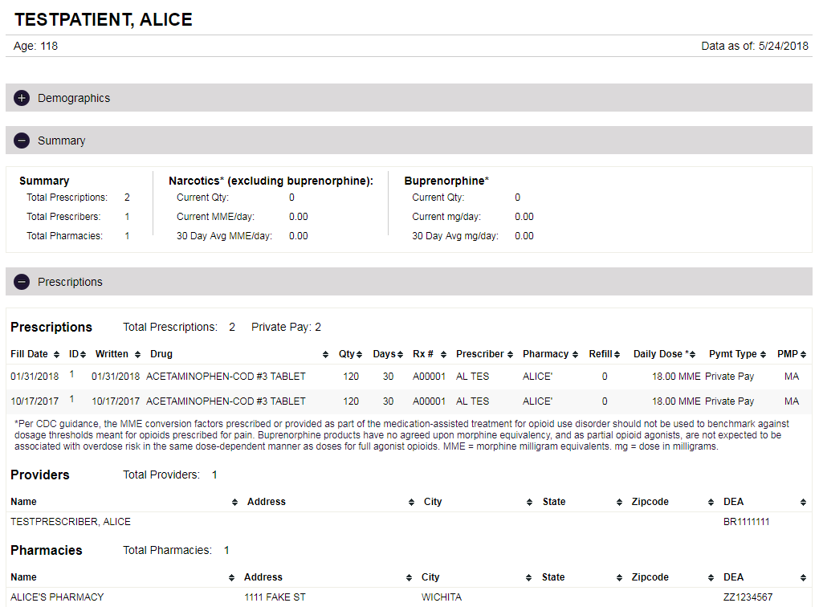

Option 2: American Society for Standardization in Pharmacy (ASAP)
The American Society for Standardization in Pharmacy (ASAP) has also developed standards for integration. The PMP Gateway is prepared to integrate with EHRs via ASAP, which is an XML integration option. Because this is an XML connection option, healthcare entities will be responsible for determining how the data is presented within the EHR.
Please note that there are a handful of data elements that are available via API Version 5.1 and the MassPAT web application that are not available via the ASAP standard. The missing data elements are the summary statistics: morphine milligram equivalence (MME), payment type, and patient ID information.

Option 3: Epic SSO
Those organizations using Epic as their EHR vendor will have the option to use Epic’s Single Sign-On (SSO) to integrate with MassPAT. This integration option will return prescription data and render it in an HTML page.

What is the integration request process?
- Follow the instructions on the Massachusetts PMP EHR Integration Request Form website.

- Complete the Integration Request Form, Terms & Conditions, and PMP Gateway Licensee Questionnaire.

  - Please ensure that you identify a primary contact (the person leading the project within your organization) as well as a contact for your software vendor.

- Appriss Health, the MassPAT software vendor, will contact you to discuss next steps (see below for more information).

What is the implementation process?
Several EHR vendors have already completed the PMP Gateway integration development work to deliver controlled substance prescription data within their products/service offerings. If your vendor has not yet completed integration, Appriss Health will work with you and your vendor to initiate that process.

If your EHR vendor has completed integration:

  - Appriss Health will create pre-production (test) and production PMP Gateway credentials for your Healthcare Entity.
    - This process should take 2-3 business days
  - Credentials will then be sent to your EHR vendor (or directly to you, depending upon your vendor) to start the process.
    - Appriss Health recommends you contact your EHR vendor to let them know you have submitted a request to be integrated under the MassPAT EMR Integration project.
  - Your EHR vendor will reach out to you to start the implementation process.
  - You must create a certificate signing request that can be submitted to the PMP Gateway certificate authority. PMP Gateway then generates a certificate that the licensee uses to make requests to PMP Gateway’s two-way SSL/TLS enabled endpoint. *Separate certificates must be created for pre-production (test) and production.*
    - You must have an active licensee administrator account in PMP Gateway.
      - You will be issued your account information when your credentials are provided by Appriss Health.
    - Additional configuration details will be sent with the account information.
- Once testing is complete, you must send test results and a screenshot of the integration within your EHR/PMS to MA DPH using the “EHR Integration Readiness Document” which can be found in Appendix A and on the PMP website. *This is a requirement before you can move to production.
    - Please send the readiness document to PMP.EHR@massmail.state.ma.us with the subject of “[Organization Name] - EHR Testing”.
    - Once this is received, MA DPH will approve your access to production. You should receive an automated email once you are approved.
- You will work with your EHR/PMS vendor to determine the final roll-out schedule and communicate this timeline with MA DPH.
*Please note: If you are using Epic as your EHR vendor, the implementation process will vary from what is outlined above. The implementation process is more involved at the HCE level and Appriss Health will contact the HCE directly to coordinate the implementation for Epic sites.
If your EHR vendor has not completed the necessary integration development:

- An Appriss Health Project Manager (PM) will reach out to the point of contact listed on your Integration Request Form and let you know that they are initiating communication with your vendor.
- Appriss Health will provide the EHR vendor with the technical API documentation
  - Please note: Depending upon the engagement level of the vendor or existing project backlog, this process can take up to several months.

- Appriss Health will provide testing instructions and test patients to your EHR vendor and will provide technical support as needed.
- Your EHR vendor will work to ensure all provider roles are mapped correctly to the appropriate PMP Gateway role.
- Your EHR Vendor will demo the PMP Gateway Integration for Appriss Health so that they may provide any additional recommendations or changes. This demo may also include representatives from MA DPH.
- Once your EHR vendor’s integration development has been approved by Appriss Health and MA DPH, Appriss Health will notify you to begin the process of integrating this within your system.
- You must create a certificate signing request that can be submitted to the PMP Gateway certificate authority. PMP Gateway then generates a certificate that the licensee uses to make requests to PMP Gateway’s two-way SSL/TLS enabled endpoint.
    - You must have an active licensee administrator account in PMP Gateway.
      - You will be issued your account information when your production credentials are sent.
    - Additional configuration details will be sent with the account information.
- Once testing is complete, you must send test results and a screenshot of the integration within your EHR/PMS to MA DPH using the “EHR Integration Readiness Document” which can be found in Appendix A and on the PMP website. *This is a requirement before you can move to production.
    - Please send the readiness document to PMP.EHR@massmail.state.ma.us with the subject of “[Organization Name] - EHR Testing”.
    - Once this is received, MA DPH will approve your access to production. You should receive an automated email once you are approved.
- You will work with your EHR/PMS vendor to determine the final roll-out schedule and communicate this timeline with MA DPH.

Clinical workflow
When determining where in the clinical workflow the EHR will query the MassPAT system, it is important to note that there are key functional differences between the MassPAT web portal and EHR integration. The goal for integration is to provide the key data elements to providers in a streamlined workflow.
EHR integration removes the need for a user to:
- Exit the EHR and go to www.mass.gov/dph/masspat
- Enter username & password in two separate systems
- Navigate to a patient request
- Enter a patient’s first name, last name, and date of birth
- Determine the date range to search
- Select which states to query
- Click ‘search’
Instead, the integration packages all of the information listed above to deliver a patient report. MassPAT integration is focused on delivering a streamlined workflow for providers to access a patient report. More complex MassPAT functionality must be accessed through the MassPAT web portal.
MassPAT functionality not included in EHR integration:
- Delegate access to conduct MassPAT searches
- View MyRx
- Search history (including delegate search history)
- Bulk patient search
- Delegate management
- User profile
- Interstate data sharing options (see Interstate data sharing section below)
- Announcements
- Password reset
- Patient alerts
- Prescriber Reports
There are a few scenarios where EHR users will encounter a “disallowed message” from the PMP Gateway and users will have to complete the search via the MassPAT web portal. These scenarios are:
- When multiple patients meet the search criteria
  - If this occurs, the user must complete the search via the MassPAT web portal.
- If the user does not have an active account in MassPAT
  - If this occurs, the user will need to register an account on the MassPAT web portal before proceeding

Role mapping
When the EHR sends a query to MassPAT, there are a few key data elements about the provider requesting the data that must be included in that query. In addition to the facility identifiers, the query will include the provider’s credentials: DEA, NPI, or Professional License Number and type (vary by role). The MassPAT system then validates that the provider requesting the data has an active account within MassPAT.
Delegates - both unlicensed and licensed - are not able to access MassPAT data via EHR integration. Instead, delegates will continue to access MassPAT via the web application.
Each HCE will need to map their EHR roles to the PMP Gateway and MassPAT roles. The complete list of roles and the associated credential that is passed with each request is listed below. The crosswalk below is to help clarify that some MassPAT users will not be able to have access via the EHR. If someone is improperly registered within MassPAT with the wrong role, there should be no impact so long as the appropriate credentials are passed.
The payload details are provided within each of the schemas. DEA and NPI follow the national standard whereas pharmacist professional license follows the MA standard format of PH followed by 6 numbers (PH000000).
Please note that the PMP Gateway Roles are Case Sensitive.
MassPAT Role | PMP Gateway Role | Credential passed with search request
Physician (MD, DO) | Physician (MD, DO) | Personal DEA #
Dentist | Dentist | Personal DEA #
Nurse Practitioner / Clinical Nurse Specialist | Nurse Practitioner | Personal DEA #
Midwife with Prescriptive Authority | Other Prescriber | Personal DEA #
Physician Assistant | Physician Assistant with prescriptive authority | Personal DEA #
Podiatrist (DPM) | Physician (MD, DO) | Personal DEA #
Pharmacist | Pharmacist | Professional License #
IHS Prescriber | Physician (MD, DO) | Personal DEA #
IHS Dispenser | No PMP Gateway Role | No integration option
VA Prescriber | Physician (MD, DO) | Personal DEA #
VA Dispenser | No PMP Gateway Role | No integration option
Pharmacy Technician | No PMP Gateway Role | No integration option
Prescriber Delegate – unlicensed | Prescriber Delegate – unlicensed | No integration option
Pharmacist with Prescriptive Authority | Pharmacist with prescriptive authority | Personal DEA #
Medical Resident with Prescriptive Authority | Medical Resident with prescriptive authority | Personal NPI #
Pharmacist’s Delegate - unlicensed | No PMP Gateway Role | No integration option
Pharmacist’s Delegate - licensed | No PMP Gateway Role | No integration option
Prescriber Delegate – licensed | No PMP Gateway Role | No integration option
Prescriber without DEA | Other Prescriber  Please note: Prescribers without a DEA will only have access via PMP Gateway API V5.1 and not ASAP. | Professional license #
No MassPAT role | Psychologist with prescriptive authority | No integration option
No MassPAT role | Optometrist with prescriptive authority | No integration option
No MassPAT role | Naturopathic physician with prescriptive authority | No integration option
No MassPAT role | Medical intern with prescriptive authority | No integration option
No MassPAT role | Medical resident with no independent prescriptive authority | No integration option
No MassPAT role | Medical intern with no independent prescriptive authority | No integration option
No MassPAT role | Other – non prescriber | No integration option

Interstate data sharing
As of June 2017, MassPAT is connected to 31 states and districts. Please visit the PMP website for the latest interstate data sharing information.
A component of the EHR integration process will be for the healthcare entity to determine which states they would like to connect with. There are a few key components to keep in mind:
- The states that the HCE elects to connect with will be their default states and will be searched with each query.
- The searches will be as fast as the slowest state queried.
- The default states users select in the web application will be irrelevant for EHR integration. The default states for integration are set at the HCE level.

User onboarding
A healthcare provider wishing to access the MassPAT data via EHR integration will still need to have an active MassPAT account. There are three reasons users will need to have an active MassPAT account:
- Each time a patient prescription history request comes across via the EHR integration, identifying information is sent about the healthcare provider. Before the MassPAT system sends the EHR the patient prescription history, MassPAT will ensure the person requesting the search is authorized to conduct a search. Only providers with an active MassPAT account are authorized to conduct searches.
- Provided within the MassPAT web application is a 12 month history of all searches the user has conducted and the searches a delegate has conducted on the user’s behalf. The search history is comprehensive and includes searches that have been completed in the web application and via EHR.
- There are a few differences between the information available in MassPAT and the data available via EHR integration. The only way to access this functionality, as described in Clinical Workflow, is via the web portal. EHR integration optimal use is when a provider is seeing a patient, whereas the web portal is optimized for a provider to complete practice management responsibilities (view full search history; manage delegates, MyRx, etc.).

Testing
The Appriss Health project manager will provide pre-production test cases and credentials to the HCE. As mentioned in the Integration Process section, the MA PMP will need to review the test results prior to go-live approval. Please send an email to PMP.EHR@massmail.state.ma.us including a screenshot displaying a successful test within your EHR/PMS. Once development and pre-production testing are complete, Appriss Health will provide production credentials.

What are the legal parameters for integration?
There are a handful of legislative and statutory parameters surrounding MassPAT integration. Please review the Terms & Conditions of Use for a comprehensive view. In short, no EHR can store PMP data. That is to say, once a provider has viewed the data, the EHR must purge the data from their system. All providers who view PMP data within the EHR must be captured in the MassPAT audit log. To view data in an EHR, end users must have an account in MassPAT with active credentials (i.e. DEA, NPI, and Professional License).

Data security
PMP data contains both personally identifiable data (PII) and protected health information (PHI). To protect patient’s rights, the highest standard of data security must be applied to PMP data. In Massachusetts, there are laws in place to ensure PMP data security. To ensure that patient data is protected, the EHR integration requires that HCEs comply with Massachusetts’ security measures, which are outlined below.
- Two-way Secure Sockets Layer (2-way SSL) is required for all integration options. Please ensure that you are prepared to conduct 2-way SSL requests and receive the response with the security key. Ahead of system integration go-live, HCEs must provide a server certification to Massachusetts. HCEs are responsible for managing these certificates and renewals as applicable.
- All communication between the HIE or PMP Gateway must be at least FIPS 140-2 compliant (or equivalent) for all data in transit and at rest.
- Each call that initiates a patient request includes credentials to identify the HCE that is requesting the patient report. These credentials are unique to each HCE and expire annually. HCEs are responsible for renewing these credentials on an annual basis. Failure to renew HCE credentials annually will result in PMP Gateway and HIE system call errors – preventing providers from accessing PMP data within their EHR.

Ongoing maintenance of certifications and credentials
PMP Gateway web service passwords will expire on an annual basis. If your web service password expires, you will not be able to authenticate with the PMP Gateway service until it has been reset. Please ensure your technical staff is following the appropriate process for resetting the web service password prior to the expiration date. As part of your initial set-up, you will receive an additional set of credentials for a Licensee Administrator account. The Licensee Administrator account is associated with an email address and, as noted above, will allow you to manage certificates for 2-way SSL as well as manage your web service password. Prior to your web service password expiring, you will receive reminder emails to update your password. You will login to the PMP Gateway portal and update your web service password from there.

Post Implementation Support

PMP Gateway Client Certificate Authentication (2-way SSL)
Massachusetts requires client certificate authentication in order for a Licensee to make requests to the PMP Gateway. This set of features allows a Licensee Administrator to apply for a digital identity certificate by sending a certificate signing request to the PMP Gateway certificate authority. PMP Gateway then generates a certificate that the Licensee uses to make requests to PMP Gateway’s 2-way SSL enabled endpoint. The certificate expires after 5 years and the HCE is responsible for managing and renewing these as applicable.

Web Service Credential Maintenance
The password of a licensee’s web service user may be configured to expire annually. Once expired, the PMP Gateway will deny the web service user’s requests and respond with “401 Unauthorized” until the password is updated. Ahead of expiration, you will receive an automated system generated email reminding you to update your system password.

Post Implementation Technical Support
If users are experiencing an issue when attempting to access MassPAT data via the EHR, please first contact your internal IT helpdesk for assistance. Please note: Appriss Health does not control any aspect of your EMR/EHR or Pharmacy Management System. Any issues related to your EMR/EHR vendor’s application should be directed to your EMR/EHR vendor contact.
If it is determined that the PMP Gateway service is non-operational, please submit a support request form to Appriss Health. This will create a service ticket with the Appriss Health helpdesk to troubleshoot the issue. You can access the form here. Please allow up to 24 hours for Appriss Health to acknowledge your issue.
In the event there is a disruption in the PMP Gateway integration service, providers should login to the MassPAT portal to request patient reports.

Relevant Hyperlinks
PMP Website
Integration Request Form
MassPAT web application
Appriss Health

Appendix A - EHR Integration Readiness Document
EHR Integration Readiness Document
Completed forms must be submitted via email to PMP.EHR@massmail.state.ma.us
Commonwealth of Massachusetts, Department of Public Health,
Office of Prescription Monitoring and Drug Control Program,
250 Washington Street, Boston, MA 02108
Telephone 617-753-7310 Fax 617-973-0985

Purpose

This document defines the measurable criteria to be assessed prior to MA PMP activating production credentials for a health care entity to connect to the PMP Gateway. The undersigned acknowledge that they have reviewed and completed the items under the Project Acceptance Criteria section, agree with the information presented within this document, and are ready to have their organization’s production credentials approved.
Please send all completed forms to PMP.EHR@massmail.state.ma.us with the subject of “[Organization Name] - EHR Testing”.

Project Owners
Name | Role | Signature

Project Acceptance Criteria
Item | Complete? | Approved By
Reviewed Welcome Packet
Able to connect to PMP Gateway
Able to view Prescription Report
End users registered in MassPAT
End users trained on proper usage and workflow
All outstanding issues resolved
Ready for Production Approval

Proof of Testing

Please include a screenshot of a successful patient search as displayed within your system below.

