1st Check-In Job Aid
- Log into SAP Success Factors home page https://performancemanager4.successfactors.com/login#/login
- On the homepage, select the ACES Inbox link or use the drop-down arrow next to Home in the upper left corner of the screen and select the 3rd link (ACES Inbox).

- Once you are in your inbox, select the MassPerform FY20 form with your name in the title.
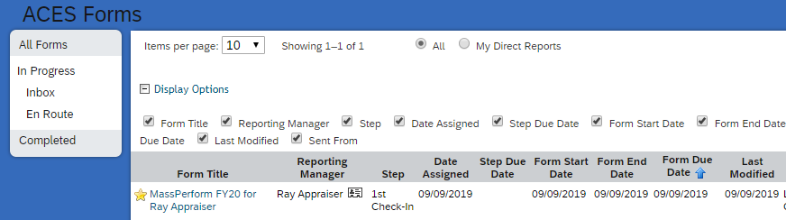
- Confirm that your form is at 1st Check-In. The bread-crumb number will indicate your current step.
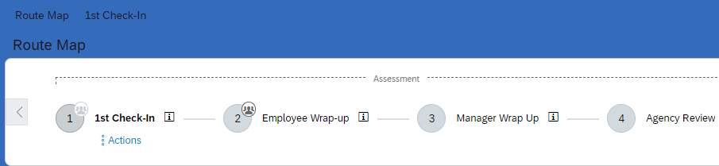
- Answer the 3 questions.
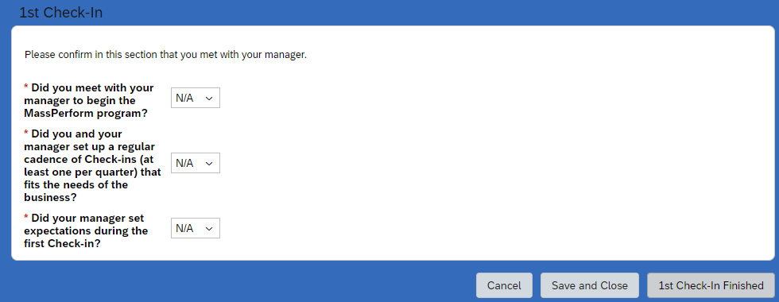
- Select “1st Check-In finished.”
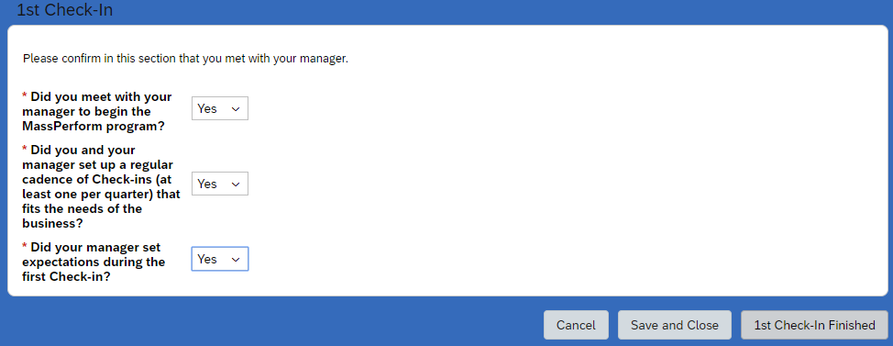
Did you and your manage set
- Select “1st Check-In finished” a second time.
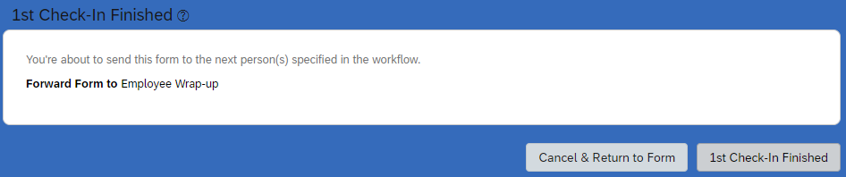
STOP!!
For now, you are finished with MassPerform. Your next action in the system will take place next June when the Wrap UP stage begins. The Wrap-Up stage includes employee’s entering comments about his or her performance; the Manager adding comments and an overall rating. Between now and next June, you will meet informally with you manager to discuss performance in your quarterly check-ins.

