Introduction/Background

INDOOR AIR QUALITY ASSESSMENT

Advanced Math and Science Academy Charter School
165, 199, and 201 Forest Street
Marlborough, MA

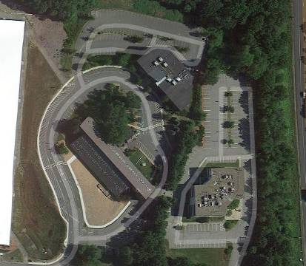

Prepared by:
Massachusetts Department of Public Health
Bureau of Environmental Health
Indoor Air Quality Program
December 2013

In response to a request from Robert Landry, Marlborough Board of Health, the Massachusetts Department of Public Health (MDPH), Bureau of Environmental Health (BEH) provided assistance and consultation regarding indoor air quality (IAQ) at the Advanced Math and Science Academy Charter School (AMSA) located at 165, 199, and 201 Forest Street, Marlborough, Massachusetts. The visit was prompted by ongoing concerns about mold and general IAQ in the building. On September 13, 2013, Michael Feeney, Director of BEH’s IAQ Program visited the school with by Sharon Lee, Environmental Analyst/Inspector, and Ruth Alfasso, Environmental Engineer/Inspector in BEH’s IAQ Program. BEH/IAQ staff were accompanied by Mr. Landry, members of the AMSA facilities and legal staff, and employees of RMA Management, the property management company.
The AMSA is located on a campus consisting of three buildings: 165 Forest Street (Building 165), 199 Forest Street (Building 199), and 201 Forest Street (Building 201). Prior to occupancy by the AMSA these buildings were used for office space, although Building 201 was originally constructed for manufacturing. Renovations to the buildings were made when AMSA first moved onto the campus in 2005.
Building 165 is a four-story structure. AMSA currently occupies the second floor. A portion of the bottom floor of the building is occupied by a day care and the top two floors are reportedly vacant. Currently, most classrooms are located along the outside edge of this diamond-shaped structure. The building’s outer envelope appears to consist of an exterior insulation finishing system (EIFS), with the appearance of stucco panels.
Building 199 is a three-story red brick building with a trapezoidal floor plan. The AMSA occupies all three floors of this building.
Building 201 is a three-story building with a large sloped roof. The building may have originally been constructed for manufacturing and was significantly remodeled prior to the school taking occupancy. The sloped roof forms the majority of the exterior wall to classrooms; the roof plane is interrupted by classroom windows (Picture 1). Of all the buildings on campus, only Building 201 has openable windows.

Methods
Air tests for carbon monoxide, carbon dioxide, temperature and relative humidity were conducted with the TSI, Q-Trak, IAQ Monitor, Model 7565. Air tests for airborne particle matter with a diameter less than 2.5 micrometers were taken with the TSI, DUSTTRAK™ Aerosol Monitor Model 8520. BEH/IAQ staff also performed visual inspection of building materials for water damage and/or microbial growth.

Results
The school serves approximately 1,200 students in grades 6-12 and has approximately 100 staff members. The IAQ tests were taken during normal operations. Results appear in Table 1.

Discussion

Ventilation
It can be seen from Table 1 that carbon dioxide levels were elevated above 800 parts per million (ppm) in all eleven areas tested in Building 165, all 37 areas in Building 199, and all but one of the 36 areas in Building 201, indicating inadequate ventilation throughout the school at the time of the visit (Table 1). Some of the carbon dioxide levels were in excess of 2,500 ppm. It is important to note that 23 rooms in Building 201 had a population of 2 or fewer individuals, yet had carbon dioxide measurements over 800 ppm, which is an indication of suboptimal fresh air supply (Table 1). In the experience of BEH/IAQ staff, rooms that are empty/sparsely populated or have windows open can greatly reduce carbon dioxide levels. Carbon dioxide levels would be expected to increase with higher occupancy and windows shut.
The carbon dioxide levels measured in each building are likely due to a lack of adequate fresh air supply and exhaust ventilation. According to a letter from RDK Engineers, the current ventilation systems in “both 199 and 201 Forest Street…do not meet the Indoor Air Quality Standard ventilation rates” (RDK, 2012). RDK lists the Indoor Air Quality Standard ventilation rates as “classrooms…10 CFM/person; 7.5 CFM/person…for cafeterias and 5 CFM/person…for office space” (RDK, 2012), which match the minimum ventilation rates for classrooms, cafeteria, and offices pursuant to the 2009 International Mechanical Code (IMC). The 2009 IMC was incorporated by reference in the 2011 Massachusetts State Building Code (MSBC).
It is important to note that the AMSA was renovated prior to the adoption of the 2009 IMC in Massachusetts. Prior to 2011, building ventilation systems had to meet the minimum ventilation rates set forth in the Building Officials Code Administrators (BOCA), which set the following ventilations rates: classrooms 15 CFM/person; cafeterias 20 CFM/person and offices 20 CFM/person (BOCA, 1993). Based on the carbon dioxide measurements conducted, none of the building supply an adequate amount of fresh air to occupied spaces as delineated under the MSBC that was in force when the building were renovated for use by AMSA.
Buildings 165 and 199 are equipped with similar Heating, Ventilating and Air Conditioning (HVAC) systems. Fresh air is provided by rooftop air-handling units (AHU) and ducted to classrooms via ceiling-mounted supply diffusers (Picture 2). Exhaust air is drawn through ceiling-mounted vents and returned to AHUs via ductwork. In Building 199, many of the exhaust vents were located close to hallway doors, which were often found open. In this configuration, exhaust vents would be likely to draw air from the hallway instead of from the room, limiting the ability to remove stale air (Picture 3).
In both Buildings 165 and 199, thermostats were found to be set to the “automatic” setting, rather than “on”. This means that fresh air is only supplied when the system calls for heating/cooling. When the specified pre-set temperature is reached, fresh air supply is turned off. The MDPH/BEH recommends that thermostats be set to “on” when the school is occupied to ensure continuous provision of fresh air and filtration.
Science labs in room 606 of Building 199 were equipped with chemical fume hoods, which were observed to be closed and deactivated. No record of the last date of calibration or inspection of the hoods was readily apparent. A chemical hood should be recalibrated on an annual basis or as recommended by the manufacturer, to ensure proper function. Sufficient supply of air is needed for the hoods to operate properly.

Building 201
In Building 201, fresh air is supplied through AHUs located in two mechanical rooms; air is ducted to supply vents in each room. The AHUs for Building 201 appear to be undersized for the building size and population, resulting in insufficient fresh air to each area. Lack of fresh air contributes to elevated carbon dioxide levels (Table 1).
The supply of fresh air is further hindered by the current ductwork configuration. Ductwork from one of the AHUs was observed with an approximately 180-degree bend after leaving the AHU, which will reduce the ability for air to flow through the ducts (Picture 4). Gaps/holes were also noted in AHU walls (Picture 5), which allows the draw of air and other pollutants present in the mechanical space into the AHU, which would then be distributed to occupied areas of the building.
Elevated carbon dioxide levels in building 201 can also be attributed a lack of mechanical exhaust ventilation. Each room appears to have a passive vent located in an interior wall (Picture 6). Air intakes for the AHU are located in hallways (Picture 7). This type of system is called a transfer air vent. A transfer air vent allows air to move between two interior locations of a building. “[A]ir transferred from occupied space shall be permitted to serve as make up air for required exhaust systems in such spaces as kitchens, baths, toilet rooms, elevators and smoking lounges” (BOCA, 1993; emphasis added). The 2009 IMC also has similar language, stating “air transferred from occupiable spaces is not prohibited from serving as makeup air for required exhaust systems in such spaces and kitchens, baths, toilet rooms, elevators and smoking lounges (IMC, 2009). It is assumed that Building 201 was required to comply with the Massachusetts Building Code prior to occupancy by the AMSA. If this were the case, the use of a transfer air vent as an exhaust vent for classrooms and offices would not be permitted.
Transfer air vents for use as part of a general ventilation system have been prohibited since it is a breech in wall integrity, which would allow fire to rapidly move through a building. It is for this reason that the use of transoms in ventilation design has been abandoned.
Without adequate exhaust ventilation, normally occurring environmental pollutants can build up. For example, as described later in this report, the likely source of increased relative humidity measurements in Building 201 is from the respiration of building occupants. Adequate exhaust ventilation would remove environmental pollutants, reduce relative humidity and increase the comfort of building occupants.
Supplemental cooling on the top floor of Building 201 is supplied by window-mounted air conditioners. Additional heating, cooling, and filtration is provided by fan coil units (FCUs) located along walls between windows in each room (Picture 8). These FCUs draw air from the room, heat or cool it using fluid-filled heating/cooling coils, then filter and discharge it back into the room (Figure 1). No fresh air is supplied by FCUs.
Because of the location of the FCUs and the slope of the wall/roof where they are mounted, the flow of air from the FCUs is directed at the wooden roof/wall. In the cooling season, this results in chilling of the surface of the wood, which is likely to bring it below the dew point and result in condensation; this is described in more detail in the Microbial/Moisture Concerns section of this report. In the heating season, a flow of warm, dry air is directed at the wood, which can lead to cracking and aging of the material, leading to premature deterioration. In addition, since the flow of air is blocked by the slanted roof/wall, this prevents circulation of air in the room.

General HVAC System Issues Common to All Campus Buildings
To maximize air exchange, the MDPH recommends that both supply and exhaust ventilation operate continuously during periods of occupancy. In order to have proper ventilation with a mechanical supply and exhaust system, the systems must be balanced to provide an adequate amount of fresh air to the interior of a room while removing stale air from the room. It is recommended that heating, ventilating and air-conditioning (HVAC) systems be re-balanced every five years to ensure adequate air systems function (SMACNA, 1994). The date of the last balancing/commissioning of these systems was not known at the time of the visit.
Minimum design ventilation rates are mandated by the Massachusetts State Building Code (MSBC). Until 2011, the minimum ventilation rate in Massachusetts was higher for both occupied office spaces and general classrooms, with similar requirements for other occupied spaces (BOCA, 1993). The current version of the MSBC, promulgated in 2011 by the State Board of Building Regulations and Standards (SBBRS), adopted the 2009 International Mechanical Code (IMC) to set minimum ventilation rates. Please note that the MSBC is a minimum standard that is not health-based. At lower rates of cubic feet per minute (cfm) per occupant of fresh air, carbon dioxide levels would be expected to rise significantly. A ventilation rate of 20 cfm per occupant of fresh air provides optimal air exchange resulting in carbon dioxide levels at or below 800 ppm in the indoor environment in each area measured. MDPH recommends that carbon dioxide levels be maintained at 800 ppm or below. This is because most environmental and occupational health scientists involved with research on IAQ and health effects have documented significant increases in indoor air quality complaints and/or health effects when carbon dioxide levels rise above the MDPH guidelines of 800 ppm for schools, office buildings and other occupied spaces (Sundell et al., 2011). The ventilation must be on at all times that the room is occupied. Providing adequate fresh air ventilation with open windows and maintaining the temperature in the comfort range during the cold weather season is impractical. Mechanical ventilation is usually required to provide adequate fresh air ventilation.
Carbon dioxide is not a problem in and of itself. It is used as an indicator of the adequacy of the fresh air ventilation. As carbon dioxide levels rise, it indicates that the ventilating system is malfunctioning or the design occupancy of the room is being exceeded. When this happens, a buildup of common indoor air pollutants can occur, leading to discomfort or health complaints. The Occupational Safety and Health Administration (OSHA) standard for carbon dioxide is 5,000 parts per million parts of air (ppm). Workers may be exposed to this level for 40 hours/week, based on a time-weighted average (OSHA, 1997).
The MDPH uses a guideline of 800 ppm for publicly occupied buildings. A guideline of 600 ppm or less is preferred in schools due to the fact that the majority of occupants are young and considered to be a more sensitive population in the evaluation of environmental health status. Inadequate ventilation and/or elevated temperatures are major causes of complaints such as respiratory, eye, nose and throat irritation, lethargy and headaches. For more information concerning carbon dioxide, consult Appendix A.
Temperature measurements in Building 165 ranged from 72°F to 76°F; in Building 199 from 70°F to 75°F; and in Building 201 from 68°F to 76°F. All but two of the readings were within the MDPH recommended comfort guidelines at the time of assessment (Table 1). The MDPH recommends that indoor air temperatures be maintained in a range of 70°F to 78°F in order to provide for the comfort of building occupants. In many cases concerning indoor air quality, fluctuations of temperature in occupied spaces are typically experienced, even in a building with an adequate fresh air supply.
Relative humidity measurements in Building 165 ranged from 43 to 55 percent; in Building 199 from 44 to 61 percent; and in Building 201 from 54 to 71 percent (Table 1). While all of the readings in Buildings 165 and 199 were within or very close to the MDPH comfort range, most of the readings in Building 201 were above the MDPH recommended comfort range. The MDPH recommends a comfort range of 40 to 60 percent for indoor air relative humidity.
Note that at the time of assessment, the relative humidity outdoors was measured at 64 percent; outdoor relative humidity levels can influence relative humidity indoors. It is important to note that the HVAC system for Building 201 was operating in its chill mode, which would reduce relative humidity as water vapor condenses on cooling coils. Typically, relative humidity would be significantly reduced in a manner similar to what was measured in the other AMSA buildings. In the case of Building 201, relative humidity measurements in 15 areas were greater than or equal to outdoors (64 percent), and relative humidity levels in 27 areas were greater than the highest relative humidity measured in other campus buildings. Humidity measurements above background can indicate that the ventilation system is not operating effectively to remove occupant-generated moisture from the building. Moisture removal is important since higher humidity at a given temperature reduces the ability of the body to cool itself by perspiration; “heat index” is a measurement that takes into account the impact of a combination of heat and humidity on how hot it feels. At a given indoor temperature, the addition of humid air increases occupant discomfort and may generate heat complaints. If moisture levels are decreased, the comfort of the individuals increases. In addition, as discussed in the Microbial/Moisture Concerns section of this report, relative humidity in excess of 70 percent for extended periods of time can provide an environment for mold and fungal growth (ASHRAE, 1989).
Relative humidity levels in the building would be expected to drop during the winter months due to heating. The sensation of dryness and irritation is common in a low relative humidity environment.

Microbial/Moisture Concerns

Building 165
As mentioned previously, building 165 has an outer envelope constructed of EIFS panels. Damage to the panels could be seen at the lower edge (Picture 9), and the panels appear to be warped/buckled along the upper portion of the building (Picture 10). This type of damage is an indication of moisture penetration and weather damage. Seams between panels did not appear to be tight in some areas, despite reported recent attempts to reseal them. These observations suggest that the outer envelope of the building is not able to keep water out. Water-damaged paint was observed on the interior walls of room 805 (Picture 11). Moisture sampling indicated that some areas of gypsum wallboard (GW) were moist at the time of assessment. The external envelope of the building needs to be rendered watertight, including repairs to the EIFS panels and sealing between them.
Building 165 has two small lower roof segments (Picture 12), both of which had water pooling on them. Water pooling can damage the roof and infiltrate the building. Drains on these roof segments appear to be above the level of the roof itself. Drains should be reconfigured to allow removal of water. Standing water can also be a breeding ground for mosquitoes.

Building 199
Water-damaged GW was noted in Classroom 420 (Picture 13). At the time of assessment, the GW was moist. BEH/IAQ staff observed conditions on the building’s exterior, and noted that there was a crack in the cement apron where water was likely penetrating the classroom (Picture 14). The cement closest to the exterior of the building had settled to a lower grade than that cement to its foreground Since the cement portions are at different grades, water can pool against the building and penetrate the classroom. Sealing and repaving this area to direct water away from the building will help to prevent future water penetration.

Building 201
Building 201 has unusual construction and building component details that make it particularly prone to water damage and mold growth. The roof of the building is deeply sloped and reaches from the peak down to the first story of the building (Picture 1). Many classrooms have walls that follow the slope of the roof (Figure 2). In the experience of BEH/IAQ staff, FCUs are usually installed so that airflow from the diffuser does not directly impinge upon building components. In Building 201, the FCUs in most classrooms are located against the exterior wall/roof, with a section of the wood clad roof directly above the air diffuser (Picture 8). This is a poor design for the following reasons:
During the heating season, the slope directs the heated air into the peak of the ceiling of each room. With no ducted exhaust system, there is no mechanical means to draw the heated air downwards to warm occupants.
During the cooling season, the chilled air from each FCU cools the wood cladding and subjects it to moistening from water vapor created by the operation of cooling coils propelled by the unit’s fan.
Due to the location of FCUs (e.g., beneath sloped, wood-clad, wall/roof), the operation of the FCUs appears to generate condensation, which can be a significant source of water damage and mold growth. In times of elevated relative humidity in the building, such as the day of assessment, there is the potential for wood to be chilled below the dew point. Note that the dew point is determined by air temperature and relative humidity that indicates the temperature at which the water in the air will begin to condense. For example, at a temperature of 73º F and relative humidity of 57 percent indoors, the dew point for water to collect on a surface is approximately 57º F (IICRC, 2000). Therefore, any surface that has a temperature below the dew point would be prone to condensation generation under those temperature and relative humidity conditions. Warping, discoloration, and other similar signs of water damage noted on wood paneling above FCUs is an indication of repeated exposure to moisture (Picture 8). Some wood panels had staining that appeared consistent with mold colonization.
In some classrooms, the metal grates on some FCUs were observed to be wet with condensation (Picture 15; Table 1). Some classroom materials stored near or on top of air diffusers were found to be wet from the operation of FCUs. In the experience of BEH/IAQ staff, these conditions may result from operating FCUs with coolant at too low a temperature or excessive fan speed. The water vapor load in the building was likely increased by the lack of adequate exhaust ventilation in occupied areas. Alteration of airflow as well as the operation of FCUs needs to be changed in order to prevent the recurrence of condensation and water damage to woodwork.
Also of note is the configuration of window system, which is a design that would be more appropriate in a dry, arid climate. Windows are installed directly into the roof (Picture 1). Typically in New England, windows installed in a roof are usually in a dormer configuration (Figure 3). A dormer consists of a small peaked roof that directs water around the window. In the case of Building 201, windows are installed as raised skylights that are parallel to the roof line and perpendicular to the flow of rainwater off the roof. BEH/IAQ staff could not determine whether the skylights had integral flashing to reduce/prevent water penetration. The current window configuration creates a dam effect; where water can accumulate along the upper side of the window. Water leaks can occur, particularly if the skylight does not have integral flashing. In addition, each window would also likely be prone to forming an ice dam. The interior wood around skylights showed signs of water staining, but no deterioration or mold colonization was observed.
Lastly, water infiltration and damage was also observed in the hallway near an exterior door (Pictures 16 and 17). AMSA staff reported that water had penetrated the building in the days prior to the MDPH assessment. BEH/IAQ staff observed wood mulch debris in the hallways, indicating that water had penetrated into the hallway. Wood mulch could be observed on the exterior grounds of this area. During heavy rain, wood mulch likely clogs exterior drainage, allowing water to enter the building. Flooding is likely further exacerbated by the grade outside this area of the building. Due to repeated water issues in the area, the ground directly exterior to the building has become depressed and the overall grade is pitched towards the building. The trench drain (Picture 18) is also likely undersized. Consideration should be given to regrading this area, and using a stone material instead of mulch for ground cover.

Other Moisture-related Conditions
The exterior of each building was examined for possible sources of water infiltration and related conditions. Plants, trees and shrubbery were observed in close proximity to the buildings, particularly Building 201 (Picture 19 and 20). The heavy foliage can hold moisture against the side of the building, leading to deterioration of the brick façade. In some places, plants were rooted to the bricks themselves (Picture 21), which can damage the material. The growth of roots against exterior walls can bring moisture in contact with the foundation. Plant roots can eventually penetrate the exterior, leading to cracks and/or fissures. Over time, this process can undermine the integrity of the building envelope, providing a means of water entry into the building via capillary action through foundation concrete and masonry (Lstiburek & Brennan, 2001).
Water-damaged ceiling tiles were observed in some classrooms in Buildings 199 and 201 (Table 1; Picture 22), indicating water leaks from the building envelope or plumbing. Water-damaged ceiling tiles can be a source of mold and should be replaced once a water leak has been repaired.
Some classrooms had sinks, and BEH/IAQ staff observed that a few of the backsplashes were open or not fully sealed (Table 1). If not watertight, water can penetrate through the seam, causing water damage. Water-damaged wood was observed in one sink cabinet from a historic plumbing leak or condensation from cold-water piping. Several classroom sinks were also found to have porous materials (e.g., cardboard, paper, cloth; Picture 23) stored beneath them where the materials can be subject to water exposure.
Plants and terrariums were noted in several classrooms (Table 1; Picture 24). In some cases, plants were observed near ventilation sources. Plants, soil and drip pans can serve as sources of mold growth. Plants should be properly maintained, over-watering of plants should be avoided and drip pans should be inspected periodically for mold growth. Plants should also be located away from ventilation sources to prevent aerosolization of dirt, pollen or mold. Aquariums and animal cages were also observed in several classrooms (Table 1; Pictures 25 and 26). Aquariums and animal cages can be a source of moisture or spills and, if not cleaned regularly, can emit unpleasant odors.
Refrigerators and water dispensing equipment were observed on carpeting (Picture 27). These appliances can leak or spill, which can moisten carpet. It is recommended that these items be located on a non-porous surface.
The US Environmental Protection Agency (US EPA) and the American Conference of Governmental Industrial Hygienists (ACGIH) recommends that porous materials be dried with fans and heating within 24 to 48 hours of becoming wet (US EPA, 2001; ACGIH, 1989). If porous materials (e.g., wood) are not dried within this time frame, mold growth may occur. Cleaning cannot adequately remove mold growth from water-damaged porous materials. The application of a mildewcide to mold-contaminated porous materials is not recommended.

Other IAQ Evaluations
Indoor air quality can be negatively influenced by the presence of respiratory irritants, such as products of combustion. The process of combustion produces a number of pollutants. Common combustion emissions include carbon monoxide, carbon dioxide, water vapor and smoke (fine airborne particle material). Of these materials, exposure to carbon monoxide and particulate matter with a diameter of 2.5 micrometers (μm) or less (PM2.5) can produce immediate, acute health effects upon exposure. To determine whether combustion products were present in the indoor environment, BEH/IAQ staff obtained measurements for carbon monoxide and PM2.5.

Carbon Monoxide
Carbon monoxide is a by-product of incomplete combustion of organic matter (e.g., gasoline, wood and tobacco). Exposure to carbon monoxide can produce immediate and acute health affects. Several air quality standards have been established to address carbon monoxide and prevent symptoms from exposure to these substances. The MDPH established a corrective action level concerning carbon monoxide in ice skating rinks that use fossil-fueled ice resurfacing equipment. If an operator of an indoor ice rink measures a carbon monoxide level over 30 ppm, taken 20 minutes after resurfacing within a rink, that operator must take actions to reduce carbon monoxide levels (MDPH, 1997).
The American Society of Heating Refrigeration and Air-Conditioning Engineers (ASHRAE) has adopted the National Ambient Air Quality Standards (NAAQS) as one set of criteria for assessing indoor air quality and monitoring of fresh air introduced by HVAC systems (ASHRAE, 1989). The NAAQS are standards established by the US EPA to protect the public health from six criteria pollutants, including carbon monoxide and particulate matter (US EPA, 2006). As recommended by ASHRAE, pollutant levels of fresh air introduced to a building should not exceed the NAAQS levels (ASHRAE, 1989). The NAAQS were adopted by reference in the Building Officials & Code Administrators (BOCA) National Mechanical Code of 1993 (BOCA, 1993), which is now an HVAC standard included in the MSBC (SBBRS, 2011). According to the NAAQS, carbon monoxide levels in outdoor air should not exceed 9 ppm in an eight-hour average (US EPA, 2006).
Carbon monoxide should not be present in a typical, indoor environment. If it is present, indoor carbon monoxide levels should be less than or equal to outdoor levels. Outdoor carbon monoxide concentrations were non-detect (ND) at the time of assessment (Table 1). No measureable levels of carbon monoxide were detected inside the building during the assessment (Table 1).

Particulate Matter
The US EPA has established NAAQS limits for exposure to particulate matter. Particulate matter is airborne solids that can be irritating to the eyes, nose and throat. The NAAQS originally established exposure limits to particulate matter with a diameter of 10 μm or less (PM10). According to the NAAQS, PM10 levels should not exceed 150 micrograms per cubic meter (μg/m3) in a 24-hour average (US EPA, 2006). These standards were adopted by both ASHRAE and BOCA. Since the issuance of the ASHRAE standard and BOCA Code, US EPA established a more protective standard for fine airborne particles. This more stringent PM2.5 standard requires outdoor air particle levels be maintained below 35 μg/m3 over a 24-hour average (US EPA, 2006). Although both the ASHRAE standard and BOCA Code adopted the PM10 standard for evaluating air quality, MDPH uses the more protective PM2.5 standard for evaluating airborne particulate matter concentrations in the indoor environment.
Outdoor PM2.5 concentrations the day of assessment were measured at 12 μg/m3. PM2.5 levels measured inside Building 165 ranged from 6 to 20 μg/m3; inside Building 199 from 8 to 17 μg/m3 and inside Building 201 from 5 to 23 μg/m3 (Table 1). All indoor and outdoor PM 2.5 levels were below the NAAQS PM2.5 level of 35 μg/m3. Frequently, indoor air levels of particulates (including PM2.5) can be at higher levels than those measured outdoors. A number of activities that occur indoors and/or mechanical devices can generate particulate during normal operations. Sources of indoor airborne particulates may include but are not limited to particles generated during the operation of fan belts in the HVAC system, use of stoves and/or microwave ovens in kitchen areas; use of photocopiers, fax machines and computer printing devices; operation of an ordinary vacuum cleaner and heavy foot traffic indoors.

Volatile Organic Compounds
Indoor air concentrations can be greatly impacted by the use of products containing volatile organic compounds (VOCs). VOCs are carbon-containing substances that have the ability to evaporate at room temperature. Frequently, exposure to low levels of total VOCs (TVOCs) may produce eye, nose, throat and/or respiratory irritation in some sensitive individuals. For example, chemicals evaporating from a paint can stored at room temperature would most likely contain VOCs. In an effort to identify materials that can potentially increase indoor VOC concentrations, BEH/IAQ staff examined rooms for products containing these respiratory irritants.
Cleaning products were found in a number of rooms throughout the buildings (Table 1). Cleaning products contain chemicals that can be irritating to the eyes, nose and throat of sensitive individuals. These products should be properly labeled and stored in an area inaccessible to children. In addition, Material Safety Data Sheets (MSDS) should be available at a central location for each product in the event of an emergency. Consideration should be given to providing teaching staff with school issued cleaning products and supplies to prevent any potential for adverse chemical interactions between residues left from cleaners used by the facilities staff and those left by cleaners brought in by others.
Hand sanitizer was also observed in several areas (Table 1). Hand sanitizing products may contain ethyl alcohol and/or isopropyl alcohol, which are highly volatile and may be irritating to the eyes and nose, and may also contain fragrances to which some people may be sensitive.
There are several rooms in the building containing photocopiers. Photocopiers can be sources of pollutants such as VOCs, ozone, heat and odors, particularly if the equipment is older and in frequent use. Both VOCs and ozone are respiratory irritants (Schmidt Etkin, 1992). Photocopiers should be kept in well ventilated rooms, and should be located near windows or exhaust vents.
Several classrooms contained a large number of computers and other electronic equipment. Computers and electronics contain plastics, resins and metal components which may give off fumes and odors, particularly when they are new or when they are heated (Maddalena, et al, 2011). If rooms are not designed with sufficient supply and exhaust for the equipment present, these pollutants can build up and cause irritation.
Many classrooms contained dry erase boards and related materials. Materials such as dry erase markers and dry erase board cleaners may contain VOCs, such as methyl isobutyl ketone, n-butyl acetate and butyl-cellusolve (Sanford, 1999), which can be irritating to the eyes, nose and throat.
A variety of chemicals are used and stored in the chemistry areas. A flammables cabinet in this area was opened; items stored inside appeared to be in good order. Other chemical storage areas appeared to be organized with items clean and well-labeled. However, chemicals were observed to be stored inside closed fume hoods, which is not recommended practice, as chemicals should be kept in proper cabinets when not in use. Appendix B contains additional information regarding school chemical laboratory safety (“Guidance Concerning Proper Use and Storage of Chemicals in Schools to Protect Public Health”).

Other Conditions
Other conditions that can affect indoor air quality were observed during the assessment. Upholstered furniture and area carpets were observed in some rooms (Table 1). Upholstered furniture is covered with fabrics that are exposed to human skin. This type of contact can leave oils, perspiration, hair and skin cells. Dust mites feed upon human skin cells and excrete waste products that contain allergens. In addition, if relative humidity levels increase above 60 percent, dust mites tend to proliferate (US EPA, 1992). In order to remove dust mites and other pollutants, frequent vacuuming of upholstered furniture is recommended (Berry, 1994). It is also recommended that upholstered furniture in schools be professionally cleaned on an annual basis. Where an excessively dusty environment exists due to outdoor conditions or indoor activities (e.g., renovations), cleaning frequency should be increased (every six months) (IICRC, 2000).
In two classrooms in Building 199, occupants reported seeing insects (likely wasps) in the classroom, and BEH/IAQ staff observed one in a classroom. One potential route of entry for wasps was noted on the outside of the building, where a pipe for the sprinkler system exited through the brick (Picture 28). It appears that there may be gaps between the pipe and the wall, which may allow insects to enter the ceiling plenum above classrooms in this area. Sealing of this and any similar space is recommended to prevent continued pest entry. A wasp nest was also observed in the eaves of Building 201. A professional exterminator may be needed to address ongoing pest issues.
A buildup of chalk dust was observed in one classroom (Picture 29). Chalk dust may be aerosolized and become a respiratory irritant. Trays should be cleaned regularly to prevent irritation.
In some classrooms and offices, items were observed on windowsills, tabletops, counters, bookcases, and desks (Table 1). The large number of items stored in classrooms provides a source for dusts to accumulate. These items make it difficult for custodial staff to clean. Items should be reduced, relocated, and/or cleaned periodically to avoid excessive dust build up. Dust can also accumulate on flat surfaces (e.g., desktops, shelving and carpets) in occupied areas and subsequently be re-aerosolized causing further irritation. Items were also observed hanging from ceiling tiles. The movement or damage to ceiling tiles can release accumulated dirt, dust and particulates that accumulate in the ceiling plenum into occupied areas.
A number of classroom ceiling and FCU vents had accumulated dust/debris. If vents are not operating, backdrafting may occur, resulting in re-aerosolization of accumulated dust particles. Personal fans in some rooms were also found to be dusty. Vents and fans should be cleaned periodically to prevent dust/debris accumulation on louvers and fan blades.
Many classrooms and other areas in the AMSA are carpeted. The Institute of Inspection, Cleaning and Restoration Certification (IICRC), recommends that carpeting be cleaned annually (or semi-annually in soiled high traffic areas) (IICRC, 2005).

Recommendations
Based on findings during the assessment, the BEH/IAQ Program recommends a two-phase approach to improving indoor environmental conditions at the AMSA. The first consists of short-term measures to improve air quality and the second consists of long-term measures that will require planning and resources to adequately address overall IAQ/building concerns.

Short term Recommendations

Building 201
- Remove wood above FCUs in a manner consistent with the guidelines in “Mold Remediation in Schools and Commercial Buildings” published by the US Environmental Protection Agency (US EPA, 2001). This document can be downloaded from the US EPA website at: http://www.epa.gov/mold/mold_remediation.html.
- Retrofit each FCU with a diffuser system to direct airflow at an angle parallel to the roof slope to minimize moistening of woodwork once the water damaged/mold colonized woodwork is removed. This alteration should also result in better heat distribution during cold weather.
- Modify the coolant temperature of FCUs and/or reduce fan speed to reduce/prevent the generation of condensation on FCU components during summer months. Consider contacting an HVAC engineering firm for further advice/guidance.
- Use openable windows in Building 201 to provide additional fresh air as weather permits. Ensure that windows are sealed at the end of the school day to prevent water infiltration and freezing of pipes during winter months. Windows should not be opened when the HVAC system is in its cooling mode during warm weather months.
- Repair AHUs in Building 201 to remove gaps in casing and close AHU doors in all mechanical rooms.

All School Areas
- Operate, supply and exhaust ventilation and FCUs continuously in all buildings during periods of school occupancy to maximize air exchange. Remove blockages from the fronts/sides of FCUs to allow airflow.
- Consider adopting a balancing schedule for mechanical ventilation systems of every 5 years, as recommended by ventilation industrial standards (SMACNA, 1994).
- Install filters in AHUs properly to prevent air bypass. Consider upgrading to a disposable filter with an increased dust spot efficiency in FCUs. Continue to change filters regularly (e.g., 2-4 times a year).
- Ensure that chemical hoods are calibrated/inspected annually (or as recommended by the manufacturer) and the inspection sticker is visible on the unit.
- Activate chemical hoods whenever experiments are underway. Do not store chemicals or other items inside hoods when not in use.
- For buildings in New England, periods of low relative humidity during the winter are often unavoidable. Therefore, scrupulous cleaning practices should be adopted to minimize common indoor contaminants whose irritant effects can be enhanced when the relative humidity is low. To control dusts, a high efficiency particulate arrestance (HEPA) filter equipped vacuum cleaner in conjunction with wet wiping of all surfaces is recommended. Avoid the use of feather dusters. Drinking water during the day can help ease some symptoms associated with a dry environment (throat and sinus irritations).
- Ensure roof/plumbing leaks are repaired and replace/repair any remaining water-damaged ceiling tiles and building materials. Examine the area above these tiles for mold growth. Disinfect areas of water leaks with an appropriate antimicrobial, as needed. Notify staff prior to ceiling tile replacement to prevent collection of dust on area items.
- Repair sweeps and weather-stripping on exterior doors. Ensure tightness by monitoring for light penetration and drafts around doorframes.
- Examine and repair space around sprinkler pipe as shown in Picture 28. Seal any similar breaches in the building’s exterior to prevent pest entry.
- Monitor the roof membrane and drains for proper operation, particularly after severe weather events, and repair/reconfigure as needed.
- Consider moving refrigerators and water dispensing equipment to areas with tile floors or place them on waterproof mats to avoid moistening of carpeting.
- Avoid storage of porous materials in areas that may be prone to condensation in hot, humid weather, such as lower level floors and ensure that air can flow around non-porous items in these areas to facilitate drying.
- Ensure plants have drip pans. Avoid over watering and examine drip pans periodically for mold growth. Disinfect with an appropriate antimicrobial where necessary.
- Ensure that aquariums and terrariums are maintained to prevent odors.
- Trim back plants, trees, and shrubs at least five feet away from exterior walls/foundation of the building.
- Repair points of water penetration, and replace all water-damaged wall materials. For more information on mold consult Mold Remediation in Schools and Commercial Buildings published by the US EPA (2001). This document is available from the US EPA website: http://www.epa.gov/mold/mold_remediation.html.
- Consider installing a larger trench drain (Picture 18) to improve drainage along exterior of building.
- Seal breaches, seams, and spaces between sink countertops and backsplashes to prevent water damage.
- Clean chalk and dry erase boards and trays, as well as pencil sharpeners regularly to avoid build-up of particulates.
- Relocate or consider reducing the amount of materials stored in classrooms to allow for more thorough cleaning. Clean items regularly with a wet cloth or sponge to prevent excessive dust build-up.
- Store cleaning products properly and out of reach of students. Ensure spray bottles are properly labeled. All cleaning products used at the facility should be approved by the school department/administration with MSDS’ available at a central location.
- Ensure local exhaust is operating in areas with photocopiers and lamination machines; if not feasible consider relocating to areas with local exhaust ventilation or install local exhaust ventilation in areas where this equipment is used to reduce excess heat and odors.
- Refrain from using air fresheners and deodorizers to prevent exposure to VOCs.
- Clean exhaust/return vents, ceiling fans, FCUs and personal fans periodically to prevent excessive dust accumulation.
- Refrain from hanging objects from the ceiling tile system in order to avoid introducing dust/debris from the ceiling plenum into classrooms.
- Use the principles of integrated pest management (IPM) to prevent pest infestation. The IPM Guide can be obtained at the following Internet address: http://www.mass.gov/eea/agencies/agr/pesticides/.
- Clean carpeting annually or semi-annually in soiled high traffic areas as per the recommendations of the Institute of Inspection, Cleaning and Restoration Certification (IICRC). Copies of the IICRC fact sheet can be downloaded at: http://1.cleancareseminars.net/?page_id=185 (IICRC, 2005).
- Consider adopting the US EPA (2000) document, “Tools for Schools”, as an instrument for maintaining a good indoor air quality environment in the building. This document is available at: http://www.epa.gov/iaq/schools/index.html.
- Refer to resource manual and other related indoor air quality documents located on the MDPH’s website for further building-wide evaluations and advice on maintaining public buildings. These documents are available at: http://mass.gov/dph/iaq.

Long-term measures:
- Determine whether transfer air vents used for exhaust ventilation of classrooms in Building 201 are in compliance with current the Massachusetts Building Code as well as state and local fire codes.
- Consider installing ducted exhaust vents or a ceiling plenum return system in Building 201.
- Consider upgrading or replacing HVAC systems in all buildings. In order for the HVAC system to function appropriately, it may be necessary to replace the existing AHUs with those having a sufficient capacity to provide adequate fresh air supply for the current number of building occupants.
- Regrade exterior around Building 201 to direct water away from building. Consider using a stone material instead of mulch for ground cover.

References
ACGIH. 1989. Guidelines for the Assessment of Bioaerosols in the Indoor Environment. American Conference of Governmental Industrial Hygienists, Cincinnati, OH.
ASHRAE. 1989. ASHRAE Standard: Ventilation for Acceptable Indoor Air Quality. Sections 5.11, 5.12. American Society of Heating, Refrigerating and Air-Conditioning Engineers, Inc. Atlanta, GA.
Berry, M.A. 1994. Protecting the Built Environment: Cleaning for Health. Michael A. Berry, Chapel Hill, NC.
BOCA. 1993. The BOCA National Mechanical Code/1993. 8th ed. Building Officials and Code Administrators International, Inc., Country Club Hill, IL.
IICRC. 2000. IICRC S001. Reference Guideline for Professional On-Location Cleaning of Textile Floor Covering Materials. Institute of Inspection, Cleaning and Restoration Certification. Institute of Inspection Cleaning and Restoration, Vancouver, WA.
IICRC. 2005. Carpet Cleaning FAQ 4 Institute of Inspection, Cleaning and Restoration Certification. Institute of Inspection Cleaning and Restoration, Vancouver, WA.
IMC. 2009. 2009 International Mechanical Code. International Code Council Inc., Country Club Hills, IL.
Lstiburek, J. & Brennan, T. 2001. Read This Before You Design, Build or Renovate. Building Science Corporation, Westford, MA. U.S. Department of Housing and Urban Development, Region I, Boston, MA.
Maddalena. 2011. Maddalena, R., T. McKone, H. Destaillats, M. Rusell, A. Hodgson, and C. Perino. Quantifying Pollutant Emissions from Office Equipment: A Concern in Energy‐Efficient Buildings. California Energy Commission, PIER Energy‐Related Environmental Research. CEC-500-2011-046.
MDPH. 1997. Requirements to Maintain Air Quality in Indoor Skating Rinks (State Sanitary Code, Chapter XI). 105 CMR 675.000. Massachusetts Department of Public Health, Boston, MA.
OSHA. 1997. Limits for Air Contaminants. Occupational Safety and Health Administration. Code of Federal Regulations. 29 C.F.R 1910.1000 Table Z-1-A.
RDK. 2012. Letter to Mr. David Gibbs, Bowdich and Dewey, LLP, RE: Advanced Math and Science Academy Existing Ventilation Systems, dated January 4, 2012. RDK Engineering, Andover, MA.
Sanford. 1999. Material Safety Data Sheet (MSDS No: 198-17). Expo® Dry Erase Markers Bullet, Chisel, and Ultra Fine Tip. Sanford Corporation. Bellwood, IL.
SBBRS. 2011. Mechanical Ventilation. State Board of Building Regulations and Standards. Code of Massachusetts Regulations, 8th edition. 780 CMR 1209.0.
Schmidt Etkin, D. 1992. Office Furnishings/Equipment & IAQ Health Impacts, Prevention & Mitigation. Cutter Information Corporation, Indoor Air Quality Update, Arlington, MA.
SMACNA. 1994. HVAC Systems Commissioning Manual. 1st ed. Sheet Metal and Air Conditioning.
Sundell. 2011. Sundell, J., H. Levin, W. W. Nazaroff, W. S. Cain, W. J. Fisk, D. T. Grimsrud, F. Gyntelberg, Y. Li, A. K. Persily, A. C. Pickering, J. M. Samet, J. D. Spengler, S. T. Taylor, and C. J. Weschler. Ventilation rates and health: multidisciplinary review of the scientific literature. Indoor Air, Volume 21: pp 191–204.
US EPA. 1992. Indoor Biological Pollutants. US Environmental Protection Agency, Environmental Criteria and Assessment Office, Office of Health and Environmental Assessment, research Triangle Park, NC. EPA 600/8-91/202. January 1992.
US EPA. 2000. Tools for Schools. Office of Air and Radiation, Office of Radiation and Indoor Air, Indoor Environments Division (6609J). EPA 402-K-95-001, Second Edition. http://www.epa.gov/iaq/schools/tools4s2.html.
US EPA. 2001. “Mold Remediation in Schools and Commercial Buildings”. Office of Air and Radiation, Indoor Environments Division, Washington, DC. EPA 402-K-01-001. March 2001. Available at: http://www.epa.gov/iaq/molds/mold_remediation.html.
US EPA. 2006. National Ambient Air Quality Standards (NAAQS). US Environmental Protection Agency, Office of Air Quality Planning and Standards, Washington, DC. http://www.epa.gov/air/criteria.html.
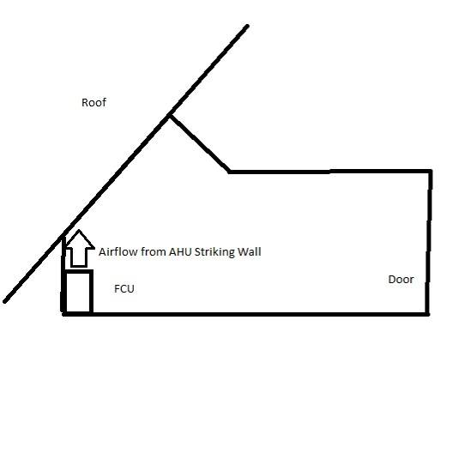
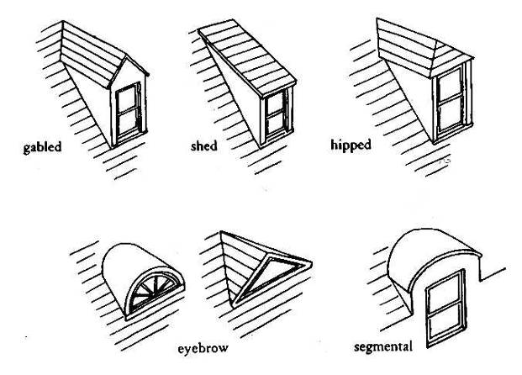
Source: http://tothestuds.wordpress.com/2011/07/04/dormers/

Picture 1
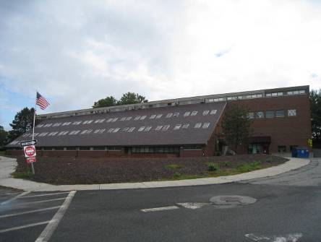
201 Forest Street (Building 201) showing slanted roof with windows
Picture 2
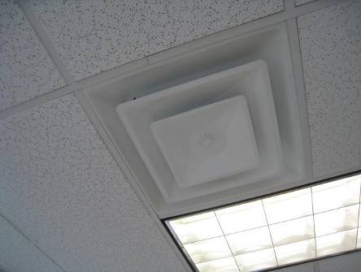
Fresh air supply diffuser in Building 165

Picture 3
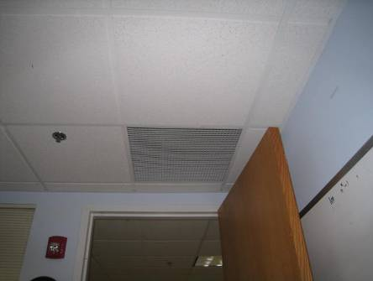
Exhaust vent in Building 199, note proximity to open classroom door
Picture 4
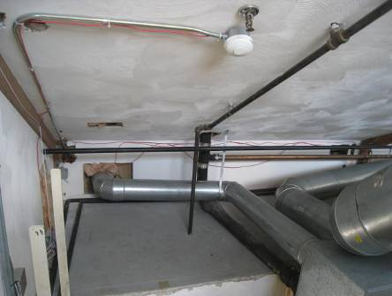
Ductwork in mechanical room showing sharp turns, which restrict airflow

Picture 5
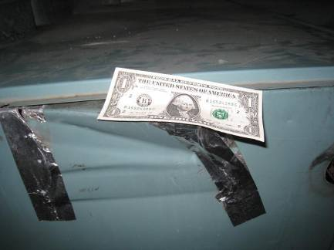
Dollar bill adhering to hole in AHU casing, showing that air from the mechanical room is getting drawn inside
Picture 6
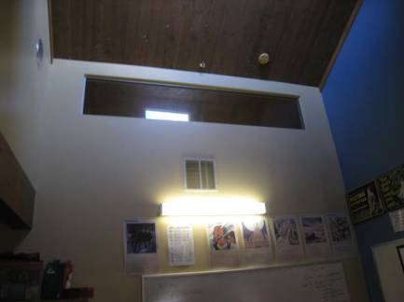
Passive/transfer air vent in wall in Building 201

Picture 7
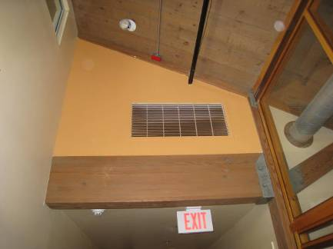
Hallway vent in Building 201
Picture 8
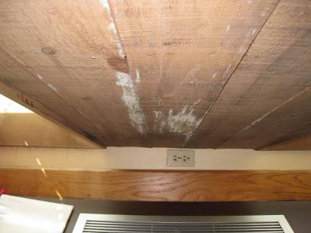
Top of fan coil unit and slanted wooden wall. Note staining, deterioration of wood and location of electrical outlet

Picture 9
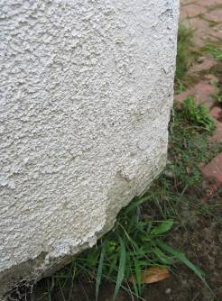
Damaged EIFS siding on building 165
Picture 10
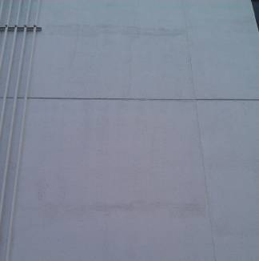
Staining on panels consist with water penetration behind EIFS panels

Picture 11
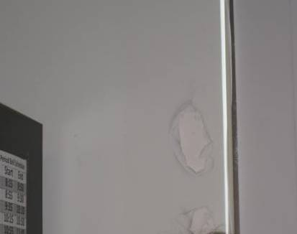
Water-damaged wall in room 805 of Building 165
Picture 12
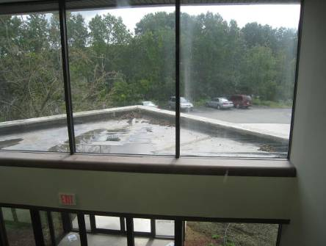
Entryway roof section on Building 165, note water accumulation showing poor drainage

Picture 13
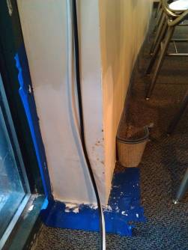
Water-damaged wall in classroom 420 of Building 199
Picture 14
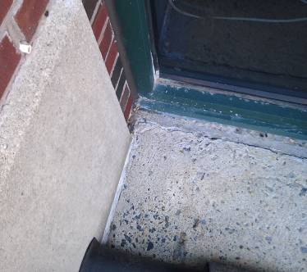
Damaged cement outside classroom 420 of Building 199

Picture 15
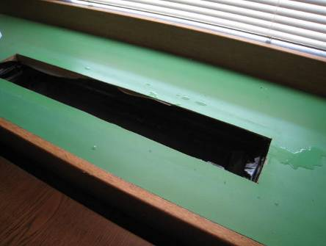
FCU on lower level of Building 201 with metal grate removed; water to the right (arrow) had condensed on metal grate
Picture 16
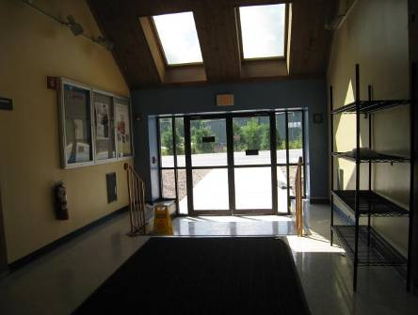
Hallway with repeated water penetration in Building 201
Picture 17
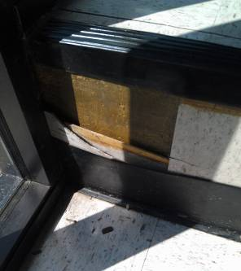
Damaged tiling in hallway of Building 199, note wood mulch debris
Picture 18
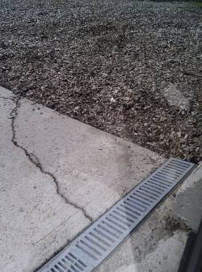
Trench stormwater drain

Picture 19
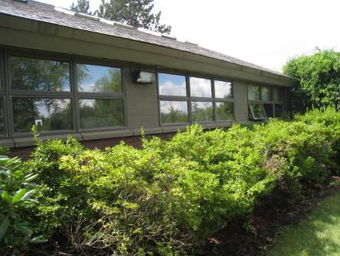
Plants/foliage against building 201
Picture 20
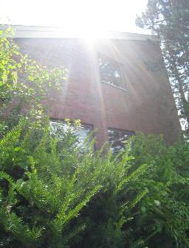
Plants/foliage against building 201
Picture 21
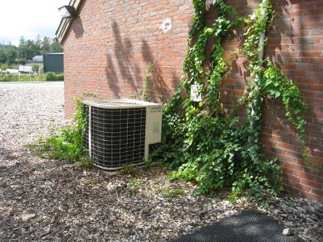
Vines growing up Building 201 façade
Picture 22
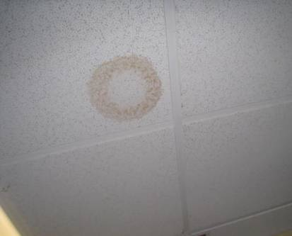
Water-stained ceiling tile
Picture 23
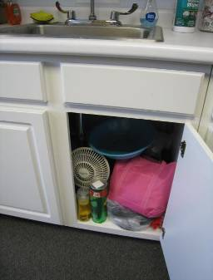
Items, including porous items and cleaning products, stored beneath sink
Picture 24
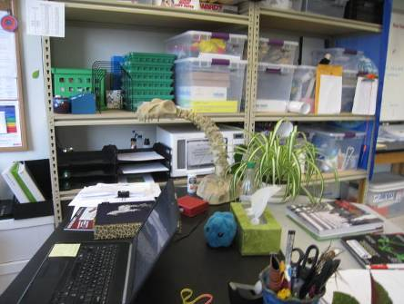
Plant in classroom
Picture 25
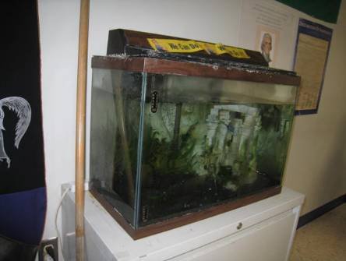
Aquarium in hallway

Picture 26
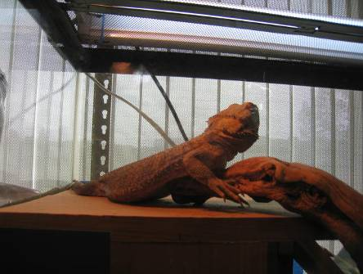
Reptile in cage in classroom
Picture 27
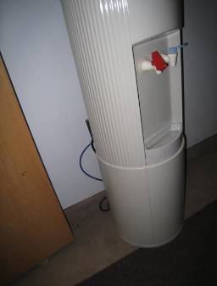
Water dispenser on carpet
Picture 28
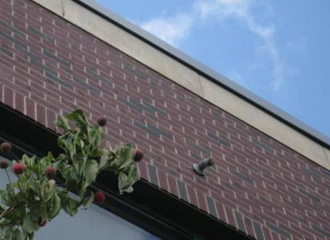
Protruding sprinkler pipe, may have annular space wide enough to admit wasps

Picture 29
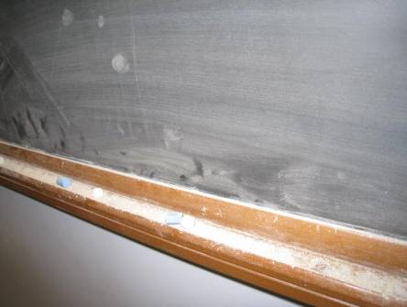
Chalk dust in chalk tray

Location/ Room | Carbon Dioxide  (ppm) | Carbon Monoxide  (ppm) | Temp  (°F) | Relative Humidity (%) | PM2.5  (µg/m³) | Occupants in Room | Windows  Openable | Ventilation |  | Remarks
 |  |  |  |  |  |  |  | Supply | Exhaust
Background | 310 | ND | 74 | 64 | 12 |  |  |  |  | Showery with sun breaks, 10 am
165 Building
Ladies room |  | ND |  |  |  |  | N | Y | Y | Exhaust on and dusty
800 |  | ND | 72 | 48 | 7 | 1 | N | Y | Y
801 | 2400 | ND | 73 | 46 | 6 | 25 | N | Y | Y | DEM, HS
802 | 1897 | ND | 74 | 43 | 10 | 24 | N | Y | Y | DO, DEM, CPs
803 | 2118 | ND | 75 | 48 | 10 | 13 | N | Y | Y | DEM, PF
804 | 2013 | ND | 75 | 45 | 10 | 24 | N | Y | Y | DO, DEM, CPs
805 | 2186 | ND | 74 | 48 | 9 | 20 | N | Y | Y | DEM CPs, WD-wall
806 | 2451 | ND | 75 | 55 | 7 | 17 | N | Y | Y | DEM, NC, plants, coffee maker, fridge
807 | 2644 | ND | 74 | 51 | 6 | 22 | Y | Y | Y | DEM, NC
808 | 2669 | ND | 75 | 54 | 10 | 26 | N | Y | Y | DEM
809 | 2372 | ND | 75 | 55 | 9 | 17 | N | Y | Y | Plants, DEM, items hanging from ceiling
810 (Teacher’s lounge) | 2700 | ND | 76 | 49 | 7 | 6 | N | Y | Y | 2 PCs, fridge, microwave, sink w/items under
818 | 1968 | ND | 73 | 48 | 20 | 12 | N | Y | Y | CPs
199 Building
501 | 1274 | ND | 73 | 46 | 9 | 1 | Y | Y | Y | Carpet, DEM, HS
502 | 1459 | ND | 74 | 53 | 13 | 1 | N | Y | Y | DEM, DO
503 | 1353 | ND | 75 | 52 | 13 | 1 | N | Y | Y | DEM, PF, DO, 50+ computers
504 | 1684 | ND | 75 | 57 | 12 | 25 | N | Y | Y near door | DEM, lots of computers, DO
505 | 1606 | ND | 75 | 56 | 12 | 15 | N | Y | Y near door | DEM, DO, portable heater
506 | 1371 | ND | 74 | 58 | 14 | 25 | N | Y | Y | DO, DEM, CD, HS, CPs
507 | 1371 | ND | 74 | 56 | 11 | 11 | N | Y | Y | Computers, NC, HS, tools. DEM
508 | 1310 | ND | 73 | 59 | 13 | 18 | N | Y | Y | Plants, DEM, DO
509 | 1309 | ND | 73 | 56 | 9 | 1 | N | Y | Y | DEM, NC, DO
510 | 1394 | ND | 73 | 61 | 17 | 0 | N | Y | Y | DO, DEM, fridge, CD
523 ITD | 1228 | ND | 75 | 49 | 12 | 1 | N | Y | Y | DO
5 Girls bathroom |  | ND |  |  |  |  | N | Y | Y | Exhaust dusty
6 Copy room |  | ND |  |  |  |  | N | Y | N | 2 PCs, DO, carpet
Nurse’s office, main | 1338 | ND | 73 | 51 | 11 | 1 | N | Y | Y | HS, fridge, items under sink, CPs
Principal/  Admin. office | 1300 | ND | 75 | 45 | 9 | 0 | N | Y | Y | DEM, DO, wall to wall carpet
601 | 1705 | ND | 70 | 46 | 11 | 12 | N | Y | Y | 2 WD-CT, DEM
602 | 1941 | ND | 71 | 48 | 13 | 20 | N | Y | Y | DEM, relocate teacher’s desk away from supply vent
603 | 1744 | ND | 71 | 49 | 12 | 3 | N | Y | Y | DEM, 6 computers, CPs, stinging insect problem
604 | 1916 | ND | 72 | 49 | 12 | 20 | N | Y | Y | DEM
605 | 1606 | ND | 72 | 44 | 12 | 0 | N | Y | Y | CPs
606 Science | 1613 | ND | 72 | 56 | 8 | 0 | N | Y | Y | Fume hoods (no certification labels seen), flammable cabinet (kept locked, appears in order inside)
607 Science prep | 1706 | ND | 71 | 55 | 9 | 0 | N | Y | Y | Odors, CP under sink, aqua, fridge, autoclave, lab furnace, chemicals
608 | 1675 | ND | 70 | 51 | 9 | 2 | N | Y | Y | CP, lab sinks (used regularly), plants, dead plant, safety shower
609 | 1813 | ND | 71 | 53 | 9 | 15 | N | Y | Y | Terra, NC, DEM, lab sinks (used regularly), plants, safety shower
610 | 1760 | ND | 71 | 51 | 9 | 17 | N | Y | Y | Stinging insect problem, fridge, NC, aqua
611 | 1702 | ND | 73 | 53 | 10 | 0 | N | Y | Y | NC
612 | 1921 | ND | 74 | 55 | 12 | 19 | N | Y | Y | Aqua, terra, DO, DEM, plants, NC
613 | 2029 | ND | 72 | 49 | 12 | 21 | N | Y | Y | Aqua, DEM, plants, DO
School store |  |  |  |  |  | 0 | N | Y | Y | Printed items (shirts) and ink odor
4 Guidance, main | 2141 | ND | 74 | 49 | 9 | 0 | N | Y | Y | Carpet
401 | 2757 | ND | 72 | 52 | 11 | 0 | N | Y | Y | DEM, NC
403 | 2800 | ND | 72 | 55 | 10 | 21 | N | Y | Y | NC, DEM
404 | 1552 | ND | 71 | 53 | 10 | 0 | N | Y | Y | NC, DEM
405 | 1533 | ND | 71 | 55 | 10 | 0 | N | Y | Y | NC, DEM
406 Guidance | 1830 | ND | 73 | 50 | 9 | 2 | N | Y | N
406 | 1699 | ND | 72 | 55 | 11 | 2 | N | Y | Y | Carpet, items
407 | 1730 | ND | 72 | 47 | 9 | 2 | N | Y | N | DO, carpet
419 Cafeteria | 2152 | ND | 75 | 52 | 14 | ~200 | N | Y | Y
420 | 2057 | ND | 72 | 50 | 14 | 0 | N | Y | N | WD-dry wall in corner, CPs DEM
421 | 2277 | ND | 75 | 49 | 12 | 2 | N | Y | N | Water cooler on carpet, PC
201 building
Art setup | 2617 | ND | 76 | 55 | 5 | 0 | N |  |  | WD under sink, backsplash open, NC
Cafeteria | 1091 | ND | 74 | 66 | 21 | ~200 | N | Y | Y
Main office | 1592 | ND | 72 | 62 | 10 | 1 | N | N | N
Music | 2526 | ND | 75 | 54 | 7 | 2 | N | Y | Y | Items, carpeted, dehumidifier drains to outside, door to outside
104 (extended day) | 574 | ND | 70 | 63 | 17 | 0 | Y | Y | Y | Items on vents, condensation on FCU, door to outside, windows do not seal well
106 | 1323 | ND | 75 | 65 | 23 | 22 | Y | Y | Y dusty | Passive vent to hallway (dirty, debris), carpeted, PF, condensation on FCU grill, DEM, door to outside, windows do not seal well
110 | 1460 | ND | 74 |  | 15 | 4 | N | Y | Y
200 | 2210 | ND | 73 | 64 | 11 | 21 | Y | T | Y | 2 FCU, DEM, DO
201 | 930 | ND | 72 | 66 | 8 | 0 | N | T | Y | 2 WD CT
202 | 1068 | ND | 72 | 62 | 11 | 1 | Y | T | Y
203 | 2320 | ND | 74 | 69 | 10 | 24 | N | T | Y | WAC
204 | 950 | ND | 73 | 65 | 11 | 5 | Y | Y | Y
206 | 1380 | ND | 73 | 63 | 11 | 27 | Y | Y | Y
207 | 2394 | ND | 73 | 62 | 11 | 0 | Y | Y  open | Y | WAC, DO, DEM
208 | 1400 | ND | 74 | 60 | 7 | 1 | Y | Y | Y | WD-wood above FCU  WAC
209 | 920 | ND | 76 | 61 | 7 | 1 | Y | Y | Y | 28 computer
211 | 1850 | ND | 75 | 60 | 8 | 1 | Y | Y | Y | 2 WD CT, 27 computers, WAC
213 | 1356 | ND | 70 | 62 | 7 | 5 | Y | Y | Y | WAC 32 computers
251 | 1600 | ND | 73 | 63 | 10 | 0 | Y open | N | N | FCU
252 | 1450 | ND | 73 | 62 | 8 | 0 | Y | N | N | FCU
253 | 1814 | ND | 72 | 63 | 6 | 3 | Y | N | N | FCU
254 | 1605 | ND | 72 | 62 | 5 | 0 | Y | N | N | WAC, FCU
255 | 1608 | ND | 71 | 60 | 6 | 2 | Y | N | N | FCU, air purifier
256 | 1793 | ND | 72 | 62 | 7 | 1 | Y | N | N | FCU, air purifier
257 | 1656 | ND | 71 | 65 | 7 | 2 | Y | N | N | FCU, 1 WD CT
301 | 1549 | ND | 70 | 67 | 5 | 28 | Y | Y | Y | DEM, clutter
302 | 961 | ND | 69 | 71 | 7 | 2 | Y | Y | Y | Odor
303 | 1018 | ND | 68 | 69 | 6 | 1 | Y | Y | Y | DEM
304 | 1843 | ND | 71 | 70 | 7 | 26 | Y | Y | Y | DO
306 | 1766 | ND | 70 | 66 | 8 | 23 | Y | Y | Y | WD wood above FCU, DO
307 | 1348 | ND | 71 | 66 | 8 | 1 | Y | Y | N | DO
308 | 978 | ND | 71 | 62 | 6 | 1 | Y | Y | Y | WD wood above FCU
310 | 1065 | ND | 73 | 64 | 6 | 0 | Y | Y | Y | DEM, DO, book blocking FCU vent
313 | 1470 | ND | 72 | 67 | 10 | 22 | Y | Y | Y | DEM, FCU blocked
317 | 1146 | ND | 71 | 60 | 7 | 0 | Y | Y | Y | DEM
319 | 1457 | ND | 72 | 61 | 8 | 0 | Y | Y | Y | Clutter

CFM means cubic feet per minute of outdoor air.
Integral flashing for a skylight is a manufactured unit that has the window frame and flashing made as one piece without a seam.

