Data Quality Report Generation
To run the data quality report -
- To run the data quality report - Go to Report Writer, select QA/QI folder under “All Reports” and select Data Quality Report.
Report Writer QA/QI Data Quality Report.
- A new Data Quality Report page shows up, fill in details as suggested below.
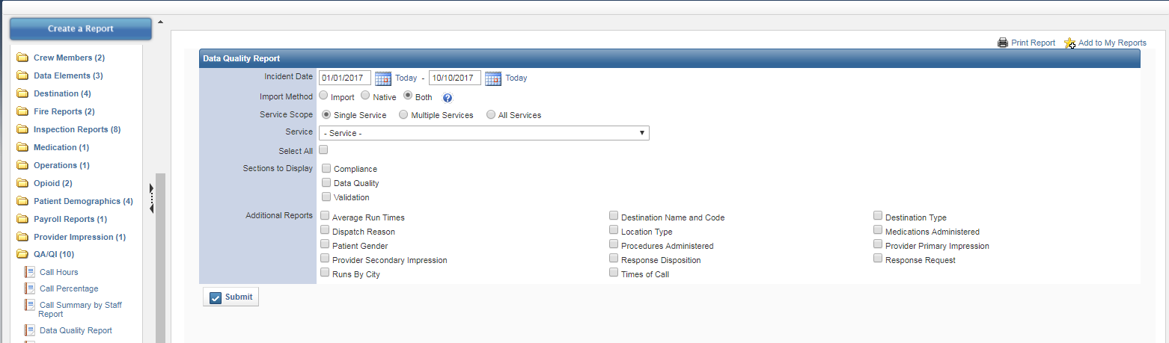
- Incident Date range – The date range for which data quality report needs to run .
- Import Method - Both
- Service scope - select Single Service (may not apply to all ID types, may default)
- Service - Select the service name (may not apply to all ID types, may default)
- Select All – Select this checkbox. All checkboxes below will be automatically checked. Here you can uncheck the boxes if you would like to omit some reports from being displayed in the Data Quality report.
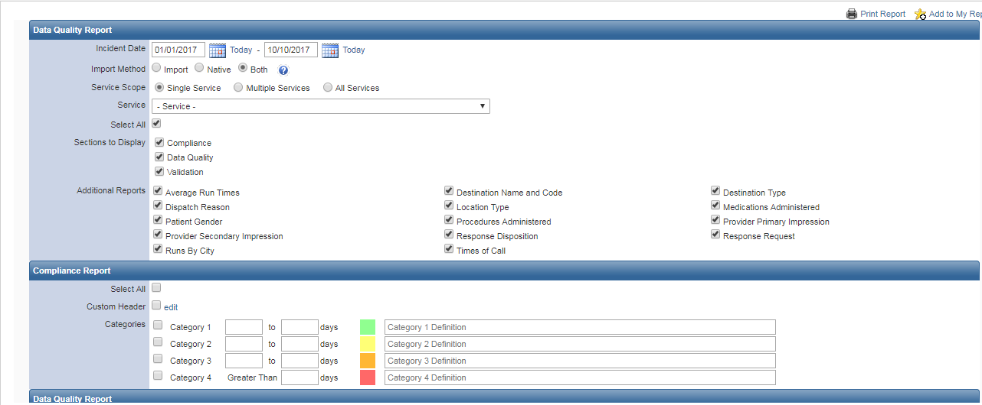

- Fill in the Compliance Report section.

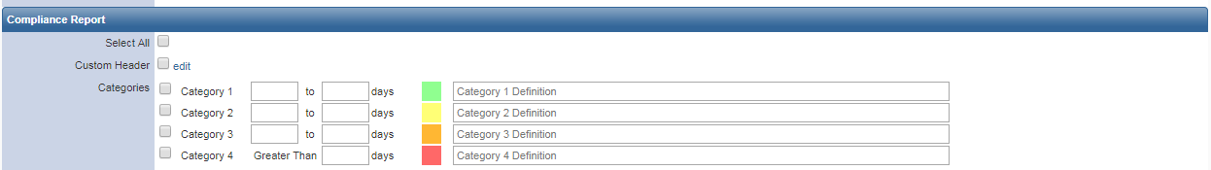

- Check the Select All box and then enter the following:
- Category 1 –> Enter 1, 14 days in the consecutive text boxes and for Definition “Meets Compliance standard”.
- Category 2 –> Enter 14, 30 days in the consecutive text boxes and for Definition “Below Compliance Standard”.
- Category 3 –> uncheck the box
- Category 4 –> Enter 30 days in the text box and for Definition “Delinquent”.
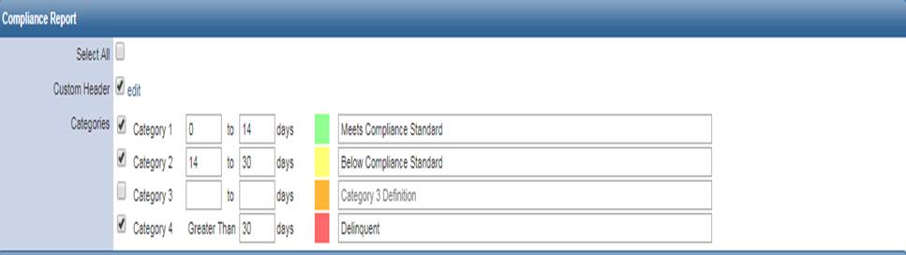
- Fill in the Data Quality Report Section
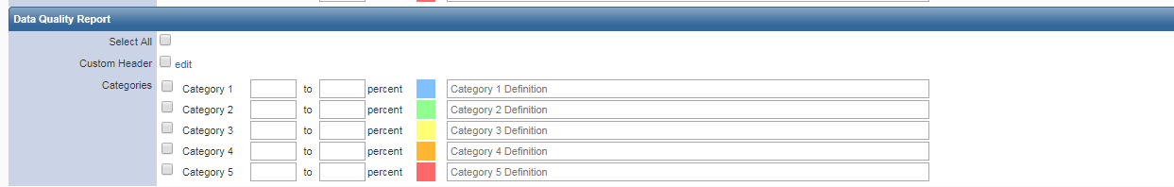
- Check the “Select All” box.
- For Category 1 –> Enter 100 - 100 ; Category 1 Definition - Complete report, no validation errors - Good job!
- For Category 2 –> Enter 80 - 99 ; Category 2 Definition - Almost all critical elements valid
- For Category 3 –> Enter 60 - 79 ; Category 3 Definition - Report missing some critical elements and should be reviewed.
- For Category 4 –> Enter 40 - 59 ; Category 4 Definition - Report is missing too many critical elements to be complete and should be reviewed.
For Category 5 –> Enter 0 - 39 ; Category 5 Definition - Report is incomplete and needs to be reviewed.

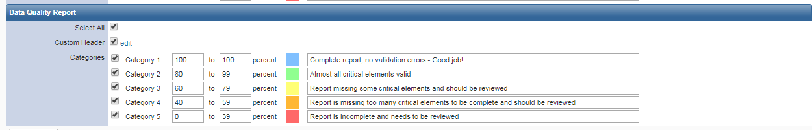

- Click Submit.
- The Data quality report will be displayed.

- To Save the report
- Click Print report on the top right corner.
- Click on “change” button and select “Save as PDF” and then click on Save. ( In Google Chrome). Give an appropriate file name and save it.
- Alternatively the report can be printed directly.

