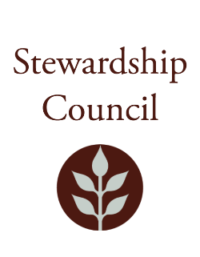

Stewardship Council Meeting
Thursday, May 9, 2024 | 9:00 to 11:00 AM
Blackstone Heritage Corridor Visitor Center at Worcester
3 Paul Clancy Wy, Worcester, MA 01607

Agenda

TOPIC | SEGMENT
Welcome and Chair’s Update – Jack Buckley, Chair | 9:00 – 9:10 AM
DCR Report – Brian Arrigo, Commissioner | 9:10 – 9:25 AM
Regular Business I  - Bicycle and Pedestrian Advisory Board Presentation, Peter Sutton, Pedestrian and Bicycle Coordinator, Mass DOT  - Approve Minutes: April 11, 2024  - Public Comment | 9:25-10:00 AM
Regular Business II  - Committee Updates  - Councilor Comments | 10:00 – 11:00 AM
Adjourn | 11:00 AM

May Meeting of the DCR Stewardship Council Observation Link (Public comments cannot be taken via Zoom)

Join Zoom Meeting
https://zoom.us/j/97294075088?pwd=dElWaXd5U1BQd3RidDZ3K21JL3BZdz09

Meeting ID: 972 9407 5088
Passcode: 029250

One tap mobile
+16469313860,,97294075088#,,,,*029250# US
+19294362866,,97294075088#,,,,*029250# US (New York)

Please contact Matt Perry at matthew.s.perry1@mass.gov for accessibility information.

