INDOOR AIR QUALITY ASSESSMENT

Mass Bay Transit Authority
Engineering Building, Building 2
21 Arlington Avenue
Charlestown, MA

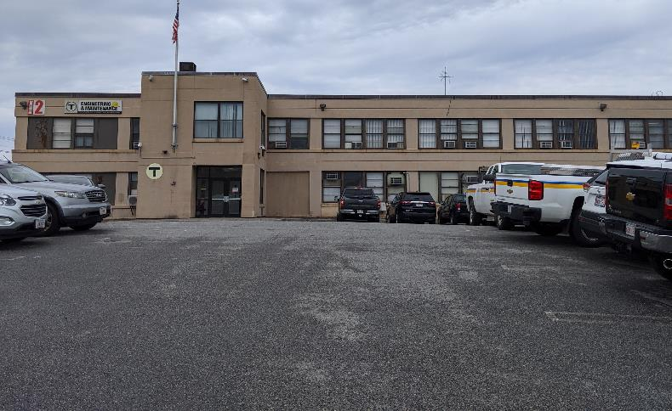

Prepared by:
Massachusetts Department of Public Health
Bureau of Environmental Health
Indoor Air Quality Program
October 2019

Background
Building: | Mass Bay Transit Authority (MBTA) Engineering Building
Address: | 21 Arlington Avenue, Building 2, Charlestown, MA
Assessment Requested by: | Daniel Meinsen  Deputy Director of Occupational Health and Safety, Mass Bay Transit Authority (MBTA)
Reason for Request: | Indoor Air Quality (IAQ) concerns from an occupant.
Date of Assessment: | October 8, 2019
Massachusetts Department of Public Health/Bureau of Environmental Health (MDPH/BEH) Staff Conducting Assessment: | Ruth Alfasso, Environmental Engineer/Inspector IAQ Program
Building Description: | This building is a former warehouse converted to 2 floors of office space. It is attached by an open entry to Building 3, and has a basement which is used for utilities.
Windows: | Openable in most areas

Methods
Please refer to the IAQ Manual for methods, sampling procedures, and interpretation of results (MDPH, 2015).

IAQ Testing Results
The following is a summary of indoor air testing results (Table 1):
- Carbon dioxide levels were below the MDPH guideline of 800 parts per million (ppm) in areas tested on the second floor and in about half the areas tested on the first floor, indicating that more fresh air is needed on the first floor.
- Temperature was within the recommended range of 70°F to 78°F in all occupied areas tested.
- Relative humidity was within the recommended range of 40 to 60% in all occupied areas tested, and above in the basement.
- Carbon monoxide levels were non-detectable (ND) in the areas tested.
- Fine particulate matter (PM2.5) concentrations measured were all below the National Ambient Air Quality (NAAQS) limit of 35 μg/m³.

Ventilation
A heating, ventilating and air conditioning (HVAC) system has several functions. First it provides heating and, if equipped, cooling. Second, it is a source of fresh air. Finally, an HVAC system will dilute and remove normally-occurring indoor environmental pollutants by not only introducing fresh air, but by filtering the airstream and ejecting stale air to the outdoors via exhaust ventilation. Even if an HVAC system is operating as designed, point sources of respiratory irritation may exist and cause symptoms in sensitive individuals.
No direct examination of the HVAC system was able to be made during this visit. Based on observations made, the second floor appears to have fresh air supplied by ceiling-mounted vents (Picture 1) and ceiling-mounted return vents (Picture 2). No vents were noted on the first floor, which likely accounts for the higher carbon dioxide levels measured. This HVAC configuration may be a holdover from previous use as a warehouse. Ducts for fresh air existed at the top of a high open area in its original configuration. The warehouse was subsequently divided into two complete floors with no HVAC system installed on the first floor.
Supplemental heat is provided by steam radiators in areas near the exterior walls. Many areas on both floors had window-mounted air conditioners (WACs, Picture 3) or wall-mounted ductless air conditioners (Picture 4) to provide cooling. Windows in some areas were open to provide fresh air. Also note that WACs can be used in the fan-only mode to introduce fresh air even when cooling is not needed.
The MDPH typically recommends that HVAC systems be re-balanced every five years to ensure adequate air systems function (SMACNA, 1994). It is not known when the last time these systems were balanced or if they are able to be balanced in the current configuration.

Microbial/Moisture Concerns
Occupant concerns that prompted this assessment specifically mentioned mold and moisture. Water-damaged ceiling tiles were observed in many areas on the top floor, likely from roof leaks (Pictures 2, 5 and 6). In some areas, tiles had been removed due to repeated moistening. Ceiling tiles are porous materials that may grow mold if moistened for a sufficiently long period of time. None of the tiles appeared to be mold-colonized, however conditions leading to chronic water damage to building materials should be corrected to prevent microbial growth in the future. Water-damaged ceiling tiles should be removed and replaced when discovered. The ceiling plenum above the suspended ceiling should be examined for signs of water damage/microbial growth and cleaned as needed.
Other water-damaged materials were noted, including water staining under sinks, and deterioration/cracking of wooden panels around WACs (Picture 3). Wall plaster in one office on the first floor was cracked and spalling (Pictures 7 and 8). While plaster, metal, and floor tile are non-porous and resistant to mold growth, the damaged wall creates dust and debris, and chronic water penetration will moisten other nearby areas/items in the room, which are conditions that will worsen as the wall integrity is further compromised. The building envelope exterior in this area should be repaired to prevent water penetration. Until repairs can be done, items/furniture should be moved away from the wall to prevent water damage, and debris should be cleaned regularly.
The hallway on the first floor is of particular note. The ceiling tiles in this area were replaced with open “egg crate” style vents (Pictures 9 and 10), reportedly due to excess humidity from failing steam pipes in the basement below. While these open grids no longer accumulate moisture and are unlikely to grow mold, the ceiling is now exposed to any ongoing moistening from steam. Paint on the ceiling is flaking (Picture 10) and the ceiling grid does not block paint debris from falling into occupied areas. It is possible this paint may contain lead or other regulated materials. There were also stains on walls in the hallway, likely from chronic condensation, (Picture 11) which should be cleaned.
Buildings 2 and 3 have a shared basement. The entry to the basement stairs no longer has a door (Picture 12) which means any odors or dust from below can migrate to occupied areas. The ceiling in the basement had gaps and showed signs of deterioration (Picture 13) which may include mold growth. This also may allow moisture and odors into occupied areas of the building, particularly since floor tiles in some areas were missing.
Building staff reported that the basement was recently cleaned due to impacts from failing steam pipes. However, floors and other surfaces in the basement, including the stairs, had a significant coating of debris from wear to building materials (Picture 12). In addition, the relative humidity in the basement was higher than that elsewhere in the building as well as outside (69%). At 70% relative humidity, moisture from the air alone can moisten building materials and lead to microbial growth (ASHRAE, 1985). A dehumidifier should be used to keep conditions in the basement from deteriorating. In addition, nothing porous or hard to clean should be stored here.
The US Environmental Protection Agency (US EPA) and the American Conference of Governmental Industrial Hygienists (ACGIH) recommends that porous materials (e.g., wallboard, carpeting) be dried with fans and heating within 24 to 48 hours of becoming wet (US EPA, 2008; ACGIH, 1989). If porous materials are not dried within this time frame, mold growth may occur.
Other potential moisture issues were noted, including:
- Drain hoses for ductless air conditioning units and possibly other equipment directed outside in a disorganized manner. Hoses should be only as long as needed and should be checked periodically and cleaned as needed to prevent clogs and leaks (Picture 14);
- Plants growing close to the building and out of wells that may have once contained windows (Picture 15); and
- Damage to exterior building envelope (Picture 16).

Other Concerns
Exposure to low levels of total volatile organic compounds (TVOCs) may produce eye, nose, throat, and/or respiratory irritation in some sensitive individuals. BEH/IAQ examined spaces for products containing VOCs. BEH/IAQ staff noted hand sanitizers, cleaners, and dry erase markers in the office space (Table 1). All of these products have the potential to be irritants to the eyes, nose, throat, and respiratory system of sensitive individuals. This is particularly important in areas without supply or exhaust ventilation like some parts of the lower level.
Window air conditioners were dusty/dirty in some areas. These units also have filters that needed to be cleaned periodically to prevent a build-up of dust that can lead to odors and impair function. Supply and return vents were also dusty in many places. This dust can be reaerosolized or can provide a medium for mold growth if moistened.
In many areas, items such as paper, boxes, and other porous items were found on the floor and other flat surfaces. These items can be a source for dust to build up, can become colonized with mold if moistened and will prevent thorough cleaning. Note that this building does not have regular janitorial services to perform routine cleaning.
A few offices are carpeted, although facility staff report that many carpets have been replaced with floor tile. Carpets should be cleaned annually (or semi-annually in soiled/high traffic areas) in accordance with Institute of Inspection, Cleaning and Restoration Certification (IICRC) recommendations, (IICRC, 2012).
Occupant concerns in this building also included the potential for exposure to asbestos-containing floor tiles. Floor tiles were missing in a few areas but tiles examined in place appeared to be intact. Any removal, remediation, or disturbance of potential asbestos-containing materials should be conducted in accordance with state and Federal regulations. Consult the Department of Labor Standards regarding safely handing materials with asbestos.

Conclusions/Recommendations
Some of the conditions listed in this report can be remedied by the actions of building occupants. Other remediation efforts will require alteration to the building structure and equipment. For these reasons, a two-phase approach is recommended. The first consists of short-term measures to improve air quality and the second consists of long-term measures that will require planning and resources to adequately address overall IAQ conditions. In view of the findings at the time of the visit, the following recommendations are made:

Short-term recommendations
- Use operable windows for fresh air during temperate weather. Ensure windows are tightly closed at the end of the day and during hot, humid weather or while AC is operating.
- Ensure all windows that are opened have intact screens.
- Operate WACs in the fan-only mode to introduce fresh air when cooling is not needed.
- Operate supply and exhaust ventilation continuously in all areas during occupied periods. Ensure all HVAC equipment is cleaned/maintained in accordance with manufacturer’s instructions.
- Periodically check bathroom exhaust vents to ensure they are functioning and repair as needed.
- Change filters for HVAC equipment 2-4 times a year. If possible in current equipment, use pleated filters of a Minimum Efficiency Rating Value (MERV) 8, which are adequate in filtering out pollen and mold spores (ASHRAE, 2012). Consider increasing filtration to the highest MERV rating that can be used with current equipment due to the presence of the bus garage and related diesel traffic.
- If possible, balance the HVAC system every 5 years in accordance with Sheet Metal and Air Conditioning Contractors’ National Association (SMACNA) recommendations (SMACNA, 1994).
- Clean supply, return and exhaust vents to prevent reaerosolization of dust. Clean the casings and filters of window air conditioners as well.
- For buildings in New England, periods of low relative humidity during the winter are often unavoidable. Therefore, scrupulous cleaning practices should be adopted to minimize common indoor air contaminants whose irritant effects can be enhanced when the relative humidity is low. To control for dusts, a high efficiency particulate arrestance (HEPA) filter equipped vacuum cleaner in conjunction with wet wiping of all surfaces is recommended. Avoid the use of feather dusters. Drinking water during the day can help ease some symptoms associated with a dry environment (throat and sinus irritations).
- Until building envelope leaks can be addressed, avoid storing any porous materials in areas with known leaks.
- Replace water-damaged wooden frames around WAC with non-porous materials.
- Clean debris from spalling wall shown in Pictures 7 and 8.
- Repair or clean other water-damaged materials including areas under sinks and stained walls.
- Add/replace a doorway to the basement from the first floor. Seal other gaps/pathways between occupied and unoccupied areas.
- Thoroughly clean debris from the basement using a HEPA-filtered heavy-duty vacuum cleaner or other method that will not disperse debris. Avoid storing any items, particularly porous or hard to clean items, in this area.
- Remove/repair as much damaged material in the basement as possible to reduce creation of debris.
- Consider use of a dehumidifier in the basement. If used, ensure the equipment is emptied and cleaned periodically.
- Determine the function of various drain tubing (e.g. condensate from ductless air conditioners) and ensure all the pumps and tubing are functioning correctly to prevent leaks.
- Remove plants from adjacent to the building. Seal any holes and unneeded former window wells.
- If steam leaks have been resolved, replace the “egg crate” grids with closed ceiling tiles to prevent distribution of dust/debris from flaking paint.
- Remove/repair flaking paint in hallway ceiling.
- Reduce the use of products containing VOCs, especially scented products and air fresheners.
- Keep items in offices organized to allow for effective cleaning. Remove items from floors and other surfaces periodically so that surface cleaning and dusting can be performed.
- Keep food preparation equipment and areas clean.
- It is difficult to keep up with cleaning without a regular janitorial crew. Consider means to have daily and more thorough periodic cleaning performed in this building.
- Clean remaining carpeting in accordance with IICRC recommendations (IICRC 2012).
- Ensure that any removal, remediation or disturbance to potential-asbestos containing materials is conducted in accordance with state and federal regulations. Consult the Department of Labor Standards regarding safely handing materials with asbestos (https://www.mass.gov/asbestos-safety-program).
- Refer to resource manual and other related IAQ documents located on the MDPH’s website for further building-wide evaluations and advice on maintaining public buildings. These documents are available at: http://mass.gov/dph/iaq.

Long-term recommendations
- Repair water-damaged plaster in lower level.
- Remove remaining carpeting from offices.
- Consult with a building engineer/construction manager to make repairs to the building envelope including the roof.
- Finalize repairs to the steam system in the basement and consult with a basement waterproofing contractor to ensure dry conditions in the basement.
- Consider adding a fresh-air ventilation system to the lower level.

References
ACGIH. 1989. Guidelines for the Assessment of Bioaerosols in the Indoor Environment. American Conference of Governmental Industrial Hygienists, Cincinnati, OH.
ASHRAE. 1985. ASHRAE Transactions. Optimum Relative Humidity Ranges for Health. American Society of Heating, Refrigeration and Air Conditioning Engineers. Vol. 91, Part 1B.
ASHRAE. 2012. American Society of Heating, Refrigeration and Air Conditioning Engineers (ASHRAE) Standard 52.2-2012 -- Method of Testing General Ventilation Air-Cleaning Devices for Removal Efficiency by Particle Size (ANSI Approved). 2012.
IICRC. 2012. Institute of Inspection, Cleaning and Restoration Certification. Carpet Cleaning: FAQ.
MDPH. 2015. Massachusetts Department of Public Health. Indoor Air Quality Manual: Chapters I-III. Available at: http://www.mass.gov/eohhs/gov/departments/dph/programs/environmental-health/exposure-topics/iaq/iaq-manual/.
SMACNA. 1994. HVAC Systems Commissioning Manual. 1st ed. Sheet Metal and Air Conditioning Contractors’ National Association, Inc., Chantilly, VA.
US EPA. 2008. “Mold Remediation in Schools and Commercial Buildings”. Office of Air and Radiation, Indoor Environments Division, Washington, DC. EPA 402-K-01-001. September 2008. Available at: http://www.epa.gov/mold/mold-remediation-schools-and-commercial-buildings-guide.

Picture 1
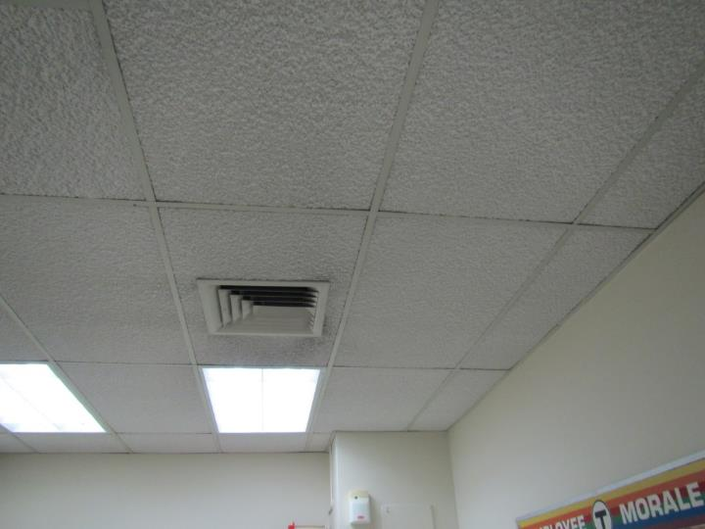
Ceiling-mounted supply vent
Picture 2
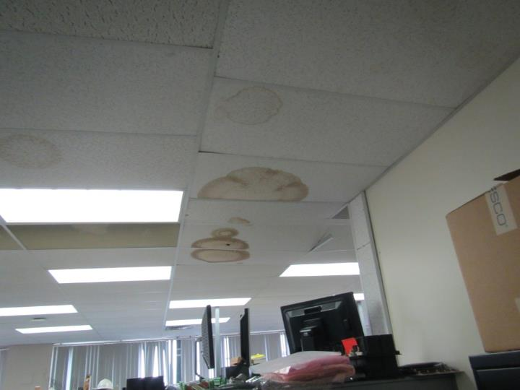
Ceiling-mounted return vent, also note water-damaged ceiling tiles
Picture 3
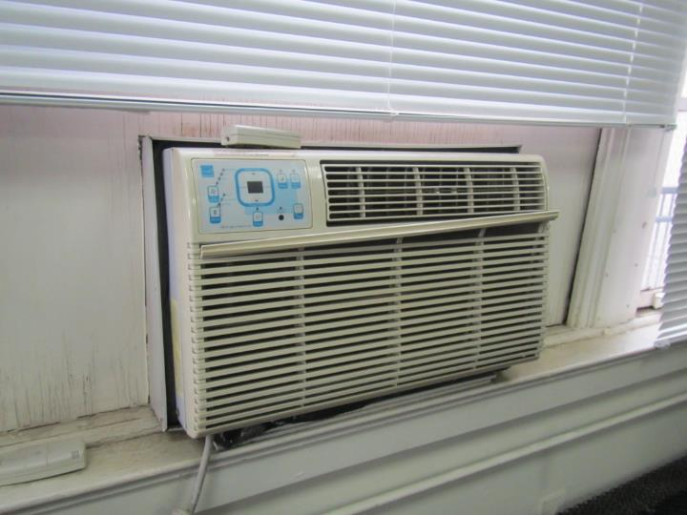
Window-mounted air conditioner, note cracked and water-damaged wooden framing
Picture 4
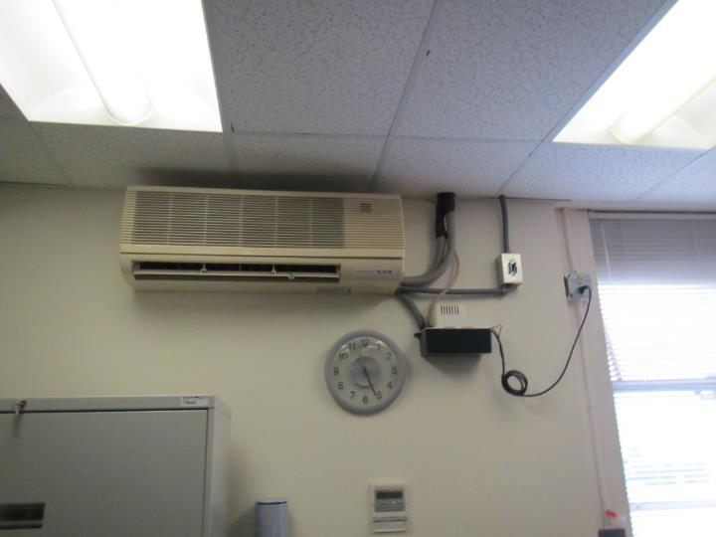
Ductless air conditioner with condensate pump
Picture 5
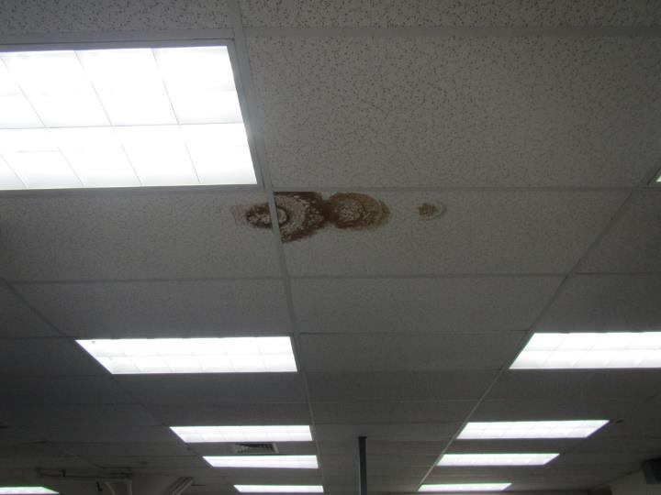
Water-damaged ceiling tiles
Picture 6
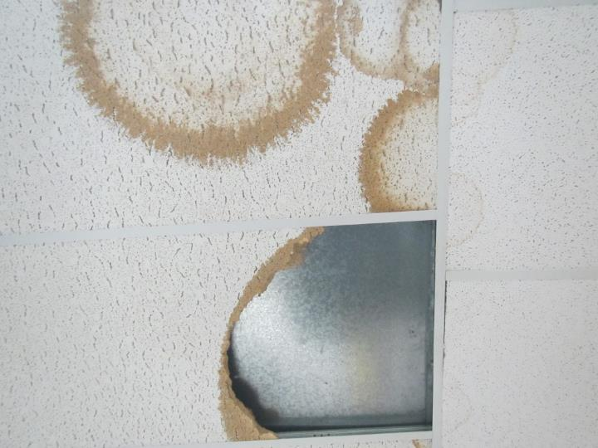
Water-damaged and broken ceiling tiles
Picture 7
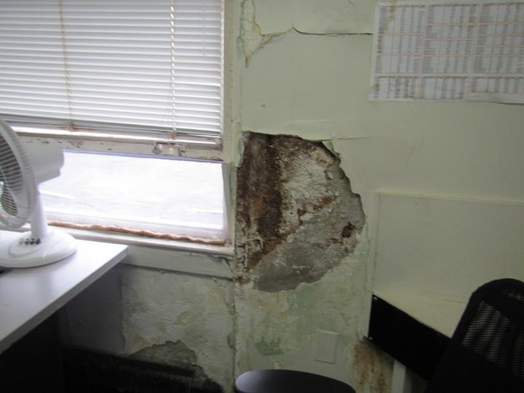
Cracked, spalling wall in first floor office
Picture 8
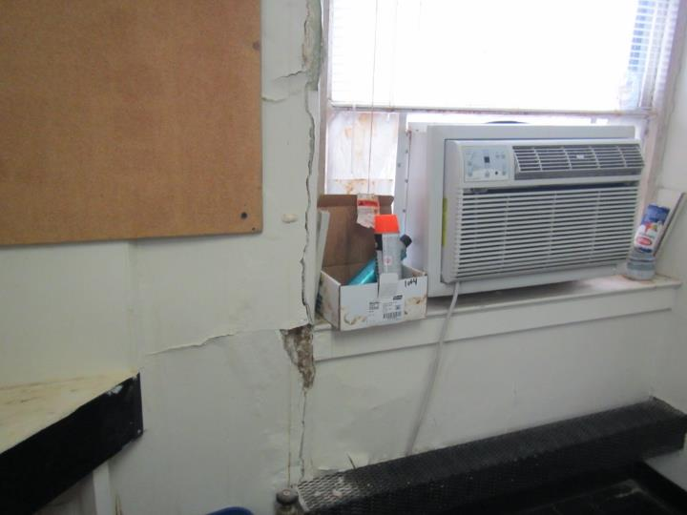
Cracked, spalling wall and plaster debris
Picture 9
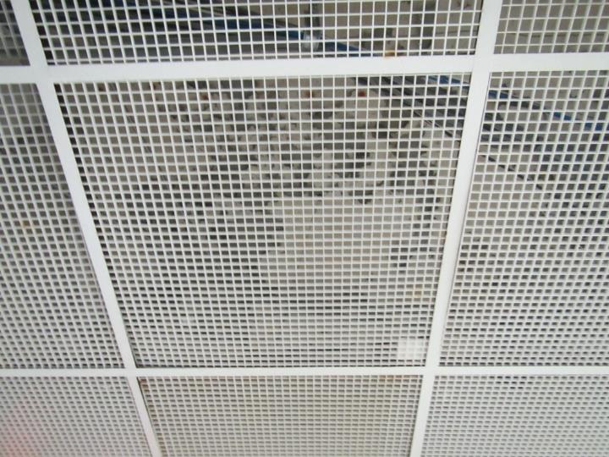
Egg-crate-style pieces in the ceiling tile grid in the first floor hallway
Picture 10
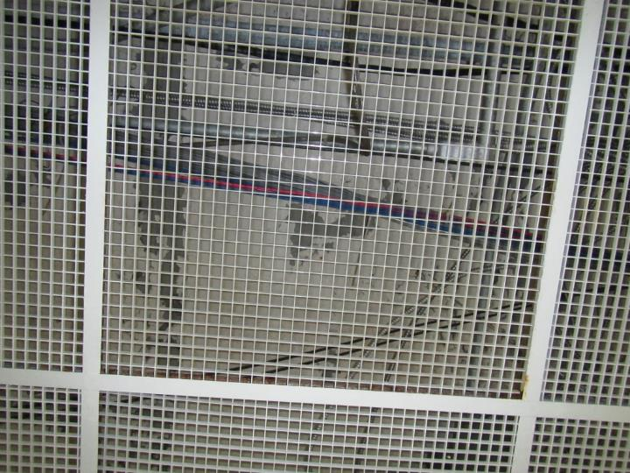
Flaking paint on ceiling above grid
Picture 11
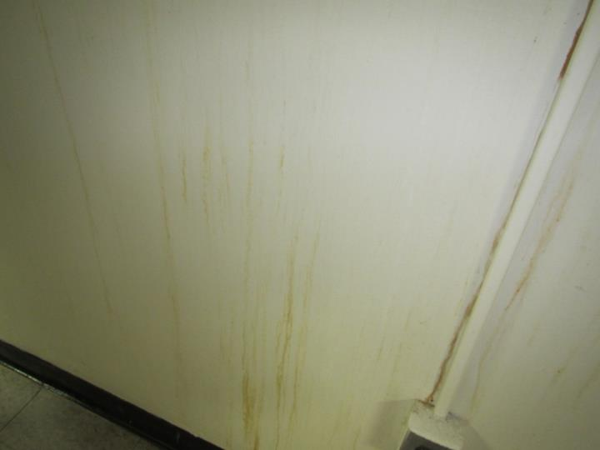
Stains on walls in first floor hallway
Picture 12
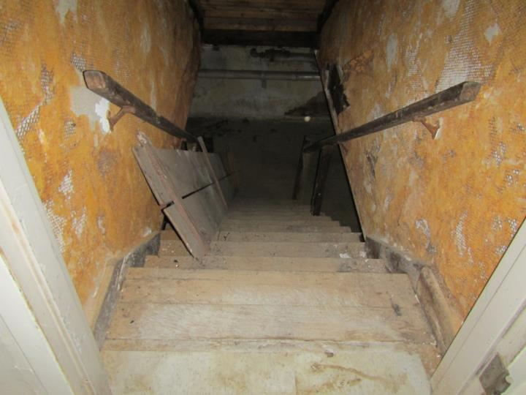
Basement stairway with no door on the ground floor, note debris
Picture 13
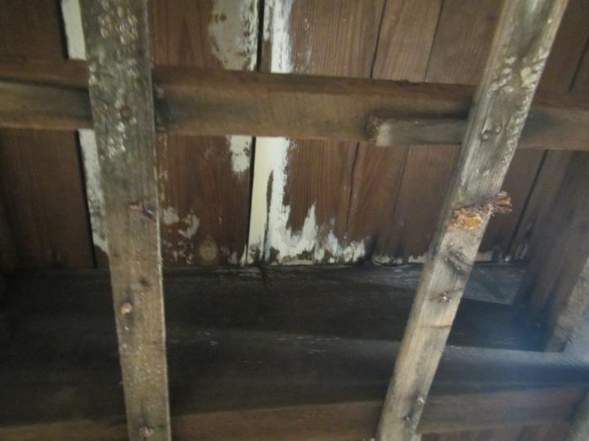
Poor condition of ceiling in basement showing gaps and potential mold growth
Picture 14
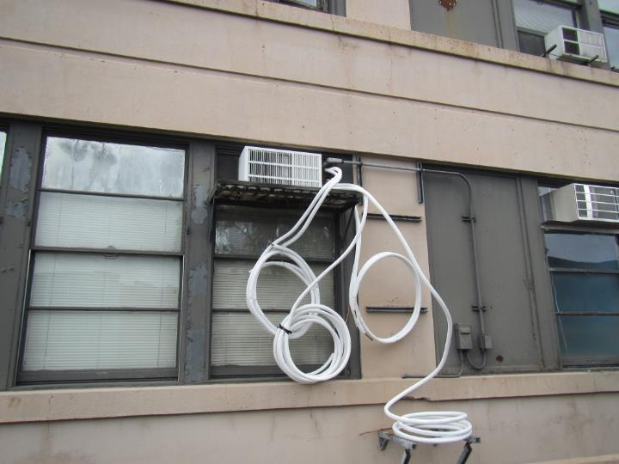
Disorganized condensate drainage
Picture 15
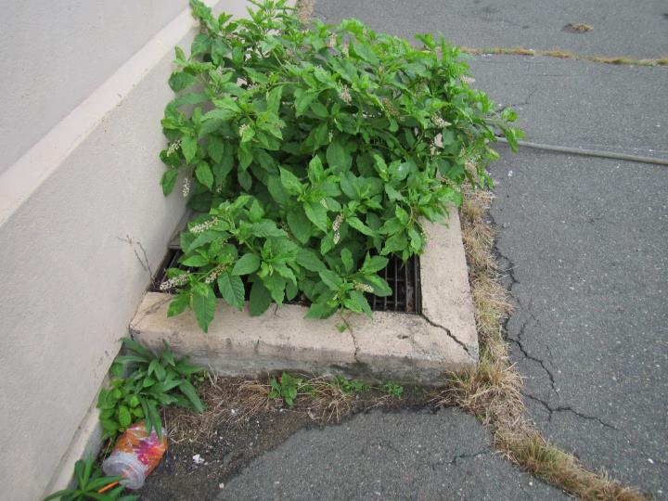
Plant growing out of building area, possible former window well
Picture 16
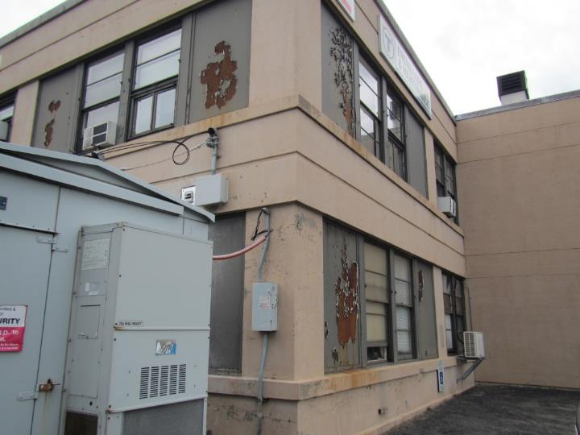
Damage to building exterior
Location | Carbon  Dioxide  (ppm) | Carbon Monoxide  (ppm) | Temp  (°F) | Relative  Humidity  (%) | PM2.5  (µg/m³) | Occupants  in Room | Windows  Openable | Ventilation |  | Remarks
 |  |  |  |  |  |  |  | Supply | Exhaust
Background | -- | -- | -- | -- | -- |  |  |  |  | Cloudy with showers, location is next to large bus garage with low activity at the time of assessment
2nd floor
Kitchen | 530 | ND | 73 | 53 | 3 | 0 | N | Y |  | Stove (electric), other food prep equipment, HS
Cube area | 567 | ND | 74 | 51 | 4 | 5 | Y | Y | Y | HS, WD CT, NC
Lunch/office | 508 | ND | 72 | 50 | 4 | 0 | N | Y | Y | 2 WD CT, WAC – dusty
Office | 505 | ND | 72 | 52 | 4 | 1 | Y open | Y | Y | WD CT, AI, WAC
Office | 556 | ND | 72 | 52 | 5 | 2 | N | Y | Y | WD CT, NC
MCC office | 562 | ND | 73 | 52 | 4 | 2 | Y | Y |  | DEM, WAC, used to be carpeted now NC
McEleny | 577 | ND | 73 | 53 | 4 | 1 | Y | Y |  | WAC, carpeting (old)
Office | 614 | ND | 74 | 52 | 4 | 1 | Y | Y |  | WAC, fridge, NC
Flynn office | 526 | ND | 73 | 50 | 4 | 1 | Y | Y |  | WAC
Office | 593 | ND | 73 | 55 | 5 | 0 | N | N | N | NC
First Floor
Cube area | 715 | ND | 73 | 53 | 7 | 0 | N | N | N | NC
Gauthier office | 946 | ND | 73 | 55 | 7 | 1 |  | N | N | WAC, HS, NC, DEM, refrigerator
Jennette office | 720 | ND | 73 | 52 | 6 | 0 | Y | N | N | WAC, food prep equipment
Payne office | 693 | ND | 73 | 51 | 6 | 0 | Y | N | N | WAC, DEM, NC
Printing room | 613 | ND | 72 | 50 | 7 | 1 | Y | N | N | WAC
Office | 608 | ND | 71 | 50 | 7 | 1 | Y | N | N | Wall in bad condition – spalling plaster, etc. WAC
Ciaccio office | 798 | ND | 72 | 53 | 5 | 2 | Y | N | N | Ductless AC, NC, coffeemaker
Deluca office | 756 | ND | 72 | 54 | 6 | 3 | Y | N | N | WAC, DEM, CF, WD CT, NC
Lombardo office | 879 | ND | 73 | 53 | 6 | 1 | Y | N | N | DEM, CP, dusty PF
Quilty office | 1073 | ND | 73 | 55 | 7 | 1 | Y | N | N | Ductless AC, NC, AI, CF
Swing space | 1070 | ND | 73 | 56 | 6 | 3 | Y | N | N | WAC, coffee maker, DEM
Conference | 1219 | ND | 73 | 57 | 7 | 1 | Y | N | N | DEM, upholstered furniture, NC
TFM area | 847 | ND | 71 | 47 | 5 | 0 |  | N | N | NC, ductless AC
Melchionda | 851 | ND | 71 | 49 | 6 | 1 | Y | N | N | WAC, CF, NC, AI
Non-work spaces
Lower level hallway |  |  |  |  |  |  |  |  |  | Egg-crate open ceiling due to chronic moisture, ceiling above has peeling paint, NC
Basement | 413 | ND | 62 | 69 | 8 |  | N |  |  | Dirt/debris on stairs, floor. Walls in bad condition, recently had many items/materials removed

