INDOOR AIR QUALITY ASSESSMENT

MBTA Charlie Card Service Office
7 Chauncy Street
Downtown Crossing MBTA Concourse
Boston, MA

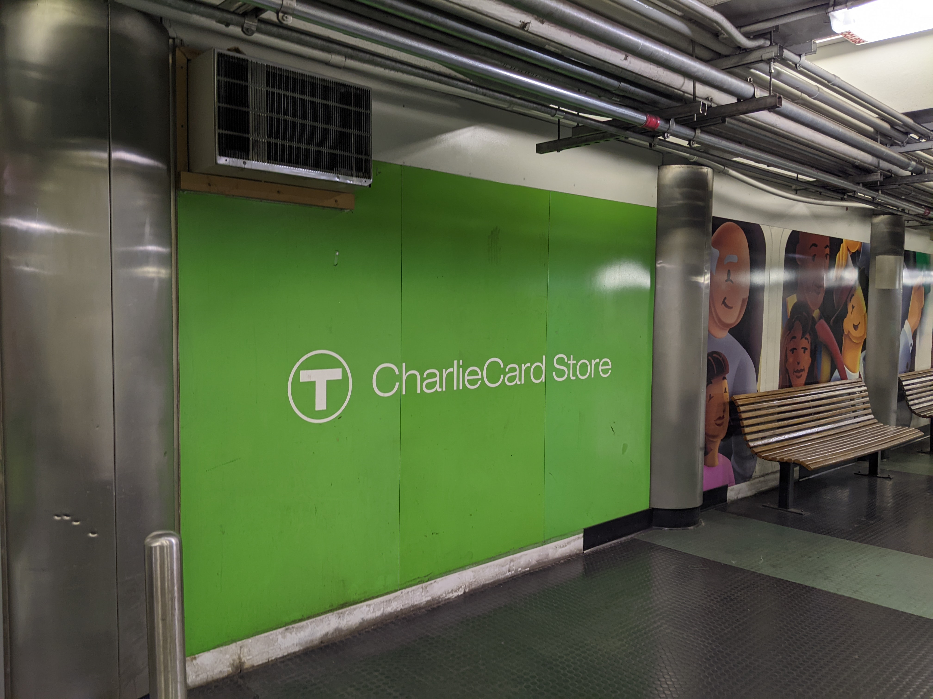

Prepared by:
Massachusetts Department of Public Health
Bureau of Environmental Health
Indoor Air Quality Program
August 2022

Background
Building: | Massachusetts Bay Transit Authority (MBTA) Charlie Card Service Office (CCO)
Address: | 7 Chauncy Street, Downtown Crossing MBTA concourse, Boston
Assessment Requested by: | Lisandra Serrano, Charlie Card Office Manager
Reason for Request: | Temperature and Indoor Air Quality (IAQ) concerns
Dates of Assessment: | July 15, 2022 and July 19, 2022
Massachusetts Department of Public Health/Bureau of Environmental Health (MDPH/BEH) Staff Conducting Assessment: | Mike Feeney, Director, and Ruth Alfasso, Environmental Engineer/Inspector, Indoor Air Quality Program
Building Description: | The CCO is a small set of rooms inside the Downtown Crossing underground concourse. The concourse is divided by a set of doors into the upper concourse and the lower concourse. The Downtown Crossing Red Line station, entrances to retail stores and various entrances/exist in the upper concourse. The CCO is located in the lower concourse, which also contains various secured MBTA operations rooms and a turnstile to a door labelled Q01leading to a former evacuation tunnel (Q01 tunnel), and the Chauncy Street Red Line entrance. The CCO contains offices, cubicles, a service desk, and a customer waiting area. Customers also wait outside in the concourse hallway for service.
Windows: | There are no windows in the space assessed.

INTRODUCTION

On July 15, 2022, IAQ staff visited the MBTA CCO, which is adjacent to an area that formerly sold T Passes and tokens (TPT). IAQ staff returned to the concourse on Jul 19, 2022, during a summer heatwave to conduct examination of ventilation equipment, to identify both internal and external heat sources effecting the concourse, and to conduct temperature and relative humidity measurements to determine the heat index.

Methods
Please refer to the IAQ Manual for methods, sampling procedures, and interpretation of results (MDPH, 2015).

IAQ Testing Results
The following is a summary of indoor air testing results taken on July 15, 2022 (Table 1), and July 19, 2022 (Table 2). Note that on July 15, 2022, air tests were conducted at different times to determine if changes in measurements occurred. These measurements were taken approximately an hour apart.
On July 19, 2022, temperature and relative humidity measurements were conducted in the hallway/concourse as well as adjacent areas outside the Charlie Card Store (CCS).
- Carbon dioxide levels were below MDPH guideline of 800 parts per million (ppm) in all areas surveyed on July 15, 2022. Levels were also below 800 ppm in all areas tested on July 19, 2022.
- Temperature was within the recommended range of 70°F to 78°F in the areas inside the CCO, and higher than the recommended range in the hallway outside on July 15, 2022. All measurements taken on July 19, 2022 (in the hallway/concourse) were above the recommended range.
- Relative humidity was within or close to the upper end of the recommended range of 40 to 60% in the areas tested on July 15, 2022. Relative humidity was within the recommended range in areas tested on July 19, 2022.
- Carbon monoxide levels ranged from non-detectable (ND) to 1 ppm in areas tested inside the CCO at approximately 11AM on July 15, 2022. Samples taken in the same locations at 12PM on July 15, 2022, were slightly higher, ranging from 1.5 to 1.6 ppm. Levels in the hallway outside the CCO on July 15, 2022, ranged from 1.6 to 1.9 ppm.
- Fine particulate matter (PM2.5) concentrations measured were below the National Ambient Air Quality (NAAQS) limit of 35 μg/m³ in all areas inside the CCO tested at approximately 11 am on July 15, 2022. Some levels inside the CCO and all levels in the concourse were above 35 μg/m³ measured at approximately 12PM on July 15, 2022.
- Heat index was calculated for the relative humidity and temperatures measured outside the CCS on July 19, 2022 (Table 2). These ranged from 88°F to 103°F.

Ventilation
A heating, ventilating and air conditioning (HVAC) system has several functions. First it provides heating and, if equipped, cooling. Second, it is a source of fresh air. Finally, an HVAC system will dilute and remove normally-occurring indoor environmental pollutants by not only introducing fresh air, but by filtering the airstream and ejecting stale air to the outdoors via exhaust ventilation. Even if an HVAC system is operating as designed, point sources of respiratory irritation may exist and cause symptoms in sensitive individuals.

The CCO
The CCO does not appear to be a have any centralized air handling units (AHUs) located within its footprint. Several different kinds of HVAC equipment appear to provide heat and/or cooling for the CCO in an uncoordinated way:
- An AHU was found in the adjacent TPT space, which is now used for storage and a break room. IAQ staff believe this AHU serves the CCO through ductwork above the ceiling. Although operating, it does not appear to be regularly serviced and is in poor condition, noted by a build-up of dust/debris inside the unit as well as the installation of an improperly sized, soiled air filter (Pictures 1 through 4).
- Multiple window-mounted air conditioners were installed in the side walls of the CCO. Each of these units eject waste heat into the concourse (Pictures 5 through 7).
- A ceiling-mounted air conditioner was noted in the back-office CCO cubicle area (Picture 8). Cooling for this unit may be supplied by a chiller located elsewhere along the hallway (e.g. chillers located in the Q01 tunnel).
- Ductless (mini-split) air conditioners were also installed in the CCO (Picture 9).
- There is a small vent in the wall of the CC next to the employee entrance. This appears to function as a passive pressure equalization vent.
Thermostats are present in several CCO office areas (Picture 10). It is not known what portions of the HVAC system are controlled by the thermostats. Note that the thermostat temperatures were set to 68°F, while the service greeter kiosk had a personal heater that was on during the assessment. In addition, some thermostats displayed “time to clean filter” indicating that equipment needed maintenance, however it is not clear which units/filters this referred to.
While levels of carbon dioxide in the office area were below the MDPH guidance level of 800 ppm during the assessment(s), there is no source of fresh air. Air can enter the office through the public service door from the concourse during occupied hours, however this air comes from the hallway outside, which, as noted above, becomes very warm. Air from the concourse can also impacted by stagnation and the impact of trains and other equipment operating elsewhere in the concourse as noted by air testing.
Of particular note is the difference between measurements of particulates and carbon monoxide taken about an hour apart on July 15, 2022. Levels of both were notably higher at the later measurement time (Table 1). One likely source for the increased particulates is the AHU unit located in the TPT. This AHU inspection doors were opened, which may have disturbed and aerosolized the debris. Because this AHU lacks a properly installed filter, disturbed debris could be distributed to the CCO. In addition, the increase in particulate levels may also reflect increased levels in the concourse from the passage of subway cars through the Red Line over the course of the day.
It is recommended that HVAC systems be re-balanced every five years to ensure adequate air systems function (SMACNA, 1994), however in the current configuration and likely age, it is unlikely the CCO HVAC systems can be balanced.

The Upper and Lower Concourse
The concourse has no mechanical HVAC system to provide fresh air or exhaust ventilation, and it is also used as a location to vent waste heat from air-conditioning equipment serving other spaces such as the CCO. IAQ staff identified 9 air-conditioning waste heat sources in the concourse: two chillers in the Q01 tunnel, an AHU serving a secure room (Picture 11), a series of air-conditioners that are typically installed in windows (Pictures 5-7) and a portable air-conditioner inside the TPT (Picture 12). Cooling coils of these units had a range of 78°F to 122°F (Table 3) which contribute waste heat into the concourse.
To provide airflow and vent waste heat, it appears a series of wall-mounted and floor pedestal fans were used to direct air in the concourse from the Downtown Crossing Red Line stop (upper concourse) toward the passive air vent (Picture 13) next to the Q01 tunnel in the lower concourse. Fans were likely placed in a series along the concourse and inside the Q01 tunnel to create one-way airflow. The following fans were identified:
- A wall-mounted fan at the doors separating the upper and lower concourse. It is believed a second fan was installed on the opposite wall but was removed to install electrical conduit for the CCO.
- A number of benches exist outside the CCS with floor pedestal fans blowing against each other (Picture 14).
- A ceiling-mounted fan installed on the ceiling in a manner to blow air against a ceiling support beam (Picture 15).
- A number of pedestal floor fans are positioned to direct air to the AHU in Picture 11.
- A series of unused fans exist in the Q01 tunnel (Pictures 16 and 17).
All of these fans in the lower concourse are positioned in a manner that does not create one-way airflow to direct air into the Q01 tunnel passive vent.

Ventilation in the Q01 Tunnel
As noted previously, the Q01 tunnel contains two industrial-sized chillers (Picture 18) located near the passive vent. The chillers provide coolant for air-conditioning equipment, possibly for the CCO. During operation, these chillers produce significant waste heat which requires a means of venting for this equipment to function appropriately. The IAQ Program believes that fans in the Q01 tunnel were designed to be placed in a series to draw air from the lower concourse through the passive vent down the Q01 tunnel to exit at its terminus. Several conditions in the Q01 tunnel indicate that this method to exhaust heat from the chillers or lower concourse is not in use:
- A large pile of boxes and debris are piled between the chillers and passive vent (Picture 19). The piled materials block airflow via the passive vent. Given the temperature of the chillers, these materials also pose a fire hazard.
- While several portable fans were found in the Q01 tunnel, none are plugged into a power source or oriented into a position to draw air from the passive vent to cool the chiller coils.
- A ventilation duct and AHU of unknown purpose exists in the Q01 tunnel (Pictures 20 and 21). This system was not operating and does not appear to serve any waste heat venting purpose.

Temperature Issues in the Concourse
Temperature concerns were expressed regarding the concourse area where members of the public wait to enter the CCS. Air temperatures measured in this area were as high as 87°F on July 15, 2022 and as high as 88°F on July 19, 2022. Reportedly, many individuals who visit the CCS are elderly or disabled, as this is the only location to access certain special fare card transactions. Excess heat can have a greater effect on individuals who are older or ill (CDC, 2022).

Heat Index
Thermal comfort is dependent on the perception of heat by an individual, which can be expressed as the heat index. The body cools by producing sweat to reduce internal body heat through the skin. When relative humidity increases, the ability of moisture to evaporate from skin decreases, therefore preventing heat loss and increasing an individual’s discomfort. The heat index is a description of how hot a person feels as temperature in combination with relative humidity rises. The following chart produced by the National Weather Service (NWS) shows the heat index that corresponds to the air temperature and relative humidity.

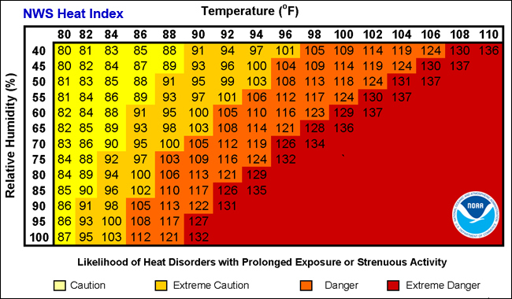
Heat Index Chart

Classification | Heat Index | Effect on the body
Caution | 80°F - 90°F | Fatigue possible with prolonged exposure and/or physical activity
Extreme Caution | 90°F - 103°F | Heat stroke, heat cramps, or heat exhaustion possible with prolonged exposure and/or physical activity
Danger | 103°F - 124°F | Heat cramps or heat exhaustion likely, and heat stroke possible with prolonged exposure and/or physical activity
Extreme Danger | 125°F or higher | Heat stroke highly likely

Using this chart as a guide, when the heat index indoors exceeds 90°F, methods to increase the thermal comfort of building occupants should be employed. As shown in Table 2, heat index values for the CCS waiting area in the concourse exceeded 88°F.

Microbial/Moisture Concerns
A few issues related to water damage were noted in the CCO. The occupant of one of the offices along the hallway wall reported that water has come into the office from the wall in the past. On the concourse side of the office wall is a floor drain of unknown purpose (Picture 22). It is likely that water from this drainage system penetrated through the wall to wet carpeting. While no obvious sign of water damage (stains, odors, loose carpeting) were noted during the assessment, carpeting that is repeatedly wetted can become colonized with mold. In addition, if the source of the water is not clean, it may contain harmful constituents that may continue to be present in the indoor environment. It is recommended that the carpeting be removed and replaced with a non-porous floor covering. Water dispensers and replacement water jugs were also located on carpeted areas, where spills or leaks can damage the carpeting and lead to microbial growth.
In the former MBTA ticket office, the AHU was in a room also used for storage. Cardboard boxes were stored in piles directly on the floor (Picture 23) and many showed signs of water damage. In addition, several of the boxes were labeled to indicate they could have been properly discarded many years before. Porous materials should not be stored in areas with water leaks or high humidity, as water damage to items such as cardboard can release odors and may lead to mold growth.
The US Environmental Protection Agency (US EPA) and the American Conference of Governmental Industrial Hygienists (ACGIH) recommends that porous materials (e.g., wallboard, carpeting) be dried with fans and heating within 24 to 48 hours of becoming wet (US EPA, 2008; ACGIH, 1989). If porous materials are not dried within this time frame, mold growth may occur.

Other IAQ Evaluations
Other issues were noted in the space which may impact indoor air quality. Note that in the absence of effective supply and exhaust ventilation, regularly-occurring indoor pollutants can build up and become a source of irritation. A photocopier is located in the space. Photocopiers, particularly those that are older or heavily used, can release particulate matter, VOCs and odors during operation. Food preparation equipment was noted in a break area. If this equipment is not kept clean, it can become a source of smoke and odors, and may be attractive to pests.
High Efficiency Particulate Air (HEPA) filter units were located in several offices inside the CCO. These units need to be maintained regularly including cleaning and filter changes.

Conclusions/Recommendations
Based on observations made in and near the CCO, the following recommendations are made regarding conditions and operations. These recommendations are separated into short-term recommendations, and long-term recommendations that may require planning and capital funds to achieve.

Short-term Recommendations

Concourse Ventilation Recommendations
Based on observations, the creation of one-way airflow is necessary to vent waste heat from the lower concourse, which would also increase comfort for CCS patrons. At minimum, existing operational portable fans should be used to create one-way airflow from the upper concourse towards the Q01 Tunnel passive vent. The following recommendations are made to aid in heat venting from the lower concourse that can be used with existing equipment and resources:
- Remove/discard cardboard and other debris from the Q01 tunnel between the passive vents and chillers. Do not move and store this refuse elsewhere in the Q01 tunnel or any other location in the upper and lower concourses.
- Operate portable fans in the Q01 tunnel in a manner to draw air from the lower concourse via the passive vent to cool the chillers. All fans should be oriented in series to direct air one way down the Q01 tunnel.
- Identify the HVAC system in the Q01 tunnel and ascertain if it can be used to assist heat venting.
- Place a portable fan on the lower concourse to blow air into the passive vent.
- Place a fan, pointed into the concourse close to the Chauncy Street exit to inject outdoor air into the concourse.
- Reposition pedestal fans around CCS waiting area benches to direct air toward the Q01 passive vent.
- Place two fans in opposing corners in the upper concourse near the doors to draw air and direct it into the lower concourse.
- Consider repositioning portable fans near each wall-mounted air-conditioning unit in a manner to direct waste heat to the Q01 Tunnel passive vent.
- Reinstall the removed wall-mounted fans to draw air from the upper concourse.

Other Ventilation Recommendations
- Catalog all HVAC equipment in use in the CCO/CCS area, including wall-mounted and ductless ACs.
  - Determine what is being controlled by thermostats or other controls.
  - Determine what chillers are connected to what units.
  - Determine if some units are not used at all and have them properly decommissioned.
  - Use the information gained to coordinate the use of available equipment for improved temperature control and airflow.
- Maintain all currently-used HVAC units, including cleaning, and changing filters using filters of the correct size and a Minimum Efficiency Rating Value (MERV) of 8 or better if the equipment can handle it.
- Consider increasing the set-point temperature of the air conditioning inside the CCO. This would reduce the need for a space heater at the greeter’s desk and reduce the waste heat being ejected outside.
- Monitor conditions in the hallway used as a waiting area and increase access to seating, fans, and water for people waiting for service when conditions become hot.

Water Damage Recommendations
- If water leaks into CCO Offices reoccur, determine the source of the water if possible and remediate. Potential sources include backflow from a drain in the outside of the wall, or leaks from condensation from the ductless air conditioner in the office.
- Consider removal of carpeting in the CCO to prevent odors and mold growth due to moistening. If not feasible, use a waterproof mat to protect carpeting under water dispensers, water storage and refrigerators.

Other Recommendations
- Ensure all HEPA filter units are properly maintained including filter changes.
- Keep food preparation equipment clean to avoid smoke and odors.
- Sort stored materials and discard any that are no longer needed or are water-damaged. Store remaining materials off the floor in a climate-controlled area.
- Refer to resource manual and other related IAQ documents located on the MDPH’s website for further building-wide evaluations and advice on maintaining public buildings. These documents are available at: http://mass.gov/dph/iaq.

Long-term recommendations
- Consider finding a new location for the CCS that better meets the needs of the population served by this store and employees.

References
ACGIH. 1989. Guidelines for the Assessment of Bioaerosols in the Indoor Environment. American Conference of Governmental Industrial Hygienists, Cincinnati, OH.
CDC, 2022. Keep Your Cool in Hot Weather! Center for Disease Control National Center for Environmental Health. https://www.cdc.gov/nceh/features/extremeheat/index.html
MDPH. 2015. Massachusetts Department of Public Health. Indoor Air Quality Manual: Chapters I-III. Available at: https://www.mass.gov/lists/indoor-air-quality-manual-and-appendices.
NWS. 2005. “What is the Heat Index?” National Weather Service, US Dept of Commerce, National Oceanic and Atmospheric Administration. https://www.weather.gov/ama/heatindex
SMACNA. 1994. HVAC Systems Commissioning Manual. 1st ed. Sheet Metal and Air Conditioning Contractors’ National Association, Inc., Chantilly, VA.
US EPA. 2008. “Mold Remediation in Schools and Commercial Buildings”. Office of Air and Radiation, Indoor Environments Division, Washington, DC. EPA 402-K-01-001. September 2008. Available at: http://www.epa.gov/mold/mold-remediation-schools-and-commercial-buildings-guide
Picture 1
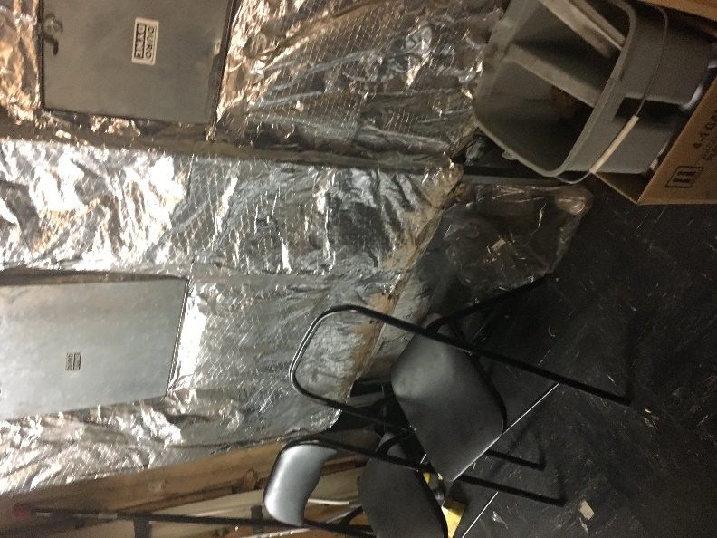
AHU in old ticket office
Picture 2
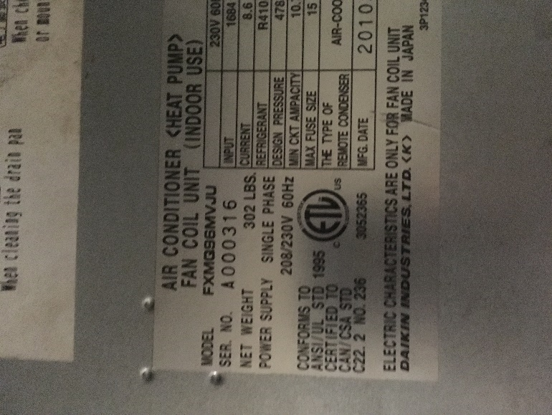
Label on AHU
Picture 3
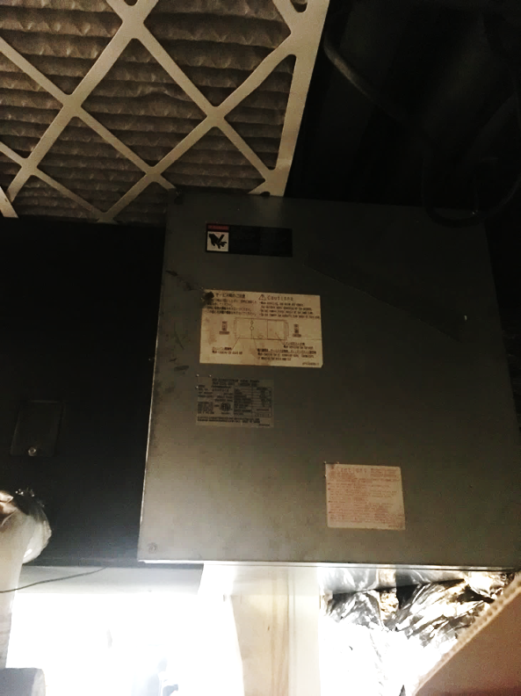
Improperly installed, oversized filter protruding from AHU
Picture 4
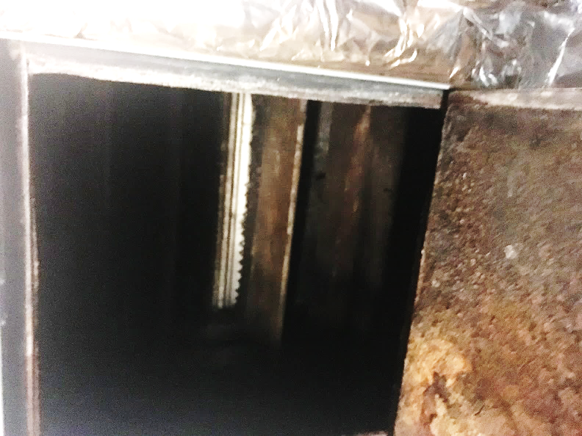
Interior of AHU showing corrosion and debris
Picture 5
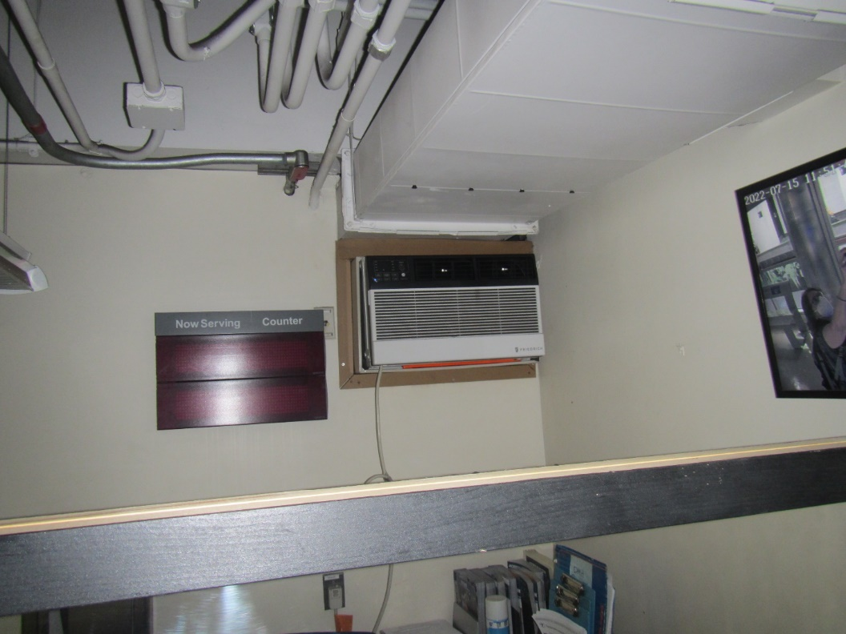
Window-mounted style air conditioned mounted in wall in CCO
Picture 6
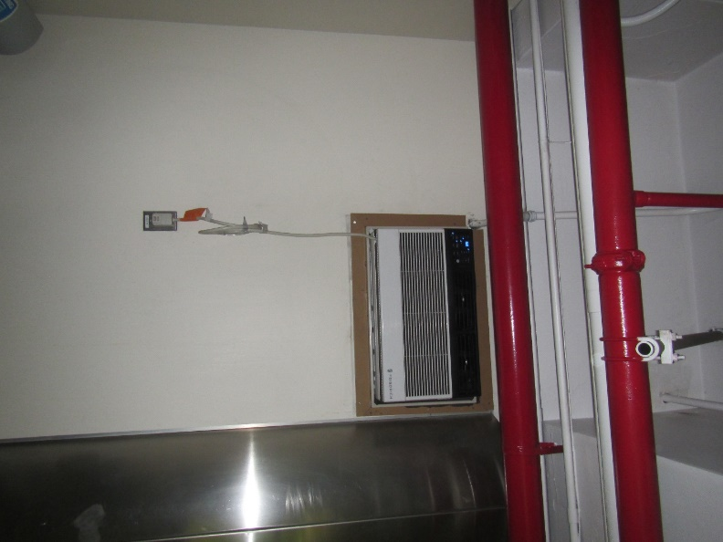
Window-mounted AC mounted in wall in CCO
Picture 7
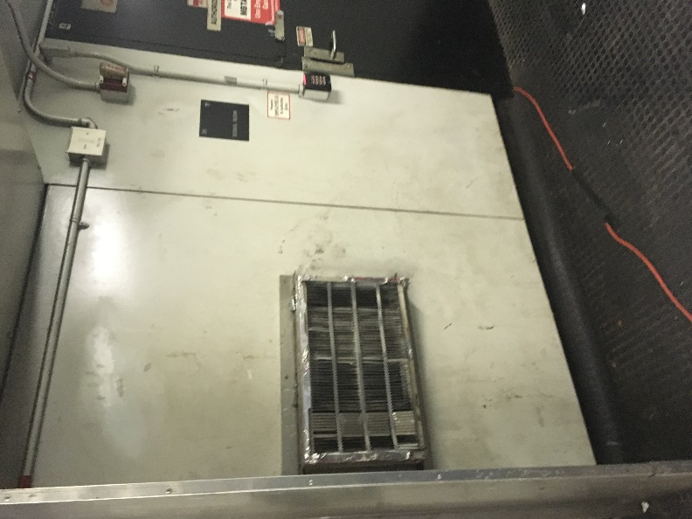
Coils end of a window-mounted style air conditioner mounted in a wall
Picture 8
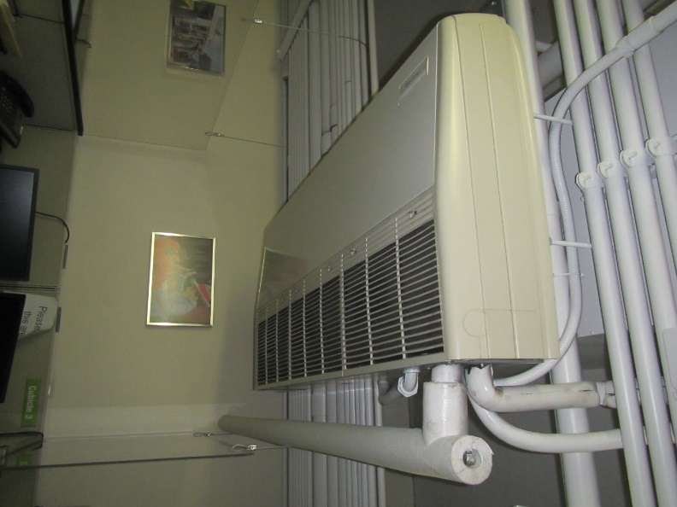
Ceiling-mounted air conditioning unit in the CCO
Picture 9
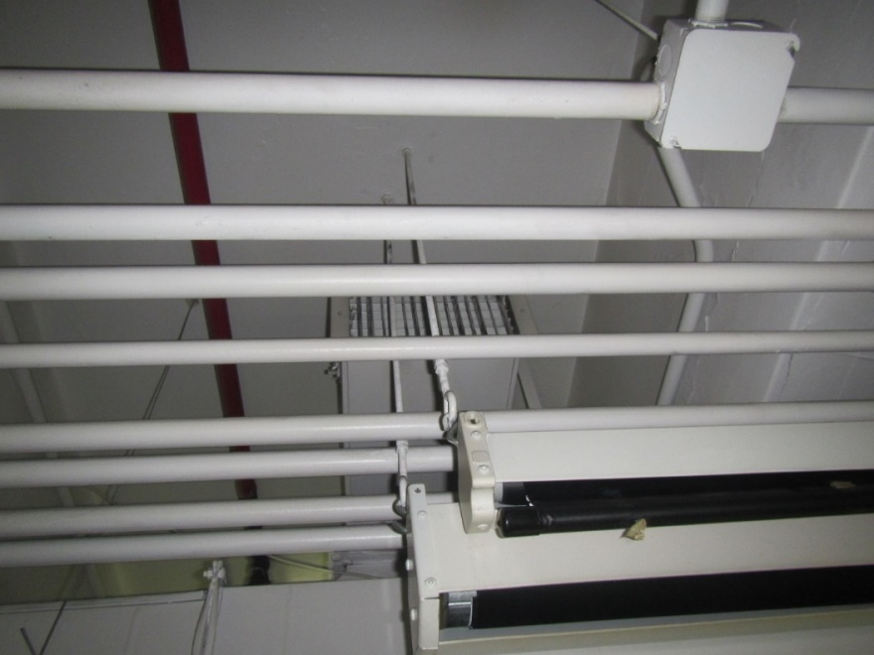
Ductless, mini-split style air conditioning
Picture 10
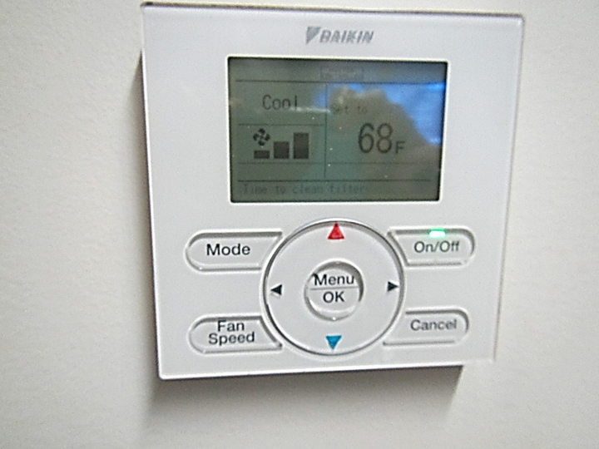
Thermostat in office in CCO, note set temperature and “time to clean filter”
Picture 11
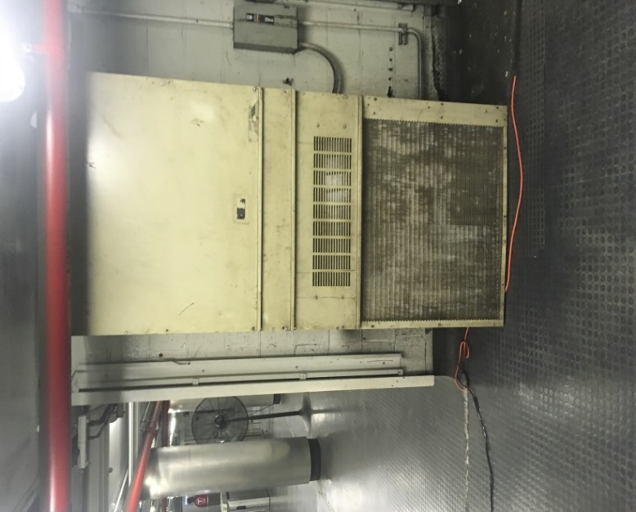
AHU serving unidentifiable location in lower concourse
Picture 12
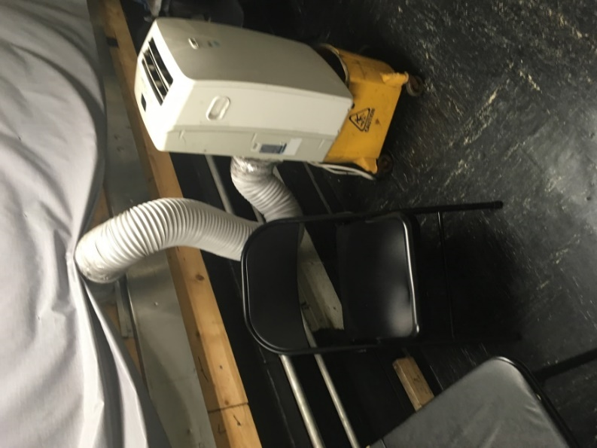
Portable air-conditioner in the TPT
Picture 13
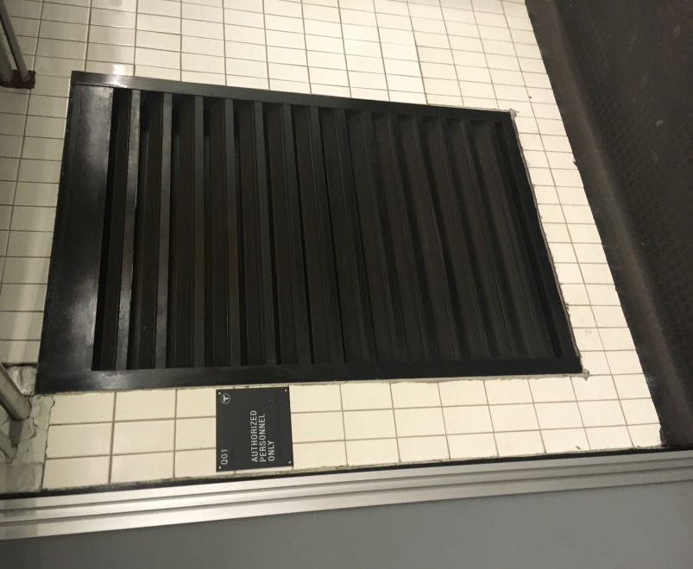
Passive air vent on wall of Q01 Tunnel
Picture 14
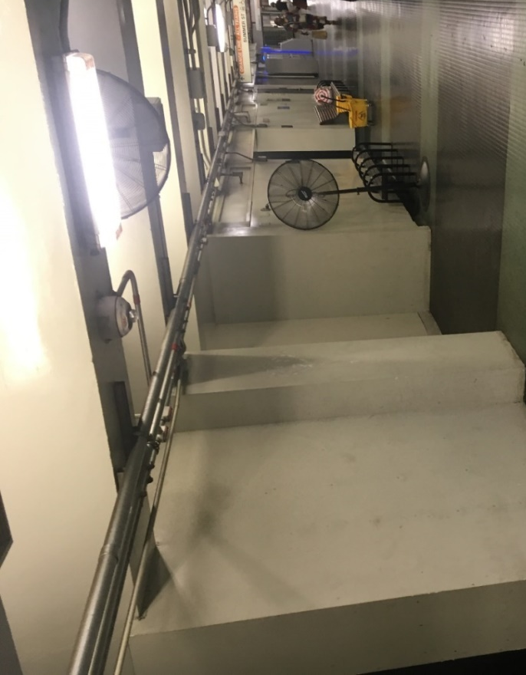
Floor fan and wall-mounted fan in concourse hallway
Picture 15
Fan installed against ceiling beam, limiting its ability to efficiently draw and direct air
Picture 16
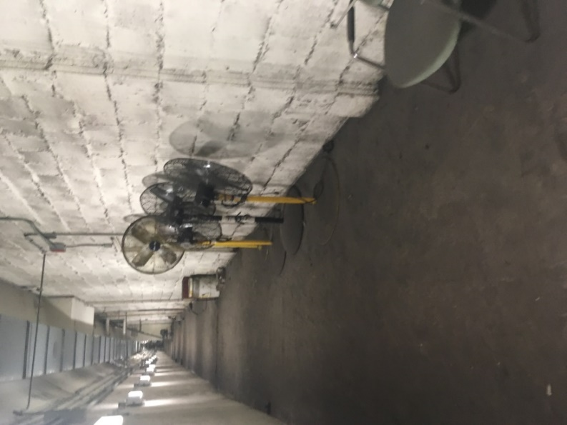
Unused fans in the Q01 tunnel
Picture 17
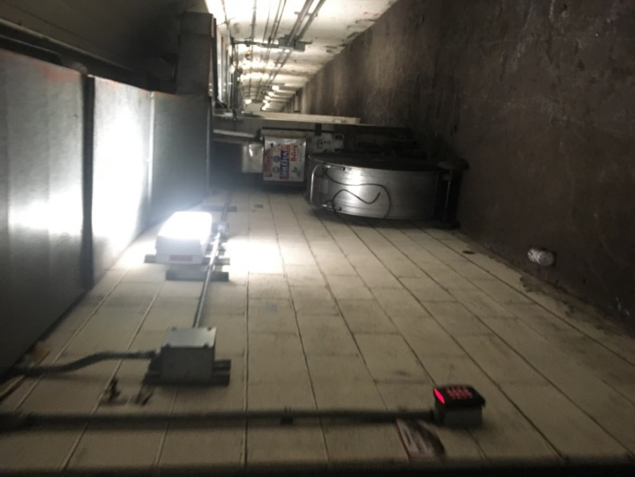
Unused large fan in the Q01 tunnel
Picture 18
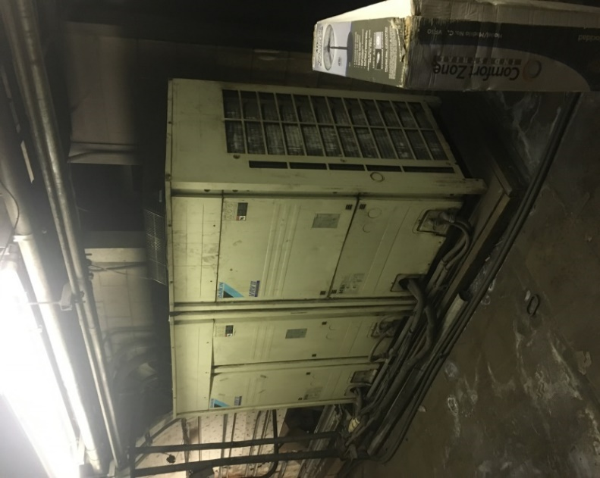
Chillers in Q01 tunnel
Picture 19
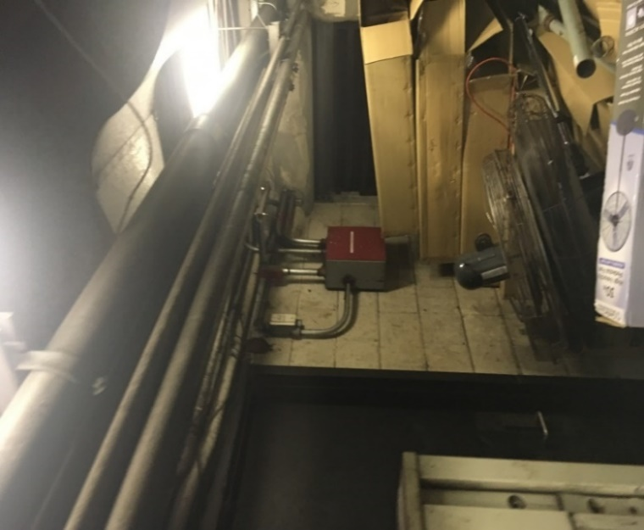
Large pile of boxes and debris are piled between the chillers and passive vent, note close proximity of chiller (arrow) venting waste heat near this debris

Picture 20
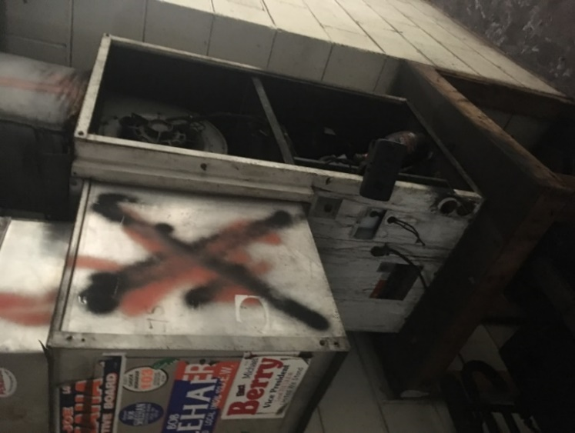
AHU of unknown purpose in the Q01 tunnel
Picture 21
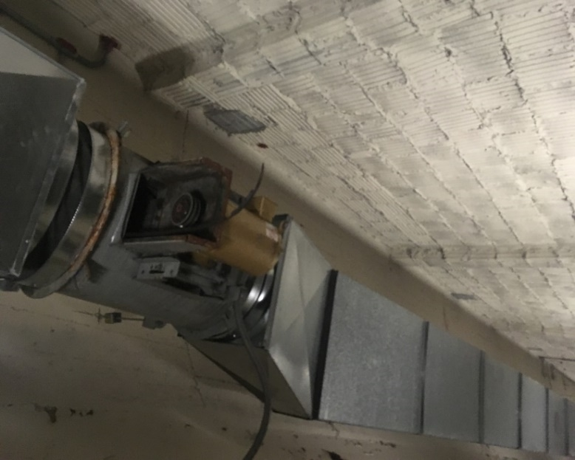
Non-operating duct-mounted fan in Q01 tunnel, note broken fan belt
Picture 22
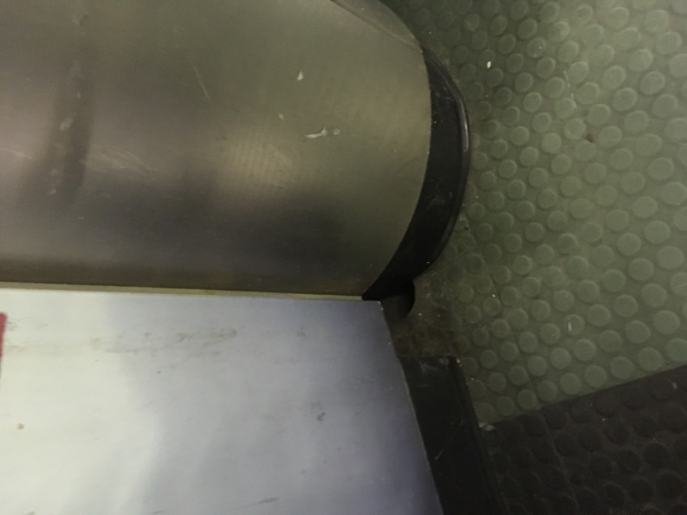
Floor drain at exterior base of CCO wall
Picture 23
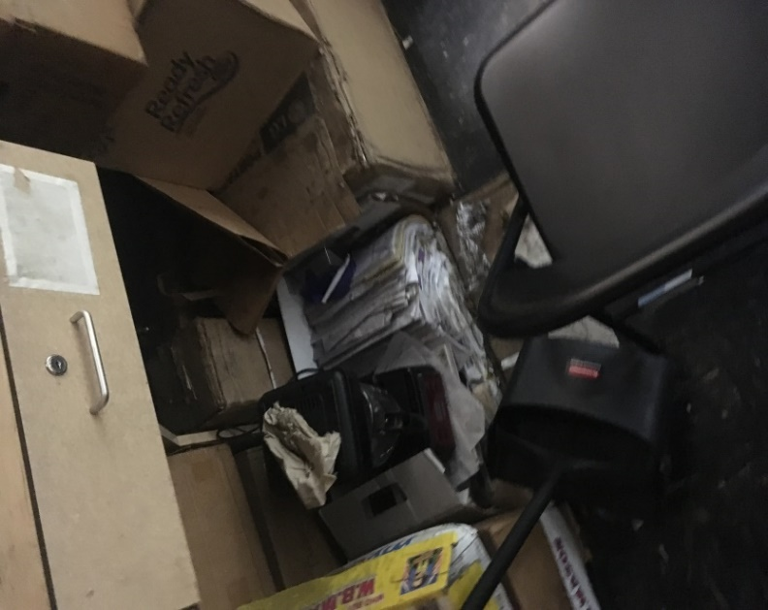
Water-damaged materials stored in AHU room in TPT

Location | Carbon  Dioxide  (ppm) | Carbon Monoxide  (ppm) | Temp  (°F) | Relative  Humidity  (%) | PM2.5  (µg/m³) | Occupants  in Room | Windows  Openable | Ventilation |  | Remarks
 |  |  |  |  |  |  |  | Supply | Exhaust
Outside | 402 | 2.2 | 81 | 41 | 9 |  |  |  |  | Sunny
Testing conducted at approximately 11 am.
Serrano office | 765 | ND | 72 | 63 | 15 | 3 | N |  |  | Carpeted, PF on, plant, peeling ceiling paint, ductless AC, refrigerator on carpet, carpet has reportedly been wet in the past, no obvious signs of water damage
Break area | 641 | 1 | 73 | 61 | 15 | 0 | N |  |  | Water jugs on carpet, toaster, microwave and fridge, food.
Cube 2-4 | 653 | ND | 74 | 60 | 20 | 2 | N |  |  | Large ceiling-mounted AC, PC
Cube 1 and adjacent area | 636 | ND | 73 | 61 | 17 | 1 | N |  |  | Water cooler on carpet, shredder
Office 105 | 632 | ND | 73 | 61 | 16 | 0 | N |  |  | DEM, fridge, thermostat “off”
Service desk, employee side | 569 | 1 | 72 | 60 | 16 | 0 | N |  |  | NC, PF off, HEPA unit
102 | 528 | 1 | 72 | 59 | 17 | 0 | N |  |  | NC, thermostat
Greeter desk | 530 | 1 | 72 | 58 | 19 | 0 | N |  |  | NC, heater
Open waiting area (inside) | 588 | 1 | 72 | 58 | 17 | 0 | N |  |  | NC
Second measurements taken about an hour after initial (approximately 12 pm)
Serrano office | 595 | 1.5 | 72 | 62 | 41 | 2 | N
Cubes 2-4 | 532 | 1.5 | 73 | 62 | 31 | 2 | N
Service area | 585 | 1.5 | 73 | 60 | 31 | 0 | N
Greeter area | 540 | 1.6 | 72 | 59 | 28 | 0 | N |  |  | Heater on
Outside of Charlie Card Office (after 12 pm)
Adjacent to employee entry | 591 | 1.8 | 77 | 61 | 29 | 0 | N |  |  | Hot side of AC unit
Hallway | 518 | 1.8 | 82 | 52 | 45 | 0 | N |  |  | Fans
Hallway in front of store | 504 | 1.6 | 84 | 48 | 41 | 5 | N |  |  | Fans on
Front of line for waiting outside office | 529 | 1.9 | 87 | 45 | 41 | 8 | N |  |  | Fans on

Location | Carbon  Dioxide  (ppm) | Temp  (°F) | Relative  Humidity  (%) | Floor Temp  (°F) | Dew  Point  (°F) | Wall  Temp  (°F) | Heat  Index  (°F) | Ventilation |  | Remarks
 |  |  |  |  |  |  |  | Supply | Exhaust
Outdoors (Background) | 393 | 85 | 54 |  | 67
Bench against Charlie Card Office | 466 | 86 | 52 | 81 | 65 | 81 | 88 |  |  | Floor fan
Bench 10’ from fan | 522 | 87 | 53 | 81 | 65 | 81 | 90 |  |  | Floor fan
Former ticket office | 580 | 86 | 50 | 83 | 66 | 84 | 88 |  |  | Floor fan
Hall doors on Downtown Crossing Red Line concourse | 581 | 87 | 48 | 84 | 64 | 81 | 89 |  |  | Ceiling-mounted fans
Bench closet to Chauncy Street Entrance | 541 | 88 | 52 | 82 | 68 | 79 | 92 |  |  | Floor fans
End of black metal grate tunnel | 410 | 88 | 49 |  |  |  |  |  |  | All fans deactivated
Q01 at chiller | 399 | 94 | 50 | 87 | 61 | 112 | 103 |  |  | All fans deactivated

Location of Chiller Coil | Temperature of Surface of Coils  (°F)
Room 18 #1 | 122
Room 18 #2 | 119
Charlie Card #1 | 115
Charlie Card #2 | 78
Old Ticket office vent of portable AC | 83
Room 01 #1 | 112
Room 01 #2 | 120
Porter’s Room | 82
Q01 chiller room | 94

This chart is based upon shady, light wind conditions. Exposure to direct sunlight can increase the heat index by up to 15°F. Due to the nature of the heat index calculation, the values in the tables below have an error +/- 1.3ºF (NWS, 2005).

