## **Medically Complex Care Consultation Programs (MC3): Consultant Contacts**

|  |  |  |  |  |  |
| --- | --- | --- | --- | --- | --- |
| **Region** | **MC3 Program** | **Address** | **Contact name** | **Email** | **Phone** |
| **Central** | Criterion Valley Early Intervention Program | 300 East Main St  Milford, MA 01757 | Kim Kinz | [kkinz@criterionchild.com](mailto:kkinz@criterionchild.com) | 508-498-6983 |
| **Boston Metro** | Thom Boston Metro Early Intervention Program | 555 Amory St  Jamaica Plain, MA 02130 | Katrina Veidins | [kveidins@thomchild.org](mailto:kveidins@thomchild.org) | 781-558-8708 (c) |
| **Metro West** | Step One Early Intervention  Aspire Health Alliance | 1501 Washington St  Braintree, MA 02184 | Emily Daggett | [edaggett@aspirehealthalliance.org](mailto:edaggett@aspirehealthalliance.org) | 617-689-1853 |
| **Northeast** | Aspire Developmental Services | 176 Franklin St  Lynn, MA 01904 | Jen Jackson | [mc3@aspiredevelopmental.org](mailto:mc3@aspiredevelopmental.org) | 781- 593-2727 |
| **Southeast** | Meeting Street Early Intervention Program | 543 North Street  New Bedford, MA 02740 | Karin Taylor | [ktaylor@meetingstreet.org](mailto:ktaylor@meetingstreet.org) | 774-305-5527 (c) |
| **Western** |  |  |  |  |  |

## **Regions**

The Department of Public Health uses these regions for statistical, care coordination and administrative purposes. The regions—Western, Central, Northeast, Metro West, Boston, and Southeast—are based on geographical groupings of cities and towns in the map below:

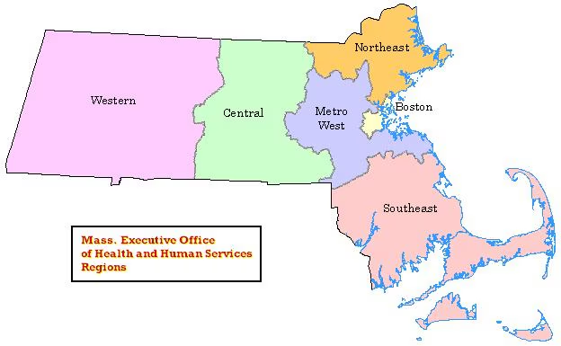

[MassGIS Data: MA Executive Office of Health & Human Services Regions | Mass.gov](https://www.mass.gov/info-details/massgis-data-ma-executive-office-of-health-human-services-regions)