Water Damage Investigation

McAvinnue Elementary School
131 Mammoth Road
Lowell, Massachusetts

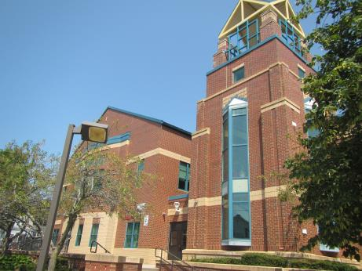

Prepared by:
Massachusetts Department of Public Health
Bureau of Environmental Health
Indoor Air Quality Program
August 2018

Background
Building: | McAvinnue Elementary School (MES)
Address: | 131 Mammoth Road, Lowell
Assessment Requested by: | Rick Underwood, Director of Operations,  Lowell Public Schools
Reason for Request: | Water damage/mold concerns on ceiling tiles/items and surfaces in classroom 109 and condensation in classroom 210. Several other classrooms were also observed for comparison.
Date of Assessment: | August 24, 2018
Massachusetts Department of Public Health/Bureau of Environmental Health (MDPH/BEH) Staff Conducting Assessment: | Jason Dustin, Environmental Analyst/Inspector, IAQ Program
Building Description: | The MES is a two-story brick structure reportedly opened in 1993 and contains approximately 60,000 square feet.
Windows: | Openable

Methods
BEH/IAQ staff conducted a visual assessment of suspect classroom items for water damage and possible mold colonization. Please refer to the IAQ Manual and appendices for methods, sampling procedures, and interpretation of results (MDPH, 2015).

Results and Discussion
A heating, ventilating, and air conditioning (HVAC) system has several functions. First it provides heating and, if equipped, cooling. Second, it is a source of fresh air. Finally, an HVAC system will dilute and remove normally occurring indoor environmental pollutants by not only introducing fresh air, but also filtering the airstream and ejecting stale air to the outdoors via exhaust ventilation. The act of cooling/providing air conditioning is two-fold; the system chills the air via cooling coils while also typically removing moisture from the air.
Moisture removal is important since the sensation of heat conditions increases as relative humidity (RH) increases (the relationship between temperature and RH is called the heat index). As indoor temperatures rise, the addition of more RH will make occupants feel hotter. If moisture is removed, the comfort of the individuals is improved.
While temperature is mainly a comfort issue, RH in excess of 70 percent for extended periods of time can provide an environment for mold and fungal growth (ASHRAE, 1989).Visual inspection of classrooms indicates that elevated indoor RH levels experienced over the summer have resulted in some ceiling tiles and other items becoming moistened, which has led to mold growth. In addition, condensation moistening dust and debris collected on non-porous surfaces, including tables and rigid insulation can become a source of mold growth.

- Classroom 109: MES facilities personnel reported that numerous ceiling tiles had become mold-colonized. In addition, dust/debris on surfaces (e.g., desks) were colonized with mold in some areas of this room. During this assessment, all but one of the affected ceiling tiles had already been discarded but new tiles were not yet in place (Picture 1 and 2). In addition, it was reported that the room had been fogged with an antimicrobial product and all surfaces cleaned twice thoroughly. The carpet was clean and dry and no musty odors were detected. However, there appeared to be some spots of colonization on the rigid pipe insulation above the ceiling tile system in one area, likely on dust/debris on the insulation (Picture 3). The MES was reported to utilize ducted return lines rather than a ceiling plenum return system which will greatly reduce the risk of entrainment into the HVAC system (Picture 4).
- Classroom 210: This room was reported to have had several water-damaged ceiling tiles due to insufficient insulation of the HVAC cooling lines above. Since the temperature of the cooling lines was likely well below the dew point temperature, condensation was responsible for this water damage. These tiles had already been discarded and contractors were finishing the new insulation of the HVAC cooling lines during the assessment (Picture 5). No other porous materials appeared to be affected by water damage. The floor and walls were nonporous and easily cleanable (e.g. tile and concrete block). MES facilities personnel stated that this room will be thoroughly cleaned following the completion of the work.

The US Environmental Protection Agency (US EPA) and the American Conference of Governmental Industrial Hygienists (ACGIH) recommends that porous materials (e.g., ceiling tiles, carpeting) be dried with fans and heating within 24 to 48 hours of becoming wet (US EPA, 2008; ACGIH, 1989). If porous materials are not dried within this time frame, mold growth may occur. If porous materials become mold-colonized they should be discarded as they cannot be effectively cleaned.
Symptoms commonly associated with molds include allergic reactions and respiratory irritation. Some people with chronic respiratory conditions, such as asthma, are more likely to experience health symptoms. Controlling moisture is the key to preventing mold growth and potential health symptoms.

Other Conditions
Other conditions that can affect IAQ were observed during the assessment. Some areas have area rugs. The Institute of Inspection, Cleaning, and Restoration Certification (IICRC) recommends that carpeting be cleaned annually (or semi-annually in soiled high traffic areas) (IICRC, 2012). Regular cleaning with a high efficiency particulate air (HEPA) filtered vacuum in combination with an annual cleaning will help to reduce accumulation and potential aerosolization of materials from carpeting.
Floor temperatures were taken with an infrared thermometer; these were measured at 75°F. The dew point temperature of 60°F and the relative humidity of 64% should prevent further mold growth and condensation barring any future extreme humidity events.

Conclusions and Recommendations
In view of the findings at the time of the visit, the following recommendations are made:
- Continue to discard any remaining porous items if found to be colonized with mold (e.g., ceiling tiles, seat cushions, area rugs, cardboard) or water-damaged.
- Inspect the water-damaged cooling line insulation closely. If colonization appears to be on the surface (in dust/debris) then these areas may be cleaned with mild detergent. If the colonization has penetrated the nonporous coating and entered into the fabric wrapping or insulation, then the insulation would need to be cut out, discarded and replaced with new insulation
- Perform any work during unoccupied hours and thoroughly clean the area and surfaces after work is complete.
- Clean supply and exhaust/return vents of accumulated debris regularly.
- Replace all water-damaged/missing ceiling tiles.
- Consider using dehumidifiers in areas prone to excessive moisture/condensation especially during forecasted extended high humidity weather events.
- Ensure that procedures are in place and encourage occupants to report HVAC/maintenance issues so that they can be logged and repaired promptly.
- Clean carpeting and area rugs annually or semi-annually in soiled high traffic areas as per the recommendations of the Institute of Inspection, Cleaning and Restoration Certification (IICRC, 2012).
- For more information about mold/remediation consult Mold Remediation in Schools and Commercial Buildings” published by the US Environmental Protection Agency (US EPA, 2008).
- Refer to resource manual and other related indoor air quality documents located on the MDPH’s website for further building-wide evaluations and advice on maintaining public buildings. These documents are available at http://mass.gov/dph/iaq.

REFERENCES
ACGIH. 1989. Guidelines for the Assessment of Bioaerosols in the Indoor Environment. American Conference of Governmental Industrial Hygienists, Cincinnati, OH.
ASHRAE. 1989. Ventilation for Acceptable Indoor Air Quality. American Society of Heating, Refrigeration and Air Conditioning Engineers. ANSI/ASHRAE 62-1989.
IICRC. 2012. Carpet Cleaning FAQ 4 Institute of Inspection, Cleaning and Restoration Certification. Institute of Inspection Cleaning and Restoration, Vancouver, WA.
MDPH. 2015. Massachusetts Department of Public Health. Indoor Air Quality Manual: Chapters I-III. Available at: http://www.mass.gov/eohhs/gov/departments/dph/programs/environmental-health/exposure-topics/iaq/iaq-manual/.
US EPA. 2008. Mold Remediation in Schools and Commercial Buildings. US Environmental Protection Agency, Office of Air and Radiation, Indoor Environments Division, Washington, D.C. EPA 402-K-01-001. http://www.epa.gov/mold/mold-remediation-schools-and-commercial-buildings-guide.

Picture 1
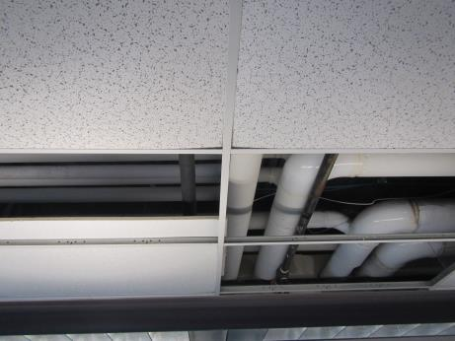
Most water-damaged or mold-colonized ceiling tiles were removed prior to this assessment
Picture 2
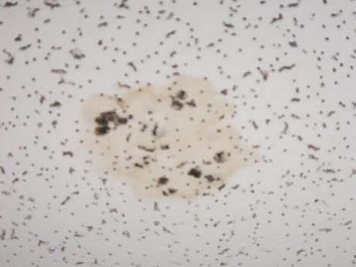
Single remaining water-damaged ceiling tile remaining above light fixture in classroom 109 (to be removed)
Picture 3
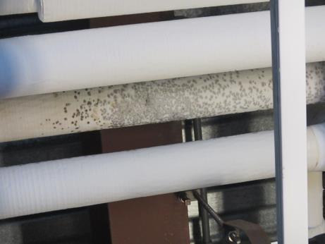
Spots of mold-colonization on outside of cooling line insulation
Picture 4
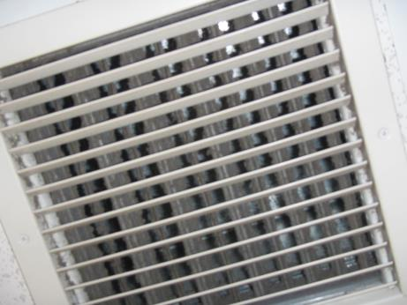
Ducted return line in classroom 109 (note dust on vent)
Picture 5
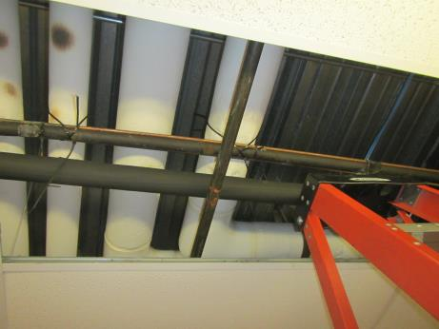
New cooling line insulation being installed in classroom 210 where condensation occurred

