INDOOR AIR QUALITY ASSESSMENT

Mass Commission for the Blind and
Mass Commission for the Deaf and Hard of Hearing
600 Washington Street, 3rd Floor, Boston, MA

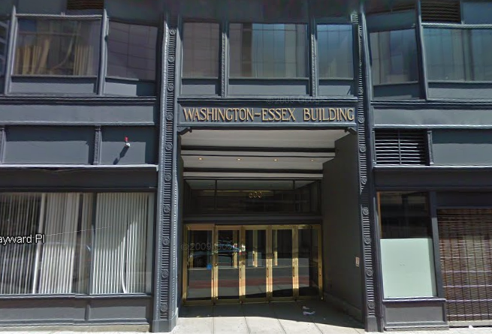

Prepared by:
Massachusetts Department of Public Health
Bureau of Environmental Health
Indoor Air Quality Program
November 2017

Background
Building: | MA Commission for the Blind/MA Commission for the Deaf and Hard of Hearing
Address: | 600 Washington Street, 3rd Floor, Boston
Assessment Requested by: | Sharlene Sharif, Executive Office of Health and Human Services (EOHHS) Field Operations
Reason for Request: | General Indoor Air Quality (IAQ) and health concerns
Date of Assessment: | October 30, 2017
Massachusetts Department of Public Health/Bureau of Environmental Health (MDPH/BEH) Staff Conducting Assessment: | Ruth Alfasso, Environmental Engineer, indoor air quality (IAQ) Program
Building Description: | The offices examined are on the 3rd floor of a seven-story, brick-faced building. The building underwent interior renovations in 2011. It has a flat roof with a black rubber membrane.
Windows: | Not openable

Methods
Please refer to the IAQ Manual for methods, sampling procedures, and interpretation of results (MDPH, 2015).

IAQ Testing Results
The following is a summary of indoor air testing results (Table 1).
- Carbon dioxide levels were below 800 parts per million (ppm) in all but one area surveyed, indicating adequate air exchange.
- Temperature was within the recommended range of 70°F to 78°F in all areas tested.
- Relative humidity was within or slightly above the recommended range of 40 to 60% in the areas tested.
- Carbon monoxide levels were non-detectable (ND) in all areas tested.
- Fine particulate matter (PM2.5) concentrations measured were below the National Ambient Air Quality (NAAQS) limit of 35 μg/m³ in all areas tested.

Ventilation
A heating, ventilating and air conditioning (HVAC) system has several functions. First it provides heating and, if equipped, cooling. Second, it is a source of fresh air. Finally, an HVAC system will dilute and remove normally-occurring indoor environmental pollutants by not only introducing fresh air, but by filtering the airstream and ejecting stale air to the outdoors via exhaust ventilation. Even if an HVAC system is operating as designed, point sources of respiratory irritation may exist and cause symptoms in sensitive individuals.
Fresh air is supplied by air handling units and delivered to supply vents located in the ceilings of rooms (Pictures 1 and 2). Return air is drawn through grates using a plenum return (Picture 3). In some areas, such as bathrooms, directly-vented exhausts are present (Picture 4). Note that although supply and return vents are present in open areas, some offices consist of tall partitions that almost reach the ceiling (Picture 5) and not all of these areas have both a supply and return vent near the top. This configuration may make distribution of fresh air, removal of stale air, and temperature control more difficult especially when doors are closed.
It is recommended that HVAC systems be re-balanced every five years to ensure adequate air systems function (SMACNA, 1994). It is not known when the last time these systems were balanced. Balancing should also occur when the space is significantly rearranged.
In a few rooms, strong sunlight was streaming in windows (Table 1) which may contribute to temperature control issues in the office. The use of adjustable blinds to block sunlight and help control temperature in offices with windows is recommended.

Microbial/Moisture Concerns
A few water-damaged ceiling tiles were observed (Pictures 5 and 6). These likely originate with plumbing or HVAC system leaks. Stained tiles should be replaced after a leak is repaired.
Note that some window frames had peeling paint and were otherwise in poor condition, mostly on the outside of the building (Picture 7). No water infiltration was noted or reported, however continued deterioration of window frames can lead to leaks inside.
Plants were observed in some offices and cubicles (Pictures 8 and 9). Some of these plants were in poor condition or located on porous surfaces such as carpet. Plants should be well maintained and not overwatered to prevent odors, water damage, and pests.
Small refrigerators and water dispensers were observed in carpeted areas (Picture 10; Table 1). These appliances may spill or leak and lead to carpet damage and microbial growth. Many of them were placed on waterproof mats already, and it is recommended others be located in areas without carpeting or on waterproof mats. Refrigerators should be kept clean to prevent odors and microbial growth.

Other IAQ Evaluations
Exposure to low levels of total volatile organic compounds (TVOCs) may produce eye, nose, throat, and/or respiratory irritation in some sensitive individuals. To determine if VOCs were present, BEH/IAQ staff examined rooms for products containing VOCs. BEH/IAQ staff noted cleaners, hand sanitizers, air fresheners and other products in use within the building (Picture 9, Table 1). All of these products have the potential to be irritants to the eyes, nose, throat, and respiratory system of sensitive individuals.
Rodent traps were observed in several areas (Picture 10; Table 1). Rodent infestation can result in IAQ-related symptoms due to materials in their wastes. Mouse urine contains a protein that is a known sensitizer (US EPA, 1992). A sensitizer is a material that can produce symptoms (e.g., running nose or skin rashes) in sensitive individuals after repeated exposure. To eliminate exposure to allergens, rodents must be removed from the building. Please note that removal, even after cleaning, may not provide immediate relief since allergens can exist in the interior for several months after rodents are eliminated (Burge, 1995). Once the infestation is eliminated, a combination of cleaning and increased ventilation and filtration should serve to reduce allergens associated with rodents.
Cooking equipment, including toasters (Picture 11), microwave ovens, and coffee machines, were located in various parts of the office space. Food areas and cooking equipment need to be kept clean to prevent odors and pests.

In some areas, stored materials and accumulated items make it more difficult for custodial staff to clean (Picture 12; Table 1). Items should be stored neatly and moved periodically to allow for wet-wiping and vacuuming of surfaces. The configuration of cubicle walls and dividers create some areas that are difficult to access for cleaning, including some that are used for storage of items (Picture 13). Regular examination and cleaning of these areas, including removal of lost items and debris, should be conducted to prevent the areas becoming harborage for pests or a source of odors. Items should also not be stored on top of radiators (e.g., Picture 14) or in the airstream of ventilation equipment as heating and moving air can cause items to release dusts and odors.
Personal fans were observed in a number of areas. Fan blades to some of these units had settled dust, which can be reaerosolized when the fan is activated.
The offices were mostly carpeted. Carpets should be vacuumed regularly with a high efficiency particulate arrestance (HEPA) filter equipped vacuum cleaner and cleaned annually (or semi-annually in soiled/high traffic areas) in accordance with Institute of Inspection, Cleaning and Restoration Certification (IICRC) recommendations, (IICRC, 2012). Note that service animals are regularly present in this office and dog hair and dander are common allergens. Because of this factor and any issues with rodents, frequent and thorough cleaning of carpets is needed to remove hair, dander, debris and associated odors. It was reported that carpets had been deep cleaned a few days before this visit. Wet wiping of surfaces to remove dust and potentially allergenic debris is also recommended.

Conclusions/Recommendations
Based on observations at the time of assessment, the following is recommended:
- Operate supply and exhaust ventilation continuously in all areas during occupied periods. Ensure all HVAC equipment is cleaned/maintained in accordance with manufacturer’s instructions. Avoid piling items on top of radiators
- Have the HVAC system balanced every 5 years in accordance with SMACNA recommendations (SMACNA, 1994). Consider a rebalancing when the building layout is changed.
- Use adjustable blinds to control solar heating and glare.
- For buildings in New England, periods of low relative humidity during the winter are often unavoidable. Therefore, scrupulous cleaning practices should be adopted to minimize common indoor air contaminants whose irritant effects can be enhanced when the relative humidity is low. To control for dusts, a high efficiency particulate arrestance (HEPA) filter equipped vacuum cleaner in conjunction with wet wiping of all surfaces is recommended. Avoid the use of feather dusters. Drinking water during the day can help ease some symptoms associated with a dry environment (throat and sinus irritations).
- Repair plumbing/HVAC leaks and replace water-damaged ceiling tiles.
- Monitor windows for leakage in areas which appear damaged. Report damaged windows to maintenance.
- Keep plants in good condition, avoid overwatering, and remove from the airstream of heating and ventilation equipment.
- Consider the use of waterproof mats underneath all water dispensers and refrigerators to protect carpet. Keep refrigerators clean.
- Reduce the use of cleaning products, sanitizers, and other items that contain VOCs. Minimize the use of scented products.
- Ensure that all cooking equipment is kept clean.
- Use the principles of Integrated Pest Management (IPM) and the services of a licensed pest control operator to remove rodents and reduce the potential for pest infestation. Ensure that any area where rodents may have been is thoroughly cleaned to remove allergens.
- Reduce the amount of items stored on flat surfaces to allow regular cleaning.
- Ensure that areas between cubicle walls and the exterior wall of the building are monitored for debris and cleaned regularly.
- Clean blades of personal fans to prevent aerosolization of dust.
- Deep clean carpeting semi-annually or more frequently due to the presence of dogs and potential rodent issues per the recommendations of the Institute of Inspection, Cleaning and Restoration Certification (IICRC).
- Refer to resource manual and other related IAQ documents located on the MDPH’s website for further building-wide evaluations and advice on maintaining public buildings. These documents are available at: http://mass.gov/dph/iaq.

References
Burge, H.A. 1995. Bioaerosols. Lewis Publishing Company, Boca Raton, FL.
IICRC. 2012. Institute of Inspection, Cleaning and Restoration Certification. Carpet Cleaning: FAQ. Retrieved from http://www.iicrc.org/consumers/care/carpet-cleaning.
MDPH. 2015. Massachusetts Department of Public Health. Indoor Air Quality Manual: Chapters I-III. Available at: http://www.mass.gov/eohhs/gov/departments/dph/programs/environmental-health/exposure-topics/iaq/iaq-manual/.
SMACNA. 1994. HVAC Systems Commissioning Manual. 1st ed. Sheet Metal and Air Conditioning Contractors’ National Association, Inc., Chantilly, VA.
US EPA. 1992. Indoor Biological Pollutants. US Environmental Protection Agency, Environmental Criteria and Assessment Office, Office of Health and Environmental Assessment, research Triangle Park, NC. EPA 600/8-91/202. January 1992.

Picture 1
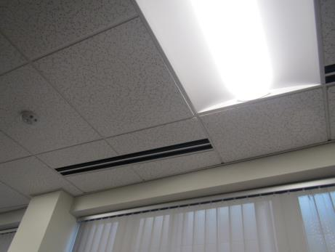
Supply vent along windows
Picture 2
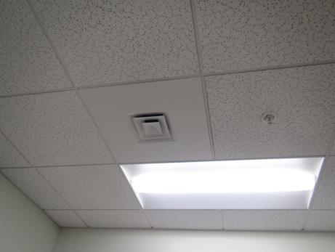
Supply vent
Picture 3
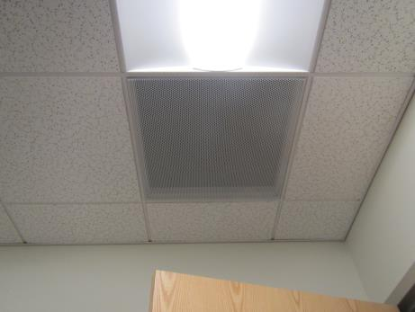
Typical plenum return grill
Picture 4
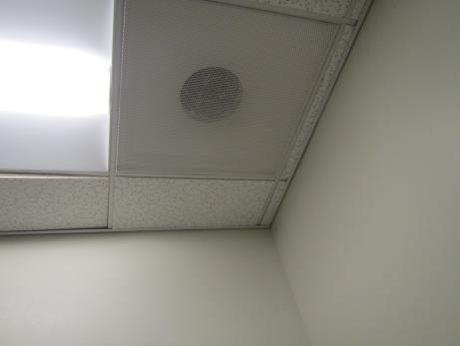
Direct vented exhaust vent
Picture 5
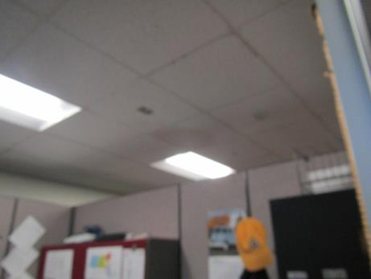
Almost full-height partition walls, also note water-damaged ceiling tile
Picture 6
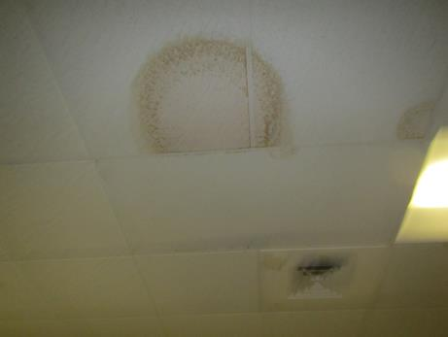
Water-damaged ceiling tile
Picture 7
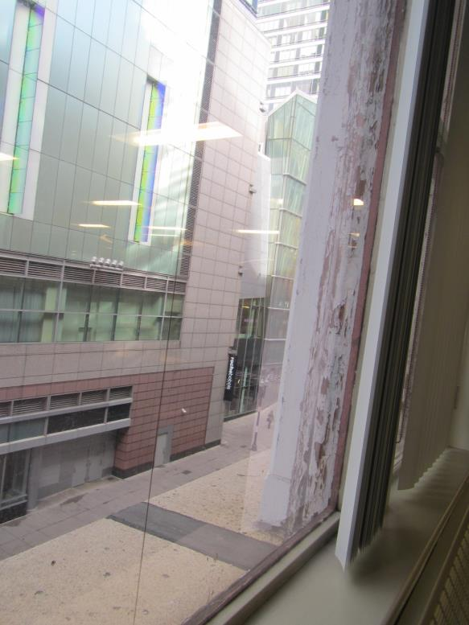
Peeling paint on exterior of window frame
Picture 8
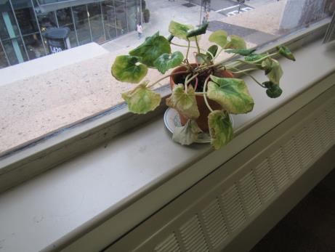
Plant in poor condition with porous materials
Picture 9
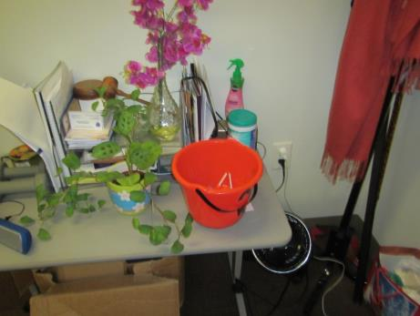
Plant and cleaning materials
Picture 10
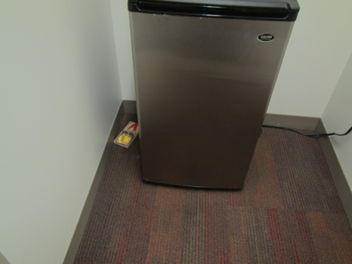
Refrigerator on carpet, also note mousetrap
Picture 11
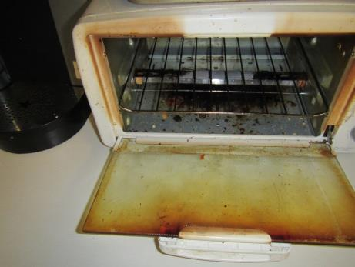
Toaster with crumbs
Picture 12
Papers on a desk
Picture 13
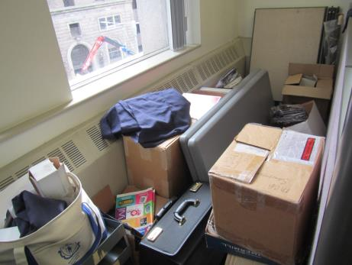
Difficult to access storage area between cubicle dividers and exterior wall
Picture 14
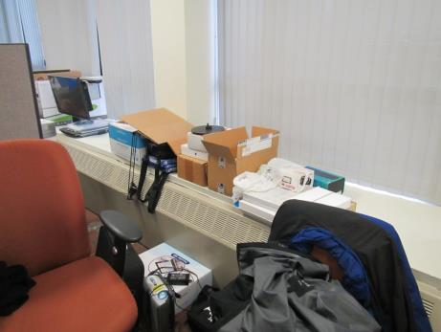
Items on radiator

Location | Carbon  Dioxide  (ppm) | Carbon Monoxide  (ppm) | Temp  (°F) | Relative  Humidity  (%) | PM2.5  (µg/m³) | Occupants  in Room | Windows  Openable | Ventilation |  | Remarks
 |  |  |  |  |  |  |  | Supply | Exhaust
Background | 397 | 0.8 | 69 | 49 |  |  |  |  |  | Very windy, light drizzle
MCB
Restroom |  |  |  |  |  | 0 | N | Y | Y
3079-80 cubes | 533 | ND | 70 | 63 | ND | 2 | N | Y | Y | Items on radiator
3012 cubes | 625 | ND | 73 | 61 | ND | 1 | N | Y | Y
3067 cubes | 515 | ND | 71 | 59 | ND | 0 | N | Y | Y
3069 recording | 514 | ND | 71 | 58 | ND | 0 | N | Y | Y | Microphones, shredder
3070 storage | 510 | ND | 71 | 57 | ND | 0 | N | Y | Y
3071 | 879 | ND | 72 | 65 | 1 | 1 | N | Y | Y
3072 | 583 | ND | 71 | 62 | 1 | 1 | N | Y | Y
3073 | 534 | ND | 71 | 62 | 1 | 0 | N | Y | Y | AI
3075 cubes | 534 | ND | 71 | 62 | 7 | 0 | N | Y | Y | HS, items on radiator
3082 cubes | 615 | ND | 70 | 64 | ND | 0 | N | Y | Y
3084 records | 567 | ND | 71 | 59 | ND | 0 | N | Y | Y | NC
3085 Kitchen | 501 | ND | 73 | 57 | ND | 0 | N | Y | Y | NC, toaster with crumbs, fridge, microwaves
3086 | 506 | ND | 73 | 60 | ND | 0 | N | Y | Y
3087 | 542 | ND | 73 | 60 | ND | 1 | N | Y | Y | Boxes on floor
3088 | 516 | ND | 72 | 61 | ND | 0 | N | Y | Y | DO, return near door
3089 | 520 | ND | 72 | 62 | ND | 1 | N | Y | Y | Boxes on floor
3090 | 507 | ND | 72 | 62 | ND | 0 | N | Y | Y | Scented spray, plant, food, CP, PF, boxes on floor
3092 | 513 | ND | 71 | 64 | 1 | 0 | N | Y | Y | Food
3093 | 519 | ND | 71 | 64 | ND | 0 | N | Y | Y
3094 | 546 | ND | 71 | 64 | ND | 2 | N | Y | Y | WD CT (2)
3095 cubes | 651 | ND | 72 | 62 | ND | 0 | N | Y | Y
3097 cubes | 562 | ND | 72 | 62 | ND | 0 | N | Y | Y
3171-74 cubes | 434 | ND | 74 | 57 | ND | 0 | N | Y | Y | Fake plant in airstream, HS/wipes
3175-78 cubes | 457 | ND | 74 | 57 | ND | 0 | N | Y | Y | HS/wipes
3099 cubes | 541 | ND | 71 | 61 | ND | 0 | N | Y | Y | Boxes on floor
3169-70 cubes | 454 | ND | 74 | 56 | ND | 1 | N | Y | Y | Sunlight, wipes/HS, PF
3100 cubes | 583 | ND | 72 | 62 | ND | 1 | N | Y | Y | HS/wipes, plush item
3105 | 590 | ND | 73 | 59 | ND | 0 | N | Y | Y
3106 | 501 | ND | 74 | 59 | ND | 1 | N | Y | Y | PF, fridge on carpet
3107 | 578 | ND | 74 | 58 | ND | 1 | N | Y | Y | Fridge on carpet in hallway, mousetrap in hallway
3108 | 633 | ND | 75 | 59 | ND | 1 | N | Y | Y
3109 | 592 | ND | 74 | 59 | ND | 0 | N | Y | Y | Boxes on floor, HS
3110 | 518 | ND | 74 | 57 | ND | 0 | N | Y | Y | PF, food
3121 cubes | 508 | ND | 74 | 57 | ND | 0 | N | Y | Y | HS, water cooler on mat
3126 cubes | 503 | ND | 74 | 57 | ND | 0 | N | Y | Y | Items on floor, PF
3129 cubes | 523 | ND | 74 | 57 | ND | 1 | N | Y | Y | PF, HS
3131 cubes | 520 | ND | 74 | 57 | ND | 1 | N | Y | Y | PF
3134 | 483 | ND | 73 | 59 | ND | 0 | N | Y | Y
3135 | 588 | ND | 73 | 58 | ND | 0 | N | Y | Y | AI, papers
3136 | 543 | ND | 73 | 59 | ND | 0 | N | N | Y | AI, HS, AF
3137 cubes | 553 | ND | 73 | 59 | ND | 1 | N | Y | Y
3141 cubes | 512 | ND | 72 | 58 | ND | 0 | N | Y | Y | Plant, PC, AI
3143 cubes | 506 | ND | 76 | 58 | ND | 0 | N | Y | Y | Boxes, CP
3146 cubes | 503 | ND | 73 | 58 | ND | 3 | N | Y | Y
3148 cubes | 514 | ND | 73 | 58 | ND | 0 | N | Y | Y
3151 cubes | 504 | ND | 73 | 57 | ND | 0 | N | Y | Y
3158 | 480 | ND | 73 | 59 | ND | 0 | N | Y | Y | PF, old windows, mouse trap
3159 | 556 | ND | 71 | 59 | ND | 1 | N | Y | Y
3160 | 584 | ND | 73 | 58 | ND | 1 | N | Y | Y | Fridge on carpet, dog, water bowl
3161 conference | 506 | ND | 73 | 58 | ND | 0 | N | Y | Y | Fridge on carpet, microwave
3162 | 514 | ND | 72 | 59 | ND | 1 | N | Y | Y | Shredder
3163 | 522 | ND | 71 | 59 | ND | 0 | N | Y | Y
3164 | 523 | ND | 72 | 59 | ND | 1 | N | Y | Y
3165 | 573 | ND | 72 | 59 | ND | 1 | N | Y | Y | Boxes on floor
3166 | 525 | ND | 72 | 60 | ND | 1 | N | Y | Y | Shredder
3168 | 446 | ND | 74 | 56 | ND | 1 | N | Y | Y | Sunlight, microwave, papers on walls
3180 | 431 | ND | 71 | 57 | ND | 0 | N | Y | Y | Dried/fake plant
3181 | 561 | ND | 71 | 56 | ND | 1 | N | Y | Y | Storage and open space behind cube walls, mousetrap
MCDHH
3007-10 cubes | 409 | ND | 71 | 54 | ND | 2 | N | Y | Y | HS
3058-60 cubes | 523 | ND | 72 | 54 | ND | 2 | N | Y | Y | WD CT (2), fridge on carpet, HS
3030-31 cubes | 464 | ND | 72 | 53 | ND | 0 | N | Y | Y
3005-06 cubes | 408 | ND | 71 | 54 | ND | 0 | N | Y | Y
3011-12 cubes | 447 | ND | 71 | 55 | ND | 0 | N | Y | Y | Items hanging from ceiling
3038-39 | 418 | ND | 70 | 55 | ND | 1 | N | Y | Y
3001 | 459 | ND |  |  |  | 1 | N | Y | Y
3002 | 437 | ND | 72 | 54 | ND | 0 | N | Y | Y | Small conference room, DEM
3003 | 439 | ND | 72 | 55 | ND | 2 | N | Y | Y | AI, concerns about IAQ
3004 | 427 | ND | 71 | 54 | ND | 0 | N | Y | Y
3013 conference | 399 | ND | 71 | 53 | ND | 0 | N | Y | Y
3014 storage/resource room | 425 | ND | 70 | 54 | ND | 0 | N | Y | Y | CP
3016 | 482 | ND | 71 | 54 | ND | 0 | N | Y | Y
3017 | 452 | ND | 71 | 55 | ND | 1 | N | Y | Y | PF, HS
3018 | 462 | ND | 71 | 55 | ND | 1 | N | Y | Y
3019 | 418 | ND | 71 | 54 | ND | 0 | N | Y | Y | PF
3021 | 406 | ND | 71 | 54 | ND | 0 | N | Y | Y
3022 | 407 | ND | 71 | 53 | ND | 0 | N | Y | Y
3023 | 425 | ND | 72 | 54 | ND | 0 | N | Y | Y
3024 | 432 | ND | 71 | 54 | ND | 0 | N | Y | Y | AI
3025 | 416 | ND | 71 | 54 | ND | 0 | N | Y | Y
3027 | 459 | ND | 72 | 55 | ND | 1 | N | Y | Y | HS and wipes
3028 cubes | 396 | ND | 71 | 53 | ND | 0 | N | Y | Y | Damaged plant on windowsill, PF
3029 | 404 | ND | 71 | 53 | ND | 0 | N | Y | Y | HS
3034 cubes | 409 | ND | 71 | 54 | 1 | 0 | N | Y | Y
3037 cubes | 432 | ND | 71 | 56 | ND | 1 | N | Y | Y | AI
3041 | 468 | ND | 70 | 55 | ND | 0 | N | Y | Y | CP, plants, AI
3042 | 534 | ND | 71 | 56 | ND | 1 | N | Y | Y
3043 | 405 | ND | 71 | 54 | ND | 0 | N | Y | Y | DEM, AI
3044 | 393 | ND | 71 | 54 | ND | 1 | N | Y | Y
3045 | 407 | ND | 71 | 54 | 1 | 0 | N | Y | Y | Very cluttered
3046 | 414 | ND | 71 | 54 | 1 | 0 | N | Y | Y | PF
3049 | 444 | ND | 72 | 52 | ND | 0 | N | Y | Y | Fabric items and printer
3050 | 401 | ND | 72 | 53 | ND | 0 | N | Y | Y | Wipes
3051 | 499 | ND | 72 | 52 | ND | 0 | N | Y | Y
3052 | 514 | ND | 72 | 53 | ND | 0 | N | Y | Y
3053 | 502 | ND | 72 | 54 | ND | 1 | N | Y | Y
3056 | 559 | ND | 72 | 54 | ND | 2 | N | Y | Y | Boxes on floor
3061 | 461 | ND | 72 | 53 | ND | 0 | N | Y | Y
3063 | 533 | ND | 72 | 53 | ND | 2 | N | Y | Y | Boxes on floor
3064 cubes | 463 | ND | 73 | 53 | ND | 0 | N | Y | Y
3065 | 470 | ND | 73 | 53 | ND | 0 | N | Y | Y | HS/wipes
3066 | 493 | ND | 73 | 54 | ND | 0 | N | Y | Y

