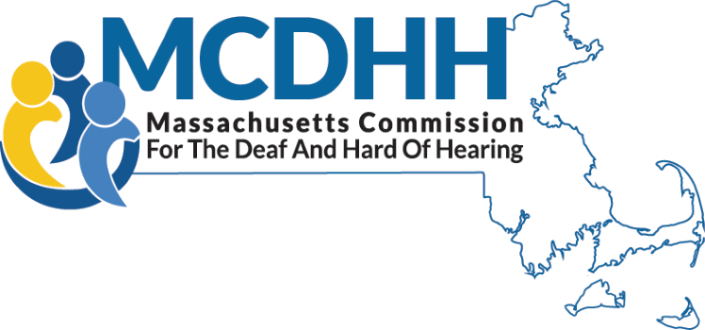

Charles D. Baker

Governor

Karyn E. Polito

Lieutenant Governor

Marylou Sudders

Secretary HHS

Dr. Opeoluwa S. Sotonwa

Commissioner

CHILDREN AND FAMILY SERVICES
The Children and Family Services at Massachusetts Commission for the Deaf and Hard of Hearing provides unique support services to families with children who are Deaf or hard of hearing throughout the Commonwealth.
Children’s Specialists are carefully selected staff experienced in working with children and adolescents with varying degrees of hearing loss. Each staff possesses a wealth of knowledge in communicative and educational choices available for deaf and hard of hearing children. All Children’s Specialists are bilingual in English and American Sign Language (ASL).

CHILDREN’S SPECIALISTS

Boston/North Region
Melissa Dowler
600 Washington Street
Boston, MA 02111
617-694-9781 Cell/Text
617-861-8847 VP
melissa.dowler@mass.gov

South Region
Melissa Adams, LCSW
600 Washington Street
Boston, MA 02111
617-872-4087 Cell/Text
617-409-7496 VP
melissa.adams@mass.gov

Central Region
Terri Pancare, MA
167 Lyman Street
Westborough, MA 01581
508-395-3634 Cell/Text
terri.pancare@mass.gov

Berkshire/Western Region
Emily Graves-Harrison
436 Dwight Street, Suite 204
Springfield, MA 01103
857-208-8009 Cell/Text
413-276-4524 VP
emily.graves-harrison@mass.gov

It is the goal of the Children’s Specialists at MCDHH to empower families and children to access equitable education options, services, and resources in their communities.
SERVICES
    - Parent Education relative to the effects of hearing loss at birth, during childhood and in the teenage years.
    - Identification of Intervention Strategies for parents and others, including the appropriate usage of hearing aids, assistive listening devices and system, alerting and signaling devices, medical procedures, early intervention, communication and language development and more.
    - Objective Information regarding choices for early language development.
    - Information and Referral to specialized services such as mental health (or “behavioral” health or both?), psycho-educational evaluation and testing, speech and language pathologist and audiologists.
    - Technical Assistance to Early Intervention and educational programs regarding the communication needs and cultural perspectives of Deaf and hard of hearing children.
    - Advocacy and Support to families and agencies in the development and utilization of service plans.
    - Connecting Children and Families to recreational and social activities as well as other families and Deaf adult role models.
    - General Case Management services as needed.
All services are free and confidential

Massachusetts Commission for the Deaf and Hard of Hearing
600 Washington Street, Boston, MA 02111
Toll free numbers: 800.882.1155 (V) | 617.326.7546 (VP)
http://www.mass.gov/mcdhh

Updated 9/212022

