Massachusetts Behavioral Health Partnership
Report for Laura Conrad-Laberinto, Program Manager Office of Behavioral Health for MassHealth
Sources: 5368 ESP Encounter Cube, 1/7/18 Run Date

MOBILE CRISIS INTERVENTION KEY INDICATORS: PROVIDER LEVEL
Indicator 1: Number of Distinct MCI Encounters by Provider
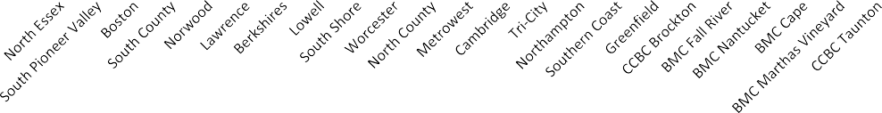Definition: Number of distinct MCI encounters by provider over time, where payers are MassHealth Non-MCE, MassHealth Non-MBHP, Medicare/Medicaid, MassHealth MBHP, OneCare, Careplus, Uninsured, Medicare Only, DMH Only, Health Safety Net, and Commercial with MassHealth TPL.
Number of Distinct MCI Encounters by Provider
(October - December 2017) All Ages
1,300
1,200
1,100
1,000
900
800
700
600
500
400
300
200
100
-
Provider

- Blue shading denotes area one or more standard deviations away from the average across providers.
Number of Distinct MCI Encounters
All Ages
- For All Ages, the mean number of MCI encounters across 23 ESP providers from October through December is 425. The median number of MCI encounters across providers from October through December 2017 is 372.

- Four providers (Cambridge, BMC Nantucket, BMC Cape, and BMC Marthas Vineyard) recorded a number of encounters that are one or more standard deviations below the average. Three providers (North Essex, South Pioneer Valley, and Metrowest) recorded a number of encounters that are one or more standard deviations above the average.
- 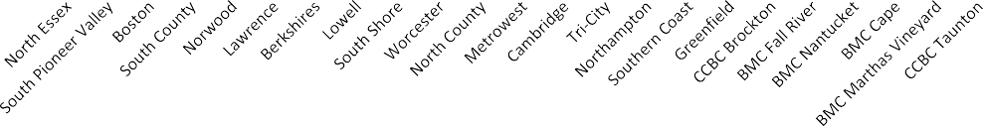Please see Appendix A for a detailed chart.
Number of Distinct MCI Encounters by Provider
(October - December 2017) Age Group 0-14
1,200
1,100
1,000
900
800
700
600
500
400
300
200
100
-
Provider
Number of Distinct MCI Encounters

- Blue shading denotes area one or more standard deviations away from the average across providers.

Age Group 0-14
- For Age Group 0-14, the mean number of MCI encounters across the 23 ESP providers from October through December is 219. The median number of MCI encounters across providers from October through December 2017 is 185.
- Four providers (Cambridge, BMC Nantucket, BMC Cape, and BMC Marthas Vineyard) recorded a number of encounters that are one or more standard deviations below the average. Three providers (North Essex, South Pioneer Valley, and Boston) each recorded a number of encounters that are one or more standard deviations above the average.
- 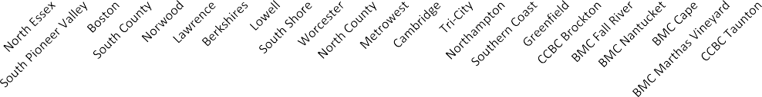Please see Appendix A for a detailed chart.
Number of Distinct MCI Encounters by Provider
(October - December 2017) Age Group 15-18
600
500
400
300
200
100
-
Provider
Number of Distinct MCI Encounters

- Blue shading denotes area one or more standard deviations away from the average across providers.

Age Group 15-18
- For Age Group 15-18, the mean number of MCI encounters across the 23 ESP providers from October through December 2017 is 154. The median number of MCI encounters across providers from October through December 2017 is 143.
- Five providers (Cambridge, Greenfield, BMC Nantucket, BMC Cape, and BMC Marthas Vineyard) recorded a number of encounters that are one or more standard deviations below the average. Three providers (South Pioneer Valley, North Essex and Metro West) recorded a number of encounters that are one or more standard deviations above the average.
- Please see Appendix A for a detailed chart.

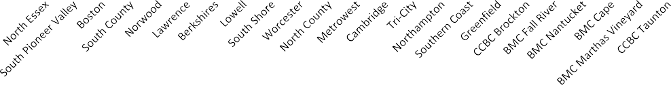

Number of Distinct MCI Encounters by Provider (October - December 2017)
Age Group 19-20
600
500
400
300
200
100
-

Provider
Number of Distinct MCI Encounters

* Blue shading denotes area one or more standard deviations away from the average across providers.
Age Group 19-20
· For Age Group 19-20, the mean number of MCI encounters across the 23 ESP providers from October through December 2017 is 52.
The median number of MCI encounters across providers from October to December is 50.
· Six providers (Cambridge, Greenfield, BMC Fall River, BMC Nantucket, BMC Marthas Vineyard, and CCBC Taunton) recorded a number of encounters that are one or more standard deviations below the average of 40. Three providers (North Essex, South Pioneer Valley and
Boston) recorded a number of encounters that are one or more standard deviations above the average.
· Please see Appendix A for a detailed chart.

Indicator 2: Percent of Encounters Occurring in Community (non- ED) Locations by Provider

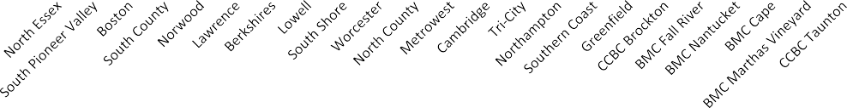Definition: Percent of distinct MCI encounters that occur in a non-ED community location, where payers are MassHealth Non-MCE, MassHealth Non-MBHP, Medicare/Medicaid, MassHealth MBHP, OneCare, Careplus, Uninsured, Medicare Only, DMH Only, Health Safety Net, and Commercial with MassHealth TPL. Community locations encompass mobile locations and the Community-Based Locations (CBLs), which are service delivery sites operated by the ESP. Some of the ESPs refer to these CBLs as urgent care centers (UCCs).
Percent of Encounters Occurring in Community (non- ED) Locations by Provider
(October - December 2017)
All Ages
100%
90%
80%
70%
60%
50%
40%
30%
20%
10%
0%
Provider

- Blue shading denotes area one or more standard deviations away from the average across providers.
Percent of Encounters Occurring in Community
All Ages

- For All Ages, the average percent of MCI encounters occurring in a community location across the 23 ESP providers is 54% percent from October through December 2017. The median percentage of MCI encounters occuring in community locations is 53%. Three providers (Lowell, Cambridge and CCBC Brockton) are one or more standard deviations below the provider average. Four providers (Greenfield, BMC Fall River, Tri-City and Norwood) are one or more standard deviations above the provider average.
- 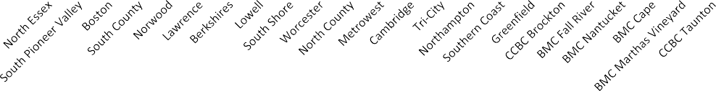Please see Appendix B for a detailed chart.
Percent of Encounters Occurring in Community (non- ED) Locations by Provider
(October - December 2017) Age Group 0-14
100%
90%
80%
70%
60%
50%
40%
30%
20%
10%
0%
Provider
Percent of Encounters Occurring in Community

- Blue shading denotes area one or more standard deviations away from the average across providers.
Age Group 0-14

- For Age Group 0-14, the average percent of MCI encounters occurring in a community location across the 23 ESP providers is 67% from October through December 2017. The median percentage of MCI encounters occuring in community locations is 67%. Three providers (Lowell, Northampton, and Cambridge) are one or more standard deviations below the provider average. Four providers (Metrowest, Tri-City, Greenfield and BMC Fall River) are substantially above the provider average.
- Please see Appendix B for a detailed chart.

- 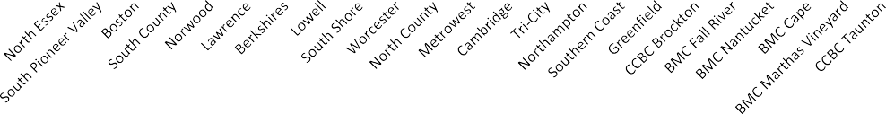Blue shading denotes area one or more standard deviations away from the average across providers.
Percent of Encounters Occurring in Community (non- ED) Locations by Provider
(October - December 2017) Age Group 15-18
100%
90%
80%
70%
60%
50%
40%
30%
20%
10%
0%
Provider
Percent of Encounters Occurring in Community

Age Group 15-18

- For Age Group 15-18, the average percent of MCI encounters occurring in a community location across the 23 ESP providers is 46% from October through December 2017. The median percentage of MCI encounters occuring in community locations is 46%. Six providers (Lawrence, Lowell, Cambridge, CCBC Brockton, BMC Nantucket and BMC Cape) are one or more standard deviations below the provider average. Two providers (Norwood and Tri-City) are one or more standard deviations above the provider average.
- 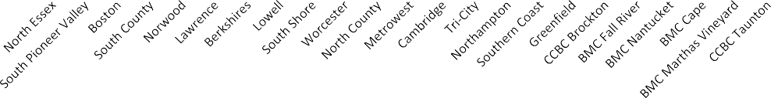Please see Appendix B for a detailed chart.
Percent of Encounters Occurring in Community (non- ED) Locations by Provider
(October - December 2017) Age Group 19-20
100%
90%
80%
70%
60%
50%
40%
30%
20%
10%
0%
Provider
Percent of Encounters Occurring in Community

- Blue shading denotes area one or more standard deviations away from the average across providers.
Age Group 19-20

- For Age Group 19-20, the average percent of MCI encounters occurring in a community location across the 23 ESP providers is 25% from October through December 2017. The median percentage of MCI encounters occuring in community locations is 25%. Four providers (Cambridge, CCBC Brockton, BMC Nantucket, and BMC Marthas Vineyard) are one or more standard deviations below the provider average while two providers (Greenfield and BMC Fall River) are one or more standard deviations above the provider average.
- Please see Appendix B for a detailed chart.

Indicators 3 - 5: % of MCI Encounters Occurring in Mobile, ESP/CB/UCC and ED Location by Provider

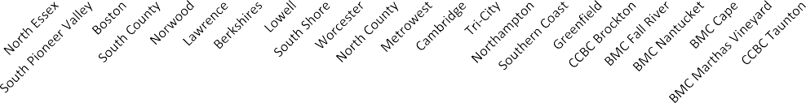Definition: Percent of distinct MCI encounters that occur in community (Mobile and ESP/CB/UCC) and ED Locations, where payers are MassHealth Non-MCE, MassHealth Non-MBHP, Medicare/Medicaid, MassHealth MBHP, OneCare, Careplus, Uninsured, Medicare Only, DMH Only, Health Safety Net, and Commercial with MassHealth TPL.
% of MCI Encounters Occurring in Mobile Location by Provider
(October - December 2017) All Ages
100%
90%
80%
70%
60%
50%
40%
30%
20%
10%
0%
Provider
Percent of Distinct MCI Encounters

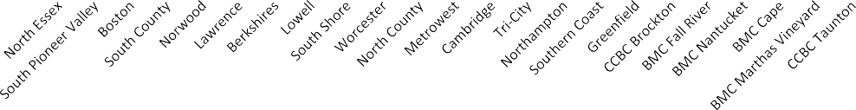Mean: 32% SD: 15%
% of MCI Encounters Occurring in ESP/CB/UCC Location by Provider
(October - December 2017) All Ages
100%
90%
80%
70%
60%
50%
40%
30%
20%
10%
0%
Provider
Percent of Distinct MCI Encounters

Mean: 22% SD: 14%

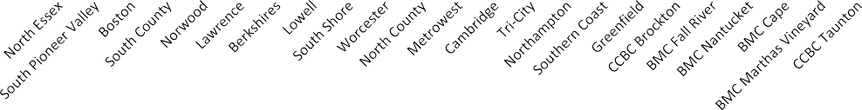Mean: 46% SD: 9%

% of MCI Encounters Occurring in ED Location by Provider (October - December 2017)
All Ages
100%
90%
80%
70%
60%
50%
40%
30%
20%
10%
0%

Provider
Percent of Distinct MCI Encounters
- Blue shading denotes area one or more standard deviations away from the average across providers.
All Ages
- For All Ages, the above graphs show the percent of distinct MCI encounters occurring in Mobile, ESP/CB/UCC and ED locations from October through December 2017. The average percent of encounters in each location across the 23 ESP provider groups are 32, 22, and 46 percent respectively.
- 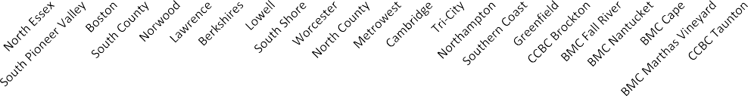Please see Appendix C for a detailed chart.
% of MCI Encounters Occurring in Mobile Location by Provider
(October - December 2017) Age Group 0-14
100%
90%
80%
70%
60%
50%
40%
30%
20%
10%
0%
Provider
Percent of Distinct MCI Encounters

Mean: 42% SD: 19%

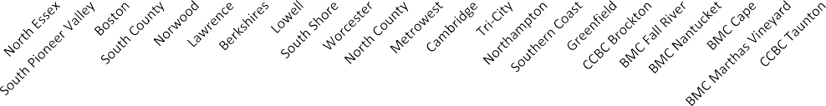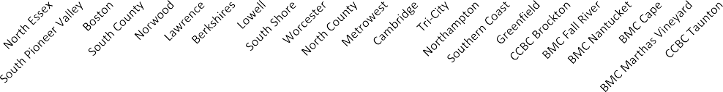Mean: 25% SD: 17%

% of MCI Encounters Occurring in ESP/CB/UCC Location by Provider
(October - December 2017) Age Group 0-14
100%
90%
80%
70%
60%
50%
40%
30%
20%
10%
0%

Provider
% of MCI Encounters Occurring in ED Location by Provider
(October - December 2017) Age Group 0-14
100%
90%
80%
70%
60%
50%
40%
30%
20%
10%
0%
Provider
Percent of Distinct MCI Encounters
Percent of Distinct MCI Encounters

Mean: 33% SD: 8%
- Blue shading denotes area one or more standard deviations away from the average across providers.

Ages 0-14
- For Age 0-14, the above graphs show the percent of distinct MCI encounters occurring in Mobile, ESP/CB/UCC and ED locations from October through December 2017. The average percent of encounters in each location across the 23 ESP provider groups are 42, 25 and 33 percent respectively.
- 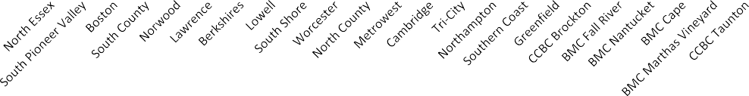Please see Appendix C for a detailed chart.
% of MCI Encounters Occurring in Mobile Location by Provider
(October - December 2017)
Age Group 15-18
100%
90%
80%
70%
60%
50%
40%
30%
20%
10%
0%
Provider
Percent of Distinct MCI Encounters

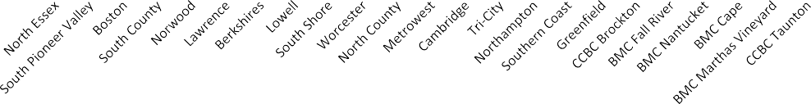Mean: 25% SD: 12%
% of MCI Encounters Occurring in ESP/CB/UCC Location by Provider
(October - December 2017) Age Group 15-18
100%
90%
80%
70%
60%
50%
40%
30%
20%
10%
0%
Provider
Percent of Distinct MCI Encounters

Mean: 21% SD: 14%

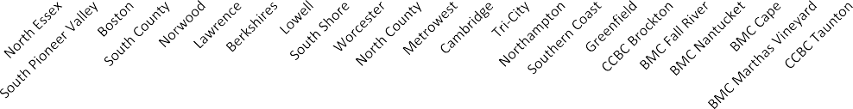Mean: 54% SD: 12%

% of MCI Encounters Occurring in ED Location by Provider (October - December 2017)
Age Group 15-18
100%
90%
80%
70%
60%
50%
40%
30%
20%
10%
0%

Provider
Percent of Distinct MCI Encounters
- Blue shading denotes area one or more standard deviations away from the average across providers.

Age Group 15-18
- For Age Group 15-18, the above graphs show the percent of distinct MCI encounters occurring in Mobile, ESP/CB/UCC and ED locations from October through December 2017. The average percent of encounters in each location across the 23 ESP provider groups are 25, 21 and 54 percent respectively.
- 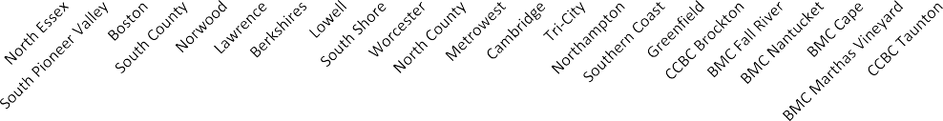Please see Appendix C for a detailed chart.
% of MCI Encounters Occurring in Mobile Location by Provider
(October - December 2017) Age Group 19-20
100%
90%
80%
70%
60%
50%
40%
30%
20%
10%
0%
Provider
Percent of Distinct MCI Encounters

Mean: 11% SD: 10%

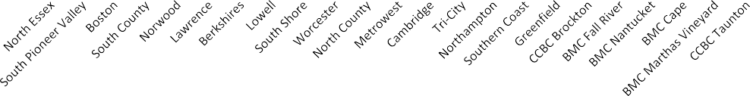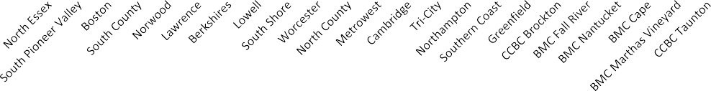Mean: 14% SD: 12%

% of MCI Encounters Occurring in ESP/CB/UCC Location by Provider
(October - December 2017) Age Group 19-20
100%
90%
80%
70%
60%
50%
40%
30%
20%
10%
0%

Provider
% of MCI Encounters Occurring in ED Location by Provider
(October - December 2017)
Age Group 19-20
100%
90%
80%
70%
60%
50%
40%
30%
20%
10%
0%
Provider
Percent of Distinct MCI Encounters
Percent of Distinct MCI Encounters

Mean: 70% SD: 21%
- Blue shading denotes area one or more standard deviations away from the average across providers.

Age Group 19-20
- For Age Group 19-20, the above graphs show the percent of distinct MCI encounters occurring in Mobile, ESP/CB/UCC and ED locations from October through December 2017. The average percent of encounters in each location across the 23 ESP provider groups are 11, 14 and 70 percent respectively.
- Please see Appendix C for a detailed chart.

Indicator 6: Percent of MCI Encounters Resulting in Inpatient Admission by Provider

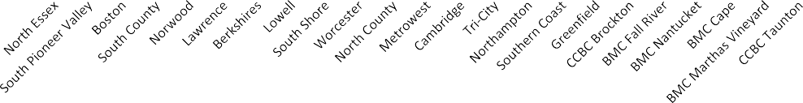Definition: Percent of distinct MCI encounters with a primary disposition of inpatient psychiatric private, inpatient psychiatric general, observation bed (up to 23 hours) or intensive observation bed (up to 72 hours), where payers are MassHealth Non-MCE, MassHealth Non-MBHP, Medicare/Medicaid, MassHealth MBHP, OneCare, Careplus, Uninsured, Medicare Only, DMH Only, Health Safety Net, and Commercial with MassHealth TPL.

Percent of MCI Encounters Resulting in Inpatient Admission by Provider (October - December 2017)
All Ages
100%
90%
80%
70%
60%
50%
40%
30%
20%
10%
0%

Provider

- Blue shading denotes area one or more standard deviations away from the average across providers.
Percent of MCI Encounters Resulting in Inpatient
Admission
All Ages
- For All Ages, the average percent of MCI encounters resulting in inpatient admission (inpatient psychiatric at a private hospital, inpatient psychiatric at a general/acute care hospital, observation bed or intensive observation bed) across the 23 ESP providers is 17% from October through December 2017.
- There are four providers (South Pioneer Valley, Worcester, Greenfield, and BMC Nantucket) whose percent of MCI encounters resulting in inpatient admission is one or more standard deviations below the provider average. Two providers (Cambridge and BMC Cape) are one or more standard deviations above the provider average.
- 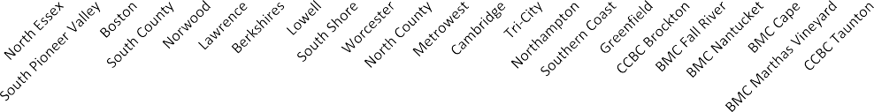Please see Appendix D for a detailed chart.

Percent of MCI Encounters Resulting in Inpatient Admission by Provider (October - December 2017)
Age Group 0-14
100%
90%
80%
70%
60%
50%
40%
30%
20%
10%
0%

Provider
Percent of MCI Encounters Resulting in Inpatient
Admission

- Blue shading denotes area one or more standard deviations away from the average across providers.
Age Group 0-14
- For Age Group 0-14, the average percent of MCI encounters resulting in inpatient admission (inpatient psychiatric at a private hospital, inpatient psychiatric at a general/acute care hospital, observation bed or intensive observation bed) across the 23 ESP providers is 9% from October through December 2017.

- There are six providers (South County, Berkshires, Worcester, Southern Coast, Greenfild, and BMC Nantucket) whose percent of MCI encounters resulting in inpatient admission is one or more standard deviations below the provider average. Two providers (Cambridge and BMC Cape) are one or more standard deviations above the provider average.
- Please see Appendix D for a detailed chart.

- 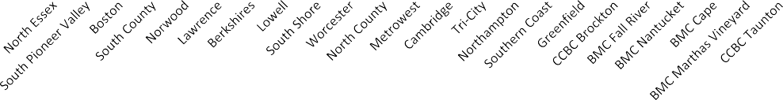Blue shading denotes area one or more standard deviations away from the average across providers.
Percent of MCI Encounters Resulting in Inpatient Admission by Provider
(October - December 2017) Age Group 15-18
100%
90%
80%
70%
60%
50%
40%
30%
20%
10%
0%
Provider
Percent of MCI Encounters Resulting in Inpatient
Admission

Age Group 15-18
- For Age Group 15-18, the average percent of MCI encounters resulting in inpatient admission (inpatient psychiatric at a private hospital, inpatient psychiatric at a general/acute care hospital, observation bed or intensive observation bed) across the 23 ESP providers is 21% from Octomber through December 2017.

- Two providers (Worcester and BMC Nantucket) who have MCI encounters resulting in inpatient admission are one or more standard deviations below the provider average. Three providers (BMC Cape, ) are one or more standard deviations above the provider average.
- 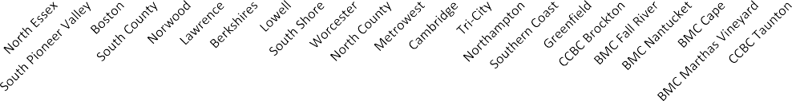Please see Appendix D for a detailed chart.
Percent of MCI Encounters Resulting in Inpatient Admission by Provider
(October - December 2017)
Age Group 19-20
100%
90%
80%
70%
60%
50%
40%
30%
20%
10%
0%
Provider
Percent of MCI Encounters Resulting in Inpatient
Admission

- Blue shading denotes area one or more standard deviations away from the average across providers.
Age Group 19-20
- For Age Group 19-20, the average percent of MCI encounters resulting in inpatient admission (inpatient psychiatric at a private hospital, inpatient psychiatric at a general/acute care hospital, observation bed or intensive observation bed) across the 23 ESP providers is 36% from October through December 2017.

- Two providers (BMC Nantucket and BMC Marthas Vineyard) have a percent of MCI encounters resulting in inpatient admission is one or more standard deviations below the provider average. One provider, Cambridge is substantially more than one standard deviations above the provider average.
- Please see Appendix D for a detailed chart.

Indicator 7: Average Response Time by Provider

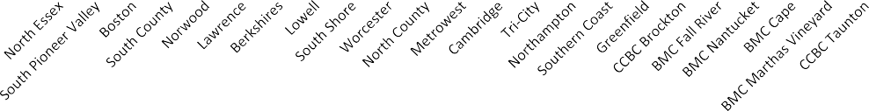Definition: Average amount of time in minutes between the time the youth is ready to begin the intervention to the start time of MCI encounter, where payers are MassHealth Non-MCE, MassHealth Non-MBHP, Medicare/Medicaid, MassHealth MBHP, OneCare, Careplus, Uninsured, Medicare Only, DMH Only, Health Safety Net, and Commercial with MassHealth TPL.
Average Response Time by Provider
(October - December 2017) All Ages
150
125
100
75
50
25
0
Average Response Time

- Blue shading denotes area one or more standard deviations away from the average across providers.
All Ages
- For All Ages, average response time across the 23 ESP providers is 46 minutes from October through December 2017. Three provider (Berkshires, Northampton and BMC Nantucket) has an average response time that is one or more standard deviations below the provider average. Four providers (South Pioneer Valley, Lawrence, Worcester and North County) have an average response time that is one or more standard deviations above the provider average.
- Please see Appendix E for a detailed chart.

- 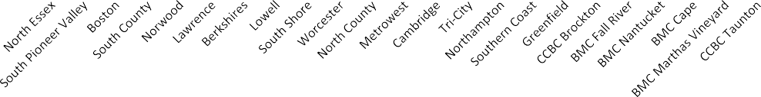Blue shading denotes area one or more standard deviations away from the average across providers.

Average Response Time by Provider (October - December 2017)
Age Group 0-14
150
125
100
75
50
25
0
Average Response Time
Age Group 0-14
- For Age Group 0-14, average response time across the 23 ESP providers is 41 minutes from October through December 2016. Seven providers (Berkshires, South Shore, Metrowest, Tri-City, Northampton, Greenfield and BMC Nantucket) have an average response time that is one or more standard deviations below the provider average. Three providers (South Pioneer Valley, Worcester, and North County) have an average response time that is one or more standard deviations above the provider average.
- 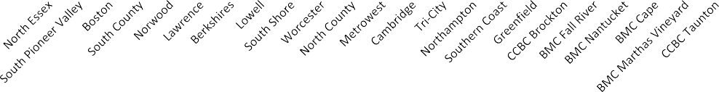Please see Appendix E for a detailed chart.
Average Response Time by Provider
(October - December 2017)
Age Group 15-18
150
125
100
75
50
25
0
Average Response Time

- Blue shading denotes area one or more standard deviations away from the average across providers.

Age Group 15-18
- For Age Group 15-18, average response time across the 23 ESP providers is 48 minutes from October through December 2017. Three providers (Northampton, BMC Nantucket, and BMC Marthas Vineyard) have an average response time that is one or more standard deviations below the provider average. Four providers (South Pioneer Valley, Lawrence, Worcester, and North County) have an average response time that is one or more standard deviations above the provider average.
- 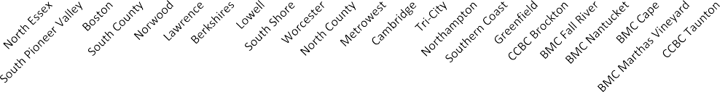Please see Appendix E for a detailed chart.
Average Response Time by Provider
(October - December 2017)
Age Group 19-20
250
200
150
100
50
0
Average Response Time

- Blue shading denotes area one or more standard deviations away from the average across providers.
Age Group 19-20
- For Age Group 19-20, average response time across the 23 ESP providers is 57 minutes from October through December 2017. Two providers (Berkshires and BMC Nantucket) have an average response time that is one or more standard deviations below the provider average. Three providers ( Lawrence, Worcester, and North County) have an average response time that is one or more standard deviations above the provider average.
- Please see Appendix E for a detailed chart.

Indicator 8: Percent of MCI Encounters with Response Time < 60 Minutes by Provider

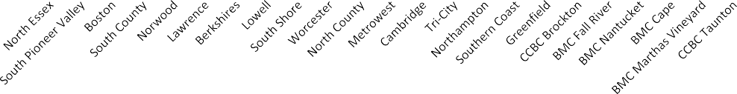Definition: Percent of MCI encounters with less than 60 minutes between the time the youth is ready to begin the intervention to the start time of MCI encounter, where payers are MassHealth Non-MCE, MassHealth Non-MBHP, Medicare/Medicaid, MassHealth MBHP, OneCare, Careplus, Uninsured, Medicare Only, DMH Only, Health Safety Net, and Commercial with MassHealth TPL.
Percent of MCI Encounters with Response Time < 60 Minutes by Provider
(October - December 2017)
All Ages
100%
90%
80%
70%
60%
50%
40%
30%
20%
10%
0%

- Blue shading denotes area one or more standard deviations away from the average across providers.
Percent of MCI Encounters with Response Time < 60 Minutes
All Ages

- For All Ages, across the 23 ESP providers, the average percent of MCI encounters with a response time less than 60 minutes is 78% from October through December 2017. Five providers (South Pioneer Valley, Boston, Lowell, Cambridge, and BMC Cape) have an average response time that is one or more standard deviations below the provider average. Five providers (Northampton, BMC Nantucket, and BMC Marthas Vineyard) have an average response time that is one or more standard deviations above the average.
- 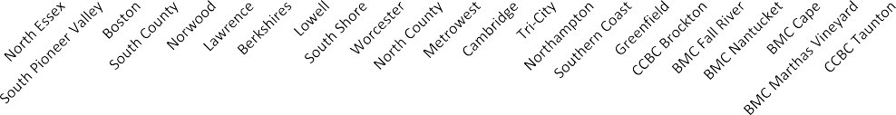Please see Appendix F for a detailed chart.
Percent of MCI Encounters with Response Time < 60 Minutes by Provider
(October - December 2017)
Age Group 0-14
100%
90%
80%
70%
60%
50%
40%
30%
20%
10%
0%
Percent of MCI Encounters with Response Time < 60 Minutes

- Blue shading denotes area one or more standard deviations away from the average across providers.

Age Group 0-14
- For Age Group 0-14, across the 23 ESP providers, the average percent of MCI encounters with a response time less than 60 minutes is 80% from October through December 2017. Five providers (South Pioneer Valley, Boston, Lowell, Cambridge, and BMC Cape) have an average response time that is one or more standard deviations below the provider average. Three providers (Tri-City, Northampton, and BMC Nantucket) have an average response time that is one or more standard deviations above the average.
- 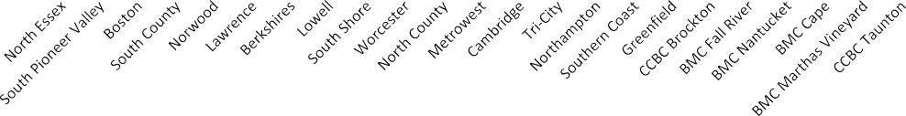Please see Appendix F for a detailed chart.
Percent of MCI Encounters with Response Time < 60 Minutes by Provider
(October - December 2017) Age Group 15-18
100%
90%
80%
70%
60%
50%
40%
30%
20%
10%
0%
Percent of MCI Encounters with Response Time < 60 Minutes

- Blue shading denotes area one or more standard deviations away from the average across providers.
Age Group 15-18
- For Age Group 15-18, across the 23 ESP providers, the average percent of MCI encounters with a response time less than 60 minutes is 77% from October through December 2017. Six providers (South Pioneer Valley, Boston, Lawrence, North County,Cambridge, and BMC Cape) have an average response time that is one or more standard deviations below the provider average. Three providers (Northampton, BMC Nantucket, and BMC Marthas Vineyard) have an average response time that is one or more standard deviations above the average.
- 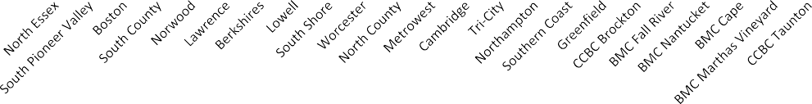Please see Appendix F for a detailed chart.
Percent of MCI Encounters with Response Time < 60 Minutes by Provider
(October - December 2017) Age Group 19-20
100%
90%
80%
70%
60%
50%
40%
30%
20%
10%
0%
Percent of MCI Encounters with Response Time < 60 Minutes

- Blue shading denotes area one or more standard deviations away from the average across providers.
Age Group 19-20
- For Age Group 19-20, across the 23 ESP providers, the average percent of MCI encounters with a response time less than 60 minutes is 69% from October through December 2017. Three providers (Lowell, Cambridge, and BMC Marthas Vineyard) had an average response time that is one or more standard deviations below the provider average. Two providers (Norwood, and BMC Nantucket) have an average response time that is one or more standard deviations above the average.
- Please see Appendix F for a detailed chart.

Indicator 9: Percent of MCI Encounters Resulting in CBAT Admission by Provider

Definition: Percent of distinct MCI encounters with a primary disposition of Community-Based Acute Residential Treatment (CBAT), where payers are MassHealth Non-MCE, MassHealth Non-MBHP, Medicare/Medicaid, MassHealth MBHP, OneCare, Careplus, Uninsured, Medicare Only, DMH Only, Health Safety Net, and Commercial with MassHealth TPL.

- 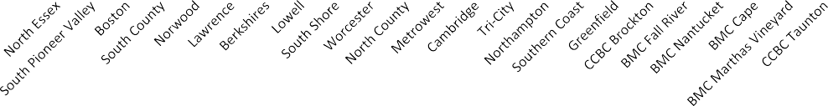Blue shading denotes area one or more standard deviations away from the average across providers.

Percent of MCI Encounters Resulting in CBAT Admission by Provider (October - December 2017)
All Ages
50%
40%
30%
20%

10%

0%
Percent of MCI Encounters with Response Time < 60 Minutes
All Ages
- For All Ages, the average percent of MCI encounters resulting in CBAT admission across the 23 providers is 8% from October through December 2017.
- There are four providers (South Shore, Cambridge, Tri-City, and BMC Marthas Vineyard) whose percent of MCI encounters resulting in CBAT admission is one or more standard deviations below the provider average. Three providers (Southern Coast, North County and Norwood) are one or more standard deviations above the provider average.
- 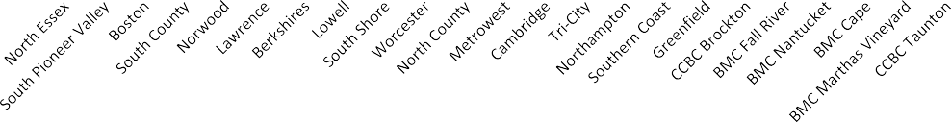Please see Appendix G for a detailed chart.

Percent of MCI Encounters Resulting in CBAT Admission by Provider (October - December 2017)
Age Group 0-14
50%

40%

30%
20%
10%

0%
Percent of MCI Encounters with Response Time < 60 Minutes

- Blue shading denotes area one or more standard deviations away from the average across providers.

Age Group 0-14
- For Age Group 0-14, the average percent of MCI encounters resulting in CBAT admission across the 23 providers is 11% from October through December 2017.
- There is four providers (South Pioneer Valley, South Shore, Cambridge, Tri-State) whose percent of MCI encounters resulting in CBAT admission is one or more standard deviations below the provider average. Three providers (Worcester, North County, and Southern Coast) are one or more standard deviations above the provider average.
- 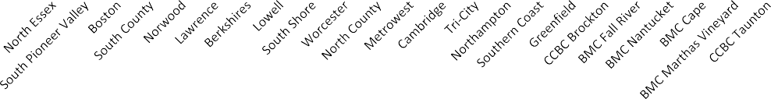Please see Appendix G for a detailed chart.
Percent of MCI Encounters Resulting in CBAT Admission by Provider
(October - December 2017) Age Group 15-18
50%

40%
30%

20%

10%
0%
Percent of MCI Encounters with Response Time < 60 Minutes

- Blue shading denotes area one or more standard deviations away from the average across providers.
Age Group 15-18
- For Age Group 15-18, the average percent of MCI encounters resulting in CBAT admission across the 23 providers is 7% from October through December 2017.
- Eight providers (Lawrence, Berkshires, Lowell, South Shore, Cambridge, Greenfield, BMC Nantucket, and BMC Marthas Vineyard) has a percent of MCI encounters resulting in CBAT admission is one or more standard deviations below the provider average. Two providers (Norwood and North County) are one or more standard deviations above the provider average.
- 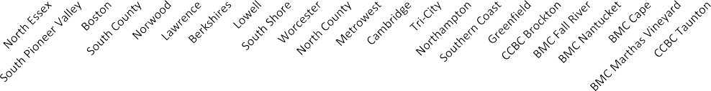Please see Appendix G for a detailed chart.
Percent of MCI Encounters Resulting in CBAT Admission by Provider
(October - December 2017)
Age Group 19-20
10%
0%
Percent of MCI Encounters with Response Time < 60 Minutes

- Blue shading denotes area one or more standard deviations away from the average across providers.
Age Group 19-20
- For Age Group 19-20, there are no CBAT encounters from October through December 2017.
- There are no providers whose percent of MCI encounters resulting in CBAT admission is one or more standard deviations below the provider average or one or more standard deviations above the provider average.
- Please see Appendix G for a detailed chart.

Appendix A
 | Number of Distinct MCI Encounters (October - December 2017)
Provider Name | Age 0-20 | Age 0-14 | Age 15-18 | Age 19-20
North Essex | 905 | 436 | 366 | 103
South Pioneer Valley | 1086 | 603 | 338 | 145
Boston | 1301 | 759 | 388 | 154
South County | 463 | 211 | 195 | 57
Norwood | 343 | 170 | 147 | 26
Lawrence | 458 | 237 | 159 | 62
Berkshires | 296 | 151 | 95 | 50
Lowell | 531 | 275 | 192 | 64
South Shore | 442 | 208 | 171 | 63
Worcester | 467 | 255 | 161 | 51
North County | 372 | 185 | 141 | 46
Metrowest | 816 | 383 | 355 | 78
Cambridge | 138 | 69 | 55 | 14
Tri-City | 418 | 206 | 143 | 69
Northampton | 210 | 86 | 78 | 46
Southern Coast | 479 | 261 | 159 | 59
Greenfield | 196 | 120 | 63 | 13
CCBC Brockton | 220 | 85 | 106 | 29
BMC Fall River | 237 | 139 | 81 | 17
BMC Nantucket | 11 | 6 | 4 | 1
BMC Cape | 144 | 66 | 46 | 32
BMC Marthas Vineyard | 30 | 16 | 14 | 0
CCBC Taunton | 204 | 102 | 82 | 20

- Blue shading denotes providers who are 1 or more SDs above or below the mean for all pro
 | Age 0-20 | Age 0-14 | Age 15-18 | Age 19-20
Mean | 425 | 219 | 154 | 52
Median | 372 | 185 | 143 | 50
Standard Deviation | 327 | 182 | 111 | 40
Range | 11 - 1301 | 6 - 759 | 4 - 388 | 0 - 154

Appendix B
Provider Name | Percent of MCI Encounters Occurring in Community Location |  |  |  | Percent of MCI Encounters Occurring in ED Location
 | Age 0-20 | Age 0-14 | Age 15-18 | Age 19-20 | Age 0-20 | Age 0-14 | Age 15-18 | Age 19-20
North Essex | 50% | 59% | 48% | 21% | 50% | 41% | 52% | 79%
South Pioneer Valley | 60% | 73% | 49% | 37% | 40% | 27% | 51% | 63%
Boston | 54% | 64% | 46% | 27% | 46% | 36% | 54% | 73%
South County | 58% | 73% | 54% | 21% | 42% | 27% | 46% | 79%
Norwood | 69% | 74% | 69% | 35% | 31% | 26% | 31% | 65%
Lawrence | 47% | 64% | 31% | 19% | 53% | 36% | 69% | 81%
Berkshires | 53% | 66% | 44% | 30% | 47% | 34% | 56% | 70%
Lowell | 38% | 46% | 33% | 19% | 62% | 54% | 67% | 81%
South Shore | 47% | 58% | 46% | 14% | 53% | 42% | 54% | 86%
Worcester | 58% | 67% | 53% | 29% | 42% | 33% | 47% | 71%
North County | 53% | 65% | 46% | 28% | 47% | 35% | 54% | 72%
Metrowest | 61% | 75% | 54% | 22% | 39% | 25% | 46% | 78%
Cambridge | 41% | 58% | 27% | 7% | 59% | 42% | 73% | 93%
Tri-City | 67% | 78% | 68% | 29% | 33% | 22% | 32% | 71%
Northampton | 49% | 56% | 56% | 24% | 51% | 44% | 44% | 76%
Southern Coast | 58% | 69% | 45% | 41% | 42% | 31% | 55% | 59%
Greenfield | 73% | 83% | 56% | 62% | 27% | 17% | 44% | 38%
CCBC Brockton | 41% | 64% | 34% | 0% | 59% | 36% | 66% | 100%
BMC Fall River | 67% | 78% | 49% | 59% | 33% | 22% | 51% | 41%
BMC Nantucket | 45% | 67% | 25% | 0% | 55% | 33% | 75% | 100%
BMC Cape | 46% | 67% | 26% | 31% | 54% | 33% | 74% | 69%
BMC Marthas Vineyard | 60% | 69% | 50% | 0% | 40% | 31% | 50% | 0%
CCBC Taunton | 53% | 67% | 44% | 25% | 47% | 33% | 56% | 75%
 | Age 0-20 | Age 0-14 | Age 15-18 | Age 19-20 | Age 0-20 | Age 0-14 | Age 15-18 | Age 19-20
Mean | 54% | 67% | 46% | 25% | 46% | 33% | 54% | 70%
Median | 53% | 67% | 46% | 25% | 47% | 33% | 54% | 73%
Standard Deviation | 9% | 8% | 12% | 16% | 9% | 8% | 12% | 21%
Range | 38% - 73% | 46% - 83% | 25% - 69% | 0% - 62% | 27% - 62% | 17% - 54% | 31% - 75% | 0% - 100%

Appendix C
Provider Name | Percent of Encounters Occurring in |  |  |  | Percent of Encounters Occurring in |  |  |  | Percent of Encounters Occurring in |  |  |  | Ratio Mobile to ESP/CB/UCC Location  (Rounded to Zero Decimal Places)
 |  | Mobile Location |  |  |  | ESP/CB/UCC Location |  |  |  | ED Location
 | Age | Age | Age | Age | Age | Age | Age | Age | Age | Age | Age | Age | Age | Age | Age | Age
 | 0-20 | 0-14 | 15-18 | 19-20 | 0-20 | 0-14 | 15-18 | 19-20 | 0-20 | 0-14 | 15-18 | 19-20 | 0-20 | 0-14 | 15-18 | 19-20
North Essex | 20% | 25% | 18% | 5% | 30% | 34% | 30% | 17% | 50% | 41% | 52% | 79% | 20:31 | 25:34 | 18:31 | 5:17
South Pioneer Valley | 42% | 53% | 34% | 17% | 18% | 19% | 15% | 19% | 40% | 27% | 51% | 63% | 7:3 | 53:20 | 34:15 | 17:20
Boston | 50% | 60% | 42% | 17% | 5% | 4% | 4% | 10% | 46% | 36% | 54% | 73% | 10:1 | 12:1 | 42:5 | 17:11
South County | 39% | 51% | 33% | 12% | 20% | 21% | 21% | 9% | 42% | 27% | 46% | 79% | 39:20 | 51:22 | 3:2 | 4:3
Norwood | 34% | 42% | 29% | 8% | 35% | 32% | 40% | 27% | 31% | 26% | 31% | 65% | 34:35 | 21:16 | 29:41 | 8:27
Lawrence | 13% | 18% | 10% | 3% | 34% | 46% | 21% | 16% | 53% | 36% | 69% | 81% | 13:34 | 18:47 | 5:11 | 3:17
Berkshires | 53% | 66% | 44% | 28% | 0% | 0% | 0% | 2% | 47% | 34% | 56% | 70% | 53:1 | n/a | n/a | 14:1
Lowell | 4% | 5% | 3% | 0% | 34% | 41% | 30% | 19% | 62% | 54% | 67% | 81% | 4:35 | 5:42 | 1:10 | 0:1
South Shore | 14% | 19% | 12% | 0% | 33% | 39% | 33% | 14% | 53% | 42% | 54% | 86% | 7:17 | 19:39 | 6:17 | 0:1
Worcester | 39% | 48% | 35% | 2% | 20% | 19% | 19% | 27% | 42% | 33% | 47% | 71% | 39:20 | 12:5 | 35:19 | 1:14
North County | 29% | 38% | 24% | 7% | 25% | 28% | 22% | 22% | 47% | 35% | 54% | 72% | 29:25 | 19:14 | 12:11 | 7:22
Metrowest | 40% | 49% | 36% | 12% | 21% | 27% | 17% | 10% | 39% | 25% | 46% | 78% | 20:11 | 49:27 | 2:1 | 12:11
Cambridge | 39% | 57% | 25% | 7% | 1% | 1% | 2% | 0% | 59% | 42% | 73% | 93% | 39:2 | 57:2 | 25:2 | n/a
Tri-City | 48% | 60% | 46% | 19% | 18% | 18% | 22% | 10% | 33% | 22% | 32% | 71% | 48:19 | 60:19 | 23:11 | 19:11
Northampton | 10% | 13% | 10% | 7% | 39% | 43% | 46% | 17% | 51% | 44% | 44% | 76% | 10:39 | 13:44 | 10:47 | 7:18
Southern Coast | 16% | 22% | 8% | 10% | 42% | 47% | 37% | 31% | 42% | 31% | 55% | 59% | 8:21 | 22:47 | 4:19 | 10:31
Greenfield | 34% | 43% | 19% | 23% | 39% | 40% | 37% | 38% | 27% | 17% | 44% | 38% | 34:39 | 43:40 | 19:37 | 23:39
CCBC Brockton | 29% | 41% | 26% | 0% | 12% | 22% | 8% | 0% | 59% | 36% | 66% | 100% | 29:13 | 41:23 | 13:4 | n/a
BMC Fall River | 49% | 62% | 32% | 29% | 18% | 17% | 17% | 29% | 33% | 22% | 51% | 41% | 49:18 | 62:17 | 16:9 | 29:30
BMC Nantucket | 45% | 67% | 25% | 0% | 0% | 0% | 0% | 0% | 55% | 33% | 75% | 100% | n/a | n/a | n/a | n/a
BMC Cape | 44% | 65% | 24% | 31% | 1% | 2% | 2% | 0% | 54% | 33% | 74% | 69% | 22:1 | 65:2 | 8:1 | n/a
BMC Marthas Vineyard | 13% | 13% | 14% | 0% | 47% | 56% | 36% | 0% | 40% | 31% | 50% | 0% | 13:47 | 13:57 | 7:18 | n/a
CCBC Taunton | 39% | 52% | 27% | 25% | 14% | 15% | 17% | 0% | 47% | 33% | 56% | 75% | 13:5 | 52:15 | 3:2 | n/a

Appendix D
Provider Name | Number of MCI Encounters Resulting in  Inpatient Admission |  |  |  |  | Total Number of |  |  | Percent of MCI Encounters Resulting in  Inpatient Admission
 |  |  |  |  |  | MCI Encounters
 | Age | Age | Age | Age 19-20 | Age | Age | Age | Age 19-20 | Age | Age | Age | Age 19-20
 | 0-20 | 0-14 | 15-18 |  | 0-20 | 0-14 | 15-18 |  | 0-20 | 0-14 | 15-18
North Essex | 175 | 48 | 89 | 38 | 905 | 436 | 366 | 103 | 19% | 11% | 24% | 37%
South Pioneer Valley | 119 | 35 | 49 | 35 | 1086 | 603 | 338 | 145 | 11% | 6% | 14% | 24%
Boston | 274 | 98 | 110 | 66 | 1301 | 759 | 388 | 154 | 21% | 13% | 28% | 43%
South County | 52 | 8 | 29 | 15 | 463 | 211 | 195 | 57 | 11% | 4% | 15% | 26%
Norwood | 62 | 17 | 34 | 11 | 343 | 170 | 147 | 26 | 18% | 10% | 23% | 42%
Lawrence | 75 | 18 | 35 | 22 | 458 | 237 | 159 | 62 | 16% | 8% | 22% | 35%
Berkshires | 36 | 7 | 17 | 12 | 296 | 151 | 95 | 50 | 12% | 5% | 18% | 24%
Lowell | 96 | 26 | 42 | 28 | 531 | 275 | 192 | 64 | 18% | 9% | 22% | 44%
South Shore | 73 | 21 | 33 | 19 | 442 | 208 | 171 | 63 | 17% | 10% | 19% | 30%
Worcester | 45 | 16 | 14 | 15 | 467 | 255 | 161 | 51 | 10% | 6% | 9% | 29%
North County | 66 | 21 | 27 | 18 | 372 | 185 | 141 | 46 | 18% | 11% | 19% | 39%
Metrowest | 151 | 35 | 79 | 37 | 816 | 383 | 355 | 78 | 19% | 9% | 22% | 47%
Cambridge | 47 | 15 | 22 | 10 | 138 | 69 | 55 | 14 | 34% | 22% | 40% | 71%
Tri-City | 96 | 29 | 35 | 32 | 418 | 206 | 143 | 69 | 23% | 14% | 24% | 46%
Northampton | 47 | 7 | 16 | 24 | 210 | 86 | 78 | 46 | 22% | 8% | 21% | 52%
Southern Coast | 65 | 14 | 33 | 18 | 479 | 261 | 159 | 59 | 14% | 5% | 21% | 31%
Greenfield | 19 | 4 | 10 | 5 | 196 | 120 | 63 | 13 | 10% | 3% | 16% | 38%
CCBC Brockton | 46 | 11 | 25 | 10 | 220 | 85 | 106 | 29 | 21% | 13% | 24% | 34%
BMC Fall River | 26 | 7 | 12 | 7 | 237 | 139 | 81 | 17 | 11% | 5% | 15% | 41%
BMC Nantucket | 0 | 0 | 0 | 0 | 11 | 6 | 4 | 1 | 0% | 0% | 0% | 0%
BMC Cape | 51 | 14 | 23 | 14 | 144 | 66 | 46 | 32 | 35% | 21% | 50% | 44%
BMC Marthas Vineyard | 4 | 1 | 3 | 0 | 30 | 16 | 14 | 0 | 13% | 6% | 21% | 0%
CCBC Taunton | 33 | 13 | 12 | 8 | 204 | 102 | 82 | 20 | 16% | 13% | 15% | 40%

  - Blue shading denotes providers who are 1 or more SDs above or below the mean for all providers for percent of encounters resulting in inpatient admission.
 | Age 0-20 | Age 0-14 | Age 15-18 | Age 19-20
Mean | 17% | 9% | 21% | 37%
Median | 17% | 9% | 21% | 38%
Standard Deviation | 8% | 5% | 10% | 15%
Range | 0% - 35% | 0% - 22% | 0% - 50% | 0% - 71%

Appendix E
 | Average Response Time in Minutes
Provider Name | Age 0-20 | Age 0-14 | Age 15-18 | Age 19-20
North Essex | 53 | 40 | 58 | 90
South Pioneer Valley | 79 | 71 | 91 | 85
Boston | 58 | 60 | 57 | 49
South County | 62 | 50 | 65 | 98
Norwood | 23 | 24 | 23 | 19
Lawrence | 82 | 59 | 106 | 108
Berkshires | 18 | 19 | 19 | 11
Lowell | 69 | 67 | 64 | 89
South Shore | 23 | 19 | 25 | 31
Worcester | 121 | 107 | 123 | 181
North County | 102 | 82 | 117 | 136
Metrowest | 25 | 20 | 30 | 23
Cambridge | 62 | 62 | 58 | 75
Tri-City | 21 | 14 | 18 | 47
Northampton | 18 | 18 | 10 | 31
Southern Coast | 37 | 34 | 41 | 43
Greenfield | 20 | 20 | 21 | 18
CCBC Brockton | 32 | 36 | 33 | 21
BMC Fall River | 25 | 23 | 30 | 19
BMC Nantucket | 15 | 15 | 15 | 15
BMC Cape | 56 | 40 | 62 | 82
BMC Marthas Vineyard | 26 | 45 | 4 | 0
CCBC Taunton | 34 | 29 | 39 | 42

- Blue shading denotes providers who are 1 or more SDs above or below the mean for all providers.
 | Age 0-20 | Age 0-14 | Age 15-18 | Age 19-20
Mean | 46 | 41 | 48 | 57
Median | 34 | 36 | 39 | 43
Standard Deviation | 29 | 25 | 34 | 46
Range | 15 - 121 | 14 - 107 | 4 - 123 | 0 - 181

Appendix F
Provider Name | Percent of MCI Encounters with Response Time
 |  | < 60 Minutes
 | Age 0-20 | Age 0-14 | Age 15-18 | Age 19-20
North Essex | 75% | 79% | 73% | 64%
South Pioneer Valley | 58% | 59% | 57% | 60%
Boston | 55% | 53% | 53% | 72%
South County | 72% | 79% | 71% | 49%
Norwood | 92% | 92% | 90% | 96%
Lawrence | 64% | 72% | 59% | 48%
Berkshires | 92% | 91% | 92% | 94%
Lowell | 60% | 61% | 66% | 39%
South Shore | 87% | 90% | 86% | 83%
Worcester | 66% | 69% | 64% | 55%
North County | 66% | 74% | 61% | 52%
Metrowest | 91% | 94% | 89% | 90%
Cambridge | 54% | 52% | 58% | 43%
Tri-City | 89% | 96% | 88% | 74%
Northampton | 96% | 97% | 97% | 93%
Southern Coast | 81% | 84% | 77% | 81%
Greenfield | 90% | 92% | 89% | 85%
CCBC Brockton | 84% | 81% | 84% | 93%
BMC Fall River | 85% | 86% | 84% | 88%
BMC Nantucket | 100% | 100% | 100% | 100%
BMC Cape | 52% | 62% | 41% | 47%
BMC Marthas Vineyard | 97% | 94% | 100% | 0%
CCBC Taunton | 90% | 93% | 88% | 85%

* Blue shading denotes providers who are 1 or more SDs above or below the mean for all providers.
 | Age 0-20 | Age 0-14 | Age 15-18 | Age 19-20
Mean | 78% | 80% | 77% | 69%
Median | 84% | 84% | 84% | 74%
Standard Deviation | 16% | 15% | 17% | 25%
Range | 52% - 100% | 52% - 100% | 41% - 100% | 0% - 100%

Appendix G
Provider Name | Number of MCI Encounters Resulting in |  |  |  |  | Total Number of |  |  | Percent of MCI Encounters Resulting in
 |  | CBAT Admission |  |  |  | MCI Encounters |  |  |  | CBAT Admission
 | Age | Age | Age | Age | Age | Age | Age | Age | Age | Age | Age | Age
 | 0-20 | 0-14 | 15-18 | 19-20 | 0-20 | 0-14 | 15-18 | 19-20 | 0-20 | 0-14 | 15-18 | 19-20
North Essex | 92 | 63 | 29 | 0 | 905 | 436 | 366 | 103 | 10% | 14% | 8% | 0%
South Pioneer Valley | 67 | 37 | 29 | 1 | 1086 | 603 | 338 | 145 | 6% | 6% | 9% | 1%
Boston | 74 | 62 | 12 | 0 | 1301 | 759 | 388 | 154 | 6% | 8% | 3% | 0%
South County | 49 | 29 | 20 | 0 | 463 | 211 | 195 | 57 | 11% | 14% | 10% | 0%
Norwood | 49 | 24 | 24 | 1 | 343 | 170 | 147 | 26 | 14% | 14% | 16% | 4%
Lawrence | 27 | 26 | 1 | 0 | 458 | 237 | 159 | 62 | 6% | 11% | 1% | 0%
Berkshires | 21 | 18 | 3 | 0 | 296 | 151 | 95 | 50 | 7% | 12% | 3% | 0%
Lowell | 27 | 24 | 3 | 0 | 531 | 275 | 192 | 64 | 5% | 9% | 2% | 0%
South Shore | 18 | 14 | 4 | 0 | 442 | 208 | 171 | 63 | 4% | 7% | 2% | 0%
Worcester | 61 | 47 | 14 | 0 | 467 | 255 | 161 | 51 | 13% | 18% | 9% | 0%
North County | 65 | 41 | 24 | 0 | 372 | 185 | 141 | 46 | 17% | 22% | 17% | 0%
Metrowest | 51 | 28 | 22 | 1 | 816 | 383 | 355 | 78 | 6% | 7% | 6% | 1%
Cambridge | 3 | 2 | 1 | 0 | 138 | 69 | 55 | 14 | 2% | 3% | 2% | 0%
Tri-City | 16 | 11 | 5 | 0 | 418 | 206 | 143 | 69 | 4% | 5% | 3% | 0%
Northampton | 13 | 8 | 5 | 0 | 210 | 86 | 78 | 46 | 6% | 9% | 6% | 0%
Southern Coast | 64 | 51 | 13 | 0 | 479 | 261 | 159 | 59 | 13% | 20% | 8% | 0%
Greenfield | 18 | 17 | 1 | 0 | 196 | 120 | 63 | 13 | 9% | 14% | 2% | 0%
CCBC Brockton | 16 | 9 | 7 | 0 | 220 | 85 | 106 | 29 | 7% | 11% | 7% | 0%
BMC Fall River | 25 | 21 | 4 | 0 | 237 | 139 | 81 | 17 | 11% | 15% | 5% | 0%
BMC Nantucket | 1 | 1 | 0 | 0 | 11 | 6 | 4 | 1 | 9% | 17% | 0% | 0%
BMC Cape | 10 | 7 | 3 | 0 | 144 | 66 | 46 | 32 | 7% | 11% | 7% | 0%
BMC Marthas Vineyard | 1 | 1 | 0 | 0 | 30 | 16 | 14 | 0 | 3% | 6% | 0% | 0%
CCBC Taunton | 21 | 14 | 7 | 0 | 204 | 102 | 82 | 20 | 10% | 14% | 9% | 0%

  - Blue shading denotes providers who are 1 or more SDs above or below the mean for all providers for percent of encounters resulting in CBAT admission.
NOTE: The majority of CBAT providers expect MBHP members to max out at age 18. Individuals within the 19-20 age category could appear within the figures if they were 18 at the time of the initial encounter then turned 19 during their CBAT service.

 | Age 0-20 | Age 0-14 | Age 15-18 | Age 19-20
Mean | 8% | 11% | 7% | 0%
Median | 7% | 11% | 6% | 0%
Standard Deviation | 4% | 5% | 5% | 1%
Range | 2% - 17% | 3% - 22% | 0% - 17% | 0% - 4%

