INDOOR AIR QUALITY ASSESSMENT

McKinley Elementary School
65 Yeamans Street
Revere, Massachusetts



Prepared by:
Massachusetts Department of Public Health
Bureau of Environmental Health
Indoor Air Quality Program
June 2012

Background/Introduction
At the request of a concerned parent and the Revere Board of Health, the Massachusetts Department of Public Health (MDPH), Bureau of Environmental Health (BEH) conducted an indoor air quality (IAQ) assessment at the McKinley Elementary School (MES), 65 Yeamans Street, Revere, Massachusetts. The request was prompted by an anonymous parent complaint regarding concerns related to mold, pests and general IAQ. On May 16, 2012, a visit to conduct a general IAQ assessment was made to the MES by Michael Feeney, Director of BEH’s IAQ program. Mr. Feeney was accompanied by Ruth Alfasso Environmental Engineer/Inspector, in BEH’s IAQ Program. Members of the school’s facility staff accompanied Mr. Feeney and Ms. Alfasso during the visit.
The MES is a three-story brick building originally constructed in 1902, with an addition completed in 1926. Windows are openable in most areas of the building.

Methods
Air tests for carbon monoxide, carbon dioxide, temperature and relative humidity were conducted with the TSI, Q-Trak, IAQ Monitor, Model 7565. Air tests for airborne particle matter with a diameter less than 2.5 micrometers were taken with the TSI, DUSTTRAK™ Aerosol Monitor Model 8520. BEH staff also performed a visual inspection of building materials for water damage and/or microbial growth.

Results
The school houses approximately 500 students in grades K through 5 and has a staff of approximately 45. The tests were taken during normal operations at the school and appear in Table 1.

Discussion

Ventilation
It can be seen from Table 1 that carbon dioxide levels were above 800 parts per million of air (ppm) in 18 of 30 areas surveyed indicating poor air exchange in more than half of the areas surveyed on the day of assessment. It is also important to note that windows were open in many classrooms and some areas were empty/sparsely populated, which can greatly reduce carbon dioxide levels. Carbon dioxide levels would be expected to increase with windows closed and higher room occupancy.
A fresh air source is necessary for the dilution of indoor air pollutants. The MES was designed with a natural/gravity ventilation system to provide airflow to most classrooms in combination with openable windows. With this design, ventilation is supplemented by open windows and cross ventilation through transoms. Many rooms are now served by unit ventilator (univent) systems. A univent is designed to draw air from outdoors through a fresh air intake located on the exterior wall of the building (Picture 1). Return air is drawn through an air intake located at the base of each unit where fresh and return air are mixed, filtered, heated and provided to classrooms through an air diffuser located in the top of the unit (Figure 1).
At the time of the MDPH assessment, univents were found deactivated in most classrooms (Table 1), reportedly because the warm outdoor temperatures did not require a call for heat. In some classrooms, univents were found obstructed with classroom items (Table 1). In order for univents to provide fresh air as designed, intakes/returns must remain free of obstructions. Importantly, these units must remain “on” and be allowed to operate while rooms are occupied.
Exhaust ventilation in the 1902 sections of the school was originally provided by “cubbyhole” vents located near the floor in each room (Picture 2) connected to an exhaust ventilation shaft that runs to the roof. Whether these systems were still operational could not be determined, and most of the cubbyholes had materials stored in them which would obstruct flow through the vents. In the 1926 sections of the building, exhaust vents are located on the wall at floor level (Picture 3). As shown in Picture 3, some of these units were also found to be blocked by furniture and other items.
A school of this age and design is meant to have windows open when weather permits; the presence of transoms allow for cross ventilation. When transoms or classroom doors along with windows are open in opposing classrooms, airflow is created. For example, airflow enters an open window on the windward side, passes through a classroom and out the classroom door or transom, enters the hallway, passes through the opposing open classroom door or transom, into the opposing classroom and exits the building on the leeward side (Figure 2). The system fails if the windows and transoms or doors are closed (Figure 3).
A new ventilation system which includes cooling has been installed in the basement, reportedly in 2011, consisting of an air handling unit (AHU) and ducted vents installed on the ceiling (Picture 4). However, not all rooms in the basement are served by this system. Of particular note is the ELL Room, which has neither a mechanical ventilation system nor openable windows.
It was also noted that the basement hallway and corner room had exhaust fans mounted in the exterior wall (Picture 5). These fans were not in activation and outdoor light was visible through the louvers of these exhaust fans. In this configuration, unconditioned outdoor air can enter the building, resulting in increased humidity, as well as be an entry point for pests, pollen and dirt. The fans should be removed from these housings and the penetrations fully sealed.
The Massachusetts Building Code requires that each room have a minimum ventilation rate of 15 cubic feet per minute (cfm) per occupant of fresh outside air or have openable windows (SBBRS, 1997; BOCA, 1993). The ventilation must be on at all times that the room is occupied. Providing adequate fresh air ventilation with open windows and maintaining the temperature in the comfort range during the cold weather season is impractical. Mechanical ventilation is usually required to provide adequate fresh air ventilation.
Carbon dioxide is not a problem in and of itself. It is used as an indicator of the adequacy of the fresh air ventilation. As carbon dioxide levels rise, it indicates that the ventilating system is malfunctioning or the design occupancy of the room is being exceeded. When this happens, a buildup of common indoor air pollutants can occur, leading to discomfort or health complaints. The Occupational Safety and Health Administration (OSHA) standard for carbon dioxide is 5,000 parts per million parts of air (ppm). Workers may be exposed to this level for 40 hours/week, based on a time-weighted average (OSHA, 1997).
The MDPH uses a guideline of 800 ppm for publicly occupied buildings. A guideline of 600 ppm or less is preferred in schools due to the fact that the majority of occupants are young and considered to be a more sensitive population in the evaluation of environmental health status. Inadequate ventilation and/or elevated temperatures are major causes of complaints such as respiratory, eye, nose and throat irritation, lethargy and headaches. For more information concerning carbon dioxide, see Appendix A.
Temperature measurements ranged from 71 ºF to 79 ºF on the day of the visit, which were within or close to the MDPH recommended comfort range. The MDPH recommends that indoor air temperatures be maintained in a range of 70 ºF 78 ºF in order to provide for the comfort of building occupants. In many cases concerning indoor air quality, fluctuations of temperature in occupied spaces are typically experienced, even in a building with an adequate fresh air supply.
The relative humidity measured in the building ranged from 59 to 72 percent at the time of the visit, mostly above the MDPH recommended comfort range (Table 1); note that outdoor relative humidity was measured at 66 percent with intermittent rain on the day of the assessment. The MDPH recommends a comfort range of 40 to 60 percent for indoor air relative humidity. Humidity measurements above background indicate that the ventilation system is not operating effectively to remove occupant-generated moisture from the building. Moisture removal is important since higher humidity at a given temperature reduces the ability of the body to cool itself by sweating; “heat index” is a measurement that takes into account the impact of a combination of heat and humidity on how hot it feels. At a given indoor temperature, the addition of humid air increases occupant discomfort and may generate heat complaints. If moisture levels are decreased, the comfort of the individuals increases. In addition, as described in more detail in the Microbial/Moisture Concerns section, relative humidity in excess of 70 percent for extended periods of time can provide an environment for mold and fungal growth (ASHRAE, 1989).
Humidity levels were generally higher in the basement, potentially influenced by the open fan penetrations previously referenced. High humidity in the basement is of particular concern because the basement was most likely built directly on soil without a crawlspace or vapor barrier. Soil temperatures do not change as much with the seasons as air temperatures, therefore the floors in the basement will be colder than the air during the summer. If the dew point (a measure of humidity which indicates the temperature at which water in the ambient air will start to condense to liquid water) is higher than the temperature of the floor, condensation will result, wetting anything which is in contact with the floor, including carpeting and furniture. This can create an environment in which mold will grow. As an example, the temperature in room B3 was measured at 72 ºF and the relative humidity was 74 percent on the day of the assessment, which corresponds to as dew point of 62 ºF; the ground temperature at the time of the assessment may be as low as the mid-50s, which is below the dew point.
Relative humidity levels in the building would be expected to drop during the winter months due to heating. The sensation of dryness and irritation is common in a low relative humidity environment. Low relative humidity is a very common problem during the heating season in the northeast part of the United States.

Microbial/Moisture Concerns
Water-damaged ceiling tiles were observed in some classrooms (Picture 6, Table 1). The large number of water-damaged ceiling tiles in room 16 were attributed to a historic leak from the kitchen/cafeteria level on the top floor. Other water-damaged ceiling tiles and a water-damaged windowsill were noted. Water-damaged ceiling tiles can provide a source for mold growth and should be replaced after a water leak is discovered and repaired.
As noted, areas in the basement had high relative humidity readings. Standing water was also observed in the special education (SPED) classroom, possibly from ground water infiltration or from condensation. A carpet was noted in the ELL classroom, which was directly on the floor. As mentioned above in reference to humidity, the presence of humid air is likely to lead to condensation on the floor, which would repeatedly moisten this carpet. Although no overt signs of water damage or mold growth were noted, carpeting is strongly not recommended in below-grade areas; this carpet should be removed.
The US Environmental Protection Agency (US EPA) and the American Conference of Governmental Industrial Hygienists (ACGIH) recommends that porous materials be dried with fans and heating within 24 to 48 hours of becoming wet (US EPA, 2001; ACGIH, 1989). If porous materials are not dried within this time frame, mold growth may occur. Water-damaged porous materials cannot be adequately cleaned to remove mold growth. The application of a mildewcide to moldy porous materials is not recommended.
A portable air-conditioning unit was found in the computer lab (Room 11, Picture 7). These units generate condensate that needs to be properly drained. Drainage of the unit appeared to be through a long condensate drain line; this line needs to be monitored to make sure the water drains away from the building and does not leak and moisten the carpet or other porous building materials.
Plants were observed in a few areas (Table 1). Plants can be a source of pollen and mold which can be respiratory irritants to some individuals. Plants should be properly maintained and equipped with drip pans and located away from univents to prevent the aerosolization of dirt, pollen and mold.
BEH staff examined the outside perimeter of the building to identify breaches in the building envelope and/or other conditions that could provide a source of water penetration. An exterior door had visible gaps beneath it (Picture 8), which can allow moisture to enter the building. In addition, these breaches can allow insects and rodents access to the building. A ¼-inch breach is enough space for rodents to enter a building (MDFA, 1996). It was reported that this door was planned for replacement.
Dripping water was noted from the gutter system in several areas around the building, suggesting that they are in need of cleaning or repair. Gutter drainpipes were also found disconnected and it was not clear if this was an intentional modification of the system. If gutters and downspouts do not function effectively, water can’t drain away from the foundation of the building, which can lead to water penetration and damage.
Finally, mulch and soil was piled against the building, and plants were noted growing through cracks in concrete around the building (Picture 9). These represent potential water penetration sources. Over time, these conditions can undermine the integrity of the building envelope and provide a means of water entry into the building via capillary action through foundation concrete and masonry (Lstiburek & Brennan, 2001). The freezing and thawing action of water during the winter months can create cracks and fissures in the foundation. In addition, these breaches may provide a means for pests/rodents to enter the building.

Other IAQ Evaluations
Indoor air quality can be negatively influenced by the presence of respiratory irritants, such as products of combustion. The process of combustion produces a number of pollutants. Common combustion emissions include carbon monoxide, carbon dioxide, water vapor, and smoke (fine airborne particle material). Of these materials, exposure to carbon monoxide and particulate matter with a diameter of 2.5 micrometers (μm) or less (PM2.5) can produce immediate, acute health effects upon exposure. To determine whether combustion products were present in the indoor environment, BEH staff obtained measurements for carbon monoxide and PM2.5.

Carbon Monoxide
Carbon monoxide is a by-product of incomplete combustion of organic matter (e.g., gasoline, wood and tobacco). Exposure to carbon monoxide can produce immediate and acute health affects. Several air quality standards have been established to address carbon monoxide and prevent symptoms from exposure to these substances. The MDPH established a corrective action level concerning carbon monoxide in ice skating rinks that use fossil-fueled ice resurfacing equipment. If an operator of an indoor ice rink measures a carbon monoxide level over 30 ppm, taken 20 minutes after resurfacing within a rink, that operator must take actions to reduce carbon monoxide levels (MDPH, 1997).
The American Society of Heating Refrigeration and Air-Conditioning Engineers (ASHRAE) has adopted the National Ambient Air Quality Standards (NAAQS) as one set of criteria for assessing indoor air quality and monitoring of fresh air introduced by HVAC systems (ASHRAE, 1989). The NAAQS are standards established by the US EPA to protect the public health from six criteria pollutants, including carbon monoxide and particulate matter (US EPA, 2006). As recommended by ASHRAE, pollutant levels of fresh air introduced to a building should not exceed the NAAQS levels (ASHRAE, 1989). The NAAQS were adopted by reference in the Building Officials & Code Administrators (BOCA) National Mechanical Code of 1993 (BOCA, 1993), which is now an HVAC standard included in the Massachusetts State Building Code (SBBRS, 1997). According to the NAAQS, carbon monoxide levels in outdoor air should not exceed 9 ppm in an eight-hour average (US EPA, 2006).
Carbon monoxide should not be present in a typical, indoor environment. If it is present, indoor carbon monoxide levels should be less than or equal to outdoor levels. Outdoor carbon monoxide levels were measured at 1.1 ppm on the morning of the assessment, most likely due to weather and traffic conditions. No measurable levels of carbon monoxide were detected inside the building (Table 1).

Particulate Matter (PM2.5)
The US EPA has established NAAQS limits for exposure to particulate matter. Particulate matter is airborne solids that can be irritating to the eyes, nose and throat. The NAAQS originally established exposure limits to particulate matter with a diameter of 10 μm or less (PM10). According to the NAAQS, PM10 levels should not exceed 150 micrograms per cubic meter (μg/m³) in a 24-hour average (US EPA, 2006). These standards were adopted by both ASHRAE and BOCA. Since the issuance of the ASHRAE standard and BOCA Code, US EPA established a more protective standard for fine airborne particles. This more stringent PM2.5 standard requires outdoor air particle levels be maintained below 35 μg/m³ over a 24-hour average (US EPA, 2006). Although both the ASHRAE standard and BOCA Code adopted the PM10 standard for evaluating air quality, MDPH uses the more protective PM2.5 standard for evaluating airborne particulate matter concentrations in the indoor environment.
Outdoor PM2.5 concentrations were measured at 14 μg/m³ on the day of the visit (Table 1). PM2.5 levels measured inside the school ranged from 8 to 22 μg/m³ (Table 1), which were below the NAAQS PM2.5 limit of 35 μg/m³. Frequently, indoor air levels of particulates (including PM2.5) can be at higher levels than those measured outdoors. A number of mechanical devices and/or activities that occur indoors can generate particulate during normal operations. Sources of indoor airborne particulates may include but are not limited to particles generated during the operation of fan belts in the HVAC system, use of stoves and/or microwave ovens in kitchen areas; use of photocopiers, fax machines and computer printing devices; operation of an ordinary vacuum cleaner and heavy foot traffic indoors.

Volatile Organic Compounds
Indoor air concentrations can be greatly impacted by the use of products containing volatile organic compounds (VOCs). VOCs are carbon-containing substances that have the ability to evaporate at room temperature. Frequently, exposure to low levels of total VOCs (TVOCs) may produce eye, nose, throat and/or respiratory irritation in some sensitive individuals. For example, chemicals evaporating from a paint can stored at room temperature would most likely contain VOCs. In an effort to identify materials that can potentially increase VOC concentrations, BEH staff examined classrooms for products that may contain these respiratory irritants.
Household cleaning products were found in several areas (Picture 10, Table 1). Cleaning products and air deodorizers contain chemicals that can be irritating to the eyes, nose and throat of sensitive individuals. Additionally, a Material Safety Data Sheet (MSDS) should be available at a central location for all school chemicals in the event of an emergency such as an adverse chemical interaction between residues left from cleaners used by the facilities staff and those left by cleaners brought in by others.
Many classrooms contained dry erase boards and dry erase board markers (Table 1). Spray cans of paint, markers and other products were found in some classrooms. Materials such as permanent markers, dry erase markers and dry erase board cleaners and paints may contain VOCs, such as methyl isobutyl ketone, n-butyl acetate and butyl-cellusolve (Sanford, 1999), which can be irritating to the eyes, nose and throat.
A laminator was located in the copy room off of the teacher’s lounge along with two photocopiers; additional copiers were located in other areas of the building (Table 1). The copy rooms did not have dedicated exhaust ventilation or openable windows. Lamination machines melt plastic and produce odors and VOCs. VOCs and ozone can be produced by photocopiers, particularly if the equipment is older and in frequent use. Ozone is a respiratory irritant (Schmidt Etkin, 1992). Local exhaust should be activated/repaired where available or added when feasible to remove excess heat, odors and particulates when equipment is operating.

Other Conditions
Other conditions that can affect indoor air quality were observed during the assessment. Of specific concern was the ELL room located in the basement. The walls consist of laminate paneling affixed to a frame of wood studs inside of a room which was the former coal bin (Picture 11), as evidenced by the sloped floor in the unfinished section of the room and the fire door on the hallway entrance. As previously noted, this room has neither mechanical ventilation or openable windows. The storage area contains athletic equipment which is reportedly accessed/moved several times a day through the room. Although no elevated levels of particulates were noted in the ELL room at the time of the visit, and no dust deposits suggestive of coal were noted, the area was not designed originally nor converted subsequently into a room that could be routinely occupied. BEH staff suggests that its use be limited to storage only.
A number of fans/blades and exhaust vents had accumulated dust/debris. Fans should be cleaned periodically in order to prevent them from serving as a source of aerosolized particulates. Exhaust vents should also be cleaned to prevent re-aerosolization of dust due to backdrafting.
A build up of pencil shavings was observed in several classrooms (Table 1, Picture 12). These materials can be aerosolized by air movement from the ventilation system, doors opening and closing, or foot traffic and may present an eye or respiratory irritant.
In several classrooms, items were observed on the floors, windowsills, tabletops, counters, bookcases and desks (Picture 13 and 14). The items stored in classrooms provide a source for dusts to accumulate. These items (e.g., papers, folders, boxes) make it difficult for custodial staff to clean. Curtains used to cover stored items can also collect dusts and be difficult to clean. Items should be relocated and/or be cleaned periodically to avoid excessive dust build up. In addition, these materials can accumulate on flat surfaces (e.g., desktops, shelving and carpets) in occupied areas and subsequently be re-aerosolized causing further irritation. Similarly, dust/debris from items placed on top of radiators and univents can become airborne through movement of the heated air.
Area carpets were observed in several classrooms (Table 1). The Institute of Inspection, Cleaning and Restoration Certification (IICRC), recommends that carpeting be cleaned annually (or semi-annually in soiled high traffic areas) (IICRC, 2005). Where an excessively dusty environment exists due to outdoor conditions or indoor activities (e.g., renovations), cleaning frequency should be increased (every six months) (IICRC, 2000).

Conclusions/Recommendations
Based on observations at the time of the visit, a number of recommendations are provided. According to discussions with school personnel, the building is planned for replacement in approximately three years; a number of the recommendations made could warrant significant capital outlay and therefore not likely to occur, but maintenance and repair and other practices that can improve the IAQ for the building for the remaining time it is occupied are critical:
- To maximize air exchange operate existing ventilation equipment (in working order) continuously throughout the building (e.g., gym, auditorium, classrooms) during periods of school occupancy independent of thermostat control. Ensure all blockages to supply and exhaust vents are removed.
- Use openable windows in conjunction with existing operable equipment to facilitate air exchange. Care should be taken to ensure windows are properly closed at night and weekends to avoid the freezing of pipes and potential flooding.
- Ensure any roof/exterior/plumbing leaks are repaired and replace water-damaged ceiling tiles and building materials. Examine the area above and around these areas for mold growth including the flashing. Disinfect areas of water leaks with an appropriate antimicrobial.
- Discontinue use of the ELL room in the basement as soon as feasible with the exception of storage.
- Ensure that no material that can be a source of mold growth is stored either directly on the floor or metal shelves in contact with the floor or foundation wall in basement area. Such materials include, but are not limited to paper, cardboard, fabrics, soft plastic and other water permeable materials.
- Monitor SPED room for moisture, repair leaks and maintain floor in dry condition.
- Utilize air conditioners and/or dehumidifiers as needed during extended periods of elevated relative humidity (> 70%). Ensure dehumidifiers are cleaned and maintained per the manufacturer’s instructions to prevent microbial growth.
- Seal penetrations for the old ventilation fans in the basement.
- Monitor condensate lines from portable air conditioner in the computer lab for leaks and ensure that condensate drains away from the building.
- For buildings in New England, periods of low relative humidity during the winter are often unavoidable. Therefore, scrupulous cleaning practices should be adopted to minimize common indoor air contaminants whose irritant effects can be enhanced when the relative humidity is low. To control for dusts, a high efficiency particulate arrestance (HEPA) filter equipped vacuum cleaner in conjunction with wet wiping of all surfaces is recommended. Avoid the use of feather dusters. Drinking water during the day can help ease some symptoms associated with a dry environment (throat and sinus irritations).
- Ensure staff are provided with school-sanctioned cleaning products with appropriate MSDSs. Remove/discard any household cleaners and air deodorizing materials. Keep cleaning products out of reach of students.
- Ensure plants are equipped with drip pans. Examine drip pans periodically for mold growth and disinfect with an appropriate antimicrobial, as needed.
- Repair/maintain building gutters and downspouts to reduce the potential for water infiltration.
- Take measures to tighten exterior doors (e.g., weather-stripping) to prevent drafts, moisture infiltration and pest/rodent entry. Ensure tightness of doors by monitoring for light penetration and drafts around doorframes.
- Remove plants from perimeter and foundation and remove excess soil and mulch from around the building exterior.
- If possible, add local exhaust ventilation to the copy room next to the teacher’s lounge to remove pollutants generated by the copiers and laminator.
- Clean accumulated pencil shavings regularly.
- Clean supply/exhaust vents and personal fans periodically to prevent excessive dust build-up.
- Clean carpeting annually or semi-annually in soiled high traffic areas as per the recommendations of the Institute of Inspection, Cleaning and Restoration Certification (IICRC). Copies of the IICRC fact sheet can be downloaded at: http://www.certifiedcleaners.org/faq.shtml (IICRC, 2005).
- Relocate or consider reducing the amount of materials stored in classrooms to allow for more thorough cleaning of classrooms. Clean items regularly with a wet cloth or sponge to prevent excessive dust build-up. Use of plastic totes for storage of items not in use will allow for more thorough cleaning.
- Consider adopting the US EPA (2000) document, “Tools for Schools”, to maintain a good indoor air quality environment in the building. This document can be downloaded from the Internet at http://www.epa.gov/iaq/schools/index.html.
- Refer to resource manuals and other related indoor air quality documents for further building-wide evaluations and advice on maintaining public buildings. Copies of these materials are located on the MDPH’s website: http://mass.gov/dph/iaq.

References
ACGIH. 1989. Guidelines for the Assessment of Bioaerosols in the Indoor Environment. American Conference of Governmental Industrial Hygienists, Cincinnati, OH.
ASHRAE. 1989. ASHRAE Standard: Ventilation for Acceptable Indoor Air Quality. Sections 5.11, 5.12. American Society of Heating, Refrigerating and Air-Conditioning Engineers, Inc. Atlanta, GA.
BOCA. 1993. The BOCA National Mechanical Code/1993. 8th ed. Building Officials and Code Administrators International, Inc., Country Club Hill, IL.
IICRC. 2000. IICRC S001 Reference Guideline for Professional On-Location Cleaning of Textile Floor Covering Materials Institute of Inspection, Cleaning and Restoration Certification. Institute of Inspection Cleaning and Restoration, Vancouver, WA.
IICRC. 2005. Carpet Cleaning FAQ 4 Institute of Inspection, Cleaning and Restoration Certification. Institute of Inspection Cleaning and Restoration, Vancouver, WA.
Lstiburek, J. & Brennan, T. 2001. Read This Before You Design, Build or Renovate. Building Science Corporation, Westford, MA. U.S. Department of Housing and Urban Development, Region I, Boston, MA.
MDFA. 1996. Integrated Pest Management Kit for Building Managers. Massachusetts Department of Food and Agriculture, Pesticide Bureau, Boston, MA.
MDPH. 1997. Requirements to Maintain Air Quality in Indoor Skating Rinks (State Sanitary Code, Chapter XI). 105 CMR 675.000. Massachusetts Department of Public Health, Boston, MA.
OSHA. 1997. Limits for Air Contaminants. Occupational Safety and Health Administration. Code of Federal Regulations. 29 C.F.R 1910.1000 Table Z-1-A.
Sanford. 1999. Material Safety Data Sheet (MSDS No: 198-17). Expo® Dry Erase Markers Bullet, Chisel, and Ultra Fine Tip. Sanford Corporation. Bellwood, IL.
SBBRS. 1997. Mechanical Ventilation. State Board of Building Regulations and Standards. Code of Massachusetts Regulations. 780 CMR 1209.0.
Schmidt Etkin, D. 1992. Office Furnishings/Equipment & IAQ Health Impacts, Prevention & Mitigation. Cutter Information Corporation, Indoor Air Quality Update, Arlington, MA.
US EPA. 2000. Tools for Schools. Office of Air and Radiation, Office of Radiation and Indoor Air, Indoor Environments Division (6609J). EPA 402-K-95-001, Second Edition. http://www.epa.gov/iaq/schools/tools4s2.html
US EPA. 2001. “Mold Remediation in Schools and Commercial Buildings”. Office of Air and Radiation, Indoor Environments Division, Washington, DC. EPA 402-K-01-001. March 2001. Available at: http://www.epa.gov/iaq/molds/mold_remediation.html
US EPA. 2006. National Ambient Air Quality Standards (NAAQS). US Environmental Protection Agency, Office of Air Quality Planning and Standards, Washington, DC. http://www.epa.gov/air/criteria.html
Picture 1

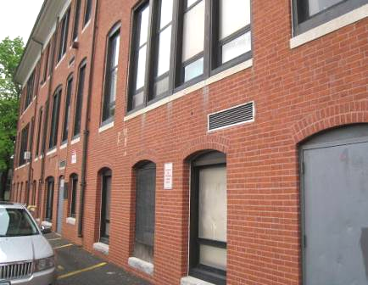

Air intake for univent (arrow)

Picture 2

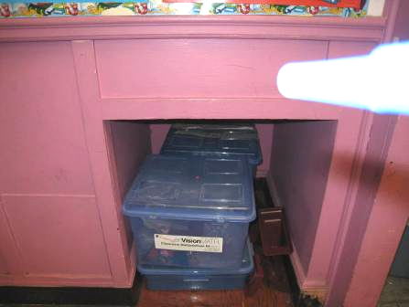

Cubby for old exhaust system, note items stored in it

Picture 3

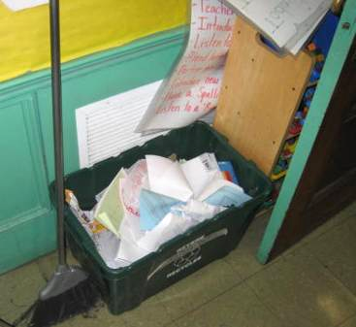

Exhaust vent in the 1924 section of the building; note partial blockage

Picture 4

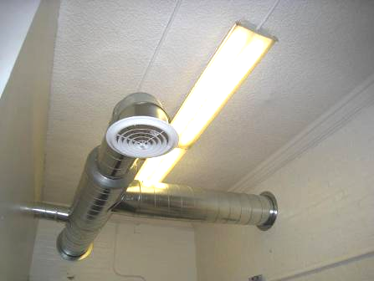

New basement supply ducts and vent

Picture 5

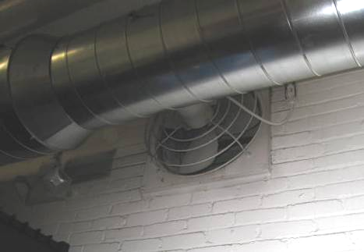

Old basement exhaust fan alongside new ductwork; light could be seen between the vanes showing where unconditioned air can enter the basement

Picture 6

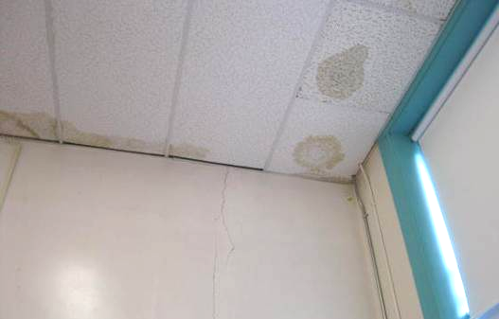

Water-damaged ceiling tiles

Picture 7

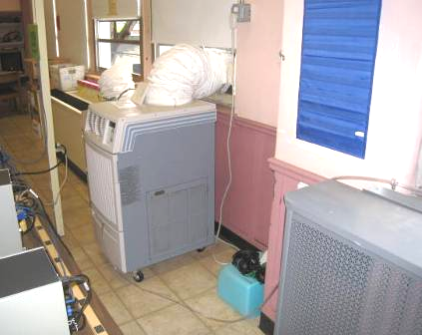

Portable air-conditioning unit in computer lab, note long condensate drain line (arrows)

Picture 8

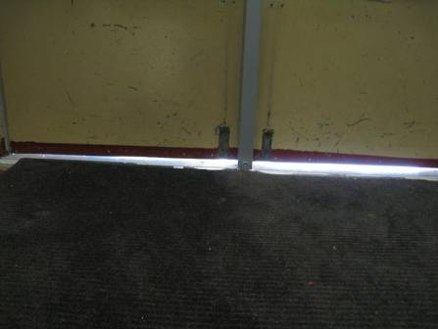

Light visible beneath an outside door

Picture 9

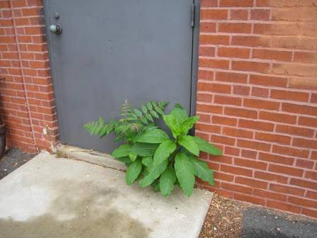

Plant growing out of door sill on exterior of building

Picture 10

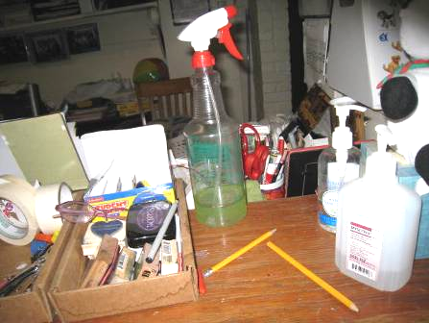

Cleaning products

Picture 11

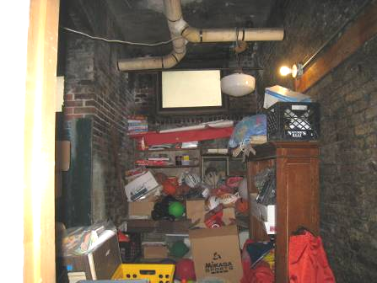

Athletic equipment storage in old coal bin off the ELL room

Picture 12

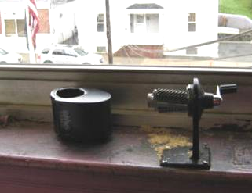

Pencil shavings in classroom

Picture 13



Items in classroom, note baskets on top of univent diffusers

Picture 14

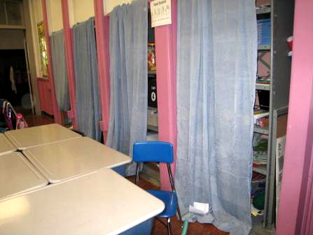

Storage of items in classroom behind fabric curtains
Location/ Room | Carbon  Dioxide  (ppm) | Carbon Monoxide  (ppm) | Temp  (°F) | Relative  Humidity  (%) | PM2.5  (µg/m³) | Occupants  in Room | Windows  Openable | Ventilation |  | Remarks
Background | 292 | 1.1 | 76 | 66 | 14 |  |  |  |  | Humid, clouds and showers
Main office | 746 | ND | 73 | 65 | 14 | 5 | Y | Y | Y | Partially carpeted, DO, 2 PCs
Cafeteria | 1096 | ND | 75 | 68 | 19 | ~90 | Y, all open | Y | Y | Cracked ceiling plaster, large stand fan, on
Teacher’s lounge | 923 | ND | 75 | 64 | 15 | 8 | Y open |  |  | Microwave, coffeemaker, fridge
Copy room, next to teacher’s lounge | 1180 | ND | 75 | 65 | 16 | 0 | N | N | N | 2 PCs, laminator
Mrs. Consoli | 840 | ND | 75 | 75 | 14 | 25 | Y, 1 open | Y | Y | Computers, unlabeled spray cleaner bottle
B1 | 505 | ND | 71 | 73 | 10 | 0 | Y, 2 open |  | Y part blocked, dusty | Area rug, DEM, DO
ELL room | 642 | ND | 72 | 71 | 11 | 2 | N | N | N | Carpet, DEM, DO, next to store room which had been coal bin
B4 | 589 | ND | 74 | 70 | 8 | 0 | Y, 1 open | Y | Y, partly blocked | UV on, DEM, DO
Maintenance office | 831 | ND | 73 | 67 | 10 | 0 | Y closed | N | N | DO, storage of cleaning materials
B3 | 588 | ND | 72 | 72 | 12 | 25 | Y | Y | Y
SPED | 594 | ND | 71 | 71 | 23 | 0 | Y | Y | Y | Standing water, sump pump
Title 1 room left | 853 | ND | 76 | 62 | 14 | 1 | Y, 1 open | N | N | WD CT, PF
Title 1 room, right | 844 | ND | 76 | 61 | 14 | 2 | Y closed | N | Y, in attached bathroom on switch
1 | 1327 | ND | 75 | 71 | 14 | 25 | Y, 1 open | Y |  | Items, UV off
2 | 1845 | ND | 75 | 72 | 14 | 25 | Y, 1 open | Y | Y | UV off, chalk, DEM
3 | 779 | ND | 75 | 67 | 13 | 25 | Y, 1 open | Y |  | UV on, DEM, items
4 | 1032 | ND | 75 | 69 | 12 | 25 | Y, 1 open | Y | Y | Gravity exhaust cubby blocked, items on UV, 1 WD CT, DEM, area rug, PS
5 | 649 | ND | 75 | 66 | 14 | 0 | Y | Y off | Y off | DO
6 | 822 | ND | 75 | 64 | 17 | 0 | Y | Y on | Y off | DO
7 | 536 | ND | 75 | 66 | 16 | 0 | Y open | Y off | Y off | WD windowsill, holes
8 | 676 | ND | 75 | 68 | 15 | 1 | Y open | Y off | Y off | Floor sink
11 (computer) | 465 | ND | 79 | 61 | 14 | 1 | Y open | Y off | Y off | Portable AC, 28 computers, DO
12 (computer) | 708 | ND | 78 | 59 | 15 | 0 | Y open | Y off | Y off | 30 computers
13 | 1555 | ND | 76 | 69 | 15 | ~50 | Y, 1 open | Y | Y | UV off, DEM, chalk, exhaust cubby has material stored in it
14 | 1112 | ND | 76 | 66 | 14 | 25 | Y open | Y | Y | UV off, PS, debris in UV, DEM, chalk, exhaust through gravity “cubby”
15 | 1103 | ND | 77 | 62 | 16 | 0 | Y, 1 open | Y, UV off | Y partially blocked | DEM, UV has debris in it, plants, WD CT, items on UV, trees outside window
16 | 1205 | ND | 76 | 66 | 17 | 28 | Y closed | Y |  | Many WD CT, DEM, plants, area rug
17 | 1248 | ND | 77 | 66 | 22 | 24 | Y open | Y off | Y off | Fiberglass insulation, peeling paint, DO, items on UV
18 | 1217 | ND | 77 | 65 | 17 | 1 | Y open | Y off | Y off | DO
19 | 1377 | ND | 77 | 64 | 20 | 22 | Y open | Y off | Y off | Books on UV

