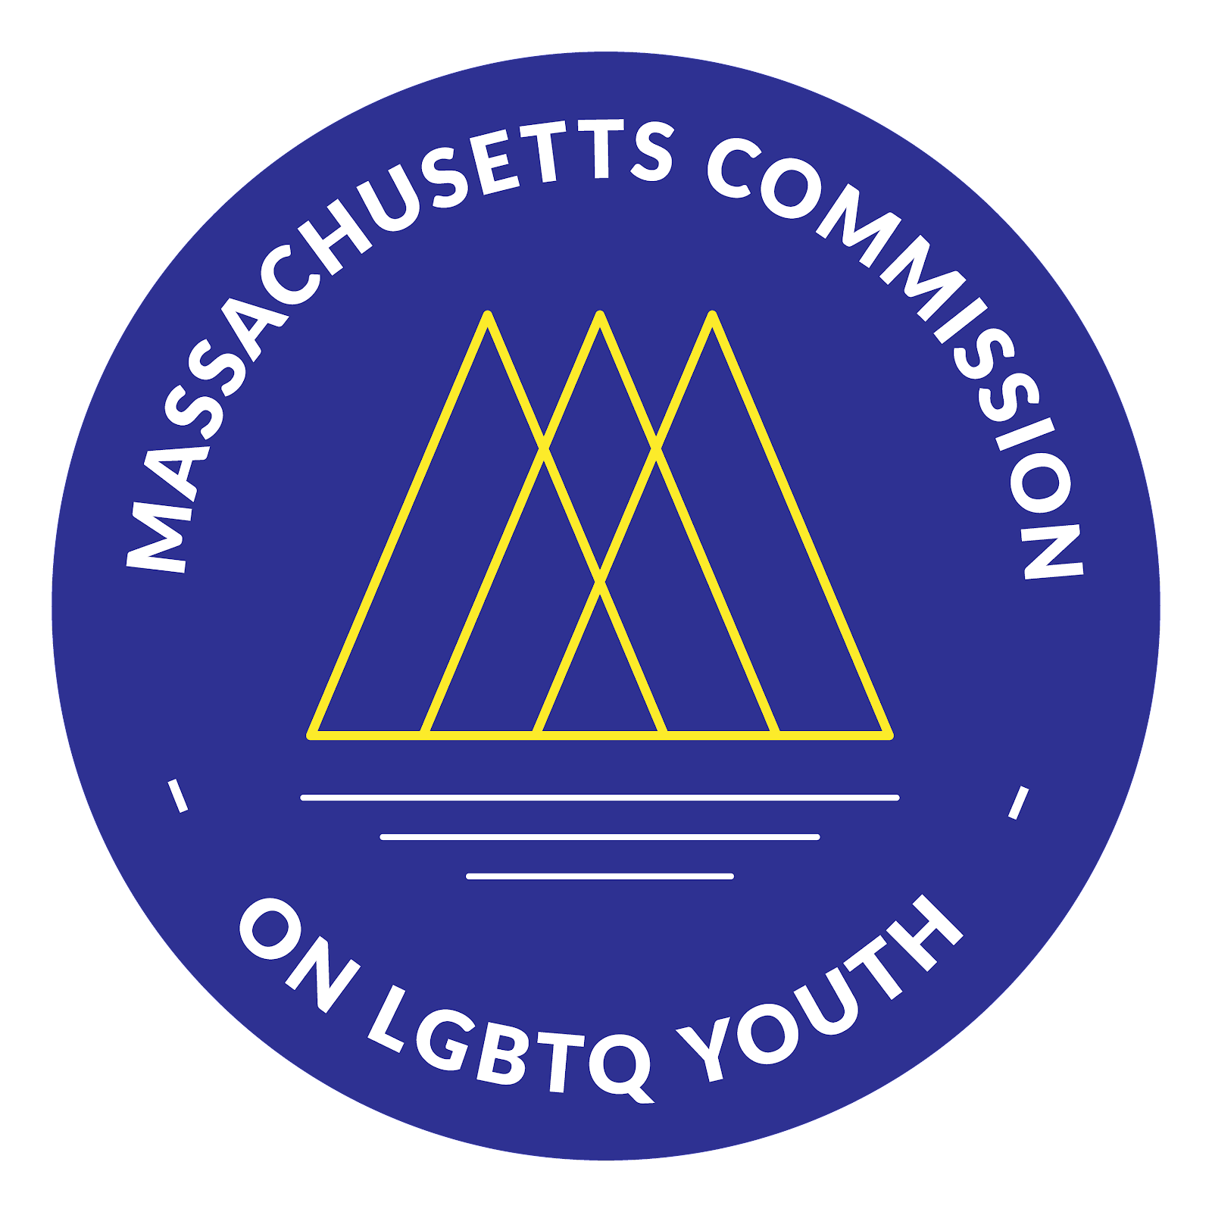
Massachusetts Commission

on LGBTQ Youth

“Working for a Commonwealth where all youth thrive”

Spring Quarterly Meeting Agenda
March 16, 2022
6:00-8:00pm

Zoom registration link: https://www.google.com/url?q=https://us02web.zoom.us/meeting/register/tZ0qfuGrqDIvH9JjkokM-bjxW2La0aT7Ehn-&sa=D&source=calendar&usd=2&usg=AOvVaw03sPw-rIyHemaSKAgU1U5-

6:00 - 6:30 PM: Opening
- Land acknowledgement
- Intros & Icebreakers in small groups
- Approval of minutes from:
  - December Quarterly Meeting (12/14/2021)
  - Special Commission Meeting (12/22/2021)

6:30 - 6:45 PM: Meet the New Executive Director
- Introduction (Roger)
- Remarks by new Executive Director, Shaplaie Brooks

6:45 - 7:15 PM: Call to Action on Trans Day of Visibility—March 31, 2022
- Commission Statement
- Preliminary Planning Ideas for Commission Event
- Q & A

7:15 - 7:35 PM: Report Outs
- Budget (Molly)
  - FY22 internal budget amendments
    - Budget amendments
    - Budget as amended 2/23/22
  - FY23 state budget line item increase request
    - Letter to House Ways & Means
    - Letter to Senate Ways & Means
- Policy (Molly & Legislative Team)
- Safe Schools Program (Ashley & Staff)
- Sex Work Research Team (Ivy)
- Racial Justice Committee (Fahmina)

7:35 - 7:55 PM: Announcements
- Seeking proposals for spring contracts – RFPs (Rayna)
- Announcements from Commission Membership?

7:55 PM: Closing
- Members: please share your feedback on this meeting

