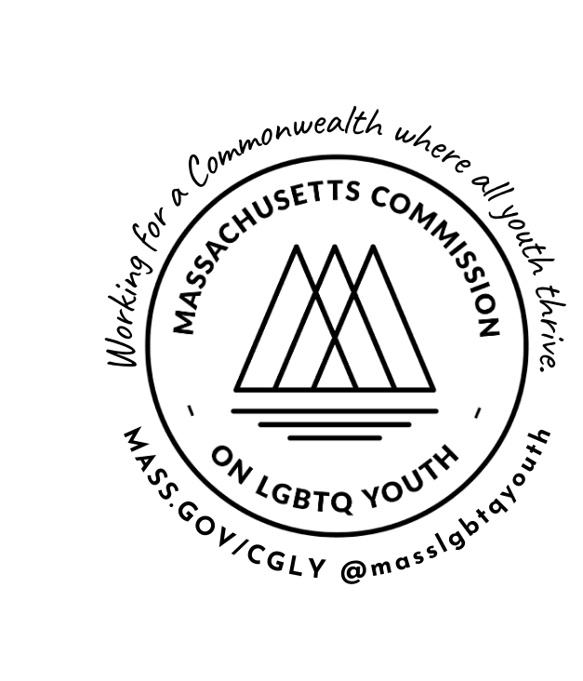REPORT & RECOMMENDATIONS
MASSACHUSETTS COMMISSION ON LESBIAN, GAY, BISEXUAL, TRANSGENDER, QUEER & QUESTIONING YOUTH
F iscal year 2024
JULY 1, 2023--JUNE 30, 2024

Recommended citation: Massachusetts Commission on Lesbian, Gay, Bisexual, Transgender, Queer, and Questioning Youth. (2023). Massachusetts Commission on LGBTQ Youth: Report and Recommendations for Fiscal Year 2024. Retrieved from https://www.mass.gov/annual-recommendations

The Commission sincerely thanks the contributions of its staff, members, and consultants:

Shaplaie Brooks, Executive Director and lead co-editor
Rayna Hill, Legislative & Policy Manager, lead co-editor and author of ‘Eliminating Barriers to Service’, ‘Ending Homelessness’, ‘Advancing Justice’, and agency recommendations
Craig Martin and Noemi Uribe, Commission Co-Chairs and co-authors of the Introduction Letter Joan Halford, lead researcher and author of “Protecting LGBTQ Child Welfare & Well-Being”
Kimm Topping, Safe Schools Program Manager, lead author of “Uplifting Education” & education agency recommendations
Cas Martin, Lead Trainer (Western MA), co-author of "Uplifting Education"
Karina Sumano, lead researcher and author of “Broadening Pregnancy & Gynecological Health” Sarah Prager, lead researcher and author of “Improving Sexual Health”
Dallas Ducar, lead researcher and author of “Addressing Pediatric Health” Alexandra Gago, lead researcher and author of “Destigmatizing Public Health”
Max Tang, Social Work Fellow, lead researcher and author of “Supporting Mental Health” and co-author of "Uplifting Education"
Karina Zeferino, lead researcher and author of “Expanding Inclusive Service Provision” Leija Helling, lead researcher and author of “Understanding Environmental Justice”
Hannah Hussey, lead researcher and author of agency recommendations to the Office of the Child Advocate and Committee for Public Counsel Services
Brenda Gonzalez, Policy & Research Intern, copyeditor Gianna Medeiros, Policy & Research Intern, copyeditor Hanyuan Zhang, Policy & Research Intern, copyeditor

Acknowledgments: The authors thank the Commission members, youth, consultants, agency liaisons, community partners, and others who offered their feedback and opinions that contributed to this report.

About Us: The Massachusetts Commission on Lesbian, Gay, Bisexual, Transgender, Queer, and Questioning (LGBTQ) Youth is established by law as an independent agency of the Commonwealth to recommend to all branches of state government effective policies, programs, and resources for LGBTQ youth to thrive. Per its legislative authority, the Commission works closely with the agencies to which it issues non-binding recommendations to receive their input and assist them in achieving the goals that the Commission has set. The Commission was originally founded as the Governor’s Commission on Gay and Lesbian Youth in 1992 in response to high suicide rates among gay and lesbian young people, and was reestablished by the legislature as an independent agency in 2006 (Act of Jul. 1, 2006, Ch. 139 §4, codified in Mass. Gen. Laws Ch. 3 §67). Thirty- one years after the creation of the original Governor’s Commission, it remains the first and only such commission in the country dedicated to uplifting LGBTQ youth voices in state government.

Contact Us: For print copies, permissions, and other inquiries, contact us at commission@ma-lgbtq.org.

Letter from Leadership

Nearly 500 anti-LGBTQ bills have been introduced by policymakers in states across the nation; some have already been passed in Utah, South Dakota, Mississippi, Arkansas, Tennessee, West Virginia, Iowa, Georgia, and Idaho. Across the country, states are legislating discrimination, dehumanization, terrorization, and the erasure of millions of queer, gender expansive, and transgender youth, as well as their caregivers, providers, and educators.

As the Commission releases its FY 2024 annual report in April of 2023, we condemn the fervent and disgraceful attacks from other states that seek to strip away the autonomy of LGBTQ youth and their caregivers. We understand that, for our LGBTQ youth, the COVID pandemic has exacerbated serious health disparities and socioeconomic experiences that are only compounded by the emotional, psychological, and physical pressures of homophobia, transphobia, xenophobia, and the terror of mass shootings that crush over 50.7 million students in schools across the United States.

Across the nation, our LGBTQ youth are seeking light, love, and liberation from their families, schools, healthcare providers, legislators, and communities, all while trying to thrive in a dangerous political environment that is attempting to erase them from history. As of April 24, 2023, the 469 anti-LGBTQ bills introduced target our youths’ rights to visibility, access to life-saving gender-affirming care, access to school sports, and LGBTQ books and literature. As a result, 50% of our queer and trans youth have seriously considered suicide in the past year. More than 70% of our LGBTQ youth experience anxiety, and 58% report symptoms of depression. Despite these statistics, 1 in 2 of LGBTQ youth in Massachusetts were unable to access the mental health care they desperately wanted. As discussed throughout the following annual report, when we look at the experiences of Black, Latiné, Asian & Pacific Islander, and Indigenous LGBTQ youth, we observe higher rates of victimization, sexual violence, policing, homelessness, foster care, and invisibility.

When our LGBTQ youth can thrive as affirmed individuals who can live with dignity; enjoy equal access to sustainable livelihoods; receive nondiscriminatory and empowering education and health care; and are able to freely participate more fully in civic and democratic processes within their schools and communities, everyone wins! Research shows that LGBTQ youth who are nurtured in schools and communities that intentionally serve as lighthouses of school connectedness foster exponential positive effects on their livelihoods. In environments where LGBTQ youth are supported and cared for by family, loved ones, friends, and educators; are accurately gendered; engage inclusive educational learning; have access to life-giving mental and health care; as well as see positive representations of themselves we see higher rates of connectedness, attendance, and thriving as whole beings.

As the state with the only Commission on LGBTQ Youth in the country, we believe it is our responsibility to be the lighthouse for LGBTQ youth and to uplift underserved populations across the Commonwealth. At every level, and within every institution, the Commission calls for the Commonwealth to say, “Not in Massachusetts!”

But, in order to do so, the Commonwealth must continuously address its own negligence towards ensuring comprehensive care for LGBTQ youth. Massachusetts General Law Chapter 76 section 5 explicitly states “No person shall be excluded from or discriminated against in admission to a public school of any town, or in obtaining the advantages, privileges and courses of study of such public school on account of race, color, sex, gender identity, religion, national origin or sexual orientation.” Yet, even within this state, we must acknowledge that there is an rise of anti-LGBTQ activity of people targeting the civil rights of children, youth, and families, including proposed book bans, protests at drag story hours, and bomb threats against Boston Children's Hospital for providing gender-affirming care. By ignoring these attacks, we unintentionally send a poignant message to our youth that – while those in power know of their suffering – there is little care and attention to the necessary work to protect the health, safety, and well-being of youth in this state.

For 31 years, the Commission has had the honor of working with many advocates, legislators, parents, teachers, and administrators who care deeply for youth, and commends their important work thus far to protecting LGBTQ youth. With their help, the Commonwealth has become a leader in model legislation in regards to our laws and policies which have proven to improve outcomes for LGBTQ youth, including our expansive anti-discrimination protections for sexual orientation and gender identity; comprehensive anti-bullying laws; and nonbinary gender markers in schools, agencies, and state identification. The Commission implores the Commonwealth to continue this critical work, and continue to support its work in creating brave and nurturing spaces and communities where all youth thrive.

When we think of a safe space for all youth and how to make it better, we often silo problems in an effort to eradicate a single issue. When we house a youth, that same youth could be in danger of losing their housing because we didn’t take into consideration their gender identity, the employment discrimination they are facing, and its threat to their economic stability. This oversight subsequently places them at high risk for homelessness - again. Let’s take it a step further. This youth is not only transgender, but she is a multisystem-involved (DCF and DYS) youth with a history of commercial sexual exploitation; she has an IQ of 70, a mental health diagnosis, and she is Black. All of these identities place this youth at a much higher risk of marginalization, and failing to receive the appropriate services she needs.

More often than not, other marginalized intersections are not considered when addressing systemic barriers to services. Understanding these not so subtle nuances in identities are critical to servicing all youth and preparing them to thrive in a world built to work against them. Doing so often places our young people in a never ending cycle of oppression. When we look at youth holistically, we move beyond micro-level approaches to care and service provision onto a path that will create real structural change that benefits the whole person and community. Advocating and creating pathways to freedom and equity for the most marginalized person in the room not only liberates everyone else, it chips away at a broken system in order to rebuild better.

Additionally, to free everyone, we must free the most marginalized person in the room. Those with multiple intersecting identities have often been disregarded due to the systemic and insidious structures of white supremacy within this country, and the state of Massachusetts. We, as the Commission and people of this country, have to speak truth to power and disavow the heteronormative and racist

ideologies that have been cemented into law, and continue to seek new footholds across the country. The MA Commission on LGBTQ Youth will remain relentless and committed to utilizing our voice and power as unabated champions for all LGBTQ youth, their families, and educators across the Commonwealth. Through partnerships, advocacy, love, and pride, our work will expand in the coming fiscal year to protect and uplift each youth at the core of their every intersection.

Within this FY 2024 report, we provide recommendations now to 21 state entities. These recommendations are intended to amplify, not replace, the voices of the most marginalized young people in our communities, especially Black, Brown, Indigenous, immigrant, disabled, neurodivergent, transgender, intersex, and gender expansive youth, as well as those in foster care, experiencing homelessness, are incarcerated, or have experienced sexual exploitation.

As the Commission celebrates over 30 years of advocating on the behalf of LGBTQ youth, we also look to renew our focus to hold ourselves, our colleagues, school communities & districts, legislators, and agencies accountable to proactive, consistent, and inclusive approaches to service provision to create long-lasting change. As we look to publish new recommendations and special reports on the realities of LGBTQ and QTBIPOC youth in the Commonwealth, we call to action all those in position to make significant changes to address the harms and disparities faced by too many in this state.

The Commonwealth must commit to becoming united.

Sincerely,

Craig Martin Co-Chair He/Him/His
Noemi Uribe
Co-Chair They/She
Shaplaie Brooks Executive Director She/Her/Hers

TABLE OF CONTENTS

2021 MYRBS Analysis
Anti-LGBTQ Attacks - Massachusetts Protecting LGBTQ Child Welfare Uplifting Education
Destigmatizing Public Health Supporting Mental Health Addressing Pediatric Health
Broadening Pregnancy & Gynecological Health
Improving Sexual Health Ending Homelessness Advancing Justice Inclusive Service Provision
Understanding Environmental Justice Eliminating Barriers to Services Agency Recommendations
Glossary
Commission Member List
1
9
10
22
36
58
82
97
116
131
144
156
172
185
190
271
277



CONTENTS

Early Education and Care Higher Education
Elementary & Secondary Education
Children & Families
Office of the Child Advocate Committee for Public Counsel Services Commission for the Blind
Commission for the Deaf and Hard of Hearing
Rehabilitation Commission Mental Health
Public Health MassHealth
Office for Refugees and Immigrants Transitional Assistance
Youth Services
Public Safety & Security
190
194
198
206
213
222
225
227
230
233
238
242
246
250
253
257

CONTENTS CONT.

Registry of Motor Vehicles Board of Library Commissioners
Housing & Community Development
MassHire - Career Services
259
261
264
268

2021 MYRBS Analysis

The Massachusetts Youth Risk Behavior Survey (MYRBS) is a biennial, representative survey of youth statewide. The longitudinal analyses presented here use data from 2015-2021. The other results rely upon 2021 data whenever possible (the most recent survey data available), but sometimes use data pooled across the 2019 and 2021 surveys, particularly where intersectionality of LGBTQ identity and other identities such as gender and race are examined.

Longitudinal Trends, 2015-2021

As shown in Figure 1, the percentage of youth in Massachusetts who identify as LBGTQ has increased gradually and significantly from 12.6% in 2015 to 21.9% in 2021 (p<.001), and almost all of this increase occurred among youth who identify as female. The percentage of youth identifying as female who identified as LGBTQ was 15.5% percent in 2015, and doubled to 32.9% in 2021, whereas among males, the percentage of youth identifying as LGBTQ increased only slightly, from 9.0% to 10.2%.

2021 Number of LGBTQ Youth
35

30

25

20

15

10

5

0
2015
2019
2021
Total LGBTQ Youth Total Female Total Male

The percentage of youth who identify as transgender also increased significantly between 2015-2021 (p<.001), from 2.9% in 2015 to 5.3% in 2021, but most of the increase occurred between 2019 and 2021. In 2015, there was no gender difference in the percentage of youth who identified as transgender. In 2017, there was a slight and statistically significant difference, with youth who identified as male being more likely to identity as transgender (3.2% versus 2.1%, p<.01), and in 2019 there was no difference again. In 2021, youth who identified as female were significantly more likely to identify as transgender (6.3% versus 3.3%, p<.001).

Looking at the intersection of race/ethnicity and LGBTQ identity, there were statistically differences (p<.05) in the percentage of LGBTQ youth by race/ethnicity in all years except for 2021 (See Figure 2.) The percentage of Asian youth who identify as LGBTQ has increased steadily, from 10.5% to 22.3%. The percentage of Black or African American youth who identify as LGBTQ has nearly doubled from 10.0% to 19.6%, the percentage of White youth nearly doubled also, from 11.5% to 20.7%, and the percentage among Latinx youth increased from 12.5% to 19.1%. Among youth who identify as Latinx and multiracial, the percentage increased only slightly, from 21.3% to 25%, and among youth who identify as multiracial and not Latinx, it more than doubled from 14.1% to 31.3%. The percentage of youth who identify as transgender is not analyzed by race/ethnicity longitudinally for 2015-2021, because the number of youth in each subgroup is too small to produce reliable estimates. Instead, 2019-2021 data were pooled to produce an estimate across the two years of data collection: 3.6% of Asian youth, 3.2% of Black or African American youth, 4.4% of White youth, 3.7% of Latinx youth, 4.1% of multiracial Latinx youth, and 6.7% of multiracial non-Latinx youth identified as transgender in 2019-2021.

Figure 2: Racial Breakdown of LGBTQ Youth
35

30

25

20

15

10

5

0
Asian
Black or African
American
White
Latinx
Latinx &
Multiracial
Multiracial
2015 2021

LGBTQ youth were significantly less likely to be able to talk with at least one of their parents or another adult member about things that are important to them compared with heterosexual, cisgender (het-cis) youth across all years. While LBGTQ youth seemed to make some gains in this area in 2017 and 2019, in 2021 only 60.6% said that they could talk with an adult at home, an even lower percentage than in 2015 (65.2%). In contrast, the percentage of het-cis youth who could talk with an adult at home has held fairly steady across this period, between 81-85%. Additionally, LGBTQ youth were also significantly less likely than het-cis youth to have at least one teacher or other adult at school they could talk to if they had a problem in 2015, 2019, and 2021, but the difference was not significant in 2017. The percentage of LGBTQ youth who had an adult at school to talk with increased slightly from 66.7% in 2015 to 71.3% in 2017, but then decreased back to 69.9% in 2019, and in 2021 was only 60.0%. The percentage of het-cis youth who

had someone at school they could talk to also declined between 2019 and 2021, suggesting that the COVID-19 pandemic has affected relationships between youth and adults at school more broadly.

LGBTQ youth were about twice as likely to be bullied in school, and that difference is both statistically significant and consistent across the years. The percentage of youth who were bullied is lower in 2021 for both LGBTQ youth and cis-het youth and is at its lowest level in that year: 8.7% for cis-het youth and 18.7% for LGBTQ youth.

LGBTQ youth were significantly more likely than cis-het youth to be threatened at school and that difference is both statistically significant across the years. The percentage of LBGTQ youth who were threatened at school peaked at 11.7% in 2019 and then declined to 9.5% in 2021, the lowest percentage during this period. LGBTQ youth were about three times more likely to skip school in the last 30 days because they felt they would be unsafe at school or on their way to or from school, and that difference is also statistically significant and consistent across the years. While the percentage skipping school dipped a bit in 2017, it rose again in 2021, with 17.4% of LGBTQ youth reporting that they did so.

Figure 3: Bullying & Self-Harm
Suicide Attempt
Suicidal Ideation
Self-Harm
Sex Against Will
Bullied Electronically
0
10
20
30
40
50
60
Cis-Het Youth LGBTQ Youth

Figure 3 shows the percentage of LBGTQ and het-cis youth who reported being bullied electronically. LGBTQ youth were about twice as likely as het-cis youth to be bullied in this manner, and those differences were statistically significant in each year (p<.001). In 2021, 25.9% of LGBTQ youth and 10.4% of het-cis youth reported being bullied electronically.

LGBTQ youth were significantly more likely than het-cis youth to have ever been physically forced to have sexual intercourse when they did not want to (see Figure 3). The percentage of LGBTQ youth increased from 12.4% in 2015 to 15.4% in 2017 to 19.1% in 2019, but then decreased to 16.0% in 2021, and het-cis youth reported a similar increase and then decrease across those years. In 2021, LGBTQ youth were four

times more likely than het-cis youth to report ever having been forced to have sex (16% compared with 4%).

LGBTQ youth were significantly more likely to experience sexual dating violence and physical dating violence between 2015-2021, compared with het-cis youth (p<.001). LGBTQ were over twice as likely to report that in the past 12 months someone they were dating or going out with forced them to do sexual things they did not want to do, including kissing, touching, or being physically forced to have sexual intercourse. The percentage of LGBTQ youth who reported this increased from 15.8% in 2015 to 20.8% in 2019 and then declined slightly to 17.8% in 2021. LGBTQ youth were also over twice as likely to report that in the past 12 months someone they were dating or going out with physically hurt them on purpose, including being hit, slammed into something, or injured with an object or weapon. The percentage of LGBTQ youth who reported this form of violence was 13.2% in 2015, decreased to 9.6% in 2017, increased to 16.3% in 2019, and decreased to 13.9% in 2021.

Figure 3 also provides some mental health experiences from 2015-2021 for LGBTQ and het-cis youth, showing the percentage of youth who hurt themselves, considered suicide, and attempted suicide. Throughout this period, LBGTQ youth were about three times more likely than het-cis youth to report hurting themselves, with statistically significant differences in all years (p<.001). The biggest difference occurred in 2021, when 49.5% of LGBTQ youth and 11.3% of het-cis youth reporting hurting themselves. Likewise, LGBTQ youth were about three times more likely to consider suicide, with statistically significant differences in all years (p<.001). In 2021, LGBTQ youth were almost four times more likely to do so: 43.8% compared with 10.9% among het-cis youth. LGBTQ youth were three to four times more likely than het- cis youth to attempt suicide. In 2021, 18.0% of LGBTQ youth and 4.4% of het-cis youth attempted suicide.

Adverse Household and Mental Health Experiences

In 2021, the MYRBS included several new questions about COVID-19 and other adverse experiences, and the results of comparative analyses for LGBTQ and het-cis youth are provided in Table 1. The survey asked youth, “During the COVID-19 pandemic, how often was your mental health not good? (Poor mental health includes stress, anxiety, and depression.)” Poor mental health status is strongly associated with LGBTQ identity (p<.001). As represented in Figure 4, only 4.5% of LGBTQ youth said their mental health was never not good, 8.0% said it was rarely not good, 21.0% said it was sometimes not good, 35.5% said that it was not good most of the time, and 31.0% said it was always not good. In contrast, 21.9% of het-cis youth said that it was never not good, 23.5% said it was rarely not good, 25.9% said was sometimes not good, 20.5% said that it was not good most of the time, and 8.3% said it was always not good.


Figure 4: Mental Health Status
60

50

40

30

20

10

0
Never Not Good
Rarely Not Good Sometimes Not Good Not Good Most of
the Time
Always Not Good
LGBTQ Youth Cis-Het Youth

LGBTQ youth were also significantly more likely to report some level of physical abuse at home during the COVID-19 pandemic (p<.001), according to a survey question that asked, “Did the COVID-19 pandemic, how often did a parent or other adult in your home hit, beat, kick, or physically hurt you in any way?” Among LGBTQ youth, 83.6% said never, 10.3% said rarely, 5.4% said sometimes, 0.4% said most of the time, and 0.4% said always, compared with 91.2% of het-cis youth who said never, 6.1% who said rarely, 2.0% said sometimes, 0.4% said most of the time, and 0.3% who said always.

Another new question on the survey asked about physical abuse in the home more broadly (beyond the COVID-19 pandemic): “During your life, how often has a parent or other adult in your home hit, beat, kicked, or physically hurt you in any way?” Among LGBTQ youth, 61% said that they had never been abused physically by an adult in their home, 21.9% said rarely, 12.1% said sometimes, 3.8% said most of the time, and 1.1% said always. Among het-cis youth, 77.4% said they had never been abused physically by an adult in their home, 16.3% said rarely, 5.8% said sometimes, 0.3% said most of the time, and 0.2% said always. (See Table 1.)

Another new MYRBS survey question asked about neglect: “During your life, how often has there been an adult in your household who tried hard to make sure your basic needs were met, such as looking after your safety and making sure you had clean clothes and enough to eat?” LGBTQ youth were significantly less likely than het-cis youth to have their needs met overall (p<.001). Among LGBTQ youth, 2.8% said that they had never had their needs met, 4.9% said rarely, 9.1% said sometimes, 21.6% said most of the time, and 61.6% said their needs had always been met. Among het-cis youth, 4.7% said they had never had their needs met, 2.6% said rarely, 4.4% said sometimes, 13.5% said most of the time, and 74.8% said their needs had always been met.

Table 1. Percentage of Youth with Adverse Household and Mental Health Experiences (2021)

Adverse Experience | Het-Cis Youth | LGBTQ Youth
Mental health not good during COVID-19***
Never | 21.9% | 4.5%
Rarely | 23.5% | 8.0%
Sometimes | 25.9% | 21.0%
Most of the time | 20.5% | 35.5%
Always | 8.3% | 31.0%
Physical abuse during COVID-19***
Never | 91.2% | 83.6%
Rarely | 6.1% | 10.3%
Sometimes | 2.0% | 5.4%
Most of the time | 0.4% | 0.4%
Always | 0.3% | 0.4%
Physical abuse at any time***
Never | 77.4% | 61.1%
Rarely | 16.3% | 21.9%
Sometimes | 5.8% | 12.1%
Most of the time | 0.3% | 3.8%
Always | 0.2% | 1.1%
Physical needs not met***
Never | 4.7% | 2.8%
Rarely | 2.6% | 4.9%
Sometimes | 4.4% | 9.1%
Most of the time | 13.5% | 21.6%
Always | 74.8% | 61.6%
*** p<.001

Comparative analyses of these questions for transgender and cisgender youth are provided in Table 2. Transgender youth were significantly more likely to report poor mental health status (p<.001), adult physical abuse in the home during COVID-19 (p<.001), adult physical abuse ever in their lives (p<.001), and physical neglect of their needs (p<.001). Only 4.4% of transgender youth reported that their mental health status was never not good, 6.6% said that it was rarely not good, 19.1% said that it was sometimes not good, 31.6% said that it was not good most of the time, and 38.2% said that it was always not good, compared with 18.8% of het-cis youth who said it was never not good, 20.4% who said it was rarely not good, 25.1% who said it was sometimes not good, 23.4% who said it was not good most of the time, and 12.3% who said it was always not good.

Among transgender youth, 77.2% never experienced abuse by an adult in their home during COVID-19, 14.0% said never, 6.6% said sometimes, 0.7% said most of the time, and 1.5% said always, compared with

89.7% of cisgender youth who said never, 6.9% who said always, 2.7% who said sometimes, 07.% who said most of the time, and 0.3% who said always. In terms of ever experiencing physical abuse by an adult in their household, among LGBTQ youth, 50% said that they had never experienced it, 31.2% said that they had rarely experienced it, 13.0% said sometimes, 4.3% said most of the time, and 1.4% said always. In contract, among het-cis youth, 74.6% said they had never experienced it, 16.7% said rarely, 7.4% said sometimes, 1.0% said most of the time, and 0.2% said always.

Among transgender youth, 2.9% said that they had never had their needs met, 6.6% said rarely, 12.5% said sometimes, 24.3% said most of the time, and 53.7% said that they always had their needs met. Among het-cis youth, 4.4% said they had never had their needs met, 2.9% said rarely, 5.1% said sometimes, 15.1% said most of the time, and 72.6% said their needs had always been met.

Table 2. Percentage of Youth with Adverse Household and Mental Health Experiences (2021)

Adverse Experience | Cisgender Youth | Transgender Youth
Mental health not good during COVID-19***
Never | 18.8% | 4.4%
Rarely | 20.4% | 6.6%
Sometimes | 25.1% | 19.1%
Most of the time | 23.4% | 31.6%
Always | 12.3% | 38.2%
Physical abuse during COVID-19***
Never | 89.7% | 77.2%
Rarely | 6.9% | 14.0%
Sometimes | 2.7% | 6.6%
Most of the time | 0.4% | 0.7%
Always | 0.3% | 1.5%
Physical abuse at any time***
Never | 74.6% | 50.0%
Rarely | 16.7% | 31.2%
Sometimes | 7.4% | 13.0%
Most of the time | 1.0% | 4.3%
Always | 0.2% | 1.4%
Physical needs not met***
Never | 4.4% | 2.9%
Rarely | 2.9% | 6.6%
Sometimes | 5.1% | 12.5%
Most of the time | 15.1% | 24.3%
Always | 72.6% | 53.7%
*** p<.001

Physical Health

Table 3 compares multiple dimensions of physical health between LGBTQ and het-cis youth. LGBTQ youth were significantly more likely than het-cis youth to describe themselves as slightly or very overweight (36.8% versus 26.5%) and were more likely to report trying to lose weight (52.8% versus 40.8%). While LGBTQ youth were no more likely to be overweight based on BMI (15.9% versus 15.3%), they were slightly more likely to be obese using BMI (18.1% versus 13.9%). Compared with het-cis youth, LGBTQ youth were less likely to eat breakfast (16.0% versus 22.7%), less likely to be physically active at least 60 minutes per day on 5 or more days (28.1% versus 47.9%), and less likely to get 8 or more hours of sleep (15.4% versus 21.7%).

Table 3. Physical Health Measures for Het-Cis and LGBTQ Youth (2021)

Physical Health Measure | Het-Cis Youth | LBGTQ Youth
Described self as overweight*** | 26.5% | 36.8%
Trying to lose weight*** | 40.8% | 52.8%
Overweight based on BMI | 15.3% | 15.9%
Obese based on BMI* | 13.9% | 18.1%
Did not eat breakfast*** | 16.0% | 22.7%
Got 8 or more hours of sleep** | 21.7% | 15.4%
Physically active at least 60 mins/day 5+ days/week*** | 47.9% | 28.1%
*** p<.001; ** p<.01; * p<.05

Table 4 compares these multiple dimensions of physical health between transgender and cisgender youth. Transgender youth were significantly more likely than cisgender youth to describe themselves as slightly or very overweight (44.1% versus 28.3%) and were more likely to report trying to lose weight (55.7% versus 42.7%). While transgender youth were no more likely to be overweight based on BMI (13.4% versus 15.5%), they were significantly more likely to be obese using BMI (27.7% versus 14.2%). Compared with cisgender youth, transgender youth were not significantly less likely to eat breakfast (22.8% versus 17.1%) or to get 8 or more hours of sleep (14.7% versus 20.5%) but were significantly less likely to be physically active at least 60 minutes per day on 5 or more days (25.6% versus 43.5%).

Table 4. Physical Health Measures for Cisgender and Transgender Youth (2021)
Physical Health Measure | Het-Cis Youth | LBGTQ Youth
Described self as overweight*** | 28.3% | 44.1%
Trying to lose weight** | 42.7% | 55.7%
Overweight based on BMI | 15.5% | 13.4%
Obese based on BMI*** | 14.2% | 27.7%
Did not eat breakfast | 17.1% | 22.8%
Get 8 or more hours of sleep | 20.5% | 14.7%
Physically active at least 60 mins/day 5+ days/week*** | 43.5% | 25.6%
*** p<.001; ** p<.01

Anti-LGBTQ Attacks in Massachusetts

As discussed throughout this annual report, the nation is seeing an unprecedented political barrage of attacks against LGBTQ youth, families, and educators. As of April 23, 2023, 469 anti-LGBTQ bills have been filed across the country with bans against education materials, gender-affirming care, and books featuring LGBTQ characters or talking about race. It is a critical and alarming time for our LGBTQ youth in Massachusetts with 90% of youth experiencing mental distress because of the degrading rhetoric lobbied on social media, through news outlets, and in dozens of state assemblies.

Now more than ever, LGBTQ youth need Massachusetts communities, educators, agencies, and policymakers to stand up and enshrine safety and freedom of the right to autonomy and queer joy. Already Massachusetts LGBTQ youth enjoy many protections that are not experienced by youth in surrounding states, but there is room for ongoing action.

Time and time again, the Commission hears from community members, advocates, and policymakers that there is little need to address anti-LGBTQ activity across the state, because it does not appear to be happening and the state’s protections are strong. However, this is not entirely the case. Across the state, numerous challenges to LGBTQ freedoms are occurring with little explicit action from the state to support local schools, communities, families, and youth. Per information obtained from MassEquality, more than 43 Massachusetts school districts have seen anti-LGBTQ organizing in schools and communities for the past several years, with the rate of attacks increasing since 2022.

These areas include, but are not limited to:

Abington, Arlington, Andover, Barnstable, Bedford, Beverly, Boston, Brewster, Brookline, Bridgewater- Raynham, Bristol County, Clarksburg, Concord-Carlisle, Danvers, Dudley, Edgartown, Fitchburg, Florida, Foxborough, Greater Fall River, Hamilton-Wenham, Hanover, Ludlow, Mansfield, Medway, Mendon- Upton, Middleborough, Millbury, Milton, Nauset, Needham, Newton, Norfolk County, North Brookfield, Old Rochester, Pepperell, Plymouth, Revere, Rockland, Scituate, Somerville, and South Hadley.

The attacks being seen on the ground by advocates and youth include book bans, LGBTQ flag removals in schools, graffiti, drag story hour protests, drag show bans, curriculum disputes, harassment at school committee meetings, doxxing against LGBTQ librarians and teachers, and much more. Furthermore, for months, healthcare providers at facilities, including Boston Children’s Hospital, have been receiving constant security, bombing, and violent threats for the provision of gender-affirming care. Combine these with the alarming rise in racist hate crimes being seen across the state, and youth are terrified and angry.

The Commission has serious concerns for the safety of LGBTQ youth, families, providers, librarians, and educators in Massachusetts with little activity occurring at the state government level to publicly address these incidents. The Commission urges the Commonwealth to take direct and explicit action to protect LGBTQ youth, educators, librarians, and caregivers.

Protecting LGBTQ Child Welfare & Well-Being

Introduction: Toward a Commonwealth in Which All Youth Thrive

Now in its 31st year, the Massachusetts Commission on LGBTQ Youth voices its mission through the motto, “Helping All Youth Thrive.” The realization of this seemingly simple saying requires leaders to take a high- level view of the stunningly complicated issues affecting the well-being of today’s LGBTQ youth—without losing sight of the importance of their individual realities.

What does it mean to serve all youth? And what does it mean for LGBTQ youth to thrive?

From the wide-angle lens of international comparison, to a snapshot of the current national climate, to a nuanced view of the complexities of youth-serving systems in our state, particularly the child-welfare system, many layers of consideration inform the most promising legislation to support the well-being of LGBTQ young people today.

Although the Commonwealth has made significant strides for LGBTQ youth, we continue to fall short, sometimes with tragic results, in many arenas that affect our young people. Equipped with a clear vision of goals for the well-being of LGBTQ youth, decision-makers can effect meaningful change. Legislative actions that support the well-being of LGBTQ youth in turn support the strength and vitality of our Commonwealth. When all youth thrive, Massachusetts thrives.

FY 2024 Recommendations to the Governor and Legislature on Child Welfare

Introduce the legislation needed to bring Massachusetts up to minimum standards of the United Nations Convention on the Rights of the Child.

As discussed further below, the United States remains the only United Nations member state that has failed to ratify the most-ratified human rights treaty in world history: The United Nations Convention on the Rights of the Child (CRC). ¹ In a 2022 Human Rights Watch evaluation of all 50 U.S. states, Massachusetts - like most other states - earned a ‘D’ in its protections for youth in the Commonwealth. In order to bring Massachusetts up to the minimum standards of the convention, the Commission recommends that the state abolish corporal punishment in all settings, including private schools, alternative care settings, and penal settings; and increase the minimum age of juvenile jurisdiction from 12 to 14.

Create a program for universal basic income for foster care youth.

The Commission recommends that the legislature pass An Act providing for a universal basic income for youth aging out of foster care (S.114), which would provide youth transitioning out of foster care with a

$1,000 per month cash stipend for 5 years. Youth transitioning out of the foster care system face significant challenges in finding stability, as discussed in this section and subsequent sections throughout this annual report. By establishing a universal basic income (UBI) for youth transitioning out of foster care, as being piloted in California, ² the state can help mitigate risk factors such as housing instability or involvement in the criminal legal system. The Commission advises policymakers and administrators to ensure that - should this program become a reality - there is a clear plan on how to directly transfer the cash assistance and make youth aware of the existence of the program.³

Establish an independent foster care review office.

The Commission supports and prioritizes the creation of an independent foster care review office (S.66 / H.158) outside of the Department of Children & Families to ensure that all cases are appropriately receiving impartial reviews. Currently, state law requires that a review of all DCF cases takes place every six months to ensure that every child is receiving appropriate care and services. However, these reviews take place within DCF, leaving advocates to continuously raise tremendous concerns over the quality and consistency of the review process.

Codify the foster child bill of rights in state law.

The Commission was pleased to see the development of the Foster Child Bill of Rights developed by DCF’s Youth Advisory Board which includes guidance that every child should be treated with respect without regard to gender identity and sexual orientation. The Commission supports An Act Establishing a Bill of Rights for Children in Foster Care (S. 68 / H.164) which would require DCF to present a copy of these rights to youth, and their attorneys.

Protect youth in the foster care system from having their federal benefits stripped away.

The Commission recommends that Massachusetts enact legislation to address the confiscation of federal benefits from children in the foster care system, as suggested in An Act Protecting Benefits Owed to Foster Children (S. 65 / H.157). In a 2021 study from The Marshall Project and NPR,⁴ it was detailed that 10% of foster youth across the country are entitled to Social Security benefits, with 36 states - including Massachusetts - then accessing these benefits, often without ever notifying the child or families.⁵ In 2018, Massachusetts took a reported $6.31 million from youth in the foster care system. (Citation) Historically, child welfare agencies - including DCF - accessed Supplemental Support Income (SSI) and Social Security Disability Insurance (SSDI) to cover the cost of placements, particularly given that youth were not able to build up assets over $2,000 to maintain eligibility for these benefits. DCF advises the Commission that it is currently working with the Disability Law Center and Fidelity Investments to set up ABLE accounts for youth eligible for SSI and SSDI.

Solidify parental rights for LGBTQ families.

Despite the significant strides that Massachusetts has made over the last couple of decades to support LGBTQ families, there still remain gaps in state law to ensure that all families have the same legal protections. The Commission strongly recommends and prioritizes the passage of An Act to Ensure Legal Parentage Equality (S. 947 / H.1713), also known as the Massachusetts Parentage Act (MPA), which would update and strengthen legal parentage laws in the Commonwealth. The MPA clarifies how the state establishes parentage for children in families who are born through assisted reproduction or surrogacy, or to same-sex parents who are not married, as well as would recognize de facto parentage.⁶

Improve Massachusetts child abuse laws to explicitly include the withholding of gender-affirming care for LGBTQ youth.

With the significant rise in public transphobia across the state, the Commission has serious concerns about the wellbeing of trans and gender expansive youth in the home, and advises that the state examine current laws around child abuse and welfare to ensure that the unique situations faced by LGBTQ youth are being addressed. In particular, the Commission recommends that the state examine the possibility of codifying gender-affirming child welfare protections in state law to better support youth and families.

Explore the creation of an LGBTQ youth maltreatment code system within the Department of Children and Families.

The Commission recommends that the state explore the creation of a maltreatment code system for use in the child welfare system to better support social workers in tracking and addressing critical cases and incidents, with a specific maltreatment code being assigned to LGBTQ youth. The Commission understands that there are other states, such as Georgia,⁷ that have implemented a maltreatment code system that provides multiple benefits, including indicating and categorizing levels of imminent risk – used by social workers to better prepare and support youth in their caseload – as well as better categorizing a case’s eligibility for family preservation services; and providing the state and researchers with helpful data to better understand critical trends and gaps in case. Furthermore, proper coding of cases minimizes child abuse and neglect (CAN) registries for parents and families by supporting service intervention rather than a removal, as CAN registry can negatively impact caregivers’ economic status and ability to retain employment.

However, despite the unique experiences faced by LGBTQ youth who may be in the child welfare system, or may potentially become involved in the system, no state has any LGBTQ-specific codes to support youth, providers, and families. Without these codes, collecting more comprehensive qualitative and quantitative data on LGBTQ youth maltreatment experiences is incredibly difficult.⁸

Update Chapter 119, Section 89 of the Massachusetts General Laws to include the Commission on the Juvenile Justice Policy and Data Board as a voting member.

As discussed further in this annual report, the Juvenile Justice Policy and Data Board (JJPAD) evaluates juvenile justice system policies and outcomes to make recommendations on areas of improvement. Risk factors for juvenile justice system involvement is involvement in the child welfare system, which also is a factor for childhood trauma. However, despite the fact that LGBTQ youth often face numerous disparities in both the child welfare and juvenile justice systems, there remains no formal and dedicated voice for LGBTQ youth on JJPAD or its Childhood Trauma Task Force (CTTF). The Commission urges the legislature to address this concerning gap in representation by passing An Act Updating the Juvenile Justice Policy and Data Board (S. 78).

Research: Defining what it means for Youth to Thrive

The development of effective policies to support LGBTQ young people begins with an understanding of the youth themselves. For many, their lived reality involves intersectionality—multiple layers of identity.⁹ An LGBTQ young person, already a member of a vulnerable group, may belong to multiple groups, including racial, ethnic, linguistic, religious, cognitive, and ability-related minorities. Many of the Commonwealth’s LGBTQ young people identify with multiple groups, and this intersectionality holds

significant implications, both for opportunity and for oppression. Diversity merits positive recognition as a source of strength for our society. However, as detailed further in several of the subsequent sections of the Commission’s report, the harsh realities of minority stress experienced by LGBTQ youth¹⁰ can be compounded when youth identify with additional minority groups. A recent report from The Trevor Project illustrates this challenge,

“LGBTQ youth of color may have parents or caregivers who have concerns about their child facing further discrimination and victimization on top of their racial/ethnic identity and may feel that withholding support for their sexual orientation is in the best interest of their safety.”¹¹

Leaders are called to recognize the complexities of identity as they consider effective, culturally relevant policies. Specifically, throughout this report, we seek to illuminate the underserved needs of QTBIPOC (Queer, Trans, Black, Indigenous People of Color) youth in the Commonwealth. Further, we believe that to truly serve all youth implies that the voices and realities of young people themselves must inform the decisions made in their names.

Though at first glance, an understanding of well-being may seem self-evident, some analysts believe that a lack of consensus on what children and youth actually need to thrive is hampering the United States in the development of children’s rights policies.¹⁰ Child development experts worldwide, however, do concur that a holistic view of well-being for children and youth involves physical, medical, social, emotional, psychological, moral, and educational dimensions, which necessarily involve environmental, cultural, and artistic components.¹¹ Dimensions of well-being promote thriving youth and thriving youth see hopeful futures for themselves as adults. Later sections of this report address each of these domains in detail.

Of all the dimensions of wellbeing, emotional health continues to demand special attention as a leverage point for policymakers. Longstanding research underscores the specific importance of emotional health for LGBTQ youth, particularly in our politically polarized and often hostile climate. The research on emotional support for LGBTQ youth has evolved significantly in recent decades. Social scientists have developed models to foster family acceptance, even among unsupportive and reticent adults.¹² Specific supportive behaviors have been correlated with positive emotional outcomes for LGBTQ youth.¹³ Indeed, the ongoing presence of a single supportive adult can make an enormous difference to a vulnerable young person.

When the Commission on LGBTQ Youth was formed in 1992, in the wake of alarming suicide trends among gay and lesbian youth, policy discussion focused primarily on reducing harm. Today, although harm reduction remains a priority, leaders have broadened the scope of their work to help LGBTQ young people realize the totality of their potential, both as individuals and as important contributing members of society. ¹⁴ The focus has expanded from surviving to thriving.

The International Context: Massachusetts As Compared Internationally

LGBTQ youth are first and foremost young people. Contrary to popular opinion, the sobering reality for children in the United States is that they lack most of the basic human rights that children enjoy in other

nations. The United States remains the only United Nations member state that has failed to ratify the most-ratified human rights treaty in world history: The United Nations Convention on the Rights of the Child (CRC).¹² Adopted in 1989, the United Nations CRC offers a minimum standard for the legal protection of children and youth in domains that affect their well-being including child marriage, juvenile justice, child labor, corporal punishment, and education, among other critical arenas.

Given the impact of state-level laws on children’s rights in our country, the Human Rights Watch recently evaluated the laws of the individual 50 United States against four of the key protections of the United Nations Convention on the Rights of the Child: child marriage, corporal punishment, child labor, and juvenile justice.¹³ Most states demonstrate overwhelming noncompliance with internationally accepted children’s rights standards. Only four states earned a C in the evaluation, and Massachusetts, which ranked fifth, earned a D. This evaluation merits significant attention because it underscores key areas in which our state can make legal changes to bring the rights of all our children, including LGBTQ youth, up to the baseline level of other countries.

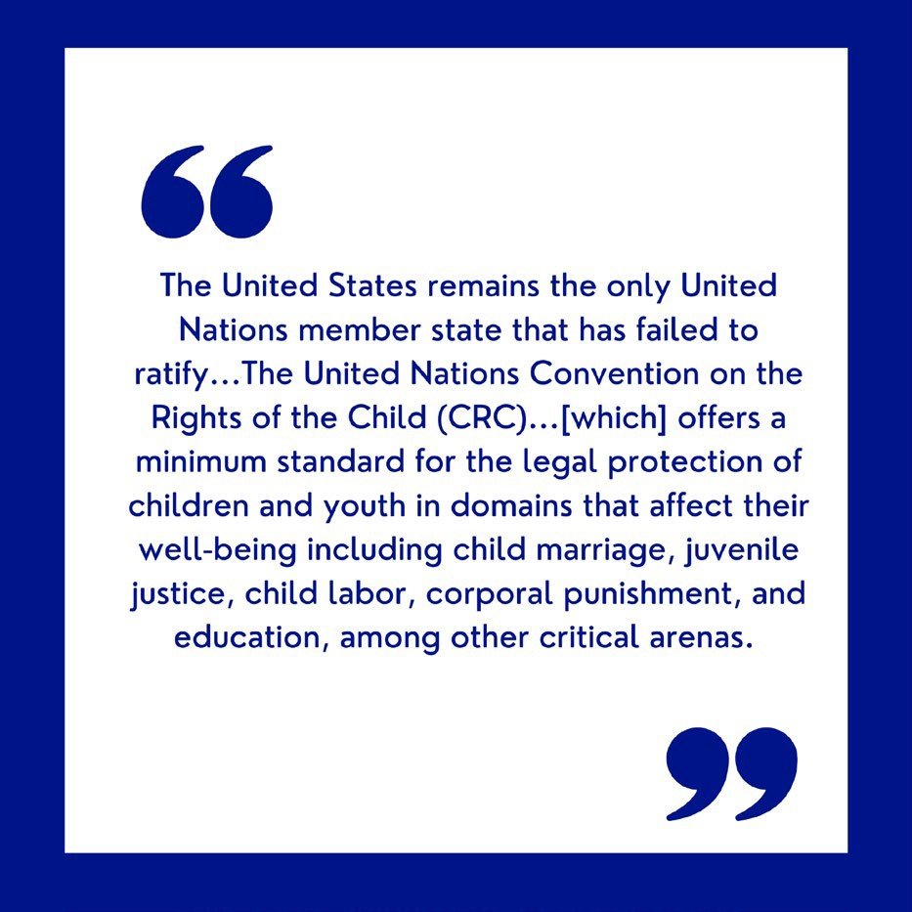
Although our nation has not ratified the United Nations Convention on the Rights of the Child, our Commonwealth can and should consider the specifics of the CRC as part of its legislative roadmap. To align with the rights in the United Nations CRC, Massachusetts would need to abolish corporal punishment in all settings raise the minimum age for agricultural work from zero to 15, raise the minimum age for hazardous agricultural work from 16 to 18, increase the minimum age of juvenile jurisdiction from 12 to 14, and explicitly prohibit the transfer of any child under 18 to adult courts for any reason. Corporal punishment, which disproportionately harms LGBTQ youth, remains legal in Massachusetts in private schools, alternative care settings, and penal settings. Further, QTBIPOC
youth are overrepresented and mistreated in our juvenile justice system,¹⁴ a system that requires change in all 50 states to be brought to the minimum international standard articulated in the United Nations CRC. Juvenile justice, education, and labor rights are all addressed more specifically in subsequent sections of this report.

One important measure on which Massachusetts only recently became compliant with the United Nations CRC is child marriage. In July 2022, Massachusetts passed MA Gen L Ch. 207 § 7 (2021) to raise the minimum age for marriage to 18 without exception, effectively ending child marriage—a protection and victory for all children.

Beyond a consideration of the standards set by the United Nations Convention, other global indicators put the realities of LGBTQ youth in Massachusetts in perspective. The United States continues to rank at the bottom of developed countries for child poverty. In a comparison of 26 OECD (Organization for Economic Co-operation and Development) countries, the U.S. rates of poverty are substantially higher

and more extreme than those found in the other 25 nations.¹⁵ Among developed countries, the average poverty rate stands at 10%; in the United States 17% of children live at or below the poverty line—a stark contrast.¹⁶ At 12%, the child poverty rate in Massachusetts is lower than the national average, however Massachusetts fares worse than 21 other states because of the Commonwealth’s high cost of living.¹⁷ Though in Massachusetts poverty does not affect LGBTQ youth uniquely, it does affect them profoundly.

Recent international research that evaluates the social acceptance of LGBTQ people offers another helpful lens for contextualizing the situation of youth in Massachusetts. Social acceptance of LGBTQ people is correlated with their well-being and economic vitality. Using a sophisticated Global Acceptance Model, research at UCLA ranked social acceptance of LGBTI people in 175 countries and locations.¹⁸ This study found that although support of LGBT and intersex people is on the rise worldwide, some nations, including the United States, have become more polarized. In this evaluation, the United States ranked 23rd overall for social acceptance among world nations. Canada, just a few hours’ drive from the Statehouse in Boston, ranked 5th.

Beyond human rights and social acceptance, recent international comparative research has also identified the economic power of LGBTQ rights. Drawing from data sets worldwide, including data from the United States, research demonstrates a positive effect between LGBT inclusion and economic development.¹⁹ When decision-makers work to improve the lives of LGBTQ people, including youth, their jurisdictions benefit economically.

The National Context: Massachusetts as a Potential Beacon for a Troubled Nation

The Commission on LGBTQ Youth, the only commission of its type among all 50 states for more than 30 years, offers Massachusetts decision-makers expertise that uniquely positions the Commonwealth to lead the way in the nation and beyond with effective policies to better serve LGBTQ youth. Sadly, that leadership is needed more than ever. In the United States, from Supreme Court threats to LGBTQ rights on Capitol Hill to the daily microaggressions LGBTQ youth endure at school and at home, the challenge has grown more crucial while the nation has grown more volatile.

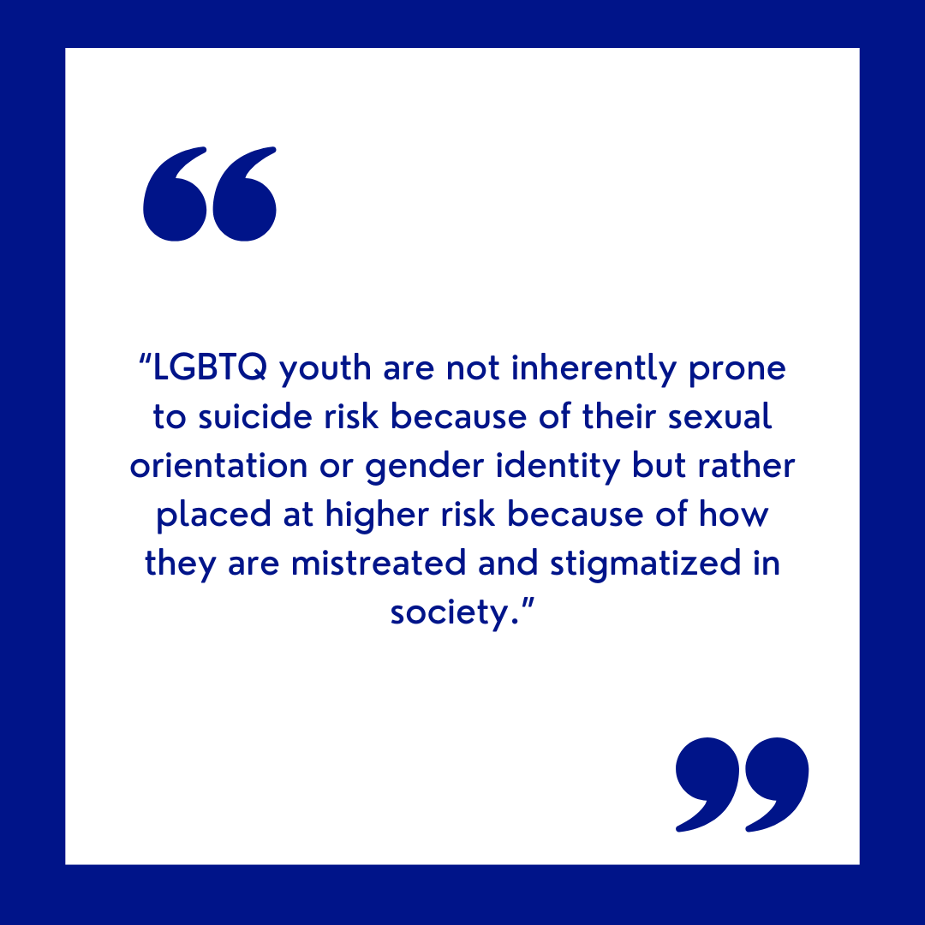
An explosion of proposed anti-LGBTQ rights laws in the United States in recent months reflects and amplifies hostility toward LGBTQ youth. As of the week of April 24, 2023, 469 anti-LGBTQ bills have been introduced across the United States – the highest number of anti-LGBTQ ever on record. Many of these pieces of proposed legislation specifically target transgender youth.²⁰

The current political climate and the very existence of these proposals stigmatize and harm the well-being of young people. Even in states where anti-LGBTQ legislation has not been proposed, youth are experiencing collective trauma.²¹ Indeed, throughout the nation, the pervasive sense of reality is that LGBTQ rights are conditional and can be rescinded. In

a December 2022 survey from The Trevor Project, 90% of LGBTQ youth in Massachusetts stated that the recent national and community rhetoric attacking LGBTQ youth had negatively affected their well-being. In its analysis of the poll results, The Trevor Project notes that “LGBTQ youth are not inherently prone to suicide risk because of their sexual orientation or gender identity, but rather placed at higher risk because of how they are mistreated and stigmatized in society.”²² The mental health toll on youth of the current national environment underscores the need for Massachusetts policymakers to bolster laws that protect our LGBTQ young people and for educators, providers, and agencies to examine their own responsibilities in serving LGBTQ youth.

The State Context: Anxiety, Vulnerable Youth, and Failing Systems

Narrowing the focus from international and national perspectives to a state-level view, recent data specific to Massachusetts reveal unsettling levels of anxiety and distress--despite the state’s history of efforts to support LGBTQ youth. As highlighted in the MYRBS analysis section, new data from the 2021 Massachusetts Youth Risk Behavior Survey indicates that at least 1 in 5 (21.9%) Massachusetts youth identify as LGB, with 5.3% identifying as transgender or questioning. The 2022 U.S. National Survey on LGBTQ Youth Mental Health by State reveals that in Massachusetts last year, 41% of LGBTQ youth, including 51% of transgender and nonbinary youth, seriously considered suicide in the past year. Further, 11% of LGBTQ youth, including 15% of transgender and nonbinary youth, attempted suicide in the past year. These feelings do not come unaccompanied, 71% of LGBTQ youth, including 78% of transgender and nonbinary youth, reported experiencing symptoms of anxiety symptoms, and 51% of LGBTQ youth, including 64% of transgender youth, reported experiencing symptoms of depression.

As noted above, the Commission recommends that the legislature codify the Massachusetts Parentage Act, which would update the Commonwealth’s outdated parentage laws by allowing same-gender non- biological parents to be legally recognized as parents, as well as would recognize de-facto parentage which would reduce instances of youth being placed in the child welfare system.²³

Among the Most Marginalized: LGBTQ Youth in the Child Welfare, Juvenile Justice, and Mental Health Systems

Though the well-being of all LGBTQ young people in the state merits concerted ongoing attention, LGBTQ young people involved with the child welfare, juvenile justice, and mental health systems are among the most vulnerable youth in our state. The state agencies that serve youth in crisis demand particular attention, as national data indicates that QTBIPOC youth are often the most underserved among youth in the child welfare and juvenile justice systems.²⁴

Often, youth involved in one system are actually involved in multiple systems;²⁵ these young people may be labeled as multisystem-involved youth, dual-system-involved youth, or crossover youth. The effects of entering these systems cascade as children develop. Pre-adolescent children who enter the child welfare system disproportionately enter the mental health system; and adolescents who enter the child welfare system often become enmeshed in the juvenile justice system as well as the mental health system. Research underscores that multisystem-involvement compounds negative outcomes for all young people,

perhaps in part because the goals of each of these systems can be at odds and because inadequate tracking and communication exists among the systems. The situations of multisystem-involved youth, especially and including LGBTQ youth, remain largely understudied. What is known is that the systems meant to help youth often harm already vulnerable LGBTQ youth, too often with negative and tragic outcomes. The subsequent sections of this report dedicated to juvenile justice and mental health delve further into approaches to support LGBTQ multisystem-involved youth.

LGBTQ Youth Aging Out of Foster Care: An Acutely Vulnerable Population

Of the many underserved LGBTQ youth in Massachusetts, LGBTQ youth aging out of foster care, known as transition-aged youth, merit special focus. On their 18th birthdays, youth in foster care exit the child- welfare system unless they sign a voluntary placement agreement to remain until they are 23. In 2022, 2,761 of the young people aging out of foster care, or 73%, chose to remain in care. Many of these transition-aged young people have lingered in care for years without finding permanent homes, and as such, they are uniquely vulnerable; transition-aged youth can easily fall into homelessness and too often become victims of trafficking and predation. A subsequent section of this report addresses agency-specific internal policy recommendations for the Department of Children and Families.

The Massachusetts Child Welfare System: Among the Worst Performing In the Nation

Recent years have seen several major reports declare a state of emergency regarding the Massachusetts child welfare system, including this Commission’s own report, “LGBTQ Youth in the Massachusetts Child Welfare System: A Report on Pervasive Threats to Safety, Wellbeing, and Permanency,” released in July 2021. ²⁶ Another report, “Failing Our Kids: Measures of the Broken Child Welfare System in Massachusetts,”²⁷ released by the advocacy group Friends of Children, asserts:

“Children and youth involved with DCF, among the most vulnerable in our society, have very little presence in our legislative chambers, our newsrooms, and our boardrooms. And they have no direct say whatsoever in our voting booths. A total of 13,045 unique children were in foster care during FY2022, a staggering number of young lives … Children have no money and no power. They are functionally voiceless in the policy decisions that most affect their lives … children in DCF custody in Massachusetts would do better to live in almost any other state.”

With a $1.2 billion annual budget, the Massachusetts Department of Children and Families (DCF) remains one of the worst-performing state child welfare agencies in the nation based on comparisons of federally mandated data on several critical measures: the average length of time in foster care; the percentage of children in foster care for more than five years; children experiencing four or more foster care placements while in DCF custody; and the percentage of children adopted by relatives.²⁸

Across the nation, LGBTQ youth, and QTBIPOC youth in particular, are disproportionately represented in the child welfare system and experience disproportionate negative outcomes, including more placement changes, a longer duration in the system, a lower rate of adoption, and negative and frightening outcomes when aging out of the child welfare system.²⁹ As of DCF’s initial SOGIE data reporting in its most recent quarterly report for the end of 2022, approximately 400 youth (5%) aged 3-17 identified as LGBQ, though a further 1,059 were marked as ‘not listed’ or ‘other’ which could suggest higher numbers if the youth

identify with a sexual orientation not listed; 132 youth aged 3-17 identified as transgender or otherwise under the gender expansive umbrella. For youth in DCF care over the age of 18, 10% identify as LGB.³⁰ Further data is expected to be collected for remaining cases, and the Commission cautions providers and policymakers from relying heavily on reported initial data, as many LGBTQ youth often conceal their sexual orientation and/or gender identity when asked.

For child advocates, particularly those working with LGBTQ youth, the state child welfare system is mired in complexity. From the moment LGBTQ children and youth enter the Massachusetts child welfare system, the system fails to fully serve them—by failing to even collect complete and accurate data on the reasons they are entering the system. Although DCF should be credited for positively improving its collection of SOGIE data, the agency must also mandate the collection of more complete information on why LGBTQ youth are entering the system in the first place. National research indicates that family rejection of LGBTQ youth for their sexual orientation and/or gender identity may in fact lead to their overrepresentation in child welfare systems. Massachusetts policymakers need more data to better serve youth and accurately report on the misfortunes they face. A subsequent section of this report on inclusion further addresses significant data gaps.

Once in the child welfare system, LGBTQ youth typically experience higher risks of bullying and physical violence due to serious difficulty finding foster placements that are affirming. Involvement with a system that is meant to help them only worsens their well-being. The Commission’s 2021 report, “LGBTQ Youth in the Massachusetts Child Welfare System: A Report on Pervasive Threats to Safety, Wellbeing, and Permanency,” further examines the harms to the well-being of LGBTQ youth caught in this system.

The Need for True Oversight, Accountability, and Transparency for the Child Welfare System

Perpetuating alarming failures are a lack of adequate oversight, accountability, and transparency among the systems serving our most vulnerable youth. The recent Friends of Children report, “Ten Myths about Child Welfare Oversight in Massachusetts”³³ details the misconceptions about the current child welfare system that enable the system to evade change. Many of the key roles leading the child welfare system, including the Secretary of the Office of Health and Human Services, the DCF Commissioner, and juvenile court judgeships are gubernatorial appointments, and as such the Governor has outsize influence over the Massachusetts child welfare system as compared to other states. Apart from the Governor and the Executive Office of Health and Human Services, other accountability mechanisms for DCF have little to no authority over DCF. In Massachusetts, the Office of the Child Advocate (OCA) is directed to provide oversight and accountability for state agencies serving the Commonwealth’s most vulnerable youth. However, as discussed in the OCA recommendations below, the Commission has serious concerns about the OCA’s commitment to impartial and transparent accountability for the child welfare system.

In Massachusetts, the child welfare Ombudsman is an employee of DCF charged with investigating complaint reports against DCF, leading to concerns from the Commission about the appropriate impartiality of the role. Additionally, foster case review occurs internally through DCF, leading to little external accountability to ensure that the well-being of youth in foster care is being protected. To better address these concerns, the Commission recommends that the state implement an independent foster care review office - used by many other states across the U.S. - which would provide an opportunity to objectively assess each child welfare case and make impartial recommendations to all relevant

stakeholders regarding the safety and well-being of youth in DCF. For LGBTQ youth, who are among the most vulnerable youth in foster care, the establishment of independent foster care review is paramount to protecting their well-being.

In Massachusetts, Juvenile Court judges make decisions regarding the custody of children and youth, the termination of parental rights, guardianship, and adoption. However, due to several MA Supreme Judicial Court rulings, the legal standard to overcome DCF decisions is high, and Juvenile Court judges in Massachusetts have limited recourse on DCF’s actions. Additionally, it is the Commission’s understanding that the juvenile courts are suffering from a shortage of public defenders to represent children, youth, and parents when the court has granted custody to DCF;³⁴ these attorneys are hired by the Committee for Public Counsel Services which the Commission has newly issued recommendations to for FY 2024. Further, many issues exist regarding the quality of the defense and the support youth and families receive from their assigned attorneys. Worse still, required hearings are not always held in a timely fashion, further distressing youth in custody.

Additionally, the lack of transparency in Massachusetts resulting from weak or nonexistent public meeting and public records laws further perpetuates the dysfunction of systems serving vulnerable children. Citizens, advocates, and the media often cannot access records related to the content of important meetings, nor can the public access voting records in many state-agency hearings. The COVID pandemic has also compromised transparency. The deleterious effects of the pandemic on the well-being of LGBTQ youth, particularly system-involved youth, continue to alarm those who serve them. However, all too often in recent months, officials have claimed the COVID pandemic as a smokescreen for failing to address issues in state government agencies that existed long before the pandemic. The Commission recommends that Massachusetts examine how it can increase state and local government transparency to better offer avenues of accountability on behalf of youth.

In Conclusion: Helping All Youth Thrive, From Understanding to Legislation

The Commission appreciates the ongoing work of youth, families, advocates, agencies, and legislators to comprehensively address systemic barriers that prevent all youth from thriving in the Commonwealth. However, as discussed in this section, and throughout this annual report, the state must broaden its understanding of what it means to thrive, and the role of state government and agencies within this framework.

Acknowledgments & Endnotes

Acknowledgements: Joan Montgomery Halford, lead researcher and author

1 Office of the United Nations High Commissioner for Human Rights, “Convention on the Rights of the Child,” Office of the United Nations High Commissioner for Human Rights, March 2023, https://www.ohchr.org/en/instruments- mechanisms/instruments/convention-rights-child.
2 Eli Dvorkin and Mo Russell Leed, “Basic Income for Transition-Age Foster Youth: Adopting California’s Approach,” Center for an Urban Future (CUF), accessed April 24, 2023, https://nycfuture.org/research/basic-income-for-transition-age-foster-youth.

3 ChildWelfare.gov, “Providing Direct Financial Assistance to Youth and Young Adults,” April 7, 2023, https://www.childwelfare.gov/pubPDFs/div-x/product7-direct-financial-assistance.pdf.
4 Michelle Pitcher, Weihua Li, and David Eads, “These States Take Money Meant for Foster Children,” The Marshall Project, May 17, 2021, https://www.themarshallproject.org/2021/05/17/these-states-take-money-meant-for-foster-children.
5 “States Take Social Security Benefits Of Foster Care Children To Pay For Services : NPR,” accessed April 1, 2023, https://www.npr.org/2021/04/22/988806806/state-foster-care-agencies-take-millions-of-dollars-owed-to-children-in-their-ca.
6 “MPA Overview,” GLAD, accessed March 14, 2023, https://www.glad.org/mpa-overview/.
7 “Online Directives Information System - ODIS,” accessed March 27, 2023, https://odis.dhs.ga.gov/General/Home/Search?searchtext=Maltreatment%20Codes.
8 Lindsay Huffhines et al., “Case File Coding of Child Maltreatment: Methods, Challenges, and Innovations in a Longitudinal Project of Youth in Foster Care,” Children and Youth Services Review 67 (August 2016): 254–62, https://doi.org/10.1016/j.childyouth.2016.06.019.
9 The Trevor Project, “Protectiveness of Family Sexual Orientation Support,” November 2022, https://www.thetrevorproject.org/research-briefs/protectiveness-of-family-sexual-orientation-support-nov-2022/.
10 Mark L. Hatzenbuehler and John E. Pachankis, “Stigma and Minority Stress as Social Determinants of Health Among Lesbian, Gay, Bisexual, and Transgender Youth: Research Evidence and Clinical Implications,” Pediatric Clinics of North America 63, no. 6 (December 2016): 985–97, https://doi.org/10.1016/j.pcl.2016.07.003.
11 The Trevor Project, “Protectiveness of Family Sexual Orientation Support.”
12 Office of the United Nations High Commissioner for Human Rights, “Convention on the Rights of the Child,” Office of the United Nations High Commissioner for Human Rights, March 2023, https://www.ohchr.org/en/instruments- mechanisms/instruments/convention-rights-child.
13 Human Rights Watch, “How Do US States Measure Up on Child Rights?,” September 29, 2022, https://www.hrw.org/feature/2022/09/13/how-do-states-measure-up-child-rights.
14 Kerith J. Conron and Bianca D.M. Wilson, “LGBTQ Youth of Color Impacted by the Child Welfare and Juvenile Justice Systems,” A Research Agenda (Williams Institute: UCLA School of Law, July 2019), https://williamsinstitute.law.ucla.edu/publications/lgbtq-yoc-social-services/.
15 Rank, Mark and Hirschl, Tom, “America’s Poor Are Worse Off Than Elsewhere,” Confronting Poverty, School of Social Work, Washington University of Saint Louis, 2023, https://confrontingpoverty.org/poverty-facts-and-myths/americas-poor-are-worse- off-than-elsewhere/.
16 US Census Bureau, “Poverty Rate of Children Higher Than National Rate, Lower for Older Populations,” Census.Gov, October 2022, https://www.census.gov/library/stories/2022/10/poverty-rate-varies-by-age-groups.html.
17 Anne Calef, “Massachusetts Shows Progress on Poverty, but Remains Worse than 21 Other States Due to High Cost of Living,” Boston Indicators, September 21, 2022, https://www.bostonindicators.org/article-pages/2022/september/supplemental- poverty-measure-2022.
18 Andrew R. Flores, “Social Acceptance of LGBTI People in 175 Countries and Locations” (Williams Institute: UCLA School of Law, November 2021), https://williamsinstitute.law.ucla.edu/publications/global-acceptance-index-lgbt/.
19 M.V. Lee Badgett, Kees Waaldijk, and Yana van der Meulen Rodgers, “The Relationship between LGBT Inclusion and Economic Development” (Williams Institute: UCLA School of Law, August 2019), https://williamsinstitute.law.ucla.edu/publications/lgbt- inclusion-development/.
20 American Civil Liberties Union, “Mapping Attacks on LGBTQ Rights in U.S. State Legislatures,” American Civil Liberties Union, 2023, https://www.aclu.org/legislative-attacks-on-lgbtq-rights.
21 “New Poll Emphasizes Negative Impacts of Anti-LGBTQ Policies on LGBTQ Youth,” The Trevor Project, January 19, 2023, https://www.thetrevorproject.org/blog/new-poll-emphasizes-negative-impacts-of-anti-lgbtq-policies-on-lgbtq-youth/.
22 The Trevor Project, “2022 National Survey on LGBTQ Youth Mental Health,” 2023, https://www.thetrevorproject.org/survey- 2022/.
23 “MPA Overview.”
24 Conron and Wilson, “LGBTQ Youth of Color Impacted by the Child Welfare and Juvenile Justice Systems.”
25 Sarah Vidal et al., “Multisystem-Involved Youth: A Developmental Framework and Implications for Research, Policy, and Practice,” Adolescent Research Review 4, no. 1 (March 2019): 15–29, https://doi.org/10.1007/s40894-018-0088-1.
26 Hussey, Hannah, “LGBTQ Youth in the Massachusetts Child Welfare System: A Report on Pervasive Threats to Safety, Wellbeing, and Permanency” (Massachusetts Commission on LGBTQ Youth, July 2021), https://www.mass.gov/doc/commission-report-on-dcf.
27 June Ameen, Kate Lowenstein, and Joan Montgomery Halford, “Failing Our Kids” (Friends of Children, 2021), https://friendsofchildreninc.org/failing-our-kids/.
28 Ameen, Lowenstein, and Halford.
29 Hussey, Hannah, “LGBTQ Youth in the Massachusetts Child Welfare System: A Report on Pervasive Threats to Safety, Wellbeing, and Permanency.”
30 Department of Children & Families, “MASSACHUSETTS DEPARTMENT OF CHILDREN & FAMILIES QUARTERLY PROFILE --
FY’2023, Q2 (10/01/22 - 12/31/22),” n.d., https://www.mass.gov/doc/quarter-2/download.

COMMISSION ON LGBTQ YOUTH
EMOTIONAL WELLBEING AND CHILD WELFARE

ABOUT
" H E L P I N G A L L Y O U T H T H R I V E "

In order to best serve our youth in complicated times, leaders must understand all youth. Understanding the intersectionality of identity of our LGBTQ youth gives insight into their mental stressors.
90%
Of LGBTQ youth in Massachusetts claim that recent national rhetoric has negatively affected their well- being

51%
of Massachusetts transgender and
nonbinary youth seriously contemplated suicide
RECOMMENDATIONS
Codify the foster child bill of rights in state law.
Improve Massachusetts child abuse laws to explicitly include the withholding of gender-
affirming care for LGBTQ youth.
Create a program for universal basic income
for foster care youth.

469
Anti-LGBTQ laws have been introduced as of April 2023, specifically targeting LGBTQ youth

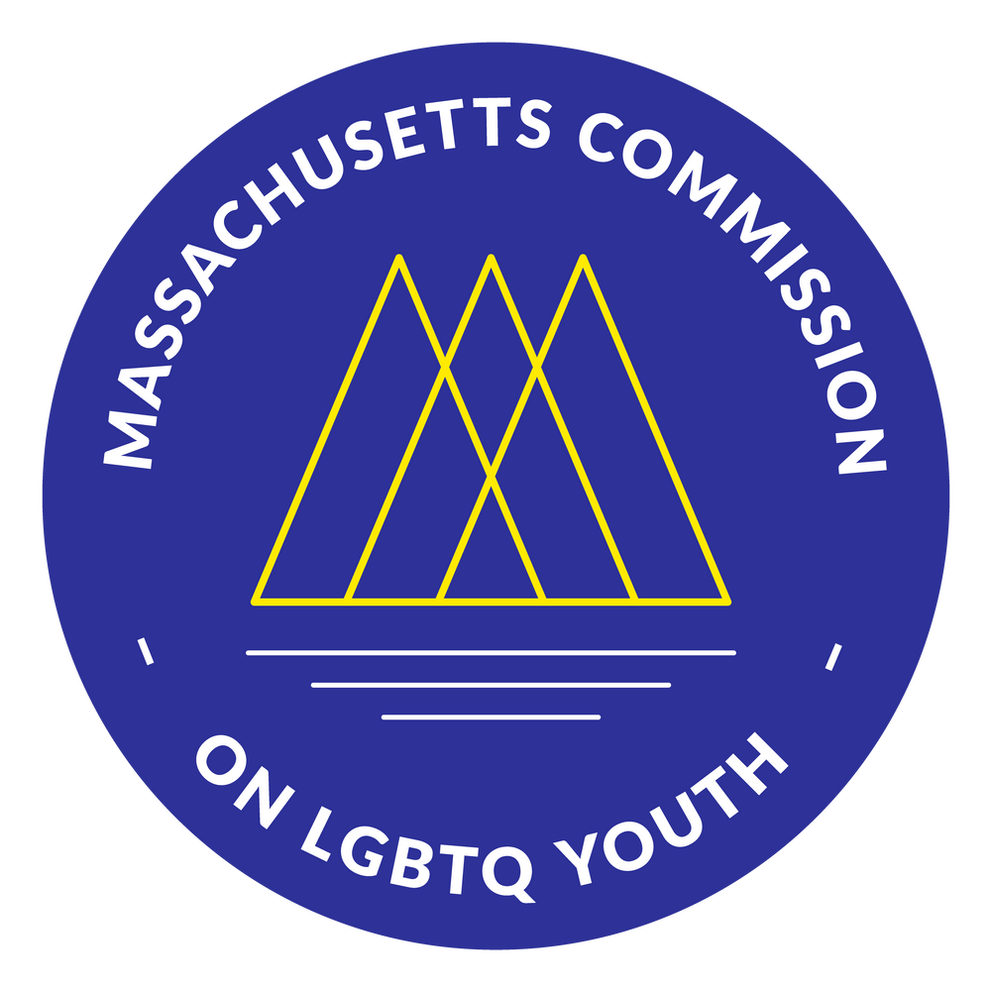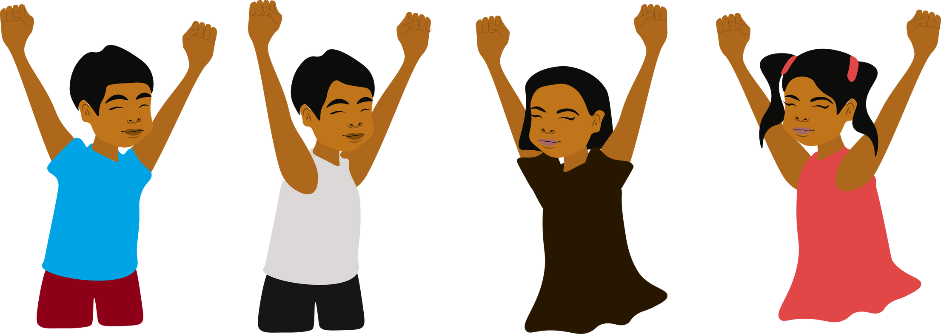

LEGISLATION
S.114: Universal Basic Income for Transition-Aged Youth S.68/H.164: Bill of Rights for Children in Foster Care
S.947/H.1713: Massachusetts Parentage Act

Uplifting Education in Schools

Introduction

Following the Commission’s report on child welfare and well-being, this report on education highlights key local and national findings that illustrate proven methods to create safer and supportive schools for LGBTQ youth, families, and educators.

“The fact that there are organizations like this [Safe Schools Program for LGBTQ Students] that want to help the world and fight for people’s rights makes me happy for my future. Becoming more involved with the queer community also makes me feel hopeful about my future.” -Rosie, 16

The Commission and the Department of Elementary and Secondary Education (DESE) jointly sponsor the Safe Schools Program for LGBTQ Students, a program which offers direct support to districts across Massachusetts on policy, training, technical assistance, and student leadership. The annual report of the Safe Schools Program for LGBTQ Students (to be released in July of 2023) offers more context and details of the program’s direct work in FY 2023 related to the issues outlined in this report, and a later report to be released in the fall of 2023 will highlight further research topics to be considered by policymakers and schools.

FY 2024 Recommendations to the Governor and Legislature on Education

Advise administrators and educators to proactively voice support of LGBTQ materials, and establish statewide process guidelines for challenged book reviews.

The Commission recommends that administrators proactively voice their support of LGBTQ materials, in line with the Principles for Ensuring Safe and Supportive Learning Environments for LGBTQ Students.¹ Furthermore, as discussed throughout this annual report, schools and libraries are seeing an unprecedented increase in book challenges, particularly against LGBTQ and BIPOC affirming books and materials. The Commission recommends that superintendents and school committees determine thoughtful processes for reviewing any books that are challenged.

Furthermore, the Commission advises that schools prioritize and encourage the development of identity- based affinity programs, such as Gender-Sexuality Alliances (GSAs), and provide funding opportunities for students to improve recruitment and retention of engaged youth.

Ensure that all subject areas are reflective of LGBTQ & BIPOC individuals, historical events, and concepts.

While largely conversations around LGBTQ-inclusive education are limited to history lessons, the

Commission recommends that policymakers and educators broaden its focus on LGBTQ-inclusive curricula and materials by ensuring that all state subject frameworks include LGBTQ and BIPOC individuals, historical events, and social concepts. In particular, the Commission highlights the necessity of updating health, arts, and music curricula frameworks to include LGBTQ and BIPOC contributions. The Commission supports An Act Relative to LGBTQ+ Inclusive Curriculum (S.259/H.498), though highlights the limitations of the bill as its current filed draft only targets inclusivity in history curriculum. Additionally, the Commission advises that schools - preK-12 and colleges - should provide resources and professional development opportunities for educators to support instruction in these areas.

Provide ongoing training and support for athletic directors, coaches, and captions, and develop guidance for schools on supporting gender expansive youth in athletics.

Across the nation, LGBTQ rights in sports are under attack, as gender expansive youth rights are ignored in favor of misinformation, stigmatization, and discrimination. The Commission recommends that Massachusetts education agencies, schools, and policymakers affirm the rights of LGBTQ youth to play sports, and develop guidance for schools on how best to support gender expansive youth. Furthermore, schools and programs should provide ongoing training and support for staff and volunteers overseeing and participating in youth sports.

Review and update school handbooks to include clear statements about protections for LGBTQ students, particularly transgender students.

In a review of public school student/caregiver handbooks last year, the Commission found that approximately one-fifth of Massachusetts public schools did not include gender identity as a protected class in their handbooks. Furthermore, as discussed below, only 19.4% of Massachusetts schools include gender identity in their district-level policies. The Commission advises that schools be required to review all handbooks and policies discussing support for youth in schools to ensure that LGBTQ youth are appropriately reflected.

Invest in resources for family liaisons, and provide professional development opportunities for all school staff related to family engagement and acceptance.

As discussed further below, LGBTQ youth are significantly less likely to have a caregiver or other adult to talk about things that are important to them compared to heterosexual, cisgender youth. A large role of schools is to partner with families to support youth; some schools have added family liaison roles to partner with families and advise on resources or programs to support students. However, as more schools begin to follow this model and hire family liaisons, the Commission advises that these staff are supported with professional development opportunities on how best to support and affirm LGBTQ youth and their families.

Provide scenario-based, interactive trainings on intervention into bullying, and guidance on how school staff can support victims of bullying in schools.

For many years, the Commission has worked with schools, educators, and youth to address anti-bullying against LGBTQ youth in schools. However, as highlighted in the MYRBS 2021 Analysis, bullying remains a core issue for LGBTQ youth in public schools across Massachusetts. The Commission recommends that schools continue to provide interactive trainings on how to intervene in bullying incidents, as well as provide education on how youth can prevent bullying and discrimination in schools with particular attention to supporting neurodivergent and disabled youth. Further recommendations around bullying are provided in the public health section of this annual report.

Additionally, the Commission advises that schools should be required to adopt policies on student suicide prevention, intervention, and postvention support. Such policies should specifically address groups at a higher risk of bullying, discrimination, and violence, including LGBTQ youth.

Mandate annual professional development for all educators.

The Commission recommends that schools at all levels develop strategic plans to address goals for LGBTQ- inclusivity in all areas, as well as training plans for all staff and educators on empathy building, inclusive curriculum, skills building for support, student leadership and development, and policy development. Such plans should be attentive to the unique needs often faced by QTBIPOC students, and should solicit feedback from students and families.

Research: Uplifting LGBTQ Youth in Schools

“I have been very impacted by the anti-trans and anti-LGBTQ legislation around the country, even though I live in MA. I have friends in dozens of states around the country. I’ve connected with a mother who lost her son to suicide in the past year due to fear of anti- trans legislation. This is a horrific reality to be living in, and many students’ mental health is affected by current events and politics.” - Alia, 17

National Data

GLSEN’s National School Climate Survey provides data every two years about issues impacting LGBTQ youth in schools. The 2021 report highlights what policies and practices work well to create a more positive school climate and better outcomes for LGBTQ students, ranging from school attendance and academic achievement to mental health and more. A specific snapshot of Massachusetts students highlights the challenges faced by LGBTQ students in MA during the start of the COVID-19 pandemic.² This serves as a model for the depth of data and evaluation that Massachusetts needs to fully understand what is working well and where the gaps are for LGBTQ students, educators, and families.

As noted throughout this annual report, as of April 24, 2023, 469 anti-LGBTQ bills have been filed so far in areas including public accommodations, school rights and education, free speech and expression, gender-affirming IDs, civil rights, and more.³ Of these bills, at least 210 negatively impact schools and education.

“Politics impacts my mental health because it’s usually mostly negative. Seeing the people in power working to hurt queer youth all of the time takes a huge toll. We need more legislation designed to help queer youth, whether that be medically, socially, academically, etc.” - Ronan, 18

Given the influx of harmful anti-LGBTQ and racist legislation across the country, this is a critical time to promote joy and well-being for LGBTQ youth, especially QTBIPOC youth. The Trevor Project’s 2022 poll on social and political issues impacting LGBTQ youth found that 85% of transgender and nonbinary youth feel that recent debates around anti-trans bills have negatively impacted their mental health. LGBTQ youth identified racism as the “most important” issue impacting the world; more than 65% also said issues like anti-LGBTQ hate crimes, police brutality, gun violence, climate change, and efforts to restrict abortion access often give them stress and anxiety. ⁴ Even though Massachusetts has widespread legislative protections for LGBTQ individuals, the impact of the national anti-LGBTQ rhetoric is significant. Additionally, as highlighted in this annual report, Massachusetts is no exception to anti-LGBTQ organizing and rhetoric, particularly at the local level, which is having significant impacts against curriculum and educational access for youth.

Massachusetts Data

The Massachusetts Youth Risk Behavior Survey - discussed in the 2021 MYRBS Analysis section - is administered every two years to a sample of high school districts and asks students about risk behaviors and experiences. Within this report, data on sexual orientation and gender identity is collected from survey respondents which allows researchers to disaggregate the data to better understand health and behaviors of youth across the state. Year after year, these results show higher risk for LGBTQ youth in every category of risk behavior and experience.

Additionally, the VOCAL survey, which is administered through the Massachusetts Comprehensive Assessment System (MCAS), is also able to analyze data for nonbinary students as students’ responses are connected to their State Assigned Student Identifiers (SASID). In 2022, 238 students identified as nonbinary based on their State Assigned Student Identifiers (SASID) gender marker, and in 2023, this increased to 1845 identifying as nonbinary, a 675% increase.⁵

Statewide and School-Based Policy

A 2020 study found that LGBTQ-focused policies were more strongly associated with student perceptions of teacher support.⁶ Additionally, GLSEN’s National School Climate Survey found that students in schools with anti-bullying policies that protect sexual orientation and gender expression experienced less anti- LGBTQ remarks and victimization, missed school less often due to feeling unsafe, and were more likely to feel they belonged at school.⁷

When students of any marginalized identity enter a school building or classroom, they are often looking for signs or signals of safety; anything in a school building could be considered part of the curriculum because it signals the schools’ values and policies. GLSEN found that students in schools with an LGBTQ- inclusive curriculum were more likely to report higher self-esteem, less depressive symptoms, and lower

likelihood to have seriously considered suicide in the previous year.⁸ In Massachusetts, only 31% of LGBTQ students surveyed were taught positive representations of LGBTQ+ people, history, or events (“inclusive curriculum”), 54% said they had access to inclusive library resources, and 15% of LGBTQ+ students in Massachusetts reported receiving LGBTQ+-inclusive sex education at school.⁹

However, visibility is only the first marker of inclusion, and needs to be paired with actions such as interrupting microaggressions and bullying, including LGBTQ people’s contributions in all subject areas, and supporting transgender students through school policy.

As such, as noted above, administrators should proactively voice their support of LGBTQ-affirming curriculum and education materials, in line with the Principles for Ensuring Safe and Supportive Learning Environments for LGBTQ Students. ¹⁰ According to GLSEN, LGBTQ students who reported seeing Safe Space stickers and posters were more likely to report having one or more supportive staff at school.¹¹ They also reported higher self-esteem, fewer symptoms of depression, and lower rates of having seriously considered suicide in the previous year. Given the potential of this strategy, it is concerning that some schools have provided unclear or oppositional guidance to staff about affirming displays, such as Stoughton High School faculty recently not being allowed to display pride flags or visuals.¹²

Given the national context of anti-LGBTQ sentiment and policy, it is critical that the state respond to the rise of anti-LGBTQ efforts in Massachusetts. The Massachusetts Board of Library Commissioners found that formal and informal challenges against library books nearly quadrupled from 2021 to 2022, including in school libraries.¹³ Additionally, the Safe Schools Program for LGBTQ Students provided support to several districts in the 2022-2023 school year around this issue. However, some school districts do not have a clear review policy; school committees and superintendents should assist school districts and determine thoughtful processes for reviewing any books that are challenged.

Furthermore, policymakers and educators should ensure that the contributions of LGBTQ people be included in all subject areas through the statewide frameworks, and that BIPOC histories are represented accurately in all subject areas. The MA All-Inclusive Curriculum Task Force, chaired by the Commission and its Safe Schools Program for LGBTQ Students, began in the summer of 2020 to advocate for LGBTQ inclusive curriculum across grade levels and school subject areas throughout the Commonwealth. An Act relative to LGBTQ inclusive curriculum would ensure that all students receive "sufficient instruction on the histories, roles, and contributions of lesbian, gay, bisexual, transgender, and queer people in the history of this country and this Commonwealth."

In addition to history curriculum frameworks, one area of particular importance is sexual health education and health education more broadly. The Safe Schools Program for LGBTQ Students has received an increase in requests to review human growth and development lessons to ensure that they are LGBTQ inclusive, as the frameworks for health education have not been updated since 1999. As noted in the sexual health section of this annual report, the Commission supports the passage of the Healthy Youth Act to require medically-accurate, consent-based, LGBTQ-inclusive sexual health education.

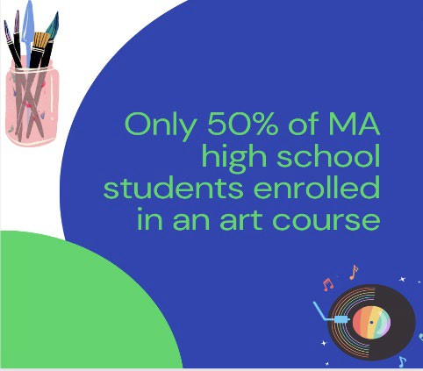
Another area of curricular importance is music and art education. Music and arts are the most popular extracurricular activities among LGBTQ high school students: a GLSEN survey found that 45.6% of LGBTQ secondary students reported being members of high school music ensembles.¹⁴ Further music education research published in 2018 found that high school choral classrooms were largely safe and supportive spaces for LGBTQ students, many of whom became more open about their sexuality through their experience singing in an ensemble. ¹⁵ Choral classes are particularly meaningful for transgender students, as singing can help one navigate the relationship between one’s identity and voice. ¹⁶ Culturally
responsive music education that includes popular and contemporary music is also found to promote resilience and open therapeutic space for QTBIPOC students.¹⁷

According to the Arts Education Data Project, 98% of Massachusetts schools provided access to arts instruction in the 2021-2022 school year.¹⁸ While most elementary school students (94%) and middle school students (93%) participate in required general music or visual arts courses, only 50% of Massachusetts high school students were enrolled in an arts course.¹⁹ Although Massachusetts has a higher rate of arts education enrollment than many other states, there were still 8,206 students without access to any arts courses at their school in the 2021-2022 school year.²⁰ Massachusetts’ continued investment in expanding equitable access to a quality arts education for all students would ultimately support the creation and growth of safe, supportive school environments for our LGBTQ youth.

Finally, though sparse, current research about LGBTQ participation in school sports specifically recommends that administrators develop policies that protect gender-expansive youths’ access to athletics. Participation in sports has been linked to higher self-esteem and school belonging and less depressive symptoms. Notably, the same research suggests that gender expansive youth do not always know that local and state policies already protect them. ²¹ Coaches and administrators can play a supportive role by ensuring that policies are clear, publicly known, and enforced. For athletics, MIAA has developed a supportive policy developed by MIAA that asserts that students should be able to participate in the sports team that aligns with their gender identity.²²

District Policies

Last year, the Commission published a special report on LGBTQ inclusive education policy, which examined whether more than 1,700 Massachusetts public schools include LGBTQ-specific language in their 2021-2022 student/caregiver handbooks. The review found that about one-fifth of public schools did not include “gender identity” as a protected class in their handbooks.

This year’s follow-up review examines whether district-level policies of Massachusetts public schools include guidance around supporting transgender/nonbinary students. These policies provide language beyond the required inclusion of “gender identity” in the district’s anti-discrimination statutes, or the commonplace anti-bullying provision that acknowledges the disproportionate rates of bullying among LGBTQ students. This review was able to locate 1,842 of 1,851 (99%) Massachusetts public schools’ district policies for the 2022-2023 school year. 358 of 1,842 schools (19.4%) are subject to specific district-level

policies related to gender identity and supporting trans/nonbinary students; these policies are maintained by 25 public school districts and 8 public charter schools/districts across the Commonwealth.

These policies are most often located in Section A (Foundations and Basic Commitments) or Section J (Students) of Massachusetts school committee policy manuals. Some districts also include specific guidance around trans inclusion in their athletics policies, administrative procedural guidelines, and staff policies.

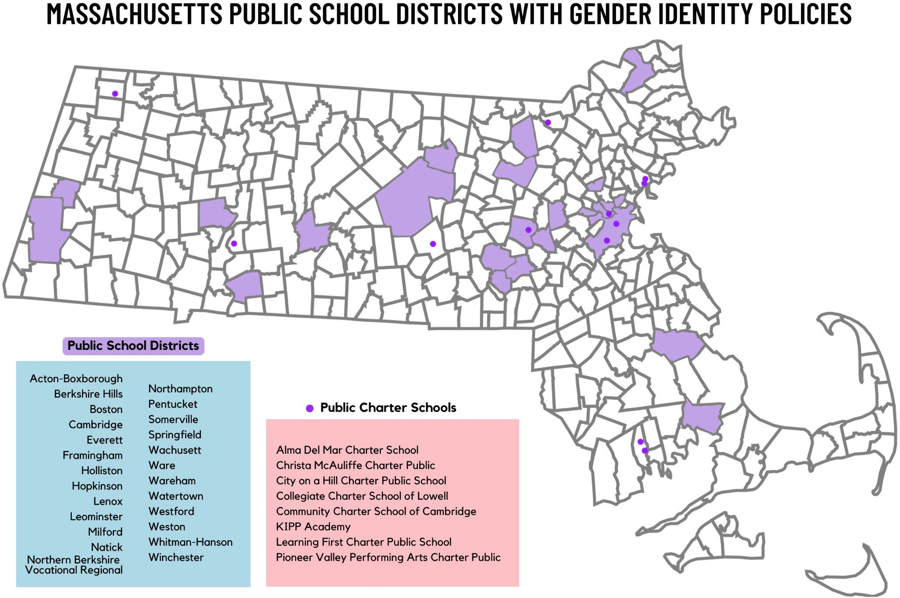

Figure 1: “Massachusetts Public School Districts With Gender Identity Policies.”

Family Supports

According to the MYRBS, LGBTQ youth were significantly less likely to be able to talk with at least one of their parents or another adult member about things that are important to them compared with heterosexual, cisgender (het-cis) youth across all years. While LBGTQ youth seemed to make some gains in this area in 2017 and 2019, in 2021, only 60.6% said that they could talk with an adult at home, an even lower percentage than in 2015 (65.2%). In contrast, the percentage of heterosexual and cisgender youth who could talk with an adult at home has held fairly steady across this period, between 81-85%.²³

Families and schools can partner with each other to acknowledge, love, and celebrate students. Often this requires culturally responsive work with families and referral to outside support groups, like PFLAG. Mores schools have added family liaison roles, and we recommend that staff in those roles be competent in LGBTQ+ inclusion. Family liaisons can also partner with district or citywide DEI directors, school mental health professionals, administrators, and educators to create sustainable plans for supporting families.

Safe Spaces in Schools

It is prevalent that trans students will restrict food and water intake in order to avoid using the restroom, either from fear of bullying in the restroom or not having an adequate all-gender restroom option. Access to safe restrooms, including all-gender restrooms, is a health concern for transgender and non-binary students in particular. While advocacy at the statewide level is happening related to the plumbing code, students can ensure that all students have access to a safe bathroom, and that any spaces that can be easily converted (like single-stall restrooms) are considered as alternatives in the meantime.

Furthermore, all schools should provide additional professional development and support for school nurses and other health-based educators. Education on trans-specific health information like safe binding practices would allow school staff to provide better information and notice any health challenges related to gender affirming care that transgender students might be facing.

Anti-Bullying

Implementation of the state’s anti-bullying plan has been a key part of the Commission’s work and the cornerstone of its programming for many years. As highlighted in the Commission’s 2021 MYRBS analysis section, new data on anti-LGBTQ bullying demonstrates the continued need to address this bias in schools to protect vulnerable students, prevent the negative health consequences of bullying, and improve educational outcomes. However, as discussed more in-depth in the public health section of this report, the Commission believes that the Commonwealth’s anti-bullying laws need to be strengthened.

School districts need more funding and clearly defined mandatory requirements for how to counter bullying and proactively build more inclusive communities; these requirements should explicitly address LGBTQ students and mandate that districts make LGBTQ trainings available to all staff on a regular basis. Given the intersection between anti-LGBTQ bias and racial and ethnic biases, and the disproportionate needs facing BIPOC LGBTQ youth, the Commission recommends that anti-racism components be included in this training. Schools can also invest in professional development focused on the positive impacts of social-emotional learning and restorative justice or transformative justice. The Department of Elementary and Secondary Education is providing resources on this topic in relation to the new mental health law,
G.L. c. 71, s. 37H ¾ (b), as amended by Chapter 177 of the Acts of 2022, An Act Addressing Barriers to Care for Mental Health.²⁴

Beyond staff training, students also need more education to prepare them to prevent and respond to bullying, bias, and mistreatment. The Commonwealth should also strengthen existing requirements that schools provide age-appropriate instruction on bullying prevention, to ensure that the state is monitoring evidence-based instruction at every level.

LGBTQ youth continue to report higher rates of self-harm and suicidality in Massachusetts. In addition to mental health supports like restorative justice practices, we recommend increased funds for staffing including school counselors, school psychologists, school social workers, nurses, and all other staff that directly address mental health needs of LGBTQ youth. On the statewide level, policy efforts are needed to address school-based resources and requirements related to suicide prevention, intervention, and postvention.

“Neurodivergent people are trying their best. But you can’t necessarily hold us to the same productivity standards as neurotypical people, it’s just not realistic for many of us to maintain high productivity and maintain our mental health. And please don’t infantilize us.
Just because we struggle with some things you may consider basic adult skills, doesn’t mean we’re not mature or mentally our physical age.” - Rosie, 16

GLSEN’s National School Climate Survey found that 73% of participants hear biased ability-focused remarks in school “often” or "frequently.” Meanwhile, 34% stated that they were harassed or assaulted at school within the last year based on their actual or perceived disability, and 17% reported experiencing this online. ²⁵ Educators can support disabled and neurodivergent students by interrupting bullying, offering transparent communication around their education, and informing them of their rights.²⁶ Overall, more training and prevention work that acknowledges the overlapping forms of oppression that students face is needed.

Student Leadership and Development

“I have been involved in the MA GSA Leadership Council since 7th grade (I’m now a Junior) and it has wildly changed my life for the better. I’m also the President of the GSA at my high school. I’ve found a support system who I know will always be there for me, and been able to begin/continue the LGBTQ advocacy work which I am so passionate about. The space is so welcoming and we do our best to make sure that everyone has a place to be safe.” - Alia, 17

Gender-Sexuality Alliances (GSAs) empower LGBTQ youth to build resilience, hope, and positive support networks, and also tend to actively improve school culture. GLSEN found that students with active GSAs experienced nearly half as much in-person victimization for their sexual orientation or gender expression as their peers. Although research shows that GSAs are effective mental health interventions, many school staff are not compensated for advising GSAs, creating issues with retaining advisors and keeping clubs open. A priority focus of the Safe Schools Program for LGBTQ Students in the coming year will be leadership development of GSA advisors. The program is developing training and technical assistance specifically focused on cultural responsiveness and BIPOC student leadership development to be shared at regional GSA meetings.

“I am a member of my school’s GSA. In this program, I’ve met and formed bonds with some of the most incredible people I’ve ever met. The program is a safe place for people of all kinds to simply go and be themselves. In this space, I can decompress, and feel like I belong somewhere. I’m not targeted with slurs, I’m not yelled at for being something I’m “not

supposed to be”. The environment is a welcoming, happy one, and that’s what you look for in a healthy social environment.” - C.H., 17

Training and Technical Assistance

The Safe Schools Program for LGBTQ Students will provide over 200 trainings to schools by the end of the 2022-2023 school year, as well as over 250 technical assistance requests.

“Folks who are willing to be compassionate before requiring comprehension are incredible to me. I think it’s a super valuable way to view the world: although you may be confused by someone like myself who is nonbinary, and maybe you don’t really understand it, you can still recognize that trans people deserve to live safe, happy lives.” - Alia, 17

Training school staff is an important strategy for supporting LGBTQ youth. Often, this training occurs through professional development programs, where staff (e.g., teachers, counselors, and school administrators) learn about the experiences of LGBTQ students and the issues they face. ²⁷ Training topics can include sexual orientation, gender identity, and gender expression (SOGIE); appropriate LGBTQ terminology; and stigma and bullying towards LGBTQ and gender-nonconforming students.²⁸ Research shows that schools with LGBTQ-focused professional development programs, such as those offered by the Safe Schools Program for LGBTQ Students, are safer and more welcoming.²⁹ Further, the presence of adults at school who are supportive of LGBTQ youth is linked to less hostile school climates — as well as greater academic and health outcomes for LGBTQ students.³⁰

Research has found that increasing staff knowledge of LGBTQ students can help ensure safer schools. According to a national survey analysis, knowing LGBTQ students is a significant predictor of how often teachers intervene in homophobic remarks.³¹ Many other studies use pre- and post-surveys to measure knowledge gained. The results show that after LGBTQ trainings, school staff report increased knowledge across a variety of topics, including:
- Transgender youth identities³²
- LGBTQ-related terminology and where to find LGBTQ-related resources³³
- Demographics and development of LGBTQ youth³⁴
- Common challenges and risk factors facing LGBTQ students³⁵
- Best practices in counseling LGBTQ students (reported by school counselors)³⁶

The survey evaluations collected by the Safe Schools Program for LGBTQ Students show that 96% of participants learn to better understand the experiences of LGBTQ students and families. Further, most participants learn more about DESE (Department of Elementary and Secondary Education) policy guidelines and about resources for creating safe and supportive learning environments for LGBTQ students.³⁷

Finally, LGBTQ trainings can positively affect school staff’s beliefs. Teachers who receive high levels of training have more positive attitudes towards LGBTQ youth compared to those with limited professional development. ³⁸ Other post-survey evaluations indicate that school staff rate the importance of

intervening in homophobic comments more highly after training. ³⁹ They also have more positive perceptions about the role of school staff in supporting LGBTQ students by creating a safer, more affirming environment.⁴⁰ However, similar to the diminishing effects of self-awareness, the same study witnessed school staff’s empathy for LGBTQ students diminish over time, hinting again that a one-time training may not be enough.⁴¹

Most of the data on the effects of LGBTQ training indicate an increase in participant self-efficacy. Even a brief two-hour training can improve school staff’s self-efficacy in addressing anti-LGBTQ behaviors and creating inclusive school environments.⁴² Specifically, school staff report a significant increase in their comfort in intervening in homophobic comments, their competence in addressing anti-LGBTQ bullying and harassment, and their confidence in promoting an inclusive environment. ⁴³ Other studies also highlight a significant improvement in confidence in both addressing anti-LGBTQ language and discussing concerns about being teased, harassed, or bullied with students.⁴⁴ Similar to the findings about knowledge and awareness, self-efficacy is also a significant predictor of how frequently teachers intervene in anti- LGBTQ remarks.⁴⁵

Two common behavior changes associated with LGBTQ professional development programs are increased school staff intervention in anti-LGBTQ behavior and increased communication with students and teachers about LGBTQ topics. For instance, school personnel report more communication with students and other staff about LGBTQ issues following their training.⁴⁶ Results from the “Step In, Speak Up!” online simulation found that afterwards most teachers reported an increase in connecting LGBTQ youth to support services (51%), speaking with students after class to see if they were okay (54%), and having conversations with other adults at school about LGBTQ harassment and bullying (58%), discriminatory language in classrooms (64%), and how to better support LGBTQ students (78%).⁴⁷

In the same study, over 50% of school staff reported an increase in the number of times they intervened when students were being teased, harassed, or bullied by students labeling them as LGBTQ.⁴⁸ After receiving training from the Safe Schools Program for LGBTQ Students, 88% of participants say they develop either “some” or “a lot” of skills to respond to bias-based bullying — and 89% say they will change their practice/policies based on what they heard or talked about during the training.⁴⁹ In a case study of the Welcoming Schools program, which offers similar training to the Safe Schools Program for LGBTQ Students, schools that completed the training experienced a 50% reduction in bullying behavior within two years.⁵⁰

While the Welcoming School study is one of the few that looked at the long-term effects of professional development training, the researchers do not explain how they measured bullying reduction. In most studies, the data is collected through self-reporting. This is a limitation since there can be a discrepancy between what school staff say they did (or will do) and what they actually do — especially when it comes to advocating for LGBTQ youth or intervening in anti-LGBTQ bullying and harassment.⁵¹ Some experts claim that it’s more realistic to change knowledge and awareness through a professional development training than actual behaviors.⁵² For example, results from the Commission’s Safe School evaluations indicate that participants had the least understanding of developing bullying intervention skills.⁵³ More ongoing trainings and practice are called for to build skills that affect behavior change for supporting LGBTQ youth.⁵⁴

There is evidence that LGBTQ-focused professional development trainings can positively impact school climate, especially compared to schools without this training.⁵⁵ School staff who experience trainings say they engage more in activities to create safer schools for LGBTQ students, such as supporting GSAs and including LGBTQ content in the curriculum.⁵⁶ Twenty years ago, researcher Laura A. Szalacha conducted a mixed methods study on the Safe Schools Program for LGBTQ Students.⁵⁷ The results state that schools that receive training from the Safe Schools Program for LGBTQ Students have more positive “sexual diversity climates,” meaning greater tolerance and lower sexual prejudice. Importantly, students at these schools report feeling more supported by teachers and counselors and believe their school is safer with a less sexually prejudiced environment. This is the only study reviewed that measures the effectiveness of professional development trainings from the perspective of students.

Acknowledgments & Citations

Acknowledgments: Kimm Topping, Safe Schools Program Manager, and lead researcher and author of Uplifting Education Report; Max Tang, Social Work Intern and co-author; Cas Martin, Western MA Lead Trainer and co-author

1 “Principles for Ensuring Safe and Supportive Learning Environments for Lesbian, Gay, Bisexual, Transgender, Queer, and Questioning (LGBTQ) Students - Student and Family Support (SFS),” accessed April 13, 2023, https://www.doe.mass.edu/sfs/lgbtq/Principles-SafeEnvironment.html.
2 GLSEN, “School Climate for LGBTQ+ Students in Massachusetts - 2021 National School Climate Survey State Snapshot,” n.d., https://maps.glsen.org/wp-content/uploads/2023/02/GLSEN_2021_NSCS_State_Snapshots_MA.pdf.
3 “Mapping Attacks on LGBTQ Rights in U.S. State Legislatures,” American Civil Liberties Union (blog), accessed April 24, 2023, https://www.aclu.org/legislative-attacks-on-lgbtq-rights.
4 “New Poll Illustrates the Impacts of Social & Political Issues on LGBTQ Youth,” The Trevor Project (blog), January 10, 2022, https://www.thetrevorproject.org/blog/new-poll-illustrates-the-impacts-of-social-political-issues-on-lgbtq-youth/.
5 Data on file with the Commission.
6 Day, J. K., Fish, J. N., Grossman, A. H., & Russell, S. T. (2020). Gay-straight alliances, inclusive policy, and school climate: LGBTQ youths’ experiences of social support and bullying. Journal of Research on Adolescence, 30(S2), 418–430. https://doi.org/10.1111/jora.12487
7 GLSEN, “The 2021 National School Climate Survey,” GLSEN, accessed April 24, 2023, https://www.glsen.org/research/2021- national-school-climate-survey.
8 GLSEN.
9 GLSEN, “School Climate for LGBTQ+ Students in Massachusetts - 2021 National School Climate Survey State Snapshot.”
10 “Principles for Ensuring Safe and Supportive Learning Environments for Lesbian, Gay, Bisexual, Transgender, Queer, and Questioning (LGBTQ) Students - Student and Family Support (SFS).”
11 GLSEN, “The 2021 National School Climate Survey.”
12 “Stoughton High School Faculty Told Not to Display Items in Classroom Deemed ‘Political’ - The Boston Globe,” accessed April 24, 2023, https://www.bostonglobe.com/2022/09/16/metro/stoughton-high-school-faculty-told-not-display-items-deemed- political-classrooms/.
13 “Book Challenges up Nationwide and in Massachusetts Libraries – MBLC Blog,” accessed April 24, 2023, https://mblc.state.ma.us/mblc_blog/2022/11/01/book-challenges-up-nationwide-and-in-massachusetts-libraries/.
14Kosciw, J. G., Clark, C. M., Truong, N. L., & Zongrone, A. D. (2012). The 2011 National School Climate Survey: The experiences of lesbian, gay, bisexual, transgender, and queer youth in our nation’s schools. Gay, Lesbian and Straight Education Network (GLSEN). Retrieved from www.glsen.org/research
15Palkki, J., & Caldwell, P. (2018). “We are often invisible”: A survey on safe space for lgbtq students in secondary school choral programs. Research Studies in Music Education, 40(1), 28-49. doi:10.1177/1321103x17734973

16Palkki, J. (2019). “My voice speaks for itself”: The experiences of three transgender students in american secondary school choral programs. International Journal of Music Education, 38(1), 126-146. doi:10.1177/0255761419890946.
17Kruse, A. J. (2016). “Therapy was writing rhymes”: Hip-hop as resilient space for a queer rapper of color. Bulletin of the Council for Research in Music Education, (207-208), 101-122.
18 “Massachusetts - Arts Education Data Project,” accessed April 24, 2023, https://artseddata.org/massachusetts/.
19 “Massachusetts - Arts Education Data Project.”
20 “Massachusetts - Arts Education Data Project.”
21 Clark, C. M., & Kosciw, J. G. ‘Engaged or Excluded: LGBTQ Youth’s Participation in School Sports and Their Relationship to Psychological Well-being’, Psychology in the Schools, 2021, https://doi.org/10.1002/pits.22500
22 https://miaa.net/wp-content/uploads/2022/01/MIAA_Handbook21_23_O.pdf
23 2021 MYRBS Analysis.
24 “Student and Family Support (SFS) - Massachusetts Department of Elementary and Secondary Education,” accessed April 24, 2023, https://www.doe.mass.edu/sfs/discipline/updated-expectations.docx.
25 Kosciw, J. G., Clark, C. M., & Menard, L. (2022). The 2021 National School Climate Survey: The experiences of LGBTQ youth in our nation’s schools. New York: GLSEN.
26 “Advocating for LGBTQ Students with Disabilities,” Human Rights Campaign, November 17, 2020, https://www.hrc.org/press- releases/hrc-partners-release-guide-to-help-educators-and-parents-advocate-for-lgbtq-students-with-disabilities.
27 Katie Swanson and Maribeth Gettinger, “Teachers’ Knowledge, Attitudes, and Supportive Behaviors toward LGBT Students: Relationship to Gay-Straight Alliances, Antibullying Policy, and Teacher Training,” Journal of LGBT Youth 13, no. 4 (October 2016): 326–51, https://doi.org/10.1080/19361653.2016.1185765.
28 Robert Marx, Leah Roberts, and Carol Nixon, “When Care and Concern Are Not Enough: School Personnel’s Development as Allies for Trans and Gender Non-Conforming Students,” Social Sciences 6, no. 1 (January 25, 2017): 11, https://doi.org/10.3390/socsci6010011.
29 Laura A. Szalacha, “Safer Sexual Diversity Climates: Lessons Learned from an Evaluation of Massachusetts Safe Schools Program for Gay and Lesbian Students,” American Journal of Education 110, no. 1 (November 2003): 58–88, https://doi.org/10.1086/377673.
30 Kristie L. Seelman et al., “School Engagement among LGBTQ High School Students: The Roles of Safe Adults and Gay–Straight Alliance Characteristics,” Children and Youth Services Review 57 (October 2015): 19–29, https://doi.org/10.1016/j.childyouth.2015.07.021.
31 Emily A Greytak, Joseph G Kosciw, and Lesbian Gay and Straight Education Network, Year One Evaluation of the New York City Department of Education"Respect for All" Training Program. (Gay, Lesbian and Straight Education Network, 2010).
32 Marx, Roberts, and Nixon, “When Care and Concern Are Not Enough.”
33 Greytak, Kosciw, and Gay, Year One Evaluation of the New York City Department of Education "Respect for All" Training Program.
34 Katie Ann McGravey, Measuring the Effectiveness of a Professional Development Workshop on Awareness, Knowledge, and Skills of Mental Health Professionals in Working with Lesbian, Gay, Bisexual, Transgender, and Questioning (LGBTQ) Youth, ProQuest LLC (ProQuest LLC, 2014).
35 Elizabeth Bradley et al., “Impact of a Simulation on Educator Support of LGBTQ Youth,” Journal of LGBT Youth 16, no. 3 (July 3, 2019): 317–39, https://doi.org/10.1080/19361653.2019.1578324; McGravey, Measuring the Effectiveness of a Professional Development Workshop on Awareness, Knowledge, and Skills of Mental Health Professionals in Working with Lesbian, Gay, Bisexual, Transgender, and Questioning (LGBTQ) Youth.
36 Rebekah Byrd and Danica G. Hays, “Evaluating A Safe Space Training for School Counselors and Trainees Using a Randomized Control Group Design,” Professional School Counseling 17, no. 1 (January 2013): 2156759X0001700, https://doi.org/10.1177/2156759X0001700103; McGravey, Measuring the Effectiveness of a Professional Development Workshop on Awareness, Knowledge, and Skills of Mental Health Professionals in Working with Lesbian, Gay, Bisexual, Transgender, and Questioning (LGBTQ) Youth.
37 Massachusetts Commission on LGBTQ Youth, “Safe Schools Program Training Evaluation Data.,” 2019, https://docs.google.com/document/d/15SzsGZwNN0k-JaeW1XeDcKFsrjlynZxaz9AM_qzNAg/edit?pli=1.
38 Swanson and Gettinger, “Teachers’ Knowledge, Attitudes, and Supportive Behaviors toward LGBT Students.”
39 Greytak, Kosciw, and Gay, Year One Evaluation of the New York City Department of Education"Respect for All" Training Program.; Emily A. Greytak, Joseph G. Kosciw, and Madelyn J. Boesen, “Educating the Educator: Creating Supportive School Personnel Through Professional Development,” Journal of School Violence 12, no. 1 (January 2013): 80–97, https://doi.org/10.1080/15388220.2012.731586.
40 Bradley et al., “Impact of a Simulation on Educator Support of LGBTQ Youth.”
41 Greytak, Kosciw, and Gay, Year One Evaluation of the New York City Department of Education "Respect for All" Training Program.
42 Greytak, Kosciw, and Boesen, “Educating the Educator.”
43 Greytak, Kosciw, and Boesen.

44 Bradley et al., “Impact of a Simulation on Educator Support of LGBTQ Youth”; Greytak, Kosciw, and Gay, Year One Evaluation of the New York City Department of Education"Respect for All" Training Program.; Swanson and Gettinger, “Teachers’ Knowledge, Attitudes, and Supportive Behaviors toward LGBT Students”; McGravey, Measuring the Effectiveness of a Professional Development Workshop on Awareness, Knowledge, and Skills of Mental Health Professionals in Working with Lesbian, Gay, Bisexual, Transgender, and Questioning (LGBTQ) Youth.
45 Emily A. Greytak and Joseph G. Kosciw, “Predictors of US Teachers’ Intervention in Anti-Lesbian, Gay, Bisexual, and Transgender Bullying and Harassment,” Teaching Education 25, no. 4 (October 2, 2014): 410–26, https://doi.org/10.1080/10476210.2014.920000.
46 Greytak, Kosciw, and Gay, Year One Evaluation of the New York City Department of Education"Respect for All" Training Program.
47 Bradley et al., “Impact of a Simulation on Educator Support of LGBTQ Youth.”
48 Bradley et al.
49 Massachusetts Commission on LGBTQ Youth, “Safe Schools Program Training Evaluation Data.”
50 Laura A. Szalacha, “An Evaluation of the Welcoming Schools Guide Pilot for Use in Elementary Schools.,” n.d., http://www.welcomingschools.org/.
51 Hillary Parkhouse, Chu Yi Lu, and Virginia R. Massaro, “Multicultural Education Professional Development: A Review of the Literature,” Review of Educational Research 89, no. 3 (June 2019): 416–58, https://doi.org/10.3102/0034654319840359.
52 Parkhouse, Lu, and Massaro.
53 Massachusetts Commission on LGBTQ Youth, “Safe Schools Program Training Evaluation Data.”
54 Laura A. Szalacha, “Educating Teachers on LGBTQ Issues: A Review of Research and Program Evaluations,” Journal of Gay & Lesbian Issues in Education 1, no. 4 (May 10, 2004): 67–79, https://doi.org/10.1300/J367v01n04_07; Greytak, Kosciw, and Boesen, “Educating the Educator”; Jennifer M. Cooper et al., “No Lone Wolf: A Multidisciplinary Approach to Creating Safe Schools for LGBTQ Youth Through the Development of Allies,” Journal of LGBT Issues in Counseling 8, no. 4 (October 2, 2014): 344–60, https://doi.org/10.1080/15538605.2014.960128; Greytak, Kosciw, and Gay, Year One Evaluation of the New York City Department of Education"Respect for All" Training Program.; Harris Interactive, Inc. and GLSEN, “Playgrounds and Prejudice: Elementary School Climate in the United States. A Survey of Students and Teachers.” (New York: GLSEN, 2012), https://www.glsen.org/sites/default/files/2020-04/Playgrounds_Prejudice.pdf; Dorothy L. Espelage, Sabina K. Low, and Shane
R. Jimerson, “Understanding School Climate, Aggression, Peer Victimization, and Bully Perpetration: Contemporary Science, Practice, and Policy.,” School Psychology Quarterly 29, no. 3 (September 2014): 233–37, https://doi.org/10.1037/spq0000090.
55 Szalacha, “Educating Teachers on LGBTQ Issues.”
56 Swanson and Gettinger, “Teachers’ Knowledge, Attitudes, and Supportive Behaviors toward LGBT Students”; Greytak, Kosciw, and Gay, Year One Evaluation of the New York City Department of Education"Respect for All" Training Program.; Parkhouse, Lu, and Massaro, “Multicultural Education Professional Development.”
57 Szalacha, “Safer Sexual Diversity Climates.”

COMMISSION ON LGBTQ YOUTH

UPLIFTING EDUCATION

ABOUT
This report highlights key findings both locally and nationally that illustrate what is proven to create safer, more supportive schools for LGBTQ+ youth, educators, and families so they can access joy, well-being, and successful futures.

RECOMMENDATIONS
Advise administrators and educators to proactively voice support of LGBTQ materials, and establish statewide process guidelines for challenged book reviews.
58%
of LGBTQ students reported hearing homophobic remarks from teachers and staff

70%
of LGBTQ+ students report being the victim of bullying

Ensure that all subject areas are reflective of LGBTQ & BIPOC individuals, historical events, and concepts.

Mandate annual professional development for all educators.
82%
of LGBTQ+ youth report not feeling safe in school due to their physical appearance

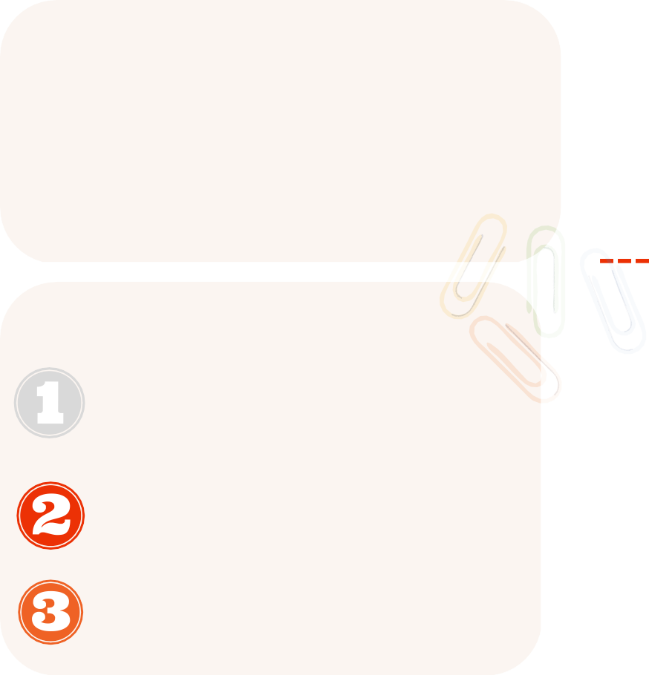
LEGISLATION
S.259/H.498: LGBTQ+ Inclusive Curriculum S.311/H.549: Educator Diversity
S.346: Mental Health Supports for K-12 Schools

Destigmatizing Public Health

Introduction

The public health crises facing LGBTQ youth are largely not because of individual risk factors, but rather systemic issues that affect how LGBTQ youth navigate the spaces in which they exist. LGBTQ youth often live in environments hostile to their existence, whether because of the current political climate, unsupportive families, or a lack of LGBTQ community and role models. The future is uncertain for many youths, and it can be difficult for them to envision a world where they are able to exist freely and safely as queer and trans adults. However, despite the hostility, LGBTQ youth continue to resist, challenge, and change the relationships, communities, institutions, and systems that act as oppressive forces.¹ Public health has an obligation to support and uplift LGBTQ youth as they resist unjust and oppressive structures.² In doing so, policymakers, providers, and educators can better pave the way for a future where all LGBTQ youth thrive.
When working to develop policies and programs to address public health concerns, it is essential to understand that many of the issues highlighted in this section are compounded by intersecting systems of oppression, including poverty, racism, homophobia, transphobia, and ableism that must simultaneously be addressed. Tackling such large structural issues may seem unfathomable, however, there are actions that can be taken in the meantime to continue providing support to LGBTQ youth and begin shifting the cultural norms that will eventually improve health outcomes for all communities.

FY2024 Recommendations to the Governor and Legislature on Public Health

Create and expand community-based public health programming that is accessible and engaging to youth with the most barriers to access, with specific attention to youth in rural communities.

The Commission recommends that Massachusetts continue to explore and develop accessible programming for youth to eliminate public health disparities, with particular attention to youth in rural areas, Deaf and hard of hearing youth, multilingual youth, and QTBIPOC youth. As detailed below, Massachusetts employs a wide array of programming services to support public health, including harm reduction, prevention, and recovery services, as well as support for survivors of intimate partner violence and sexual exploitation. The need for trauma-informed and culturally aware is essential, particularly for QTBIPOC youth who often lack sufficient access to programs that are both LGBTQ- affirming, multilingual, and anti-racist. Additionally, by creating more peer-led education programs, it is more likely that youth will become engaged and build skills needed to address public health disparities in their own communities.
Furthermore, the Commission recommends that Massachusetts improve the accessibility of holistic and community-based substance use reduction, prevention, and recovery programs. The Commission supports An Act Relative to Preventing Overdose Deaths and Increasing Access to Treatment (S.1242/H.1981), which would allow for the creation of a 10-year pilot program establishing overdose prevention centers - also known as supervised consumption sites or harm reduction sites - to increase access to health and education services. In Massachusetts, Somerville is exploring and has released a proposal to open the state’s first overdose prevention site.³

Increase funding to organizations that support LGBTQ survivors of intimate partner violence.

The Commission recommends that Massachusetts continue to increase funding to organizations that support LGBTQ youth who are survivors of intimate partner violence, and ensure that laws and services currently in place are working as intended to protect and support survivors, rather than placing an undue burden on them. As further explained below, LGBTQ survivors of intimate partner violence most desire support from services that are respectful, safe, and affirming.

Ensure that public schools, colleges, and universities have comprehensive anti-bullying, anti- cyberbullying, and anti-harassment policies.

Despite the adverse physical, emotional, mental, social, and educational outcomes that can occur from youth who are victims of bullying, confusion remains on the recourse that many students and educators have to address incidents of bullying. The Commission recommends that public schools, college, and universities examine their anti-bullying and anti-harassment policies to ensure that: 1) there is a clear and detailed plan that supports victims of bullying, and offers training and appropriate consequences for perpetrators of bullying; 2) there is a clear definition of the role of school staff and educators on addressing bullying, and recurring scenario-based professional development trainings are available on an annual basis; 3) there is a clear and impartial review process to examine disciplinary incidents occurring from bullying; 4) bullying policies include anti-cyberbullying provisions with lessons available for students and educators on appropriate technology usage.

Decriminalize sex work, and increase resources to programs working with youth at risk of commercial sex trafficking.

As highlighted in several sections of this annual report, the Commission continues to recommend the decriminalization of sex work for youth over the age of 18 to better address public health disparities, increase housing access, and reduce criminal legal system involvement for LGBTQ youth. By decriminalizing sex work, resources are better diverted to effectively address supporting youth at risk of commercial sexual exploitation and trafficking. As noted below, the incorrect conflation of sex work and sex trafficking sets up ineffective and inefficient programs to often treat incidents of consensual sex work as trafficking, while also sometimes simultaneously punishing sexually exploited victims as criminalized sex workers.

Additionally, the Commission advises that the state invest more resources to programs specifically working with youth at risk of commercial sexual exploitation, with particular attention to LGBTQ youth and cisgender boys who are often left out of conversations around sexual exploitation and trafficking. Furthermore, the Commission recommends that the state broaden its understanding of how to reduce incidents of youth exchanging sex to meet their financial or material needs. For example, programs providing gender-affirming care products have the potential to reduce risk of engaging in sex work - and thus also decreasing risks of commercial sexual exploitation - by supporting trans and gender expansive youth who may engage in sex work for funds to purchase items such as wigs, binders, packers, and makeup. Programs that already receive funding to address human sexual exploitation, or funding to support youth at risk, should explore plans to increase funding to services that provide gender-affirming products to LGBTQ youth.

Decriminalize consensual teen sex/sexting and adjust the current age of consent laws for minors engaging in consensual sexual activity.

As discussed more thoroughly below, there are a number of ways to address sexual exploitation and inequitable penalties against youth who are victims of exploitation. Currently, while Massachusetts does not have explicit laws against sexting, child pornography laws do prohibit the exchange of sexually explicit images of minors - no matter the age of the recipient. Therefore, teens under the age of 16 who engage in consensual sexting with another teen could potentially face legal ramifications for their decisions. The Commission recommends that the legislature adjust legal protections to appropriately support minors as technology and teen dating culture shifts, rather than criminalizing teens who engage in sexting without fully understanding any legal consequences that may occur.

Furthermore, the Commission additionally recommends that the legislature better understand and address any gaps in legal protections that may exist for victims of revenge porn and sexual deepfakes, particularly for those who are adults. Presumably, child pornography laws would protect and provide legal support for victims of revenge porn or deepfakes under the age of 16, however, legal supports for those over the age of consent remain unclear.

Continue to increase access to sexually-transmitted infection screenings, prevention, and treatment.

The Commission appreciates the dedication that Massachusetts policymakers, agencies, and advocates have given to increasing access to PrEP and PEP for LGBTQ youth across the state; HIV rates have continued to lower for Massachusetts youth aged 0-29 over the last decade. However, other STI transmission rates have risen for youth across the Commonwealth, and barriers to accessing prevention and screening for HIV continues to occur. The Commission recommends that the state boost its partnerships with community organizations to create more grantee and sub-grantee agreements to increase access to screening and prescriptions for PrEP and PEP. While the focus should be holistic, we are seeing a rise in STI rates in the LGBTQ community across the Commonwealth and therefore resources should not be diverted from meaningful STI screening, prevention, and treatment.

Research: Destigmatizing Public Health & Interventions

The social-ecological model, sometimes known as the socioecological model or SEM, is becoming one of the most popular models of public health intervention strategy within the field. Proposed in 1998 by McLeroy, Bibeau, Steckler, and Glanz,⁴ the SEM proposes that health is not solely an individual concern, but rather a series of interwoven factors that influence an individual at interpersonal, institutional, community and societal levels. While public health traditionally focused on changing individual behaviors to promote health, practitioners began to realize that individual health could not be achieved without creating a supporting environment in which individual behaviors occur.⁵ When creating public health interventions, it is often simply not enough to alter an individual’s behavior, but rather taking a holistic approach that investigates and remedies higher-order concerns may serve as a better and more sustainable solution.

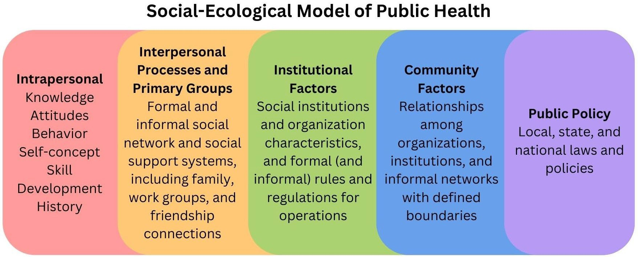
6

Data Limitations
Unfortunately, when it comes to the health outcomes of LGBTQ youth, there are glaring data gaps in most surveys and studies. Few, if any, surveys include data about intersex youth outside of a biomedical and medicalized context. Aromantic, asexual, and pansexual youth are largely left out of survey data, although some organizations have begun to include a more inclusive array of sexualities for study participants to choose from. Most studies have a very small number of non-white participants. Data regarding disability and neurodiversity is rarely, if ever, collected in surveys. Many data sets simply do not consider the intersecting identities that LGBTQ youth may hold nor the intersecting systems of oppression that LGBTQ youths may live under. LGBTQ youths are often treated as a monolith, rather than a group of unique individuals with their own identities, risk factors, and protective factors.
To combat these gaps, public health research must be deliberate in its data collection. There are several professional and non-profit organizations that have produced recommendations, including the Juvenile Justice Policy and Data Board,⁷ the Human Rights Campaign,⁸ and the National LGBTQIA+ Health Education Center. ⁹ Beyond just collecting SOGIE (sexual orientation and gender identity/expression) data, it is also extremely important to collect data regarding program participation.

Which youths are engaging in public health programming?

Which youths are falling through the cracks?

Without capturing this vital data, it is incredibly difficult to understand whether interventions and resources are appropriately serving LGBTQ youth. Without knowing this information, public health practitioners cannot successfully implement improved interventions. Of course, not every intervention will be appropriate for every youth, but programming and community resources should be designed with the needs of the youth with the most barriers to access in mind. Keeping them at the core of any public health intervention will allow the maximum number of youth to be supported.

Intimate Partner Violence

Intimate partner violence, also known as relationship violence, dating violence, or domestic violence, affects an alarming percentage of LGBTQ youth. Intimate partner violence is a serious public health issue that can have long-term negative effects on survivors’ physical, emotional, mental, and social well-being. For youth, experiencing intimate partner violence at a young age can affect “lifelong health, opportunity, and well-being”¹⁰ and make youth survivors more vulnerable to intimate partner violence as adults.
According to the 2021 Massachusetts Youth Risk Behavior Survey (MYRBS), an annual survey that examines the health behaviors of youth in grades 9 through 12, 17.8% of LGBTQ youth have experienced sexual dating violence within the last twelve months, and 13.9% of LGBTQ youth experienced physical dating violence within the last twelve months.¹¹ Among LGBTQ youth of color, 17.8% have experienced sexual dating violence within the last twelve months, with the highest rates among Hispanic/Latinx (25.0%) and multiracial Hispanic/Latinx (20.3%) respondents; and 13.8% have experienced physical dating violence within the last twelve months, with the highest rates among Hispanic/Latinx (27.8%) and multiracial non-Hispanic/Latinx (20.0%) respondents.¹²
For trans and gender expansive individuals, the numbers of intimate partner violence and sexual assault are even higher. According to the 2015 U.S. Transgender survey, which collects data for transgender and gender nonconforming individuals ages 16 and up, 47% of transgender and gender nonconforming individuals have ever experienced sexual assault during their lifetime.¹³ Nonbinary people assigned female at birth (58%), trans men (51%), and American Indian (65%), Middle Eastern (59%), and Multiracial (58%) individuals had the highest rates of experiencing sexual assault. ¹⁴ Additionally, transgender and gender-nonconforming individuals who had participated in sex work (72%), had ever been unhoused (65%), and are disabled (61%) had the highest rates of experiencing sexual assault.¹⁵ Furthermore, 54% of respondents to the survey indicated that they have experienced some form of intimate partner violence in their lifetimes.¹⁶ Transgender and gender nonconforming individuals who had participated in sex work (77%), had ever been unhoused (72%), are undocumented (68%), or are disabled (61%) had extremely high rates of experiencing intimate partner violence.¹⁷
Like with sexual assault, American Indian (73%), Middle Eastern (62%), and Multiracial (62%) trans and gender nonconforming individuals had the highest rates of experiencing intimate partner violence.¹⁸ For youth attending 2- and 4-year undergraduate institutions, transgender and gender expansive individuals consistently experience intimate partner violence at higher rates than their cisgender peers. According to the National College Health Assessment, conducted by the American College Health Association, 10.8% of trans and gender nonconforming undergraduate students have experienced emotional or verbal intimate partner violence, 3.8% have experienced physical intimate partner violence, and 5.7% have experienced sexual intimate partner violence.¹⁹

Types of Intimate Partner Violence and Interventions

Intimate partner violence is often depicted as physical violence, but intimate partner violence can manifest in a variety of forms beyond the physical. For young people in particular, intimate partner

violence often presents as emotional, verbal, or psychological abuse, with an increasing amount of harassment and violence taking place on digital platforms.²⁰

Intimate partner violence is a multi-faceted issue that requires intervention on numerous fronts. Generally, these interventions occur at the individual or interpersonal levels of the SEM, with the long-term goal of shifting cultural norms and values around intimate partner violence perpetration and victimization. The majority of successful youth intimate partner violence interventions fall under one of three categories: 1) school-based dating violence interventions, 2) community-based gender equity interventions, or 3) parent-focused relationship-building interventions. ²¹ Additionally, results from meta-analyses show that long-term programs with multiple sessions and multiple methods of engagement are more successful than single- day, single-method interventions. ²² By far the most popular type of intervention is a school-based dating violence intervention, which may take the form of group education, peer mentorship, and/or bystander intervention training.²³

These interventions have shown promising results, such as reductions in physical, psychological, and sexual violence perpetration; increased knowledge of the different types of intimate partner violence; decreased acceptance of intimate partner violence; improved conflict resolution skills; and a greater likelihood to act as active bystanders in situations of bullying or dating violence. ²⁴ , ²⁵ , ²⁶ Oftentimes, relationship skill-building and relationship violence prevention will be built into comprehensive
Intimate Partner Violence Definitions
Physical Abuse:
Physical assault including punching, kicking, slapping, or choking; physical assault with a weapon; harming loved ones or pets; threats of suicide or self-harm; denying medical care or medication; forced consumption of alcohol and/or other drugs
Emotional, Verbal, and Psychological Abuse:
Threats of physical assault, with or without a weapon; destroying physical property; humiliation, constant criticism, name-calling; isolation from or controlling contact with family and friends; gaslighting; forced outing; purposeful misgendering
Sexual Abuse, Sexual and Reproductive Coercion:
Refusing to use safer sex supplies including condoms, dental dams, or PrEP; sabotaging birth control or preventing the use of birth control; pressure to engage in a particular sex act; using alcohol and/or other drugs to facilitate sexual intercourse; sexual assault; becoming volatile when denied sex
Financial Abuse:
Stealing money or paychecks; controlling how much, when, and where money is spent; prohibiting, limiting, or controlling work opportunities
Digital Abuse:
Revenge porn and sextortion; sending threats via text, email, or social media DM; using a tracking device or service to monitor location; monitoring texts, emails, or social media DMs; becoming volatile when denied constant digital contact; stealing or demanding passwords
Stalking:
Showing up uninvited and unannounced to home, school, or work; using a tracking device or service to monitor location; constant text messages, emails, or social media DMs; sending unwanted gifts

sexuality education programs, which have also shown promising results, including increased awareness of intimate partner violence as a serious issue, decreased tolerance of abusive behaviors by peers, improved communication skills, decreased intimate partner violence perpetration, and increased positive bystander behaviors.²⁷

Unfortunately, there is no consistency across Massachusetts as to what kind of dating violence intervention students receive; some school districts have adopted the 3R’s (Rights, Respect, Responsibility) programming, which is a comprehensive sexuality education curriculum that includes education on consent and healthy relationships. ²⁸ Although this program is one of the premier comprehensive sexuality education curriculums, it has yet to be implemented at a state-wide level; as highlighted in the sexual health section of this annual report, the Healthy Youth Act (S.268/H.544) is an opportunity for Massachusetts legislators to ensure that Massachusetts youth have access to medically accurate, inclusive, culturally appropriate sexual health education.²⁹

In addition to school-based education, studies have shown that access to LGBTQ-inclusive support resources are key in supporting survivors of intimate partner violence.³⁰ According to a survey of queer and trans Massachusetts survivors, survivors want support from resources where they feel respected, safe, and comfortable, and where they will not have to explain their identities or face discrimination from a service provider.³¹ Black survivors and trans survivors, in particular, expressed a desire for LGBTQ-specific resources, stating that they appreciate when support resources understand their identities and offer culturally competent support. ³² Although LGBTQ individuals tend to experience intimate partner violence at slightly higher rates than the general population, there are few organizations that are dedicated to serving LGBTQ individuals, and fewer still that can offer culturally humble support services to LGBTQ survivors of color. Additionally, many intimate partner violence or sexual violence support resources are located in larger cities, making them largely inaccessible to LGBTQ youth who lack consistent access to transportation and/or who are living in more rural areas of the state. Oftentimes, these organizations are chronically under-funded and do not receive enough support at the state level. This prevents organizations from doing targeted outreach to underserved populations.

Organizations with LGBTQ  Youth-Specific Resources | Programs with LGBTQ Youth-  Specific Resources | Hotlines with LGBTQ Youth-  Specific Resources
The Network/La Red | Fenway Violence Recovery  Program | The National Domestic  Violence Hotline
love is respect | Start Strong | The National Sexual Assault  Hotline
One Love | RESPECTfully | LGBT National Youth Hotline

Sexually Transmitted Infections and PrEP Interventions

Sexually transmitted infections (STIs – also known as sexually transmitted diseases or STDs) have long been considered a public health crisis, particularly for the 15 to 24 age group. According to the Centers for Disease Control and Prevention, nationally, youths ages 15 to 24 make up almost half of new STI infections each year.³³ In Massachusetts, chlamydia and gonorrhea are the two most common STIs for this age group, although public health officials closely monitor rates of HIV, Hepatitis A-B-C, and syphilis, as well. ³⁴ If left untreated, STIs can cause several long-term health conditions, making STI prevention and treatment of particular interest to public health officials. Unfortunately, although STIs are largely preventable and treatable, many LGBTQ youths are not able to access STI testing, treatment, or prophylactic measures. LGBTQ youth of color, transgender youth, low-income LGBTQ youth, and LGBTQ youth at the intersection of these identities, are at an increased risk for STI infection

and lack of access to testing and treatment. ³⁵ According to the 2021 Massachusetts Youth Risk Behavior Survey, only 6.8% of LGBTQ youth have ever been tested for an STI other than HIV (including gonorrhea and chlamydia).³⁶ Among high school-age LGBTQ youth of color, only 10.9% of respondents have ever been tested for an STI other than HIV.³⁷ Testing rates were lowest amongst Asian (6.5%) and multi-racial non-Hispanic/Latinx (11.6%) respondents.³⁸

There are a number of reasons why STI rates remain so high among youths ages 15 to 24. One such reason is a lack of knowledge about STIs and how to prevent them.³⁹ Like with intimate partner violence, LGBTQ youth are simply not receiving the quality education that they need to be able to make informed and safe decisions about their sexual health. LGBTQ youth are at a particular disadvantage, as only 6.7% of youth nationally report receiving LGBTQ-inclusive sex education in school.⁴⁰ In Massachusetts, only 40.2% of LGBTQ youth have ever received education in school about how to correctly use a condom.⁴¹ While school is not the only place that youth may learn about safer sex practices, this lack of education likely contributes to low rates of prophylactic use. Among Massachusetts LGBTQ youth of color, only 38.9% of respondents used a condom during the last time they had sexual intercourse.⁴² Condom use was lowest among Hispanic/Latinx (28.6%) and multiracial Hispanic/Latinx (16.3%) respondents.⁴³

At the individual and interpersonal levels, the most effective intervention has been comprehensive sexuality education that includes not only information about STIs, barrier methods, PrEP, and testing, but also information and skill building around how to negotiate safer sex with a partner.⁴⁴ However,
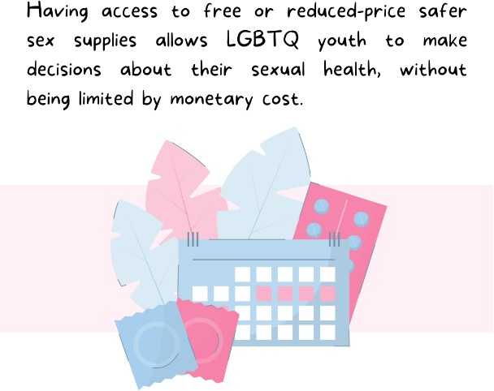
high rates of STIs are not only due to individual knowledge, but also due to structural access issues. As further discussed in the sexual health section, LGBTQ youth may know how and when to use particular safer sex supplies, however they may find the cost of these prophylactic measures to be prohibitive.⁴⁵ When they are able to find safer sex supplies for free at a local community health clinic or youth program, those facilities may not stock the kinds of safer sex supplies LGBTQ youth are looking for, such as dental dams.⁴⁶ Having access to free or reduced-price safer sex supplies allows LGBTQ youth to make decisions about their sexual health, without being limited by monetary cost.
Access to STI testing and treatment may be equally as prohibitive.⁴⁷ LGBTQ youth, particularly, low- income youth, unhoused youth, undocumented youth, and rural youth, may lack consistent access to healthcare.⁴⁸ LGBTQ youth who are still on their parents’ health insurance may be reluctant to seek STI testing and treatment due to fear of being outed to their parents or due to the stigma of receiving STI testing.^{49,50} In Massachusetts, all youth over the age of thirteen have the right to receive STI testing without parental consent.⁵¹ However, this service is not widely advertised, and many youths may not take advantage of this important service. LGBTQ youth may also avoid seeking testing or treatment due to prior negative experiences with a healthcare provider.⁵² If healthcare providers are unwilling to acknowledge the identities of their LGBTQ patients or simply make assumptions about the kinds of sex their LGBTQ patients are having, LGBTQ youths are unlikely to feel comfortable discussing STI risk

reduction and testing options. ⁵³ One possible solution to this is offering STI testing outside of a traditional healthcare setting, such as through mobile testing vans, community-based testing sites, or mobile technologies and telehealth.⁵⁴ Further ensuring that clinics have youth-focused services and LGBTQ-competent clinicians can increase the likelihood that LGBTQ youth are able to access testing and treatment options on their own terms in a safe space.⁵⁵

Pre-Exposure Prophylaxis (PrEP) is another widely underutilized and highly successful HIV prevention method. PrEP is approved for use by the FDA for anyone over twelve years of age weighing 77 pounds or more.⁵⁶ PrEP, since it must be prescribed by a health care provider, can be particularly difficult for youth to access – although 93% of healthcare providers are aware that PrEP exists, only 64.8% prescribe PrEP to adolescents.⁵⁷ Additionally, although the rates of PrEP use have not been studied specifically for LGBTQ youth, studies of the general LGBTQ population indicate that PrEP use is lowest among Black, Hispanic/Latinx, and Asian individuals and cisgender women. ⁵⁸ Stigma and discrimination may prevent LGBTQ youth from accessing PrEP or continuing PrEP once they have started a regimen.⁵⁹ LGBTQ youth of color may face additional medical discrimination due to their race or ethnicity, and a lack of culturally-relevant materials about PrEP may increase mistrust in the drug. ⁶⁰ , ⁶¹ Digital, peer-led interventions via social media platforms have proven successful in increasing PrEP use, positive attitudes towards using PrEP, and adherence to a PrEP regimen.⁶² Digital interventions are additionally helpful for advertising locations to acquire PrEP, particularly community-based locations.⁶³

It is equally important that any PrEP materials should be culturally relevant, community-created, avoid stigmatizing language, and include identity-labels that are commonly used by the priority populations.⁶⁴ By using inclusive language and avoiding negative language about PrEP use, LGBTQ youth will be more likely to seek out PrEP, adhere to a PrEP regimen, and discuss PrEP use positively with friends and other LGBTQ youth.⁶⁵

Bullying and Cyberbullying Interventions

Bullying and cyberbullying are another significant issue faced by LGBTQ youth and a major concern for public health practitioners. Like intimate partner violence, bullying and cyberbullying can have severe and lifelong consequences. Bullying can lead to adverse physical, emotional, mental, social, and educational outcomes, as well as increase the likelihood of substance use, suicidal ideation, and experiencing violence later in life.⁶⁶ Bullying can take the form of verbal, physical, or psychological aggression, with an increasing amount of bullying occurring digitally. As further discussed in the education section of this annual report, in Massachusetts, 54% of LGBTQ students have experienced verbal harassment due to their sexuality, 17% have experienced physical harassment, and 8% have experienced physical assault.⁶⁷

Additionally, 46% of Massachusetts LGBTQ students have experienced verbal harassment due to their gender, with 14% having experienced physical harassment and 7% having experienced physical assault;⁶⁸ 68% of Massachusetts students regularly heard homophobic remarks, and 64% regularly

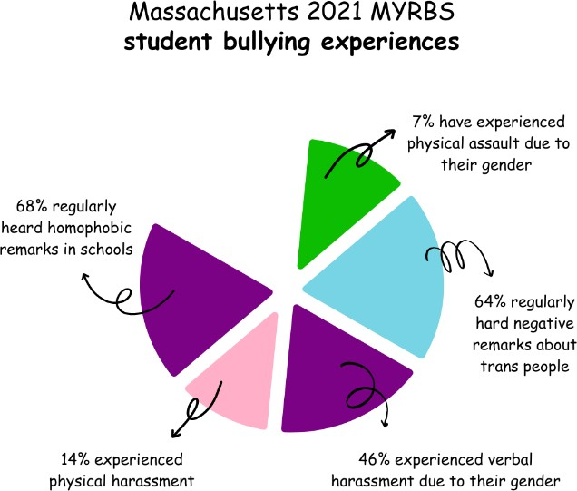
heard negative remarks about transgender people. ⁶⁹ Furthermore, 49.5% of students nationally frequently heard negative comments regarding ability, and 32.1% frequently heard racist comments. ⁷⁰ When it comes to cyberbullying nationally, in 2021 47.1% of LGBTQ students experienced some form of online harassment, with 34.6% of these students indicating that the harassment took place via social media direct message (DM), 20.4% indicating that the harassment took place via text, and 19.1% indicating that the harassment took place via a public social media post.⁷¹

Individuals who were out as transgender or perceived as transgender faced significant amounts of mistreatment and harassment. According to the 2015 U.S. Transgender Survey: Massachusetts State Report, 73% of respondents experienced verbal, physical, and/or sexual mistreatment or harassment at some point between kindergarten and Grade 12, with 11% of respondents reporting that they had to leave the school due to the severity of the incidents. ⁷² For slightly older individuals in college or vocational school, around 24% of respondents experienced some kind of verbal, physical, or sexual harassment during their time at their institution.⁷³ LGBTQ youth of color were particularly vulnerable to identity-based bullying. According to GLSEN’s National School Climate Survey, LGBTQ Native American and Indigenous students had the highest rates of in-person victimization for both sexual orientation (86.0%) and gender expression (82.8%), followed by LGBTQ Middle Eastern and North African (MENA) students (67.7% and 61.5%, respectively) and LGBTQ Latinx students (63.4% and 60.9%, respectively).⁷⁴ LGBTQ Native American and Indigenous students experienced the highest rates of in-person victimization based on race and ethnicity (63.8%), followed by LGBTQ Asian American and Pacific Islander (AAPI) students (62.8%) and LGBTQ Black students (55.2%). ⁷⁵ Online, LGBTQ Native American and Indigenous students experienced victimization based on sexual orientation (60.8%) and gender expression (59.7%) at significantly higher rates than any other racial or ethnic group.⁷⁶

Regarding digital technology, social media is a multi-faceted and complex tool that can affect LGBTQ youth both positively and negatively. According to the Trevor Project’s 2021 National Survey on LGBTQ+ Youth Mental Health, LGBTQ youth stated that social media had both “positive (96%) and negative (88%)” effects on their mental health.⁷⁷ On one hand, social media allows youth to connect with LGBTQ peers when they may otherwise have no safe physical space to engage with their community. For example, youth may use social media to explore their identities, chat with other LGBTQ youth, or find reprieve from a stressful home or school situation.⁷⁸ LGBTQ youth living in rural or remote areas, in particular, expressed that social media was a vital tool to avoid feelings of isolation. ⁷⁹ Additionally, meta-analysis has shown that positive social media use can lead to a reduction in mental illness symptoms and improvement in overall well-being.⁸⁰ On the other hand, social media allows bullies easy access to vulnerable youth.

There are a number of interventions that can be taken to both prevent bullying and cyberbullying, as well as mitigate their negative long-term effects. Because bullying and cyberbullying involve so many

actors (the bullies, the bullied, and the bystanders), these issues are often tackled through interventions at multiple levels of the SEM. Fostering an inclusive school climate is widely regarded as a crucial primary component to bullying prevention. This can be done through a variety of methods, including supporting GSAs, implementing anti-bullying policies and inclusive practices, and providing anti-bullying training to students, faculty, and staff. Although teachers are in a prime position to intervene and prevent bullying, very few have received LGBTQ-specific training or support. ⁸¹ Nationally, 69.6% of students reported that they did not report an incident of harassment or bullying due to a lack of confidence in school staff responding appropriately to the report.⁸² Nationally, only a third of teachers have received training in how to support LGBTQ students and only a quarter have received a similar training regarding transgender students, leaving the majority of teachers unaware of how to appropriately support students who may come forward to report bullying.⁸³

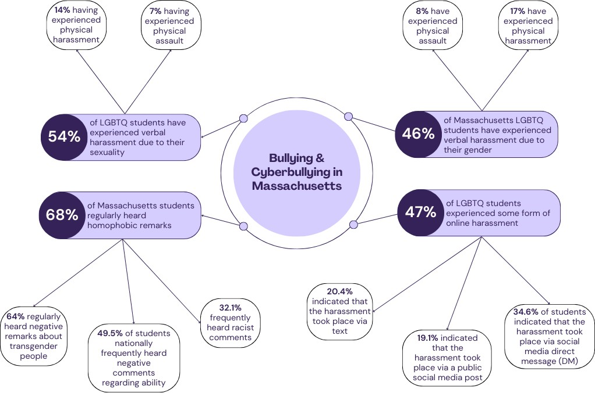

This lack of knowledge is multiplied for LGBTQ students of color, who feel even less supported due to having to explain both their sexual orientation and/or gender identity, as well as their racial and/or ethnic identity to faculty and staff members before receiving assistance. ⁸⁴ The Massachusetts Department of Elementary and Secondary Education (DESE) and the Commission jointly host the Safe Schools Program for LGBTQ Students, which supports schools through curriculum development, professional trainings, and management of the Massachusetts Gender and Sexuality Alliance (GSA) Student Leadership Council.⁸⁵ Although the training content and length varies from school to school, students whose teachers received Safe Schools Program training did report feeling more supported.⁸⁶ However, Massachusetts students indicated that they wish that faculty and staff received more intersectional training, stating that faculty and staff members were often not aware of the specific vulnerabilities faced by students with multiple marginalized identities. ⁸⁷ This issue became more

prominent at institutions where faculty and staff members do not share similar identities to their students.⁸⁸

Likewise, GSAs have been shown to have a profoundly positive impact on LGBTQ youth, particularly trans and gender expansive youth, and serve as protective factors against a variety of public health concerns.^{89,90} GSAs have been shown to make schools safer for LGBTQ students by creating positive changes to school climate, allow students to more easily identify safe and supportive faculty and staff members, and lower the frequency of absenteeism due to harassment or discrimination.⁹¹ The Safe Schools Program has already done an excellent job creating, promoting, and engaging local GSAs, but there are still many public high schools that do not have GSAs, and even fewer public middle and elementary schools that have GSAs. Although more difficult, it would also be worthwhile for programs to explore doing outreach to private and charter schools to promote the creation of GSAs at their institution. Another important factor to consider is that GSAs have historically served larger numbers of white youth, while community-based organizations have historically served larger numbers of youth of color.⁹² Ensuring that all LGBTQ youth have spaces to explore their identities and connect with other LGBTQ youth will be key in fostering inclusive school environments.

Furthermore, it is extremely important to have comprehensive anti-bullying policies, as well as comprehensive LGBTQ inclusion policies in place in schools, as these play a key role in promoting a school climate that is welcoming towards LGBTQ students.^{93,94} This is equally important in both K-12 education settings, as well as
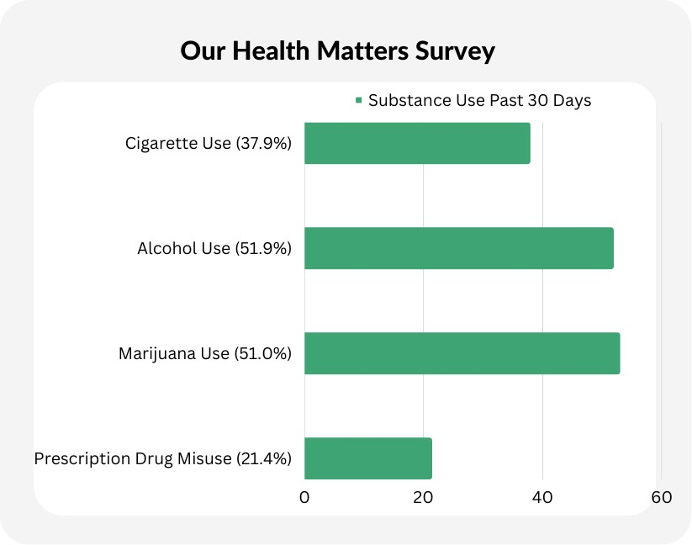
higher education. For example, many colleges and universities have recently begun streamlining the process for submitting a name change in university systems, making it easier for transgender and gender expansive students to have their names recognized. Many institutions have begun requiring mandatory diversity and inclusion training to both new students and new employees. All schools that receive federal funding are required to have a Title
IX policy, which prohibits discrimination on the basis of sex, and the majority of schools have some kind of anti-discrimination or equity policy that covers conduct not addressed under Title IX. By implementing policies like these, schools, colleges, and universities can ensure that their campus climates are inclusive of and welcoming to LGBTQ youth.

Substance Use and Interventions

Substance use is a major public health crisis in Massachusetts. In 2022 alone, there were 1,340 deaths due to opioid overdose, and almost 10% of deaths in youths under the age of 25 were caused by opioid overdose. ⁹⁵ Although there is no data regarding the gender identities or sexualities of these individuals, it is likely that several of them were LGBTQ youth. Beyond opioids, public health practitioners have been pushing for more regulation on the tobacco and alcohol industries for

decades, in the hopes of mitigating both the short-term consequences (such as drunk driving), as well as the long-term (such as lung cancer from secondhand smoke) for youths and adults. Substance use and substance use disorders stem from a variety of factors including victimization (experiencing harassment, discrimination, or physical violence), a lack of support for LGBTQ identity (at home, in the community, or at school), psychological stress due to personal experiences or current events, and a lack of secure and stable housing. ⁹⁶ Transgender and gender expansive youth are particularly vulnerable to these factors due to increased victimization and discrimination.⁹⁷ In regard to tobacco products, 17.0% of Massachusetts LGBTQ youth in grades 9-12 report having ever smoked a cigarette, while 35.4% reporting having ever used a vape product.⁹⁸ Likewise, 24.5% of LGBTQ youth reported drinking alcohol within the last 30 days, and 32.4% of LGBTQ reported ever having used marijuana.⁹⁹

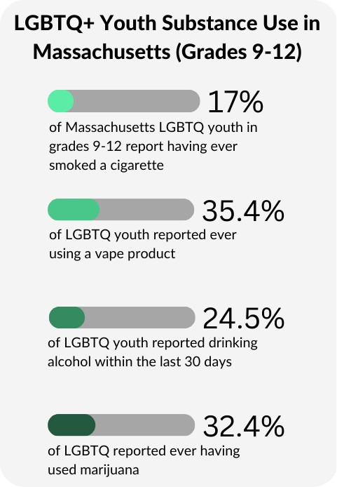
Among Massachusetts LGBTQ youth of color ages 13 to 25 who responded to the Our Health Matters Survey, 37.9% reported having smoked cigarettes within the last 30 days, with 13.9% of those respondents reporting smoking 10-19 days out of the past 30 days. ¹⁰⁰ In regards to alcohol, 51.9% of respondents reported binge drinking in the last 30 days.¹⁰¹ Similarly, 53.0% of respondents reported smoking marijuana within the past 30 days, with 13.2% of those respondents reporting smoking 40 or more times during the past 30 days. ¹⁰² 21.4% of respondents reported misusing prescription drugs within the last 30 days. ¹⁰³ For controlled substances, 18.5% of youth had ever used MDMA (ecstasy), 19.2% of youth had ever used cocaine, 13.6% had ever used methamphetamine, and 10.1% had ever used heroin. ¹⁰⁴ Respondents to this survey ages 13-18 had the lowest rates of substance use. ¹⁰⁵ However, though access to medications like
buprenorphine can be beneficial to LGBTQ youth, a 2022 study reported that patients who were younger, Black, and/or female were less likely to receive buprenorphine treatment.¹⁰⁶

Despite a higher than average risk, LGBTQ youth have a number of protective factors that can reduce their risk of substance use.¹⁰⁷ For example, fostering a supportive and inclusive school environment, including positive teacher-student mentoring relationships, is associated with lower rates of tobacco, alcohol, and marijuana use. ¹⁰⁸ Youth-focused organizations, whether in-school (like GSAs) or community-based, foster connections between LGBTQ youths and give LGBTQ youths the opportunity to engage with their peers in a sober space.¹⁰⁹ These organizations can also be used to foster youth- adult mentorship relationships, as well. Additionally, research has shown that the higher the number of LGBTQ specific school and community resources available to LGBTQ youth, the lower the rate of substance use among LGBTQ youth.¹¹⁰ Whether or not youths actually use the resources, just knowing that there is a strong community network and that there are supportive resources readily available serves as a key protective factor against substance use.¹¹¹

When asked, LGBTQ youth of color additionally expressed interest in community-based healing, LGBTQ youth-specific treatment and healing spaces, and more holistic/less medicalized treatment

options.¹¹² Low-income youth and undocumented youth in particular may have trouble accessing traditional, clinic-based substance use disorder recovery care.¹¹³ While not studied specifically for LGBTQ youth, both peer-led substance use recovery and prevention programming are highly successful and more effective than adult-led programming. ¹¹⁴ Youths expressed that they found “peer-led sessions more enjoyable,” and were more willing to actively engage with peers, rather than adults.¹¹⁵ Youths additionally stressed the importance of culturally-competent treatment options, as well as interventions that promote harm-reduction.¹¹⁶ For example, ensuring that LGBTQ youth have access to community-based safe consumption sites and needle exchange programs can reduce the number of overdoses, as well as the number of cases of HIV and Hepatitis C.¹¹⁷ These have shown great promise in many cities and towns across Massachusetts, but are oftentimes inaccessible to young people, especially those who are still in school or who live in more rural areas of the state, including parts of central Massachusetts.^{118,119} Many youths already engage informally with harm- reduction strategies, so ensuring that prevention and recovery programming support this goal is important to ensuring that youth actually participate in the programs.¹²⁰

Commercial Sexual Exploitation & Sex Work

Traffickers often target marginalized individuals who have previously experienced violent victimization, who lack strong family or friend support, or who are experiencing financial hardship.¹²¹ Some youth are exploited by romantic partners, while others are exploited by family members or employers. ¹²² Youth who have experienced intimate partner or sexual violence, bullying or discrimination, and involvement in the child welfare system are particularly vulnerable. ¹²³ Additionally, unhoused youth, transgender youth of color, and youth with substance use disorders are at an increased risk for sexual exploitation.¹²⁴ Some LGBTQ youth may fall into one or all of these categories, increasing their risk of commercial sexual exploitation. Although there is little data regarding the number of LGBTQ youths who experience commercial sexual exploitation each year, experts estimate that it is likely extremely underreported. ¹²⁵ An estimated 19-41% of unhoused LGBTQ youth have experienced commercial sexual exploitation.¹²⁶ Among LGBTQ youth of color, Black youth of any gender are most likely to be criminalized and arrested for being sexually exploited.¹²⁷ Additionally, while LGBTQ youth likely make up a high percentage of sexually exploited minors, there are very few services that focus on the particular support needs of LGBTQ youth.¹²⁸

However, when considering interventions to address sexual exploitation and trafficking for youth over the age of 18, it is essential to avoid conflating exploitation/trafficking with sex work. As noted throughout this report, the Commission defines ‘youth’ as under 25, but when discussing sex work, the Commission is discussing youth 18 and over; any instance of youth under 18 trading sexual contact for a fee is trafficking, and interventions should be targeted accordingly while centering minors with support and resources rather than punitive measures. While the age of consent in Massachusetts is set at 16, federal law defines youth under 18 as victims of trafficking.¹²⁹ The Commission understands the reality that there are minors exchanging sexual contact with other minors for money or goods, which is a nuanced conversation currently outside of the scope of this report, and is legally still unlawful. Per Massachusetts law (MGL c.265, § 23) - as noted later in the criminal justice section of this report - it is unlawful for persons under 16 to engage in sexual intercourse, even if the other person is also under the age of 16.¹³⁰

The Commission finds it necessary to define the differences between the terms trafficking and sex work, as many advocacy materials and media use the terms interchangeably, which inaccurately

captures and conflates the disparate realities faced by those engaging in sex work over the age of
18.131 Sex work, by definition, is consensual, though many individuals who engage in sex work may also be victims of trafficking and exploitation.¹³² LGBTQ youth over the age of 18 may engage in sex work to meet their needs due to financial necessity, particularly if they have been kicked out of their home due to their gender identity or sexuality or have been unable to find employment due to harassment or discrimination.^{133,134}

According to the 2015 U.S. Transgender Survey, among transgender and gender nonconforming individuals aged 16 and older, 12% reported ever having done sex work (including, but not limited to, dancing in clubs, virtual webcam work on platforms such as OnlyFans, or filming pornography for wide release) for income during their lifetimes.¹³⁵ Among survey participants who reported participating in income-based sex work, 50% were trans women, 23% were nonbinary people assigned female at birth, and 19% were trans men. Individuals living with HIV (32%), undocumented individuals (29%), and Black trans women (24%) reported participating in sex work for income within the past year at the highest rates.¹³⁶ Reaching out for support if they have a bad experience with a client may be particularly difficult for older LGBTQ youth, due to a fear of criminal persecution or a fear of not being believed.¹³⁷

Historically, sexually exploited youths have been treated as perpetrators and criminals in the juvenile justice system, rather than victims and survivors in need of care.¹³⁸ This practice stems from a culture of control, where both sexually exploited youth and adults engaging in sex work were viewed as deviants in need of reform.¹³⁹ Decriminalizing sex work has long been thought to be a major part of the solution to end sex trafficking and commercial sexual exploitation. By decriminalizing sex work, youth who are experiencing commercial sexual exploitation will be able to come forward, report any abuse, and receive care without fear of being criminally prosecuted.¹⁴⁰ Furthermore, youth who are engaging sex work to meet their needs will be able to report any violence they experience from their clients, rather than being silenced out of fear of prosecution for engaging in sex work. Decriminalization further destigmatizes sex work and helps youth who may have had to participate in survival sex work resist further marginalization.¹⁴¹

Furthermore, despite having laws that punish youth under 16 for engaging in consensual sexting, Massachusetts does not have any laws that protect victims over the age of 16 against revenge porn (the purposeful, non-consensual spreading of explicit images by the receiving party), sextortion (extortion for money with threats of sharing explicit images), or sexual deepfakes (edited photos or videos that falsely show a person engaging in a sex act).¹⁴² For example, minors who consensually send explicit images to each other will likely face equal punishment as a minor who purposefully and non- consensually shares another minor’s explicit images, or an adult who digitally exploits minors.¹⁴³ Even worse, victims of revenge porn and digital commercial sexual exploitation are usually punished to the same, or sometimes even greater, extent as the perpetrator.¹⁴⁴ Although these kinds of laws may not seem directly related to commercial sexual exploitation, they foster a hostile environment around sexuality and make youth feel uncomfortable or even unsafe coming forward to reveal sexual exploitation or sexual violence for fear of punishment and criminalization.

When examining interventions to prevent commercial youth sexual exploitation and support survivors/victims, there are notable gaps in Boston when it comes to trauma-informed health care and access to mental health services that specialize in supporting commercially sexually exploited youth.¹⁴⁵ Care providers need more training, as well as more funding, to appropriately and adequately

support sexually exploited youth;¹⁴⁶ training service providers on how to better support survivors of sexual exploitation is also key to ending stigma. ¹⁴⁷ Instead of taking a carceral view of youth commercial sexual exploitation, a cultural shift must occur in how providers view survivors/victims of sexual exploitation and how victims/survivors are supported and connected with resources, rather than criminalized and punished. ¹⁴⁸ Furthermore, it is important to involve survivors/victims in intervention creation, as survivors/victims have largely been left out of leadership positions and have been further exploited as talking-points for organizations, rather than uplifted and supported. ¹⁴⁹ Without taking into account the needs of victims/survivors, it will be impossible to create successful outreach programs.

Engaging LGBTQ Youth

LGBTQ youth have a right to be involved in the creation of the programs meant to support their well- being. No matter the public health issue, it is important that the voices and opinions of LGBTQ youth are included in any kind of program development and implementation. LGBTQ youth know best what resources they need and how they can best be supported, oftentimes more so than the adults in their lives who may be unaware or uninformed about the issues faced by LGBTQ youth.¹⁵⁰ Peer health education programs, whether for dating violence, substance use, or bullying, have been highly successful.¹⁵¹ Peer education finds its success in the fact that peer-to-peer education is often less awkward, and peer educators understand the current social, cultural, and political landscape that youths navigate on a day-to-day basis.¹⁵² Beyond peer support, peer education programs and youth- led advocacy allow peer health educators to become content experts for a particular public health topic, increase communication with parents and other adults, and inspire peer educators to play a role in their community’s long-term wellness.¹⁵³

There are already a number of models for incorporating youths into advocacy efforts, from peer health education programs to youth representatives and councils.¹⁵⁴ For example, the International Planned Parenthood Federation passed a resolution in 2001 that strongly encouraged member organizations to aim for at least 20% youth participation in their leadership structures.¹⁵⁵ Across Massachusetts, some examples - though not the only - of this model would be the Start Strong program hosted by the Boston Public Health Commission, a high school peer leadership program designed to promote healthy relationships and change attitudes towards teen dating violence through peer education. ¹⁵⁶ Advocates for Youth, a youth-led and adult-supported sexual health and reproductive justice advocacy group, continues to lead the charge on today’s most relevant and pressing reproductive justice issues. ¹⁵⁷ Lastly, Winthrop CASA, a local organization that supports youth through community engagement, has a public health Youth Advisory Board that helps develop CASA’s programming.¹⁵⁸ The Commission highlights the important need of funding and supporting LGBTQ-specific youth groups and advocacy organizations, as there remain very few in the more rural and underserved areas of the state.

The following table illustrates some of the organizations that are currently serving LGBTQ youths in Massachusetts, from social clubs and family support networks to advocacy groups and legal counsel. Many of these organizations rely on peer education, peer mentorship, or youth leadership council models.

Local and National LGBTQ Youth Support Resources
Advocates for Youth | Hispanic Black Gay Coalition (HBGC)
AIDS Action Committee Massachusetts | It Gets Better Project
AIDS Project Worcester (APW) | Lesbians of Color Symposium (LOCS)
BAGLY (The Boston Alliance of Gay, Lesbian, Bisexual  and Transgender Youth) | MAP (Massachusetts Asian + Pacific  Islanders) for Health
Boston Area Transgender Support (BATS) | Out Now
Boston GLASS | Peer Health Exchange
Cape and Islands Gay & Straight Youth Alliance  (CIGSYA) | PFLAG
Gender-Sexuality Alliances (GSAs) | Roxbury Youth Works
Generation Q | Safe Homes/The Bridge
Getting to Zero MA | Start Strong
GLAD (GLBTQ Legal Advocates & Defenders) | The Trevor Project
GLBT Youth Group Network of MA | Winthrop CASA (Community Actions for  Safe Alternatives)
GLSEN | Youth on Fire

Finally, as we have learned throughout the COVID pandemic, expanding programming and support services to a virtual format can have a significant impact on youth who would otherwise be unable to engage with critical resources.¹⁵⁹ Rural LGBTQ youth and LGBTQ youth with disabilities, in particular, may find virtual resources particularly helpful. Moving forward, public health professionals should embrace the technology that was developed and improved upon over the course of the pandemic to better serve diverse populations of LGBTQ youth. Ultimately, LGBTQ youth are the future, but without support, it can be hard for them to envision a world with them in it. Public health has the opportunity to support LGBTQ youth as they resist, challenge, and change the structures that prevent them from fully attaining physical, mental, and emotional wellness.

Acknowledgments & Citations

Acknowledgments: Alexandra Gago, lead researcher and author

1 Brandon Andrew Robinson and Rachel M. Schmitz, “Beyond Resilience: Resistance in the Lives of LGBTQ Youth,” Sociology Compass 15, no. 12 (2021): e12947, https://doi.org/10.1111/soc4.12947.
2 Robinson and Schmitz.
3 “Somerville Maps Fastest Path to State’s First Supervised Consumption Clinic — Starting in a Parking Lot,” accessed April 24, 2023, https://www.wbur.org/news/2022/07/29/massachusetts-supervised-drug-site-somerville-plan.
4 Shelley D. Golden and Jo Anne L. Earp, “Social Ecological Approaches to Individuals and Their Contexts: Twenty Years of Health Education & Behavior Health Promotion Interventions,” Health Education & Behavior 39, no. 3 (June 1, 2012): 364– 72, https://doi.org/10.1177/1090198111418634.
5 Golden and Earp.
6 American College Health Association, “Ecological Model,” Healthy Campus, accessed December 17, 2022, https://www.acha.org/HealthyCampus/HealthyCampus/Ecological_Model.aspx.
7 “Recommended Data Reporting Standards: Recommendations for Reporting on Race, Ethnicity, Sexual Orientation and Gender Identity” (Massachusetts: The Juvenile Justice Policy and Data Board, November 2020), https://drive.google.com/drive/u/2/folders/18_t2Wa0JjoIyKMPhwpJLiKhzK0G6VdNJ.
8 Alison Delpercio and Gabe Murchison, “SOGIE* Data Collection” (Washington, D.C.: Human Rights Campaign Foundation, 2017), http://assets2.hrc.org/files/assets/resources/HRC_ACAF_SOGIE_Data_Collection_Guide.pdf.

9 “Ready, Set, Go! Guidelines and Tips For Collecting Patient Data on Sexual Orientation and Gender Identity (SOGI) – 2022 Update” (Boston, Massachusetts: National LGBTQIA+ Health Education Center - A Program of the Fenway Institute, May 5, 2022), https://www.lgbtqiahealtheducation.org/publication/ready-set-go-a-guide-for-collecting-data-on-sexual- orientation-and-gender-identity-2022-update/.
10 “Fast Facts: Preventing Teen Dating Violence,” Centers for Disease Control and Prevention - Violence Prevention, February 8, 2023, https://www.cdc.gov/violenceprevention/intimatepartnerviolence/teendatingviolence/fastfact.html.
11 “2021 Massachusetts Youth Risk Behavior Survey Data,” n.d.
12 “2021 Massachusetts Youth Risk Behavior Survey Data.”
13 S. E. James et al., “The Report of the 2015 U.S. Transgender Survey” (Washington, D.C.: National Center for Transgender Equality and National Gay and Lesbian Task Force, 2016), https://transequality.org/sites/default/files/docs/usts/USTS-Full- Report-Dec17.pdf.
14 James et al.
15 James et al.
16 James et al.
17 James et al.
18 James et al.
19 American College Health Association, “American College Health Association-National College Health Assessment III: Undergraduate Student Reference Group Executive Summary Spring 2022” (Silver Springs, MD: American College Health Association, 2022), https://www.acha.org/documents/ncha/NCHA- III_SPRING_2022_UNDERGRAD_REFERENCE_GROUP_EXECUTIVE_SUMMARY.pdf.
20 National Domestic Violence Hotline, “Types of Abuse,” The Hotline, accessed January 4, 2023, https://www.thehotline.org/resources/types-of-abuse/.
21 Rebecka Lundgren and Avni Amin, “Addressing Intimate Partner Violence and Sexual Violence Among Adolescents: Emerging Evidence of Effectiveness,” Journal of Adolescent Health, International Conference on Population and Development, 56, no. 1, Supplement (January 1, 2015): S42–50, https://doi.org/10.1016/j.jadohealth.2014.08.012.
22 Lundgren and Amin.
23 Lundgren and Amin.
24 Katie M. Edwards, Ryan C. Shorey, and Kalei Glozier, “Primary Prevention of Intitmate Partner Violence Among Sexual and Gender Minorities,” in Intimate Partner Violence and the LGBTQ+ Community: Understanding Power Dynamics (Switzerland: Springer, 2020), 161–76, https://link.springer.com/content/pdf/10.1007/978-3-030-44762-5.pdf?pdf=button. 25 Lisa De La Rue et al., “A Meta-Analysis of School-Based Interventions Aimed to Prevent or Reduce Violence in Teen Dating Relationships,” Review of Educational Research 87, no. 1 (February 1, 2017): 7–34, https://doi.org/10.3102/0034654316632061.
26 Lundgren and Amin, “Addressing Intimate Partner Violence and Sexual Violence Among Adolescents.”
27 Eva S. Goldfarb and Lisa D. Lieberman, “Three Decades of Research: The Case for Comprehensive Sex Education,” Journal of Adolescent Health 68, no. 1 (January 1, 2021): 13–27, https://doi.org/10.1016/j.jadohealth.2020.07.036.
28 “Healthy Youth Act Coalition,” Healthy Youth Act Coalition, accessed January 11, 2023, https://www.healthyyouthact.org/.
29 “Healthy Youth Act Coalition.”
30 Beth Leventhal, Charly Robles, and Jenn Ho, “Survivor Stories: Learning from LGBQ/T Communities in MA” (Boston, Massachusetts: The Network/La Red, 2020), https://www.tnlr.org/wp-content/uploads/CNA-w-cover-Final.pdf.
31 Leventhal, Robles, and Ho.
32 Leventhal, Robles, and Ho.
33 “Adolescents and Young Adults,” Centers for Disease Control and Prevention, October 18, 2022, https://www.cdc.gov/std/life-stages-populations/adolescents-youngadults.htm.
34 “2021 Massachusetts Integrated HIV, STD and Viral Hepatitis Surveillance Report” (Jamaica Plain, MA: Massachusetts Department of Public Health, Bureau of Infectious Disease and Laboratory Sciences, 2022).
35 Elizabeth Campanella Day, “Communicating with LGBTQ Adolescents: Preventing HIV and Other STIs.,” Pediatric Nursing
48, no. 4 (July 1, 2022): 163–67.
36 “2021 Massachusetts Youth Risk Behavior Survey Data.”
37 “2021 Massachusetts Youth Risk Behavior Survey Data.”
38 “2021 Massachusetts Youth Risk Behavior Survey Data.”
39 “Youth STIs: An Epidemic Fuelled by Shame,” The Lancet Child & Adolescent Health 6, no. 6 (June 1, 2022): 353, https://doi.org/10.1016/S2352-4642(22)00128-6.
40 Ashley B. Woolweaver et al., “Leveraging Comprehensive Sexuality Education as a Tool for Knowledge, Equity, and Inclusion,” Journal of School Health, November 20, 2022, https://doi.org/10.1111/josh.13276.
41 “2021 Massachusetts Youth Risk Behavior Survey Data.”
42 “2021 Massachusetts Youth Risk Behavior Survey Data.”
43 “2021 Massachusetts Youth Risk Behavior Survey Data.”
44 Goldfarb and Lieberman, “Three Decades of Research.”
45 Meredith Dank, Lilly Yu, and Jennifer Yahner, “Access to Safety: Health Outcomes, Substance Use and Abuse, and Service Provision for LGBTQ Youth, YMSM, and YWSW Who Engage in Survival Sex” (Urban Institute, February 2016), https://www.urban.org/research/publication/access-safety-health-outcomes-substance-use-and-abuse-and-service-
provision-lgbtq-youth-ymsm-and-ywsw-who-engage-survival-sex.

46 Dank, Yu, and Yahner.
47 “Youth STIs.”
48 Mary Jane Rotheram-Borus, Sung-Jae Lee, and Dallas Swendeman, “Getting to Zero HIV Among Youth: Moving Beyond Medical Sites,” JAMA Pediatrics 172, no. 12 (December 1, 2018): 1117–18, https://doi.org/10.1001/jamapediatrics.2018.3672.
49 “Youth STIs.”
50 C. L. Shannon and J. D. Klausner, “The Growing Epidemic of Sexually Transmitted Infections in Adolescents: A Neglected Population,” Current Opinion in Pediatrics 30, no. 1 (February 2018): 137, https://doi.org/10.1097/MOP.0000000000000578.
51 “Minors’ Access to STI Services,” Guttmacher Institute, February 1, 2023, https://www.guttmacher.org/state- policy/explore/minors-access-sti-services.
52 Rotheram-Borus, Lee, and Swendeman, “Getting to Zero HIV Among Youth.”
53 Rotheram-Borus, Lee, and Swendeman.
54 Rotheram-Borus, Lee, and Swendeman.
55 Dank, Yu, and Yahner, “Access to Safety.”
56 Campanella Day, “Communicating with LGBTQ Adolescents.”
57 Campanella Day.
58 Campanella Day.
59 Katherine G. Quinn et al., “Intersectional Discrimination and PrEP USe Among Young Black Sexual Minority Individuals: The Importance of Black LGBTQ Communities and Social Support,” AIDS and Behavior 27 (2023): 290–302, https://doi.org/10.1007/s10461-022-03763-w.
60 Quinn et al.
61 Errol L. Fields et al., “Identifying Community-Informed Language to Promote HIV Preesposure Prophylaxis (PrEP) in Black LGBTQ Communities in Baltimore,” AIDS Education and Prevention 32, no. 2 (2020): 152–68.
62 Viraj V. Patel et al., “Empowering With PrEP (E-PrEP), a Peer-Led Social Media–Based Intervention to Facilitate HIV Preexposure Prophylaxis Adoption Among Young Black and Latinx Gay and Bisexual Men: Protocol for a Cluster Randomized Controlled Trial,” JMIR Research Protocols 7, no. 8 (2018): e11375, https://doi.org/10.2196/11375.
63 Patel et al.
64 Fields et al., “Identifying Community-Informed Language to Promote HIV Preesposure Prophylaxis (PrEP) in Black LGBTQ Communities in Baltimore.”
65 Fields et al.
66 “Fast Fact: Preventing Bullying,” Centers for Disease Control and Prevention - Violence Prevention, April 14, 2022, https://www.cdc.gov/violenceprevention/youthviolence/bullyingresearch/fastfact.html.
67 “School Climate for LGBTQ Students in Massachusetts (State Snapshot)” (New York, NY: GLSEN, 2021), https://www.glsen.org/sites/default/files/2021-01/Massachusetts-Snapshot-2019_1.pdf.
68 “School Climate for LGBTQ Students in Massachusetts (State Snapshot).”
69 “School Climate for LGBTQ Students in Massachusetts (State Snapshot).”
70 Joseph G. Kosciw, Caitlin M. Clark, and Leesh Menard, “The 2021 National School Climate Survey: The Experiences of LGBTQ+ Youth in Our Nation’s Schools” (New York, NY: GLSEN, 2022), https://www.glsen.org/sites/default/files/2022- 10/NSCS-2021-Full-Report.pdf.
71 Kosciw, Clark, and Menard.
72 “2015 U.S. Transgender Survey: Massachusetts State Report” (Washington, D.C.: National Center for Transgender Equality, 2017).
73 “2015 U.S. Transgender Survey: Massachusetts State Report.”
74 Kosciw, Clark, and Menard, “The 2021 National School Climate Survey: The Experiences of LGBTQ+ Youth in Our Nation’s Schools.”
75 Kosciw, Clark, and Menard.
76 Kosciw, Clark, and Menard.
77 “2021 National Survey on LGBTQ Youth Mental Health” (West Hollywood, CA: The Trevor Project, 2021), https://www.thetrevorproject.org/wp-content/uploads/2021/05/The-Trevor-Project-National-Survey-Results-2021.pdf.
78 Matthew N Berger et al., “Social Media Use and Health and Well-Being of Lesbian, Gay, Bisexual, Transgender, and Queer Youth: Systematic Review,” Journal of Medical Internet Research 24, no. 9 (September 21, 2022): e38449, https://doi.org/10.2196/38449.
79 Berger et al.
80 Berger et al.
81 Elizabeth Bradley et al., “Step In, Speak Up! LGBTQ Youth Bullying Prevention,” in Games and Simulations in Teacher Education, ed. Elizabeth Bradley, Advances in Game-Based Learning (Cham: Springer International Publishing, 2020), 35– 54, https://doi.org/10.1007/978-3-030-44526-3_4.
82 Kosciw, Clark, and Menard, “The 2021 National School Climate Survey: The Experiences of LGBTQ+ Youth in Our Nation’s Schools.”
83 Bradley et al., “Step In, Speak Up! LGBTQ Youth Bullying Prevention.”
84 Sari L. Reisner et al., “Addressing LGBTQ Student Bullying in Massachusetts Schools: Perspectives of LGBTQ Students and School Health Professionals,” Prevention Science 21, no. 3 (April 1, 2020): 408–21, https://doi.org/10.1007/s11121-019-
01084-4.

85 “Safe Schools Program for LGBTQ Students,” Massachusetts Department of Elementary and Secondary Education, accessed January 7, 2023, https://www.doe.mass.edu/sfs/lgbtq/.
86 Bradley et al., “Step In, Speak Up! LGBTQ Youth Bullying Prevention.”
87 Reisner et al., “Addressing LGBTQ Student Bullying in Massachusetts Schools.”
88 Reisner et al.
89 Tecelli Domínguez-Martínez and Rebeca Robles, “Preventing Transphobic Bullying and Promoting Inclusive Educational Environments: Literature Review and Implementing Recommendations,” Archives of Medical Research, Special Issue: Mental Health, 50, no. 8 (November 1, 2019): 543–55, https://doi.org/10.1016/j.arcmed.2019.10.009.
90 V. Paul Poteat et al., “Greater Engagement in Gender-Sexuality Alliances (GSAs) and GSA Characteristics Predict Youth Empowerment and Reduced Mental Health Concerns,” Child Development 91, no. 5 (2020): 1509–28, https://doi.org/10.1111/cdev.13345.
91 Domínguez-Martínez and Robles, “Preventing Transphobic Bullying and Promoting Inclusive Educational Environments.”
92 Jessica N. Fish et al., “‘I’m Kinda Stuck at Home With Unsupportive Parents Right Now’: LGBTQ Youths’ Experiences With COVID-19 and the Importance of Online Support,” Journal of Adolescent Health 67, no. 3 (September 1, 2020): 450–52, https://doi.org/10.1016/j.jadohealth.2020.06.002.
93 Domínguez-Martínez and Robles, “Preventing Transphobic Bullying and Promoting Inclusive Educational Environments.”
94 Kosciw, Clark, and Menard, “The 2021 National School Climate Survey: The Experiences of LGBTQ+ Youth in Our Nation’s Schools.”
95 “Opioid-Related Overdose Deaths, All Intents, MA Residents – Demographic Data Highlights” (Massachusetts Department of Public Health, December 2022), https://www.mass.gov/doc/opioid-related-overdose-deaths- demographics-december-2022/download.
96 Jeremy T. Goldbach et al., “Minority Stress and Substance Use in Sexual Minority Adolescents: A Meta-Analysis,”
Prevention Science 15, no. 3 (June 1, 2014): 350–63, https://doi.org/10.1007/s11121-013-0393-7.
97 Jack K. Day et al., “Transgender Youth Substance Use Disparities: Results From a Population-Based Sample,” Journal of Adolescent Health 61, no. 6 (December 1, 2017): 729–35, https://doi.org/10.1016/j.jadohealth.2017.06.024.
98 “Results of the Massachusetts Youth Health Survey 2021” (Boston, Massachusetts: Office of Data Management and Outcomes Assessment, Massachusetts Department of Public Health, October 6, 2022), https://www.mass.gov/doc/results- of-the-massachusetts-youth-health-survey-2021/download.
99 “Results of the Massachusetts Youth Health Survey 2021.”
100 Kerith Conron et al., “Our Health Matters: Mental Health, Risk, and Resilience among LGBTQ Youth of Color Who Live, Work, or Play in Boston” (Boston, Massachusetts: The Fenway Institute, November 2015), https://fenwayhealth.org/wp- content/uploads/our-health-matters.pdf.
101 Conron et al.
102 Conron et al.
103 Conron et al.
104 Conron et al.
105 Conron et al.
106 Wakeman, Sarah E., Eugene Lambert, Sunny Kung, Nicholas M. Brisbon, Aleta D. Carroll, Thu-Trang Hickman, Charles Covahey, Thomas D. Sequist, and Scott G. Weiner. "Trends in buprenorphine treatment disparities during the COVID pandemic in Massachusetts." Substance Abuse 43, no. 1 (2022): 1317-1321.
107 Amy L. Gower et al., “Supporting Transgender and Gender Diverse Youth: Protection Against Emotional Distress and Substance Use,” American Journal of Preventive Medicine 55, no. 6 (December 1, 2018): 787–94, https://doi.org/10.1016/j.amepre.2018.06.030.
108 Gower et al.
109 Gower et al.
110 Marla E. Eisenberg et al., “Supportive Community Resources Are Associated with Lower Risk of Substance Use among Lesbian, Gay, Bisexual, and Questioning Adolescents in Minnesota,” Journal of Youth and Adolescence 49, no. 4 (April 1, 2020): 836–48, https://doi.org/10.1007/s10964-019-01100-4.
111 Eisenberg et al.
112 Conron et al., “Our Health Matters: Mental Health, Risk, and Resilience among LGBTQ Youth of Color Who Live, Work, or Play in Boston.”
113 Rotheram-Borus, Lee, and Swendeman, “Getting to Zero HIV Among Youth.”
114 Keith James Topping, “Peer Education and Peer Counselling for Health and Well-Being: A Review of Reviews,” International Journal of Environmental Research and Public Health 19, no. 10 (January 2022): 6064, https://doi.org/10.3390/ijerph19106064.
115 Topping.
116 Emily K. Jenkins, Allie Slemon, and Rebecca J. Haines-Saah, “Developing Harm Reduction in the Context of Youth Substance Use: Insights from a Multi-Site Qualitative Analysis of Young People’s Harm Minimization Strategies,” Harm Reduction Journal 14, no. 1 (July 31, 2017): 53, https://doi.org/10.1186/s12954-017-0180-z.
117 “LGBTQ People and Syringe Services Programs” (Washington, D.C.: National LGBTQ Task Force), accessed February 23, 2023, https://www.hivlawandpolicy.org/sites/default/files/Syringe%20Access%20LGBT%20Fact%20Sheet.pdf.
118 “Establishing a Syringe Services Program in Rural America,” National Harm Reduction Coalition, 2020, https://harmreduction.org/issues/establishing-rural-programs/.

119 “Syringe Service Program Locator | Mass.Gov,” Mass.gov, accessed February 23, 2023, https://www.mass.gov/info- details/syringe-service-program-locator.
120 Jenkins, Slemon, and Haines-Saah, “Developing Harm Reduction in the Context of Youth Substance Use.”
121 “Sex Trafficking and LGBTQ+ Youth” (Washington, D.C.: Polaris Project, n.d.), https://polarisproject.org/wp- content/uploads/2019/09/LGBTQ-Sex-Trafficking.pdf.
122 “Sex Trafficking and LGBTQ+ Youth.”
123 Meaghan Tomasiewicz, “Sex Trafficking of Transgender and Gender Nonconforming Youth in the United States,” Center for the Human Rights of Children, May 1, 2018, https://ecommons.luc.edu/chrc/16.
124 Kimberly A. Hogan and Dominique Roe-Sepowitz, “LGBTQ+ Homeless Young Adults and Sex Trafficking Vulnerability,”
Journal of Human Trafficking 0, no. 0 (November 11, 2020): 1–16, https://doi.org/10.1080/23322705.2020.1841985.
125 Hogan and Roe-Sepowitz.
126 Hogan and Roe-Sepowitz.
127 Hogan and Roe-Sepowitz.
128 Hogan and Roe-Sepowitz.
129 “Citizen’s Guide To U.S. Federal Law On Child Sex Trafficking,” May 26, 2015, https://www.justice.gov/criminal- ceos/citizens-guide-us-federal-law-child-sex-trafficking.
130 “Massachusetts Law about Sex | Mass.Gov,” accessed April 24, 2023, https://www.mass.gov/info- details/massachusetts-law-about-sex.
131Sex Workers and Allies Network and Yale Global Health Justice Partnership, “SEX WORK VS TRAFFICKING: HOW THEY ARE DIFFERENT AND WHY IT MATTERS,” June 2020,
https://law.yale.edu/sites/default/files/area/center/ghjp/documents/issue_brief_sex_work_vs_trafficking_v2.pdf.
132 “Erased - The Impact of FOSTA-SESTA and the Removal of Backpage 2020,” Hacking//Hustling, accessed April 24, 2023, https://hackinghustling.org/erased-the-impact-of-fosta-sesta-2020/.
133 “Sex Trafficking and LGBTQ+ Youth.”
134 “LGBTQIA+ Youth and Experiences of Human Trafficking: A Healing-Centered Approach | 2021” (Health Resources and Services Administration of the U.S. Department of Health and Human Services, 2021), https://www.lgbtqiahealtheducation.org/wp-content/uploads/2021/09/Supporting-LGBTQIA-Youth-Who-Have- Experienced-Trafficking.pdf.
135 James et al., “The Report of the 2015 U.S. Transgender Survey.”
136 James et al.
137 “Sex Trafficking and LGBTQ+ Youth.”
138 Laura S Abrams et al., “Collaborative Responses to Commercial Sexual Exploitation as a Model of Smart Decarceration,”
Social Work 65, no. 4 (October 1, 2020): 387–96, https://doi.org/10.1093/sw/swaa040.
139 Abrams et al.
140 Erin Albright and Kate Adamo, “Decreasing Human Trafficking through Sex Work Decriminalization,” AMA Journal of Ethics 19, no. 1 (January 1, 2017): 122–26, https://doi.org/10.1001/journalofethics.2017.19.1.sect2-1701.
141 Albright and Adamo.
142 “Existing Nonconsensual Pornography, Sextortion, and Deep Fake Laws,” Cyber Civil Rights Initiative, accessed January 7, 2023, https://cybercivilrights.org/existing-laws/.
143 Joanna Lampe, “A Victimless Sex Crime: The Case for Decriminalizing Consensual Teen Sexting,” University of Michigan Journal of Law Reform, no. 46.2 (2013): 703, https://doi.org/10.36646/mjlr.46.2.victimless.
144 Blaire Bayliss, “The Kids Are Alright 😂😂😂😂 🍆🍆🍆🍆 🍑🍑🍑🍑: Teen Sexting, Child Pornography Charges, and the Criminalization of Adolescent Sexuality,” University of Colorado Law Review 91 (2020): 251–82.
145 Wendy L. Macias-Konstantopoulos et al., “The Commercial Sexual Exploitation and Sex Trafficking of Minors in the Boston Metropolitan Area: Experiences and Challenges Faced by Front-Line Providers and Other Stakeholders,” Journal of Applied Research on Children 6, no. 1 (2015), https://eric.ed.gov/?id=EJ1188522.
146 Macias-Konstantopoulos et al.
147 Charles Hounmenou and Caitlin O’Grady, “A Review and Critique of the U.S. Responses to the Commercial Sexual Exploitation of Children,” Children and Youth Services Review 98 (March 1, 2019): 188–98, https://doi.org/10.1016/j.childyouth.2019.01.005.
148 Abrams et al., “Collaborative Responses to Commercial Sexual Exploitation as a Model of Smart Decarceration.”
149 Dora Ducak et al., “Perspectives of Stakeholders Working to End the Commercial Sexual Exploitation of Children in Atlanta, Georgia,” Violence and Gender 9, no. 2 (June 2022): 73–79, https://doi.org/10.1089/vio.2021.0048.
150 Lauren M. Sava et al., “LGBTQ Student Health: A Mixed-Methods Study of Unmet Needs in Massachusetts Schools,”
Journal of School Health 91, no. 11 (2021): 894–905, https://doi.org/10.1111/josh.13082.
151 Topping, “Peer Education and Peer Counselling for Health and Well-Being.”
152 Amy D. Benton et al., “Peer-Led Sexual Health Education: Multiple Perspectives on Benefits for Peer Health Educators,”
Child and Adolescent Social Work Journal 37, no. 5 (October 1, 2020): 487–96, https://doi.org/10.1007/s10560-020-00661-
9.
153 Benton et al.
154 Laura Villa-Torres and Joar Svanemyr, “Ensuring Youth’s Right to Participation and Promotion of Youth Leadership in the Development of Sexual and Reproductive Health Policies and Programs,” Journal of Adolescent Health 56, no. 1 (January 2015): S51–57, https://doi.org/10.1016/j.jadohealth.2014.07.022.
155 Villa-Torres and Svanemyr.

156 “Start Strong,” Boston Public Health Commission, accessed January 7, 2023, https://www.thehallsboston.com/.
157 Advocates for Youth, accessed December 17, 2022, https://www.advocatesforyouth.org/.
158 Winthrop CASA, accessed January 8, 2023, https://www.winthropcasa.org.
159 Jessica N. Fish et al., “LGBTQ Youth-Serving Community-Based Organizations: Who Participates and What Difference Does It Make?,” Journal of Youth and Adolescence 48, no. 12 (December 1, 2019): 2418–31, https://doi.org/10.1007/s10964-019-01129-5.

COMMISSION ON LGBTQ YOUTH

PUBLIC HEALTH

ABOUT
The public health crises facing LGBTQ youth are largely not because of individual risk factors, but rather systemic issues that affect how LGBTQ youth navigate the spaces in which they exist. Despite hostility, LGBTQ youth continue to resist, challenge, and change the relationships, communities, institutions, and systems that act as oppressive forces. Public health has an obligation to support and uplift LGBTQ youth as they resist unjust and oppressive structures. In doing so, policymakers, providers, and educators can better pave the way for a future where all LGBTQ youth thrive.
RECOMMENDATIONS
Create and expand community-based public health programming that is accessible and engaging to youth with the most barriers to access.
Increase funding to organizations that support LGBTQ survivors of intimate partner violence.
Ensure that public schools, colleges, and universities have comprehensive anti-bullying, anti-cyberbullying, and anti-harassment policies.
54%
of LGBTQ students have experienced verbal harassment due to their sexuality

6.8%
of LGBTQ youth have ever
been tested for an STI other than HIV

17.8%
of LGBTQ high school students have experienced sexual dating violence in the past year



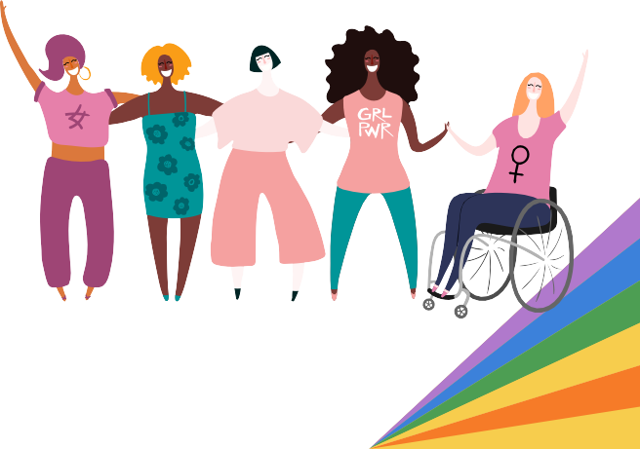
LEGISLATION
S.1242/H.1981: Overdose Prevention Centers S.619/H.1085: Access to HIV Prevention Medication

Supporting Mental Health

Introduction

The personal is political – and that includes mental health, too. Across the Commonwealth, LGBTQ youth mental health is in crisis. Last year, LGBTQ youth reported alarmingly high levels of depression, anxiety, suicidality, and trauma, yet most who wanted mental healthcare did not receive it. In this report, the Commission discusses ways that allies across many fields can promote evidence-based, intersectional, and trauma-informed mental healthcare for LGBTQ youth, all while highlighting youths’ voices and strengths. From the classroom to the campaign trail, discrimination wears down LGBTQ youths’ physical, social, and mental health on an everyday basis; LGBTQ youth mental health is a community-wide issue that deserves community- based solutions – and everyone has a part to play. For this dedicated section on mental health, the Commission’s recommendations center around three key principles: recognize that discrimination causes trauma, invest in early intervention, and fuel systemic change rather than focusing only on individual therapy.

“If I am depressed or anxious, it’s likely not because I have issues with my gender identity, but because everyone else does.” –
Youth from New England,¹ 2017

FY 2024 Recommendations to the Governor on Mental Health

- Fund more statewide research about mental health and suicide prevention treatment approaches for LGBTQ youth.

The Commission strongly recommends that the state fund more in-depth, community-based research on mental health and suicide prevention treatment approaches for LGBTQ youth, particularly those in oft undeserved communities, such as rural youth, undocumented youth, disabled youth, and QTBIPOC youth. There is a significant crisis for mental health care across the country, and numerous efforts to mitigate the crisis are underway - however, it is essential that policymakers understand the unique needs of LGBTQ youth and the desperate need for affirming and accessible mental health care. By conducting further needs assessments, the state can better understand potential innovative methods of addressing the mental healthcare crisis, and building capacity within communities.

- Support reforms of the mental healthcare and health insurance systems.

The Commission recommends that the legislature support and pass effective reforms to recruit more trauma- informed and culturally-responsive mental health professionals to support intersectional mental health support and to reduce the costs of mental health services. Furthermore, the Commission advises policymakers to invest in non-clinical community-based programs, such as peer support programs, mental health advocate programs, mental health first aid trainings, and mental health literacy campaigns. Additional potential areas of

investment would be telehealth or online programs, peer summer camps, and programs based on art, movement, and activism.

- Promote services that address youths’ intersectional identities, including race/ethnicity, immigration, ability, involvement in juvenile justice or foster care, and rural residence.

As detailed below, there remains limited access to LGBTQ-affirming, trauma-informed, and culturally competent care for QTBIPOC youth, as well as access for youth who are undocumented and/or have disabilities. More research needs to occur to better understand access for youth in the juvenile justice and child welfare systems in Massachusetts, but the significant mental healthcare crisis likely affects these populations critically. The Commission recommends that the Commonwealth allocates more funding to LGBTQ youth and family services, and encourages programs to make concerted efforts to ensure that their programs are affirming and welcoming for all youth.

- Increase funding to hire and retain more MHPs in order to meet nationally-recommended ratios between MHPs and youth.

As discussed throughout this report, mental healthcare is in a state of crisis. The Commission recommends that the Commonwealth continue to prioritize and invest in mental health professionals, and ensure that K-12 schools, higher education, juvenile justice programs, and the child welfare system are able to provide effective and affirming mental health services for youth in their care. The Commission urges the legislature to explore innovative ways to invest in mental healthcare professionals, including at the student level by providing funding opportunities and easing barriers to access for BIPOC and LGBTQ social work students to licensure.

Massachusetts LGBTQ Youth Mental Health – Data & Theories

Against the backdrop of the ongoing COVID-19 pandemic, growing social and political hostility, and a growing shortage of affordable and accessible mental healthcare, the state of LGBTQ youth mental health continues to deteriorate. Overall, more and more youth have been experiencing anxiety and considering suicide over the last three years of the global pandemic. Additionally, more youth are experiencing depression than in 2020, while suicide attempt rates have stayed relatively level.² Most alarmingly, in 2021, 1 in 2 LGBTQ youth in Massachusetts were not able to get mental healthcare when they wanted it.³

In the Trevor Project’s most recent survey on LGBTQ youth mental health, 71% of 13-18 year-old LGBTQ participants in Massachusetts reported experiencing anxiety, while 51% felt symptoms of depression. ⁴ Meanwhile, 41% of participants reported seriously considering suicide in the last year, and 11% reported attempting suicide (vs. 14% nationwide). Across the US, more than 1 in 3 youth have experienced physical threats or harm based on their identities – and youth who were victimized attempted suicide at over twice as often as peers who were not.⁵ Finally, the US Census Bureau’s Household Pulse Survey recently found that LGBTQ adults ages 18-29 were nearly twice as likely as non-LGBTQ peers to report having symptoms of anxiety (61% of adults) and depression (50%).⁶

Data Limitations

While LGBTQ youth face mental health challenges across the board, there are clear disparities for BIPOC, multiracial, and gender expansive (transgender and non-binary) LGBTQ youth. For instance, in the Trevor Project’s 2022 National Survey, Indigenous, Middle Eastern/North African (MENA), and multiracial LGBTQ youth were the top three reporters of anxiety, depression, and threats and acts of physical harm. Gender expansive youth across the Commonwealth and the country also reported significantly higher rates of anxiety, depression, and suicidality – for instance, 64% of gender expansive youth. Finally, over half of Indigenous and gender expansive youth reported high levels of trauma symptoms.

It is also important to acknowledge that many youth remain invisible in research. No recent national and state- level survey about LGBTQ mental health exists that is disaggregated by intersex status, immigration status, geographical location, disability, or involvement with child welfare or juvenile justice. When data collection is monolithic, it paints over critical needs, leading authorities to assume that entire populations do not need support. Going forward, the Commission urges local and state agencies to collect and discuss disaggregated youth demographics.

The Role of Minority Stress: How Oppression Impacts Mental Health

Why are mental health concerns so widespread among LGBTQ youth, and how can allies support them?

To understand LGBTQ youth’s inner worlds, decision-makers should first look at the world in which they live. To begin, four months into 2023, 469 anti-LGBTQ bills have already been filed across the US, with the majority targeting gender expansive people.⁷ This is only the latest escalation in a mounting barrage of anti-LGBTQ political and social rhetoric over the last decade – and it takes a toll. Even though Massachusetts is considered a safe haven for LGBTQ policy, the majority of LGBTQ youth in the Commonwealth reported to the Trevor Project that recent politics had negatively impacted their well-being sometimes (49%) or a lot (41%). Across the US, the overwhelming majority of gender expansive youth have worried about local or state laws denying transgender people’s access to medical care (93%), bathrooms (91%), and sports (83%).⁸

Many youth also feel unsafe in their classrooms, neighborhoods, and homes. In 2021, 61% of Massachusetts LGBTQ youth did not feel they lived in an affirming home, and nearly 1 in 2 did not attend an affirming school. Meanwhile, 32% of youth had experienced threats or acts of physical harm because of their sexual orientation or gender identity during their lifetime, while 67% had faced discrimination.⁹

Considering the hostility that youth face in their homes, communities, and country, it is no surprise that LGBTQ youth mental health is in crisis. For decades, researchers have shown that anti-LGBTQ cultural, political, and societal conditions have the power to erode LGBTQ people’s physical,¹⁰ mental,¹¹ and financial health, an experience often called minority stress. Many studies have explored how minority stressors (like bullying, negative media depictions, and hostile legislation) are directly related to mental health challenges (like depression,¹² anxiety, PTSD, and suicide attempts.¹³) For instance, in the year after marriage equality was passed in Massachusetts, there was a statistically significant drop in medical and mental health-related care visits among gay and bisexual men.¹⁴

Three Key Principles of Support: Trauma-Informed Services, Early Intervention, and Collaboration

The realities of minority stress shape the Commission’s recommendations in three key ways. First, all supporters of LGBTQ youth should recognize that discrimination is not simply “stressful”; it is also a form of trauma. Therefore, all of our recommendations should be implemented in a trauma-informed way, expecting that any youth being served may have experienced trauma. Clinical, school, and community-based providers should follow the Substance Abuse and Mental Health Services Administration (SAMHSA)’s six principles of LGBTQ trauma-informed care: 1) center survivors’ voices and desires in services, 2) build collaborative relationships, 3) demonstrate trustworthiness and transparency, 4) create safety by proactively communicating an affirming stance, 5) recognize and discuss cultural, historical, and gender influences on youths’ identities and experiences, and 6) promote peer support.¹⁵

Second, the Commission’s recommendations include investing in early intervention, rather than reacting only after youths’ mental health issues become obvious. While LGBTQ children begin experiencing more bullying than their peers by age 9, it does not become obvious that they suffer from more mental health and substance use challenges until early adolescence (i.e. age 12 or 15).¹⁶ This delayed impact of bullying on youth health is minority stress in action. This is why youth should be supported early in life, such as through inclusive curriculum and peer support spaces, even when adults assume that youth do not yet know they are LGBTQ. Preventative support in schools and communities will decrease the lifelong impacts of minority stress and help bridge the massive gap in access to needed professional mental health support.

Finally, the Commission follows current research recommendations by taking a sociopolitical, holistic approach to LGBTQ youth mental health instead of an individualistic or pathologizing approach. That is, LGBTQ youths’ mental health challenges can be seen as natural human responses to their experiences in school, home, community, and society – not just “personal issues.” Therefore, all support efforts should be anti-oppressive: they should fuel systemic change that tangibly reshapes services, schools, communities, policies, and laws rather than focusing only on individual mental health support.

Research: Supporting LGBTQ Mental Healthcare Needs

In addition to early intervention and anti-oppressive, trauma-informed services, the Commission also urges decision-makers and allies to pay attention to youths’ intersectional identities. Key identities to consider include race/ethnicity, immigration status, disability/neurodivergence/Deafness, involvement in child welfare and juvenile justice systems, and rural residence.

Race & Ethnicity: Taking an Anti-Racist, Intersectional Approach

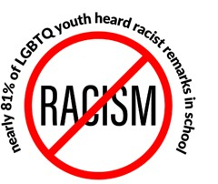
Queer and transgender BIPOC (QTBIPOC) youth do not just experience minority stress through LGBTQ-phobia, but also through racism – which “is not an abnormal experience, but an everyday occurrence.”¹⁷ For instance, GLSEN’s 2021 National School Climate Survey found that nearly 81% of LGBTQ youth heard racist remarks in school at least “sometimes.”
Meanwhile, many QTBIPOC youth have reported being harassed or assaulted based on their race or ethnicity – either at school (over 1 in 2 youth) or online (over 1 in 4).¹⁸

Racism is not just interpersonal. Systems such as housing and employment create and maintain generational inequities in income and health, leading to minority stress. Mental healthcare and social service systems are not exempt. Research shows that BIPOC youth across the board do not get the mental healthcare they need more often than their white peers, partially due to barriers like cost, insurance, parent and youth work or childcare responsibilities, and transportation. Importantly, youth may also avoid or distrust providers who use Eurocentric theories and treatment models that focus on the individual, “other” non-white clients’ values or experiences, and ignore or misaddress issues of power, culture, poverty, race, and racism.¹⁹ For example, mounting evidence shows that Black and Latine male youth are significantly more likely than their white peers to be misdiagnosed with disruptive behavioral disorders rather than trauma, ADHD, or autism, partially due to clinician bias.²⁰

In addition to the double burden of everyday oppression, some QTBIPOC people report feeling doubly isolated. That is, they feel unseen and unprotected in both LGBTQ and racial/ethnic affinity spaces.²¹ One well-known example is the “no fats, no femmes, no Asians” line that Asian men who date men report encountering on dating apps, on top of the stigma that they face in cultural affinity spaces.²² Double isolation is also more common among youth who have limited access to LGBTQ and racial/ethnic spaces, such as youth in the juvenile justice system, the child welfare system, or rural areas.

Given the everyday, systemic, and isolating nature of intersectional oppression, it is not surprising that research shows that QTBIPOC youth have elevated rates of anxiety, depression, suicidality, school discipline, and substance use. These challenges can be seen as a human response to long-term exposure to multiple forms of traumatic discrimination.

Given all of these unique challenges, allies in mental healthcare, youth services, and policy should recognize that QTBIPOC youth may not automatically feel safe simply because a support effort is LGBTQ-friendly. Instead, allies should intentionally build safe spaces for QTBIPOC youth by 1) openly discussing how racialized inequities and experiences may impact people differently and 2) shaping services around ongoing feedback from QTBIPOC youth about their own goals and needs. Allies should also proactively respond to possible distrust of white- majority LGBTQ services by 1) recruiting, meaningfully compensating, and retaining BIPOC staff; 2) openly discussing and acting against racism that comes up in the organization, community, and news; and 3) building
relationships with communities where BIPOC youth are. Finally, allies should invest resources in addressing

structural barriers, like cost, scheduling availability, or transportation access, so that more QTBIPOC youth can access services.

Although QTBIPOC youth face concerning mental health disparities, they also have many personal, family, and cultural strengths. Their intersectional identities do not just expose them to harm; they are great sources of connection, coping, and pride – and supporters should tap into and celebrate them.

Current research highlights multiple tools that QTBIPOC youth use to cope with discrimination: chosen family and community-building, self-advocacy, and cultivating ethnic or racial identity pride.²³ QTBIPOC youth also often cope with LGBTQ-phobic bullying²⁴ using skills they first learned from family and friends to cope with racism. Since peer validation is such a strong buffer against racial minority stress, the Commission recommends investing funding and resources into promoting LGBTQ-friendly racial and cultural affinity spaces in schools and communities, as well as specific racial/cultural affinity spaces in LGBTQ youth groups (like GSAs). These are unique spaces where QTBIPOC youth can develop identity pride, discuss intersectional experiences and strengths, safely unload experiences of oppression, and advocate for themselves and one another.

Immigration & Migration: Culturally-Responsive Support

QTBIPOC youth may also experience minority stress when they have personal or family experience with being an immigrant, refugee, or undocumented person. Structural inequalities, discriminatory comments or policies, xenophobia in political debates and acts, and cross-cultural stressors can all impact LGBTQ immigrant youths’ mental health on a day-to-day basis. For example, GLSEN’s 2021 National School Climate Survey found that 18% of student participants said they hear biased remarks about immigration status “often” or “frequently,” while 16% hear them “sometimes.”²⁵

There is scarce research about LGBTQ foreign-born youth, and the findings about mental health are mixed.²⁶ Overall, risk factors include poverty, lack of social support and stable housing, risk of detainment and deportation, discriminatory experiences, dehumanizing public discourse and policy, and barriers to care, such as waiting periods to access public health insurance. However, immigrant youth have also been found to have similar or better physical and mental health outcomes than native-born peers, a phenomenon called the “immigrant health paradox.”²⁷ This advantage levels out over generations, not just due to acculturation, like shifts in diet and exercise, but also through the wear-and-tear of minority stress.

With these mixed results in mind, the Commission recommends that supporters seek to understand LGBTQ foreign-born youths’ mental health in the context of their position in the US immigration system. It is additionally important to highlight that not all foreign-born youth have the same privileges and stressors. The Trevor Project found that LGBTQ youth with at least one immigrant parent had higher odds of attempting suicide when they worried about deportation (63% more likely) or faced immigration-based discrimination (2.5 times more likely.)²⁸ Supporters should also consider how anti-LGBTQ sentiment and xenophobia shape youths’ past and current experiences. For instance, LGBTQ youth may flee trauma in their first countries only to face intersectional discrimination in the US, such as pressure to conform to Western LGBTQ labels while seeking asylum or refugee status.²⁹

Despite these diverse stressors, foreign-born youth have also always invented their own strategies to survive

and thrive. For instance, they are significantly more likely than their peers to befriend other foreign-born individuals from the same generation, and less likely to report negative health behaviors and outcomes when they do so.³⁰ Because same-generation immigrant peer support protects youths’ mental health, care providers and youth workers should address differences in immigration status in their services. For instance, services for LGBTQ youth can create space for immigrant, refugee, asylee, and undocumented youth to build relationships and advocate for themselves, while also connecting them with immigrant community networks.

As the benefits of peer support suggest, foreign-born youth thrive when they feel understood. Yet in 2022, the Trevor Project found that youth from all non-white racial and ethnic groups were 4 to 10 times more likely than their white peers to feel that care providers would not understand their culture. Middle Eastern/North African (MENA) (21%), AAPI (18%), and Black youth (13%) reported most often that they felt care providers would not understand their cultures, followed by Latine and
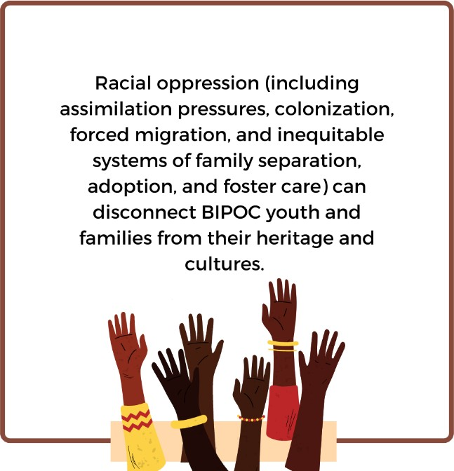
Indigenous (9% each), multiracial (8%), and white (2%) youth.³¹ It is crucial, then, for supporters to not only take an anti-racist and intersectional stance, but also a culturally-responsive one. Whether in policy, youth services, or mental healthcare, cultural responsiveness begins with curiosity rather than generalization.

First, supporters of LGBTQ youth should recognize that every country – including the US – has multiple cultures with diverse values, and that foreign-born youth blend these cultures differently across generations, regions, and families. Further, racial oppression (including assimilation pressures, colonization, forced migration, and inequitable systems of family separation, adoption, and foster
care) can disconnect BIPOC youth and families from their heritage cultures. Thus, supporters should avoid assuming that all foreign-born youth have the same cultural values or that they are comfortably connected with their heritage cultures. Instead, supporters should recognize that each individual has their own relationship to culture.

Second, the Commission urges supporters not to place Western standards of mental health or LGBTQ identity upon all youth. One example is to avoid assuming that youth want to eventually “come out,” since this does not fit all cultural norms. In Hong Kong, some use the “coming home” method of simply bringing their partners home instead, forgoing a direct conversation or declaration.³² Another example is to remember that mental health is expressed differently across cultures. Asian Americans are more likely to express mental health issues as physical symptoms; when service providers only look for Western signs of distress, these issues go undetected, misdiagnosed, or treated inappropriately.³³

Third, supporters should invest in culturally-responsive, LGBTQ-affirming mental health resources. In 2020, the Trevor Project found that many LGBTQ youth did not access mental healthcare because they faced mental health stigma in their communities or worried that providers would not understand the impact of racism and culture in

their lives.³⁴ Thus, the Commonwealth should invest in providers and services who are culturally representative and multilingual. Language access is especially lacking; before 2021, for instance, bilingual social workers in Boston Public Schools covered almost double the schools as their monolingual peers, at 25 schools per professional.³⁵ Additionally, decision-makers should work to provide foreign-born communities with financial and logistical resources so that they can respond to cultural mental health stigma in their own ways; one possible model is the promotora method, discussed further below.

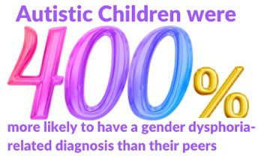
Finally, research finds that when QTBIPOC youth find pride in their racialized and cultural traits, such as values, traditions, or hairstyles, they cope better with the stress of acculturation and discrimination,³⁶ and advocates should support programming in which youth can positively develop their racial,
ethnic, and cultural identities.

Disability, Neurodiversity, and Deafness: Accessible, Affirming Care

This is another opportunity for youth voices. Disability, deafness, and neurodivergence typically go completely unaddressed in research about LGBTQ youth, yet 1 in 3 LGBTQ adults and more than half of transgender adults reported having a disability in 2020.³⁷ These identities are common among youth as well; for instance, one recent study found that autistic children were 400% more likely to have a gender dysphoria-related diagnosis than their peers.³⁸

Minority stress from ableism begins to impact LGBTQ disabled youths’ mental health from an early age. GLSEN found that 73% of participants hear biased ability-focused remarks in school “often” or "frequently.” Meanwhile, 34% stated that they were harassed or assaulted at school within the last year based on their actual or perceived disability, and 17% reported experiencing this online.³⁹

Disabled LGBTQ youth are excluded and discriminated against past age 18 as well. A few studies have found that the majority of disabled LGBTQ students do not receive accommodations in their colleges. ⁴⁰ Other research shows that disabled gender expansive people experience heightened discrimination within employment, housing, and social services such as mental health centers, rape crisis centers, and domestic violence shelters.⁴¹ Disabled LGBTQ people have been found to face depression and suicidality at higher rates than peers, yet inequitable policies can prevent them from accessing mental healthcare. This includes inaccessible services, a shortage of professionals who accept public insurance, and policies that revoke lifesaving SSI or SSDI benefits should recipients get married or hold over $2,000 in assets.

Given the prevalence of disability among LGBTQ people, accessibility should not be an afterthought to supporters of LGBTQ youth mental health. Disabled, Deaf, and neurodivergent LGBTQ youth have diverse strengths and challenges, and supporters should work to specifically include each group in services. However, allies can broadly support these three populations with the following principles.

First, expect differences: assume that disabled, Deaf, and neurodivergent youth are already using services and make them accessible to as many youth as possible. This includes when communicating (closed captions), moving about (ramps), socializing (supporting use of non-verbal communication), self-regulating (sensory or quiet spaces), and more. Second, challenge ableist attitudes that disabled, Deaf, and neurodivergent youth are helpless, burdensome, tragic, lazy, or deficient. Instead, take their lead in exploring the positive and negative

nuances of their own experiences, and inquire about any impacts of ableism on their mental health. Third, practice “nothing about us without us”; shape services around ongoing feedback from youth about their own goals, and create meaningful opportunities for leadership and active participation.

Rural Youth

Rural youth experience unique risk factors for mental health. Firstly, they may be more isolated from social spaces and services for LGBTQ and other fellow marginalized people. Local cultural norms, such as comparison, conformity, and dwelling on difference, may also intensify their feelings of marginalization and expose them to targeted prejudice and discrimination.⁴² Intersecting oppression, such as for being disabled, Indigenous, non-Christian, or BIPOC in a white-majority area, may intensify minority stress on youths’ mental health. Possible areas of investment for rural LGBTQ youth mental health will be discussed further in the “Community- Based Support” section.

Youth Involved in the Child Welfare and Juvenile Justice Systems

Youth who are involved in the juvenile and criminal justice systems also often have multiple marginalized identities. Nationally, nearly 60% of girls in juvenile justice facilities identify as LGBQ, up to 85% of LGBTQ youth in the justice system are also BIPOC, and nearly 1 in 2 women in prison report having a disability. ⁴³ In Massachusetts, DYS Annual Report 2022 reports that only 7.4% of youth in the juvenile justice system identify as LGBTQ, though 83% of its detained juvenile population identifies as BIPOC.⁴⁴ Many LGBTQ prisoners are survivors of childhood abuse and trauma, were unemployed or homeless before incarceration, and experience violence, sexual assault, and human rights abuses within the gender-segregated justice system. Finally, research shows that arrest rates are higher for BIPOC (especially Black, Latine, and Indigenous) and transgender youth, due at least in part to prejudice, poverty, and inequitable laws such as criminalization of sex work.

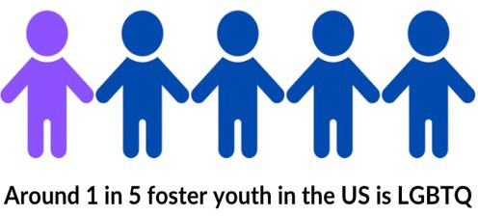
Meanwhile, around 1 in 5 foster youth in the US is LGBTQ, though as discussed in the child welfare section of this annual report, this number is currently estimated to be lower in Massachusetts. However, staff often do not ask about youths’ identities, putting them at risk of being denied services or mistreated within foster placements.⁴⁵ This is troubling, as one study found that, nationally, LGBTQ youth had an average of 6 foster placements, nearly double that of their straight peers; LGBTQ foster youth are also twice as
likely to report being unfairly treated by the child welfare system, explaining why rates of placement run-away, school absenteeism, discipline, and dropout are so high. Unsurprisingly, LGBTQ foster youth are nearly three times as likely to be hospitalized for emotional reasons – yet when they age out of services, many are left on their own.⁴⁶

Overall, the child welfare and juvenile justice systems should ensure that policies and programs supporting LGBTQ youth include supporting youth and families to prevent removal or detainment in the first place; recognizing trauma responses rather than simply maligning youth as aggressive; offering LGBTQ competency trainings for system employees and foster parents; extending eligibility for support services after youth exit

the systems; offering trauma-informed, LGBTQ-specific social spaces and support services; and creating pathways for reporting and enforcing consequences for anti-LGBTQ discrimination. For more detailed recommendations for DCF, see the Commission’s 2021 report, “LGBTQ Youth in the Massachusetts Child Welfare System: A Report on Pervasive Threats to Safety, Wellbeing, and Permanency.”

Evidence-Based Clinical, School & Community-Based Mental Health Support

When LGBTQ youth face mental health challenges like depression, trauma, or suicidality, professional support is often the first step. However, research about therapy for LGBTQ youth is still “severely lacking.” ⁴⁷ One recent study reviewed over six thousand studies from 2000 to 2019 and found that only nine evaluated treatment for substance use, mental illness, or victimization among LGBTQ youth. Even then, most studies were small and focused on individual therapy;⁴⁸ investment in research about specific treatment approaches for LGBTQ youth, especially those who are multiply-marginalized and underrepresented in the mental healthcare field, is essential to understanding LGBTQ youth needs.

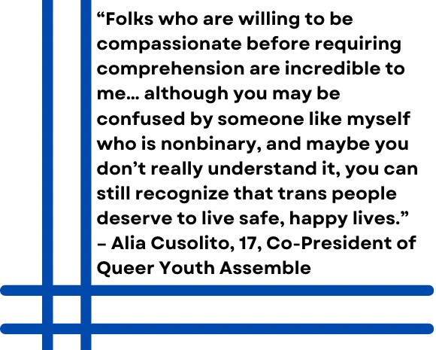
In general, mental healthcare providers (MHPs) who want to provide affirming care for LGBTQ youth can adopt the following best practices. First, MHPs should recognize that the personal is political: minority stress is intersectional, comes from many angles, and leaves many marks. Growing up in an LGBTQ-phobic world can cause complex (prolonged or repetitive) trauma, including shame, betrayal, or abandonment. By asking about the various impacts of minority stress on youths’ lives, such as hearing political candidates debate the validity of youths’ identities, MHPs can help youth connect their personal experiences to wider social conditions,
unlearn internalized LGBTQ-phobia, and develop positive identity. For more on this topic, see SAMHSA’s six principles of LGBTQ trauma-informed care and McCormick, Scheyd, & Terrazas’ considerations for trauma- informed care with LGBTQ youth.⁴⁹

Second, MHPs should adapt their services to be accessible and relevant to youth. For instance, many LGBTQ youth are active Internet users, more so during the age of COVID. Online services are more convenient, safe, and familiar for some youth, especially those who have privacy concerns, lack transportation, or live in rural areas. Groups can also be uniquely healing for youth – in particular, those who do not have many safe, supportive relationships or have limited contact with others like them.

Finally, research recommends that MHPs see LGBTQ youth mental health in terms of holistic emotional well- being, including social networks, community connections, and personal meaning in life.⁵⁰ Thus, MHPs should pay extra attention to LGBTQ youths’ relationships, including peers, supportive adults, families, communities, and advocacy/affinity-based groups. Community-building and creativity-based approaches align very well with Western LGBTQ cultures and should be considered as well.

The few current evidence-based modalities for LGBTQ youth are adapted from mainstream traditional models. CBT is the most-studied modality for LGBTQ youth, likely since it can be done in brief individual or group sessions. ⁵¹ Examples include Rainbow SPARX, a game-based psychoeducational platform that significantly reduced depression in LGBTQ youth ages 13 to 19,⁵² as well as AFFIRM, a new 8-session group CBT intervention

that validates participants’ lived experiences, reduces depression and sexual and mental health risks, and improves coping and mood in LGBTQ youth.⁵³

Other interventions include LGBTQ-affirming mindfulness to help youth develop core mindfulness and self- compassion skills for stress,⁵⁴ as well as adaptations of Solution-Focused Brief Therapy,⁵⁵ Emotion-Focused Therapy, ⁵⁶ and Narrative Exposure Therapy with gender expansive youth or adults. ⁵⁷ When it comes to supporting families, one LGBTQ-specific option is ABFT-SGM (Attachment-Based Family Therapy), a manualized intervention for parental rejection that raised maternal acceptance of LGBTQ young adults’ identities and reduced avoidance in their relationships with their parents.⁵⁸ Motivational Interviewing can also be used with caregivers who are ambivalent to their child’s coming out process.⁵⁹

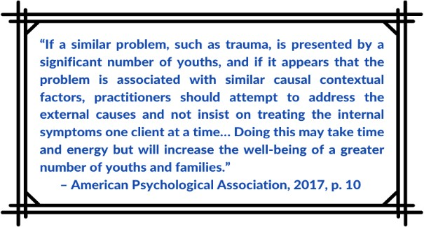
In the spirit of the above quote, decision-makers should not expect traditional individual therapy to single- handedly solve the LGBTQ youth mental health crisis. Families, schools, communities, and institutions all play a role in creating minority stress, but they are also potential
sources of care and healing. Group programs allow all to become actively involved in supporting LGBTQ youth. They also fulfill several of SAMHSA’s principles for LGBTQ trauma- informed care: Peer Support, Safety, and Collaboration and Mutuality. This is why the Commission recommends that allies invest resources in non-clinical, community-based interventions, including online and in-person programs,
GSAs, peer summer camps, activism, bodywork, and expressive arts.

Furthermore, LGBTQ youth peer support programs have huge potential for improving youth mental health – in fact, this is one of SAMHSA’s six tenets of LGBTQ trauma-informed care. Research has shown for decades that social support is life-affirming for LGBTQ people. In the Trevor Project’s 2022 National Survey, nearly half of youth reported living in a “somewhat accepting” community, while 38% lived in a “somewhat or very unaccepting” community. Predictably, suicide attempt rates were highest among youth in very unaccepting communities (21%) versus somewhat accepting (13%) or very accepting (8%). Yet peer support may be even more influential than family support: youth attempted suicide more often when they had low to moderate support from peers as opposed to from family.⁶⁰
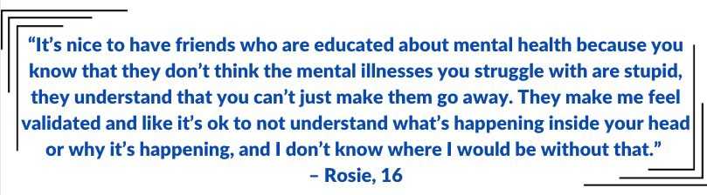

Virtual Programs

Whether in-person, online, or through a school, community, or camp, LGBTQ youth groups are versatile. Virtual groups can provide brief, evidence-based clinical interventions such as CBT or DBT, but they can also be based

around socializing, peer support, activism, common interests, and more, acting as safe oases where youth feel more implicitly understood and accepted than in other areas of life.

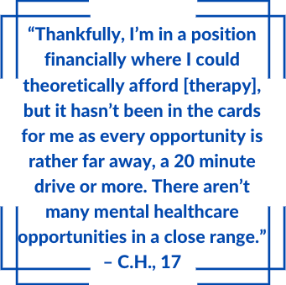
To begin, since LGBTQ youth face high rates of online harassment and maintain active subcultures and affinity spaces online, virtual interventions are a promising avenue for LGBTQ youth mental health support. Research suggests that youth feel more comfortable sharing personal experiences via text than face-to-face,⁶¹ as this lessens fears about outing or social discomfort. Online groups are also more accessible for youth who lack reliable transportation, live in rural areas, or are not allowed to travel (such as those in juvenile justice systems). Finally, they are useful for providing affinity-based spaces for LGBTQ youth with specific identities or experiences across far distances, since youth may not find others with the
same intersectional identities in-person. The Trevor Project’s chat line and Q Chat Space, an adult-facilitated program that connects and supports youth, are two evidence-based models of online support.

In-Person Peer Programs in Schools and Communities

Next, in-person peer programs have been popular for decades and have more evidence for improving mental health. GSAs are the quintessential example in schools – they empower LGBTQ youth to build resilience, hope, and positive support networks, and also tend to actively improve school culture. In 2019, one study found that more frequent meetings and more mental health discussions in GSAs predicted less depressive and anxiety symptoms. Additionally, when students engaged more with the GSA over the school year, they reported higher perceived levels of peer validation and self-efficacy to promote social justice.⁶² Accordingly, GLSEN found that students with active GSAs experienced nearly half as much in-person victimization for their sexual orientation or gender expression as their peers.⁶³

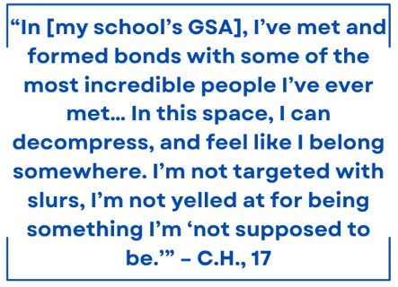
Outside of school, in-person programs can be based in LGBTQ organizations or hubs such as religious buildings, libraries, and community health clinics, and often involve LGBTQ peers or families. Hatch Youth is one case: it provides free social time, consciousness-raising, and a youth- led peer support group four nights a week to 13 to 20 year-old LGBTQ youth. One study showed that Hatch Youth increased perceived social support, leading to depressive symptoms, higher self-esteem, and better coping skills.⁶⁴

Retreats and Summer Camps

Time-limited programs, such as retreats, can also be potent boosts for LGBTQ youth mental health. The CDC recognizes summer camps as one evidence-based intervention for helping youth build socioemotional skills.⁶⁵ Brave Trails, a one-to-two week summer camp for youth ages 12-18 in California and Maryland, found that

campers experienced significant increases in self-esteem, hope, identity affirmation, and resilience,⁶⁶ as well as drops in symptoms of depression and anxiety.⁶⁷ Gender expansive youth in particular have reported being able to have social interactions they could not find otherwise.⁶⁸

Activism-Oriented, Somatic, and Expressive Arts Interventions

Arts, body-based, and activist programs are leading mental health interventions for LGBTQ youth, especially trauma survivors. To begin, arts programs are engaging for many LGBTQ youth because self-expression is a celebrated value in US LGBTQ culture and a key developmental goal for young people. They also build self- esteem and identity by helping youth connect, perform, redefine, and be who they are despite discrimination.⁶⁹ Arts programs can be done anywhere – for instance, a community-based mural project or a Hip Hop Therapy group in a juvenile detention facility. Another example is ReScripted – a theater, play, and movement-based pilot program by the Center for Trauma and Embodiment that improves trauma survivors’ interoception, active choice-making, and self-regulation of behavior.⁷⁰

Next, somatic (body-based) interventions are increasingly popular among professionals and survivors because of mounting evidence that they are uniquely effective in treating trauma. One example is Trauma Center Trauma-Sensitive Yoga, the leading-edge program of its kind. A 2022 pilot study showed that female survivors of military sexual trauma who did TCTSY experienced benefits sooner and were more likely to complete treatment than peers who used Cognitive Processing Therapy. ⁷¹ The Trauma Center is also currently researching the effectiveness of trauma-informed weight lifting with gender expansive people.⁷² Due to the high rates of trauma and victimization among LGBTQ youth, these types of interventions should be given special attention when allocating resources and funding.

Finally, research shows that activism-based programming connects LGBQ⁷³ and transgender youth⁷⁴ to a sense of community and purpose. Activism also directly meets three of SAMHSA’s principles of LGBTQ trauma- informed care – Empowerment, Voice and Choice, and Cultural, Historical, and Gender Issues. Activism helps youth build personal resources for resilience, like self-pride and hope, as well as social resources, like community belonging.⁷⁵ It is also cathartic and can also be uniquely helpful for multiply-marginalized LGBTQ youth. For instance, research demonstrates that activism among LGBTQ women of color reduces the likelihood of feeling emotional distress about sexism.⁷⁶ It has also been shown to be a useful coping mechanism and source of meaning after sexual assault – which many LGBTQ youth, especially gender expansive youth, experience.⁷⁷

At the same time, supporters should remember that activism does not always decrease anxiety or depressive symptoms, especially when it leads youth to take on more responsibilities, burn out, or feel hyper-aware of issues facing the community.⁷⁸ Thus, any activism-based programming for LGBTQ youth should avoid placing the burden of legislative, policy, and cultural change upon youth. Rather, adult decision-makers should keep primary responsibility for driving reform, tapping youth to be the guiding voices and supporters of these causes.

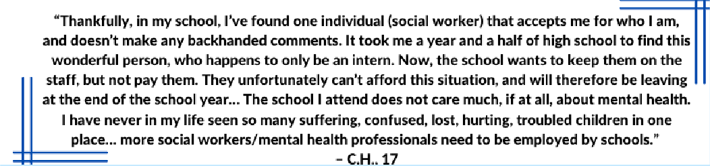

Systemic Barriers to Care: Mental Health Stigma, MHP Burnout, and Low Compensation

Lack of access to mental healthcare has reached a crisis point for youth across the US. In 2021, SAMHSA found that around 60% of 12 to 17 year-olds who had a major depressive episode in the past year did not receive treatment. Meanwhile, in Massachusetts, in 2021, the Trevor Project uncovered that 53% of LGBTQ youth who wanted mental healthcare in the last year were not able to get it.

Reasons for being unable to access care vary. In Massachusetts, LGBTQ youths’ top five reported barriers include being afraid to talk about mental health with another person (43%); not wanting to get guardians’ permission (40%); being afraid of not being taken seriously (32%); not being able to afford care (31%); and being afraid it wouldn’t work (30%). Since many of these reasons relate to stigma and fear about care-seeking, reforms such as mental health literacy projects have high potential.

The severe shortage of MHPs – especially those who are LGBTQ and culturally competent – is another significant barrier to care; MHP trainees such as social work students often provide life-affirming mental health support in internships across Massachusetts. However, many are required to provide this unpaid labor for roughly half of the work week over two years in order to graduate – and pay increased tuition for these placements. Combined with already-high tuition, living costs, and loan interest rates, this financial burden mirrors the low wages and overwhelming caseloads that MHPs face after graduation. These conditions fuel high rates of burning out, turning over, and leaving the field entirely, as it is already difficult for MHPs to graduate, let alone find meaningfully-paid work. This is why the Commission recommends that allies advocate for policies which support MHP students in every stage of the school-to-workforce pipeline.

Finally, the health insurance system creates many barriers to care. The Mental Health ABC Act took vital steps toward reform, such as by guaranteeing coverage of annual mental health wellness exams, raising reimbursement minimums to mirror those of primary healthcare providers, and expanding access to mental health support in schools and the foster care system.⁷⁹ However, there is still a growing trend among MHPs to stop accepting insurance due to clawbacks, audits, lack of control over session length and content, and lengthy wait times for low reimbursement.⁸⁰ As a result, community mental health centers and clinicians who do accept insurance have increasingly long waitlists. Additionally, the traditional model of mental healthcare requires youth to commute to receive in-person, individual support from professionals with years of expensive training. This makes care inconvenient, slow, and harder to find – especially for youth with rural areas, childcare or work responsibilities, or non-affirming guardians. Supporters of LGBTQ youth should advocate for policies that support simplicity, patients’ rights, fair compensation of MHPs, and greater access to insurance.

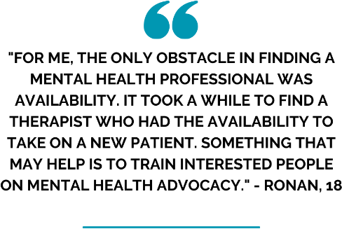
Fund Direct Mental Healthcare in K-12/Higher Education, Juvenile Justice, and Child Welfare

Although it is vital for all LGBTQ youth to have access to mental health support in schools, not all youth attend school or feel supported by MHPs in school. Youth who are involved in the juvenile justice and child welfare systems deserve specialized support.

Starting with foster care, current and former foster youth have been vocal for decades about what they want and need.
First, foster youth have asked for foster families and child welfare professionals to be trained to be trauma-informed and LGBTQ-affirming. They have also advocated for agencies to adopt enforceable anti- discrimination policies and clearly communicate youths’ rights and resources (such as DCF’s foster child bill of rights). Further, many youth have named the systemic issues with “aging out” of services. This leads to many youth becoming unhoused and unsafe or defaulting to living in restrictive, often dehumanizing, and potentially re-traumatizing residential care settings.

The Commission’s 2021 report, “LGBTQ Youth in the Massachusetts Child Welfare System: A Report on Pervasive Threats to Safety, Wellbeing, and Permanency,” laid out detailed evidence-based recommendations for DCF to respond to systemic crises among LGBTQ youth in its care. Since the release of this report, the Commission and DCF have actively been working together to address the recommendations provided, with many of the recommendations since resolved, as detailed in the DCF- specific agency recommendations. In particular, DCF has been working to create a formal mechanism to identify affirming placements, since many gender expansive youth are only placed in homes after reaching their maximum length of stay in residential programs. Additionally, DCF has updated its congregate care contracts to ensure that their staff and policies are LGBTQ-competent and regularly ask youth how they can improve their services.

As for LGBTQ youth in the criminal legal system, UCLA’s David Geffen School of Medicine recently put forth multiple recommendations that Massachusetts can follow. First, law enforcement agencies, courts, and detention facilities should all ensure that staff and policies are LGBTQ-affirming and trauma-informed, such as by ensuring youth of all ages can access gender-affirming clothing and care. Correctional agencies should seek funding to hire more affirming MHPs; communicate and implement policies for protecting LGBTQ youth from discrimination and harm; and provide virtual, trauma-relevant, and peer-based programs. Further, school districts should implement their own practices and policies to disassemble the school-to-prison pipeline, including crisis intervention protocol, training to recognize and respond to trauma, training and consequences for disciplining students according to (un)conscious bias, and resources for LGBTQ-affirming mentors and peer spaces.

Allies must also invest more resources in support for LGBTQ youth who are dependent on substances. In 2021, the Trevor Project found that over half of all LGBTQ youth had used alcohol in the last year, while almost a third had used marijuana and one in ten used prescription drugs that were not their own. LGBTQ youth who use substances are also significantly more likely to attempt suicide, while adolescent overdose rates across the US doubled between 2019 and 2021. The prevalence of substance use among LGBTQ youth makes it even more important to fund affirming, affordable, trauma-informed, and culturally responsive treatment options.

Yet when people in Massachusetts need support for substance use disorders, they may be met with judgment and criminal charges instead. For instance, when defendants relapse and fail court-mandated drug testing, they are often incarcerated, where they experience further trauma and receive non- evidence-based treatment.

Finally, because LGBTQ youth face many risk factors that can push them into crisis, hospitalization, and suicidality, allies should strongly advocate for more care options that are LGBTQ-affirming, affordable, and do not cause further trauma. On this front, congregate mental health support services in particular lack crucial funding. At present, it appears that there are only a few LGBTQ-specific partial hospitalization programs in Massachusetts (including Walden’s virtual Rainbow Road Programs and HRI Hospital’s Triangle Program), as well as one group home in New England (The Home for Little Wanderers’ Waltham House, with a capacity of 12 youth.)

Expanding Youth Access to Community-Based and Peer Support

Overall, while individual-based professional mental healthcare urgently deserves funding and reform, community-based programs can also significantly improve LGBTQ youth mental health. Given the high rates of lack of access to mental healthcare, decision-makers should invest in task-shifting to help more LGBTQ youth get support from their own peers and communities; task-shifting circumvents common barriers to care, like cost and long waitlists, by training laypeople and paraprofessionals to provide emotional support and psychoeducation. This allows more people to address stress and mental health concerns without having to wait to find an affordable therapist, preventing them from reaching a crisis point. Task-shifting has been evaluated in controlled studies of lay treatment of depression, anxiety, eating disorders, trauma, and alcohol dependency.⁸¹

One way that communities and decision-makers can begin task-shifting is to increase funding and resources for peer support work. Peer workers relieve the intense demand that mental health professionals face. It has been piloted with LGBTQ mental health peer advocates in rural areas. ⁸² The promotora model, where respected laypeople become health advocates in their own communities, is another powerful strategy for reducing stigma in a culturally relevant way. They can collaborate with social workers, medical professionals, teachers, and more, and often come from more isolated or marginalized communities, like rural, immigrant, or BIPOC-majority neighborhoods.⁸³

Proud and Empowered, a small-group program, is an example of peer work in schools. The program provided a 10-session program for LGBTQ youth, but it also trained “popular” students to be allies in a 4-session leadership program, shifting the burden of changing school climate to students with privilege. ⁸⁴ The first national review of peer and non-peer transition services makes useful recommendations about the needs and preferences of peer workers, including greater funding for coaching and training.⁸⁵

Another way that schools and communities can task-shift is by hosting free mental health first aid trainings and mental health literacy campaigns. Mental health first aid teaches laypeople to recognize and intervene in mental health emergencies such as panic attacks and suicidal ideation; it has been shown to significantly decrease mental health stigma in parents.⁸⁶ Since reluctance about getting parental permission is a major reason why LGBTQ youth do not seek mental health care, decreasing community-wide mental health stigma is important.

Optimize LGBTQ Youth Programming and Promoting Positive Youth Development

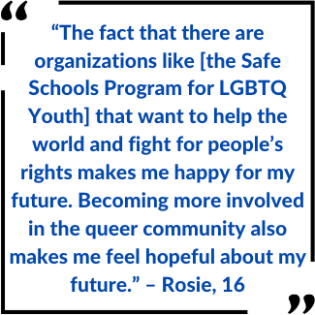
Shifting focus from communities to organizations, the Commission urges decision-makers to allocate more funding to LGBTQ youth services. This includes funding LGBTQ-specific organizations as well as incentivizing community-serving organizations (such as places of worship, nonprofits, etc.) to host services and programs that improve the emotional well-being of LGBTQ youth and their families. Non-LGBTQ-specific youth programming can also be harnessed to provide support and early intervention for LGBTQ youth. Positive Youth Development (PYD) is one evidence-based intervention that taps into youths’ strengths, interests, and voices to improve emotional
well-being in family, school, and community contexts. Preexisting school and community-based youth programs could be adapted to be LGBTQ-inclusive, since many of them already adhere to PYD. Examples include 4-H and Scouting.⁸⁷

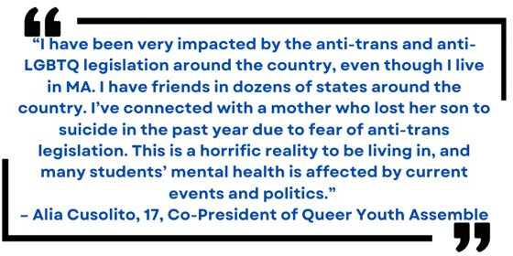
Elected officials in Massachusetts have a public health mandate to advance bills that defend LGBTQ youths’ rights and well-being. In their 2021 policy brief, Fenway Health urged candidates and officials not to forget that their actions have a life-changing impact on LGBTQ youth.⁸⁸ In January 2021, the Trevor Project found that 3 in 4 LGBTQ youth follow news about issues that affect
transgender people, 2 in 3 stated that debates about anti- transgender legislation have negatively impacted their mental health, and 3 in 5 felt afraid about the future. ⁸⁹ Meanwhile, affirming policy can promote LGBTQ youths’ mental health. School policy is one example: GLSEN found that students in schools with GSAs, positive curriculum about LGBTQ people, and
more supportive school staff had higher self-esteem and lower levels of depression and suicidal ideation than peers who lacked these key supports.⁹⁰

Suicide Prevention: Uplifting Queer Futures & Queer Joy

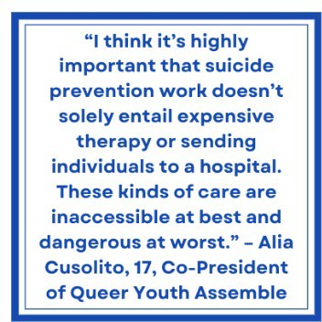
Despite the alarming suicidality rates among LGBTQ youth, there is still scarce research about how professionals can effectively support suicidal LGBTQ youth. However, it is broadly understood that anti-LGBTQ minority stress and trauma are linked to depression and PTSD, and these
disorders are linked to suicidal ideation. In 2022, the Trevor Project found that more than 1 in 3 youth had experienced physical threats or harm based on their identities, and youth who were victimized attempted suicide at over twice as often as peers who were not.⁹¹ Furthermore, hopelessness is a key ingredient for suicidality. ⁹² This is important because many of the recommendations in this report, like GSAs, summer camps, and activist programs, have been shown to increase hope. For instance, a recent study showed that GSAs foster hope by
helping youth discover and work toward their goals, leading to less symptoms of depression and anxiety by the end of the year.⁹³

How can service providers improve services for suicidal LGBTQ youth? One study from 2021 sought out youths’ insights. Participants shared that they were unaware that mental health resources already existed for them. They also wanted confidentiality for their suicidality and identities, clear visual signs of affirming attitudes, and emotional support from their caregivers about their identities.⁹⁴

Despite the lack of research about LGBTQ-specific professional mental health support, it is clear that LGBTQ youth suffer when they live in families, schools, communities, and a society that erases, debates, and threatens them. Suicide prevention includes professional mental healthcare, but it is not limited to it. Protective legislation, supportive school policies, mental health literacy initiatives, comprehensively funded MHP and youth worker positions and programs, intersectional and trauma-informed services, and all of the other interdisciplinary recommendations made in this report – these, too, are suicide prevention.
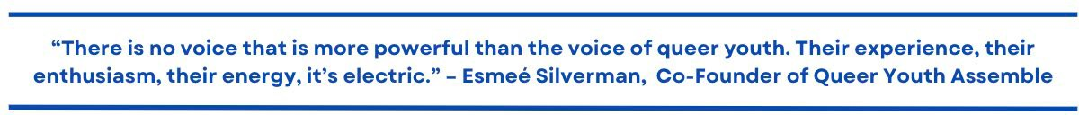

The above statement, made during the 2022 Massachusetts school walkout to protest anti-LGBTQ legislation in Florida and Texas, captures the spirit of resilience that LGBTQ youth cultivate in themselves and in one another. The power of youths’ interests, energy, and lived wisdom should never be underestimated. Although the statistics, the news, and the issues in this report may feel overwhelming, we remember that uncounted generations of LGBTQ people have always found ways to survive and thrive. This heritage is a cultural treasure that should be celebrated and drawn upon.

LGBTQ youth survive, heal, and thrive when they have supportive people as well as each other. Chosen family and peer support are resources to which LGBTQ people have always turned, and they continue to be effective interventions for mental health. On that note, even though LGBTQ youth face high levels of trauma and fear about the future, a wealth of research shows that factors like family acceptance, peer support, and relationships with supportive school staff can uplift youth mental health.⁹⁵ GLSEN found that when youth experienced discrimination or higher levels of in-person victimization, they were nearly twice as likely not to

have plans to attend college or trade school.⁹⁶ On the other hand, in schools with inclusive curricula, protective anti-discrimination policies, and GSAs, students had higher self-esteem, less depressive symptoms, and were more likely to aim to pursue higher education. Supportive people, especially adults, will always be vital members of support networks for LGBTQ youth.

The Trevor Project’s 2022 National Survey concluded with a list of sources of joy for LGBTQ youth, from therapy and medication to laws that protect LGBTQ rights; from all-gender restrooms to hope and excitement for the future; from music and dance to video games and cooking. The personal and political are inextricably intertwined in mental health. As long as prejudice is traumatizing, LGBTQ joy is healing – and everyone has a part to play.

Conclusion

This report is a clarion call for supporters of LGBTQ youth across Massachusetts to collaborate on trauma- informed, anti-oppressive, and systemic ways to support LGBTQ youth mental health. The majority of youth in the Commonwealth are struggling with depression and anxiety and are unable to receive mental healthcare when they want it. At the same time, we celebrate all youths’ lived wisdom and intersectional strengths in the face of the everyday minority stressors they face, whether at home, in school, or on the TV. From increasing funding for mental health professionals and peer support programs across every setting to reforming structural access to mental healthcare and empowering community members to support one another’s mental health, decision-makers of all kinds have the influence – and the public health mandate – to make life-affirming, life- saving change.

F. Acknowledgments & Citations

Acknowledgments: Max Tang, Social Work Fellow, lead researcher & author

1 Turban, Jack, Tony Ferraiolo, Andrés Martin, and Christy Olezeski. “Ten Things Transgender and Gender Nonconforming Youth Want Their Doctors to Know.” Journal of the American Academy of Child & Adolescent Psychiatry 56, no. 4 (April 2017): 275–77. https://doi.org/10.1016/j.jaac.2016.12.015.
2 The Trevor Project, “2022 National Survey on LGBTQ Youth Mental Health,” 2022, https://www.thetrevorproject.org/survey- 2022/assets/static/trevor01_2022survey_final.pdf.
3 The Trevor Project, “2022 National Survey on LGBTQ Youth Mental Health: Massachusetts,” 2022, https://www.thetrevorproject.org/wp-content/uploads/2022/12/The-Trevor-Project-2022-National-Survey-on-LGBTQ-Youth- Mental-Health-by-State-Massachusetts.pdf.
4 The Trevor Project, “2022 National Survey on LGBTQ Youth Mental Health: Massachusetts,” 2022, https://www.thetrevorproject.org/wp-content/uploads/2022/12/The-Trevor-Project-2022-National-Survey-on-LGBTQ-Youth- Mental-Health-by-State-Massachusetts.pdf.
5 The Trevor Project, “Trauma and Suicide Risk Among LGBTQ Youth,” July 28, 2022, https://www.thetrevorproject.org/research-briefs/trauma-and-suicide-risk-among-lgbtq-youth-july-2022/.
6 US Census Bureau. “Mental Health Struggles Higher Among LGBT Adults Than Non-LGBT Adults in All Age Groups.” Census.gov. Accessed March 20, 2023. https://www.census.gov/library/stories/2022/12/lgbt-adults-report-anxiety-depression- at-all-ages.html.
7 Human Rights Campaign. “Human Rights Campaign Working to Defeat 340 Anti-LGBTQ+ Bills at State Level Already, 150 of Which Target Transgender People – Highest Number on Record,” February 15, 2023. https://www.hrc.org/press-

releases/human-rights-campaign-working-to-defeat-340-anti-lgbtq-bills-at-state-level-already-150-of-which-target- transgender-people-highest-number-on-record.
8 The Trevor Project, “2022 National Survey on LGBTQ Youth Mental Health,” 2022, https://www.thetrevorproject.org/survey- 2022/assets/static/trevor01_2022survey_final.pdf.
9 The Trevor Project, “2022 National Survey on LGBTQ Youth Mental Health: Massachusetts,” 2022, https://www.thetrevorproject.org/wp-content/uploads/2022/12/The-Trevor-Project-2022-National-Survey-on-LGBTQ-Youth- Mental-Health-by-State-Massachusetts.pdf.
10 Frost, David M., Keren Lehavot, and Ilan H. Meyer. “Minority Stress and Physical Health among Sexual Minority Individuals.”
Journal of Behavioral Medicine 38, no. 1 (February 2015): 1–8. https://doi.org/10.1007/s10865-013-9523-8.
11 Hatzenbuehler, Mark L., Katie A. McLaughlin, Katherine M. Keyes, and Deborah S. Hasin. “The Impact of Institutional Discrimination on Psychiatric Disorders in Lesbian, Gay, and Bisexual Populations: A Prospective Study.” American Journal of Public Health 100, no. 3 (March 2010): 452–59. https://doi.org/10.2105/AJPH.2009.168815.
12 Hughto, Jaclyn M.W., David Pletta, Lily Gordon, Sean Cahill, Matthew J. Mimiaga, and Sari L. Reisner. “Negative Transgender- Related Media Messages Are Associated with Adverse Mental Health Outcomes in a Multistate Study of Transgender Adults.” LGBT Health 8, no. 1 (January 1, 2021): 32–41. https://doi.org/10.1089/lgbt.2020.0279.
13 Fulginiti, Anthony, Harmony Rhoades, Mary Rose Mamey, Cary Klemmer, Ankur Srivastava, Garrett Weskamp, and Jeremy T. Goldbach. “Sexual Minority Stress, Mental Health Symptoms, and Suicidality among LGBTQ Youth Accessing Crisis Services.” Journal of Youth and Adolescence 50, no. 5 (May 2021): 893–905. https://doi.org/10.1007/s10964-020-01354-3.
14 Hatzenbuehler, Mark L., Conall O’Cleirigh, Chris Grasso, Kenneth Mayer, Steven Safren, and Judith Bradford. “Effect of Same- Sex Marriage Laws on Health Care Use and Expenditures in Sexual Minority Men: A Quasi-Natural Experiment.” American Journal of Public Health 102, no. 2 (February 2012): 285–91. https://doi.org/10.2105/AJPH.2011.300382.
15 Levenson, Jill S., Shelley Craig, and Ashley Austin. 2021. “Trauma-Informed and Affirmative Mental Health Practices with LGBTQ+ Clients.” Psychological Services. https://lgbtqequity.org/wp-content/uploads/2021/06/Trauma-InformedCare-Final.pdf 16 Mittleman, Joel. “Sexual Minority Bullying and Mental Health From Early Childhood Through Adolescence.” Journal of Adolescent Health 64, no. 2 (February 2019): 172–78. https://doi.org/10.1016/j.jadohealth.2018.08.020.
17 Constance-Huggins, Monique. “Critical Race Theory in Social Work Education.” Critical Social Work 13, no. 2 (May 29, 2019). https://doi.org/10.22329/csw.v13i2.5861.
18 Kosciw, Joseph, Caitlin Clark, and Leesh Menard, “The 2021 National School Climate Survey: The Experiences of LGBTQ+ Youth in Our Nation’s Schools” (New York: Gay, Lesbian and Straight Education Network, 2022), https://www.glsen.org/sites/default/files/2022-10/NSCS-2021-Full-Report.pdf.
19 Castro-Ramirez, Franckie, Maha Al-Suwaidi, Pedro Garcia, Osiris Rankin, Jordyn R. Ricard, and Matthew K. Nock. “Racism and Poverty Are Barriers to the Treatment of Youth Mental Health Concerns.” Journal of Clinical Child & Adolescent Psychology 50, no. 4 (July 4, 2021): 534–46. https://doi.org/10.1080/15374416.2021.1941058.
20 Fadus, Matthew C., Kenneth R. Ginsburg, Kunmi Sobowale, Colleen A. Halliday-Boykins, Brittany E. Bryant, Kevin M. Gray, and Lindsay M. Squeglia. “Unconscious Bias and the Diagnosis of Disruptive Behavior Disorders and ADHD in African American and Hispanic Youth.” Academic Psychiatry 44, no. 1 (February 2020): 95–102. https://doi.org/10.1007/s40596-019-01127-6.
21 Pattisapu, Krishna. “The Necessity of Intentionally Closed Spaces for LGBTQ Youth of Color.” The Assembly: A Journal for Public Scholarship on Education 2. June 30, 2019. http://www.colorado.edu/journal/assembly/2019/06/30/necessity- intentionally-closed-spaces-lgbtq-youth-color.
22 Ching, Terence H. W., Sharon Y. Lee, Julia Chen, Rachel P. So, and Monnica T. Williams. “A Model of Intersectional Stress and Trauma in Asian American Sexual and Gender Minorities.” Psychology of Violence 8, no. 6 (November 2018): 657–68. https://doi.org/10.1037/vio0000204.
23 Hailey, Jamal, Whitney Burton, and Joyell Arscott. “We Are Family: Chosen and Created Families as a Protective Factor Against Racialized Trauma and Anti-LGBTQ Oppression Among African American Sexual and Gender Minority Youth.” Journal of GLBT Family Studies 16, no. 2 (March 2, 2020): 176–91. https://doi.org/10.1080/1550428X.2020.1724133.
24 Toomey, Russell B., Maura Shramko, Melissa Flores, and Karla Anhalt. “Family Socialization for Racism and Heterosexism: Experiences of Latinx Sexual Minority Adolescents and Young Adults.” Journal of Family Issues 39, no. 13 (September 2018): 3586–3611. https://doi.org/10.1177/0192513X18783807.
25 Kosciw, Joseph, Caitlin Clark, and Leesh Menard, “The 2021 National School Climate Survey: The Experiences of LGBTQ+ Youth in Our Nation’s Schools” (New York: Gay, Lesbian and Straight Education Network, 2022), https://www.glsen.org/sites/default/files/2022-10/NSCS-2021-Full-Report.pdf.
26 Prescott, Amy, Matthew Alcala, and Nadine Nakamura. “Structural Stigma and LGBTQ PoC Health.” In Heart, Brain and Mental Health Disparities for LGBTQ People of Color, edited by James J. García, 149–60. Cham: Springer International Publishing, 2021. https://doi.org/10.1007/978-3-030-70060-7_12.
27 Bacong, Adrian Matias, and Cecilia Menjívar. “Recasting the Immigrant Health Paradox Through Intersections of Legal Status and Race.” Journal of Immigrant and Minority Health 23, no. 5 (October 1, 2021): 1092–1104. https://doi.org/10.1007/s10903-
021-01162-2.

28 The Trevor Project. “The Trevor Project Research Brief: LGBTQ Youth from Immigrant Families,” April 2021. www.thetrevorproject.org/wp-content/uploads/2021/07/Trevor-Project-First-Generation-Research-Brief.pdf.
29 Munro, Lauren, Robb Travers, Alex St. John, Kate Klein, Heather Hunter, David Brennan, and Chavisa Brett. “A Bed of Roses?: Exploring the Experiences of LGBT Newcomer Youth Who Migrate to Toronto.” Edited by Dr Carol Mutch And Dr Jay Marlowe. Ethnicity and Inequalities in Health and Social Care 6, no. 4 (November 29, 2013): 137–50. https://doi.org/10.1108/EIHSC-09-
2013-0018.
30 McMillan, Cassie. “Tied Together: Adolescent Friendship Networks, Immigrant Status, and Health Outcomes.” Demography 56, no. 3 (June 1, 2019): 1075–1103. https://doi.org/10.1007/s13524-019-00770-w.
31 The Trevor Project, “2022 National Survey on LGBTQ Youth Mental Health,” 2022, https://www.thetrevorproject.org/survey- 2022/assets/static/trevor01_2022survey_final.pdf.
32 Ariana. “Roots Run Deep: How History and Culture Impact LGBT+ Acceptance in Asia,” December 29, 2020. www.arianalife.com/topics/lgbt/roots-run-deep-how-history-and-culture-impact-lgbt-acceptance-in-asia/.
33 Chau, Victoria, and Perry Chan. “One Size Does Not Fit All: Appreciating the Diversity of Asian Americans, Native Hawaiians, and Pacific Islanders (AANHPIs) and the Implications for Mental Health.” Substance Abuse and Mental Health Services Administration (SAMHSA) Blog (blog), May 25, 2021. www.samhsa.gov/blog/one-size-does-not-fit-all-appreciating-diversity- asian-americans-native-hawaiians-pacific.
34 Green, A.E., Price-Feeney, M. & Dorison, S. (2020). Breaking barriers to quality mental health care for LGBTQ Youth. New York, New York: The Trevor Project.
35 Martin, Naomi. “Schools Are Increasing Mental Health Support This Year, but Experts Fear It’s Still Not Enough.” The Boston Globe, September 6, 2021. https://www.bostonglobe.com/2021/09/06/metro/schools-are-increasing-mental-health-support- this-year-experts-fear-its-still-not-enough/.
36 Ahmed, Sawssan R., Maryam Kia-Keating, and Katherine H. Tsai. “A Structural Model of Racial Discrimination, Acculturative Stress, and Cultural Resources Among Arab American Adolescents.” American Journal of Community Psychology 48, no. 3–4 (December 2011): 181–92. https://doi.org/10.1007/s10464-011-9424-3.
37 Human Rights Campaign. “Understanding Disability in the LGBTQ+ Community.” Accessed March 5, 2023. https://www.hrc.org/resources/understanding-disabled-lgbtq-people.
38 Kallitsounaki, Aimilia, and David M. Williams. “Autism Spectrum Disorder and Gender Dysphoria/Incongruence. A Systematic Literature Review and Meta-Analysis.” Journal of Autism and Developmental Disorders, May 20, 2022. https://doi.org/10.1007/s10803-022-05517-y.
39 Kosciw, Joseph, Caitlin Clark, and Leesh Menard, “The 2021 National School Climate Survey: The Experiences of LGBTQ+ Youth in Our Nation’s Schools” (New York: Gay, Lesbian and Straight Education Network, 2022), https://www.glsen.org/sites/default/files/2022-10/NSCS-2021-Full-Report.pdf.
40 Miller, Ryan A., Sandra L. Dika, David J. Nguyen, Michael Woodford, and Kristen A. Renn. “LGBTQ+ College Students with Disabilities: Demographic Profile and Perceptions of Well-Being.” Journal of LGBT Youth 18, no. 1 (January 2, 2021): 60–77. https://doi.org/10.1080/19361653.2019.1706686.
41 Kattari, Shanna K., N. Eugene Walls, and Stephanie Rachel Speer. “Differences in Experiences of Discrimination in Accessing Social Services Among Transgender/Gender Nonconforming Individuals by (Dis)Ability.” Journal of Social Work in Disability & Rehabilitation 16, no. 2 (April 3, 2017): 116–40. https://doi.org/10.1080/1536710X.2017.1299661.
42 Rand, Joseph J., and Megan S. Paceley. “Exploring the Lived Experiences of Rural LGBTQ + Youth: Navigating Identity and Authenticity within School and Community Contexts.” Journal of Gay & Lesbian Social Services 34, no. 1 (January 2, 2022): 21–
39. https://doi.org/10.1080/10538720.2021.1911902.
43 Human Rights Campaign. “Understanding Disability in the LGBTQ+ Community.” Accessed March 5, 2023. https://www.hrc.org/resources/understanding-disabled-lgbtq-people.
44 “DYS Reports and Resources | Mass.Gov,” accessed March 1, 2023, https://www.mass.gov/service-details/dys-reports-and- resources.
45 Schaub, Jason, Willem J. Stander, and Paul Montgomery. “LGBTQ+ Young People’s Health and Well-Being Experiences in Out- of-Home Social Care: A Scoping Review.” Children and Youth Services Review 143 (December 2022): 106682. https://doi.org/10.1016/j.childyouth.2022.106682.
46 McCormick, Adam, Kathryn Schmidt, and Samuel Terrazas. “LGBTQ Youth in the Child Welfare System: An Overview of Research, Practice, and Policy.” Journal of Public Child Welfare 11, no. 1 (January 2017): 27–39. https://doi.org/10.1080/15548732.2016.1221368.
47 P. 170. Bochicchio, Lauren, Kelsey Reeder, Andre Ivanoff, Hunter Pope, and Ana Stefancic. “Psychotherapeutic Interventions for LGBTQ + Youth: A Systematic Review.” Journal of LGBT Youth 19, no. 2 (April 3, 2022): 152–79. https://doi.org/10.1080/19361653.2020.1766393.
48 Coulter, Robert W. S., James E. Egan, Suzanne Kinsky, M. Reuel Friedman, Kristen L. Eckstrand, Jessica Frankeberger, Barbara
L. Folb, et al. “Mental Health, Drug, and Violence Interventions for Sexual/Gender Minorities: A Systematic Review.” Pediatrics
144, no. 3 (September 1, 2019): e20183367. https://doi.org/10.1542/peds.2018-3367.

49 McCormick, Adam, Karey Scheyd, and Samuel Terrazas. “Trauma-Informed Care and LGBTQ Youth: Considerations for Advancing Practice With Youth With Trauma Experiences.” Families in Society: The Journal of Contemporary Social Services 99, no. 2 (April 2018): 160–69. https://doi.org/10.1177/1044389418768550.
50 Fish, Jessica N. “Future Directions in Understanding and Addressing Mental Health among LGBTQ Youth.” Journal of Clinical Child & Adolescent Psychology 49, no. 6 (November 1, 2020): 943–56. https://doi.org/10.1080/15374416.2020.1815207.
51 Tasnim, Samia, Nusrat Fahmida Trisha, Qiping Fan, Abida Sultana, Shayla Haque Mishu, Nishat Tasnim Hasan, and Md Mahbub Hossain. “Improving Mental Health and Wellbeing among Sexual and Gender Minorities Using Digital Interventions: A Systematic Review.” Preprint. PsyArXiv, February 5, 2020. https://doi.org/10.31234/osf.io/9wu42.
52 Iacovides, I., Samra, R., Lucassen, M., & Wallace, L. (2017). Game-based cognitive behavioural therapy (CBT) for sexual minority youth: Rainbow SPARX in the UK. Chi Play.
53 Craig, Shelley L., Gio Iacono, Ashley Austin, Andrew D. Eaton, Nelson Pang, Vivian W. Y. Leung, and Cressida J. Frey. “The Role of Facilitator Training in Intervention Delivery: Preparing Clinicians to Deliver AFFIRMative Group Cognitive Behavioral Therapy to Sexual and Gender Minority Youth.” Journal of Gay & Lesbian Social Services 33, no. 1 (January 2, 2021): 56–77. https://doi.org/10.1080/10538720.2020.1836704.
54 Iacono, Gio, Shelley L. Craig, Rachael Crowder, David J. Brennan, and Emily K. Loveland. “A Qualitative Study of the LGBTQ+ Youth Affirmative Mindfulness Program for Sexual and Gender Minority Youth.” Mindfulness 13, no. 1 (January 1, 2022): 222–
37. https://doi.org/10.1007/s12671-021-01787-2.
55 Rottnek, James P. “Affirming Solutions: Using Solution-Focused Brief Therapy With Transgender, Gender Nonconforming, and Gender Questioning Youth.” Journal of Systemic Therapies 39, no. 4 (December 2020): 13–28. https://doi.org/10.1521/jsyt.2020.39.4.13.
56 Westmacott, Robin, and Christopher Edmondstone. “Working with Transgender and Gender Diverse Clients in Emotion Focused Therapy: Targeting Minority Stress.” Person-Centered & Experiential Psychotherapies 19, no. 4 (October 1, 2020): 331–
49. https://doi.org/10.1080/14779757.2020.1717986.
57 Lange, Tiffany M. “Trans-Affirmative Narrative Exposure Therapy (TA-NET): A Therapeutic Approach for Targeting Minority Stress, Internalized Stigma, and Trauma Reactions among Gender Diverse Adults.” In Practice Innovations, 5:230–45, 2020. https://doi.org/10.1037/pri0000126.
58 Diamond, Gary M., Rotem Boruchovitz-Zamir, Ofir Nir-Gotlieb, Inbal Gat, Eran Bar-Kalifa, Priel-Yehoshua Fitoussi, and Shira Katz. “Attachment-based Family Therapy for Sexual and Gender Minority Young Adults and Their Nonaccepting Parents.” Family Process 61, no. 2 (June 2022): 530–48. https://doi.org/10.1111/famp.12770.
59 O’Neill, R., B. Gilea, and S. Fellenger. “Motivational Interviewing for Caregivers of LGBT Youth.” Journal of LGBT Youth 17, no. 3 (July 2, 2020): 315–30. https://doi.org/10.1080/19361653.2019.1591322.
60 The Trevor Project, “2022 National Survey on LGBTQ Youth Mental Health,” 2022, https://www.thetrevorproject.org/survey- 2022/assets/static/trevor01_2022survey_final.pdf.
61 Fish, Jessica N., Natasha D. Williams, Lauren B. McInroy, Megan S. Paceley, Rachel N. Edsall, Jackson Devadas, Sara Birnel Henderson, and Deborah S. Levine. “Q Chat Space: Assessing the Feasibility and Acceptability of an Internet-Based Support Program for LGBTQ Youth.” Prevention Science 23, no. 1 (January 1, 2022): 130–41. https://doi.org/10.1007/s11121-021-01291- y.
62 Poteat, V. Paul, Jerel P. Calzo, Hirokazu Yoshikawa, Arthur Lipkin, Christopher J. Ceccolini, Sarah B. Rosenbach, Michael D. O’Brien, Robert A. Marx, Gabriel R. Murchison, and Esther Burson. “Greater Engagement in Gender-Sexuality Alliances (GSAs) and GSA Characteristics Predict Youth Empowerment and Reduced Mental Health Concerns.” Child Development 91, no. 5 (September 2020): 1509–28. https://doi.org/10.1111/cdev.13345.
63 Truong, Nhan, Caitlin Clark, Sarah Rosenbach, and Joseph Kosciw. “The GSA Study: Results of National Surveys About Students’ and Advisors’ Experiences in Gender and Sexuality Alliance Clubs.” New York: Gay, Lesbian and Straight Education Network, 2021. https://www.glsen.org/sites/default/files/2021-12/GLSEN_ResearchInstitute_GSAStudy_12012021.pdf.
64 Wilkerson, J. Michael, Vanessa R. Schick, Kim A. Romijnders, Jessica Bauldry, Seyram A. Butame, and the Montrose Center. “Social Support, Depression, Self-Esteem, and Coping Among LGBTQ Adolescents Participating in Hatch Youth.” Health Promotion Practice 18, no. 3 (May 2017): 358–65. https://doi.org/10.1177/1524839916654461.
65 Centers for Disease Control and Prevention. “School Connectedness: Strategies for Increasing Protective Factors among Youth.” Atlanta: US Department of Health and Human Services, 2009. https://files.eric.ed.gov/fulltext/ED511993.pdf.
66 Gillig, Traci K., Lynn C. Miller, and Courtney M. Cox. “‘She Finally Smiles … for Real’: Reducing Depressive Symptoms and Bolstering Resilience Through a Camp Intervention for LGBTQ Youth.” Journal of Homosexuality 66, no. 3 (February 23, 2019): 368–88. https://doi.org/10.1080/00918369.2017.1411693.
67 Gillig, Traci K., and Leila Bighash. “Network and Proximity Effects on LGBTQ Youth’s Psychological Outcomes during a Camp Intervention.” Health Communication 38, no. 4 (March 21, 2023): 641–47. https://doi.org/10.1080/10410236.2021.1958983. 68 Weinhardt, Lance S., Linda M. Wesp, Hui Xie, Jennifer (Jen) Murray, Jeanette Martín, Sarah DeGeorge, Caleb B. Weinhardt,
Maren Hawkins, and Patricia Stevens. “Pride Camp: Pilot Study of an Intervention to Develop Resilience and Self-Esteem among LGBTQ Youth.” International Journal for Equity in Health 20, no. 1 (June 29, 2021): 150. https://doi.org/10.1186/s12939-021-
01488-1.
79 |

69 Craig, Shelley L., Andrew D. Eaton, Alexa Kirkland, Egag Egag, Rachael Pascoe, Kourteney King, and Sreedevi Krishnan. “Towards an Integrative Self: A Digital Photo Elicitation Study of Resilience among Key Marginalized Populations of Sexual and Gender Minority Youth.” International Journal of Qualitative Studies on Health and Well-Being 16, no. 1 (January 1, 2021): 1961572. https://doi.org/10.1080/17482631.2021.1961572.
70 ReScripted: A Program of the Center for Trauma & Embodiment at JRI. “ReScripted: Act. Embody. Empower.” Accessed January 16, 2023. https://www.rescriptedjri.org.
71 Zaccari, Belle, Athena D. F. Sherman, Sarah Febres-Cordero, Melinda Higgins, and Ursula Kelly. “Findings from a Pilot Study of Trauma Center Trauma-Sensitive Yoga versus Cognitive Processing Therapy for PTSD Related to Military Sexual Trauma among Women Veterans.” Complementary Therapies in Medicine 70 (November 1, 2022): 102850. https://doi.org/10.1016/j.ctim.2022.102850.
72 Trauma Informed Weight Lifting: A Project of the Center for Trauma & Embodiment at JRI. “Research.” Accessed January 16, 2023. https://www.traumainformedweightlifting.com/research.
73 Wagaman, M. Alex. “Promoting Empowerment Among LGBTQ Youth: A Social Justice Youth Development Approach.” Child and Adolescent Social Work Journal 33, no. 5 (October 1, 2016): 395–405. https://doi.org/10.1007/s10560-016-0435-7.
74 Matsuno, Emmie, and Tania Israel. “Psychological Interventions Promoting Resilience Among Transgender Individuals: Transgender Resilience Intervention Model (TRIM).” The Counseling Psychologist 46, no. 5 (July 2018): 632–55. https://doi.org/10.1177/0011000018787261.
75 Barcelos, Chris, j. nyla mcneil, Yanté Turner, and Edie Ma’iingan Redwine. “The Trans Youth Justice Project: A Political Education and Leadership Development Program.” Journal of LGBT Youth 20, no. 2 (April 3, 2023): 265–81. https://doi.org/10.1080/19361653.2021.2020703.
76 DeBlaere, Cirleen, Melanie E. Brewster, Kristin N. Bertsch, Aubrey L. DeCarlo, Karen A. Kegel, and Candice D. Presseau. “The Protective Power of Collective Action for Sexual Minority Women of Color: An Investigation of Multiple Discrimination Experiences and Psychological Distress.” Psychology of Women Quarterly 38, no. 1 (March 2014): 20–32. https://doi.org/10.1177/0361684313493252.
77 Strauss Swanson, Charlotte, and Dawn M Szymanski. “From Pain to Power: An Exploration of Activism, the #Metoo Movement, and Healing from Sexual Assault Trauma.” Journal of Counseling Psychology 67, no. 6 (November 1, 2020): 653–68. https://doi.org/10.1037/cou0000429.
78 Poteat, V. Paul, Jerel P. Calzo, Hirokazu Yoshikawa, Arthur Lipkin, Christopher J. Ceccolini, Sarah B. Rosenbach, Michael D. O’Brien, Robert A. Marx, Gabriel R. Murchison, and Esther Burson. “Greater Engagement in Gender-Sexuality Alliances (GSAs) and GSA Characteristics Predict Youth Empowerment and Reduced Mental Health Concerns.” Child Development 91, no. 5 (September 2020): 1509–28. https://doi.org/10.1111/cdev.13345.
79 Comerford, Jo. “Addressing Barriers to Care: What’s in the Legislature’s Final Mental Health Bill.” The People’s Blog (blog), August 3, 2022. https://senatorjocomerford.org/addressing-barriers-to-care-whats-in-the-legislatures-final-mental-health-bill/. 80 Mulqueen, Maggie. “Covid’s Mental Health Toll Makes Therapists Hard to Find. Insurance Companies Make It Harder.” NBC News, December 22, 2021, sec. Health & Technology. https://www.nbcnews.com/think/opinion/covid-s-mental-health-toll- makes-therapists-hard-find-insurance-ncna1286502.
81 Kazdin, Alan E. “Annual Research Review: Expanding Mental Health Services through Novel Models of Intervention Delivery.”
Journal of Child Psychology and Psychiatry 60, no. 4 (April 2019): 455–72. https://doi.org/10.1111/jcpp.12937.
82 Willging, Cathleen E., Tania Israel, David Ley, Elise M. Trott, Catherine DeMaria, Aaron Joplin, and Verida Smiley. “Coaching Mental Health Peer Advocates for Rural LGBTQ People.” Journal of Gay & Lesbian Mental Health 20, no. 3 (July 2, 2016): 214–
36. https://doi.org/10.1080/19359705.2016.1166469.
83 Noel, Lailea, Qi Chen, Liana J. Petruzzi, Farya Phillips, Ricardo Garay, Carmen Valdez, María P. Aranda, and Barbara Jones. “Interprofessional Collaboration between Social Workers and Community Health Workers to Address Health and Mental Health in the United States: A Systematised Review.” Health & Social Care in the Community 30, no. 6 (November 2022). https://doi.org/10.1111/hsc.14061.
84 Goldbach, Jeremy T., Harmony Rhoades, Joshua Rusow, and Peter Karys. “The Development of Proud & Empowered: An Intervention for Promoting LGBTQ Adolescent Mental Health.” Child Psychiatry & Human Development 54, no. 2 (April 1, 2023): 481–92. https://doi.org/10.1007/s10578-021-01250-2.
85 Jivanjee, Pauline, Leigh Grover, Kristin Thorp, Brie Masselli, Johanna Bergan, and Eileen M. Brennan. “Training Needs of Peer and Non-Peer Transition Service Providers: Results of a National Survey.” The Journal of Behavioral Health Services & Research 47, no. 1 (January 1, 2020): 4–20. https://doi.org/10.1007/s11414-019-09667-3.
86 Marsico, Kristen F., Cixin Wang, and Jia Li Liu. “Effectiveness of Youth Mental Health First Aid Training for Parents at School.”
Psychology in the Schools 59, no. 8 (August 2022): 1701–16. https://doi.org/10.1002/pits.22717.
87 Fish, Jessica N. “Future Directions in Understanding and Addressing Mental Health among LGBTQ Youth.” Journal of Clinical Child & Adolescent Psychology 49, no. 6 (November 1, 2020): 943–56. https://doi.org/10.1080/15374416.2020.1815207.
88 Richgels, Carrie, Sean Cahill, Julie Thompson, and Mason Dunn. “State Bills Restricting Access of Transgender Youth to Health Care, School Facilities, and School Athletics Threaten Health and Well-Being.” Fenway Health, 2021.
https://fenwayhealth.org/wp-content/uploads/Anti-trans-legislation-policy-brief-FINAL.pdf.

89 “Issues Impacting LGBTQ Youth: Polling Analysis.” The Trevor Project, January 2022. https://www.thetrevorproject.org/wp- content/uploads/2022/01/TrevorProject_Public1.pdf.
90 Kosciw, Joseph, Caitlin Clark, and Leesh Menard, “The 2021 National School Climate Survey: The Experiences of LGBTQ+ Youth in Our Nation’s Schools” (New York: Gay, Lesbian and Straight Education Network, 2022), https://www.glsen.org/sites/default/files/2022-10/NSCS-2021-Full-Report.pdf.
91 The Trevor Project. “Trauma and Suicide Risk Among LGBTQ Youth,” July 28, 2022. https://www.thetrevorproject.org/research-briefs/trauma-and-suicide-risk-among-lgbtq-youth-july-2022/.
92 Fulginiti, Anthony, Harmony Rhoades, Mary Rose Mamey, Cary Klemmer, Ankur Srivastava, Garrett Weskamp, and Jeremy T. Goldbach. “Sexual Minority Stress, Mental Health Symptoms, and Suicidality among LGBTQ Youth Accessing Crisis Services.” Journal of Youth and Adolescence 50, no. 5 (May 1, 2021): 893–905. https://doi.org/10.1007/s10964-020-01354-3.
93 Poteat, V. Paul, Jerel P. Calzo, Hirokazu Yoshikawa, Arthur Lipkin, Christopher J. Ceccolini, Sarah B. Rosenbach, Michael D. O’Brien, Robert A. Marx, Gabriel R. Murchison, and Esther Burson. “Greater Engagement in Gender-Sexuality Alliances (GSAs) and GSA Characteristics Predict Youth Empowerment and Reduced Mental Health Concerns.” Child Development 91, no. 5 (September 2020): 1509–28. https://doi.org/10.1111/cdev.13345.
94 Zullo, Lucas, Ilana Seager van Dyk, Elizabeth Ollen, Natalie Ramos, Joan Asarnow, and Jeanne Miranda. “Treatment Recommendations and Barriers to Care for Suicidal LGBTQ Youth: A Quality Improvement Study.” Evidence-Based Practice in Child and Adolescent Mental Health 6, no. 3 (July 3, 2021): 393–409. https://doi.org/10.1080/23794925.2021.1950079.
95 The Trevor Project. “Trauma and Suicide Risk Among LGBTQ Youth,” July 28, 2022. https://www.thetrevorproject.org/research-briefs/trauma-and-suicide-risk-among-lgbtq-youth-july-2022/.
96 Kosciw, Joseph, Caitlin Clark, and Leesh Menard, “The 2021 National School Climate Survey: The Experiences of LGBTQ+ Youth in Our Nation’s Schools” (New York: Gay, Lesbian and Straight Education Network, 2022), https://www.glsen.org/sites/default/files/2022-10/NSCS-2021-Full-Report.pdf.

COMMISSION ON LGBTQ YOUTH

MENTAL HEALTH: AN UPWARD TREND

ABOUT
The personal is political – and that includes mental health, too. Across the Commonwealth, LGBTQ youth mental health is in crisis. Last year, LGBTQ youth reported alarmingly high levels of depression, anxiety, suicidality, and trauma, yet most who wanted mental healthcare did not receive it.

1 IN 2
Massachusetts LGBTQ youth were unable to access mental healthcare

71%
Massachusetts LGBTQ youth experience anxiety
RECOMMENDATIONS

Fund more statewide research about mental health and suicide prevention treatment approaches for LGBTQ youth.

Promote services that address youths’ intersectional identities, including race, ethnicity, immigration, ability, involvement in juvenile justice or foster care, and rural residence.

Support reforms of the mental healthcare and health insurance systems.

11%
of Massachusetts LGBTQ youth attempted suicide in the past year


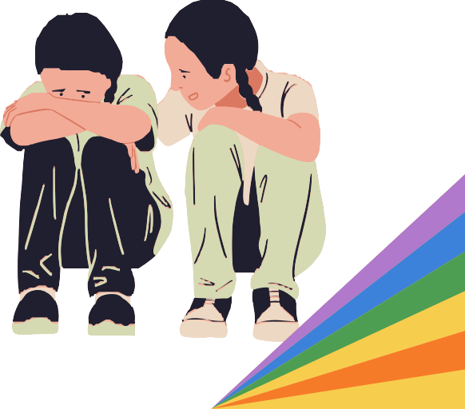

Addressing Pediatric Health

Introduction

The history of LGBTQ pediatric health is plagued by stigma, discrimination, and violence, and LGBTQ youth in the Commonwealth continue to face numerous challenges in accessing quality, culturally competent healthcare. It is imperative that the Commonwealth continue to address priority needs identified in subsequent sections of this report, while also taking on additional challenges identified in this section while prioritizing addressing the multiple forms of oppression often experienced by individuals in uniquely adverse situations.¹ The Commonwealth must address the social inequities that create health disparities amongst marginalized and underserved communities, focus on social determinants of health, and move away from an individualistic model of care. For the first time in recent years, the Commission dedicates this new health section to research and recommendations in the specific areas of pediatric health, or the health care of youth under 18.

FY 2024 Recommendations to the Governor and Legislature on Pediatric Health

Invest in access to culturally competent LGBTQ healthcare in rural and underserved communities.
The Commission recommends that the state continue to invest in and broaden access to affirming healthcare for LGBTQ youth across the state, particularly in rural and underserved communities. Given the national attacks against gender-affirming care, it is likely that Massachusetts will see a significant increase in out-of-state patients needing gender-affirming care services - with LGBTQ youth in Massachusetts already struggling to access facilities with long wait times or high costs, it is essential that Massachusetts invest in building capacity for LGBTQ healthcare across the state. Furthermore, the Commission recommends that the Commonwealth make a systemic investment in telehealth services and create parity in primary care telehealth insurance reimbursement.

Invest in substantial community-based, participatory, action-oriented research with non-white LGBTQ youth to better understand the needs of this population, and improve SOGIE data collection standards.
Comprehensive research on the needs of underserved youth is essential to better understand needs and gaps in service provision. The Commission urges decision-makers to invest in new community-based research and needs assessments that prioritizes the experiences of QTBIPOC youth, families, and providers across the state. Through this outreach, these partnerships can engage sustainable participation, and ultimately create long-lasting, community-driven interventions.²
The Commission further recommends that the state advance its SOGIE data collection practices to take a broader understanding of the disparities in healthcare. The lack of standardized data collection practices

has resulted in a failure to understand the impact of the pandemic among LGBTQ communities.³ More inclusive data collection, including inclusive electronic health records (EHRs), can be life-saving. ⁴ The Governor’s office can also learn from the recently released Federal Evidence Agenda on LGBTQ Equity that represents an important step forward in collecting SOGI data.⁵

Improve research on intersex youth communities, and prohibit non-consensual unnecessary medical interventions on minors.
There is a significant and concerning lack of information at the state level about the experiences of intersex youth in healthcare spaces. As some intersex youth identify with the LGBTQ community, the Commission urges the Commonwealth to increase its research efforts to better understand the unique needs of intersex youth. Additionally, the Commission strongly recommends that the state prohibit the non-consensual practices of performing medically unnecessary surgeries on intersex infants to reconstruct genitalia, except for when emergency intervention is necessary. By postponing non- consensual surgeries, minor patients are more able to fully participate in decision-making around their own bodies at a later date.⁶

Expand coverage of gender-affirming care and increase reimbursement to incentivize care.
There are multiple tenets of gender-affirming care; as defined by the World Health Organization, gender- affirming care includes social, psychological, behavioral, and medical interventions that affirm a patient’s gender identity and expression. Therefore, gender-affirming care coverage should include, though not be limited to, hair removal, voice therapy, and increased access to family-building services. Furthermore, the Commission recommends that the Commonwealth consider codifying the provisions of the 2021 DOI Bulletin ⁷ prohibiting discrimination in health insurance on the basis of gender identity and gender dysphoria, with the addition of a private right of action.

Dedicate funding to address intimidation and violence towards healthcare workers and healthcare centers.
Given the alarming rise in security threats against gender-affirming pediatric providers, including Boston Children’s Hospital, the Commission recommends that state agencies and organizations collaborate to establish clear and specific guidance for youth, families, and providers. The guidance should include what communities and facilities can do when threatened; a clear pathway for providers of LGBTQ health care to be protected by the state; and investigation and prosecution of those who engage in cyber-harassment or cyberterrorism.

Integrate gender-affirming health care into the modern health care environment, and combine with primary care, mental health, and community services.
As discussed throughout this section on pediatric health, access to gender-affirming care and capacity for existing facilities is limited, thus the state must examine ways to integrate gender-affirming health care into the modern health environment. The Commission recommends that, instead of being relegated to specialty clinics, pediatric providers and clinicians in all facilities should be trained to provide gender-

affirming care. In tandem with this, there must be more resources and education devoted to the pursuit of better care for neurodiverse individuals who are more likely to identify as LGBTQ. Furthermore, the Commission recommends that primary care, mental health, and community services be integrated under one roof, in line with the medical home model that many integrated LGBTQ health centers have begun to adopt. While much of the funding for LGBTQ health has been focused on STI screening, prevention, and treatment more can be done to focus on the holistic needs of the LGBTQ community. This includes hiring more diverse clinicians and investing in a trauma-informed work environment.

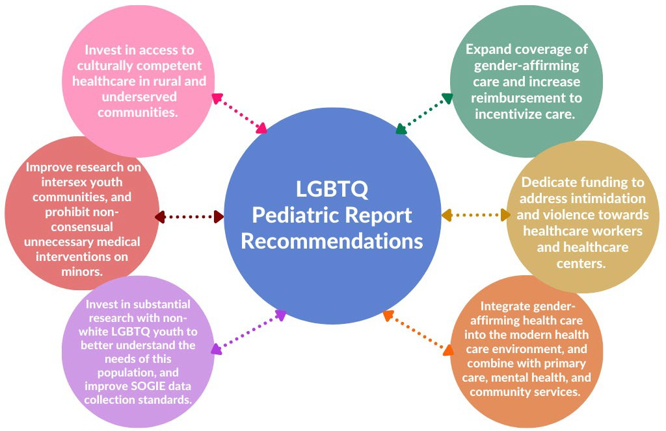

Research: Protecting LGBTQ Youth Pediatric Health

When strategizing and developing policies and programs to address health disparities for LGBTQ youth across the Commonwealth, it is essential to understand that the experiences of LGBTQ youth are shaped by the intersections of multiple aspects of their identities, and that addressing the issues they face requires a holistic and intersectional approach.
In particular, the experiences of youth in health care spaces can vary; QTBIPOC youth, intersex youth, youth with disabilities, and undocumented youth can often have differing experiences than may be experienced by their peers, impacting their overall well-being in Massachusetts. In particular, as discussed in depth throughout this annual report, QTBIPOC youth often face additional barriers and discrimination due to the intersections of their sexual orientation or gender identity with their race or ethnicity. Additionally, QTBIPOC over the age of 18 report experiencing higher rates of healthcare discrimination and increased difficulty accessing care,⁸ though there is little to no research examining this disparity in the pediatric populations.

LGBTQ youth with disabilities often experience greater health disparities than non-disabled LGBTQ youth, including higher rates of depressive symptoms and lowered self-esteem,⁹ or may face communication difficulties, or increased stigmatization and discrimination. For example, research has shown that gender dysphoria is significantly more common in children with autism spectrum disorder,¹⁰ and neurodivergent LGBTQ youth may experience difficulty in communicating with others, including their healthcare providers, about their gender identity.¹¹ Many youth who are able to communicate about their gender identity report not being believed due to their autism.¹²
Immigration status can also be an important aspect of intersectionality for LGBTQ youth, as they may face additional barriers and discrimination due to their status as immigrants or the children of immigrants. As highlighted in a subsequent section, undocumented youth in particular lack appropriate access to health insurance coverage, and may avoid health care facilities even when needed. Additionally, sexual minority immigrants are more likely than their heterosexual counterparts to report financial-related barriers to care and unmet mental health needs.¹³
Furthermore, LGBTQ youth experience unique challenges within the child welfare system, including a lack of placement options.¹⁴ Until 2021, the Massachusetts Department of Children and Families lacked a clear policy on gender-affirming care. Prior to this policy, many transgender youth in DCF’s care reported being denied access to providers to diagnose gender dysphoria, and experiencing delays in accessing gender- affirming care.¹⁵ It remains to be seen if these updated policies have succeeded in decreasing barriers to care in this vulnerable population, but, as discussed in the agency recommendations below, the Commission continues to work with DCF and youth in the child welfare system to better understand areas of improvement and success.
As discussed throughout this annual report, once in the child welfare system, youth face an increased risk of entering the juvenile justice system, known as the foster-care-to-prison pipeline.¹⁶ Nationally, a brief from the Center for American Progress found that gay and transgender youth are disproportionately represented in the juvenile justice system, and the majority of these youth are Black or Latino.¹⁷ This research showed that LGBTQ youth were more likely to experience factors that place youth at risk of entering the juvenile justice system, including family conflict, child abuse, and homelessness. Additionally, LGBTQ youth face the threat of being placed in restrictive settings due to their sexual orientation and gender identity. A 2009 study found that LGBTQ youth in the juvenile system experience difficulties accessing culturally competent mental healthcare,¹⁸ but little research has been done on the topic since. In Massachusetts, LGBTQ youth are reported to make up approximately 6% of youth in the Department of Youth Services’ custody, and DYS has enacted several policies over the years to better address and improve access to essential health care for youth in the juvenile justice system.
Many intersex youth also identify as

LGBTQ; ¹⁹ intersex refers to people who are born with a difference of sex development or variations of sex characteristics.²⁰ Unfortunately, research on intersex individuals is severely lacking, and research on intersex youth in
Intersex youth are often subject to non-consensual medical interventions to alter their genitalia as infants, a practice that is condemned by the United Nations, and closer to home, by the Massachusetts Medical Society.

pediatric spaces even more so. Existing research shows that many intersex youth face difficulty communicating with healthcare professionals about their specific needs²¹ and are often kept in the dark about their intersex status by providers and caregivers.²² As a result, many intersex individuals report high rates of healthcare avoidance and thus poorer physical and mental health outcomes. ²³ As discussed above, intersex youth are often subject to non-consensual medical interventions to alter their genitalia as infants,²⁴ a practice that is condemned by the United Nations,²⁵ and closer to home, by the Massachusetts Medical Society. ²⁶ Intersex youth are also more likely than non-intersex LGBTQ youth to report experiencing suicide ideation, and are also more likely to have undergone conversion therapy. ²⁷ Significantly more research needs to be done in this area to better understand the challenges experienced by this subgroup of youth.

Social Determinants of Health

The World Health Organization defines social determinants of health as non-medical factors that influence health outcomes.²⁸ These factors can include economic stability, education, geographical location, and discrimination and trauma. As members of marginalized and underserved communities, LGBTQ youth, particularly QTBIPOC youth, are more likely to experience health disparities linked to social determinants of health. For example, LGBTQ individuals on average experience higher rates of poverty than their cisgender counterparts.²⁹ This economic instability may in part be linked to high rates of homelessness among LGBTQ youth, which is often caused by running away or being kicked out of their homes due to caregiver rejection.³⁰ LGBTQ youth also report high levels of trauma exposure; in one study, 43% of LGBTQ youth reported experiencing multiple adverse childhood experiences (ACEs), and pansexual, transgender and gender nonconforming, American Indian/Native American, Latinx, and rural youth were more likely to report a higher number of ACEs.³¹

LGBTQ youth also face social stressors outside of the home. As discussed throughout this report, and particularly in the education section, LGBTQ youth who experience discrimination and bullying in schools are more likely to experience suicidal ideation, and physical, mental, and emotional health disparities.³² This is consistent with the minority stress model, which explains that minorities experience social stressors which accumulate over time, leading to poorer health outcomes.³³ However, education can typically serve as either a source of stress or a protective factor. In a recent study of LGBTQ students in Massachusetts, students reported experiencing verbal, social, and physical bullying, but school health professionals in turn reported a low awareness of this bullying.³⁴ In a separate study, LGBTQ students reported concerns related to the sexual violence against and harassment of transgender students, and racism directed towards students of color; students identified access to safe bathrooms, information on gender transition, and access to safe spaces as priorities. One example given of an existing safe space was the school nurse’s office, suggesting that school nurses may play a key role in addressing LGBTQ student health needs.³⁵

In addition to education, other socioeconomic factors can influence a child’s access to safe spaces and resources. Research has established an association between community size and resources for sexual and gender minority youth, with larger metropolitan areas having more resources. Conversely, LGBTQ youth

in suburban and rural areas expressed a need and desire for more spaces to socialize and meet other LGBTQ youth.³⁶ In particular, rural LGBTQ youth experience higher rates of depressive symptoms and PTSD compared to their urban peers due to heightened levels of minority stress.³⁷ Despite the clear need for competent health services, rural youth typically lack access to competent and affirming health care because of the general shortage of healthcare professionals in rural areas. This shortage is particularly acute for LGBTQ specialty services, which are often located in larger cities, an example clearly seen by the locations of LGBTQ organizations, programs, and services in Massachusetts.

One method for bridging this gap is telehealth, which has been shown to expand access to LGBTQ health in rural areas.³⁸ Telehealth has also proven to be a high-quality strategy for pediatric health access and can be delivered in nontraditional settings such as schools and community centers.³⁹ A study of rural parents of children with special health needs found that parents using telehealth were less likely to experience common barriers to health access, such as traveling over an hour for appointments or missing work.⁴⁰ A pediatric gender-affirming clinic reported that telehealth increased access to care during the COVID-19 pandemic, and that many patients continued to request telehealth appointments even after social distancing guidelines were relaxed.⁴¹ Despite concerns that telehealth could raise healthcare costs and claims by insurance companies that telehealth lowers costs, preliminary research shows that telehealth is cost-neutral in that it does not reduce operating costs.⁴²

Heath Care Access and Quality

Access to competent, culturally sensitive healthcare remains a pressing issue for LGBTQ youth.^{43,44} Many healthcare providers do not feel informed about the specific health needs of the LGBTQ community,⁴⁵ and report receiving little to no training on the topic of LGBTQ youth.⁴⁶ A 2021 from the Center for American Progress noted that, in the last year, one-third of transgender respondents reported having to teach their doctor about transgender people in order to receive adequate care.⁴⁷
In addition to primary care, LGBTQ youth also struggle to access critical mental health care. In 2016, the American Psychological Association reported that most states had less than half the necessary number of public psychiatry beds, and that only 21% of children and adolescents received necessary mental health care due to a lack of mental health facilities.⁴⁸ The report detailed youth waiting in emergency rooms until inpatient psychiatric beds become available, the shortage of psychiatric care for youth in general, and how these system deficits leave many youths untreated and families without help. Adding to the crisis, the demand for psychiatric beds increased sharply during the COVID-19 pandemic. ⁴⁹ This issue is especially pressing for LGBTQ youth, who are significantly more likely to attempt suicide than their heterosexual peers,⁵⁰ and transgender and intersex youth in particular, who face unique risk factors that lead to an increased risk of suicide.⁵¹
Despite the illegality of automatic, categorical exclusions of transgender care,⁵² many LGBTQ youth and caregivers report experiencing insurance exclusions when accessing care.⁵³ A 2019 Pennsylvania study found that 47% of surveyed insurance plans contained at least one transgender-specific exclusion policy, and 33% flagged or denied coverage based on gender markers.⁵⁴ More research needs to be done to

examine how LGBTQ youth in Massachusetts are being impacted, and what additional insurance barriers exist beyond exclusions, such as prior authorizations and denials.
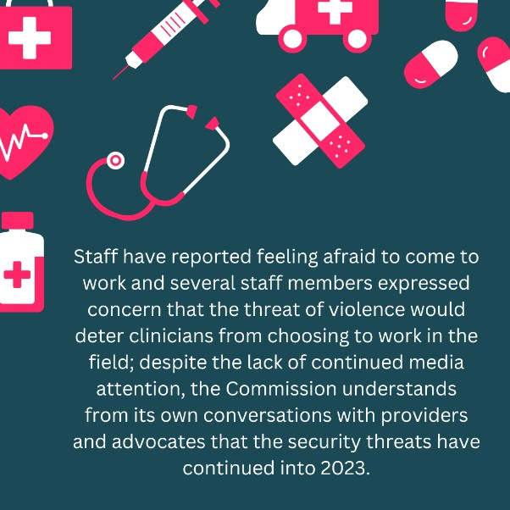
Further barriers in Massachusetts include safety in healthcare facilities. In the last year, security has emerged as a serious threat to pediatric gender-affirming care spaces. In August of 2022, Boston Children’s Hospital began receiving daily death threats, bomb threats, and hate mail as a result of a right-wing Twitter account that falsely accused the hospital of performing hysterectomies on children. ⁵⁵ Staff have reported feeling afraid to come to work and several staff members expressed concern that the threat of violence would deter clinicians from choosing to work in the field; despite the lack of continued media attention, the Commission understands from its own conversations with providers and advocates that the security threats have continued into 2023.
At every level - local, state, and federal - youth, families, educators, and providers have continued to endure online harassment and threats into 2023. As highlighted throughout this annual report, the rights of LGBTQ youth - particularly those who are BIPOC, trans and gender expansive - are under attack across the country, and even in Massachusetts. In 2022, at least 18 states considered or passed legislation banning gender-affirming care,⁵⁶ and lawmakers introduced 306 bills specifically targeting transgender communities, 86% of which focused on trans youth - 15% of those bills became law.⁵⁷ This trend has exploded into 2023; as of the end of April, 469 have been introduced targeting LGBTQ youth from prohibiting gender-affirming care to preventing teachings of gender, sexuality, and race in schools.⁵⁸
The constant barrage of attacks and anti-trans and anti-Black rhetoric has had profound implications for transgender and gender expansive youth and youth of color who are coming of age in an atmosphere of fear, anxiety, and violence. Many transgender and gender expansive youth, even in Massachusetts, report feeling concerned that their state or local areas will pass anti-transgender legislation, and this fear is linked to higher rates of depression, anxiety, and PTSD.⁵⁹ Exposure to debates surrounding anti-trans legislation has been linked to poor mental health in trans youth and crisis hotlines, like the Trevor Project, have reported a 150% increase in calls over the last year.⁶⁰
In 2022, Massachusetts Governor Charlie Baker signed a law defining the legality of and protections for gender-affirming care in Massachusetts; the law also protected providers and patients from legal action from other states.⁶¹ This is one of the most robust LGBTQ laws Massachusetts has passed to date, as it declares that gender-affirming care is legally protected healthcare, regardless of the patient's location. Certain states, like California, have gone further, introducing legislation to support transgender youth and families fleeing states with anti-transgender policies, laws, and pending legislation.⁶² The Commission strongly recommends that the Massachusetts legislature explore further legislation to protect LGBTQ youth and their families fleeing to Massachusetts, which has already begun to occur.

As highlighted above, despite gender-affirming care being a right in Massachusetts, patients continue to face barriers that include insurance exclusions, inconsistent coverage, wrongful denials of care, burdensome prior authorization processes, and low reimbursement rates leading to less economic incentive to provide this care.⁶³ Barriers for patients enrolled in MassHealth include many specific areas related to hair removal, surgery, and voice therapy - with many policies out of step with World Professional Association for Transgender Health (WPATH) Standards of Care.⁶⁴

Affirming Care Model

Gender-affirming care has been shown to be life-saving for children, reducing the incidence of suicidality and increasing access to healthcare services. Just as diabetes clinics were once separate and specialized clinics, so too does gender-affirming care remain largely isolated to specific clinics.⁶⁵ However, the history of gender-affirming care is one that is increasingly moving from urban academic institutions to mainstream primary care and medical home settings. Numbers of trans-competent or gender-affirming providers have been slowly but steadily increasing over time, particularly in states like Massachusetts.⁶⁶ Moreover, the vast majority of trans and gender expansive youth who socially transition do continue to identify in their affirmed gender.⁶⁷ Unfortunately, despite this increase in access, many barriers to care remain including financial access, insurance coverage, lack of availability, and individuals' fears. Many youth and caregivers also report systemic barriers including bias, discrimination, and lack of provider education.⁶⁸
An affirming-care-model is one that affirms the child and their identity, leading with listening to the patients’ and the family’s needs, and creating a team of support and guidance to provide information, options and clinical expertise. Importantly, an affirming model removes judgment and barriers to culturally sensitive care, meeting the individual where they are and delivering basic clinical competencies.⁶⁹ A 2021 study in New England conducted qualitative interviews with healthcare providers and transgender and gender nonconforming adults where community members emphasized the importance of integrated mental and physical health.⁷⁰

Moreover, if you are not counted, you will not count.

The lack of existing guidelines for collecting sexual orientation and gender identity (SOGI) data in the pediatric population remains a profound issue. Additionally, there are currently no standardized guidelines for the collection of intersex data. When SOGI and intersex data is not collected, policymakers, agencies, and organizations do not have a complete understanding of the patient population, limiting the ability of providers to deliver specialized care to LGBTQ individuals. Recent recommendations for collecting SOGI data published in New England take into consideration children’s developmental stages, the role of caregivers, and the need to protect the privacy of this information.⁷¹

Reproductive Health

Fertility preservation and family-building remain priority issues in the care of LGBTQ adolescents. Current guidelines for the care of transgender and gender-diverse adolescents and young adults recommend discussing potential fertility impairment and fertility preservation options with youth and their caregivers prior to the initiation of certain gender-affirming treatments. ⁷² , ⁷³ Despite this guidance, provider knowledge and referral practices vary widely, resulting in inconsistent experiences in fertility counseling.^{74,75} However, research has demonstrated that many transgender adults express a desire to have a child and are interested in biological parenthood.⁷⁶ Despite this, fertility preservation rates remain low among transgender youth; a 2017 review of medical records at a pediatric academic center found that only 2 out of 72 patients engaged in fertility preservation, even when counseling was offered.⁷⁷
Many barriers exist for transgender individuals who desire fertility preservation, including the cost of treatment, having to delay hormonal therapy, fear of invasive procedures, concern about the attitudes of
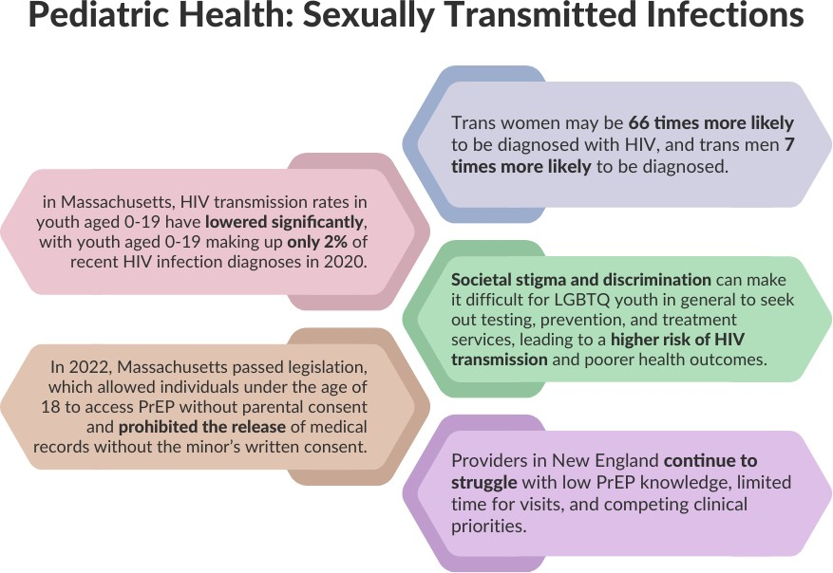
medical staff, and the unavailability of procedures locally.^{78,79,80} Additionally, the lack of insurance coverage for fertility preservation remains a major barrier.
LGBTQ young adults may not immediately see the possibility of building a family when they do not see themselves reflected in adults and family structures around them. When discussing family planning with LGBTQ youth and their caregivers, providers should discuss the various options
available, such as surrogacy, adoption, assisted reproduction, or co-parenting. Providers should also ensure that youth understand that testosterone is not a form of birth control, and that transgender men and nonbinary individuals may still become pregnant while on testosterone. This counseling is especially important since LGBTQ youth may be at an increased risk for teenage pregnancy.⁸¹

Sexually Transmitted Infections (STIs)

In a recent national 2021 HIV study of youth over 18, it is clear that the risk of HIV for LGBTQ youth is still much higher compared to their non-LGBTQ peers, especially among young gay and bisexual cisgender men and transgender women.⁸² Furthermore, trans women may be 66 times more likely to be diagnosed with HIV, and trans men 7 times more likely to be diagnosed. These disparities are likely due to a number of factors, including stigma and discrimination, lack of access to comprehensive sexual health education

and resources, and higher rates of risky behaviors such as unprotected sex and injection drug use. Fortunately, in Massachusetts, HIV transmission rates in youth aged 0-19 have lowered significantly, with youth aged 0-19 making up only 2% of recent HIV infection diagnoses in 2020.⁸³
Unfortunately, it is still important to note that societal stigma and discrimination can make it difficult for LGBTQ youth in general to seek out testing, prevention, and treatment services, leading to a higher risk of HIV transmission and poorer health outcomes. Many LGBTQ youth do not ask for sexual health information or discuss their sexual orientation with their provider because of a concern that the provider would disclose this information to their caregiver.⁸⁴ Privacy concerns also affect access to pre-exposure prophylaxis (PrEP) and post-exposure prophylaxis (PEP), which are HIV medications that reduce the risk of HIV transmission. LGBTQ youth face privacy risks when accessing PrEP, such as having an explanation of benefits sent to their caregiver, which could potentially out them before they are ready.⁸⁵
In 2022, Massachusetts passed legislation, fulfilling a previous recommendation from the Commission, which allowed individuals under the age of 18 to access PrEP without caregiver consent and prohibited the release of medical records related to PrEP without the minor’s written consent.⁸⁶ Despite this increase in access, there remains the risk of low adherence demonstrating the need for culturally tailored follow- up efforts and assistance with the structural barriers to health experienced by LGBTQ youth, especially young transgender women.⁸⁷ Moreover, providers in New England continue to struggle with low PrEP knowledge, limited time for visits, and competing clinical priorities.⁸⁸

COVID Pandemic

The ongoing COVID pandemic and containment measures, such as stay-at-home orders and remote learning, have exacerbated existing mental health disparities in the LGBTQ community. According to the Trevor Project, 70% of LGBTQ youth stated that their mental health was poor during the pandemic.⁸⁹ This was partially attributed to being confined in homes with families who were not aware or supportive of their gender identity. Research has shown that suicide and depression rates for LGBTQ youth with unsupportive family members are much higher than peers with supportive families.⁹⁰
COVID-19 also worsened existing socioeconomic stressors and caused disruptions in physical and mental health services.⁹¹ LGBTQ people, in general, are more likely to suffer from chronic conditions, substance abuse disorders, breast cancer, certain sexually transmitted diseases, and certain cancers.⁹² Many of these underlying conditions are associated with a high risk for severe COVID-19, which could further lead to hospitalization, intensive care, ventilation, or even death.⁹³ While the COVID vaccination mitigates some of the health-related risks, COVID has likely worsened pre-existing health disparities, identity-based discrimination, and inequitable access to care.⁹⁴

Acknowledgments & Citations

Acknowledgments: Dallas Ducar, lead researcher and author, Shannon Collins & Mel DeSilva, co-authors & researchers

1 Crenshaw, Kimberlé W. On Intersectionality: Essential Writings. The New Press, 2017.
2 Oaks, Laury, Tania Israel, Kristin J. Conover, Alise Cogger, and Todd Raymond Avellar. "Community-based participatory research with invisible, geographically-dispersed communities: Partnering with lesbian, gay, bisexual, transgender and queer communities on the California central coast." Journal for Social Action in Counseling & Psychology 11, no. 1 (2019): 14-32.
3 Sage, 2021, “A year into the pandemic, LGBTQ life and death remains largely invisible,” https://www.sageusa.org/news- posts/a-year-into-the-pandemic-lgbtq-life-and-death-remains-largely-invisible/
4 Comstock, 2019, “More inclusive EHRs can help extend welcome, save transgender lives,” https://www.healthcareitnews.com/news/more-inclusive-ehrs-can-help-extend-welcome-save-transgender-lives
5 FACT SHEET: Biden-Harris Administration Releases First-Ever Federal Evidence Agenda on LGBTQI+ Equity, January 24, 2023. https://www.whitehouse.gov/ostp/news-updates/2023/01/24/fact-sheet-biden-harris-administration-releases-first-ever- federal-evidence-agenda-on-lgbtqi-equity/
6 “Gender Incongruence and Transgender Health in the ICD,” accessed April 24, 2023, https://www.who.int/standards/classifications/frequently-asked-questions/gender-incongruence-and-transgender-health-in- the-icd.
7 Commonwealth of Massachusetts. “Continuing Applicability of Guidance Regarding Prohibited Discrimination on the Basis of Gender Identity or Gender Dysphoria Including Medically Necessary Gender-Affirming Care and Related Services.” 2021.
8 Kattari, Shanna K., N. Eugene Walls, Darren L. Whitfield, and Lisa Langenderfer-Magruder. 2015. “Racial and Ethnic Differences in Experiences of Discrimination in Accessing Health Services among Transgender People in the United States.” International Journal of Transgenderism 16 (2): 68–79. https://doi.org/10.1080/15532739.2015.1064336.
9 Argenyi MS, Mereish EH, Watson RJ. Mental and Physical Health Disparities Among Sexual and Gender Minority Adolescents Based on Disability Status. LGBT Health. 2022 Oct 26. doi: 10.1089/lgbt.2022.0032. Epub ahead of print. PMID: 36301253.
10 Hisle-Gorman E, Landis CA, Susi A, Schvey NA, Gorman GH, Nylund CM, Klein DA. Gender Dysphoria in Children with Autism Spectrum Disorder. LGBT Health. 2019 Apr;6(3):95-100. doi: 10.1089/lgbt.2018.0252. Epub 2019 Apr 2. PMID: 30920347.
11 Scott B. Greenspan, Samuel Carr, Ashley C. Woodman, Amy Cannava & Yena Li (2022) Identified protective factors to support psychological well-being among gender diverse autistic youth, Journal of LGBT Youth, DOI: 10.1080/19361653.2022.2119188
12 Strang, John F., Meredith D. Powers, Megan Knauss, Ely Sibarium, Scott F. Leibowitz, Lauren Kenworthy, Eleonora Sadikova, et al. 2018. “‘They Thought It Was an Obsession’: Trajectories and Perspectives of Autistic Transgender and Gender-Diverse Adolescents.” Journal of Autism and Developmental Disorders 48 (12): 4039–55. https://doi.org/10.1007/s10803-018-3723-6. 13 Gonzales, Gilbert, Reema Dedania, and Ryan Driscoll. 2018. “Health Insurance Coverage and Access to Care among US-Born and Foreign-Born Sexual Minorities.” Journal of Immigrant and Minority Health 21 (3): 540–48. https://doi.org/10.1007/s10903-018-0774-x.
14 Adam McCormick, Kathryn Schmidt & Samuel Terrazas (2017) LGBTQ Youth in the Child Welfare System: An Overview of Research, Practice, and Policy, Journal of Public Child Welfare, 11:1, 27-39, DOI: 10.1080/15548732.2016.1221368
15 “LGBTQ Youth in the Massachusetts Child Welfare System a Report on Pervasive Threats to Safety, Wellbeing, and Permanency Massachusetts Commission on Lesbian, Gay, Bisexual, Transgender, Queer, and Questioning Youth.” n.d. Accessed February 15, 2023. https://www.mass.gov/doc/commission-report-on-dcf/download.
16 Maschi, Tina, Schnavia Smith Hatcher, Craig S. Schwalbe, and Nancy Scotto Rosato. 2008. “Mapping the Social Service Pathways of Youth to and through the Juvenile Justice System: A Comprehensive Review.” Children and Youth Services Review 30 (12): 1376–85. https://doi.org/10.1016/j.childyouth.2008.04.006.
17Wilber, Shannaen. Lesbian, Gay, Bisexual and Transgender Youth in the Juvenile Justice System 11 (Annie E. Casey Foundation 2015)
https://assets.aecf.org/m/resourcedoc/AECF-lesbiangaybisexualandtransgenderyouthinjj-2015.pdf
18 Majd, Katayoon, Jody Marksamer, and Carolyn Reyes. "Hidden injustice: Lesbian, gay, bisexual and transgender youth in juvenile courts." (2016).
19 “The Mental Health and Well-Being of LGBTQ Youth Who Are Intersex.” n.d. https://www.thetrevorproject.org/wp- content/uploads/2021/12/Intersex-Youth-Mental-Health-Report.pdf.
20 Carpenter, Morgan. 2020. “The OHCHR Background Note on Human Rights Violations against Intersex People.” Sexual and Reproductive Health Matters 28 (1): 1731298. https://doi.org/10.1080/26410397.2020.1731298.
21 Callens, Nina, Baudewijntje P.C. Kreukels, and Tim C. van de Grift. 2021. “Young Voices: Sexual Health and Transition Care Needs in Adolescents with Intersex/Differences of Sex Development—a Pilot Study.” Journal of Pediatric and Adolescent Gynecology 34 (2): 176-189.e2.
22 Rosenwohl-Mack, Amy, Suegee Tamar-Mattis, Arlene B. Baratz, Katharine B. Dalke, Alesdair Ittelson, Kimberly Zieselman, and Jason D. Flatt. 2020. “A National Study on the Physical and Mental Health of Intersex Adults in the U.S.” Edited by Sergio A. Useche. PLOS ONE 15 (10): e0240088. https://doi.org/10.1371/journal.pone.0240088.
23 Medina, Caroline, and Lindsay Mahowald. 2021. “Key Issues Facing People with Intersex Traits.” Center for American Progress. October 26, 2021. https://www.americanprogress.org/article/key-issues-facing-people-intersex-traits/.
24 Ibid.

25 Carpenter, Morgan. 2020. “The OHCHR Background Note on Human Rights Violations against Intersex People.” Sexual and Reproductive Health Matters 28 (1): 1731298. https://doi.org/10.1080/26410397.2020.1731298.
26 “Massachusetts Medical Society: Oops!” n.d. Www.massmed.org. Accessed March 2, 2023. https://www.massmed.org/News/Press-Releases/Massachusetts-Medical-Society-announces-policies-on-opioid-use-disorder. 27 “The Mental Health and Well-Being of LGBTQ Youth Who Are Intersex.” n.d. https://www.thetrevorproject.org/wp- content/uploads/2021/12/Intersex-Youth-Mental-Health-Report.pdf.
28 World Health Organization. 2022. “Social Determinants of Health.” World Health Organisation. 2022. https://www.who.int/health-topics/social-determinants-of-health#tab=tab_1.
29 Badgett, M.V. Lee, Soon Kyu Choi, and Bianca D.M. Wilson. 2019. “LGBT Poverty in the United States.” Williams Institute. October 2019. https://williamsinstitute.law.ucla.edu/publications/lgbt-poverty-us/.
30 Corliss HL, Goodenow CS, Nichols L, Austin SB. High burden of homelessness among sexual-minority adolescents: findings from a representative Massachusetts high school sample. Am J Public Health. 2011 Sep;101(9):1683-9. doi: 10.2105/AJPH.2011.300155. Epub 2011 Jul 21. PMID: 21778481; PMCID: PMC3154237.
31 Craig SL, Austin A, Levenson J, Leung VWY, Eaton AD, D'Souza SA. Frequencies and patterns of adverse childhood events in LGBTQ youth. Child Abuse Negl. 2020 Sep;107:104623. doi: 10.1016/j.chiabu.2020.104623. Epub 2020 Jul 16. PMID: 32682145. 32 Almeida, J., Johnson, R.M., Corliss, H.L. et al. Emotional Distress Among LGBT Youth: The Influence of Perceived Discrimination Based on Sexual Orientation. J Youth Adolescence 38, 1001–1014 (2009). https://doi.org/10.1007/s10964-009- 9397-9
33 Meyer, Ilan H. 2003. “Prejudice, Social Stress, and Mental Health in Lesbian, Gay, and Bisexual Populations: Conceptual Issues and Research Evidence.” Psychological Bulletin 129 (5): 674–97. https://doi.org/10.1037/0033-2909.129.5.674.
34 Earnshaw, V. A., D. D. Menino, L. M. Sava, J. Perrotti, T. N. Barnes, D. L. Humphrey, and S. L. Reisner. “LGBTQ Bullying: A Qualitative Investigation of Student and School Health Professional Perspectives.” Journal of LGBT Youth 17, no. 3 (2019): 280–
97. https://doi.org/10.1080/19361653.2019.1653808.
35 Sava LM, Earnshaw VA, Menino DD, Perrotti J, Reisner SL. LGBTQ Student Health: A Mixed-Methods Study of Unmet Needs in Massachusetts Schools. J Sch Health. 2021 Nov;91(11):894-905. doi: 10.1111/josh.13082. Epub 2021 Sep 22. PMID: 34553384. 36 Paceley, Megan S., Jessica N. Fish, Aaron Conrad, and Nikolaus Schuetz. 2019. “Diverse Community Contexts and Community Resources for Sexual and Gender Minority Youth: A Mixed-Methods Study.” Journal of Community & Applied Social Psychology 29 (6): 445–60. https://doi.org/10.1002/casp.2417.
37 Goldbach JT, Parra LA, O'Brien RP, Rhoades H, Schrager SM. Explaining behavioral health differences in urban and rural sexual minority adolescents: A longitudinal investigation of minority stress in a diverse national sample of sexual minority adolescents: A longitudinal investigation of minority stress in a diverse national sample of sexual minority adolescents. J Rural Health. 2023 Jan;39(1):262-271. doi: 10.1111/jrh.12706. Epub 2022 Aug 17. PMID: 35977886; PMCID: PMC9771913.
38 Whaibeh, Emile, Hossam Mahmoud, and Emily L. Vogt. "Reducing the treatment gap for LGBT mental health needs: The potential of telepsychiatry." The journal of behavioral health services & research 47, no. 3 (2020): 424-431.
39 Marcin, James P., Ulfat Shaikh, and Robin H. Steinhorn. 2015. “Addressing Health Disparities in Rural Communities Using Telehealth.” Pediatric Research 79 (1-2): 169–76. https://doi.org/10.1038/pr.2015.192.
40 Marcin, J. P., J. Ellis, R. Mawis, E. Nagrampa, T. S. Nesbitt, and R. J. Dimand. 2003. “Using Telemedicine to Provide Pediatric Subspecialty Care to Children with Special Health Care Needs in an Underserved Rural Community.” PEDIATRICS 113 (1): 1–6. https://doi.org/10.1542/peds.113.1.1.
41 McGregor, Kerry, Coleen R Williams, Ariel Botta, Francie Mandel, and Jennifer Gentile. “Providing Essential Gender-Affirming Telehealth Services to Transgender Youth during COVID-19: A Service Review.” Journal of Telemedicine and Telecare 29, no. 2 (2022): 147–52. https://doi.org/10.1177/1357633x221095785.
42 Schoenberg, Shira. 2022. “Early Data Finds Telehealth Is Largely Cost Neutral.” CommonWealth Magazine. October 12, 2022. https://commonwealthmagazine.org/health-care/early-data-finds-telehealth-is-largely-cost-neutral/.
43 Gridley SJ, Crouch JM, Evans Y, Eng W, Antoon E, Lyapustina M, Schimmel-Bristow A, Woodward J, Dundon K, Schaff R, McCarty C, Ahrens K, Breland DJ. Youth and Caregiver Perspectives on Barriers to Gender-Affirming Health Care for Transgender Youth. J Adolesc Health. 2016 Sep;59(3):254-261. doi: 10.1016/j.jadohealth.2016.03.017. Epub 2016 May 24. PMID: 27235374. 44 Reisner, Sari & Benyishay, Matan & Stott, Brooke & Vedilago, Virginia & Almazan, Anthony & Keuroghlian, Alex. (2021).
Gender-Affirming Mental Health Care Access and Utilization Among Rural Transgender and Gender Diverse Adults in Five Northeastern U.S. States. Transgender Health. 7. 10.1089/trgh.2021.0010.
45 Nowaskie, Dustin Z., and John S. Sowinski. 2018. “Primary Care Providers’ Attitudes, Practices, and Knowledge in Treating LGBTQ Communities.” Journal of Homosexuality 66 (13): 1927–47. https://doi.org/10.1080/00918369.2018.1519304.
46 Vance, Stanley R., Bonnie L. Halpern-Felsher, and Stephen M. Rosenthal. 2015. “Health Care Providers’ Comfort with and Barriers to Care of Transgender Youth.” Journal of Adolescent Health 56 (2): 251–53. https://doi.org/10.1016/j.jadohealth.2014.11.002.
47 Medina, Caroline, Lindsay Mahowald, Thee Santos, and Sharita Gruberg. 2021. “Protecting and Advancing Health Care for Transgender Adult Communities.” Center for American Progress. August 18, 2021. https://www.americanprogress.org/article/protecting-advancing-health-care-transgender-adult-communities/.

48 American Psychological Association, Position Statement on Psychiatric Hospitalization of Children and Adolescents, accessed January 10 2023, https://www.psychiatry.org/File%20Library/About-APA/Organization-Documents-Policies/Policies/Position- 2016-Psychiatric-Hospitalization-of-Children-and-Adolescents.pdf
49 The Psychiatric Bed Crisis in the US: Understanding the Problem and Moving Towards Solutions. American Psychological Association, 2022. https://www.psychiatry.org/File%20Library/About-APA/Organization-Documents-Policies/Policies/Position- 2016-Psychiatric-Hospitalization-of-Children-and-Adolescents.pdf
50 Aranmolate, Rasaki, Danielle R. Bogan, Tiffany Hoard, and Anthony R. Mawson. "Suicide risk factors among LGBTQ youth."
JSM Schizophrenia 2, no. 2 (2017): 1011.
51 Haas, Ann P., Mickey Eliason, Vickie M. Mays, Robin M. Mathy, Susan D. Cochran, Anthony R. D’Augelli, Morton M. Silverman, et al. 2010. “Suicide and Suicide Risk in Lesbian, Gay, Bisexual, and Transgender Populations: Review and Recommendations.” Journal of Homosexuality 58 (1): 10–51. https://doi.org/10.1080/00918369.2011.534038.
52 “Know Your Rights: Health Care.” 2014. National Center for Transgender Equality. 2014. https://transequality.org/know-your- rights/health-care.
53 Gridley SJ, Crouch JM, Evans Y, Eng W, Antoon E, Lyapustina M, Schimmel-Bristow A, Woodward J, Dundon K, Schaff R, McCarty C, Ahrens K, Breland DJ. Youth and Caregiver Perspectives on Barriers to Gender-Affirming Health Care for Transgender Youth. J Adolesc Health. 2016 Sep;59(3):254-261. doi: 10.1016/j.jadohealth.2016.03.017. Epub 2016 May 24. PMID: 27235374. 54 Dowshen, Nadia L., Julie Christensen, and Siobhan M. Gruschow. 2019. “Health Insurance Coverage of Recommended
Gender-Affirming Health Care Services for Transgender Youth: Shopping Online for Coverage Information.” Transgender Health 4 (1): 131–35. https://doi.org/10.1089/trgh.2018.0055.
55 Jessica Bartlett. “Boston Children’s Faced Months of Death Threats and Hate Mail. Here’s How Staff Members Are Coping.” BostonGlobe.com. Accessed February 22, 2023. https://www.bostonglobe.com/2022/12/03/metro/boston-childrens-faced- months-death-threats-hate-mail-heres-how-staff-are-coping/?event=event12.
56 Stanton, Cady. n.d. “11 States Have Already Introduced Bills Targeting Transgender Health Care in 2023.” USA TODAY. https://www.usatoday.com/story/news/nation/2023/01/09/bills-targeting-transgender-healthcare-2023/11012864002/.
57 Nakajima, Koko, and Connie Hanzhang Jin. 2022. “Bills Targeting Trans Youth Are Growing More Common — and Radically Reshaping Lives.” NPR, November 28, 2022, sec. National. https://www.npr.org/2022/11/28/1138396067/transgender-youth- bills-trans-sports.
58 “Mapping Attacks on LGBTQ Rights in U.S. State Legislatures,” American Civil Liberties Union (blog), accessed April 24, 2023, https://www.aclu.org/legislative-attacks-on-lgbtq-rights.
59 Hughto, Jaclyn M. W., David J. Meyers, Matthew J. Mimiaga, Sari L. Reisner, and Sean Cahill. 2021. “Uncertainty and Confusion Regarding Transgender Non-Discrimination Policies: Implications for the Mental Health of Transgender Americans.” Sexuality Research and Social Policy, June. https://doi.org/10.1007/s13178-021-00602-w.
60 Weaver, Josh. “New Poll Illustrates the Impacts of Social & Political Issues on LGBTQ Youth,” The Trevor Project, January 10, 2022.
61 GLAD. 2022. “Advocates Praise MA Protection for Abortion, Gender-Affirming Care.” GLAD. August 1, 2022. https://www.glad.org/post/advocates-praise-ma-protection-for-abortion-gender-affirming-care/.
62 Twitter, Instagram, Email, and Facebook. 2022. “Newsom Signs Bill Protecting Transgender Youths and Families Fleeing Red- State Policies.” Los Angeles Times. September 30, 2022. https://www.latimes.com/california/story/2022-09-29/with-new-law- california-welcomes-out-of-state-transgender-youth.
63 Sl, Reisner, White Jm, and Dunham Ee. n.d. “Discrimination and Health in Massachusetts: A Statewide Survey of Transgender and Gender Nonconforming Adults.” https://fenwayhealth.org/documents/the-fenway-institute/policy-briefs/The-Fenway- Institute-MTPC-Project-VOICE-Report-July-2014.pdf.
64 Ibid.
65 Zajac, Jacek, Anil Shrestha, Parini Patel, and Leonid Poretsky. "The main events in the history of diabetes mellitus." Principles of diabetes mellitus (2010): 3-16.
66 Turban, Jack L., Dana King, Jeremi M. Carswell, and Alex S. Keuroghlian. "Pubertal suppression for transgender youth and risk of suicidal ideation." Pediatrics 145, no. 2 (2020).
67 Olson, Kristina R., Lily Durwood, Rachel Horton, Natalie M. Gallagher, and Aaron Devor. "Gender identity 5 years after social transition." Pediatrics 150, no. 2 (2022).
68 Puckett, Jae A., Peter Cleary, Kinton Rossman, Brian Mustanski, and Michael E. Newcomb. "Barriers to Gender-affirming care for transgender and gender nonconforming individuals." Sexuality Research and Social Policy 15 (2018): 48-59.
69 Ducar, Dallas. “Gender-affirming health care is simply good health care. The Boston Globe, July, 2022. https://www.bostonglobe.com/2022/07/04/opinion/gender-affirming-health-care-is-simply-good-health-care/
70 Loo, Stephanie, Anthony N. Almazan, Virginia Vedilago, Brooke Stott, Sari L. Reisner, and Alex S. Keuroghlian. 2021. “Understanding Community Member and Health Care Professional Perspectives on Gender-Affirming Care—a Qualitative Study.” Edited by Stefano Federici. PLOS ONE 16 (8): e0255568. https://doi.org/10.1371/journal.pone.0255568.

71 Goldhammer H, Grasso C, Katz-Wise SL, Thomson K, Gordon AR, Keuroghlian AS. Pediatric sexual orientation and gender identity data collection in the electronic health record. J Am Med Inform Assoc. 2022 Jun 14;29(7):1303-1309. doi: 10.1093/jamia/ocac048. PMID: 35396995; PMCID: PMC9196694.
72 Hembree, Wylie C., Peggy T. Cohen-Kettenis, Louis Gooren, Sabine E. Hannema, Walter J. Meyer, M. Hassan Murad, Stephen
M. Rosenthal, Joshua D. Safer, Vin Tangpricha, and Guy G. T’Sjoen. "Endocrine treatment of gender-dysphoric/gender- incongruent persons: an endocrine society clinical practice guideline." The Journal of Clinical Endocrinology & Metabolism 102, no. 11 (2017): 3869-3903.
73 Ethics Committee of the American Society for Reproductive Medicine. "Access to fertility services by transgender persons: an Ethics Committee opinion." Fertility and Sterility 104, no. 5 (2015): 1111-1115.
74 Chen, Diane, Victoria D. Kolbuck, Megan E. Sutter, Amy C. Tishelman, Gwendolyn P. Quinn, and Leena Nahata. "Knowledge, practice behaviors, and perceived barriers to fertility care among providers of transgender healthcare." Journal of Adolescent Health 64, no. 2 (2019): 226-234.
75 Chen, Diane, Moira A. Kyweluk, Afiya Sajwani, Elisa J. Gordon, Emilie K. Johnson, Courtney A. Finlayson, and Teresa K. Woodruff. "Factors affecting fertility decision-making among transgender adolescents and young adults." LGBT health 6, no. 3 (2019): 107-115.
76 Nahata, Leena, Diane Chen, Molly B. Moravek, Gwendolyn P. Quinn, Megan E. Sutter, Julia Taylor, Amy C. Tishelman, and Veronica Gomez-Lobo. 2019. “Understudied and Under-Reported: Fertility Issues in Transgender Youth—a Narrative Review.” The Journal of Pediatrics 205 (February): 265–71. https://doi.org/10.1016/j.jpeds.2018.09.009.
77 Nahata, Leena, Amy C. Tishelman, Nicole M. Caltabellotta, and Gwendolyn P. Quinn. 2017. “Low Fertility Preservation Utilization among Transgender Youth.” Journal of Adolescent Health 61 (1): 40–44. https://doi.org/10.1016/j.jadohealth.2016.12.012.
78 Vyas, Nina, Christopher R. Douglas, Christopher Mann, Amy K. Weimer, and Molly M. Quinn. 2020. “Access, Barriers, and Decisional Regret in Pursuit of Fertility Preservation among Transgender and Gender-Diverse Individuals.” Fertility and Sterility, December. https://doi.org/10.1016/j.fertnstert.2020.09.007.
79 Stolk, T. H. R., J. D. Asseler, J. A. F. Huirne, E. van den Boogaard, and N. M. van Mello. 2023. “Desire for Children and Fertility Preservation in Transgender and Gender-Diverse People: A Systematic Review.” Best Practice & Research Clinical Obstetrics & Gynaecology 87 (March): 102312. https://doi.org/10.1016/j.bpobgyn.2023.102312.
80 Rogers, Chloë, Mike Webberley, Roxana Mateescu, Yasmeen El Rakhawy, Anaïs Daly-Gourdialsing, and Helen Webberley. 2020. “A Retrospective Study of Positive and Negative Determinants of Gamete Storage in Transgender and Gender-Diverse Patients.” International Journal of Transgender Health 22 (1-2): 167–78. https://doi.org/10.1080/26895269.2020.1848693. 81 Lindley, Lisa L., and Katrina M. Walsemann. 2015. “Sexual Orientation and Risk of Pregnancy among New York City High- School Students.” American Journal of Public Health 105 (7): 1379–86. https://doi.org/10.2105/ajph.2015.302553.
82 Stutterheim, Sarah E., Mart van Dijk, Haoyi Wang, and Kai J. Jonas. "The worldwide burden of HIV in transgender individuals: an updated systematic review and meta-analysis." PLoS One 16, no. 12 (2021): e0260063.
83 Massachusetts Department of Public Health, Bureau of Infectious Disease and Laboratory Sciences. Massachusetts HIV Epidemiologic Profile, Statewide Report – Data as of 1/1/2022 https://www.mass.gov/lists/hivaids-epidemiologic-profiles. Published February 2022. Accessed March 2 2023.
84 Fisher, Celia B., Adam L. Fried, Margaret Desmond, Kathryn Macapagal, and Brian Mustanski. 2018. “Perceived Barriers to HIV Prevention Services for Transgender Youth.” LGBT Health 5 (6): 350–58. https://doi.org/10.1089/lgbt.2017.0098.
85 Seiler, Naomi. n.d. Review of Enhancing Medicaid Provider and Patient Engagement and Education to Deliver PrEP Intervention Services. AcademyHealth. Accessed January 10, 2023. https://academyhealth.org/sites/default/files/engagementmedicaidprep_issuebrief_may2019.pdf.
86 “PrEP for Minors in Massachusetts.” n.d. GLAD. https://www.glad.org/prep-for-minors-in- massachusetts/#:~:text=Massachusetts%20has%20a%20new%20law.
87 Connolly, Maureen D., Doreen N. Dankerlui, Tony Eljallad, Isadore Dodard-Friedman, Amy Tang, and Christine LM Joseph. "Outcomes of a PrEP Demonstration Project with LGBTQ Youth in a Community-Based Clinic Setting with Integrated Gender- Affirming Care." Transgender Health 5, no. 2 (2020): 75-79.
88 Valente, Pablo K., Jack C. Rusley, Don Operario, and Katie B. Biello. "Readiness to Provide Oral and Injectable PrEP for Sexual and Gender Minority Youth Among Healthcare Providers and Clinics in the US Northeast." Journal of Adolescent Health (2023). 89 The Trevor Project, “National Survey on LGBTQ Youth Mental Health 2021,” 2021, https://www.thetrevorproject.org/survey- 2021/?section=Introduction.
90 Andraska, Elizabeth Ann, Olamide Alabi, Chelsea Dorsey, Young Erben, Gabriela Velazquez, Camila Franco-Mesa, and Ulka Sachdev. 2021. “Health Care Disparities during the COVID-19 Pandemic.” Seminars in Vascular Surgery 34 (3). https://doi.org/10.1053/j.semvascsurg.2021.08.002.
91 Cameron K. Ormiston and Faustine Williams, “LGBTQ Youth Mental Health during COVID-19: Unmet Needs in Public health and Policy,” The Lancet 399 (2022): 501-503. https://doi.org/10.1016/S0140-6736(21)02872-5.
92 “LGBTQ Health Disparities,” Cigna, February 2017, https://www.cigna.com/individuals-families/health- wellness/lgbt- disparities.

93 “People with Certain Medical Conditions,” Center for Disease Control and Prevention, April 29, 2021, https://www.cdc.gov/coronavirus/2019-ncov/need-extra-precautions/people-with-medical-conditions.html. 94 M.V. Lee Badgett, Soon Kyu Choi, and Bianca D.M. Wilson, LGBT Poverty in the United States: A Study of
Differences between Sexual Orientation and Gender Identify Groups (Los Angeles: Williams Institute at UCLA School of Law, 2019), https://williamsinstitute.law.ucla.edu/wp-content/uploads/National-LGBT-Poverty-Oct-2019.pdf.

COMMISSION ON LGBTQ YOUTH

PEDIATRIC HEALTH

ABOUT
The history of LGBTQ pediatric health is plagued by stigma, harm, and discrimination. Across the Commonwealth, LGBTQ youth continue to face numerous challenges in accessing quality, culturally competent healthcare, including a lack of affordable and inclusive services.

It is imperative that the Commonwealth continue to address priority needs and work on centering intersectionality with an eye on the multiple forms of oppression often experienced by individuals in uniquely adverse situations. Importantly, intersectionality recognizes the intertwined, inequitable social systems that create disease and disparities.
RECOMMENDATIONS
Invest in access to culturally competent LGBTQ healthcare in rural and underserved communities.

Improve research on intersex youth communities, and prohibit non-consensual unnecessary medical interventions on minors.

Expand coverage of gender-affirming care and increase reimbursement to incentivize care.
LEGISLATION
S. 596/H.1037: Trans-Inclusive Health Care Access
33%
of insurance plans flag or deny converage based on gender markers

70%
of LGBTQ youth say their mental health was poor during the COVID-19 pandemic

469
Bills as of April 2023 target
LGBTQ youth across the nation, including banning gender- affirming health care

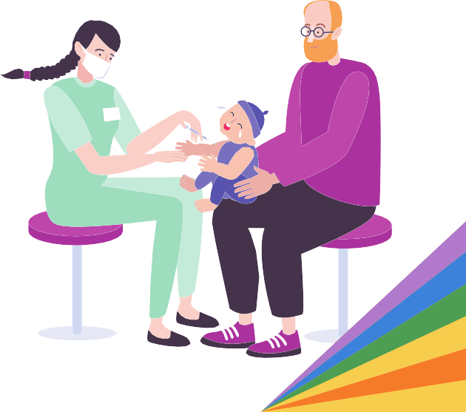

Broadening Pregnancy and Gynecological Health

Introduction

This report provides background information and literature regarding issues that fall under the umbrella of pregnancy and gynecological health related to LGBTQ youth. The information details healthcare services such as gender-affirming care, contraceptives, fertility treatments, and abortion discussed in relation to LGBTQ youth and the general LGBTQ population. Background on menstruation and pregnancy is detailed below to capture the inequities LGBTQ youth and the general LGBTQ population experience with these two biological functions. Maternal mortality is also a topic of discussion as there is a lack of universal data collection on maternal deaths for LGBTQ birthing people.

The second part of this report demonstrates Massachusetts’ efforts in expanding reproductive health care that could improve pregnancy and gynecological outcomes for LGBTQ youth and where some policies fall short. Healthcare coverage is an essential component that can provide LGBTQ youth patients access to healthcare providers and facilities. This is crucial for LGBTQ birthing people who need healthcare access during pregnancy and post-partum. LGBTQ youth may experience infertility due to hormone therapy or may not be able to conceive with a partner who is the same sex or has the same reproductive anatomy. Expanding access to fertility treatments for LGBTQ individuals assigned female at birth furthers reproductive rights for those who do not fall under the heteronormative ideals of what a “mother” or parent should be. For LGBTQ youth, doula services can provide a wide range of support whether it be for pregnancy-related reasons, abortion support, and even gender-affirming healthcare support. LGBTQ youth also deserve access to abortion care, birth control access, and access to menstrual products and the Commonwealth has the opportunity to further expand access through legislation.

FY 2024 Recommendations to the Governor and Legislature on Pregnancy & Gynecological Health

Improve SOGI data collection efforts across state services as it relates to pregnancy service needs and mortality rates.

As discussed throughout this section, there remains a critical lack of SOGI data collection as it relates to pregnancy and abortion services, as well as mortality rates for birthing people. Without this information, it is difficult to accurately capture the experiences of LGBTQ individuals across the state who seek reproductive health care. The Commission recommends that agencies explore ways to include SOGI data collection where appropriate to better understand the need for LGBTQ-inclusive health care in all areas.

Create and fund community birthing centers across the Commonwealth, and increase access to culturally competent doula services.

In a 2022 national poll from the American Association of Medical Colleges, 51% of LGBTQ birthing people reported that the quality of their birthing experiences was negatively impacted by bias or discrimination.¹

For many people, birthing centers provide a more comfortable space for people with low-risk pregnancies to give birth, especially for transgender or gender expansive people who may be more likely to face discrimination in a hospital setting. In Massachusetts, only one community birthing center currently exists
- Seven Sisters Midwifery & Community Birth Center - and, though the Commission is pleased to note that the center offers gender-affirming care, there remains a great need for more community birthing centers across the state. The Commission recommends that the Commonwealth invest in community birthing centers across the state to alleviate medical costs and health inequities for all birthing people across the state. The Commission urges the legislature to pass An Act Relative to Birthing Justice in the Commonwealth (S.1415), which would introduce a framework to better address health inequities faced by birthing people across the state.

Furthermore, the Commission urges legislators and agencies to expand access to affirming doula services across the Commonwealth. As discussed later in this section, doulas can alleviate health inequities and provide greater physical, emotional, and informational support for birthing people, particularly for Black LGBTQ birthing communities who face greater health risks, bias, or discrimination when birthing in hospital spaces. Additionally, the Commission recommends that the Commonwealth expand its approach to doula services, and consider investing in gender doulas to provide transition support for trans and gender expansive communities.

Expand LGBTQ cultural awareness, anti-bias, and racial equity trainings for public hospital providers and staff.

Given the alarming disparities and structural racism faced by Black birthing people in Massachusetts, the Commission strongly recommends that the Commonwealth explore the expansion of mandated trainings to reduce incidents of discrimination, bias, and racism faced by LGBTQ and BIPOC individuals across the state. Agencies should examine professional development practices where relevant in public hospitals and facilities to ensure that medical providers and staff are receiving frequent and mandatory opportunities for LGBTQ cultural awareness, anti-bias, and racial equity trainings.

Research: LGBTQ Youth and Healthcare Access

Pregnancy and gynecological healthcare have typically been framed as a heterosexual cisgender “women’s rights” issue, but many LGBTQ people such as lesbians, bisexual women, transgender men, Two-Spirit, intersex, nonbinary and gender nonconforming individuals use contraception, have the capacity to carry pregnancy, experience miscarriages, and choose to get abortions. While LGBTQ people often explore numerous paths to parenthood, this report focuses on the experiences of people with the capacity for pregnancy and need for affirming-gynecological care in the Massachusetts healthcare system.

Research has shown that LGBTQ people face systemic and individual barriers to accessing health care. ² LGBTQ individuals are more likely to be underinsured and uninsured, making cost a major barrier to accessing health care. This is especially true for transgender and nonbinary individuals. According to the 2015 U.S. Transgender Survey, a third of respondents could not afford healthcare services when they needed them; transgender people of color, including multiracial, American Indian, Black, and Latinx respondents were more likely to not have seen a healthcare provider in the past year due to cost.³ LGBTQ immigrants face multiple barriers to healthcare access due to their

citizenship status and sexual orientation or gender identity. In the U.S. it is estimated that 22% of the LGBTQ population is undocumented,⁴ though there is no current empirical data on the percentage of undocumented LGBTQ individuals in Massachusetts. Undocumented LGBTQ individuals may have an additional layer of difficulty when trying to access healthcare through Medicaid and other public programs, leading to not having unmet healthcare needs. Transgender adolescents and youth are further disadvantaged, as they might rely on their parents for insurance coverage. This could be problematic if their parents or guardians lack health care coverage due to economic reasons, or if their parents are unsupportive of their sexuality and gender identity, thus cutting off a trans youth’s access to insurance coverage.

Although the reproductive health care needs of LGBTQ individuals assigned female at birth are similar to cisgender, heterosexual individuals, LGBTQ people still have unique needs in regards to reproductive health care and face barriers when pursuing care.⁵ When actually attempting to access health care services, studies have shown that LGBTQ youth had negative experiences with primary health care providers.⁶ Discrimination, or the potential for discrimination in healthcare settings, deters LGBTQ individuals from seeking healthcare due to past experiences with being misgendered, mistreated for their sexuality or gender identity, or being denied healthcare services that are related to their gender transition. ⁷ Transmasculine youth of color have reported experiencing cissexism, heterosexism, and racism when accessing and utilizing reproductive health services, particularly gynecological health care.⁸ Studies have shown that primary care providers are less likely to discuss birth control with LGBTQ youth patients,⁹ thus showing how healthcare providers approach LGBTQ patients through a heteronormative lens and assuming that contraceptives are only necessary for people who engage in primarily heterosexual relations.

Gender-Affirming Health Care

Transgender, nonbinary, and gender-nonconforming patients who have retained their reproductive organs including the cervix, uterus, one or both fallopian tubes and/or ovaries require routine gynecological care. This includes standard sexual reproductive care such as contraception counseling, reproductive health education, breast, and gynecological cancer screenings, STI testing, and menstruation management. Breast exams are also part of gynecological care. For transmen and gender diverse patients who underwent top surgery to remove their breasts, they may still need chest exams as they could still be at risk for breast cancer. The LGBTQ community is not a monolithic population and youth within this community have different needs and experiences with accessing reproductive and sexual healthcare. All people who are capable of becoming pregnant, including queer women, transmasculine people, and nonbinary people may need full spectrum pregnancy care, family planning, and abortion care.

Intersex people also need gender-affirming health care. It is important to note that people born with variations in their sex characteristics may or may not identify as intersex or as part of the LGBTQ community, but their reproductive and gynecological healthcare needs may be similar to transgender and gender non-conforming patients in that they may have a gender identity that does not corresponded with the sex they were assigned at birth. Intersex patients also experience barriers when accessing gender affirming healthcare and reproductive healthcare based on the fact that they have sex characteristic variations that transcend typical notions of female and male bodies.¹⁰ Sex characteristic variations may occur in the chromosomes, external genitalia, gonads, hormone production, hormone responsiveness, internal reproductive organs, or any combination of these, among others. People born with variations of sex characteristics that do not fit the gender binary may be subjected to unnecessary medical procedures and surgeries without their consent, usually when they are children thus not being able to consent to these procedures. There is no evidence demonstrating the benefits of cosmetic surgeries and genital surgeries on intersex children.¹¹

A survey found that 6% of transgender and gender-diverse individuals residing in rural areas across five northeastern states, such as Connecticut, Massachusetts, New Hampshire, New York, and Vermont reported that there were no gender-affirming clinicians available where they accessed primary care. They also reported that they had to travel at least two hours for gender-affirming primary care.¹²

Menstruation

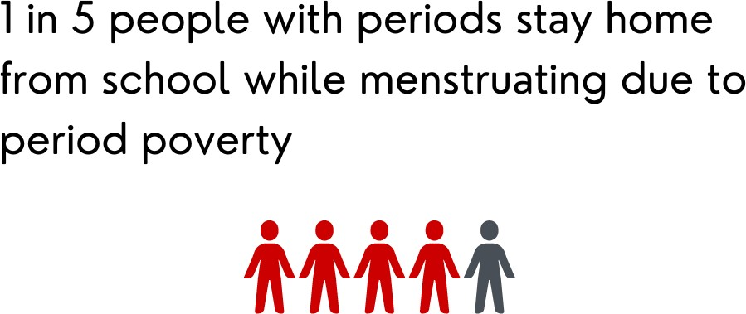
Transgender, non-binary and gender non-conforming individuals with female reproductive organs experience menstruation, which may lead to dysphoria for some transgender and non-binary folks.¹³ A recent study has shown that 93% of trans and nonbinary youth experience distress related to having their periods, and reported a desire for medical assistance to reduce or eliminate their periods. ¹⁴ Gender-affirming hormone therapy is a viable option for transgender youths who are interested in amenorrhea, or the cessation of menstruation.¹⁵ Although hormone therapy is an option, many LGBTQ youth may be too young or uninterested in taking testosterone, leaving the best menstrual care treatment for LGBTQ youth unclear. In the meantime, LGBTQ youth with menstrual cycles still need gynecological and sexual health treatment.

Along with healthcare access, LGBTQ youth need access to menstrual products. Period poverty refers to the phenomena of not being able to afford menstrual products such as pads, tampons, or liners to manage bleeding. It has been reported that 1 in 5 girls have stayed home from school while on their period and many youth in New Bedford and Southeastern Massachusetts are currently experiencing period poverty.¹⁶ Transgender populations are three times more likely to be unemployed and more than twice as likely to live in poverty compared to the general population, thus making transgender youth more likely to experience period poverty. Those who are disabled, people of color, or undocumented immigrants are especially likely to be unemployed and living in poverty.¹⁷ Even when menstrual products are free, transgender individuals may not be able to access them still. While menstrual products are sometimes available in women’s restrooms, they may not be available in men’s restrooms, making them inaccessible for menstruating individuals who feel comfortable using a men’s restroom. Homeless transmasculine individuals face similar barriers in men’s homeless shelters where virtually no menstrual products are provided.¹⁸ Access to menstrual products is also an issue in both women and men’s prisons, where transgender and nonbinary individuals might be incarcerated in either.

Contraceptives

Due to heteronormative social structures, the use of contraceptives, or birth control, has been culturally understood to be exclusively by cisgender women who have heterosexual relations with cisgender men to prevent pregnancy, despite the fact that there are a variety of health reasons why women would choose or need to be on birth control. These heteronormative cultural understandings of birth control exclude LGBTQ youth from discourse around contraceptives, which takes root in the medical system. Healthcare providers are less likely to discuss birth control options with LGBTQ youth patients. ¹⁹ LGBTQ youth patients deserve access to contraceptives and health care providers need to inform them of their options whether it be for pregnancy prevention, menstrual suppression or both; oral contraceptives, IUDs, contraceptive patches, vaginal rings, Depo injections, implants, and the emergency

contraceptive pills are viable options for LGBTQ youth, especially for transgender and gender diverse patients who were assigned female at birth. ²⁰ Access to contraceptives helps LGBTQ youth prevent pregnancy and manage menstruation, two biological functions that might cause distress and gender dysmorphia, as noted above.

Some transgender men and genderqueer youths assigned female at birth may lack sufficient knowledge around contraceptives and their reproductive capacity when undergoing testosterone therapy, which is why it is essential for LGBTQ youth to have access to LGBTQ-competent healthcare providers and facilities. Although testosterone reduces fertility, it is still possible for transgender individuals with female reproductive capacity on testosterone therapy to become pregnant. Existing misconceptions about testosterone as an effective contraceptive may lead transgender men and other individuals assigned female at birth to believe that they are infertile. Consequently, this can lead to unintended pregnancies in transgender men undergoing testosterone therapy. A study found that one- third of pregnancies for trans men were unplanned and that usage of contraceptives prior to pregnancy was lower for transgender individuals who were using testosterone gender affirming therapy compared to those who had not had testosterone.²¹

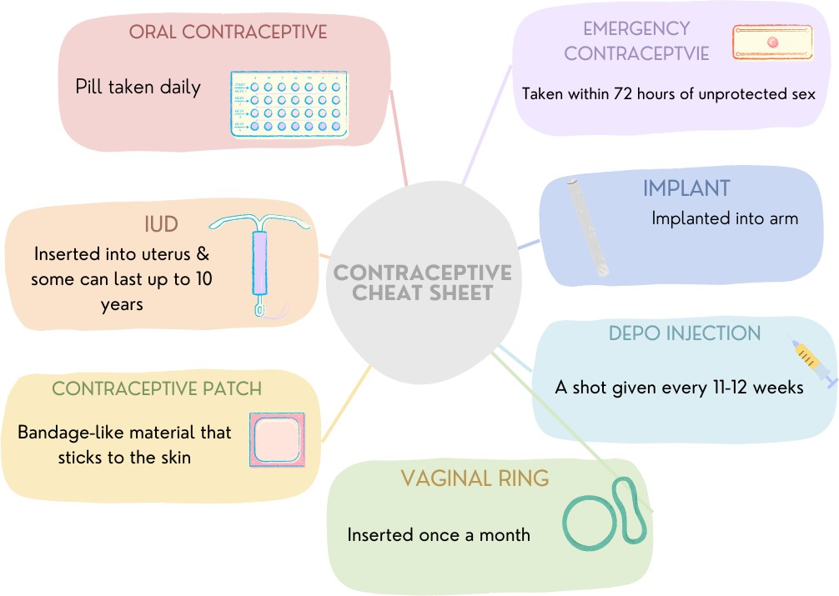
For transmen and other gender diverse patients assigned female at birth who desire birth control to either prevent pregnancy or to prompt the cessation of menstruation, it is important that they have access to contraceptive resources and consult with a healthcare provider on which forms of contraceptives are right for them, especially during testosterone gender affirming therapy. Progestin-only contraceptive methods, such as pills, IUDs, and implants do not interfere with testosterone. This may be a preferable method for patients due to progestin’s high rates of amenorrhea and potential for masculinizing effects. ²² Another type of hormonal birth control is combined hormonal contraceptives (CHC), which includes pills, patches, and vaginal rings. However, there is a
lack of evidence on whether the estrogen in CHCs may or may not interfere with testosterone for transgender men. Though transgender male patients can choose CHCs, some may not prefer this method due to concerns about having estrogen in their system and for potential feminizing traits to appear.²³

Non-hormonal contraceptives, such as the copper IUD, does not interfere with testosterone, but there are risks of bleeding, both insertion and menstrual bleeding, which may not be ideal for transgender men and nonbinary patients experiencing gender dysmorphia.²⁴ However, some transmasculine patients elect to have an IUD because they may prefer not to take birth control pills daily as this task can be associated with cisgender women.²⁵ LGBTQ- focused healthcare providers should be equipped with this medical information and familiarize themselves with the nuances of the reproductive healthcare needs of LGBTQ youth in order to empower their transgender and nonbinary patients when considering birth control options while going through gender-affirming hormone therapy. There is currently no evidence-based guidelines to draw from in offering contraception to transmasculine individuals who are on hormone-based therapy and typically, empirical assumptions have been that all contraception available to

cisgender women are all viable options for transgender and nonbinary patients.²⁶ More research is needed on the interactions and effects between contraceptives containing estrogen and testosterone therapy.

Fertility Preservation

Counseling on fertility and reproductive options is recommended prior to the initiation of puberty blockers or gender-affirming hormones for transgender youth. Studies have shown that around half of transgender adults wished to have children, and more than a third of transmasculine adults and half of transfeminine adults report they would have considered preserving reproductive gametes had this been an available option for them.²⁷ Although fertility preservation services are routinely offered, reports have shown that only between 0%-2% of transmasculine youth and 8%-14% of transfeminine youth complete fertility preservations prior to starting gender-affirming medical treatment.²⁸ There are numerous factors that pose barriers to transgender youth receiving fertility preservation services, including dysphoria related to fertility preservation procedures, invasiveness of procedures, cost, lack of coverage of these services by insurance, concerns about delaying or pausing gender-affirming care to undergo fertility preservation, and lack of affirming providers and facilities that offer fertility preservation.²⁹

Pregnancy

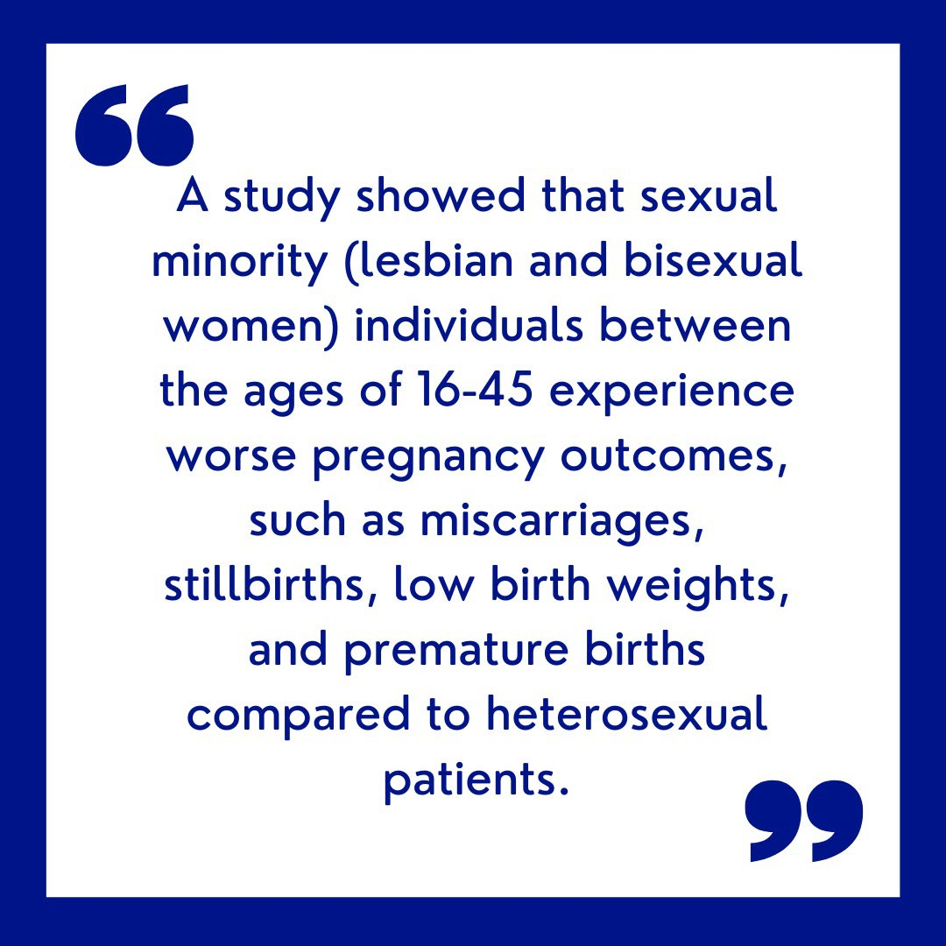
Due to heteronormative societal structures, LGBTQ youth may feel pressured to conform to such standards by having sexual intercourse to prove they are heterosexual, thus increasing the risk of pregnancy. LGBTQ individuals under the age of 20 are more likely to experience an unintended pregnancy, especially a teen pregnancy, compared to their heterosexual counterparts. ³⁰ This is alarming, especially for LGBTQ youth in Massachusetts high schools who have a higher percentage of experiencing sexual assault compared to their non- LGBTQ peers.³¹ Furthermore, one study showed that sexual minority (lesbian and bisexual women) individuals between the ages of 16-45 experience worse pregnancy outcomes, such as miscarriages, stillbirths, low birth weights, and premature births compared to heterosexual patients. ³² At the intersection of race, ethnicity, and sexual identity, Black and Latina lesbian and bisexual women have an additional risk for adverse birth outcomes.³³ Data is currently limited regarding the pregnancy outcomes of transgender birthing people.

Transgender men and nonbinary individuals who have transitioned hormonally and are taking testosterone but retain their female reproductive organs have the potential to become pregnant. Since the United States has been tracking pregnant people as female, there is a lack of data on how many transgender men and nonbinary people give birth each year. A report on pregnancy in transgender men found that pregnant transmasculine individuals who were previously on testosterone therapy preferred to have elective cesarean as the mode of delivery to lessen dysphoria.³⁴A Rutgers University study shows that pregnant transgender men are at risk for depression.³⁵ This is alarming since transgender individuals are at higher risk for suicide compared to the general population in the United States.³⁶ Just as a cisgender woman is at risk for postpartum depression, transmasculine patients who give birth are also at risk for postpartum depression.

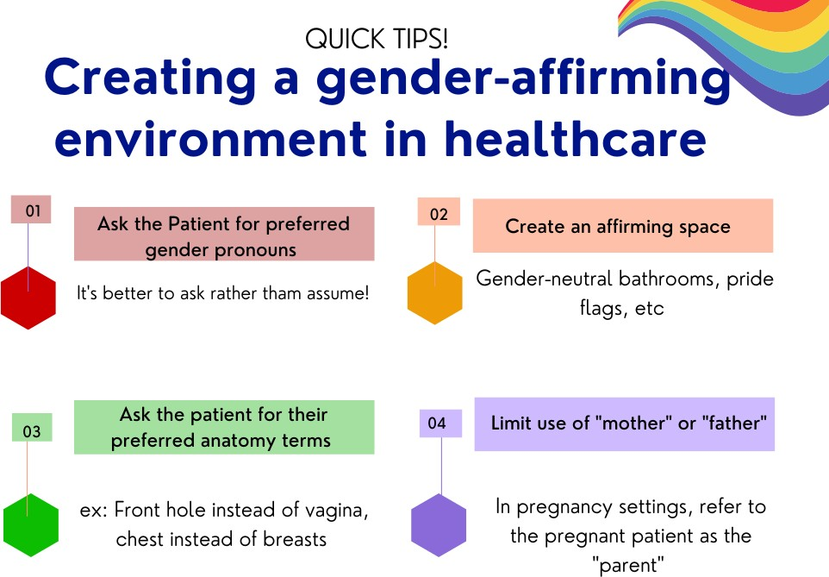
A study that interviewed 22 healthcare providers demonstrated that they typically advised transgender patients to discontinue testosterone therapy either six months before trying to get pregnant or immediately after finding out about the pregnancy; they also advised withholding hormone therapy during chestfeeding. These guidelines are advised to pregnant transmen and nonbinary patients out of concern that testosterone will cause excess androgen exposure to the fetus. The same study interviewed 70 transgender and nonbinary people who were pregnant or were intending to be pregnant; they reported that they felt like they had to choose between their mental health or the well-being of their child when making decisions about pausing hormone therapy during pregnancy. There is inadequate empirical evidence guiding the practice of pausing testosterone therapy for pregnant transmen and gender-diverse patients. Most of the existing medical research on the effects of excess androgen exposure to the fetus focuses on pregnant people with polycystic ovary syndrome whose testosterone levels fall between those of cisgender women and cisgender men.³⁷ More research on various dosages of testosterone may affect all stages of pregnancy and chestfeeding and is needed
to further expand better pregnancy and birthing outcomes for transgender and nonbinary birthing people. It’s important for healthcare providers to understand how gendered expectations and heteronormative ideals of birthing could elicit gender dysmorphia, depression, and distress for birthing transgender people even if they desired pregnancy from the beginning.

Fertility Treatments

The World Health Organization defines “infertility” as a disease of the male and female reproductive system defined by the
failure to achieve pregnancy after 12 months of or more of regular unprotected sexual intercourse.³⁸ This physical understanding of “infertility” does not capture the experience of most LGBTQ individuals; for some LGBTQ individuals, they are not biologically infertile yet cannot become pregnant. For example, a lesbian assigned female at birth could have the reproductive capabilities of becoming pregnant but they cannot get pregnant by their partner who is also female assigned at birth. Biologically, this couple cannot conceive together through sexual intercourse. Medically, the language around fertility assumes heterosexuality. Many LGBTQ individuals make their own choice in going through pregnancy, often seeking fertility treatments to achieve pregnancy,³⁹ although disparities in access to fertility treatments exist along the lines of race, ethnicity, education, class, gender identity, and sexual orientation.⁴⁰ Even when living in states with mandated insurance coverage for fertility treatments, racial and socioeconomic disparities exist among fertility patients accessing care. ⁴¹ As discussed further below, infertility for the LGBTQ community is usually the inability to be able to afford fertility treatments to get pregnant, whereas heterosexual families are more likely to afford fertility treatments through tax loopholes.

Maternal Mortality

In recent years, the United States has seen an increase in maternal mortality by 26.6%, from 18.8 in 2000 to 23.8 in 2014.⁴² States vary in degrees of disparity due to the availability of programs and policies for pregnant people. For Massachusetts, the maternal mortality rate is 8.4 per 100,000 births, making it the state with the second lowest maternal mortality rate.⁴³ Although maternal deaths are low in Massachusetts, racial, ethnic, age and insurance

disparities remain. A report from the Massachusetts Department of Public Health showed that Black women were approximately twice as likely as white women to experience pregnancy-associated mortality, with a large percentage of these deaths reported to be preventable.⁴⁴ At the intersection of race, Black women with pregnancy-related conditions such as preeclampsia, eclampsia, placental abruption, placenta previa, and postpartum hemorrhage, who gave birth are four times more likely to die than white women who gave birth. Alarmingly, Black pregnant people do not show a higher significance of pregnancy-related medical conditions but were more likely to die from these conditions than white pregnant people with the same pregnancy-related conditions.⁴⁵ The lack of universal data collection on the gender identity and sexuality of pregnant people makes it difficult to know the extent of pregnancy associated-deaths in LGBTQ populations.

Abortion

In 1973, the Supreme Court had constitutionally ruled the right to an abortion in Roe v. Wade, until the ruling was reversed in the summer of 2022. At the time before the overturning, the federal Medicaid program covered the cost of an abortion. The Hyde Amendment, which prohibits Medicaid funding for abortion services, was passed and implemented in the Medicare funding bill in 1976. As a result, this affects LGBTQ individuals who already experience access disparities for healthcare services due to a lack of insurance coverage or being underinsured. A 2018 survey by the Center for American Progress found that 20% of LGBTQ people reported receiving Medicaid benefits compared to 12.9% of non-LGBTQ people. LGBTQ people of color reported receiving Medicaid benefits at the rate of 24% compared to 18.8% of white LGBTQ people; and 21.4% of transgender people reported that they or their family received Medicaid benefits, compared to 13.4% of cisgender people. Additionally, LGBTQ individuals with disabilities reported receiving Medicaid benefits at a rate of 44.4%, as compared to 11.8% of non-disabled LGBTQ people.⁴⁶

LGBTQ people who receive Medicaid may experience cost barriers when seeking abortion services, especially since LGBTQ individuals under the age of 20 are more likely to have an abortion compared to their heterosexual counterparts.⁴⁷ A 2017 study showed that an estimated number of 462 to 530 transgender and nonbinary individuals obtained abortion care services, but only 23% of those clinics provided transgender-specific care. ⁴⁸ The recent overturn of Roe v. Wade may add another layer of inaccessibility to abortion care services for LGBTQ youth, particularly in more conservative states and rural areas. According to a recent survey by the Trevor Project, over 65% of LGBTQ youth expressed that abortion restrictions and bans heighten their feelings of stress and anxiety.⁴⁹

Although Massachusetts tends to have progressive views and policies on abortion rights, certain regions in the state lack access to routine abortion care providers, making it difficult to schedule an appointment for an abortion; these areas include Cape Cod, Martha’s Vineyard, Plymouth County, and the entire South Coast, which includes two major gateway cities, New Bedford and Fall River, home to a million residents and numerous hospitals and medical centers. There are also limited abortion providers in Western Massachusetts and although populations are low and dispersed, there is still a huge travel distance between residents and abortion services.⁵⁰ Abortions are not illegal in these areas but many hospitals and medical providers are not required to provide routine abortion services. Instead they are expected to perform an abortion if necessary, such as when the pregnant person is in a medical emergency and the medical provider needs to perform an abortion to stabilize the patient. In compliance with the Massachusetts Health and Hospital Association, all hospitals are expected to perform an abortion if necessary to stabilize the pregnant patient. However, hospitals and medical providers are not required to provide abortion as a regular service but can refer pregnant people with unintended pregnancies to other medical centers or providers who can provide routine abortion services. Statewide, only nine hospitals provide routine abortion services with seven of them being in Boston and Cambridge. Fortunately, those nine hospitals that provide routine abortion services appear to also provide gender-affirming care or are trained in LGBTQ healthcare.

According to a directory designed by a New England-based abortion rights group, Reproductive Equity Now, the nearest abortion service providers in New Bedford are 43 miles away – Four Women's Health Services in Attleboro and the Women and Infant Hospital in Providence, RI. Pregnant people in Cape Cod would need to travel almost 100 miles to access routine abortion service providers in the greater Boston area.⁵¹ This becomes a barrier to abortion access for LGBTQ youth who cannot afford to cover travel expenses, such as gas, especially if the lack of accessible public transportation is an existing problem as well. They also might not be able to take time off from work to travel for an abortion appointment or miss classes if they attend a state college or university in those areas that lack routine abortion providers nearby. Some LGBTQ youth may not be able to travel freely if they are under the care of a parent or guardian and may not feel comfortable disclosing their pregnancy to them.

Policy

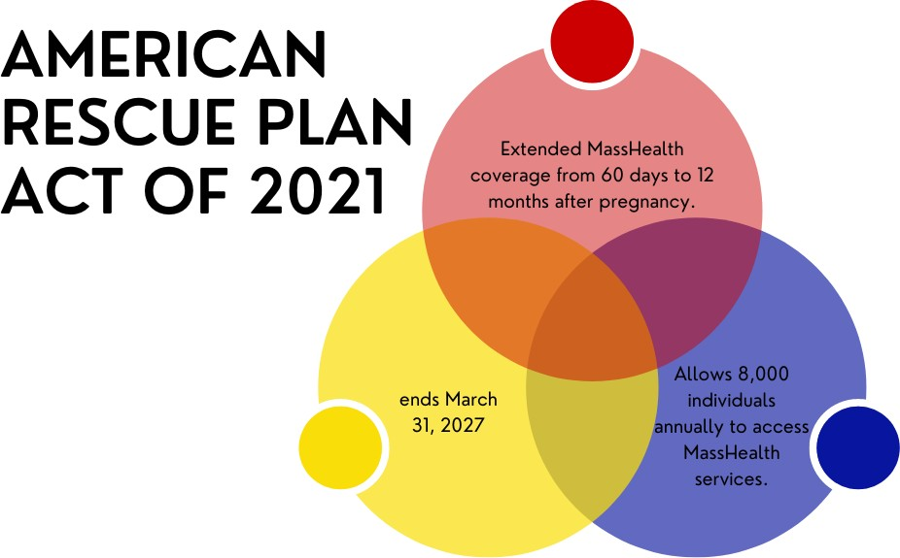
A systemic policy review of maternal health- related policies and legislations addressing racial disparities proposed federally and at the state-level in Massachusetts between 2010 and 2020 showed that 16-state level bills were proposed. Of those 16 proposed only 2 of them were signed into law. Interestingly, a majority of the bills proposed were centered around expanding healthcare coverage that would cover prenatal, pregnancy, and postpartum services, and would allow for care beyond the current coverage of 60 days postpartum through Medicaid for low-income people who had just given birth. It is clear that expanding healthcare coverage is essential for pregnancy
and gynecological health needs, especially after giving birth. Under federal law, Medicaid can only cover 60 days postpartum. This policy design does not take into consideration the fact that pregnant people are more likely to experience postpartum complications after 60 days of giving birth.

In April 2022, the Biden-Harris Administration announced that 720,000 pregnant and postpartum people across the United States could be eligible for Medicaid and Children’s Health Insurance Program coverage for a full 12 months rather than 60 days. Under the American Rescue Plan Act of 2021 (ARP), states were given the incentives and option to expand Medicaid services for postpartum services from 60 days to 12 months. In July 2022, the U.S. Department of Health and Human Services (HHS), through the Federal Centers for Medicare and Medicaid Services, approved Massachusetts’ request to extend MassHealth coverage from 60 days to 12 months after pregnancy. This coverage expansion will allow an additional 8,000 individuals annually to access MassHealth services.⁵² The ARP’s state plan option is currently limited to a five-year period that ends March 31, 2027, meaning that this state coverage expansion will expire.

Although the APR’s state plan has a lengthy expansion period, Massachusetts needs to pass legislation that requires MassHealth to grant recipients a 12-month expansion of postpartum care services under their Medicaid benefits after the ARP’s state plan expires in 2027, assuming that the presidential administration at that time does not extend it.

Access to Fertility Treatments

Heteronormative ideals of pregnancy and parenting typically frame fertility treatments as a service that cisgender women struggling with infertility seek. LGBTQ individuals who desire to become pregnant and parent a child seek out fertility treatments if they cannot conceive a pregnancy if they do not desire sex with someone with a penis, particularly a cisgender male. LGBTQ patients might also look to fertility treatments due to infertility caused by hormone therapy. As mentioned earlier in this section, LGBTQ folks who desire to become pregnant often cannot afford fertility treatments. In June 2022, The Equal Access to Reproductive Care Act (H.R.8190) was introduced in the United States Congress, though this bill did not progress, which would have closed a loophole in the tax code to cover fertility treatments as “medical care.” Heterosexual couples can usually cover the cost of fertility by claiming the expenses associated with surrogacy or IVF treatments in their income tax. The legislation would then classify assisted reproduction as a tax deductible medical expense, which would expand access to fertility treatments for LGBTQ families.

Doula Services

A systemic policy review study on Massachusetts bills related to maternal health and racial equity has shown that the common theme among legislative bills relates to the need for doula and midwives services.⁵³ A doula is a trained professional who provides continuous physical, emotional, and informational support to clients before, during, and after childbirth.⁵⁴ Unlike midwives, they do not provide medical care and cannot assist in delivery. Rather, they are a companion who supports their client with reproductive health related experiences. According to DONA International, birthing people who use doulas are less likely to have cesarean sections, make fewer requests for pain medications, report less anxiety, and overall have greater salinification with their birth experiences.⁵⁵ Doulas that specialize in LGBTQ issues can be helpful for LGBTQ individuals who need support navigating a health care system that oftentimes may discriminate against them, mistreat them, and misgender them based on heteronormative societal ideals around birthing and parenting. ⁵⁶ Doulas can also help reduce racial, gender, and other health inequities in health care settings.

Birth doulas are the most commonly known type of doula but there are different types of doulas, many of which can be helpful for LGBTQ populations and youth who need support navigating the various stages of birthing experiences. Transition doulas are caregivers for clients experiencing the wide spectrum of gender-affirming transitions. They may provide resources and referrals centered around LGBTQ healthcare, support clients receiving hormone shots, and provide compassionate trauma-informed wellness and support. Abortion doulas can also be helpful for LGBTQ youth who need support navigating the experience of getting an abortion.

An Act Relative to Medicaid Coverage for Doula Services (S.782/H.1240) was initially proposed in 2019, and during the 2023-2024 Massachusetts legislative session was re-introduced; this bill would require MassHealth to provide coverage for doula services, which are services typically paid for out-of-pocket. Additionally, the bill would also produce a Doula Care Advisory Commission which would handle many of the administrative aspects of implementation. If Massachusetts accomplishes implementing MassHealth coverage for doula services, the state would join alongside other states who have their state Medicaid services cover doula services, such as California, whose Medicaid program made doula services free for Medi-Cal recipients in January 2023, ⁵⁷ and Oregon and Minnesota which both have legislation that require their Medicaid programs to cover doula services.⁵⁸

Although legislation requiring Medicaid-provided doulas services has not passed into law yet, Massachusetts is making the effort to build awareness for doula services and how they can benefit low-income, BIPOC communities. The Birth Equity and Support through the Inclusion of Doula Expertise (BESIDE) Investment Program, offered by the

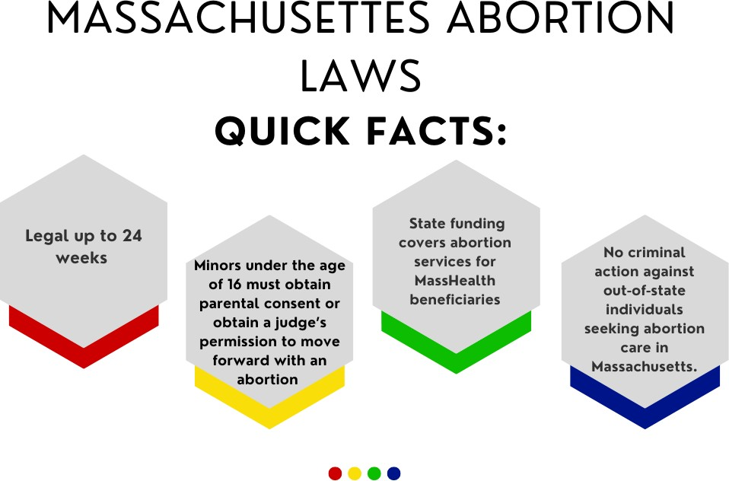
Massachusetts Health Policy Commission, seeks to address inequities in maternal health outcomes and improve the care and patient experience of Black birthing people by increasing access to doula services.⁵⁹

Of the over 400 birth centers in the United States, there is only one community birthing center in Massachusetts. The Commonwealth and the Department of Public Health should work to invest and grant funding for community birthing centers, especially LGBTQ-friendly and gender affirming birthing centers. Birthing centers with both midwifery services and doula services could create better
pregnancy outcomes and birthing experiences for LGBTQ youth, especially transgender birthing people who are more likely to choose alternative settings for birthing to avoid harassment and discrimination from medical facilities who may not have effective LGBTQ training for healthcare providers.⁶⁰ Aside from birthing doulas, abortion doulas and gender doulas can alleviate health inequity outcomes and aid LGBTQ youth with navigating the healthcare system when seeking pregnancy and gynecological healthcare. The MA Department of Public Health should consider implementing pilot programs for gender doulas that can provide guidance and support for LGBTQ youth seeking gynecological healthcare, thus reducing gender dysphoria.

Maternity Leave

The United States is one of the only industrialized nations without federally paid maternity leave. Compared to other countries, the U.S. offers unpaid, job-protected leave for only 12 weeks through the Family and Medical Leave Act. A number of states, including Massachusetts, have their own paid family and parental leave programs. The Paid Family and Medical Leave (PFML) program in Massachusetts is a program different from the Family and Medical Leave Act and is funded through employer and employee contributions. Most Massachusetts employees are eligible for up to 26 weeks of combined family and medical leave per benefit year.

Abortion Access

In the United States alone, there are over 600,000 abortions performed annually.⁶¹ Despite the fact that abortions are quite common and a necessary healthcare procedure, abortion inaccessibility in the United States continues to grow. The recent overturn of Roe v. Wade has sparked uncertainty around the future of abortion access across the country, particularly in states with strong anti-abortion views. In the United States, 13 states – Arkansas, Idaho, Kentucky, Louisiana, Mississippi, Missouri, North Dakota, Oklahoma, South Dakota, Tennessee, Texas, Utah, and Wyoming-- have implemented trigger bans, which are laws that would automatically ban abortion after a Roe v. Wade overturn.⁶²

In 2017, 18,850 abortions were provided in Massachusetts, though some of the abortions were not performed for Massachusetts residents but for out-of-state individuals. It’s possible that some people in Massachusetts traveled to other states to get an abortion. In 2017, some 43% of Massachusetts counties had no clinics that provide abortion, and 13% of Massachusetts women live in those counties. It should be noted that the statistics mentioned may not cover birthing people across the gender spectrum.

In Massachusetts, abortion is legal at 24 weeks but may be performed past 24 weeks or more in cases where the pregnant person’s life is determined to be endangered or there is a lethal fetal anomaly. Although the Hyde Amendment prevents Medicaid from using federal funding to cover abortion services, Massachusetts is one of the 33 states that use state funding to cover abortion services for MassHealth beneficiaries.⁶³

The ROE Act (S.1209) was codified into law by the Massachusetts legislature, expanding abortion access in the Commonwealth after the Senate overrode Governor Baker’s veto. Despite Governor Baker’s veto of the ROE Act, Baker had signed an executive order after Roe v. Wade was overturned, preventing criminal action against out-of- state individuals seeking abortion care in Massachusetts.

The parent or guardian of a minor younger than 16 must consent before an abortion is provided.⁶⁴ After the ROE Act became law, it repealed the parental consent provision for older teens aged 16 and 17 years old. It also made it official for judicial bypass hearings to take place virtually rather than
in person. The Massachusetts Judicial Bypass Process law requires minors under the age of 16 to obtain parental consent or navigate the court system to obtain a judge’s permission to move forward with an abortion.⁶⁵ Although the judicial bypass law is an option for youths to access an abortion without parental permission, the implementation of parental consent laws for youths under 16 makes it difficult for those with unintended pregnancies who might not feel comfortable disclosing their pregnancies to their parents or guardians.

A study found that the Massachusetts Judicial Bypass Process Law delays youth’s access to abortion by 14.8 days, which is 6.1 days longer than youth who had parental permission. It is also noted that the majority of young people navigating the judicial system to
obtain a judge’s permission were disproportionately low-income, people of color.⁶⁶ Going through the legal process may also be time-consuming, especially if the pregnant person does not have the privilege of taking time off from work to navigate the legal system, which can be a distressing situation. The judicial bypass process not only delays access to surgical abortions but also delays youths' eligibility for medication abortions. Medication abortions might be the only safe and private way for youths to terminate their unintended pregnancies.

In July 2022, former Governor Charlie Baker signed An Act Expanding Protections For Reproductive and Gender- affirming Care which expanded reproductive healthcare and gender-affirming services in the Commonwealth. The bill, now law, included a section that ensures public university students have access to medication abortion through their university’s health services or by being connected to outside resources. This legislation also created the Public University Health Center Sexual and Reproductive Health Preparation Fund to help cover expenses for implementing new programs.⁶⁷

Additionally, in April of 2023, after a federal court ruling from Texas that blocked further distribution of the medication abortion pill mifepristone, Governor Maura Healey issued an Executive Order affirming protections for abortion access in Massachusetts, and directing the state to begin stockpiling more than 15,000 doses of mifepristone to ensure access to the medication for over one year.⁶⁸

However, though Massachusetts leans progressively toward abortion rights, the Massachusetts Department of Public Health's lack of requiring medical providers and facilities it funds to provide routine abortion services creates

a barrier for Massachusetts residents to access abortion services at certain medical facilities in the state, thus causing pregnant people to travel far distances for abortion services. Fortunately, the Commonwealth has ensured that medical providers and facilities perform emergency abortions to stabilize the pregnant person in the event of a medical emergency. However, lack of access to routine abortion services can negatively impact LGBTQ youth with unintended pregnancies. Although unintended pregnancies are not classified as “emergencies” or “life-threatening,” unwanted pregnancies are still distressing to LGBTQ youth who do not want to be pregnant, especially if the pregnancy amplifies feelings of gender dysphoria. The Commonwealth should urge the Department of Public Health to revise its provision of abortion requirements for medical facilities and programs it funds. The state should also work with the Department of Public Health to expand funding to invest in abortion-competent medical providers and resources in order to expand routine abortion service access to Massachusetts residents. Pregnant people with unintended pregnancies would not have to travel long distances within the state for an abortion.

Birth Control Access

In November 2017, Governor Charlie Baker signed An Act Relative to Advancing Contraceptive Coverage and Economic Security (ACCESS), which further expanded access to birth control. This law allows (1) eligible people to get a year’s supply of no-cost birth control and (2) emergency contraceptives, such as Plan B One-Step or ella. Eligible patients can get birth control pills, patches, rings, or injectable birth control. To be eligible, one must be fully insured by a health insurance plan subject to Massachusetts law, including health plans from MassHealth and plans purchased on the MA Health Connector. Insurances through the MA Group Insurance Commission are also covered. This is an essential component that furthers reproductive rights.

Unfortunately, this provision may not have been effectively implemented; only about 300 eligible AFAB people obtained a 12-month supply of birth control in 2020 through the state’s largest insurers. Patients and healthcare providers have reported poor experiences with trying to obtain or prescribe a 12-month supply of birth control. Not many eligible patients, healthcare providers, and pharmacies are even aware of this provision and there has been confusion on whether MassHealth beneficiaries are eligible due to poor awareness of the law and roll-out of the provision.⁶⁹

However, information about the ACCESS law is housed in the Mass.gov web services,⁷⁰ where there is some detailed advice on how to find out if you are eligible for a one-year supply of prescription birth control, which includes speaking with your health insurance provider, employee benefits administrator, or human resources. In the event that a patient’s clinician or pharmacist claims to be unaware of the ACCESS provisions, there is a script provided for patients to utilize when discussing their desire for birth control.⁷¹ Providing advice and conversational starter tips on accessing a one-year supply of birth control are helpful at the individual level. Despite this, instead of the issue of access falling on the legislature or agencies, it becomes an individualized problem that shifts the responsibility to the patient rather than the state.

At the national level, groups of reproductive justice and youth activists, advocacy groups, and healthcare professionals have formed the Free the Pill coalition to push for over-the-counter birth control pills. Over-the- counter birth control pills would be a major step in advancing reproductive rights and access. However, this process requires a pharmaceutical company to submit an Rx-to-OTC switch application to the FDA, which could take time to process and pass. OTC birth control would remove an access barrier for people assigned female at birth. This would make it so they would not need to acquire a prescription, thus making it easier for LGBTQ youth who need to quickly get birth control and would not need a prescription from a clinician or primary care doctor. Aside from shielding LGBTQ youth from the possibility of experiencing trauma, discrimination, and mistreatment from primary care doctors, it can already be difficult to schedule an appointment with a healthcare provider for a birth control prescription since appointments tend to get scheduled 2-3 months out. Since there does not seem to be any legislative push for over-the-counter birth control at the state level, in the meantime, it’s recommended that the Commonwealth invests in robust planning, implementation, and campaigning when rolling out reproductive health policies. The state health agencies should invest in and implement training for healthcare providers, pharmacists, and insurers on the ACCESS law and other wide ranges of reproductive health-related provisions. The Commonwealth should also invest in creating more effective campaigning and implementing an education
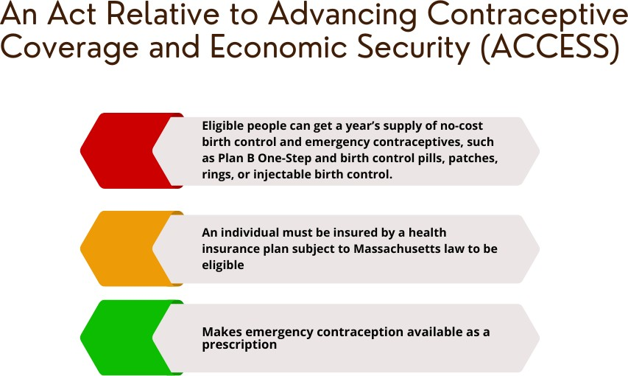
component to the ACCESS law.

In Massachusetts, youth under the age of 18 can get a prescription for birth control without parental or guardian’s permission, though they do need parental consent for abortion procedures. Essentially, anyone of any age can get prescription birth control. The Massachusetts Department of Public Health funds state-wide family planning programs that provide low or no-cost reproductive and sexual health healthcare and information that adolescents can access.⁷²

Access to Menstrual Products

In May 2021, to commemorate Menstrual Hygiene Day, the Menstrual Equity for All Act of 2021 (H.R.3614) was introduced to the United States Congress, though did not progress. The bill aimed to increase the availability and affordability of menstrual products for individuals with limited access, and for other purposes. The legislation’s components include giving states the option to use federal funds to provide students with free menstrual products in schools, incentivizing universities to implement pilot programs that provide free menstrual products, ensuring free menstrual products to detainees in federal, state, and local facilities (including immigration detention centers), ensure that homeless shelters can use grants to cover menstrual products, requiring Medicaid to cover the cost of menstrual products, directing large employers with 100 employees or more to provide free menstrual products to employees, and require all federal buildings to provide free menstrual products in restrooms. This is a federal, comprehensive initiative that would further reproductive access for menstruating LGBTQ youth, especially youth in schools, prisons, and homeless shelters. The progression of this bill has remained stagnant since its introduction to the U.S. Congress. However, various states such as California, Illinois, and Maryland have passed menstrual equity

legislation that requires schools to provide menstrual products to students in female restrooms. Other states, including Massachusetts, have introduced menstrual equity bills.

In the 2023-2024 legislative session, Massachusetts lawmakers reintroduced An Act to Increase Access to Disposable Menstrual Products (S.1381/H.534) which would provide access to free menstrual products to all menstruating individuals in schools, shelters, and prisons. Just like the Menstrual Equity for All Act, the I AM bill would expand reproductive care for menstruating LGBTQ youth primarily in Massachusetts who attend public schools, are experiencing homelessness and need to stay in homeless shelters, or are incarcerated in the prison system. In 2019, Boston Public Schools launched a period product pilot program that brought free menstrual supplies to students. This initiative came out around three years after Cambridge and Somerville Public Schools started similar programs. Public school systems taking initiative to run menstrual product programs alleviate some inaccessibility to period products for menstruating LGBTQ youth and reduce the stigma around menstruation. The Commission urges the Commonwealth to sign the I AM bill into law to further expand access to menstrual products across the state.

Another way to expand access to menstrual products is through the Supplemental Nutrition Assistance Program, the federal nutrition program that aims to
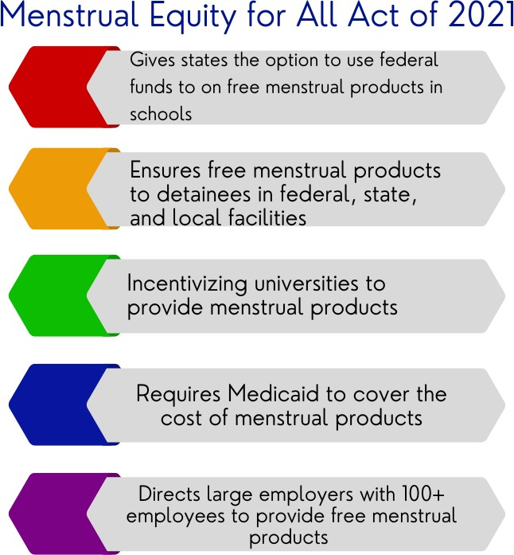
reduce food insecurity for low-income communities. Surveys have shown that more than 1 in 4 lesbian, gay, and bisexual individuals aged 18-44 participated in SNAP, compared to 20% of heterosexual participants.⁷³ Most federal surveys do not sufficiently measure participants’ gender identity but studies have shown that transgender individuals have struggled with food insecurity more so than their cisgender counterparts. ⁷⁴ At the federal level, menstrual products are not covered by SNAP benefits. However, the Commonwealth can introduce legislation that can allow SNAP recipients to purchase period products with their benefits, similar to what Illinois implemented in January 2022.⁷⁵

Queer Health Equity Framework

As mentioned earlier in the report, Massachusetts is one of the states with the lowest maternal mortality rates. However, disparities among racial, ethnic, and class backgrounds remain. Massachusetts has a Maternal Mortality Review Committee that reviews maternal deaths, studies pregnancy complications, and makes recommendations to improve maternal outcomes and prevent mortality.⁷⁶ This is a step in the right direction in addressing maternal mortality inequities as a study has shown that states with maternal mortality review committees play an integral role in understanding preventable causes of maternal mortality. They also apply a health equity approach to understand the structural drivers of racial, ethnic, and geographic inequities in maternal deaths.⁷⁷ The MA Maternal Mortality Review Committee and the Department of Public Health should consider applying an LGBTQ-inclusive lens approach when reviewing maternal deaths in the state.

Acknowledgments & Citations

Acknowledgments: Karina Sumano, lead researcher & author

1 “Polling Spotlight: Understanding the Experiences of LGBTQ+ Birthing People,” Center For Health Justice, accessed April 24, 2023, https://www.aamchealthjustice.org/news/polling/lgbtq-birth.
2 Meghan Romanelli and Kimberly D. Hudson, “Individual and Systemic Barriers to Health Care: Perspectives of Lesbian, Gay, Bisexual, and Transgender Adults,” American Journal of Orthopsychiatry 87, no. 6 (2017): 714–28, https://doi.org/10.1037/ort0000306.
3 James, S. E., Herman, J. L., Rankin, S., Keisling, M., Mottet, L., & Anafi, M. (2016). The Report of the 2015 U.S. Transgender Survey. Washington, DC: National Center for Transgender Equality.
4 Abbi Coursolle, “Meeting the Health Care Needs of LGBTQ Immigrants,” National Health Law Program, August 16, 2021, https://healthlaw.org/meeting-the-health-care-needs-of-lgbtq-immigrants/.
5 Wingo, Erin, Natalie Ingraham, and Sarah C.M. Roberts. “Reproductive Health Care Priorities and Barriers to Effective Care for LGBTQ People Assigned Female at Birth: A Qualitative Study.” Women’s Health Issues 28, no. 4 (July 2018): 350–57. https://doi.org/10.1016/j.whi.2018.03.002.
6 Barbara K. Snyder, Gail D. Burack, and Anna Petrova, “LGBTQ Youth’s Perceptions of Primary Care,” Clinical Pediatrics 56, no. 5 (May 2017): 443–50, https://doi.org/10.1177/0009922816673306.
7 “Discrimination Prevents LGBTQ People From Accessing Health Care,” Center for American Progress (blog), accessed August 11, 2022, https://www.americanprogress.org/article/discrimination-prevents-lgbtq-people-accessing-health-care/.
8 Agénor, Madina, Dougie Zubizarreta, Sophia Geffen, Natasha Ramanayake, Shane Giraldo, Allison McGuirk, Mateo Caballero, and Keosha Bond. 2022. “‘Making a Way Out of No Way:’ Understanding the Sexual and Reproductive Health Care Experiences of Transmasculine Young Adults of Color in the United States.” Qualitative Health Research 32 (1): 121–34. https://doi.org/10.1177/10497323211050051.
9 Barbara K. Snyder, Gail D. Burack, and Anna Petrova, “LGBTQ Youth’s Perceptions of Primary Care,” Clinical Pediatrics 56, no. 5 (May 2017): 443–50, https://doi.org/10.1177/0009922816673306.
10 Publication Published on 6 August 2020, “Affirming Primary Care for Intersex People 2020 » LGBTQIA+ Health Education Center,” LGBTQIA+ Health Education Center (blog), accessed December 3, 2022, https://www.lgbtqiahealtheducation.org/publication/affirming-primary-care-for-intersex-people-2020/.
11 lbid
12 “New Study Finds Significant Barriers to Gender-Affirming Primary Care among Transgender People Living in Rural Areas - Fenway Health: Health Care Is A Right, Not A Privilege.,” August 18, 2022, https://fenwayhealth.org/new-study-finds- significant-barriers-to-gender-affirming-primary-care-among-transgender-people-living-in-rural-areas/.
13 Claire E. Lunde et al., “Beyond the Binary: Sexual and Reproductive Health Considerations for Transgender and Gender Expansive Adolescents,” Frontiers in Reproductive Health 3 (2021), https://www.frontiersin.org/articles/10.3389/frph.2021.670919.
14 Beth I. Schwartz et al., “Experiences with Menses in Transgender and Gender Nonbinary Adolescents,” Journal of Pediatric and Adolescent Gynecology 35, no. 4 (August 2022): 450–56, https://doi.org/10.1016/j.jpag.2022.01.015.
15 Molly B. Moravek, “Gender-Affirming Hormone Therapy for Transgender Men,” Clinical Obstetrics & Gynecology 61, no. 4 (December 2018): 687–704, https://doi.org/10.1097/GRF.0000000000000398.
16 “Menstrual Access Advocacy Project – YWCA Southeastern Massachusetts,” accessed December 4, 2022, https://ywcasema.org/menstrual-access-advocacy-project/.
17 James, S. E., Herman, J. L., Rankin, S., Keisling, M., Mottet, L., & Anafi, M. (2016). Executive Summary of the Report of the 2015 U.S. Transgender Survey. Washington, DC: National Center for Transgender Equality.
18 https://www.aclu.org/news/lgbtq-rights/menstruation-related-discrimination-is-sex-discrimination-we-dont-need-to-erase- trans-or-non-binary-people-to-make-that-point
19 Barbara K. Snyder, Gail D. Burack, and Anna Petrova, “LGBTQ Youth’s Perceptions of Primary Care,”
20 Jamie Mehringer and Nadia L. Dowshen, “Sexual and Reproductive Health Considerations among Transgender and Gender- Expansive Youth,” Current Problems in Pediatric and Adolescent Health Care 49, no. 9 (September 2019): 100684, https://doi.org/10.1016/j.cppeds.2019.100684.
21 Danielle Boudreau and Ronica Mukerjee, “Contraception Care for Transmasculine Individuals on Testosterone Therapy,”
Journal of Midwifery & Women’s Health 64, no. 4 (July 2019): 395–402, https://doi.org/10.1111/jmwh.12962. 22 “Contraception for Your Transgender Patients,” Birth Control Pharmacist (blog), April 24, 2020, https://birthcontrolpharmacist.com/2020/04/23/contraception-for-your-transgender-patients/.
23 Ibid.
24 Ibid.

25 Danielle Boudreau and Ronica Mukerjee, “Contraception Care for Transmasculine Individuals on Testosterone Therapy,”
26 Danielle Boudreau and Ronica Mukerjee, “Contraception Care for Transmasculine Individuals on Testosterone Therapy,”
27 Jamie Mehringer and Nadia L. Dowshen, “Sexual and Reproductive Health Considerations among Transgender and Gender- Expansive Youth,” Current Problems in Pediatric and Adolescent Health Care 49, no. 9 (September 2019): 100684, https://doi.org/10.1016/j.cppeds.2019.100684.
28Ibid.
29 Ibid.
30 Charlton, Brittany M., Bethany G. Everett, Alexis Light, Rachel K. Jones, Elizabeth Janiak, Audrey J. Gaskins, Jorge E. Chavarro, Heidi Moseson, Vishnudas Sarda, and S. Bryn Austin. “Sexual Orientation Differences in Pregnancy and Abortion Across the Lifecourse.” Women’s Health Issues 30, no. 2 (March 2020): 65–72. https://doi.org/10.1016/j.whi.2019.10.007.
31 “Annual Recommendations - Commission on LGBTQ Youth | Mass.Gov,” accessed December 4, 2022, https://www.mass.gov/lists/annual-recommendations-commission-on-lgbtq-youth.
32 Everett, Bethany G., Michelle A. Kominiarek, Stefanie Mollborn, Daniel E. Adkins, and Tonda L. Hughes. “Sexual Orientation Disparities in Pregnancy and Infant Outcomes.” Maternal and Child Health Journal 23, no. 1 (January 2019): 72–81. https://doi.org/10.1007/s10995-018-2595-x.
33 Bethany G. Everett et al., “Sexual Identity and Birth Outcomes: A Focus on the Moderating Role of Race-Ethnicity,” Journal of Health and Social Behavior 62, no. 2 (June 2021): 183–201, https://doi.org/10.1177/0022146521997811.
34 Sajal Patel and Lori B. Sweeney, “Maternal Health in the Transgender Population,” Journal of Women’s Health 30, no. 2 (February 2021): 253–59, https://doi.org/10.1089/jwh.2020.8880.
35 “Pregnant Transgender Men at Risk for Depression and Lack of Care, Rutgers Study Finds,” accessed August 1, 2022, https://www.rutgers.edu/news/pregnant-transgender-men-risk-depression-and-lack-care-rutgers-study-finds.
36 “Suicide Thoughts and Attempts Among Transgender Adults,” Williams Institute, accessed August 12, 2022, https://williamsinstitute.law.ucla.edu/publications/suicidality-transgender-adults/.
37 Carla A. Pfeffer, “Transgender Men and Nonbinary People Are Asked to Stop Testosterone Therapy during Pregnancy – but the Evidence for This Guidance Is Still Murky,” The Conversation, accessed December 5, 2022, http://theconversation.com/transgender-men-and-nonbinary-people-are-asked-to-stop-testosterone-therapy-during- pregnancy-but-the-evidence-for-this-guidance-is-still-murky-187672.
38 “Infertility,” accessed December 4, 2022, https://www.who.int/news-room/fact-sheets/detail/infertility.
39 Janelle M. Downing, “Pathways to Pregnancy for Sexual Minority Women in Same-Sex Marriages,” American Journal of Obstetrics and Gynecology 221, no. 3 (September 2019): 281–82, https://doi.org/10.1016/j.ajog.2019.04.019.
40 Margot Kelly-Hedrick, “DISPARITIES IN ACCESS TO FERTILITY CARE IN THE UNITED STATES: ETHICAL CONSIDERATIONS FOR EQUITABLE SOLUTIONS,” n.d., 37.
41 Isabel Galic et al., “Disparities in Access to Fertility Care: Who’s in and Who’s out,” F&S Reports 2, no. 1 (November 18, 2020): 109–17, https://doi.org/10.1016/j.xfre.2020.11.001.
42 MacDorman, Marian F., Eugene Declercq, Howard Cabral, and Christine Morton. “Recent Increases in the U.S. Maternal Mortality Rate: Disentangling Trends From Measurement Issues.” Obstetrics & Gynecology 128, no. 3 (September 2016): 447–
55. https://doi.org/10.1097/AOG.0000000000001556.
43 “The States with the Highest (and Lowest) Maternal Mortality, Mapped,” accessed August 11, 2022, https://www.advisory.com/Daily-Briefing/2018/11/09/maternal-mortality.
44 Massachusetts Department of Health. Maternal Mortality and Morbidity Review in Massachusetts: A Bulletin for Health Care Professionals, Pregnancy- Associated Mortality, 2000-2007. Bureau of Family Health and Nutrition, Massachusetts Department of Public Health (2014). Available online at: https://www.mass.gov/doc/2014- report- pregnancy- associated- mortality-2000- 2007/download
45 Tucker, Myra J., Cynthia J. Berg, William M. Callaghan, and Jason Hsia. “The Black–White Disparity in Pregnancy-Related Mortality From 5 Conditions: Differences in Prevalence and Case-Fatality Rates.” American Journal of Public Health 97, no. 2 (February 2007): 247–51. https://doi.org/10.2105/AJPH.2005.072975
46 “Protecting Basic Living Standards for LGBTQ People,” Center for American Progress (blog), accessed August 11, 2022, https://www.americanprogress.org/article/protecting-basic-living-standards-lgbtq-people/.
47 Brittany M. Charlton et al., “Sexual Orientation Differences in Pregnancy and Abortion Across the Lifecourse,” Women’s Health Issues 30, no. 2 (March 2020): 65–72.
48 Rachel K. Jones, Elizabeth Witwer, and Jenna Jerman, “Transgender Abortion Patients and the Provision of Transgender- Specific Care at Non-Hospital Facilities That Provide Abortions,” Contraception: X 2 (2020): 100019, https://doi.org/10.1016/j.conx.2020.100019.
49 “New Poll Illustrates the Impacts of Social & Political Issues on LGBTQ Youth,” The Trevor Project (blog), January 10, 2022, https://www.thetrevorproject.org/blog/new-poll-illustrates-the-impacts-of-social-political-issues-on-lgbtq-youth/.

50 Stephanie Ebbert, “Massachusetts Has Expanded Abortion Rights. But Even in the Metro Region, Clinics Can Be Distant. - The Boston Globe,” accessed December 4, 2022, https://www.bostonglobe.com/2022/10/09/metro/massachusetts-has-expanded- abortion-rights-even-metro-region-clinics-can-be-distant/.
51 https://abortioncarenewengland.org/providers-by-zipcode
52 “MassHealth’s Extended 12-Month Postpartum Coverage Approved by the Federal Centers for Medicare & Medicaid Services
| Mass.Gov,” accessed December 4, 2022, https://www.mass.gov/news/masshealths-extended-12-month-postpartum- coverage-approved-by-the-federal-centers-for-medicare-medicaid-services.
53 Keri Carvalho et al., “A Systematic Policy Review of Black Maternal Health-Related Policies Proposed Federally and in Massachusetts: 2010–2020,” Frontiers in Public Health 9 (October 21, 2021): 664659, https://doi.org/10.3389/fpubh.2021.664659.
54 “What Is a Doula - DONA International,” accessed December 4, 2022, https://www.dona.org/what-is-a-doula/.
55 Hodnett ED. Pain and women’s satisfaction with the experience of childbirth: a systematic review. Am J Obstet Gynecol 2002; 186(5) S160-72. Hodnett ED, Gates S, Hofmeyr G J, Sakala C, Weston J. Continuous support for women during childbirth [PDF]. Cochrane Database Syst Rev 2011, Issue 2.
56 “LGBTQ+ Doulas Help New Parents Thrive, No Matter How They Identify | Them,” accessed December 4, 2022, https://www.them.us/story/lgbtq-doulas.
57 “Doula Services,” accessed December 5, 2022, https://www.dhcs.ca.gov/provgovpart/Pages/Doula-Services.aspx.
58 “Medicaid Coverage for Doula Care: State Implementation Efforts - National Health Law Program,” accessed December 5, 2022, https://healthlaw.org/medicaid-coverage-for-doula-care-state-implementation-efforts/.
59 “Birth Equity and Support through the Inclusion of Doula Expertise (BESIDE) Investment Program | Mass.Gov,” accessed December 5, 2022, https://www.mass.gov/service-details/birth-equity-and-support-through-the-inclusion-of-doula-expertise- beside-investment-program.
60 Sajal Patel and Lori B. Sweeney, “Maternal Health in the Transgender Population,”
61 Jeff Diamant and Besheer Mohamed, “What the Data Says about Abortion in the U.S.,” Pew Research Center (blog), accessed December 4, 2022, https://www.pewresearch.org/fact-tank/2022/06/24/what-the-data-says-about-abortion-in-the-u-s-2/.
62 “13 States Have Abortion Trigger Bans—Here’s What Happens When Roe Is Overturned,” Guttmacher Institute, June 6, 2022, https://doi.org/10.1363/2022.33571.
63 “State Facts About Abortion: Massachusetts,” Guttmacher Institute, June 28, 2022, https://www.guttmacher.org/fact- sheet/state-facts-about-abortion-massachusetts.
64 “Massachusetts Law about Abortion | Mass.Gov,” accessed December 4, 2022, https://www.mass.gov/info- details/massachusetts-law-about-abortion.
65 “New Study Finds Massachusetts Judicial Bypass Process Delays Access to Abortion | Planned Parenthood Advocacy Fund of Massachusetts, Inc.,” accessed December 4, 2022, https://www.plannedparenthoodaction.org/planned-parenthood-advocacy- fund-massachusetts-inc/pressroom/new-study-finds-massachusetts-judicial-bypass-process-delays-access-to-abortion.
66 Elizabeth Janiak et al., “Massachusetts’ Parental Consent Law and Procedural Timing Among Adolescents Undergoing Abortion,” Obstetrics & Gynecology 133, no. 5 (May 2019): 978–86, https://doi.org/10.1097/AOG.0000000000003190. 67 “New Law Ensures Medication Abortion Access for Public University Students in Mass.,” News, August 1, 2022,
https://www.wgbh.org/news/local-news/2022/08/01/new-law-ensures-medication-abortion-access-for-public-university- students-in-mass.
68 “Governor Healey Announces Immediate Action to Protect Access to Medication Abortion in Massachusetts | Mass.Gov,” accessed April 24, 2023, https://www.mass.gov/news/governor-healey-announces-immediate-action-to-protect-access-to- medication-abortion-in-massachusetts.
69 Sarah Betancourt, “2017 Birth Control Provision Fell through the Cracks,” CommonWealth Magazine (blog), February 28, 2021, https://commonwealthmagazine.org/health/2017-birth-control-provision-fell-through-the-cracks/.
70 “ACCESS to Birth Control and Emergency Contraception | Mass.Gov,” accessed December 4, 2022, https://www.mass.gov/info-details/access-to-birth-control-and-emergency-contraception.
71 “Talk to Your Clinician or Pharmacist about the ACCESS Law | Mass.Gov,” accessed December 4, 2022, https://www.mass.gov/info-details/talk-to-your-clinician-or-pharmacist-about-the-access-law.
72 “DPH-Funded Family Planning Programs | Mass.Gov,” accessed December 5, 2022, https://www.mass.gov/info-details/dph- funded-family-planning-programs.
73 Taylor N T Brown, Adam P Romero, and Gary J Gates, “FOOD INSECURITY AND SNAP PARTICIPATION IN THE LGBT COMMUNITY,” n.d., 28.
74 lbid.
75 “Menstrual Hygiene Products Can Be Purchased with SNAP and WIC Benefits under Villa Law,” ISDC, August 5, 2021, https://www.illinoissenatedemocrats.com/caucus-news/72-senator-karina-villa-news/2886-menstrual-hygiene-products-can- be-purchased-with-snap-and-wic-benefits-under-villa-law.

76 “Maternal Mortality and Morbidity Initiative | Mass.Gov,” accessed December 5, 2022, https://www.mass.gov/service- details/maternal-mortality-and-morbidity-initiative.
77 Michael R. Kramer et al., “Changing the Conversation: Applying a Health Equity Framework to Maternal Mortality Reviews,” American Journal of Obstetrics and Gynecology 221, no. 6 (December 2019): 609.e1-609.e9, https://doi.org/10.1016/j.ajog.2019.08.057.

COMMISSION ON LGBTQ YOUTH
PREGNANCY REPORT

ABOUT
Many LGBTQ people such lesbians, bisexual women, transgender men, Two-Spirit, intersex, nonbinary and gender nonconforming individuals use contraception, have the capacity to carry pregnancy, experience miscarriages, and choose to get abortions. Pregnancy is not confined to cisgender women.

RECOMMENDATIONS
100
miles that pregnant individuals on Cape Cod may need to travel to access abortion services

93%

of non-binary and transgender youth face distress due to menstruation

Improve SOGI data collection efforts across state services as it relates to pregnancy service needs and mortality rates.

Create and fund community birthing centers across the Commonwealth, and increase access to culturally competent doula services.

Expand LGBTQ cultural awareness, anti-bias, and racial equity trainings for public hospital providers and staff.
65%
of LGBTQ youth expressed that abortion restrictions and bans heighten their feelings of stress and anxiety

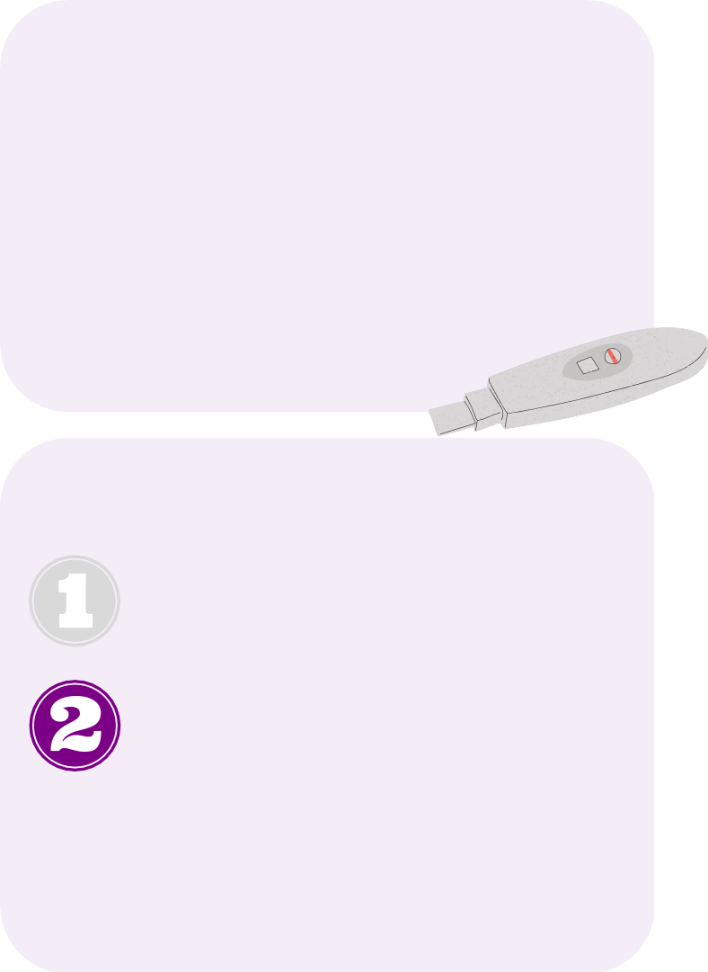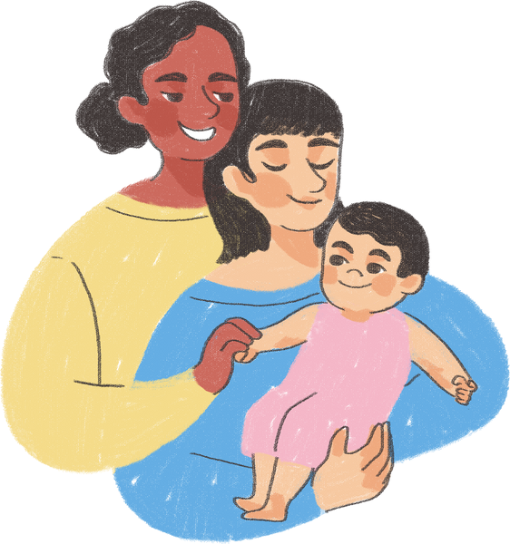

LEGISLATION

S.1415: Birthing Justice in the Commonwealth

Improving Sexual Health

Introduction: Understanding LGBTQ Youth Sexual Health

The Commission was founded in the early 1990s to address the significant disparities in LGBTQ youth mental health occurring during the AIDS epidemic. Since then, the Commission has dedicated much of its work and resources to supporting LGBTQ youth sexual health through supporting policies increasing access to PrEP and PEP; advocating for comprehensive sexual health education; addressing factors leading to disparities around sexual victimization; and more. While Massachusetts remains a leader in many areas of LGBTQ legal protections, there still remain a concerning number of areas where the state has failed to stay ahead and ensure that the unique gaps in resources, education, and services for LGBTQ youth are addressed.
To this day, across the state and the nation, LGBTQ youth remain at a higher risk for STIs, HIV, and sexual violence. Furthermore, as discussed in the pregnancy section of this annual report, LGBTQ youth are often left out of conversations around national and statewide conversations involving pregnancy, abortion access, and gynecological health, but often face significant disparities in access and care. Compounding these issues, LGBTQ youth frequently encounter barriers to accessing contraceptives, affirming medical care, and inclusive sexual health education. Across the nation, 29 states and D.C. mandate sexual health education in schools, though only 7 states require curricula to include information on sexual orientation and gender identity - Massachusetts, which has not updated its education standards since 1999, mandates neither.¹
As highlighted in numerous areas throughout this report, sexual health goes beyond just conversations around HIV, AIDS, and education. The following recommendations highlight solutions for critical gaps in Massachusetts policies and services, while also taking a broader look at how LGBTQ youth are affected by poor sexual health policies across the state.

FY 2024 Recommendations to the Governor and Legislature on Sexual Health

Ensure that all youth have access to age-appropriate, LGBTQ-inclusive, and consent-based sexual health education, and that educators are provided with implementation support.
Most youth across the country rely on schools to provide basic education on sexual health, building healthy relationships, and consent. For a variety of reasons, including financial disparities and lack of support from parents, many schools in Massachusetts fail to provide adequate sexual health education to students. LGBTQ youth often fail to receive appropriate sexual health education from their families, especially if their parents are cisgender and heterosexual. As a result, many youth turn to find information in schools and, failing that, will seek to learn from peers or the Internet - both of which often provide

inaccurate and harmful education. Furthermore, most sexual health curricula fails to appropriately educate youth on the basis of consent, particularly youth in elementary school who often do not receive any education around correct names for body parts. Without this basic education, LGBTQ youth of all ages are at a greater risk of sexual victimization.
The Commission supports and prioritizes the implementation of An Act Relative to Healthy Youth (S.268/H.544), also known as the Healthy Youth Act (HYA), which would ensure that all schools that elect to teach sexual health education update their curriculum materials to include age-appropriate, consent- based, and LGBTQ-inclusive information. However, the Commission supports this bill on the understanding that the phrase “human sexuality issues” must be removed from the bill text before it is passed through the State House. The phrase as written seemingly provides a loophole being used by transphobic parents to opt students out from all LGBTQ-related curriculum being provided by schools, including history lessons and story hours, which in many instances has led for lessons to be canceled for all students. The Commission advises the legislature to remove these words to alleviate the significant burden that youth, parents, school administrators, and teachers are currently facing in dealing with these confusing challenges.
Furthermore, the Commission advises the state to examine all curriculum being taught to youth in state custody and services - with particular attention to the Department of Children & Families (DCF), Department of Youth Services (DYS), and Department of Developmental Services (DDS).

Support and increase HIV & STI prevention and treatment services for LGBTQ youth, and awareness campaigns across the state.
Massachusetts is seeing an alarming rise in sexually-transmitted infections and diseases in youth, per information received from the Department of Public Health (DPH). It is widely understood that LGBTQ youth - particularly QTBIPOC youth - are disproportionately impacted by HIV, and access to HIV prevention and treatment is limited. The Commission strongly recommends that the legislature pass An Act to Prevent Barriers to HIV Prevention Medication (S.619/H.1085), which would further address barriers in access to HIV prevention medication. The Commission congratulates the legislature for fulfilling a previous FY 2023 recommendation from the Commission by expanding access to PrEP and PEP for youth under 18 in July of 2022.

Prohibit medical providers from performing non-consensual examinations on unconscious patients.

The Commission supports the passage of An Act Prohibiting Nonconsensual Intimate Examinations of Anesthetized or Unconscious Patients (S.1333/H.2146), which would ban the common practice employed by teaching hospitals – of which Massachusetts has several – by allowing medical students to perform pelvic examinations on unconscious patients without their consent. While most research and advocacy is directed towards cisgender women without distinction to intersex status,² the Commission is seriously concerned about the implications of such practices for women of color, transgender men, and intersex individuals, particularly given the medical profession’s history of medical racism, transphobia, and

disregard for ethical care for intersex patients,³ as discussed below. The Commission advises that Massachusetts pass a gender-neutral ban on these invasive practices, and set up accountability systems and educational campaigns to ensure that patients who suspect that such a practice might have occurred have a reporting method easily available to them.

Increase access to critical reproductive and sexual health items, such as contraceptives and menstrual products.
Having access to contraceptives guarantees that the Commonwealth will see much lower rates of sexually- transmitted infections, diseases, and unwanted pregnancy rates. Despite misconceptions, LGBTQ youth - particularly bisexual girls - are more likely to have an unintended pregnancy, for reasons discussed in- depth below. Lack of education, cost, stigma, and discrimination provide significant barriers to contraceptive access for youth. The Commission supports An Act Relative to Hormonal Contraceptives, and advises that the legislature pass the version of the bill filed in the House (H.2133) which would increase access to youth under 18. Furthermore, the state should explore funding programs and services to provide free contraceptives to youth in public buildings and hospitals, as well as conduct awareness campaigns to educate the public on types of contraceptives and proper use. Recent decisions by some universities - including Boston University - to establish contraceptive vending machines for students should be replicated, expanded, and funded by the state.

Additionally, the Commission continues to recommend the implementation of An Act to Increase Access to Disposable Menstrual Products (S.1381/H.534), also known as the ‘I AM’ bill, which would require that disposable menstrual products be provided to all youth in schools, prisons, and homeless shelters. The Commission further advises that the state explore increasing funding to libraries and community centers to provide similar access.

Continue to explore paths to increase access to abortion services, and address barriers resulting from the proliferation of anti-abortion centers in the state.
With the fall of the Supreme Court decision Roe v. Wade in the summer of 2022 and continued subsequent attacks against abortion access across the nation, Massachusetts has done well to rapidly implement stronger protections to ensure that residents - and non-residents traveling into the state - continue to receive appropriate medical care and control over their own bodies. The Commission appreciates the recent April 2023 actions from Governor Healey to protect access to mifepristone, and encourages the state to continue to explore further actions that ensure that underserved communities - particularly youth of color - do not lose access to this critical medication.

Research: What is Sexual Health?

Inclusive Sexual Health Education

Sexual health is a fundamental right that includes the right to sexual identity, expression, and activity.

Comprehensive sexual health education has received widespread support for the benefits it provides to youth, including from the American Academy of Pediatrics.⁴ According to the World Health Organization, the definition of sexual health is expansive:

“[Sexual health] is a state of physical, emotional, mental and social well-being in relation to sexuality; it is not merely the absence of disease, dysfunction or infirmity. Sexual health requires a positive and respectful approach to sexuality and sexual relationships, as well as the possibility of having pleasurable and safe sexual experiences, free of coercion, discrimination and violence. For sexual health to be attained and maintained, the sexual rights of all persons must be respected, protected and fulfilled.”⁵

Unequivocally, frank discussions of sexual activity and health are largely considered to be taboo in U.S. society, especially in regards to LGBTQ youth; 7 states in the U.S. prohibit the mention of LGBTQ sexuality and identities in a positive light in schools through legislation coined as “‘no promo homo’ laws.”⁶ As discussed in multiple sections of this annual report, hundreds of anti-LGBTQ bills have swept across the nation to continue to force LGBTQ youth identities into the shadows, increasing fear, anxiety, and stigma.
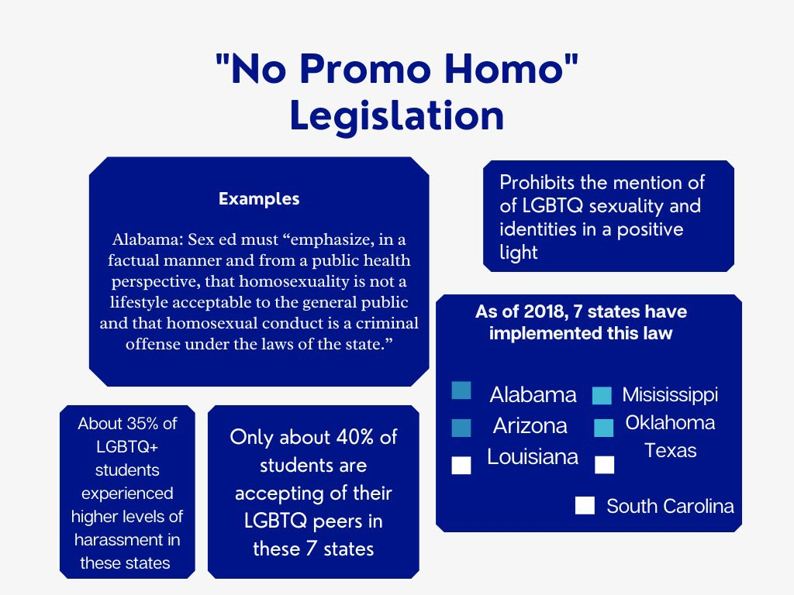
Regardless of the significant individual and societal benefits of sexual health education, the concept has continued to remain a controversial issue for decades. Massachusetts - despite its already weak requirements for sexual health education - is no exception to challenges to its curriculum, with two bills being filed in the 2023-24 session to require parents to opt-in to sexual health education. Opt-in provisions have consistently been proven to provide worse educational and societal outcomes for youth, and provide undue burdens for youth, teachers, and parents.⁷ The
Commission unquestionably stands against An Act Relative to Parental Notification (H.509), to require Massachusetts parents to opt-in their children to sexual health education.
Sexual health education must be mandated in all schools across the state, for a number of reasons. First, schools often do not receive enough support - financial and/or otherwise - from the state and local communities to offer or prioritize appropriate sexual health education. The Commission understands from its own conversations with advocates and schools that constant challenges and attacks against school curriculum have left Massachusetts schools wary of improving - and even discussing - their sexual health

curricula, or giving youth the appropriate space to process and understand the information being
provided.
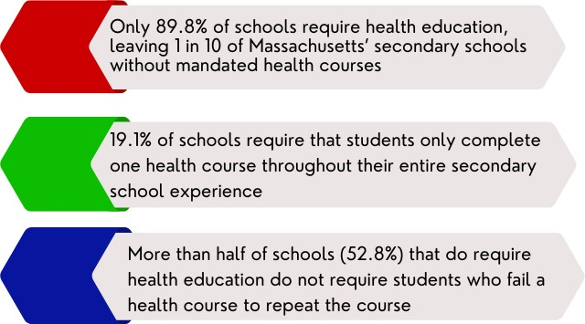
In the most recent 2020 School Health Profiles, Massachusetts educators provided the following information:

Of schools that required a health education course, most schools delivered the course between 6th
and 9th grade, with only a concerning 37.8% of schools delivering a course in 11th grade and 33.6% in 12th grade.⁸ However, even though three-quarters of responding schools taught health education at least once between 6th and 9th grade, only roughly half of Massachusetts schools included information on reducing sexual risk behaviors, the importance of condoms, and methods of contraception other than condoms; only 34.3% reported that they taught students how to appropriately use a condom. In Boston specifically - the only Massachusetts city reported in the public CDC profiles - only 29% of schools covered all 22 of the recommended sexual health topics between 6th and 8th grade, compared to states where comprehensive sexual health education is mandated which had cities with compliance rates as high as 97.1%.⁹
Comprehensive sexual health education gives youth the tools they need to avoid situations where they might have unprotected sex, subsequently reducing STIs, HIV/AIDS transmission, and unintended pregnancy rates. All youth are entitled to medically-accurate knowledge about their own bodies, how to build healthy relationships, and how to give and ask for consent; all of these areas are core factors of comprehensive sexual health education.¹⁰ Unfortunately, LGBTQ youth are often less likely to receive adequate and accurate education compared to their cisgender and heterosexual peers, with QTBIPOC youth further reporting disparate experiences in seeing appropriate and inclusive information pertaining to race, ethnicity, and culture in sexual health education.¹¹
Many of the opposing arguments around mandating sexual health education in schools centers around a parent’s right to have these conversations in the home - or, rather, only in the home. However, it is important to highlight the fact that most parents - in fact the majority of parents - are not opposed to sexual health education in schools, with 93% of parents of high school students reporting that teaching about sexual health in schools is important. Furthermore, 85% of the same parents supported including sexual orientation as a sexual health topic in schools; though given the widespread cultural shifts in the last six years since this 2017 survey was completed, the Commission suspects that this number has continued to rise.¹²
Finally, the Commission understands that by not passing a mandate for sexual health education or specific funding for curriculum updates, many lower-income schools, and areas with limited financial and community support may stop teaching sexual health topics altogether. This issue is particularly concerning

as QTBIPOC youth, who are more likely to face sexual violence than white youth, are also more likely to attend underfunded schools where sexual health education may not be a priority.¹³ Black women and girls are significantly more likely to face sexual violence or coercion, with 40-60% of Black women reporting being subjected to coercive sexual contact by the age of 18; 1 in 4 Black girls will be sexually abused before the age of 18.¹⁴ However, 53% of Black trans women report experiencing sexual violence, and are killed at higher rates than any other population.¹⁵ Ensuring that all schools teach a consent-based curriculum is essential, but especially in impoverished areas that lack the support to equip schools with healthy learning environments. However, as highlighted in multiple areas of this annual report, improving sexual health education only works to make an impact towards these numbers, and must work in tandem with other harm reduction and systemic improvement practices to ensure that all youth are safe and thriving.

Sexual Health Education Beyond Public Schools

Over the last year, the Commission has broadened its focus on sexual health education to examine disparities faced by youth outside of the public school system. In particular, the Commission, DCF, DYS, and DDS have had initial conversations in FY 2023 around updating sexual health education in the child welfare system, juvenile justice system, and services offered by DDS for youth with disabilities. The Commission encourages policymakers, advocates, families, and educators to take a wider look at the needs of youth as it pertains to health and education.

Language and Education that Fully Includes LGBTQ Youth

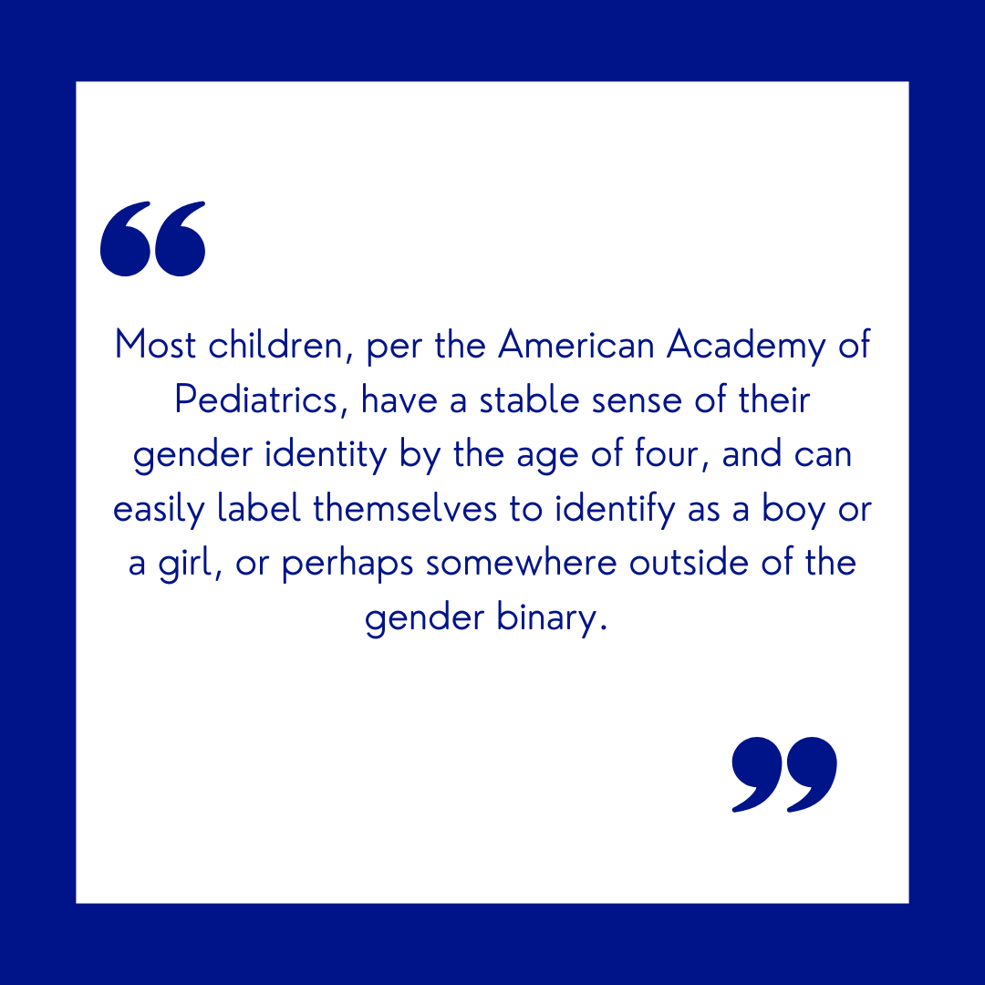
Entire cultural shifts must happen before we achieve a state where LGBTQ youth experience affirmation wherever they go, and the concept of sexual health and affirmation is broader than just looking at education in schools. In fact, LGBTQ- affirming education begins before a child’s first birthday, by teaching children that they have agency over their own bodies; that they should respect others’ bodies; and that adults in their lives respect who they are. Most children, per the American Academy of Pediatrics, have a stable sense of their gender identity by the age of four, and can easily label themselves to identify as a boy or a girl, or perhaps somewhere outside of the gender binary.¹⁶
Unfortunately, in a 2015 Massachusetts survey, 73% of youth who were out or were perceived as transgender between kindergarten and 12th-grade experience some form of mistreatment, harassment,

and physical and/or sexual violence; 11% of youth faced such severe mistreatment in schools as a transgender youth that they withdrew from school.¹⁷ The Massachusetts Youth Risk Behavior Survey shows that, while bullying and harassment rates have gone down in schools, transgender youth are still much more likely than their cisgender peers to experience cyberbullying and physical violence.
Support from caregivers, providers, educators, and other adults in youths’ lives can lay a critical foundation for children forming healthy
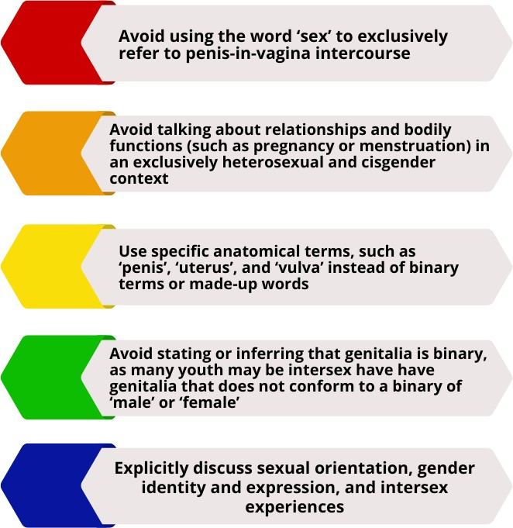
understandings of gender and sexuality. Encouraged methods beginning in early years include using gender-neutral pronouns in storytelling; highlighting LGBTQ figures and role models in curricula and storybooks; teaching about bodily autonomy and consent; supporting youth by using their chosen name and pronouns without hesitation; and encouraging youth to express themselves through choosing their own clothing and hairstyles.
While more formal sexual health education might begin in middle school, it is essential for caregivers to lay down
foundations of accurate information, as youth often receive incorrect and harmful information from peers, family members, and media.
As youth grow up, the creation and provision of safe and brave spaces is essential for youth to find communities where they can learn in structured and unstructured environments. Local community programs focusing on skills building and relationship development both in and out of schools can support youth as they explore their own personal growth.¹⁸
For supporting gender expansive youth in particular, caregivers and educators must ensure that youth are empowered from a young age in their gender identities, but also given room to be playful and flexible in their expressions. There are many options for young gender expansive youth to socially transition with taking any steps to alter their bodies, including haircuts, name changes, and clothing expression. As children get older, the use of makeup and other gender-affirming items, like wigs, packers, and padded bras may be other options to support youth’s gender expression prior to or alongside puberty blockers. Supported by numerous medical organizations and providers, puberty blockers are a safe, temporary, and effective method - lasting only as long as a patient uses the blockers - of delaying the onset of puberty to allow gender expansive youth the time to explore their gender identity and decide what future steps they may want to take in their transition with very little risk.¹⁹ Research has decisively shown that taking puberty blockers has significantly positive mental health effects for gender expansive youth, including reducing rates of suicidal ideation and attempts;²⁰ and 98% of youth who use puberty blockers continue gender-affirming treatment into adulthood.²¹

Bodily Autonomy for Intersex Youth

When having conversations around bodily autonomy, it is essential that caregivers, advocates, and policymakers include the experiences of intersex youth. Though performing medically unnecessary surgeries on intersex infants has been widely condemned by medical professionals and advocates - including the American Academy of Family Physicians²² and Amnesty International²³ - as unethical and harmful to youth, surgeries intended to make intersex babies’ genitals more typical in a binary appearance still occur across the United States. Such surgeries can result in irreversible lifelong effects including sterilization, scarring, chronic pain and incontinence, as well as loss of sexual sensation, psychological trauma, and gender dysphoria.²⁴ In 2020, Boston Children’s Hospital announced that it would stop performing genital reconstruction surgeries on intersex patients unable to offer consent, though the Commission is unaware if any other hospitals in Massachusetts have continued or discontinued these surgical practices on intersex infants.²⁵
In addition to surgery, caregivers and providers may often unethically compromise intersex youths’ bodily autonomy in other ways, such as keeping intersex identity from the youth, or providing hormone therapy or puberty blockers to unaware youth. In a 2021 Trevor Project survey on youth mental health, nearly 1 in 2 intersex youth seriously considered suicide, compared to 41% of LGBTQ youth who did not identify as intersex; and two-thirds of responding intersex youth noted that they had experienced symptoms of major depressive disorder within the two weeks prior.²⁶

Contraceptive Options and Access

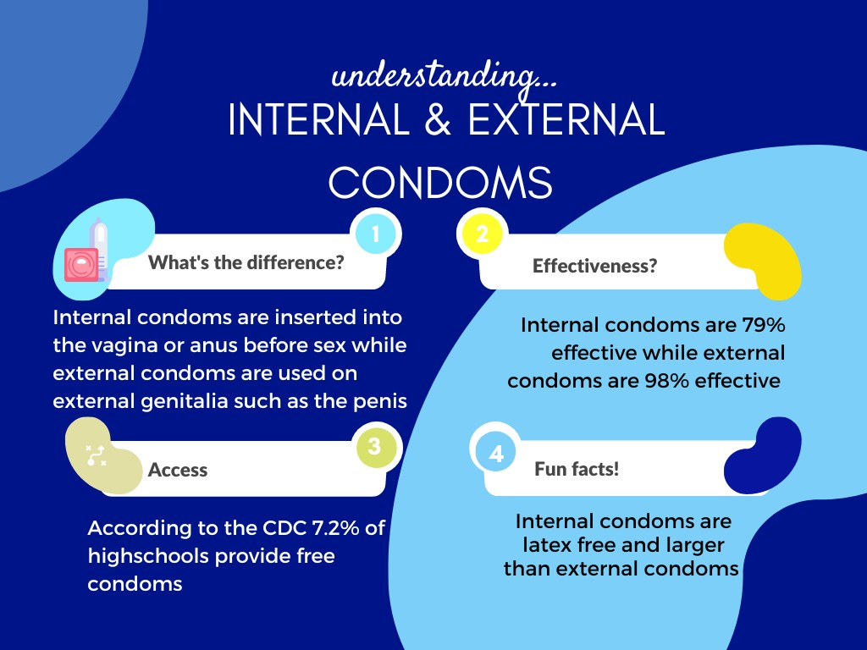
Far too often, the conversations around contraception with youth are limited to external condoms as the primary option for contraceptive devices - an approach that often ignores alternative, and sometimes more relevant, LGBTQ-inclusive contraceptive devices. Condoms - both external and internal - are highly effective at reducing infections, HIV transmission, and unintended pregnancies, and are the most accessible as they can often be purchased at convenience
stores. However, cost, safety, transportation, mobility, and fear of stigmatization can often be challenging barriers to overcome, particularly for youth still living with their parents, who may opt out of purchasing condoms altogether and participating in unprotected sexual behaviors.

As recommended above, it is essential to increase access to all types of contraceptive devices for youth, and increase education campaigns around the importance of proper usage. A 2021 national study showed that only 38% of LGBTQ youth used a condom during their last sexual intercourse compared to 60% of heterosexual and cisgender youth.²⁷ Furthermore, only 11% of bisexual high school boys who had a same- sex partner used a condom during their last sexual intercourse.²⁸ As discussed in the Commission’s previous FY 2023 MYRBS analysis, there has been a concerning decline in condom usage amongst youth in Massachusetts, with only 54.3% of youth in 2019 reporting using a condom during their last sexual intercourse - between 2019 and 2021 there was only a 4% increase in condom usage amongst Massachusetts youth.
Besides distribution, as discussed above, education to reduce misinformation about condom usage — such as loss of pleasurable sensation and misconceptions that someone has an STI if they ask to use one
— should be provided as part of sexual health education, as should lessons on how to negotiate condom use and risk factors involved; internal condoms are 95% effective at preventing STIs and pregnancy if used correctly, but end up being 75-95% correctly because of tears, spillage, placement, or other issues,²⁹ whereas external condoms are often noted as 98% effective at preventing pregnancy but, in reality, are only about 87% effective due to improper use.³⁰
Additionally, as discussed in other sections of this report, LGBTQ youth may engage in types of sex work for a variety of different reasons. LGBTQ youth face higher rates of homelessness, poverty, involvement with the criminal legal system, and substance abuse due to societal factors influenced by stigma, discrimination, and racism. However, as a result, LGBTQ are three times more likely to engage in sex work, and may exchange sexual acts for food, housing, or other needs.³¹ Not all sex work involves sexual intercourse, though, and LGBTQ youth may also engage in online sex work like OnlyFans or selling nude pictures for income; as such, sexual health education curriculum should be sure to cover potential privacy risks and safety concerns that may occur from engaging in online relationships.³² Unfortunately, LGBTQ youth engaging in sex work are more likely to avoid purchasing contraceptive devices, as possession of condoms - regardless of whether an individual is intending to engage in sex work at that time - can be used as proof of sex work, leading to disproportionate arrests of Black and brown LGBTQ youth, particularly trans women of color, undocumented, and homeless youth.³³
Overall, transgender and gender expansive youth may also avoid using contraceptive devices that may cause gender dysphoria, though contraception can also be used as a key facet of gender-affirming care.³⁴ Similarly, contacting a medical provider for an IUD insertion or a birth control injection, or picking up birth control or Plan B at a pharmacy, can often be complicated and inaccessible choices for individuals who are transgender or gender expansive due to fear of stigmatization or medical discrimination.³⁵ In a 2015 survey of Massachusetts, 28% of transgender people experienced a problem in the past year with their insurance, such as being denied coverage for routine care because they were transgender.³⁶ Lack of ID due to the cost of updating identification documents, immigration status, and lack of address due to homelessness are all possible reasons LGBTQ youth may not have health resources. Without health insurance, the cost of an IUD, birth control pills, Plan B, or a birth control injection can be expensive, and

youth may not know where else they can go for access, particularly outside of urban areas. Furthermore, in the same survey, 31% of transgender people who saw a health care provider reported having at least one negative experience (verbal abuse, refusal to be treated, physical assault, sexual assault, needing to teach the provider about transgender in order to get appropriate care) related to being transgender.³⁷ While the Commission waits for results on the experiences of transgender youth in Massachusetts from an incoming 2022 U.S. Transgender Survey, the Commission continues to be notified by youth, families, and advocates that fear of stigmatization, discrimination, and racism continue to pose barriers for LGBTQ, QTBIPOC, and intersex youth seeking medical care.

Pregnancy in LGBTQ Youth

As discussed further in the section on pregnancy in this annual report, LGBTQ women, girls and nonbinary youth (as high as 46.6%) are more likely to become pregnant than straight, cisgender youth.³⁸ Research indicates that unintended teen pregnancy rates have been shown to be higher for youth who are Black, Latinx, Native, Pacific Islander, living in foster care, homeless, or have an intellectual disability.^{39,40,41} Further potential disparate factors for unintended pregnancies include childhood abuse, increased rates of sexual assault, bullying, family’s low income, and lack of access to appropriate sexual health education.⁴²
Consequently, LGBTQ youth are more likely than cisgender, heterosexual youth to seek access for abortion services; one national study indicated that bisexual teens were three times more likely than heterosexual teens to have an abortion.⁴³ In a 2021 national study of transgender, nonbinary, and gender expansive people assigned-female-at-birth or intersex who were mostly under 30 years old, 21% who had been pregnant had gotten an abortion.⁴⁴ Similar barriers to contraception access also exist for abortion access, including cost, health insurance coverage, transportation, medical discrimination and racism, unsupportive caregivers, and immigration status.

Sexual Victimization

As discussed further in the public health section, LGBTQ youth, particularly QTBIPOC youth, are at a much higher risk of sexual violence compared to white, cisgender, and heterosexual youth. Stigmatization and hypersexualization of LGBTQ people, racism, sexism, transphobia, homophobia, and other forms of marginalization are some of the factors that lead to these concerning disparities, and also make it less likely that LGBTQ youth will report sexual violence incidents or assaults to law enforcement.⁴⁵
Furthermore, LGBTQ youth reported childhood sexual abuse at a higher rate than heterosexual, cisgender teens;⁴⁶ 19% of gender expansive teens reported childhood sexual abuse, with nonbinary youth assigned- female-at-birth most at risk.⁴⁷ In the 2021 Massachusetts YRBS survey,⁴⁸ 20% of LGBQ youth indicated they were forced to have sex when they did not want to, compared to 5% of straight youth. In the same survey, 22% of LGBQ+ youth reported experiencing any sexual violence compared to 8% of heterosexual

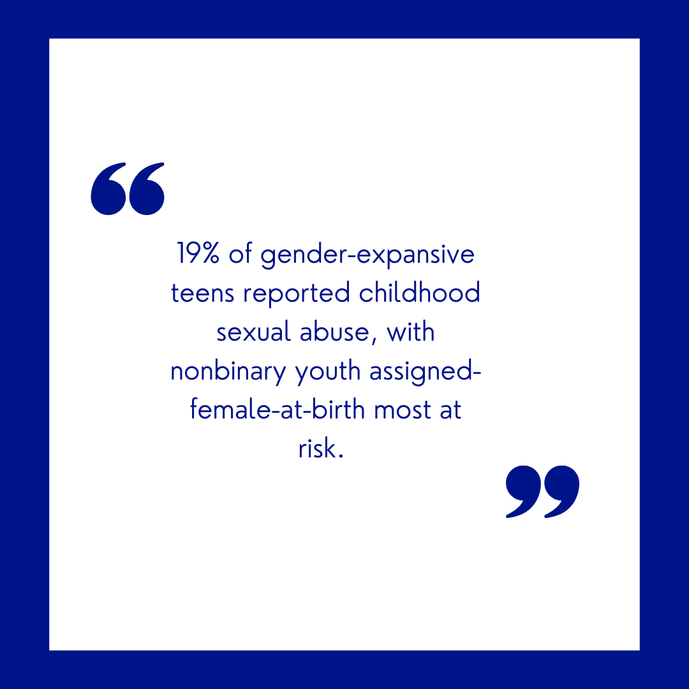
youth in Massachusetts. As mentioned above, nearly half of transgender people in the U.S. report being sexually abused or assaulted at some point in their life;⁴⁹ 46% of bisexual women also report being raped at some point in their lifetime (compared to 17% of straight women) and for nearly 48% of those women, their first rape occurred between the ages of 11 and 17.⁵⁰ Across college campuses, research has long demonstrated that sexual violence is a pervasive issue that LGBTQ youth experience sexual violence at disproportionate rates. The Commission commends the actions of Massachusetts advocates, legislators, and campus officials for prioritizing campus safety for youth across the state, but urges campuses to continue to explore ways to support LGBTQ youth.
Within carceral and education institutions, as well as shelters and transitional housing units,⁵¹ LGBTQ youth experience disproportionately higher rates of sexual violence. Nationwide, in a 2014 survey 40% of transgender people reported being sexually assaulted or abused in a carceral institution, which is nearly ten times the rate of cisgender incarcerated people.⁵² As noted in the criminal justice and homelessness sections of this annual report, transgender youth who are housed in single-sex environments that do not match their gender identity are more likely to be at risk of sexual assault from other residents and facility staff. Furthermore, homelessness, history of abuse, disengagement from family, and substance abuse all increase LGBTQ youth’s risk of being sexually exploited or trafficked.⁵³
When looking at sexual victimization prevention strategies, including in bystander intervention methods training, it is important to take specific societal and cultural considerations for LGBTQ and QTBIPOC youth into account. For example, one way a well-meaning bystander may try to intervene is by calling the police to mediate an incident. However, as discussed further in the criminal justice section of this annual report, police intervention for QTBIPOC youth can sometimes be particularly dangerous, given the disproportionate rates of police hostility, harassment, and violence.⁵⁴

Conclusion

Unequivocally, improving sexual health in Massachusetts is essential for ensuring that LGBTQ youth are able to thrive. Below, the Commission provides a list of relevant resources and recommendations from health bodies and organizations supporting youth sexual health.

Relevant Recommendations from Health Bodies and Nonprofit Organizations
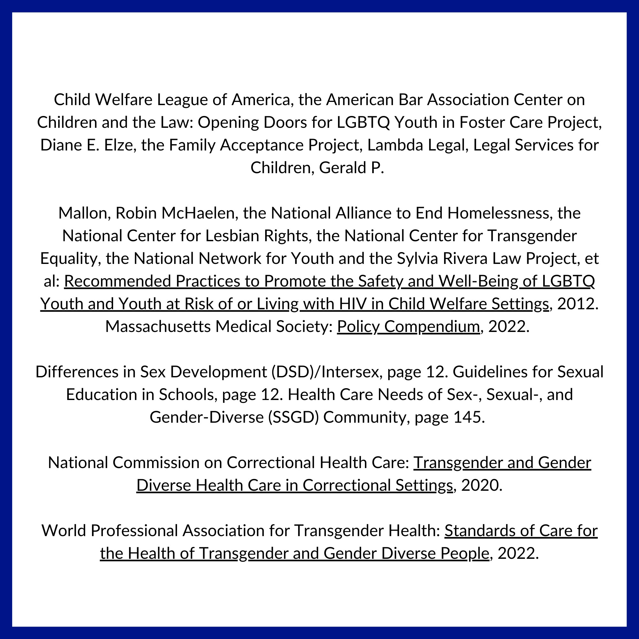

Resources
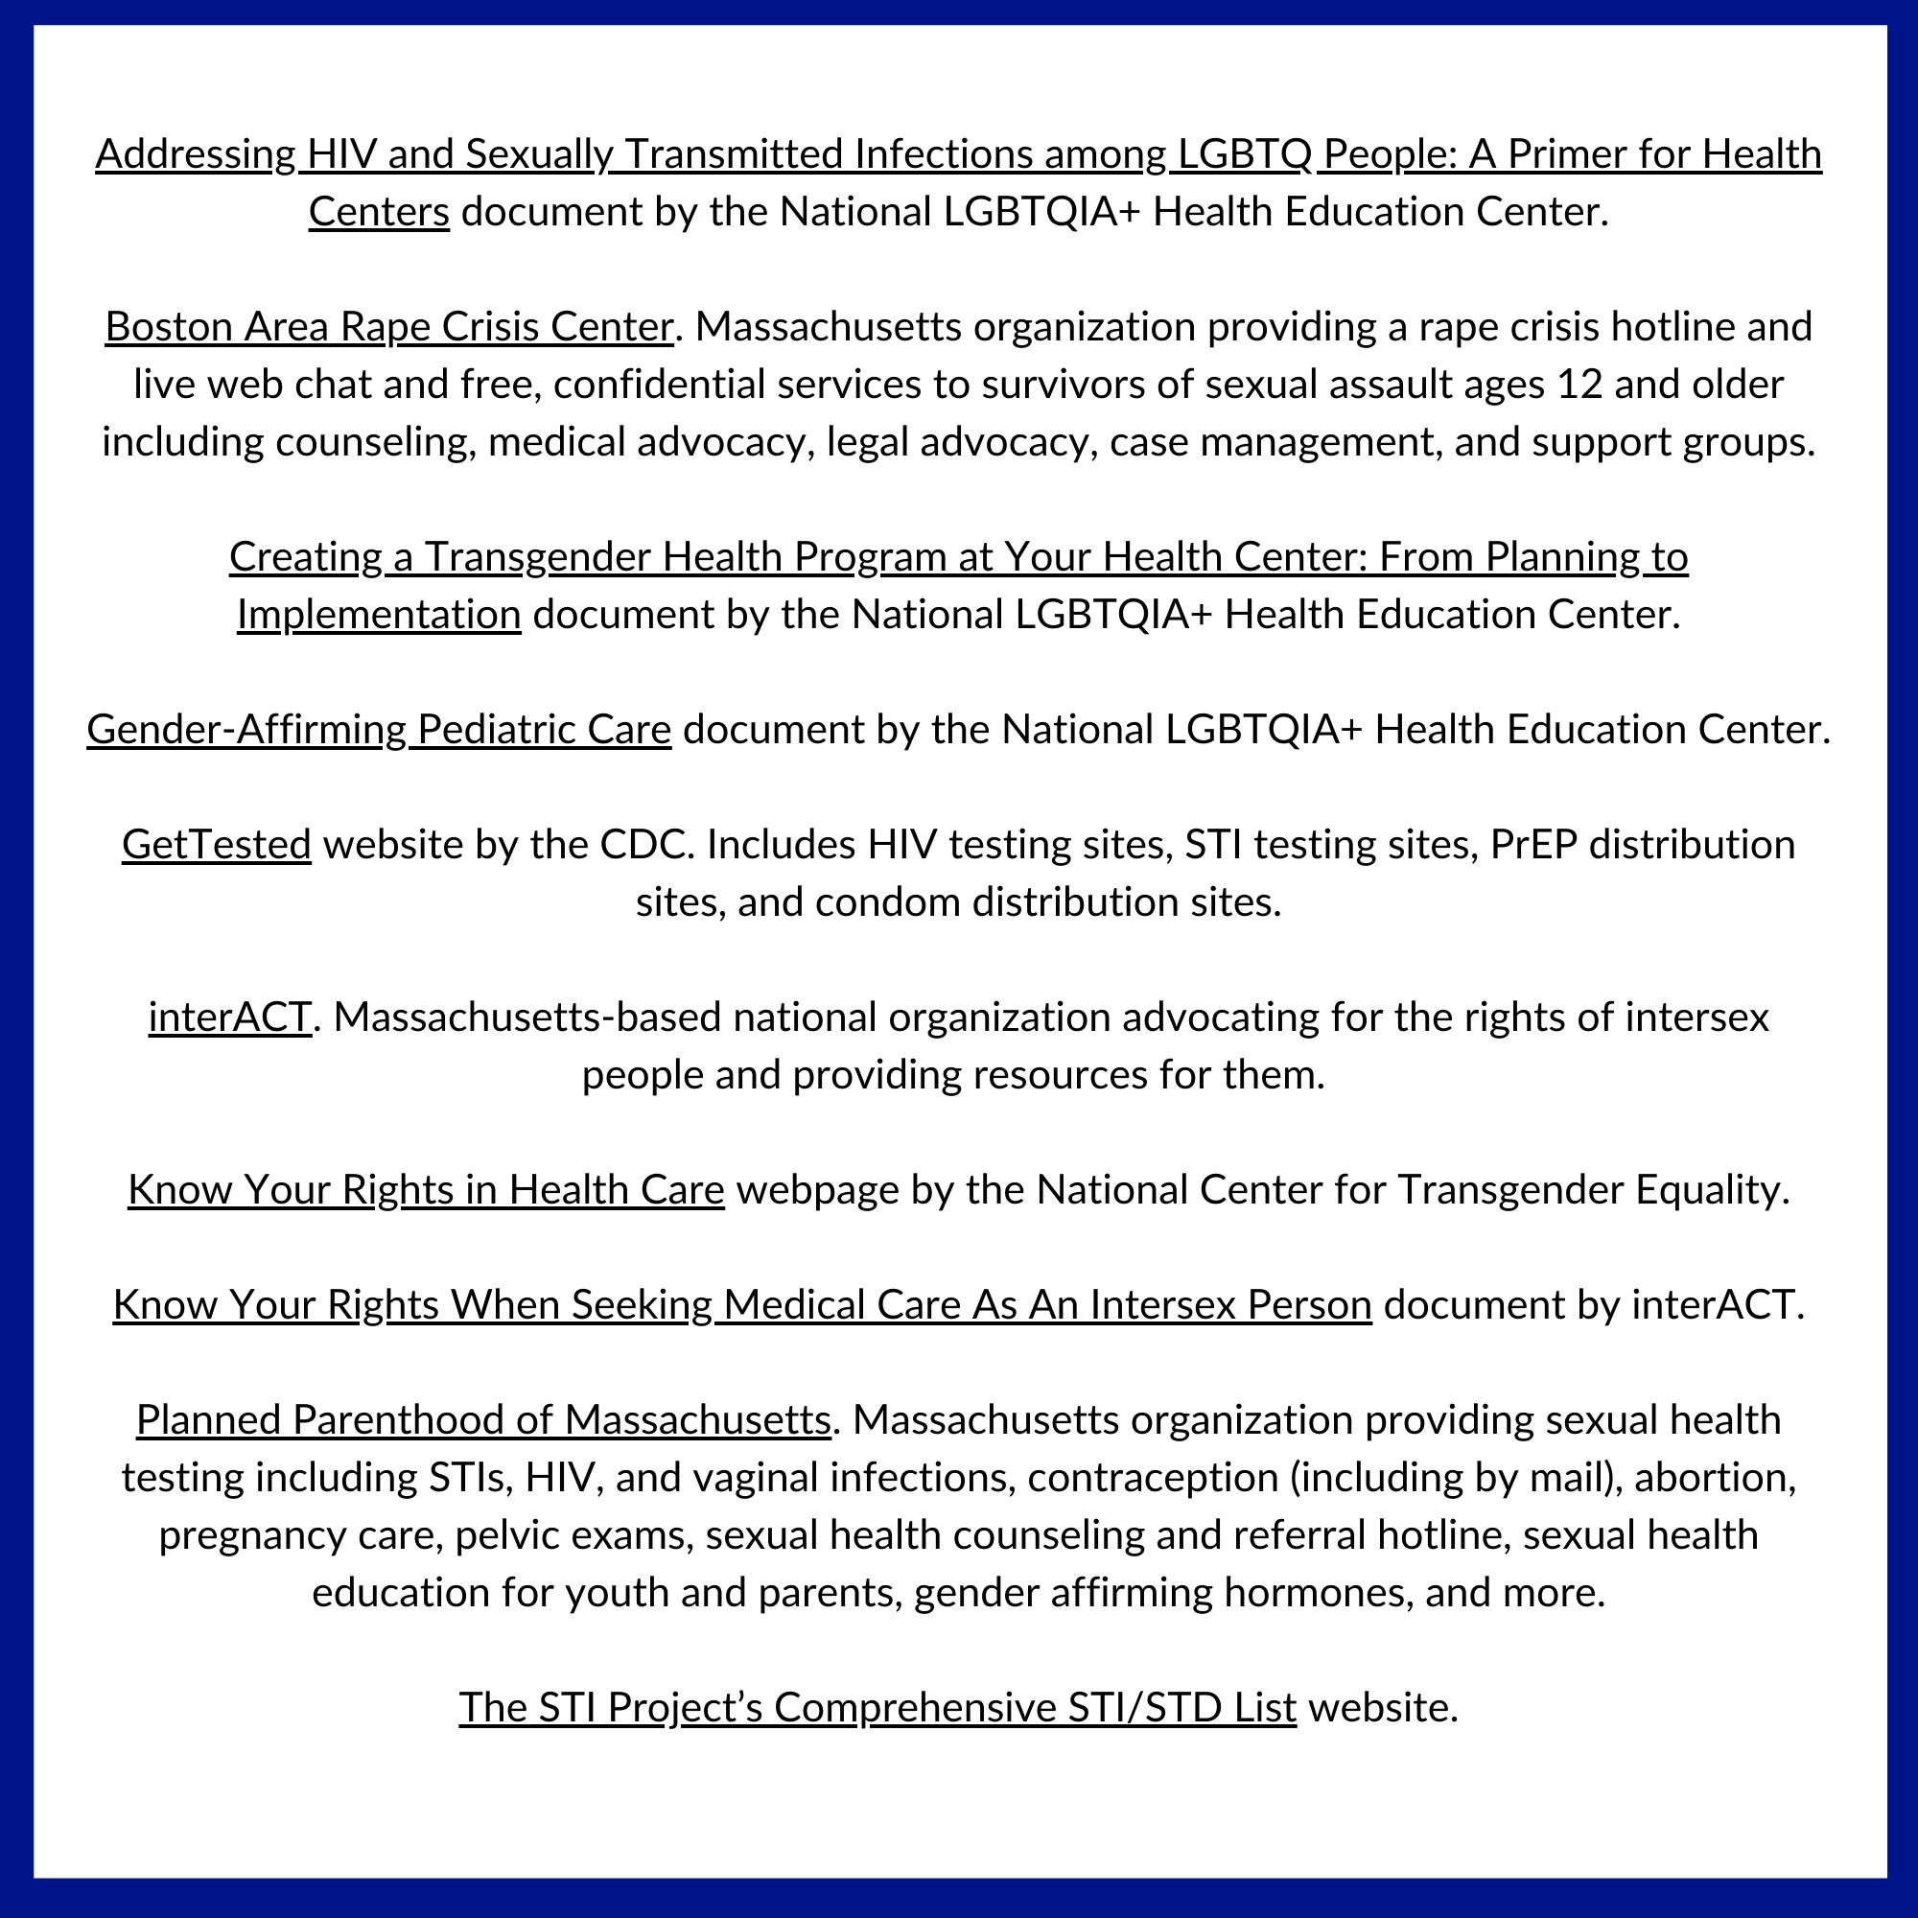

Acknowledgments & Citations

Acknowledgments: Sarah Prager, lead researcher and author

1 “The SIECUS State Profiles 2019 / 2020 - The State of Sex Ed,” SIECUS, accessed April 24, 2023, https://siecus.org/state- profiles-2019-2020/.

2 Samantha L. Seybold, “Not Just ‘Bodies with Vaginas’: A Kantian Defense of Pelvic Exam Consent Laws,” Bioethics 36, no. 9 (November 2022): 940–47, https://doi.org/10.1111/bioe.13084.
3 “Law and Policy,” NJCASA, accessed March 17, 2023, https://njcasa.org/our-work/law-and-policy/.
4 “The Importance of Access to Comprehensive Sex Education,” accessed April 24, 2023, https://www.aap.org/en/patient- care/adolescent-sexual-health/equitable-access-to-sexual-and-reproductive-health-care-for-all-youth/the-importance-of- access-to-comprehensive-sex-education/.
5 “Sexual Health,” accessed February 14, 2023, https://www.who.int/health-topics/sexual-health.
6 GLSEN, “Laws That Prohibit the ‘Promotion of Homosexuality’: Impacts and Implications,” 2018, https://www.glsen.org/sites/default/files/2019-12/No_Promo_Homo_2018.pdf.
7 “Opt-In vs. Opt-Out: State Sex Ed & Parental Consent Policies,” SIECUS, accessed April 24, 2023, https://siecus.org/resources/opt-in-vs-opt-out-state-sex-ed-parental-consent-policies/.
8 “Adolescent and School Health (DASH) | CDC,” March 16, 2023, https://www.cdc.gov/healthyyouth/index.htm.
9 “Adolescent and School Health (DASH) | CDC.”
10 Christine Panchaud and Ragnar Anderson, “Demystifying Data: Using Evidence to Improve Young People’s Sexual Health and Rights—Workshop Toolkit,” August 5, 2016, https://www.guttmacher.org/report/demystifying-data-workshop-toolkit.
11 SIECUS: Sex Ed for Social Change, et al. May 2021. “A Call to Action: LGBTQ+ Youth Need Inclusive Sex Education,” page 2. https://hrc-prod-requests.s3-us-west-2.amazonaws.com/Call-to-Action-LGBTQ-Sex-Ed-Report-2021.pdf.
12 Kantor, Leslie, and Nicole Levitz. 2017. “Parents’ Views on Sex Education in Schools: How Much Do Democrats and Republicans Agree?” PLOS ONE 12, no. 7 (July 3, 2017). https://10.1371/journal.pone.0180250.
13 Robert Atkins et al., “The Effects of School Poverty on Adolescents’ Sexual Health Knowledge,” Research in Nursing & Health
35, no. 3 (June 2012): 231–41, https://doi.org/10.1002/nur.21471.
14 “Black Women, the Forgotten Survivors of Sexual Assault,” https://www.apa.org, accessed April 24, 2023, https://www.apa.org/pi/about/newsletter/2020/02/black-women-sexual-assault.
15 Maya Finoh and Jasmine Sanofka, “The Legal System Has Failed Black Girls, Women, and Non-Binary Survivors of Violence | ACLU,” American Civil Liberties Union (blog), January 28, 2019, https://www.aclu.org/news/racial-justice/legal-system-has- failed-black-girls-women-and-non.
16 Rafferty, Jason. 2022. “Gender Identity in Children.” American Academy of Pediatrics.
17 National Center for Transgender Equality. 2017. “2015 U.S. Transgender Survey: Massachusetts State Report.” https://transequality.org/sites/default/files/docs/usts/USTSMAStateReport(1017).pdf
18 “Student and Family Support (SFS) - Massachusetts Department of Elementary and Secondary Education,” accessed March 12, 2023, https://www.doe.mass.edu/sfs/?section=family.
19 “Movement Advancement Project | LGBTQ Policy Spotlight: Efforts to Ban Health Care for Transgender Youth Infographics,” accessed April 24, 2023, https://www.lgbtmap.org/2021-spotlight-health-care-bans-infographics.
20 Turban, Jack. February 2020. “Pubertal Suppression for Transgender Youth and Risk of Suicidal Ideation.” Pediatrics. Volume 145, Volume 2. https://www.ncbi.nlm.nih.gov/pmc/articles/PMC7073269/.
21 van der Loos, Maria Anna Theodora Catharina, et al. October 20, 2022. “Continuation of gender-affirming hormones in transgender people starting puberty suppression in adolescence: a cohort study in the Netherlands.” The Lancet. Volume 6, Issue 12: pp. 869-875. https://doi.org/10.1016/S2352-4642(22)00254-1.
22 “Genital Surgeries in Intersex Children | AAFP,” accessed March 2, 2023, https://www.aafp.org/about/policies/all/genital- surgeries.html.
23 “The Rights of Children Born Intersex,” Amnesty International, May 9, 2017, https://www.amnesty.org/en/latest/campaigns/2017/05/intersex-rights/.
24 Kyle Knight, “‘I Want to Be Like Nature Made Me,’” Human Rights Watch, July 25, 2017, https://www.hrw.org/report/2017/07/25/i-want-be-nature-made-me/medically-unnecessary-surgeries-intersex-children-us. 25 Boston Children’s Hospital. “Behavioral Health, Endocrinology, Gynecology, Urology (BEING-U).” https://www.childrenshospital.org/programs/being-u.
26 “Intersex: Not Invisible,” The Trevor Project (blog), October 26, 2022, https://www.thetrevorproject.org/blog/intersex-not- invisible/.
27 SIECUS: Sex Ed for Social Change, et al. May 2021. “A Call to Action: LGBTQ+ Youth Need Inclusive Sex Education,” page 7. https://hrc-prod-requests.s3-us-west-2.amazonaws.com/Call-to-Action-LGBTQ-Sex-Ed-Report-2021.pdf.
28 SIECUS: Sex Ed for Social Change, et al. May 2021. “A Call to Action: LGBTQ+ Youth Need Inclusive Sex Education,” page 7. https://hrc-prod-requests.s3-us-west-2.amazonaws.com/Call-to-Action-LGBTQ-Sex-Ed-Report-2021.pdf.
29 National Library of Medicine. 2022. “Female condoms.” https://medlineplus.gov/ency/article/004002.htm.
30 Planned Parenthood. “How effective are condoms?” https://www.plannedparenthood.org/learn/birth-control/condom/how- effective-are-condoms.

31 Bauer, Elizabeth Edmondson, et al. “College-Aged but On the Streets: Young Adults Who Experience Homelessness and Sexual Violence,” page 5. National Sexual Assault Coalition Resource Sharing Project. https://evawintl.org/wp- content/uploads/YoungAdultsWhoExperienceHomelessnessandSexualViolenceMay2017.pdf.
32 Marie Lippmann, Natalie Lawlor, and Christine E. Leistner, “Learning on OnlyFans: User Perspectives on Knowledge and Skills Acquired on the Platform,” Sexuality & Culture, January 9, 2023, https://doi.org/10.1007/s12119-022-10060-0.
33 Margaret H Wurth et al., “Condoms as Evidence of Prostitution in the United States and the Criminalization of Sex Work,” Journal of the International AIDS Society 16, no. 1 (May 24, 2013): 10.7448/IAS.16.1.18626, https://doi.org/10.7448/IAS.16.1.18626.
34 Rula V. Kanj et al., “Hormonal Contraceptive Choices in a Clinic-Based Series of Transgender Adolescents and Young Adults,” The International Journal of Transgenderism 20, no. 4 (July 1, 2019): 413–20, https://doi.org/10.1080/15532739.2019.1631929. 35 A. Francis, S. Jasani, and G. Bachmann, “Contraceptive Challenges and the Transgender Individual,” Women’s Midlife Health 4 (July 13, 2018): 12, https://doi.org/10.1186/s40695-018-0042-1.
36 National Center for Transgender Equality. 2017. “2015 U.S. Transgender Survey: Massachusetts State Report,” page 3. https://transequality.org/sites/default/files/docs/usts/USTSMAStateReport(1017).pdf.
37 National Center for Transgender Equality. 2017. “2015 U.S. Transgender Survey: Massachusetts State Report,” page 3. https://transequality.org/sites/default/files/docs/usts/USTSMAStateReport(1017).pdf.
38 Charlton, Brittany, et al. March 2021. “Teen Pregnancy Risk Factors Among Young Women of Diverse Sexual Orientations.” In Pediatric Collections: LGBTQ+: Support and Care (Part 2: Health Concerns and Disparities). American Academy of Pediatrics. https://doi.org/10.1542/9781610025409-teen.
39 Centers for Disease Control and Prevention. 2021. “About Teen Pregnancy.” https://www.cdc.gov/teenpregnancy/about/index.htm.
40 Thompson, Sanna, et al. April 11, 2008. “Runaway and Pregnant: Risk Factors Associated with Pregnancy in a National Sample of Runaway/Homeless Female Adolescents.” The Journal of Adolescent Health, Volume 43, Issue 2, 125–132. https://www.ncbi.nlm.nih.gov/pmc/articles/PMC2742657/.
41 Center for Youth and Adults with Conditions of Childhood, Indiana School of Medicine. “Teenage Pregnancy and Youth with Intellectual Disabilities.” https://instrc.indiana.edu/pdf/resources/Fact_Sheet_Teen_Pregnancy_with_Disability.pdf.
42 Charlton, Brittany, et al. March 2021. “Teen Pregnancy Risk Factors Among Young Women of Diverse Sexual Orientations.” In Pediatric Collections: LGBTQ+: Support and Care (Part 2: Health Concerns and Disparities). American Academy of Pediatrics. https://doi.org/10.1542/9781610025409-teen.
43 Charlton, Brittany, et al. December 2019. “Sexual Orientation Differences in Pregnancy and Abortion Across the Lifecourse.” Guttmacher Institute. https://www.guttmacher.org/article/2019/12/sexual-orientation-differences-pregnancy-and-abortion- across-lifecourse.
44 Moseson, Heidi et al. September, 24, 2020. “Abortion experiences and preferences of transgender, nonbinary, and gender- expansive people in the United States.” American Journal of Obstetrics & Gynecology, Volume 224, Issue 4, 376.e1 - 376.e11. https://doi.org/10.1016/j.ajog.2020.09.035.
45 Heather Tillewein et al., “Silencing the Rainbow: Prevalence of LGBTQ+ Students Who Do Not Report Sexual Violence,” International Journal of Environmental Research and Public Health 20, no. 3 (January 22, 2023): 2020, https://doi.org/10.3390/ijerph20032020.
46 Thoma, Brian, et al. August 2021. “Disparities in Childhood Abuse Between Transgender and Cisgender Adolescents.”
Pediatrics: Volume 148, Issue 2. https://pubmed.ncbi.nlm.nih.gov/34226247/.
47 Thoma, Brian, et al. August 2021. “Disparities in Childhood Abuse Between Transgender and Cisgender Adolescents.”
Pediatrics: Volume 148, Issue 2. https://pubmed.ncbi.nlm.nih.gov/34226247/.
48 2021 MYRBS Analysis – data on file with Commission.
49 Office for Victims of Crime. June 2014. “Sexual Assault in the Transgender Community: The Numbers.” https://ovc.ojp.gov/sites/g/files/xyckuh226/files/pubs/forge/sexual_numbers.html.
50 National Center for Injury Prevention and Control. “NISVS: An Overview of 2010 Findings on Victimization by Sexual Orientation.” https://www.cdc.gov/violenceprevention/pdf/cdc_nisvs_victimization_final-a.pdf.
51 Bauer, Elizabeth Edmondson, et al. “College-Aged but On the Streets: Young Adults Who Experience Homelessness and Sexual Violence,” page 4. National Sexual Assault Coalition Resource Sharing Project. https://evawintl.org/wp- content/uploads/YoungAdultsWhoExperienceHomelessnessandSexualViolenceMay2017.pdf.
52 National Center for Transgender Equality. December 18, 2014. “Federal Survey: 40% of Transgender Prisoners Are Sexually Abused Each Year.” https://transequality.org/blog/federal-survey-40-of-transgender-prisoners-are-sexually-abused-each-year. 53 Hernandez, Rebecca. July 27, 2021. “The Commercial Exploitation of Boys & LGBTQ+ Youth: A Systematic Literature Review.” https://scholarworks.calstate.edu/downloads/2v23w095f.
54 Gabriel L. Schwartz, Jaquelyn L. Jahn, and Amanda Geller, “Policing Sexuality: Sexual Minority Youth, Police Contact, and Health Inequity,” SSM - Population Health 20 (November 17, 2022): 101292, https://doi.org/10.1016/j.ssmph.2022.101292.

COMMISSION ON LGBTQ YOUTH
SEXUAL HEALTH & WELLNESS

ABOUT
LGBTQ youth remain at a higher risk for STIs, HIV, and sexual violence. Furthermore, as discussed in the above section, LGBTQ youth are often left out of conversations around national and statewide conversations involving pregnancy, abortion access, and gynecological health, but often face significant
34%
of schools in Massachusettes taught students how to appropriately use a condom

disparities in access and care. Compounding these
issues, LGBTQ youth frequently encounter barriers to accessing contraceptives, affirming medical care, and

inclusive sexual health education.
RECOMMENDATIONS
Ensure that all youth have access to age-appropriate, LGBTQ-inclusive, and consent-based sex ed and provide educators with implementation support.

Support and increase HIV & STI prevention and treatment services for LGBTQ youth, and awareness campaigns across the state.

Prohibit medical providers from performing non- consensual examinations on unconscious patients.
Support and increase HIV & STI prevention and treatment services and awareness campaigns.

40-60%
of Black women reporting being
subjected to coercive sexual contact by the age of 18

38%
of LGBTQ youth used a condom during their last sexual intercourse compared to 60% of heterosexual and cisgender youth




LEGISLATION
S.268/H.544: The Healthy Youth Act S.619/H.1085: HIV Prevention Medication Access
S.1333/H.2146: Prohibit Nonconsensual Intimate Examinations

Ending Youth Homelessness

Introduction

Currently, Massachusetts is ranked #1 in the nation by the True Color’s State Index of Youth Homelessness. This distinction recognizes the Commonwealth for the depth and breadth of its infrastructure, policies, and programs that support youth experiencing homelessness or housing instability. While there is much to be celebrated, there also remains work to be done. In the Commonwealth, LGBTQ youth—particularly queer, transgender, Black, Indigenous, and people of color (QTBIPOC) - are disproportionately represented among youth experiencing homelessness.¹ Like other sections of this report, because the Commission has a broad definition of youth as ‘those under 25’, this section discusses experiences of youth who are minors, and youth over 18. While many of these experiences overlap, there remain few services or shelter spaces dedicated to minor - or unaccompanied - youth, as minors experiencing homelessness are often placed into the child welfare system.

The Commonwealth must maintain its commitment to collaboration with individuals, families, communities and institutions to advocate for prevention, assistance, and ongoing support for housing insecure youth, while appreciating the intersecting identities of race, ethnicity, sexual orientation, gender identity, and gender expression. Multiple risk factors contribute to LGBTQ youth’s experience of higher rates of homelessness, such as family rejection, abandonment and conflict, poverty, medical and mental health difficulties, discrimination, and racism. Moreover, many LGBTQ youth have cited additional vulnerabilities with regard to familial and communal rejection of their identities based on claimed religious values and beliefs.

Over the last several years, the Commission has taken an in-depth view into the impact of uncertainties faced by LGBTQ youth – especially QTBIPOC and gender expansive youth - during the COVID-19 pandemic. The COVID-19 pandemic has highlighted and exacerbated the existing multifaceted disparities impacting marginalized communities. To address the current state of young people experiencing homelessness and housing insecurity in Massachusetts, the Commonwealth must commit to collaborating with stakeholders to advocate for prevention, assistance, and ongoing support for housing insecure youth.

Recommendations to the Governor and Legislature on Homelessness

- Improve access to state IDs for youth experiencing homelessness and gender expansive youth.

Proper identification is crucial for homeless individuals, especially youth, to prove eligibility to access services such as financial benefits, housing assistance, food assistance, and educational and vocational opportunities.² As noted throughout this annual report, barriers to accessing and maintaining legitimate forms of identification for youth experiencing homelessness include, but are not limited to, the identity verification catch-22, or the requirement of official ID(s) to request an ID; residency verification; varied limits on type and age of ID requestor (parent/guardian/self); cost and arduous bureaucratic process; limited to no access of space for safekeeping personal items; and lack of accessible amendment policies to gender marking and name change.³

LGBTQ people are more likely to experience harassment and discrimination when seeking shelter and housing assistance, which may be complicated by a lack of proper identification.^{4,5}

- Increase services for LGBTQ youth experiencing homelessness or housing instability, and ensure that providers are adhering to best and promising practices.

The Commonwealth oversees, provides, and funds many services for youth who are at risk for or are currently experiencing housing instability or homelessness. However, the Commission has continued to hear from youth and providers that there are not enough programs that are LGBTQ-affirming, or have staff who are knowledgeable about salient issues facing LGBTQ and QTBIPOC youth experiencing homelessness or housing instability. For example, youth frequently report that some of the providers they interact with do not appreciate the complexity of family reunification - which is not always possible, and is rarely easy - for youth facing rejection relating to their LGBTQ identity. Furthermore, QTBIPOC youth continue to report numerous instances of racism and xenophobia within programs described as ‘safe spaces’, in addition to feeling ostracized from their own racial and ethnic communities.^{6,7}

Providers and program administrators should ensure that their programs and services are working to address the impact of intersectional identities and systemic oppression on QTBIPOC youth’s experience of accessing resources. To ensure quality care to all LGBTQ youth, programs should further ensure that they are using a variety of means - such as trainings, professional development, contractual requirements, and policy development - to increase the adherence to best and promising practices.

Furthermore, the Commission urges the Commonwealth’s legislature to continue expanding funding under line items for services directed towards LGBTQ youth experiencing housing instability or homelessness, and explore further service provision possibilities for minors experiencing homelessness. Specifically, funding should expand to increase permanent housing opportunities as well as statewide safe drop-in spaces for unhoused young people, especially LGBTQ youth that provide food, shelter, social connection, healthcare, and social services. Such funding and services should pay particular attention to underserved QTBIPOC and immigrant communities.

- Codify a bill of rights for people experiencing homelessness.

LGBTQ youth are already more likely than others to face discrimination in their daily lives and are more likely to experience homelessness, a status that greatly increases the risk of facing bias and discrimination. This vulnerability is amplified with consideration of QTBIPOC identities among LGBTQ youth and those identified as transgender or gender expansive. The Commission supports the bill of rights legislation for people experiencing homelessness that reflects common concerns raised by this population. It includes the rights to move freely while in public spaces, to be treated equitably by government agencies, to receive care in emergencies, and others such as those proposed in An Act Establishing a Bill of Rights for Individuals Experiencing Homelessness (S.1112/H.211).

- Increase LGBTQ participation as youth ambassadors and respondents to the Youth Count.

The Youth Count is a critical source of data on LGBTQ and other youth experiencing homelessness or who are at risk of becoming homeless. This valuable collaboration between state and nonprofit entities, and the data it

generates, can be strengthened with additional funding and participation. The Commission recommends that the state-supported and locally-directed Youth Ambassador programs ensure that the voices of gender expansive and BIPOC youth are appropriately being captured. Further, it is critical that local administrators of the survey continue to seek counsel for and update guidance on conducting outreach that is inclusive of LGBTQ youth and QTBIPOC youth. It is important for outreach to be done with respect to cultural sensitivity and that proper training of administrators continues to be provided prior to connecting with youth in the community. Local program administrators may benefit from implicit bias workshops and training opportunities that emphasize best-practice strategies when conducting inclusive community-based participatory research, and the Commission would be interested in providing connections and resources to such training.

- Create and fund more accessible, inclusive youth drop-in centers and shelter spaces.

The Commission recommends that the Commonwealth invest in accessible, LGBTQ and BIPOC-affirming youth drop-in centers across the state, with particular attention to youth who may need more support in underserved rural areas. As discussed below, drop-in spaces are more likely to have opportunities to connect youth experiencing homelessness with needed services and support. By creating spaces with clear LGBTQ-affirming materials and policies, the Commonwealth can better address youth homelessness and factors leading to homelessness.

Furthermore, the Commission strongly recommends that the Commonwealth examine ways to increase shelter spaces for LGBTQ youth who leave home when they are minors, and address concerns that many LGBTQ youth express about entering or returning to the child welfare system.

- Investigate and address issues occurring from youth shifting between Continuums of Care.

In some situations, youth who travel between shelters in different Massachusetts cities are often subjected to red-tape as Continuums of Care shift. The Commission has been informed by several community providers working directly with youth experiencing homelessness of the significant problems that result when youth move between continuums of care in Massachusetts. The Commission recommends that decision-makers investigate and address these systemic issues that occur when youth shift between Continuums of Care.

- Invest in upstream homelessness prevention assistance for youth and families in transition.

As reflected throughout this annual report, often some of the most effective policy initiatives work to improve prevention efforts, rather than only reactively addressing symptoms of deeper systemic issues. The Commission recommends that the legislature and state agencies work to support policies and programs that address upstream homelessness prevention, including by passing An Act Providing Upstream Homelessness Prevention Assistance to Families, Youth, and Adults (S.856/H.1312).

- Implement rent stabilization to address the significant housing crisis across the state.

The Commission strongly recommends that the Commonwealth implements rent stabilization to address the critical housing crisis which is increasingly leading to severe housing instability and homelessness among youth across the state. The Commission further urges the state to follow examples set by other major cities by prohibiting or setting up a program to remove the burden of broker fees from low-income households.

- Create more independent living programs for transition-aged youth, with particular attention to the unique needs of QTBIPOC youth.

The Commissions strongly recommends that the Commonwealth dedicate more resources to the expansion and improvement of transition-aged youth resources, including independent living programs. As discussed throughout this annual report, LGBTQ youth transitioning out of the child welfare or juvenile justice systems often lack the appropriate skills, resources, and documentation needed for long-term success and independence. The Commission further recommends that existing programs serving transition-aged youth make explicit resources and materials available to LGBTQ youth available on their websites, and ensure that a clear plan for supporting youth is available that includes updating documentation (such as name or gender marker changes), access to gender-affirming items and medication, healthcare resources and warm hand-offs to affirming providers, employment support, and connections to local LGBTQ community groups.

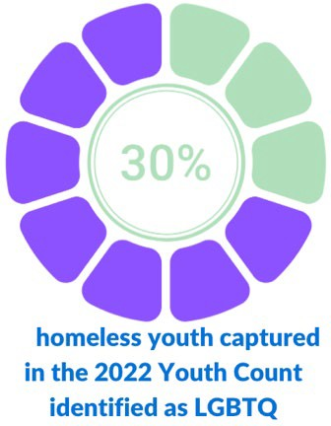
Research: Understanding Youth Homelessness

Every year, an estimated 4.2 million youth in the United States experience homelessness.⁸ In a 2022 national survey, 28% of youth respondents reported experiencing homelessness or housing instability at some point in their life. Additionally, in the same survey, approximately 80% of LGBTQ youth noted that the COVID pandemic had made their living situations more unstable or stressful.⁹ When looking at how Massachusetts is doing to address experiences of homelessness amongst LGBTQ youth, a concerning 30% of youth captured in the 2022 Youth Count identified as LGBTQ; within this number, 5.6% identified as transgender, nonbinary, or Two-Spirit. ¹⁰ Considering that only 21% of Massachusetts youth identify as LGB, and 5% identifying as transgender or
questioning,¹¹ this Youth Count data clearly indicates that LGBTQ youth are still overrepresented among youth experiencing homelessness.

According to the 2020 Special Report to the MA Unaccompanied Homeless Youth Commission, preliminary data reported a 38% increase in youth and young adults accessing housing support services, including homelessness prevention programs.¹² However, the 2022 Massachusetts Youth Count reports that 12% of LGBTQ youth reported sleeping in an unsheltered location, and only 32% report being able to access the services they needed.¹³

As discussed throughout this annual report, LGBTQ youth experience daily stigmatization and discrimination; those who hold multiple marginalized, oppressed, and underserved identities, such as QTBIPOC youth and youth with disabilities, must contend with additional compounding factors of racism and ableism that can further result in detrimental psychological, physical, and emotional effects.¹⁴ The effects of systemic racism are highlighted by the significantly higher rates of BIPOC youth experiencing homelessness and housing instability. Though the 2022 Youth Count does not break out race and ethnicity factors by sexual orientation or gender identity, 60% of youth experiencing homelessness in Massachusetts identify as BIPOC. Of these youth, 22.9% identified as Black, 17.8% as Latino, and 16.1% as multiracial. Despite the disparities discussed in the paragraph below at the national level, only 0.5% of youth experiencing homelessness in Massachusetts identified as American Indian (Native/Indigenous).¹⁵

However, nationally, the Trevor Project captured the following disparities: Native/Indigenous LGBTQ youth were more than twice as likely as white youth to experience homelessness, and 44% of Native/Indigenous LGBTQ or Two-Spirit youth reported experiencing homelessness or housing instability. While this number is not reflected in current data of youth experiencing homelessness in Massachusetts, it is essential to understand that youth identifying as Indigenous and LGBTQ or Two-Spirit typically face even greater risks of rejection, isolation, assault, and cultural erasure compared to other LGBTQ peers. When designing culturally responsible homelessness prevention and intervention strategies across the Commonwealth, decision-makers must collaborate with Indigenous stakeholders to better support Two-Spirit youth. ¹⁶ Furthermore, 36% of multiracial youth, 28% of Black youth, and 27% of Latinx LGBTQ youth reported experiencing homelessness or housing instability across the nation, and were more likely to experience challenges exiting homelessness compared to white LGBTQ youth.¹⁷

Given the multifaceted risk factors that youth experiencing homelessness face, the Commission is grateful to continue its partnership with the Unaccompanied Homeless Youth Commission to support the implementation of the Massachusetts State Plan to End Youth Homelessness. This plan envisions a system “in which every community in the Commonwealth has coordinated, developmentally appropriate, and trauma-informed resources that are effective, regionally accessible, and reliably funded.”¹⁸
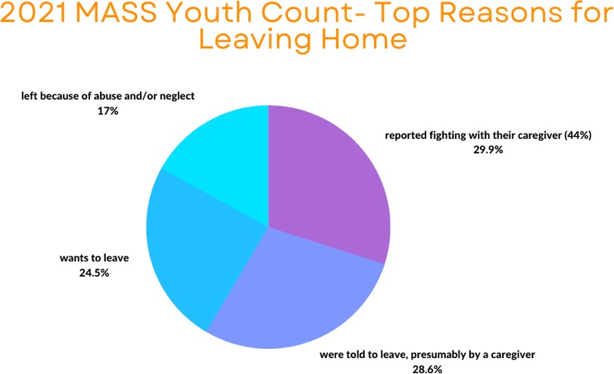

Homelessness is a complex and multi-layered issue in the United States, correlated with poverty, systemic racism, substance use, and mental health that intersects with individuals who have experienced institutionalization including foster care, instances of sexual abuse, discrimination and stigma, and unsupportive and rejecting families.¹⁹ LGBTQ youth are often situated at the intersection of discrimination, poverty, and racism that results in an increased risk of housing instability and homelessness; some of the top reasons LGBTQ youth cite for their experience of homelessness are familial rejection, abandonment, or abuse, mistreatment at school, and aging out of or running away from foster care. ²⁰ According to the 2021 Massachusetts Youth Count, some of the top reasons for leaving home were: 1) 44% reported fighting with their caregiver; 2) 42% were told to leave, presumably by a caregiver, and 36% wanted to leave; and 3) 25% left because of abuse and/or neglect.²¹

Nationally, youth experiencing homelessness who identified as LGBTQ were more likely than other non-LGBTQ respondents to report abuse and neglect, parental substance use, engagement in the foster care system, and

personal drug use as reasons for not living with their parent or guardian.²² Consistently, the leading cause of homelessness among youth identifying as LGBTQ is familial rejection or abandonment due to their sexual orientation and/or gender identity. Furthermore, research indicates that many LGBTQ youth choose to leave their homes, and become homeless for their own well-being and safety, as remaining in their home or assigned placement may have led to even worse outcomes for their physical or mental health. ²³ Nationally, approximately 90% of transgender youth experiencing homelessness report being rejected by their family;²⁴ 10% of transgender youth leave home before the age of 15.²⁵ However, some LGBTQ youth may also leave before rejection - before “coming out” to their families - due to fear or anticipation of rejection.²⁶

Across the nation, as discussed throughout this annual report, anti-trans attacks have skyrocketed due to intense waves of misinformation and stigmatization; many of the reasons LGBTQ youth face familial rejection stem from moral and/or religious values that judge their identities to be deviant or immoral. Other reasons may also be that caregivers may hope that their rejection can somehow sway their LGBTQ children to reconsider what they view as a ‘choice’ of identifying as LGBTQ. ²⁷ As such, the Commission advises that programs targeting LGBTQ youth at-risk of homelessness - particularly youth under 18 - should focus on caregiver education to support reunification. LGBTQ youth who have been previously abused within their family system are more likely to enter the foster care system with mental health issues from the abuse, which are all predictors of homelessness or experiences that may lead to running away from programs and placements.²⁸

Disproportionately, LGBTQ youth in the foster care system report being in the child welfare system due to the instability and rejection they experience at home. Nationally, LGBTQ youth currently experiencing homelessness were six times more likely to report that they had been in foster care at one point in their life.²⁹ In Massachusetts, DCF’s most recent SOGIE data report suggests that 5% identify as LGBTQ, though DCF does not currently report on factors involved in why these youth are involved in DCF services.³⁰ Overall, LGBTQ youth in foster care are more likely to report discrimination, inadequate treatment or housing, and a higher number of placements and, as noted above, are more likely to leave or age out of foster care and experience homelessness or housing instability.³¹ National research suggests that up to 36% of youth who enter the child welfare system will end up experiencing homelessness upon leaving or aging out.³²

Resource and skills building programs for LGBTQ youth transitioning out of foster care or the juvenile justice system often lack LGBTQ-affirming supports; those that do specifically cater to LGBTQ transition-aged youth often lack capacity or funding to serve those in need. In Massachusetts, there are very few dedicated LGBTQ independent living programs or skills building programs across the state, with programs like the Waltham House only having space for 12 youth at a time.³³ Transition-aged youth, particularly LGBTQ youth, are more likely to face barriers to long-term success, experience chronic homelessness at higher rates, and are more likely to reengage with substance abuse, sex work, and the criminal legal system.³⁴

LGBTQ youth experiencing homelessness are more likely to also experience physical, emotional, and sexual abuse than their cisgender, heterosexual peers.³⁵ Nationally, LGBTQ youth experiencing homelessness were three times more likely to experience being physically threatened or abused compared to youth who had no experience with homelessness or housing instability; 34% of transgender and gender expansive youth were more likely than cisgender LGB youth to experience violence.³⁶

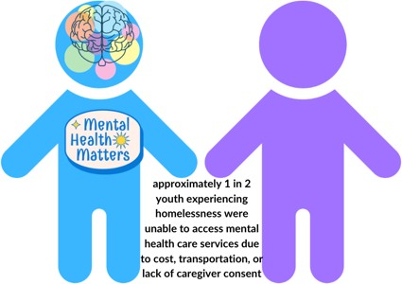
Furthermore, as discussed throughout this annual report, LGBTQ youth are more likely to experience unique psychosocial stressors that include intimate partner violence, hate crimes, and bullying, which often result in lower self-esteem, depression, substance use, and suicidal ideation, all of which are factors that can contribute to homelessness.³⁷ Additionally, LGBTQ youth experiencing homelessness
are much more likely to suffer from suicidal ideation, anxiety or depression, as well as are more likely to self-harm. Nationally, approximately 1 in 2 youth experiencing homelessness were unable to access mental health care services due to cost, transportation, or lack of caregiver consent.³⁸ In Massachusetts, 71% of LGBTQ experiencing homelessness reported needing access to mental health care resources, though only 36% of youth received assistance.³⁹

Negative experiences in school, such as bullying and harassment, can also lead to a path to homelessness, as LGBTQ youth are twice as likely to drop out of school as their heterosexual, cisgender peers;⁴⁰ youth who do not complete high school have a 346% higher risk of experiencing homelessness.⁴¹ In the 2021 MYRBS survey, Black, Latinx, and multiracial LGBTQ students were all more likely to report skipping school because they felt unsafe.⁴² Furthermore, youth currently experiencing homelessness that attempt to continue to go to school face poor academic performance and attainment, intermittent attendance, and often report an inability to fully devote their attention and time to their education.⁴³

Finally, as discussed throughout this annual report, LGBTQ youth over the age of 18 are more likely to face housing discrimination, such as being charged higher rental rates or being denied a mortgage.⁴⁴ Involvement in the criminal legal systems are additional common causes of homelessness and are factors that disproportionately impact LGBTQ youth, particularly due to the difficulties of obtaining appropriate housing or employment when re-entering society from previous incarceration.

Experiences While Homeless

In Massachusetts, approximately 3,800 youth - unaccompanied and young adults - experience homelessness
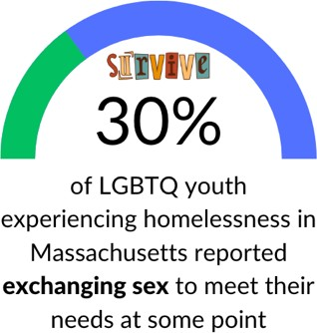
every year.⁴⁵ Updated from 2019 where youth were more likely to have slept in their car or outside the night before, the 2022 Massachusetts Youth Count found that LGBTQ youth (52.9%) were more likely to have slept in a shelter, as well as were more likely to receive the help they needed from shelter, food, housing, and cash services and assistance. However, 30% of LGBTQ youth experiencing homelessness in Massachusetts reported exchanging sex to meet their needs at some point, making up 56.6% of all youth exchanging sex to meet their needs.⁴⁶

As discussed throughout this annual report, LGBTQ youth are more likely to engage in sex work to exchange sexual encounters for money, food, or shelter than cisgender, heterosexual youth; youth engaging in sex work typically report higher rates of discrimination, increased contact with law enforcement, disqualification from public housing, and expulsion for education institutions.⁴⁷ The Commission appreciates the recent work of the Unaccompanied Homeless Youth Commission’s recent work related to improving supports to youth and young

adults experiencing homelessness who exchange sex to meet their needs; the findings and subsequent recommendations, reflected by similar recommendations made by the Commission’s past few annual reports, are inclusive of LGBTQ youth and point to the universal need for lower barrier housing, safer sex supplies, more inclusive and informed behavioral health supports, and income support.

As discussed in the new environmental justice section of this report, physical health is a significant concern for all youth who are homeless, and these include exposure to harsh weather, injuries, and physical assault that are exaggerated by barriers such as cost of care, transportation limitations, and fear of discrimination by providers.⁴⁸ Inclement weather in Massachusetts surely contributes to negative health outcomes, particularly concerning significant cold and hot weather shifts through the seasons. Combined with a lack of appropriate shelter spaces for youth under the age of 18, the Commission is incredibly concerned about the well-being of LGBTQ minors experiencing homelessness.

Furthermore, as noted above, LGBTQ youth - particularly those who identify as QTBIPOC - have much higher
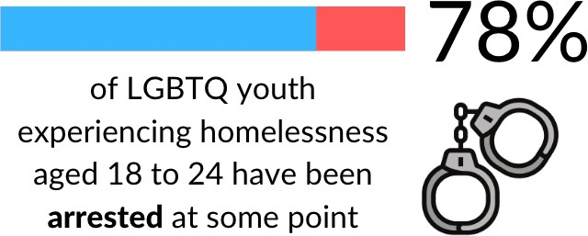
rates of interacting with police, and being arrested and incarcerated. ⁴⁹ Factors that increase the likelihood of LGBTQ youth experiencing homelessness interacting with police include, but are not limited to, engaging in sex work, sleeping in public places, loitering, and substance use. ⁵⁰ Across the nation, LGB individuals are three times more likely to be incarcerated, and approximately 1 in 6
transgender individuals report experiencing incarceration at some point.⁵¹ While data on the involvement of LGBTQ youth over the age of 18 in the adult legal system is scarce, national data indicates that up to 78% of LGBTQ youth experiencing homelessness aged 18 to 24 have been arrested at some point.⁵² In Massachusetts, 33% of youth who left home as minors experienced interactions with the criminal legal systems - either juvenile or adult - compared to 23% of those who became homeless after 18.⁵³

Lack of appropriate identification documents can also present barriers for LGBTQ youth experiencing homelessness. Without proper ID documents, LGBTQ youth experiencing homelessness are unable to open bank accounts, enroll in school, access housing, or become employed.⁵⁴ Transgender and gender expansive youth, especially, may experience disproportionate difficulties in accessing affirming services if their documentation does not match with their chosen name or appropriate gender marker; therefore, providers should be sure to prioritize supporting youth experiencing homelessness with accessing identification documents that affirm their identities.

Overall, for transgender and gender expansive individuals, homelessness likely exacerbates the significant discrimination and lack of understanding that transgender people already face in schools, workplaces, housing, and healthcare facilities. ⁵⁵ Transgender and gender expansive youth may feel particularly unsafe seeking medical treatment, including routine care, for a number of reasons including negative prior experiences and or the fear of being over-pathologized. Collectively, these negative experiences have likely contributed to the high rates of undetected illnesses and poorly managed treatable chronic/acute conditions within transgender and gender expansive communities. The Commission strongly urges Massachusetts decision-makers to ensure that they are addressing the critical need to improve LGBTQ youth access to robust and affirming community services.

Finally, LGBTQ youth experiencing homelessness are also more likely to be living with HIV or an STI. ⁵⁶ Nationally, the rate of HIV in LGBTQ youth experiencing homelessness is three times greater than HIV rates in cisgender, heterosexual youth. ⁵⁷ Several factors may increase their risk; for example, on average, sexual minority and transgender young men experiencing homelessness have their first sexual encounter one year earlier, a greater number of lifetime sexual partners, a higher likelihood of sexual assault, and a higher rate of unprotected sex with female partners than their non-homeless peers.⁵⁸ Another study showed that LGBTQ youth experiencing homelessness were more likely to engage in sexual behaviors that heightened their risk of HIV infection or viral hepatitis, such as having sex with strangers who used IV drugs, having unprotected sex with strangers, having anal sex with strangers, and having sex with strangers after using drugs themselves than their non-LGBTQ peers.⁵⁹ Among LGBTQ youth, homelessness is a consistent independent risk factor for drug use and sexual behavior that increases the likelihood of transmitting sexually transmitted infections (STIs).⁶⁰

Services for Those Experiencing Homelessness

LGBTQ youth are often forced to choose between their physical safety and their psychological safety.⁶¹ For example, the only option to avoid the environmental and interpersonal dangers of the streets may be to enter a shelter or engage with housing services where they experience discrimination based on sexual orientation, gender expression, and gender identity. Research shows that LGBQ youth often report housing, employment, education, and acceptance of their LGBQ status as primary needs, while transgender youth express the need for housing, employment, education, and transition support.⁶² Another study indicated that the needs for LGB youth and transgender youth are different as LGB youth reported that their greatest need was acceptance and emotional support, while transgender youth reported the need for more transition support.⁶³ Transgender youth experiencing homelessness can often lack access to medical resources for transitioning including difficulty obtaining insurance, access to prescription hormones, and access to gender-affirming products.⁶⁴

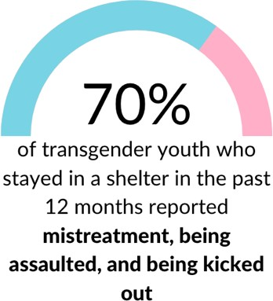
Shelters are important and invaluable resources for those experiencing homelessness. However, LGBTQ youth experiencing homelessness over the age of 18 report that adult shelters are often a place of danger.⁶⁵ One of the unique challenges faced by LGBTQ youth is the increased risk for harassment and victimization relative to cisgender and heterosexual peers, and when reported, it is often met with inaction by staff.⁶⁶ Further, LGBTQ youth who enter the adult shelter system often report being bullied, harassed, and even assaulted by others.⁶⁷ LGBTQ youth nationally also report that shelter staff harassed and discriminated against them, refused to work with them, and refused to acknowledge their gender identity or gender expression. ⁶⁸
Another national study reported that 70% of transgender youth who stayed in a shelter in the past 12 months reported mistreatment, being assaulted, and being kicked out. ⁶⁹ These experiences of discrimination and harassment accumulate and deter LGBTQ youth from entering the shelter system. The Commission advises that the Commonwealth work to better understand the specific experiences of transgender and gender expansive youth over the age of 18 experiencing homelessness in Massachusetts, and increasing funding for LGBTQ-affirming shelter spaces and programs.

Nationally, LGBTQ youth need culturally responsive services that meet the needs of those seeking services, such as private showers, culturally responsive training for providers, and services that are inclusive of the needs of young LGBTQ folks. Specifically, transgender and gender expansive individuals experience being turned away from shelters due to their gender identity or the absence of instituted shelter policies inclusive of all genders, such as binary segregated accommodations and programming.⁷⁰ Further, the lack of LGBTQ inclusive policies, whether intentional or due to lack of awareness, implies that these services are not for LGBTQ youth. This implicit exclusion of LGBTQ youth by shelters becomes a contributing factor in an LGBTQ youth’s need to turn to survival sex work to meet their need for housing.⁷¹ Finally, LGBTQ youth under the age of 18 may fear accessing shelters because staff will turn them over to police or social services for family reunification, which may not be possible in every case, and could lead to further trauma.⁷²

LGBTQ-specific drop-in centers can help provide basic needs for LGBTQ youth who choose to remain unsheltered due to discrimination, such as food, water, laundry, and showers.⁷³ Research has shown that youth drop in centers are better at connecting youth to services than shelter systems.⁷⁴ Drop-in center staff often connect youth to services as mental health treatment, substance use treatment, HIV/STI-related programs, job training, academic support, and school drop-out prevention.⁷⁵ Researchers contend that drop-in centers can be utilized more to target LGBTQ youth, who are often invisible in research and policy development. Specifically, as noted above, the Commission recommends the Commonwealth continue to create drop-in centers that include mentorship and peer support; extended clinic hours; programming that includes art, cultural, and recreational activities that are intersectional and anti-racist; and programming that targets LGBTQ youth who have recently immigrated.

The Commission applauds the progress made within the Commonwealth and the United States during the past year and looks forward to ongoing collaboration with Governor Healey, the Massachusetts legislature, statewide agencies, and local organizations/stakeholders dedicated to eradicating youth homelessness. A wide array of programs and resources have been made available in recent years to end youth homelessness, and the Commission appreciates the dedication of legislators, agencies, and providers to ensuring that the needs of LGBTQ youth experiencing homelessness are being met. However, broader conversations must occur on how the Commonwealth can continue to address risk factors of homelessness, discussed in this section and others, such as familial rejection, financial instability, substance abuse, and housing discrimination.

Acknowledgments & Citations

Acknowledgments: Rayna Hill, Legislative & Policy Manager, lead author and researcher.
The Commission greatly appreciates the input of the Unaccompanied Homeless Youth Commission.

1 The Executive Office of Health and Human Services, Council on Housing and Homelessness, and Office of Children, Youth, and Families. (2019). Furthering the Work of the MA State Plan to End Youth Homelessness. Retrieved from: https://www.mass.gov/doc/furthering-the-work-2019/download
2 Center for American Progress. (2015). Expanding ID Card Access for LGBT Homeless Youth. Retrieved from: https://cdn.americanprogress.org/wp-content/uploads/2015/10/01071118/IDhomelessLGBT.pdf
3 “Proving I Exist: Strategies for Assisting“Proving I Exist.” Youth in Obtaining Identification Documents,” accessed February 17, 2023, https://www.americanbar.org/groups/litigation/committees/childrens-rights/articles/2017/fall2017-proving-i-exist- strategies-assessting-youth-obtaining-id-docs/.

4 Romero, A.P., Goldberg, S.K., & Vasquez, L.A. (2020). LGBT People and Housing Affordability, Discrimination, and Homelessness. The Williams Institute. Retrieved from: https://williamsinstitute.law.ucla.edu/wp- content/uploads/LGBT- Housing-Apr-2020.pdf
5 “Proving I Exist.”
6 Annemarie Vaccaro and Robert M. Koob, “A Critical and Intersectional Model of LGBTQ Microaggressions: Toward a More Comprehensive Understanding,” Journal of Homosexuality 66, no. 10 (2019): 1317–44, https://doi.org/10.1080/00918369.2018.1539583.
7 Greathouse, M. & Kelly, R. (2021). Proud & Thriving Literature Review - Exploring Mental Health Considerations for LGBTQ+ Students. Retrieved from JED-LGBQ-Queer-and-Question-Lit-Review-FINAL.pdf (jedfoundation.org)
8 “Missed Opportunities: Youth Homelessness in America – Voices of Youth Count,” accessed April 24, 2023, https://voicesofyouthcount.org/brief/national-estimates-of-youth-homelessness/.
9 “Homelessness and Housing Instability Among LGBTQ Youth,” The Trevor Project (blog), February 3, 2022, https://www.thetrevorproject.org/research-briefs/homelessness-and-housing-instability-among-lgbtq-youth-feb-2022/.
10 Laurie Ross, “Massachusetts 2022 Youth Count,” 2022, https://www.mass.gov/doc/2022-youth-count-report/download.
11 2021 MYRBS Analysis – data on file with the Commission
12 The Massachusetts Commission on Unaccompanied Homeless Youth. (2020). Special Report to the MA Unaccompanied Homeless Youth Commission. Retrieved from https://www.mass.gov/doc/2020-special-report-to- the-ma-unaccompanied- homeless-youth-commission/download
13 City of Boston. (2018). The State of the System: Ending Youth Homelessness in Boston. Retrieved from https://www.boston.gov/sites/default/files/embed/t/the_state-of-the-system-a-brief-on-the-status-of-youth-and- young- adult-homelessness-in-boston_181017.pdf
14 Hao, J., Beld, M., Khoddam-Khorasani, L., Flentje, A., Kersey, E., Mousseau, H., and Dawson-Rose, C. (2021). Comparing substance use and mental health among sexual and gender minority and heterosexual cisgender youth experiencing homelessness. Plos one, 16(3), e0248077.
15 2022 Youth Count
16 Tribal Institute. (2014). Walking in Two Worlds: Understanding the Two-Spirit & LGBTQ Community. Retrieved from: http://www.tribal-institute.org/2014/INCTwo-SpiritBooklet.pdf
17 Erney, R., and Weber, K. (2018) "Not all Children are Straight and White: Strategies for Serving Youth of Color in Out-of-Home care who Identify as LGBTQ." Child Welfare v.96, no. 2.
18 The Commonwealth of Massachusetts Special Commission on Unaccompanied Homeless Youth. (2018). Massachusetts State Plan to End Youth Homelessness. Retrieved from: https://www.mass.gov/files/documents/2018/05/01/Massachusetts%20State%20Plan%20to%20End%20Youth%2 0Homelessness%20-%202018.pdf
19 Brodie Fraser et al., “LGBTIQ+ Homelessness: A Review of the Literature,” International Journal of Environmental Research and Public Health 16, no. 15 (August 2019): 2677, https://doi.org/10.3390/ijerph16152677.
20 Shelton, J., & Bond, L. (2017). “It just never worked out”: How transgender and gender expansive youth understand their pathways into homelessness. Families in Society, 98(4), 284-291.
21 Ross, “Massachusetts 2022 Youth Count.”
22 Massachusetts Coalition for the Homeless, Massachusetts Youth Count (2019), retrieved from https://www.mass.gov/doc/2019-massachusetts-youth-count/download.
23 Fraser et al., “LGBTIQ+ Homelessness.”
24 Soon Kyu Choi et al., “Serving Our Youth 2015: The Needs and Experiences of Lesbian, Gay, Bisexual, Transgender, and Questioning Youth Experiencing Homelessness,” June 1, 2015, https://escholarship.org/uc/item/1pd9886n.
25 S. E. James et al., “The Report of the 2015 U.S. Transgender Survey” (Washington, D.C.: National Center for Transgender Equality and National Gay and Lesbian Task Force, 2016), https://transequality.org/sites/default/files/docs/usts/USTS-Full- Report-Dec17.pdf.
26 Fraser et al., “LGBTIQ+ Homelessness.”
27 Brian L. B. Willoughby, Nathan D. Doty, and Neena M. Malik, “Parental Reactions to Their Child’s Sexual Orientation Disclosure: A Family Stress Perspective,” Parenting: Science and Practice 8 (2008): 70–91, https://doi.org/10.1080/15295190701830680.
28 Nicholas Forge, Robin Hartinger-Saunders, and Eric Wright, “Out of the System and onto the Streets: LGBTQ-Identified Youth Experiencing Homelessness with Past Child Welfare System Involvement - ProQuest,” accessed April 24, 2023, https://www.proquest.com/openview/5021cba1f9f2d595a7592f4d1544ebd3/1?pq-origsite=gscholar&cbl=40853.
29 “Homelessness and Housing Instability Among LGBTQ Youth.”
30 Department of Children & Families, “MASSACHUSETTS DEPARTMENT OF CHILDREN & FAMILIES QUARTERLY PROFILE --
FY’2023, Q2 (10/01/22 - 12/31/22),” n.d., https://www.mass.gov/doc/quarter-2/download.
31 Laura Baams, Bianca D.M. Wilson, and Stephen T. Russell, “LGBTQ Youth in Unstable Housing and Foster Care,” Pediatrics
143, no. 3 (March 1, 2019): e20174211, https://doi.org/10.1542/peds.2017-4211.

32 LGBTQ Homeless Youth Fact Sheet. National Alliance to End Youth Homelessness. Retrieved from http://www.safeschoolscoalition.org/LGBTQhomelessFactSheetbyNAEH.pdf
33 “The Home for Little Wanderers,” accessed March 2, 2023, https://thehome.org/waltham-house.
34 Dana D. DeHart, Brandi Anderson, and Jeremy Martin, “Transition-Aged Youth Who Are Homeless and Misuse Substances: A Qualitative Study of Service Needs,” Journal of Social Service Research 47, no. 6 (November 2, 2021): 872–85, https://doi.org/10.1080/01488376.2021.1941503.
35 Les B. Whitbeck et al., “Mental Disorder, Subsistence Strategies, and Victimization among Gay, Lesbian, and Bisexual Homeless and Runaway Adolescents,” Journal of Sex Research 41, no. 4 (November 2004): 329–42, https://doi.org/10.1080/00224490409552240.
36 “Homelessness and Housing Instability Among LGBTQ Youth.”
37 A. Jess Williams et al., “A Systematic Review and Meta-Analysis of Victimisation and Mental Health Prevalence among LGBTQ+ Young People with Experiences of Self-Harm and Suicide,” PloS One 16, no. 1 (2021): e0245268, https://doi.org/10.1371/journal.pone.0245268.
38 “Homelessness and Housing Instability Among LGBTQ Youth.”
39 Ross, “Massachusetts 2022 Youth Count.”
40 Choi et al., “Serving Our Youth 2015.”
41 “Missed Opportunities.”
42 2021 MYRBS Analysis – data on file with the Commission.
43 J J Cutuli, “Homelessness in High School: Population-Representative Rates of Self-Reported Homelessness, Resilience, and Risk in Philadelphia,” Social Work Research 42, no. 3 (September 1, 2018): 159–68, https://doi.org/10.1093/swr/svy013.
44 Adam Romero, Shoshana Goldberg, and Luis Vasquez, “LGBT People and Housing Affordability, Discrimination, and Homelessness,” Williams Institute, accessed April 24, 2023, https://williamsinstitute.law.ucla.edu/publications/lgbt-housing- instability/.
45 The Executive Office of Health and Human Services, Council on Housing and Homelessness, and Office of Children, Youth, and Families. (2019)
46 Ross, “Massachusetts 2022 Youth Count.”
47 “Locked In: Interactions with the Criminal Justice and Child Welfare Systems for LGBTQ Youth, YMSM, and YWSW Who Engage in Survival Sex,” Urban Institute, September 29, 2015, https://www.urban.org/research/publication/locked- interactions-criminal-justice-and-child-welfare-systems-lgbtq-youth-ymsm-and-ywsw-who-engage-survival-sex.
48 Jennifer P. Edidin et al., “The Mental and Physical Health of Homeless Youth: A Literature Review,” Child Psychiatry and Human Development 43, no. 3 (June 2012): 354–75, https://doi.org/10.1007/s10578-011-0270-1.
49 “The Lavender Scare in Homonormative Times: Policing, Hyper-Incarceration, and LGBTQ Youth Homelessness - Brandon Andrew Robinson, 2020,” accessed April 24, 2023, https://journals.sagepub.com/doi/full/10.1177/0891243220906172.
50 Kimble, S. (2015). Lesbian, gay, bisexual, and transgender youth (and adult) homelessness. In W. Swan (Ed.), Gay, lesbian, bisexual, and transgender civil rights: A public policy agenda for uniting a divided America (pp. 229– 250). Boca Raton, FL: CRC Press. doi:10.1201/b17485-21.
51 Susan M. Snyder et al., “Homeless Youth, Strain, and Justice System Involvement: An Application of General Strain Theory,”
Children and Youth Services Review 62 (March 1, 2016): 90–96, https://doi.org/10.1016/j.childyouth.2016.02.002.
52 Snyder et al.
53 Ross, “Massachusetts 2022 Youth Count.”
54 Hannah Hussey, “Expanding ID Card Access for LGBT Homeless Youth,” Center for American Progress (blog), October 1, 2015, https://www.americanprogress.org/article/expanding-id-card-access-for-lgbt-homeless-youth/.
55 National Center for Transgender Equality. (2017). “2015 U.S. Transgender Survey: Massachusetts State Report.” http://www.transequality.org/sites/default/files/docs/usts/USTSMAStateReport%281017%29.pdf
56 Edward McCann and Michael Brown, “Homelessness among Youth Who Identify as LGBTQ+: A Systematic Review,” Journal of Clinical Nursing 28, no. 11–12 (June 2019): 2061–72, https://doi.org/10.1111/jocn.14818.
57 Fraser et al., “LGBTIQ+ Homelessness.”
58 Marlene LaLota et al., “The Miami, Florida, Young Men’s Survey: HIV Prevalence and Risk Behaviors among Urban Young Men Who Have Sex with Men Who Have Ever Runaway,” Journal of Urban Health : Bulletin of the New York Academy of Medicine 82, no. 2 (June 2005): 327–38, https://doi.org/10.1093/jurban/jti056.
59 Kimberly A. Tyler, “Homeless Youths’ HIV Risk Behaviors with Strangers: Investigating the Importance of Social Networks,” Archives of Sexual Behavior 42, no. 8 (November 2013): 10.1007/s10508-013-0091–0093, https://doi.org/10.1007/s10508-013- 0091-3.
60 Michael C. Clatts et al., “Homelessness and Drug Abuse among Young Men Who Have Sex with Men in New York City: A Preliminary Epidemiological Trajectory,” Journal of Adolescence 28, no. 2 (April 2005): 201–14, https://doi.org/10.1016/j.adolescence.2005.02.003.
61 Alex Abramovich, “Understanding How Policy and Culture Create Oppressive Conditions for LGBTQ2S Youth in the Shelter System,” Journal of Homosexuality 64, no. 11 (2017): 1484–1501, https://doi.org/10.1080/00918369.2016.1244449.

62 Choi et al., “Serving Our Youth 2015.”
63 Elaine M. Maccio and Kristin M. Ferguson, “Services to LGBTQ Runaway and Homeless Youth: Gaps and Recommendations,”
Children and Youth Services Review 63 (April 1, 2016): 47–57, https://doi.org/10.1016/j.childyouth.2016.02.008.
64 Mitchell Dylan Sellers, “Absent Inclusion Polices: Problems Facing Homeless Transgender Youth: Public Integrity,” 20(6) accessed February 2, 2023, 625-639 https://www.tandfonline.com/doi/abs/10.1080/10999922.2018.1446629?journalCode=mpin20.
65 Fraser et al., “LGBTIQ+ Homelessness.”
66 Deborah Coolhart and Maria T. Brown, “The Need for Safe Spaces: Exploring the Experiences of Homeless LGBTQ Youth in Shelters,” Children and Youth Services Review 82 (2017): 230–38, https://doi.org/10.1016/j.childyouth.2017.09.021.
67 Coolhart and Brown.
68 Coolhart and Brown.
69 James et al., “The Report of the 2015 U.S. Transgender Survey.”
70 Abramovich, “Understanding How Policy and Culture Create Oppressive Conditions for LGBTQ2S Youth in the Shelter System.”
71 Choi et al., “Serving Our Youth 2015.”
72 Sean McCandless, “LGBT Homeless Youth and Policing,” Public Integrity 20, no. 6 (November 2, 2018): 558–70, https://doi.org/10.1080/10999922.2017.1402738.
73 Layla Parast et al., “Utilization and Perceptions of Drop-in Center Services Among Youth Experiencing Homelessness,” The Journal of Behavioral Health Services & Research 46, no. 2 (April 2019): 234–48, https://doi.org/10.1007/s11414-018-9632-9. 74 Jama Shelton and Lynden Bond, “‘It Just Never Worked Out’: How Transgender and Gender Expansive Youth Understand Their Pathways into Homelessness,” 2017, https://journals.sagepub.com/doi/10.1606/1044-3894.2017.98.33.
75 Parast et al., “Utilization and Perceptions of Drop-in Center Services Among Youth Experiencing Homelessness.”

COMMISSION ON LGBTQ YOUTH
ENDING HOMELESSNESS

ABOUT
LGBTQ youth are disproportionately represented within rates of youth experiencing homelessness. Multiple risk factors contribute to LGBTQ youth’s experience of higher rates of homelessness, such as family rejection, abandonment and conflict, poverty, medical and mental health difficulties, discrimination, and racism.
30%
of Massachusetts youth experiencing homelessness identify as LGBTQ+

12%
LGBTQ youth reported sleeping in an unsheltered location
RECOMMENDATIONS
Improve access to state IDs for youth experiencing homelessness and gender expansive youth.
Increase safe places and community centers for LGBTQ youth experiencing homelessness.
Codify a bill of rights for people experiencing homelessness.

60%
of Massachusetts youth experiencing homelessness identify as BIPOC




LEGISLATION
S.1112/H.211: Bill of Rights for People Experiencing Homelessness

S.856/H.1312: Upstream Homelessness Assistance

Advancing Criminal Justice

Introduction

The Commission on LGBTQ Youth operates under a definition of ‘youth’ as persons being under the age of 25. Therefore, when considering recommendations to make under the topic of LGBTQ youth in the criminal legal system in Massachusetts, it is important to note that the Commission’s report covers both the juvenile and adult legal systems.

LGBTQ youth face a significant amount of challenges in the criminal legal systems across the United States, and Massachusetts is no exception. Nationally, it has been shown that LGBTQ youth are twice as likely to enter the juvenile system compared to cisgender and heterosexual youth;¹ of those youth, QTBIPOC youth are estimated to comprise a staggering 85% of LGBTQ youth in the juvenile justice system.² However, in the Massachusetts juvenile system, the Department of Youth Services has published data that indicates that LGBTQ youth make up only 7.4% of DYS youth.³

For LGBTQ individuals over the age of 18, transgender individuals are nearly twice as likely to have been incarcerated and transgender people of color reporting a rate of past incarceration at four times higher than their LGBQ peers.⁴ The Department of Correction does not currently collect or publicize any sexual orientation, gender identity, and gender expression (SOGIE) data on incarcerated people in Massachusetts that allows policymakers to fully understand disparities faced by LGBTQ youth facing incarceration.⁵

To combat the concerning disparities faced by LGBTQ young people, the Commission has worked closely with many state agencies and entities in Massachusetts to establish more equitable state policies within the criminal legal systems. The Commission has also worked in coalition with community organizations such as Citizens for Juvenile Justice to advance legislation to further reform the juvenile system and improve the lives and conditions of LGBTQ individuals involved in the juvenile and adult criminal legal systems.

Recommendations to the Governor and Legislature on Advancing Justice

Increase the collection of data on sexual orientation and gender identity to identify and reduce disparities throughout the criminal legal systems.

Without comprehensive data, the state has little insight to the widespread disparities experienced by LGBTQ youth in the Commonwealth. In 2018, the legislature created the Juvenile Justice Policy and Data Board (JJPAD) which was tasked with collecting data to identify disparities and make recommendations on how to improve the experience of youth in the juvenile legal system. However, there are still further

improvements to be made in the collection of SOGIE data in the criminal legal systems, including by mandating the collection of SOGIE data in the adult legal system.

One such path forward would be for the legislature to pass An Act to Promote Rehabilitation Including Guaranteed Health, Treatment, and Safety for Incarcerated LGBTQI+ People, also known as the RIGHTS Act (S.1499/H.2357), which would collect data on LGBTQI prisoners held in restrictive housing. Additionally, the Commission advises that the legislature should pass An Act Improving Juvenile Justice Data Collection (S.931/H.1802), which would include sexual orientation and gender identity in the collection and reporting of juvenile data to identify and evaluate policies to reduce racial disparities in the juvenile justice system.

As noted in the above Child Welfare section of this annual report, the Commission further recommends that the legislature amend the appointed members of the JJPAD to add dedicated representatives for LGBTQ youth and youth with disabilities. Since December of 2022, the Commission has been in conversations with the legislature on the best path forward for this endeavor.

Limit the use of force by law enforcement and correctional officers, and establish community-based response systems to reduce police intervention.
In 2020, Massachusetts passed several police reform bills following the murders of George Floyd and Breonna Taylor at the hands of police, as well as countless other instances of police brutality. Since 2020, there has been no further major evolutions in Massachusetts law, and the 2020 reforms fell short in several areas, including: failing to (1) restrict the government’s use of dangerous, racially-biased and transphobic facial surveillance technology; (2) abolish or meaningfully roll back qualified immunity for police officers, which shields police from liability for violating the rights of an individual; (3) establish clear definitions of police use of force, the failure of which leaves the appropriate standard for police use of physical force open to subjective interpretation; and (4) require local elected government bodies, like city councils, to approve any transfers to military equipment to their local police department.

In January of 2023, Cambridge police officers shot and killed a 20-year-old University of Massachusetts student from Bangladesh, Sayed Faisal, who was reportedly having a mental health crisis. Since then, the Middlesex District Attorney’s has begun an inquest into the shooting, and the city of Cambridge has announced the implementation of a body camera program for police, and is examining alternative responses to emergency calls in mental health crisis situations.⁶ The Commission strongly recommends that the State examine all local practices and policies as it relates to police responses to emergency calls to ensure that youth are protected from violence and discrimination when in crisis.

The Commission further recommends that Massachusetts ban the use of facial surveillance technology, such as suggested in An Act to Implement the Recommendations of the Special Commission on Facial Recognition Technology (S.927/H.1728). As discussed below, facial surveillance technology has been shown to increase the likelihood of false arrests and criminal charges against QTBIPOC individuals.

Remove police from schools and require schools to collect SOGIE information in disciplinary cases.
The Commission continues to support the removal of police officers from schools, and recommends that the legislature pass the newly refiled bill, An Act Relative to the Location of School Resource Officers (H.565), which would require that school resource officers be located at police stations and not on school grounds. Furthermore, the Commission recommends that schools be mandated to collect SOGIE demographic information on students involved in disciplinary cases. As highlighted throughout this annual report, LGBTQ youth are more likely to be victims of bullying, and thus more likely to be involved in a disciplinary process that can sometimes lead to the victims being punished more than the perpetrator.

Decriminalize consensual sexual relations among parties close in age, and support education rather than criminal discipline.
The Commission recommends that the state decriminalize the consensual sexual relations among parties close in age, such as relationships between 14 and 15-year-olds. LGBTQ youth are often the victims of discriminatory use of these laws as a means of punishing stigmatized relationships between LGBTQ young people, which more typically more affects young boys. Relatedly, the Commission further recommends that legislators decriminalize the engaging of minors in disseminating explicit visual material amongst peers, and stress the need for education in this area instead of criminal punishment. Furthermore, given the harmful effects of the criminalization of consensual sexual relationships between minors as noted above, state entities can play a role in clarifying when such reporting should occur and in helping to clarify for youth when they are able to seek services without fear of punishment. The Commission has heard from actors in fields such as education, health, and congregate care that the current lack of clarity and fairness in the law presents a major problem for delivering services, and the state can easily remedy this challenging situation.

Eliminate common nightwalking laws, and increase funding for programs serving LGBTQ youth at-risk of sexual exploitation.
The Commission recommends that the Commonwealth explore a path to the decriminalization of sex work for youth over the age of 18, through bills such as An Act Relative to the Expungement of Certain Marijuana and Prostitution-Related Records (H.1757), which would eliminate common night-walking laws and expunge records for those convicted of sex work; and An Act to Prevent Human Trafficking and Improve the Health and Safety of Sex Workers (S.1046/H.1758), which would further support sex workers and victims of trafficking or exploitation by developing a Human Trafficking Prevention and Sex Worker Project, and establish an interagency committee to study more effectively a path for the full decriminalization of sex work in the Commonwealth.

For years, research has shown that the criminalization of sex work has made sex workers more vulnerable to violence and discrimination from police, and leads to poorer public health outcomes.⁷ Furthermore, due to increased likelihood of experiencing homelessness and financial insecurity, LGBTQ youth are more likely to exchange sex to meet their financial and material needs, than their heterosexual, cisgender peers,

as well as more at-risk of sexual exploitation and trafficking. As discussed thoroughly in the public health section of this annual report, too often, law enforcement officers and policymakers conflate ‘sex work’ with ‘sex trafficking’ which leads to ineffective policy implementations, and increased criminalization of LGBTQ youth.⁸

Improve prison conditions for incarcerated LGBTQ and intersex youth.
Nationally, LGBTQ and intersex individuals are overrepresented among prison inmates in the adult legal system, and face higher rates of abuse and physical and sexual assault than their non-LGBTQ peers. While little research exists on current prison conditions for incarcerated intersex individuals, studies have shown this group to be particularly vulnerable to sexual abuse. As noted above, the Commission strongly urges the state to pass and enact the RIGHTS Act (S.1499/H.2357) to ensure stronger protections of LGBTQI incarcerated youth in the adult criminal legal system, as well as conduct research studies to better understand the experiences of LGBTQ individuals being detained across the state.

Raise the age of the juvenile system to include 18-to 20-year-olds.
The Commission recommends that the legislature raise the age of the juvenile justice system to gradually include 18- to 20-year-olds to improve public safety and improve outcomes for the teens as proposed in An Act to Promote Public Safety and Better Outcomes for Young Adults (S.942/H.1710), also known as ‘Raise the Age.’ Massachusetts is well-known to have better outcomes for youth in the juvenile justice system through the Department of Youth Services and for youth over the age of 18, these formative years are particularly important for LGBTQ youth who often struggle with mental health issues.

Expand access to record sealing, and judicial diversion for low-level offenses.
The Commission supports the expansion of access to record sealing, and the automatic sealing of all eligible juvenile an adult records within 90 days, as proposed in an Act Providing Easier and Greater Access to Record Sealing (S.979/H.1598), as the process of sealing records can be difficult and lengthy given the current backlogs. Furthermore, the Commission supports the expansion of access to judicial diversion for youth who commit low-level offenses in order to better support diverting youth away from the juvenile system, as proposed in An Act Promoting Diversion of Juveniles to Community Supervision and Services (S.940/H.1495).

Increase transitional housing resources for formerly incarcerated LGBTQ youth.
The Commission strongly recommends that the Commonwealth allocate funding to the development of and expansion of transitional housing resources for formerly incarcerated LGBTQ youth, particularly for those aged 22 to 24 who may not be eligible for other state services. Such examples of transitional housing are demonstrated through the creation of the Alexia Norena House from Black & Pink Massachusetts which supports up to 5 transgender individuals re-entering society from previous incarceration.⁹ Another example is offered by the Transgender Emergency Fund Transitional Housing Program, which houses up to eight transgender and gender expansive individuals currently experiencing homelessness.¹⁰

Research: Advancing Juvenile Justice for LGBTQ Youth

As discussed throughout this annual report, LGBTQ youth face unique risk factors that make them more susceptible to engaging in the criminal legal system through factors such as homelessness, engagement in the child welfare system, criminalization of survival sex work, drug use and/or sales, and employment discrimination. Unfortunately, despite some progress made over the last few years, data related to experiences of Massachusetts youth under 25 in the criminal legal systems is slim. Anecdotally, the Commission understands from its own conversations with youth, providers, and advocates that there is still a great deal of work to be done - particularly for youth over the age of 18.

Nationally, lesbian, gay, and bisexual youth are twice as likely to enter the juvenile system as heterosexual youth,¹¹ while transgender and gender expansive youth are four times more likely than cisgender youth to engage with the criminal legal system. ¹² Additionally, youth of color are more likely to report engagement with the legal system, and are more likely to be victims of police violence than white youth.¹³ National research has found that Black youth are four times more likely to be incarcerated, Native/Indigenous youth nearly three times more likely, and Latinx/Latine youth 1.5 times more likely than white youth. Furthermore, it is estimated that - nationally - anywhere from 85 - 90% of LGBTQ youth in the juvenile justice system are youth of color.¹⁴ For youth in DYS custody, 84% of youth identify as BIPOC and 7.4% of all DYS youth identify as LGBTQ;¹⁵ DYS has assured the Commission that a better breakdown of race/ethnicity and SOGI data will be present in DYS’ next annual report.

Examining Risk Factors

As mentioned above, LGBTQ youth are often victims of systemic failures that lead to the overrepresentation of LGBTQ young people in the criminal legal systems, as well as societal discrimination and stigmatization. Harassment, bullying, and violence often lead to LGBTQ youth coping through criminalized compensatory behaviors, and survival economies - such as, sex work and the selling of drugs. Police are also more likely to disproportionately target LGBTQ youth, particularly youth of color and those experiencing homelessness.¹⁶ Traumatic experiences such as interactions with the criminal justice system can have lifelong repercussions, particularly when they occur during adolescence, a critical period of brain development.¹⁷

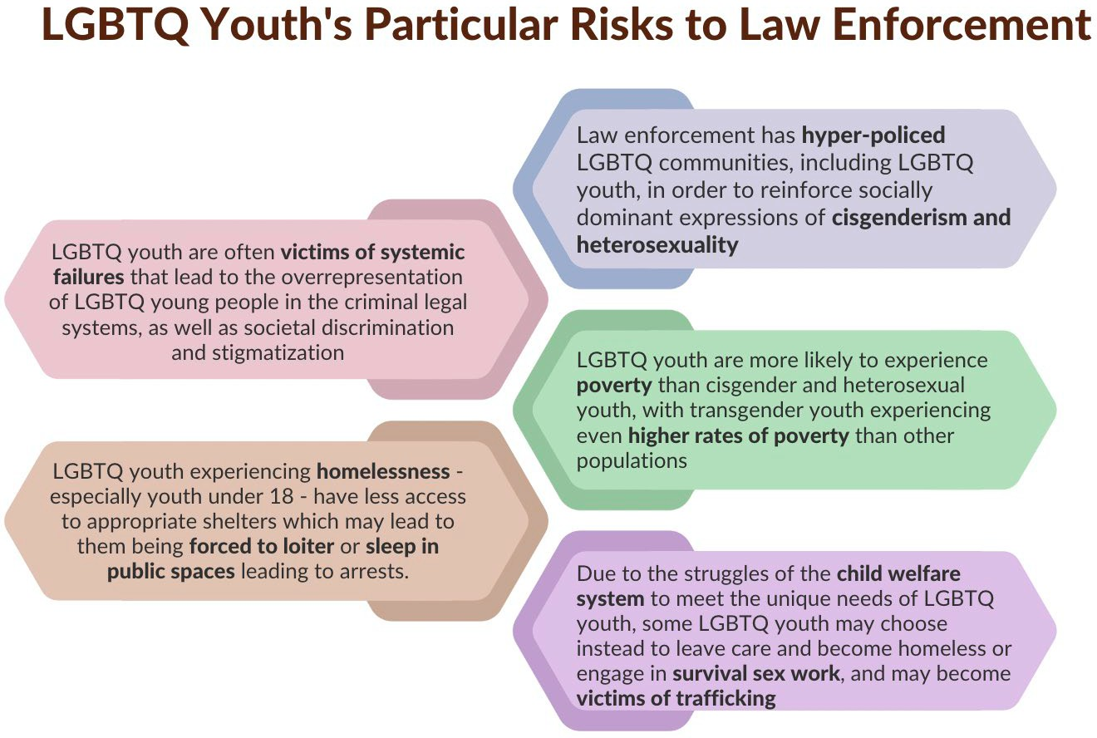

Historically, law enforcement has hyper-policed LGBTQ communities, including LGBTQ youth, in order to reinforce socially dominant expressions of cisgenderism and heterosexuality.¹⁸ Additionally, research has suggested that LGBTQ bias, stigma, and discrimination lead to the disproportionate criminalization of LGBTQ girls and youth of color.¹⁹ However, despite this, LGBTQ youth who are victims of crimes often experience significant under-policing, indifference, and hostile treatment when reporting a crime or incident; Black and transgender survivors of hate crimes, in particular, were significantly more likely to experience violence by police when reporting a crime.²⁰

Furthermore, LGBTQ youth are more likely to experience poverty than cisgender and heterosexual youth, with transgender youth experiencing even higher rates of poverty than other populations.²¹ Similarly, youth experiencing homelessness or who are facing housing instability are more likely to identify as LGBTQ, with 30% of youth experiencing homelessness identifying as LGBTQ in Massachusetts.²² As a result of these experiences, LGBTQ youth may turn to sex work or selling drugs in order to survive, which can often lead to some type of involvement with the criminal legal system, including incarceration.²³

Additionally, LGBTQ youth experiencing homelessness - especially youth over 18 - have less access to appropriate shelters which may lead to them being forced to loiter or sleep in public spaces leading to arrests.²⁴ In Massachusetts, many shelter providers across the state do not have enough resources, and far too often the shelter spaces are unsafe for LGBTQ youth. For youth under 18, the Commission advises that the state improve the availability of shelter spaces in underserved geographic regions.

Over the last several years, the Commission has taken a deeper look at the experiences of LGBTQ youth in intersecting systems, such as the child welfare system and criminal legal system. Across the country, research has shown that LGBTQ youth are overrepresented in the child welfare system; in Massachusetts, DCF’s most recent Quarter 2 report for FY 2023, 15% of youth identify as within the LGBTQ communities with 5% being youth under 18 and 10% youth over 18 in DCF services.²⁵ LGBTQ youth in the child welfare system can experience what is known as the “foster care-to-prison pipeline,”²⁶ which particularly affects BIPOC youth and youth with disabilities and mental illnesses.²⁷ While in the child welfare system, LGBTQ youth often report intolerance, mistreatment, and neglect from their caregivers and/or peers. ²⁸ The Commission has made recommendations to DCF for several years around improving the recruitment and training of LGBTQ-affirming foster parents, as well as creating a database to better track these homes; DCF’s continued progress on these recommendations since 2021 is captured in the below agency recommendations to DCF.

Additionally, across the country, due to a lack of affirming foster homes - or ways to track affirming homes
- LGBTQ youth are more likely to be placed in a group home or foster homes that lack affirming caregivers, which places them at an increased risk for violence and discrimination. The experience of being placed in the child welfare system is often a deeply traumatic time, and these disparities faced by LGBTQ youth often compound the profoundly negative impacts on their mental and emotional well-being.²⁹ Youth within the child welfare system often experience mental health issues and trauma that often goes untreated, or over-treated in the form of over-prescribed psychotropic medications.³⁰ As established above, youth experiencing mental health crises often face incarceration.

Due to the struggles of the child welfare system to meet the unique needs of LGBTQ youth, some LGBTQ youth may choose instead to leave care and become homeless or engage in survival sex work, and may become victims of trafficking.³¹ Even for youth who stay in care until they ‘age out’, there is often minimal support for transition-aged LGBTQ youth with few independent living programs appropriately preparing youth for transitioning out of care. ³² Transition-aged youth may experience unstable housing or homelessness; inadequate access to education or documentation; unemployment or under-employment; physical and mental health issues; ³³ and lack of access to appropriate health care. ³⁴ All of these experiences may often lead to interactions with the juvenile justice system as youth struggle to survive.

In Massachusetts, 2021 Youth Risk Behavior Survey data indicates that nearly 1 in 5 of LGBTQ high school students have experienced bullying in their schools.³⁵ As detailed in the in-depth education section of this annual report, LGBTQ youth are more likely to face bullying, threats of violence, and being involved in fights where there is a weapon involved. As youth face discrimination and violence in schools, they are more likely to skip classes or school entirely due to feeling unsafe, and are more likely to bring a weapon to school for protection.³⁶

In 2021, only 60% of Massachusetts students noted that they could identify at least one supportive staff member, but were also more likely to note that staff members did nothing to assist them when they were being bullied or harassed. Approximately 9 in 10 did not report a violent incident to school staff, as they feared repercussions, or doubted that they would receive support or resolution.³⁷ Often, LGBTQ youth

experiencing bullying or harassment report being disciplined more harshly than the perpetrator, with some LGBTQ youth even being suspended after reporting bullying incidents.³⁸
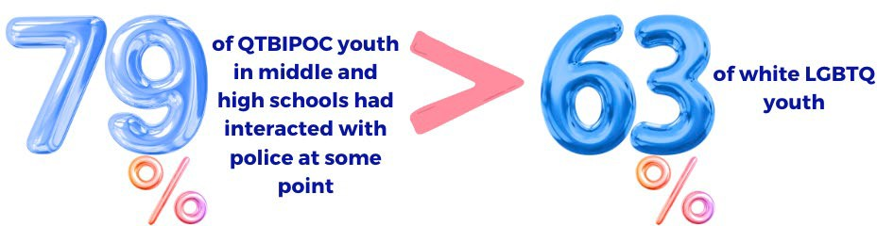

Overall, LGBTQ youth face disproportionate rates of suspension and expulsion compared to heterosexual and cisgender youth, particularly for QTBIPOC youth. In a national study, 79% of QTBIPOC youth in middle and high schools had interacted with police at some point, compared to 63% of white LGBTQ youth. Disciplinary infractions in schools can sometimes mark the beginnings of a criminal record that can follow LGBTQ youth through their life, affecting their future employment, housing, and more.³⁹ Due to these experiences, LGBTQ youth are more likely to interact with school resource officers (SROs), and face arrests and/or incarceration. Nationally, schools with SROs are more likely to refer LGBTQ youth to the juvenile justice system, though further research needs to occur to better understand disciplinary disparities in Massachusetts.⁴⁰

Experiences of LGBTQ Youth in the Criminal Legal Systems

From arrest all the way through incarceration phases in the criminal legal systems, LGBTQ youth of color consistently report negative treatment and disproportionate experiences and lengths of stay compared to white LGBTQ youth.⁴¹ Although the Prison Rape Elimination Act (PREA) and the Juvenile Justice and Delinquency Prevention Act established basic standards on the treatment of LGBTQ youth in prison, the implementation of these acts has been inconsistent, and often leads to unintended consequences that negatively impact incarcerated youth.⁴² National research continues to demonstrate that LGBTQ youth experience bias, discrimination, and abuse from staff and other inmates due to their sexual orientation and gender identity. In a 2019 study, it was noted that the Bureau of Justice Statistics reported that adult gay and bisexual men and transgender women are ten times more likely to be sexually victimized in prison than those who are cisgender and heterosexual.⁴³ Furthermore, the rate of sexually transmitted infections and HIV transmission is significantly higher among those who have been recently released from criminal facilities, as compared to the general population.⁴⁴

Furthermore, as noted in the below section on foreign-born LGBTQ youth, the conditions of immigration detention are often dangerous, especially for LGBTQ immigrants. There are currently nine immigration detention facilities in Massachusetts, overseen by ICE, and nationally, physical and sexual abuse is a persistent problem in adult detention centers, with rates of sexual abuse similar to the high levels

reported in prisons overall. Transgender immigrants are at an even higher risk, and the practice of housing transgender immigrants based on their anatomy or sex assigned at birth is not only psychologically harmful but drastically increases their vulnerability to abuse. ⁴⁵ For example, a statewide survey in California found that when transgender women were held in men’s prisons, they were 13 times more likely to report sexual abuse than other inmates.⁴⁶ Instead of placing trans detainees in housing consistent with their gender identity, facility officials often place them in protective custody or solitary confinement, with the misguided intention that separating trans detainees from the general population will protect them from sexual abuse. LGBTQ detainees in protective custody have reported incidents where they were kept in total isolation for up to 23 hours a day, often without access to library resources, telephones, outdoor recreation, religious services, or legal services that are otherwise available to other detainees.⁴⁷ Psychologists have long documented the harmful psychological effects caused by solitary confinement: severe anxiety, depression, paranoia, hallucinations, and impulsive, self-directed violence. ⁴⁸ The Commission urges Massachusetts to conduct further research to better understand the experiences of LGBTQ youth who may be detained in detention facilities in Massachusetts.



Those who escape physical or sexual assault typically face daily harassment and threats. For example, transgender detainees are often subject to humiliating searches by staff of their birth-assigned gender, sometimes without any justifiable reason. Additionally, while current detention standards prescribe access to adequate health care for all detainees, including care for HIV and gender dysphoria, these non- binding standards do not ensure transgender detainees can access the health care they need. ⁴⁹

For many years, the Commission has worked with DYS to improve the treatment of LGBTQ youth in juvenile justice facilities across the Commonwealth, particularly around employee training, data collection, and inclusive policies, but its work with DOC has been limited. Massachusetts law protects youth under 18 from being confined in adult facilities, ⁵⁰ and the Commission has recommended for several years that Massachusetts pass ‘Raise the Age’ which would raise the age of the juvenile justice system from 18 to 20 and expand protections to improve life outcomes for LGBTQ youth who might otherwise have been placed in the adult legal system.

Overall, data on LGBTQ youth experiences in the criminal legal system in Massachusetts is severely limited. The Commission advises that all agencies involved in the criminal legal system in Massachusetts thoroughly examine their SOGIE data collection standards in a way that protects confidentiality; youth are often asked about their identities during intake, and likely will not answer truthfully for fear of

discrimination. Additionally, many LGBTQ youth report being outed to their families or friends by facility staff during visitation sessions, further compounding the trauma and isolation that they face in incarceration.⁵¹

As has been noted in previous Commission reports, the 2018 Massachusetts juvenile and criminal justice reform package worked to attempt to address many of the disparities faced by LGBTQ youth in the juvenile justice systems. A strong emphasis on diversion to rehabilitation, treatment, and other services remains a key piece of the reform, and has been the focus of several new programs over the last few years. As highlighted above, the creation of JJPAD and the Childhood Trauma Taskforce has given insight into the needs of youth, but the lack of LGBTQ-specific data remains a serious concern to the Commission.

However, while a great deal of reform has taken place at the juvenile level, there is significantly more work to be done to protect LGBTQ youth over the age of 18. As noted above, while non-serious offenses committed before the age of 21 can be expunged from youth’s records, the process to get these offenses expunged is not automatic, and can be a confusing and lengthy process. Many LGBTQ youth already face discrimination when seeking employment, housing, and social services, which can be severely exacerbated by having a criminal record - even with non-serious offenses.

In particular, the Commission notes the significant need that has been highlighted by advocates for more LGBTQ-specific support services and resources for those reentering society, or with a history of incarceration. In 2022, Black & Pink Massachusetts opened up the first transitional housing resource specifically for recently incarcerated transgender and gender nonconforming individuals - the Alexia Norena House - which can support for only up to five residents. Black & Pink MA has noted that the house is currently full due to overwhelming need, and that there still remains a significant demand for more trans-specific housing resources.⁵²

Acknowledgments & Citations

Acknowledgments: Rayna Hill, Legislative & Policy Manager, lead author

1 “Addressing the Intersections of Juvenile Justice Involvement and Youth Homelessness: Serving LGBTQ Youth,” Coalition for Juvenile Justice, 2017, https://www.juvjustice.org/sites/default/files/ckfinder/files/LGBTQ%20youth%20report%20Final.pdf.
2 “Unjust: LGBTQ Youth Incarcerated in the Juvenile Justice System, Center for American Progress, MAP, and Youth First, June 2017, https://www.lgbtmap.org/file/lgbtq-incarcerated-youth.pdf.
3 “DYS Reports and Resources | Mass.Gov,” accessed April 24, 2023, https://www.mass.gov/service-details/dys-reports-and- resources.
4 Lambda Legal, “Protected and Served? School Security, Policing and Discipline,” January 7, 2016, https://www.lambdalegal.org/node/30521.
5 Massachusetts Department of Correction, “103 DOC 653: Identification, Treatment, and Correctional Management of Gender Non-Conforming Inmates: Policy,” October 26, 2022, https://www.mass.gov/doc/doc-653-identification-treatment-and- correctional-management-of-gender-non-conforming-inmates/download.
6 Mark Herz, “Independent Investigation Begins in Fatal Cambridge Police Shooting,” WGBH, February 24, 2023, https://www.wgbh.org/news/local-news/2023/02/24/independent-investigation-begins-in-fatal-cambridge-police-shooting.

7 ACLU, “‘Is Sex Work Decriminalization the Answer? What the Research Tells Us.’” (ACLU, 2020), https://www.aclu.org/report/sex-work-decriminalization-answer-what-research- tells-us.
8 Melissa Ditmore and Sex Workers Project, “The Use of Raids to Fight Trafficking in Persons,” 2009, https://sexworkersproject.org/downloads/swp-2009-raids-and-trafficking-report.pdf.
9“The Alexia Norena House,” Black and Pink Massachusetts, accessed March 15, 2023, https://www.blackandpinkma.org/our- house.
10 TEFAdmin, “Transitional Housing,” Transgender Emergency Fund (blog), accessed March 15, 2023, https://transemergencyfund.org/transitional-housing/.
11 Rebecca Vallas and Sharon Dietrich, “One Strike and You’re Out: How We Can Eliminate Barriers to Economic Security and Mobility for People with Juvenile Records, Center for American Progress, December 2, 2014, https://www.americanprogress.org/issues/poverty/reports/2014/12/02/102308/one-strike-and-youre-out.
12 Lambda Legal, “Protected and Served? School Security, Policing and Discipline,” January 7, 2016, https://www.lambdalegal.org/node/30521.
13 Stemming the Rising Tide: Racial & Ethnic Disparities in Youth Incarceration & Strategies for Change (Oakland: The W. Haywood Burns Institute, 2020), https://burnsinstitute.org/wp-content/uploads/2020/09/Stemming-the- Rising-Tide-
_compressed.pdf.
14 Keith J. Conron and Bianca D.M. Wilson, LGBTQ Youth of Color Impacted by the Child Welfare and Juvenile Justice Systems (Los Angeles: Williams Institute at the UCLA School of Law, 2019), https://williamsinstitute.law.ucla.edu/wp-content/uploads/LGBTQ- YOC-Social-Services-Jul-2019.pdf.
15 “DYS Reports and Resources | Mass.Gov.”
16 Brandon Andrew Robinson, “The Lavender Scare in Homonormative Times: Policing, Hyper-incarceration, and LGBTQ Youth Homelessness,” Gender & Society 34(2), 2020, https://journals.sagepub.com/doi/full/10.1177/0891243220906172.
17 Steinberg, L. (2015). Age of Opportunity: Lessons from the New Science of Adolescence. New York: An Eamon Dolan Book.
18 Brandon Andrew Robinson, “The Lavender Scare in Homonormative Times: Policing, Hyper-incarceration, and LGBTQ Youth Homelessness,” Gender & Society 34(2), 2020, https://journals.sagepub.com/doi/full/10.1177/0891243220906172.
19 Christy Mallory, Amira Hasenbush, and Brad Sears, “Discrimination and Harassment by Law Enforcement Officers in the LGBT Community,“ March 2015, https://williamsinstitute.law.ucla.edu/publications/lgbt-discrim-law- enforcement.
20 Emily Waters, Lesbian, Gay, Bisexual, Transgender, Queer, and HIV-Affected Hate Violence in 2016 (New York: National Coalition of Anti-Violence Programs, 2017), http://avp.org/wp- content/uploads/2017/06/NCAVP_2016HateViolence_REPORT.pdf.
21 M.V. Lee Badgett, Soon Kyu Choi, and Bianca D.M. Wilson, LGBT Poverty in the United States: A Study of Differences between Sexual Orientation and Gender Identify Groups (Los Angeles: Williams Institute at UCLA School of Law, 2019), https://williamsinstitute.law.ucla.edu/wp-content/uploads/National-LGBT-Poverty-Oct-2019.pdf
22 Laurie Ross, “Massachusetts 2022 Youth Count,” 2022, https://www.mass.gov/doc/2022-youth-count-report/download.
23 “Criminalization & Incarceration,” National Center for Lesbian Rights, accessed May 15, 2022, https://www.nclrights.org/our- work/racial-economic-justice/criminalization-incarceration.
24 Emily Peiffer “Five Charts that Explain the Homelessness-Jail Cycle- and How to Break It,” Urban, September 16, 2020, https://www.urban.org/features/five-charts-explain-homelessness-jail-cycle-and-how-break-it.
25 Department of Children & Families, “MASSACHUSETTS DEPARTMENT OF CHILDREN & FAMILIES QUARTERLY PROFILE --
FY’2023, Q2 (10/01/22 - 12/31/22),” n.d., https://www.mass.gov/doc/quarter-2/download.
26 Irvine, Angela and Aisha Canfield. 2016. “The Overrepresentation of Lesbian, Gay, Bisexual, Questioning, Gender Nonconforming, and Transgender Youth Within the Child Welfare to Juvenile Justice Crossover Population.” Journal on Gender, Social Policy, and the Law, 24(2): 243-261.
27 Juvenile Law Center, “What is the Foster Care-to-Prison Pipeline,” May 26, 2018, https://jlc.org/news/what- foster-care-prison- pipeline.
28 Ryan Berg, “A Hidden Crisis: The Pipeline from Foster Care to Homelessness for LGBTQ Youth,” The Imprint, October 14, 2016, https://imprintnews.org/child-welfare-2/hidden-crisis-pipeline-foster-care-homelessness-lgbtq- youth/21950.
29 Hannah Hussey and Commission on LGBTQ Youth, “LGBTQ Youth in the Massachusetts Child Welfare System: A Report on Pervasive Threats to Safety, Wellbeing, and Permanency,” July 2021, https://www.mass.gov/doc/commission-report-on- dcf/download.
30 “Foster Children: HHS Guidance Could Help States Improve Oversight of Psychotropic Prescriptions [Reissued on December 15, 2011] | U.S. GAO,” accessed March 4, 2023, https://www.gao.gov/products/gao-12-201.
31 National LGBTQIA+ Health Education Center, Futures Without Violence, and Health Partners on IPV+ Exploitation, “LGBTQIA+ Youth and Experiences of Human Trafficking: A Healing-Centered Approach,” 2021, https://www.lgbtqiahealtheducation.org/wp-content/uploads/2021/09/Supporting-LGBTQIA-Youth-Who-Have-Experienced- Trafficking.pdf? cf_chl_tk=s.y6xpLVDveulpcRchcwLF2xaRxD7Ibbyemmg9zwXeU-1682388339-0-gaNycGzNDFA.

32 Saralyn C. Ruff and Kristi Harrison, “‘Ask Me What I Want’: Community-Based Participatory Research to Explore Transition- Age Foster Youth’s Use of Support Services,” Children and Youth Services Review 108 (January 1, 2020): 104608, https://doi.org/10.1016/j.childyouth.2019.104608.
33 Natalia Ramos, Elizabeth Barnert, and Eraka Bath, “Addressing the Mental Health Needs of LGBTQ Youth in the Juvenile Justice System,” Journal of the American Academy of Child and Adolescent Psychiatry 61, no. 2 (February 2022): 115–19, https://doi.org/10.1016/j.jaac.2021.06.014.
34 Youth.gov, “Young Adults Formerly in Foster Care: Challenges and Solutions,” accessed April 18, 2023, https://youth.gov/youth-briefs/foster-care-youth-brief/challenges.
35 2021 MYRBS Analysis – data on file with the Commission
36 2021 MYRBS Analysis – data on file with the Commission
37 2021 MYRBS Analysis – data on file with the Commission
38 Shannon D. Snapp and Stephen T. Russell, “Discipline Disparities for LGBTQ Youth: Challenges That Perpetuate Disparities and Strategies to Overcome Them,” in Inequality in School Discipline: Research and Practice to Reduce Disparities, ed. Russell J. Skiba, Kavitha Mediratta, and M. Karega Rausch (New York: Palgrave Macmillan US, 2016), 207–23, https://doi.org/10.1057/978-1-137-51257-4_12.
39 Lambda Legal, “Protected and Served? School Security, Policing and Discipline,” January 7, 2016, https://www.lambdalegal.org/node/30521.
40 “Civil Rights School Climate Principles,” GLSEN, accessed April 24, 2023, https://www.glsen.org/activity/civil-rights-school- climate-principles.
41 Loyal | thisisloyal.com, “LGBTQ Youth of Color Impacted by the Child Welfare and Juvenile Justice Systems,” Williams Institute, accessed April 24, 2023, https://williamsinstitute.law.ucla.edu/publications/lgbtq-yoc-social-services/.
42 Brad Brockmann, et al, Emerging Best Practices for the Management and Treatment of Incarcerated Lesbian, Gay, Bisexual, Transgender, and Intersex (LGBTI) Individuals (Boston: The Fenway Institute, 2019), tps://fenwayhealth.org/wp- content/uploads/TFIP-33_Best-Practices-for-LGBTI-Incarcerated-People-Brief_web.pdf
43 Brad Brockmann, et al, Emerging Best Practices for the Management and Treatment of Incarcerated Lesbian, Gay, Bisexual, Transgender, and Intersex (LGBTI) Individuals (Boston: The Fenway Institute, 2019), https://fenwayhealth.org/wp- content/uploads/TFIP-33_Best-Practices-for-LGBTI-Incarcerated-People- Brief_web.pdf.
44 Catherine Hanssens and Rene Bennett-Carlson, Juvenile Injustice: The Unfulfilled Rights of Youth in State Custody to Comprehensive Sexual Health Care (New York: The Center for HIV Law and Policy, 2010), https://www.hivlawandpolicy.org/sites/default/files/TS%20LRM%20Dec.%202010.pdf.
45National Immigrant Justice Center, “LGBTQ Immigrants,” https://immigrantjustice.org/stop-abuse-detained-lgbt-immigrants 46Valerie Jenness, Cheryl Maxson, Kristy Matsuda, and Jennifer Macy, “Violence in California Correctional Facilities: An Empirical Examination of Sexual Assault,” 2007, Center for Evidence-Based Corrections, https://www.prearesourcecenter.org/sites/default/files/library/55-preapresentationpreareportucijennessetal.pdf
47Crosby Burns, Ann Garcia, and Philip Wolgin, “Living in Dual Shadows: LGBT Undocumented Immigrants,” 2013, Center for American Progress, https://www.americanprogress.org/wp-content/uploads/2013/04/LGBTUndocumentedReport-6.pdf 48National Immigrant Justice Center and Physicians for Human Rights, “Invisible in Isolation - The Use of Segregation and Solitary Confinement in Immigration Detention,” 2012, https://immigrantjustice.org/sites/immigrantjustice.org/files/Invisible%20in%20Isolation- The%20Use%20of%20Segregation%20and%20Solitary%20Confinement%20in%20Immigration%20Detention.September%20201 2_7.pdf
49National Center for Transgender Equality, “Our Moment for Reform: Immigration and Transgender People,” 2013, https://transequality.org/sites/default/files/docs/resources/OurMoment_CIR_en.pdf
50 U.S. Department of Justice, Office of Justice Programs, Office of Juvenile Justice and Delinquency Prevention. (2015). Sight and Sound Separation, 2014. Retrieved from http://www.ojjdp.gov/ojstatbb/structure_process/qa04306.asp?qaDate=2014
51 Shannon Wilber, Lesbian, Gay, Bisexual and Transgender Youth in the Juvenile Justice System: A Guide to Juvenile Detention Reform (Baltimore: The Annie E. Casey Foundation, 2015), https://www.nclrights.org/wp- content/uploads/2015/09/AECF_LGBTinJJS_FINAL2.pdf
52 “The Alexia Norena House.”

COMMISSION ON LGBTQ YOUTH
ADVANCING JUSTICE

ABOUT
Harassment, bullying, and violence often lead to LGBTQ youth coping through criminalized compensatory behaviors, and survival economies - such as, sex work and the selling of drugs. Police are also more likely to disproportionately target LGBTQ youth, particularly youth of color and those experiencing homelessness.

Traumatic experiences such as interactions with the criminal justice system can have lifelong repercussions, particularly when they occur during adolescence, a critical period of brain development.
84%
Of youth in the Massachusetts juvenile justice system are youth of color.

9 IN 10
LGBTQ students who experienced harassment in Massachusetts high schools did not report the incident to school staff.

79%
RECOMMENDATIONS
Increase SOGI data collection to identify and reduce disparities throughout the criminal legal systems.
Raise the age of the juvenile system to include 18-to 20-year-olds.
of QTBIPOC middle and high school students across the nation interacted with the police at some point



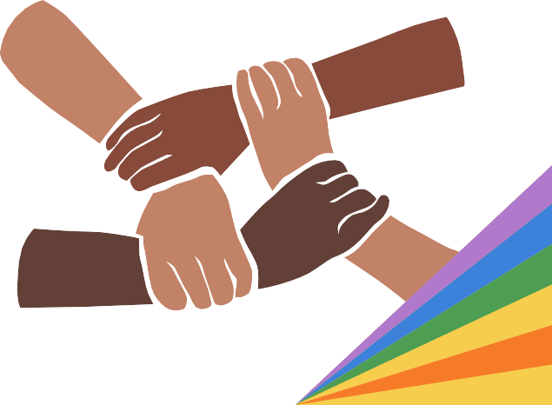
LEGISLATION
S.1499/H.2357: RIGHTS Act
S.931/H.1802: Juvenile Justice Data Collection S.942/H.1710: Raise the Age

Expanding Inclusive Service Provision for Foreign-Born LGBTQ Youth

Introduction

For the first time, the Commission offers a dedicated section on research and recommendations to improve policies, services, and programs for LGBTQ foreign-born Massachusetts residents, including first- generation, undocumented, asylee, and refugee youth. The Commission uses the term ‘foreign-born’ throughout this report to encompass experiences of those who are legal residents and undocumented residents, as well as those who may have only temporarily migrated to the state. As detailed throughout this section, there are many reasons that LGBTQ individuals and families may immigrate to the U.S., including to escape persecution, violence, and discrimination in their country of origin. While Massachusetts has made great strides in recent years towards improving its service provision for these communities, further steps should still be taken to ensure that all LGBTQ youth have the opportunity to thrive.

FY 2024 Recommendations to the Governor on Foreign-Born LGBTQ Youth

Improve the availability of multilingual, LGBTQ-affirming services for foreign-born residents, and increase funding for existing programs.
The Commission recommends that the state increase and improve its current service provision for immigrants, refugees, and asylees who are LGBTQ. As explored below, while very little state-specific research and data exists, there remains a great need for affirming services, particularly in the areas of mental health care and housing support. It is clear that organizations currently working to serve LGBTQ immigrant, refugee, and asylee populations have limited capacity and funding to meet the demand for their services. For example, the LGBT Asylum Task Force, based in Worcester, is one of very few LGBTQ- specific asylum seeker support programs in the whole of the United States, and provides long-term rental assistance to asylum seekers who by law cannot work for at least 180 days after entering the U.S.
Furthermore, the Commission recommends that state agencies, nonprofit organizations, and community programs examine their outreach and accessibility for LGBTQ residents who may not be fluent in English. The Commission supports An Act Relative to Language Access and Inclusion, (S.1990/H.3084), which would require state agencies to provide public materials and information in the primary languages spoken by Massachusetts residents aside from English. Additionally, to avoid unnecessary obstacles, service providers should ensure that forms are clear to non-native English speakers, and that ID or citizenship information is not required to access services not dependent on immigration status. Organizations can also improve accessibility by hiring and appropriately compensating bilingual staff, providing materials and signs in multiple languages, and fostering relationships with interpreting services to improve service provision for non-English-speaking clients.

Establish an LGBTQ Immigrant & Refugee Task Force.
The Commission recommends that Massachusetts explore the creation of an LGBTQ Immigrant & Refugee Task Force composed of LGBTQ refugees, families, first-generation youth, and advocates to inform services at the state and local levels. As demonstrated for three decades by the Commission, having a dedicated voice at the state level to oversee policy development and service improvement is essential. By establishing a specific task force, those who are often left without a voice in Massachusetts decision- making are able to influence effective change.

Address the concerning lack of SOGIE data collection at the state level.
As the Commission works to better understand the experiences of foreign-born LGBTQ youth in Massachusetts, the staggering lack of available data and research at the local, state, and national levels presents a significant barrier. The Commission strongly recommends that all state agencies explore ways to increase their data collection and outreach efforts to better capture the experiences of all LGBTQ youth across the state.

Protect and support undocumented youth.
Increasingly, undocumented communities are being targeted across the country by federal, state, and local governments. The Commission recommends that Massachusetts continue to explore ways to increase protections and services for undocumented youth in the Commonwealth. Over the last few years, the state has taken numerous steps that work to address and improve the experiences of undocumented youth. Most recently in January of 2023, Barnstable County Sheriff’s Office, which was the last sheriff’s office in New England to have a formal agreement with the U.S. Immigration and Customs Enforcement (ICE), ended the agreement that empowered Massachusetts sheriffs’ offices to detain, interrogate, and transport residents suspected of being undocumented immigrants.¹ In the same month, in Boston, Boston Police Department (BPD) reported that it had ignored all 12 federal requests to detain suspected undocumented immigrants, and noted that zero residents were detained by BPD in 2022.²
To further extend protections and support to undocumented youth, the Commission recommends that the legislature pass An Act to Protect the Civil Rights and Safety of all Massachusetts Residents (S. 1510/H.2288), also known as the Safe Communities Act, which would increase access to court and police protection for undocumented youth by ending local and state involvement in civil immigration enforcement. The Commission further supports the Tuition Equity Act, An Act Providing Access to Higher Education for High School Graduates in the Commonwealth (S. 817/H.1281) to increase access to state financial aid and in-state tuition for undocumented youth who graduated from a Massachusetts high school, and An Act to Ensure Equitable Health Coverage for Children, (S.740/H.1237) which would broaden youth eligibility for MassHealth coverage.

National & State Immigration Context

Individuals choose to immigrate or seek asylum in the United States for a variety of reasons, such as work opportunities, access to education and medical services, and other conditions that influence an individual’s quality of life. ³ LGBTQ individuals often migrate to the U.S. to escape persecution and oppression due to their sexual orientation or gender identity. According to Human Rights Watch, at least sixty-seven countries have national laws criminalizing same-sex relations between consenting adults.⁴ In addition, at least nine countries have national laws criminalizing forms of gender expression that target transgender and gender-nonconforming people.⁵
However, despite these reasons, the United States for decades has continued to establish and exacerbate barriers to prevent foreign-born LGBTQ individuals from fully finding integration and affirming spaces across the nation. In 1917, federal law restricted immigration by individuals who showed signs of what
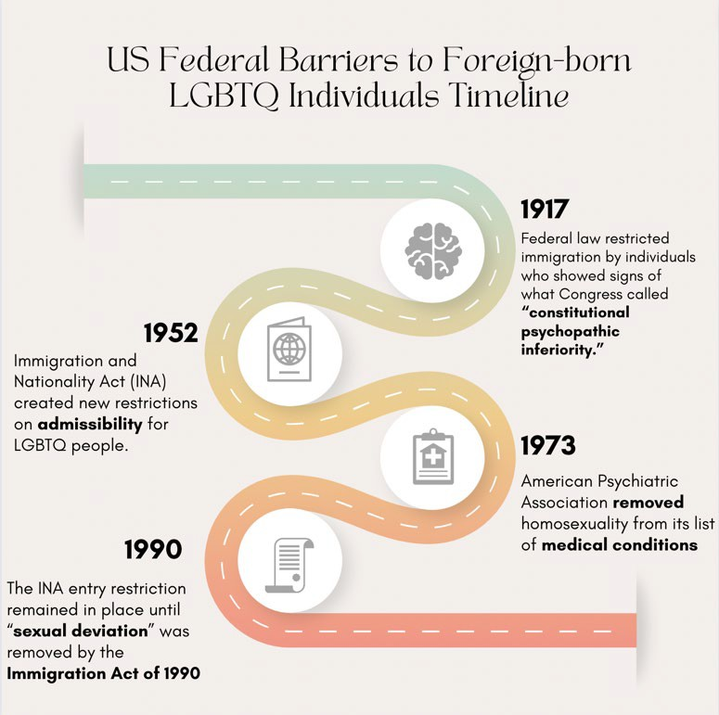
Congress called “constitutional psychopathic inferiority.”⁶ This law prevented LGBTQ people from immigrating to the United States, even when they faced persecution in their home country. Similarly, the 1952 Immigration and Nationality Act (INA) created new restrictions on admissibility for LGBTQ people. ⁷ The INA replaced the exclusion for immigrants possessing a “psychopathic personality” with a ban on “sexual deviation,” a catch-all to exclude LGBTQ people from entering the United States. Although the American Psychiatric Association removed homosexuality from its list of medical conditions in 1973, the INA entry restriction remained in place until “sexual deviation” was removed by the Immigration Act of 1990.⁸
Despite this reform, many LGBTQ immigrants were still denied admission to the United States, since the ban on people with HIV entering the country was not lifted until 2010.⁹ Similarly, although the United States recognized persecution on the basis of sexual orientation as grounds for asylum in 1994, Congress passed the Defense of Marriage Act (DOMA) in 1996, which openly discriminated against same-sex married couples by denying them access to marriage-based federal benefits, including the ability to sponsor a spouse for a green card.¹⁰ It was not until 2013, when the Supreme Court found Section 3 of DOMA unconstitutional, that same-sex couples could petition for their partners and family members. Although these events demonstrate a stride toward greater freedom and equality, LGBTQ foreign-born undocumented and documented people continue to face barriers to success in the United States.
Although roughly 1 in 6 of Massachusetts residents are foreign-born (almost 1.2 million people, or 16.9% of the population) and another 1 in 7 are U.S.-born with at least one foreign-born parent, Massachusetts

has a mixed history with policy development to benefit foreign-born residents. ¹¹ However, as noted above, in recent years, Massachusetts has taken several strides forward to better support foreign-born individuals, families and communities, but has continued to see controversial challenges to these efforts. For example, though vetoed by former Governor Baker in the summer of 2022, Massachusetts lawmakers passed a bill to allow undocumented residents to obtain driver’s licenses through the Registry of Motor Vehicles (RMV) which the Commission had supported for several years. Shortly after, a push to overturn the new law appeared on the midterm ballot as Question 4, which passed by slim margins: about 54% of voters supported the measure and 46% did not.¹²

Research: Understanding Policy and Resource Needs

Data Overview and Limitations

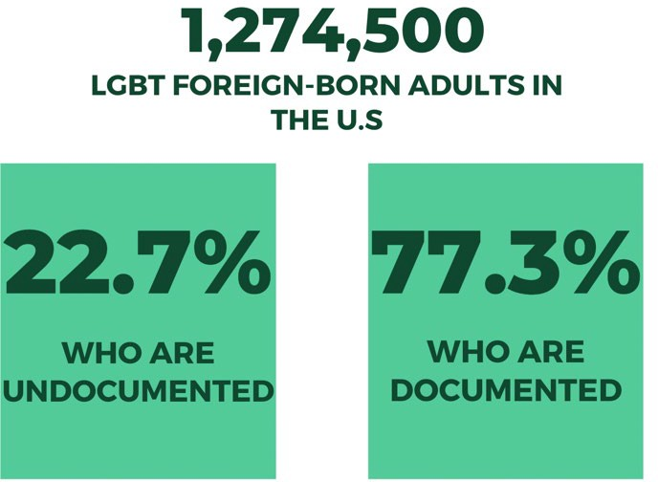
In the United States, little information is available about the number or characteristics of LGBTQ immigrants. Using data from the Pew Research Center, the 2017 Gallup Daily Tracking Survey, and the U.S. Census Bureau’s American Community Survey, UCLA’s School of Law Williams Institute estimates that there are approximately 1,274,500 LGBT foreign-born adults in the U.S., including 289,700 (22.7%) who are undocumented and 984,800 (77.3%) who are documented.¹³ Their report found the following: relative to all undocumented
immigrants, LGBT undocumented immigrants are more often male, between the ages of 18 and 29, and Latino/a; the same holds true for LGBTQ documented immigrants.
Similarly, using data from The Trevor Project’s 2020 National Survey on LGBTQ Youth Mental Health,¹⁴ researchers found that nearly 1 out of 4 LGBTQ youth (24%) in their sample indicated that they are a first- generation youth. However, more research needs to be done to capture the national and state number and characteristics of first-generation LGBTQ youth, and their experiences in state systems.
Representative information about LGBTQ foreign-born youth specifically is largely missing for the U.S. population because large surveys conducted by the U.S. Census Bureau, such as the American Community Survey and Current Population Survey, do not collect data about sexual orientation and gender identity or expression (SOGIE). ¹⁵ Additionally, neither federal nor state agencies collect SOGIE data in its immigration programs, making data on this population scarce.¹⁶ Beyond the given estimates in this report, not much is reported about the number of or specific experiences of foreign-born LGBTQ youth in Massachusetts; all of the data presented in this report stems from national research, as there is little to no accessible state-level data available on foreign-born LGBTQ youth in Massachusetts.

Additionally, in research, scholars of immigration and sexuality have suggested a profound heteronormativity in immigration scholarship and a clear assumption of LGBTQ people possessing citizenship in their country of residence.¹⁷ These blindspots in both kinds of scholarship lead to the erasure of the lives, experiences, and needs of those who are LGBTQ and not a citizen of the country where they reside.

Note on Intersectionality

For every LGBTQ person, “coming out” is a process that continues throughout life.¹⁸ Identifying within the LGBTQ community has its coming out process, which can include challenges around personal acceptance, family acceptance, and societal stigmas. Similarly, being part of a family with undocumented or mixed immigration status also comes with unique struggles, including navigating various government systems and institutions, and forcing LGBTQ youth to make difficult choices between their well-being and that of their family. Additionally, due to multiple intersecting factors including race, ethnicity, sexual orientation, gender identity, and disability, foreign-born LGBTQ youth can often face compounded stigma and discrimination that contributes to a lack of access to health care, housing, economic security, legal services, and education.

Mental Health

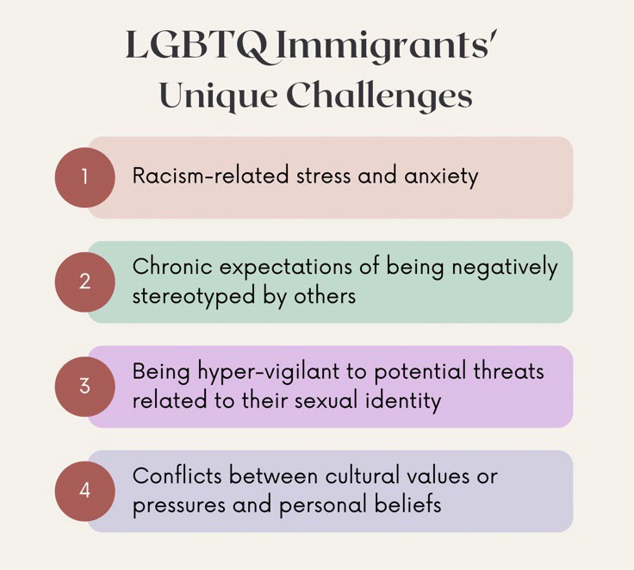
As discussed in the mental health section of this annual report, studies continue to suggest that LGBTQ youth face significant disparities in suicide risk compared to their straight and cisgender peers.¹⁹ LGBTQ youth are not inherently prone to suicide risk because of their sexual orientation or gender identity, but rather, they are placed at higher risk because of societal the discrimination, stigmatization, and violence stemming from racism, homophobia, and transphobia. LGBTQ youth living in the U.S. represent a diversity of experiences, including youth who are foreign-born. Studies have shown, however, that foreign-born individuals often experience considerable stressors such as discrimination, acculturation stress, and immigration concerns that lead to poor health outcomes.²⁰ Acculturative stress is the psychosocial strain experienced by immigrants in response to
challenges encountered while adapting to cultural differences in a new country. These stressors result from circumstances such as immigration status, language barriers, economic deficiencies, disruption in family cohesion, and discrimination.²¹
Although the process of immigrating to a new country and acculturating to an unfamiliar set of cultural beliefs and societal practices presents challenges for immigrants regardless of gender identity or sexual orientation, research has shown that LGBTQ youth face unique challenges in this process. At the intra-individual level, some

difficulties LGBTQ immigrants may face include racism-related stress and anxiety, chronic expectations of being negatively stereotyped by others, and being hyper-vigilant to potential threats related to their sexual identity.²² At the interpersonal or intergroup level, conflicts between cultural values or pressures and personal beliefs may also present challenges for LGBTQ immigrants. For example, traditional gender role expectations and norms of masculinity and femininity are particularly stringent within Latino communities. For gender non-conforming gay Latinos, the cultural value of “machismo”, a strict and idealized form of masculinity for men, may be a source of conflict and challenge.²³ Additionally, because of the varying values, norms, and expectations of their various communities, LGBTQ immigrants may encounter difficulties with different social groups and communities. For example, LGBTQ foreign-born individuals are often not welcomed or accepted in many ethnic communities, and may then be discouraged from accessing sources of support that might typically be utilized either in their ethnic community (e.g., family members) or in the LGBTQ community (e.g., support services and organizations) due to overt hostility or the perception of being unwelcome.²⁴
In the Trevor Project’s recent 2021 research brief “LGBTQ Youth from Immigrant Families,” researchers attempted to examine mental health at the intersection of these two identities;²⁵ it was found that first- generation LGBTQ youth actually reported slightly lower rates of anxiety, depression, and suicidal ideation compared to LGBTQ youth whose parents were born in the U.S. However, researchers discovered that suicide risk among first-generation LGBTQ youth was more associated with worrying about themselves or a family member being deported due to immigration policies. Roughly 30% of first-generation LGBTQ youth worried “sometimes” or “a lot” about immigration-related detainment or detention compared to 5% of LGBTQ youth whose parents were born in the U.S. Immigration fears were reported most often by first-generation Latinx LGBTQ youth, followed by first-generation LGBTQ youth who are more than one race/ethnicity.
Overall, first-generation LGBTQ youth who reported being worried about themselves or a family member being deported had 63% greater odds of reporting a suicide attempt in the past year. Additionally, discrimination based on actual or perceived immigration status was reported by nearly 1 in 10 of first-
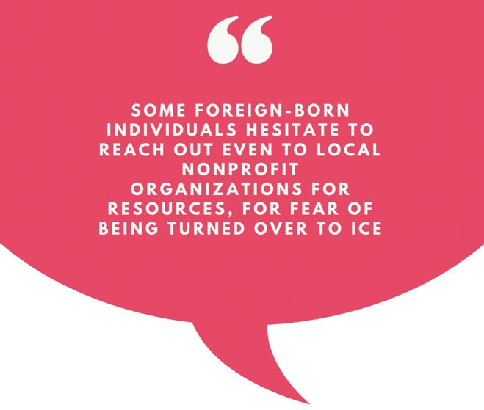
generation LGBTQ youth compared to 2% of LGBTQ youth whose parents were born in the U.S. First- generation LGBTQ youth who faced discrimination based on their actual or perceived immigration status had more than 2.5 times greater odds of attempting suicide compared to first-generation LGBTQ youth who did not.
The Trevor Project study demonstrates the impact that a young person’s immigration status can have on their mental health, or the immigration status of close family members. As previous research demonstrates, feeling unsure about access to education, health care, and the
possibility of deportation can cause a great deal of stress and anxiety that can affect a young person’s sense of belonging and well-being.²⁶ This also leads LGBTQ youth to avoid interaction with police and

potentially with immigration officials like I.C.E. by avoiding activities such as seeking mental health, or even reporting discrimination or violence, as they may potentially have to reveal their immigration status. This constant self-monitoring and reluctance to seek mental health care as a way to stay under the radar from police and immigration officials, can increase stress and anxiety, and act as a barrier to mental health care. As discussed in the New England-based MIRA Coalition’s 2021 Annual Report, some foreign-born individuals hesitate to reach out even to local nonprofit organizations for resources, for fear of being turned over to ICE, highlighting the critical need of local and state agencies to be intentional about building outreach and trust with foreign-born individuals or families with mixed-resident status.²⁷
As noted above, some cities in Massachusetts, such as Boston, have passed legislation that bars city police from cooperating in most cases with federal immigration authorities to detain immigrants who are in the country illegally, and have also ended agreements through county sheriff’s offices with ICE. These measures allow Massachusetts to make progress at creating a space where foreign-born undocumented residents can live without fear of being deported.²⁸

Criminal Justice Involvement

As noted in the criminal justice section of this annual report, research has shown that LGBTQ people are more likely to interact with law enforcement due to discrimination, over-policing, and violence. Although 4.1% of adults in the U.S. identify as LGBTQ, they are three times more likely to be incarcerated than the general population.²⁹ A large contributing factor to the high incarceration rate of LGBTQ people is the discrimination they face in many aspects of life, including housing and employment discrimination.³⁰ Without protections for basic necessities, such as employment and safe shelter, LGBTQ people are at risk of being homeless or being forced to rely on survival economies, such as sex work.³¹ A 2022 national study by Lambda Legal found that 57% of LGBTQ people surveyed reported face-to-face contact with police within the past five years; of those individuals, 45% reported that police engaged in misconduct (false accusations, verbal assault, or sexual harassment).³²
Another factor contributing to the increased interaction between LGBTQ people and law enforcement is the high rate of violence they face. According to the 2021 Massachusetts Hate Crime Report, the number of hate crime incidents reported by police in Massachusetts rose 4% from 2020 to 2021. The increase, from 386 to 403 incidents, is part of a broader trend in the state that has seen hate crimes increasing every year since 2018. The data reveals that some groups have seen an increase in the number of hate crimes targeted toward them: anti-LGBTQ violent attacks rose from 61 incidents to 74, or 14.3% to 18.6%.³³
The increased police contacts and violence faced by LGBTQ people are compounded by immigration status. As Legal Services NYC states, “homophobia and transphobia, combined with being undocumented, puts LGBTQ people at greater risks of police contact.” ³⁴ For instance, according to the 2015 U.S. Transgender Survey, the rate of reported incidents of hate violence against LGBTQ undocumented immigrants is rising, from 6% of LGBTQ survivors of hate violence in 2014 to 17% in 2015.³⁵ Additionally, nearly 1 in 4 transgender unauthorized immigrants reported being physically attacked in the past year.³⁶ Undoubtedly, these rates of discrimination and violence have likely increased since this survey was

conducted, as anti-immigrant rhetoric and misinformation significantly increased across the nation after 2016.³⁷
One likely explanation for these high rates of violence is the compounded discrimination that LGBTQ foreign-born individuals face living at the intersection of multiple marginalized communities. When law enforcement is working with immigration enforcement, LGBTQ immigrants are reluctant to look to law enforcement for assistance, placing them at an even greater risk of violence and health disparities.

Barriers to Accessing Services

As noted above, many LGBTQ foreign-born youth can face significant barriers to accessing affirming services for housing, healthcare, and legal, education, and employment services. The following research section includes information stemming from two major studies centering LGBTQ immigrant communities: a 2017 report from the Center for American Progress on “Serving LGBTQ Immigrants and Building Welcoming Communities,” detailing services available to LGBTQ immigrants in six major U.S. cities - Chicago, New York, Miami, Houston, Los Angeles, and Washington, D.C³⁸ and a 2011 article detailing findings from a needs assessment conducted in Southern Arizona from LGBTQ foreign-born individuals, as well as service providers.³⁹ Both studies provide a starting point for other scholars and service providers elsewhere who are invested in these communities and issues in their own cities and towns. However, it is important to note the age of both reports, with one being more than ten years old; given the limited nature of more recent and inclusive studies, the Commission strongly recommends that Massachusetts conduct a needs assessment for LGBTQ foreign-born residents in the next few years.
The first, and sometimes most prevalent, barrier to many LGBTQ foreign-born youth participating in services is often language access. In fact, roughly 1.2 million foreign-born Massachusetts residents have limited English proficiency (LEP).⁴⁰ Alarmingly, research has shown that people with LEP are more likely to live in poverty, making access to basic services critical.⁴¹ Yet without language access resources, it is difficult for these individuals to locate and use services. Similarly, LEP has been linked to poor health outcomes; on a practical level, not speaking English proficiently and needing interpretation services are two major barriers to accessing and remaining in health care services, including mental health care.⁴² The inability to communicate in the dominant language of care space influences health outcomes by producing social isolation, insecurity, lack of access to relevant information, and difficulty establishing social relationships, which in turn impacts self-esteem and position within the family and other social systems.

Housing

As noted in the section of this annual report on youth experiencing homelessness, research indicates that LGBTQ people are disproportionately impacted by homelessness, and LGBTQ foreign-born youth are more likely to face challenges to gaining access to housing services. In the 2011 Chávez study, undocumented non-citizens were more than twice as likely to report experiencing homelessness, to be physically assaulted in a place of public accommodation, and to be evicted because of their gender identity. Additionally, many participants had or knew someone who had, at various points, been thrown out of their homes because of their sexuality or gender identity. Unfortunately, more recent research attempting

to understand experiences of LGBTQ undocumented individuals experiencing homelessness does not currently exist. Most of these individuals turned to other family members or friends as opposed to any service agencies or providers; other than through friends, most participants had no information about where to seek help if they found themselves without housing. This problem can be compounded for those with limited English language skills or knowledge of U.S. culture.⁴³
In Massachusetts, 30% of respondents in the 2022 Youth Count identified as LGBTQ, 60.2% identified as BIPOC, and 8% were born outside of the U.S. ⁴⁴ However, the 2022 Youth Count did not include a breakdown of youth born outside of the U.S. But, the 2021 Youth Count survey did include a brief breakdown on the challenges faced by youth born outside of the U.S. in accessing housing services during the COVID pandemic, with 55% of youth struggling to afford food, 45% to find a place to sleep, and 40% could not access public places (like parks).⁴⁵
As mentioned in the homelessness section of this annual report, the Commission recommends that the Massachusetts legislature pass An Act Providing Upstream Homelessness Prevention Assistance to Families, Youth, and Adults (S.856/H.1312), to protect all low-income state residents, which includes LGBTQ foreign-born youth, from eviction or foreclosure by codifying and streamlining access to DHCD’s homelessness prevention program, Residential Assistance for Families in Transition (RAFT), and restoring critical COVID-era protections.⁴⁶

Healthcare

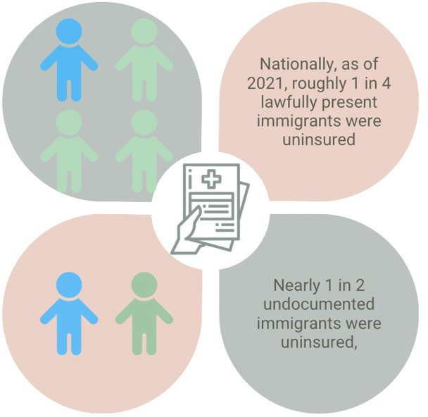
As highlighted in the various health sections of this annual report, LGBTQ youth often receive a lower quality of care than their cisgender, heterosexual peers, particularly as many medical providers display a lack of sensitivity to the unique health care needs of LGBTQ communities. However, the problem is often even more severe for undocumented youth, as undocumented individuals are barred from accessing federally funded insurance plans, and even purchasing insurance in state exchanges.⁴⁷ In Massachusetts, MassHealth does offer some healthcare coverage options for undocumented communities, but access is mostly limited to emergency services
rather than preventative care.⁴⁸ Nationally, as of 2021, roughly 1 in 4 lawfully present immigrants, and nearly 1 in 2 undocumented immigrants were uninsured, compared to 8% of non-elderly U.S.-born citizens.⁴⁹
Between a lack of insurance, fear of discrimination and violence, and fear of being reported to immigration authorities, many LGBTQ undocumented youth go without adequate health and gender-affirming care. Furthermore, foreign-born communities also struggle to access care due to factors such as cultural misunderstanding and insensitivity, and a lack of translated health-related information held by and

supplied to these diverse communities. Many immigrants either do not seek healthcare or find themselves subject to cultural insensitivity because services are not linguistically appropriate or fail to align with the immigrant group’s cultural values.⁵⁰
Legally, ICE recognizes health care centers as “sensitive locations” and cannot detain Massachusetts residents at a hospital, doctor’s office, health clinic, or urgent care center, unless there are special circumstances or with prior approval. Furthermore, federal and state privacy laws protect health information held by health care providers, and providers should only collect what information is medically relevant and needed for treatment.⁵¹ However, many foreign-born communities continue to express concerns around fear of cultural insensitivity, and being detained by immigration officials when seeking health care.
In the 2017 report from the Center for American Progress, twelve of the thirty-two organizations interviewed provided health care services for undocumented individuals, with the most common service provided being HIV/AIDS prevention and treatment. The range of health care services offered by these 12 organizations included mental health care, treatment for substance and drug abuse, medical care, health education, and prevention and testing for HIV/AIDS and other sexually transmitted infections. One LGBTQ community organization in Houston made a specific accommodation by amending its policies so that interpreters could join clients in therapy sessions, therefore ensuring that its mental health services were accessible to immigrants with limited English language proficiency. Providers indicated the importance of understanding the particular challenges faced by LGBTQ immigrants in relation to their mental health such as trauma, substance and drug abuse, domestic violence, sexual abuse, hate crimes, coming out, and being transgender.⁵²

Legal & Employment Services

Research demonstrates that, whether they are seeking asylum or involved in other sorts of legal action, immigrants represented by legal counsel are more likely to win their cases in court. More specifically, they are nearly six times more likely to prevail in court than immigrants lacking representation.⁵³ Immigrants in Massachusetts are six times more likely to win a deportation case if they have legal representation; 62% win their cases when they have representation compared with 10% when they do not.⁵⁴
Many immigration organizations in the New England area offer a variety of legal services, including DACA and naturalization applications, family-based immigration, visas for victims of certain crimes, detention representation, and work permit renewals.⁵⁵ However, it is essential that legal resources also advertise LGBTQ-specific legal resources, as LGBTQ immigrants often lack access to counsel, as well as immigration assistance, to protect themselves against discrimination and bias in areas of housing, employment, and family recognition.
Furthermore, there are a number of barriers that LGBTQ foreign-born youth encounter when attempting to find employment which might include unfamiliarity with the U.S. job market; legal barriers, such as asylum seekers not being able to work for at least 180 days after arrival; lack of appropriate identification or legal documents; lack of stable housing or financial security; skills or certifications that do not transfer between countries; and language barriers. Consequently, when foreign-born youth do manage to find

work, they are often exploited by their employers and have few avenues for recourse, or choose not to report the exploitation for fear of being detained and/or deported.⁵⁶ The Commission recommends that when agencies, such as MassHire, provide job readiness and placement services they identify LGBTQ- friendly workplaces, and also ensure that LGBTQ foreign-born youth understand their legal rights and resources for reporting exploitation, assault, or discrimination.
Many foreign-born individuals may have limited educational opportunities in their country of origin, particularly for those coming from countries at war. As mentioned above, even those who have achieved educational degrees or certification may have difficulty transferring the credentials from their country of origin to the U.S.⁵⁷ Transferring degrees, like licenses and certificates, is often expensive and complex, and is one of the most time-consuming parts of an immigrant’s career process, and can take as little as several weeks or as long as several months to complete - or may not happen at all. For those who lack access to their transcripts of documentation, it can be almost impossible to transfer credentials to the U.S., with no federal standards or regulations to assist them.
Additionally, some foreign-born individuals may have to retake licensing exams, degree programs, and/or trainings. One study found that 25% of immigrants with foreign degrees are underemployed or unemployed, compared to 17% of those born in the U.S. with degrees.⁵⁸ This problem is particularly acute in health care, where more than 20% of immigrants with foreign medical credentials are unable to practice in Massachusetts due to “costly licensing requirements, language barriers, lack of targeted career services and other factors.” ⁵⁹ Helping these practitioners gain accreditation in Massachusetts through comprehensive training and language programs, or by modifying license requirements, would ensure that the Commonwealth avoids underutilizing an important, readily available talent resource.

Education Access & DACA

The Deferred Action for Childhood Arrivals (DACA) program provides temporary protection from deportation for Dreamers, the term used to refer to people who would have been protected by the yet- to-pass federal “Dream Act” which would protect undocumented youth who migrated to the U.S. as children, but may be vulnerable to deportation. ⁶⁰ Since the program was established in 2012, DACA recipients have been able to pursue higher education, participate fully in the labor force, purchase homes and cars, and support their families. For DACA recipients who identify as LGBTQ, the program has meant even more: it has allowed them to openly be themselves, free from the daily fear of deportation.

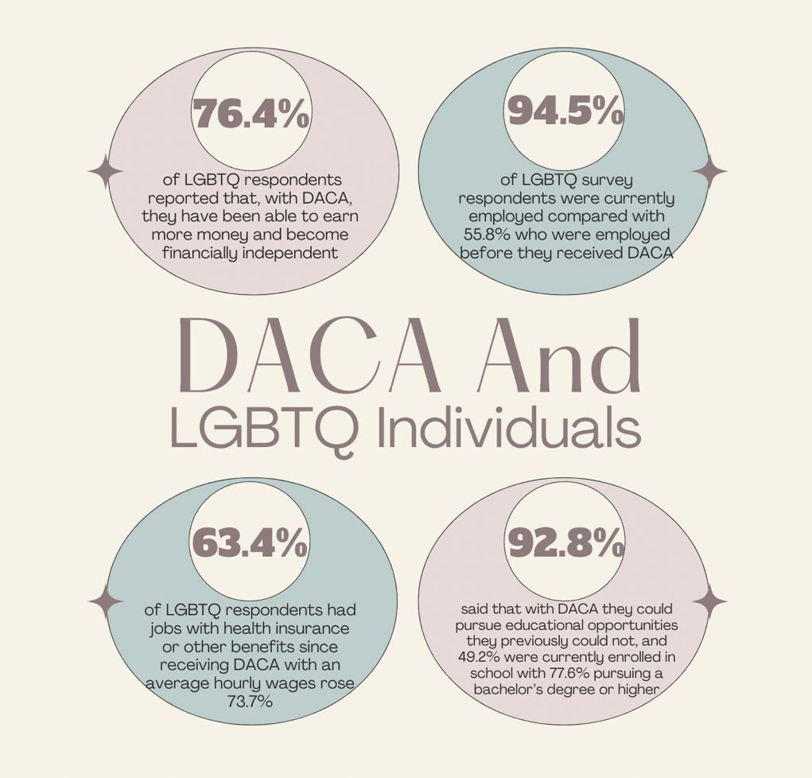

The Williams Institute estimated in 2020 that around 36,000 LGBTQ people may be enrolled in the DACA program;⁶¹ and a previous 2017 survey found that approximately 10% of DACA recipients identified as LGBTQ. ⁶² DACA has helped LGBTQ young people improve their economic security and meet their education goals. According to the survey, 76.4% of LGBTQ respondents reported that, with DACA, they have been able to earn more money and become financially independent.⁶³ In addition, 94.5% of LGBTQ survey respondents were currently employed compared with 55.8% who were employed before they received DACA. Not only were more LGBTQ individuals able to obtain employment with DACA, but they also obtained higher-paying jobs with benefits. Average hourly wages rose 73.7%, and 63.4% of LGBTQ respondents had jobs with health insurance or other benefits since receiving DACA. Among those currently in school, 92.8% said that with DACA they could pursue educational opportunities they previously could not, and 49.2% were currently enrolled in school with 77.6% pursuing a bachelor’s degree or higher.
In recent years, the fate of DACA has been uncertain, receiving scrutiny from courts and government attempts to terminate the program. The Trump administration ended the program in 2017, a decision overturned by the U.S. Supreme Court in June 2022.⁶⁴ As of today, Dreamers are still waiting on Congress to pass legislation that provides them with the permanent protection they need and deserve. If LGBTQ DACA recipients lose their protected status, not only will they no longer be able to work and thrive in the U.S., but they will also face deportation to countries they may not have set foot in since childhood and where their lives could be in danger. Before being deported, LGBTQ immigrants would likely spend time in a detention facility, an environment where horrific abuse is well-documented.

Currently, Massachusetts only allows students holding some form of federal documentation (e.g., DACA) to pay in-state tuition, even as many other states allow all status and non-status holding students to pay in-state prices.⁶⁵ Some states further allow these students access to financial aid, though this is less common. These policies can yield real benefits for students because in-state tuition is often significantly cheaper. Extending in-state tuition benefits to all immigrants regardless of status is one way to ensure that all young people who grew up in Massachusetts can continue their studies, allowing youth not covered by DACA to attend public colleges and universities.

Resources

The above information provides numerous questions around the reality of the day-to-day experiences of LGBTQ foreign-born youth in Massachusetts. The Commission hopes that this new section in its annual report encourages policymakers and advocates to better understand the intersecting identities that many LGBTQ youth in Massachusetts face.
Below is a list of programs and services available to LGBTQ foreign-born youth in Massachusetts. The Office for Refugees and Immigrants (ORI)
The ORI supports services that meet the cultural and linguistic needs of refugees and immigrants through a network of service providers in Massachusetts. There are, however, no programs specifically tailored for LGBTQ communities, nor does ORI collect any data or information on the LGBTQ populations it serves.
De Novo
Provides high-quality, free legal assistance to low-income immigrants and asylum seekers who are living in MA. They assist with asylum cases, which deal with immigrants who flee their home country because of past persecution or fear of persecution because of race, religion, gender, nationality, social group, or political views. De Novo also assists torture survivors, victims of LGBTQ or gender-based violence, and unaccompanied minors, among other special vulnerable populations.
The Department of Mental Health - Multicultural Mental Health Resource Directory
This Directory contains information about organizations in Massachusetts that offer culturally and linguistically appropriate services for communities of color, the LGBTQ community, the Deaf and hard of hearing community, immigrants, and refugees. Although this Directory contains information about a variety of organizations in MA that offer culturally and linguistically appropriate services for both immigrants and the LGBTQ community, there are no organizations that offer services for LGBTQ immigrant youth specifically.
LGBT Asylum Task Force
Provides shared housing for LGBTQ asylum seekers in Worcester, Massachusetts. If funds are available, they provide a small monthly stipend to pay for food, transportation, and other basic expenses. Housing and stipend support continues until asylum seekers receive their work permits (EAD). They also provide a list of pro bono immigration lawyers that might be able to assist asylum seekers with the application

process. Additionally, they help asylum seekers to get connected to a doctor and therapist at the local health center.
Greater Boston Immigrant Defense Fund & United Legal Defense Fund for Immigrants
Both of these Funds support local organizations that provide representation to individuals in deportation proceedings who are otherwise unable to afford it. In addition to legal representation, both these Funds support nonprofits running legal education programs for immigrants such as “know your rights” trainings to prevent detention and deportation, and help immigrants navigate application processes. In the case of the United Legal Defense Fund, this support extends to covering court or other fees.

Acknowledgments & Citations

Acknowledgments: Karina Zeferino, lead researcher and author

1 Associated Press, “Massachusetts Sheriff Ends Enforcement Agreement with ICE,” January 5, 2023, https://www.wgbh.org/news/local-news/2023/01/05/massachusetts-sheriff-ends-enforcement-agreement-with-ice.
2 Sean Philip Cotter, “Boston Police Say They Received, Ignored 12 ICE Immigration Detainer Requests,” January 9, 2023, https://www.bostonherald.com/2023/01/09/boston-police-say-they-received-ignored-12-ice-immigration-detainer-requests/. 3 Adi Daniels, “Why Do People Immigrate? - The Different Causes of Immigration,” LIRS (blog), July 15, 2021, https://www.lirs.org/causes-of-immigration/.
4 “#OUTLAWED: ‘The Love That Dare Not Speak Its Name,’” accessed April 3, 2023, https://features.hrw.org/features/features/lgbt_laws.
5 “#OUTLAWED.”
6 Hasalyn Modine, “A Short History of LGBTQ Immigration Policy,” Boundless, June 6, 2022, https://www.boundless.com/blog/a-short-history-lgbtq-immigration-policy/.
7 Sharita Gruberg, “On the 50th Anniversary of the Immigration and Nationality Act, Changes Are Needed to Protect LGBT Immigrants - Center for American Progress,” Center for American Progress, March 23, 2015, https://www.americanprogress.org/article/on-the-50th-anniversary-of-the-immigration-and-nationality-act-changes-are- needed-to-protect-lgbt-immigrants/.
8 Gruberg.
9 Devin Dwyer, “U.S. Ban on HIV-Positive Visitors, Immigrants Expires - ABC News,” ABC News, January 5, 2010, https://abcnews.go.com/Politics/united-states-ends-22-year-hiv-travel-ban/story?id=9482817.
10 Gruberg, “On the 50th Anniversary of the Immigration and Nationality Act, Changes Are Needed to Protect LGBT Immigrants - Center for American Progress.”
11 MIRA Coalition, “Immigrants Are Our Commonwealth,” 2019, https://miracoalition.org/wp-content/uploads/2020/01/Mass- Immigrant-Facts-Jan2019.pdf.
12 “2022 Election Results Live,” NPR, accessed April 24, 2023, https://apps.npr.org/election-results-live-2022/.
13 Shoshana Goldberg and Kerith Conron, “LGBT Adult Immigrants in the United States,” Williams Institute, February 2021, https://williamsinstitute.law.ucla.edu/publications/lgbt-immigrants-in-the-us/.
14 “The Trevor Project National Survey 2020,” accessed April 3, 2023, https://www.thetrevorproject.org/survey-2020/.
15 Goldberg and Conron, “LGBT Adult Immigrants in the United States.”
16 Sharita Gruberg, Caitlin Rooney, and Ashe McGovern, “Serving LGBTQ Immigrants and Building Welcoming Communities,” Center for American Progress (blog), January 24, 2018, https://www.americanprogress.org/article/serving-lgbtq-immigrants- building-welcoming-communities/.
17 Karma R. Chavez, “Identifying the Needs of LGBTQ Immigrants and Refugees in Southern Arizona,” Journal of Homosexuality
58, no. 2 (2011): 189–218, https://doi.org/10.1080/00918369.2011.540175.
18 “Latinx LGBTQ+ Immigrant Youth / Jovenes Inmigrantes Latinx LGBTQ+ Provider Fact Sheet,” Each Mind Matters Resource Center, accessed April 24, 2023, https://emmresourcecenter.org/resources/latinx-lgbtq-immigrant-youth-jovenes-inmigrantes- latinx-lgbtq-provider-fact-sheet.

19 Michelle M. Johns et al., “Transgender Identity and Experiences of Violence Victimization, Substance Use, Suicide Risk, and Sexual Risk Behaviors Among High School Students — 19 States and Large Urban School Districts, 2017,” MMWR. Morbidity and Mortality Weekly Report 68 (2019), https://doi.org/10.15585/mmwr.mm6803a3.
20 Margarita Alegría, Kiara Álvarez, and Karissa DiMarzio, “Immigration and Mental Health,” Current Epidemiology Reports 4, no. 2 (June 2017): 145, https://doi.org/10.1007/s40471-017-0111-2.
21 Consuelo Arbona et al., “Acculturative Stress Among Documented and Undocumented Latino Immigrants in the United States,” Hispanic Journal of Behavioral Sciences 32, no. 3 (August 2010): 362–84, https://doi.org/10.1177/0739986310373210. 22 Nicole N. Gray, David M. Mendelsohn, and Allen M. Omoto, “Community Connectedness, Challenges, and Resilience Among Gay Latino Immigrants,” American Journal of Community Psychology 55, no. 0 (March 2015): 202, https://doi.org/10.1007/s10464-014-9697-4.
23 Fernando Estrada et al., “Machismo and Mexican American Men: An Empirical Understanding Using a Gay Sample,” Journal of Counseling Psychology 58, no. 3 (July 2011): 358–67, https://doi.org/10.1037/a0023122.
24 The APA Presidential Task Force on Immigration. (2013). Crossroads: The psychology of immigration in the new century.
Journal of Latina/o Psychology, 1(3), 133–148. https://doi.org/10.1037/lat0000001
25 “LGBTQ Youth from Immigrant Families,” The Trevor Project (blog), April 30, 2021, https://www.thetrevorproject.org/research-briefs/lgbtq-youth-from-immigrant-families-2/.
26 “Latinx LGBTQ+ Immigrant Youth / Jovenes Inmigrantes Latinx LGBTQ+ Provider Fact Sheet.”
27 MIRA Coalition, “2021 MIRA Coalition Annual Report,” 2021, https://miracoalition.org/wp- content/uploads/2022/09/MIRAAnnualReport2021Final.pdf.
28 Sarah Betancourt, “Walsh, Zakim Submit Changes to Immigrant Trust Act,” CommonWealth Magazine (blog), December 9, 2019, https://commonwealthmagazine.org/immigration/walsh-zakim-submit-changes-to-immigrant-trust-act/.
29 Ilan H. Meyer et al., “Incarceration Rates and Traits of Sexual Minorities in the United States: National Inmate Survey, 2011- 2012,” American Journal of Public Health 107, no. 2 (February 2017): 267–73, https://doi.org/10.2105/AJPH.2016.303576; Gallup Inc, “LGBT Identification in U.S. Ticks Up to 7.1%,” Gallup.com, February 17, 2022, https://news.gallup.com/poll/389792/lgbt-identification-ticks-up.aspx.
30 Sarah McBride, Laura Durso, and Hannah Hussey, “We the People,” Center for American Progress (blog), December 10, 2014, https://www.americanprogress.org/article/we-the-people-2/.
31 Movement Advancement Project and Center for American Progress, “Movement Advancement Project | Unjust: How the Broken Criminal Justice System Fails LGBT People of Color,” 2016, https://www.lgbtmap.org/policy-and-issue-analysis/criminal- justice-poc.
32 Lambda Legal and Black & Pink National, “Projected & Served? 2022 Annual Report: Executive Summary,” Protected & Served?, accessed April 24, 2023, https://www.protectedandserved.org/2022-report-executive-summary.
33 Massachusetts Executive Office of Public Safety & Security, “Hate Crimes in Massachusetts 2021,” 2022, https://www.mass.gov/doc/2021-massachusetts-hate-crime-report/download
34 Sharita Gruberg, “How Police Entanglement with Immigration Enforcement Puts LGBTQ Lives at Risk,” Center for American Progress (blog), April 12, 2017, https://www.americanprogress.org/article/police-entanglement-immigration-enforcement- puts-lgbtq-lives-risk/.
35 S. E. James et al., “The Report of the 2015 U.S. Transgender Survey” (Washington, D.C.: National Center for Transgender Equality and National Gay and Lesbian Task Force, 2016), https://transequality.org/sites/default/files/docs/usts/USTS-Full- Report-Dec17.pdf.
36 James et al.
37 Gruberg, “How Police Entanglement with Immigration Enforcement Puts LGBTQ Lives at Risk.”
38 Gruberg, Rooney, and McGovern, “Serving LGBTQ Immigrants and Building Welcoming Communities.”
39 Chavez, “Identifying the Needs of LGBTQ Immigrants and Refugees in Southern Arizona.”
40 Simon Rios, “For Non-English Speakers, Difficult Language Barriers Become Dire Amid Outbreak,” WBUR, accessed April 24, 2023, https://www.wbur.org/news/2020/04/07/coronavirus-translation-problems.
41 Rios.
42 Jason Espinoza and Sabrina Derrington, “How Should Clinicians Respond to Language Barriers That Exacerbate Health Inequity?,” AMA Journal of Ethics 23, no. 2 (February 1, 2021): 109–16, https://doi.org/10.1001/amajethics.2021.109.
43 Espinoza and Derrington.
44 {Citation}
45 Laurie Ross, “Massachusetts 2021 Youth Count,” 2021, https://www.mass.gov/doc/2021-youth-count-report/download.
46 Senate and House of Representative of the Commonwealth of Massachusetts, An Act providing upstream homelessness prevention assistance to families, youth, and adults, SD. 1169, https://malegislature.gov/Bills/193/SD1169
47 National Immigration Law Center, “A Quick Guide to Immigrant Eligibility for ACA and Key Federal Means-Tested Programs,” April 2018, https://www.nilc.org/issues/economic-support/quick-guide-aca-means-tested-programs/.
48 “Information for Immigrant Patients and Their Health Care Providers on Immigration Enforcement | Mass.Gov,” accessed April 24, 2023, https://www.mass.gov/service-details/information-for-immigrant-patients-and-their-health-care-providers-on-

immigration-enforcement.
49 KFF, “Health Coverage and Care of Immigrants,” KFF (blog), December 20, 2022, https://www.kff.org/racial-equity-and- health-policy/fact-sheet/health-coverage-and-care-of-immigrants/.
50 Chavez, “Identifying the Needs of LGBTQ Immigrants and Refugees in Southern Arizona.”
51 “Information for Immigrant Patients and Their Health Care Providers on Immigration Enforcement | Mass.Gov.”
52 Gruberg, Rooney, and McGovern, “Serving LGBTQ Immigrants and Building Welcoming Communities.”
53 Peter Markowitz et al., “Accessing Justice: The Available and Adequacy of Counsel in Removal Proceedings,” Cardozo Law Review 33 (December 1, 2011): 357.
54 Trevor Mattos, Andre Lima, and Peter Ciurczak, “Growing Wave of Restrictions,” Boston Indicators, 2019, https://www.bostonindicators.org/reports/report-website-pages/growing-wave-of-restrictions.
55 “Legal Services,” MIRA Coalition (blog), accessed April 24, 2023, https://miracoalition.org/resources/legal-services/.
56 Josselyn Andrea Garcia Quijano, “Workplace Discrimination and Undocumented First-Generation Latinx Immigrants,” Crown Family School of Social Work, Policy, and Practice, accessed April 24, 2023, https://crownschool.uchicago.edu/student- life/advocates-forum/workplace-discrimination-and-undocumented-first-generation-latinx.
57 Cassie Arnita, “Barriers to Career Advancement Among Skilled Immigrants in the US,” Ballard Brief, 2022, https://ballardbrief.byu.edu/issue-briefs/barriers-to-career-advancement-among-skilled-immigrants-in-the-us.
58 James D. Bachmeier, Jeanne Batalova, and Michael Fix, “Untapped Talent: The Costs of Brain Waste among Highly Skilled Immigrants in the United States,” migrationpolicy.org, December 2, 2016, https://www.migrationpolicy.org/research/untapped-talent-costs-brain-waste-among-highly-skilled-immigrants-united-states.
59 Mattos, Lima, and Ciurczak, “Growing Wave of Restrictions.”
60 Sharita Gruberg, “What Ending DACA Means for LGBTQ Dreamers - Center for American Progress,” October 11, 2017, https://www.americanprogress.org/article/ending-daca-means-lgbtq-dreamers/.
61 Kerith Conron, Winston Luhur, and Taylor N.T. Brown, “LGBT ‘Dreamers’ and Deferred Action for Childhood Arrivals (DACA),” Williams Institute, June 2020, https://williamsinstitute.law.ucla.edu/publications/lgbt-dreamers-daca/.
62 Tom K. Wong, Greisa Martinez Rosas, and Adam Luna, “DACA Recipients’ Economic and Educational Gains Continue to Grow,” Center for American Progress (blog), August 28, 2017, https://www.americanprogress.org/article/daca-recipients- economic-educational-gains-continue-grow/.
63 Wong, Rosas, and Luna.
64 Asumi Shuda, “New Department of Homeland Security Rule Aims to Preserve Deferred Action for Childhood Arrivals Program amid Court Scrutiny | The Daily Nexus,” November 12, 2022, https://dailynexus.com/2022-11-12/new-department-of- homeland-security-rule-aims-to-preserve-deferred-action-for-childhood-arrivals-program-amid-court-scrutiny/.
65 Mattos, Lima, and Ciurczak, “Growing Wave of Restrictions.”

COMMISSION ON LGBTQ YOUTH
INCLUSIVE SERVICE PROVISION FOR FOREIGN- BORN LGBTQ YOUTH

ABOUT
For LGBTQ foreign-born youth who face discrimination based on their sexual orientation and gender identity as well as their immigration status, the state of Massachusetts must work to remove these barriers to integration. To ensure that LGBTQ youth thrive, it is critical to invest in culturally competent immigration integration resources that are responsive to the needs of diverse communities.
RECOMMENDATIONS
Improve the availability of multilingual, LGBTQ- affirming services for foreign-born residents, and increase funding for existing programs.

Establish an LGBTQ Immigrant & Refugee Task Force.

Address the concerning lack of SOGIE data collection at the state level.
Protect and support undocumented youth.

1 IN 6
of Massachusetts residents are foreign-born

30%
of first-generation LGBTQ youth worry about deportation "sometimes" or "a lot"

1 IN 10
of first-generation LGBTQ youth reported experiencing discrimination based on actual or perceived immigration status




LEGISLATION
S. 1510/H.2288: Safe Communities Act S.817/H.1281: Access to Higher Education S.740/H.1237: MassHealth coverage

Understanding Environmental Justice

Introduction

Research examining the environmental justice needs of LGBTQ communities is still emerging, but a growing body of evidence indicates that environmental justice is a key element of the complex web of inequities that impact the health and well-being of LGBTQ youth, particularly LGBTQ youth of color and Indigenous, immigrant, disabled, and low-income LGBTQ youth. The necessity of examining the undue environmental burdens placed on LGBTQ youth is undeniable; exposure to environmental stressors such as air pollution and toxic chemicals exacerbates the health and economic inequalities LGBTQ communities already face. Those who hold multiple marginalized identities, such as QTBIPOC youth, experience compounding effects from multiple overlapping systems of oppression. Developing a more complete picture of the burdens and injustices faced by LGBTQ youth in Massachusetts, a population which itself holds great diversity, requires bringing intersectionality to the forefront and understanding the interactions between the multiple social, economic, environmental, and institutional systems that impact LGBTQ youth. As environmental justice and climate justice become increasingly high policy priorities in Massachusetts under the leadership of Governor Maura Healey, we must make sure that the needs of diverse LGBTQ communities are meaningfully incorporated into environmental and climate policymaking.

In this new section of the Commission’s annual report, the environmental justice needs of LGBTQ youth in Massachusetts will be explored. First, we will review what is meant by “environmental justice” and discuss the importance of intersectionality in examining the needs of LGBTQ youth and understanding environmental injustice. Next, two conceptual frameworks from public health – Cumulative Impacts and Social Determinants of Health – will be introduced to inform our understanding of how environmental exposures lead to outcomes in health and well-being. With these frameworks in mind, we will discuss certain environmental exposures which disproportionately affect LGBTQ populations, including ambient air pollution, secondhand smoke, and toxic chemicals in beauty and personal care products. Next, we will investigate the links between disproportionate environmental exposures and health disparities, examining how underlying health challenges disproportionately affecting LGBTQ communities, barriers accessing health care, and other socioeconomic factors worsen the health impacts of exposure. Finally, we will discuss the disproportionate impacts of climate change on LGBTQ populations and the unique needs of LGBTQ youth related to climate justice, such as the need for inclusive disaster response systems.

FY 2024 Recommendations to the Governor and Legislature on Environmental Justice

Expand existing policies and programs addressing environmental inequities to include and address the unique impacts on LGBTQ youth across the Commonwealth.

The Commission recommends that the Commonwealth examine and expand existing policies and programs working to address environmental inequities to ensure that this critical work is addressing unique impacts on LGBTQ youth, particularly BIPOC youth, youth with disabilities, and low-income youth. In January 2023, Governor Maura Healey signed an Executive Order to establish the Office of Climate Innovation and Resilience to coordinate climate policy across state agencies and communities; the Commission urges this new office to center QTBIPOC communities in its work, and to take a broad understanding of how to tackle climate justice.

Promote QTBIPOC youth voice in environmental justice initiatives, research, working groups, and task forces.

As the Commonwealth further explores its engagement in environmental and climate justice, the Commission strongly recommends that policymakers and agencies engage QTBIPOC youth in important discussions in recognition of their presence in environmental justice communities. Furthermore, the Commission advises that the state should engage LGBTQ youth in community-based participatory approaches when considering policies addressing toxic chemicals in makeup, and tobacco cessation campaigns.

Improve access to quality health care, affordable housing, and stable income.

As detailed throughout the annual report, LGBTQ youth well-being is affected by a wide array of systemic inequities. In order to best address environmental well-being for LGBTQ youth, the state must simultaneously improve access to quality health care; increase access to affordable, accessible, stable, and safe housing; and address the significant wealth inequities disproportionately affecting BIPOC youth in Massachusetts.

Research: Understanding Environmental Justice and LGBTQ Youth

Environmental justice describes the right of all people to be protected from environmental hazards and to enjoy the benefits of a clean, healthy environment. Historically, environmental justice organizing emerged out of grassroots activism that sought to address the unfair exposure of poor, Black communities to industrial pollution and hazardous land uses through the lens of civil rights.¹ Environmental justice is also inextricably tied to Indigenous rights and movements for Landback.² Indigenous communities are leaders in fighting fossil fuel expansion and industrial pollution, protecting shared resources such as clean

water, and stewarding the land and its biological diversity in Massachusetts, the United States, and across the globe.^{3,4} Restoring lands to Indigenous control is a crucial aspect of environmental justice.⁵

One of the tenets of environmental justice as defined by the Massachusetts Executive Office of Energy and Environmental Affairs (EEA) is the “equal protection and meaningful involvement of all people and communities” in the environmental policymaking process.⁶ Environmental justice principles have been incorporated into policies and programs at the federal, state, and local level to help address the disproportionate share of environmental burdens experienced by low-income communities and communities of color and ensure a more equitable distribution of environmental assets, such as green space.⁷ Many of these programs and policies rely on identifying “environmental justice populations” based on census data on income, race, ethnicity, and English language proficiency.⁸ In Massachusetts, the EEA works to engage environmental justice populations in environmental decision-making, improve neighborhood environmental quality, and protect communities from pollution through its Environmental Justice Policy.⁹

While environmental justice has traditionally focused on the disproportionate burdens faced by low- income communities of color, researchers and activists are increasingly recognizing disparities in the environment based on many axes of oppression, such as gender, age, religion, immigration status, ability, and sexual orientation.¹⁰ Intersectionality reminds us that examining environmental injustice through the lenses of race and class alone is not enough – we must consider the unique environmental injustices that LGBTQ, Indigenous, immigrant, and disabled communities experience, and, most crucially of all, the compounding injustices experienced by people who hold multiple oppressed identities, such as QTBIPOC youth.¹¹

Cumulative Impacts and Social Determinants of Health

Before we explore research on environmental inequities impacting LGBTQ youth, let’s first consider a few frameworks from public health that may help us better understand the relationship between exposures to toxic chemicals in the environment and negative health impacts, particularly for communities facing multiple stressors such as LGBTQ youth. The relationship between exposure to pollution and the long- term impacts of that exposure on your health is rarely straightforward. First, there is often a time lag between the exposure and the development of a disease which makes it difficult to link the two. Furthermore, the long-term health conditions that are caused by toxic chemicals and environmental hazards are often complex and influenced by many genetic and environmental risk factors, making it very difficult to prove that a specific exposure was the cause of a condition such as cancer or heart disease.

To make matters even more complicated, most people are exposed to many chemicals over the course of their lifetime, and health conditions might not be caused by one specific exposure, but they may rather be a result of the cumulative impact of all of these exposures added together over time. There are also many socioeconomic factors that play important mediating roles in determining the level of risk posed by an exposure. For example, someone with stable access to food, housing, health care, and employment will likely be more resilient in the face of an exposure than someone who faces barriers to accessing these

resources. So, in light of these complexities, how can we make sense of the impacts of the environment on communities facing environmental injustice?

Cumulative Impacts and Social Determinants of Health are two frameworks from environmental and public health that can help us understand the relationship between exposure to pollution and detrimental long-term health outcomes. The Cumulative Impacts model of environmental health highlights the fact that, in the real world, people are rarely exposed to a single pollutant at a high concentration, but rather accumulate multiple burdens of chemical exposures and nonchemical co-stressors from many different exposures over their lifespan. Nonchemical co-stressors refer to factors that can worsen the health impacts of exposure to pollution, such as access to health care, housing, and economic stability. The Cumulative Impacts approach reflects growing recognition that the health impacts of exposure to pollution must be examined in the context of socioeconomic status, preexisting health conditions, and other environmental stressors such as extreme temperatures and lack of access to green space which can exacerbate the effects of exposure. ¹² Communities experiencing a disproportionate burden of environmental health risks, often due to multiple environmental and socioeconomic stressors which act cumulatively to create persistent environmental health disparities, are sometimes referred to as “overburdened communities.”¹³

Social Determinants of Health is another framework that describes how inequitable social systems create conditions for health inequalities among marginalized populations.¹⁴ Due to their marginalized status, residents of environmental justice communities may both bear a disproportionate burden of environmental health risk, and face additional barriers and burdens that contribute to worse health outcomes after exposure. ¹⁵ For example, inequitable social systems affecting LGBTQ youth impede economic stability, prevent access to health care, increase rates of homelessness, and contribute to preexisting mental and physical health burdens. These factors both increase the risk of exposure to harmful pollution and reduce the capacity to respond to environmental harm, such as by accessing necessary health care.¹⁶ Who can take paid time off work due to a medical condition, and who might lose their source of income as a result? Who has access to regular cancer screenings, and who might not have regular access to a doctor, resulting in a later diagnosis? Who has greater access to green space, which has been shown to support mental and physical health? Social Determinants of Health reminds us that while it is important to examine disparities in who is exposed to pollution, exposure is only half of the story. We must also consider who experiences the conditions for health and wellbeing, and who is at greater risk of harm due to the social and institutional marginalization that accompanies disproportionate exposure.

Data Limitations

Unfortunately, there are significant data gaps when it comes to examining the environmental justice needs of LGBTQ youth. Gender and sexuality are still not commonly considered as important factors in environmental justice research, and there are limited studies and data sources that explore the intersections of gender and sexuality with access to environmental benefits and exposure to hazards.

Overall, there is limited data on where LGBTQ people live, which poses a challenge to understanding the environmental injustices faced by LGBTQ communities since much of environmental justice research depends on residence data. For instance, U.S. Census Bureau data is widely used to examine disparities in exposure to environmental hazards and access to environmental benefits and does not typically include expansive SOGIE (sexual orientation and gender identity/expression) data. The 2020 Census did give people the option to identify a relationship as same-sex for the first time, but this comes nowhere close to encompassing the diversity of LGBTQ communities. Data on same-sex households omits partners that don’t live together, single LGBTQ people, most LGBTQ youth, many bisexual and trans people, and still operates within the gender binary, excluding nonbinary and intersex people.¹⁷ Collecting more complete LGBTQ residence data will be crucial for deeper analysis of environmental disparities facing LGBTQ youth.

There are also numerous barriers to response when collecting data on sexuality and gender identity, particularly when surveying LGBTQ youth. LGBTQ people responding to a survey may not reveal their identity due to institutional discrimination, social stigma, or to maintain their safety. In addition, gender and sexuality are fluid and people may change how they identify over time. The process of exploring how you relate to gender and sexuality, prefer to identify, and express yourself is a continuous, lifelong journey. To capture the complexity of LGBTQ identities and experiences, surveys should include not only identity but also attraction and behavior. Very few surveys currently do so. The Centers for Disease Control Youth Risk Behavior Survey provides a good example in its questions about both gender identity and sexual contacts, but could also include questions about attraction to capture an even more comprehensive picture.

Although more data explicitly exploring the intersections of gender and sexuality with environmental justice is urgently needed, we can begin to examine the environmental justice needs of LGBTQ youth using data about socioeconomic factors that cause LGBTQ youth to be disproportionately exposed to pollution and social determinants of health that worsen the impacts of exposure. In addition, it is important to consider the value of multiple types of knowledge. Although data is a powerful tool, it also has many limitations and uncertainties. In the sections that follow, we will not only consider surveys and studies that use numerical data to draw conclusions, but also draw on experiential knowledge shared directly by community members.

Exposure to Pollution and Environmental Hazards

Research on LGBTQ health disparities is vast but has historically left out the role of the physical environment.¹⁸ However, there is mounting evidence that LGBTQ communities are disproportionately exposed to pollution and environmental hazards; it is especially important to consider the disproportionate environmental exposures faced by LGBTQ populations affected by multiple intersecting systems of oppression. Research and organizing around disparities in exposures based on race, class, and Indigeneity are extensive and clearly demonstrate that low-income communities of color experience the greatest exposure to pollution in the places they live, work, and play, as well as the consumer products they use. Black and Indigenous communities bear particularly high burdens of pollution and environmental health risk. When considering the impacts of environmental exposures on LGBTQ

populations, it is crucial to highlight that QTBIPOC youth and low-income LGBTQ youth may experience multiple compounding burdens of environmental exposure.

First, there is growing evidence that ambient air pollution disproportionally affects LGBTQ youth because of the places LGBTQ people live. Due to higher rates of poverty compared to non-LGBTQ populations, LGBTQ people may be more likely to live in neighborhoods where they will face higher exposure to air pollution. In 2021, survey data from the Behavioral Risk Factor Surveillance System (BRFSS) and the U.S. Census Household Pulse System (HPS) showed that 17% of LGBTQ people, 21% of trans people, and 25% of LGBTQ people of color lived in poverty in the U.S., compared to 12% of non-LGBTQ people and 20% of non-LGBTQ people of color.¹⁹ The last state-level analysis of LGBTQ poverty rates was completed in 2019 using BRFSS survey data from 2015-2017. In this dataset, the poverty rate was higher for LGBTQ people in Massachusetts (13%) than for cis straight people (9%), LGBTQ people of color (26%) had a higher poverty rate than white LGBTQ people (9%), and LGBTQ people aged 18-44 (16%) had a higher poverty rate than LGBTQ people aged 45 or older (8%).²⁰ Disparities in exposure to ambient air pollution based on race and class are well-documented in Massachusetts and across the United States, further demonstrating that low-income QTBIPOC youth in particular face particularly disproportionate burdens of air pollution. There are many reasons why low-income and communities of color often face higher exposure to pollutants, including discriminatory housing policies and urban planning decisions that disproportionately locate hazardous land uses such as landfills, power plants, and major highways in lower income areas and communities of color.^{21,22}

Research directly relating air pollution to the places where LGBTQ people live is limited, but two studies, one focusing on Houston, Texas, and one examining trends on a national scale, have used census data on same-sex couples to examine the relationship between same-sex enclaves and air pollution.^{23,24} These early analyses indicate that sexual orientation, even when accounting for race, is a strong indicator of living in an area with higher levels of air pollution. Similar disparities may exist for different types of neighborhood environmental exposures such as water and soil contamination, and should be studied further.

Higher rates of homelessness and housing instability among LGBTQ youth may also result in greater exposure to environmental hazards. People experiencing homelessness frequently face high exposure to ambient air pollution, soil contamination, and water pollution due to living outdoors, often near major roadways and other emission sources.²⁵ Criminalization worsens exposures, as police sweeps may force people into more environmentally hazardous areas such as freeway underpasses.²⁶ LGBTQ youth are more likely to experience housing instability and homelessness in Massachusetts, and thus at greater risk of facing associated environmental injustices. In a dataset from the 2022 Massachusetts Youth Count annual survey which seeks to learn about the needs of youth who are unstably housed or experiencing homelessness, 12% of LGBTQ youth experiencing homelessness reported being unsheltered the night before.²⁷ Working to decrease rates of homelessness and housing instability among LGBTQ youth and improve access to services is vital to reducing unjust environmental exposures faced by LGBTQ youth.

Exposure to tobacco smoke is another environmental justice concern for LGBTQ youth. Numerous studies show that LGBTQ populations are more likely to smoke cigarettes than non-LGBTQ populations.²⁸ In Massachusetts, the 2019 Youth Risk Behavior Survey (MYRBS) data showed that LGBTQ youth (12%) were more likely to smoke cigarettes than non-LGBTQ youth (5%). ²⁹ Higher rates of smoking in LGBTQ communities also mean higher exposure to secondhand smoke in the places where LGBTQ people live and socialize. One study in California found that LGBTQ people were twice as likely to be exposed to secondhand smoke in their household.³⁰ Another study found that visitors of LGBTQ bars and venues were 38% more likely to be exposed to secondhand smoke than non-LGBTQ venues.³¹ Exposure to secondhand smoke is associated with respiratory illnesses, cancer, and heart disease.³²

As further evidence of disproportionate exposure, health conditions linked to air pollution and secondhand smoke have been found at disproportionate rates among LGBTQ communities, including LGBTQ youth. Multiple analyses have found that asthma and chronic obstructive pulmonary disease, two respiratory illnesses related to environmental exposures such as air pollution and smoking, disproportionately affect LGBTQ populations.^{33,34} ^{,35,36} One study based on national YRBS data found that rates of asthma are significantly higher among LGBTQ youth (28%) compared to non-LGBTQ youth (21%);³⁷ YBRS data on asthma rates among Massachusetts youth is not currently available.³⁸ Studies have also found higher rates of cardiovascular diseases linked to environmental exposures in some LGBTQ subpopulations.³⁹

Chemical Exposures from Beauty and Personal Care Products

Consumer products such as beauty and personal care products are another source of environmental chemical exposure that may disproportionately affect LGBTQ and QTBIPOC youth. Many beauty products that are used and sold widely in the United States contain toxic chemicals that can harm health, such as phthalates, parabens, formaldehyde, lead, mercury, and other compounds that are linked to endocrine disruption, cancer, reproductive harm, and neurodevelopmental harm in children.⁴⁰ A new study in 2021 found that over half of cosmetic products sold in the US contain PFAS, a “forever chemical” associated with serious health conditions such as cancer and pregnancy complications.⁴¹

The burdens of toxic chemical exposures from beauty and personal care products are not distributed equally. Socioeconomic factors, systemic racism, and societal norms impact the type and quality of products that people use, affecting their exposure to toxic chemicals and posing risks to their health.⁴² Although much more research is needed in this area, LGBTQ people, particularly drag communities and LGBTQ youth, may face unequal chemical burdens from beauty and personal care products. In a 2021 discussion hosted by West Harlem Environmental Action, also known as WE ACT for Environmental Justice, a panel of researchers, advocates, and queer drag performers discussed the impact of toxic chemicals found in beauty and personal care products on the queer community. For example, a panelist mentioned that young people who are first starting out in drag or are exploring gender expression may use cheaper products that contain more toxic chemicals due to budget and availability constraints.⁴³

As an increasing number of studies reveal the widespread use of toxic substances in beauty and personal care products sold in the U.S., many states are taking legislative action to ban toxic ingredients in cosmetics. Action at the state level is crucial to fill gaps posed by the federal government’s limited authority to regulate the cosmetics industry. In 2023, at least 12 states including Washington, Hawaii, Illinois, Massachusetts, Michigan, Nevada, New Jersey, New York, North Carolina, Oregon, Rhode Island, Texas, and Vermont are considering policies to restrict or require disclosure of toxic chemicals in cosmetics and personal care products.⁴⁴ Some states have already taken significant actions to regulate the safety of personal care products. California has passed several laws that regulate cosmetics ingredients and labeling, including the California Safe Cosmetics Act in 2005, the California Toxic-Free Cosmetic Act in 2020, and a ban on PFAS in personal care products.⁴⁵ In Massachusetts, a bill to ban PFAS from consumer products, including personal care products, was filed in February 2023.⁴⁶

From Environmental Exposures to Health Outcomes

In addition to disparities in exposure, LGBTQ communities are likely to experience more serious health impacts from those exposures due to socioeconomic inequities and preexisting conditions. In epidemiology, effect modification refers to a situation where the impact that an exposure has on a health outcome is affected by a third variable, such as access to health care or a preexisting health condition. Not only do LGBTQ populations experience disproportionate exposure to environmental hazards, but they also likely experience more severe health outcomes from those exposures. Underlying health conditions disproportionately affecting LGBTQ communities, challenges accessing health care, and stressors such as economic instability and housing insecurity may worsen the health impacts of exposure. ⁴⁷ Black, Indigenous, immigrant, disabled, and low-income LGBTQ communities facing the combined burdens of heightened environmental exposures and structural racism, colonialism, ableism, and poverty are particularly at risk for health disparities. For example, research on the socioeconomic status of Two-Spirit and LGBTQ Indigenous people has found that 26% are unemployed, 55% experience food insecurity, and 23% live in extreme poverty due to discrimination, marginalization, stigmatization, and historical trauma.^{48,49}

Preexisting health conditions among LGBTQ+ populations, such as HIV, can worsen the health impacts of pollution. Since HIV compromises the immune system, people with HIV are particularly susceptible to negative health consequences from exposure to environmental hazards such as air pollution. Numerous studies have investigated how exposure to air pollution exacerbates HIV; air pollution can cause and worsen conditions like pneumocystis pneumonia and tuberculosis (TB). One study linked exposure to particulate matter, nitrogen dioxide and ozone, three of the most common air pollutants, with pneumonia hospitalization in people with HIV.⁵⁰ Another found positive association between carbon monoxide and nitrogen dioxide exposure and contracting TB.⁵¹ Studies also suggest that the combined effects of air pollution and HIV may amplify the development of cardiovascular disease.⁵²

Hazardous environmental conditions can also exacerbate the high mental health burdens that LGBTQ youth already face. The link between environmental exposures and mental health challenges is understudied, but emerging research demonstrates that exposure to air pollution, noise pollution,

extreme weather, and environmental disasters can increase the risk of mental health conditions such as depression.^{53,54,55} More research into the connection between pollution exposure and mental health is extremely important for understanding the needs LGBTQ youth, who already face heightened risks to their mental health and wellbeing.

In addition to risks from preexisting conditions, LGBTQ populations may have a decreased capacity to respond to the health impacts of pollution due to barriers to obtaining medical care and difficulty avoiding hazardous environmental conditions. The challenges LGBTQ people often face in receiving health care are well-documented. LGBTQ people are less likely to seek medical care until they have a serious health issue because of fear of discrimination or costs.⁵⁶ One study found that more than 1 in 6 LGBTQ adults avoided seeking health care because of anticipated discrimination.⁵⁷ Another study on LGBTQ youth’s perceptions of health care revealed that most youth did not feel their health care needs were well met and expressed concerns about disrespectful behavior, poor communication, lack of confidentiality, and discrimination.⁵⁸ These realities place LGBTQ youth in a more vulnerable position when dealing with the health impacts of environmental exposures if they are less willing or able to access comprehensive health care. Higher rates of poverty, unemployment, and homelessness among LGBTQ youth can be additional barriers to accessing adequate health care. As previously discussed, these factors may also force LGBTQ youth to live in environmentally hazardous living situations or make it challenging for them to change hazardous conditions.

All in all, it is clear that LGBTQ youth not only face higher exposure to environmental hazards, but are likely to experience worse health outcomes from those exposures due to these additional burdens and risk factors. Holistic actions to decrease health disparities and support the wellbeing of LGBTQ youth such as reducing rates of poverty, increasing access to health care, and ensuring access to mental health support are crucial to working towards environmental justice.

Climate Justice and Inclusive Disaster Response

Climate justice is a framework that addresses the disproportionate impacts of climate change on historically marginalized groups. It is abundantly clear that the negative social, economic, and health impacts of climate change will disproportionately affect communities already facing marginalization; climate change will exacerbate existing inequalities. Globally, nationally, regionally, and locally, low- income communities, communities of color, Indigenous communities, and people with disabilities are on the frontlines of climate impacts such as extreme weather, flooding, heat, poor air quality, access to food and clean water, and sea level rise. Not only are marginalized communities experiencing the worst impacts, but they also face barriers to adaptation and resilience.⁵⁹ In Massachusetts, climate justice and resilience is becoming a top policy priority, as evidenced by Governor Maura Healey’s Executive Order establishing the first ever Climate Chief position and Office of Climate Innovation and Resilience on her first day in office in January 2023. ⁶⁰ LGBTQ youth are another key group that may be particularly vulnerable to the impacts of climate change, and unique considerations to include this population in climate justice efforts should be taken into account.

First, supporting LGBTQ youth in securing stable housing and economic opportunities is crucial for climate justice. LGBTQ youth who are facing housing instability, experiencing homelessness, or living in less climate-resilient areas due to lower economic opportunities may face greater exposure to extreme heat, flooding, storms, and environmental disasters such as hurricanes and wildfires. LGBTQ communities may also be more susceptible to the health impacts of climate change due to preexisting conditions and challenges accessing adequate health care. LGBTQ people who face barriers accessing medical care or who have preexisting health conditions such as HIV may be particularly impacted by extreme heat or poor air and water quality caused by environmental disasters. For instance, people with HIV may be more seriously affected by mold in their homes caused by water damage from flooding. ⁶¹ Environmental disasters and hardships due to climate impacts can also have immediate mental health impacts and may exacerbate existing mental health challenges LGBTQ populations face.⁶²

Discriminatory disaster response policies and services also cause LGBTQ communities to bear a greater burden of climate impacts. A growing body of research into the unique marginalization and vulnerability LGBTQ populations face during environmental disasters demonstrates that LGBTQ populations bear greater impacts from environmental disasters due to hindered access to disaster response resources and discrimination from disaster response services.^{63,64} For example, the prevalence of religious organizations in disaster relief services can be a barrier to access, particularly for trans individuals. ⁶⁵ Furthermore, staying in an emergency shelter can be a dangerous and traumatic experience for some LGBTQ communities, particularly Black trans women. In one reported case following Hurricane Katrina, two Black trans women were arrested after using the women’s restroom at an emergency shelter.⁶⁶ For trans and undocumented people, identification requirements can pose another barrier to accessing federal emergency relief services.⁶⁷

Lack of strong legal protections for LGBTQ communities in disaster response programs and policies allows discrimination in disaster response services to continue. However, laws protecting LGBTQ people from discrimination and requiring local governments to work collaboratively with LGBTQ communities to plan for disasters can be passed at the state level. In 2012, the Human Rights Campaign (HRC) released a report on how best to eliminate discrimination in disaster preparation and response including recommendations about including members of the LGBTQ community in the disaster response planning process, respecting family structure and relationship status, and ensuring safety in emergency shelters.⁶⁸ Massachusetts has an opportunity to lead in this space by putting HRC’s guidance into action, since very few states or local governments have incorporated the recommendations into disaster response efforts so far.

The importance of environmental justice to the health and wellbeing of LGBTQ youth is abundantly clear. The specific needs of LGBTQ populations must be incorporated into environmental and environmental justice policy in Massachusetts, particularly during this time of exciting innovation in environmental policymaking under the leadership of Governor Maura Healey. More research examining the environmental justice needs of LGBTQ communities is needed to better understand the unique disparities in environmental exposures and health outcomes that LGBTQ communities face. However, existing research clearly shows that environmental justice is a key element of the multifaceted system of inequities that impact the health and wellbeing of LGBTQ youth, particularly LGBTQ youth of color and Indigenous,

immigrant, disabled, and low-income LGBTQ youth. By embracing the needs of QTBIPOC youth, Massachusetts can be a leader in working towards environmental justice for all.

Acknowledgments & Citations

Acknowledgments: Leija Helling, lead researcher and author

1 OEJECR US EPA, “Environmental Justice Timeline,” Collections and Lists, April 15, 2015, https://www.epa.gov/environmentaljustice/environmental-justice-timeline.
2 “LANDBACK Manifesto,” LANDBACK, accessed April 2, 2023, https://landback.org/manifesto/.
3 “About | Indigenous Environmental Network,” December 30, 2012, https://www.ienearth.org/about/.
4 Eve Zuckoff, “On Martha’s Vineyard, Tribal Elders Work to Restore Land to Its Pre-Colonial State,” NPR, June 29, 2022, sec. National, https://www.npr.org/2022/06/29/1106404838/on-marthas-vineyard-tribal-elders-work-to-restore-land-to-its-pre- colonial-state.
5 Dina Gilio-Whitaker, “Environmental Justice Is Only the Beginning,” High Country News, July 1, 2022, https://www.hcn.org/issues/54.7/indigenous-affairs-perspective-environmental-justice-is-only-the-beginning.
6 “Environmental Justice Policy | Mass.Gov,” accessed February 5, 2023, https://www.mass.gov/service-details/environmental- justice-policy.
7 “Objectives of Environmental Justice | Mass.Gov,” accessed February 17, 2023, https://www.mass.gov/service- details/objectives-of-environmental-justice.
8 “Environmental Justice Populations in Massachusetts | Mass.Gov,” accessed February 17, 2023, https://www.mass.gov/info- details/environmental-justice-populations-in-massachusetts.
9 “Objectives of Environmental Justice | Mass.Gov.”
10 Timothy W. Collins, Sara E. Grineski, and Danielle X. Morales, “We Need Environmental Health Justice Research and Action for LGBTQ+ People,” American Journal of Public Health 112, no. 1 (January 2022): 54–56, https://doi.org/10.2105/AJPH.2021.306477.
11 Kimberlé Crenshaw, “Kimberlé Crenshaw: The Urgency of Intersectionality | TED Talk,” accessed February 17, 2023, https://www.ted.com/talks/kimberle_crenshaw_the_urgency_of_intersectionality.
12 ORD US EPA, “EPA Researchers Release Cumulative Impacts Report, Prioritizing Environmental Justice in New Research Cycle,” Overviews and Factsheets, October 11, 2022, https://www.epa.gov/sciencematters/epa-researchers-release- cumulative-impacts-report-prioritizing-environmental-justice.
13 OEJECR US EPA, “EJ 2020 Glossary,” Data and Tools, October 20, 2016, https://www.epa.gov/environmentaljustice/ej-2020- glossary.
14 “Social Determinants of Health - Healthy People 2030 | Health.Gov,” accessed February 17, 2023, https://health.gov/healthypeople/priority-areas/social-determinants-health.
15 John D. Prochaska et al., “Social Determinants of Health in Environmental Justice Communities: Examining Cumulative Risk in Terms of Environmental Exposures and Social Determinants of Health,” Human and Ecological Risk Assessment: HERA 20, no. 4 (2014): 980–94, https://doi.org/10.1080/10807039.2013.805957.
16 Leo Goldsmith and Michelle L. Bell, “Queering Environmental Justice: Unequal Environmental Health Burden on the LGBTQ+ Community,” American Journal of Public Health 112, no. 1 (January 2022): 79–87, https://doi.org/10.2105/AJPH.2021.306406. 17 Leo Goldsmith and Michelle L. Bell, “Queering Environmental Justice: Unequal Environmental Health Burden on the LGBTQ+ Community,” American Journal of Public Health 112, no. 1 (January 2022): 79–87, https://doi.org/10.2105/AJPH.2021.306406.
18 Collins, Grineski, and Morales, “We Need Environmental Health Justice Research and Action for LGBTQ+ People.”
19 Bianca D M Wilson et al., “LGBTQ Poverty in the United States: Trends at the Onset of COVID-19” (Williams Institute, UCLA School of Law, February 2023), https://williamsinstitute.law.ucla.edu/wp-content/uploads/LGBT-Poverty-COVID-Feb-2023.pdf. 20 Soon Kyu Cho, M.V. Lee Badgett, and Bianca D.M. Wilson, “State Profiles of LGBT Poverty in the United States” (Williams Institute, UCLA School of Law, December 2019), https://doi.org/10.4324/9780429397868-75.
21 American Lung Association, “Disparities in the Impact of Air Pollution,” accessed February 19, 2023, https://www.lung.org/clean-air/outdoors/who-is-at-risk/disparities.

22 Jiawen Liu et al., “Disparities in Air Pollution Exposure in the United States by Race/Ethnicity and Income, 1990–2010,”
Environmental Health Perspectives 129, no. 12 (n.d.): 127005, https://doi.org/10.1289/EHP8584.
23 Timothy W. Collins, Sara E. Grineski, and Danielle X. Morales, “Sexual Orientation, Gender, and Environmental Injustice: Unequal Carcinogenic Air Pollution Risks in Greater Houston,” Annals of the American Association of Geographers 107, no. 1 (January 2, 2017): 72–92, https://doi.org/10.1080/24694452.2016.1218270.
24 Timothy W. Collins, Sara E. Grineski, and Danielle X. Morales, “Environmental Injustice and Sexual Minority Health Disparities: A National Study of Inequitable Health Risks from Air Pollution among Same-Sex Partners,” Social Science & Medicine 191 (October 1, 2017): 38–47, https://doi.org/10.1016/j.socscimed.2017.08.040.
25 Maeve G. MacMurdo et al., “Ambient Air Pollution Exposure among Individuals Experiencing Unsheltered Homelessness,”
Environmental Health Perspectives 130, no. 2 (n.d.): 027701, https://doi.org/10.1289/EHP10414.
26 Erin Goodling, “Intersecting Hazards, Intersectional Identities: A Baseline Critical Environmental Justice Analysis of US Homelessness,” Environment and Planning E: Nature and Space 3, no. 3 (September 1, 2020): 833–56, https://doi.org/10.1177/2514848619892433.
27 Massachusetts Commission on Unaccompanied Homeless Youth, “Massachusetts Youth Count,” 2022, https://www.mass.gov/doc/2022-massachusetts-youth-count/download.
28 CDCTobaccoFree, “LGBTQ+ People and Commercial Tobacco: Health Disparities and Ways to Advance Health Equity,” Centers for Disease Control and Prevention, June 24, 2022, https://www.cdc.gov/tobacco/health-equity/lgbtq/index.html.
29 “Youth Risk Behavior Surveillance System (YBSS),” January 18, 2023, https://www.cdc.gov/healthyyouth/data/yrbs/index.htm.
30 Wendy B. Max et al., “Sexual Identity Disparities in Smoking and Secondhand Smoke Exposure in California: 2003–2013,”
American Journal of Public Health 106, no. 6 (June 2016): 1136–42, https://doi.org/10.2105/AJPH.2016.303071.
31 Amanda Fallin et al., “Secondhand Smoke Exposure Among Young Adult Sexual Minority Bar and Nightclub Patrons,”
American Journal of Public Health 104, no. 2 (February 2014): e148–53, https://doi.org/10.2105/AJPH.2013.301657.
32 Goldsmith and Bell, “Queering Environmental Justice.”
33 “CDC Confirms LGB People at Greater Risk of COVID-19,” Human Rights Campaign, February 4, 2021, https://www.hrc.org/press-releases/cdc-releases-report-confirming-lesbian-gay-and-bisexual-people-at-greater-risk-of-covid- 19-illness-calls-for-more-data-collection.
34 John R. Blosnich et al., “Asthma Disparities and Within-Group Differences in a National, Probability Sample of Same-Sex Partnered Adults,” American Journal of Public Health 103, no. 9 (September 2013): e83-87, https://doi.org/10.2105/AJPH.2013.301217.
35 Jason M. Nagata et al., “Disparities across Sexual Orientation in Obstructive Airway Disease among U.S. Adults,” Annals of the American Thoracic Society 19, no. 3 (March 2022): 500–503, https://doi.org/10.1513/AnnalsATS.202104-513RL.
36 Brian W. Ward, “Selected Diagnosed Chronic Conditions by Sexual Orientation: A National Study of US Adults, 2013,”
Preventing Chronic Disease 12 (2015), https://doi.org/10.5888/pcd12.150292.
37 Cindy B. Veldhuis et al., “The Association of Asthma, Sexual Identity, and Inhaled Substance Use among U.S. Adolescents,”
Annals of the American Thoracic Society 18, no. 2 (February 2021): 273–80, https://doi.org/10.1513/AnnalsATS.202001-062OC.
38 “Youth Risk Behavior Surveillance System (YBSS).”
39 Catherine Meads et al., “Systematic Review and Meta-Analysis of Diabetes Mellitus, Cardiovascular and Respiratory Condition Epidemiology in Sexual Minority Women,” BMJ Open 8, no. 4 (April 17, 2018): e020776, https://doi.org/10.1136/bmjopen- 2017-020776.
40 Toxics Are a Drag: June 2021 Uptown Chats, 2021, https://www.youtube.com/watch?v=1jgchaRTc_Y.
41 “Study: Half of US Cosmetics Contain Toxic Chemicals | AP News,” accessed March 13, 2023, https://apnews.com/article/canada-science-health-business-government-and-politics-769d9740a0ddc8a4fe72619885511a23. 42 Jasmine A. McDonald et al., “The Environmental Injustice of Beauty Products: Toward Clean and Equitable Beauty,” American Journal of Public Health 112, no. 1 (January 2022): 50–53, https://doi.org/10.2105/AJPH.2021.306606.
43 Toxics Are a Drag.
44 Michael Scaturro, “States Seek Crackdown on Toxic Ingredients in Cosmetics to Close Gaps in Federal Oversight,” Kaiser Health News, February 23, 2023, https://khn.org/news/article/states-seek-crackdown-on-toxic-ingredients-in-cosmetics-to- close-gaps-in-federal-oversight/.
45 “Safer Beauty & Cosmetics State Laws,” Breast Cancer Prevention Partners (BCPP) (blog), accessed March 6, 2023, https://www.bcpp.org/resource/safer-beauty-and-cosmetics-state-laws/.
46 “Bill H.2197,” accessed March 13, 2023, https://malegislature.gov/Bills/193/HD3324.
47 Leo Goldsmith and Michelle L. Bell, “Queering Environmental Justice: Unequal Environmental Health Burden on the LGBTQ+ Community,” American Journal of Public Health 112, no. 1 (January 2022): 79–87, https://doi.org/10.2105/AJPH.2021.306406. 48 National Congress of American Indians Policy Research Center, “A Spotlight on Two Spirit (Native LGBT) Communities,” accessed April 2, 2023, https://www.ncai.org/policy-research-center/research-data/prc- publications/A_Spotlight_on_Native_LGBT.pdf.

49 The Fenway Institute, “Health Care Considerations for Two Spirit and LGBTQIA+ Indigenous Communities,” January 2022, https://www.lgbtqiahealtheducation.org/publication/health-care-considerations-for-two-spirit-and-lgbtqia-indigenous- communities/.
50 Alejandro Alvaro-Meca et al., “Pneumocystis Pneumonia in HIV-Positive Patients in Spain: Epidemiology and Environmental Risk Factors,” Journal of the International AIDS Society 18, no. 1 (2015): 19906, https://doi.org/10.7448/IAS.18.1.19906.
51 Geneé S. Smith et al., “Air Pollution and Pulmonary Tuberculosis: A Nested Case–Control Study among Members of a Northern California Health Plan,” Environmental Health Perspectives 124, no. 6 (June 2016): 761–68, https://doi.org/10.1289/ehp.1408166.
52 Sophia Toe et al., “Ambient Air Pollution Is Associated with Vascular Disease in Ugandan HIV-Positive Adolescents,” AIDS (London, England) 36, no. 6 (May 1, 2022): 863–70, https://doi.org/10.1097/QAD.0000000000003186.
53 Cristina Vert et al., “Effect of Long-Term Exposure to Air Pollution on Anxiety and Depression in Adults: A Cross-Sectional Study,” International Journal of Hygiene and Environmental Health 220, no. 6 (August 1, 2017): 1074–80, https://doi.org/10.1016/j.ijheh.2017.06.009.
54 Joanne B. Newbury et al., “Association between Air Pollution Exposure and Mental Health Service Use among Individuals with First Presentations of Psychotic and Mood Disorders: Retrospective Cohort Study,” The British Journal of Psychiatry: The Journal of Mental Science 219, no. 6 (December 2021): 678–85, https://doi.org/10.1192/bjp.2021.119.
55 Antonio Ventriglio et al., “Environmental Pollution and Mental Health: A Narrative Review of Literature,” CNS Spectrums 26, no. 1 (February 2021): 51–61, https://doi.org/10.1017/S1092852920001303.
56 Gwendolyn P. Quinn et al., “Lesbian, Gay, Bisexual, Transgender, Queer/Questioning (LGBTQ) Perceptions and Health Care Experiences,” Journal of Gay & Lesbian Social Services 27, no. 2 (April 3, 2015): 246–61, https://doi.org/10.1080/10538720.2015.1022273.
57 Logan S. Casey et al., “Discrimination in the United States: Experiences of Lesbian, Gay, Bisexual, Transgender, and Queer Americans,” Health Services Research 54, no. S2 (2019): 1454–66, https://doi.org/10.1111/1475-6773.13229.
58 Barbara K. Snyder, Gail D. Burack, and Anna Petrova, “LGBTQ Youth’s Perceptions of Primary Care,” Clinical Pediatrics 56, no. 5 (May 1, 2017): 443–50, https://doi.org/10.1177/0009922816673306.
59 “Environment & Climate Justice,” accessed February 17, 2023, https://naacp.org/know-issues/environmental-climate-justice.
60 “Governor Healey Signs Executive Order Creating Massachusetts’ First Ever Climate Chief | Mass.Gov,” accessed March 14, 2023, https://www.mass.gov/news/governor-healey-signs-executive-order-creating-massachusetts-first-ever-climate-chief.
61 Goldsmith and Bell, “Queering Environmental Justice.”
62 American Psychological Association and ecoAmerica, “Mental Health and Our Changing Climate: Impacts, Implications, and Guidance: (503122017-001)” (American Psychological Association, 2017), https://doi.org/10.1037/e503122017-001.
63 Leo Goldsmith, Vanessa Raditz, and Michael Méndez, “Queer and Present Danger: Understanding the Disparate Impacts of Disasters on LGBTQ+ Communities,” Disasters 46, no. 4 (2022): 946–73, https://doi.org/10.1111/disa.12509.
64 Dale Dominey-Howes, Andrew Gorman-Murray, and Scott McKinnon, “Queering Disasters: On the Need to Account for LGBTI Experiences in Natural Disaster Contexts,” Gender, Place & Culture 21, no. 7 (August 9, 2014): 905–18, https://doi.org/10.1080/0966369X.2013.802673.
65 Goldsmith, Raditz, and Méndez, “Queer and Present Danger.”
66 “Transgender Evacuee Survives All Obstacles,” accessed March 14, 2023, https://www.chron.com/news/hurricanes/article/Transgender-evacuee-survives-all-obstacles-1931933.php.
67 Goldsmith, Raditz, and Méndez, “Queer and Present Danger.”
68 Human Rights Campaign, “Working with the LGBTQ Community: A Cultural Competence Guide for Emergency Responders and Volunteers,” 2012, https://assets2.hrc.org/files/assets/resources/EmergencyResponders_-_LGBT_Competency.pdf.

COMMISSION ON LGBTQ YOUTH
ENVIRONMENTAL JUSTICE

ABOUT
Environmental justice is a key element of the complex web of inequities that impact the health and well-being of LGBTQ youth, particularly LGBTQ youth of color and Indigenous, immigrant, disabled, and low-income LGBTQ youth. The necessity of examining the undue environmental burdens placed on LGBTQ youth is undeniable; exposure to environmental stressors such as air pollution and toxic chemicals exacerbates the health and economic inequalities LGBTQ communities already face. QTBIPOC youth experience compounding effects from multiple overlapping systems of oppression. Developing a more complete picture of the burdens and injustices faced by LGBTQ youth in Massachusetts requires bringing intersectionality to the forefront and understanding the interactions between the multiple social, economic, environmental, and institutional systems that impact LGBTQ youth.
38%
more likely to be exposed to second- hand smoke in LGBTQ bars/venues than in non-LGBTQ bars

28%
of LGBTQ youth suffer from asthma

23%
of Two-Spirit and LGBTQ Indigenous people live in extreme poverty due to discrimination, marginalization, stigmatization, and historical trauma


RECOMMENDATIONS
Expand existing policies and programs addressing environmental inequities to include and LGBTQ youth across the Commonwealth.
Promote QTBIPOC youth voices.
Improve access to quality health care,
affordable housing, and stable income.



Eliminating Barriers to Service

- Improve SOGIE data collection practices.
- Mandate that all state agencies develop a nondiscrimination policy, and a plan to update all relevant state forms asking about sex, gender, and sexual orientation demographics.
- Ensure that all agencies are providing mandated LGBTQ cultural awareness trainings.
- Develop a Youth Risk Behavior Survey at the middle-school level, and conduct an assessment on the needs of parents and elementary school educators.
- Codify provisions to allow residents to change gender markers on birth certificates.
- Update the state plumbing code to allow for the creation of multi-stall all gender restrooms.
- Eliminate archaic homophobic and transphobic language in the Massachusetts General Laws.

Introduction

Supporting and affirming LGBTQ youth in Massachusetts requires an integrated and comprehensive effort by all state systems, leaders, educators, providers, and advocates. In the development of the Commission’s FY 2024 annual report, it noted many overarching themes of gaps in data collection, a greater need for mandatory and comprehensive trainings, and expanded policy development across the state. Throughout this report, the Commission has highlighted numerous areas in its core sections and below agency sections that Massachusetts must address to better support the overall well-being of LGBTQ youth and families.

This section provides an overview of the Commission’s recommendations on thematic areas applicable to the whole state, as well as suggested revisions to existing Massachusetts laws. With this section, the Commission advises the state on recommendations that broadly intersect the core sections of the Commission’s annual report and the below agency recommendations to affirm and support LGBTQ youth. The Commission appreciates the ongoing collaboration opportunities with its community and agency partners, legislators, and youth throughout FY 2023 and into FY 2024.

FY 2024 Expanded Recommendations to the State

Improve and standardize SOGIE data collection practices to allow for more cross-agency data analysis, and develop a plan to update all relevant state forms asking about sex, gender, and sexual orientation demographics.

One of the core aspects of the Commission’s work with state agencies is to advise on best practices for SOGIE data collection through state forms and survey development. As language naturally develops

among LGBTQ communities, data collection standards must also continuously evolve to remain appropriately inclusive of LGBTQ identities. The Commission appreciates the dedication that several state agencies and lawmakers have shown in updating internal systems and state laws to allow for the expansion of SOGIE data collection where relevant. The Commission understands that there are numerous scenarios where it is inappropriate for the state to ask about sexual orientation in its service provision, but further notes that many, many state forms and systems look for demographic information on biological sex, rather than gender identity. The Federal Evidence Agenda on LGBTQI+ Equity serves as a helpful guide for agencies looking to improve their data collection.¹

The Commission’s overarching recommendation is that the state must improve its SOGIE data collection in all relevant areas to better understand the number of LGBTQ individuals receiving services and disparities in access or care. One possibility is for the Governor or legislature to create a statewide task force or committee to examine SOGIE data collection standards across agencies, investigate areas of improvement, and create work plans for state agencies to work on internally. The Commission advises that a priority of the task force - or state agencies - should be to collaborate on the development or review of data standards to better standardize, offer feedback, and overall improve data collection to allow for cross-agency analysis, and identify gaps in data collection. As the Commission has noted throughout this annual report, there are several critical areas of missing data, including on LGBTQ foreign-born youth and LGBTQ pregnancy care. While the Commission appreciates the need for unique and targeted questions in some areas, in many cases it has seen agencies struggling to update their data standards which another agency had already resolved.

The Commission attends a quarterly EOHHS Interagency Working Group which works to provide updates on progress towards the Commission’s recommendations, and identifies problems and solutions collaboratively. The Commission advises that a much larger quarterly meeting could occur with more youth-serving state agencies to better identify systemic barriers and administrative (or legislative) solutions, including for data collection.

Mandate that all state agencies develop a nondiscrimination policy, and a plan to review all relevant internal policies to ensure LGBTQ-inclusivity.

As historically discussed, as well as through several of this year’s FY 2024 agency recommendations, the Commission advises that all agencies have an explicit nondiscrimination policy that is publicly available to indicate the agency’s commitment to supporting its LGBTQ clients, employees, and contractors. The Commission supports An Act Relative to Nondiscrimination (S.1160), which would require all state agencies to develop and implement a plan to create a nondiscrimination policy, as well as a plan detailing recourse in the case of discrimination and timelines for personnel training on nondiscrimination and equal access.

Ensure that all agencies are providing mandated LGBTQ cultural awareness trainings.

The Commission recommends that all agencies engage their employees and contracted providers in mandatory, recurring, and in-person LGBTQ cultural awareness trainings. The Commission appreciates the additions of LGBTQ-inclusive practices in various statewide online training portals for onboarding and annual reviews, and is excited to continue working with state agencies on further development of online curriculum units for state employees. However, extensive research has shown the benefits of recurring, scenario-based and in-person professional development opportunities particularly for direct service and client-facing providers. It is essential that state employees and contractors are able to deliver competent, equitable, and affirming services to LGBTQ clients and residents, and learn how to work professionally and respectfully with LGBTQ colleagues. Additionally, as is true with the Commission’s training curriculum, training opportunities should center concepts of intersectionality and issues particular to QTBIPOC communities. The Commission believes that by uplifting the most marginalized youth among us, we can uplift all youth.

For the last few years, the Commission has been grateful for the support and collaboration with the Executive Office of Health and Human Services (EOHHS) on the development and implementation of a statewide LGBTQ training curriculum. In November of 2022, the Commission and EOHHS officially launched a statewide agency training request system, and have launched a brand new series of train-the- trainer sessions to build internal training capacity within seven state agencies. The Commission has further begun conversations with the Department of Early Education and Care (EEC) and the Executive Office of Public Safety and Services (EOPSS) for trainings in the summer of FY 2024. In FY 2024, the Commission hopes to build on this system by partnering with health-based community organizations, medical facilities, and state agencies to launch a training initiative to support health care providers improve their services for LGBTQ youth, particularly in areas of mental health and gender-affirming care.

Develop a Youth Risk Behavior Survey at the middle-school level, and conduct an assessment on the needs of parents and elementary school educators.

The Commission recommends that the state develop and conduct a biannual Youth Risk Behavior Survey at the middle-school level to better capture experiences of LGBTQ youth in public middle schools. As discussed throughout this annual report, the Massachusetts Youth Risk Behavior Survey (MYRBS) is one of the largest statewide data sources on LGBTQ youth experiences at the high school level. The MYRBS is conducted by the Department of Elementary and Secondary Education (DESE) in collaboration with the Department of Public Health (DPH) and the Centers for Disease Control and Prevention (CDC) on odd numbered years in randomly-selected high schools. The survey provides a wide array of questions on health and sexual behaviors which help determine strategies and plans to improving the health and education of youth across the state. This FY 2024 annual report provides an analysis on the 2021 MYRBS, and captures an estimated number of total LGBTQ youth across the state.

However, for several years, the Commission has discussed the benefits of developing a statewide middle school survey to better understand and address risk behaviors occurring during early adolescence. According to the 2021 Trevor Project survey, bullying was reported much more often by LGBTQ middle school students at 65%, compared to 49% high school students. Among these middle school youth, 29% attempted suicide in the past year due to experiences with in-person or cyberbullying, compared to 25% of high school students.²

Codify provisions to allow residents to change gender markers on birth certificates.

As noted throughout this annual report, youth without access to appropriate identification documents experience higher rates of mental distress, and barriers to services or affirming care. The Commission supports and encourages the passage of An Act Relative to Gender Identity on Massachusetts Identification (S.2207/H.3017), also known as the Gender “X” bill, which would allow individuals to change their gender designation on a birth certificate to a nonbinary “X” marker without requiring medical documentation, court order, or proof of name change. Furthermore, the bill would require the Secretary of Administration and Finance (A&F) to develop a plan to ensure that any state form or document asking about gender would provide opportunities for gender markers other than just male or female. The bill would further require youth-serving state agencies to develop processes to assist youth in their care update their documentation.

Update the state plumbing code to allow for the creation of multi-stall all gender restrooms.

The Commission continues to recommend that the legislature pass An Act Establishing Gender-Neutral Bathrooms (S.1978/H.3019) which would update the Massachusetts plumbing code to allow multi-stall all gender restrooms to be built, regardless of whether the building is new construction or the bathroom is being renovated or alternated in an existing building. By adjusting the plumbing code, the bill would allow for schools, state agencies, and businesses to create restroom spaces that benefit not only trans and gender expansive youth, but also caregivers to better assist their children and individual with caregivers to assist with disabilities.

Eliminate archaic homophobic and transphobic language in the Massachusetts General Laws.

The Commission recommends that Massachusetts establish a permanent commission or task force directed to review the laws and statues of the Commonwealth to eliminate archaic and inequitable homophobic and transphobic language. As anti-LGBTQ rhetoric and legislation continues to sweep across the nation and in Massachusetts, it is essential for lawmakers to eliminate laws that - while not enforceable in the modern day - still remain on the books as a living reminder of the legal attacks against LGBTQ communities.

1 “FACT SHEET: Biden-Harris Administration Releases First-Ever Federal Evidence Agenda on LGBTQI+ Equity | OSTP,” The White House, January 24, 2023, https://www.whitehouse.gov/ostp/news-updates/2023/01/24/fact-sheet-biden-harris- administration-releases-first-ever-federal-evidence-agenda-on-lgbtqi-equity/.
2 “Bullying and Suicide Risk among LGBTQ Youth,” The Trevor Project (blog), October 14, 2021, https://www.thetrevorproject.org/research-briefs/bullying-and-suicide-risk-among-lgbtq-youth/.

Executive Office of Education Recommendations

The Commission has for many years enjoyed a particularly strong relationship with the Department of Elementary and Secondary Education (DESE). The work of the Commission is closely tied to that of DESE through the Commission’s founding legislation, the funding it receives to implement anti-bullying work, and the relationships that the Safe Schools Program—which today is co-sponsored by the Commission and DESE—has forged with the Department. More recently, the Commission has also developed fruitful relationships with the Department of Early Education and Care (EEC) and the Department of Higher Education (DHE), both of which are represented along with DESE in the sections that follow.

The Commission looks forward to increasing its collaboration with and between these three agencies to ensure that the policies it recommends have maximum effect. For example, public school students in Massachusetts can presently elect to use a third, nonbinary gender marker in lieu of “male” or “female,” due to a policy change at DESE. However, many colleges and universities in the state do not offer a similar option, leaving open an opportunity that DHE and the Commission could potentially work together to support. This is but one example of how increasing collaboration and coordination of the Commission’s recommendations to EEC, DESE, and DHE could improve service delivery for all three agencies and have an even greater impact for the Commonwealth’s LGBTQ youth.

Department of Early Education and Care

FY2024 Recommendations

  - Develop an online training module on best practices for serving LGBTQ youth and families, and offer in-person cultural awareness trainings for EEC staff.
  - Clarify that providers can and should house transgender youth based on their gender identity.
  - Continue to collaborate with the Department of Elementary and Secondary Education (DESE) and other state agencies on the Statewide Family Engagement Framework (prenatal through post- secondary) to ensure that LGBTQ content and family diversity are well-represented.
  - Include a non-binary gender marker option during the development of EEC’s online applications.
  - Share information and best practices related to early education populations.

Introduction

The Department of Early Education and Care (EEC) not only provides guidance on early education, but also assists teenage parents, and licenses child-serving organizations that work with the state government, including temporary shelters and foster homes. The Commission has worked with EEC for several years and is appreciative of EEC’s commitment to youth of all ages under its care.

EEC is well-positioned to support youth in early education programs, as well as LGBTQ youth impacted by systemic oppression through its process of licensing child-serving organizations, including temporary shelters and foster homes. The Commission continues to hear that agencies managing group homes are unsure of best practices for serving LGBTQ youth, and in particular that they believe existing licensing requirements are a barrier to housing transgender young people according to their gender identity rather than sex assigned at birth.

Beyond the recommendations issued below, the Commission looks forward to working with EEC to examine how LGBTQ competencies might be included in the Professional Qualifications Registry database.

FY 2024 Expanded EEC Recommendations

Develop an online training module on best practices for serving LGBTQ youth and families, and offer in-person cultural awareness trainings for EEC staff.

Like many state agencies, EEC relies on online training modules for many of its trainings. Therefore, the Commission recommends that in the upcoming fiscal year EEC develops a regularly-updated module, or continuing education unit, that incorporates agency-specific information around supporting LGBTQ youth and families. The Commission and its Safe Schools Program have been in conversations for a handful of years about how best to develop this training, and look forward to continuing to support as EEC navigates this development.

Furthermore, the Commission recommends that EEC offer mandatory in-person LGBTQ cultural awareness trainings for its staff that includes information on best practices for creating safe, affirming, and trauma-informed environments for LGBTQ youth and families. Training should also include an analysis of structural issues and systems of oppression impacting LGBTQ youth, and how EEC fits within the work of interrupting those systems. The Commission urges EEC to collaborate with community partners and other state agencies to ensure that educators and staff receive in-depth training and professional development on a recurring basis. Over FY 2023, the Commission and EEC have been engaged in conversations around facilitating training sessions through the Commission’s own agency training system, and the Commission looks forward to continuing these conversations in the upcoming weeks.

Clarify that providers can and should house transgender youth based on their gender identity.

Without affirming placements, transgender young people experience barriers to success and stability. Where relevant, the Commission continues to recommend that EEC update the Residential and Placement regulations to include protection against discrimination based on gender identity and to include youth voice and autonomy in decision-making around room assignments and programming. These updates would ensure that licensees make housing and placement decisions for transgender youth in residential programs based on their gender identities, consistent with best practices and the preferences of the young person. When any young person expresses safety-based concerns, EEC should support licensed programs in making individualized housing and placement decisions for the young person.

Specifically, the Commission recommends that:

  - EEC update the Residential and Placement regulation 3.04 (03)(l) to include discrimination protections for gender identity:

“(l) The licensee may not discriminate in providing services to children and their families on the basis of race, religion, ethnic background, cultural heritage, national origin, marital status, sexual orientation, gender identity, or disability, or in approving shelter home parent applicants on the basis of age, sex, race, religion, ethnic background, cultural heritage, national origin, marital status, sexual orientation, gender identity or disability.”

  - EEC update Residential and Placement regulation 3.07(3) to include youth voice in decision making around room assignment and programming:

“(a) The licensee shall assure that all room assignments are appropriate, taking into consideration the ages and needs of residents by collaborating with youth, the clinical team, guardian and referral source.

(b) The licensee shall assure that appropriate programming is provided for each age group served by collaborating with youth, clinical team, guardian, and referral
source.

Continue to collaborate with the Department of Elementary and Secondary Education (DESE) and other state agencies on the Statewide Family Engagement Framework (prenatal through post- secondary) to ensure that LGBTQ content and family diversity are well-represented.

The Commission encourages EEC to continue its collaboration with DESE and other state agencies on the Statewide Family Engagement Framework, STRENGTHENING PARTNERSHIPS A Framework for Prenatal through Young Adulthood Family Engagement in Massachusetts. This effort was informed by affinity

listening groups for several populations, including a group for LGBTQ+ families conducted by Jeff Perrotti, Senior Consultant for the Safe Schools Program for LGBTQ Students. This report informs the Commission’s work on family acceptance which is important for reducing family rejection of LGBTQ youth. The Office of Student and Family Support also hosts a number of additional resources for family engagement on their website.

Include a nonbinary gender marker option during the development of EEC’s online applications.

EEC created the option of a nonbinary gender marker for its new Professional Qualifications Registry database in FY 2021. This adds EEC to the growing number of state agencies within and beyond Massachusetts who are providing a third gender marker, including the Department of Elementary and Secondary Education, which has created such an option for public school students. Discussions with staff working on the registry have focused on better understanding the workforce being served to help with data collection to form a baseline data plan for recruitment retention. The EEC is also exploring opportunities to update its Educator Registry to better reflect LGBTQ identities.

Share information and best practices related to early education populations.

The Safe Schools Program for LGBTQ Students has received an increase in requests for elementary trainings, as well as requests for technical assistance related to the formation of Rainbow Clubs or GSA groups at the elementary level. The Commission invites EEC to continue sharing new research and best practices with the Safe Schools Program for LGBTQ Students in order to strengthen its training and technical assistance programming.

Acknowledgments: The Commission appreciates the contributions of its EEC agency liaisons.

Department of Higher Education

FY 2024 Recommendations

- Encourage public and private higher education institutions to enact anti-discrimination policies and best practices that include sex, gender identity, gender expression, and sexual orientation.
- Continue to support quantitative and qualitative data collection measures across both the public and private higher education sectors to address potential inequities in sexual misconduct occurrence among LGBTQ students versus their non-LGBTQ counterparts.
- Host listening sessions to identify the unique needs of students related to community college access, housing, mental health, among other issues.
- Collaborate with community colleges to develop resources for LGBTQ youth on campus.

Introduction

The Department of Higher Education (DHE) offers vital educational opportunities to nearly 300,000 students at 15 community colleges, nine state universities, and the five campuses of the University of Massachusetts. DHE seeks to provide accessible and relevant programs that meet the changing individual and societal needs for education and employment in the Commonwealth. The Commission began meeting with DHE in 2013 to promote inclusive and welcoming campus climates and to improve educational outcomes for LGBTQ students at the collegiate level. Through our work together, DHE has ensured that state campuses consider LGBTQ identities in model guidance and best practices; has updated its campus safety and violence prevention regulations; has committed to ensuring the protection of LGBTQ students and students of color; and has researched the inclusion of gender identity and sexual orientation in college and university anti-discrimination statements.

While there is limited information regarding the experience and outcomes of LGBTQ students on public university and college campuses across the country, including in Massachusetts, national research suggests that LGBTQ college students face barriers to access and achievement in higher education programs. Despite the existence of inclusive anti-discrimination policies at some institutions, many LGBTQ students and staff members face harassment or feel pressured to hide their sexual orientation or gender identity on campus. Indeed, the harassment and discrimination that many LGBTQ high school students experience continues beyond secondary school and into higher education. A report by Campus Pride, an organization that rates universities and colleges based on LGBTQ inclusion, indicates that LGBTQ individuals are significantly more likely to experience harassment on campus compared to their non-LGBTQ peers.¹ Harassment based on sexual orientation or gender identity may also intersect with racial bias, resulting in even higher levels of harassment for LGBTQ students of color in higher educational settings.²

Additionally, the sexual violence that is pervasive on college campuses across the country affects LGBTQ students at disproportionate rates. For instance, a survey of Minnesota college students found that 12% of bisexual students and 7% of gay and lesbian students, as compared to 3.3% of heterosexual students, reported a sexual assault in the past year. The same study found that 47% of bisexual college students and 33% of gay and lesbian students, versus only 17% of heterosexual students, reported one or more incidents of sexual assault in their lifetime. ³ LGBTQ students are already more likely to begin higher education having been exposed to unwanted sexual contact, with 21.8% of LGBTQ students in Massachusetts reporting such an experience compared to 7.4% of their non-LGBTQ peers.⁴ However, the Commission is encouraged by the steps being taken by Massachusetts and DHE through the implementation of the 2021 Campus Sexual Assault Law.⁵

Overall, five of Massachusetts’ twenty-nine public and private colleges and universities are listed on the national Campus Pride index. The Campus Pride Index issues each campus a rating out of five stars that are determined by the existence of and commitment to forms of LGBTQ student inclusion, such as inclusion policies, institutional support, academic life, housing and residence life, student life, campus safety, counseling and health, and LGBTQ recruitment and retention efforts. Of those listed, UMass Dartmouth earned a three-star rating; Salem State University, Bridgewater State University, and Worcester State University earned a four-and-a-half-star rating; and UMass Amherst earned a five-star rating.⁶

Stress and concerns induced by anti-LGBTQ campus climate - whether through lack of support or targeted acts of hate - can interfere with the education of LGBTQ students. The Commission surveyed students and campus professionals in 2015 and found that LGBTQ college students are more likely to consider withdrawing from their institution and more likely to fear for their physical safety on campus than their non-LGBTQ peers. Additionally, LGBTQ students often feel that their public college or university does not provide adequate resources on LGBTQ issues or respond appropriately to incidents of harassment on campus. The Commission is particularly concerned that this is the reality on some public campuses, especially at community colleges where limited resources exist for student services.

In November of 2022, the Boston University Student Task Force on LGBTQIA+ Students published a report detailing a series of recommendations and results from a climate survey from 156 LGBTQIA+ Boston University (BU) graduate and undergraduate students. In the survey, 27.6% of respondents indicated that they were very unsatisfied with BU’s LGBTQIA+ resources, and a further 35.9% indicated that they were merely unsatisfied, rather than very.⁷ As a result, in February of 2023, BU announced the opening of a new LGBTQIA+ Student Resource Center, which is expected to open at the beginning of the 2023-24 academic year.⁸

LGBTQ students interact with every facet of the higher education system. Best practices in policies related to housing, bias incident reporting protocols, health services, health insurance plans, and changing identity documents are increasingly addressing LGBTQ student needs on campuses nationwide. The Commission is eager to work with DHE to ensure that our public campuses have access to the resources they need to develop the internal policies, procedures, and best practices necessary for our campuses to exceed national standards for LGBTQ student support.

FY 2024 Expanded DHE Recommendations

Encourage public and private higher education institutions to enact anti-discrimination policies and best practices that include sex, gender identity, gender expression, and sexual orientation.

As with younger students, scholars in higher education programs do best when their classrooms and campuses offer a safe and supportive climate free from violence, discrimination, or harassment. DHE is uniquely positioned to support institutions in establishing policies and guidance that provide campus professionals with the tools they need to support LGBTQ young people. While DHE has a limited role in the affairs of individual institutions, the Commission strongly urges DHE to act as a role model and encourage higher education institutions to pursue anti-discrimination policies above and beyond the baseline required by state law.

In DHE’s recent review of current anti-discrimination policies in place at all 115 public and private colleges and universities located and operating in the Commonwealth, it found that the vast majority have sexual orientation included in their anti-discrimination policy (103). However, less include gender (97), gender identity (88), sex (81), and even less for gender expression. This signals the opportunity for greater emphasis on and resources related to gender identity protections. The Commission urges DHE to create educational materials to inform colleges and universities of the importance of anti-discrimination policy, including this data and sample statements.

Continue to support quantitative and qualitative data collection measures across both the public and private higher education sectors to address potential inequities in sexual misconduct occurrence among LGBTQ students versus their non-LGBTQ counterparts.

National data indicates that sexual violence continues to have a disproportionate impact on LGBTQ students. In the 2019-2020 legislative session, 2021 Campus Sexual Assault Law was signed into law by Governor Baker (Ch. 337 of the Acts of 2020). This legislation established a task force on sexual misconduct surveys and gave the Commission the power to nominate a task force member for appointment; Commission member Fahmina Zaman was appointed to the task force along with 26 other members. The “Commonwealth of Massachusetts Task Force Report on Sexual Misconduct Surveys” was released on May 3, 2022, and provided a model campus climate survey to the Commissioner of Higher Education, as well as recommendations related to “the content, timing, and application of the surveys.” While there were some limitations to what the task force could recommend in relation to SOGI data collection to protect student anonymity, the Commission looks forward to reviewing next steps with the task force and DHE in FY23.

In addition, the DHE has begun to work with Commonwealth’s higher education institutions to implement the new law’s requirement that institutions provide sexual assault crisis services, or alternatively, enter into MOUs with community-based sexual assault crisis service centers and domestic violence prevention programs funded by DPH to provide survivor services to students and employees. The Commission urges

DHE to encourage institutions to make explicit provisions in these MOUs that provide for LGBTQ-specific cultural competency trainings around the delivery of sexual assault services to LGBTQ students and employees.

The Commission further urges DHE to continue supporting data collection efforts that allow Massachusetts institutions to identify disparities in student success and inclusion on their campuses, and to develop inclusive policy and programmatic solutions to end them. Additionally, the Commission encourages DHE to provide LGBTQ cultural competency trainings to its own staff as it reviews internal policies as they relate to nondiscrimination and intersectionality.

Host listening sessions to identify the unique needs of students and faculty related to community college access, housing, mental health, among other issues.

The Commission recommends that DHE host listening sessions across the Commonwealth to identify the unique needs of LGBTQ students, as well as faculty, as it relates to access in the areas of education, housing, and mental health. Furthermore, the Commission encourages DHE to examine the need for LGBTQ cultural competency professional development for college staff and faculty, and guide colleges on the development of a strategic plan to address these needs.

Collaborate with community colleges to develop resources for LGBTQ youth on campus.

Finally, the Commission recommends that DHE partner with community colleges across Massachusetts to understand the specific needs of LGBTQ youth, and provide guidance on the development of resources in partnership with colleges and youth.

Acknowledgments: The Commission sincerely thanks the contributions of its DHE agency liaisons.

1 Rankin, S., Weber, G., Blumenfeld, W., & Frazer, S. (2010). 2010 state of higher education for lesbian, gay, bisexual, and transgender people. Campus Pride. Retrieved from http://www.campuspride.org/ Campus%20Pride%202010%20LGBT%20Report%20Summary.pdf
2 Lust, K. (2011). College Student Health Survey Report 2007–2011: Health and Health-Related Behaviors Minnesota Postsecondary Lesbian, Gay, and Bisexual Students. Boynton Health Service, University of Minnesota. Retrieved from http://www.bhs.umn.edu/surveys/survey-results/2007-2011_LGB_CSHSReport.pdf
3 Lust, K.
4 Heck, N. C., Poteat, V. P., & Goodenow, C. S. (2016). Advances in research with LGBTQ youth in schools. Psychology of Sexual Orientation and Gender Diversity, 3(4), 381–385. https://doi.org/10.1037/sgd0000206
5 “Campus Safety & Violence Prevention / Strategic Initiatives / Massachusetts Department of Higher Education,” accessed April 25, 2023, https://www.mass.edu/strategic/csvp.asp.
6 “Campus Pride Index,” accessed January 5, 2023, https://www.campusprideindex.org/.
7 Alene Bouranova, “LGBTQIA+ BU Student Task Force Report Makes Recommendations for Achieving a More Inclusive BU,” Boston University, March 11, 2023, https://www.bu.edu/articles/2023/lgbtqia-student-task-force-report-inclusive-bu/.
8 Alene Bouranova, “Boston University to Open New LGBTQIA+ Student Resource Center,” Boston University, February 23, 2023, https://www.bu.edu/articles/2023/boston-university-new-lgbtqia-student-resource-center/.

Department of Elementary and Secondary Education

FY 2024 Recommendations

  - Revise and publish the Guidance for Massachusetts Public Schools Creating a Safe and Supportive School Environment to be implemented in the 2023-2024 school year.
  - Continue collaboration with the Commission with respect to the Safe Schools Program for LGBTQ Students and programs in special education, early education, adult education, sexual health, afterschool programming, curriculum, homeless assistance, family engagement, student leadership, student discipline, college and career technical education, and the Safe and Supportive Schools Commission.
  - Explore ways to increase data relating to sexual orientation, gender identity, and gender expression.
  - Ensure LGBTQ inclusivity of all curriculum initiatives, including curriculum frameworks, model curriculum units, and supplementary curricular materials.
  - Develop and model strategies for school districts to recruit and retain a diverse workforce that includes diversity in gender identity and sexual orientation.
  - Partner with the Commission to better understand and meet the needs of BIPOC LGBTQ students.
  - Work with the Commission to build more internal and district-level capacity for trainings and professional development in LGBTQ competency.
  - Continue collaboration with the Commission to find new ways to support nonbinary students, educators, and staff.
  - Work with administrative leadership to review and update school handbook non-discrimination policies.
  - Collaborate with the Board of Library Commissioners to align efforts on addressing book challenges, protests, and hate crimes against state and school libraries and staff.

Introduction

The Commission is fortunate to have a strong working relationship with the Massachusetts Department of Elementary and Secondary Education (DESE). At the center of this relationship is the Safe Schools Program for LGBTQ Students, a joint initiative of the Commission and DESE that was founded in 1993 and

remains a national leader in creating policies and programs to foster safe and supportive environments for LGBTQ students. Through this program, which the Commission administers with financial and in-kind support, as well as invaluable input and mentorship from DESE staff in the Student and Family Support Unit, approximately 200 trainings and workshops are held each year on addressing anti-LGBTQ bullying and building safer environments in public schools, in addition to nearly 200 technical assistance responses. The Program also manages the GSA Student Leadership Council, including statewide and regional components that meet monthly throughout the year and include student leadership and teacher professional development components. The Safe Schools Program for LGBTQ Students has collaborated with DESE to increase its capacity to create and implement landmark policies (i.e. Guidance for Massachusetts Public Schools Creating a Safe and Supportive School Environment: Nondiscrimination on the Basis of Gender Identity (2012), Principles for Ensuring Safe and Supportive Learning Environments for Lesbian, Gay, Bisexual, Transgender, Queer, and Questioning (LGBTQ) Students (2015); provide professional development and technical assistance to schools; and promote student leadership throughout the Commonwealth.

Since the establishment of a Memorandum of Understanding (MOU) with DESE in 2013, the Safe Schools Program for LGBTQ Students has worked on multiple initiatives, including trainings for school personnel on bias-based bullying and policy guidance to implement the landmark policies mentioned previously. The Commission is grateful to DESE for its leadership on these issues, the support of key staff, and the annual Commissioner's letter to school administrators. The Commission also thanks DESE for providing space and support for the Safe Schools Program for LGBTQ Students.

Part of the MOU with DESE includes annual meetings with the DESE Commissioner and presentations every other year to the Board of Elementary and Secondary Education. The Commission had its first meeting with current Commissioner Jeffrey C. Riley in the summer of 2018, which proved very productive in introducing the Commissioner to the Commission and Safe Schools Program, and identifying shared priorities. Since then, Commissioner Riley has continued to support the Commission and Program, including sending out the annual Commissioner’s letter to schools explaining the Safe Schools Program’s services. The Commission met with Commissioner Riley and DESE staff in March 2020, shortly before the COVID-19 crisis.

In spring of 2023, Commissioner Riley met with the Commission staff and student members of the GSA Student Leadership Council. The biannual presentation to the Board of Elementary and Secondary Education is anticipated for spring of 2023 as well. The Safe Schools Program for LGBTQ Students and MA Commission on LGBTQ Youth staff discussed with Commissioner Riley the rise in anti-LGBTQ actions within schools across the state, highlighting opportunities for DESE and the Board of Elementary and Secondary Education to continue its leadership in protecting LGBTQ students of the Commonwealth.

FY 2024 Expanded DESE Recommendations

- Update and publish the Guidance for Massachusetts Public Schools Creating a Safe and Supportive School Environment to be implemented in the 2023-2024 school year.

Given that ten years have passed since the implementation of the updated student anti-discrimination law to include gender identity, and given the increase in requests for clarity on the Guidance, the Commission recommends that DESE revise and publish the Guidance for Massachusetts Public Schools Creating a Safe and Supportive School Environment to be introduced in the 2023-2024 school year. We

recommend this happens through a thoughtful facilitated partnership between DESE and the Safe Schools Program for LGBTQ Students staff, including many stakeholders throughout the state to best reflect the current needs of LGBTQ youth across the Commonwealth.

Continue collaboration with the Commission on the Safe Schools Program for LGBTQ Students and programs in special education, early education, adult education, human development and sexual health, mental health, after school programming, curriculum, homeless assistance, family engagement, student leadership, rethinking discipline, and safe and supportive schools.

LGBTQ students and families need safe and supportive learning environments both in and out of the classroom. LGBTQ students may have unique needs based on race, ethnicity, age, disability, experiences of trauma, and more. By leveraging the resources of the Safe Schools Program for LGBTQ Students, DESE is addressing the needs of young people by incorporating LGBTQ topics in statewide and regional trainings. The Commission recommends that DESE continue to integrate resources and personnel from the Safe Schools Program for LGBTQ Students into programmatic work in these areas to maximize the opportunities provided for LGBTQ students and families.

With the hiring of a Program Manager, Kimm Topping, in February 2021, the program has expanded its capacity with mentorship from Jeff Perrotti, Senior Consultant and Founding Director, to build intentional relationships and document previous and future opportunities for collaboration. The program has expanded its capacity for training and technical assistance with the addition of two Lead Trainers, Landon Callahan in Eastern MA and Cas Martin in Western MA. Ev Gilbert, Youth Programs Coordinator, was promoted to a full-time role to better meet the needs of youth programming across the state, primarily through the work of the GSA Student Leadership Council in its 13th year.

The GSA Student Leadership Council works with the State Student Advisory Council (SSAC) to help determine the appointment of a student member to the Safe and Supportive Schools Commission. Alex Nugent, a Concord-Carlisle High School junior, was appointed in 2023.

Explore ways to increase data relating to sexual orientation, gender identity, and gender expression.

Massachusetts has made great progress in increasing data on sexual orientation, gender identity, and gender expression (SOGIE) with respect to the student population, which are included in the MYRBS. The Commission encourages DESE to continue exploring how to increase SOGIE data and thus better understand the needs and opportunities to serve LGBTQ students. For example, the Commission is very interested in how LGBTQ students are affected by school disciplinary measures, but SOGIE data is not currently being collected beyond a student’s gender. Learning how to effectively and safely collect this data could shine new light on whether LGBTQ students face disparities with respect to discipline in Massachusetts schools, as seems likely given other available data points on discriminatory and disproportionate discipline of LGBTQ youth at the national level. The Commission also urges DESE to explore ways to include students in SOGIE data collection who may be excluded from surveys and other traditional means of data collection.

The Commission recommends a twice annual meeting between the staff of the Safe Schools Program for LGBTQ Students and relevant staff members at DESE directly working on data initiatives that include LGBTQ+ people, including but not limited to the YRBS, School Health Profiles, and VOCAL data. This will allow for regular communication of ways to improve measurements and opportunities to be proactive

about changes in terminology, etc. that impact collection of data. The Commission also recommends additional funding be allocated to developing additional elementary and middle school measurements related to mental health and school climate.

Another area in which members of the Commission have expressed interest is data relating to SOGIE status and school performance. Massachusetts law requires DESE to develop a student survey on school climate to be administered at least once every four years to assess the prevalence, nature, and severity of bullying in schools. For future surveys, the Commission encourages DESE to include more questions that ask if students observe bullying at one’s school on the basis of sexual orientation, gender identity, and/or gender expression and whether students themselves experienced bullying based on their real or perceived SOGIE status. Additionally, DESE notes that important data on LGBTQ status and bullying is already available through the MYRBS. DESE has expressed continued interest in considering and discussing how to best help schools, districts, and the state collect and share information that will be helpful and not potentially harmful to students.

The Commission recommends more opportunities for student-led and community-led data collection and analysis to provide more local-level information, as well as community conversations around data. In FY 2023, the Safe Schools Program for LGBTQ Students entered a partnership with the Getting to “Y” pilot program in collaboration with the Office of Student and Family Support. This partnership provides opportunities for youth leaders of the GSA Student Leadership Council to address local and statewide YRBS data impacting their communities.

In 2016, DESE updated its school records system to include a nonbinary gender marker. This is important both on the micro level, in which individual students have their identities recognized and affirmed, and the macro level, as the statewide data could be useful. In 2022, 238 students identified as non-binary based on their State Assigned Student Identifiers (SASID) gender marker. In 2023, this increased to 1845 identifying as non-binary, a 675% increase. The Commission will continue to support DESE in helping to ensure that students who wish to use the nonbinary marker are aware of the option. This increase also further supports our recommendations focused on more policy-making and school-based supports regarding nonbinary students.

Ensure LGBTQ inclusivity of all curriculum initiatives, including curriculum frameworks, model curriculum units, and supplementary curricular materials.

LGBTQ-inclusive curriculum is shown to improve school climate, according to the GLSEN National School Climate Survey (2021). DESE’s regulation, Access to Equal Educational Opportunity Regulations for the Student Anti-discrimination Law, and the Principles for Ensuring Safe and Supportive Learning Environments for LGBTQ Students, both indicate that curricula shall encourage respect for the human and civil rights of all individuals, including LGBTQ individuals. It states:

“Research shows that inclusion of LGBTQ topics in curricula corresponds to all students reporting that they feel safer in school, regardless of sexual orientation or gender identity. Curricula should reflect issues of sexual orientation and gender identity, as relevant, to be inclusive across subject areas, including, but not limited to, health, social science, language arts, and family life curricula.”

The Commission appreciates the work that DESE has done in advancing the LGBTQ-inclusive curriculum materials that has been developed in partnership, and hopes that more materials will become available

in FY 2024, including resources in STEM and Spanish language. The Commission recommends, however, that DESE take more active steps in promoting the LGBTQ-inclusive curriculum materials that are currently available to ensure the materials reach as many educators and students as possible. One tangible recommendation in this area is to co-sponsor an annual conference for educators to receive professional development on how to implement these curriculum units. The Safe Schools Program for LGBTQ Students is also working with a researcher to examine the impact of current curricula in MA schools.

The Commission also appreciates DESE including its staff and consultants in the comprehensive health framework revision process. The Commission believes that the work done so far is promising in terms of its LGBTQ inclusivity, and urges DESE to continue promoting districts’ use of sexual health education that is comprehensive, evidence-based, and LGBTQ-inclusive. Making such education available to every student in the Commonwealth is a major priority of the Commission, as identified in the core recommendations above. The Commission also appreciates DESE’s effort to maintain sexual health education and programming in schools despite some funding cuts at the federal level and encourages the Department to continue seeking funding to do this important work. In FY 23, the Safe Schools Program for LGBTQ Students has noticed an increase in requests from school districts related to health and human development curricula. Looking ahead to the coming school years, the Commission and DESE can further collaborate on staffing resources to reply to this increase of technical assistance requests.

Develop and model strategies for school districts to recruit and retain a diverse workforce that includes diversity in gender identity and sexual orientation.

DESE’s Principles for Ensuring Safe and Supportive Learning Environments for Lesbian, Gay, Bisexual, Transgender, Queer, and Questioning (LGBTQ) Students states, in part:

“Schools are encouraged to have a diverse workforce. In order to provide authentic role models for all students, schools are encouraged to have diverse staff who reflect the protected categories in the Student Anti- discrimination Law, including gender identity and sexual orientation… [I]t is important that school systems have work environments where openly LGBTQ staff members feel safe, supported, and valued.”

In addition to ensuring that non-LGBTQ educators and staff are culturally responsive in LGBTQ issues, the Commission also recommends that DESE state clearly its commitment to foster a diverse workforce by supporting and valuing LGBTQ educators, collecting relevant data and best practices, determining areas to focus attention and resources, and modifying the Educator Licensure And Renewal (ELAR) system to include a nonbinary gender marker. The Education Personnel Information Management System (EPIMS) has offered a third gender marker since 2016.The Commission would also appreciate support in sharing the guidance it has issued on making workplaces more inclusive of diverse gender identities, as noted in the core recommendations for FY 2023.

In recent years, educators have experienced harassment in Massachusetts and nationally for their inclusion of LGBTQ+ curriculum and for rightfully supporting students in accordance with Massachusetts best practices. The Commission recommends that the Safe Schools Program for LGBTQ Students and relevant members of the DESE staff continue to work closely on technical assistance related to teacher support, development, and protection. The staff of the Safe Schools Program for LGBTQ Students have worked closely with several districts in the 2022-2023 school year facing these challenges.

We look forward to meeting with Commissioner to discuss these challenges and ways that DESE can further support Superintendents in their leadership around preventing and responding to anti-LGBTQ organizing in schools. A regular and direct response is needed to address the rise in anti-LGBTQ rhetoric and action across the state.

Partner with the Commission to better understand and meet the needs of BIPOC LGBTQ students.

The Commission recommends that DESE investigate how BIPOC LGBTQ students are affected by policies and practices that create barriers to a safe and successful learning experience and develop trauma- informed strategies and interventions to address these barriers. The Commission has been particularly concerned with the impact of the school-to-prison pipeline on BIPOC LGBTQ students, and notes that DESE’s guidance on supporting LGBTQ students calls on schools to examine how LGBTQ students are affected by related factors like disciplinary action and involvement in the juvenile justice system.

As the Commission carries out its own work on racial justice, it looks forward to continuing this discussion with DESE, including how shared findings on the needs of BIPOC youth can inform Safe Schools Program for LGBTQ Students delivery. The Safe Schools Program for LGBTQ Students has recently gone through a review process of its curriculum with a Racial Justice Consultant and will be implementing a new training curriculum with greater emphasis on racial equity and global gender diversity in the 2023-2024 school year.

We also look forward to continuing the DESE Pride Book Club, which has provided student-led, adult- supported opportunities to discuss books centered on BIPOC LGBTQ+ characters. The fourth iteration of this program will be held in June of 2023.

In an effort to reach more BIPOC students in districts across the state, we invite DESE to work closely with the Safe Schools Program for LGBTQ Students in identifying an outreach plan for priority districts for the 2023-2024 school year. This would include creating strategies for increasing attendance at GSA Student Leadership Council meetings, providing training/technical assistance to districts, and understanding the landscape of BIPOC affinity student groups in schools across the state.

Finally, the Commission recommends that DESE lead additional efforts focused on advocacy and leadership opportunities for BIPOC LGBTQ+ students. Currently, the Department has had success at modeling student leadership councils through the Student Advisory Council and the GSA Student Leadership Council, however these Councils are over-represented by white students. There is not yet a student leadership opportunity at the statewide level for BIPOC students to advocate for anti-racist efforts within their schools and across the state. This would provide an additional leadership opportunity for BIPOC students to influence policy and decision-making at the Department. We recommend investment in both supporting the outreach and recruitment for existing councils, and fostering future opportunities.

Work with the Commission to build more internal and district-level capacity for trainings and professional development in LGBTQ inclusion.

The Commission hopes to work with DESE to develop more capacity for the Department and individual school districts to carry out initiatives such as district-wide LGBTQ inclusion trainings, training superintendents, and other professional development around LGBTQ issues. The Safe Schools Program for LGBTQ Students has increased its capacity to facilitate district-wide initiatives in FY 2023 and looks

forward to further partnering with DESE, and statewide associations, including but not limited to: Massachusetts Association of School Superintendents, Massachusetts School Administrators Association, Massachusetts Interscholastic Athletic Association, Massachusetts Association of School Committees, to create strategic approaches to supporting district leaders.

Continue collaboration with the Commission to find new ways to support nonbinary students, educators, and staff.

DESE has committed to providing ongoing support of nonbinary students over the past few years. Initiatives such as including a Non-Binary data element in the student information management system (SIMS), and collecting data on gender identity and expression through the MYRBS, has provided the Commonwealth with incredibly useful data. The Commission recommends that DESE continue to collaborate with the Commission, GSA Student Leadership Council, and the Safe Schools Program for LGBTQ Students to develop new ways to support nonbinary students, educators, and staff in schools. The Safe Schools Program for LGBTQ Students is actively collaborating with DESE staff to provide all-gender restrooms at the Malden office. In FY 2022, all-gender restrooms were included during GSA Student Leadership Council meetings. In FY 2023, a more permanent option was introduced.

Access to all-gender restrooms is a common challenge among school districts and individual school buildings as well. The Commission recommends convening regular meetings with Commission and DESE staff to discuss the ongoing challenges and propose solutions.

Work with administrative leadership to review and update school handbook non-discrimination policies.

In a study of school handbooks across the state last year, we found that 71% of school handbooks sampled did not mention lesbian, gay, bisexual, transgender, queer, or questioning students. Similarly, only 25% directly discussed protections for transgender and nonbinary students. We recommend that DESE offers sample language to administrators to be included in school handbooks. The Safe Schools Program for LGBTQ Students is able to support the drafting of such statements.

Collaborate with the Board of Library Commissioners to align efforts on addressing book challenges, protests, and hate crimes against state and school libraries and staff.

In response to a rise in book challenges as well as requests for book recommendations, the MA Commission on LGBTQ Youth is working with the MA Board of Library Commissioners to create an updated book recommendation list to be shared with school librarians. The Commission recommends that DESE partner with MBLC to better support educators, and address book challenges across the state in public and school libraries. One of the major problems with addressing anti-LGBTQ attacks across the state of Massachusetts is the lack of collaboration between state agencies and community organizations to support ongoing work across institutions. In particular, as both schools and libraries are attacked, collaboration between the Department of Elementary and Secondary Education (DESE), the Massachusetts School Library Association, and MBLC is essential to align on efforts to address book challenges, and support educators and librarians.

Acknowledgments: The Commission appreciates the contributions of its DESE liaisons.

Executive Office of Health and Human Services

In FY 2017, the Executive Office of Health and Human Services (EOHHS) formed an interagency committee on LGBTQ youth issues co-chaired by the Commission. The Commission appreciates the frequent and thoughtful collaboration with staff of agencies within EOHHS, including taking a coordinated and collaborative approach to addressing the recommendations presented by the Commission to EOHHS agencies.

The EOHHS interagency committee, which the Commission hopes will be a model for other executive offices, is comprised of representatives from each of the relevant EOHHS agencies. These representatives have met regularly since the end of FY 2022 to discuss their individual recommendations from the Commission, the many commonalities, and how they can best work together to effectively and efficiently achieve goals related to LGBTQ youth.

This interagency effort reached a major milestone in November 2019 when an LGBTQ inclusion training resource being developed by the group received the input and feedback of every agency in the secretariat. This resource is a product of the Commission, through a collaboration with EOHHS, which offers a curriculum for agencies to use in training their staff, contractors, and providers in the importance of LGBTQ inclusion. Since the product was finalized and launched in the fall of FY 2023, the Commission and EOHHS agencies have worked to arrange both in-person and remote trainings; the feedback thus far has been overwhelmingly positive. The Commission encourages EOHHS to continue to work with its agencies to create comprehensive LGBTQ inclusion policies, which some agencies have already published or drafted, as well as to consider if EOHHS-wide policies would be appropriate. This could include goals around increasing SOGIE data collection, which has been another discussion point of the interagency committee.

Department of Children & Families

FY2024 Recommendations

  - Ensure thorough and accurate SOGI data collection through implementation of the new mandatory data elements and staff training.
  - Review and continue implementation of LGBTQ-inclusive policies.
  - Update the LGBTQ Guide and ensure that all staff, providers, youth, and families are aware of its existence and able to access a copy.
  - Ensure implementation of the updated MAPP training curriculum, and establish a system of frequent reviews and updates to assure continued relevance.
  - Improve recruitment of LGBTQ-affirming foster parents, and create a statewide database of LGBTQ-affirming homes.
  - Hire LGBTQ regional specialists.
  - Partner with LGBTQ youth and organizations to create and disseminate tangible resources for youth, families, and social workers.
  - Expand and mandate LGBTQ cultural engagement trainings, as well as trainings on racial equity, ableism, and adultism.
  - Improve interagency work to support “warm hand-offs” for transition-aged youth attempting to access services, in partnership with the Department of Mental Health, MassHealth, and the Department of Youth Services.
  - Improve family preservation services to safely monitor and mitigate concerns that may lead to the removal of a child.
  - Collaborate with the Commission and providers to create an LGBTQ parent education curriculum to better support family preservation services.
  - Review all internal curriculum provided to youth, and ensure that youth are receiving appropriate sexual health and health care education.

Introduction

The Massachusetts Department of Children and Families (DCF) is the state agency directed to support the permanency and well-being of children in the Commonwealth. Overseeing a wide array of services,

programs, and systems, DCF strives to protect children from abuse and neglect, and provides support services to youth aged 18 to 22 transitioning out of DCF care into independent living. DCF provides foster care services with the ultimate goal of family preservation and reunification where possible. Where parental reunification is not possible, DCF works to find permanent families through kinship, guardianship, or adoption.

Since 2011, the Commission has issued recommendations to DCF around data collection, policy development, trainings, resources, and structural change to provide more affirming support for LGBTQ youth in the child welfare system. In July of 2021, the Commission published a first-of-its-kind report on the experiences of LGBTQ youth in the child welfare system after the Commission identified pervasive threats to the safety, well-being, and permanency of DCF-involved LGBTQ youth.

The Commission appreciates the ongoing commitment of DCF staff to have monthly conversations to address how best the state can support LGBTQ in foster care, and transition-aged youth leaving care.

Past & Ongoing Work

DCF has made progress in addressing many of the recommendations issued by the Commission in the last couple of years. In September of 2021, DCF released a new gender-affirming care policy outlining the process for ensuring that LGBTQ youth are able to access affirming healthcare - a particularly meaningful change for transgender youth and their families. The Commission understands that DCF is in the process of completing an annual review of this policy, and looks forward to continuing to discuss how to disseminate much needed resources and information to youth, families, and staff on affirming health care resources. Additional policies were disseminated between June of 2022 and February 2023, fulfilling previous recommendations from the Commission, including DCF’s updated nondiscrimination policy, an updated Safe and Supportive Placements policy, and an updated Licensing of Foster, Pre-Adoptive, and Kinship Families policy. As discussed below, DCF has advised that the latter two policies provide a basis to continue to address the Commission’s recommendation around formally identifying and certifying LGBTQ- affirming placements across the state.

DCF has also expanded training opportunities for staff on LGBTQ cultural awareness, though there remains an urgent need for more in-depth training opportunities that reaches all staff, contractors, and foster parents. DCF has advised the Commission that all DCF social workers are required to take 30 hours of training on any topic each year, and trainings on LGBTQ cultural awareness would count - though the topic is not required. Since the spring of 2022, DCF has offered ten training opportunities to DCF staff in partnership with the Commission and EOHHS on LGBTQ+ Inclusive Workplaces (April and May 2022) and “Working with Families to Support LGBTQIA+ Youth” (January and December 2022, May 2023), as well as two trainings on “(SOGIE) in Youth in Child Welfare” in May of 2022 and January of 2023. The Commission notes below that DCF has continued to participate in internal EOHHS agency train-the-trainer sessions to build internal capacity to deliver LGBTQ cultural awareness trainings throughout DCF.

The Commission appreciates the attention that DCF has been paying to educating DCF staff on the importance of SOGI data collection. For decades, a barrier to progress in Massachusetts has been the lack of quantitative information on LGBTQ youth across state agencies - as detailed throughout this annual report. Although DCF initially adopted SOGI data fields in 2016, the IT changes were incomplete and remained optional, leading to low completion rates and unreliable data that was later reported in DCF’s FY20 and FY21 annual reports. Done properly, collecting data on sexual orientation and gender identity (SOGI) not only provides better information on the experiences of LGBTQ youth in care, but also promotes opportunities for those same youth to discuss their identities without bearing the burden of initiating the conversation.

DCF took a significant step forward in April 2022 by making SOGI data a mandatory part of its i-FamilyNet system, with further updates occurring in September 2022 to add fields for pronouns and chosen names. DCF was able to include its initial SOGI data from these update in its most recent FY23Q2 Quarterly Report, as noted below. The Commission was pleased to meet DCF’s new LGBTQIA+ Director in early 2023, and learn more about the goals of the new LGBTQIA+ specialist unit. DCF notes that a large part of the role of this new unit will be to take on the continued collection, tracking, and analysis of the SOGI information in order to better inform DCF’s work and resource development.

FY 2024 Expanded DCF Recommendations

Ensure thorough and accurate SOGI data collection through implementation of the new mandatory data elements and staff training.

The Commission has been pleased with DCF’s recent progress on SOGIE data collection, and was gratified to see its initial results in DCF’s most recent FY23Q2 Quarterly Report. This data is collected during DCF’s Family Assessment and Action Planning process which occurs every 6 months, and within a year DCF will ideally have a mostly comprehensive report to release. The Commission recommends that DCF continue to review its SOGIE data collection efforts throughout every agency function in it’s data base, and to continuously review its process to ensure that youth are being supported through this data. Furthermore, DCF should ensure that all social workers and foster parents are aware of the need to build trusting relationships with youth and continuously update the demographics of youth within their care to ensure that appropriate support is being given. DCF is in the process of hiring new LGBTQIA+ specialist staff, as noted below, that will take on the responsibilities of managing these SOGIE data collection processes.

To further extend their data transparency, DCF is in the process of launching a public dashboard that will allow the public to interact with DCF data by FY 2024. The Commission looks forward to seeing a demo of this new system before its launch, which DCF hopes to occur in the summer of FY 2024.

Review and continue implementation of LGBTQ-inclusive policies.

The Commission commends DCF’s progress on releasing its nondiscrimination policy in early FY 2023, and appreciates its continued commitment to reviewing internal policies to ensure that providers, families, and youth have clarity and accountability from the agency. Furthermore, as noted above, the Commission highlights the release of the Department’s two new Foster Care Policies in February 2023, which also work to clarify the necessity of ensuring youth placement based on gender identity, which had been a separate Commission recommendation for several years. The newly released policies also serve as a basis for improving efforts to better identify LGBTQ-affirming homes. The Commission recommends that DCF continue to review and update its policies based on feedback from internal and external stakeholders, while also ensuring that staff, families, and youth are made aware of and trained on these new policy developments.

Update the LGBTQ Guide and ensure that all staff, providers, youth, and families are aware of its existence and able to access a copy.

In 2015, DCF released an LGBTQ Guide on working with LGBTQ youth and families that was written by its internal LGBTQ Liaisons. However, many workers, youth, families, and providers knew of the existence of the Guide, leading to the incorporation of the Guide into DCF onboarding materials and staff trainings. Given the significant cultural shifts that have taken place since its previous update in 2018, the Guide requires yet another update, which DCF has been in the process of organizing since FY 2022. The Commission strongly recommends that DCF work quickly to get the LGBTQ Guide updated in FY 2024, and ensure that all staff, providers, families, and youth are aware of the updates to the Guide and able to access a copy. Furthermore, DCF should implement a system to encourage annual review and updates of the Guide. DCF has noted that it hopes its new LGBTQIA+ unit will take this project on in FY 2024, and that the Guide will ideally be uploaded to a platform that allows for frequent updates, easy access, ADA compliance, and translation services.

Ensure implementation of the updated MAPP training curriculum, and establish a system of frequent reviews and updates to assure continued relevance.

Over the past few years, DCF has been engaged in a process to update its foster parent training curriculum
- Massachusetts Approach to Partnerships in Parenting (MAPP) - which it has accomplished, and is in the process of preparing for a launch in early FY 2024. The Commission strongly recommends that DCF commit to and establish a system of frequent reviews and updates to ensure that the training continues to hold relevance, while also soliciting early feedback from internal and external stakeholders - including foster youth and parents.

Improve recruitment of LGBTQ-affirming foster parents, and create a statewide database of LGBTQ- affirming homes.

The Commission recommends that DCF continue to improve its methods of conducting outreach and recruitment for LGBTQ-affirming foster parents. Furthermore, DCF should create a thorough statewide database of LGBTQ-affirming homes to replace the informal list maintained by DCF Liaisons. In its FY 2023 conversations with the Commission, DCF has noted that this work is currently in progress, and has actively

taken steps to begin this process. As noted above, in February of 2023, DCF released two Foster Care Policies and an IT update that provided the list of LGBTQ-affirming homes through its i-FamilyNet portal for all DCF offices to access. DCF has further noted a need for additional feedback to create a formal process to certify foster homes as LGBTQ-affirming, which the Commission looks forward to discussing in its ongoing meetings with DCF.

Hire LGBTQ regional specialists.

The Commission was delighted to see DCF make progress on its previous recommendation to hire a dedicated LGBTQ Director position to help guide DCF’s internal and external work to improve services for LGBTQ youth; DCF’s new LGBTQIA+ Director was hired and onboarded at the beginning of 2023. The agency is now in the process of working to hire 3 regional LGBTQIA+ Specialists with the hope of a late spring 2023 hiring timeline. The Commission looks forward to its continued partnership with its DCF liaisons in FY 2024.

Partner with LGBTQ youth and organizations to create and disseminate tangible resources for youth, families, and social workers.

The Commission strongly recommends that DCF partner with LGBTQ youth within care, foster parents, and statewide organizations to create and disseminate tangible LGBTQ-affirming resources for youth, families, and social workers. In particular, the Commission has received feedback indicating a desperate need for education and resources on supporting LGBTQ youth under the age of 10, as well as the need for further guidance and resources around affirming pediatric health care. DCF has advised the Commission about its intent to have specialists in the new DCF LGBTQIA+ unit to bridge resource needs between community providers and DCF staff to help create and disseminate resources on LGBTQ-affirming care. DCF further notes that it is launching a Support & Stabilization contract Request For Responses (RFR) in the hopes of soliciting additional support services from providers.

Expand and mandate LGBTQ cultural engagement trainings, as well as trainings on racial equity, ableism, and adultism.

Since the spring of FY 2022, DCF has been engaged in a series of internal trainings on LGBTQ cultural engagement with the Commission. Recently, one DCF staff member committed to taking part in a cross- agency train-the-trainer series with EOHHS to build internal DCF capacity to deliver trainings to its workforce. Additionally, DCF is in the process of soliciting information on alternative training vendors to continue to build upon previous trainings and expanding topics, such as ableism. The Commission appreciates this commitment to diversifying knowledge and skills and further recommends that DCF ensure that mandatory racial equity and adultism trainings are included in its training plans for all staff. DCF further noted in its January 2023 meeting with the Commission that it previously coordinated a vendor to deliver a training on LGBTQ youth who are autistic, with the hopes of delivering this training agency-wide and starting a broader conversation about accessibility. The Commission looks forward to its continued partnership with DCF on trainings and exploring further avenues of training topics with the agency.

Improve interagency work to support “warm hand-offs” for transition-aged youth attempting to access services, in partnership with the Department of Mental Health, MassHealth, and the Department of Youth Services.

As discussed throughout the Commission’s FY 2024 annual report, multisystem-involved transition-aged youth are often the most marginalized and underserved youth across the Commonwealth. Often, when youth transition between agency systems, such as going from DYS to DCF or vice versa, some youth experience little to no direct handoff to new services. Unfortunately, this means that youth often fall between systemic cracks as agencies fail to collaborate, leaving youth and their families without any clear guidance or direction for assistance.

The Commission has even received notice from some DCF social workers that agencies have failed to notify them when their youth have been transferred into DYS custody. This is particularly concerning given that cases being monitored by DCF for abuse and neglect are closed if youth are committed by DYS, and also in cases where DCF has custody and care of the youth, which makes DYS the ‘parent’ of the youth. Once they leave DYS custody, the Commission understands that the youth are often then returned to their family of origin without any further monitoring by DYS or DCF to assess for safety. The Commission is concerned by this process as it does not believe that DYS is equipped with the tools or structures to investigate for safety, permanency, or wellbeing to reunify and reconcile family systems that have been disrupted.

DCF notes that the agency has multiple points of interagency collaboration, including: the implementation of a new complex case resolution process being developed by EOHHS; transition planning and the 688 process as required by law to support youth with disabilities; an internal Mental Health Specialist Unit collaboration process with DMH; interagency meetings with youth-serving agencies; and an MOU with DYS for dual-involved youth being detained pretrial. DCF further notes that if a Care and Protection Petition (C&P) or Child Requiring Assistance (CRA) petition is dismissed in court, and a minor is released from DYS custody, a new 51A would need to be filed for DCF to become involved once more. Alternatively, if a youth over 18 is released from DYS, and there was not a dismissed C&P or CRA, then youth may be able to sign back in with DCF depending on federal eligibility.

The Commission emphasizes that DCF is not solely responsible for addressing existing gaps in service provision that transition-aged youth are facing; one of the only ways for the state to fully address these gaps is to increase collaboration and center youth and families in conversations around how to best improve service provision.

Improve family preservation services to safely monitor and mitigate concerns that may lead to the removal of a child.

As it continues to work with DCF to improve services and programs engaging LGBTQ youth in the child welfare system, the Commission recommends that DCF work to improve its family preservation services to better monitor and address concerns that may lead to the removal of a child. The Commission makes

this recommendation with particular attention to mitigating the disparate experiences that many BIPOC families have that might lead to DCF investigations. In its previous conversations, DCF has noted to the Commission that there is a differential response process that allows the state to provide support to families without opening a case with DCF, which can later lead to negative consequences if a DCF case shows up on a background check.

Additionally, the Commission advises that DCF should improve its services to better address situations in which LGBTQ youth are reunified with families where there is a risk of repeated maltreatment or removals.

Collaborate with the Commission and providers to create an LGBTQ parent education curriculum to better support family preservation services.

The Commission strongly recommends that DCF partner with the Commission and other community partners to create an education curriculum for parents of LGBTQ youth to uplift and support youth in need of DCF oversight and services; such a curriculum could work in tandem with existing or new family preservation programs.

Review all internal curriculum provided to youth, and ensure that youth are receiving appropriate sexual health and health care education.

For many years, the Commission has been concerned about the state of sexual health education in schools for LGBTQ youth. Often, youth who do not receive appropriate school health education will turn to a parent or the Internet. In the case of youth within the state’s custody, DCF could be the stated ‘parent’ of the youth, or foster parents who may similarly be unequipped to provide comprehensive sexual health education for youth. Across FY 2023, the Commission and DCF have been in conversations around DCF’s current curriculum being provided to youth through the PAYA program through DCF’s Adolescent Youth Services Unit. The Commission recommends that DCF review the current PAYA curriculum and integrate comprehensive LGBTQ-inclusive, culturally appropriate, and medically-accurate sexual health education for youth within its custody in FY 2024.

Acknowledgments: The Commission sincerely thanks the contributions of its DCF staff liaisons.

Office of the Child Advocate

FY 2024 Recommendations

  - Fully investigate, respond to, and analyze complaints and requests for assistance from LGBTQ youth.
  - Visit, investigate, and report on congregate care facilities.
  - Conduct a LGBTQ training audit of youth-serving facilities.
  - Address LGBTQ youth in public affairs work.
  - Support inclusion of LGBTQ experts in Child and Family Service Review (CFSR).
  - Ensure meaningful LGBTQ community participation and input in all projects and initiatives.
  - Address the needs of LGBTQ transition-aged youth.
  - Request and report on sexual orientation and gender identity (SOGI) data, including child welfare data.
  - Review, publicize, and address juvenile justice SOGI data.
  - Examine needs of LGBTQ youth in residential schools and identify opportunities to collaborate with the Commission’s Safe Schools Program.
  - Identify opportunities to address suicidality among LGBTQ youth, including through collaboration with the Commission.

Introduction

In 2021, the Commission published a report illustrating a crisis for LGBTQ youth in the Commonwealth’s foster care system.^{i} The report highlighted violence, abuse, and discrimination against LGBTQ young people in the child welfare system. The Commission issued a set of recommendations for DCF and has since been working with the agency to implement them.

Sustained, meaningful change for LGBTQ youth in the child welfare system - as well as those interacting with Massachusetts schools, juvenile justice facilities, and other youth-serving entities - requires an active and attentive watchdog. Under statute, this role belongs to OCA. To date, however, efforts to hold DCF and other state agencies accountable for the experiences of LGBTQ youth who interact with them have fallen largely to the Commission and to nonprofit organizations, none of whom have the authority to exercise the powers given to OCA under state law, leaving an oversight gap.

While DCF has engaged with the Commission over the past year to make improvements, quality control over this critically important system for vulnerable youth cannot depend on monitoring by the same agency that delivers the services. It is essential that OCA is responsive to problems in all aspects of foster care services, ranging from foster homes to congregate care facilities. The Commission urges OCA to use its authority to the fullest extent to investigate mistreatment of youth by state systems and to communicate its findings and its own recommendations to state agencies, legislative policymakers, and the public.

The Commission issued its first set of recommendations to OCA in FY 2023, with a focus on state systems of care and custody (including better understanding the concerns of LGBTQ youth in these systems, addressing the needs of LGBTQ youth in proposed reforms, and better data collection and reporting), education, and public health. As detailed below, these recommendations remain just as relevant one year later. Indeed, OCA’s FY 2022 annual report is, with a few exceptions, largely silent on patterns impacting and the needs of LGBTQ youth, despite the availability of significant quantitative data and anecdotal reports related to LGBTQ youth interacting with state systems. The Commission is available to support the OCA’s implementation of its recommendations and looks forward to being able to describe progress toward them when it releases future sets of recommendations.

OCA’s active and vocal engagement on LGBTQ issues matters now more than ever, given the avalanche of anti-LGBTQ legislation and vitriolic attacks across the country targeting transgender youth and LGBTQ young people more broadly. ^{ii} The impact on LGBTQ youth mental health is significant: 90% of Massachusetts LGBTQ youth reported that debates about state laws restricting the rights of LGBTQ young people were impacting their mental health negatively.^{iii} Among other issues, the state has seen efforts to dismantle protections for LGBTQ youth in schools, and Boston Children’s Hospital received a barrage of bomb threats, hate mail, and death threats after social media attacks on its program that provides gender- affirming care to transgender youth - which resulted in a lockdown, temporary hospital closure, and removal of educational resources from the hospital’s website. ^{iv} The Commission understands from conversations with advocates and providers in 2023 that these security threats against Boston Children’s Hospital and other gender-affirming care providers in the state are ongoing. In this context, silence on LGBTQ youth issues appears, at best, as complacence while LGBTQ youth’s safety, wellbeing, and rights are under attack and, at worst, as condoning this treatment. It is critical that OCA take every opportunity to proactively voice support for LGBTQ youth, and that such expressions of support are rooted in substantive efforts to improve how state government serves LGBTQ young people.

The Commission notes that OCA can most effectively perform its critical functions when it is fully independent of state executive agencies and when its structure requires incorporating input from community members and advocates, including the queer youth and youth of color who are disproportionately present in foster care. Although outside the scope of the Commission’s recommendations to OCA, the Commission urges state policymakers to explore ways to increase the OCA’s efficacy. For instance, the Commission encourages policymakers to ensure that the Child Advocate does not report to the Secretary of HHS in any capacity but rather has a direct line of communication with

the Governor’s office along with the Joint Committee on Children, Families, and Persons with Disabilities.^{v} The Commission also requests that a designee of the Commission - as well as other advocates and individuals with lived experience - be appointed to the OCA Advisory Board and to any commissions or subcommittees convened by OCA in the future.

FY 2024 Expanded OCA Recommendations

Fully investigate, respond to, and analyze complaints and requests for assistance from LGBTQ youth.

OCA has a statutory duty to receive complaints from children and families, including children in state care, and to assist them in resolving problems and concerns.^{vi} Concerns that young people may bring forward include (but are not limited to) those related to placement, access to behavioral health services, plans for lifelong adult connections, and independent living.^{vii} The OCA has a specific duty to develop procedures to ensure appropriate responses to the concerns of youth in foster care.^{viii} To date, OCA has not publicized whether it has detected patterns of complaints from LGBTQ youth and their allies, or even whether it receives complaints involving issues related to sexual orientation and gender identity. In its FY 2023 recommendations, the Commission urged OCA to make efforts to understand the concerns of LGBTQ youth in state care and custody and to publicize how it responds to those concerns (which the Commission noted might include targeted outreach to LGBTQ youth and/or meetings with LGBTQ youth organizations). The Commission is unaware of any progress toward that recommendation, and offers specific guidance this year on OCA’s complaint line as a way to improve its understanding of and responsiveness to concerns about LGBTQ young people.

To ensure that OCA is meeting its duty with regard to LGBTQ youth, the Commission recommends that OCA review one year’s worth of complaints prior to issuing its next annual report to determine whether and to what extent they involve LGBTQ youth and/or SOGI-related issues and the extent to which information about race, ethnicity, and disability are available within those complaints. The Commission further recommends that OCA publicize its findings in its annual report. The Commission notes that it hears concerns involving LGBTQ youth interacting with state services on a regular basis, both from individuals directly involved as well as from partner organizations. If OCA is not receiving similar complaints, that would suggest further work is necessary to engage LGBTQ youth communities and their allies. Ensuring LGBTQ youth and their allies are able to effectively use the Complaint Line is important both for addressing individual harms and because OCA uses information from the complaint line to identify systemic patterns and potential policy changes.^{ix}

Echoing last year’s recommendation, the Commission suggests that OCA reach out to and partner with organizations serving LGBTQ youth to ensure they understand the existence of the OCA complaint line, what to expect when a complaint is filed, and what other kinds of help they can expect from OCA. The Commission is available to assist in that work and invites OCA to attend a Commission meeting to present information regarding the complaint line, including the procedures it has in place to respond to complaints

and/or requests for assistance from youth in foster care, and to hear questions and feedback from Commission members. To build and maintain community trust, it will be critical that OCA respond fully to these complaints, including complaints about individual foster homes. OCA reports that it acts on only a small percentage of the complaints it receives (as opposed to providing the caller with information), and advocates have informed the Commission that callers often receive only referrals to an agency ombudsman or similar role, which they indicate often leaves the young person without the help they need. In many cases, a mere referral to, e.g., an ombudsman will be insufficient, particularly where (as with DCF) that role is filled by an agency employee and particularly where there are issues related to bias, harassment, or discrimination.^{x} OCA must fully investigate concerns, contact staff or leadership at other state agencies directly, and follow up to ensure resolution of complaints. It is also critical that OCA inform complainants - online, in emails, and during phone conversations - about the privacy protections available to them when filing a complaint. Finally, given that the Commission’s 2021 report revealed that some individuals who have experienced or witnessed mistreatment related to the child welfare system fear retaliation by the Department of Children and Families if they come forward, OCA must ensure that appropriate safeguards exist for children and adults who make complaints.

Visit, investigate, and report on congregate care facilities.

The Commission’s 2021 report on experiences of DCF-involved LGBTQ youth revealed alarming safety concerns for LGBTQ youth in group homes, particularly Black and transgender youth. Incidents described by informants included one in which a worker asked relatives to beat up a youth at a group home, a young person who attempted suicide after their program director responded poorly during a conversation about using the youth’s correct pronouns, a worker dismissively responding to abuse against a boy in a group home by referring to the boy as “such a queen,” and exploitation of a transgender girl by other youth in her group home that was so severe that her subsequent caretaker filed a 51A. Given that these reports were anecdotal in nature, the Commission fears that similar incidents occur much more frequently than state agencies and policymakers realize. Massachusetts law gives the Child Advocate or their designee access to all facilities operated, licensed, and funded by an executive agency.^{xi}

Last year, the Commission recommended that OCA play a more active role in providing oversight of congregate care facilities. The Commission is unaware of any steps taken to make these facilities safer and more affirming for LGBTQ youth since then. The Commission recommends that OCA create and implement a plan to make unannounced visits to every congregate care facility contracted to serve youth in foster care in Massachusetts, including interviews with staff and youth, as well as inquiries into the licensing status and history of each facility and review of records as appropriate. These visits should include specific inquiries into the prevalence of, and responses to, anti-LGBTQ and racial harassment, violence, and discrimination. They should also examine issues related to the housing and placement of transgender youth, including whether they have been placed according to their gender identity and/or stated preference, and for how long they have been in congregate care.

This work would be an opportunity to make progress on last year’s recommendations, in which the Commission urged OCA to investigate compliance with nondiscrimination requirements and LGBTQ cultural competence in congregate care facilities. OCA should document its findings in writing and should share those findings with the Governor’s Office, the Executive Office of Health and Human Services, the Department of Early Education and Care, the Committee on Children, Families, and Persons with Disabilities, and the Commission, along with publishing them in its annual report or a stand-alone document made available to the public online. Finally, OCA should verify that critical incidents occurring in congregate care are being appropriately reported. It should ensure that it is fully investigating each one, and that it is making - and recording in a publicly accessible way - independent recommendations to prevent similar incidents in conjunction with each one.

Conduct a LGBTQ training audit of youth-serving facilities.

Adequate training is an important component of improving the skillsets of professionals who work with LGBTQ youth. To that end, OCA should develop and implement a plan to review whether staff at group homes, residential schools, and other youth-serving facilities are receiving training on LGBTQ cultural competency and other LGBTQ-related topics and, if so, the content included in such trainings. OCA should work with these entities on measuring the impact of those trainings, such as requiring post-training evaluations or audits at designated time frames (such as six months after the training) to assess their efficacy.

Address LGBTQ youth in public affairs work.

Last year, the Commission noted that OCA had very little public-facing information available around LGBTQ youth, which could discourage LGBTQ youth and their allies from voicing concerns to or seeking assistance from OCA. That lack of information continues today and has grown only more troubling in the context of attacks on LGBTQ youth and their allies in Massachusetts and nationally. The Commission and other Massachusetts organizations periodically publicize - through workshops, social media, and other channels - resources to promote health and well-being for LGBTQ youth, as well as to educate young people on their rights. The Commission recommends OCA partner with the Commission and with other LGBTQ organizations to amplify messaging, collaborate on events, and build deeper relationships with advocates and providers for LGBTQ youth. The Commission further recommends OCA seek out opportunities to demonstrate support for LGBTQ-affirming policies in Massachusetts and to provide information to LGBTQ youth and the public on nondiscrimination protections in Massachusetts.

Support inclusion of LGBTQ experts in Child and Family Service Review (CFSR).

The CFSR examines the Commonwealth’s compliance with federal requirements, evaluates child welfare system performance, and requires the state to make improvements in outcomes for children and families. The federal government has outlined opportunities within the CFSR process for states to examine and

advance equity and inclusion in the child welfare system, including attention to LGBTQ individuals.^{xii} The Commission has not yet been offered an opportunity to formally participate in the CFSR, nor is it aware of targeted invitations to the state’s leading LGBTQ child welfare advocates. The Commission recommends that the OCA use its platform as an oversight agency and convener to ensure that the Commission and other LGBTQ child welfare experts are integrated into all remaining aspects of the CFSR process, including stakeholder interviews with state or federal interviewers and Performance Improvement Plan design and implementation.

Ensure meaningful LGBTQ community participation and input in all projects and initiatives.

The Commission and LGBTQ providers and advocates across the state have been working on many of the issues relevant to LGBTQ youth interacting with state systems for decades. For OCA to address the needs of this population in more than a tokenizing manner, it is critical that LGBTQ young people and their allies have opportunities to provide input into every OCA initiative. The Commission recommends that OCA permit LGBTQ youth and those who work with them to provide input and public comment through a variety of channels - which could include written testimony, video, or other formats that are accessible to young people and that provide assurance that their thoughts will be accurately captured and conveyed. As part of this, OCA should seek expertise from LGBTQ community experts to ensure that the information used to inform important OCA initiatives and partner projects - including the Center on Child Wellbeing and Trauma - incorporates intersectional research, data, and best practices that address the needs of LGBTQ youth and youth of color. As an example, the Commission notes that LGBTQ advocates and community members may have valuable expertise to offer to DCF’s Family Support and Stabilization Services Redesign, for which OCA hosted a series of focus groups. Additionally, the Commission asks that a Commission member or Commission designee be formally included in each task force or work group established by OCA and that it receive formal invitations to those where appointees are selected by the Legislature.

Address the needs of LGBTQ transition-aged youth.

As it did last year, the Commission urges that OCA incorporate specific challenges for LGBTQ young people into its work on transition-aged youth. The Commission has identified numerous barriers that LGBTQ young adults face - including identity documents with incorrect name and gender marker information, barriers to employment, and a shortage of LGBTQ-affirming housing resources - and would be eager to work with OCA to ensure state efforts address these issues. Attention to issues facing transition-aged LGBTQ youth should include work related to the Transition Age Youth Housing Pilot. While the Commission is aware that the Pilot has reported data on how the percentage of program participants who identify as LGBTQ, future work as part of the pilot should also address the specific needs of LGBTQ young adults and how the pilot program or other resources can meet those needs. ^{xiii} Additionally, the Commission urges OCA to work with other agencies - particularly DCF and DYS - to reduce the gaps in services impacting young people who are dually involved with both child welfare and juvenile justice

agencies. A key element of this work should include making low-barrier support services available across agencies to the young people who need them.

Request and report on sexual orientation and gender identity (SOGI) data, including child welfare data.

The Commission has worked with a number of child-serving agencies, including DCF, to improve data collection and reporting related to sexual orientation and gender identity. The Commission recommends that OCA build on and reinforce that work by including SOGI data along with data on race, ethnicity, and disability status in its own data collection and reporting. This should include reporting an intersectional data analysis in its next annual report or in a stand-alone document (combining multiple years of data if necessary to ensure a sufficient sample size), to shine additional light on the experiences of LGBTQ youth of color and LGBTQ youth with disabilities. The Commission appreciates that OCA included the percentage of youth involved in critical incidents who were transgender or gender nonconforming in its FY 2022 annual report (although the Commission notes that those data should be regarded as preliminary, while DCF continues to implement new data collection procedures).^{xiv}

The Commission recommends that in the future, OCA also report on the sexual orientation of youth involved in critical incidents. The Commission further recommends that OCA request and provide SOGI information when releasing data on supported reports of abuse and neglect in out-of-home settings. OCA should similarly report data based on race, ethnicity, and disability status. Such data are critical to ensuring that policymakers, advocates, and the public accurately understand the experiences and needs of LGBTQ youth in out-of-home settings. Finally, the Commission urges OCA to address SOGI data anywhere else it is available (such as including SOGI data from the Massachusetts Youth Risk Behavior Survey and the Massachusetts Youth Count) and incorporate that into other reporting, such as the data snapshot of youth in Massachusetts included in its FY 2022 annual report.^{xv}

Review, publicize, and address juvenile justice SOGI data.

OCA should, through the Juvenile Justice Policy and Data Board (JJPAD) and Childhood Trauma Task Force or other appropriate entities, ensure the publication of detailed information regarding LGBTQ youth dually involved in the child welfare and juvenile justice systems. National data suggest that LGBTQ youth in the juvenile justice system are more likely than their non-LGBTQ peers to have histories of removal from their homes and placement in foster care.^{xvi} Additionally, Massachusetts data show that LGBTQ youth in DYS custody reported a history of physical abuse at three times the rate of their straight peers and a history of sexual abuse at five times the rate of their straight peers.^{xvii} It is critical that the JJPAD, and the OCA generally, address these patterns in data reporting; the 2022 JJPAD annual report, for instances, shares only limited SOGI data.^{xviii} Massachusetts advocates and policymakers have the data needed to understand how LGBTQ youth move between the child welfare and juvenile justice systems, how they are supported, and the extent to which their needs are addressed in that movement. Such data

should, at a minimum, be disaggregated by race, gender, age, and ethnicity. The Commission also urges OCA to review the SOGI data collected by the Department of Youth Services (DYS) and ensure those data are incorporated into the work of the Juvenile Justice Policy and Data Board in an ongoing manner.

Examine needs of LGBTQ youth in residential schools and identify opportunities to collaborate with the Commission’s Safe Schools Program.

Very little is known about the experiences of LGBTQ youth in residential schools in Massachusetts. The Commission appreciates OCA’s 2017 report of the Interagency Working Group on Residential Schools. In last year’s recommendations, the Commission noted it was eager to learn more about any ongoing work resulting from that report and how the Commission and its Safe Schools Program for LGBTQ Students might collaborate with OCA to understand the experiences of LGBTQ youth in residential schools and to contribute to any needed changes. The Commission continues to recommend OCA devote attention to this issue.

Identify opportunities to address suicidality among LGBTQ youth, including through collaboration with the Commission.

As the Commission has noted for many years in its annual recommendations, LGBTQ youth report suicidal ideation at alarming rates.^{xix} The Commission has partnered with the Department of Public Health for many years on suicide prevention efforts specific to and inclusive of LGBTQ young people. The Commission remains eager to learn more about OCA’s work on suicide prevention and opportunities to collaborate.

Acknowledgments: The Commission sincerely thanks author Hannah Hussey, and contributors Kate Lowenstein and Polly Crozier.

i Hannah Hussey. (2021). LGBTQ Youth in the Massachusetts Child Welfare System: A Report on Pervasive Threats to Safety, Wellbeing, and Permanency. Massachusetts Commission on LGBTQ Youth. https://www.mass.gov/doc/commission-report-on- dcf/download.
ii See, e.g., Movement Advancement Project. (2023). Under Fire: The War on LGBTQ People in America. https://www.mapresearch.org/file/Under%20Fire%20report_MAP%202023.pdf.
iii The Trevor Project, “2022 National Survey on LGBTQ Youth Mental Health Massachusetts,” 2022, https://www.thetrevorproject.org/wp-content/uploads/2022/12/The-Trevor-Project-2022-National-Survey-on-LGBTQ-Youth- Mental-Health-by-State-Massachusetts.pdf2022 National Survey on LGBTQ Youth Mental Health Massachusetts.
iv See Stephanie Barry. 2022. “Parents File Federal Lawsuit Against Ludlow School Officials over Gender Identity Protocols.” MassLive, April 15, 2022. https://www.masslive.com/news/2022/04/parents-file-federal-lawsuit-against-ludlow-school- officials-over-gender-identity-protocols.html; Abby Patkin. 2023. “Stoughton High Senior Leads Growing Movement to Restore Pride Flags in Town Schools.” Boston.com, January 11, 2023. https://www.boston.com/news/schools/2023/01/11/stoughton- high-senior-leads-growing-movement-to-restore-pride-flags-in-town-schools/; Jessica Bartlett. 2022. “Boston Children’s Faced Months of Death Threats and Hate Mail. Here’s How Staff Members Are Coping.” Boston Globe, December 3, 2022.

https://www.bostonglobe.com/2022/12/03/metro/boston-childrens-faced-months-death-threats-hate-mail-heres-how-staff- are-coping/; Human Rights Foundation. (2022). Online Harassment, Offline Violence: Unchecked Harassment of Gender- Affirming Care Providers and Children’s Hospitals on Social Media, and Its Offline Violent Consequences. https://hrc-prod- requests.s3-us-west-2.amazonaws.com/HRCF-OnlineHarassmentOfflineViolence.pdf.
v See Mass. Gen. Laws Ann. ch. 18C, § 2 (“There shall be an office of the child advocate which shall be independent of any supervision or control by any executive agency”).
vi Mass. Gen. Laws ch. 18C, § 5 (“The child advocate shall receive complaints relative to the provision of services to children by an executive agency and shall review and monitor the complaints that reasonably cause him to believe that a child may be in need of assistance and to ensure that the complaint is resolved. If the complaint is not resolved by the relevant executive agency within a reasonable period of time in light of the circumstances, if the resolution is determined to be unsatisfactory to the child advocate, or if the complaint reasonably causes the child advocate to believe that a child may be in need of immediate assistance, the child advocate may conduct an investigation and upon completion of the investigation, the child advocate may provide relevant information in the form of a report to any relevant agencies and request a meeting, if necessary, to review the investigation and accompanying report”).
vii Mass. Gen. Laws ch. 18C, § 5.
viii Ibid.
ix Office of the Child Advocate. 2023. Office of the Child Advocate Annual Report: Fiscal Year 2022. https://www.mass.gov/doc/oca-annual-report-fiscal-year-2022/download.
x Ibid.
xi Mass. Gen. Laws Ann. ch. 18C, § 6.
xii U.S. Administration for Children and Families, Children’s Bureau. Advancing Equity and Inclusion Through the Child and Family Service Reviews. https://www.cfsrportal.acf.hhs.gov/resources/round-4-resources/cfsr-round-4-process/advancing-equity-and- inclusion-through-cfsrs
^{xiii} Alexis Henry and Carter Pratt, “Evaluation of a Housing Stabilization and Support Program for DCF-Involved Youth and Young Adults: FY22 Update,” August 2022, https://www.mass.gov/doc/a-housing-stabilization-and- support-program-for-young-adults-opting-out-of-dcf-care-interim-evaluation-august-2022-update-on-hssp- pilot/download.
xiv Office of the Child Advocate. 2023. Office of the Child Advocate Annual Report: Fiscal Year 2022. https://www.mass.gov/doc/oca-annual-report-fiscal-year-2022/download.
xv Ibid.
xvi Angela Irvine and Aisha Canfield, “The Overrepresentation of Lesbian, Gay, Bisexual, Questioning, Gender Nonconforming and Transgender Youth Within the Child Welfare to Juvenile Justice Crossover Population,” Journal on Gender, Social Policy, and the Law 24, no. 2 (2016): 245. https://static1.squarespace.com/static/60da0d6e99c93c16e9951f78/t/60feb3d0735d6f7990c4f328/16273049199 84/irvine.canfield.jgspl.2016.pdf.
xvii Data on file with the Commission.
xviii Juvenile Justice Policy and Data Board. (2023). Massachusetts Juvenile Justice System: 2022 JJPAD Annual Report.
https://www.mass.gov/doc/jjpad-2022-annual-report/download
xix Massachusetts Commission on Lesbian, Gay, Bisexual, Transgender, Queer & Questioning Youth. (2022). Report and Recommendations for Fiscal Year 2023. https://www.mass.gov/doc/mclgbtqy-annual-recommendations-fy-2023/download.

Committee for Public Counsel Services

FY 2024 Recommendations

  - Address expectations for representing LGBTQ clients within the CAFL Performance Standards.
  - Provide consistent and high-quality training on working with LGBTQ clients.
  - Designate one or more point people on LGBTQ issues.
  - Ensure that legal case management systems include a field for chosen names and pronouns, and provide support on collecting sexual orientation, gender identity (SOGI), and other demographics.

Introduction

As part of its ongoing focus on improving the quality of state services for LGBTQ youth involved in the child welfare system, the Commission is pleased to be making its first set of recommendations to the Committee for Public Counsel Services (CPCS) for the Children and Family Law Division (CAFL).

CAFL represents children and parents in care and protection cases in which the Department of Children and Families (DCF) removes children from their homes in connection with allegations of neglect or abuse. CAFL also represents children and parents in Child Requiring Assistance cases. CAFL lawyers include both private attorneys and CPCS staff members.

LGBTQ youth in foster care routinely face violence, harassment, and discrimination. The Commission has received numerous reports from youth, advocates, and providers about LGBTQ youth who have been abused in congregate care and misgendered and bullied in foster homes.¹ Many LGBTQ youth in foster care also face harassment, discrimination, and unfair disciplinary practices at school.² In many cases, their parents and other caregivers don’t receive support on how to affirm LGBTQ young people or meet their healthcare needs; and, youth who want a legal name change but age out without one face difficulty in getting identity documents consistent with their name and gender identity - a situation that creates challenges in obtaining employment, engaging in educational programs, accessing services, and pursuing other opportunities.

CAFL lawyers have a critical role to ensure that LGBTQ youth have their rights respected while in foster care and that there is appropriate support for them in reunifying with their families, integrating into a new home, or aging out of the system. The Commission understands that CAFL is already considering how to ensure greater consistency in providing LGBTQ-affirming legal services. The Commission supports CAFL continuing to build on that work through the following recommendations.

Given previous conversations between the Commission, advocates, and CAFL leadership, the Commission has focused its recommendations to CPCS this year on CAFL. However, the Commission notes that LGBTQ

issues are equally important in the work of the Youth Advocacy Division (YAD), and encourages YAD to consider how the recommendations to CAFL could inform its own policies and practices. The Commission looks forward to engaging with YAD and hopes to issue its first set of recommendations to YAD next year.

FY 2024 Expanded CAFL Recommendations

Address expectations for representing LGBTQ clients within the CAFL Performance Standards.

The Commission recommends that CAFL include in its Performance Standards expectations around providing services free from discrimination and bias on the basis of sexual orientation, gender identity, race, and ethnicity. The Commission encourages CAFL to illustrate what such expectations include - for example, using the appropriate names and pronouns for clients, addressing needs such as name and gender marker changes, and engaging in training, continuing legal education programming, and other opportunities to increase cultural competency. As part of this work, the Commission encourages CAFL to identify how it will evaluate attorney performance in this area and how it will respond when attorneys are not meeting expectations. That should include ensuring youth clients (and their adult allies) have easy access to CAFL’s complaint forms or other mechanisms for reporting when attorneys contribute to bias or discrimination in the court system or fail to advocate for LGBTQ young people’s needs. To accomplish this goal, CAFL needs a strong, transparent, and consistent process for investigating and responding to those complaints, holding attorneys accountable for deficient representation of LGBTQ clients, and taking steps to resolve the unmet needs of LGBTQ clients (e.g. by providing additional support or oversight, or assigning a new lawyer or co-counsel).

Provide consistent and high-quality training on working with LGBTQ clients.

The Commission planned a training with CPCS in 2017. More recently, the Commission understands that CAFL has identified opportunities to address issues related to sexual orientation and gender identity in its certification training for new attorneys, as well as in specific trainings on representing youth and young adults. The Commission urges CAFL to continue expanding training for both CAFL staff and private attorneys on working with LGBTQ clients. Training opportunities should include both introductory materials on working with LGBTQ communities as well as specialized training on topics such as name changes, gender-affirming healthcare, advocating for LGBTQ young people in schools, DCF policies and internal resources for LGBTQ individuals, and resources to promote family acceptance. Importantly, there must be a mechanism to require that all CAFL attorneys - whether staff or private - receive regular, up-to- date training on the needs of LGBTQ youth clients. The Commission is particularly concerned that attorneys who have been practicing long enough to have received no LGBTQ content in their initial certification training may not opt into voluntary LGBTQ trainings and may in fact never have received training on working with LGBTQ clients.

Designate one or more point people on LGBTQ issues.

Having at least one designated subject matter expert provides a consistent resource for colleagues to turn to for questions or advice on advocating for LGBTQ clients. The Commission has seen similar resources - such as DCF’s internal group of LGBTQ “liaisons” and dedicated LGBTQ outreach staff positions - be effective at other agencies. In order for such a resource to be most impactful, the job description of a subject matter expert should explicitly include this work - for instance, by ensuring a low enough caseload to accommodate consultations with colleagues and participating in internal policy, training, and resource development work. The Commission recommends that CAFL create such a position and ensure that it is filled by someone with expertise in LGBTQ cultural competency. While such a position would ideally be occupied by someone with previous experience representing children or parents, to the extent that funding is not immediately available, the Commission notes that CAFL may be eligible to host a legal fellow with an eye toward creating a permanent role after fellowship funding ends.³

Ensure that legal case management systems include a field for chosen names and pronouns, and provide support on collecting sexual orientation, gender identity (SOGI), and other demographics.

As attorneys and other staff members periodically transfer on and off cases, the Commission recommends that CAFL provide space to indicate what the client’s pronouns are. To avoid unwanted disclosures, any such field should also include a mechanism to indicate whether there are spaces in which the client is not comfortable with their pronouns being used - e.g. with DCF staff, their judge, specific service providers, foster parents, or family members. The Commission also recommends that CAFL encourage private attorneys to adopt similar practices within their own law offices, particularly in offices where more than one attorney or other professional may interact with the case file. Finally, the Commission notes the importance of collecting demographic data as part of evaluating the needs of, outcomes for, and service delivery to LGBTQ youth, including the needs of, outcomes for, and service delivery to LGBTQ youth of color and LGBTQ youth with disabilities. The Commission recommends CAFL provide support to attorneys on when and how to collect and report such data. The Commission has worked with a number of other agencies to improve SOGI data collection and is available as a resource to CAFL in designing and implementing data collection policies, procedures, and training that work for both attorneys and clients.

Acknowledgments: Hannah Hussey, lead author & researcher

Thank you to Tamar Alexanian for offering helpful insight into best practices for attorneys serving LGBTQ children in the child welfare system, and to contributors Kate Lowenstein and Polly Crozier.

1 Hannah Hussey. (2021). LGBTQ Youth in the Massachusetts Child Welfare System: A Report on Pervasive Threats to Safety, Wellbeing, and Permanency. Massachusetts Commission on LGBTQ Youth. https://www.mass.gov/doc/commission-report-on- dcf/download
2 Id.
3 For example, the Justice Catalyst fellowship permits government agencies to serve as host organizations for a legal fellow. See
https://catalystfellowships.org/fellowship/jc-fellowship/

Commission for the Blind

FY 2024 Recommendations

  - Provide LGBTQ cultural engagement and racial equity trainings to all staff and contracted providers on a mandated and recurring basis.
  - Continue to advise staff and providers on how to collect information like gender pronouns in client notes and exploring options for increasing data collection relating to sexual orientation and gender identity.

Introduction

The Massachusetts Commission for the Blind (MCB) is the principal agency in the Commonwealth that works on behalf of people of all ages who are legally blind. MCB provides access to vocational rehabilitation and employment opportunities, as well as social rehabilitation to increase independence and self-empowerment. Regrettably, there exists very little research that examines the experiences of LGBTQ youth who are blind, or the accessibility of needed services. The Commission hopes that future studies and state surveys can provide information on these critical intersections to ensure that the experiences of blind LGBTQ youth in Massachusetts are not being ignored.

Past & Ongoing Work

The Commission and MCB have had an ongoing relationship since FY 2018 that has yielded several positive results. Since 2017, MCB has hosted nearly annual optional staff trainings on LGBTQ inclusivity, and in early FY 2023 was in conversations to continue these trainings for its child services departments. MCB has also worked to incorporate the collection of pronouns into case notes through its providers, though the Commission currently has no data on how this initiative has gone so far. The Commission hopes to continue these conversations around new initiatives with MCB in FY 2024.

Furthermore, the Commission hopes to work more closely with MCB in the upcoming fiscal year to identify opportunities for resource development and support for blind LGBTQ youth, with particular attention to Deafblind communities.

FY 2024 Expanded MCB Recommendations

Provide LGBTQ cultural engagement and racial equity trainings to all staff and contracted providers on a mandated and recurring basis.

Since 2017, MCB has partnered with the Commission to organize trainings on LGBTQ communities for its staff almost annually, and trained staff on how to collect pronouns and SOGIE information from clients who self-identify. The Commission hopes to partner once more in FY 2024 to also examine opportunities for more intersectional approaches to MCB trainings on racial equity.

Continue to advise staff and providers on how to collect information like gender pronouns in client notes and exploring options for increasing data collection relating to sexual orientation and gender identity.

Since the Commission first made this recommendation several years ago, MCB has made significant progress in collecting SOGIE data and training staff on how to appropriately ask questions to avoid incorrect assumptions of pronouns, as well as to be aware of potential services or issues that might impact clients; some of these issues may be around employment access or social support.

Additionally, since 2021, MCB has provided an option for clients to select ‘other’ as a gender marker, rather than only ‘male’ or ‘female’, for those who might identify as gender expansive. The Commission understands that, like for many state agencies, updates to the data system to include more - or change existing - data fields is challenging, but hopes that MCB keeps these fields in mind as they consider future IT updates.

Commission for the Deaf and Hard of Hearing

FY2024 Recommendations

  - Review current SOGIE data collection and management.
  - Provide LGBTQ competency training opportunities to staff and providers.
  - Partner with the Commission to collaborate on resource development.

Introduction

The Massachusetts Commission for the Deaf and Hard of Hearing (MCDHH) is the principal agency in the Commonwealth that works on behalf of people of all ages who are Deaf and hard of hearing. MCDHH works to provide accessible communication, education, and advocacy to consumers and private and public entities so that programs, services, and opportunities throughout Massachusetts are fully accessible to persons who are Deaf and hard of hearing.

Although there is limited data and research available on the intersections of LGBTQ youth identities with Deaf and hard of hearing communities, the Commission understands that LGBTQ Deaf and hard of hearing youth experience unique challenges in schools, the work place, and in the general public. These challenges include a lack of accessible communication (such as sign language interpretation or closed caption devices) in LGBTQ spaces; and navigating being open about their sexual orientation and/or gender identity in an often close-knit Deaf community or with medical providers.¹ Additionally, finding LGBTQ community spaces within the Deaf community can be a challenge² - particularly for those who are Deafblind - though many Deaf LGBTQ people note that Deaf communities often feel more supportive and welcoming than hearing communities.³

Massachusetts census data notes that approximately 1.2 million residents are Deaf and hard of hearing, but there is currently no public information reflecting the number of Deaf and hard of hearing Massachusetts LGBTQ residents. In March of 2022, The Trevor Project released a briefing based off of its national 2020 Mental Health Survey that remains one of the most comprehensive studies on Deaf LGBTQ communities so far. Nationally, 5% of LGBTQ youth (out of a pool of 40,001) identified as experiencing deafness or hard of hearing. Within this percentage, 25% of Deaf LGBTQ youth reported that they struggled, or were unable to access, basic services to meet their needs. Furthermore, 59% of Deaf LGBTQ youth reported incidents of discrimination based on their gender identity or sexual orientation which is nearly 20% more than hearing youth; 1 in 2 Deaf LGBTQ youth (55%) reported that they seriously considered suicide in the past year and 1 in 4 (26%) attempted suicide.⁴

Additionally, accurate, culturally competent, and accessible sexual health education and information is often lacking for Deaf and hard of hearing youth. The Commission hopes to work further on this issue as it prioritizes sexual health education in the coming FY 2024 year.

Past & Ongoing Work

The Commission has been pleased to meet three times with MCDHH this past fiscal year to learn more about the essential services it provides with Deaf and hard of hearing youth in the Commonwealth. Commission staff were delighted by the opportunity to meet with MCDHH youth specialists in October of 2022 to learn more about the ongoing work and need for youth in their care. The specialists work to provide support around education and communication in schools and hospitals for youth under the age of 23; MCDHH specialists also work to provide support to families and their youth. Overwhelmingly, the specialists noted that more resources and support for youth workers, families, and youth themselves is needed in the Commonwealth. One particular area that was noted was the need for LGBTQ resources and support for children of deaf adults (CODAs), who often feel as though they don’t fit in Deaf or hearing communities.

The Commission looks forward to working with MCDHH to address these concerns and to improve its own work in becoming more accessible for all LGBTQ communities in the Commonwealth in FY 2024. Given the serious lack of available Massachusetts-specific data on the needs of Deaf and hard of hearing LGBTQ youth and families, the Commission hopes to partner with MCDHH, organizations, and policymakers to address significant gaps in service provision and support.

FY 2024 Expanded MCDHH Recommendations

Review and continue to evaluate how to add to data on sexual orientation and gender identity.

In 2019, MCDHH included in its client management database a nonbinary gender marker option. Due to the significant lack of available data on Massachusetts Deaf LGBTQ youth, the Commission hopes to see some data publicly available to ensure that the needs of these youth are appropriately being met.

Provide LGBTQ competency training opportunities to staff and providers.

The Commission recommends that MCDHH develop opportunities for staff around LGBTQ cultural competency trainings. While MCDHH has previously noted that internal materials have been routinely circulated to staff, the last training opportunity for all staff was in 2016.

Partner with the Commission to collaborate on resource development.

The Commission appreciates the broad range of resources that MCDHH provides for youth across the Commonwealth. In early FY 2023 meetings with youth specialists, the Commission and MCDHH discussed

potential collaborations on resource development for LGBTQ Deaf and hard-of-hearing youth in the Commonwealth. The Commission looks forward to continuing this conversation in FY 2024.

Acknowledgments: The Commission thanks the contributions of its MCDHH staff liaisons.

1 Cara A. Miller, Andrew Biskupiak, and Poorna Kushalnagar, “Deaf LGBTQ Patients’ Disclosure of Sexual Orientation and Gender Identity to Health Care Providers,” Psychology of Sexual Orientation and Gender Diversity 62, no. 2 (June 2019): 194–203, https://doi.org/10.1037/sgd0000319.
2 The Trevor Project, “Mental Health of Deaf* LGBTQ Youth,” The Trevor Project (blog), March 28, 2022, https://www.thetrevorproject.org/research-briefs/mental-health-of-deaf-lgbtq-youth-mar-2022/.
3 Ibid
4 Ibid

Massachusetts Rehabilitation Commission

FY2024 Recommendations

  - Create a comprehensive nondiscrimination and inclusion policy for LGBTQ clients.
  - Review intake forms and appropriately train staff on implementation procedures.
  - Facilitate mandatory LGBTQ cultural awareness trainings, and offer recurring skills building opportunities for staff.
  - Partner with the Commission to develop an outreach plan to LGBTQ youth and resource development.
  - Review internal policies to identify opportunities for improvement.

Introduction

The Massachusetts Rehabilitation Commission (MRC) promotes equality, empowerment, and independence for individuals with disabilities. MRC provides programs that assist individuals with employment opportunities and training, community living support, and assistance with determining federal benefits eligibility. For youth 14 and older, MRC offers transition services to support high school students with pre-employment support or support for further education after high school.

Research suggests that LGBTQ youth are more likely than their heterosexual and cisgender peers to identify as having a physical disability, long-term health problems, or learning disabilities. LGBTQ youth are already disproportionately more likely to face discrimination and exclusion from services and employment; for youth with disabilities these experiences can be compounded by further ableism, discrimination, and stigma. Furthermore, as discussed previously in the MCDHH section, even LGBTQ community spaces are often inaccessible for youth with disabilities, particularly when lacking accessible bathrooms, translation and/or captioning services, and can be overly stimulating with little access to quiet spaces.¹

Ensuring that MRC services are appropriately inclusive and accessible is critical to making sure that all LGBTQ youth in the Commonwealth have the opportunity to thrive.

Past & Ongoing Work

MRC has accomplished a significant amount of work in recent years to improve its approach to service provision for LGBTQ clients; MRC has offered multiple training opportunities, conducted an internal staff climate survey related to LGBTQ issues, and created an internal LGBTQ working group. In 2020, MRC incorporated a nonbinary gender marker option into their MRC Connect online application. More recently, the internal working group developed and finalized a Unity Statement that the agency is looking at adapting into its more formal nondiscrimination policy.

Expanded Recommendations

Create a comprehensive nondiscrimination and inclusion policy for LGBTQ clients.

The Commission commends the internal MRC Unity Group’s release of a nondiscrimination statement for its staff, providers, and clients. After the release of the statement, MRC noted to the Commission that they would begin using the statement to draft a formal nondiscrimination policy for the agency. The Commission looks forward to assisting in this policy development in FY 2024.

Review intake forms and appropriately train staff on implementation procedures.

The Commission recommends that MRC review its intake forms to ensure that all forms used by MRC are inclusive of LGBTQ language wherever possible and follow SOGIE data collection best practices. Furthermore, MRC should ensure that all staff are appropriately being trained on the necessity of SOGIE data collection and understand how the data is being used to improve MRC services.

Facilitate mandatory LGBTQ cultural awareness trainings, and offer recurring skills building opportunities for staff.

In FY 2023, MRC committed to partnering with the Commission to participate in an EOHHS cross-agency train-the-trainer series that will continue into FY 2024 to build internal training capacity on LGBTQ trainings. The Commission looks forward to working with MRC on these trainings, and further exploring ways to offer skill-building opportunities for MRC employees and providers.

Partner with the Commission to develop an outreach plan to LGBTQ youth and resource development.

The Commission recommends that MRC develop an outreach plan to LGBTQ youth and to schools to share MRC resources, as well as to receive feedback on how to improve MRC services. MRC has noted the difficulty in reaching out to some regions, particularly the Cape, and intends to further explore these issues with the Commission in FY 2024. One upcoming possibility for MRC to expand its outreach efforts is to participate in statewide Pride events, which the Commission has offered insight on to assist in MRC’s planning efforts.

Review internal policies to identify opportunities for improvement.

Over the last fiscal year, MRC staff has been through a great deal of transition, which has put a hold on some of the ongoing projects that intersect with the Commission’s recommendations. One area of improvement that was noted in a January 2023 meeting was to uplift stronger collaboration with the policy department to ensure that all internal MRC policies are being considered in internal efforts to ensure LGBTQ-inclusivity. The Commission recommends that MRC work with the LGBTQ Allies Working Group to undertake an agency-wide policy review to ensure that all MRC policies are meeting best practice standards, particularly as it works to explore the creation of a nondiscrimination policy.

The Commission offers its sincere gratitude and appreciation for the ongoing collaboration from MRC staff liaisons: Caitlyn Folino, Kathleen Hammerstrom, Jenifer Harris, and Rob Arnau.

1 Movement Advancement Project. July 2019. LGBT People With Disabilities. https://www.lgbtmap.org/lgbt-people-disabilities.

Department of Mental Health

FY2024 Recommendations

  - Explore further SOGIE data collection & IT changes needed to collect comprehensive data on the mental health needs of LGBTQ youth.
  - Facilitate trainings on LGBTQ cultural awareness and racial equity, with particular attention to youth and access to affirming care.
  - Explore and implement opportunities to improve education & workplace training for new mental health workers in the areas of health equity for LGBTQ and QTBIPOC communities.
  - Explore and implement solutions to navigate youth privacy concerns in cases of potentially unsupportive guardians.
  - Develop accessible, trauma-informed mental health resources and programs for QTBIPOC youth and first-generation youth.
  - Improve interagency work to support “warm hand-offs” for transition-aged youth attempting to access services, in partnership with the Department of Children and Families, Department of Youth Services, and MassHealth.

Introduction

The Department of Mental Health (DMH) is tasked with providing access to services and support for the mental health needs of individuals of all ages in Massachusetts. DMH oversees a number of programs and initiatives that directly and indirectly affect LGBTQ youth, including residential placements and the Transitional Age Youth (TAY) Initiative.

As discussed in detail throughout this annual report, LGBTQ youth are in crisis. Across the nation, a barrage of anti-trans and racist policies have critically impacted youths’ well-being, with 90% of LGBTQ youth reporting that the anti-trans rhetoric is significantly impacting their mental health. Unfortunately, for years, access to affirming mental health care has been sparse, and 1 in 2 LGBTQ youth who wanted mental health care in Massachusetts in the past year were unable to access care.¹ The Commission is incredibly concerned about the state of well-being for youth in the Commonwealth, particularly for often underserved QTBIPOC communities, and youth in state systems.

The Commission sincerely appreciates DMH’s ongoing commitment to offer greater support and services for LGBTQ communities across the state, and looks forward to continuing its collaboration in FY 2024.

Past & Ongoing Work

In 2014, former DMH Commissioner Fowler identified LGBTQ individuals as a population needing priority attention, leading to a wide array of service improvements to address the unique needs often faced by LGBTQ youth. Over the past few years, DMH has conducted several needs assessments, and has identified areas where its services and support are strongest and other areas where DMH employees need further training and assistance.

In 2021, DMH released a comprehensive nondiscrimination policy and accompanying guidance, and has made significant progress in training their providers on LGBTQ cultural awareness, fulfilling previous Commission recommendations. In FY 2023, the Commission and DMH have continued to engage in conversations around training - noting that DMH holds high compliance rates among its staff at all area levels, with exception of somewhat lower compliance rates for overnight staff. DMH and the Commission hope to partner through the Commission’s agency training system to help support trainings for overnight staff in FY 2024.

In early 2023, DMH’s new 24/7 behavioral health helpline which works to provide free, confidential, and accessible support for individuals seeking clinical help. The Commission appreciates DMH’s explicit commitment to ensuring that the helpline provides affirming services for individuals who identify as LGBTQ, BIPOC, and/or Deaf and hard of hearing, as well as individuals with disabilities or who have limited English proficiency. Additionally, DMH supports a wide array of community behavioral health centers that provide core clinic services, crisis services, and adult and youth community crisis stabilization services across the state.

Furthermore, DMH further released guidance on pronouns in February of 2023 which provided resources, and encouraged DMH staff to uphold cultures of inclusion for LGBTQ employees and clients by openly sharing their pronouns wherever possible.

Finally, the Commission was pleased to learn about the ten new Young Adult Access Centers that were opened in FY 2022 and FY 2023; Commission staff had the pleasure to visit DMH’s first center in Boston and learn more from staff about their work creating low-barrier, safe, and affirming spaces for youth in their own communities. DMH notes that several of the access centers have begun their own LGBTQ support groups, and are designed to be peer-focused and trauma-informed, as well as have majority BIPOC, LGBTQ, and bilingual staff. The spaces work to connect youth with need services, promote leadership opportunities, and provide skills building and community support. The Commission looks forward to exploring ways to partner with DMH further to support these much needed centers across the state.

FY 2024 Expanded DMH Recommendations

Explore further SOGIE data collection & IT changes needed to collect comprehensive data on the mental health needs of LGBTQ youth.

For several years, DMH has been exploring opportunities to collect comprehensive sexual orientation and gender identity and expression data. In a 2021 audit of its current data collection measures, DMH relayed to the Commission that there are existing issues with the data collection field. These issues include the fields being difficult to find and not being mandatory; to resolve these issues would require a thorough technology update, which can typically be a large haul for any state agency’s IT departments. Regardless, the update is necessary and is needed more than ever as the mental health needs of LGBTQ youth continue to grow, as discussed in the research section above. The Commission strongly recommends that DMH make updating their data collection systems a priority in the coming 2024 fiscal year.

Furthermore, DMH - along with a number of other agencies - have noted the difficulties of appropriately collecting SOGIE data, or ensuring that their forms and policies are inclusive, due to conflicting federal requirements. In particular, for DMH, MassHealth, and DPH, there are medical codes in place that prevent appropriate inclusive SOGIE data collection. The Commission recommends that DMH, MassHealth, and DPH form a collaborative attempt to address these barriers at the federal level.

Facilitate trainings on LGBTQ cultural awareness and racial equity, with particular attention to youth and access to affirming care.

For many years, the Commission has made a recommendation to DMH to continue to provide LGBTQ competency trainings to all DMH employees and providers. The Commission has been pleased with DMH’s progress in this area, with high compliance rates across most regions and areas. Additionally, in FY 2022, DMH embedded a section on LGBTQ service provision into their mandatory employee annual review training. With the understanding that gaining high compliance rates on training for 24/7 program staff continues to be difficult, the Commission & DMH are working to find flexible and considerate solutions to provide trainings to overnight staff.

Further steps that DMH should take in the area of trainings are to offer more specific trainings on service provision for LGBTQ youth with staff who are most likely to directly interface with these populations; DMH has additionally noted a need for higher-level trainings for clinicians in regards to gender identity and expression, which the Commission is prepared to collaborate with the agency on. The Commission further recommends both DMH ensure that its trainings on LGBTQ cultural responsiveness are intersectional with attention to QTBIPOC youth, disabled youth, intersex youth, and immigrant youth; and that DMH provides specific trainings for its employees, providers, and vendors on racial cultural responsiveness and the unique needs of BIPOC communities in the mental health sphere.

Explore and implement opportunities to improve education & workplace training for new mental health workers in the areas of health equity for LGBTQ and QTBIPOC communities.

A comprehensive way to ensure the expansion of access to trauma-informed mental health resources for LGBTQ youth is to equip new mental health workers with the skills and knowledge they need to appropriately serve LGBTQ and BIPOC communities. The Commission recommends that DMH explore opportunities to improve education and workplace training for new mental health workers, and collaborate with other agencies and education programs in this area.

Explore and implement solutions to navigate youth privacy concerns in cases of potentially unsupportive guardians.

LGBTQ youth in unsupportive households are much more likely to face significant mental health concerns, abuse, and housing instability. For youth receiving treatment for mental health needs, being ‘outed’ by providers or educators - whether intentionally or unintentionally - to unsupportive caregivers can often put LGBTQ youth in danger. However, the support of mental health providers and the space to bring their whole selves to their treatment is essential for LGBTQ youths’ wellbeing. Unfortunately, DMH has noted that privacy concerns can sometimes conflict with a guardian’s legal rights to their child’s medical records, which can contain information about chosen names, pronouns, sexual orientation, or gender identity that youth may not wish their caregivers to see. The Commission strongly recommends that DMH explore solutions to navigate youth privacy concerns to ensure appropriate health care and safety.

Develop accessible, trauma-informed mental health resources and programs for QTBIPOC youth and LGBTQ foreign-born youth.

As discussed in the Commission’s core sections above, the need for trauma-informed mental health resources and programs for LGBTQ foreign-born youth is immense. The Commission strongly recommends that DMH partners with ORI and community-based organizations serving these populations of youth to address the significant gaps in service provision often seen for youth who do not have English as a first language, are undocumented, or do not overall have the same access to mental health resources.

As previously established throughout this report, culturally competent mental health care for QTBIPOC youth is sparse. As of the spring of 2023, DMH has made excellent strides in opening a series of ten young adult access centers designed to provide low-barrier spaces for LGBTQ & BIPOC youth to receive access to community-based mental & public health services, skill-building, and peer support. However, based on conversations with DMH liaisons, LGBTQ youth, and state-based surveys on mental health needs, the Commission recommends that DMH develop stronger partnerships and opportunities to engage on the ground with youth-serving organizations and youth themselves to better understand the barriers to mental health care. Such engagement should take particular care to engage in the Western Massachusetts and Cape Cod regions as rural areas are even less likely to have appropriate access to mental health services.

Improve interagency work to support “warm hand-offs” for transition-aged youth attempting to access services, in partnership with the Department of Children and Families, Department of Youth Services, and MassHealth.

The Commission appreciates DMH’s commitment to ensuring successful transitions for LGBTQ youth within and between agency services. The Commission understands that DMH implements a wide array of collaborations across the state to support youth and families; DMH notes that its efforts include: participation in interagency working groups; cross-agency forums and individual transition plan meetings around specific youth, including area level consultations; and the creation of a new role in 2022 of the Director of Young Adult Transitional Services to review transition processes and identify gaps in systems and policies. Many of these processes already involve other state agencies, including DYS, MassHealth, and DCF. However, the Commission and DMH agree that processes can be further strengthened to better support the needs of multisystem-involved youth.

The Commission understands from youth and providers that there remain some critical gaps in service provision for transition-aged youth, and that QTBIPOC youth seem to be among the most underserved populations. DMH is not solely responsible for the failures of agencies to appropriately support transition- aged youth, and the Commission notes that the one of the only ways to fully address these inequities are to improve cross-agency collaboration among youth-serving agencies in partnership with community providers, families, and youth.

Acknowledgments: The Commission thanks the contributions of its internal DMH agency liaisons.

1 The Trevor Project, “2022 National Survey on LGBTQ Youth Mental Health Massachusetts,” 2022, https://www.thetrevorproject.org/wp-content/uploads/2022/12/The-Trevor-Project-2022-National- Survey-on-LGBTQ-Youth-Mental-Health-by-State-Massachusetts.pdf2022 National Survey on LGBTQ Youth Mental Health Massachusetts.

Department of Public Health

FY 2024 Recommendations

  - Expand training opportunities for staff and contracting organizations on LGBTQ cultural engagement, racial equity, and adultism.
  - Develop new strategic partnerships to diversify connections and investment into LGBTQ communities.
  - Explore ways to expand SOGIE data collection through DPH programs, with particular attention to pregnancy, parental mortality, and gender-affirming care services, and make data publicly available.
  - Partner with the Commission to research the needs of LGBTQ transition-aged youth with multisystem-involvement.

Introduction

The Massachusetts Department of Public Health (DPH) is a state agency dedicated to promoting and ensuring access to health services, with a specific focus on prevention, overall wellness, and health equity for all communities. The Commission and DPH have had a longstanding supportive relationship, and the Commission is grateful for DPH’s continued support and collaboration looking into FY 2024. Prior to the COVID pandemic, DPH provided vital administrative and operational support, including housing its staff, and it has continued to offer support, including through funding and provision of meeting spaces. The Commission is confident that DPH recognizes the long-term health and economic benefits of public health interventions with youth. Additionally, the Commission appreciates the significant strides DPH has continued to take to impact the intersecting systems of oppression that provide and compound systemic barriers to health and wellness for QTBIPOC communities.

As highlighted in the above public health section, a wide array of issues contribute to the significant health disparities affecting LGBTQ youth, families, and communities, including violence and abuse, sexually- transmitted infections, bullying, and substance use. However, despite these disparities, LGBTQ youth consistently face barriers to accessing essential programs and services, such as transportation, cost, and fear of stigmatization and discrimination. The Commission looks forward to continuing to work with DPH on these issues, and understanding ways to create, improve, and broaden programs and services for LGBTQ communities across the state.

Past & Ongoing Work

DPH has long been committed to developing consistent policies and practices for working with LGBTQ populations, as well as expanding its services and support for effective programs across the Commonwealth. Notably, through its Division of Violence and Injury Prevention, DPH administers the Safe Spaces for LGBTQIA+ Youth Programs, which provides a variety of services, including an accessible community drop-in space, peer-led, adult-supported support groups, and services for transition-aged LGBTQ youth.

The Commission has been pleased to work with DPH’s Bureau of Substance Abuse Services (BSAS), which has extended efforts through its Office of Youth and Young Adult Services (OYYAS) to review documents and data collection standards to ensure that LGBTQ youth are affirmed through DPH outreach and services. The Commission has further partnered with DPH’s SOGI Data Standards Working Group, and in April 2023 provided input on the agency’s upcoming COVID Community Impact Survey (CCIS) 2.0. The Commission looks forward to continuing to collaborate with DPH on these data collection efforts in the upcoming fiscal year.

The Commission commends DPH for its work on racial justice initiatives, including by its release of a Racial Equity Data Road Map in October of 2020 which provides “a suggested methodology for programs to assess their progress in addressing racial inequities in service delivery and health outcomes.”¹ In May of 2022, DPH noted that the agency had secured The Racial Equity Institute to provide a two-day training session to DPH leaders and staff which focused on anti-racism and capacity-building, which it intends to continue to offer to staff as requested.

Ongoing work from DPH further includes the prioritization of LGBTQ youth in its strategic plan for smoking prevention, and continued resource provision to programs focused on suicide prevention and HIV prevention. In FY 2023, the Commission and DPH discussed further areas of collaboration and investment into community-based public health and advocacy programs to build capacity and education efforts in local communities. Additionally, in 2021, DPH’s Bureau of Infectious Disease and Laboratory Sciences (BIDLS) provided its partner organizations with LGBTQ-inclusive guidance on using social media to promote health and disease prevention, as well as has continued to support innovative ways to engage LGBTQ communities in sexual health services.

FY 2024 Expanded DPH Recommendations

Expand training opportunities for staff and contracting organizations on LGBTQ cultural engagement, racial equity, and adultism.

The Commission has been pleased to work with DPH for many years in its training efforts. Currently, five DPH staff members are involved in a cross-agency train-the-trainer series hosted by the Commission and EOHHS that will cross into FY 2024. The curriculum used within this series was heavily contributed to by

DPH, and the Commission is looking forward to future opportunities to develop new curriculum in partnership with DPH on other topics. In February of 2023, the Commission met with representatives from DPH to discuss the possibility of developing a new LGBTQ health-based curriculum to be delivered to medical providers and facilities across the state.

The Commission recommends that DPH continue to examine its training efforts to ensure that all employees, particularly those directly interfacing with youth, are given the tools needed to build upon their base understanding of LGBTQ communities. Furthermore, the Commission recommends that DPH continue to review its training efforts to ensure that the intersections of LGBTQ youth are captured through racial equity trainings, as well as trainings on adultism.

Develop new strategic partnerships to diversify connections and investment into LGBTQ communities.

Over the course of FY 2023, the Commission has had several conversations with DPH partners on ways to continue to engage LGBTQ communities in public health education and health services. The Commission recommends that DPH develop new strategic outreach plans to diversify its connections within LGBTQ communities, with particular attention to QTBIPOC communities and organizations in underserved regions. While reviewing its current partnerships, DPH should connect with LGBTQ community members to identify gaps in its outreach, and also work to improve its internal collaboration to minimize duplicated efforts across departments.

Explore ways to expand SOGIE data collection through DPH programs, with particular attention to pregnancy, parental mortality, and gender-affirming care services, and make data publicly available.

For several years, DPH has been involved in robust efforts to ensure that its SOGIE data collection standards appropriately capture the experiences of LGBTQ communities. The Commission looks forward to continuing to work with DPH to ensure that all areas the agency collects data are reflective of these standards. One possible area of improvement is to examine any and all data collection related to pregnancy, maternal/parental mortality, and gender-affirming care services to ensure that it is LGBTQ- inclusive. As discussed in the Commission’s FY 2024 Pregnancy & Gynecological Health report, little to no state data exists that is inclusive of LGBTQ identities as it relates to pregnancy and parental mortality. The Commission hopes to work with DPH and other agency partners in FY 2024 to examine how to improve this data to capture disparities and experiences, including through the upcoming CCIS 2.0.

Partner with the Commission to research the needs of LGBTQ transition-aged youth with multisystem-involvement.

Over the course of this annual report, the Commission has detailed the necessity of youth-serving state entities collaborating on a macro-level to ensure that the needs of youth are not following through

systemic cracks. However, little research currently exists that examines the widespread experiences of transition-aged youth with multisystem-involvement in Massachusetts, which the Commission hopes to resolve in the upcoming fiscal year. The Commission hopes to collaborate with DPH on this research initiative to better understand where gaps in state agency service provision are occurring, and potential solutions.

Acknowledgments: The Commission sincerely thanks the contributions of its DPH agency liaisons.

1 Department of Public Health, “Racial Equity Data Road Map: Data as a Tool Towards Ending Structural Racism,” October 12, 2020, https://www.mass.gov/doc/racial-equity-data-road-map-pdf/download.

MassHealth

FY 2024 Recommendations

  - Review MassHealth policies and guidelines to increase access to gender-affirming care and reduce health disparities among LGBTQ+ communities and communities of color.
  - Expand data collection efforts beyond federal requirements to collect data on sexual orientation and gender identity and expression (SOGIE).
  - Collaborate with the Commission to expand training programs to all workers and supervisors on issues that affect LGBTQ youth and young adults.
  - Improve interagency work to support “warm hand-offs” for transition-aged youth attempting to access services in partnership with other youth-serving state agencies to ensure that the health needs of LGBTQ youth are being met.

Introduction

MassHealth works to provide health and dental benefits and financial support for Massachusetts residents, and combines Medicaid and the Children’s Health Insurance Program into one program. The Commission began issuing recommendations to MassHealth for the first time in FY 2022 on issues impacting LGBTQ youth in healthcare spaces. MassHealth provides vital resources to underserved communities, and the Commission is extremely grateful for its services, which continue to play an important part in supporting LGBTQ life. As discussed throughout this annual report, LGBTQ youth experience numerous health-related inequities, particularly including access to affirming-care.

As MassHealth seeks to elevate LGBTQ health as a priority within the agency, the Commission notes that agency leadership must take steps to expand these services and understand the current landscape of LGBTQ health. The Commission recommends several initiatives that involve not just a systematic analysis and revamping of what MassHealth covers, but also discerning how to make this coverage more accessible to all LGBTQ populations.

Past & Ongoing Work

The Commission commends MassHealth for the steps it has took to fill the Commission’s FY 2022 recommendations, including establishing a permanent liaison to the Commission; expanding access to its gender-affirming services; and establishing a commitment to internal trainings on LGBTQ affirming-care in its facilities. The Commission looks forward to its continued work with MassHealth in FY 2024..

FY 2024 Expanded MassHealth Recommendations

Review MassHealth policies and guidelines to increase access to gender-affirming care and reduce health disparities among LGBTQ communities and communities of color.

The Commission recommends that MassHealth continue to review policies and guidelines to increase access to gender-affirming care, and to reduce health disparities among LGBTQ and BIPOC communities. Furthermore, the Commission continues to recommend that MassHealth adopts a comprehensive policy on expanding healthcare access and trauma-informed care to transgender communities. It should address eliminating anti- LGBTQ discrimination from healthcare and benefits practices, as well as mandate trainings for LGBTQ competency, and the creation of an employee handbook on LGBTQ resources and topics.

Expand data collection efforts beyond federal requirements to collect data on sexual orientation and gender identity and expression (SOGIE).

A majority of data at MassHealth is currently dependent on diagnoses of gender dysphoria, making comprehensive gender-affirming care difficult to come by for many transgender individuals, especially those who are not open about their identities. As SOGIE data is often collected only through community partner programs or member surveys, there is still a large gap in accurate information, which harms the efficient and inclusive provision of healthcare services. The Commission recommends the urgent application of data collection services that include questions on gender identity, sex assigned at birth, and sexual orientation which should be reinforced by proper training of healthcare providers on the uses and importance of these questions. The Commission also recommends updating MassHealth computer systems to include the option of ‘non-binary’ under ‘sex’.

As reporting laws require data to be sent to the federal government, there is the challenge of federal laws that allow only binary Male/Female categorical selections for sex. In order to support the counting and inclusion of LGBTQ identities in the healthcare system, the Commission strongly recommends that MassHealth add a disclaimer or explanation to all data collection efforts to clarify that federal guidelines require this information and that MassHealth recognizes the need for better categorizations. MassHealth noted in its May 2022 report that additional challenges lie in determining applicable best practices for SOGIE data collection and working with existing IT barriers. However, it additionally noted that this recommendation is a top priority for the MassHealth Health Equity Alignment Team.

The Commission further recommends that MassHealth partner with community organizations and other state agencies - particularly DMH - to develop guidelines for pediatric providers on SOGIE data collection practices where there is a risk of outing youth, or caregivers are answering on behalf of youth.

Collaborate with the Commission to expand training programs to all workers and supervisors on issues that affect LGBTQ youth and young adults.

The Commission strongly believes LGBTQ cultural humility trainings, especially concerning transgender and gender expansive youth amidst rising violence and health disparities, would be highly beneficial for MassHealth to establish across the agency and all operational regions. Monthly staff meetings should be conducted to review LGBTQ content and knowledge of resource access, and training should be prioritized for both MassHealth staff and its affiliate provider agencies.

When examining current healthcare provider practices, MassHealth should focus on a range of topics impacting LGBTQ students in the Commonwealth. Faculty, counselors, mental health providers, and school-based clinical staff should be required to complete competency training in LGBTQ health (and particularly trans health). MassHealth notes that it has been facilitating internal trainings for staff on the healthcare needs of LGBTQ communities. However, the Commission continues to recommend that MassHealth should work with the Commission to address how these trainings are currently, if at all, provided and whether they are administered at the state or local level, through the Executive Office of Education, or another state agency.

The Commission further recommends that MassHealth implement guidance for school-based counselors and mental health clinicians to provide support to students as well as their families, including on how to assist families in supporting their trans children. School-based providers can play a large role in creating safe school environments, and they should be guided in best practices for referring children or making recommendations for gender-affirming care, depending on student needs. Additionally, there is ample room for MassHealth to spearhead and/or support initiatives around gender inclusivity and trans health awareness for students, staff, families, and communities.

Improve interagency work to support “warm hand-offs” for transition-aged youth attempting to access services in partnership with other youth-serving state agencies to ensure that the health needs of LGBTQ youth are being met.

Over the course of this annual report, the Commission has detailed the necessity of youth-serving state entities collaborating on a macro-level to ensure that the needs of youth are not following through systemic cracks. MassHealth notes that it has previously collaborated with numerous youth-serving state agencies, including DCF, DMH, DTA, and DYS, to develop a Housing Stabilization and Support Program (HSSP) for DCF-Involved Youth and Young Adults, which works to provide youth-centered strategies to support transition-aged youth gain access to services. Within this program, MassHealth notes that approximately 13-15% of the youth being served by the program so far have identified as LGBTQ.

However, MassHealth notes that it does not currently have any other cross-agency partnerships, though plans to coordinate further discussions in this area as part of the office’s equity and inclusion strategic planning. Overall, the Commission recommends that MassHealth explore increasing its collaboration with other youth-serving state agencies to better understand the needs and gaps in service provision for

transition-aged youth in a way that solicits feedback and engages with youth and providers, with particular attention to Western Massachusetts and Cape regions.

Office of Refugees & Immigrants

FY 2024 Recommendations

  - Ensure that all ORI service providers have information on LGBTQ resources available on site.
  - Facilitate mandatory LGBTQ cultural awareness training, as well as trainings on racial equity, for all staff.
  - Draft and implement a nondiscrimination policy, and disseminate to employees and clients.
  - Examine and improve SOGIE data collection efforts.
  - Establish an interagency collaboration to investigate and improve the availability of services and resources for LGBTQ refugee and immigrant youth.
  - Conduct direct outreach to LGBTQ immigrants and refugees to uplift youth voice in ORI work.

Introduction

The Massachusetts Office for Refugees and Immigrants (ORI) operates to support “services that meet the cultural and linguistic needs of refugees and immigrants through a network of service providers in Massachusetts.” Largely funded through the federal Office of Refugee Resettlement, ORI provides funding and administers direct service programs to support groups that include Afghan and Iraqi Special Immigrant Visa Holders, Amerasians, Cuban/Haitian Entrants, asylees, human trafficking victims, legal permanent residents, and refugees.

The Commission is concerned that ORI has yet to take public significant steps to better understand or meet the unique needs of LGBTQ immigrants, refugees, and asylees in Massachusetts. Little to no accessible data currently exists on the number of LGBTQ immigrant, asylee, and refugee residents in Massachusetts, let alone youth populations. ORI’s most recent published FY 2021 annual report, it was reported that Massachusetts welcomed 1,018 new refugees in FY 2021, though none of the reported information reflects any LGBTQ-specific services.¹ As discussed in the above Inclusive Service Provision section, research has indicated that the number of undocumented youth who identify as LGBTQ across the nation is estimated as high as 1 in 4.² The Commission hopes that ORI, as well as other Massachusetts agencies, narrows in on these potentially severely underserved communities in the upcoming FY 2024. LGBTQ refugees, asylees, and migrants face unique challenges as they work to establish themselves in the United States, often with few LGBTQ-specific resources.

Sixty-nine countries around the world criminalize LGBTQ communities, and at least 11 countries have legalized the death penalty for homosexuality. In some instances, LGBTQ youth migrate to the U.S. seeking to escape persecution and violence based on their sexual orientation and/or gender identity. A 2021 study

on asylum claims in the U.S. between 2007 and 2017 yielded information that 4,385 asylum claims that lead to fear interviews (an interview that occurs with asylum officers when a migrant expresses fears of persecution or torture in their country of origin) were related to sexual orientation or gender identity.³ Other LGBTQ youth may migrate to the U.S. for unrelated reasons, but may have experiences in the U.S. related to their sexual orientation and/or gender identity that compounds their difficulty in accessing appropriate services. Dual-layer minority statuses often create obstacles to accessing resources and support; often LGBTQ immigrants report high rates of discrimination related to their sexual orientation and gender identity, as well as their immigration status or the immigration status of their families.

A recent report posits that “in order to ensure that LGBTQ immigrants thrive, it is critical to invest in culturally competent immigrant integration resources that are responsive to the needs of diverse communities, enabling them to fully participate and contribute to American society.”⁴

Past & Ongoing Work

Very little has been accomplished by ORI in the past several years as it relates to examining and improving its services and programs for LGBTQ immigrants and refugees in the Commonwealth. Despite the Commission’s consistent recommendations around a nondiscrimination policy and trainings for the last several years, neither recommendation has come to fruition. While ORI did internally draft and finalize an LGBTQ-inclusive nondiscrimination policy a couple of years ago, the policy has not yet been approved by EOHHS and published. The Commission recommends that this policy be reviewed once again with EOHHS to better understand why it has not yet seen approval.

Once again, the Commission is providing a recommendation that ORI offers mandatory LGBTQ cultural engagement to all staff, and offers similar trainings for direct service providers - or examine the policies and practices of each program that ORI refers its clients to for services. ORI has not undertaken a training on LGBTQ cultural engagement since 2016, and the Commission has strong concerns around its seemingly low prioritization of improving its service provision for these populations.

FY 2024 Expanded ORI Recommendations

Ensure that all ORI service providers have information on LGBTQ resources available on site.

The Commission has appreciated past opportunities to develop materials for ORI service providers to connect LGBTQ immigrants and refugees with resources. In FY 2024, the Commission hopes to once again partner with ORI to understand the need for more recent and tangible resource development for providers and communities.

Facilitate mandatory LGBTQ cultural engagement training, as well as trainings on racial equity, for all staff.

The Commission recommends that ORI staff participate in a series of mandatory LGBTQ cultural engagement trainings, as well as trainings on racial equity. Furthermore, the Commission strongly encourages ORI to work with the Commission to offer mandatory trainings for all providers, particularly those who work closely with youth.

Implement a nondiscrimination policy, and disseminate to employees and clients.

The Commission continues to recommend that ORI implement a nondiscrimination policy. In FY 2022, the Commission was made aware of a delay within EOHHS’ approval system, and received notification that the EOHHS nondiscrimination policy should suffice. The Commission recommends that ORI pursue a publicly available nondiscrimination statement at minimum, particularly given that many LGBTQ immigrants and refugees come to the United States due to anti-LGBTQ violence from their home country. Further, as noted above, the Commission recommends that ORI and EOHHS review the already drafted policy to better understand why ORI - unlike many other state agencies - cannot have its own specific nondiscrimination policy.

Examine and improve SOGIE data collection efforts.

The Commission recognizes that language differences and federal mandates provide barriers to standardized SOGIE data collection practices. However, the Commission continues to recommend that ORI gather and publish SOGIE data in its annual reports so as to better serve its LGBTQ refugee and immigrant clients through LGBTQ-specific programs and youth services. Without LGBTQ-inclusive data collection, ORI is unable to comprehensively analyze its service provision and address the unique disparities faced by LGBTQ refugee and immigrant youth.

Establish an interagency collaboration to investigate and improve the availability of services and resources for LGBTQ refugee and immigrant youth.

In order to better understand the specific needs of LGBTQ refugees and immigrants in Massachusetts, the Commission recommends that ORI establish an interagency collaboration with youth-serving organizations and agencies. In a memo distributed to the Commission, ORI notes that it does engage in several interagency collaborations with DCF, DESE, and DPH that LGBTQ youth receive the services of through the Unaccompanied Refugee Minors Program (URMP); the Afghan Refugee School Impact: Support to Schools Initiative; the Refugee Medical Screening (RMS)/Refugee Health Assessment Program (RHAP); the MA Refugee Health Promotion Program (MRHPP); and the Refugee Mental Health Initiative (ReMHI).

However, while the Commission appreciates the breadth of services offered by ORI for refugee populations, the Commission further notes that none of these programs appear to directly or explicitly address or incorporate the unique needs faced by LGBTQ refugee or immigrant youth. Additionally, as noted above, ORI does not collect SOGIE data on its clients nor does it solicit feedback from LGBTQ communities, and therefore cannot definitively state that LGBTQ youth are appropriately receiving affirming services.

Conduct direct outreach to LGBTQ immigrants and refugees to uplift youth voice in ORI work.

Working in tandem with the above recommendations, the Commission further recommends that ORI conduct direct outreach to LGBTQ immigrant and refugee youth in partnership with community partners and providers, and come up with a strategic plan to address concerns and needs of these communities in FY 2024.

Acknowledgments: The Commission thanks the contributions of its ORI staff liaisons.

1 Office of Refugees and Immigrants, “Annual Report 2021,” 2022, https://www.mass.gov/doc/2021-ori-annual- report/download.
2 Shoshana Goldberg and Kerith Conron, “LGBT Adult Immigrants in the United States,” Williams Institute, February 2021, https://williamsinstitute.law.ucla.edu/publications/lgbt-immigrants-in-the-us/.
3 Ari Shaw et al., “LGBT Asylum Claims in the United States,” Williams Institute, March 2021, https://williamsinstitute.law.ucla.edu/publications/lgbt-asylum-claims/.
4 Sharita Gruberg, Caitlin Rooney, and Ashe McGovern, “Serving LGBTQ Immigrants and Building Welcoming Communities,” Center for American Progress (blog), January 24, 2018, https://www.americanprogress.org/article/serving-lgbtq-immigrants- building-welcoming-communities/.

Department of Transitional Assistance

FY2024 Recommendations

  - Explore the creation and hiring of a full-time DTA-specific LGBTQ outreach specialist position.
  - Continue to review opportunities to collect inclusive SOGIE data information, and update IT systems to include new data fields where appropriate.
  - Expand intersectional LGBTQ training efforts and mandate racial justice trainings for all DTA employees.
  - Support internal working groups to uplift conversations & events on intersectionality in the workplace.
  - Develop resources and outreach materials targeted towards LGBTQ & BIPOC youth to raise awareness about services & programs available.

Introduction

The Department of Transitional Assistance (DTA) assists low-income individuals and their families to meet their basic needs, increase their incomes, and improve overall quality of life. Per DTA’s website, the agency services 1 in 7 Massachusetts families every year with direct assistance through cash benefits, food assistance, and workplace training opportunities. Like many agencies and programs, DTA has experienced a significant growth in the demand for its services during the COVID pandemic.

It is difficult to capture specific experiences of Massachusetts LGBTQ residents as DTA does not currently collect SOGIE data from clients. However, research indicates that LGBTQ youth are disproportionately food insecure as compared to their heterosexual and cisgender peers. To begin, the most recent Massachusetts 2021 Youth Count, noted that 36.2% of youth experiencing homelessness identified as LGBTQ and 67% of all youth experiencing homelessness identified as BIPOC.¹

A national study in 2014 found that LGB adults raising children are nearly twice as likely to receive SNAP benefits as their heterosexual counterparts. Additionally, 26% of LGB youth aged 18 to 24 received SNAP benefits compared to 17% of heterosexual and cisgender youth.² In the first year of the COVID pandemic, a SNAP participation study noted that 18% of LGBTQ women received SNAP benefits compared to 10% of heterosexual and cisgender women.³ Overall, as discussed in several above sections of this annual report, LGBTQ communities - especially QTBIPOC communities - are particularly vulnerable to poverty due to stigma, lack of accessibility, employment discrimination, systemic barriers, and more.

Past & Ongoing Work

For many years, the Commission has appreciated the opportunity to collaborate with DTA to support internal efforts to help offices become more affirming for LGBTQ youth, families, and employees. Recently, DTA released an LGBTQ-inclusive nondiscrimination policy and guidance that fulfilled a previous Commission recommendation.

Additionally, the Commission and DTA have been engaged in conversations for several years around how to best capture SOGIE information; such an opportunity would likely be provided through the SNAP program and be added on to demographic information already collected (like biological sex, race, and ethnicity). Unfortunately, like many other agencies, DTA is unsure the extent to which it is able to improve its data collection as SNAP is heavily regulated by the federal government. The Commission looks forward to continuing this conversation with DTA in FY 2024.

FY 2024 Expanded DTA Recommendations

Explore the creation and hiring of a full-time DTA-specific LGBTQ outreach specialist position.

Over the past year, the Commission has been pleased to see Massachusetts state agencies take seriously the unique needs of LGBTQ youth in the Commonwealth by creating specific LGBTQ-oriented positions as outreach & community specialists, program directors, and more within their agencies. The Commission recommends that DTA create a specific position for LGBTQ internal and external work. These positions are often tasked with overseeing DEI & training work internally, external outreach, and resource development. While this is a great deal of work for one staff person to oversee, the Commission hopes that agencies continue to develop these offices internally to build capacity, and more community-based outreach efforts.

Continue to review opportunities to collect inclusive SOGIE data information, and update IT systems to include new data fields where appropriate.

The Commission has been working with DTA over the last fiscal year to examine areas where inclusive data on SOGI can be collected. Currently, DTA’s data collection is limited to demographic info on race and biological sex. DTA notes that the vast majority of its data collection happens through the SNAP program which is heavily regulated by the federal government; as noted in the Eliminating Barriers to Services section, federal forms often inhibit inclusive data collection efforts at the state level. Additionally, outdated IT systems often take an enormous amount of effort and time to update to include better data fields or tracking. However, without the appropriate information, agencies cannot ensure that their services are reaching target populations, like LGBTQ youth, particularly if they are only tracking sex-assigned-at-birth markers rather than gender identity/expression markers.

Expand intersectional LGBTQ training efforts and mandate racial justice trainings for all DTA employees.

Training on LGBTQ culture and experiences is essential for every state agency employee - those who work on the ground in direct contact with communities, and internal employees who create policies, procedures, and systems to serve communities. Over the latter half of the 2023 fiscal year, DTA has partnered with the Commission and EOHHS DEI staff to participate in the internal train-the-trainer model to develop cross-agency capacity, which is expected to continue into FY 2024. As discussed in the research above, it is essential that trainings for employees incorporate an intersectional approach; the Commission recommends that DTA further include trainings on racial equity that are mandated for all employees, which has similarly been recommended by DTA’s Diversity Council. In FY 2023, managers were mandated to attend a two-day intensive racial equity training, which DTA is beginning to roll out in June of this year and continue through the upcoming fiscal year.

Support internal working groups to uplift conversations & events on intersectionality in the workplace.

Over the last year, DTA internal working groups within the Diversity Council have made great strides in extending internal conversations on intersectionality and LGBTQ resources. The Commission appreciates the dedication that DTA has shown in uplifting the voices and experiences of LGBTQ and BIPOC staff members internally. Recently, in March of 2023, DTA hosted a panel discussion titled “Who We Are: Elevating the Voices & Experiences of LGBTQI+ Staff”, in support of Transgender Day of Visibility, and Gender Equality Month, attended by 80 DTA staff members. The panel featured three DTA employees, and was moderated by the agency’s Diversity, Equity, & Inclusion Manager. The event featured a thoughtful and engaging discussion that highlighted challenges faced by members of the LGBTQI+ community, as well as queer joy, and provided a venue that demonstrated the agency’s commitment to ensuring that staff who identify as a member of the community feel seen, valued, and celebrated.

The Commission recommends that DTA continue to expand efforts to uplift conversations on intersecting identities within the workplace, particularly around LGBTQ & BIPOC-inclusive workplace environments. The Commission further recommends that DTA examine its own internal demographics to ensure that LGBTQ and BIPOC employees feel supported in the workplace.

Develop resources and outreach materials targeted towards LGBTQ & BIPOC youth to raise awareness about services & programs available.

As noted in the above research section, QTBIPOC youth are more likely to need services provided by DTA. However, government systems are often difficult to navigate, or not visible in some communities. The Commission recommends that DTA develop resources and do targeted outreach to LGBTQ & BIPOC communities to raise awareness about DTA services.

Acknowledgments: The Commission sincerely thanks the contributions of its DTA agency liaisons.

1 Laurie Ross, “Massachusetts 2022 Youth Count,” 2022, https://www.mass.gov/doc/2022-youth-count-report/download.
2 Taylor N.T. Brown, Adam P. Romero, and Gary J. Gates, “Food Insecurity and SNAP Participation in the LGBT Community,” Williams Institute, July 2016, https://williamsinstitute.law.ucla.edu/publications/lgbt-food-insecurity-snap/.
3 Margaux Johnson-Green and Cara Claflin, “Gender and Racial Justice in SNAP,” National Women’s Law Center, July 2021, 14.

Department of Youth Services

FY 2024 Recommendations

  - Update DYS SOGIE data collection standards, and publish more in-depth information on youth in DYS services.
  - Provide annual mandatory trainings to all DYS state and contracted provider staff.
  - Ensure implementation of LGBTQ-affirming material into existing curricula and programming provided to youth and families in its services.
  - Improve interagency work to support “warm hand-offs” for transition-aged youth attempting to access services, in partnership with the Department of Children & Families, the Department of Mental Health, and MassHealth.
  - Collaborate with the Commission to establish an LGBTQ parent education curriculum within juvenile diversion programs.

Introduction

The Department of Youth Services (DYS) is the state agency charged with serving youth in pre-trial detention or youth committed as juvenile delinquents or youthful offenders. For a decade, DYS has led the nation in developing and implementing policies and guidelines to prohibit discrimination and harassment against LGBTQ youth. The DYS policy and guidelines, which became effective in July 2014, were developed through collaboration with community advocates, including members of the Commission. DYS has received state and national recognition for its work on behalf of youth in the juvenile justice system.

Past & Ongoing Work

For many years, national research has suggested that LGBTQ youth - particularly QTBIPOC youth - are overrepresented within the juvenile justice system, as discussed in the above Advancing Justice section. However, DYS data indicates that only 7.1% of youth in DYS services identify as LGBTQ, though 83% of youth in its service identify as BIPOC. The Commission has worked with DYS for many years to explore ways to improve DYS services through policy development, trainings, and data collection. The Commission looks forward to continuing this work in FY 2024.

FY 2024 Expanded DYS Recommendations

Update DYS SOGIE data collection standards, and publish more in-depth information on youth in DYS services.

In FY 2022, DYS has noted that it established a task force to review its SOGIE data collection practices as part of its Strategic Plan equity work. The review has since led to DYS’ commitment to update its LGBTQ+ Guidelines to ensure that youth are given appropriate spaces for privacy upon intake, and that SOGIE data fields are reviewed frequently throughout a youth’s care or custody. The Commission has previously noted the need for DYS to establish a more formal process for ensuring that its SOGIE data collection standards are routinely reviewed, which DYS has committed to doing, to better capture the actual number of LGBTQ youth within DYS programs and their experiences.

The Commission further advises that DYS review the information it publishes publicly, including age of discharge from services and experiences of youth in DYS services. The Commission was disappointed to see a concerning lack of SOGIE data analysis in the agency’s FY 2022 end-of-year reports, and the exclusion of any explicit LGBTQ-related commitments in the text of DYS’ 2022-2024 Strategic Plan; DYS has noted to the Commission that it has flagged this gap in critical information in its Annual Report, and plans to update its report format for FY 2023.

The Commission advises that, moving forward, DYS should be more explicit and transparent in its public facing documents regarding its internal commitments to supporting LGBTQ youth and staff involved in DYS services.

Provide annual mandatory trainings to all DYS state and contracted provider staff.

DYS’ has previously noted to the Commission that all DYS staff are engaged in basic LGBTQ cultural awareness trainings at the time of onboarding, and that it includes guidelines on LGBTQ best practices in its annual review trainings with all direct care state and contracted provider employees. However, the Commission and DYS have discussed the need for all employees and contracted providers to engage in mandated and recurring in-person trainings to better provide support to staff, providers, and LGBTQ youth. The Commission, with its free, in-depth agency training model, would be happy to work with DYS in FY 2024 on this initiative.

Ensure implementation of LGBTQ-affirming material into existing curricula and programming provided to youth and families in its services.

DYS provides a wide array of services to youth and their families across the Commonwealth, including educational programming. The Commission recommends that DYS review all curriculum being presented to youth and families in its services to ensure that LGBTQ-affirming material is appropriately embedded into all areas. In particular, the Commission understands that DYS residential programs provide sexual health education to youth within their custody, but has been notified by DYS that the curriculum has not

been updated or reviewed in at least seven years. The Commission strongly recommends that DYS immediately reviews its current sexual health education curriculum across the agency to ensure that the curriculum is LGBTQ-inclusive, culturally appropriate, and medically accurate.

Improve interagency work to support “warm hand-offs” for transition-aged youth attempting to access services, in partnership with the Department of Children & Families, the Department of Mental Health, and MassHealth.

As discussed throughout the Commission’s FY 2024 annual report, multi-system involved transition-aged youth are often the most marginalized and underserved youth across the Commonwealth. Often, when youth transition between agency systems, such as going from DYS to DCF or vice versa, some youth are experiencing little to no direct handoffs between services. Unfortunately, this means that youth often fall between systemic cracks as agencies fail to collaborate and sometimes can even fail to transfer official custody of a youth between systems, leaving youth and their families without any clear guidance or direction for assistance.

The Commission has even received notice from some DCF social workers that agencies have failed to notify them when their youth have been transferred into DYS custody. This is particularly concerning given that cases being monitored by DCF for abuse and neglect are closed if youth are committed by DYS, and also in cases where DCF has custody and care of the youth, which makes DYS the ‘parent’ of the youth. Once they leave DYS custody, the Commission understands that the youth are often then returned to their family of origin without any further monitoring by DYS or DCF to assess for safety. The Commission is concerned by this process as it does not believe that DYS is equipped with the tools or structures to investigate for safety, permanency, or wellbeing to reunify and reconcile family systems that have been disrupted.

DYS notes that there are multiple existing points of collaboration between other youth-serving agencies, including with DCF: an expedited medical record request and review process; a Data Utilization Agreement since 2018 to notify agencies of overnight arrests of youth in DCF custody; a 2019 MOU to facilitate data exchange, streamlined notification processes, collaboration between clinical staff, and weekly interagency meetings around individual cases.

And with DMH: routine coordination communications around DMH-involved youth; family and youth support with DMH referrals, applications and appeals; cross-agency meetings; behavioral health supports for individual youth in crisis; and an MOU to support referral of DYS youth for behavioral health services through the Intensive Residential Treatment Program.

While the Commission appreciates the wide array of ongoing collaboration between agencies targeted towards supporting transition-aged youth in the Commonwealth, the Commission has received and is investigating feedback from youth, staff, and providers that there continue to be gaps in service provision that appear to be disproportionately affecting LGBTQ and BIPOC youth. The Commission looks forward to continuing to work with DYS and other youth-serving agencies in FY 2024 to better understand where these gaps are occurring.

Collaborate with the Commission to establish an LGBTQ parent education curriculum within juvenile diversion programs.

Part of the work of DYS is to support juvenile diversion, and in 2021, DYS and the OCA launched the Youth Diversion Initiative which works to support positive and equitable youth development. Within these diversion programs, DYS partners with referred youth and their families to reduce the likelihood of future contact with the juvenile justice system. However, in cases where families fail to support the youth’s sexual orientation and/or gender identity, this may lead to further strife and increase the likelihood of some youths continued interaction with the juvenile justice system. In FY 2024, DYS and the OCA should partner with the Commission to discuss providing a parent education curriculum that works to uplift, educate, and support parents with LGBTQ youth.

Acknowledgments: The Commission appreciates the contributions of its DYS staff liaisons.

Additional State Entities

Executive Office of Public Safety and Security

FY 2024 Recommendations

  - Convene an interagency committee to discuss the needs of LGBTQ young people encountering EOPSS agencies, and explore options for improving data collection, training, and policies.
  - Connect the Commission with direct liaisons for the Municipal Police Training Committee, Massachusetts State Police, Department of Correction, Office of the Chief Medical Examiner, and Office of Grants and Research.
  - Provide LGBTQ cultural awareness trainings to all EOPSS agency staff and providers.

Introduction

The Executive Office of Public Safety and Security (EOPSS) provides oversight and development for agencies, boards, and commissions in the areas of criminal justice, law enforcement, homeland security, and emergency preparedness and response. These agencies include the Massachusetts State Police, Sex Offender Registry Board, Department of Correction (DOC), and the Municipal Police Training Committee (MPTC). The Commission began issuing recommendations to EOPSS in FY 2018 in order to address the needs of LGBTQ youth, particularly QTBIPOC youth, who are impacted by these agencies.

As discussed throughout this annual report, there are numerous factors that impact LGBTQ youth to make them more likely to come into contact with the public safety and criminal legal systems, such as homelessness, financial insecurity, family rejection, and poor school climates. While Massachusetts has accomplished much in improving the experiences of youth in the juvenile justice system overseen by the Department of Youth Services under the Executive Office of Health and Human Services, the Commission is concerned and unclear about the specific efforts being taken by EOPSS to improve the experiences of LGBTQ individuals in the adult legal system, and also those interacting with the public safety system.

FY 2024 Expanded EOPSS Recommendations

Convene an interagency committee to discuss the needs of LGBTQ young people encountering EOPSS agencies, and explore options for improving data collection, training, and policies.

The Commission continues to recommend that EOPSS explore the creation of an interagency committee model to better support and coordinate its efforts to be more inclusive and affirming of LGBTQ

communities, particularly given that topics like data collection and nondiscrimination policies may not function well in isolation within the larger EOPSS system. The Commission further recommends that EOPSS continue to explore areas in which its agencies can expand the collection and reporting of data on sexual orientation and gender identity (SOGI) to address disparities facing LGBTQ youth across the multiple systems overseen by EOPSS.

Connect the Commission with direct liaisons for the Municipal Police Training Committee, Massachusetts State Police, Department of Correction, Office of the Chief Medical Examiner, and Office of Grants and Research.

The Commission hopes to build more direct relationships with EOPSS agencies in the upcoming fiscal year to better understand the cross-agency efforts to be more culturally aware and inclusive of LGBTQ communities. The Commission asks EOPSS to facilitate connections with direct liaisons for the Municipal Police Training Committee, Massachusetts State Police, Department of Correction, Office of the Chief Medical Examiner, and Office of Grants and Research in early FY 2024.

Provide LGBTQ cultural awareness trainings to all EOPSS agency staff and providers.

For several years, the Commission has been engaged in conversations with EOPSS around providing LGBTQ cultural awareness trainings, and identified MPTC, DOC, the State Police, and the Massachusetts National Guard as key agencies to begin this process with. However, the Commission’s relationship with EOPSS lapsed between FY 2021 and the end of FY 2022. In FY 2023, the Commission began conversations with a new EOPSS liaison, and has scheduled conversations for the spring of 2023, beginning in April, to discuss future trainings through the Commission’s agency training system with DOC and MPTC.

Acknowledgments: The Commission thanks its EOPSS agency staff liaisons.

Registry of Motor Vehicles

FY 2024 Recommendations

  - Provide LGBTQ cultural engagement and racial equity training for all staff.

Introduction

The Massachusetts Commission on LGBTQ Youth has been pleased to have an ongoing relationship with the Registry of Motor Vehicles (RMV) for the last several years. Due to the RMV’s oversight of state IDs, the Commission and the RMV have worked to promote better access to identity documents and ensure that staff are appropriately trained in LGBTQ cultural competency to improve service. As noted in the throughout this annual report, access to accurate and up-to-date identity documents are critical for LGBTQ youth. Without accurate identity documents, youth struggle to appropriately access education, employment, and financial services, as well as face a higher risk of adverse encounters with law enforcement. Additionally, it is the right of all youth to be able to hold appropriate identity documents that correspond with their name and gender marker.

ID access is critical for LGBTQ youth. Research has shown that nearly one-third of transgender individuals who showed an ID that did not match up with their gender presentation had a negative experience, such as being harassed, denied services, or attacked.¹ For youth experiencing homelessness, not having a proper ID can often bar youth from receiving access to much-needed services - the 2021 Massachusetts Youth Count indicated that 28% of youth experiencing homelessness had difficulty accessing services due to lack of an ID or other identification documents.²

If ID cards are lost, stolen, or confiscated by youth experiencing homelessness, obtaining their ID cards once more can often be challenging. The Commission is pleased to know that the RMV has a system in place to help address these barriers by working with youth and providers to provide residency documentation for the ID applications if a youth is experiencing homelessness. In the case where a youth may have previously had an ID, the RMV can reissue a duplicate card - which happens in the vast majority of cases. Unfortunately, there remain barriers for unaccompanied youth under 18 who must provide a notarized affidavit and a parent or guardian to sign off on the identification card application. The Commission and the RMV hope to continue to work together to identify further barriers and solutions in the coming fiscal year.

Past & Ongoing Work

Since 2019, Massachusetts has allowed for residents to select a nonbinary ‘X’ marker on driver’s licenses and non-driver state IDs, while still being fully compliant with federal REAL ID requirements. No

documentation is required, and prior to this policy change in 2018, the RMV had also enacted policy changes to ensure that transgender residents who wished to update their gender marker from ‘male’ to ‘female’ or vice versa did not have to provide documentation.³ These changes have helped to remove many of the barriers that LGBTQ youth have faced in obtaining appropriate identity documents.

Still further changes could be made at the state level to continue to address barriers in access. As detailed in previous annual reports, the RMV has continued to share data relating to the selection of the ‘X’ marker for Massachusetts residents. The Commission has heard from youth and advocates that many QTBIPOC youth, particularly Black youth, do not use the ‘X’ marker on their documentation for fear of inspiring further discrimination from law enforcement. As detailed in the above ‘Advancing Justice’ section, QTBIPOC youth face disproportionate attention from police, and are often the victims of police harassment and violence, some of which is instigated during traffic stops. While the Commission understands that the RMV does not currently collect race & ethnicity data on license applications, the Commission hopes to work with the RMV and advocates for solutions to addressing these barriers.

FY 2024 Expanded RMV Recommendations

Provide LGBTQ cultural engagement and racial equity training for all staff.

The Commission is pleased to offer this one recommendation to the RMV this upcoming fiscal year, as it recognizes the significant progress being made in Massachusetts to improve access to identification documents for LGBTQ youth. Throughout the 2023 fiscal year, the Commission has been engaged in conversations with the RMV to explore ways to provide trainings to all staff. The RMV is interested in participating in the Commission’s agency training curriculum, and the Commission looks forward to facilitating these trainings in FY 2024.

Acknowledgments: The Commission thanks the contributions of its RMV staff liaisons.

1 S. E. James et al., “The Report of the 2015 U.S. Transgender Survey” (Washington, D.C.: National Center for Transgender Equality and National Gay and Lesbian Task Force, 2016), https://transequality.org/sites/default/files/docs/usts/USTS-Full- Report-Dec17.pdf.
2 Laurie Ross, “Massachusetts 2021 Youth Count,” 2021, https://www.mass.gov/doc/2021-youth-count-report/download.
3 Commission on LGBTQ Youth, “Massachusetts Allows Nonbinary Marker on Licenses, IDs | Mass.Gov,” accessed April 25, 2023, https://www.mass.gov/news/massachusetts-allows-nonbinary-marker-on-licenses-ids.

Board of Library Commissioners

FY 2024 Recommendations

  - Develop and disseminate a new recommended LGBTQ book list in partnership with the Safe Schools Program for all libraries in Massachusetts.
  - Partner with the Commission and communities to equip Massachusetts librarians with conflict resolution skills, talking points, and protection to handle anti-LGBTQ protests against programs and book challenges.
  - Support libraries with LGBTQ-inclusive programming.
  - Collaborate with the Department of Elementary and Secondary Education to align efforts on addressing book challenges, protests, and hate crimes against state and school libraries and staff.

Introduction

The Massachusetts Board of Library Commissioners (MBLC) is the state agency responsible for organizing, developing, coordinating, and improving library services throughout the Commonwealth. Its commissioners and staff work to develop policy, and provide local and statewide programming and services for libraries and residents. Libraries are a vital resource for LGBTQ youth, caregivers, and educators for culturally-inclusive books, community programming, and information technology. While the number of LGBTQ youth accessing library services is difficult to capture, libraries often cultivate a wide array of diverse books that center queer joy and belonging.

Libraries provide essential access to knowledge, and often act as a safe haven for LGBTQ youth - whether it be a school or public library - and a place of community. By providing a space where youth can find LGBTQ-themed books or materials, librarians facilitate a learning environment where LGBTQ youth feel affirmed and welcome, and straight, cisgender youth can find literature to better understand LGBTQ history and culture.¹ Programs, like drag queen story hours or Pride celebrations, are increasingly being offered across the state, and can further provide a space for LGBTQ community for youth to feel affirmed.

Additionally, public libraries can also be a key resource for youth experiencing homelessness, as they are open during the day when shelters are often closed, and may provide free and accessible programming for underserved populations. For example, the American Library Association (ALA) notes that library programming including computer courses, arts and crafts, and educational workshops on rental assistance and applying for government benefits can be beneficial to people experiencing homelessness.² Libraries can also connect youth experiencing homelessness or housing instability with local resources or opportunities through flyer handouts or online.³

Over the last several years, school and public libraries have seen a significant rise in censorship challenges against LGBTQ and BIPOC books and materials. In March of 2023, the ALA noted an unparalleled number of reported book challenges in 2022 reached 1,269, with 2,571 unique titles being targeted for censorship; the vast majority of these titles being challenged centered around LGBTQ communities and communities of color, with 90% of the challenges attempts to censor multiple titles at one time.⁴ In the ALA’s list of “Top 10 Most Challenged Books of 2022” 7 of the books were challenged due to LGBTQ content, with Gender Queer by Maia Kobabe being the most banned book in the U.S.⁵ The Commonwealth has seen no exceptions to these challenges, with the ACLU & GLAD releasing a letter in January of 2023 in response to the continued attacks seen by LGBTQ youth, families, and advocates across the state.⁶

Past & Future Work

The Commission has been pleased to work with MBLC for several years to collaborate on supporting librarians and LGBTQ youth receiving Massachusetts library services. Over the last fiscal year, the Commission has been involved in numerous conversations with MBLC staff and librarians on how best to support libraries seeing an influx of book challenges and protests across the state. The Commission anticipates continuing these conversations in FY 2024 and implementing events and actionable items to help support library communities.

FY 2024 Expanded MBLC Recommendations

Develop and disseminate a new recommended LGBTQ book list in partnership with the Safe Schools Program for all libraries in Massachusetts.

In 2019, the Commission developed a recommended LGBTQ book list which has since become outdated. As of spring of 2023, the Commission is in the process of developing a new LGBTQ book list with the state library system to be made widely available to educators, parents, librarians, and youth. The Commission hopes to continue to partner with MBLC and librarians across the state to ensure more frequent reviews and updates to the list as more LGBTQ titles are released over the coming years.

With the significant rise in anti-LGBTQ & racist book challenges, the Commission recognizes the importance of ensuring equitable access across the Commonwealth to these titles. Thus, the Commission recommends that MBLC work with libraries, the Massachusetts Library Association, and the Massachusetts Library System to ensure that youth consistently are able to gain access to LGBTQ-inclusive and anti-racist books.

Partner with the Commission and communities to equip Massachusetts librarians with conflict resolution skills, talking points, and protection to handle anti-LGBTQ protests against programs and book challenges.

As discussed in above sections, the Commission is actively working with community and agency partners to address the alarming rise in anti-LGBTQ and racist attacks across the Commonwealth in schools and

libraries. Unfortunately, the rise in violent attacks - verbal and physical - has left educators, librarians, and advocates in need of significant support from the state. The Commission strongly recommends that MBLC continue to partner with the Commission to identify ways to equip Massachusetts librarians with conflict resolution skills, talking points, and protection to handle anti-LGBTQ protests against programs and book challenges.

Support libraries with LGBTQ-inclusive programming.

Now more than ever, it is essential that youth have visible and safe opportunities to learn more about the LGBTQ community, and for LGBTQ youth to have spaces to connect with other LGBTQ youth in their communities. The Commission recommends that MBLC continue to support libraries across the Commonwealth to hold safe and accessible programs for LGBTQ youth.

Collaborate with the Department of Elementary and Secondary Education to align efforts on addressing book challenges, protests, and hate crimes against state and school libraries and staff.

One of the major problems with addressing anti-LGBTQ attacks across the state of Massachusetts is the lack of collaboration between state agencies and community organizations to support ongoing work across institutions. In particular, as both schools and libraries are attacked, collaboration between the Department of Elementary and Secondary Education (DESE), the Massachusetts School Library Association, and MBLC is essential to align on efforts to address book challenges, and support educators and librarians.

Acknowledgments: The Commission appreciates the contributions of its librarian and MBLC staff liaisons.

1 Yalsa Projects, “‘They Kind of Rely on the Library’: School Librarians Serving LGBT Students,” The Journal of Research on Libraries and Young Adults (blog), March 18, 2016, https://www.yalsa.ala.org/jrlya/2016/03/they-kind-of-rely-on-the-library- school-librarians-serving-lgbt-students/.
2 American Library Association, “Extending Our Reach: Reducing Homelessness Through Library Engagement,” Text, About ALA, October 8, 2012, https://www.ala.org/aboutala/offices/extending-our-reach-reducing-homelessness-through-library- engagement-3.
3 Boston Public Library, “Resources for Youth Experiencing Housing Insecurity,” accessed April 25, 2023, https://www.bpl.org/resources-for-youth-experiencing-housing-insecurity.
4 American Library Association, “American Library Association Reports Record Number of Demands to Censor Library Books and Materials in 2022,” Text, News and Press Center, March 22, 2023, https://www.ala.org/news/press-releases/2023/03/record- book-bans-2022.
5 American Library Association, “Top 13 Most Challenged Books of 2022,” Text, Advocacy, Legislation & Issues, April 21, 2023, https://www.ala.org/advocacy/bbooks/frequentlychallengedbooks/top10.
6 GLAD and ACLU Massachusetts, “ACLU, GLAD Urge Massachusetts Schools to Reject Calls for Book Bans | ACLU Massachusetts,” January 23, 2023, https://www.aclum.org/en/news/aclu-glad-urge-massachusetts-schools-reject-calls-book- bans.

Department of Housing and Community Development

FY2024 Recommendations

  - Develop and implement an agency-wide nondiscrimination policy.
  - Continue to explore areas to improve SOGIE data collection and intake for LGBTQ youth.
  - Review guidance to all Massachusetts shelters on best practices for LGBTQ youth seeking shelter.
  - Continue to work with the Interagency Council on Housing and Homelessness and the Commission on Unaccompanied Homeless Youth to ensure that LGBTQ youth needs are met in the areas of housing access.
  - Investigate and explore solutions to addressing the inequities of the homelessness day count that are occurring when youth travel between some continuums of care in Massachusetts.
  - Explore ways to encourage the development and funding of LGBTQ-specific and safe shelters for youth, and alternative ways to address the housing crisis for youth.
  - Explore and examine further collaborations with DCF and DYS to support transition-aged youth leaving care.
  - Provide LGBTQ cultural engagement and racial equity trainings for DHCD employees and shelter providers.

Introduction

The Department of Housing and Community Development (DHCD) is responsible for providing safe and affordable housing options for Massachusetts residents, including oversight of regional networks of shelter agencies and partners, as well as housing stabilization and emergency assistance programs. Numerous constituencies within and outside of state government have raised the issue of the critical housing needs of LGBTQ youth and young adults.

As discussed in-depth throughout this report, LGBTQ youth are more likely to experience homelessness or housing instability. The 2022 Massachusetts Youth Count noted that 30% of unaccompanied youth respondents identified as LGBTQ, and 5.6% identified as transgender, nonbinary, or Two-Spirit. Of these youth, 52.9% reported being in a shelter the night before, 35.1% couch-surfing, and 12% being unsheltered. ^{i} This data clearly indicates the critical need of LGBTQ-affirming services for youth experiencing homelessness or housing instability in the Commonwealth for shelter spaces and housing services. Additionally, homelessness does not only impact unaccompanied LGBTQ youth, but also youth who are living with their families in unstable or unsheltered situations. Parents who are struggling to

navigate homelessness or housing instability may be particularly in need of assistance from state agencies or providers in locating resources for their LGBTQ children.

Past & Ongoing Work

The Commission appreciates the ongoing collaboration from DHCD to address improving LGBTQ-affirming housing and shelter services across the Commonwealth. The Commission understands that DHCD is limited in its ability to address all aspects of the Commission’s recommendations over the years due to state and federal requirements.

DHCD has made progress in a few areas since the Commission began issuing recommendations to its agency. In FY 2022, the Commission noted that DHCD’s Common Housing Application for Massachusetts Public Housing (CHAMP) is inclusive of transgender and nonbinary youth gender markers. Additionally, in FY 2019, DHCD drafted shelter guidance to direct staff on best practices to affirm transgender and LGBTQ youth clients, as well as has been engaged with shelters on how to improve privacy and safety practices for youth.

DHCD has noted that its current data collection is driven by two external forces - the state legislature and the Department of Housing and Urban Development (HUD) requirements. In FY 2022, HUD’s Homeless Management Information System (HMIS) standards were revised to ensure that questions regarding gender were not binary and provided a drop-down list for individuals to choose from; shelters are required to use HMIS, meaning that DHCD is not able to address individual shelter data collection practices.

FY 2024 Expanded DHCD Recommendations

Develop and implement an agency-wide nondiscrimination policy.

The Commission continues to recommend that DHCD finalize and implement an agency-wide nondiscrimination policy to incorporate gender identity and LGBTQ-affirming language. The Commission understands that DHCD has been engaged in the development of this policy for a couple of years, and looks forward to continuing conversations around implementation.

Continue to explore areas to improve SOGIE data collection and intake for LGBTQ youth.

The Commission recommends that DHCD continue to explore areas of data collection to capture information on gender identity of youth using DHCD-funded services consistent with applicable HUD requirements, while also ensuring the protection and understanding of privacy. Furthermore, the Commission recommends that DHCD continues to review its current SOGIE data collection standards to meet best practices, and allow individuals to self-attest where applicable.

Review guidance to all Massachusetts shelters on best practices for LGBTQ youth seeking shelter.

As DHCD elevates to a secretariat-level agency, the Commission recommends that DHCD review its policies and guidance relevant to LGBTQ youth seeking shelter in DHCD-funded services to ensure that policies are up-to-date and follow best practices. DHCD has noted to the Commission the need to explore additional resources provided by HUD and alternative sources, which the Commission looks forward to working on in FY 2024.

Continue to work with the Interagency Council on Housing and Homelessness and the Commission on Unaccompanied Homeless Youth to ensure that LGBTQ youth needs are met in the areas of housing access.

The Commission looks forward to working with DHCD, ICHH, and UHYC to further expand efforts to support affordable housing and safe shelters for LGBTQ youth in Massachusetts, and ensuring that the State is appropriately serving these youth. Furthermore, the Commission recommends that DHCD partner with the Commission to explore connections with LGBTQ-youth-serving organizations to create and disseminate inclusive housing resources.

Investigate and explore solutions to addressing the inequities of the homelessness day count that are occurring when youth travel between some Continuums of Care in Massachusetts.

Until relatively recently, couch-surfing did not count as an instance of homelessness, which severely limited access to shelter services for youth. In several conversations with community providers and advocates, the Commission has become aware of what seems to be a gap in service provision as youth travel between shelters in different Massachusetts cities - and thus, Continuums of Care (CoC).

An example of these critical issues could be described as such: if an LGBTQ youth is staying at a community housing program or shelter and feels unsafe or unsupported, or are asked to leave, for 14 days in one CoC jurisdiction (Boston), and they move into a different shelter in a different CoC jurisdiction (Cambridge), the numbers of days that they are considered to be ‘imminently homeless’ resets and begins again in that new CoC jurisdiction. The consequence of this resetting is that youth who are experiencing chronic homelessness, or who are imminently homeless, have a lower priority on that jurisdiction’s priority list for a housing voucher, or other services, even though they would be higher on the list in a different jurisdiction. To compound the issue further, there appears to be no clear information publicly available to youth - or adults - that clarifies for youth that they must remain in one Continuum of Care jurisdiction to remain on the housing voucher list. The same is true if they are able to remain at two different friends’ houses for 7 days each; their homelessness day count will reset because they were not recorded at a shelter and, though couch-surfing is now considered to be an instance of homelessness, it appears that this may not be common knowledge among providers.

The Commission understands that the only caveat to this process is that youth who move between continuums of care due to domestic violence are automatically placed once more at the top of the priority list, due to the domestic violence situation. While typically understood to be intimate partner violence, the domestic violence youth experience could be violence from parents, friends, roommates, or shelter

staff, but this is not widely understood or explained to youth. Furthermore, as discussed in above sections of the Commission’s recommendations, LGBTQ youth do not often report domestic violence to police or shelter staff for fear of being discriminated against or not being believed. Without this clear process and evidence, youth are at risk of being lower on the priority list for housing assistance.

While there is legislation that has been filed to address some of these issues and some can only be determined at the federal level, the Commission recommends that DHCD work with the ICHH and community partners to explore potential state solutions to address the inequities faced by youth experiencing homelessness who travel between continuums of care, and to make more information available to the public about the process and guidelines youth must follow.

Explore ways to encourage the development and funding of LGBTQ-specific and safe shelters for youth, and alternative ways to address the housing crisis for youth.

Massachusetts is in the midst of a severe housing crisis, but for LGBTQ youth the situation is even more severe due to the distinct lack of youth shelters and beds within existing shelters. The Commission understands that DHCD is limited in its ability to encourage the development of new shelters and housing projects, but encourages the agency to explore solutions in partnership with external stakeholders and youth. Furthermore, the Commission recommends that DHCD partner with state agencies and community-centered organizations to explore systems for temporary emergency shelter options for youth.

Explore and examine further collaborations with DCF and DYS to support transition-aged youth leaving care.

The Commission recommends that DHCD examine current relationships and programs with DCF and DYS to ensure that the needs of LGBTQ transition-aged youth leaving care are being met, and partner with LGBTQ youth and providers to better understand the needs of these underserved youth populations.

Provide LGBTQ cultural engagement and racial equity trainings for DHCD employees and shelter providers.

Having informed and knowledgeable staff working with homeless or unstably housed LGBTQ youth is essential, particularly with attention to intersections of race, ethnicity, immigration status, and disability. The Commission looks forward to partnering with DHCD in FY 2024 to facilitate widespread agency and shelter trainings on LGBTQ communities, and collaborate on racial equity trainings.

Acknowledgments: The Commission thanks the contributions of its DHCD agency liaisons.

i Laurie Ross, “Massachusetts 2022 Youth Count,” 2022, https://www.mass.gov/doc/2022-youth-count-report/download.

Department of Career Services – MassHire

FY 2024 Recommendations

  - Promote job opportunities to LGBTQ youth.
  - Review SOGIE data collection methods to reflect best practices on LGBTQ-related data and evaluate that data to improve LGBTQ client experiences.
  - Facilitate mandatory LGBTQ cultural awareness and racial equity trainings for all staff.
  - Create and hire a dedicated LGBTQ-specific staff person.

Introduction

The MassHire Department of Career Services oversees workforce development activities, which includes providing access to quality education, skills training, and employment opportunities for job seekers. Through its statewide network of 29 MassHire Career Centers and 17 MassHire Workforce Boards, MassHire works to build connections between businesses and job seekers by helping residents and employers with resources, job matching, tax credit programs, and labor market information.

Despite Massachusetts’ nondiscrimination protections, LGBTQ youth continue to experience systemic barriers that make obtaining employment more difficult, including discrimination, low wages, and lack of appropriate professional development opportunities. Additionally, as discussed throughout this annual report, LGBTQ youth are more likely to experience housing insecurity or homelessness, unsafe educational environments, lack of proper identification documents (like social security cards with their chosen name), and involvement in the criminal legal system. QTBIPOC youth are more likely to attend unsafe or underserved schools, as well as disproportionate rates of school suspensions and arrests, which put them at a distinct disadvantage when entering the workforce. It is essential to note that QTBIPOC youth face the additional burdens of social stigma and discrimination on the basis of race, ethnicity, and language.^{i} Furthermore, QTBIPOC adults have significantly higher rates of unemployment than the national average, suggesting that the obstacles QTBIPOC youth face continue to follow them throughout their lifespans.^{ii}

Past & Ongoing Work

Since the Commission has begun working with MassHire, the agency has made commendable progress in a few areas of the Commission’s recommendations. In 2021, MassHire updated its intake and data collection procedures to include a nonbinary gender marker, and further allows clients to self-select whether they had registered with the selective service (more colloquially known as the military draft),

which is a federal requirement only for those assigned-male-at-birth. Additionally, the Commission worked with MassHire in 2017 to update and revise its nondiscrimination policy to be LGBTQ-inclusive. The Commission looks forward to continuing its collaborations with MassHire in FY 2024, including through an upcoming meeting with DCS youth specialists.

FY 2024 Expanded MassHire Recommendations

Promote job opportunities to LGBTQ youth.

In the fall of 2023, the Safe Schools Program and Commission staff hosted a panel for LGBTQ youth on being ‘out’ in the workplace and career readiness. One of the standout questions that staff members received was how they found LGBTQ-inclusive jobs, and whether they had experienced discrimination at work in the last several years.

Overwhelmingly, LGBTQ youth are beginning to make up large factions of the workforce as nearly a quarter of youth identify within the LGBTQ communities. However, dedicated resources to promoting LGBTQ-inclusive job opportunities are scarce, and few companies make clear their dedication to providing a safe and inclusive work environment. As MassHire connects LGBTQ youth to jobs and career resources, it is essential that it keeps in mind the unique fears many LGBTQ youth face in their workplace. One way to improve career services for LGBTQ youth is by planning and creating career fairs specifically targeted toward LGBTQ youth, such as the career fairs offered by the Massachusetts LGBT Chamber of Commerce.

The Commission strongly recommends that MassHire work to establish a review system to connect LGBTQ youth with LGBTQ-inclusive workplaces; partnering with community organizations such as the Massachusetts LGBT Chamber of Commerce will likely aid such an endeavor.

Review data collection methods to reflect best practices on LGBTQ-related data and evaluate that data to improve LGBTQ client experiences.

The Commission recommends that MassHire review their SOGIE data collection methods to ensure that they reflect current best practices on LGBTQ-related data, and that they continue to evaluate the data already received to adjust services as needed. Furthermore, MassHire should ensure that the complaints system provided by MassHire career centers is inclusive of SOGIE data collection to ensure that clients are not disproportionately facing discrimination in MassHire services.

Facilitate mandatory LGBTQ cultural awareness and racial equity trainings for all staff.

For several years, the Commission has engaged in conversations with MassHire on offering trainings on LGBTQ cultural engagement to uplift the unique needs of LGBTQ youth in MassHire services. In FY 2022,

MassHire staff participated in a training offered by PFLAG on how to be more inclusive in its service provision. The Commission has offered to partner with MassHire through its agency training curriculum, and hopes to set up a series of trainings for all MassHire staff in the coming fiscal year. The Commission additionally recommends that MassHire ensure that racial equity trainings are provided to all staff that highlights the intersectional identities LGBTQ youth often carry with them in the workplace.

Create and hire a dedicated LGBTQ-specific staff person.

Over the last couple of years, the Commission has been pleased to see a number of state agencies, such as the Department of Children & Families and the Department of Public Health, create LGBTQ-specific staff positions dedicated to ensuring that the needs of LGBTQ youth are being met by the agency. The Commission strongly recommends that MassHire follow this model to create positions dedicated to overseeing the outreach & resource development to LGBTQ youth.

Acknowledgments: The Commission thanks the contributions of its MassHire agency liaison.

i Movement Advancement Project, “Movement Advancement Project | LGBT Workers of Color Are Among the Most Disadvantaged in the U.S. Workforce,” accessed April 25, 2023, https://www.lgbtmap.org/news/broken-bargain-lgbt-workers- of-color-release.
ii Ibid.

Appendix A: Glossary of Terms

Agender: literally “without gender”; used by people who understand themselves as genderless, gender neutral, unaligned with a specific gender, and/or having a gender that defies terminology

Asexual/Ace: an umbrella term used to describe a spectrum of identities characterized by having little or no interest in sex, and/or little or no interest in romantic relationships.

Assigned sex/sex assigned at birth: the sex (e.g. “male” or “female”) that is noted on an individual's birth certificate issued at birth. This is also referred to as sex assigned at birth, birth sex, and/or sex recorded at birth. Some individuals may opt to change the sex assigned to them on their birth certificate to better reflect their gender identity.

Binary sex/gender system: the idea that there are only two sexes/genders (male and female, or masculine and feminine) and that they are distinct, opposite forms of each other. This view is increasingly being challenged by the idea that both sex and gender are social constructions that operate along continuums, are fluid, and not necessarily congruent.

Bisexual: a person who identifies as having an emotional, sexual, spiritual, and/or relational attraction to people of more than one gender.

Cisgender: a term used for someone whose gender identity matches their sex assigned at birth, i.e. who is not transgender or gender expansive.

Cisnormativity: Cisnormativity refers to the societal assumption that gender identity and assigned sex at birth align for the majority of people, and that cisgender identities are the norm or default. Cisnormativity reinforces the gender binary and traditional gender roles, with the assumption that individuals are either male or female based on their assigned sex at birth. Cisnormativity operates through various forms of discrimination, including but not limited to, exclusion from social and political power, lack of legal protections, and limited access to healthcare.

Cissexism: Cissexism refers to the systemic and individual practices that privilege and center cisgender individuals and experiences, while marginalizing and devaluing transgender and gender non- conforming individuals. Cissexism operates through various forms of discrimination, including but not limited to, exclusion from social and political power, lack of legal protections, and limited access to healthcare. Cissexism reinforces gender binary norms, assumptions, and expectations, and contributes to the perpetuation of transphobia and discrimination against transgender and gender non- conforming individuals.

Consent: In a sexual context, consent means an agreement to participate in sexual activity by lawful adults. Consent must be freely given, meaning it was not obtained by force or coercion, under the influence of drugs or alcohol, or while unconscious or incapacitated, and must be fully informed.
Consent also must be specific and reversible, so it only applies to activities that are wanted at the time

they occur. Some models of consent require that it also be both explicit and enthusiastic. All sexual activities, not just heterosexual sex or sex involving intercourse, can be characterized as consensual or not.

Deadnaming: Deadnaming refers to the act of referring to a transgender individual by their former or birth name, rather than their chosen name that reflects their gender identity. Deadnaming is a form of disrespect and invalidation of an individual's gender identity and can be emotionally harmful.

Demisexual: an individual experiences sexual attraction only after forming a strong emotional connectiong with someone

First-generation youth: a youth born outside of the United States to parents neither of whom was a
U.S. citizen

Foreign-born youth: a group of youth including naturalized U.S. citizens, lawful permanent residents, refugees, asylees, legal nonimmigrants (holders of temporary visas), and those who are undocumented

Gay: an overarching term to refer to a broad array of sexual orientation identities other than heterosexual. Can also refer more specifically to the identity of attraction to others of the same gender.

Gender diverse: Gender diverse refers to the wide range of gender identities and expressions that exist beyond the binary categories of male and female. It includes individuals who identify as non-binary, genderqueer, genderfluid, as well as those who identify as transgender or cisgender. Gender diverse individuals may express their gender in a variety of ways, and their experiences may be shaped by intersecting identities, such as race, ethnicity, class, and disability.

Gender dysphoria: formerly known as Gender Identity Disorder (GID), and described as the extreme discomfort or distress resulting from a mismatch between one's sex assigned at birth and one’s gender identity. Gender dysphoria is also the formal diagnosis for transgender identity in the Diagnostic and Statistical Manual, fifth edition (DSM 5). In order to be diagnosed with gender dysphoria, one must have a marked incongruence between one's experienced/expressed gender and assigned gender for at least six months. In children, identification with a gender other than the one assigned at birth must be present and verbalized. The condition is associated with clinically significant distress or impairment in social, school, occupational, or other important areas of functioning. Not all members of the transgender community choose to take on the formal diagnosis, as there is still some stigma associated with a formal diagnosis.

Gender expansive: Gender expansive refers to a wide range of gender identities and expressions beyond the binary categories of male and female. Gender expansive individuals may identify as non- binary, genderqueer, genderfluid, or any other gender identity outside of the binary. It can also refer to individuals who express their gender in a non-conforming way, such as through clothing, hairstyles, or mannerisms that are not traditionally associated with their gender.

Gender expression: how a person publicly presents or expresses their gender identity to others. This includes how they speak or act, wear their hair, dress, and otherwise present themselves to the world. Gender expression is not necessarily indicative of sexual orientation or gender identity.

Gender identity: The gender a person experiences and accepts as descriptive of themselves. Traditionally gender identities have been limited to man or woman. Currently there are many other additional gender identities, such genderqueer and nonbinary. Gender identity is separate from sexual orientation.

Gender-neutral: a term that describes something, many times a space (like a bathroom) or a thing (such as clothing), that is not segregated by sex or gender.

Gender-nonconforming (GNC): a term used to describe people whose gender expression differs from stereotypical expectations of gender appropriate behavior or ways men and women are expected to act. Not all gender non-conforming people identify as LGBTQ. This may also be referred to as gender variance or gender expansive.

Gender role: Duties associated with a person’s social function; traditionally based on the sexual division of labor e.g. traditional woman – wife, mother, caregiver, emotional support; traditional man – husband, father, protector, financial provider.

Genderqueer: a term for people who identify outside the confines of the binary definition of gender (male/female). Genderqueer people may consider themselves to be two or more genders, without a gender, a third gender, and/or fluid.

Heteronormativity: Heteronormativity refers to the societal assumption that heterosexuality is the norm or default sexual orientation, and that relationships and identities outside of heterosexuality are abnormal or deviant. Heteronormativity reinforces the gender binary and traditional gender roles, with the assumption that men are attracted to women and vice versa. It is a system of beliefs and practices that privileges and centers heterosexual individuals and experiences while marginalizing and excluding non-heterosexual identities and relationships.

Heterosexism: Heterosexism is a systemic and individual set of beliefs, attitudes, and practices that privilege and normalize heterosexual relationships, while marginalizing and stigmatizing non- heterosexual identities and relationships. Heterosexism reinforces the notion that heterosexuality is the norm and ideal, and that other sexual orientations are deviant, abnormal, or inferior. Heterosexism operates through various forms of discrimination, including but not limited to, exclusion from social and political power, lack of legal protections, and limited access to healthcare.

Homophobia: fear, hatred or discriminatory response to a person who is or is perceived to be lesbian, gay, bisexual, or queer.

Intersex: a person born with a combination of chromosomes, hormones, and primary and secondary sex characteristics that do not place them into either one of the two accepted sex categories (male /

female) as defined by the medical establishment in our society.

Lesbian: a woman who self-identifies as having an emotional, sexual, spiritual, and/or relational attraction to other women.

Misgendering: Misgendering is the act of using language that does not accurately reflect an individual's gender identity. This can include using incorrect pronouns, titles, or descriptors that do not align with an individual's gender identity.

Neopronouns: non-traditional pronouns that individuals may use to refer to themselves or others, particular those who do not feel comfortable using gendered pronouns like he/him or she/her. Neopronouns can include words like they/them, ze/hir, and xe/xem, as well as other custom-made pronouns

Nonbinary: describes any gender identity which does not fit the male and female binary spectrum. A person who identifies as gender nonbinary may identify as both male and female, somewhere in between, have multiple genders, have a third gender entirely, or no gender at all, and may reject this binary construct altogether. A nonbinary gender marker on an ID would be one that is neither male nor female, but instead might be represented by an X or an N.

Pansexual: attracted to others regardless of gender identity or expression

PrEP: pre-exposure prophylaxis, or a medication taken daily to reduce one’s risk of being infected with HIV.

Pubertal suppression: a medical process that pauses hormonal changes that initiate puberty in adolescents, resulting in a purposeful delay in the development of secondary sex characteristics (e.g. breast growth, facial hair, body fat redistribution, voice changes, etc.). Suppression can prevent gender dysphoria that often accompanies puberty for transgender or gender- nonconforming youth, and is not permanent.

Queer: The term “queer” was reclaimed in the early 90’s as an umbrella term for those who do not conform to rigid (heteropatriarchal) notions of gender identity and expression or sexual orientation. Because this term has historically been used derogatorily, some older people find its reclamation to be controversial. It is the preferred identity term for many younger people.

Questioning: a term used to describe a person who is exploring their sexual orientation and/or gender identity

Reproductive health: a health focus on the provision of healthcare services, health facilities, research, and a person’s relationship with their provider

Reproductive justice: a contemporary and political approach in activism using a human rights framework

to draw attention to and resist laws, public, and corporate policies based on racial, gender, and class oppression, noting that people have the right to have safe and healthy autonomy over their own body

Reproductive rights: the centering and protections of a person’s legal rights to reproductive health care, including the right to an abortion, birth control, affordable healthcare, prenatal and pregnancy care, and sexual health education

Second-generation youth: youth born in the United States with at least one first-generation parent

Sexual orientation: refers to a person's emotional, sexual, spiritual, and/or relational attraction, or lack thereof, towards other people with respect to their gender. Some common sexual orientations include lesbian, gay, bisexual, heterosexual, queer, pansexual, and asexual. There are many other terms that people may use to identify their sexual orientation.

Transgender: an umbrella term used to describe a person whose gender identity is different from that traditionally associated with their assigned sex at birth. A transgender person may identify as heterosexual, lesbian, gay, bisexual, queer, questioning, pansexual, or something else.

Transitioning: a process of changing one’s gender or sex to another one.

Social transitioning refers to the process of disclosing oneself as transgender to friends, family, co- workers, and/or classmates. This often includes asking that others use a name, pronouns, or gender that reflects that person's gender identity. Additionally, this person may begin to use facilities such as bathrooms, locker rooms, or dormitories associated with their gender identity.

Medical transition refers to a process that utilizes hormonal treatments and/or affirming surgical interventions in affirmation of a person's gender identity. Such procedures are referred to as “gender affirming”. Not all transgender people desire to transition medically, due to various medical, social, financial, and/or safety reasons.

Transgender man/FTM/Female-to-male: a person who identifies as male, but was assigned female at birth. Note that the terms FTM and female-to-male are often used in literature and sometimes used as a self-identification, but should be generally avoided as they can be interpreted as not respecting the validity of someone’s gender identity. A “transgender man,” or simply “man,” is the appropriate way to refer to such an individual

Transgender woman/MTF/Male-to-female: a person who identifies as female, but was assigned male at birth. Note that the terms MTF and male-to-female are often used in literature and sometimes used as self-identification, but should be generally avoided as they can be interpreted as not respecting the validity of someone’s gender identity. A “transgender woman,” or simply “woman,” is the appropriate way to refer to such an individual.

Transphobia: fear, hatred, or discriminatory response to a person who is or is perceived to be transgender or gender-nonconforming.

Transsexual: a term describing someone who undergoes the process of changing their birth- assigned sex, usually through a medical transition. Today, many consider the term outdated and offensive, preferring to use “transgender” as a more inclusive and affirming term.

Transvestite: outdated term to describe someone who wears the clothes of the “opposite” sex. Cross- dresser is currently the preferred term.

Appendix B: FY 2024 Commission Member List

ELECTED MEMBERS

Alyssa Rayman-Read Amanda Shabowich Amy Zhou
Avery Selk Bethany M Allen
Lezlie Braxton Campbell Chris Martinez
Clarence Morse Jr. Courtney Chelo
Craig C Martin (Co-Chair) Cristian Morales
Defne Olgun Eunice Innocent Frankie Walsh Mason J. Dunn
Monica Johnson (Vice Chair) Muhammad Salman Khan Noemi Uribe (Co-Chair)
Olly Kelly Paulette Piñero Ray Winig Stacey Lee

APPOINTED MEMBERS

American Academy of Pediatrics, Massachusetts Chapter

Andrew Cronyn, MD, FAAP David P. Norton, MD
Em Grybko

American Federation of Teachers Massachusetts Masha Stine

Fenway Health Lauren Doty Brown
Matthew Palmer

GLSEN Massachusetts Carm Chamblain
Kelly Simon

Greater Boston PFLAG Aude Henin
Julia M. Paget Rebecca Bact René Rives

Massachusetts Association of School Superintendents
Sara E. Ahern, Ed.D. Sean Precious Victoria Greer

Massachusetts Coalition for Suicide Prevention Paula Tessier
Elliott Marrow Fahmina Zaman

Massachusetts Gay & Lesbian Political Caucus Grace Sterling Stowell
Sasha Goodfriend

Massachusetts Public Health Association Carlene Pavlos
Chastity Bowick

MassEquality Tanya V. Neslusan

National Association of Social Workers, Massachusetts Chapter
Ashley Waterberg Gary Bailey
Ricky Saucedo

277 |

