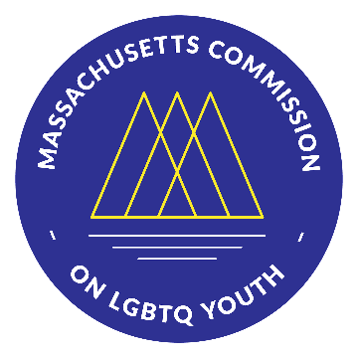 | Massachusetts Commission on LGBTQ Youth  “Working for a Commonwealth where all youth thrive”
https://www.mass.gov/orgs/massachusetts-commission-on-lgbtq-youth

AGENDA
Executive Committee Meeting
Wednesday February 23, 2022 @ 6:00 pm
Pursuant to Chapter 20 of the Acts of 2021, this meeting will be conducted via remote participation.

Register here to receive a personal link to join the Zoom meeting or to automatically join if the meeting has begun: https://us02web.zoom.us/meeting/register/tZYkc-uupzktHdH3p8k6H6HhOUTM_D3Ax_QU
-----------------------------------------------------------------------------------------------------

- ROUTINES: 6:00 pm
  - Land Acknowledgement
  - Introductions & Check-In
  - Remarks from Commission Members
  - Remarks from the Public

- REPORTS: 6:20 pm
  - Regular Reports
    - Budget Molly
    - Legislative Team Molly
    - Sex Work Research Team Rayna
    - Safe Schools Program Team Kimm
    - Racial Justice Committee Rayna
    - Membership Committee Molly
  - Special Reports
    - Website Report Rayna
    - Jordan’s Transition Memo

- NEW BUSINESS: 6:40 pm
  - Approving Executive Committee meeting minutes
    - November meeting
    - January meeting
  - Budget amendment proposal
  - Task force to review bylaws and fiscal agent options
  - Annual Report Release & New Member Swearing-In Ceremony
    - Last year’s report
  - March 16th Full Commission Quarterly Meeting
  - In person meeting considerations

- OLD BUSINESS: 7:20 pm
  - Executive Director Search Update
  - In person physical work spaces for staff (DPH, DESE, JRI)

- ADJOURNMENT 8:00 pm

All meetings, with the exception of Special Meetings for Executive Session, are open to the public.
The items listed are those reasonably anticipated by the Chair to be discussed at the meeting. Not all items may in fact be discussed and other items not listed may also be brought up for discussion to the extent permitted by law. Meetings may be recorded for live stream and/or future posting to our website.

