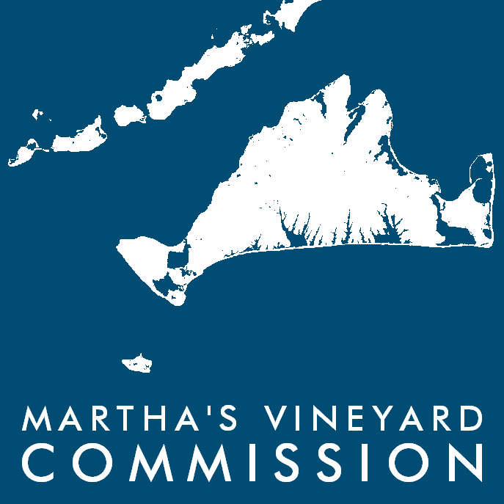

Manuel Correllus State Forest Task Force (TF) Agenda

Date: Wed., March 12th, 2025 – 9:30 AM

Place: MV Commission (Hybrid mtng) – 33 NY Ave in Oak Bluffs

- Welcome / Opening Remarks
- Plantation Removal and Restoration at MCSF presentation by DCR
- Task Force follow up questions
- Public Comment

Martha's Vineyard Commission is inviting you to a scheduled Zoom meeting.
Martha's Vineyard Commission is inviting you to a scheduled Zoom meeting.

Topic: MCSF Task Force
Time: Mar 12, 2025 09:30 AM Eastern Time (US and Canada)

Join Zoom Meeting
https://us02web.zoom.us/j/89964105225?pwd=fIOGo6CnrgBqRuB2gIUMja5AzsvwSP.1

Meeting ID: 899 6410 5225
Passcode: 411350

---

One tap mobile
+13126266799,,89964105225#,,,,*411350# US (Chicago)
+16465588656,,89964105225#,,,,*411350# US (New York)

---

Dial by your location
• +1 312 626 6799 US (Chicago)
• +1 646 558 8656 US (New York)

