INDOOR AIR QUALITY ASSESSMENT

Department of Public Health
Bureau of Health Care Safety & Quality
99 Chauncy Street
Boston, Massachusetts

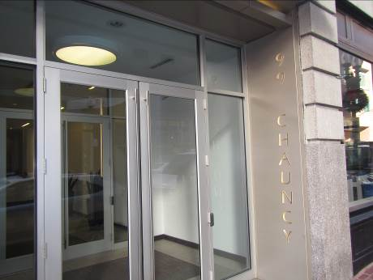

Prepared by:
Massachusetts Department of Public Health
Bureau of Environmental Health
Indoor Air Quality Program
February 2016

Background
Building: | Bureau of Health Care Safety & Quality (HCSQ)
Address: | 99 Chauncy Street, Boston floors 2, 3, & 11
Assessment Requested by: | Rob Seymour, HCSQ and Kim Schippers, HCSQ
Date of Assessment: | 1/05/16
Indoor Air Quality (IAQ) Program Staff Conducting Assessment: | Ruth Alfasso, Environmental Engineer  Jason Dustin, Environmental Analyst
Date of Building Construction: | 1870
Reason for Request: | IAQ concerns, allergies
Building Type: | 11 story, brick construction
Building Population: | Approximately 200, 20+ visitors daily
Windows: | unopenable

IAQ Testing Results
Please refer to the IAQ Manual for methods, sampling procedures, and interpretation of results (MDPH, 2015). The following is a summary of indoor air testing result (Table 1).
- Carbon dioxide levels were below 800 parts per million (ppm) in roughly a 75% of the areas surveyed, indicating adequate air exchange in the majority of areas.
- Temperature was within the recommended range of 70°F to 78°F in almost all areas tested; two occupied areas were slightly below the recommended range.
- Relative humidity was below the recommended range of 40 to 60% in all areas tested.
- Carbon monoxide levels were non-detectable in all areas tested.
- PM2.5 concentrations measured were below the NAAQS limit of 35 μg/m³ in all areas tested.
This sampling indicates that the ventilation system in the building provides adequate air exchange in most areas.

Ventilation
A heating, ventilating and air conditioning (HVAC) system has several functions. First it provides heating and, if equipped, cooling. Second, it is a source of fresh air. Finally, an HVAC system will dilute and remove normally-occurring indoor environmental pollutants by not only introducing fresh air, but by filtering the airstream and ejecting stale air to the outdoors via exhaust ventilation. Even if an HVAC system is operating as designed, point sources of respiratory irritation may exist and cause symptoms in sensitive individuals. The following analysis examines and identifies components of the HVAC system and likely sources of respiratory irritant/allergen exposure due to water damage, aerosolized dust and/or chemicals found in the indoor environment.
Air circulation is provided by air-handling units (AHUs). On the second and third floor, these AHUs are located in closets (Picture 1 and 2). The AHU for the 11th floor was not located and may be on the roof or a mechanical space that could not be accessed. Note that no fresh/outside air supply could be identified for the AHUs examined on the second and third floor. Without a source of fresh outside air, carbon dioxide and other indoor contaminants can build up over time. Once air is filtered, it is heated or cooled and delivered to occupied areas via ducted supply diffusers (Picture 3).
Return air is drawn through grates (Picture 4) and returned back to the AHUs. Some areas of the HCSQ appeared to have a limited number of return vents (Table 1). Limited return vents can restrict air exchange and affect the performance of the HVAC system.
The HVAC system for the HCSQ office space is controlled by digital thermostats. Thermostats examined had a fan switch with two settings, on and auto. When the fan is set to on, the system provides a continuous source of air circulation and filtration. The automatic setting on the thermostat activates the HVAC system at a pre-set temperature. Once the pre-set temperature is reached, the HVAC system is deactivated. Therefore, no mechanical ventilation is provided until the thermostat re-activates the system. At the time of the assessment, some thermostat fan settings appeared to be in the “auto” position, which likely resulted in intermittent rather than continuous ventilation (Picture 5). To maximize air exchange, we recommend that both supply and exhaust ventilation operate continuously during periods of occupancy.

Microbial/Moisture Concerns
Water-damaged ceiling tiles were observed in a few areas (Pictures 6 and 7; Table 1). After the source of the leak above the ceiling tiles is repaired, the water-damaged ceiling tiles should be removed and replaced.
The cabinet beneath the kitchen sink on the 3rd floor was noted to be water-damaged (Picture 8). Chronic moistening of porous building materials can lead to mold growth. Although IAQ staff did not note any active mold colonization, this leak should be repaired and any water-damaged porous building materials should be discarded and replaced. The areas under sinks are often moist environments and porous materials should not be stored there.
Some areas of the HCSQ had refrigerators and water coolers placed directly on the carpeting (Pictures 9 and 10). Spills or leaks from this equipment can moisten the carpet and may cause microbial growth and carpet degradation. Refrigerators and water coolers should be moved to non-carpeted areas or have water proof trays/mats placed beneath them.
Plants were noted in a few areas (Picture 11). Plants can be a source of pollen and mold, which can be respiratory irritants to some individuals. Plants should be properly maintained and equipped with drip pans and should be located away from air diffusers to prevent the aerosolization of dirt, pollen and mold.

Other IAQ Evaluations

Volatile Organic Compounds (VOCs)
Exposure to low levels of total VOCs (TVOCs) may produce eye, nose, throat, and/or respiratory irritation in some sensitive individuals. To determine if VOCs were present, IAQ staff examined rooms for products containing VOCs. IAQ staff noted air fresheners, scented hand sanitizers, cleaners, and dry erase materials in use within the building (Table 1; Picture 8). A hand sanitizer dispenser was located on a wall with staining beneath it suggesting that the product is leaking or being spilled. In addition, construction-related products such as paint and spray foam were observed in a few areas. All of these products have the potential to be irritants to the eyes, nose, throat, and respiratory system of sensitive individuals and their use should be minimized. Construction products should be used in accordance with manufacturers’ instructions and typically only during unoccupied hours.

Other Concerns

The kitchen area on the 3rd floor appeared to have mouse droppings beneath the sink. Mouse urine contains a protein that is a known sensitizer (US EPA, 1992). A sensitizer is a material that can produce symptoms (e.g., running nose or skin rashes) in sensitive individuals after repeated exposure. A three-step approach is necessary to eliminate rodent infestation:
• removal of the rodents;
• cleaning of waste products from the interior of the building; and
• reduction/elimination of pathways/food sources that are attracting rodents.
IAQ staff noted several breaches in walls/ceilings which lead to unconditioned spaces (Pictures 12 to 15). These breaches should be properly sealed to prevent pests, odors and particulates from entering occupied spaces.
Some areas of the HCSQ are currently under renovation. These areas seem to be concentrated in unoccupied hallways and exterior portions of the building. Nevertheless, guidelines concerning proper isolation techniques should be consulted to ensure that indoor air quality is not adversely affected by the renovations. Two of the suggested guidelines are: "IAQ Guidelines for Occupied Buildings Under Construction" published by the Sheet Metal and Air Conditioning Contractors National Association, Inc. (SMACNA, 2007) and “Methods Used to Reduce/Prevent Exposure to Construction/Renovation Generated Pollutants in Occupied Buildings” (MDPH, 2006).
Some personal fans, supply and exhaust vents were observed to be dusty (Table 1). Dust can be reaerisolized from these items and they should be cleaned regularly
In several areas, items were observed on the floor, windowsills, tabletops, counters, bookcases, and desks (Picture 16). The large number stored items provide a source for dusts to accumulate. These items (e.g., papers, folders, boxes) make it difficult for custodial staff to clean. Once aerosolized, they can act as irritants to eyes and the respiratory system. Items should be relocated and/or be cleaned periodically to avoid excessive dust build up.
IAQ staff observed the AHUs on the second and third floor had filters that did not fit properly (Table 1; Picture 2). Improperly fitting filters may allow particulate matter to bypass the filter as well as allow unconditioned air to be entrained into the unit. The filters observed in the second floor AHUs were also of a mesh type that provides minimal filtration (Picture 17). For the AHU on the third floor, a thin aluminum condensate collection pan with a pump was observed; this may be easily damaged and subject to leaking (Picture 2).
A fluorescent tube was stored improperly in the mechanical closet on the second floor (Picture 18). These contain mercury which can be released if they break.

Conclusions/Recommendations

The conditions related to IAQ problems at the HCSQ raise a number of issues. The general building conditions, maintenance, work hygiene practices, and the condition of HVAC equipment, if considered individually, present conditions that could degrade IAQ. When combined, these conditions can serve to further degrade IAQ. Some of these conditions can be remedied by actions of building occupants. Other remediation efforts will require alteration to the building structure or equipment.
- Continue to implement the recommendations found in the following guidelines: "IAQ Guidelines for Occupied Buildings Under Construction" published by the Sheet Metal and Air Conditioning Contractors National Association, Inc. (SMACNA, 2007) and “Methods Used to Reduce/Prevent Exposure to Construction/Renovation Generated Pollutants in Occupied Buildings” (MDPH, 2006).
- Ensure any leaks are repaired and replace water-damaged ceiling tiles.
- Repair any active leaks under kitchen sink and replace any porous water-damaged building materials.
- Work with a pest control contractor to identify extent of rodent activity, clean waste materials and eliminate food sources and pathways identified.
- Ensure all thermostat fan settings for the mechanical ventilation system are set to “fan on” for continuous ventilation/filtration during occupied hours.
- Change AHU filters a minimum of twice per year (e.g. between heating/cooling seasons) or as per the manufacturer’s instructions. Ensure that filters fit in the units and are of an appropriate efficiency. Consider using filter with a MERV rating of 9 or better.
- Seal all pathways which lead to unconditioned spaces (e.g. utility holes) to avoid odors, particulates and pests from entering occupied spaces.
- Consider replacing the thin baking pan with a permanent HVAC condensate drip pan. Monitor the pump for leaks regularly during the cooling season and clean the pan regularly to prevent leaks, stagnant water and odors.
- Plants should be properly maintained and equipped with drip pans and should be located away from air diffusers to prevent the aerosolization of dirt, pollen and mold.
- Consult with an HVAC engineer to determine adequacy of areas with limited return vents as well as ensure adequate fresh air supply to all AHUs.
- To avoid comfort complaints, consider working with staff regarding drafts (seal around windows, redirect supply diffuser stream, etc.).
- Balance ventilation after any alterations to the HVAC system and every 5 years if feasible.
- Consider placing water dispensers and refrigerators on non-carpeted areas or place a waterproof mat underneath them.
- Clean supply and return vents as well as personal fans periodically of accumulated dust.
- Relocate or consider reducing the amount of stored materials to allow for more thorough cleaning. Clean items regularly with a wet cloth or sponge to prevent excessive dust build-up.
- Clean carpeting annually or semi-annually in soiled high traffic areas as per the recommendations of the Institute of Inspection, Cleaning and Restoration Certification (IICRC, 2012).
- Consider limiting the use of hand sanitizer, dry erase boards, air fresheners/deodorizers and harsh/scented cleaning products, which can cause eye, nose and throat irritations in sensitive individuals.
- Develop a system/direct line of communication to respond to IAQ complaints.
- Properly store used and new fluorescent bulbs and properly dispose/recycle spent ones.
- For buildings in New England, periods of low relative humidity during the winter are often unavoidable. Therefore, scrupulous cleaning practices should be adopted to minimize common indoor air contaminants whose irritant effects can be enhanced when the relative humidity is low. To control for dusts, a high efficiency particulate arrestance (HEPA) filter equipped vacuum cleaner in conjunction with wet wiping of all surfaces is recommended. Avoid the use of feather dusters. Drinking water during the day can help ease some symptoms associated with a dry environment (throat and sinus irritations).
- Refer to resource manual and other related indoor air quality documents located on the MDPH’s website for further building-wide evaluations and advice on maintaining public buildings. These documents are available at http://mass.gov/dph/iaq.
References

IICRC. 2012. Carpet Cleaning FAQ 4 Institute of Inspection, Cleaning and Restoration Certification. Institute of Inspection Cleaning and Restoration. Vancouver, WA.
MDPH. 2006. Methods Used to Reduce/Prevent Exposure to Construction/Renovation Generated Pollutants in Occupied Buildings. Boston, MA.
Massachusetts Department of Public Health (MDPH). 2015. “Indoor Air Quality Manual: Chapters I-III”. Available at: http://www.mass.gov/eohhs/gov/departments/dph/programs/environmental-health/exposure-topics/iaq/iaq-manual/
SMACNA. 2007. IAQ Guidelines for Occupied Buildings Under Construction. Sheet Metal and Air Conditioning Contractors National Association, Inc. Chantilly, VA.
US EPA. 1992. Indoor Biological Pollutants. US Environmental Protection Agency, Environmental Criteria and Assessment Office, Office of Health and Environmental Assessment, research Triangle Park, NC. EPA 600/8-91/202. January 1992.

Picture 1
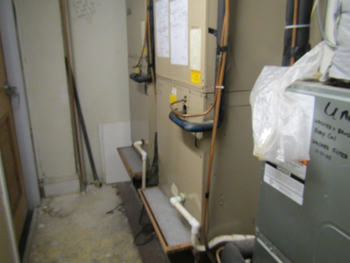
Second floor AHUs in utility closet
Picture 2
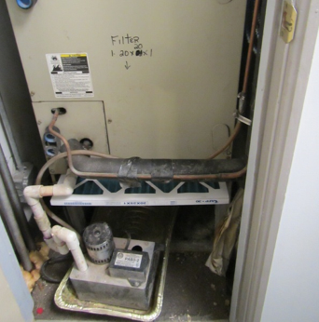
Third floor AHU in utility closet, note ill-fitting filter and makeshift condensate pan
Picture 3
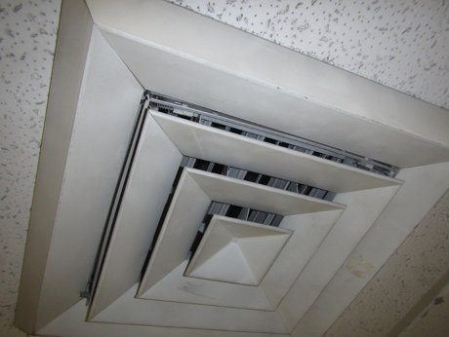
Supply air diffuser
Picture 4
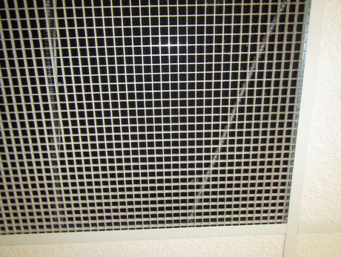
Return air grate
Picture 5
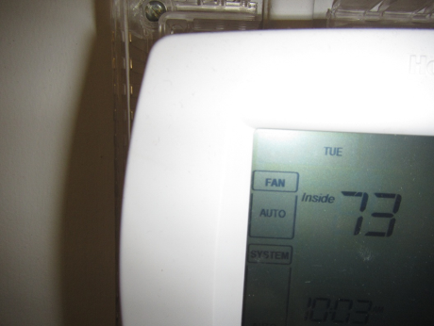
Thermostat fan set to “auto” instead of preferred “on” setting
Picture 6
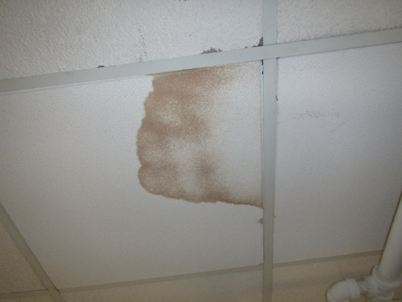
Water-damaged ceiling tile
Picture 7
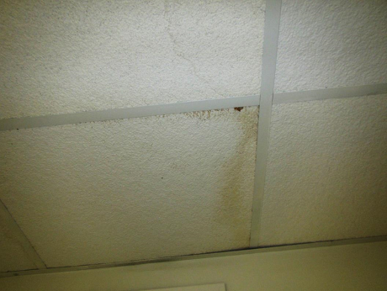
Water-damaged ceiling tiles
Picture 8
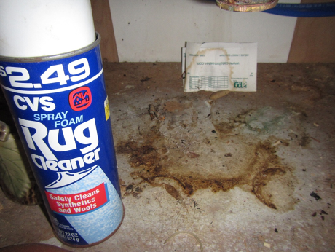
Water-damaged sink cabinet and cleaning product
Picture 9
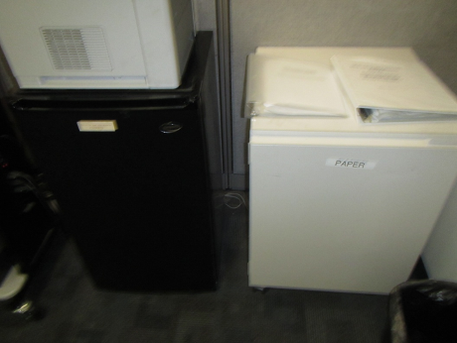
Refrigerators placed directly on carpeting
Picture 10
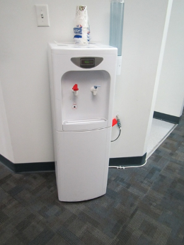
Water cooler on carpeting
Picture 11
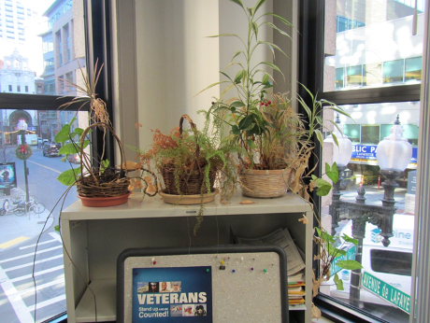
Plants in office area
Picture 12
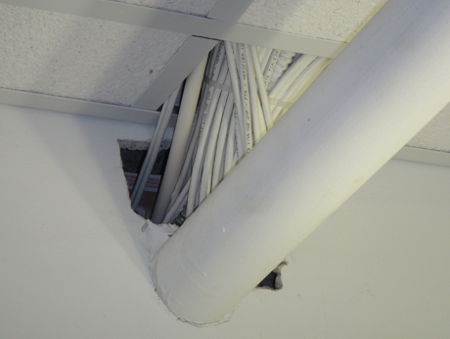
Gaps around utilities
Picture 13
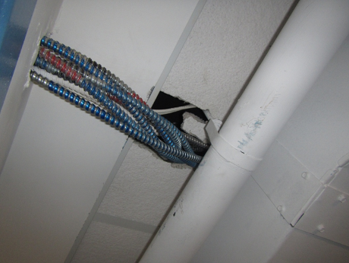
Gaps around utilities
Picture 14
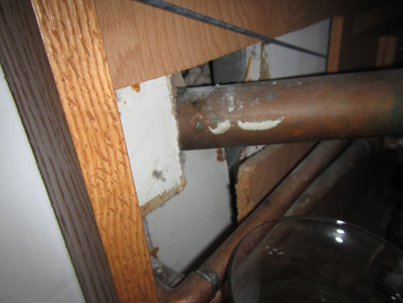
Gaps around plumbing
Picture 15
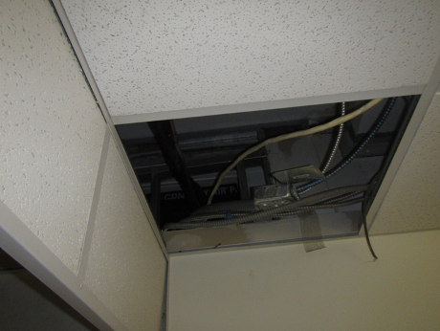
Missing ceiling tile
Picture 16
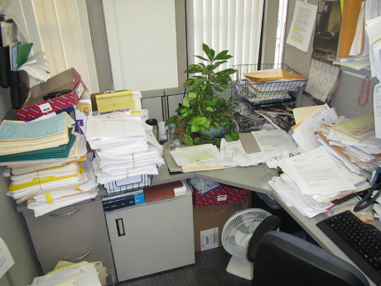
Accumulated items on surfaces impair cleaning
Picture 17
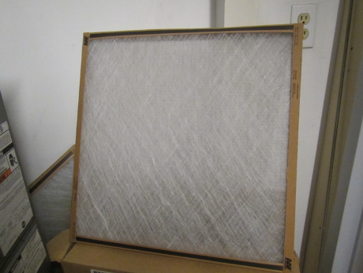
Mesh filter with low filtration efficiency
Picture 18
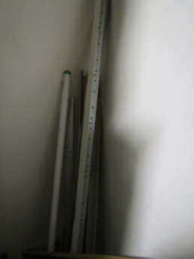
Fluorescent light bulb stored improperly
Location | Carbon  Dioxide  (ppm) | Carbon Monoxide  (ppm) | Temp  (°F) | Relative  Humidity  (%) | PM2.5  (µg/m³) | Occupants  in Room | Windows  Openable | Ventilation |  |  | Remarks
 |  |  |  |  |  |  |  | Intake | Exhaust
Background (outside) | 441 | 2.6 | 22 | 5 | 8
11th floor
Vaid | 777 | ND | 71 | 13 | 3 | 1 | N | Y |  | Y | CP
11th floor kitchen | 784 | ND | 76 | 13 | 6 | 0 | N | Y |  | Y | Plants, fridge (clean)
11th floor reception | 594 | ND | 74 | 11 | 12 | 3 | N | Y |  | N | HS
11th floor files | 550 | ND | 74 | 12 | 8 | 0 | N |  |  |  | Boxes on floor, 1 WD CT, tile floor
11th floor women’s restroom |  |  |  |  |  |  | N |  |  | Y on
11th floor Sanipper cube area | 898 | ND | 72 | 16 | 22 | 3 | N
11th floor Rao cube area | 755 | ND | 72 | 15 | 7 | 2 | N | N |  |  | Cleaners, food, clutter, photocopier
1105 | 691 | ND | 75 | 13 | 5 | 1 | N | Y |  | N | HS
1106 | 695 | ND | 74 | 13 | 7 | 1 | N | Y |  | Y | Wood floor
1107 | 688 | ND | 75 | 12 | 4 | 0 | N | Y |  | N | DEM
1109 | 688 | ND | 76 | 13 | 11 | 0 | N | Y |  | N
1110 cubes | 662 | ND | 76 | 13 | 12 | 2 | N | Y |  | N
1113 cubes | 672 | ND | 75 | 13 | 19 | 2 | N | Y |  | N | Boxes on floor
1117 | 689 | ND | 76 | 13 | 10 | 2 | N | Y |  | N | Door open, personal fan
1120 | 737 | ND | 74 | 14 | 4 | 2 | N | Y |  | Y
1126 | 787 | ND | 72 | 14 | 3 | 2 | N | Y |  | Y
1129 cubes | 759 | ND | 74 | 13 | 8 | 3 | N | Y |  | Y | HS, CP
1134 | 799 | ND | 72 | 14 | 3 | 2 | N | Y |  | Y
1136 cubes | 755 | ND | 73 | 13 | 6 | 2 | N | Y |  | N | HS, CP
1141 | 781 | ND | 73 | 13 | 26 | 3 | N | Y |  | Y | Noisy vent
1143 | 720 | ND | 73 | 14 | 7 | 1 | N | Y |  | N | Temperature complaints
1143 | 781 | ND | 73 | 13 | 7 | 0 | N | Y |  | N | Soiled carpet, DEM, food
1144 | 741 | ND | 73 | 14 | 6 | 1 | N | Y |  | N
1145 | 936 | ND | 68 | 19 | 11 | 0 | N | Y |  | N | Door open
1146 | 803 | ND | 70 | 15 | 4 | 0 | N | Y |  | N | AI, DEM
1147 | 797 | ND | 72 | 14 | 3 | 0 | N | Y |  | N | DEM, gaps around wires
1156 | 773 | ND | 72 | 18 | 11 | 0 | N | Y |  | N | 1 WD CT, windows drafty, DEM
1160 | 792 | ND | 71 | 13 | 3 | 1 | N | Y |  | Y | Drafts/comfort complaints
1160 | 750 | ND | 73 | 16 | 7 | 0 | N | Y dusty |  | N | Thermostat -fan on
3rd floor
Harter | 911 | ND | 70 | 16 | 5 | 2 | N | Y |  | Y | DEM, filter on return vent
3rd floor AHU closet |  |  |  |  |  |  |  |  |  |  | AHU filter does not fit; condensation pan with pump
301 | 604 | ND | 70 | 12 | 3 | 0 | N | Y |  | N | AI
305 | 606 | ND | 70 | 12 | 4 | 0 | N | Y |  | N
309 | 618 | ND | 70 | 14 | 3 | 1 | N | Y |  | N | Dusty supply vent
314 | 798 | ND | 70 | 14 | 4 | 2 | N | Y |  | Y
315 | 749 | ND | 71 | 14 | 4 | 0 | N | Y |  | Y | Thermostat set to “auto”, small fan, personal heater, CP, plants
316 | 590 | ND | 72 | 12 | 5 | 0 | N | Y |  | N | Plant
317 | 571 | ND | 71 | 12 | 6 | 0 | N | Y |  | N | Radiators, PF, DO
318 | 616 | ND | 72 | 13 | 5 | 0 | N | Y |  | N | DEM, WD CT, plant
319 conference | 639 | ND | 71 | 12 | 3 | 0 | N | Y |  | N | DEM
320 | 657 | ND | 71 | 20 | 22 | 0 | N | Y |  | N | Plants, printers
321 | 675 | ND | 71 | 13 | 9 | 2 | N | Y |  | N | Gaps around utilities
322 | 664 | ND | 72 | 14 | 5 | 0 | N | N |  | Y | Dusty personal fan
324 | 708 | ND | 70 | 14 | 3 | 0 | N | Y |  | Y
326 | 795 | ND | 71 | 15 | 3 | 1 | N | Y |  | Y | Plants, draft complaints, mini-fridges on carpet in hall
327 half wall | 729 | ND | 73 | 22 | 5 | 1 | N | Y |  | Y | Plants, fridge on carpet in hall
328 half wall | 738 | ND | 73 | 14 | 4 | 0 | N | N |  | N
330 | 790 | ND | 73 | 14 | 7 | 0 | N | Y |  | N | Personal fan, heater, CP
331 | 822 | ND | 72 | 16 | 3 | 1 | N | Y |  | N
332 | 874 | ND | 73 | 16 | 13 | 1 | N | Y |  | N | HS, CP (wipes)
333 | 845 | ND | 74 | 15 | 5 | 4 | N | Y |  | N | Spray foam can
336 | 865 | ND | 75 | 14 | 5 | 0 | N | Y |  | N | Personal fan
338 | 793 | ND | 72 | 15 | 3 | 1 | N | Y |  | Y
340 cubes | 902 | ND | 73 | 15 | 6 | 0 | N | N |  | N
345 cubes | 709 | ND | 73 | 13 | 5 | 2 | N | Y |  | Y
349 | 755 | ND | 71 | 14 | 3 | 1 | N | Y |  | Y
350 | 727 | ND | 71 | 14 | 4 | 0 | N | Y |  | Y
355 cubes | 777 | ND | 73 | 13 | 7-17 | 3 | N | Y |  | Y | Plants, personal fan, HS
356 cubes | 705 | ND | 73 | 13 | 5 | 2 | N | Y |  | Y | Photocopier
362 cubes | 712 | ND | 72 | 14 | 5 | 1 | N | Y |  | Y | Very dusty personal fan
2nd floor
2nd floor conference | 838 | ND | 68 | 18 | 4 | 0 | N | Y |  | Y
2nd floor elevator hall |  |  |  |  |  |  |  |  |  |  | Damaged plaster along windows to wall area, one window still covered in plastic for access to work area.
2nd floor women’s Restroom |  |  |  |  |  |  |  |  |  | Y on | WD CT, CP, air freshener
2nd floor file area |  |  |  |  |  |  |  |  |  |  | Open ceiling above file room next to HVAC room, reportedly this work has been ongoing for weeks.
2nd floor HVAC room |  |  |  |  |  |  |  |  |  |  | Filters not fitted properly, poor filtration type. See no access to fresh air. Floor in poor condition (dusty, debris)
2nd floor Rosan cubes | 777 | ND | 70 | 15 | 24 | 1 | N | Y
2nd floor Bond cubes | 778 | ND | 70 | 14 | 14 | 2 | N | Y |  |  | Next to Photocopier
2nd floor mail room | 721 | ND | 70 | 12 | 9 | 2 | N | Y |  | N | Photocopiers, mail equipment
2nd floor Altomonte | 725 | ND | 71 | 12 | 12 | 1 | N | Y |  | Y | Fridge on carpet
2nd floor Scimore | 746 | ND | 72 | 13 | 11 | 1 | N | Y |  | Y | Personal fan/heater
2nd floor Waksomoki | 781 | ND | 72 | 14 | 8 | 1 | N | Y |  | Y
202 | 820 | ND | 71 | 16 | 8 | 2 | N | Y |  | N | Radiators, personal fan, room often cold
203 | 811 | ND | 70 | 15 | 4 | 0 | N | Y |  | Y | AI
204 | 772 | ND | 72 | 16 | 7 | 1 | N | Y |  | Y
205 | 787 | ND | 72 | 14 | 4 | 1 | N | Y |  | Y
206 | 736 | ND | 75 | 13 | 7 | 1 | N | ? |  | N | Plants
207 | 805 | ND | 69 | 17 | 5 | 2 | N | Y |  | Y
207 cubes | 839 | ND | 74 | 15 | 7 | 2 | N | Y |  | N
212 cubes | 790 | ND | 74 | 13 | 7 | 1 | N | Y |  | N | Personal fan dusty
214 cubes | 763 | ND | 74 | 14 | 7 | 0 | N | Y |  |  | Small and large vents both look like supply
215 | 878 | ND | 73 | 17 | 4 | 1 | N | Y |  | N | HS, fragrances
216 | 792 | ND | 73 | 13 | 4 | 0 | N | Y |  | N | Personal fan
217 | 788 | ND | 75 | 13 | 6 | 1 | N | N |  | N | Radiators, plants
218 | 864 | ND | 75 | 15 | 10 | 1 | N |  |  |  | Plants, food, boxes on floor
220 | 929 | ND | 73 | 17 | 4 | 2 | N | Y |  | N | Plants, draft complaints
229 | 804 | ND | 71 | 14 | 6 | 0 | N | Y |  | Y
231 | 845 | ND | 70 | 15 | 5 | 1 | N | Y |  | Y
238 | 668 | ND | 71 | 10 | 11 | 1 | N | Y |  | Y | Fridge on carpet, photocopier, personal fan, heater, too many supply vents, right next to exhaust vent, plants
247 | 816 | ND | 70 | 14 | 5 | 2 | N | Y |  | Y | Personal fan, HS
247 area |  |  |  |  |  |  |  |  |  |  | Fridge on carpet, needs defrosting very badly.

