The Commonwealth of Massachusetts
Executive Office of Health and Human Services
Department of Public Health
Bureau of Health Professions Licensure
Board of Registration in Naturopathy
239 Causeway Street, Suite 500, Boston, MA 02114

Tel: 617-973-0800
TTY : 617-973-0988
www.mass.gov/dph/boards

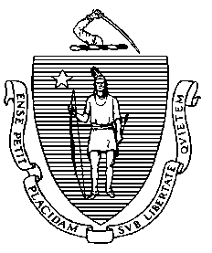

MARYLOU SUDDERS
Secretary
MONICA BHAREL, MD, MPH Commissioner

CHARLES D. BAKER
Governor
KARYN E. POLITO
Lieutenant Governor

NOTICE OF PUBLIC HEARING

Notice is hereby given pursuant to M.G.L. c. 30A, § 2, that the Board of Registration in Naturopathy (Board) within the Department of Public Health (Department), will hold a public hearing on proposed initial regulations at 273 CMR 2.00, 3.00, 4.00, 5.00, 6.00 7.00 and 8.00. These regulations set licensing and reporting requirements, scope and standards of practice, and complaint investigation and discipline of naturopathic doctors.
The public hearing will be held on Monday, December 9, 2019, at 1:00 pm in Room 417A/B (4th Floor), 239 Causeway Street, Boston, Massachusetts 02114. Hearing testimony may be presented orally or in writing; a written copy of any oral testimony will be requested.
The Department encourages all interested parties to submit written testimony electronically to the following address: Reg.Testimony@state.ma.us. Please submit electronic testimony as an attached Word document, with "BORND: 273 CMR" in the subject line. All submissions must include the sender’s full name and address. The Department will post all electronic testimony that complies with these instructions on its website. Parties who are unable to submit electronic testimony should mail submissions to: Office of the General Counsel, Department of Public Health, 250 Washington Street, Boston, Massachusetts 02108. All written testimony must be submitted by 5:00 pm on Monday, December 16, 2019.

A copy of the Notice of Public Hearing and the proposed Board regulations may be viewed on the Department’s website or obtained from the Office of the General Counsel, at (617) 624-5220.

