**Bureau of Infectious Disease and Laboratory Sciences**

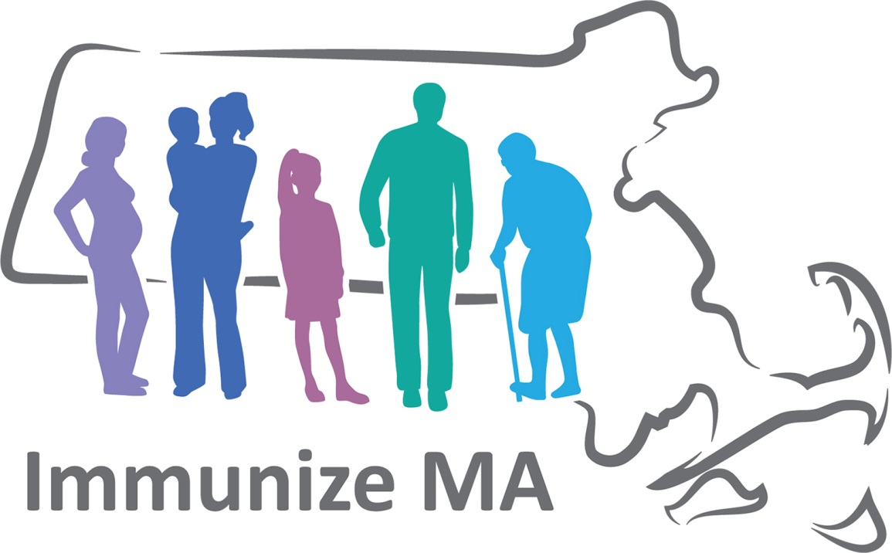

**Immunization Program**

**Massachusetts HPV Initiative**

**Raising HPV Immunization Rates to Decrease HPV-Associated Cancers**

**Key Points**

* There are approximately **42,700 HPV-associated* cancers** each year in the United States and about **33,700 cancers** are attributable to HPV.
* Cervical cancer is the most common HPV-associated cancer among women and oropharyngeal cancers are the most common among men.
* **Oropharyngeal cancer** has surpassed cervical cancer as the **most common HPV-associated cancer**.
* Antibody levels are higher and HPV vaccination is more effective when given at the recommended ages.

***The 9vHPV vaccine has the potential to prevent 92% of HPV-attributable cancers, which equals 31,000 cancer cases!***

Source: United States Cancer Statistics Data Brief, No. 4, August 2018

Cancers associated with human papillomavirus, United States—2011–2015, <https://www.cdc.gov/cancer/hpv/pdf/USCS-DataBrief-No4-August2018-508.pdf>

**Percentage of Cancers Attributable to HPV, US**

|  |  |
| --- | --- |
| Cervix | 91 |
| Vagina | 75 |
| Vulva | 69 |
| Anus | 91 |
| Oropharynx | 70 |
| Penis | 63 |

*HPV causes the majority of HPV-associated cancers.*

Source: <https://www.cdc.gov/cancer/hpv/statistics/cases.htm>

Trends in HPV-Associated Cancers – United States, 1999-2015, MMWR, <https://www.cdc.gov/mmwr/volumes/67/wr/mm6733a2.htm?s_cid=mm6733a2_w>

**Change of HPV-Associated Cancer Incidence Rate, Annual Percent, Massachusetts, 2004-2014**

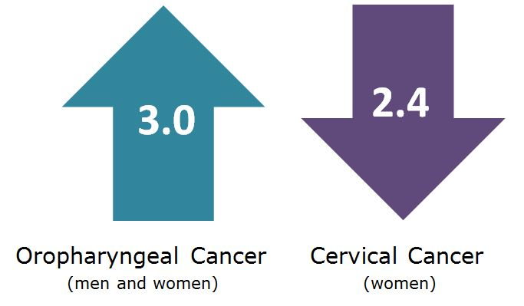

Massachusetts Rates, 2004-2014: Cook, E.E., Gershman, S.T., Kim, J.J. et al. Cancer Causes Control (2018). <https://doi.org/10.1007/s10552-018-1016-1>

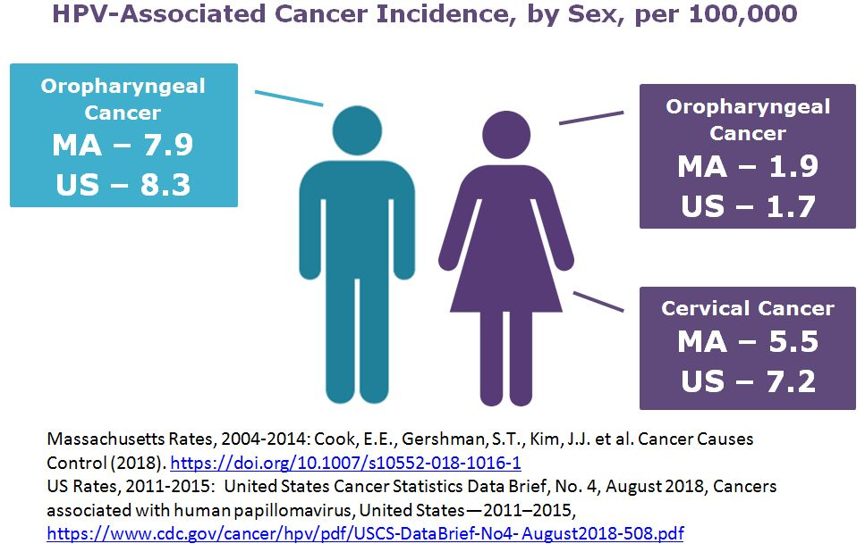

Note on terminology:

* An *HPV-associated cancer* is a specific cellular type of cancer that is diagnosed in a part of the body where HPV is often found. An *HPV-attributable cancer* is a cancer that is probably caused by HPV.

**What do we need to do?**

**Vaccinate!**

All girls and boys who are 11 or 12 years old should get the recommended series of HPV vaccine. The vaccination series can be started at age 9 years.

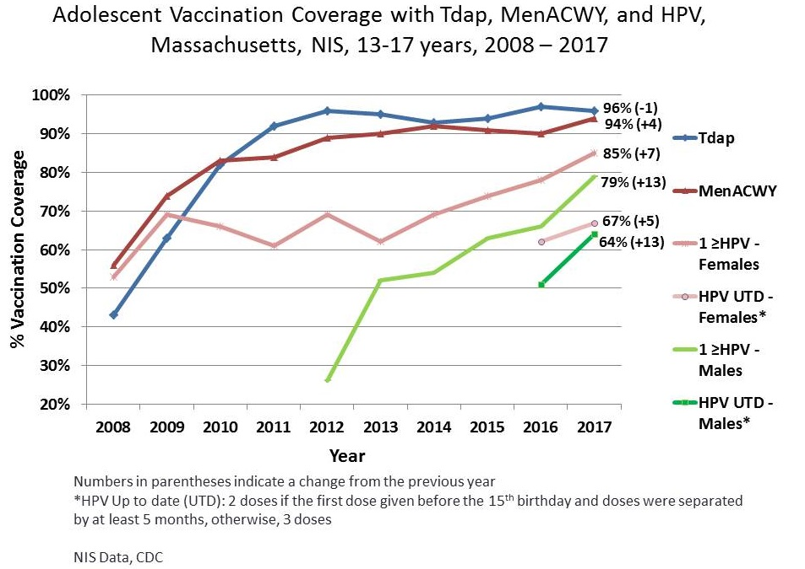

We need to continue to raise HPV vaccination rates!

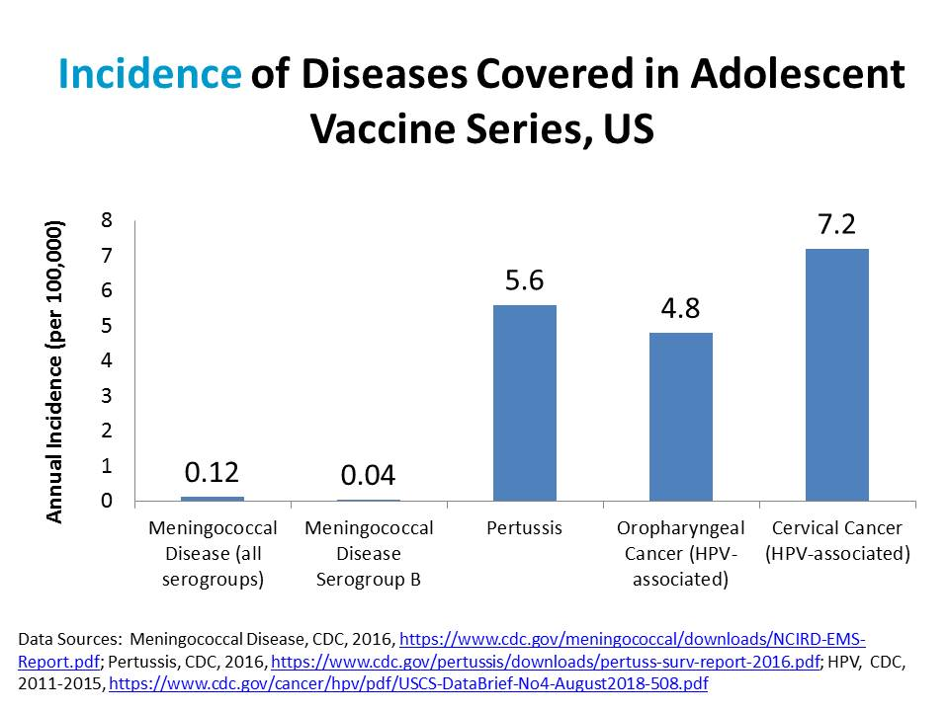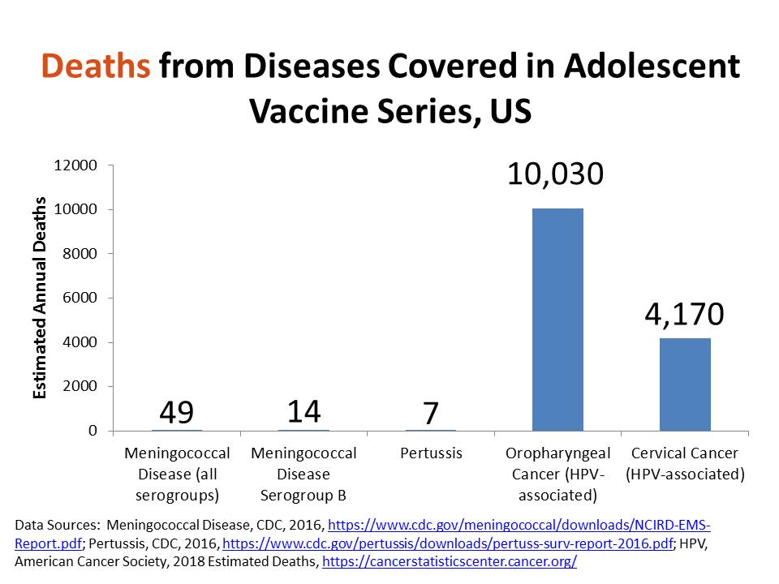

**For more information:**

MDPH, HPV Vaccine is Cancer Prevention website: [www.mass.gov/dph/hpvvax](http://www.mass.gov/dph/hpvvax)

CDC, HPV website: [www.cdc.gov/hpv](http://www.cdc.gov/hpv)

National HPV Roundtable: <https://hpvroundtable.org/>

**Contact:**

MA Division of Epidemiology and Immunization

617-683-9800

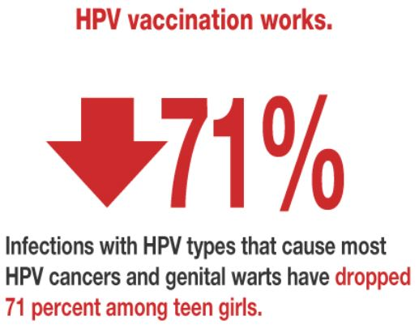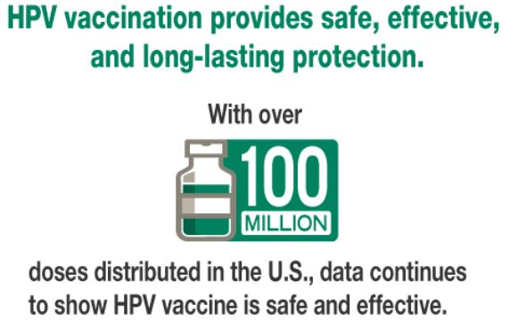

Source: <https://www.cdc.gov/hpv/infographics/vacc-six-reasons.html>