
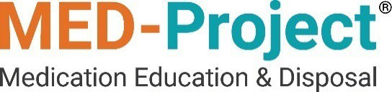

MED-Project 2023 Annual Report
Commonwealth of Massachusetts March 1, 2024

Prepared By: MED-Project LLC
Submitted To: Massachusetts Department of Public Health

Table of Contents

- Executive Summary 1
- Program Effectiveness 2
  - Effectiveness Evaluation 2
Objective 1: Website Education Materials 2
Objective 2. Aggregated Services Search Tool 3
Objective 3. Website Optimization 3
Objective 4. Media Campaign 3
Objective 5. LEA Grant Program Promotion 3
Objective 6. LEA Grant Program Implementation 4
Objective 7. Increase Kiosk Availability 4
Objective 8. Provide In-Home Services 4
- Participating Producers 6
- Collection Method and Weight 6
  - Grants 6
  - Kiosks 6
  - In-Home Services 6
  - Total Weight of Collected Unwanted Medicine 7
- Disposal Information 7
- Educational Efforts and Public Outreach 7
- Program Costs 8
Appendix A 11
Media Outreach Summary 11
Appendix B 12
List of Program Participants 12
Appendix C 23
List of Participating Collection Sites 23
Appendix D 29
Disposal Facilities 29
Appendix E 30
Website Statistics 30
Appendix F 31
MED-Project Website Pages 31
Appendix G 45
MED-Project Brochure and Posters 45

Executive Summary
MED-Project LLC (“MED-Project”) operates a product stewardship program (“Program”) under its Product Stewardship Plan for Opioids and Benzodiazepines from Households (“Plan”) in the Commonwealth of Massachusetts, dated July 16, 2018, approved on November 26, 2018, in compliance with Massachusetts General Law c. 94H, the Drug Stewardship Program. This 2023 Commonwealth of Massachusetts Annual Report (“Report”) describes the activities of MED-Project between January 1, 2023, and December 31, 2023 (the “Reporting Period”). All capitalized terminology not defined in this Report is derived from the Plan.
During the Reporting Period, MED-Project’s Program awarded a total of 171 Funding and Service Grants. MED-Project’s Program provided 120 Funding Grants (one of which was also provided a new Kiosk), and 51 Service Grants (two of which were provided new Kiosks) to Law Enforcement Agencies (“LEAs”) in 2023. During the Reporting Period, Residents received 119 Mail-Back Packages for In-Home Services.
As outlined in the approved Plan, the ultimate goal of the Program is to provide Commonwealth Residents with convenient, safe, and accessible methods to dispose of Covered Drugs.
The Plan identifies Program activities to be described in the annual report, and each section of the Report restates the corresponding Program activity and provides the relevant information.

Program Effectiveness
Plan Sec. XI (1): “Program effectiveness summary”

Effectiveness Evaluation
The Plan identified eight objectives to help achieve successful Plan implementation. As an indication of the Program effectiveness, all eight objectives were achieved in the Reporting Period by MED-Project as further described in this section.
In addition to implementing the eight Plan objectives, MED-Project implemented a resident survey designed to provide feedback on Program effectiveness. A discussion of the eight objectives and the resident survey is provided below.

Plan Objectives
The Plan identified the following eight implementation objectives:
      - Provide Residents educational materials on the safe and secure storage of medicine, and on unwanted medicine disposal information through the MED- Project website;
      - Provide Residents a convenient single resource for finding disposal options for unwanted medicine in their area through a web-based aggregation tool;
      - Enhance MED-Project website awareness in the Commonwealth using search engine optimization;
      - Perform outreach to Residents through various media including MED-Project social media postings;
      - Provide LEAs information about the Program and how to conveniently apply for a Service or Funding Grant through the MED-Project website;
      - Support the collection, transportation and disposal of Unwanted Drugs through the administration of Service or Funding Grants;
      - Expand kiosk availability in the Commonwealth through an increase in the number of unwanted medicine collection kiosk sites that meet potential underserved area needs; and
      - Provide In-Home Services to Residents including a pre-paid, pre-addressed return Mail-Back Package and/or Disposal Pouches/Kits through the MED- Project website.
OBJECTIVE 1: WEBSITE EDUCATION MATERIALS
During the Reporting Period, MED-Project continued to operate the MED-Project Massachusetts Program website, which among other things provides education materials, including an animated Public Service Announcement video, informational brochures, posters, and frequently asked questions in English and Spanish. The

materials cover the safe and secure storage of medicine as well as information about unwanted medicine disposal.
MED-Project performed an annual update of its website on August 2, 2023, to reflect all known kiosk drop-off locations (both MED-Project and non-MED-Project) throughout the Commonwealth.
OBJECTIVE 2. AGGREGATED SERVICES SEARCH TOOL
During the Reporting Period, MED-Project continued to operate the MED-Project Massachusetts website, which includes a take-back services aggregation tool that allows residents to find take-back resources in the Commonwealth in one place on the web. The MED-Project website experienced over 4,600 page views during the Reporting Period.
OBJECTIVE 3. WEBSITE OPTIMIZATION
MED-Project utilizes search engine optimization tools to ensure that the MED-Project website is prominently displayed in search results related to unwanted medicine, Unwanted Drugs, and their storage or disposal in the Commonwealth. Links to MED- Project’s social media accounts are also placed prominently on the MED-Project website.
OBJECTIVE 4. MEDIA CAMPAIGN
During the Reporting Period, MED-Project performed print, digital, and social media campaigns that ran on various platforms. These outreach activities totaled over two million impressions over the two campaigns. MED-Project targeted one of the media campaigns specifically to reach the over age 50 population. For more information on the media campaigns conducted during the Reporting Period, see Appendix A; Media Outreach Summary.
OBJECTIVE 5. LEA GRANT PROGRAM PROMOTION
MED-Project contacted over 450 existing and potential LEA kiosk sites throughout the Commonwealth by:
- Providing Program annual Grant renewal emails or phone calls to participating LEAs to promote annual resubscription in the Grant Program during the Reporting Period.
- Providing an opportunity to participate notification to LEAs that did not participate in the Grant Program in a prior year.
- Providing an opportunity to participate notification to LEAs that had not renewed in the Grant Program at the time of the mailing on March 31, 2023.

OBJECTIVE 6. LEA GRANT PROGRAM IMPLEMENTATION
During the Reporting Period, MED-Project awarded 120 Funding Grants (one of which was also provided a new kiosk) and 51 Service Grants (two of which were also provided new kiosks).
As part of the effort to award Service Grants, MED-Project submitted a request that the Massachusetts Department of Environmental Protection (“DEP”) waive any applicable hazardous waste requirements for LEAs to allow the LEAs to operate unwanted medicine collection kiosks as part of the Program. A DEP waiver has been obtained for all Service Grant sites.
MED-Project notified prior year Grant Program applicants by email to submit a new application for the 2023 Program renewal period. The process for renewing was identical to the application process for a new LEA, taking only a few minutes to complete through the MED-Project website. The fast and simple MED-Project web application process resulted in a rapid renewal rate as well as positive feedback from participating LEAs. 164 LEAs that participated in the Grant Program in a prior year renewed their participation in the Grant Program in 2023.
MED-Project contacted over 450 LEAs during the Reporting Period and recruited seven new LEAs to participate in the Grant Program that had not participated in a prior year, for a total of 171 LEAs participating in the Grant Program during the Reporting Period.
OBJECTIVE 7. INCREASE KIOSK AVAILABILITY
MED-Project approved seven new Grants and installed three new kiosks in 2023.
Of those three kiosks, one was provided through a Funding Grant and two were provided through Service Grants.
Figure 1 is a visualization of statewide kiosk drop-off site locations known to MED- Project, which includes 171 active MED-Project locations and 325 non-MED-Project locations as of December 31, 2023. Figure 1 illustrates the extent of the kiosk availability and convenience across the Commonwealth.
OBJECTIVE 8. PROVIDE IN-HOME SERVICES
During the Reporting Period, MED-Project provided an In-Home Service Program, providing Residents with an additional option for disposing of Covered Drugs from the home. MED-Project previously updated the PSA with a focus on In-Home Service options, which was used in the multi-media campaigns that were conducted in June and November 2023. MED-Project distributed 119 Mail-Back Package orders to Commonwealth Residents during the Reporting Period.

Outreach and Awareness Survey
MED-Project conducted a representative annual survey of Residents' awareness of Unwanted Drug issues, including Unwanted Drug disposal options. The survey design

was a random telephone and web survey for Residents. The survey was performed from January 3, 2023, to January 28, 2023, and the results are posted on the MED- Project website.
The survey questions cover topics such as:
- Frequency of Covered Drug use;
- Knowledge of Unwanted Drug safe disposal methods;
- Types of Unwanted Drug disposal methods used by Residents;
- Frequency of Unwanted Drug disposal methods used by Residents;
- How Residents learned of Unwanted Drug disposal options;
- Convenience of provided Unwanted Drug disposal options; and
- Overall perception of Unwanted Drug disposal programs.
Based on the survey results, 58% of Residents are aware of the safe, convenient and free disposal program for expired and/or unwanted medicine in Massachusetts.
Additionally, 32% of those surveyed have used drop-off locations, mail-back services, take-back events, or in-home disposal methods to dispose of medicines. Of this group, 62% have used drop-off locations and 54% report they use this method “most” or “all of the time” when disposing of unwanted and/or expired medicines.
As an overall indication of effectiveness and program convenience, the survey reported 84% of Residents who have used drop-box locations believe the program is easy to use, and 84% of the same group of Residents are satisfied with the current medicine disposal program.

Participating Producers
Plan Sec. XI (2): “List of Participating Producers”
See Appendix B; List of Program Participants.

Collection Method and Weight

Plan Sec. XI (3):“Collection methods provided” (4) “Number and type of grants provided” (5) “Total weight of unwanted medicine collected where such information is available to MED-Project through Vendor1 ” (6) “Total weight of any Mail-Back Packages supplied by MED-Project and received by Vendor (as determined by average Mail-Back Package weight)” (7) “Number and type of In-Home Services provided by MED-Project”

Grants
- MED-Project provided 119 Funding Only Grants to LEAs during the Reporting Period.
- MED-Project provided one Kiosk and Funding Grant to LEAs during the Reporting Period.
- MED-Project provided 51 Service Grants to LEAs during the Reporting Period.
- MED-Project awarded a total of 171 Grants for all types of unwanted medicine collection.
See Appendix C; List of Participating Collection Sites.

Kiosks
MED-Project collected 8,601.0 pounds of unwanted medicine through LEA kiosk sites with a Service Grant during the Reporting Period.

In-Home Services
MED-Project provided 119 Mail-Back Packages for In-Home Services during the Reporting Period. There were 47 Mail-Back Packages returned during the reporting

1 MED-Project will not report types of Unwanted Drugs collected because DEA requirements prohibit sorting of materials which will not allow MED-Project to determine the type of Unwanted Drugs collected.

period resulting in the collection of 28.0 pounds of unwanted medicine through Mail- Back Services.

Total Weight of Collected Unwanted Medicine
MED-Project collected a total of 8,629.0 pounds of unwanted medicine through all methods during the Reporting Period.

Disposal Information
Plan Sec. XI (8): “List of disposal sites used”
See Appendix D; Disposal Facilities.

Educational Efforts and Public Outreach
Plan Sec. XI: (9) “Media summary” (10) “Website statistics” (11) “Examples of downloadable educational materials”
MED-Project conducted the following outreach activities during the Reporting Period: provided print, social, and digital advertisement campaigns; distributed signage and brochures; and maintained the MED-Project website. The website and outreach materials, such as posters and brochures, were available in English and Spanish.
Additionally, an animated PSA was available on the MED-Project website. The PSA focuses on providing information about safe storage, usage, and disposal options for Residents.
As part of an initiative to target the over age 50 community, MED-Project conducted a print campaign in the Eldercare Review Magazine on November 16, 2023.
MED-Project also conducted a multi-media campaign targeting the general over age 18 population throughout the Commonwealth. See Appendix A for additional information about the media campaigns. MED-Project website statistics and information are provided in Appendices E and F, respectively. See Appendix G for examples of downloadable brochures and posters.
Social media platforms were utilized as part of the education and outreach program. MED-Project utilized both paid advertising on Facebook and Instagram, as well as organic posts on Facebook and X (formerly known as Twitter) platforms to promote Program information.
MED-Project ran a media campaign to increase Resident awareness of In-Home Service options available in Massachusetts. The PSA was previously updated with a focus on In-Home Service options, which was used in the multi-media campaigns.

Program Costs
Plan Sec. XI (12): “Total program cost”
The total Program cost for the Reporting Period was $584,659.622.

2 Final total Program costs are pending 2023 tax accrual confirmation.

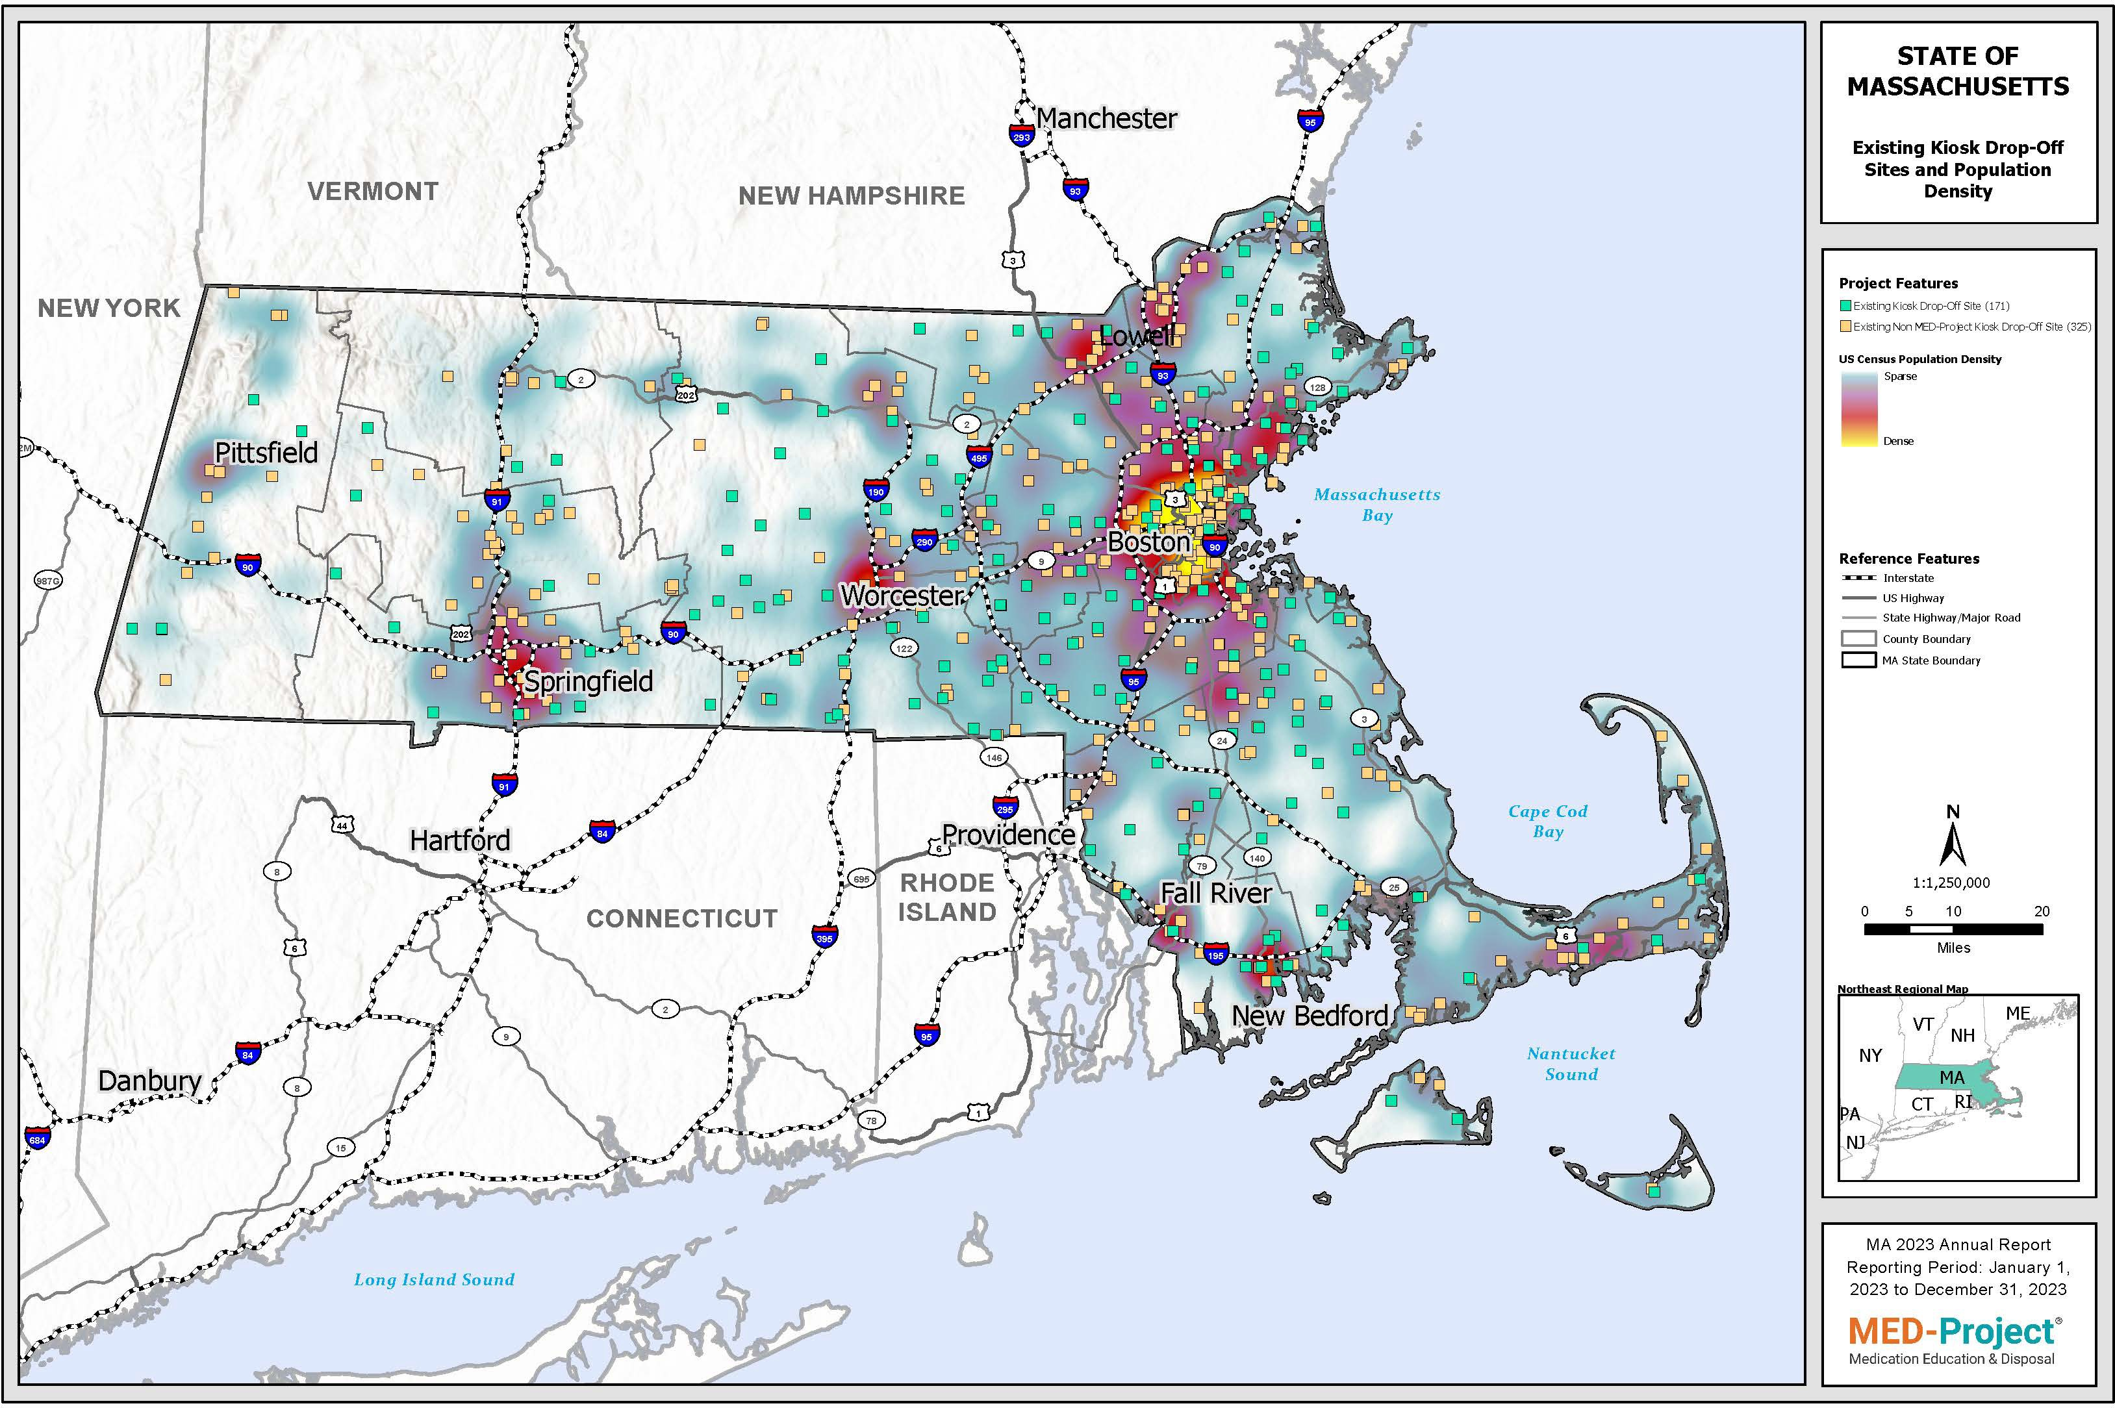

Figure 1: Map of Kiosk Drop-Off Sites

This page is intentionally left blank.

Appendix A

Media Outreach Summary

Media Channel  (Type of Media) | Start Dates | End Dates | Name of Publication / Network or Station
Media Channel  (Type of Media) |  |  | Name of Publication / Network or Station | Impressions
Digital | 06/02/2023 | 06/30/2023 | Simplifi | 514,096
Social | 06/02/2023 | 06/30/2023 | Facebook/Instagram | 1,657,651
Print | 11/16/2023 | 11/16/2023 | Eldercare Review Magazine | 110,000
Total |  |  |  | 2,281,747
Table 1: Media Outreach Summary

Appendix B

List of Program Participants
The list below includes Program participants during the Reporting Period.

Parent Company Name | Company Name | Street Address | City | State/Province | Zip/Postal Code | Country | Start Date | End Date | Add? | Drop? | Producer
ACADIA  Pharmaceuticals Inc. | ACADIA  Pharmaceuticals Inc. | 12830 El  Camino Real, Suite 400 | San Diego | California | 92130 | United States | 1/1/2023 | 12/31/2023 | N/A | N/A | Parent Company is a Producer
Accord Healthcare Inc. | Accord Healthcare Inc. | 8041 Arco  Corporate Drive | Raleigh | North Carolina | 27617 | United States | 1/1/2023 | 12/31/2023 | N/A | N/A | Parent Company is a Producer
Accord Healthcare Inc. | Accord Biopharma | 8041 Arco Corporate Drive | Raleigh | North Carolina | 27617 | United States | 1/1/2023 | 12/31/2023 | N/A | N/A | Affiliate/Subsidiary Company is a Producer
Advanz Pharma Group | Advanz Pharma Group | 5 Canewood Industrial Park | Canewood | N/A | BB11005 | Barbados | 1/1/2023 | 12/31/2023 | N/A | N/A | Parent Company is a Producer
Akorn Operating Company, LLC | Akorn Operating Company, LLC | 50 Lakeview  Pkwy #112 | Vernon Hills | Illinois | 60061 | United States | 1/1/2023 | 3/31/2023 | N/A | Drop | Parent Company is a Producer
Alora Pharmaceuticals, LLC | Alora Pharmaceuticals, LLC | 1880  McFarland Pkwy Ste 110 | Alpharetta | Georgia | 30005-  1795 | United States | N/A | N/A | N/A | N/A | Parent Company Not a Producer
Alora Pharmaceuticals, LLC | Sovereign Pharmaceuticals, LLC | 7590 Sand St | Ft. Worth | Texas | 76118 | United States | 1/1/2023 | 12/31/2023 | N/A | N/A | Affiliate/Subsidiary Company is a Producer
Alora Pharmaceuticals,  LLC | Trigen Laboratories LLC | 1880  McFarland Pkwy Ste 110 | Alpharetta | Georgia | 30005-  1795 | United States | 1/1/2023 | 12/31/2023 | N/A | N/A | Affiliate/Subsidiary Company is a  Producer
Alora Pharmaceuticals,  LLC | Vertical Pharmaceuticals,  LLC | 1880  McFarland Pkwy Ste 110 | Alpharetta | Georgia | 30005-  1795 | United States | 1/1/2023 | 12/31/2023 | N/A | N/A | Affiliate/Subsidiary Company is a  Producer
Alvogen Pharma US, Inc. | Alvogen Pharma US, Inc. | 44 Whippany Road | Morristown | New Jersey | 07960 | United States | N/A | N/A | N/A | N/A | Parent Company Not a Producer
Alvogen Pharma US, Inc. | Almaject, Inc. | 44 Whippany Road | Morristown | New Jersey | 07960 | United States | 1/1/2023 | 12/31/2023 | N/A | N/A | Affiliate/Subsidiary Company is a Producer
Alvogen Pharma US, Inc. | Almatica Pharma, LLC | 44 Whippany Road | Morristown | New Jersey | 07960 | United States | 1/1/2023 | 12/31/2023 | N/A | N/A | Affiliate/Subsidiary Company is a  Producer
Alvogen Pharma US, Inc. | Alvogen, Inc. | 44 Whippany Road | Morristown | New Jersey | 07960 | United States | 1/1/2023 | 12/31/2023 | N/A | N/A | Affiliate/Subsidiary Company is a  Producer
Alvogen Pharma US, Inc. | Norwich  Pharmaceuticals, Inc. | 6829 State  Highway 12 | Norwich | New York | 13815 | United States | 1/1/2023 | 12/31/2023 | N/A | N/A | Affiliate/Subsidiary  Company is a Producer

Parent Company Name | Company Name | Street Address | City | State/Province | Zip/Postal Code | Country | Start Date | End Date | Add? | Drop? | Producer
Amerisource Health Services, LLC DBA:  American Health Packaging | Amerisource Health Services, LLC DBA:  American Health Packaging | 2550-A John Glenn Avenue | Columbus | Ohio | 43217 | United States | 1/1/2023 | 12/31/2023 | N/A | N/A | Parent Company is a Producer
Amneal  Pharmaceuticals LLC | Amneal  Pharmaceuticals LLC | 400 Crossing  Blvd Third Floor | Bridgewater | New Jersey | 08807 | United States | 1/1/2023 | 12/31/2023 | N/A | N/A | Parent Company is a Producer
Amphastar Pharmaceuticals, Inc. | Amphastar Pharmaceuticals, Inc. | 11570 Sixth Street | Rancho Cucamonga | California | 91730 | United States | 1/1/2023 | 12/31/2023 | N/A | N/A | Parent Company is a Producer
Amphastar Pharmaceuticals, Inc. | International Medication Systems, LTD | 1886 Santa Anita Ave | South El Monte | California | 91733 | United States | 1/1/2023 | 12/31/2023 | N/A | N/A | Affiliate/Subsidiary Company is a Producer
ANI  Pharmaceuticals, Inc. | ANI  Pharmaceuticals, Inc. | 210 West Main Street | Baudette | Minnesota | 56623 | United States | 1/1/2023 | 12/31/2023 | N/A | N/A | Parent Company is a Producer
Apotex Holdings, Inc. | Apotex Holdings, Inc. | 150 Signet Drive | Toronto | Ontario | M9L 1T9 | Canada | N/A | N/A | N/A | N/A | Parent Company Not a Producer
Apotex Holdings, Inc. | Apotex Corp. | 2400 N.  Commerce Parkway Suite  400 | Weston | Florida | 33326 | United States | 1/1/2023 | 12/31/2023 | N/A | N/A | Affiliate/Subsidiary Company is a Producer
Apotex Holdings, Inc. | Aveva Drug Delivery Systems, Inc. | 2400 N.  Commerce Parkway Suite  400 | Weston | Florida | 33326 | United States | 1/1/2023 | 12/31/2023 | N/A | N/A | Affiliate/Subsidiary Company is a Producer
Ardelyx | Ardelyx | 400 Fifth Avenue Suite  210 | Waltham | Massachusetts | 02451 | United States | 1/1/2023 | 12/31/2023 | N/A | N/A | Parent Company is a Producer
Ascend  Therapeutics US, LLC | Ascend  Therapeutics US, LLC | 15 Mount  Kemble Avenue | Morristown | New Jersey | 07960 | United States | 1/1/2023 | 12/31/2023 | N/A | N/A | Parent Company is a Producer
Ascendis Pharma A/S | Ascendis Pharma A/S | Tuborg Boulevard 12 | Hellerup | N/A | 2900 | Denmark | 1/1/2023 | 5/31/2023 | N/A | Drop | Parent Company is a Producer
Assertio Therapeutics, Inc. | Assertio Therapeutics, Inc. | 100 South Saunders Rd  Suite 300 | Lake Forest | Illinois | 60045-  2508 | United States | 1/1/2023 | 12/31/2023 | N/A | N/A | Parent Company is a Producer
Aurobindo Pharma, Ltd. | Aurobindo Pharma, Ltd. | 279 Princeton Hightstown  Road | East Windsor | New Jersey | 08520-  1401 | United States | 10/7/2023 | 12/31/2023 | Add | N/A | Parent Company is a Producer
Aurobindo Pharma, Ltd. | Aurobindo Pharma USA,  Inc. | 279 Princeton Hightstown  Road | East Windsor | New Jersey | 08520-  1401 | United States | 1/1/2023 | 12/31/2023 | N/A | N/A | Affiliate/Subsidiary Company is a  Producer
Aurobindo Pharma, Ltd. | AuroHealth, LLC | 279 Princeton  Hightstown Road | East Windsor | New Jersey | 08520 | United States | 1/1/2023 | 12/31/2023 | N/A | N/A | Affiliate/Subsidiary  Company is a Producer
Aurobindo Pharma, Ltd. | Vespyr Brands Inc. | 279 Princeton  Hightstown Road | East Windsor | New Jersey | 08520-  1401 | United States | 1/1/2023 | 8/25/2023 | N/A | Drop | Affiliate/Subsidiary  Company is a Producer

Parent Company Name | Company Name | Street Address | City | State/Province | Zip/Postal Code | Country | Start Date | End Date | Add? | Drop? | Producer
Bausch Health Companies | Bausch Health Companies | 400 Somerset Corporate  Boulevard | Bridgewater | New Jersey | 08807 | United States | 1/1/2023 | 12/31/2023 | N/A | N/A | Parent Company is a Producer
Bausch Health Companies | Salix | 400 Somerset Corporate Blvd | Bridgewater | New Jersey | 08807 | United States | 1/1/2023 | 12/31/2023 | N/A | N/A | Affiliate/Subsidiary Company is a  Producer
Chartwell RX, LLC | Chartwell RX, LLC | 77 Brenner Drive | Congers | New York | 10920 | United States | 1/1/2023 | 12/31/2023 | N/A | N/A | Parent Company is a Producer
Collegium Pharmaceutical, Inc. | Collegium Pharmaceutical, Inc. | 100  Technology  Center Drive, Suite 300 | Stoughton | Massachusetts | 02072 | United States | 1/1/2023 | 12/31/2023 | N/A | N/A | Parent Company is a Producer
Collegium  Pharmaceutical, Inc. | BioDelivery Sciences, Inc. | 4131 ParkLake  Avenue, Suite 225 | Raleigh | North Carolina | 27612 | United States | 1/1/2023 | 12/31/2023 | N/A | N/A | Affiliate/Subsidiary  Company is a Producer
CSL Ltd. | CSL Ltd. | 1020 1st  Avenue | King of Prussia | Pennsylvania | 19406 | United States | 1/1/2023 | 10/24/2023 | N/A | Drop | Parent Company is a Producer
CSL Ltd. | Vifor Pharma, Inc. | 100 Cardinal Way | Redwood City | California | 94063 | United States | 1/1/2023 | 8/31/2023 | N/A | Drop | Affiliate/Subsidiary Company is a  Producer
e5 Pharma, LLC | e5 Pharma, LLC | 225 Mizner  Boulevard Ste 770 | Boca Raton | Florida | 33432 | United States | 8/23/2023 | 12/31/2023 | Add | N/A | Parent Company is a Producer
e5 Pharma, LLC | Mizner Bioscience, LLC | 225 ME Mizner  Boulevard Suite 760 | Boca Raton | Florida | 33432 | United States | 8/23/2023 | 12/31/2023 | Add | N/A | Affiliate/Subsidiary  Company is a Producer
Edenbridge Pharmaceuticals, LLC | Edenbridge Pharmaceuticals, LLC | 1 Upper Pond Road Suite D250 | Parsippany | New Jersey | 07054 | United States | 1/1/2023 | 12/31/2023 | N/A | N/A | Parent Company is a Producer
Endo Pharmaceuticals Inc. | Endo Pharmaceuticals Inc. | 1400 Atwater Drive | Malvern | Pennsylvania | 19355 | United States | 1/1/2023 | 12/31/2023 | N/A | N/A | Parent Company is a Producer
Endo Pharmaceuticals  Inc. | Par Pharmaceutical  Companies, Inc. | 6 Ram Ridge Rd | Chestnut Ridge | New York | 10977 | United States | 1/1/2023 | 12/31/2023 | N/A | N/A | Affiliate/Subsidiary Company is a  Producer
Endo Pharmaceuticals  Inc. | Par Pharmaceutical,  Inc. | 6 Ram Ridge Road | Chestnut Ridge | New York | 10977 | United States | 1/1/2023 | 12/31/2023 | N/A | N/A | Affiliate/Subsidiary Company is a  Producer
Endo Pharmaceuticals Inc. | Par Pharmaceuticals, Inc. (d/b/a Par  Pharmaceutical) | 6 Ram Ridge Rd | Chestnut Ridge | New York | 10977 | United States | 1/1/2023 | 12/31/2023 | N/A | N/A | Affiliate/Subsidiary Company is a Producer
Endo Pharmaceuticals Inc. | Par Sterile Products, LLC (d/b/a Par  Pharmaceutical) | 6 Ram Ridge Road | Chestnut Ridge | New York | 10977 | United States | 1/1/2023 | 12/31/2023 | N/A | N/A | Affiliate/Subsidiary Company is a Producer
Eywa Pharma Inc. | Eywa Pharma Inc. | 2 Research  Way, Floor #3 | Princeton | New Jersey | 08540 | United States | 1/1/2023 | 7/28/2023 | N/A | Drop | Parent Company is a Producer
Forte Bio-Pharma LLC | Forte Bio-Pharma LLC | 8311 W.  Sunset Rd. #150 | Las Vegas | Nevada | 89113 | United States | N/A | N/A | N/A | N/A | Parent Company Not a Producer

Parent Company Name | Company Name | Street Address | City | State/Province | Zip/Postal Code | Country | Start Date | End Date | Add? | Drop? | Producer
Forte Bio-Pharma LLC | FH2 Pharma LLC | 9205 W.  Russell Rd Ste 240 | Las Vegas | Nevada | 89148 | United States | 1/1/2023 | 12/31/2023 | N/A | N/A | Affiliate/Subsidiary Company is a  Producer
Fresenius Kabi USA, LLC | Fresenius Kabi USA, LLC | Three Corporate  Drive | Lake Zurich | Illinois | 60047 | United States | 1/1/2023 | 12/31/2023 | N/A | N/A | Parent Company is a Producer
Genus Lifesciences Inc. | Genus Lifesciences Inc. | 514 North 12th Street | Allentown | Pennsylvania | 18102 | United States | 1/1/2023 | 12/31/2023 | N/A | N/A | Parent Company is a Producer
Gilead Sciences, Inc. | Gilead Sciences, LLC | 333 Lakeside Drive | Foster City | California | 94404 | United States | 1/1/2023 | 8/20/2023 | N/A | Drop | Affiliate/Subsidiary Company is a Producer
Gilead Sciences, Inc. | Gilead Sciences, Inc. | 333 Lakeside Drive | Foster City | California | 94404 | United States | N/A | N/A | N/A | N/A | Parent Company Not a Producer
Golden State  Medical Supply, Inc. | Golden State  Medical Supply, Inc. | 5187 Camino Ruiz | Camarillo | California | 93012 | United States | 1/1/2023 | 12/31/2023 | N/A | N/A | Parent Company is a Producer
H2-Pharma, LLC | H2-Pharma, LLC | 2021 Berry Chase Place | Montogomery | Alabama | 36117 | United States | 1/1/2023 | 12/31/2023 | N/A | N/A | Parent Company is a Producer
Idorsia Pharmaceuticals US Inc. | Idorsia Pharmaceuticals US Inc. | One Radnor Corporate Center, Suite 101 100  Matsonford Rd. | Radnor | Pennsylvania | 19087 | United States | 1/1/2023 | 12/31/2023 | N/A | N/A | Parent Company is a Producer
Indivior Inc | Indivior Inc | 10710  Midlothian Turnpike Suite 125 | Richmond | Virginia | 23235 | United States | 1/1/2023 | 12/31/2023 | N/A | N/A | Parent Company is a Producer
Ingenus Pharmaceuticals,  LLC | Ingenus Pharmaceuticals,  LLC | 4901 Vineland Road Suite  260 | Orlando | Florida | 32811 | United States | 1/1/2023 | 12/31/2023 | N/A | N/A | Parent Company is a Producer
Invagen Pharmaceuticals,  Inc. | Invagen Pharmaceuticals,  Inc. | 7 Osar Avenue | Hauppauge | New York | 11788 | United States | N/A | N/A | N/A | N/A | Parent Company Not a Producer
Invagen  Pharmaceuticals, Inc. | Cipla Therapeutics, Inc. | 10  Independence Blvd. Suite 400 | Warren | New Jersey | 07059 | United States | 1/1/2023 | 12/31/2023 | N/A | N/A | Affiliate/Subsidiary  Company is a Producer
Invagen Pharmaceuticals, Inc. | Cipla USA, Inc. | 10  Independence Blvd., Suite  300 | Warren | New Jersey | 07059 | United States | 1/1/2023 | 12/31/2023 | N/A | N/A | Affiliate/Subsidiary Company is a Producer
Invagen Pharmaceuticals,  Inc. | Exelan Pharmaceuticals,  Inc. | 370 Camino Gardens Blvd.  Suite 204 | Boca Raton | Florida | 30046 | United States | 1/1/2023 | 12/31/2023 | N/A | N/A | Affiliate/Subsidiary Company is a  Producer
Johnson & Johnson | Johnson & Johnson | 410 George Street | New Brunswick | New Jersey | 08901 | United States | 1/1/2023 | 12/31/2023 | N/A | N/A | Parent Company is a Producer
Johnson & Johnson | Janssen Pharmaceuticals, Inc. | 1125 Trenton- Harbourton Road | Titusville | New Jersey | 08560 | United States | 1/1/2023 | 12/31/2023 | N/A | N/A | Affiliate/Subsidiary Company is a Producer

Parent Company Name | Company Name | Street Address | City | State/Province | Zip/Postal Code | Country | Start Date | End Date | Add? | Drop? | Producer
Jubilant Cadista Pharmaceuticals  Inc. | Jubilant Cadista Pharmaceuticals  Inc. | 207 Kiley Drive | Salisbury | Maryland | 21801 | United States | 1/1/2023 | 8/29/2023 | N/A | Drop | Parent Company is a Producer
Kowa Pharmaceuticals  America, Inc. | Kowa Pharmaceuticals  America, Inc. | 530 Industrial Park Blvd. | Montgomery | Alabama | 36117 | United States | 1/1/2023 | 7/6/2023 | N/A | Drop | Parent Company is a Producer
Lupin  Pharmaceuticals, Inc. (LPI) | Lupin  Pharmaceuticals, Inc. (LPI) | 111 S. Calvert St. | Baltimore | Maryland | 21202 | United States | 1/1/2023 | 12/31/2023 | N/A | N/A | Parent Company is a Producer
Mallinckrodt PLC | Mallinckrodt PLC | College Business & Technology Park  Cruiserath | Blanchardstown | Dublin | 15 | Ireland | N/A | N/A | N/A | N/A | Parent Company Not a Producer
Mallinckrodt PLC | SpecGx LLC | 385 Marshall Ave. | Webster Groves | Missouri | 63119 | United States | 1/1/2023 | 12/31/2023 | N/A | N/A | Affiliate/Subsidiary Company is a Producer
Mayne Pharma Commercial LLC | Mayne Pharma Commercial LLC | 3310 Benson  Dr. Suite 401 | Raleigh | North Carolina | 27609 | United States | 1/1/2023 | 12/31/2023 | N/A | N/A | Parent Company is a Producer
Morton Grove  Pharmaceuticals, Inc. | Morton Grove  Pharmaceuticals, Inc. | 6451 Main Street | Morton Grove | Illinois | 60053 | United States | 1/1/2023 | 5/1/2023 | N/A | Drop | Parent Company is a Producer
Mylan Inc. | Mylan Inc. | 1000 Mylan Boulevard | Canonsburg | Pennsylvania | 15317 | United States | N/A | N/A | N/A | N/A | Parent Company Not a Producer
Mylan Inc. | Alphapharm Pty Ltd | 3711 Collins Ferry Road  Reg Affs | Morgantown | West Virginia | 26505 | United States | 1/1/2023 | 12/31/2023 | N/A | N/A | Affiliate/Subsidiary Company is a  Producer
Mylan Inc. | DPT Laboratories LTD (DD) | 3711 Collins  Ferry Road Reg Affs | Morgantown | West Virginia | 26505 | United States | 1/1/2023 | 12/31/2023 | N/A | N/A | Affiliate/Subsidiary  Company is a Producer
Mylan Inc. | DPT Laboratories LTD (JS) | 3711 Collins  Ferry Road Reg Affs | Morgantown | West Virginia | 26505 | United States | 1/1/2023 | 12/31/2023 | N/A | N/A | Affiliate/Subsidiary  Company is a Producer
Mylan Inc. | Greenstone LLC | 3711 Collins Ferry Road Reg Affs | Morgantown | West Virginia | 26505 | United States | 1/1/2023 | 12/31/2023 | N/A | N/A | Affiliate/Subsidiary Company is a Producer
Mylan Inc. | Mylan Institutional Galway | 3711 Collins Ferry Road Reg Affs | Morgantown | West Virginia | 26505 | United States | 1/1/2023 | 12/31/2023 | N/A | N/A | Affiliate/Subsidiary Company is a Producer
Mylan Inc. | Mylan Institutional Inc. (IL) | 3711 Collins Ferry Road Reg Affs | Morgantown | West Virginia | 26505 | United States | 1/1/2023 | 12/31/2023 | N/A | N/A | Affiliate/Subsidiary Company is a Producer
Mylan Inc. | Mylan Institutional Inc.  (TX) | 3711 Collins Ferry Road  Reg Affs | Morgantown | West Virginia | 26505 | United States | 1/1/2023 | 12/31/2023 | N/A | N/A | Affiliate/Subsidiary Company is a  Producer
Mylan Inc. | Mylan Institutional LLC | 3711 Collins Ferry Road  Reg Affs | Morgantown | West Virginia | 26505 | United States | 1/1/2023 | 12/31/2023 | N/A | N/A | Affiliate/Subsidiary Company is a  Producer

Parent Company Name | Company Name | Street Address | City | State/Province | Zip/Postal Code | Country | Start Date | End Date | Add? | Drop? | Producer
Mylan Inc. | Mylan Laboratories Limited (1606-  1609JP) | 3711 Collins Ferry Road Reg Affs | Morgantown | West Virginia | 26505 | United States | 1/1/2023 | 12/31/2023 | N/A | N/A | Affiliate/Subsidiary Company is a Producer
Mylan Inc. | Mylan Laboratories Limited (20/21JP) | 3711 Collins Ferry Road Reg Affs | Morgantown | West Virginia | 26505 | United States | 1/1/2023 | 12/31/2023 | N/A | N/A | Affiliate/Subsidiary Company is a Producer
Mylan Inc. | Mylan Laboratories  Limited (BL) | 3711 Collins Ferry Road  Reg Affs | Morgantown | West Virginia | 26505 | United States | 1/1/2023 | 12/31/2023 | N/A | N/A | Affiliate/Subsidiary Company is a  Producer
Mylan Inc. | Mylan Laboratories Limited  (F4/F12OSD) | 3711 Collins Ferry Road Reg Affs | Morgantown | West Virginia | 26505 | United States | 1/1/2023 | 12/31/2023 | N/A | N/A | Affiliate/Subsidiary Company is a Producer
Mylan Inc. | Mylan Laboratories  Limited (H12/H13OSD) | 3711 Collins Ferry Road Reg Affs | Morgantown | West Virginia | 26505 | United States | 1/1/2023 | 12/31/2023 | N/A | N/A | Affiliate/Subsidiary Company is a Producer
Mylan Inc. | Mylan Laboratories Limited (OTL) | 3711 Collins Ferry Road Reg Affs | Morgantown | West Virginia | 26505 | United States | 1/1/2023 | 12/31/2023 | N/A | N/A | Affiliate/Subsidiary Company is a Producer
Mylan Inc. | Mylan Laboratories Limited (SF) | 3711 Collins Ferry Road Reg Affs | Morgantown | West Virginia | 26505 | United States | 1/1/2023 | 12/31/2023 | N/A | N/A | Affiliate/Subsidiary Company is a Producer
Mylan Inc. | Mylan Laboratories  Limited (SFF) | 3711 Collins Ferry Road  Reg Affs | Morgantown | West Virginia | 26505 | United States | 1/1/2023 | 12/31/2023 | N/A | N/A | Affiliate/Subsidiary Company is a  Producer
Mylan Inc. | Mylan Laboratories  Limited (SPD) | 3711 Collins Ferry Road  Reg Affs | Morgantown | West Virginia | 26505 | United States | 1/1/2023 | 12/31/2023 | N/A | N/A | Affiliate/Subsidiary Company is a  Producer
Mylan Inc. | Mylan  Pharmaceuticals, Inc. | 3711 Collins  Ferry Road Reg Affs | Morgantown | West Virginia | 26505 | United States | 1/1/2023 | 12/31/2023 | N/A | N/A | Affiliate/Subsidiary  Company is a Producer
Mylan Inc. | Mylan Specialty L.P. | 3711 Collins  Ferry Road Reg Affs | Morgantown | West Virginia | 26505 | United States | 1/1/2023 | 12/31/2023 | N/A | N/A | Affiliate/Subsidiary  Company is a Producer
Mylan Inc. | Mylan  Technologies, Inc. | 3711 Collins  Ferry Road Reg Affs | Morgantown | West Virginia | 26505 | United States | 1/1/2023 | 12/31/2023 | N/A | N/A | Affiliate/Subsidiary  Company is a Producer
Mylan Inc. | Pfizer Pharmaceuticals LLC  (Barceloneta) | 3711 Collins Ferry Road, Reg Affs | Morgantown | West Virginia | 26505 | United States | 1/1/2023 | 12/31/2023 | N/A | N/A | Affiliate/Subsidiary Company is a Producer
Mylan Inc. | Pfizer  Pharmaceuticals LLC (Vega Baja) | 3711 Collins  Ferry Road, Reg Affs | Morgantown | West Virginia | 26505 | United States | 1/1/2023 | 12/31/2023 | N/A | N/A | Affiliate/Subsidiary  Company is a Producer
Mylan Inc. | Viatris Specialty LLC | 3711 Collins Ferry Road Reg Affs | Morgantown | West Virginia | 26505 | United States | 1/1/2023 | 12/31/2023 | N/A | N/A | Affiliate/Subsidiary Company is a Producer

Parent Company Name | Company Name | Street Address | City | State/Province | Zip/Postal Code | Country | Start Date | End Date | Add? | Drop? | Producer
Neos Therapeutics, Inc. | Neos Therapeutics, Inc. | 2940 N State  Highway 360  Ste 400 | Grand Prairie | Texas | 75050-  6424 | United States | 7/19/2023 | 12/31/2023 | Add | N/A | Parent Company is a Producer
Neos Therapeutics, Inc. | Neos Therapeutics  Brands LLC | 2940 N. State  Highway 360  Suite 400 | Grand Prairie | Texas | 75050 | United States | 1/1/2023 | 7/18/2023 | N/A | Drop | Affiliate/Subsidiary Company is a  Producer
Neos Therapeutics, Inc. | Neos Therapeutics LP | 2940 N State  Highway 360  Ste 400 | Grand Prairie | Texas | 75050-  6424 | United States | 1/1/2023 | 12/31/2023 | N/A | N/A | Affiliate/Subsidiary  Company is a Producer
Norbrook  Laboratories Limited | Norbrook  Laboratories Limited | Carnbane  Industrial Estate | Newry, County Down | N/A | BT35 6QQ | United Kingdom | N/A | N/A | N/A | N/A | Parent Company Not a Producer
Norbrook  Laboratories Limited | Norbrook, Inc. | 9733 Loiret Blvd | Lenexa | Kansas | 66219 | United States | 1/1/2023 | 7/19/2023 | N/A | Drop | Affiliate/Subsidiary  Company is a Producer
Nostrum Laboratories, Inc. | Nostrum Laboratories, Inc. | 705 East Mulberry Street | Bryan | Ohio | 43506 | United States | 1/1/2023 | 12/31/2023 | N/A | N/A | Parent Company is a Producer
Novartis Group Companies | Novartis Group Companies | 59 Route 10 | East Hanover | New Jersey | 07936 | United States | N/A | N/A | N/A | N/A | Parent Company Not a Producer
Novartis Group Companies | Novartis  Pharmaceuticals Corporation | 1 Health Plaza | East Hanover | New Jersey | 07936-  1016 | United States | 1/1/2023 | 12/31/2023 | N/A | N/A | Affiliate/Subsidiary  Company is a Producer
Noven  Pharmaceuticals, Inc. | Noven  Pharmaceuticals, Inc. | 11960 SW  144th St | Miami | Florida | 33186 | United States | 1/1/2023 | 12/31/2023 | N/A | N/A | Parent Company is a Producer
Noven Pharmaceuticals, Inc. | Hisamitsu America, Inc. | 100 Campus Drive Suite 117 | Florham Park | New Jersey | 07932 | United States | 1/1/2023 | 12/31/2023 | N/A | N/A | Affiliate/Subsidiary Company is a Producer
Noven Pharmaceuticals, Inc. | Noven Therapeutics, LLC | 11960 SW  144th St | Miami | Florida | 33186-  6109 | United States | 1/1/2023 | 12/31/2023 | N/A | N/A | Affiliate/Subsidiary Company is a Producer
Noven Pharmaceuticals, Inc. | Noven Therapeutics, LLC dba Grove  Pharmaceuticals | 11960 SW  144th St | Miami | Florida | 33186 | United States | 1/1/2023 | 12/31/2023 | N/A | N/A | Affiliate/Subsidiary Company is a Producer
Padagis US LLC | Padagis US LLC | 1251 Lincoln Road | Allegan | Michigan | 49010 | United States | 1/1/2023 | 12/31/2023 | N/A | N/A | Parent Company is a Producer
Petros Pharmaceuticals, Inc. | Petros Pharmaceuticals, Inc. | 1185 Avenue of the Americas Suite  249 | New York City | New York | 10036 | United States | N/A | N/A | N/A | Drop | Parent Company Not a Producer
Petros Pharmaceuticals,  Inc. | Metuchen Pharmaceuticals,  LLC | 200 US  Highway 9  Suite 500 | Manalapan Township | New Jersey | 07726 | United States | 1/1/2023 | 1/25/2023 | N/A | Drop | Affiliate/Subsidiary Company is a  Producer
Pfizer Inc. | Biohaven Pharmaceuticals  Inc. | 234 Church St | New Haven | Connecticut | 06510 | United States | 1/1/2023 | 10/5/2023 | N/A | Drop | Affiliate/Subsidiary Company is a  Producer
Pfizer Inc. | Pfizer Inc. | 66 Hudson Boulevard East | New York | New York | 10001 | United States | 1/1/2023 | 12/31/2023 | N/A | N/A | Parent Company is a Producer

Parent Company Name | Company Name | Street Address | City | State/Province | Zip/Postal Code | Country | Start Date | End Date | Add? | Drop? | Producer
Pfizer Inc. | Array Biopharma Inc. | 3200 Walnut Street | Boulder | Colorado | 80301 | United States | 1/1/2023 | 12/31/2023 | N/A | N/A | Affiliate/Subsidiary Company is a  Producer
Pfizer Inc. | Global Blood Therapeutics Inc | 180 Oyster Point Blvd | South San Francisco | California | 94080 | United States | 1/1/2023 | 12/31/2023 | N/A | N/A | Affiliate/Subsidiary Company is a  Producer
Pfizer Inc. | Hospira | 275 N. Fields Drive | Lake Forest | Illinois | 60045 | United States | 1/1/2023 | 12/31/2023 | N/A | N/A | Affiliate/Subsidiary  Company is a Producer
Pfizer Inc. | Pharmacia &  Upjohn Company LLC | 7000 Portage Road | Kalamazoo | Michigan | 49001 | United States | 8/25/2023 | 12/31/2023 | Add | N/A | Affiliate/Subsidiary  Company is a Producer
Pharmaceutical Associates, Inc. | Pharmaceutical Associates, Inc. | 1700  Perimeter Road | Greenville | South Carolina | 29605 | United States | 1/1/2023 | 12/31/2023 | N/A | N/A | Parent Company is a Producer
Pharmasphere, Inc. | Pharmasphere, Inc. | 120 Route 17 North | Paramus | New Jersey | 07652 | United States | N/A | N/A | N/A | N/A | Parent Company Not a Producer
Pharmasphere, Inc. | WG Critical Care LLC | 120 Route 17 North | Paramus | New Jersey | 07652 | United States | 7/19/2023 | 12/31/2023 | Add | N/A | Affiliate/Subsidiary Company is a  Producer
Prestige Consumer Healthcare, Inc. | Prestige Consumer Healthcare, Inc. | 660 White Plains Road,2nd  Floor | Tarrytown | New York | 10591 | United States | 1/1/2023 | 12/31/2023 | N/A | N/A | Parent Company is a Producer
Prestige Consumer Healthcare, Inc. | C.B. Fleet Company, Incorporated | 660 White Plains Road,2nd  Floor | Tarrytown | New York | 10591 | United States | 1/1/2023 | 12/31/2023 | N/A | N/A | Affiliate/Subsidiary Company is a Producer
Prestige Consumer Healthcare, Inc. | DenTek Oral Care, Inc. | 660 White Plains Road,2nd  Floor | Tarrytown | New York | 10591 | United States | 1/1/2023 | 12/31/2023 | N/A | N/A | Affiliate/Subsidiary Company is a Producer
Prestige Consumer Healthcare, Inc. | Insight Pharmaceuticals LLC | 660 White Plains  Road,2nd Floor | Tarrytown | New York | 10591 | United States | 1/1/2023 | 12/31/2023 | N/A | N/A | Affiliate/Subsidiary Company is a Producer
Prestige  Consumer Healthcare, Inc. | Medtech Products Inc. | 660 White  Plains Road, 2nd Floor | Tarrytown | New York | 10591 | United States | 1/1/2023 | 12/31/2023 | N/A | N/A | Affiliate/Subsidiary  Company is a Producer
PuraCap International, LLC | Epic Pharma, LLC | 227-15N  Conduit Ave. | Laurelton | New York | 11413 | United States | 1/1/2023 | 7/5/2023 | N/A | Drop | Affiliate/Subsidiary Company is a Producer
PuraCap International, LLC | PuraCap International, LLC | 517 Route  1,Suite 4002 | Iselin | New Jersey | 8830 | United States | N/A | N/A | N/A | N/A | Parent Company Not a Producer
Purdue Pharma L.P. | Purdue Pharma L.P. | One Stamford Forum | Stamford | Connecticut | 06901 | United States | 1/1/2023 | 12/31/2023 | N/A | N/A | Parent Company is a Producer
Purdue Pharma L.P. | Adlon Therapeutics, LP | One Stamford Forum | Stamford | Connecticut | 06901 | United States | 1/1/2023 | 12/31/2023 | N/A | N/A | Affiliate/Subsidiary Company is a Producer

Parent Company Name | Company Name | Street Address | City | State/Province | Zip/Postal Code | Country | Start Date | End Date | Add? | Drop? | Producer
Purdue Pharma L.P. | Avrio Health L.P. | One Stamford Forum | Stamford | Connecticut | 06901 | United States | 1/1/2023 | 8/23/2023 | N/A | Drop | Affiliate/Subsidiary Company is a  Producer
Purdue Pharma L.P. | Purdue Pharmaceuticals  L.P. | 4701 Purdue Drive | Wilson | North Carolina | 27893 | United States | 1/1/2023 | 12/31/2023 | N/A | N/A | Affiliate/Subsidiary Company is a  Producer
Purdue Pharma L.P. | Rhodes  Pharmaceuticals L.P. | 498  Washington Street | Coventry | Rhode Island | 02816 | United States | 1/1/2023 | 12/31/2023 | N/A | N/A | Affiliate/Subsidiary  Company is a Producer
Quagen  Pharmaceuticals, LLC | Quagen  Pharmaceuticals, LLC | 34 Fairfield Place | West Caldwell | New Jersey | 07006 | United States | 1/1/2023 | 5/31/2023 | N/A | Drop | Parent Company is a Producer
Rising Pharma Holdings, Inc. | Rising Pharma Holdings, Inc. | 2 Tower  Center Boulevard | East Brunswick | New Jersey | 08816 | United States | 1/1/2023 | 12/31/2023 | N/A | N/A | Parent Company is a Producer
Rising Pharma Holdings, Inc. | Casper Pharma LLC | 2 Tower Center  Boulevard, Suite 1101 | East Brunswick | New Jersey | 08816 | United States | 1/1/2023 | 12/31/2023 | N/A | N/A | Affiliate/Subsidiary Company is a Producer
Rivopharm SA | Rivopharm SA | Centro Insema | Manno | N/A | 6928 | Switzerland | 1/1/2023 | 12/31/2023 | N/A | N/A | Parent Company is a Producer
Sagent Pharmaceuticals | SterRx, LLC | 141 Idaho Road | Plattsburgh | New York | 12903 | United States | 1/1/2023 | 8/24/2023 | N/A | Drop | Affiliate/Subsidiary Company is a  Producer
Sagent Pharmaceuticals | Sagent Pharmaceuticals | 1901 N.  Roselle Road Suite 450 | Schaumburg | Illinois | 60195 | United States | N/A | N/A | N/A | N/A | Parent Company Not a Producer
Sandoz, Inc | Sandoz, Inc | 100 College Road West | Princeton | New Jersey | 08540 | United States | 1/1/2023 | 12/31/2023 | N/A | N/A | Parent Company is a Producer
Sandoz, Inc | Eon Labs, Inc. | 4700 Sandoz Drive | Wilson | North Carolina | 27893 | United States | 1/1/2023 | 12/31/2023 | N/A | N/A | Affiliate/Subsidiary Company is a Producer
Sandoz, Inc | Fougera Pharmaceuticals  Inc. | 60 Baylis Road | Melville | New York | 11747 | United States | 1/1/2023 | 12/31/2023 | N/A | N/A | Affiliate/Subsidiary Company is a  Producer
Sebela Pharmaceuticals  Inc. | Sebela Pharmaceuticals  Inc. | 645 Hembree Pkwy Suite I | Roswell | Georgia | 30076 | United States | 1/1/2023 | 12/31/2023 | N/A | N/A | Parent Company is a Producer
Sebela Pharmaceuticals Inc. | Affordable Pharmaceuticals LLC | 60 Columbian St. West Suite 200 P.O. Box  850253 | Braintree | Massachusetts | 02185-  0253 | United States | 1/1/2023 | 12/31/2023 | N/A | N/A | Affiliate/Subsidiary Company is a Producer
Sebela Pharmaceuticals Inc. | Braintree Laboratories Inc. | 60 Columbian Street West  P.O. Box 850929 | Braintree | Massachusetts | 02185-  0929 | United States | 1/1/2023 | 12/31/2023 | N/A | N/A | Affiliate/Subsidiary Company is a Producer
Teva Pharmaceuticals USA, Inc. | Teva Pharmaceuticals USA, Inc. | 1090 Horsham Rd | North Wales | Pennsylvania | 19454-  1505 | United States | 1/1/2023 | 12/31/2023 | N/A | N/A | Parent Company is a Producer

Parent Company Name | Company Name | Street Address | City | State/Province | Zip/Postal Code | Country | Start Date | End Date | Add? | Drop? | Producer
Teva Pharmaceuticals  USA, Inc. | Actavis Generics | 400 Interpace Pkwy | Parsippany | New Jersey | 07054 | United States | 1/1/2023 | 12/31/2023 | N/A | N/A | Affiliate/Subsidiary Company is a  Producer
Teva Pharmaceuticals USA, Inc. | Cephalon, Inc. | Morris Corporate Center III 400 Interpace  Pkwy | Parsippany | New Jersey | 07054 | United States | 1/1/2023 | 12/31/2023 | N/A | N/A | Affiliate/Subsidiary Company is a Producer
Teva Pharmaceuticals USA, Inc. | Teva Neuroscience Inc. | 11100 Nail Ave | Overland Park | Kansas | 66221 | United States | 1/1/2023 | 12/31/2023 | N/A | N/A | Affiliate/Subsidiary Company is a Producer
Torrent Pharma Inc. | Torrent Pharma Inc. | 106 Allen Road Suite 305 | Basking Ridge | New Jersey | 07920 | United States | 1/1/2023 | 12/31/2023 | N/A | N/A | Parent Company is a Producer
Torrent Pharma Inc. | Torrent Pharmaceuticals Limited | Ahmedabab- mehsana Highway Indrad Taluka-  Kadi | Indrad | Gujarat | 382721 | India | 1/1/2023 | 12/31/2023 | N/A | N/A | Affiliate/Subsidiary Company is a Producer
Torrent Pharma Inc. | Torrent Pharmaceuticals Limited | Plot No. Z/104 to 106, Dahej SEZ Part-II Taluka Vagra,  Dist. Bharuch | Bharuch | Gujarat | 392130 | India | 1/1/2023 | 12/31/2023 | N/A | N/A | Affiliate/Subsidiary Company is a Producer
Travere Therapeutics, Inc. | Travere Therapeutics, Inc. | 3661 Valley Centre Dr. Suite 300 | San Diego | California | 92130 | United States | 1/1/2023 | 12/31/2023 | N/A | N/A | Parent Company is a Producer
Tris Pharma, Inc. | Tris Pharma, Inc. | 2033 Route  130 | Monmouth Junction | New Jersey | 08852 | United States | 1/1/2023 | 12/31/2023 | N/A | N/A | Parent Company is a Producer
Tris Pharma, Inc. | NextWave Pharmaceuticals | 2033 Route  130 | Monmouth Junction | New Jersey | 08852 | United States | 1/1/2023 | 12/31/2023 | N/A | N/A | Affiliate/Subsidiary  Company is a Producer
UCB Inc. | UCB Inc. | 1950 Lake Park Drive | Smyrna | Georgia | 30080 | United States | 1/1/2023 | 12/31/2023 | N/A | N/A | Parent Company is a Producer
UCB Inc. | Zogenix | 5959 Horton St  Ste 500 | Emeryville | California | 94608-  2120 | United States | 1/1/2023 | 11/28/2023 | N/A | Drop | Affiliate/Subsidiary Company is a  Producer
Ultragenyx Pharmaceutical,  Inc. | Ultragenyx Pharmaceutical,  Inc. | 60 Leveroni Ct | Novato | California | 94949 | United States | 1/1/2023 | 8/24/2023 | N/A | Drop | Parent Company is a Producer
VistaPharm, Inc | VistaPharm, Inc | 7325 Ulmerton Rd | Largo | Florida | 33771 | United States | 1/1/2023 | 12/31/2023 | N/A | N/A | Parent Company is a Producer
West Therapeutic Development, LLC | West Therapeutic Development, LLC | 1033 Skokie Boulevard, Suite 620 | Northbrook | Illinois | 60062 | United States | 2/14/2023 | 12/31/2023 | Add | N/A | Parent Company is a Producer
Wockhardt Holding  Corporation | Wockhardt Holding  Corporation | 20 Waterview Blvd, 3rd Floor | Parsippany | New Jersey | 07054 | United States | N/A | N/A | N/A | N/A | Parent Company Not a Producer
Wockhardt Holding  Corporation | Wockhardt USA LLC | 20 Waterview Blvd., 3rd Floor | Parsippany | New Jersey | 07054 | United States | 6/10/2023 | 12/31/2023 | Add | N/A | Affiliate/Subsidiary Company is a  Producer

Parent Company Name | Company Name | Street Address | City | State/Province | Zip/Postal Code | Country | Start Date | End Date | Add? | Drop? | Producer
Wockhardt Holding  Corporation | Wockhardt USA LLC | 20 Waterview Blvd., 3rd Floor | Parsippany | New Jersey | 07054 | United States | 1/1/2023 | 5/18/2023 | N/A | Drop | Affiliate/Subsidiary Company is a  Producer
Xspire Pharma LLC. | WraSer Pharmaceuticals | 119  Marketridge Drive Suite D | Ridgeland | Mississippi | 39157 | United States | 1/1/2023 | 6/29/2023 | N/A | Drop | Affiliate/Subsidiary Company is a  Producer
Xspire Pharma LLC. | Xspire Pharma LLC. | 119  Marketridge Drive Suite D-2 | Ridgeland | Mississippi | 39157 | United States | 1/1/2023 | 6/29/2023 | N/A | Drop | Parent Company is a Producer
Zydus  Pharmaceuticals USA Inc | Zydus  Pharmaceuticals USA Inc | 73 Route 31 North | Pennington | New Jersey | 08534 | United States | N/A | N/A | N/A | N/A | Parent Company Not a Producer
Zydus  Pharmaceuticals USA Inc | Sentynl Therapeutics, Inc. | 420 Stevens  Ave Suite 200 | Solana Beach | California | 92075 | United States | 1/1/2023 | 12/31/2023 | N/A | N/A | Affiliate/Subsidiary  Company is a Producer
Zyla Life Sciences | Zyla Life Sciences | 100 S.  Saunders Rd. Suite 300 | Lake Forest | Illinois | 60045 | United States | 1/1/2023 | 12/31/2023 | N/A | N/A | Parent Company is a Producer
Table 2: List of Program Participants

Appendix C

List of Participating Collection Sites
A list of participating collection sites during the Reporting Period.

Site | Address | City | ZIP Code
Abington Police Department | 215 Central Street | Abington | 02351
Acushnet Police Department | 64 Middle Road | Acushnet | 02743
Amesbury Police Department | 19 School Street | Amesbury | 01913
Ashburnham Police Department | 99 Central Street | Ashburnham | 01430
Ashland Police Department | 137 Main Street | Ashland | 01721
Athol Police Department | 280 Exchange Street | Athol | 01331
Barre Police Department | 655 South Street | Barre | 01005
Bellingham Police Department | 30 Blackstone Street | Bellingham | 02019
Belmont Police Department | 40 Woodland Street | Belmont | 02478
Berlin Police Department | 23 Linden Street | Berlin | 01503
Beverly Police Department | 175 Elliott Street | Beverly | 01915
Billerica Police Department | 6 Good Street | Billerica | 01821
Blackstone Police Department | 15 Saint Paul Street | Blackstone | 01504
Bolton Police Department | 15 Wattaquadock Hill Road | Bolton | 01740
Bourne Police Department | 35 Armory Road | Buzzards Bay | 02532
Brockton Police Department | 7 Commercial Street | Brockton | 02302
Carlisle Police Department | 41 Lowell Street | Carlisle | 01741
Carver Police Department | 3 Center Street | Carver | 02330
Charlton Police Department | 85 Masonic Home Road | Charlton | 01507
Cheshire Police Department | 80 Church Street | Cheshire | 01225
Chester Police Department | 15 Middlefield Road | Chester | 01011
Cohasset Police Department | 62 Elm Street | Cohasset | 02025
Dalton Police Department | 462 Main Street | Dalton | 01226
Dartmouth Police Department | 1390 Tucker Road | Dartmouth | 02747
Dedham Police Department | 600 High Street | Dedham | 02026
Dighton Police Department | 1458 Somerset Avenue | Dighton | 02715
Douglas Police Department | 29 Depot Street | Douglas | 01516
Dover Police Department | 3 Walpole Street | Dover | 02030
Dracut Police Department | 110 Loon Hill Road | Dracut | 01826
Dudley Police Department | 71 West Main Street | Dudley | 01571
Dunstable Police Department | 23 Pleasant Street | Dunstable | 01827
East Bridgewater Police Department | 153 Central Street | East Bridgewater | 02333

Site | Address | City | ZIP Code
East Brookfield Police Department | 122 Connie Mack Drive | East Brookfield | 01515
East Longmeadow Police Department | 160 Somers Road | East Longmeadow | 01028
Edgartown Police Department | 72 Peases Point Way South | Edgartown | 02539
Egremont Police Department | 171 Egremont Plain Road | Great Barrington | 01230
Emerson College Police Department | 120 Boylston Street | Boston | 02116
Endicott College Department of Public Safety and Police Department | 376 Hale Street | Beverly | 01915
Erving Police Department | 71 French King Highway | Erving | 01344
Essex Police Department | 11 John Wise Avenue | Essex | 01929
Everett Police Department | 45 Elm Street | Everett | 02149
Fairhaven Police Department | 1 Bryant Lane | Fairhaven | 02719
Fall River Police Department | 685 Pleasant Street | Fall River | 02721
Foxborough Police Department | 8 Chestnut Street | Foxborough | 02035
Franklin Police Department | 911 Panther Way | Franklin | 02038
Georgetown Police Department | 47 Central Street | Georgetown | 01833
Grafton Police Department | 28 Providence Road | Grafton | 01519
Granby Police Department | 259A East State Street | Granby | 01033
Great Barrington Police Department | 465 Main Street | Great Barrington | 01230
Groveland Police Department | 181 Main Street | Groveland | 01834
Halifax Police Department | 540 Plymouth Street | Halifax | 02338
Hamilton Police Department | 265 Bay Road | Hamilton | 01982
Hampden Police Department | 100 Allen Street | Hampden | 01036
Hanson Police Department | 775 Main Street | Hanson | 02341
Hardwick Police Department | 20 Memorial Drive | New Braintree | 01531
Harwich Police Department | 183 Sisson Road | Harwich | 02645
Hingham Police Department | 212 Central Street | Hingham | 02043
Holbrook Police Department | 300 South Franklin Street | Holbrook | 02343
Holland Police Department | 27 Sturbridge Road | Holland | 01521
Holliston Police Department | 550 Washington Street | Holliston | 01746
Hopedale Police Department | 70 Hopedale Street | Hopedale | 01747
Hopkinton Police Department | 74 Main Street | Hopkinton | 01748
Hubbardston Police Department | 7 Main Street, Unit 9 | Hubbardston | 01452
Hudson Police Department | 911 Municipal Drive | Hudson | 01749
Ipswich Police Department | 15 Elm Street | Ipswich | 01938

Site | Address | City | ZIP Code
Kingston Police Department | 244 Main Street | Kingston | 02364
Lakeville Police Department | 323 Bedford Street | Lakeville | 02347
Lancaster Police Department | 1053 Main Street | Lancaster | 01523
Lasell University Police Department | 80 Maple Street | Newton | 02458
Leicester Police Department | 90 South Main Street | Leicester | 01524
Leominster Police Department | 29 Church Street | Leominster | 01453
Leverett Police Department | 95 Montague Road | Leverett | 01054
Longmeadow Police Department | 34 Williams Street | Longmeadow | 01106
Lynn Police Department | 300 Washington Street | Lynn | 01902
Marion Police Department | 550 Mill St | Marion | 02738
Manchester Police Department | 10 Central Street | Manchester- by-the-Sea | 01944
Marblehead Police Department | 11 Gerry Street | Marblehead | 01945
Marlborough Police Department | 355 Bolton Street | Marlborough | 01752
Mashpee Police Department | 19 Frank E. Hicks Drive | Mashpee | 02649
Massachusetts Bay Transportation Authority (MBTA) Transit Police | 240 Southampton Street | Boston | 02118
Mattapoisett Police Department | 64 County Road | Mattapoisett | 02739
Medfield Police Department | 112 North Street | Medfield | 02052
Medford Police Department | 100 Main Street | Medford | 02155
Medway Police Department | 315 Village Street | Medway | 02053
Melrose Police Department | 56 West Foster Street | Melrose | 02176
Mendon Police Department | 22 Main Street | Mendon | 01756
Middleborough Police Department | 350 Wood Street | Middleborough | 02346
Milford Police Department | 250 Main Street | Milford | 01757
Millbury Police Department | 127 Elm Street | Millbury | 01527
Millis Police Department | 1003 Main Street | Millis | 02054
Millville Police Department | 10 Central Street | Millville | 01529
Milton Police Department | 40 Highland Street | Milton | 02186
Monterey Police Department | 435 Main Road | Great Barrington | 01230
Nantucket Police Department | 4 Fairgrounds Road | Nantucket | 02554
Natick Police Department | 20 East Central Street | Natick | 01760
Needham Police Department | 88 Chestnut Street | Needham | 02492
New Bedford Police Department Headquarters | 871 Rockdale Avenue | New Bedford | 02740
New Bedford Police Department Uniform Patrol Station 2 | 912 Brock Avenue | New Bedford | 02744

Site | Address | City | ZIP Code
New Bedford Police Department Uniform Patrol Station 3 | 781 Ashley Boulevard | New Bedford | 02745
Norfolk Police Department | 14 Sharon Avenue | Norfolk | 02056
North Brookfield Police Department | 55 School Street | North Brookfield | 01535
North Reading Police Department | 150 Park Street | North Reading | 01864
Northborough Police Department | 211 Main Street | Northborough | 01532
Northbridge Police Department | 1 Hope Street | Whitinsville | 01588
Norton Police Department | 82 East Main Street | Norton | 02766
Norwell Police Department | 300A Washington Street | Norwell | 02061
Oakham Police Department | 178 Barre Road | Oakham | 01068
Orleans Police Department | 99 Eldredge Park Way | Orleans | 02653
Oxford Police Department | 503 Main Street | Oxford | 01540
Peabody Police Department | 6 Allens Lane | Peabody | 01960
Pembroke Police Department | 80 Center Street | Pembroke | 02359
Phillipston Police Department | 40 The Common | Phillipston | 01331
Plainfield Police Department | 315 Main Street | Plainfield | 01070
Plympton Police Department | 5 Palmer Road | Plympton | 02367
Quincy Police Department | 1 Sea Street | Quincy | 02169
Raynham Police Department | 53 Orchard Street | Raynham | 02767
Reading Police Department | 15 Union Street | Reading | 01867
Rehoboth Police Department | 334 Anawan Street | Rehoboth | 02769
Revere Police Department | 400 Revere Beach Parkway | Revere | 02151
Rochester Police Department | 29 Dexter Lane | Rochester | 02770
Rockland Police Department | 490 Market Street | Rockland | 02370
Rockport Police Department | 168 Main Street | Rockport | 01966
Rowley Police Department | 477 Haverhill Street | Rowley | 01969
Russell Police Department | 155 Highland Avenue | Russell | 01071
Rutland Police Department | 242 Main Street | Rutland | 01543
Salem Police Department | 95 Margin Street | Salem | 01970
Salisbury Police Department | 181 Beach Road | Salisbury | 01952
Saugus Police Department | 27 Hamilton Street | Saugus | 01906
Scituate Police Department | 800 Chief Justice Cushing Highway | Scituate | 02066
Seekonk Police Department | 500 Taunton Avenue | Seekonk | 02771
Sherborn Police Department | 17 Washington Street | Sherborn | 01770
Southborough Police Department | 32 Cordaville Road | Southborough | 01772
Southbridge Police Department | 1 Mechanic Street | Southbridge | 01550
Southwick Police Department | 11 Depot Street | Southwick | 01077

Site | Address | City | ZIP Code
Spencer Police Department | 9 West Main Street | Spencer | 01562
Stoneham Police Department | 47 Central Street | Stoneham | 02180
Stoughton Police Department | 26 Rose Street | Stoughton | 02072
Sudbury Police Department | 75 Hudson Road | Sudbury | 01776
Sunderland Police Department | 105 River Road | Sunderland | 01375
Swansea Police Department | 1700 Grand Army of the Republic Highway | Swansea | 02777
Taunton Police Department | 23 Summer Street | Taunton | 02780
Tewksbury Police Department | 918 Main Street | Tewksbury | 01876
Topsfield Police Department | 210 Boston Street | Topsfield | 01983
Townsend Police Department | 70 Brookline Street | Townsend | 01469
Tufts University Police Department | 419 Boston Avenue  Dowling Hall | Medford | 02155
Tyngsborough Police Department | 20 Westford Road | Tyngsborough | 01879
University of Massachusetts Amherst Police Department | 585 East Pleasant Street | Amherst | 01002
Uxbridge Police Department | 275 Douglas Street | Uxbridge | 01569
Walpole Police Department | 50 South Street | Walpole | 02081
Warren Police Department | 1 Milton O Fountain Way | Warren | 01083
Watertown Police Department | 552 Main Street | Watertown | 02472
Wayland Police Department | 38 Cochituate Road | Wayland | 01778
Webster Police Department | 357 Main Street | Webster | 01570
Wenham Police Department | 1 Friend Court | Wenham | 01984
West Boylston Police Department | 141 Sterling Street | West Boylston | 01583
West Bridgewater Police Department | 99 West Center Street | West Bridgewater | 02379
West Brookfield Police Department | 2 East Main Street | West Brookfield | 01585
West Newbury Police Department | 401 West Main Street | West Newbury | 01985
West Tisbury Police Department | 454 State Road | West Tisbury | 02575
Westminster Police Department | 7 South Street | Westminster | 01473
Weston Police Department | 180 Boston Post Road Bypass | Weston | 02493
Westwood Police Department | 588 High Street | Westwood | 02090
Weymouth Police Department | 140 Winter Street | Weymouth | 02188
Whitman Police Department | 20 Essex Street | Whitman | 02382
Wilbraham Police Department | 2780 Boston Road | Wilbraham | 01095

Site | Address | City | ZIP Code
Wilmington Police Department | 1 Adelaide Street | Wilmington | 01887
Windsor Police Department | 1890 Massachusetts 9 | Windsor | 01270
Winthrop Police Department | 3 Metcalf Square | Winthrop | 02152
Woburn Police Department | 25 Harrison Avenue | Woburn | 01801
Worthington Police Department | 51 Huntington Road | Worthington | 01098
Yarmouth Police Department | 340 Higgins Crowell Road | Yarmouth | 02673
Table 3: List of Participating Collection Sites

Appendix D

Disposal Facilities
Service Grant Site Disposal Facilities

Name | Address
Stericycle, Inc., Warren, Ohio Facility | 1901 Pine Avenue, SE, Warren, OH 44483
Heritage Thermal Services | 1250 Saint George Street, East Liverpool, OH 43920
Table 4: Disposal Facilities

Appendix E

Website Statistics
The total number of website views, by page, during the Reporting Period.

Web Page Name | Web Page URL | VIEWS
Home | https://med-project.org/locations/massachusetts/ | 847
Medicine Usage | https://med-project.org/locations/massachusetts/medicine-usage/ | 175
Safe Storage Information | https://med-project.org/locations/massachusetts/safe-storage-information/ | 70
Find a Location | https://med-project.org/locations/massachusetts/find-a-location/ | 853
Mail-Back Services | https://med-project.org/locations/massachusetts/mail-back-services/ | 593
In-Home Services | https://med-project.org/locations/massachusetts/in-home-services/ | 141
Learn | https://med-project.org/locations/massachusetts/learn/ | 543
Apply for a Grant | https://med-project.org/locations/massachusetts/apply-for-a-grant/ | 1434
Table 5: Website Statistics

Appendix F

MED-Project Website Pages
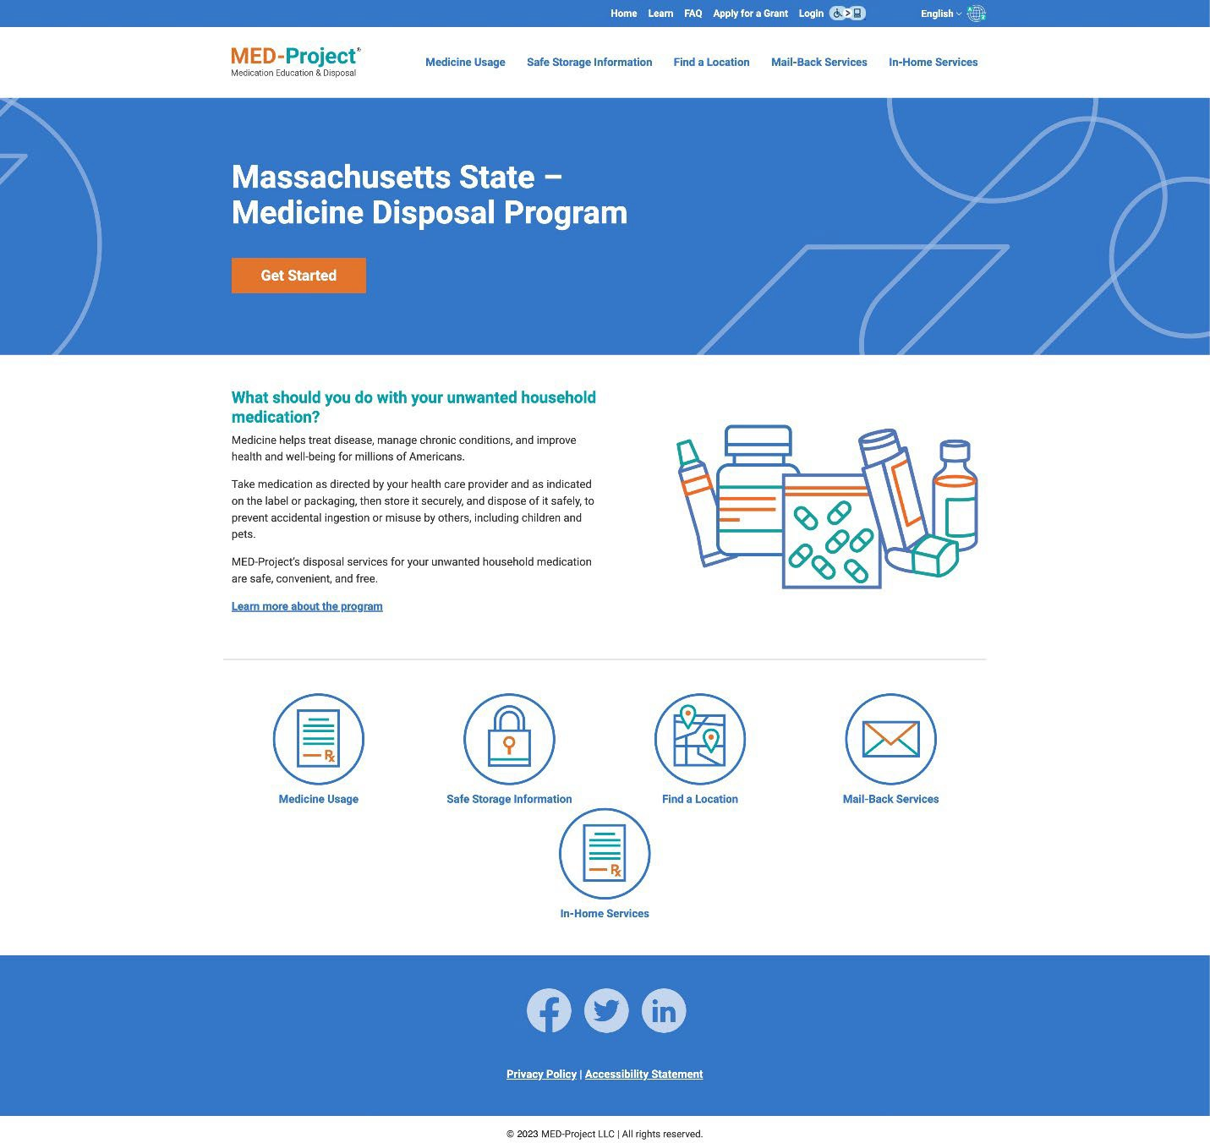
A representative sample of MED-Project website pages for Massachusetts during the Reporting Period.

Figure 2: MED-Project Website Landing Page

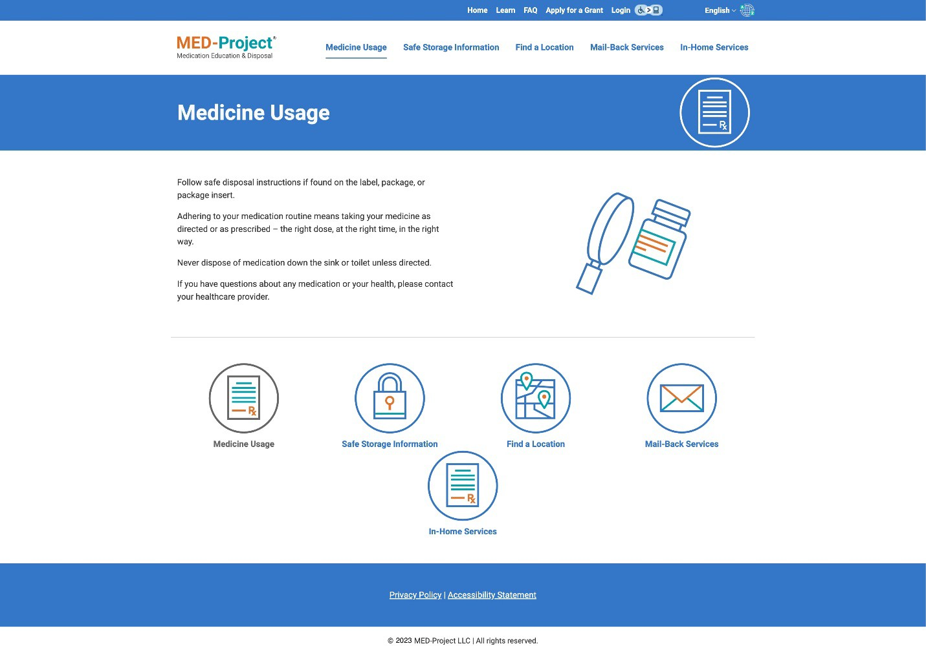
Figure 3: MED-Project Website Medicine Usage Page

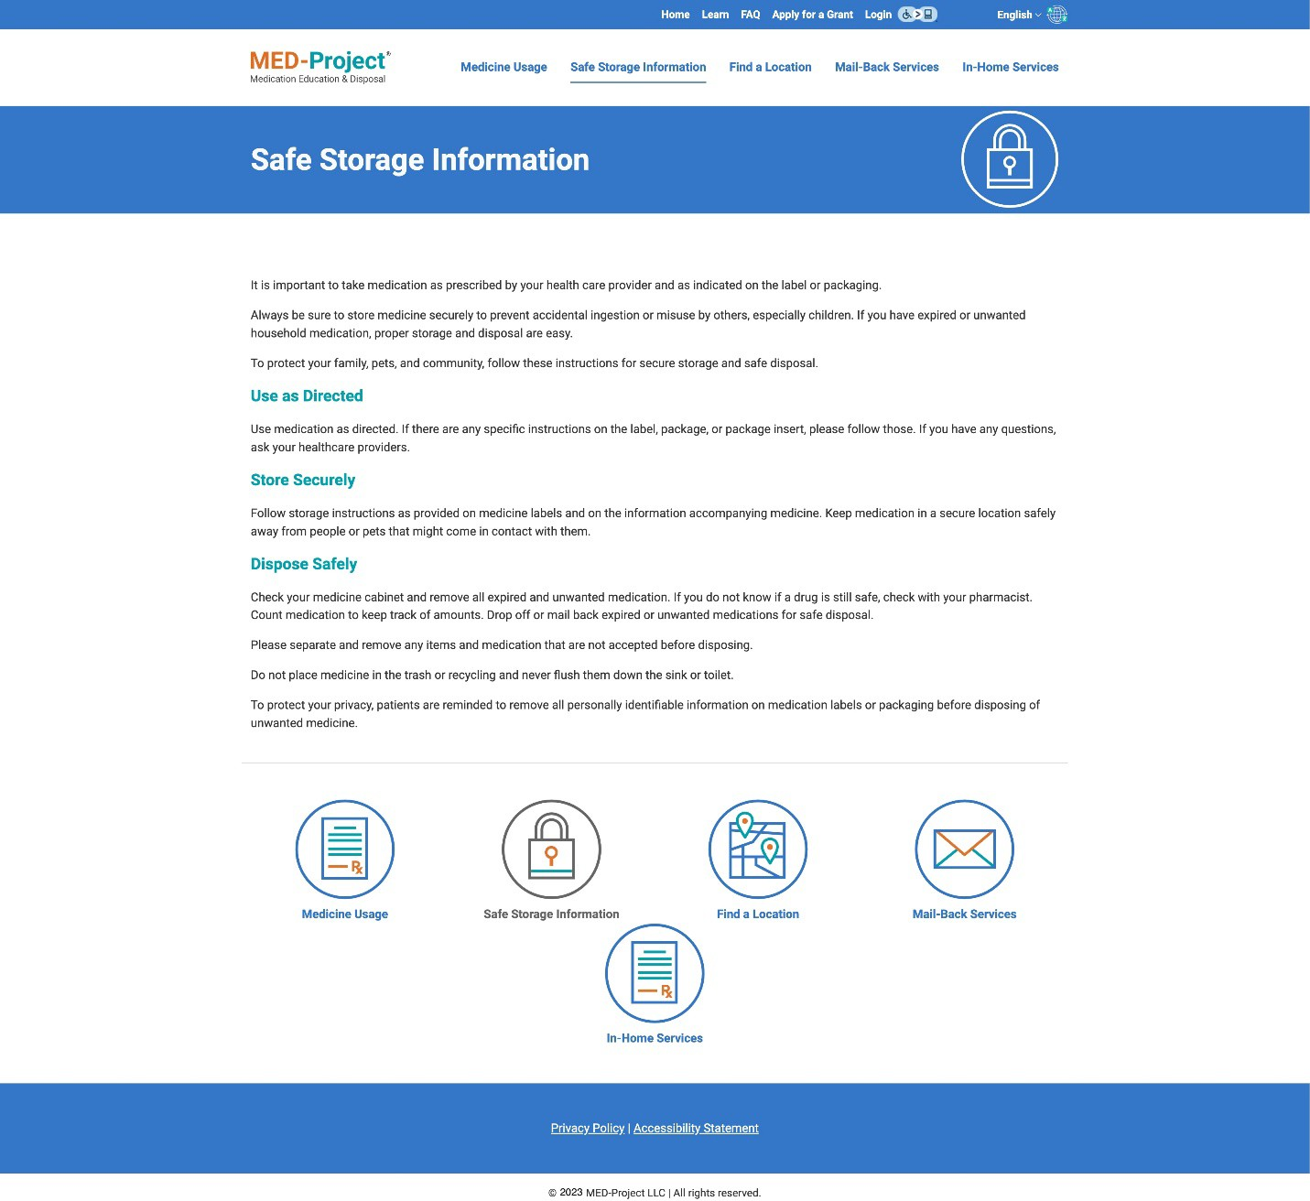
Figure 4: MED-Project Website Safe Storage Information Page

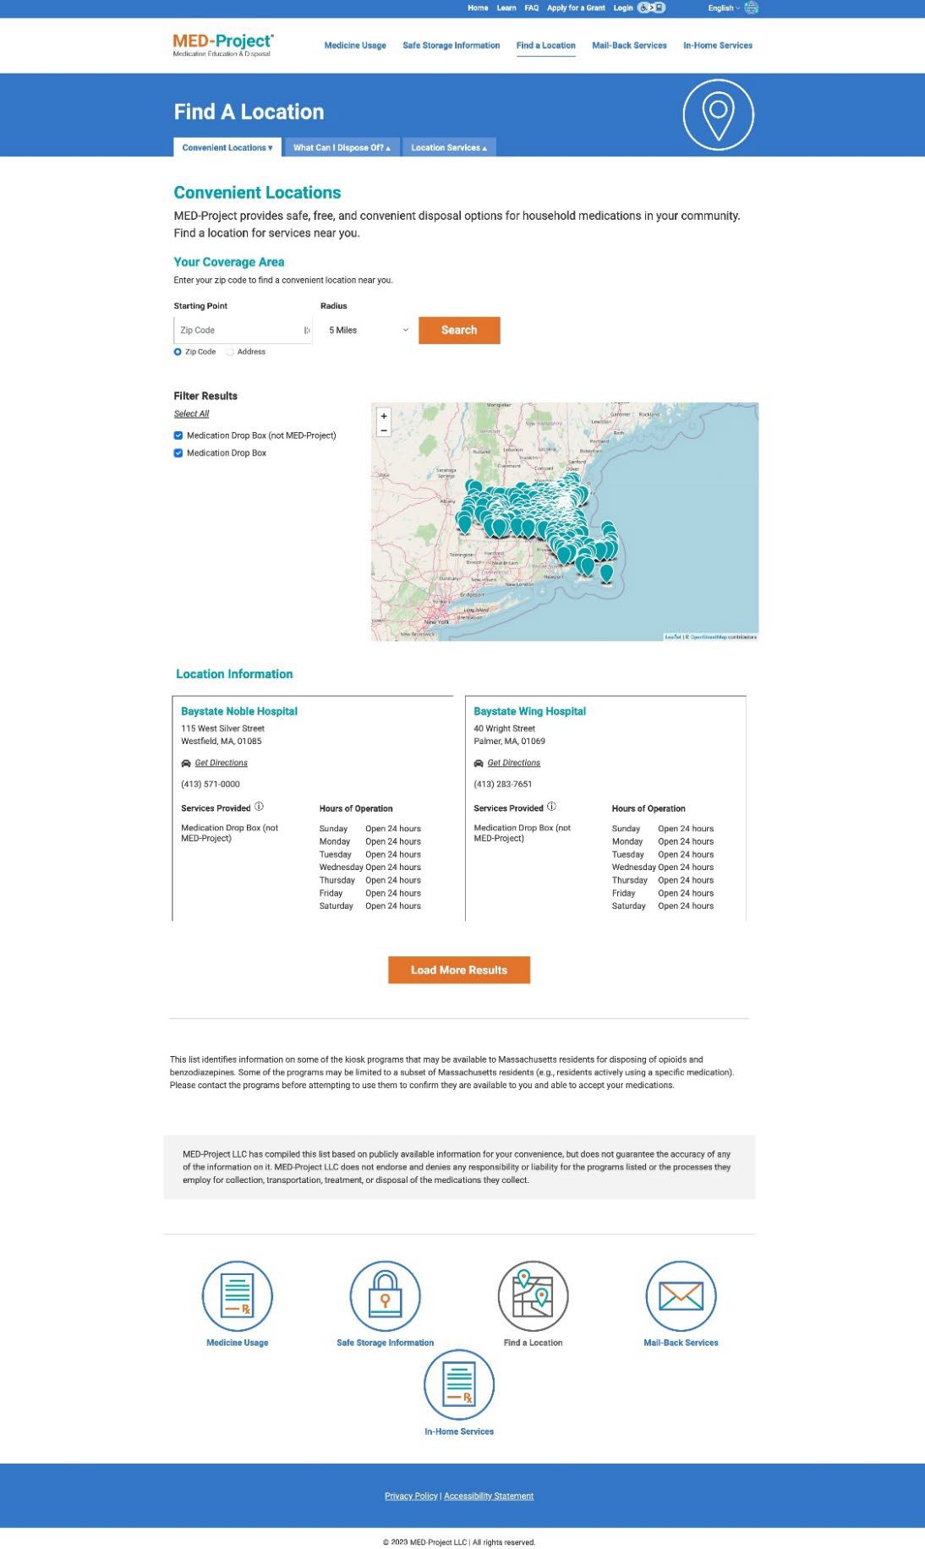

Figure 5: MED-Project Website Find A Location Page

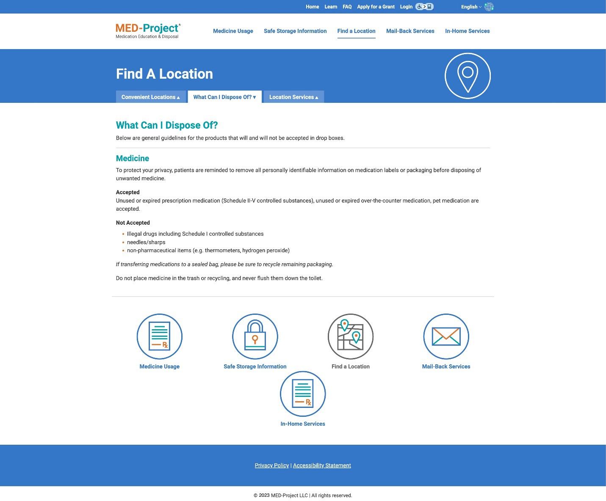
Figure 6: MED-Project Website Find A Location Page

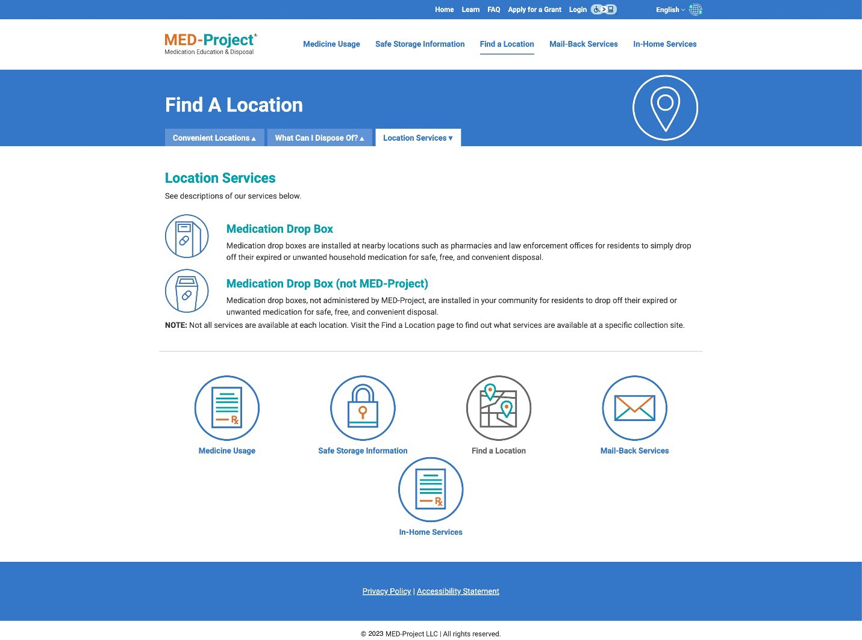
Figure 7: MED-Project Website Find A Location Page

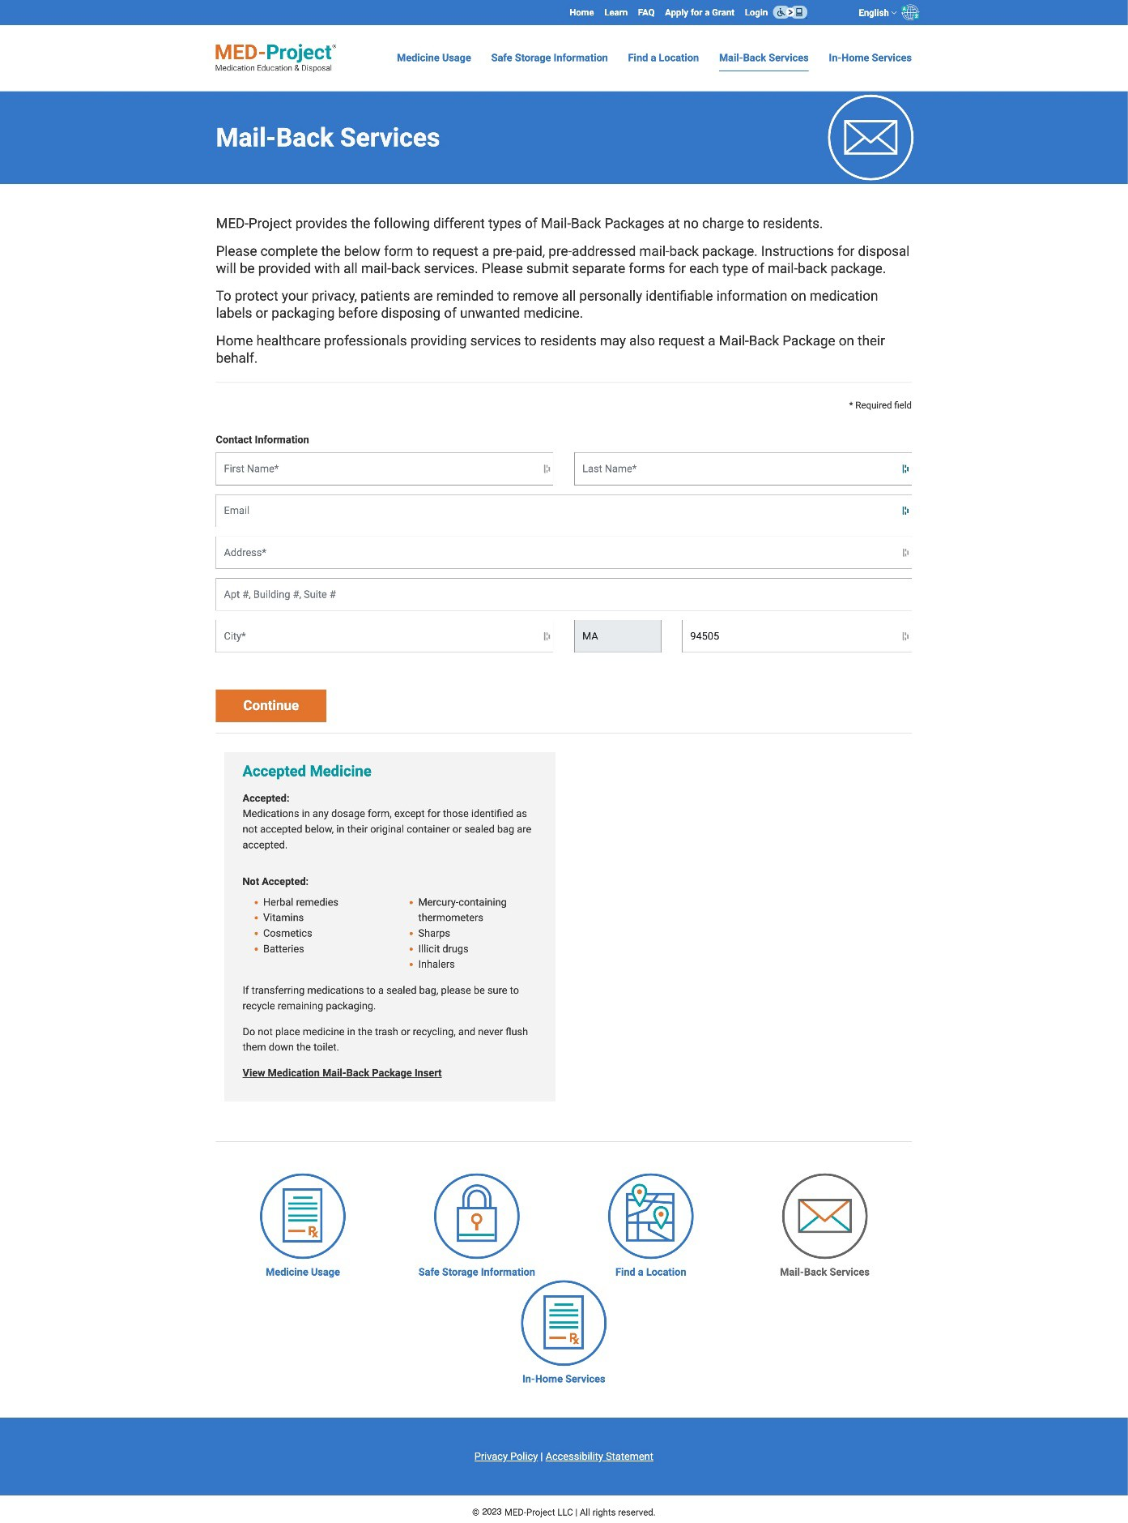
Figure 8: MED-Project Website Mail-Back Services Page

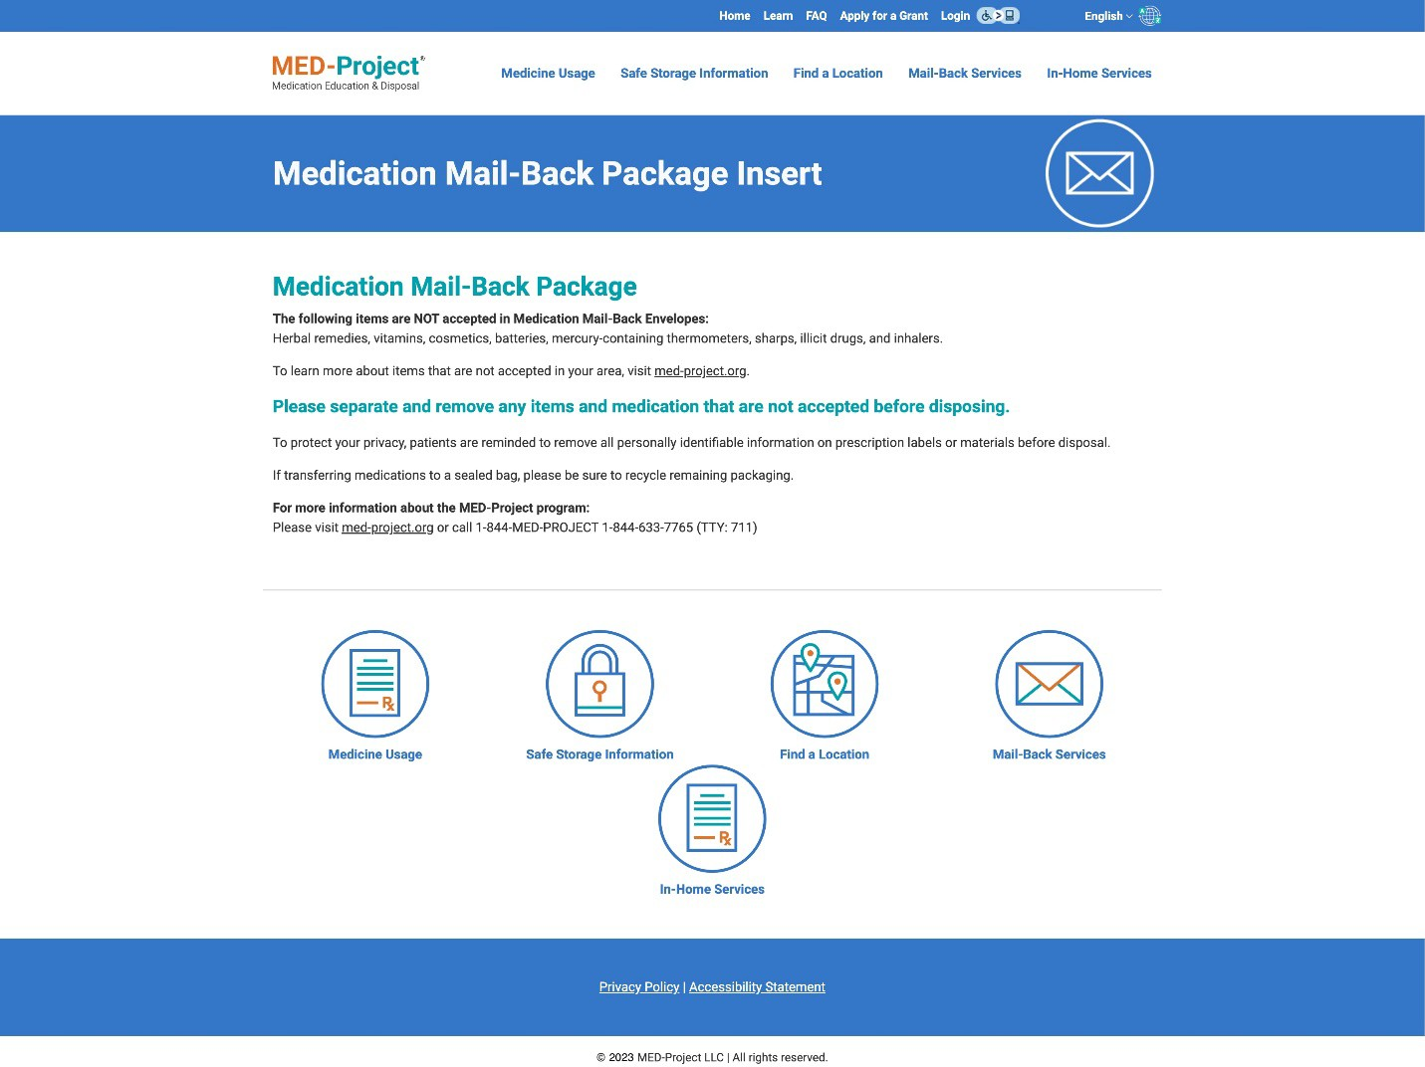
Figure 9: MED-Project Website Mail-Back Insert Page

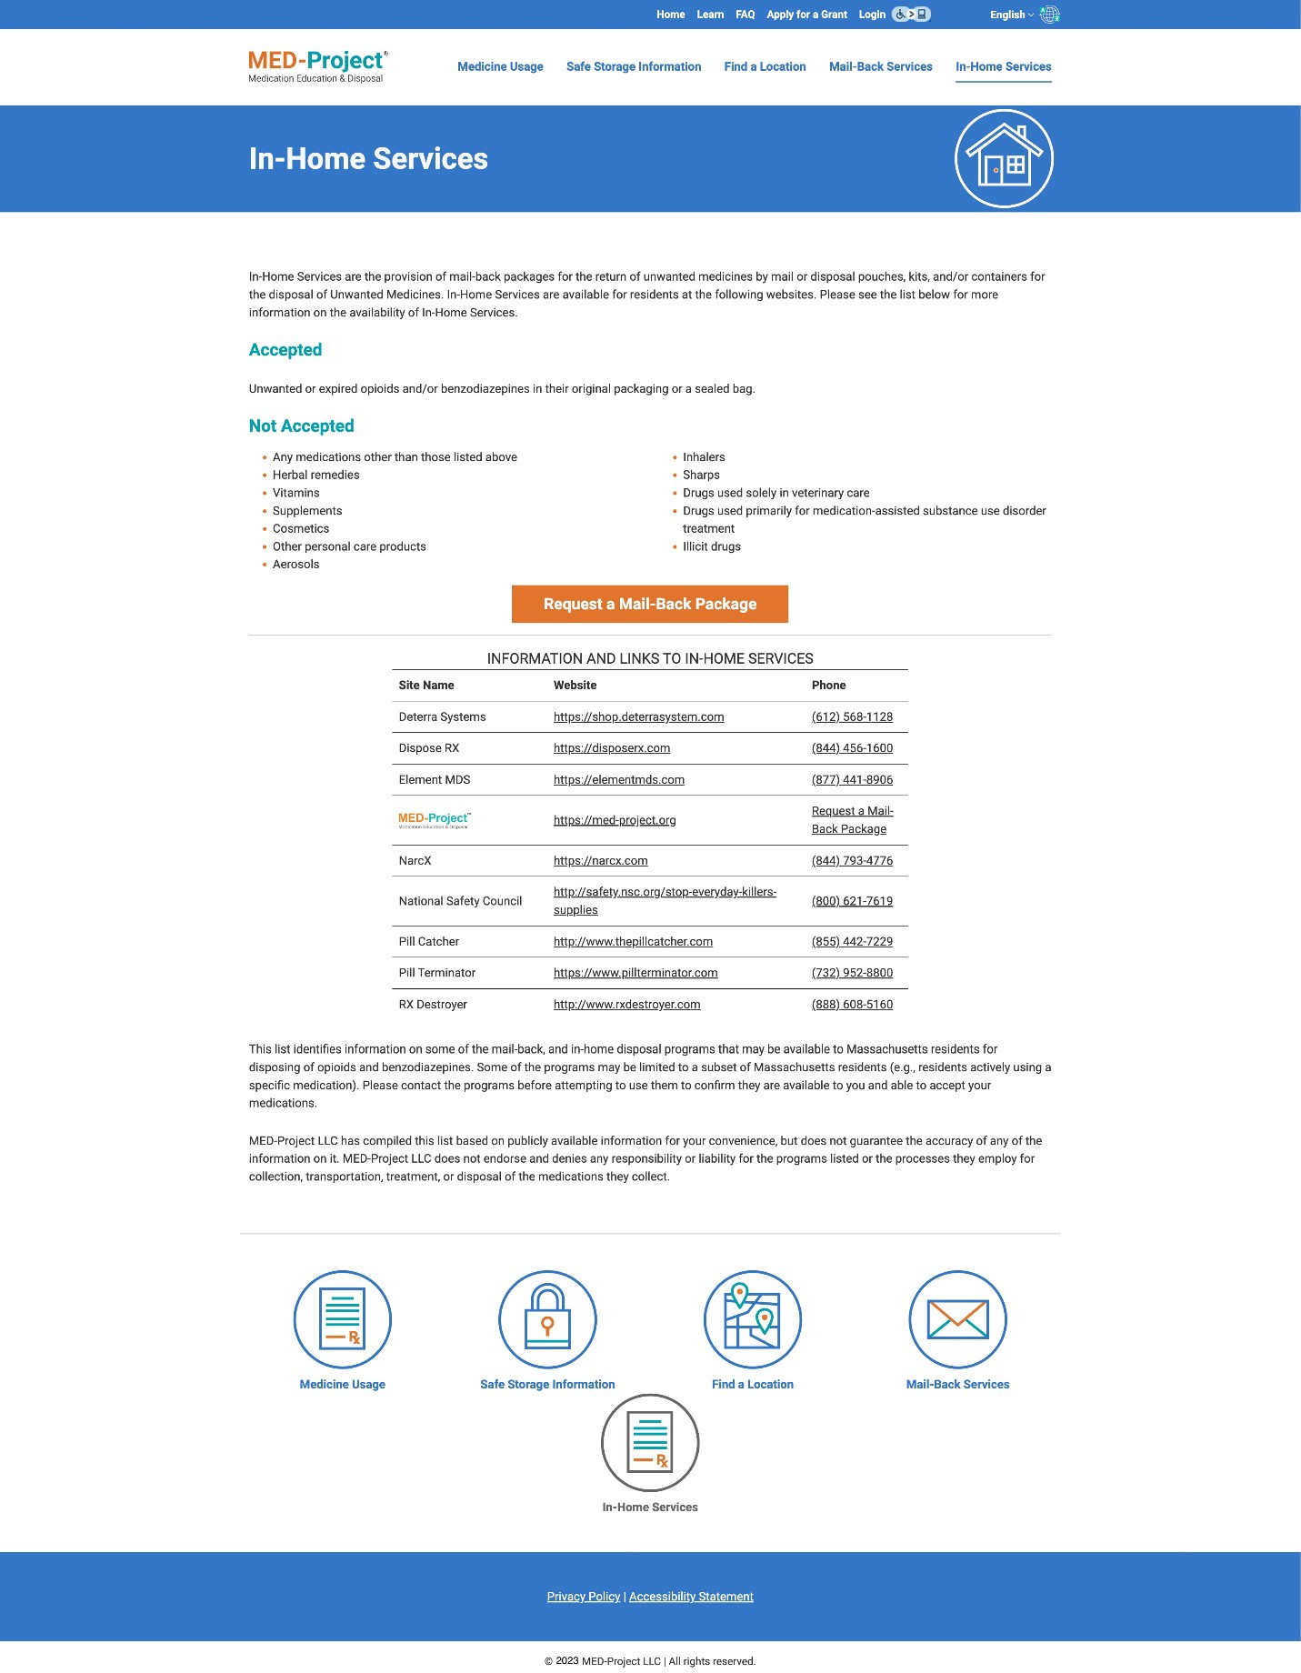

Figure 10: MED-Project Website In-Home Services Page

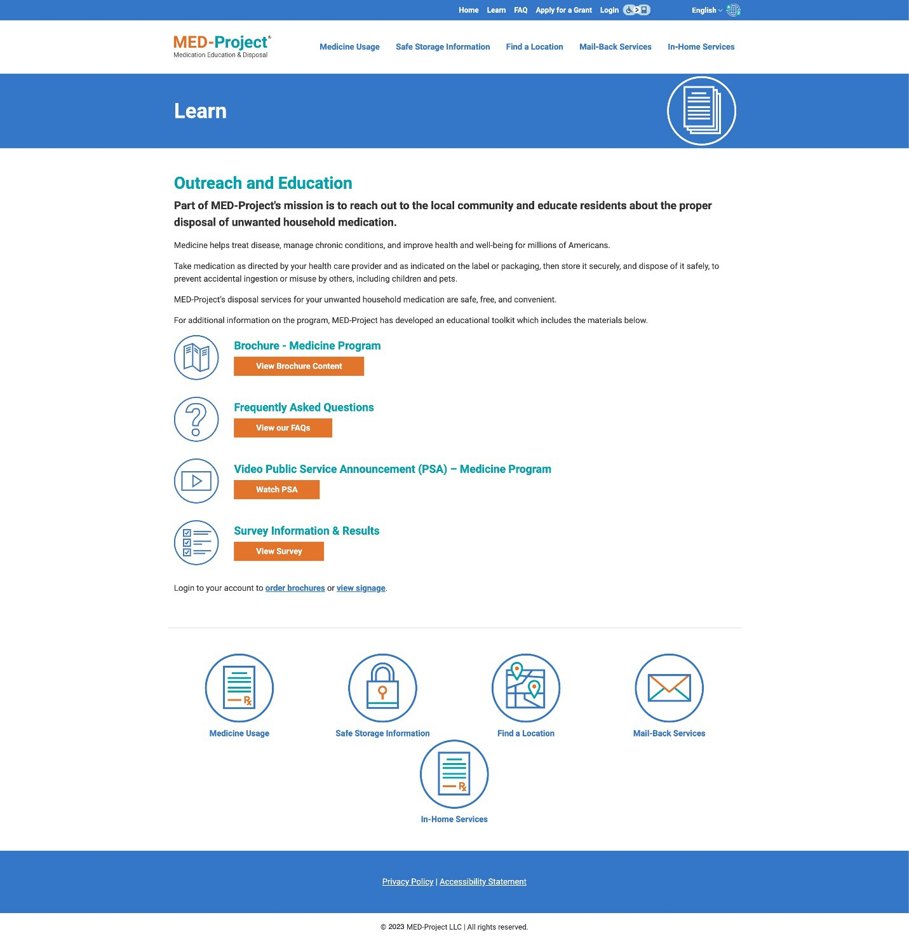
Figure 11: MED-Project Website Learn Page

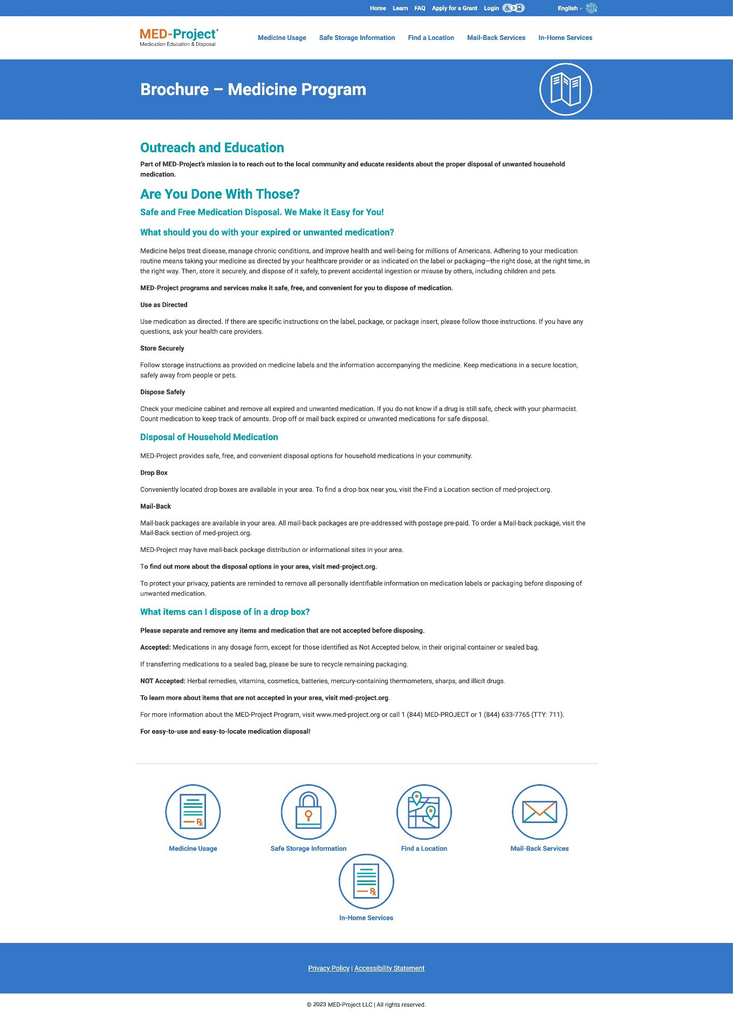
Figure 12: MED-Project Website Brochure Page

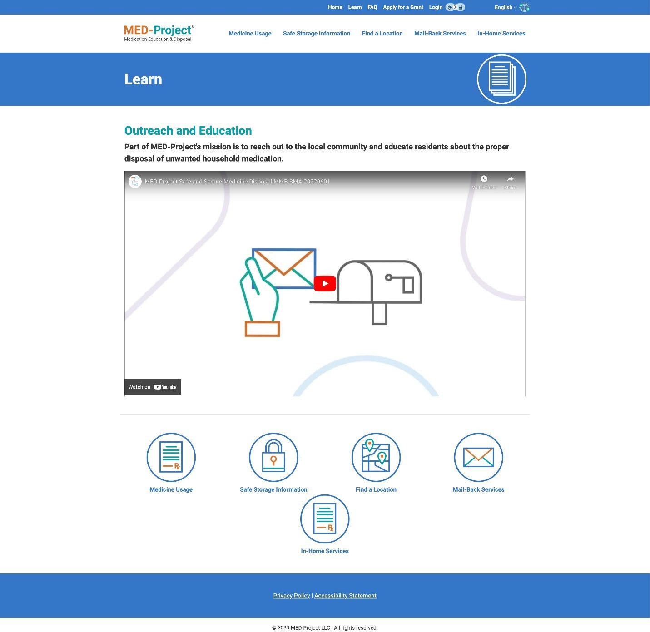
Figure 13: MED-Project Website Video Public Service Announcement Page

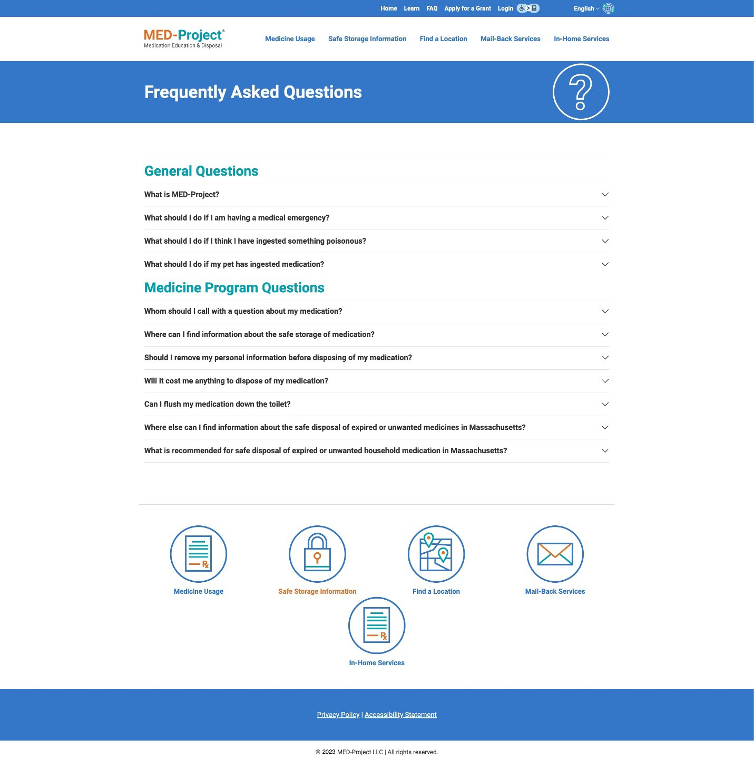
Figure 14: MED-Project Website FAQ Page

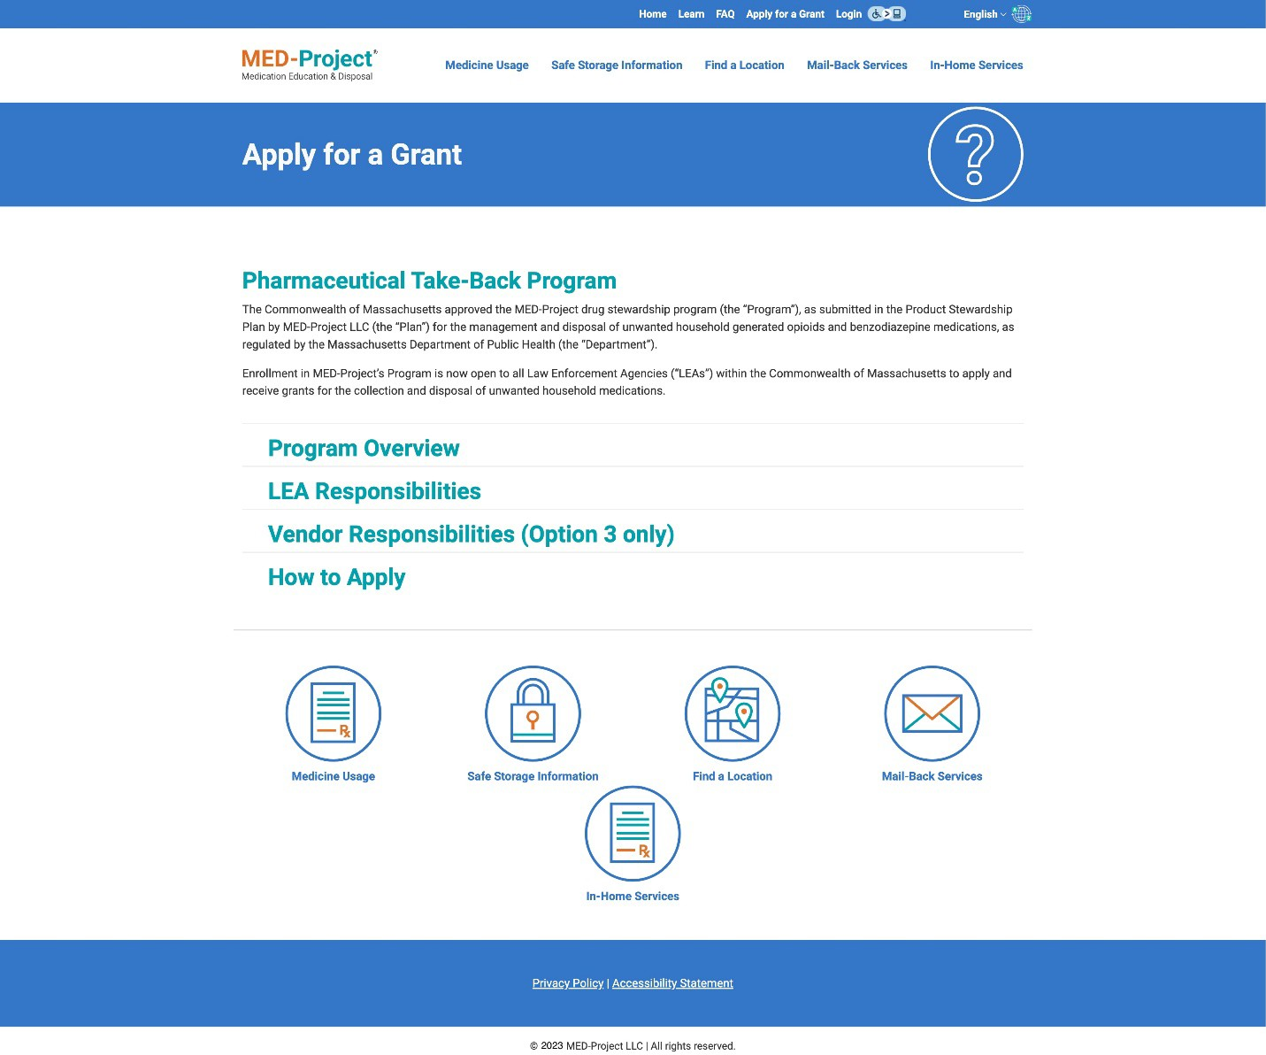
Figure 15: MED-Project Website Apply For a Grant Page

Appendix G

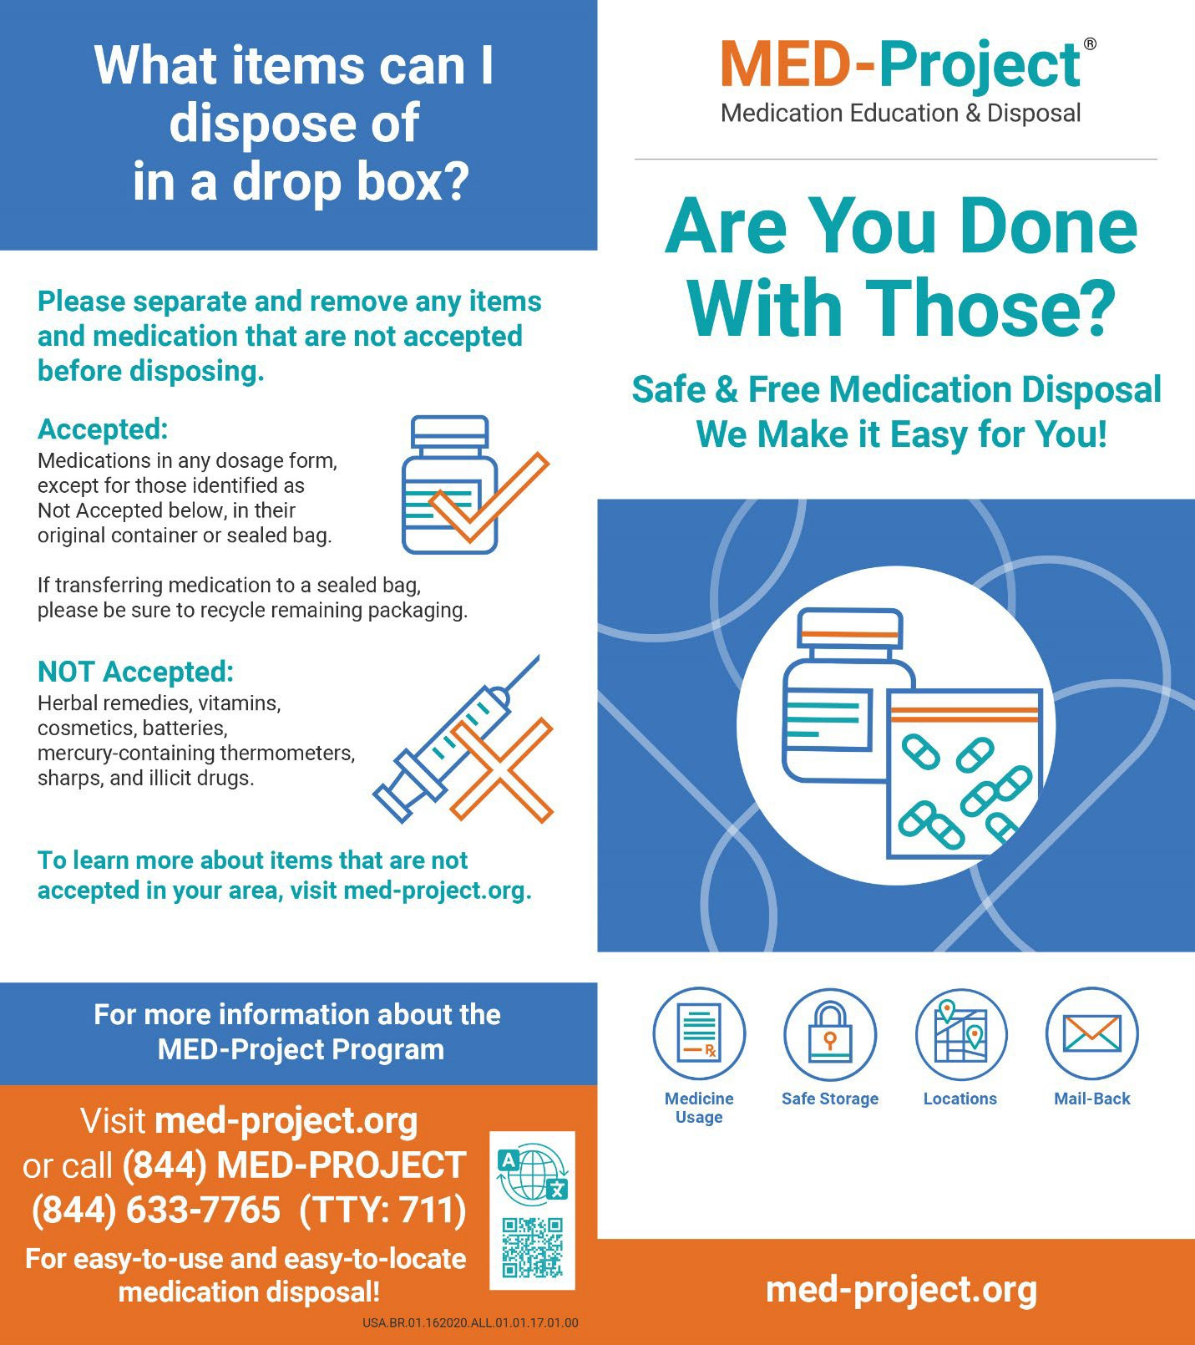
MED-Project Brochure and Posters

Figure 16: MED-Project Brochure Front (English)

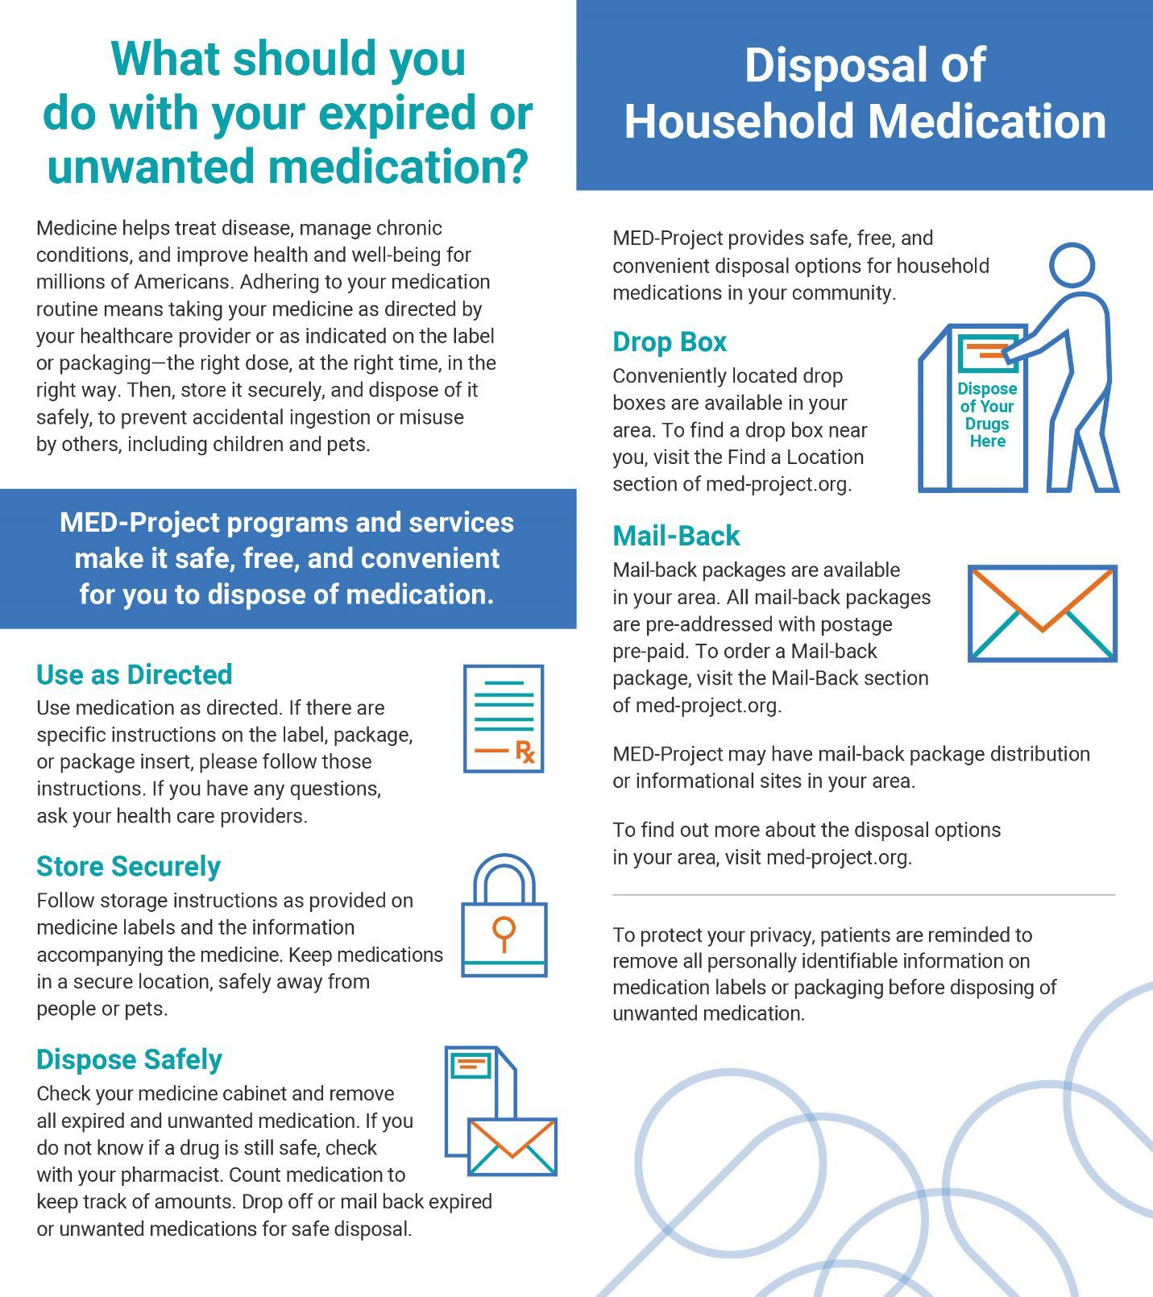
Figure 17: MED-Project Brochure Back (English)

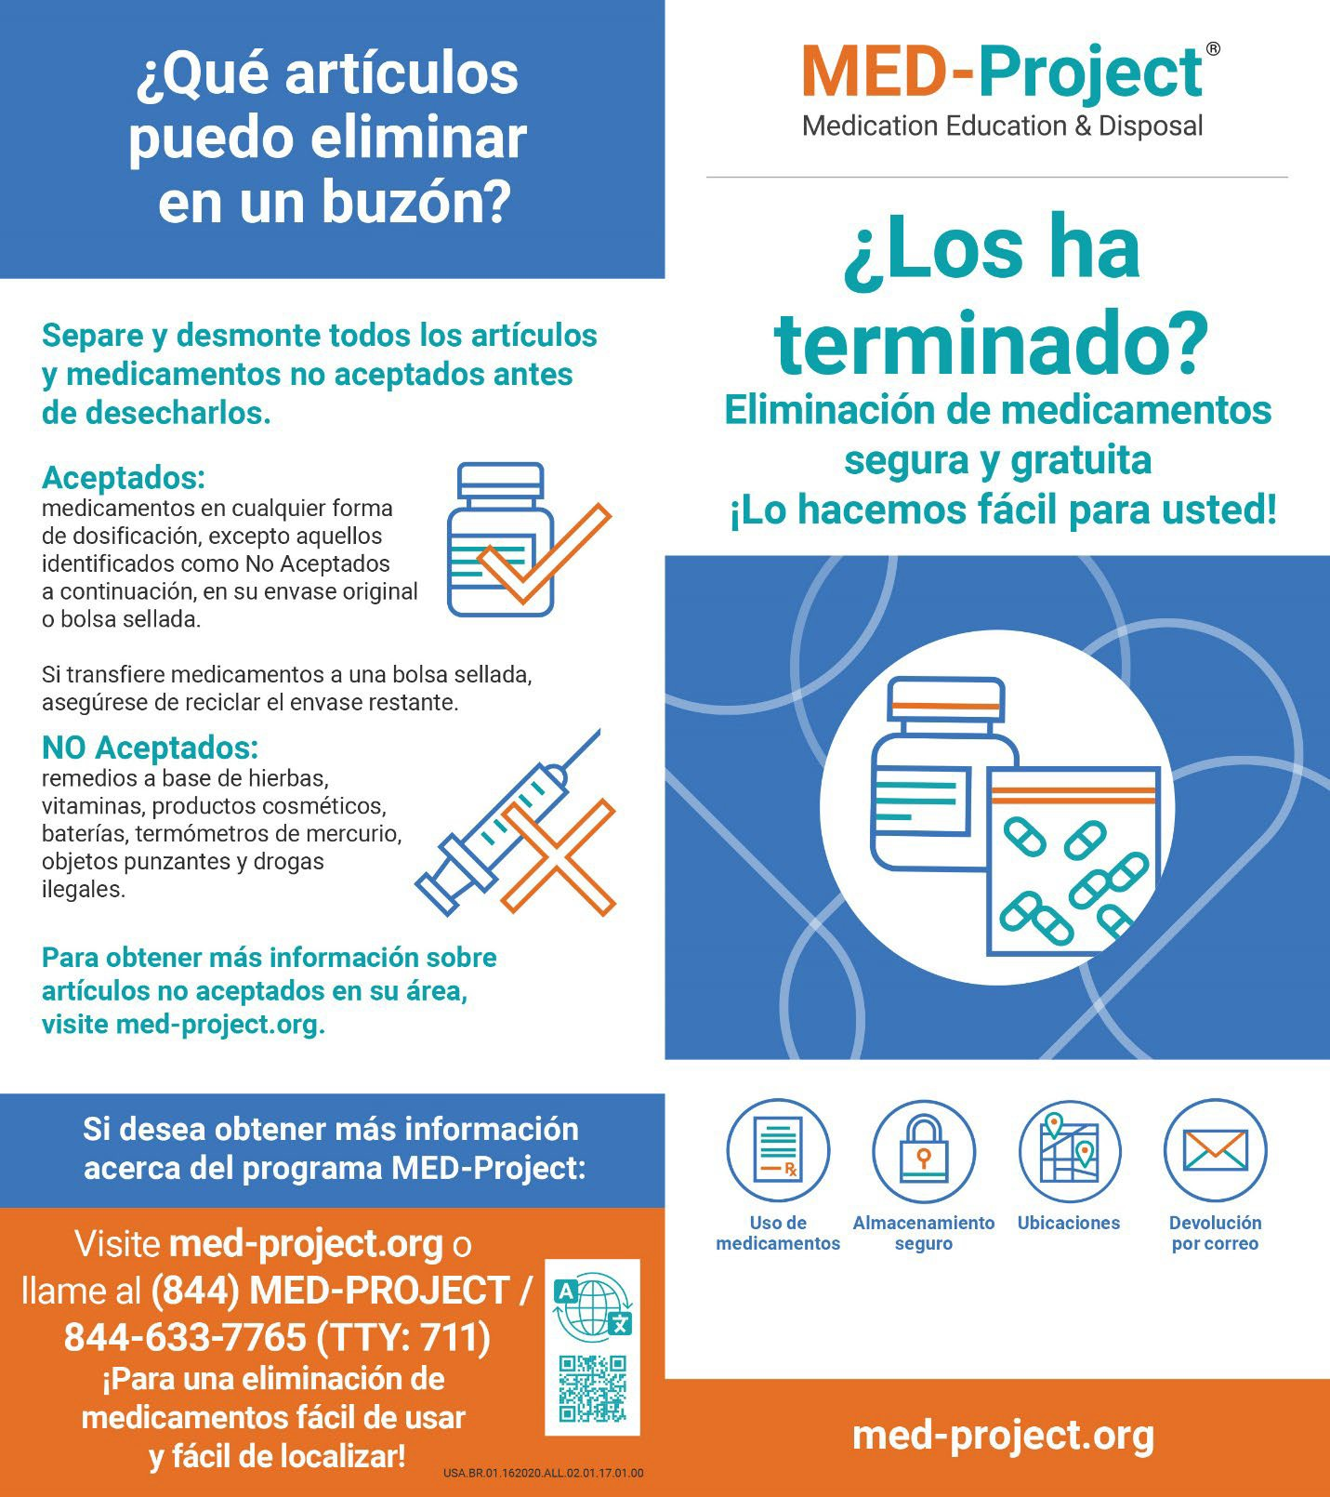
Figure 18: MED-Project Brochure Front (Spanish)

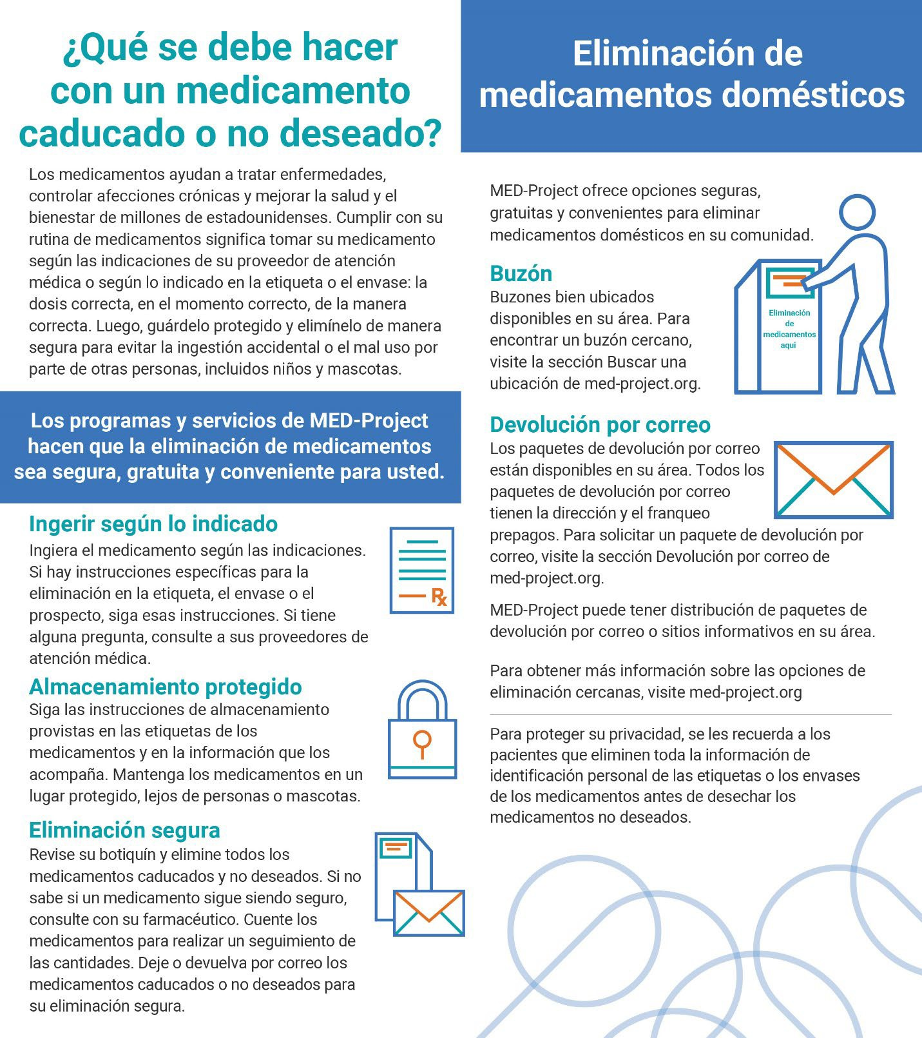
Figure 19: MED-Project Brochure Back (Spanish)

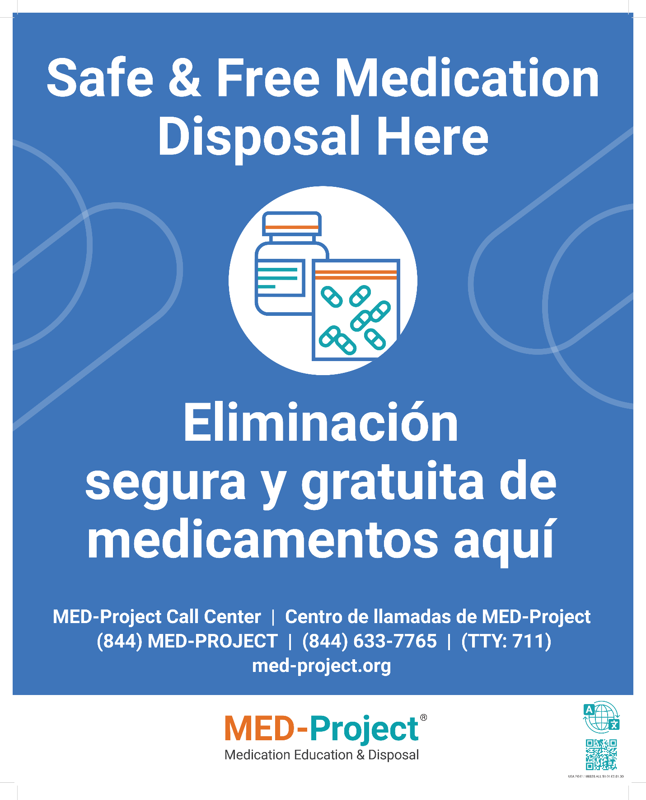
Figure 20: MED-Project Poster (English/Spanish)

