INDOOR AIR QUALITY ASSESSMENT

Medford Fire Department
South Medford Station
Zero Medford Street
Medford, Massachusetts

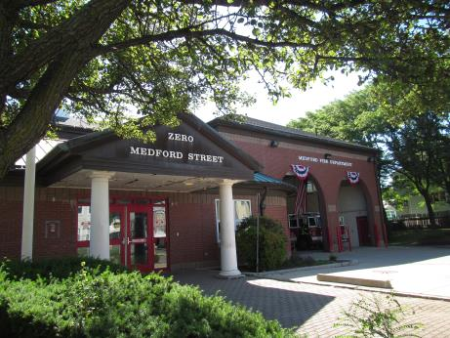

Prepared by:
Massachusetts Department of Public Health
Bureau of Environmental Health
Indoor Air Quality Program
July 2018

BACKGROUND
Building: | Medford Fire Department (MFD) South Medford Station (SMS)
Address: | Zero Medford Street, Medford
Assessment coordinated via: | Chief Frank A. Giliberti Jr., MFD
Reason for Request: | General indoor air quality (IAQ)
Date of Assessment: | June 26, 2018
Massachusetts Department of Public Health/Bureau of Environmental Health (MDPH/BEH) Staff Conducting Assessment: | Ruth Alfasso, Environmental Engineer/Inspector, IAQ Program
Date of Building Construction: | This building was dedicated in 1992.
Building/Site Description: | The MFD SMS is a two story peaked-roofed brick building located in a mixed use neighborhood in South Medford. It contains a community center meeting room on the first floor.
Building Population: | This building is staffed 24/7 with three employees at any given time. The meeting room is used about 6 times a week.
Windows: | Openable in most areas

METHODS
Please refer to the IAQ Manual for methods, sampling procedures, and interpretation of results (MDPH, 2015).

RESULTS and DISCUSSION
The following is a summary of indoor air testing results (Table 1).
- Carbon dioxide levels were below the MDPH guideline of 800 parts per million (ppm) in all areas.
- Temperature was within the MDPH recommended range of 70°F to 78°F in occupied areas.
- Relative humidity was within the MDPH recommended range of 40 to 60% in all occupied areas.
- Carbon monoxide levels were non-detect (ND) in all areas indoor areas measured.
- Particulate matter (PM2.5) concentrations measured were below the National Ambient Air Quality (NAAQS) level of 35 μg/m³ in all areas.

Ventilation
The MFD SMS has mechanical ventilation supplied by an air handling unit (AHU) located above the engine bay (Picture 1). Air from there is ducted to ceiling-mounted supply diffusers and returned back to this AHU via ducts through ceiling-mounted vents (Picture 2). There are also ceiling-mounted exhaust vents in the bathrooms and shower. It could not be determined if these were functional or on at the time of the visit. The vent over the stove in the kitchen appears to recirculate air only.
Occupants reported temperature control issues in this building. According to occupants, while air circulation is on at all times, thermostats do not provide any local control of temperature, requiring a maintenance visit for them to be set or changed. The result of this is that it is often too warm in the winter to the point where windows are left open to maintain a comfortable temperature.
The engine bay is equipped with a tailpipe exhaust collection system (Plymovent™) for each engine; they were observed to be in use at the time of the visit. MFD staff report the Plymovent is serviced three to four times a year in accordance with manufacturer’s recommendations.

Microbial/Moisture Concerns
Water-damaged ceiling tiles were noted in many areas especially on the upper level (Pictures 2 and 3; Table 1). Ceiling tiles were also missing in some locations (Table 1). Stained tiles were attributed to roof leaks. Ceiling tiles should be replaced when the source of water is repaired. Note that there is a large air space above the suspended ceiling which allows ceiling tiles to dry quickly before they can be mold-colonized. The United States Environmental Protection Agency (US EPA) and the American Conference of Governmental Industrial Hygienists (ACGIH) recommend that porous materials be dried within 24 to 48 hours of becoming wet (US EPA, 2008; ACGIH, 1989). If porous materials are not dried within this time frame, mold growth may occur.
Boxes stored in the stairwell also show signs of water damage (Picture 4). This may be due to water accumulation from condensation during humid weather, or from leaks or spills. In general, boxes and other porous items should not be placed directly on floors in contact with slab or near other sources of water. The use of shelving or pallets to raise items off the floor and allow air circulation can prevent water damage.
Other sources of water damage and related odors were identified. The sink in the meeting room had a gap in the backsplash which can allow water in and damage the countertop materials. In an upstairs utility closet, there was a mop bucket with dirty water, which can be a source of odors (Picture 5). Mops should be wrung out and buckets should be emptied when not in use.
Occupants also reported that some windows leak during heavy rains. In some locations, porous items were placed on windowsills or against windows where they could become moistened. In the bunk room, cushions were placed in windows, presumably to block light; these items could become wet due to rain and condensation.
Peeling paint and other signs of damage were noted on the overhangs near doors (Picture 6). Some gutters on the building were damaged, which can impede proper drainage and lead to leaks inside the building.
Plants were noted close to the foundation (Picture 7) which can hold moisture against the brick and cause damage which may lead to water infiltration inside the building. Plants should be trimmed to about five feet away from the building exterior.

Other IAQ Evaluations

Vehicle Exhaust/Sources
Under normal conditions, a firehouse can have several sources of environmental pollutants present from the operation of fire vehicles. These sources of pollutants can include:
- Vehicle exhaust containing carbon monoxide and soot;
- Vapors from diesel fuel, motor oil and other vehicle liquids which contain volatile organic compounds;
- Water vapor from drying hose equipment;
- Rubber odors from vehicle tires; and
- Residues from fires on vehicles, hoses, and fire-turnout gear.
Of particular importance is vehicle exhaust, which involves the process of combustion. As described above, the engine bays are equipped with a mechanical exhaust system to remove exhaust from vehicles. This equipment should be used every time, and maintained in accordance with manufacturer’s instructions.
Note that the weight/exercise area for this station is located in the engine bay (Picture 8). This will expose employees to vehicle-related pollutants during exercise. The turnout gear area for this station is also stored directly adjacent to the engine area (Picture 9) which will result in the vehicles depositing particles of combustion on the gear. Turnout gear should be stored in an area with adequate exhaust and makeup air.

Other Issues
Dust and debris was present in many areas, including on supply and exhaust vents (Picture 10), personal fans (Picture 11), and flat surfaces (Table 1). These areas should be cleaned regularly to prevent dust from becoming aerosolized or heated. Use of a high efficiency particulate arrestance (HEPA) filtered vacuum cleaner and wet wiping should be conducted periodically.
Station personnel report that the AHU does not get regularly maintained and that and that filters changes are irregular. Filters on ventilation equipment should be changed on a routine schedule in accordance with manufacturer’s instructions, typically two to four times a year.
Cooking equipment should be cleaned regularly to prevent odors, reduce smoke and attracting pests. Note that the hood over the cooktop does not vent outside, so there is no exhaust to remove cooking odors and smoke. Windows in this area should be kept in good repair with an intact screen so that it can be opened during cooking.
Upholstered furniture is present in the lounge and living areas (Picture 12; Table 1). Upholstered furniture, pillows and cushions are covered with fabric that comes in contact with human skin. This type of contact can leave oils, perspiration, hair and skin cells. Dust mites feed upon human skin cells and excrete waste products that contain allergens. In addition, if relative humidity levels increase above 60 percent, dust mites tend to proliferate (US EPA, 1992). In order to remove dust mites and other pollutants, frequent vacuuming of upholstered furniture is recommended (Berry, M.A., 1994). It is also recommended that upholstered furniture be professionally cleaned on an annual basis. If outdoor conditions or indoor activities (e.g., renovations) create an excessively dusty environment, cleaning frequency should be increased (every six months) (IICRC, 2000).

CONCLUSION AND RECOMMENDATIONS
In view of the findings at the time of the visit, the following recommendations are made:
- Maintain and use the tailpipe exhaust collection system in accordance with manufacturer’s recommendations.
- The location of the weight room inside the engine bay may expose employees to vehicle-related pollutants during use; relocation should be considered.
- Consider enclosing the turnout gear storage area and adding exhaust and make-up air to this area to prevent cross contamination of turnout gear from the engine bays.
- Ensure the HVAC system is on and operating at all times to provide fresh air and filtration.
- Ensure the AHU is maintained on a regular schedule including filter changes two to four times a year.
- Consider consulting with an HVAC engineer to determine if the system can be operated with locally-controlled thermostats to maintain a comfortable temperature during both the heating and cooling season.
- Ensure openable windows have intact screens to prevent pest entry.
- Ensure that local exhaust vents are operating correctly (e.g., bathrooms) and that exhaust is ejected outside of the building.
- Consider adopting a balancing schedule of every 5 years for all mechanical ventilation systems, as recommended by ventilation industrial standards (SMACNA, 1994).
- Replace water-damaged ceiling tiles.
- Consult with a contractor to determine if the roof needs repair or replacement to prevent leaks.
- Remove water-damaged boxed from stairwell. Ensure porous stored materials are raised above the floor, e.g., on pallets or shelves, to prevent moistening.
- Seal sink backsplash with caulking.
- Ensure mops and buckets are dried between uses to prevent odors.
- Avoid placing or storing porous items (e.g., books, pillows) near windows that may leak during wet weather. Considering installing light-blocking blinds on bunk room windows.
- For buildings in New England, periods of low relative humidity during the winter are often unavoidable. Therefore, scrupulous cleaning practices should be adopted to minimize common indoor air contaminants whose irritant effects can be enhanced when the relative humidity is low. To control for dusts, a high efficiency particulate arrestance (HEPA) filter equipped vacuum cleaner in conjunction with wet wiping of all surfaces is recommended. Avoid the use of feather dusters. Drinking water during the day can help ease some symptoms associated with a dry environment (throat and sinus irritation).
- Repair peeling paint on outside overhangs and check to see if a source of water infiltration leading to peeling paint (e.g. roof leads, gutter damage) can be identified and corrected.
- Trim plants to five feet away from the foundation.
- Periodically clean dust and debris from floors, flat surfaces, vents, fans and air conditioning units including the filters.
- HEPA vacuum frequently and clean upholstered furniture annually or semi-annually to `remove dust mites and other pollutants.
- Keep cooking and eating areas free from crumbs and store any food in tightly-sealed containers.
- Use openable windows to remove smoke and odors from cooking as needed.
- Consider scheduling a thorough professional cleaning of the station once or twice a year including carpeting, upholstered furniture, floors, walls and other flat surfaces to remove a build-up of dust, debris and other material, some of which may contain fire-related pollutants.
- Refer to resource manual and other related indoor air quality documents located on the MDPH’s website for further building-wide evaluations and advice on maintaining public buildings. These documents are available at http://mass.gov/dph/iaq.

REFERENCES
ACGIH. 1989. Guidelines for the Assessment of Bioaerosols in the Indoor Environment. American Conference of Governmental Industrial Hygienists, Cincinnati, OH.
Berry, M.A. 1994. Protecting the Built Environment: Cleaning for Health. Michael A. Berry, Chapel Hill, NC.
IICRC. 2000. IICRC S001. Reference Guideline for Professional On-Location Cleaning of Textile Floor Covering Materials. Institute of Inspection, Cleaning and Restoration Certification. Institute of Inspection Cleaning and Restoration, Vancouver, WA.
MDPH. 2015. Massachusetts Department of Public Health. Indoor Air Quality Manual: Chapters I-III. Available at: http://www.mass.gov/eohhs/gov/departments/dph/programs/environmental-health/exposure-topics/iaq/iaq-manual/.
SMACNA. 1994. HVAC Systems Commissioning Manual. 1st ed. Sheet Metal and Air Conditioning Contractors’ National Association, Inc., Chantilly, VA.
US EPA. 1992. Indoor Biological Pollutants. US Environmental Protection Agency, Environmental Criteria and Assessment Office, Office of Health and Environmental Assessment, research Triangle Park, NC. EPA 600/8-91/202. January 1992.
US EPA. 2008. “Mold Remediation in Schools and Commercial Buildings”. Office of Air and Radiation, Indoor Environments Division, Washington, DC. EPA 402-K-01-001. September 2008. Available at: http://www.epa.gov/mold/mold-remediation-schools-and-commercial-buildings-guide.
Picture 1
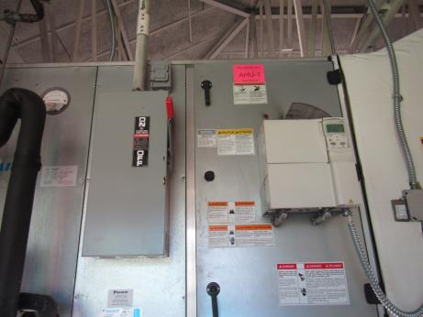
Air handling unit next to catwalk
Picture 2
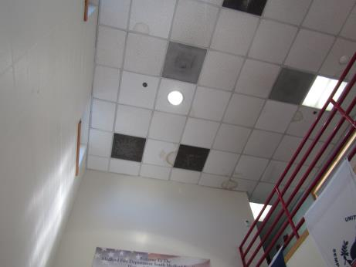
Supply and return vents above the main floor, also note water-damaged ceiling tiles
Picture 3
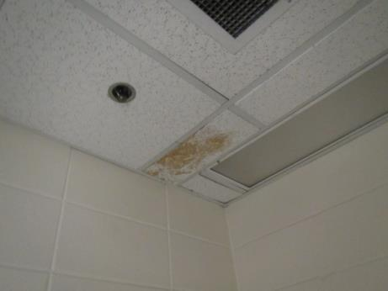
Water-damaged ceiling tile on upper level
Picture 4
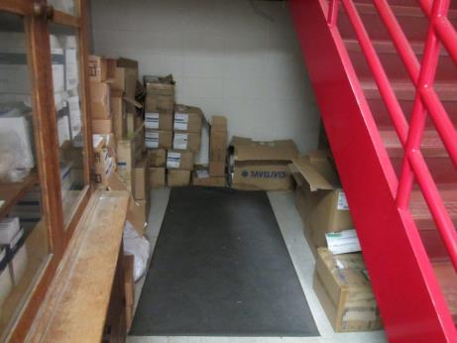
Boxes stored in stairwell, some with water damage
Picture 5
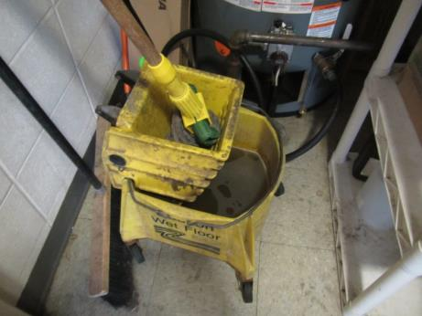
Water in mop bucket
Picture 6
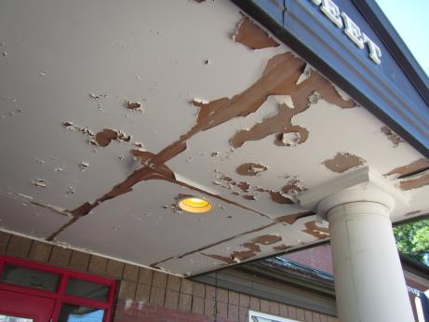
Peeling paint on door overhang
Picture 7
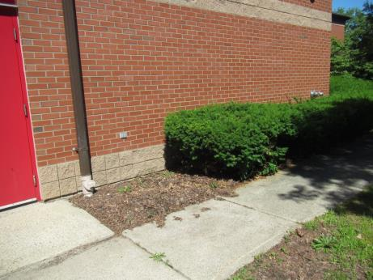
Plants near building exterior
Picture 8
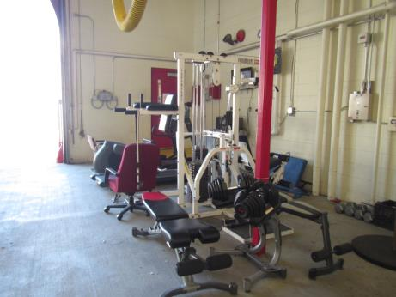
Weight room inside engine bay
Picture 9
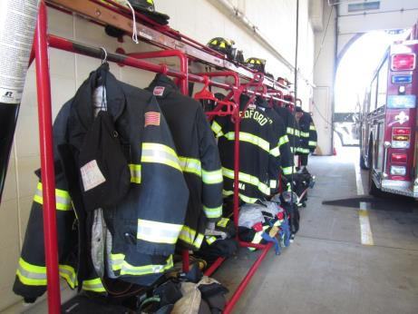
Turnout gear inside engine bay
Picture 10
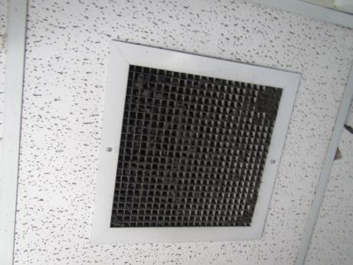
Dusty vent
Picture 11
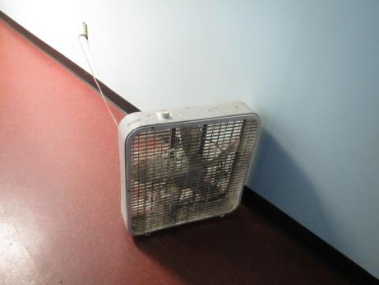
Dusty fan
Picture 12
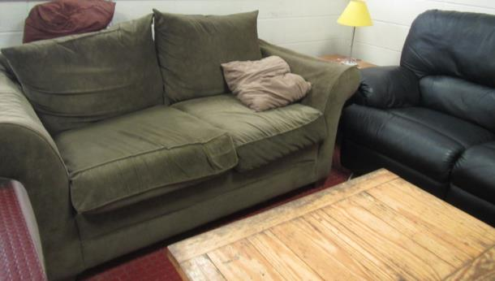
Upholstered furniture
Location | Carbon  Dioxide  (ppm) | Carbon Monoxide  (ppm) | Temp  (°F) | Relative  Humidity  (%) | PM2.5  (µg/m³) | Occupants  in Room | Windows  Openable | Ventilation |  | Remarks
 |  |  |  |  |  |  |  | Supply | Exhaust
Background (outside) | 332 | 0.7 | 71 | 42 | 1 |  |  |  |  | Partly cloudy
Kitchen | 408 | ND | 73 | 45 | 1 | 0 | Y | Y | Y | Dusty vent, fridge needs cleaning (inside and gasket), gas stove with recirculating vent, other appliances
Day room | 358 | ND | 73 | 44 | 1 | 3 | Y | Y | Y | NC, UF, WD CT in upper level, chalk
Conference/meeting | 311 | ND | 72 | 42 | 1 | 0 | Y | Y | Y | NC, sink backsplash gap, items under sink, DEM, damaged room divider
Public women’s room | 310 | ND | 72 | 44 | 1 | 0 | N | N | Y | Cleaner/bathroom odor, WD CT
Public men’s room | 319 | ND | 72 | 44 | 1 | 0 | N | N | Y | 4 WD CT, dusty vents
Dispatch/reception | 334 | ND | 72 | 42 | 1 | 0 | Y | Y | Y
Men’s restroom | 325 | ND | 72 | 43 | 1 | 0 | N | N | Y | 1 WD CT, dusty vents
Engine Bay | 290 | ND | 72 | 40 | 3 | 1 | 3 doors open to outside | N | N | Weight room in bay, turnout gear here, tailpipe collection system in use
Upstairs
Officer’s Room | 340 | ND | 73 | 42 | 1 | 0 | Y | Y | N | PFs (dusty), bed, lockers with items
Locker | 360 | ND | 73 | 43 | 1 | 0 | Y | N | Y | 1 WD CT, DO, insect trap on floor, utility room next door has wet mop bucket
Bunk | 319 | ND | 73 | 43 | 1 | 0 | Y | Y | Y | Dusty vents, cushions up against windows, floor fan (dusty), beds
Men’s restroom | 317 | ND | 73 | 42 | 1 | 0 | Y open |  | Y | Shower, MT, WD CT
Women’s restroom | 319 | ND | 73 | 43 | 1 | 0 | Y | Y | Y | Shower
Upper level catwalk over engine bay | 343 | ND | 72 | 40 | 3 | 0 | Doors below open | N | N | Access to change filters on air handling unit here, some exercise equipment (rarely used)

