INDOOR AIR QUALITY ASSESSMENT

Medford Fire Department
West Medford Station
26 Harvard Ave
Medford, Massachusetts

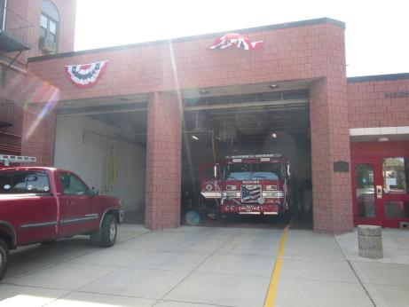

Prepared by:
Massachusetts Department of Public Health
Bureau of Environmental Health
Indoor Air Quality Program
June 2018

BACKGROUND
Building: | Medford Fire Department (MFD) West Medford Station (WMS)
Address: | 26 Harvard Ave, Medford
Assessment coordinated via: | Chief Frank A. Giliberti Jr., MFD
Reason for Request: | General indoor air quality (IAQ)
Date of Assessment: | June 12, 2018
Massachusetts Department of Public Health/Bureau of Environmental Health (MDPH/BEH) Staff Conducting Assessment: | Ruth Alfasso, Environmental Engineer/Inspector, IAQ Program
Date of Building Construction: | This building was dedicated in 1986. A new roof and ventilation equipment was installed in approximately 2015.
Building/Site Description: | The MFD WMS is a single-story, flat-roofed brick building located near the West Medford train station in a mixed use neighborhood in Medford.
Building Population: | This building is staffed 24/7 with three employees at any given time.
Windows: | Openable in most areas

METHODS
Please refer to the IAQ Manual for methods, sampling procedures, and interpretation of results (MDPH, 2015).

RESULTS and DISCUSSION
The following is a summary of indoor air testing results (Table 1).
- Carbon dioxide levels were below 800 parts per million (ppm) in all areas.
- Temperature was within the MDPH recommended range of 70°F to 78°F in occupied areas. Note that doors to the outside were open on the lower level.
- Relative humidity was within or close to the lower edge of the MDPH recommended range of 40 to 60% in all occupied areas.
- Carbon monoxide levels were non-detect (ND) in all areas measured.
- Particulate matter (PM2.5) concentrations measured were below the National Ambient Air Quality (NAAQS) level of 35 μg/m³ in all areas.

Ventilation
The MFD WMS has mechanical ventilation supplied by an air handling unit (AHU) on the roof. Air from there is ducted to ceiling-mounted supply diffusers (Picture 1) and returned back to this AHU via ducts through ceiling-mounted vents (Picture 2). There are also ceiling-mounted exhaust vents in the bathrooms and shower. It could not be determined if these were functional or on at the time of the visit. The vent over the stove in the kitchen appears to recirculate air only.
The engine bay is equipped with a tailpipe exhaust collection system (Plymovent™) for each engine; they were observed to be in use at the time of the visit. MFD staff report the Plymovent is serviced three to four times a year in accordance with manufacturer’s recommendations.

Microbial/Moisture Concerns
Water-damaged ceiling tiles were noted in a few areas (Picture 3; Table 1). Ceiling tiles were also missing in some locations (Table 1). Stained tiles were attributed to roof leaks. It was reported that the roof was repaired in 2015, which stopped many leaks, and that stained tiles were removed and replaced. If the roof requires additional repair, this should be conducted and the stained tiles replaced.
Peeled coving was observed along the side of the shower. This suggests that there has been water damage to the floor in this area, possibly from the shower overflowing. There was water-damaged paper under the sink in the kitchen (Picture 4). The area under a sink is a moist environment and porous items stored there are subject to water damage and potential mold growth.
The United States Environmental Protection Agency (US EPA) and the American Conference of Governmental Industrial Hygienists (ACGIH) recommend that porous materials be dried within 24 to 48 hours of becoming wet (US EPA, 2008; ACGIH, 1989). If porous materials are not dried within this time frame, mold growth may occur.
Indoor plants were noted in a few areas (Picture 5). Plants can be a source of pollen and mold, especially if not maintained.
The exterior walls of the building had ivy on its bricks (Picture 6). Plants can hold moisture against the brick and cause damage which may lead to water infiltration inside the building. Plants should be trimmed to about five feet away from the building exterior.

Other IAQ Evaluations

Vehicle Exhaust/Sources
Under normal conditions, a firehouse can have several sources of environmental pollutants present from the operation of fire vehicles. These sources of pollutants can include:
- Vehicle exhaust containing carbon monoxide and soot;
- Vapors from diesel fuel, motor oil and other vehicle liquids which contain volatile organic compounds;
- Water vapor from drying hose equipment;
- Rubber odors from vehicle tires; and
- Residues from fires on vehicles, hoses, and fire-turnout gear.
Of particular importance is vehicle exhaust, which involves the process of combustion. As described above, the engine bays are equipped with a mechanical exhaust system to remove exhaust from vehicles. This equipment should be used every time, and maintained in accordance with manufacturer’s instructions.
Note that the weight/exercise area for this station is located in the middle of the engine bay (Picture 7). This will expose employees to vehicle-related pollutants during exercise.
The turnout gear area for this station is also stored directly adjacent to the engine area (Picture 8) which will result in the vehicles depositing particles of combustion on the gear. Turnout gear should be stored in an area with adequate exhaust and makeup air.

Other Issues
Dust and debris was present in many areas, including on supply and exhaust vents, personal fans, and flat surfaces (Table 1). These areas should be cleaned regularly to prevent dust from becoming aerosolized or heated. Use of a high efficiency particulate arrestance (HEPA) filtered vacuum cleaner and wet wiping should be conducted periodically.
Station personnel report that the AHU on the roof does not get regularly maintained, and that the filters are only changed when there is an alarm on the system indicating that the filters are so occluded with dust and debris that airflow is disrupted. Filters on ventilation equipment should be changed on a routine schedule in accordance with manufacturer’s instructions, typically two to four times a year. Filters left in use until they have become clogged do not provide adequate filtration. In addition, the resulting back pressure may damage the equipment.
Cooking equipment should be cleaned regularly to prevent odors, smoke and attracting pests. Note that the hood over the cooktop does not vent outside, so there is no exhaust to remove cooking odors and smoke. The window in this area should be kept in good repair with an intact screen so that it can be opened during cooking. Rodent and ant activity were reported in this station on an occasional basis. Rodent infestation can result in indoor air quality related symptoms due to materials in their wastes. Mouse urine contains a protein that is a known sensitizer (US EPA, 1992). A sensitizer is a material that can produce symptoms (e.g., running nose or skin rashes) in sensitive individuals after repeated exposure. To eliminate exposure to allergens, rodents must be excluded/removed from the building. Once the infestation is eliminated, a combination of cleaning and increased ventilation and filtration should serve to reduce allergens associated with rodents (Burge, 1995).
Upholstered furniture is present in the lounge and living areas (Table 1). Upholstered furniture, pillows and cushions are covered with fabric that comes in contact with human skin. This type of contact can leave oils, perspiration, hair and skin cells. Dust mites feed upon human skin cells and excrete waste products that contain allergens. In addition, if relative humidity levels increase above 60 percent, dust mites tend to proliferate (US EPA, 1992). In order to remove dust mites and other pollutants, frequent vacuuming of upholstered furniture is recommended (Berry, M.A., 1994). It is also recommended that upholstered furniture be professionally cleaned on an annual basis. If outdoor conditions or indoor activities (e.g., renovations) create an excessively dusty environment, cleaning frequency should be increased (every six months) (IICRC, 2000). Carpeting should also be cleaned several times a year in accordance with IICRC recommendations (IICRC, 2012).

CONCLUSION AND RECOMMENDATIONS
In view of the findings at the time of the visit, the following recommendations are made:
- Maintain and use the tailpipe exhaust collection system in accordance with manufacturer’s recommendations.
- The location of the weight room inside the engine bay may expose employees to vehicle-related pollutants during use; relocation should be considered.
- Consider enclosing the turnout gear storage area and adding exhaust and make-up air to this area to prevent cross contamination of turnout gear from the engine bays.
- Ensure the HVAC system is on and operating at all times to provide fresh air and filtration.
- Ensure the AHU is maintained on a regular schedule including filter changes two to four times a year.
- Use openable windows to supplement fresh air. Ensure they are tightly closed when air conditioning is in use to prevent condensation. Ensure openable windows have intact screens to prevent pest entry.
- Ensure that local exhaust vents are operating correctly (e.g., bathrooms) and that exhaust is ejected outside of the building.
- Consider adopting a balancing schedule of every 5 years for all mechanical ventilation systems, as recommended by ventilation industrial standards (SMACNA, 1994).
- Replace water-damaged ceiling tiles.
- Remove water-damaged material from under kitchen sink and avoid storing porous materials in damp locations.
- For buildings in New England, periods of low relative humidity during the winter are often unavoidable. Therefore, scrupulous cleaning practices should be adopted to minimize common indoor air contaminants whose irritant effects can be enhanced when the relative humidity is low. To control for dusts, a high efficiency particulate arrestance (HEPA) filter equipped vacuum cleaner in conjunction with wet wiping of all surfaces is recommended. Avoid the use of feather dusters. Drinking water during the day can help ease some symptoms associated with a dry environment (throat and sinus irritation).
- Remove the ivy and other plants from the building and trim landscaping to five feet away from the foundation.
- Periodically clean dust and debris from floors, flat surfaces, vents, fans and air conditioning units including the filters.
- HEPA vacuum frequently and clean upholstered furniture annually or semi-annually to remove dust mites and other pollutants. Clean carpeting annually or semi-annually in accordance with IICRC recommendations (IICRC, 2012).
- Keep cooking and eating areas free from crumbs and store any food in tightly-sealed containers.
- Use the principles of Integrated Pest Management (IPM) and the services of a licensed pest control operator to remove rodents and reduce the potential for pest infestation. Ensure that any area where rodents may have been is thoroughly cleaned to remove allergens.
- Use openable windows to remove smoke and odors from cooking as needed.
- Given that there is no regular janitorial service in this station, consider scheduling a thorough professional cleaning of the station once or twice a year including carpeting, upholstered furniture, floors, walls and other flat surfaces to remove a build-up of dust, debris and other material, some of which may contain fire-related pollutants.
- Refer to resource manual and other related indoor air quality documents located on the MDPH’s website for further building-wide evaluations and advice on maintaining public buildings. These documents are available at http://mass.gov/dph/iaq.

REFERENCES
ACGIH. 1989. Guidelines for the Assessment of Bioaerosols in the Indoor Environment. American Conference of Governmental Industrial Hygienists, Cincinnati, OH.
Berry, M.A. 1994. Protecting the Built Environment: Cleaning for Health. Michael A. Berry, Chapel Hill, NC.
Burge, H.A. 1995. Bioaerosols. Lewis Publishing Company, Boca Raton, FL.
IICRC. 2000. IICRC S001. Reference Guideline for Professional On-Location Cleaning of Textile Floor Covering Materials. Institute of Inspection, Cleaning and Restoration Certification. Institute of Inspection Cleaning and Restoration, Vancouver, WA.
IICRC. 2012. Institute of Inspection, Cleaning and Restoration Certification. Carpet Cleaning: FAQ.
MDPH. 2015. Massachusetts Department of Public Health. Indoor Air Quality Manual: Chapters I-III. Available at: http://www.mass.gov/eohhs/gov/departments/dph/programs/environmental-health/exposure-topics/iaq/iaq-manual/.
SMACNA. 1994. HVAC Systems Commissioning Manual. 1st ed. Sheet Metal and Air Conditioning Contractors’ National Association, Inc., Chantilly, VA.
US EPA. 1992. Indoor Biological Pollutants. US Environmental Protection Agency, Environmental Criteria and Assessment Office, Office of Health and Environmental Assessment, research Triangle Park, NC. EPA 600/8-91/202. January 1992.
US EPA. 2008. “Mold Remediation in Schools and Commercial Buildings”. Office of Air and Radiation, Indoor Environments Division, Washington, DC. EPA 402-K-01-001. September 2008. Available at: http://www.epa.gov/mold/mold-remediation-schools-and-commercial-buildings-guide.
Picture 1
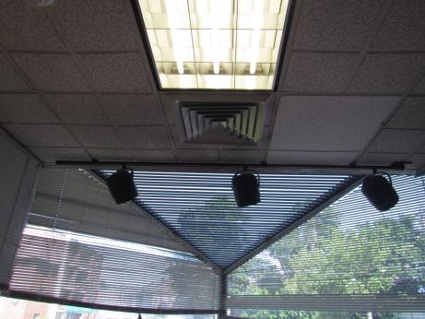
Supply vent in front dispatch/reception area
Picture 2
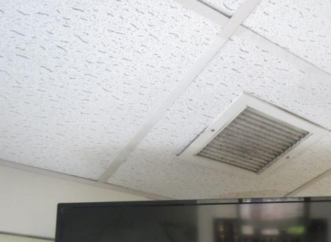
Return/exhaust vent, note dust
Picture 3
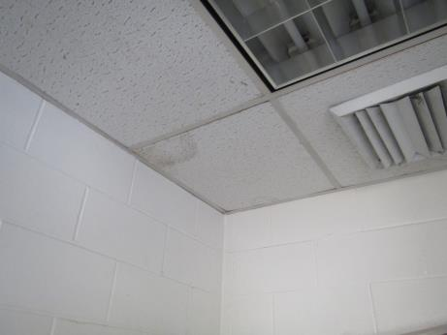
Water-damaged ceiling tile
Picture 4
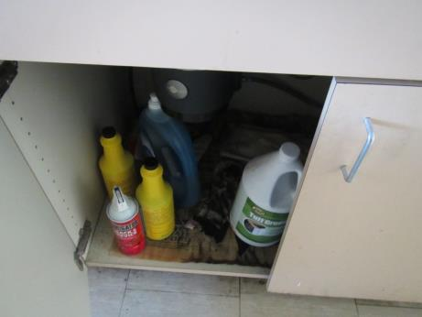
Water-damaged paper under sink
Picture 5
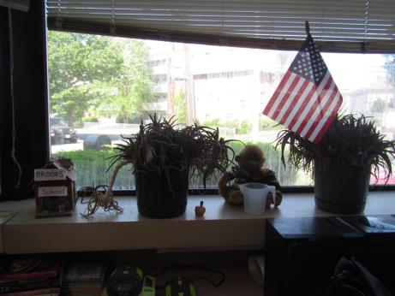
Indoor plants
Picture 6
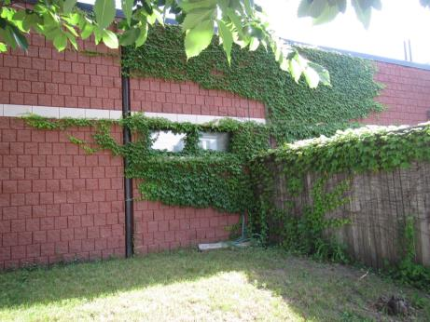
Ivy growing on station walls
Picture 7
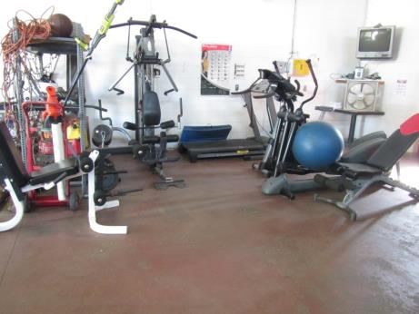
Exercise equipment in the garage area
Picture 8
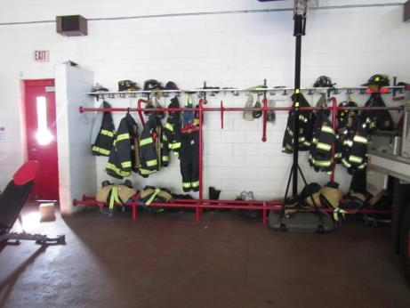
Turnout gear in the garage area
Picture 9
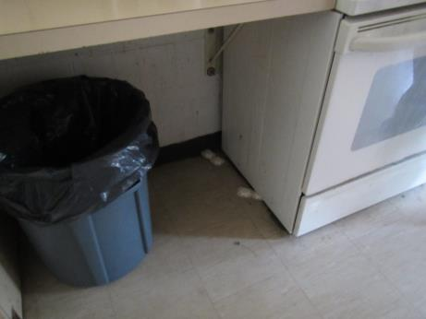
Ant traps in kitchen

Location | Carbon  Dioxide  (ppm) | Carbon Monoxide  (ppm) | Temp  (°F) | Relative  Humidity  (%) | PM2.5  (µg/m³) | Occupants  in Room | Windows  Openable | Ventilation |  | Remarks
 |  |  |  |  |  |  |  | Supply | Exhaust
Background (outside) | 564 | 0.5 | 69 | 42 |  |  |  |  |  | Sunny
Dispatch/reception | 513 | ND | 71 | 45 | 1 | 0 | N | Y | N | Door to vestibule which opens to engine bay, plants, full windows
Front restroom | 517 | ND | 71 | 44 | 2 | 0 | N | Y | Y | Dust and debris on vent
Galley/kitchen | 533 | ND | 71 | 46 | 2 | 0 | N | Y |  | Recirculating stove vent, appliances, ant traps and reports of rodents, CP, WD paper and items under sink
Day Room | 543 | ND | 71 | 44 | 1 | 0 | Y | Y | Y | UF, DEM, boxes on floor in storage area, bowed CT
Bunk/office | 549 | ND | 71 | 44 | 1 | 0 | Y | Y | Y | Dusty vents, UF, 3 WD CT, bed
Toilet room | 520 | ND | 71 | 44 | 2 | 0 | N | N | Y | CP, dusty vents
Locker | 551 | ND | 71 | 43 | 2 | 0 | N | Y | Y | Skylight, MT, peeled coving
Shower |  |  |  |  |  |  | N | N | Y | Vent in shower room
Utility |  | ND |  |  |  |  | N | N |  | Water heater and heating unit, old closed makeup air vent
Bunk | 505 | ND | 72 | 43 | 2 | 0 | Y | Y | Y | PF on
Engine | 422 | ND | 71 | 38 | 5 | 1 | Doors open | N | Y | Plymovent, weight room in bay, turnout gear adjacent to engine

