INDOOR AIR QUALITY ASSESSMENT

Medford City Hall
85 George P. Hassett Drive
Medford, Massachusetts

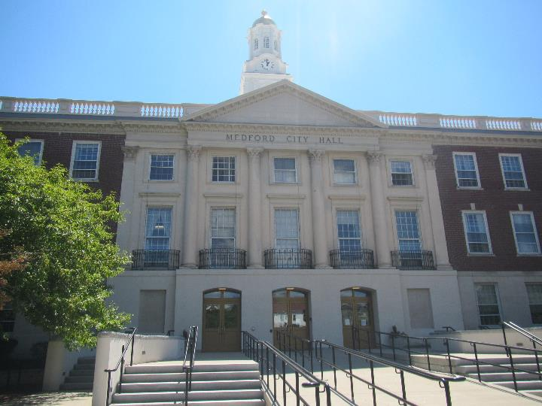

Prepared by:
Massachusetts Department of Public Health
Bureau of Environmental Health
Indoor Air Quality Program
September 2022

BACKGROUND
Building: | Medford City Hall (MCH)
Address: | 85 George P. Hassett Drive, Medford, MA
Assessment Requested By: | Mayor Breanna Lungo-Koehn, City of Medford
Reason for Request: | General indoor air quality (IAQ) concerns and health concerns in the election offices
Date of Assessment: | August 19, 2022 and August 30, 2022
Massachusetts Department of Public Health/Bureau of Environmental Health (MDPH/BEH) Staff Conducting Assessment: | Michael Feeney, Director, and Ruth  Alfasso and Jennifer Lajoie,  Environmental Inspectors, IAQ  Program
Building Description: | The MCH is a three-story brick building with a flat roof and a partly occupied basement. It was originally constructed in 1937 as a town hall.
Windows: | Openable

METHODS
Please refer to the IAQ Manual for methods, sampling procedures, and interpretation of results (MDPH, 2015).

RESULTS and DISCUSSION
The following is a summary of indoor air testing results (Table 1).
- Carbon dioxide levels were above 800 parts per million (ppm) in about one fifth of the areas examined, indicating that some areas could benefit from more fresh air for the occupancy. Note that some areas were lightly occupied or unoccupied at the time of the assessment and carbon dioxide levels would be expected to be higher with increased occupancy.
- Temperature was within or slightly above the recommended range of 70°F to 78°F in areas assessed.
- Relative humidity was within the recommended range of 40% to 60% in all areas assessed except in the basement, where some levels were slightly higher.
- Carbon monoxide levels were non-detectable (ND) in all areas assessed.
- Fine particulate matter (PM2.5) concentrations measured were below the National Ambient Air Quality Standard (NAAQS) level of 35 μg/m³ in all areas assessed

Ventilation
A heating, ventilating, and air conditioning (HVAC) system has several functions. First it provides heating and, if equipped, cooling. Second, it is a source of fresh air. Finally, an HVAC system will dilute and remove normally occurring indoor environmental pollutants by not only introducing fresh air, but by filtering the airstream, and ejecting stale air to the outdoors via exhaust ventilation. Even if an HVAC system is operating as designed, point sources of respiratory irritation may exist and cause symptoms in sensitive individuals. The following analysis examines and identifies components of the HVAC system and likely sources of respiratory irritant/allergen exposure due to water damage, aerosolized dust, and/or chemicals found in the indoor environment.
The MCH was originally designed to use open windows for fresh air and radiators for heating. The MCH was renovated to add mechanical fan coil units (FCU) along exterior walls (Picture 1 and 2) which serve to provide some circulation and filtration of air, but no fresh air supply. FCUs draw air in from a vent inside the room, filter, heat or cool the air, and return it to the room through another vent (Figure 1). Additional cooling in a few areas is provided by window air conditioners.
During the initial visit, one FCU was found open with a filter hanging down (Picture 3). During the subsequent visit, several FCU cabinets were opened. All filters observed were of a low Minimum Efficiency Rating Value (MERV) with limited ability to remove suspended particulates. The BEH IAQ program recommends the use of the best quality/highest MERV rated filters that can be used with current equipment, with MERV 8 filters considered the minimum for removal of pollen, mold spores and other potential allergens. Filters should be fitted firmly into the FCU cabinet/bracket. The filters observed were not the correct size for the FCU, and two filters were used in place of one (Picture 4). This can allow air to flow around the filters. To continue to use this size filter, the filters should be firmly taped together to avoid gaps. It is preferred that the correct type and size of filters be used.
Filters should be changed on a regular schedule, at least twice a year and more often if needed. Occupants expressed concerns that filters are not changed. The interior of FCUs contained varying amounts of debris, which indicates the equipment is not routinely maintained. Insulation of FCU covers were torn and coated with debris. Both conditions degrade the function of the FCU. Filters were also missing from some FCUs. During filter changes, the FCU cabinets should be cleaned of dust and debris.
To maximize air exchange, the MDPH recommends that both supply and exhaust ventilation operate continuously during periods of occupancy. In order to have proper ventilation with a mechanical supply and exhaust system, the systems must be balanced to provide an adequate amount of fresh air to the interior of a room while removing stale air from the room. It is recommended that HVAC systems be re-balanced every five years to ensure adequate air systems function (SMACNA, 2013). The date of the last balancing of these systems was not available at the time of the assessment.
It is also important to note that despite ongoing maintenance and replacement of parts/components, many of the HVAC units are likely at or near at the end of their service life. Efficient function of equipment of this age (~ 20 years old) is difficult to maintain, since compatible replacement parts are often unavailable. According to the American Society of Heating, Refrigeration, and Air-Conditioning Engineering (ASHRAE), the service life of this type of unit is 15-20 years, assuming routine maintenance of the equipment (ASHRAE, 1991).
Also note that drip pans are lined with Styrofoam material to provide insulation to prevent condensation from gathering on the underside of the pan which in turn, can cause wetting of the FCU interior, filter, as well as adjacent walls and floors (Picture 5). It is likely that such materials were intended by the manufacturer to be replaced once a year after the system is switched to heating mode. This material that has degraded will not be able to be cleaned.
Some of the central areas appear to have vents of an unknown use (Picture 6). These may be part of an old gravity exhaust system for the building, using the stack effect to remove heated, stale air from the building. The function of these vents should be investigated by an HVAC contractor, and either repaired for regular use, or sealed. Unused ventilation shafts can be a pathway for unconditioned air, debris, or pests to circulate into occupied space.
Restrooms appear to be equipped with exhaust vents which should be vented directly outside to remove moisture and odors from restroom operations. It could not be determined if these were operating. All restrooms examined had an odor of cleaner or air freshener.

Microbial/Moisture Concerns

Moisture issues on upper floors
Water-damaged ceiling tiles and ceiling plaster were observed in various areas around the building (Picture 7, Table 1). Water-damaged ceiling tiles and plaster indicate leaks from plumbing or the building envelope. Leaks should be repaired when they are found, and water-damaged materials such as ceiling tiles or plaster should be repaired or replaced. Water-damaged ceiling tiles can become a source of mold or odors if moistened chronically or repeatedly. Note that most of the ceiling tiles in the building are a type that are attached directly to the ceiling. These can be harder to replace, and replacement tiles may be more difficult to find. In addition, some tiles of this type may contain asbestos.
Water-damaged building materials were found in a stairwell outside the Council Chambers, where a window appeared to be broken and water stains were visible along the wall. (Pictures 8 and 9). Paint in this stairwell was also peeling in several places (Picture 10), suggesting chronic exposure to moisture.
The ceiling in room 301 had several panes of glass as part of the ceiling, one of which was missing (Picture 11). It appears as though backing paper on the glass had been water-damaged as well. Gaps/holes between conditioned and unconditioned space can allow moisture, debris, and pests into occupied space.
Many of the rooms examined had closets or insets with sinks (Picture 12, Table 1). The area around many of the sinks was carpeted, with carpeting showing stains and other signs of water damage (Table 1). Water damage/deterioration of wall material was also noted under one of the sinks (Picture 13). The area around and underneath sinks is a moist environment where spills, leaks, and condensation can moisten carpeting and other building materials. Wherever possible, carpeting should be removed from these areas and replaced with water resistant flooring. Water coolers and small refrigerators were also located on carpeting (Picture 14, Table 1) which can be moistened by spills.
Plants were noted in many offices (Picture 15). Plants can be a source of pollen, mold, and odors, particularly if not well maintained. Plants should be kept in good condition, not overwatered, and placed on waterproof drip pans that are periodically cleaned.

Moisture issues in the basement
Water-damaged materials were noted in the basement, including boxes (Picture 16) and pipe insulation (Picture 17). A number of locations where hot, moist air can enter the basement were noted, particularly exterior doors and the furnace room. Condensation in hot, humid weather tends to occur in basements due the lack of exhaust ventilation to vent water vapor from the building. Exterior walls and floors in direct contact with soil tend to have surface temperatures that are below the dew point, which make these material prone to becoming wet by condensation, that, if not dried within 24 hours, may become mold colonized.
As shown in Table 1, the relative humidity in the basement was higher than it was elsewhere else in the building. The key to managing condensation is understanding dew point. When warm, moist air passes over a cooler surface, condensation can form. The dew point is the temperature that air must reach for saturation to occur. If a building material/component has a temperature below the dew point, condensation will accumulate on that material.
A method to locate areas in a building prone to condensation is to measure air and building material temperatures using a laser thermometer. If a wide temperature range exists between measurements (>5°F), the building materials at the colder end of the range may be prone to becoming moistened with condensation if exposed to hot, humid weather for extended periods of time. While floors in the basement were found to have similar temperatures as the air (Table 1), condensation can occur on other surfaces, such as the chilled water pipes used for air conditioning. Insulation has a rating for how much it can resist heat flow. If the R value is insufficient, or the pipe wrap is incomplete, the exterior of the pipe and wrap can become chilled below the dew point, collect condensation droplets, and lead to water damage and mold growth. If pipe wrap gets wet, the R value typically decreases as well, making additional condensation more likely.
Water-damaged and mold-colonized pipe wrap should be removed and replaced, however before disturbing this material, it should be determined if it may contain asbestos, and handled in accordance with the relevant State and Federal laws.
Other water-damaged stored materials in the basement should be sorted, and items that are porous and unable to be cleaned should be discarded. If any water-damaged stored items are of significant historic value, a document restoration company should be contacted to determine if restoration is possible.
In general, it is recommended that porous material be dried with fans and heating within 24 to 48 hours of becoming wet (US EPA, 2008, ACGIH, 1989). If porous materials are not dried within this time frame, mold growth may occur. Water-damaged porous materials cannot be adequately cleaned to remove mold growth.

Exterior issues that may impact IAQ
The exterior of the building was examined for conditions that may impact the building envelope or IAQ. Plants (shrubs) were located close to the exterior of the building in a few areas (Picture 18). Plants can hold moisture against the building, can be a source of pollen and odors through open windows, and can provide harborage for pests. Plants should be trimmed at least five feet away from the building. In addition, some window frames were showing peeling paint and other deterioration (Picture 19). Damaged window frames can allow moisture into the building and can reduce the ability of the windows to insulate against outside temperatures.

Other Concerns

Election Storage Area (Basement) Concerns
One of the specific reasons for the visit to the MCH was concerns about the election machine storage area in the basement. While measurements of IAQ parameters in this area of the basement showed no unusual conditions, the election machine storeroom is a dusty humid environment. For individuals who may be hypersensitive to mold or dust, personal protective equipment (PPE) would be helpful in reducing exposure to those conditions. A letter regarding the use of PPE for access to the election machine storage area was sent under separate cover and is included as Appendix A to this report.

Other Basement Issues
Other issues were identified in the basement relative to IAQ:
- Broken floor tiles were noted particularly in the hallway closet (Picture 20, Table 1). Based on the age and style of these tiles, they may contain asbestos. Access to the hallway closet should be prohibited until the tiles can be assessed for asbestos and remediated if necessary.
- An abandoned sink was found in Room 1. It is likely the drain for this sink has a dry drain trap, which can allow sewer gas and odors into the building. Unneeded plumbing fixtures should be properly cut and capped to prevent leaks and dry drain traps.
- Large amounts of old stored items, including paper, boxes, decorations, and other materials, are stored in the basement. Items that are no longer needed should be discarded. Removal of materials for disposal was occurring during the IAQ site visit.
- The conditions of the basement, including the number of materials, makes it very difficult to clean effectively, leading to accumulations of dust and debris that can become aerosolized during activity, or can become mold-colonized when moistened.
- Pipes in some areas appear to have insulation that may contain asbestos (Table 1). Consulting with a Massachusetts licensed asbestos inspector is recommended to identify and repair insulation as needed.

General IAQ concerns

Exposure to low levels of total volatile organic compounds (TVOCs) may produce eye, nose, throat, and/or respiratory irritation in some sensitive individuals. BEH/IAQ staff noted hand sanitizers, cleaners, and dry erase materials in the office space (Table 1). All of these products have the potential to be irritants to the eyes, nose, throat, and respiratory systems of sensitive individuals.
Air purifier units were found in some offices. Based on the name, these may produce ozone, which is a respiratory irritant. Air purifiers that produce ozone should not be used in occupied areas (USEPA, 2008). Given that the MCH does not have a mechanical ventilation system capable of providing fresh air, apart from opening windows, air purifiers should be operated in the filter setting only, if feasible.
Many areas in MCH have carpeting, most of which is older and in poor condition (Picture 21). Occupants report that carpeting is rarely cleaned. Carpeting should be vacuumed regularly with a high efficiency particulate arrestance (HEPA) filter equipped vacuum cleaner to avoid particulates from causing further irritation or serving as a reservoir for microbial colonization. Also, carpeting and rugs should be deep cleaned at least once per year according to IICRC recommendations (IICRC 2012). Aging carpet can produce fibers that can be irritating to the respiratory system and may be difficult to clean effectively. Non-porous flooring solutions should be considered instead of carpeting for areas which might be subject to water exposure, such as under sinks and food preparation areas, and high traffic areas.
Food and food preparation equipment was found in many areas of the building (Pictures 22 and 23). Cooking equipment, such as toasters, refrigerators, and microwaves should be kept clean to prevent odors, microbial growth, smoke, and pests. Food should be stored in pest-proof containers and any food debris should be cleaned promptly.
Stored materials including papers, plans, boxes, equipment, and decorative items were found in many offices and other areas (Pictures 24 and 25). Stored items can be a source of dust and can make areas harder to clean. In addition, large amounts of stored items can provide harborage for pests. Stored items should be sorted, with unneeded items discarded. The remaining items should be stored in shelving, cabinets or pest and water-resistant containers when not being used.
Fluorescent light bulbs were found stored loosely in a closet. These bulbs contain mercury which can be released if they are broken. New and used fluorescent bulbs should be kept in sturdy containers to avoid breakage and spent bulbs should be sent for proper disposal regularly.

CONCLUSIONS and RECOMMENDATIONS
The IAQ staff identified a number of concerns stemming from the conditions, installation, and operation of the FCUs. Drainage issues, damage, and lack of maintenance contribute to the symptoms reported by MCH occupants.
Based on observations at the time of assessment, a two-phase approach is required for remediation. The first consists of short-term measures to improve air quality and the second consists of long-term measures that will require planning and resources to adequately address overall concerns.
Note that several issues were discovered relating to potential regulated material (asbestos). Ensure all applicable State and Federal asbestos regulations and guidance are followed, regarding potential asbestos-containing materials. Based on the observations made during this assessment, the IAQ program makes the following recommendations.

Short-term recommendations

Ventilation Recommendations
- Install appropriately sized filters in all FCUs. Due to conditions in the FCUs, it is recommended that an HVAC engineering/maintenance consultant inspect all FCU for operation and condition. Actions to repair this equipment may include:
    - Removal of insulation from FCU covers.
    - Cleaning of debris.
    - Removal/replacement of Styrofoam drip pan insulation. If no replacement insulation exists for the manufacturer, consult with the HVAC engineering/maintenance contractor of best method for replacing or installing appropriate drip pan insulation.
    - Evaluation of each FCU for function and repair /replacement as needed.
    - Installation of properly sized filters.
- Once remediated, operate fan coil units during occupied periods to filter, circulate, and condition the air. Avoid blocking units with furniture/items or placing items in the airstream.
- Use openable windows for fresh air during temperate weather. Keep windows closed during heavy rain and during hot, humid weather when the air conditioning is operating. Ensure windows have intact screens to exclude pests, and that windows are tightly closed at the end of the day.
- Change filters in HVAC equipment regularly in accordance with manufacturer’s instructions. Use high-quality filters with a Minimum Efficiency Rating Value (MERV) rating of at least 8, or higher if the HVAC equipment can operate with more restrictive filters.
- If two or more filters need to be used in one filter slot, ensure the filters are securely taped together to prevent air from flowing around them.
- Assess the function of the vents like those shown in Picture 6. If vents are obsolete/no longer in use, consider sealing all openings connected to the vent.
- Assess the function of restroom exhaust fans, and repair as needed. Ensure restroom exhaust fans operate at all times when the building is occupied to remove odors and moisture.
- Maintain window air conditioners regularly including cleaning filters.

Water Damage Recommendations
- Replace all water-damaged pipe insulation in the basement. Ensure that insulation has the appropriate R value for the pipe temperature. All pipe ends should be sealed with appropriate materials to prevent condensation between pipes and new insulation and prevent condensation wicking from exposed pipe to beneath insulation.
- Replace water-damaged ceiling tiles and repair water-damaged ceiling plaster where possible once the source of the leak is identified and repaired.
- Repair the window in the stairwell outside the Council Chambers and clean/repair water-damaged building materials there including peeling paint.
- Examine the glass ceiling panes in Room 301 to determine function. Either clean and repair the panel, including water-damaged backing paper, or replace with a solid ceiling.
- Assess office sinks. Sinks in use should be kept in good repair to prevent leaks. If no longer used, ensure that both drains and water service are properly cut and capped. If sinks are temporarily unused, ensure that drains are periodically filled with water to maintain the trap seal.
- Consider removing carpeting from underneath office sinks, or cover carpeting with a waterproof mat.
- Also consider removing carpeting, or using mats, in areas where refrigerators and water dispensers are used.
- Repair water-damaged wall/floors under sinks.
- Ensure plants in offices are well maintained, and not overwatered. Place plants on waterproof drip pans that are cleaned regularly. Avoid placing plants in the airstream of FCUs.
- Ensure any potential asbestos-containing materials such as floor tiles, floor tile mastic, and pipe wrap are assessed for asbestos. If asbestos is present, remove the affected materials in a manner consistent with Massachusetts and Federal asbestos laws.
- Consider the use of dehumidifiers in the basement area during humid weather. Ensure any units are kept clean and emptied regularly to prevent them becoming a source of odors.
- Examine all materials stored in the basement for water damage, mold growth, and odors. If an item is water-damaged or colonized with visible mold, it should be discarded in a manner consistent with recommendations made in “Mold Remediation in Schools and Commercial Buildings”, which can be found at https://www.epa.gov/mold/mold-remediation-schools-and-commercial-buildings-guide. If any damaged items are of a high historic value, consult with a document restoration company for options.
- Continue to follow the guidelines outlined in the letter dated August 23, 2022 on the use of personal protective equipment (PPE) when accessing materials in the basement for individuals who may be hypersensitive/allergic to mold or dust. See Appendix A.
- Trim bushes and plants away from the exterior of the building a minimum of five feet.
- Repair window frames where needed to ensure the building envelope is intact.
- Keep furnace room door closed at all times. Consider installing fire-rated weatherstripping and a door sweep to prevent furnace airflow into basement hallway.

Other Recommendations
- Assess damaged floor tiles in the basement for asbestos, and discard in accordance with all State and Federal laws.
- Properly cut and cap the plumbing and drain for the abandoned sink in Room 1 in the basement
- Minimize use of air fresheners and other scented products.
- Avoid the use of air purifiers that may produce ozone. Units using HEPA filtration with or without carbon filtration will provide removal of suspended particles. Ensure each unit is properly maintained in accordance with manufacturer’s instructions.
- Continue with sorting and discarding unneeded items from the basement. Minimize the use of the basement for storage.
- In both the basement and other areas, keep stored materials organized and in closed containers, on shelves, or in cabinets to protect from moisture, dust, and pests. Sort through stored items and discard unneeded items regularly.
- Keep food storage and preparation equipment clean. Only store food in sealed pest-proof containers.
- Clean all carpeting in accordance with IICRC recommendations (IICRC 2012). This includes daily vacuuming with a HEPA-equipped vacuum cleaner, and annual or semi-annual deep cleaning.
- Store new and spent fluorescent bulbs securely and remove spent bulbs on a regular basis to prevent breakage and release of mercury.
- Refer to resource manual and other related IAQ documents located on the MDPH’s website for further building-wide evaluations and advice on maintaining public buildings. These documents are available at: http://mass.gov/dph/iaq.

Long Term Recommendations

- Replace carpeting in the building that may be stained, worn or otherwise beyond its service life. Consider replacing with a non-porous and wear-resistant flooring.
- Consult with an HVAC engineering contractor to determine the feasibility of adding fresh air mechanical ventilation to the building.

REFERENCES
ACGIH. 1989. Guidelines for the Assessment of Bioaerosols in the Indoor Environment. American Conference of Governmental Industrial Hygienists, Cincinnati, OH.
ASHRAE. 1991. ASHRAE Applications Handbook, Chapter 33 “Owning and Operating Costs”. American Society of Heating, Refrigeration and Air Conditioning Engineers, Atlanta, GA.

IICRC. 2012. Institute of Inspection, Cleaning and Restoration Certification. Carpet Cleaning: FAQ.
MDPH. 2015. Massachusetts Department of Public Health. Indoor Air Quality Manual: Chapters I-III. Available at: https://www.mass.gov/lists/indoor-air-quality-manual-and-appendices.
SMACNA. 2013. HVAC Systems Commissioning Manual. 2nd ed. Sheet Metal and Air Conditioning Contractors’ National Association, Inc., Chantilly, VA.

US EPA. 2008. “Mold Remediation in Schools and Commercial Buildings”. Office of Air and Radiation, Indoor Environments Division, Washington, DC. EPA 402-K-01-001. September 2008. Available at: http://www.epa.gov/mold/mold-remediation-schools-and-commercial-buildings-guide.
US EPA. 2003. “Ozone Generators that are Sold as Air Cleaners: An Assessment of Effectiveness and Health Consequences”. US Environmental Protection Agency, Office of Air and Radiation, Indoor Environments Division, Washington, D.C. https://www.epa.gov/indoor-air-quality-iaq/ozone-generators-are-sold-air-cleaners

Figure 1

Fan Coil Unit (FCU)

Air Diffuser

Outdoors Indoors

Fan

Heating/Cooling Coil

Air Mixing Plenum

Filter

Return
Air

Picture 1
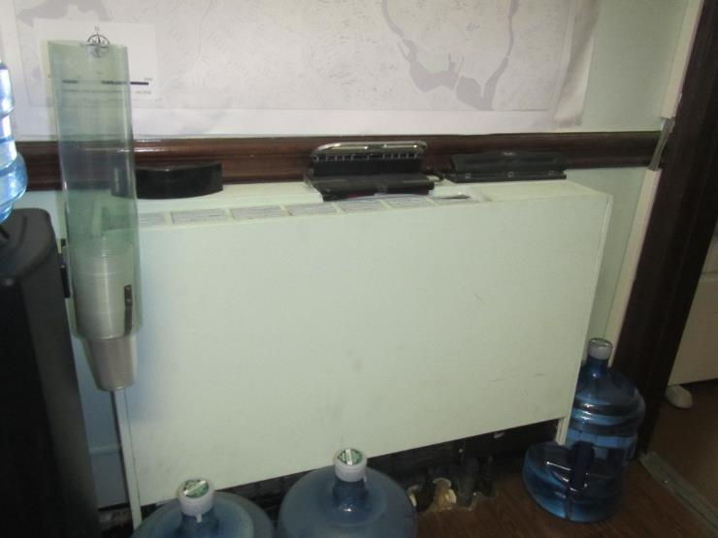
Fan coil unit in an office, note blockages around front of unit
Picture 2
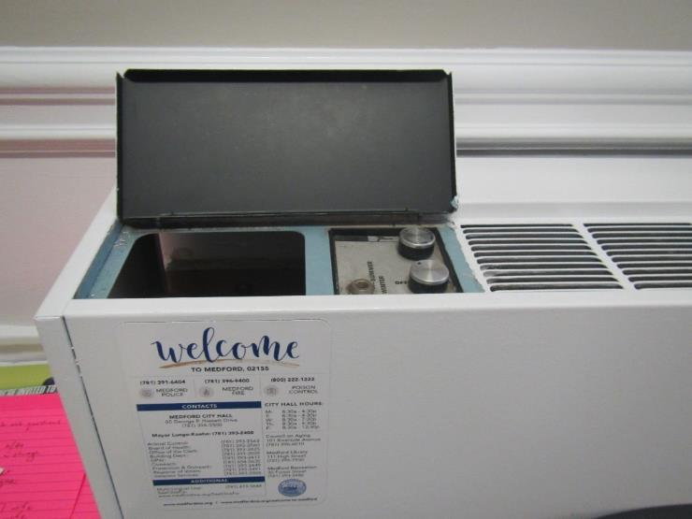
Fan coil unit controls
Picture 3
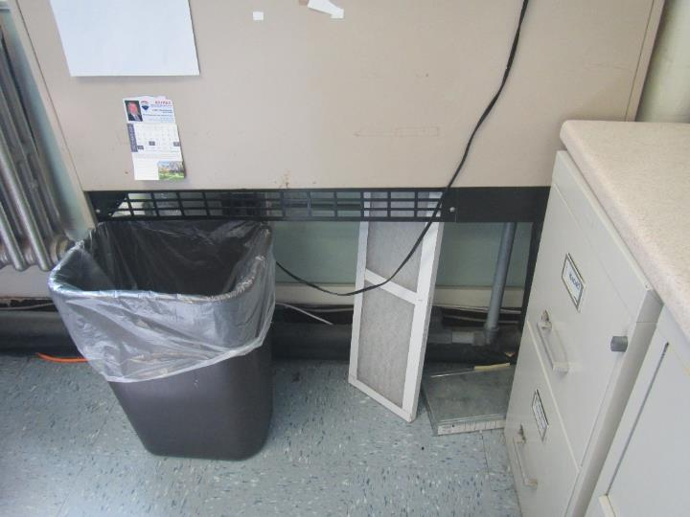
FCU filter hanging out of unit
Picture 4
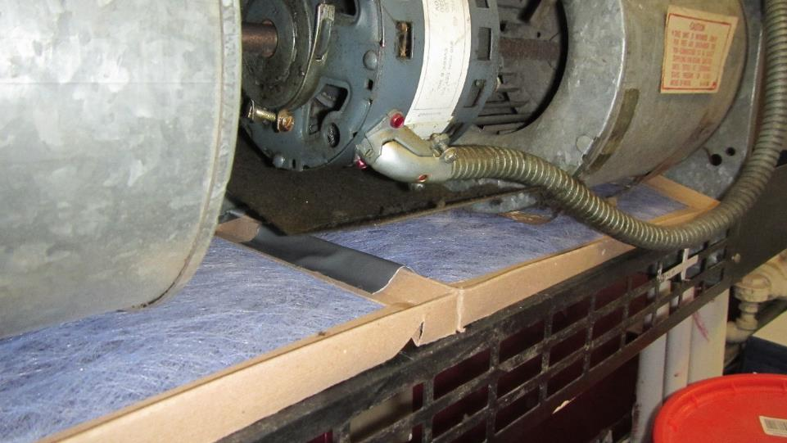
Two filters inside an FCU

Picture 5
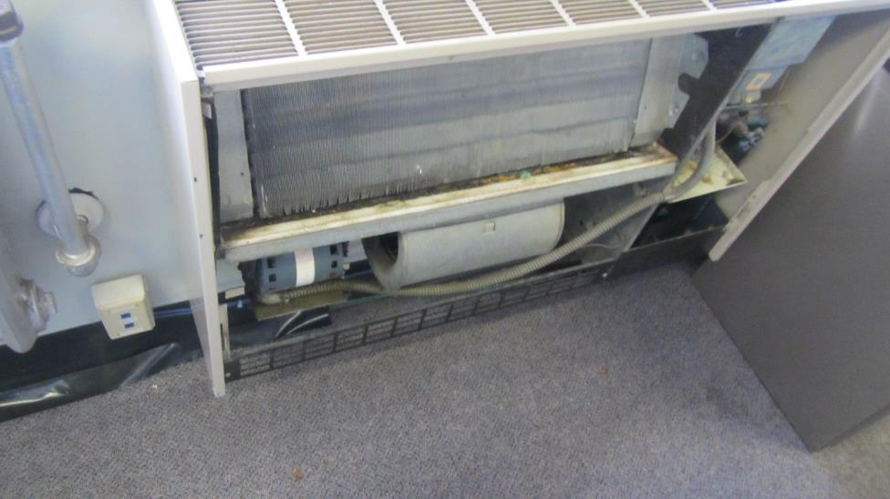
Inside of FCU (arrow indicates Styrofoam drip pan insert)
Picture 6
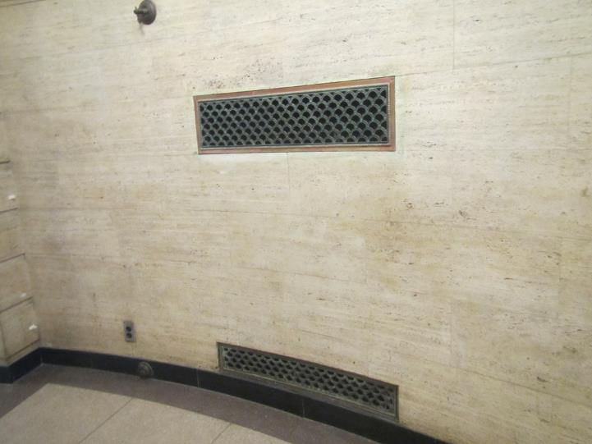
Potentially old gravity exhaust vents, or other vents of unknown use

Picture 7
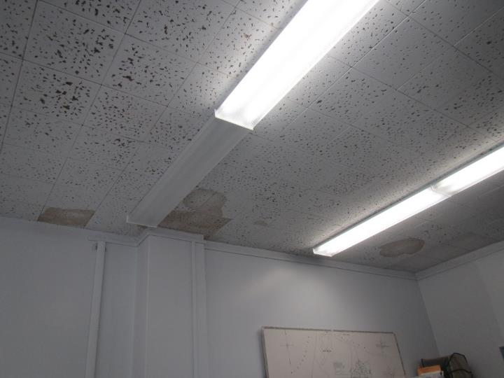
Water-damaged ceiling tiles, attached type
Picture 8
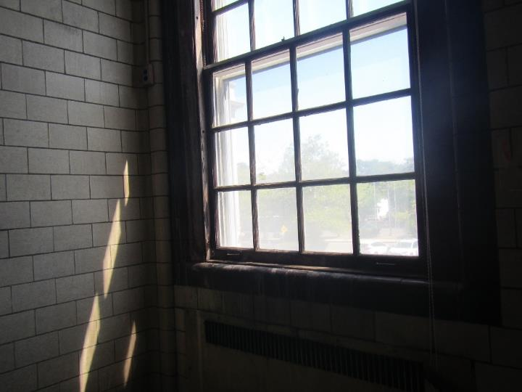
Damaged window in Council Chambers stairwell

Picture 9
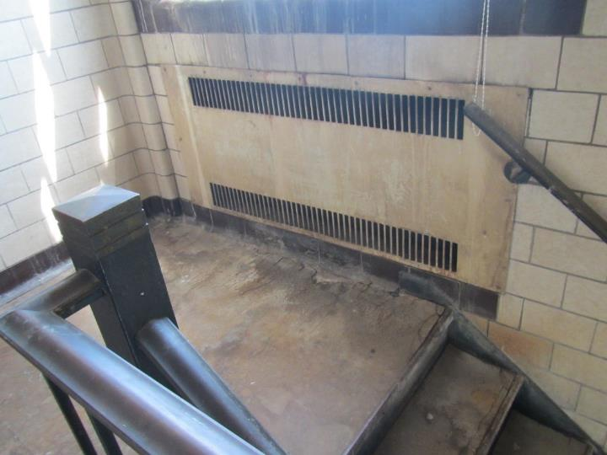
Water-damaged material in Council Chambers stairwell
Picture 10
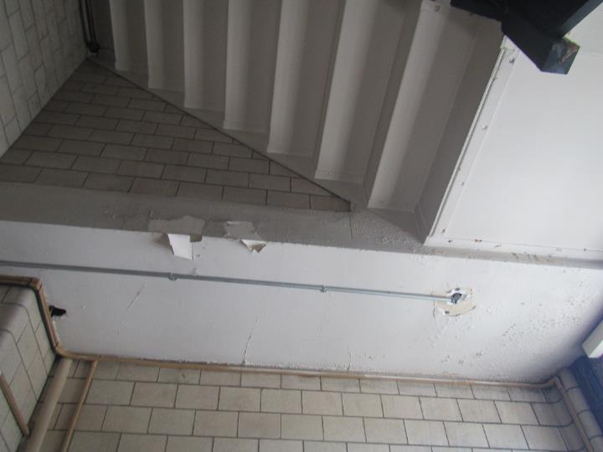
Peeling paint in Council Chambers stairwell

Picture 11
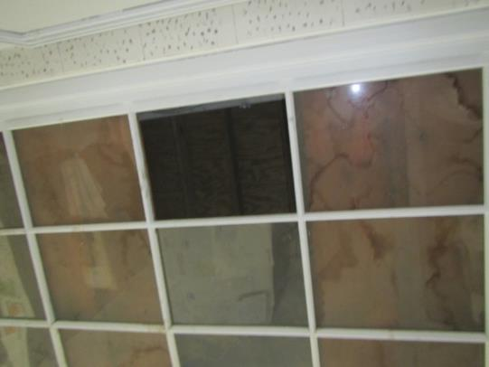
Glass panes in ceiling of room 301, note missing pane with hole into attic area
Picture 12
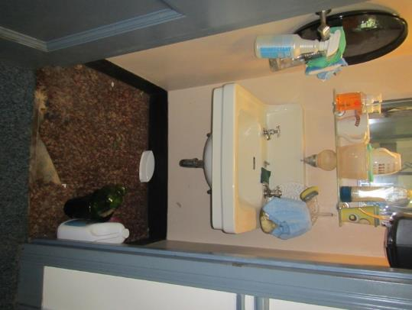
Sink inset closet with damaged carpeting

Picture 13
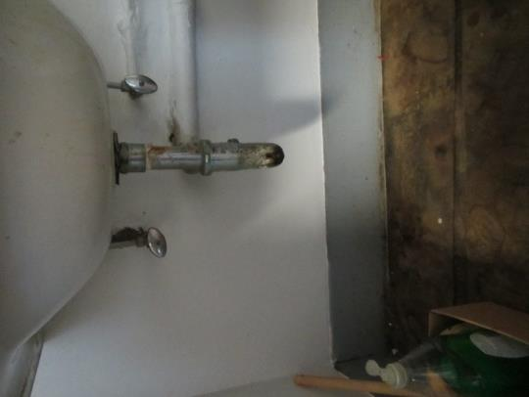
Water-damaged wall and coving beneath sink
Picture 14
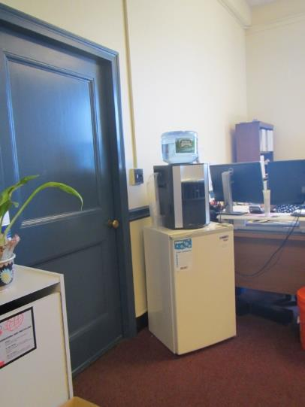
Small refrigerator on carpet

Picture 15
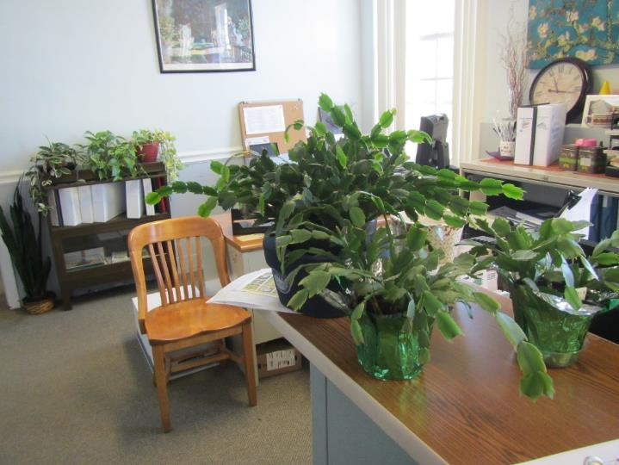
Plants in an office
Picture 16
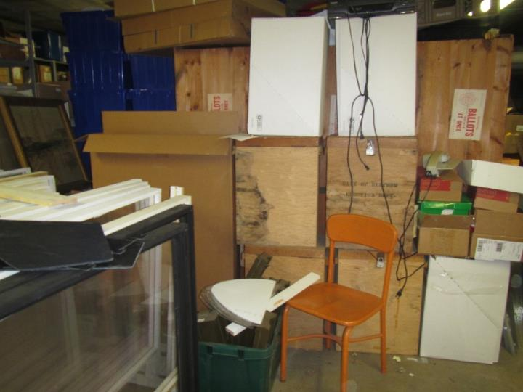
Water-damaged boxes in the basement

Picture 17
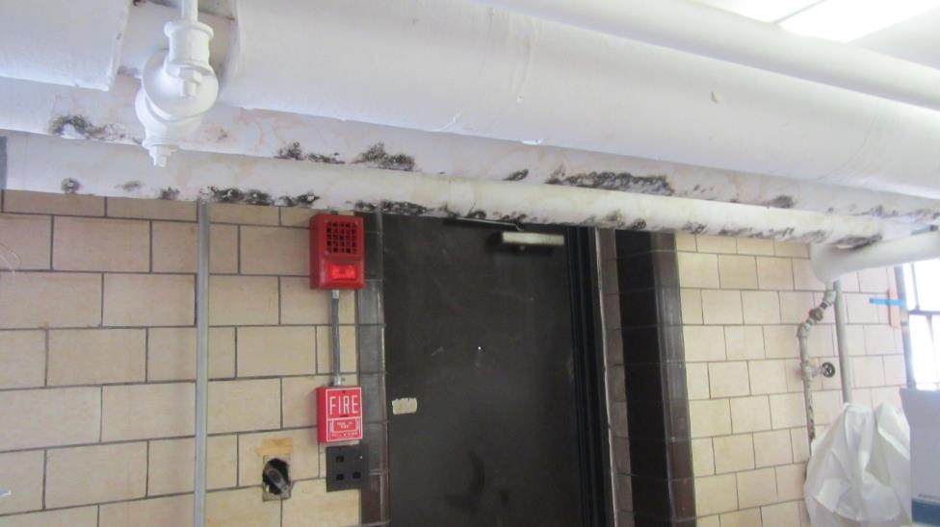
Water-damaged and potentially mold-colonized pipe wrap in the basement
Picture 18
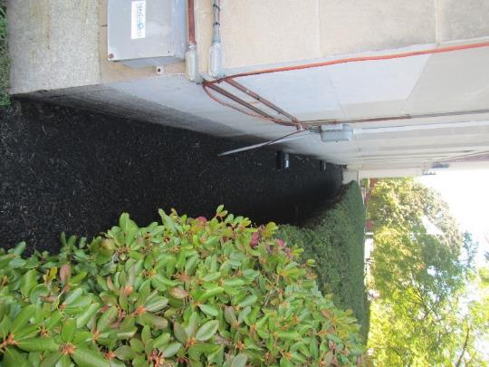
Shrubs near the building envelope

Picture 19
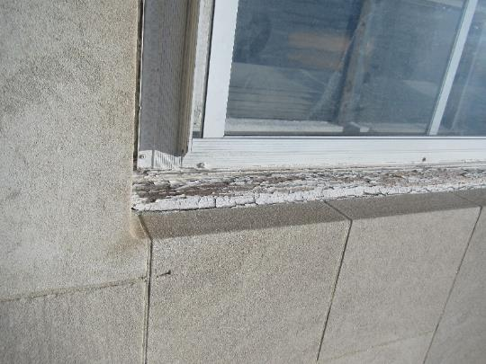
Deteriorating window frame
Picture 20
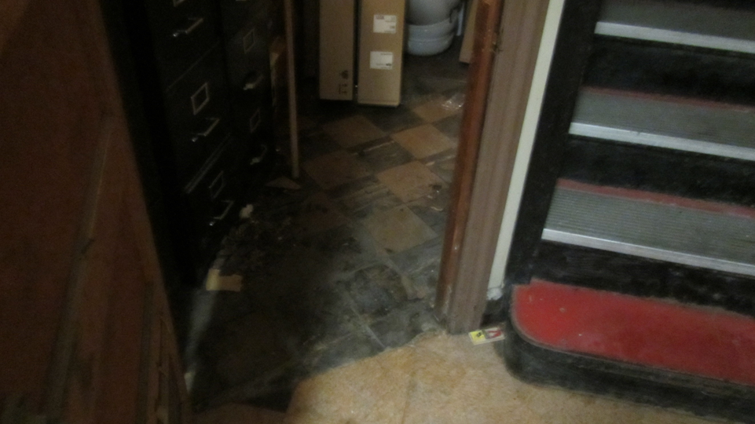
Broken floor tiles in the hallway closet

Picture 21
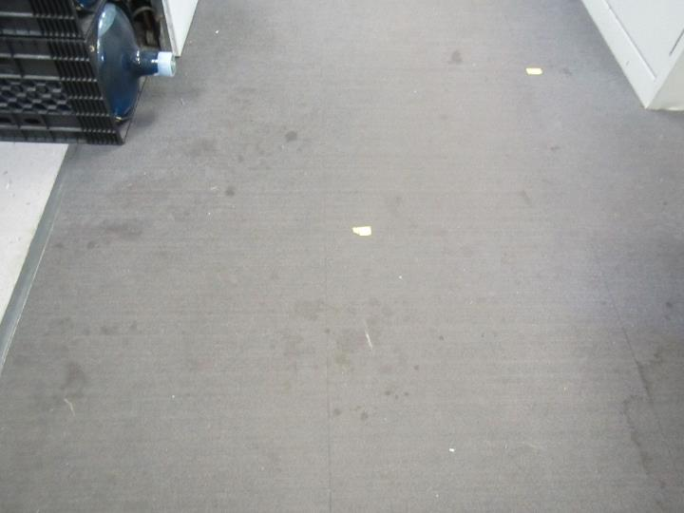
Stained, worn carpeting
Picture 22
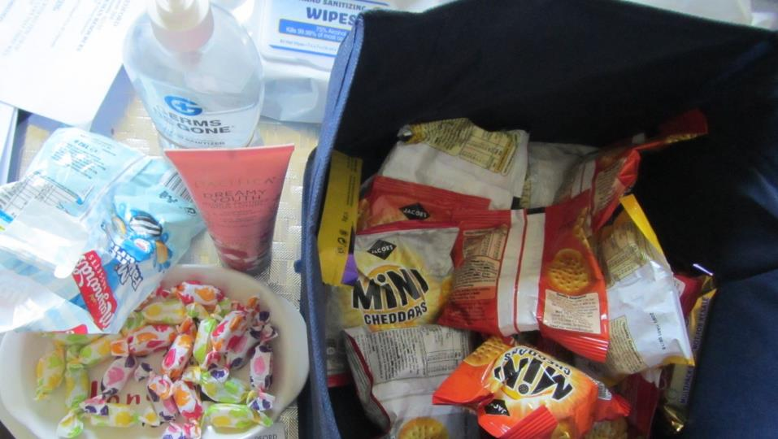
Food in an office

Picture 23
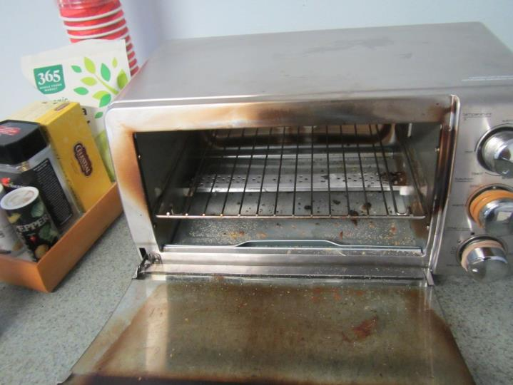
Toaster oven with crumbs
Picture 24
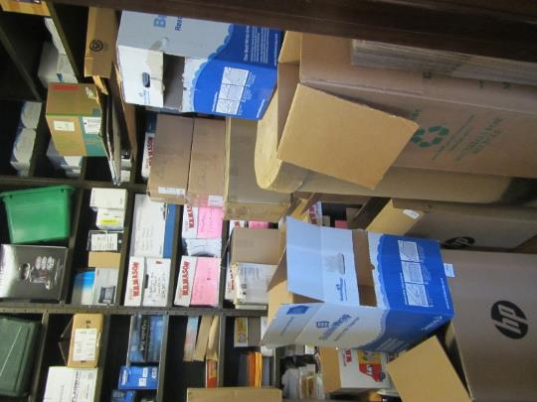
Cluttered storeroom

Picture 25
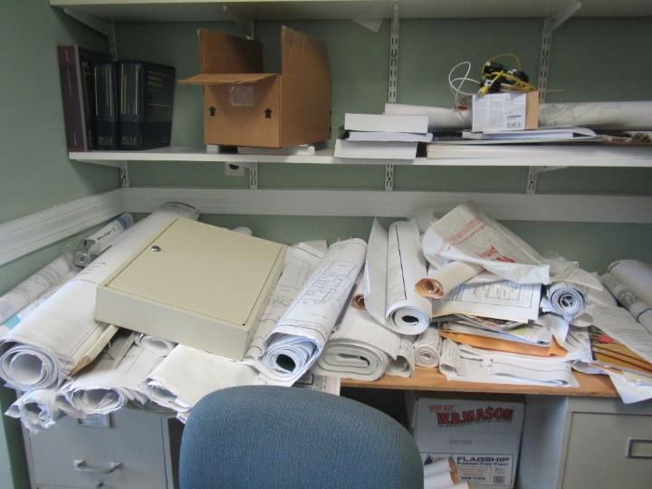
Plans stored on a desk

Location | Carbon  Dioxide  (ppm) | Carbon Monoxide  (ppm) | Temp  (°F) | Relative  Humidity  (%) | PM2.5  (µg/m³) | Occupants  in Room | Windows  Openable | Ventilation |  | Remarks
 |  |  |  |  |  |  |  | Supply | Exhaust
Background | 345 | ND | 86 | 38 | 7 |  |  |  |  | Sunny
Third Floor
300 | 766 | ND | 76 | 49 | 4 | 1 | Y | N | N | Plants, carpeted
300 conference/  storage | 915 | ND | 75 | 49 | 2 | 0 | Y | N | N | Plants
300 -inner office | 923 | ND | 76 | 51 | 1 | 1 | Y | N | N | Plants
301 | 904 | ND | 75 | 51 | 2 | 4 | Y | N | N | WD CT, missing CT (attached type), NC, Glass ceiling area with hole, old carpet
301 kitchen/  conference |  |  |  |  | 2 | 0 | N | N | N | Food preparation equipment, vent of unknown use, big sink, items on floor
301 office | 887 | ND | 75 | 50 | 2 | 1 | Y | N | N | Carpeted, dead plant, paper, not full-height walls
301 storage |  |  |  |  |  | 0 | N | N | N | Cluttered, CP, paper, boxes, decorations
302 | 651 | ND | 76 | 53 | 4 | 1 | Y | N | N | Clutter
304 | 720 | ND | 75 | 47 | 6 | 3 | Y | Y | Y | Window open with AC on, air purifier, plants, fridge on carpet, cluttered closet, fluorescent lightbulbs in closet
304 - inner office | 660 | ND | 73 | 50 | 7 | 1 | Y | N | N | Plastic on window, toaster with crumbs
305 | 610 | ND | 80 | 40 | 3 | 1 | Y | N | N | Carpeted
305 side office | 641 | ND | 79 | 41 | 1 | 0 | Y | N | N | Plants, items
305 side office | 668 | ND | 78 | 43 | 2 | 0 | Y | N | N | Storage in piles
305 side office | 627 | ND | 78 | 43 | 2 | 1 | Y | N | N | CP, plants
308 | 712 | ND | 76 | 44 | 4 | 1 | Y | N | N | Boxes, plants, printer
308 mini kitchen | 777 | ND | 75 | 45 | 1 | 0 | N | N | N | Sink, items under sink, coffee
308 rear (copy) | 749 | ND | 76 | 45 | 2 | 0 | N | N | N | PC, hole in wall, NC, boxes
311 | 659 | ND | 75 | 47 | 5 | 2 | Y | N | N | NC, DEM
311 rear |  |  |  |  |  |  | N | N | N | NC, microwave, toaster oven, boxes on floor, PC
312 | 627 | ND | 73 | 49 | 4 | 1 | Y | N | N | Paper on floor, boxes, DEM
Women’s restroom |  |  |  |  |  | 0 | N | N | Y | Cleaner odor
Second floor
200 | 658 | ND | 74 | 47 | 3 | 1 | Y | N | N | Water cooler on carpet, PC, food odor
200 sink area |  |  |  |  |  |  |  |  |  | Carpet under sink, CP
202- mayor’s office | 680 | ND | 74 | 51 | 5 | 0 | Y | Y | Y | Food, bathroom
204 | 941 | ND | 76 | 47 | 2 | 1 | Y | N | N | Boxes/clutter on floor, sanitizers, sanitizing wipes, copy machine, watercooler and fridge on carpet, food, microwave
204- inner office | 1006 | ND | 75 | 47 | 2 | 1 | Y | N | N
205 | 522 | ND | 76 | 50 | 4 | 0 | Y | N | N | Sink, fridge
207 conference | 445 | ND | 75 | 45 | 6 | 0 | Y | N | N | Adhered-type CT, carpet
209 | 366 | ND | 75 | 50 | 6 | 0 | Y | N | N | Carpet, microwave, leather furniture
210 | 531 | ND | 73 | 52 | 4 | 0 | Y | N | N | Carpet, fridge on carpet
214 | 496 | ND | 74 | 52 | 8 | 1 | Y | N | N | Carpet, WD CT (adhered type), clutter
215 | 507 | ND | 75 | 48 | 6 | 3 | Y  1 open | N | N | Carpet, plants, food
215 inside | 508 | ND | 76 | 48 | 7 | 0 | Y | N | N | Carpet, CP, boxes on floor
CC left stairs |  |  |  |  |  |  |  |  |  | Peeling paint in stairwell, broken window, water damage under window
Council chambers | 363 | ND | 74 | 51 | 7 | 1 | Y | ? |  | Carpet, leather furniture
DEI office | 682 | ND | 74 | 52 | 7 | 0 | Y | N | N | Univent blocked, food, plants, fridge on carpet, sink over carpet
Mailroom | 490 | ND | 73 | 51 | 3 | 0 | Y | N | N | WAC, big printer, NC, data/phone wires
Middle office- mayor’s office suite | 671 | ND | 73 | 54 | 5 | 2 | Y | N | N
Right side office- mayor’s office suite | 767 | ND | 73 | 54 | 6 | 0 | Y | N | N | Glade plug-in
Rotunda |  |  |  |  |  |  |  |  |  | Some WD ceiling plaster around dome base
Women’s restroom |  |  |  |  |  |  | N | N | Y | Cleaner odor
First Floor
100 | 1362 | ND | 73 | 48 | 4 | 0 | Y | N | N | FCU blocked, clutter, fridge on carpet, water cooler on carpet, light fixture hanging from ceiling
102 | 1391 | ND | 71 | 56 | 4 | 4 | Y | Y | Y | Water damage on wall/ceiling of closet, water damage under sink, cracked plaster on walls, dust in FCUs
103 | 1265 | ND | 76 | 49 | 4 | 4 | Y | N | N | NC, food equipment
103 Clerk | 1330 | ND | 76 | 51 | 2 | 1 | Y | N | N
103 Kitchen | 1216 | ND | 77 | 49 | 5 | 0 | Y | N | N | Clutter, DEM
105 | 480 | ND | 76 | 48 | 8 | 3 | Y | N | N | PC, PF, plant, sink over carpet
105 office | 457 | ND | 77 | 48 | 8 | 0 | Y | N | N | AP, DEM, cluttered storage area
108 | 550 | ND | 73 | 51 | 6 | 3 | Y  1 open | N | N | Carpet, PC, water cooler on carpet, refrigerator on carpet
108 side office | 608 | ND | 73 | 53 | 6 | 1 | Y | N | N
109 | 718 | ND | 72 | 50 | 4 | 2 | Y | N | N | Carpet (old, concerns about cleaning), plant
109 side office | 758 | ND | 73 | 50 | 4 | 0 | Y | N | N | Area rug
109 side office | 768 | ND | 73 | 48 | 4 | 0 | Y | N | N | Toaster oven, DEM, sink over carpet
110 | 746 | ND | 73 | 49 | 4 | 3 | Y | N | N | Carpet, refrigerator, coffee, food
110 side | 782 | ND | 71 | 50 | 1 | 0 | Y | N | N | Plant, AP on sink with carpet underneath
114 | 624 | ND | 74 | 50 | 6 | 0 | Y | N | N | FCU filter on the floor, low quality, NC, suspended CT
115-A | 665 | ND | 74 | 49 | 5 | 3 | Y | N | N | Old carpet, paper/boxes, food, suspended CT
115-A side office | 626 | ND | 73 | 50 | 4 | 1 | Y | N | N | Big printer
115-A waiting area | 648 | ND | 75 | 49 | 5 | 0 | N | N | N
Finance director | 466 | ND | 77 | 47 | 8 | 1 | Y  2 open | N | N | Old carpet
Women’s restroom |  |  |  |  |  |  |  | N | Y | Cleaner odor, AF
Basement
Basement Hallway |  |  | 78 | 56 | 5 | N | N | N | N | Dew point 64°F, floor temperature 73°F
“” |  |  | 76 | 60 |  | N | N | N | N | Dew point 61°F, floor temperature 74°F
Basement outside election storage |  |  | 75 | 60 |  | 3 | N | N | N | Dew point 60°F, floor temperature 72°F
Room 9 | 487 | ND |  |  | 5 | 0 | N | N | N
City Records |  |  | 74 | 64 |  | 0 | N | N | N | Dew point 61°F, floor temperature 74°F
Room 1 | 797 | ND | 74 | 57 |  | 0 | N | N | N | Dew point 58°F floor temperature 69°F, abandoned sink
Room 2 | 1024 | ND | 73 | 62 |  | 0 | N | N | N | Dew point 69°F, floor temperature 70°F
Room 4 | 375 | ND | 76 | 63 | 4 | 0 | N | N | N | Dew point 61°F, floor temperature 71°F
Election |  | ND | 74 | 65 | 5 | 0 | N | N | N | Dew point 61°F, floor temperature 71°F
Hall Closet |  |  |  |  |  |  |  |  |  | Broken tiles
Election Machines | 500 | ND | 71 | 67 | 6 | 0 | N | N | N | Dew point 60°F, floor temperature 70°F

MARYLOU SUDDERS
Secretary
MARGRET R. COOKE Commissioner

Tel: 617-624-6000
www.mass.gov/dph

CHARLES D. BAKER
Governor
KARYN E. POLITO
Lieutenant Governor
The Commonwealth of Massachusetts
Executive Office of Health and Human Services
Department of Public Health
Bureau of Environmental Health
250 Washington Street, Boston, MA 02108-4619
Phone: 617-624-5757 Fax: 617-624-5777
TTY: 617-624-5286

August 23, 2022

Emily Monea
Acting Chief of Staff
Office of the Mayor
Medford City Hall
85 George P. Hassett Drive, Room 202
Medford, MA 02155 (electronic copy)

Dear Ms. Monea:

As you are aware, on August 19, 2022, the Massachusetts Department of Public Health Indoor Air Quality (IAQ) Program staff conducted an IAQ assessment of Medford City Hall, including the basement area where voting machines were stored. Based on observations made during this visit, it is recommended that individuals with potential mold hypersensitivity, use personal protective equipment (PPE) while retrieving materials from the voting machine storage area. PPE should be used until various water-damage-related conditions are remediated in this location of the basement.
The U.S. Environmental Protection Agency makes recommendations on the use of PPE when remediating water damage. If remediation disturbs water-damaged materials, mold or mold spores can then become airborne, which can increase the risk of respiratory exposure. PPE provided should include:
- Gloves and goggles properly fitted and designed to keep out dust and small particles. Safety glasses or goggles that have open vent holes are not acceptable.
- Respirators approved by the National Institute for Occupational Safety and Health (NIOSH) should be worn. Respirators must be used according to any applicable Occupational Safety and Health Administration (OSHA) regulation.
- Disposable clothing to prevent the transfer and spread of mold to clothing and eliminate skin contact with mold. Disposable paper coveralls can be used.
These recommendations can be found at: https://www.epa.gov/mold/mold-course-chapter-6. A full report of the Medford City Hall IAQ assessment will be provided at a subsequent date.
I hope that this information is helpful. Please feel free to contact me at (617) 624-5757.

Sincerely,
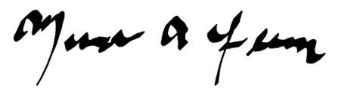
Michael A. Feeney, B.Pharm, R.Ph., J.D., C.H.O.
Director, Indoor Air Quality Program

cc: Jan Sullivan, Deputy Bureau Director, BEH
MaryAnn O’Connor, Health Director, City of Medford (electronic copy)

Enclosure(s)

The service life is the median time during which a particular system or component of [an HVAC] system remains in its original service application and then is replaced. Replacement may occur for any reason, including, but not limited to, failure, general obsolescence, reduced reliability, excessive maintenance cost, and changed system requirements due to such influences as building characteristics or energy prices (ASHRAE, 1991).

