**Medication Assisted Treatment Commission**

*Established by Section 103 of Chapter 208 of the Acts of 2018*

*October 1, 2019*

## Table of Contents

1. **Commission Overview**

* Commission Charge
* Work of the Commission
* Key Definitions
* Commission Members
* Summary of Commission Meetings and Presentations

1. **Overview of the Ongoing Opioid Crisis**

* Impact on the Nation and the Commonwealth

1. **Commission’s Findings**
2. **Commission’s Recommendations**
3. **Appendices**
4. Legislative Mandate
5. Resources Reviewed by the Commission
6. Presentations from Meetings

## Commission Charge

* The Medication Assisted Treatment (MAT) Commission was established in Section 103 of Chapter 208 of the Acts of 2018[1], also known as the CARE Act, as follows:

1. There shall be a special commission to study and make recommendations regarding the use of medication-assisted treatment for opioid use disorder in the commonwealth, including methadone, buprenorphine and injectable long-acting naltrexone.
2. The commission shall: (i) create aggregate demographic and geographic profiles of individuals who use medication-assisted treatment; (ii) examine the availability of and barriers to accessing medication-assisted treatment, including federal, state and local laws and regulations; (iii) determine the current utilization of, and projected need for, medication-assisted treatment in inpatient and outpatient settings, including, but not limited to, inpatient and residential substance use treatment facilities, inpatient psychiatric settings, pharmacy settings, mobile settings and primary care settings; (iv) identify ways to expand access to medication-assisted treatment in both inpatient and outpatient settings; (v) identify ways to encourage practitioners to seek waivers to administer buprenorphine to treat patients with opioid use disorder; (vi) study the availability of and concurrent use of behavioral health therapy for individuals receiving medication-assisted treatment; and (vii) study other related matters.
3. The commission shall consist of 19 members: the commissioner of public health or a designee, who shall serve as chair; the executive director of the health policy commission or a designee; the director of Medicaid or a designee; the house and senate chairs of the joint committee on mental health, substance use, and recovery or their designees; the ranking house and senate minority members of the joint committee on mental health, substance use and recovery or their designees; 3 representatives appointed by the commissioner of public health, 1 of whom shall be a representative of community health centers, 1 of whom shall be a primary care provider with experience providing medication-assisted treatment, and 1 of whom shall be an expert in substance use disorder treatment; and 1 representative of each of the following 9 organizations: the Massachusetts Medical Society; the Massachusetts Health and Hospital Association, Inc.; the Association for Behavioral Healthcare, Inc.; the Massachusetts Association of Behavioral Health Systems, Inc.; the Massachusetts Association of Health Plans, Inc.; Blue Cross Blue Shield of Massachusetts, Inc.; the Massachusetts Pharmacists Association; Advocates for Human Potential, Inc.; and the Massachusetts Organization for Addiction Recovery, Inc.
4. The commission shall file a report on its findings and recommendations, together with any recommendations for legislation, with the clerks of the house of representatives and the senate no later than 1 year from the effective date of this act.

## The Work of the Commission

* In developing its findings, the Commission was charged with creating aggregated demographic and geographic profiles of individuals who use MAT, the barriers to accessing MAT, the utilization of and projection of need of MAT, the exemption of MAT and how to encourage practitioners to administer MAT and the concurrent use of behavioral health therapy for individuals receiving MAT.
* The Commission’s findings initially were to be submitted to the Legislature by August 9, 2019. However, to further hone its findings recommendations the Commission requested an legislative extension to October 1, 2019.
* The Commission met six times from January 2019 through September 2019. All meetings were subject to the open meeting law and minutes were taken and approved for each meeting. Copies of all presentations, reading materials requested and considered by the Commission, and minutes from each meeting are posted on a publicly available webpage: <https://www.mass.gov/orgs/medication-assisted-treatment-mat-commission>.
* Based on input from individual Commission members, presentations and panel discussions were organized and delivered by individuals who are knowledgeable about subjects specified in the Commission’s charges, listed in the previous slide.
* The Commission’s overall findings are based on the presentations, resources shared, and discussions that occurred during its meetings, which can be found on the Commission’s [webpage](https://www.mass.gov/orgs/medication-assisted-treatment-mat-commission).
* The following table provides a summary of all meetings, with names of presenters, topics discussed, and links to copies of all presentations. This complete list is available on the Commission’s [webpage](https://www.mass.gov/orgs/medication-assisted-treatment-mat-commission).
* Per the charge of the Commission, only MAT for opioid use disorder (OUD) were reviewed.

## Key Definitions (According to the American Society for Addiction Medicine)

**Medication Assisted Treatment (MAT)[2]**

* A variation on the concept of Medication Assisted Recovery (MAR), may involve pharmacotherapy alone. It is essential that addiction treatment and recovery approaches address the various aspects of biological, psychological, social and spiritual dimensions for optimum health and wellness. It is hoped that as the public and professionals recognize that recovery and treatment need to be holistic, appropriate pharmacotherapy would be well accepted as part of treatment and recovery, such that the terms MAR and MAT would be deemed unnecessary.

**Medications[3]**

* There are three medications commonly used to treat opioid addiction:
* Methadone (mu-agonist): Methadone is a slow-acting opioid agonist. Methadone is an effective treatment for opioid withdrawal management and the treatment of opioid use disorder. Methadone is taken orally so that it reaches the brain slowly, dampening the euphoria that occurs with other routes of administration while preventing withdrawal symptoms. Methadone is only available through approved OTPs, where it is dispensed to patients on a daily or almost daily basis in the initial stages of treatment
* Buprenorphine (partial mu-agonist): Buprenorphine is recommended for the treatment of opioid use disorder. Buprenorphine relieves drug cravings without producing the euphoria or dangerous side effects of other opioids. In addition to its pharmacological properties, an important feature of buprenorphine is its ability to be prescribed in office-based treatment settings.
* Naltrexone (antagonist): Naltrexone is a long-acting opioid antagonist that may be used to prevent relapse to opioid use. Naltrexone blocks the effects of opioids if they are used. Naltrexone is available in oral and extended-release injectable formulations in office-based treatment settings.

**Addiction[4]**

* Addiction is a primary, chronic disease of brain reward, motivation, memory, and related circuitry. Dysfunction in these circuits leads to characteristic biological, psychological, social, and spiritual manifestations. This is reflected in an individual pathologically pursuing reward and/or relief by substance use and other behaviors. Addiction is characterized by inability to consistently abstain, impairment in behavioral control, craving, diminished recognition of significant problems with one’s behaviors and interpersonal relationships, and a dysfunctional emotional response. Like other chronic diseases, addiction often involves cycles of relapse and remission. Without treatment or engagement in recovery activities, addiction is progressive and can result in disability or premature death.

**Outpatient Treatment Program (OTP)[5]**

* Licensed and accredited opioid agonist treatment programs, often called methadone maintenance treatment (MMT) programs, are currently authorized to dispense methadone and buprenorphine in highly structured protocols defined by Federal and State law. Those medications have been approved for this indication and if the physician has “the capacity to refer the patients for appropriate counseling and other appropriate ancillary services”.

**Office-Based Opioid Treatment (OBOT)[6]**

* OBOT commonly refers to outpatient treatment services provided outside of licensed OTPs by clinicians to patients with addiction involving opioid use, and typically includes a prescription for the partial opioid agonist buprenorphine, the provision of naltrexone, or the dispensing of methadone, in concert with other medical and psychosocial interventions to achieve and sustain remission.

## MAT Commission Members

|  |  |
| --- | --- |
| **Name** | **Title / Affiliation** |
| **Monica Bharel, MD, MPH** | Commissioner, Department of Public Health |
| **Hannah Kloomok** | Health Policy Commission |
| **Peg Harvey** | MassHealth |
| **Adam Stoler** | MassHealth |
| **Dan Ryan** | Massachusetts State Representative |
| **William Crocker** | Massachusetts State Representative |
| **Cindy F. Friedman** | Massachusetts State Senator |
| **Holly Oh, MD** | Dimock, Community Health Center |
| **Sarah Wakeman, MD** | Massachusetts General Hospital, Primary Care Provider with MAT experience |
| **Kenneth Duckworth, MD** | Blue Cross Blue Shield Insurance |
| **Jared Owens** | Massachusetts Organization for Addiction Recovery |
| **Andrew Klein, MD** | Advocates for Human Potential |
| **Joji Suzuki, MD** | Brigham and Women's Hospital, Substance Use Disorder Expert |
| **Dennis Dimitri, MD** | Massachusetts Medical Society |
| **Leigh Youmans** | Massachusetts Health & Hospital Association |
| **Vic DiGravio** | Association of Behavioral Healthcare |
| **Jeff Hillis** | Massachusetts Association of Behavioral Health |
| **Elizabeth Ross, MD** | Tufts Health Plan, Massachusetts Association of Health Plans |

## Summary of Meetings and Input Provided to the Commission

**January 24, 2019**

* Commissioner Bharel, Chair
  + Discussion of the Commission’s charges, members’ expectations and baseline overview of MAT

**March 19, 2019**

* Hilary Smith Connery, MD, PhD, Clinical Director, Substance Use Disorders Division, McLean Hospital
  + Study of the availability of and concurrent use of behavioral health therapy for individuals receiving MAT
* Consumer Panel
  + Learning from those with lived experiences
* Siva Sundaram and Mubeen Shakir, Policy Fellows, DPH
  + DPH overview of barriers to MAT

**May 21, 2019**

* Hermik Babakhanlou-Chase, Len Young, Elizabeth Erdman, Bureau of Substance Addiction Services, DPH
  + Discussion and review of data from DPH
* David Seltz, Executive Director, Health Policy Commission (HPC)
  + Discussion and review of data from HPC
* Adam Stoler, Manager of Addiction Treatment Services, MassHealth
  + Discussion and review of data from MassHealth

**July 30, 2019**

* Commissioner Bharel, Chair
  + Discussion of the Commission’s draft report, initial findings, and preliminary recommendations

## Overview of the Ongoing Opioid Crisis

**A National Epidemic**

* In the United States (U.S.), there were 70,237 overdose deaths in 2017, a 9.6% increase from the previous year. More than two-thirds of those deaths (~47,600) were opioid-related
* Accidental opioid overdose deaths now exceed deaths from motor vehicle accidents and deaths from firearms in the U.S.[7]
* The federal government declared the opioid crisis a public health emergency on October 26, 2017.
* The introduction of illegally manufactured synthetic opioids, such as fentanyl, is one of the primary drivers of the spike in overdose deaths
* The effect of fentanyl on the body is quicker than heroin; overdoses can occur within minutes of ingestion
* In addition to fatal overdose, other individual consequences include neurological damage caused by non-fatal overdose, infectious disease spread through needle sharing, and soft-tissue infection.

**National Drug Overdose Deaths: among all ages, by gender, 1999-2017.**

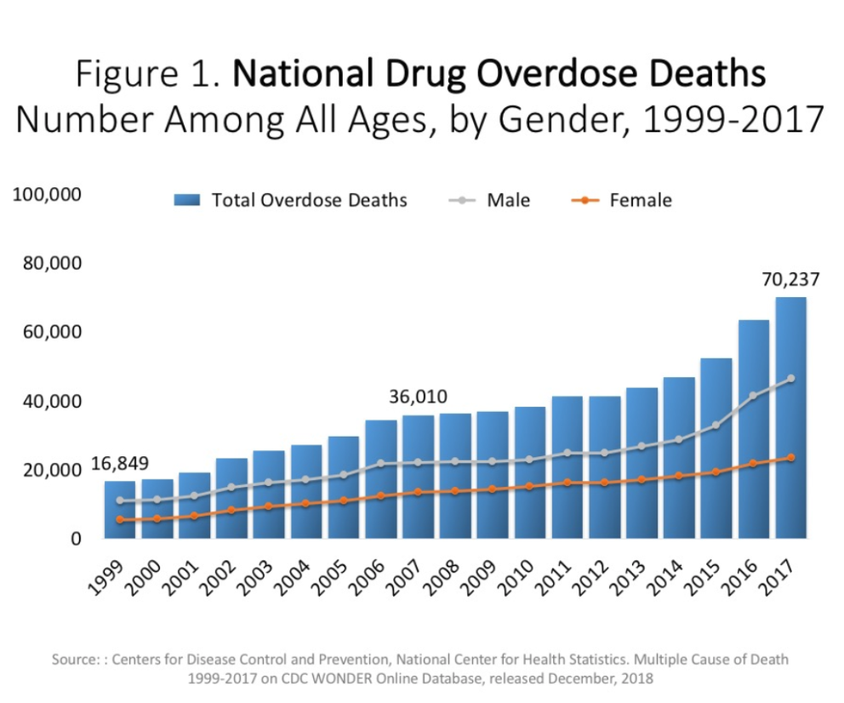

**There are three waves of the rise in opioid overdose deaths**

Wave 1: Rise in Prescription Opioid Overdose Deaths (1999-2010);
Wave 2: Rise in Heroin Overdose Deaths (2010-2016);
Wave 3: Rise in Synthetic Opioid Overdose Deaths (2013-Present)


**Fentanyl remains a key factor in opioid-related overdose deaths (92% present in toxicology screen)**

This chart illustrates that fentanyl remains a key factor in opioid-related overdose deaths, present in 92% of toxicology screens; fentanyl presence began increasing rapidly in 2014.

**Preliminary data show 938 confirmed and estimated opioid-related overdose deaths in the first six months of 2019, reflecting an 11% decline over the same period in 2018**

Preliminary data show 938 confirmed and estimated opioid-related overdose deaths in the first six months of 2019, which reflects an 11% decline over the same period in 2018.

**There was some clustering of cities and towns that experienced notable increases or decreases in opioid-related overdose deaths between 2017 and 2018**

Municipalities which saw an increase: Barnstable, Chicopee, Framingham, Gardner, Holyoke, Lawrence, Lowell, Marlborough, Springfield, Worcester.

Municipalities which saw a decrease: Attleboro, Brockton, Falmouth, Lynn, Medford, Peabody, Weymouth.

Note: A notable change was defined as having an absolute difference of 10 or more occurence or residence opioid-related overdose deaths between 2017 and 2018 and at least a 20% change during that period.

## Overall Findings

**Access to Buprenorphine – percentage of Massachusetts city/town residents receiving buprenorphine**

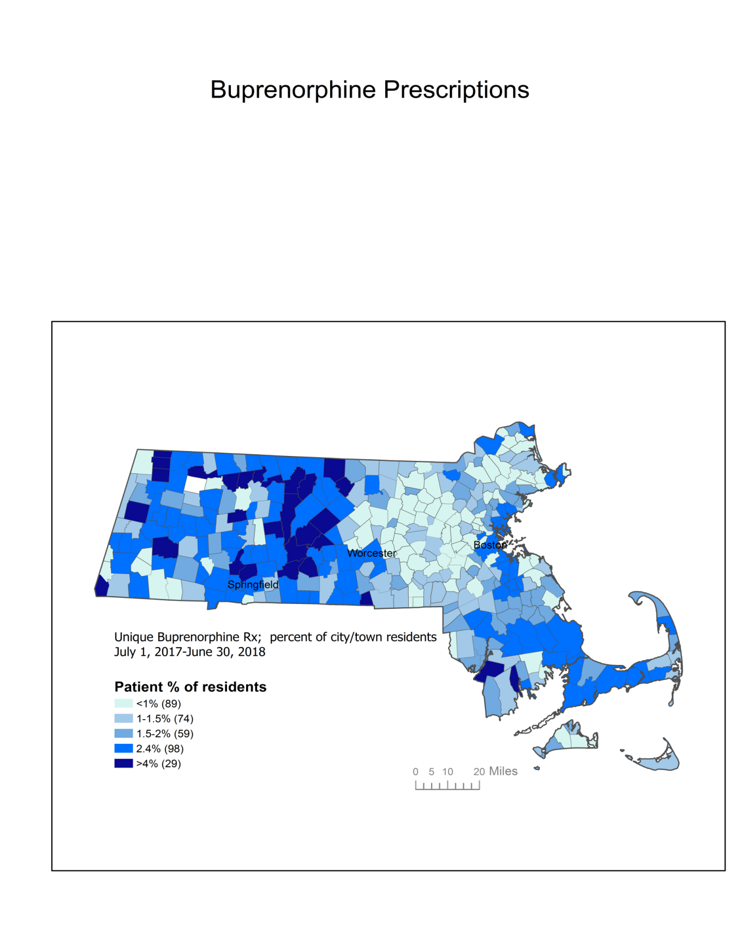

**Drug Addiction Treatment Act (DATA) waiver capacity in Massachusetts, by city/town[8]**

**This chart illustrates practitioner capacity for prescribing buprenorphine July 1, 2017-June 30, 2018.

Practitioner Capacity is defined as the number of unique patients receiving buprenorphine/sum of individual patient limits.

Practitioners with the most available capacity (<25%) are clustered in the metro Boston area, South Shore, North Shore, Metro-West, and Worcester areas.

Practitioners with the least available capacity (>75%) are clustered in Western Massachusetts, Central Massachusetts, South Coast, and the Cape and Islands.**

**DATA waiver capacity and suspected overdose rates in Massachusetts, by city/town in FY18[9]**

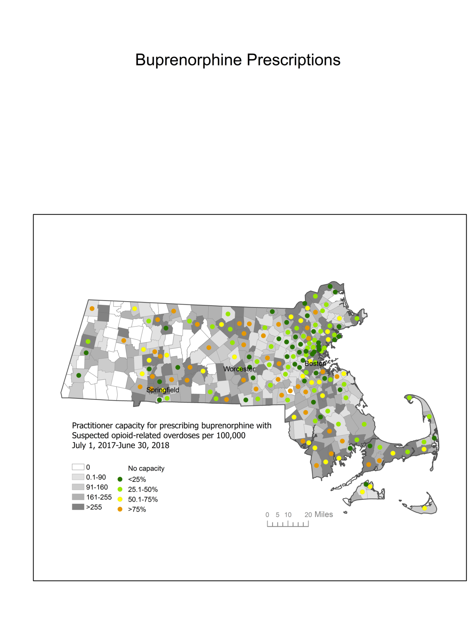

**Access to Methadone – locations across Massachusetts**

**Number of opioid treatment programs by EOHHS regions:
Boston: 6
Central: 7
Metro-West: 5
Northeast: 8
Southeast: 9
Western: 8
Total: 43.**

**Access to Naltrexone – locations across Massachusetts**

Naltrexone proviers by EOHHS region (including outpatient programs - both main and satellite, OTPs, and OBOTs):
Boston: 26
Central: 26
Metro-West: 23
Northeast: 19
Southeast: 28
Western: 38

**MAT Cost Comparison: MassHealth members on MAT have lower cost of care and have lower rates of overdose[10]**

**This chart illustrates the cost comparisons between those on any MAT ($21,329), MAT adherent ($20,801), or no MAT at all ($25,197). 

Note: overdoses in the "any MAT" and "MAT adherent" categories were after starting MAT treatment; adherence is defined as MPR>=0.8.**

* Members who are on MAT have fewer overdoses and have a lower cost of care
* Adherence to MAT shows a further decrease in overdoses and cost of care

## Commission’s Findings

**Charge 1: Create aggregate demographic and geographic profiles of individuals who use medication assisted treatment**

* General data is available, but existing data on subgroups needs to be expanded, as there is not enough demographic data
* Existing data on who is accessing and where they are receiving treatment is limited
* DPH presentation on Buprenorphine Provider Capacity in Massachusetts Cities and Towns – [linked here](https://www.mass.gov/doc/may-21-2019-mat-commission-presentation-dph/download)
* DPH Bureau of Substance Addiction Services (BSAS) presentation on Treatment Statistics From Programs Reporting to BSAS presentation on data – [linked here](https://www.mass.gov/doc/may-21-2019-mat-commission-presentation-dph-bsas/download)
* MassHealth presentation on MassHealth Medication Assisted Treatment Analysis – [linked here](https://www.mass.gov/doc/may-21-2019-mat-commission-presentation-masshealth/download)
* Health Policy Commission (HPC) presentation on Research and Programs to Expand the Availability of Evidence-Based Behavioral Health Care Treatment – [linked here](https://www.mass.gov/doc/may-21-2019-mat-commission-presentation-health-policy-commission/download)

**Charge 2: Examine the availability of and barriers to accessing medication-assisted treatment, including federal, state and local laws and regulations**

* DPH presentation on Barriers to Improve MAT Access – [linked here](https://www.mass.gov/files/documents/2019/03/22/MAT-Commission-Presentation-3-19.pdf)
* Federal buprenorphine waiver law requires 8 additional hours of training for Medical Doctors (MDs) and 24 hours for Nurse Practitioners (NPs) and Physician Assistants (PAs), unlike other medications
  + *Progress: As of 2019, all medical school graduates in Massachusetts are waiver trained*
* Patients are lost after emergency department visit due to no induction of MAT available or linkage to community-based treatment
  + *Progress: CARE Act requires MAT induction be available in emergency departments –* [*linked here*](https://malegislature.gov/Laws/SessionLaws/Acts/2018/Chapter208)
* Access to MAT for incarcerated individuals is insufficient and often not all 3 MAT are available at all jails and prisons
  + *Progress: CARE Act requires that 3 forms of MAT be available in specific facilities; data is at early stages because the implementation date is September 2019*
* State regulations for OTPs take-homes are stricter than federal regulations
  + *Progress: BSAS regulations are currently under review and are proposing to align state take-home limits with federal guidelines*
* Unclear/misinterpreted regulations lead to treatment delays and/or insufficient treatment for patients or lack offering all MAT
  + *Progress: BSAS regulations are currently under review and will be open for public comment in Fall/Winter 2019*
* Laboratory testing requirements can delay care and are confusing to providers
  + *Progress: BSAS regulatory amendments provide flexibility for testing as clinically indicated*
* Certain areas of Massachusetts are historically underserved due to workforce staffing shortages
* There is often local opposition to OTP/OBOT siting
* Insurance issues can create fragmented care and coverage due to clients’ lack of understanding of health benefits
* Lack of MAT capacity for initiation/stabilization and on-going treatment
* Insufficient referral network for both people who need stabilization and who are stabilized
* Methadone dosing hours are typically limited to the morning, limiting availability for clients
* DATA waived prescribers are clustered in certain parts of the state and there is a great need for these services in rural Massachusetts
* DATA waived prescribers in urban areas have additional patient capacity for providing buprenorphine

**Charge 3: Determine current utilization of, and projected need for, medication assisted treatment in inpatient and outpatient settings, including, but not limited to, inpatient and residential substance use treatment facilities, inpatient psychiatric settings, pharmacy settings, mobile settings and primary care settings**

* The highest percentages of buprenorphine patients per capita are on the South Coast, including Fall River and New Bedford, and in Central and Western Massachusetts, including Holyoke, Chicopee, Pittsfield, Northampton, and North Adams; please see map on page 16 for greater detail
* Practitioner capacity for prescribing buprenorphine is highest on the South Coast, South Shore, and in Central and Western Massachusetts, with pockets on the North Shore and Cape Cod; please see map on page 17 for greater detail
* In some areas, patients need to travel long distances to access services
* Federal moratorium on mobile OTP clinics limits availability of services, impacting more rural parts of the state
* SAMHSA treatment directory is limited and providers are able to opt out; there is a need for a more robust and thorough provider directory to increase awareness among providers and patients about who is able to prescribe buprenorphine
* Limited access to methadone
* Federal barriers to access, capacity, and limitations to OTPs
* Prescribers are not prescribing MATs to their waiver limit
* No easy access for patients or providers to find a prescriber
* Pharmacy barriers to accessing MAT
* Stigma around healthcare professionals: General Electric (GE), Rize, and Shatterproof released a survey on Massachusetts Healthcare Professionals and Stigma around Screening, Treating Patients with Opioid Use Disorder – [linked here](https://www.ge.com/reports/genewsroom/ge-foundation-partners-release-survey-on-massachusetts-healthcare-professionals-and-stigma-around-screening-treating-patients-with-opioid-use-disorder/)

**Charge 4: Identify ways to expand access to medication-assisted treatment in both inpatient and outpatient settings**

* Capacity of health care providers implementing high-quality addiction treatment within primary care settings in Massachusetts is somewhat limited
* Hospital settings are underutilized for initiating MATs
  + *Progress: In January 2019, the Massachusetts Health and Hospital Association (MHA) released MAT guidelines –* [*linked here*](https://patientcarelink.org/improving-patient-care/substance-use-disorder-prevention-treatment-2/)
  + *Progress: In July 2019, 12 Hospitals in Boston and Cambridge signed a commitment to provide mandatory Substance Use Disorder (SUD) training to all of their hospital-based physicians and residents in key departments –* [*linked here*](https://www.mhalink.org/MHA/MyMHA/Communications/MondayReportItems/Content/2019/07-22/Items/Hospitals-addressing-SUD.aspx)
* Some patients have difficulty accessing medication when they decide to access treatment and may be turned away and lost
* Not every model works for every patient due to personal choice or situation and patient demographic; patients also require care continuum improvements, especially during induction period
* Providers are worried about treating SUDs in their practice due to stigma and so are not waivered/do not use their waiver
* Patients seeking MAT cannot afford copays or deductibles
* Reimbursement rates for pre-independently licensed master level clinicians varies across payer type
* Workforce challenges are a major factor in treatment access across the Commonwealth; there is a lack of trained workers across the behavioral health spectrum, including licensed clinicians (LMHC, LICSW)

**Charge 5: Identify ways to encourage practitioners to seek waivers to administer buprenorphine to treat patients with opioid use disorder**

* Buprenorphine waiver law requires 8 additional hours of training for MD and 24 hours for NP and PA unlike any other medication
* Providers cite waiver training difficult to attend due to high cost of missed work day at their place of practice
  + *Progress: As of 2019, medical school graduates in Massachusetts are waiver trained*
* Nurse Practitioners and Physician Assistants do not get waivered due to large number of hours required for waiver despite similar training as physicians
* Doctors are not always proactively seeking DATA waiver to meet demand
  + *Progress: 12 Hospitals in Boston and Cambridge signed a commitment to provide mandatory SUD training to all of their hospital-based physicians and residents in key departments –* [*linked here*](https://www.mhalink.org/MHA/MyMHA/Communications/MondayReportItems/Content/2019/07-22/Items/Hospitals-addressing-SUD.aspx)

**Charge 6: Study the availability of and concurrent use of behavioral health therapy for individuals receiving medication-assisted treatment**

* Keeping patients in treatment and adherent with OUD pharmacotherapy appears to drive positive outcomes; however, patients often have treatment discontinued for missing counseling sessions despite being adherent with their medication
* There is not a one-size-fits all approach, there needs to be more of a shift towards individualized treatment planning
* MATs are easy to induce, but difficult to keep patients on
* There are not enough health professionals who are able to treat co-occurring disorders,
* *Progress: Health Policy Commission (HPC) presentation on Research and Programs to Expand the Availability of Evidence-Based Behavioral Health Care Treatment –* [*linked here*](https://www.mass.gov/files/documents/2019/05/22/HPC-Presentation-to-MAT-Commission-May-21.pdf)
* Patients treated with medications for OUD can benefit from individualized psychosocial supports; these can be offered by patients’ healthcare providers in the form of medication management and supportive counseling and/or by other providers offering adjunctive addiction counseling, recovery coaching, mental health services, and other services that may be needed by particular patients[11]
* Lack of availability should not limit access to MAT
* Counseling keeps people in treatment, but there is not any specific type of counseling that is best

## Commission’s Recommendations

1. Examine ways to encourage more provider participation in DPH/BSAS data collection efforts
2. Examine the feasibility of collecting data related to age, race, ethnicity, language, etc.
3. Conduct buprenorphine mapping project and pair with results of GE/Rize/Shatterproof provider survey and use PMP system for Buprenorphine prescriptions to better understand geographic prescribing practices
4. Examine Physician Assistant (PA) and Advanced Practice Registered Nurse (APRN) school requirements and residency requirements in Massachusetts and consider requiring education at waiver level for graduates, as we do for medical students
5. Review successful pilots of engagement, stabilization, and referral models for all forms of MAT as well as pilots currently finding success in MAT for high risk populations, including new and innovative forms and models
6. Support technical assistance for emergency departments providing induction to MAT
7. Encourage the establishment of hospital-based bridge clinics, i.e. on demand treatment and referral
8. Study the rollout of the current implementation of MAT in correctional facilities as well as the expansion of implementing MAT programs to all correctional facilities in Massachusetts
9. Develop statewide partnerships between OTPs, acute medical settings, criminal justice settings
10. Evaluate claims or other available data to access availability of all forms of MATs in the state
11. Consider providing incentives and technical assistance for OBOTs to become OTP licensed
12. Examine potential incentives for programs able to offer a certain number of on-demand prescriber days
13. Expand the availability of afternoon dosing hours at OTPs and consider providing incentives to OTPs that expand afternoon hours
14. Study the feasibility of allowing Acute Treatment Services (ATS) and Clinical Stabilization Services (CSS) to provide MAT maintenance on outpatient basis
15. Study the feasibility of expanding ECHO (Extension for Community Healthcare Outcomes) services that 1) provide training and technical assistance and opportunities for consultation to providers statewide; and 2) support OBOT by physicians in the community
16. Publicize allowance by MassHealth to utilize telemedicine, which is currently underutilized
17. Encourage commercial payers to follow MassHealth’s lead regarding telemedicine
18. Conduct outreach campaign to medical, criminal justice, and recovery communities regarding stigma in providing MAT and highlighting evidence demonstrating efficacy of MATs
19. Create loan forgiveness and repayment programs for masters and doctoral level clinicians specifically working in MAT, who also work in high-need areas with underserved populations
20. Review the feasibility of license reciprocity
21. Advocate for end of DATA waiver requirement at federal level
22. Work with municipalities on siting of new addiction services in underserved areas
23. Review regulations requiring counseling for those receiving treatment and examine the feasibility of changing to individualized treatment planning
24. Explore new payment approaches for 24 hour care (e.g. ATS, CSS) to incent initiation and continuation of MAT
25. Explore strategies for increasing provision of MAT in primary care settings
26. Encourage supporting a workforce which reflects the vulnerable and high-risk populations being served
27. Explore the feasibility of developing a patient facing treatment provider locator website tool
28. Disincentive discharges from treatment for minor infractions
29. Explore the model of pharmacists dispensing and monitoring MAT in conjunction with prescribers to increase access
30. Review Federal DEA requirements regarding methadone to explore potential changes, examine access to methadone in Massachusetts by identifying gaps and areas of need and provide recommendations to expand access
31. Identify culturally competent programming for underserved populations
32. Identify incentives for prescribers to be DATA-waivered
33. Explore models of patient-centered care to retain patients in treatment

## Appendix A: Legislative Mandate

The Commission must:

* create aggregate demographic and geographic profiles of individuals who use medication-assisted treatment;
* examine the availability of and barriers to accessing medication-assisted treatment, including federal, state and local laws and regulations;
* determine the current utilization of, and projected need for, medication-assisted treatment in inpatient and outpatient settings, including, but not limited to, inpatient and residential substance use treatment facilities, inpatient psychiatric settings, pharmacy settings, mobile settings and primary care settings;
* identify ways to expand access to medication-assisted treatment in both inpatient and outpatient settings;
* identify ways to encourage practitioners to seek waivers to administer buprenorphine to treat patients with opioid use disorder;
* study the availability of and concurrent use of behavioral health therapy for individuals receiving medication-assisted treatment;
* study other related matters

## Appendix B: Resources Reviewed by the Commission

* [Manual for Standard Medical Management of Opioid Dependence with Buprenorphine](https://www.mass.gov/files/documents/2019/03/22/SMM-manual-revised-2005-09-23-for-CTN30.pdf), by David A. Fiellin, MD, Michael V. Pantalon, PhD, Richard S. Schottenfeld, MD, Lynn Gordon, RN, MPA, Patrick G. O’Connor, MD, MPH
* [Standard Medical Management Medical Clinician Checklist](https://www.mass.gov/files/documents/2019/03/22/SMM-clinician-checklist-progress-note.pdf)
* [Medications for Opioid Use Disorder Saves Lives](https://www.nap.edu/read/25310/chapter/1), by Alan I. Leshner, PhD, Michelle Mancher, MPH

Appendix C: Presentations from Meetings

**January 24, 2019**

* [Addressing Opioid Overdose and Opioid Use Disorder: Medication-Based Treatment Approaches](https://www.mass.gov/files/documents/2019/02/04/Walley-MAT-Commission-190124.pdf), by Alexander Walley, MD, MSc

**March 19, 2019**

* [DPH - Precision Public Health: Update on the Public Health Data Warehouse/Chapter 55](https://www.mass.gov/files/documents/2019/03/22/Stimulants-and-PHD-Data-Brief-for-PHC.pdf), by Commissioner Monica Bharel, MD, MPH
* [The evidence-based role for counseling with opioid use disorder pharmacotherapy](https://www.mass.gov/files/documents/2019/03/22/Connery-2019-counseling-with-MAT-for-OUD.pdf) , by Hilary Connery, MD, PhD
* [DPH - Initiatives to Improve Barriers to MAT Access](https://www.mass.gov/files/documents/2019/03/22/MAT-Commission-Presentation-3-19.pdf), by Siva Sundaram and Mubeen Shakir

**May 21, 2019**

* [DPH - Buprenorphine Provider Capacity in Massachusetts cities and towns](https://www.mass.gov/doc/may-21-2019-mat-commission-presentation-dph/download), by Elizabeth Erdman, MS, Leonard Young, MS
* [DPH - MAT Commission Treatment Statistics from Programs Reporting to BSAS](https://www.mass.gov/files/documents/2019/05/22/MAT-Commission-BSAS-Treatment-Stats-05202019.pdf), by Hermik Babakhanlou-Chase, MPH
* [MassHealth - Medication Assisted Treatment Analysis](https://www.mass.gov/files/documents/2019/05/22/MAT-Slides-5-21-MassHealth.pdf), by Peg Harvey, PsyD, Adam Stoler
* [Health Policy Commission - Research and Programs to Expand the Availability of Evidence-Based Behavioral Health Care Treatment](https://www.mass.gov/files/documents/2019/05/22/HPC-Presentation-to-MAT-Commission-May-21.pdf), by David Seltz

1. <https://malegislature.gov/Laws/SessionLaws/Acts/2018/Chapter208>
2. <https://www.asam.org/advocacy/find-a-policy-statement/view-policy-statement/public-policy-statements/2014/08/01/terminology-related-to-addiction-treatment-and-recovery>
3. <https://www.asam.org/docs/default-source/practice-support/guidelines-and-consensus-docs/asam-national-practice-guideline-supplement.pdf>
4. <https://www.asam.org/docs/default-source/public-policy-statements/1definition_of_addiction_short_4-11.pdf?sfvrsn=6e36cc2_0>
5. <https://www.asam.org/docs/default-source/public-policy-statements/1obot-treatment-7-04.pdf?sfvrsn=0>
6. <https://www.asam.org/docs/default-source/public-policy-statements/1obot-treatment-7-04.pdf?sfvrsn=0>
7. [https://injuryfacts.nsc.org/all-injuries/preventable-death-overview/odds-of-dying](https://injuryfacts.nsc.org/all-injuries/preventable-death-overview/odds-of-dying/)
8. Practitioner capacity is defined as the number of unique patients receiving buprenorphine/sum of individual patient limits.
9. Suspected opioid-related overdoses from MATRIS July 1, 2017-June 30, 2018.
10. Overdoses in the “Any MAT” and “MAT adherent” categories were after starting MAT treatment. Adherence is defined as MPR >= 0.8.
11. [https://www.ncbi.nlm.nih.gov/books/NBK535275 /](https://www.ncbi.nlm.nih.gov/books/NBK535275%20/)