 | Welcome Family Statewide Expansion Advisory Committee Massachusetts Department of Public Health
Meeting: July Meeting: Building Awareness of Welcome Family in Communities
Date: July 13, 2026 | Start/End Time: 2-3 PM EST

Attendees:
Member |  | Attendance (yes/no)
Betti | Samantha | Yes
Blessington | Rachel | No
Caffrey | Susan | Yes
Curry | Suzanne | No
Daftary | Genevieve | No
Daniels, Jr. | Charles | No
Duff | Laura | Yes
Frias | Damaris | Yes
Gago | Cristina | Yes
Hamblin | Cherise | Yes
Horgan | Cindy | Yes
Jones | Alexandria | Yes
Kim | Kira | No
Laflamme | Elise | Yes
Lara-Cahoon | Olivia | Yes
Lichir | Asmae | No
Manning | Meg | No
Martin | Jessica | Yes
McCall | Lori | No
Milne | Isabelle | No
Morrissey | Deirdre | Yes
Nalubega | Shanish | Yes
Teixeira | Lisa | Yes
Urban | Breanna | No
Valdman | Olga | Yes
Whetzel | Leona | No

Agenda
# | Topic | Notes
1 | Introduction | - PCG presenters noted that a summary of Advisory Committee input and questions received during June's meeting have been included in this month’s slide deck and encouraged members to review those slides when they are posted.  - The state presented updates to members about the FY27 budget recently signed by Governor Healy and implications for Welcome Family statewide expansion.
2 | Advisory members were asked to respond to the following Chat Waterfall prompt:  What are the most important characteristics of a community system that helps families get connected to services and meets families’ needs? | Response Summary  - Reliability of the system: access to services for all, capacity of system to service those who want it, adequate staffing to achieve capacity, evidence-based models underlying the programs.  - Trust: cultural ‘competence’ and humility, services in the languages spoken by a community, staff that is from or reflects the community being served.  - Access: Families know the service is minimal or no cost, systems to engage in services are easy to navigate  - Funding: Adequate funding to fully staff programs and support communications in communities and across providers within systems of care.
3 | Advisory members completed a Mentimeter exercise to foster discussion, the first prompt was:  What is one practice that strengthens referral partnerships?​  The second prompt was:  What tells you a system of care is working well for families? | Each member was asked to limit their response to 1-3 words.  1st Prompt: What is one practice that strengthens referral partnerships?​  - Strong Relationships: Connections, personal connections, collaborations, meetings, ongoing relationships, cross-team activities  - Effective Communication: Communication, regular communication, feedback loops, closed-loop communication, follow-up calls, shared data systems  - Efficient Referral Processes: Standardized referrals, online referrals, warm handoffs, referral feedback  - Reliability & Follow-Through: Consistency, repetition, follow through  - Mutual Benefit: Clear benefit, benefit for both, appreciation  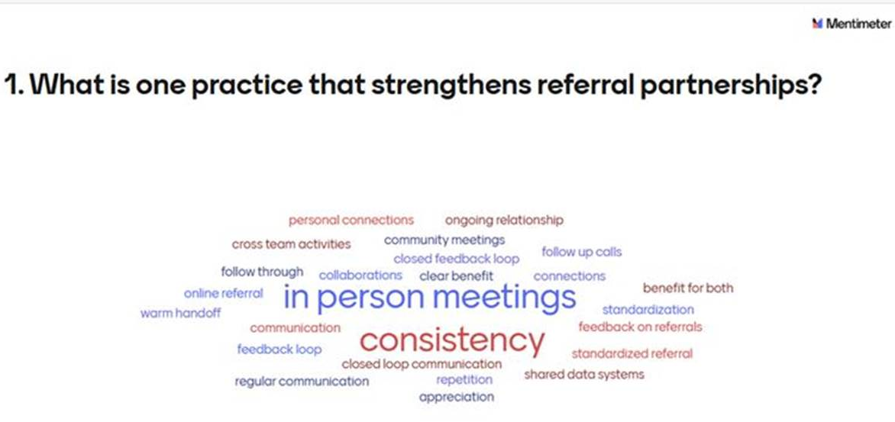  2nd Prompt  - Positive Outcomes & Impact: Positive outcomes, meeting set goals, seamless service delivery, improvement, fewer canceled visits  - Client Satisfaction: Positive feedback, family feedback, family feedback surveys, feedback from families, user reviews  - Community Trust & Referrals: Word-of-mouth referrals, families referring others, people asking for referrals  - Access & Equitable Engagement: Diverse families engaged, equitable reach, data on connections  - Service Quality & Responsiveness: Timeliness, reliable service delivery, reduced missed or canceled visits  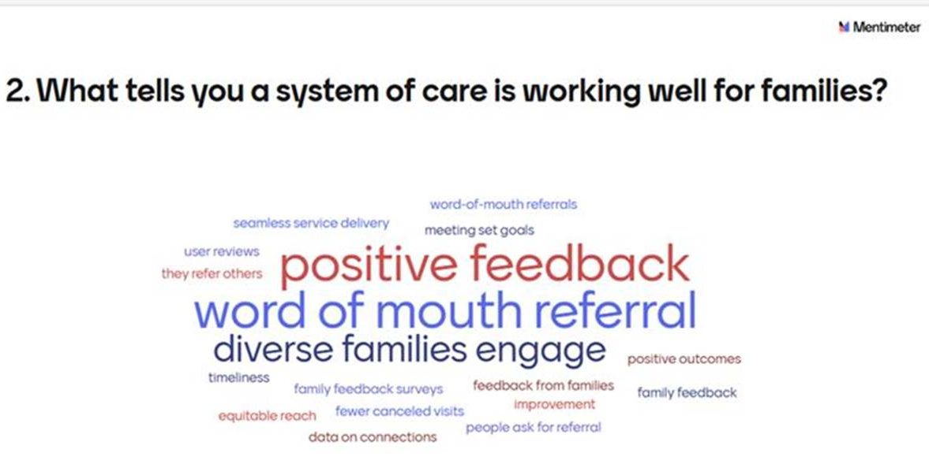  - Mentimeter survey results highlighted the importance of supporting consistent, ongoing, and effective communication between Welcome Family programs and community-based service providers to strengthen local partnerships.  - Survey participants also emphasized the value of in-person meetings and convenings that bring organizations together to build relationships, strengthen partnerships, and enhance collaboration.  - Members inquired about participant feedback mechanisms. The state confirmed that a participant experience survey is administered and noted that families are also asked about their experience during the 2 to 3 week follow-up phone call after each Welcome Family visit.  - Members requested information on the participant experience survey response rate to better understand the representativeness of the feedback collected.  - Members discussed potential survey bias and suggested including questions about what could have gone better during the Welcome Family visit to encourage constructive feedback and identify opportunities for program improvement. The state believes there is a question like this in the existing survey and will confirm with members.  - Members questioned whether a 2 to 3 week follow-up period is sufficient to assess referral effectiveness. The state explained that follow-up calls track multiple referral outcomes, including whether contact has been established between the family and the referred organization, even when access to services may still be pending.
4 | Advisory members engaged in large group Discussion and were asked the following questions:  - Which partnership-building activities should be locally designed?  - Which partnership-building activities should be standardized statewide?  - What barriers most often disrupt referral partnerships? | - Members emphasized that partnership-building should be locally driven, using strategies such as personalized outreach, in-person meetings, resource fairs, and regular communication.  - Strong community partnerships were viewed as essential to program success. Members noted that Welcome Family providers who are selected in new regions should have existing community connections and strong knowledge of local resources.  - Participants highlighted the value of cross-agency engagement opportunities, such as brown bag lunches, workgroups, and community meetings, to strengthen relationships and improve coordination.  - Members encouraged the state to support partnerships through funding for local convenings, clear communication about available resources, and guidance on key referral partners, while maintaining local flexibility.  - Discussion emphasized the importance of collecting meaningful referral and outcome data to understand service connections, identify unmet needs, and assess program effectiveness.  - Members identified several barriers to successful referrals, including staff turnover, limited service capacity, wait times, transportation and cost barriers, fragmented services, and inconsistent communication.  Follow-Up Questions and Considerations  - Should the state provide funding or other support for local partnership-building activities?  - Can reporting requirements be streamlined to reduce burden on community referral partners?  - Should the state develop an endorsed partner list or guidance on key community resources?  - How can Welcome Family better understand and respond to the needs and capacity of referral partners?  - What are the primary goals of Welcome Family, and how should success be measured?  - How can referral data be used to identify service gaps and unmet community needs?
5 | Advisory members engaged in a second large group Discussion and were asked the following questions:  - What community support domains should a Welcome Family program maintain referral relationships with to achieve an ideal referral network? (i.e., meal supports, childcare services, lactation, tenancy supports, etc).  - What supports should DPH provide to help programs build and maintain these networks?  - What supports (technical, staff or otherwise) would be the most valuable to support high quality and timely system coordination and community referrals? | - Members identified several common family needs that may require referrals, including housing support, unsafe housing or domestic violence situations, lactation services, mental health services, support groups for new parents, and infant health and development concerns.  - Participants discussed the importance of timely identification and response to urgent needs, particularly for issues such as lactation support and safety concerns, where delays may reduce the effectiveness of referrals.  - Members highlighted the potential value of HIPAA-compliant referral and communication platforms that allow providers to make referrals, track referral outcomes, and share information across organizations.  - Discussion included the need for triage processes to help Welcome Family programs identify and respond to more acute family needs and connect families to ongoing supports when appropriate.  - Members emphasized that family needs may differ across infants, parents, and the broader household, and noted the importance of tracking these needs separately when possible to better build knowledge of the needs in communities.  - Participants stressed that referrals and follow-up activities should be approached in a supportive, family-centered manner and avoid creating perceptions of judgment or punishment, especially noting caution regarding involvement of DCF in challenging situations.  - Members noted that community-based organizations often face capacity limitations and documentation requirements, which can affect referral availability and responsiveness.  - Participants suggested that state-level support could include communications materials, videos, data dashboards, multilingual resources, and tools for maintaining up-to-date partner information to help Welcome Family programs strengthen local networks and community awareness of the referral partners in each service area.  Follow-Up Questions and Considerations  - Can Welcome Family programs initiate urgent referrals before the home visit when acute needs are identified?  - How can families access Welcome Family support when urgent needs arise after the initial visit?  - Would a statewide HIPAA-compliant referral platform improve coordination, referral tracking, and communication among partners?  - Should family needs data be categorized separately for infants, parents, and households?  - How can Welcome Family programs balance responding to urgent needs while accounting for the capacity limitations of community providers?  - What state-level resources could best support local outreach, referral networks, and partner engagement?

