July 2, 2018

Meeting Minutes: Massachusetts Radiologic Technologists Advisory Commission

Location: MA Department of Public Health, 250 Washington Street, Boston, MA 02108
Date/Time: June 26, 2018 10.00 a.m.

The meeting was called to order June 26, 2018 at 10.00 a.m.

Minutes: Marla Beckford (DPH)

Attendance:

Seat | Status | Member Name
Commissioner of Public Health, or designee | Present | Jack Priest
Registered Technologist 1 | Present | Ms. Donna Hallett
Registered Technologist 2 | Present | Ms. Denise M. Monks
Registered Technologist 3 | Present | Ms. Jillian L. Connolly
Radiologic Technologist 4 | Present | Mr. Erin Beloin
Physician | Absent | Dr. Kitt Shaffer
Physician | Present | Dr. Yingbing Wang
Physician | Present | Dr. Jennifer Broder
Consumer | Present | David LeClair

Legal Counsel: James Ballin (DPH)
- Introductions
Members of the Radiologic Technologist Advisory Commission met for the first time. The Chairperson Jack Priest opened the meeting and performed roll call. Present members introduced themselves and presented their professional background information.
The Chair stated that five members are required to have a quorum and conduct a public meeting.

The Commission will meet quarterly or as determined by the Chair based on need.

Call ins to the meeting from members are only allowed with advanced approval and will be an exception.

An Advisory Commission web page linked to the Radiological Control Program (RCP) site will be set up to provide future meeting information and other information of interest for the members and the general public.
- Open Meeting Law Review
James Ballin (DPH) reviewed the Massachusetts Open Meeting Law (OML). In addition to reviewing the appropriate documents, including the Attorney General’s Open Meeting Law guide, members were reminded to complete and submit to the Chair the certification form provided.

Additionally, a link to the Attorney General’s member certification page was presented.
https://www.mass.gov/service-details/complete-public-body-member-certification

- Duties of the Advisory Commission
The Chair reviewed the duties of the commission. The Massachusetts Radiologic Technologists Advisory Commission is established by statute (MGL CH. 111, Section 5L) and is tasked with advising the Radiation Control Program regarding regulations and policies related to radiation technology and other issues identified by the Chair of the Commission.

Additional information about the Commission may be found at
https://malegislature.gov/Laws/GeneralLaws/PartI/TitleXVI/Chapter111/Section5L

- Radiation Control Program Overview
Jack Priest provided an overview of the Radiation Control Program.
- Discussion of topics interest for future Commission consideration

The Chair discussed what his program what he would like to accomplish thru the Advisory Commission including:

- Review and develop new regulations as needed for Radiologic Technologists, more regulations to come as new technologies evolve.

- Expand the roll out information related to radiation related health care in different languages to reach out to more diverse people, particularly mammography information.

- Develop better information on Continuing Education Credit requirements to improve registrant’s compliance with existing regulations.

- Develop a mechanism to expand how RCP shares root causes and corrective actions for radiation related occurrences thru pout the medical health care facilities in MA to prevent recurring events

- Public Comments

Pat Willet from the MSRT thanked the Chair and DPH for reconvening this important commission.

- Closing

The next meeting will be scheduled in September 2018.

A motion to adjourn the meeting was at 11:00 a.m. by Donna Hallet and was seconded by Denise Monks.

Submitted by:
J. M Priest Jr. 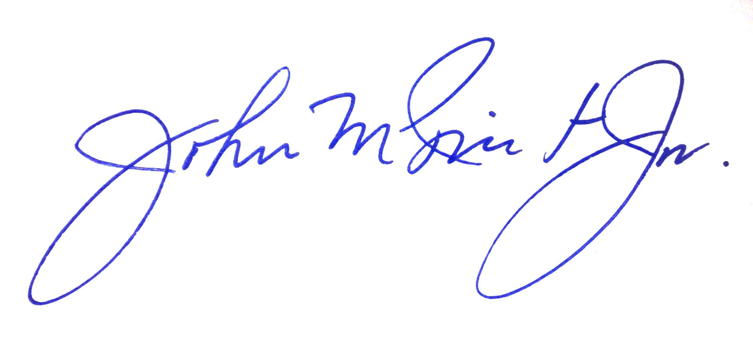
Chairman

