**Slide 1**

**Drug Formulary Commission**

**Bureau of Health Care Safety and Quality**

**Department of Public Health**

**March 17, 2016**

**Opening Remarks**

* Drug Formulary Commission Statutory Mission
* Schedule II and III Opioid Universe
* Component 1: Drugs Of Heightened Public Health Risk
* Component 2: Drug Formulary Therapeutic Substitutes With Abuse Deterrent Properties
* Component 3: “Cross Walk”

Draft Formulary

**Slide 2**

**Slide 2**

* Review of March 3rdmeeting
  + Voted to defer consideration of Zohydro ER for Crosswalk evaluation
  + Began discussion of Crosswalk structure
* Continued discussion of crosswalk structure
  + Definition of “Chemically Equivalent Substitution”
  + Drug Product Criteria
    - Drug Efficacy; Cost; Accessibility; Efficacy of Abuse Deterrent Property (ADP)

**Slide 3**

Presentation Agenda

**Crosswalk**

**Structure**

**Slide 4**

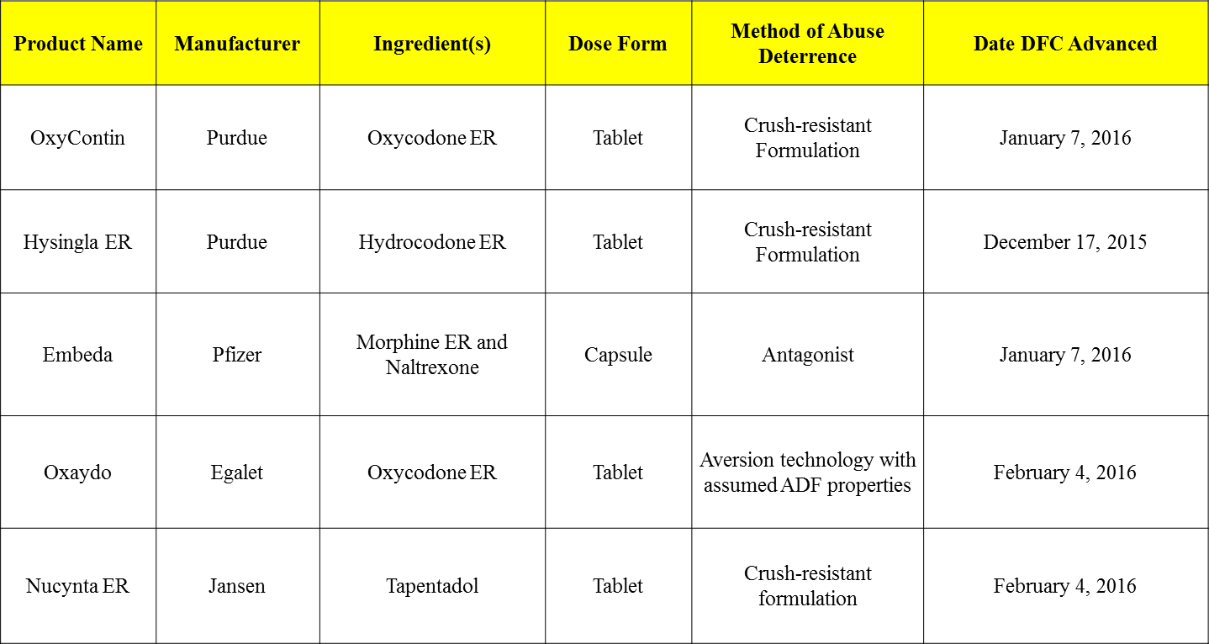

**Slide 5**

List A: Drug Products

Advanced to Component 3

as Potential Substitutes

LIST A

Schedule 2 and schedule 3 opioid drug products list

**Slide 6**

**List B: Generic Drug Products with a Heightened Public Health Risk**

LIST B - Generic

**Crosswalk Structure:  
Drug Formulary**

* List A is comprised of 5 potential substitutes of varying strengths.
* List B is comprised of 28 generic drug products, which, when the 5 potential substitutes are extracted, equals 64 total Heightened Public Health Risk (HPHR) brand name drug products of varying strengths.
* The goal of the crosswalk is to determine whether a drug product on List A should be substituted for one or more drug products on List B.

**Slide 7**

Section 13 of Chapter 17 of the General Laws, which states, in relevant part:

The commission shall also prepare a drug formulary of **chemically equivalent substitutions** for drugs that are opiates, as defined in section 1 of chapter 94C, and contained in schedule II or III of section 3 of said chapter 94C that the commission has determined have a heightened level of public health risk due to the drugs' potential for abuse and misuse …

**Slide 8**

Chemically Equivalent Substitution

**Chemically Equivalent Substitution**

* Chemically Equivalent Substitution is a term typically used in reference to generic formularies, with respect to insurance coverage of generic substitutions for brand name drug products.
* However, the term is occasionally used interchangeably with other equivalent substitution terms like:
  + Bioequivalent
  + Pharmaceutical Equivalent
  + Pharmaceutical Alternative
  + Therapeutic Equivalent; and
  + Clinical Equivalent

**Slide 9**

Section 13 of Chapter 17 of the General Laws, which states, in relevant part:

… In considering whether a drug is a **chemically equivalent substitution** the commission shall consider: the **accessibility** of the drug and its proposed substitute; whether the drug's substitute is **cost** prohibitive; the **effectiveness** of the substitution; and whether, based upon the current patterns of abuse and misuse, the drug's substitute incorporates abuse deterrent technology that will be an **effective deterrent** to such abuse and misuse.

**Slide 10**

Drug Product Criteria

**Drug Product Criteria**

Drug Efficacy

* Every drug product on List A and List B has been FDA approved for the treatment of pain.
* As such, every drug product meets the criteria for effectiveness, as set forth by the statute.

**Slide 11**

**Drug Product Criteria**

Accessibility

* DFC staff has pulled the utilization data from the Prescription Monitoring Program for:
  + Each of the 5 drug products on List A; and
  + Each of the 64 name brand drug products extracted from the 28 generic drug products on List B.
  + This data will demonstrate whether the drug is accessible.
* This data has been compiled on a chart with the cost data.

**Slide 12**

**Drug Product Criteria**

Cost

* DFC staff has pulled the wholesale acquisition cost (WAC) values from Red Book (a standard price compendium of drugs) for:
  + Each of the 5 drug products on List A; and
  + Each of the 64 name brand drug products extracted from the 28 generic drug products on List B.
  + This data will demonstrate the relative costs of the drug products.
* This data has been compiled on a chart with the accessibility data.

**Slide 13**

**Drug Product Criteria**

ADP Efficacy

* Several considerations factor into a determination whether the ADP of any of the 5 List A drugs is effective.
* Just as the commission developed a monograph to assist in the evaluation of each of these drugs as a potential substitute, the staff has developed a checklist to assist in the determination of ADP efficacy.
* This group will have the opportunity to edit and vote on this checklist in real time.

**Slide 14**

**Meeting Schedule**

* April 7, 2016 2:00PM-5:00PM
* April 21, 2016 9:00AM-12:00PM
  + April School Vacation
* May 5, 2016 2:00PM-5:00PM
* May 19, 2016 9:00AM-12:00PM

**Slide 15**