Executive Office of Elder Affairs

Home Care Licensing Commission ASAP and Home Care Agency Overview

June 2, 2021

Three Ways to Work in “Home Care”

* Agency is the employer for person providing services in the home
* Generally ***skilled services*** via medical order – injections, wound care, rehabilitative therapy
* Largely paid by health insurers
* Agencies ***may also provide supportive home care services*** – groceries, meal prep, dressing, bathing, toileting

**Home Health Agency**

* Agency is the employer for person providing supportive care services in the home. No skilled services; medical order not needed.
* Consumer may contract directly with an Agency for supportive home care services.
* Individual or long-term care insurance is payer
* Consumer may contract with professional care managers, such as an EOEA regional aging services access points (ASAPs), which then contract with Agencies for supportive home care services for ASAP consumers
* **Multiple Payers:** EOEA, MassHealth, Health Insurers, Individual or long-term care insurer

**Home Care Agency**

* Consumer is the employer and is responsible for background checks, W-2, liability insurance, etc.
* Supportive care services
* **Consumers find employees via: (1)** MassHealth Personal Care Attendant Program, **(2)** Job Boards (Craigslist, Care.com, HelpAroundTown.com, etc.),

**(3)** Friends, neighbors, etc.,

* **Payors:** Mass Health, EOEA, VA, LTC insurance and private pay

**Consumer Direct Hire**

EOEA Home Care Service Network

**Executive Office of Elder Affairs (EOEA)**

Approximately **65,000+ consumers**

**$363+ million** budget (FY’20)

**25 Aging Services Access Points (ASAP)**

Regional geographic based non-profit organizations designated by EOEA (MGL 19A) with **statewide home care coverage**

* Care Management
* Assessment
* Care Planning
* Advocacy
* Contracting with Direct Service Providers
* Provider Relations (Procurement, Contracting, Monitoring, Complaints)
* Provider management of Critical Incidents
* Adult Protective Services Program

|  |  |  |
| --- | --- | --- |
| **Direct Service Providers** | | |
| **Home Care Agencies**  (HM/PC Providers) | **Home Health Agencies**  (Certified Providers) | **Other Service Providers**  (Trans, DME, ADH, SDC, etc.) |

What is an Aging Services Access Point (ASAP)?

**“Designated” by the Executive Office of Elder Affairs (MGL 19A, Sec. 4B) to** *“provide a coordinated system of care…to assist elders in maintaining their residences in the community”*

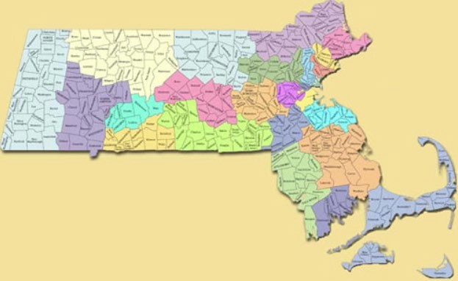

**25 ASAPs in Massachusetts**

*Every zip code has an ASAP*

**EOEA monitors performance by program contracted with ASAPs,** including supportive home care, adult protective services, ombudsman, senior nutrition, supportive and congregate housing

ASAPs contract with approximately 134

agencies to serve 65,000 consumers at home

**Home Care Agencies**

*77 providers*

**Home Health Agencies** (Certified) *57 providers*

**Services:**

* **Companion**
* **Homemaking:** meal prep, laundry, cleaning, grocery shopping
* **Chore Services:** heavy cleaning
* **Personal Care:** bathing, dressing, toileting

Process and Obligations of Home Care

6

*For discussion purposes only. Not for distribution.

Agencies Contracting with ASAPs

* ASAPs sends complaints of abuse, neglect, exploitation or theft against any Direct Service Provider/worker to appropriate investigative agency
* Unpaid Caregiver Complaints investigated by Adult Protective Services
* Paid Caregiver Complaints investigated by DPH
* ASAP reports complaints to EOEA for oversight
* Annual reporting of FEW related

**Critical Incident Management**

* All Home Care Agencies required to enroll
* Re-credentialing every 3 years
* Required to update Home Care agency record with changes on ad hoc basis
* EOEA oversight to ensure enrollment
* Adheres to CMS requirements

**MassHealth FEW Provider Enrollment**

* Every two years
* Ad hoc Incident based
* Onsite, Consumer record review, provider performance, time/attendance, worker qualifications, records, complaints, compliments
* CAP issued when performance concerns identified
* Annual Quality Data reported to EOEA and CMS

**Provider Monitoring**

* EOEA established standardized Provider agreement
* Outlines programmatic, invoicing, compliance requirements
* Consistent

standards that all home care agencies must follow

* Executed for specific service, unit type & rates
* Service descriptions & provider qualifications adhere to EOEA requirements

**Contracting**

* Minimum of three years
* Standardized RFP process
* Public advertisement
* Review of all submitted procurement applications
* Decision to contract issued based off standardized review process
* Approved by ASAP Board of Directors

**Procurement**

Two Levels of Oversight

•

•

•

•

•

•

•

Designation review (every 3 years)

Procurement process

Onboarding and termination of providers

Ensure processes in place to respond to consumer complaints Quality monitoring

Review critical incidents (real time)

Administrative oversight of corrective action

**EOEA**

**over ASAP**

•

•

•

•

•

•

•

Audit of services and billing

Resolution of consumer and family complaints

Staff and consumers surveys to ensure service provision Quality

Review critical incident reports

Point of service delivery review (onsite at time of service)

Vet compliance w personnel practices (CORI/SORI) and employee suitability requirements (Office of Inspector General list)

**ASAP**

**over Agency**

Where are the gaps?

* **Private agencies that do not contract with ASAPs** →

**no oversight at all**

* **No protection for consumers who hire services on their own** (not through ASAP, MassHealth, or managed care organizations)
  + No guarantee of service standards
  + May be called a home care agency, but there no way of knowing if workers have completed standard training or what competencies that they have
  + No financial guarantees for workers or consumers

# Questions and

**Discussion**