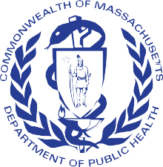

Emergency Medical Services

Advisory Committee

Bureau of Health Care Safety and Quality Department of Public Health

February 24, 2021

Agenda

Welcome and Routine Items
  - Vote on Minutes from April 2019

Department Update
  - OEMS Update
  - MIH Program updates

Reports
  - Medical Services Committee Report (Dr. Jon Burstein)
  - Workforce (Deb Clapp)

OEMS Response to COVID-19

Open Meeting Law: G.L. c. 30A, §§18-25

- The purpose of open meeting law (OML) is to ensure transparency in the deliberations on which public policy is based.
  - This requires that meetings of public bodies be open to the public.

- All meetings of a public body must be open to the public.
  - A meeting is any deliberation by a public body with respect to any matter within the body’s jurisdiction.
  - A deliberation is a communication between members among members of a public body.

- A public body is any multi-member board, commission, committee or subcommittee within the executive or legislative branches (except the Legislature) of state government
  - This includes any body created to advise or make recommendations

- Under OML the public is permitted to attend meetings.
  - Individuals in meetings may not address the public body without the permission of the chair.
  - Public participation is allowed at the discretion of the chair.

- For more information on Open Meeting Law, please visit:
  - https://www.mass.gov/the-open-meeting-law

What is a Quorum?

- A Quorum is defined as:

o A simple majority of the members of a public body, unless otherwise provided in a general or special law, executive order, or other authorizing provision. G.L. c. 30A, § 18.

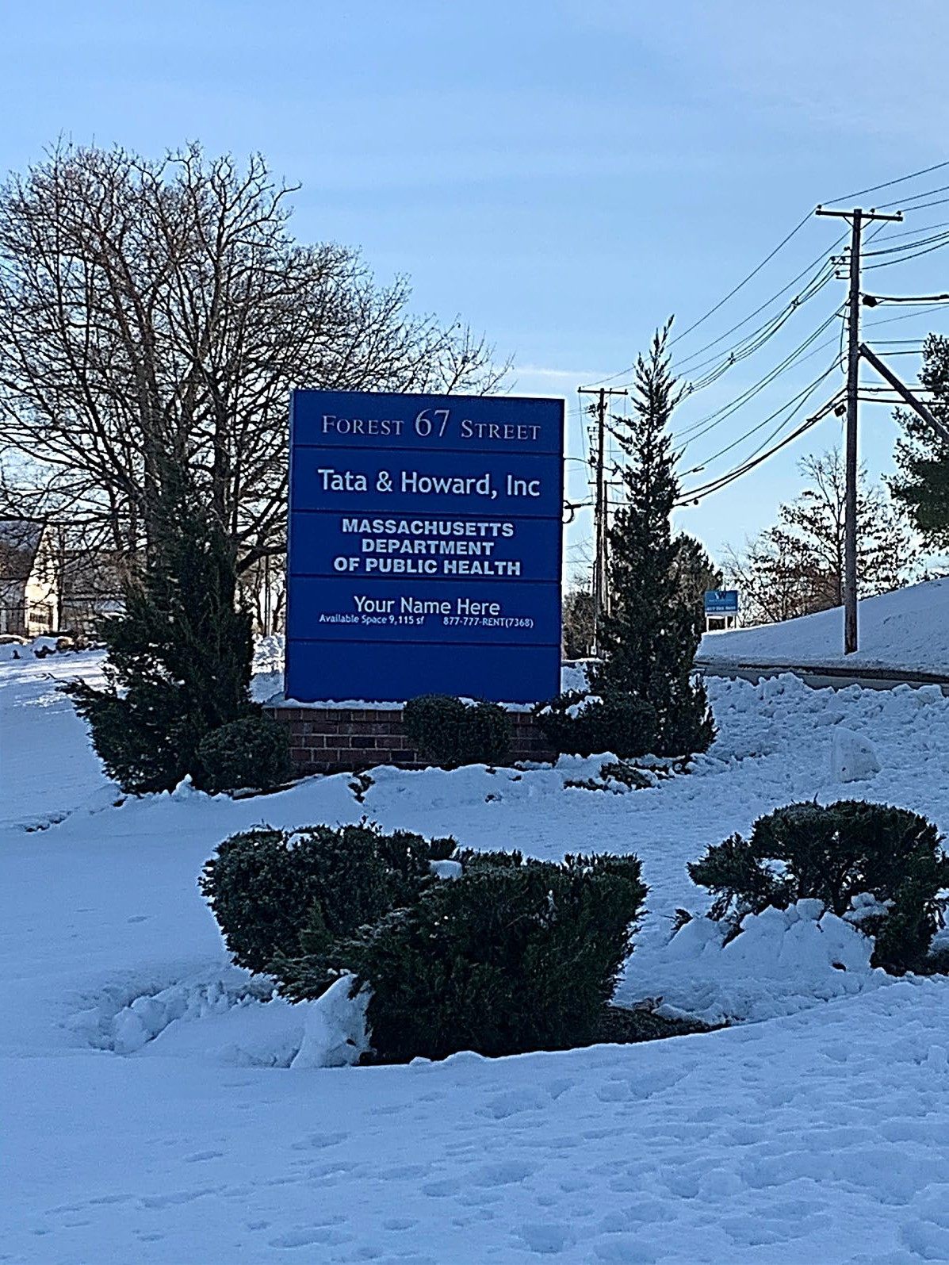OEMS Update
  - BHCSQ move to 67 Forest Street in Marlborough
    - COVID-19 impact on office and staff
  - Staffing
    - Staffing Moves
    - Retirements

Community EMS Programs
- 114 programs currently operating across 33 communities

Vaccinations (by Paramedics only) Naloxone Information and Training Home and Community Falls Prevention Fire and Burn Prevention and Education
Well-Being Checks Sharps Awareness Child Passenger Safety
Water Safety Provision of Primary Care Resource List and Referral
Home Safety Evaluation Behavioral Health Home and Community Referrals
Substance Use Disorders Education Health Promotion Screening
Emergency Preparedness Individual Evaluation Children with Special Care Needs Evaluation Poison Control Home Evaluation
CEMS Programs

23
10
10
10
9
7
6
5
5
5
4
3
3
3
3
2
2
1
1
1
1

Depression and Suicide Prevention Resource Lists in the Community
Welcome Family (Home Evaluation for New Caregivers)
Homelessness and Housing Instability
Firearms Safety Asthma Evaluation
0 5 10 15 20 25

MIH Updates
  - At this time, there are seven MIH programs operating across the Commonwealth
  - In response to the COVID-19 Public Health Emergency, MIH approved eight additional programs on a temporary basis

Approved MIH Programs

9
8
7
6
5
4
3
2
1
0 | MIH Programs - 2019 | MIH Programs - 2020 | COVID Temporary MIH Programs

Medical Services Committee Update
  - MSC continues to meet virtually on a regular basis
  - Protocol changes for 2021
    - Med Director Options
      - Use of U/S, use of transport vents
    - Inter-Facility Transfer care criteria clarified
    - Code Black status clarified in Routine Patient Care
  - COVID protocols remain in effect
    - As emergency protocols so not added to STP document
    - Will be added as generic “when ordered” High-Risk ID in 2022

Workforce Training Committee
  - Reviewed AR 2-305: “Minimum Skill Requirements for Paramedic EMT Training”
    - Identified conflicts between existing AR and current national accrediting standards
  - Recommended aligning AR wording to be consistent with national accrediting standards. (updated by OEMS per recommendation 4/20)
  - Reviewed AR-2-307 “Minimum Skill Requirements for Advanced EMT Training”
    - Due to low/no volume of AEMT training programs and lack of national accreditation standards, deferred any recommendations at this time

Workforce Training Committee
  - Topics for future meetings
    - BLS Psychomotor Exam
    - Examiner trainings/updates/new examiners
    - Instructor-Coordinator requirements/updates
    - Defining Local Continued Competency Requirements (LCCR)

Summary of OEMS Actions and Updates

- Staffing/Workforce:
  - Waiver of requirements of 170.305 (Allow minimum staffing at one EMT/Medic and one first responder)
  - Governor’s Order – Certification of temporary EMTs/Paramedics (recently expired)

- Operational Considerations:
  - Dispatching/PSAP information sharing
  - Workplace Screening, Mask Order, PPE supply management

- Clinical Guidance:
  - COVID STPs 1.2 & 1.3 (with waiver)
  - Scene Management, Risk of Aerosolizing Procedures, other considerations
  - EMS role in testing

- EMS Education/Certification/Recertification:
  - Temporary Certification of EMTs/Paramedics
  - Certification Expiration Extensions
  - Use of VILT and increase in allowance of Distributive Education
  - Changes to Initial Training Requirements/Testing & Con-Ed

- Vaccination Involvement
  - Direct Supply of Vaccine to ambulance services (MIIS and MCVP)
  - Utilization of EMS through LBOH and Mass Vaccination Site

- Changing Needs – EMS Adapts to Changing Roles/Responsibilities

Future Meetings

The next meeting of EMCAB will be in September 2021.

