

**Drug Formulary Commission**

**Bureau of Health Care Safety and Quality**

**Department of Public Health**

**November 5, 2015**

**Slide 1**

**Opening Remarks**



Draft Formulary

Component 3: “Cross Walk”

Component 2: Drug Formulary Therapeutic

Substitutes With Abuse Deterrent Properties

Component 1: Drugs Of

Heightened Public Health Risk

Schedule II and III Opioid Universe

Drug Formulary Commission

Statutory Mission

**Slide 2**

**Presentation Agenda**

* Review of October 15 Meeting
* Discussion of Evaluation Criteria

o Therapeutically Equivalent Substitution Criteria

* 1. Inclusion of Drug Products with FDA Approved Labeling
* Update on Data Requests

**Slide 3**



**Development of Draft Formulary**

**Slide 4**

**Development of the Draft**

**Formulary**

Draft Formulary:

* Guidance document for the prescribing and dispensing community.
* Consists of 3 components:
  1. Component 1: Drugs considered as having a heightened public health risk.
  2. Component 2: Drugs considered to be a therapeutically equivalent substitute.
  3. Component 3: Crosswalk of Components 1 and 2.

**Slide 5**

**Drug Formulary:**

**Mandatory or Voluntary**

* The Formulary is voluntary for physicians.
* Insurance must pay equally for a Formulary substitute.
* A pharmacy must dispense a Formulary substitute unless “no substitutions” appears on the prescription.

**Slide 6**

**Component 1: Heightened**

**Public Health Risk**

Component 1:

* Vote on October 15, 2015, to include all Schedule II and III opioids on the Formulary as having a heightened public health risk as these drug groups have been determined by the DEA as having a higher likelihood of being addictive, able to be tampered with, and misused.

**Slide 7**

**Component 2: Therapeutically**

**Equivalent Substitutes**

Component 2:

• At the October 15, 2015 meeting:

o Final discussion on the criteria to use in the development of the evaluation of drugs to determine if they should be placed on the formulary as therapeutically equivalent substitutes.

o Introduction of a draft monograph to apply the criteria in the evaluation tool.

– The monograph will be used to standardize the process and ensure a transparent review.

**Slide 8**

**Therapeutically Equivalent**

**Substitutes: Criteria**

**Monograph**

**Slide 9**

**Therapeutically Equivalent**

**Substitutes: Draft Monograph**

Overview of the Draft Monograph:

* Transparent and standardized process.
* Will begin with review of all Schedule II and III opioids:

1. All 28 drug groups that have been designated as having a heightened public health risk.
2. 381 individual drug products that compose the 28 drug groups.
   * 338 individual drug products in Schedule II.
   * 43 individual drug products in Schedule III.

**Slide 10**

**Therapeutically Equivalent**

**Substitutes: Draft Monograph**

Filtering Question:

• Proposed filtering question

* 1. “Does the drug have FDA abuse deterrent labeling or an abuse deterrent property?”
* Goal of filtering question
  1. To enable the Commission to prioritize review of individual drug products that are most likely to be considered therapeutically equivalent substitutes based on specific criteria, including:
     + FDA approved ADF labeling
     + ADF properties

**Slide 11**

**Therapeutically Equivalent**

**Substitutes: Draft Monograph**

**Sample Monograph:**

***Oxycontin CR ADF***

**Slide 12**

**Draft Formulary**

**Inclusion of Drug Products with FDA Approved Labeling**

**Slide 13**

**Draft Formulary**

**FDA Approved ADF Labeling**

* The US Food and Drug Administration (FDA) has a comprehensive review process for manufacturers to comply with in order to be approved by the FDA to label their products as abuse deterrent formulation (ADF).
* Some elements of this review process include:

– Laboratory Manipulation and Extraction Studies

– Pharmacokinetic Studies

– Clinical Abuse Potential Studies

– Post Market Studies

**Slide 14**

**Draft Formulary**

**FDA Approved ADF Labeling**

**List of Medications with Abuse-Deterrent Claims in FDA-Approved Labeling**

|  |  |  |  |  |
| --- | --- | --- | --- | --- |
| **Product Name** | **Manufacturer** | **Ingredient(s)** | **Dose Form** | **Method of Abuse Deterrence** |

|  |  |  |  |  |
| --- | --- | --- | --- | --- |
| Targiniq ER | Purdue | Oxycodone ER and Naloxone | Tablet | Antagonist |

|  |  |  |  |  |
| --- | --- | --- | --- | --- |
| OxyContin | Purdue | Oxycodone ER | Tablet | Crush-resistant Formulation |

|  |  |  |  |  |
| --- | --- | --- | --- | --- |
| Hysingla ER | Purdue | Hydrocodone ER | Tablet | Crush-resistant Formulation |

|  |  |  |  |  |
| --- | --- | --- | --- | --- |
| Embeda | Pfizer | Morphine ER and Naltrexone | Capsule | Antagonist |

**Slide 15**

**Draft Formulary**

**FDA Approved ADF Labeling**

* Does the Drug Formulary Commission want to place all Schedule II and III drug products with FDA approved ADF labeling on the drug formulary as therapeutically equivalent substitutes?

**Slide 16**

**Drug Formulary Commission:**

**Data Requests**

**Update on Data Requests**

**Slide 17**

**Update on Data Requests:**

**Introduction**

* The Commission has made requests for data to assist the development of its work.

– Some of the data is collected and analyzed by agencies outside of DPH.

* The Department is working to compile the requested data.
* We will begin by providing data on the Massachusetts Prescription Monitoring Program (MA PMP.)

**Slide 18**



* Data overview of MA PMP data, including:
  + The annual number of prescriptions;
  + The geographic location of those prescriptions;
  + An analysis of high utilizers; and
  + An analysis of high prescribers.

**Slide 19**



* In CY 2011, the MA Online PMP began requiring pharmacies to submit Schedules III-V controlled substance prescriptions in addition to Schedule II controlled substance prescriptions.
* Automatic enrollment of prescribers began in 2013.
* Automatic enrollment of mid-level prescribers began in 2015.
* Automatically enrolled prescribers now include physicians, dentist, podiatrists, physicians assistants and advance practice nurses, including nurse anesthetists.
* Based on surveys on the audits, prescribers find electronic prescriber alerts very helpful.

**Slide 20**

**Number of Prescriptions**

**Annually**

* Since CY 2012, there has been a 3.1 percent decrease in the number of Schedule II and III opioid prescriptions dispensed and reported to the MA Online PMP. The total solid quantity has decreased by 5.4 percent since CY 2012.
* Please note that this Table includes all Schedule II and III opioid prescriptions dispensed and reported to the MA Online PMP, for both in- and out-of-state residents.

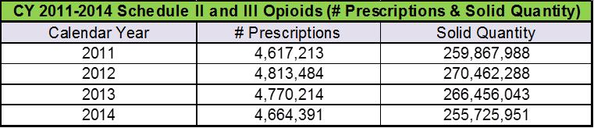

**Slide 21**

**Geographic Location of**

**Prescriptions**

* Geographic location of prescriptions, an analysis was completed on the zip codes of patients who received Schedule II and III opioids.
* The following Table sets out that information by county, in which the patient resides.
* The total number of prescriptions in the following Table includes only those prescribed to Massachusetts residents and excludes those prescriptions for individuals who have an out-of-state address.
* The Map compares the county percentages to the state total.
  + The percentages range from 16.8% in Middlesex County (i.e., individuals residing in Middlesex County account for 16.8 percent of all the Schedule II and III opioid prescriptions reported to the MA PMP) to 0.2% in Nantucket County.

**Slide 22**

**Geographic Location of**

**Prescriptions**

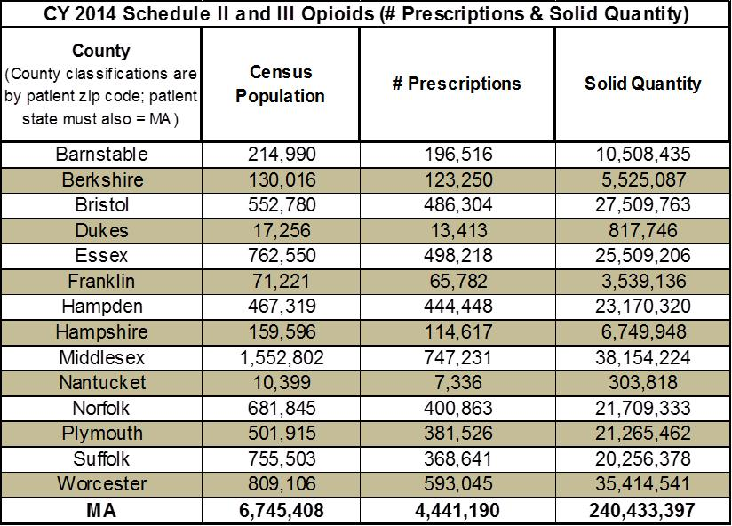

**Slide 23**

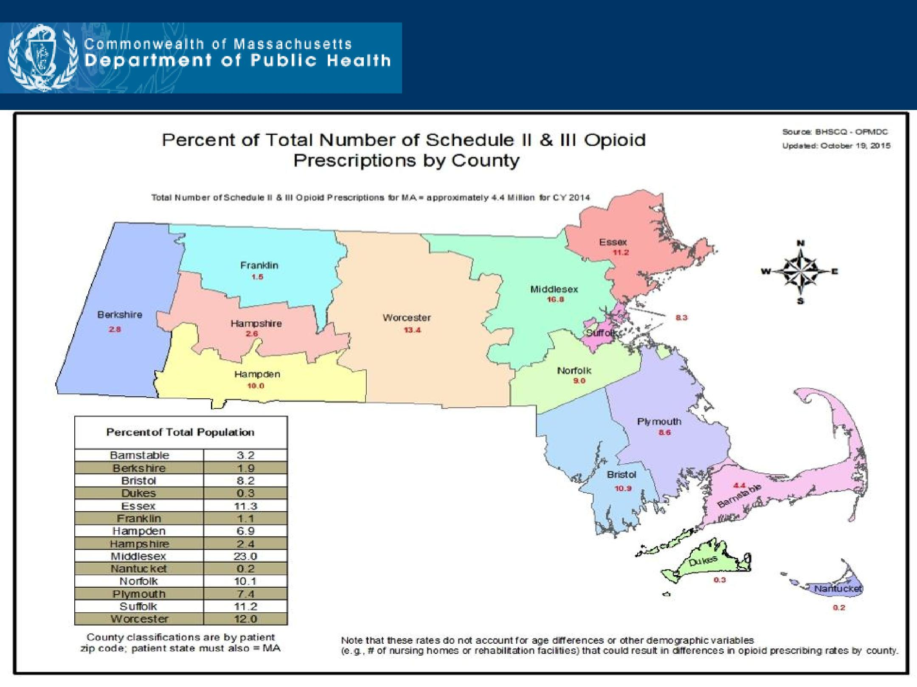**Geographic Location of**

**Prescriptions**

**Analysis of High Utilizers**

* The following Figure provides an example of Multiple Provider Episode (MPE) trends among high utilizers, and displays the MPE rates (per 100,000) for three prescriber/pharmacy thresholds between CY 2009 and CY 2014.
  + Six prescriptions and six pharmacies;
  + Eight prescriptions and eight pharmacies; and
  + Ten prescriptions and ten pharmacies.
* As shown, the rates for each of the three thresholds have been cut nearly in half over this five year period.

**Slide 25**

**Analysis of High Utilizers**

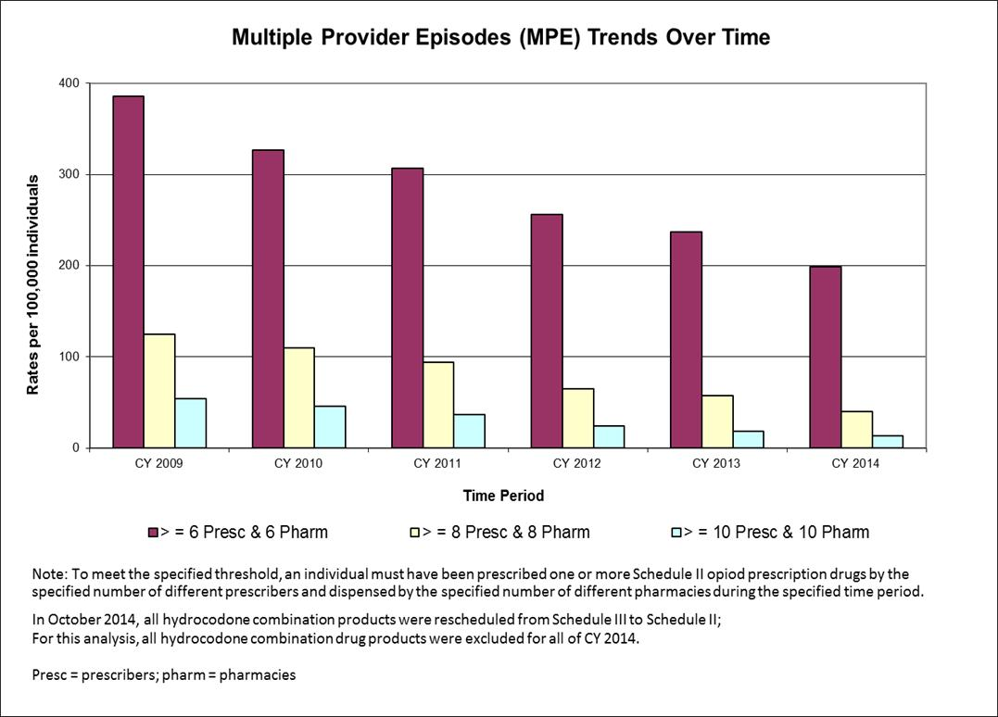

**Slide 26**

**Analysis of High Prescribers**

* The Department identified the top 10 Schedule II and III opioid drug products as reported to the PMP in CY 2014.
* The data presented represents the top 10 Schedule II and III opioid drug products prescribed by number of prescriptions, solid quantity, and solid quantity per prescription.

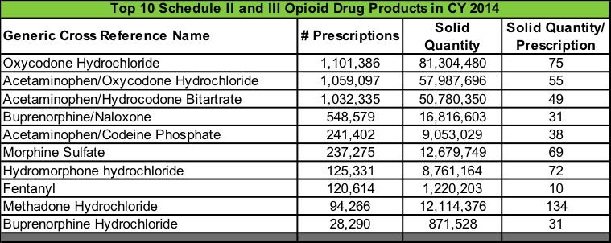



* This data provides a snapshot to assist the Commission in the understanding and identification of the annual number of prescriptions; the geographic location of those prescriptions; an analysis of high utilizers; and an analysis of high prescribers.
* The MA Online PMP is one tool in the effort to combat the growing epidemic of opioid addiction and overdose.
* Its effectiveness as a data source for prescribers and dispensers continues to grow and improve.

**Slide 28**

**Drug Formulary Commission:**

|  |  |  |  |  |
| --- | --- | --- | --- | --- |
|  | **Data Requests** | | |  |
|  |  |  |  |  |
| **Data Requests** |  | **Date of** | **Expected Presentation** |  |
|  | **Request** | **to DFC** |  |
|  |  |  |
|  |  |  |  |  |
| High Prescriber Utilizers |  | 08/06/15 | **Today** |  |
|  |  |  |  |  |
| Abuse Deterrent or Near Abuse Deterrent Products |  | 08/06/15 | **December** |  |
|  |  |  |  |  |
| High Multiple Provider Episodes Utilizers |  | 08/06/15 | **December** |  |
|  |  |  |  |  |
| Opioid Prescriptions - # of Prescriptions, Solid Quantity, and Solid Quantity |  | 09/08/15 | **December** |  |
| per Prescription |  |  |
|  |  |  |  |
|  |  |  |  |  |
| Patient-Specific Overdose Death Data Linked to PMP |  | 08/06/15 | TBD |  |
|  |  |  |  |  |
| MA All payer Claims Database |  | 08/06/15 | TBD |  |
|  |  |  |  |  |
| Pharmacies with High Number of Individuals who exceed MPE Threshold |  | 09/08/15 | TBD |  |
|  | |  |  |  |
| Frequency of Schedule II and III Drug Products that are also Prescribed with | | 09/08/15 | TBD |  |
| Potentiating Controlled Substance Drugs (Tramadol, Benzodiazepines) |  |  |
|  |  |  |  |
|  |  |  |  |  |
| Opioid Drugs Associated with Emergency Department Visits for Opioid |  | 09/08/15 | TBD |  |
| Overdose |  |  |
|  |  |  |  |

**Slide 29**

**Meeting Summary**

* Meeting Recap
* Review of takeaways
* Next steps

**Slide 30**