Safe Patient Access to Emergency Care Workgroup September 30, 2021

Agenda

Welcome and Introductions Statutory Overview Member Presentations: Nancy Hanright

Peter DeMarco Dr. Assaad Sayah Josh Safdie Edward Browne Bonnie Michelman

Statutory Authority: An Act Ensuring Safe Patient Access to Emergency Care (Laura’s Law)

Requires the Department of Public Health to promulgate regulations relative to patient access in hospital emergency rooms or departments that would require all hospitals in the Commonwealth to meet minimum criteria and standards to ensure safe, timely, and accessible patient access to hospital Emergency Departments.

Regulations must address criteria and standards related to:

legible indoor and outdoor signage; indoor and outdoor lighting;

best-practice wayfinding signage;

security and monitoring of all emergency department access points;

Regulations must also address minimum requirements for proper security monitoring of any prominent hospital door or entrance that is locked at night and through which a patient may try to enter;

and (c) any other safety feature that the Department deems necessary to ensure daytime or nighttime entry to an emergency room or department.

Statutory Requirements

In promulgating the regulations, the Department must ensure that all patients, including patients at all levels of physical, sensory and brain-based function, are able to access hospital emergency rooms or departments.

The Department must consider industry practices, including, but not limited to, standards under the federal ADA, local codes, regulations promulgated by the Architectural Access Board, and any guidance or resources from the Facility Guidelines Institute Inc., and the International Association for Healthcare Security and Safety.

DPH must convene a working group to report on and to make recommendations to inform the regulations. The working group must submit its recommendations to the legislature by December 15, 2021.

Emergency Department Renovations September 30, 2021



BMC was formed in 1996 as a merger between Boston City Hospital and University Hospital.

In 2015 we embarked on a 5 year journey to consolidate into one campus Our campus was divided and costly to operate

In consolidating we

Reduced our carbon footprint

Shed underutilized buildings that were costly to operate Achieved operating savings of ~20 million annually Improved the patient experience and clinical quality of care

One of the largest areas impacted by this construction was our Emergency Room Department Expanded our Emergency Department while remaining fully operational by ~30%

Created a new patient drop off area and expanded our Ambulance bays

▫ In doing so we temporarily moved our ED entrance.

The Menino Expansion Project

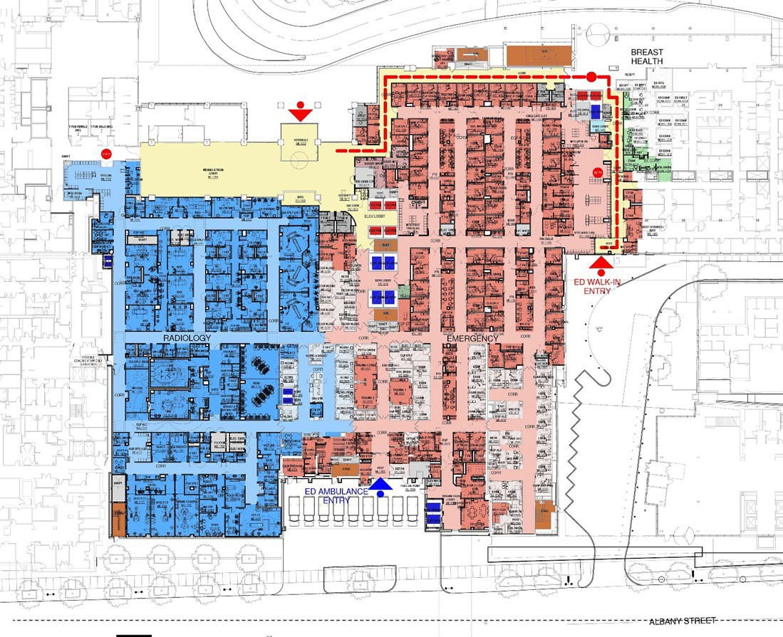

New Ambulatory Emergency Department

The new walk-in entrance to the emergency department separates pedestrian and ambulance traffic.

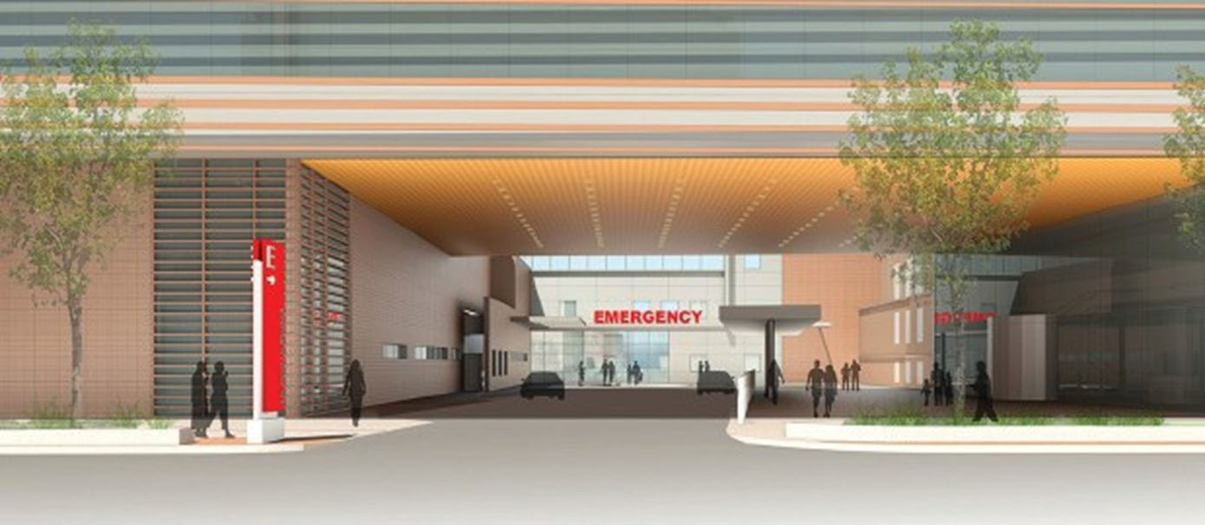

We hired a wayfinding expert to help us navigate.

Typically, hospital facility signage regulations fall under the jurisdiction of the local municipality’s sign codes. In Boston, we use the Article 11 - Boston Zoning codes and submit to the BPDA for approvals. In addition:

Hospital guide signage for vehicles approaching hospital facilities are detailed in the [MUTCD](https://protect-us.mimecast.com/s/_TtfCkRKD4CPOw86HVdO2X?domain=mutcd.fhwa.dot.gov) Manual on Uniform Traffic Control Devices for Streets and Highways and the [MASS HIGHWAY Guide Sign Policy](https://protect-us.mimecast.com/s/DI4kClYLD4Uj2M05FyAsNR?domain=mass.gov) for Secondary State Highways. These documents provide sign size, typography size, reflectivity, and lighting regulations and guidelines.

Hospital facility signage, in this case the assumption is that we are primarily considering exterior signage, might utilize these standards as a baseline, but should also take into consideration the [ADA](https://protect-us.mimecast.com/s/2WfVCmZ6G4H9jMBKc9Uey_?domain=ada.gov) and ABA Standards for Accessible Design.

The [ADA standards Chapter 7](https://protect-us.mimecast.com/s/OKjJCo2K74SQrwjLFoYvMt?domain=ada.gov) provides information on sign sizes and locations, typographic size and color contrast, and the placement of signs to ensure the signs are accessible and legible to the largest audience possible. These standards are largely aimed at interior signage.

Other existing guidelines that could be considered might be found in the [MAAB](https://protect-us.mimecast.com/s/wCvyCpYK75U7nw1Ns7nCgE?domain=mass.gov) and [IBC.](https://protect-us.mimecast.com/s/z8KbCqx5D4SV82KPfvYgjz?domain=codes.iccsafe.org)

These best practice symbols were put together through a joint partnership between SEGD* and Hablamos Juntos with support from the Robert Wood Johnson Foundation.

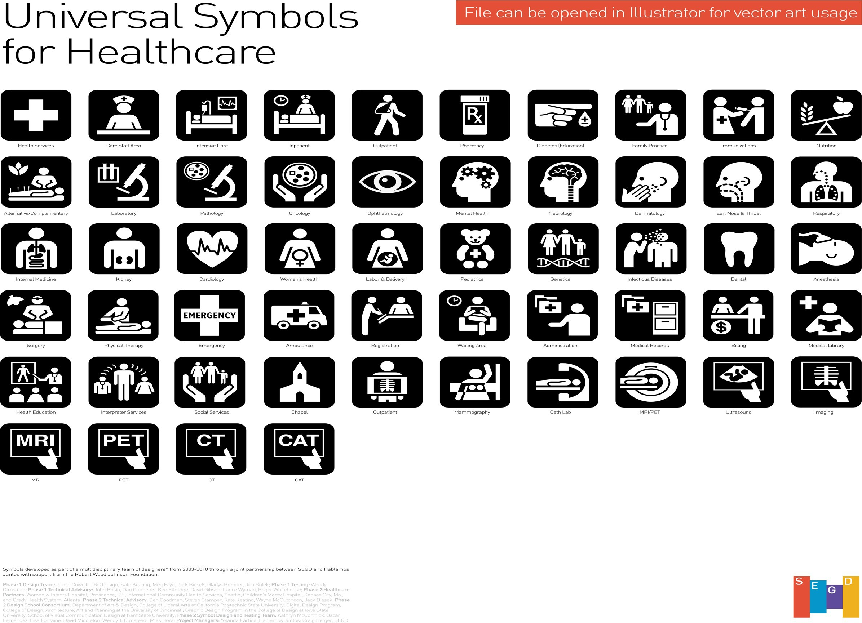

What we learned in planning:

We had a lot of work to do!

Paramount to our success was our ability to work as a team with internal and external partners. Communications coordination was key.

|  |  |  |  |
| --- | --- | --- | --- |
| Internal | Patient Facing | Community | City |
| Created a construction page on intranet  Daily huddles Email Reminders Digital Signs  Direct engagement with operators navigators and volunteers | Note in patient appointment reminders  A frame signs at entrances Temp signs on doors with maps Posted security officer  Revised our internal campus maps Posted signs in garages  Updated all external signs | South End News Community Health Center Outreach  PFAC BCIL  Digital Message Boards Neighborhood Meetings | DPH  Boston Fire Boston EMS Ambulances Boston Police |

In closing,

It is important to remember that a comprehensive hospital and emergency room wayfinding program starts before you get into the hospital. Website information should be kept up to date.

Leverage electronics whenever possible

▫ Google maps (and other cloud sourced navigation tools)

▫ Digital road maps

Use your patient reminder letters as an additional form of communication Engage your neighbors in conversation

Understand there are experts in many facets within the wayfinding sector The consistent use of terminology and symbols is important

Clear the clutter. Be sure to remove old signs.

The best wayfinding tool are the staff working in our healthcare institutions

▫ Keeping them informed of changes is crucial

Cambridge Health Alliance Learning on Patient Access to Emergency Departments

**Agenda Topics:**

* **Brief Overview of Learning and Improvements**

1) facilities and wayfinding; 2) workforce and emergency access drills;

3) collaboration with the emergency response system; and 4) other areas of learning

* **Discussion**

DPH Emergency Department Access Working Group September 30, 202

**Facilities and Wayfinding Learning**

Emergency Department Access Risk Assessment

CHA conducted an emergency care access risk assessment with internal and external subject matter experts Each of CHA’s 3 hospital campuses required a customized application of industry standards and best practices

Signage, Lighting, and Wayfinding to Better Guide Patients to Emergency Department

Cloud-based Navigation, GPS Markers and Address for Main and Emergency Department Entrances New address/GPS location for Main/ED entrance

Security Operations and Video Surveillance Center (24/7 system-wide security/video surveillance hub)

Blue Light Communications Devices 25

Workforce and Emergency Access Drills

Protocol for Searches Outside of the Emergency Department New Quarterly Emergency Access Drills

Overall EMTALA Training

26

Collaboration with Emergency Response System

Collaboration with Local Public Safety Officials Collaboration on Patient Searches External to the Hospital Public Safety Answering Point Directories

Partnering with Outside Agencies on Improvements to the 9-1-1 system

27

**Other Areas of Learning**

Larger systems improvements beyond Emergency Department Access

Enhancing communication following adverse events - across the organization and with patients and families Adding patient and family members to the Patient Safety Committee

Intentional movement on our journey to becoming a High Reliability organization, including significant improvements to the process of analyzing adverse events and initiating corrective action Power of sharing learning with hospital community, stakeholders, and policymakers 28

Americans with Disabilities Act

Broadest of all federal laws, requiring equal access to places of public accommodation for persons with disabilities Codified in the 2010 ADA Standards

Enforced only by complaint, lawsuit, or DOJ investigation

521 CMR: The Rules and Regulations of the MA Architectural Access Board (“MAAB”)

“ to provide persons with disabilities full, free and safe use of all buildings and facilities so that all such persons may… be as self-sufficient as possible” Specialized Code of 780 CMR (MA State Building Code)

Enforced by municipal inspectional services and MAAB

Accessible Route Requirements

Accessible parking or accessible pedestrian loading zone Accessible routes from “site arrival points”

From public bus stop

From public right-of-way (sidewalk) From on-site parking

Accessible entrance(s) Approach

Door(s) Threshold(s)

Interior accessible routes Corridors

Ramps Elevators / lifts

Signage & Wayfinding Information

Permanent designating signage: governed by ADA 703 and 521 CMR 41 Mounting location and height

Character proportion & height Braille, tactile letters, & pictograms Finish & contrast

Wayfinding information: governed by ADA only (no requirements in 521 CMR) Fewer requirements (no Braille, no tactile letters)

Character height based on height of sign and horizontal viewing distance No requirements for mounting location

FGI Guidelines for Design & Construction of Hospitals

Site Access, Emergency Access, Wayfinding & Security Risk Assessment September 30, 2021

Edward M. Browne, MS, CHFM, CHC, CHPA

Hospital Site Chapter 1.3 Site

*1.3-3.5 Emergency Access

A1.3-3.5 Other vehicular or pedestrian traffic should not conflict with access to the emergency services.

1.3-3.5.1 Hospitals with an organized emergency service shall have the emergency access well marked to facilitate entry from public roads or streets serving the site.

1.3-3.5.2 Access to emergency services shall be located to incur minimal damage from floods and other natural disasters. For additional requirements, see sections 1.2-4.9 (Disaster, Emergency, and Vulnerability Assessment) and 1.2-6.5 (Emergency Preparedness and Management).

1.3-3.5.3 A video surveillance system for public entrances for access to emergency care shall be provided. 1.3-3.5.4 Where emergency care public entrances may be locked, a duress alarm system shall be provided.

Note 1: Black type is current 2018 version, Green type is new language in 2022 version Note 2: Appendix material denoted with an “A” is advisory only

Emergency Care

2.2-3.1.2 Basic Emergency Care 2.2-3.1.2.2 Entrance

Walk-in and public entrances to basic emergency care shall be identified by exterior signage visible from public thoroughfares.

Ambulance entrances shall provide a minimum of 6 feet (1.83 meters) in clear width to accommodate gurneys for individuals of size, mobile patient lift devices, and accompanying attendants. Where lifts for individuals of size are provided in the covered ambulance bay, they shall be positioned to provide assistance with patient transfers.

Where basic emergency care public entrances may be locked, a duress alarm system that is conspicuously located, readily accessible, and immediately available shall be provided. Note 1: Black type is current 2018 version, Green type is new language in 2022 version Note 2: Appendix material denoted with an “A” is advisory only

Emergency Department Entrance 2.2-3.1.3 Emergency Department

*2.2-3.1.3.2 Entrance. Entrances shall meet the requirements in Section 2.1-6.2.1 (Vehicular Drop-Off and Pedestrian Entrance) as amended in this section.

A2.2-3.1.3.2 Public vehicle access should be located a sufficient distance from the entrance to provide for safe movement of pedestrians and/or wheelchair traffic.

(1) The site design shall provide a signed route from public thoroughfares that directs ambulance traffic to the ambulance entrance to the emergency department and vehicle traffic to the public entrance.

*(2) Paved emergency access to permit discharge of patients from automobiles and ambulances shall be provided.

A2.2-3.1.3.2 (2) The paved emergency access should accommodate short-term parking close to the entrance of the emergency department.

Emergency Department Entrance (cont.)

1. The emergency department entrance shall be clearly marked.
2. Where a raised platform/dock is used for ambulance discharge, a ramp or elevator/lift to grade level shall be provided for pedestrian and wheelchair access.
3. The emergency vehicle entry cover/canopy shall provide shelter for both the patient and the emergency medical crew during transfer between an emergency vehicle and the building.
4. The emergency bays shall be sized so they are compatible with horizontal and vertical vehicle clearances of EMS providers

Emergency Department Entrance (cont.)

*(7) Ambulance entrances shall provide a minimum of 6 feet (1.83 meters) in clear width to accommodate gurneys for individuals of size, mobile patient lift devices, and accompanying attendants. A2.2-3.1.3.2 (7) Where the emergency department does not have separate public and ambulance entrances, clearances should be provided that are sufficient to accommodate pedestrian, wheelchair, and gurney movement at the emergency department entrance.

1. Transfer provisions shall be considered based on the patient handling and mobility assessment [see Section 1.2-4.3 (PHAMA)]
2. A video surveillance system shall be provided for each emergency department public entrance.
3. Where emergency department public entrances may be locked, a duress alarm system that is conspicuously located, readily accessible, and immediately available shall be provided.

Note 1: Black type is current 2018 version, Green type is new language in 2022 version Note 2: Appendix material denoted with an “A” is advisory only

Wayfinding

A1.2-5.4.3 Wayfinding

1. Hospital entry points should be clearly identified from all major exterior circulation modes (e.g., roadways, bus stops, vehicular parking).
2. Clearly visible and understandable signage, icons, universal symbols, visual landmarks and/or cues for orientation (including views to the outside) should be provided. Consider accommodating the needs of various care populations (e.g., the elderly, children, cognitively impaired, visually impaired, and other particularly vulnerable populations, including people with dementia) via the provision of:

—Varied presentations of the same information to accommodate users with different cognitive processes

—Accommodations for persons with limited English proficiency, including speakers of other languages and those with limited reading ability

Note 1: Black type is current 2018 version, Green type is new language in 2022 version Note 2: Appendix material denoted with an “A” is advisory only

Wayfinding (cont.)

1. Boundaries between public and private areas should be well marked or clearly distinguished.
2. A system of interior “landmarks” should be developed to aid occupants in cognitive understanding of destinations. To be effective, landmarks should be unique and used only at decision points. Landmarks may include sealed water features, major art, distinctive color, or decorative treatments. These features should attempt to involve tactile, auditory, and language cues as well as visual recognition. When color is used as a wayfinding device, it should support the primary wayfinding system elements and be clearly distinguished from color palette decisions unrelated to wayfinding.
3. Signage systems should be flexible, expandable, adaptable, and easy to maintain. Signage should be consistent with other patient communications and supporting print, Web, and electronic media.

Note 1: Black type is current 2018 version, Green type is new language in 2022 version Note 2: Appendix material denoted with an “A” is advisory only

Wayfinding (cont.)

*1.2-6.3 Wayfinding A1.2-6.3 Wayfinding

1. During the functional programming process, input from frontline staff, facility managers, visitors, families, and patients should be sought regarding wayfinding. This should include evaluation of the most common and problematic scenarios to identify shortcomings and help develop design criteria to address them.

Consideration should be given to the following:

—Needs of first-time users

—Stress experienced by patients and families while finding their way to unfamiliar areas in a facility

—Populations served (e.g., the elderly; children; and cognitively impaired, visually impaired, and other particularly vulnerable populations, including those with Alzheimer’s and dementia)

—Needs of limited English proficient individuals, speakers of other languages, and those with limited reading ability. Where possible, use the Universal Symbols in Health Care.

—Use of unique landmarks (e.g., design elements such as color, artwork, texture, change in architecture, exterior views, plants)

—Varied presentation of the same information to accommodate different cognitive processes (e.g., those used by different individuals or by the same individuals at different points during the wayfinding process)

—Integration of the wayfinding plan with relevant security plans

Wayfinding (cont.)

1. Input from staff, visitors, families, and patients as described in Section 1.2-2 (Functional Program) should be integrated into the development of a systems approach to wayfinding. Planning for wayfinding should begin with the goal that the average visitor or staff member can easily find his or her way throughout the facility. Outside wayfinding should be considered for those walking and for those driving to the facility. If public transportation is available, directions and signage to and from transportation sites should be provided.

Wayfinding (cont.)

1. General sign recommendations

—Exterior and interior approaches to wayfinding should be coordinated

—Nomenclature should be consistent and understandable to the general public, and signs generally should be written at a sixth-grade level.

—Information (a destination hierarchy) should be developed to assure the right information is presented at the right time.

— A family of signs should be developed for consistency within the wayfinding system. This should include directional and orientation signs (e.g., overhead and wall-mounted signs and maps), destination signs, room identification signs, regulatory signs, and provisions for a multitude of hospital-specific policy and information signs

Wayfinding (cont.)

—Each sign should be accurate, legible, and functional:

Letters should contrast with the background to conform to ADA requirements. For signs in areas that primarily house the elderly, letters should contrast with the background by a minimum of 90 percent.

Colors should be differentiable by those who are color-blind.

When used, symbols and pictographs should be recognizable to the general public and the community served. (The Universal Symbols in Health Care have been tested for usability and comprehension.)

The number of symbols used on a single sign should be limited and indicate primary destinations only.

Destination hierarchies should manage the number of symbols by building, zone, or floor. Users have difficulty differentiating more than 16 unique symbols in one set. Where health care symbols are combined with other universal symbols used in transportation or accessibility, the different sets of symbols should be clearly differentiated.

Wayfinding (cont.)

You are here (YAH) map recommendations

—YAH maps should be oriented so that forward is up.

—It is preferable to use a perspective view. Where vertical navigation is required, consider illustrating the relationship between levels and which elevator cores serve which areas, especially where floors are not contiguous.

—Inset maps should be used to locate details within the overall map where appropriate. Exterior signage (general)

—Directional signs should be easily viewed from the street and located and sized so that drivers can read them when traveling at the local speed limit.

—Consistency should be used in the nomenclature of buildings.

—Directions should be clear to all users.

—Signage should be within an individual’s 60-degree “cone of vision,” whether the person is walking or driving

Wayfinding (cont.)

—Exterior directional signs should be visible at night.

—Signage should be located where it is easy to see.

—Where applicable, emergency departments should be clearly distinguished from other destinations. Exterior signage (parking)

—Directions should be provided to various parking locations, where applicable.

—Directions should be provided from the parking structure to the entrance of the facility.

—Signage should clearly indicate short-term and long-term parking rates, where applicable.

—Valet parking, if provided, should be clearly marked.

—Directional signage should be provided for automobile and pedestrian traffic.

—Floor numbers or sections should be marked clearly.

Wayfinding (cont.)

Interior signage (entrance and exit)

—A well-designed and located set of interior signs and clearly labeled directional maps should be located near the entrance. Symbols used on directional signage should be used in orientation maps for consistency and to assist users in finding primary destinations.

—Signage should clearly identify all publicly accessible functional areas of the facility (e.g., cafeteria/dining, gift shop, restrooms).

—Where symbols are used, a single symbol should be used to represent a single primary destination.

—There should be adequate signs to direct people out of the facility back to parking and public transportation.

Wayfinding (cont.)

Interior wayfinding (room numbering)

—Room numbering should be consistent from floor to floor and area to area.

—The numbering system should be simple and continuous.

—Design of the numbering system should be flexible to allow for future expansion and renovation.

— Room numbering should consider the need for sequential strategies for public wayfinding that may be different from operational and maintenance numbering.

—Signs should differentiate between spaces used by patients/visitors and those used by staff.

Wayfinding (cont.)

Interior wayfinding (sign placement)

—Signs providing directions should be placed at major decision points, including the following: Major intersections

Major destinations Changes in buildings

—If there are no major decision points, reassurance signs should be placed approximately every 250 feet (76.2 meters). Interior wayfinding (signage maintenance). Fabrication should be in a manner that allows messages to be changed.

Wayfinding (cont.)

*1.2-6.3.1 An organized approach to wayfinding about the entire campus or facility shall be provided. A1.2-6.3.1 An organized approach to wayfinding should include the following:

1. An integrated system that coordinates elements such as visible and legible signs and numbers
2. Verbal directions, paper information, and electronic information

1.2-6.3.2 Exterior wayfinding shall clearly define the access pathways from public thoroughfares to the main entrance and emergency department entrance. Note 1: Black type is current 2018 version, Green type is new language in 2022 version Note 2: Appendix material denoted with an “A” is advisory only

*1.2-4.8.2 Security Elements of the Safety Risk Assessment

Design features shall address identified security risks specific to the patient population to be served and environmental factors related to the project scope.

A1.2-4.8.2 Security elements of the safety risk assessment

a. Security considerations for project design

—Parking and exterior spaces. Hospital surroundings may include open space, parking facilities, and private roadways and may border other businesses, residential properties, or major transportation routes. Lighting design should be provided for parking and exterior spaces.

—Buildings and interior spaces. In addition to patient care areas, hospitals may include non-patient care areas such as academic and research space. These areas may present specific risks or security concerns. The physical design of buildings and integration of electronic security systems in the built environment are important components of the facility protection plan and the patient, visitor, and staff experience.

Note 1: Black type is current 2018 version, Green type is new language in 2022 version Note 2: Appendix material denoted with an “A” is advisory only

*1.2-4.8 Security Risk Assessment

A1.2-4.8 Security risk assessment. A security risk assessment addresses the unique security characteristics of a hospital, including specific needs related to the protection of vulnerable patient populations, security of sensitive areas, application of security and safety systems, and infrastructure required to support these needs. The assessment addresses external and internal security needs as well as those related to emergency management and response. Security requirements for construction, commissioning, and move- in vary according to the complexity and scope of services provided.

More detailed information regarding the guidelines in this section can be found in Security Design Guidelines for Healthcare Facilities, published by the International Association for Healthcare Security & Safety (IAHSS).

Note 1: Black type is current 2018 version, Green type is new language in 2022 version Note 2: Appendix material denoted with an “A” is advisory only