DPH PANDAS/PANS Advisory Council

May 8, 2024

4:00 – 6:00 PM

Agenda

* Welcome: Roll Call & Vote to Approve 3/13/2024 Minutes
* Announcements: General & Housekeeping
* Discussion & Q&A: Kevin Beagan, Deputy Commissioner (DOI)
* March Reflections: Mary Beth Miotto, MD, President (MCAAP)
* Wrap Up: Next Steps
* Next Meeting: Wednesday, July 10, 2024, 4-6PM
* Vote: Adjourn

Opening Roll Call & Vote

* Attendance roll call
* Vote to approve Meeting Minutes (March 13, 2024)

Statutory Authority

Section 26 of Chapter 260 of the Acts of 2020, or the Health Care Omnibus bill establishes a special advisory council, chaired by the Commissioner of the Department of Public Health, or his designee, to advise the commissioner on research, diagnosis, treatment and education relating to pediatric autoimmune neuropsychiatric disorder associated with streptococcal infections and pediatric acute neuropsychiatric syndrome (PANDAS/PANS).

General Announcements

* What announcements do people have?

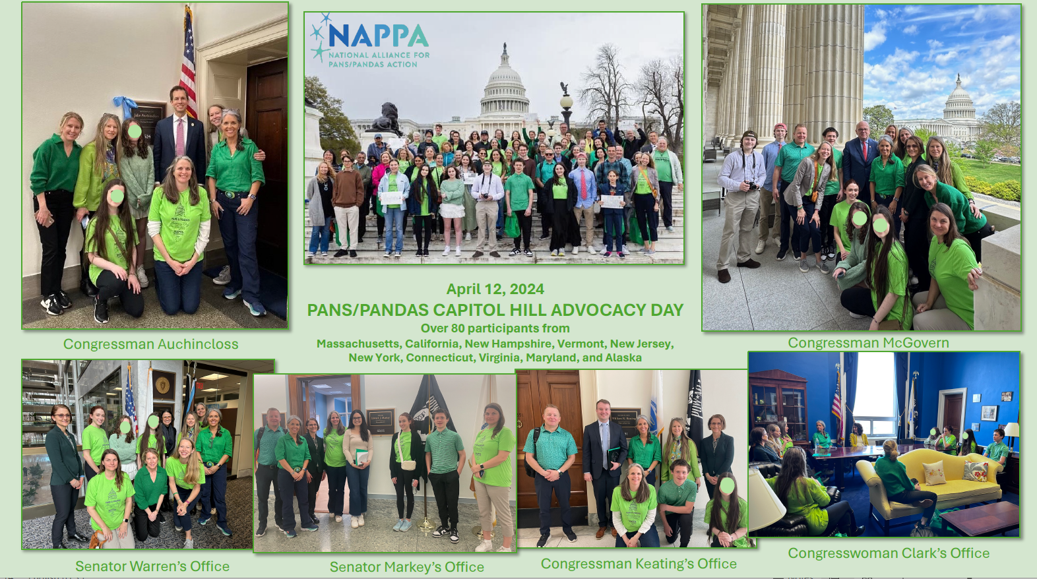





Kevin Beagan, Deputy Commissioner, Division of Insurance

* Discussion Format
* 15 minutes: Deputy Commissioner Beagan’s presentation
* 30 minutes: Questions & Answers
* Raise hand
* Be mindful of the space and time you are taking
* Foster an open discussion focused on group learning and problem solving

Immediate Reflection: DOI

* Related to the 2023 report, did the speaker share anything:
  + That supports it?
  + That contradicts it?
* Do you have follow-up questions for Deputy Commissioner Beagan?
* Do you have any recommendations for the next report yet?
* Please come prepared with recommendations for the July meeting.

March Meeting Reflection: MCAAP

* Related to the 2023 report, was there anything:
  + That supports it?
  + That contradicts it?
* What will the Council’s next steps be?
  + How will you incorporate what you heard into the 2024 report?
  + Do you have any recommendations for the 2024 report?

2024 Timeline

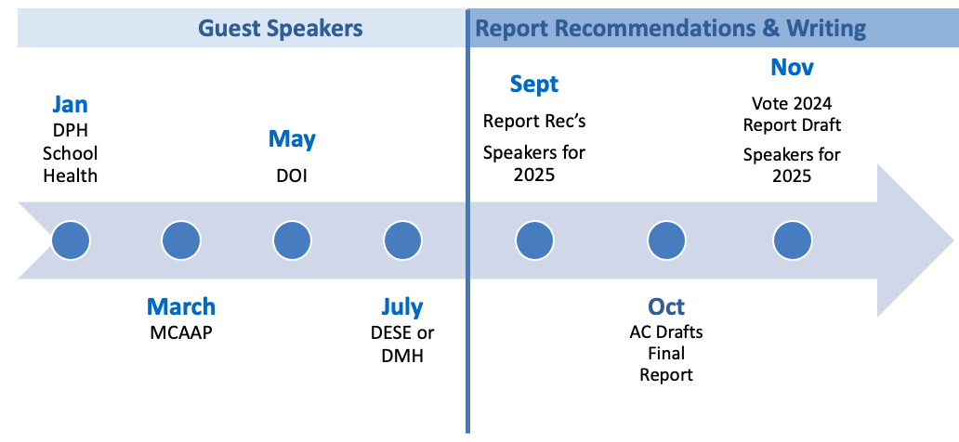

Questions for DESE and DMH

* What questions do people have specific to DESE or DMH?
* Please scan the QR code to share your questions by May 15th.



Next Steps

* Fourth meeting of 2024
  + Wednesday, July 10, 2024, 4-6 PM
  + Future meetings via WebEx Events
    - If you need help, please email Maddy Goskoski at [madelyn.m.goskoski@mass.gov](mailto:madelyn.m.goskoski@mass.gov) in advance who will find assistance.
* Next steps:
  + DESE or DMH to speak in July
  + Submit your questions for July guest speaker by May 15th.
  + Email [madelyn.m.goskoski@mass.gov](mailto:madelyn.m.goskoski@mass.gov) to get on the July agenda
  + Anything else?
  + Vote to Adjourn