Commonwealth of Massachusetts
Executive Office of Health and Human Services

Virtual Gateway


CBHI Member Progress Report Reference Guide
(Certified Assessor and Organization Roles)
May 2016



CBHI Member Progress Report Reference Guide
Contents
Summary of Reference Guide 3
Logon to Virtual Gateway 3
Generating Member Progress Report 3
Sample of a Member Progress Report 5
Questions or Need Assistance? 6

Summary of Reference Guide
The Member Progress Report will help users assess and share a Member’s progress over a period of time across organizations that have consent. This reference guide will walk a user through how to access, run and view the Member Progress Report.

Logon to Virtual Gateway
To log on to the Virtual Gateway (VG), go to https://sso.hhs.state.ma.us/. Select the Children’s Behavioral Health Initiative (CBHI) business service to enter CANS in the VG.
Note: Refer to the Login Assistance page at www.mass.gov/eohhs/provider/training-and-edu/vg/login-help-for-providers-and-state-agency-staff.html for more information on managing your Virtual Gateway (VG) account.

Generating Member Progress Report
A user with a designated organizational role or certified assessor role may generate and view the Member Progress Report.
The CANS data found in this report can be used for assessing a Member’s progress over a period of time across organizations with consent.
From the Main Assessment Menu:
- Select the [Reports] tab.
- Select [Member Progress Report] from the pick list.
- Select the [OK] button.
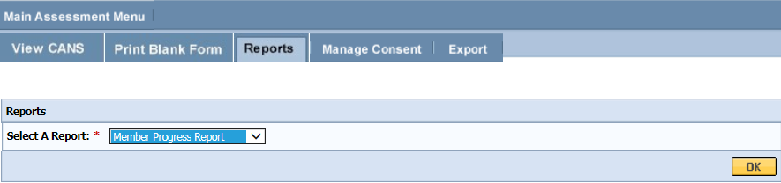
- Enter the [MassHealth ID] of the Member.
- Select the [OK] button.
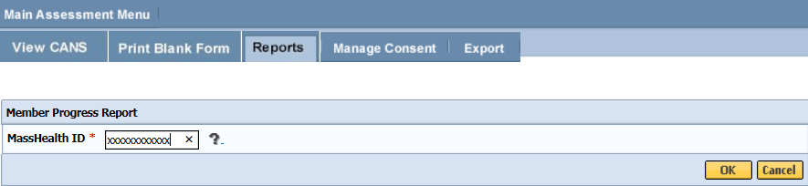
Note: For the certified assesor role, if the Member has CANS for both Under 5 and 5 Over Criteria, the CA can choose between the two.
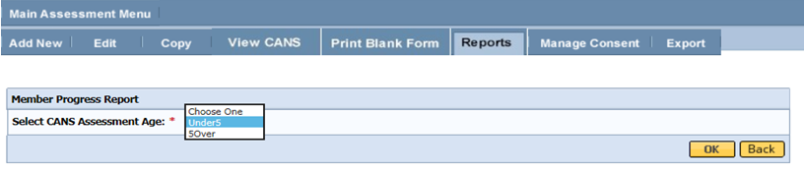
- Select the [CANS Assessments] to include in the report.
Note: If you would like the report to contain only one or up to five CANS assessments, then either click to choose a CANS assessment or use CTRL+ click to select multiple assessments. At least one must be selected.
- Select the [OK] button.
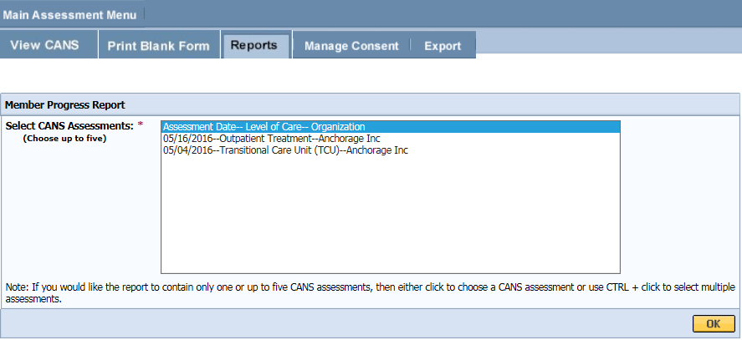
- Select the [Domains/Modules] to include in the report.
Note: By default, all domains are selected. If you would like the report to contain only one or some domains, then either click to choose a domain or use CTRL+ click to select multiple domains. At least one must be selected.
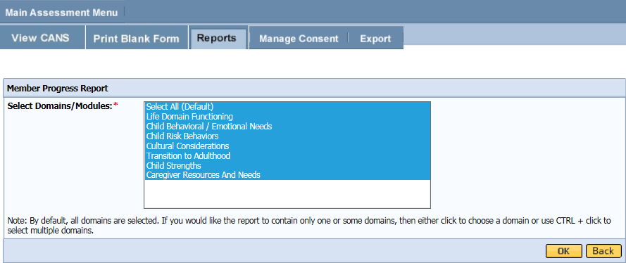
- The report can be viewed in PDF or Excel format.
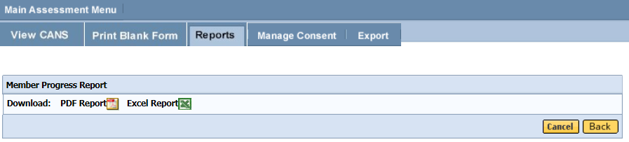

Sample of a Member Progress Report
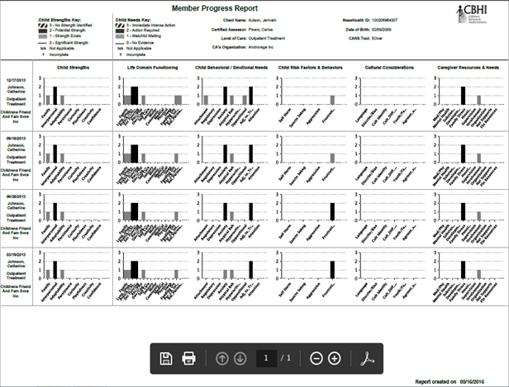
Notes:
- You may review, print or save the record in Adobe Acrobat Reader or Microsoft Excel.
- If you do not have Adobe Acrobat Reader currently installed you can download it for free at http://get.adobe.com/reader/.
- When completed, close the browser window and return to the CBHI application.
Important PHI Reminder:
You now have a file containing Protected Health Information on your computer. Remember to follow your organization's procedures regarding privacy and data security.

Questions or Need Assistance?
Call Virtual Gateway Customer Service
1-800-421-0938
(617-847-6578 - TTY for those with complete or partial loss of hearing)
8:30 am to 5:00 pm Monday through Friday
Bookmark the Children's Behavioral Health Initiative Website:
www.mass.gov/masshealth/cans

