INDOOR AIR QUALITY ASSESSMENT
Memorial Elementary School
12 Walnut Street
Milford, Massachusetts

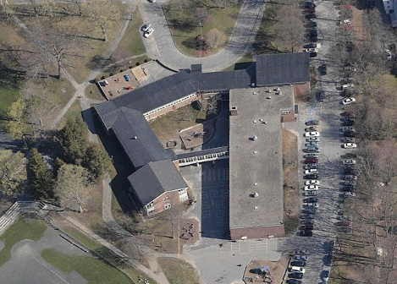

Prepared by:
Massachusetts Department of Public Health
Bureau of Environmental Health
Indoor Air Quality Program
December 2009

Background/Introduction
At the request of Paul Mazzuchelli, Director, Milford Board of Health, the Massachusetts Department of Public Health (MDPH), Bureau of Environmental Health (BEH) provided assistance and consultation regarding indoor air quality at the Memorial Elementary School (MES), 12 Walnut Street, Milford, Massachusetts. On October 30, 2009, Cory Holmes, Environmental Analyst/Inspector in BEH’s Indoor Air Quality (IAQ) Program visited the MES to conduct an assessment. During the assessment, Mr. Holmes was accompanied by Robert Quinn, Facilities Director, Milford Public Schools (MPS), and Mr. Mazzuchelli.
The MES is a two-story, brick building constructed in the late 1950s. An addition was built in 1996. The MES contains general classrooms, a computer lab, library, gymnasium, multi-purpose room, music room, art room, specialty rooms and office space. BEH staff previously visited the MES in August 2009 to conduct a water damage/mold investigation. A report detailing conditions observed at that time with recommendations to address mold concerns and improve IAQ was issued (MDPH, 2009). This report describes general IAQ conditions observed in the building at the time of the October, 2009 assessment.

Method
Air tests for carbon dioxide, temperature, relative humidity and carbon monoxide were conducted with the TSI, Q-Trak, IAQ Monitor, Model 7565. Air tests for airborne particle matter with a diameter less than 2.5 micrometers were taken with the TSI, DUSTTRAK™ Aerosol Monitor Model 8520. BEH staff performed a visual inspection of building materials for water damage and/or microbial growth. Moisture content of porous building materials was measured with a Delmhorst, BD-2000 Model, Moisture Detector equipped with a Delmhorst Standard Probe.

Results
The school houses approximately 415 students in grades K-2 with approximately 70 staff members. Tests were taken during normal school operations and results appear in Table 1.

Discussion

Ventilation
It can be seen from Table 1 that carbon dioxide levels were above 800 parts per million (ppm) in 10 of 41 areas, indicating adequate air exchange in most areas of the building at the time of the assessment. It is important to note, however, that several areas had open windows or were empty/sparsely populated, both of which can greatly reduce carbon dioxide levels. Carbon dioxide levels would be expected to increase with higher occupancy and windows closed.
Fresh air is supplied to most classrooms by unit ventilators (univent) systems (Pictures 1 and 2). A univent draws air from the outdoors through a fresh air intake located on the exterior wall of the building. Return air from the classroom is drawn through an air intake located at the base of the unit (Figure 1). Fresh and return air are mixed, filtered, heated and provided to classrooms through an air diffuser located in the top of the unit.
A number of univents appeared to be original equipment, approximately 40 to 50 years old. Univents of this age are often difficult to maintain because replacement parts are often unavailable. BEH staff found univents deactivated in several areas (Table 1); therefore, there was no means to provide mechanical ventilation to these classrooms at the time of the assessment. In several cases, univents were found obstructed by furniture and other items on top of air diffusers and/or in front of return vents along the bottom front of the units (Pictures 1 and 2). In order for univents to provide fresh air as designed, intakes/returns must remain free of obstructions. Importantly, these units must remain “on” and be allowed to operate while rooms are occupied.
Exhaust ventilation in classrooms is provided by grilled vents located on walls or in the ceilings of coat/storage closets ducted to rooftop motors (Pictures 3 and 4). Many exhaust vents were obstructed (Picture 4) and/or deactivated at the time of the assessment (Table 1). In addition, several classroom wall vents are located near hallway doors (Picture 5). When these classroom doors are open, exhaust vents for these rooms will tend to draw air from both the hallway and the classroom, reducing the effectiveness of the exhaust vent to remove common environmental pollutants. As with univents, in order to function properly, exhaust vents must be activated and allowed to operate while rooms are occupied. Without adequate supply and exhaust ventilation, excess heat and environmental pollutants can build up and lead to indoor air/comfort complaints.
The heating, ventilating and air conditioning (HVAC) system for interior rooms and common areas (e.g., gymnasium) consists of rooftop or ceiling-mounted air-handling units (AHUs). Fresh air is distributed via ceiling-mounted air diffusers and ducted back to AHUs via ceiling or wall-mounted return vents. Several of these units were found deactivated or inoperable at the time of the assessment; therefore, there were no means of mechanical air exchange in these areas, which was evidenced by elevated carbon dioxide levels in the gym.
To maximize air exchange, the MDPH recommends that both supply and exhaust ventilation operate continuously during periods of school occupancy. In order to have proper ventilation with a mechanical supply and exhaust system, the systems must be balanced to provide an adequate amount of fresh air to the interior of a room while removing stale air from the room. It is recommended that HVAC systems be re-balanced every five years to ensure adequate air systems function (SMACNA, 1994). The date of the last balancing of these systems was not available at the time of the assessment.
The Massachusetts Building Code requires a minimum ventilation rate of 15 cubic feet per minute (cfm) per occupant of fresh outside air or have openable windows in each room (SBBRS, 1997; BOCA, 1993). The ventilation must be on at all times that the room is occupied. Providing adequate fresh air ventilation with open windows and maintaining the temperature in the comfort range during the cold weather season is impractical. Mechanical ventilation is usually required to provide adequate fresh air ventilation.
Carbon dioxide is not a problem in and of itself. It is used as an indicator of the adequacy of the fresh air ventilation. As carbon dioxide levels rise, it indicates that the ventilating system is malfunctioning or the design occupancy of the room is being exceeded. When this happens, a buildup of common indoor air pollutants can occur, leading to discomfort or health complaints. The Occupational Safety and Health Administration (OSHA) standard for carbon dioxide is 5,000 parts per million parts of air (ppm). Workers may be exposed to this level for 40 hours/week, based on a time-weighted average (OSHA, 1997).
The MDPH uses a guideline of 800 ppm for publicly occupied buildings. A guideline of 600 ppm or less is preferred in schools due to the fact that the majority of occupants are young and considered to be a more sensitive population in the evaluation of environmental health status. Inadequate ventilation and/or elevated temperatures are major causes of complaints such as respiratory, eye, nose and throat irritation, lethargy and headaches. For more information concerning carbon dioxide, consult Appendix A.
Temperature measurements in the school ranged from 71° F to 75° F, which were within the MDPH recommended range (Table 1). The MDPH recommends that indoor air temperatures be maintained in a range of 70° F to 78° F in order to provide for the comfort of building occupants. Temperature complaints were reported in classrooms 3 and 4. In many cases concerning indoor air quality, fluctuations of temperature in occupied spaces are typically experienced, even in a building with an adequate fresh air supply.
The relative humidity measured in the building ranged from 33 to 42 percent at the time of the assessment, which was within or close to the lower end of the MDPH recommended comfort range in most areas (Table 1). The MDPH recommends a comfort range of 40 to 60 percent for indoor air relative humidity. Relative humidity levels in the building would be expected to drop during the winter months due to heating. The sensation of dryness and irritation is common in a low relative humidity environment. Low relative humidity is a very common problem during the heating season in the northeast part of the United States.

Microbial/Moisture Concerns
In order for building materials to support mold growth, a source of water exposure is necessary. Identification and elimination of the source of water moistening building materials is necessary to control mold growth. Water damaged ceiling plaster was observed in several areas (Table 1/Picture 6), which is evidence of current and/or former roof/plumbing leaks. In order to determine if porous building materials were wet at the time of the assessment, BEH staff conducted moisture measurements of plaster ceilings and carpeting. Materials with increased moisture content over normal concentrations may indicate the possible presence of mold growth. An active leak was discovered in classroom 10, as evidenced by moist ceiling plaster (Picture 7). No visible mold growth was observed. Carpeting directly below this area was dry at the time of the assessment. Moisture content of materials measured is a real-time measurement of the conditions present at the time of the assessment. Moisture levels of the carpeting was normal.
The US Environmental Protection Agency (US EPA) and the American Conference of Governmental Industrial Hygienists (ACGIH) recommend that porous materials be dried with fans and heating within 24 to 48 hours of becoming wet (US EPA, 2001; ACGIH, 1989). If not dried within this time frame, mold growth may occur. Once mold has colonized porous materials, they are difficult to clean and should be removed/discarded.

Other IAQ Evaluations
Indoor air quality can be negatively influenced by the presence of respiratory irritants, such as products of combustion. The process of combustion produces a number of pollutants. Common combustion emissions include carbon monoxide, carbon dioxide, water vapor and smoke (fine airborne particle material). Of these materials, exposure to carbon monoxide and particulate matter with a diameter of 2.5 micrometers (μm) or less (PM2.5) can produce immediate, acute health effects upon exposure. To determine whether combustion products were present in the school environment, BEH staff obtained measurements for carbon monoxide and PM2.5.

Carbon Monoxide
Carbon monoxide is a by-product of incomplete combustion of organic matter (e.g., gasoline, wood and tobacco). Exposure to carbon monoxide can produce immediate and acute health affects. Several air quality standards have been established to address carbon monoxide and prevent symptoms from exposure to these substances. The MDPH established a corrective action level concerning carbon monoxide in ice skating rinks that use fossil-fueled ice resurfacing equipment. If an operator of an indoor ice rink measures a carbon monoxide level over 30 ppm, taken 20 minutes after resurfacing within a rink, that operator must take actions to reduce carbon monoxide levels (MDPH, 1997).
The American Society of Heating Refrigeration and Air-Conditioning Engineers (ASHRAE) has adopted the National Ambient Air Quality Standards (NAAQS) as one set of criteria for assessing indoor air quality and monitoring of fresh air introduced by HVAC systems (ASHRAE, 1989). The NAAQS are standards established by the US EPA to protect the public health from six criteria pollutants, including carbon monoxide and particulate matter (US EPA, 2006). As recommended by ASHRAE, pollutant levels of fresh air introduced to a building should not exceed the NAAQS levels (ASHRAE, 1989). The NAAQS were adopted by reference in the Building Officials & Code Administrators (BOCA) National Mechanical Code of 1993 (BOCA, 1993), which is now an HVAC standard included in the Massachusetts State Building Code (SBBRS, 1997). According to the NAAQS, carbon monoxide levels in outdoor air should not exceed 9 ppm in an eight-hour average (US EPA, 2006).
Carbon monoxide should not be present in a typical, indoor environment. If it is present, indoor carbon monoxide levels should be less than or equal to outdoor levels. Outdoor carbon monoxide concentrations ranged from non-detect (ND) to 2.0 at the time of the assessment (Table 1). No measureable levels of carbon monoxide were detected inside the building during the assessment (Table 1).

Particulate Matter (PM2.5)
The US EPA has established NAAQS limits for exposure to particulate matter. Particulate matter is airborne solids that can be irritating to the eyes, nose and throat. The NAAQS originally established exposure limits to particulate matter with a diameter of 10 μm or less (PM10). According to the NAAQS, PM10 levels should not exceed 150 micrograms per cubic meter (μg/m³) in a 24-hour average (US EPA, 2006). These standards were adopted by both ASHRAE and BOCA. Since the issuance of the ASHRAE standard and BOCA Code, US EPA established a more protective standard for fine airborne particles. This more stringent PM2.5 standard requires outdoor air particle levels be maintained below 35 μg/m³ over a 24-hour average (US EPA, 2006). Although both the ASHRAE standard and BOCA Code adopted the PM10 standard for evaluating air quality, MDPH uses the more protective PM2.5 standard for evaluating airborne particulate matter concentrations in the indoor environment.
Outdoor PM2.5 concentrations the day of the assessment were measured at 15 μg/m³. PM2.5 levels measured inside the school ranged from 8 to 16 μg/m³ (Table 1). Both indoor and outdoor PM 2.5 levels were below the NAAQS PM2.5 level of 35 μg/m³. Frequently, indoor air levels of particulates (including PM2.5) can be at higher levels than those measured outdoors. A number of mechanical devices and/or activities that occur in schools can generate particulate during normal operations. Sources of indoor airborne particulates may include but are not limited to: particles generated during the operation of fan belts in the HVAC system; cooking in the cafeteria stoves and microwave ovens; use of photocopiers, fax machines and computer printing devices; operation of an ordinary vacuum cleaner; and, heavy foot traffic indoors.

Volatile Organic Compounds
Indoor air concentrations can be greatly impacted by the use of products containing volatile organic compounds (VOCs). VOCs are carbon-containing substances that have the ability to evaporate at room temperature. Frequently, exposure to low levels of total VOCs (TVOCs) may produce eye, nose, throat and/or respiratory irritation in some sensitive individuals. For example, chemicals evaporating from a paint can stored at room temperature would most likely contain VOCs. In an effort to identify materials that can potentially increase indoor VOC concentrations, BEH staff examined rooms for products containing these respiratory irritants.
Cleaning products were found in several rooms throughout the building. Cleaning products contain chemicals that can be irritating to the eyes, nose and throat of sensitive individuals. These products should be properly labeled and stored in an area inaccessible to children. Additionally, a Material Safety Data Sheet (MSDS) should be available at a central location for each product in the event of an emergency. Consideration should be given to providing teaching staff with school issued cleaning products and supplies to prevent any potential for adverse chemical interactions between residues left from cleaners used by the schools facilities staff and those left by cleaners brought in by others.
The majority of classrooms contained dry erase boards and related materials. Materials such as dry erase markers and dry erase board cleaners may contain VOCs, such as methyl isobutyl ketone, n-butyl acetate and butyl-cellusolve (Sanford, 1999), which can be irritating to the eyes, nose and throat.
Plug-in air fresheners were in use in a few areas (Picture 8). Air fresheners contain chemicals that can be irritating to the eyes, nose and throat of sensitive individuals. Many air fresheners contain 1,4-dichlorobenzene, a VOC which may cause reductions in lung function (NIH, 2006). Further, air fresheners do not remove materials causing odors, but rather, mask odors which may be present in the area.
The teacher’s workroom contains photocopiers and laminators. Lamination machines melt plastic and give off odors and VOCs. VOCs and ozone can be produced by photocopiers, particularly if the equipment is older and in frequent use. Ozone is a respiratory irritant (Schmidt Etkin, 1992). This area should be equipped with local mechanical exhaust ventilation to help reduce excess heat and odors.
In an effort to reduce noise from sliding desks/chairs, tennis balls had been sliced open and placed on the base of the legs (Picture 9). Tennis balls are made of a number of materials that are a source of respiratory irritants. Constant wearing of tennis balls can produce fibers and cause VOCs to off-gas. Tennis balls are made with a natural rubber latex bladder, which becomes abraded when used as a chair leg pad. Use of tennis balls in this manner may introduce latex dust into the school environment. Some individuals are highly allergic to latex (e.g., spina bifida patients) (SBAA, 2001). It is recommended that the use of materials containing latex be limited in buildings to reduce the likelihood of symptoms in sensitive individuals (NIOSH, 1997).

Other Conditions
Other conditions that can affect indoor air quality were observed during the assessment. In several classrooms, items were observed on windowsills, tabletops, counters, bookcases and desks. The large number of items stored in classrooms provides a source for dusts to accumulate. These items (e.g., papers, folders, boxes) make it difficult for custodial staff to clean. Items should be relocated and/or be cleaned periodically to avoid excessive dust build up. In addition, these materials can accumulate on flat surfaces (e.g., desktops, shelving and carpets) in occupied areas and subsequently be re-aerosolized causing further irritation.
A number of univent/supply air diffusers, exhaust vents and personal fans in classrooms were observed to have accumulated dust/debris (Pictures 3 and 10). Re-activated supply vents/fans can aerosolize dust accumulated on fan blades/housing. If exhaust vents are not functioning, backdrafting can occur, which can re-aerosolize dust particles.
Several classrooms contained upholstered furniture and/or pillows/cushions (Table 1/Pictures 11 and 12). Upholstered furniture is covered with fabric that encounters human skin. This type of contact can leave oils, perspiration, hair and skin cells. Dust mites feed upon human skin cells and excrete waste products that contain allergens. In addition, if relative humidity levels increase above 60 percent (e.g., during spring/summer), dust mites tend to proliferate (US EPA, 1992). In order to remove dust mites and other pollutants, frequent vacuuming of upholstered furniture is recommended (Berry, 1994). It is also recommended that if upholstered furniture is present in schools, it should be professionally cleaned on an annual basis or every six months if dusty conditions exist outdoors (IICRC, 2000).
Lastly, carpeting in several areas was extremely worn and damaged (Pictures 13 and 14). Disintegrating textiles can be a source of airborne particulates, which can be irritating to the eyes, nose and throat.

Conclusions/Recommendations
In view of the findings at the time of the assessment, the following recommendations are made to improve indoor quality:
- Operate all ventilation systems throughout the building (e.g., gymnasium, cafeteria, classrooms) continuously during occupied periods. To increase airflow in classrooms, set univent controls to “high”.
- Examine supply vents for offices B & C for proper airflow, adjust as needed.
- Inspect exhaust motors and belts for proper function. Repair and replace as necessary.
- Remove all blockages from univents and exhaust vents to ensure adequate airflow.
- Close classroom doors to maximize exhaust function.
- Use openable windows in conjunction with mechanical ventilation to facilitate air exchange. Care should be taken to ensure windows are properly closed at night and weekends to avoid the freezing of pipes and potential flooding.
- Consider adopting a balancing schedule of every 5 years for all mechanical ventilation systems, as recommended by ventilation industrial standards (SMACNA, 1994).
- Work with staff to resolve/mitigate temperature/comfort issues.
- Change filters for air-handling equipment (e.g., univents, AHUs and ACs) as per the manufacturer’s instructions or more frequently if needed. Vacuum interior of units prior to activation to prevent the aerosolization of dirt, dust and particulates. Ensure filters fit flush in their racks with no spaces in between allowing bypass of unfiltered air into the unit.
- For buildings in New England, periods of low relative humidity during the winter are often unavoidable. Therefore, scrupulous cleaning practices should be adopted to minimize common indoor air contaminants whose irritant effects can be enhanced when the relative humidity is low. To control for dusts, a high efficiency particulate arrestance (HEPA) filter equipped vacuum cleaner in conjunction with wet wiping of all surfaces is recommended. Avoid the use of feather dusters. Drinking water during the day can help ease some symptoms associated with a dry environment (throat and sinus irritations).
- Ensure roof leak in classroom 10 is repaired.
- Store cleaning products properly and out of reach of students. Ensure spray bottles are properly labeled. All cleaning products used at the facility should be approved by the school department with MSDS’ available at a central location.
- Clean upholstered furniture/pillows/cushions on an annual basis or every six months if dusty conditions exist outdoors (IICRC, 2000). If not possible/practical, remove upholstered furniture from classrooms.
- Relocate or consider reducing the amount of materials stored in classrooms to allow for more thorough cleaning of classrooms. Clean items regularly with a wet cloth or sponge to prevent excessive dust build-up.
- Consider providing local exhaust ventilation for photocopiers and lamination machines, or relocate to an area with mechanical ventilation.
- Clean personal fans, univent air diffusers, return vents and exhaust vents periodically of accumulated dust.
- Refrain from using air fresheners and deodorizers to prevent exposure to VOCs.
- Replace latex-based tennis balls with latex-free tennis balls or glides.
- Clean carpeting annually or semi-annually in soiled high traffic areas as per the recommendations of the Institute of Inspection, Cleaning and Restoration Certification (IICRC) (IICRC, 2005).
- Consider developing a program to replaced damaged/worn carpeting as funds become available. Consider replacing carpeting with a non-porous flooring material (e.g., tile).
- Consider adopting the US EPA (2000) document, “Tools for Schools”, as an instrument for maintaining a good indoor air quality environment in the building. This document is available at: http://www.epa.gov/iaq/schools/index.html.
- Refer to resource manual and other related indoor air quality documents located on the MDPH’s website for further building-wide evaluations and advice on maintaining public buildings. These documents are available at: http://mass.gov/dph/indoor_air.

References
ACGIH. 1989. Guidelines for the Assessment of Bioaerosols in the Indoor Environment. American Conference of Governmental Industrial Hygienists, Cincinnati, OH.
ASHRAE. 1989. Ventilation for Acceptable Indoor Air Quality. American Society of Heating, Refrigeration and Air Conditioning Engineers. ANSI/ASHRAE 62-1989
Berry, M.A. 1994. Protecting the Built Environment: Cleaning for Health, Michael A. Berry, Chapel Hill, NC.
BOCA. 1993. The BOCA National Mechanical Code/1993. 8th ed. Building Officials and Code Administrators International, Inc., Country Club Hill, IL.
IICRC. 2000. IICRC S001 Reference Guideline for Professional On-Location Cleaning of Textile Floor Covering Materials Institute of Inspection, Cleaning and Restoration Certification. Institute of Inspection Cleaning and Restoration, Vancouver, WA.
IICRC. 2005. Carpet Cleaning FAQ 4 Institute of Inspection, Cleaning and Restoration Certification. Institute of Inspection Cleaning and Restoration, Vancouver, WA.

MDPH. 1997. Requirements to Maintain Air Quality in Indoor Skating Rinks (State Sanitary Code, Chapter XI). 105 CMR 675.000. Massachusetts Department of Public Health, Boston, MA.
MDPH. 2009. Mold/Water Damage Investigation, Memorial Elementary School. Massachusetts Department of Public Health, Boston, MA.
NIOSH. 1997. NIOSH Alert Preventing Allergic Reactions to Natural Rubber latex in the Workplace. National Institute for Occupational Safety and Health, Atlanta, GA.
OSHA. 1997. Limits for Air Contaminants. Occupational Safety and Health Administration. Code of Federal Regulations. 29 C.F.R 1910.1000 Table Z-1-A.
Sanford. 1999. Material Safety Data Sheet (MSDS No: 198-17). Expo® Dry Erase Markers Bullet, Chisel, and Ultra Fine Tip. Sanford Corporation. Bellwood, IL.
SBAA. 2001. Latex In the Home And Community Updated Spring 2001. Spina Bifida Association of America, Washington, DC.
SBBRS. 1997. Mechanical Ventilation. State Board of Building Regulations and Standards. Code of Massachusetts Regulations. 780 CMR 1209.0
Schmidt Etkin, D. 1992. Office Furnishings/Equipment & IAQ Health Impacts, Prevention & Mitigation. Cutter Information Corporation, Indoor Air Quality Update, Arlington, MA.
SMACNA. 1994. HVAC Systems Commissioning Manual. 1st ed. Sheet Metal and Air Conditioning Contractors’ National Association, Inc., Chantilly, VA.
US EPA. 1992. Indoor Biological Pollutants. US Environmental Protection Agency, Environmental Criteria and Assessment Office, Office of Health and Environmental Assessment, research Triangle Park, NC. EPA 600/8-91/202 January 1992.
US EPA. 2000. Tools for Schools. Office of Air and Radiation, Office of Radiation and Indoor Air, Indoor Environments Division (6609J). EPA 402-K-95-001, Second Edition. http://www.epa.gov/iaq/schools/tools4s2.html

US EPA. 2001. “Mold Remediation in Schools and Commercial Buildings”. Office of Air and Radiation, Indoor Environments Division, Washington, DC. EPA 402-K-01-001. March 2001. Available at: http://www.epa.gov/iaq/molds/mold_remediation.html
US EPA. 2006. National Ambient Air Quality Standards (NAAQS). US Environmental Protection Agency, Office of Air Quality Planning and Standards, Washington, DC. http://www.epa.gov/air/criteria.html.
Picture 1

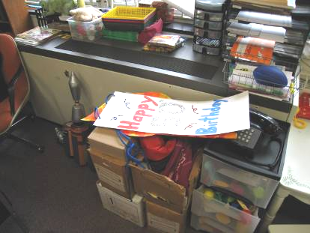

Classroom Univent 1990’s Vintage, Note Return Vent (along bottom front of unit)
Obstructed by Furniture and Other Items

Picture 2

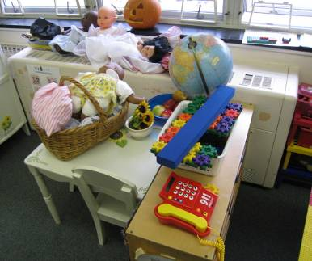

Classroom Univent 1950’s Vintage, Note Air Diffuser (top of unit) and Return Vent (along bottom front of unit) Obstructed by Furniture and Other Items

Picture 3

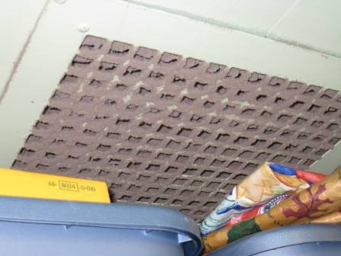

Closet Exhaust Vent, Note Dust/Debris Accumulation on Grill

Picture 4

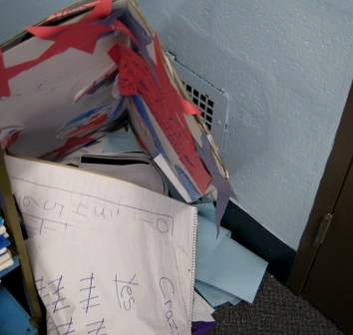

Wall-Mounted Exhaust Vent Partially Obstructed by Classroom Items

Picture 5

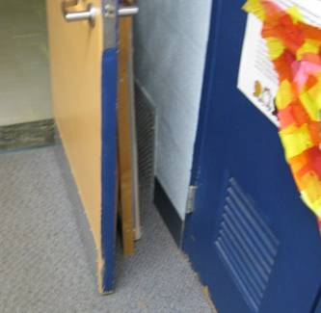

Wall-Mounted Exhaust Vent Obstructed by Open Classroom Door

Picture 6

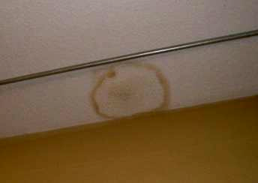

Water Damaged Ceiling Plaster

Picture 7

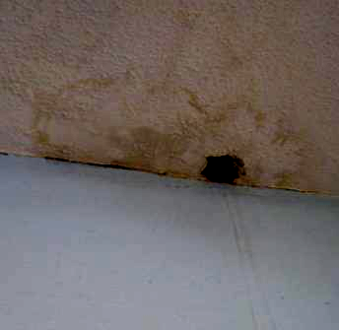

Moistened/Water Damaged Ceiling Plaster in Classroom 10

Picture 8

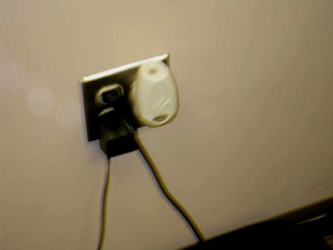

Plug-in Air Freshener in Classroom

Picture 9

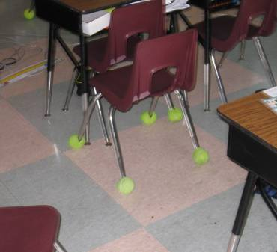

Tennis Balls on Chair Legs in Classroom

Picture 10

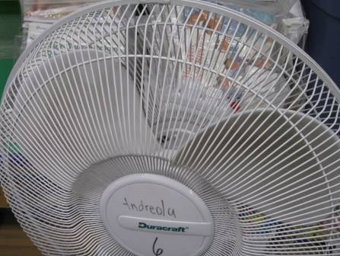

Fan/Blades in Classroom with Accumulated Dust/Debris

Picture 11

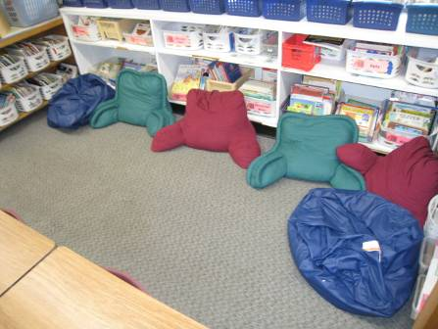

Large Pillows/Cushions in Classroom

Picture 12

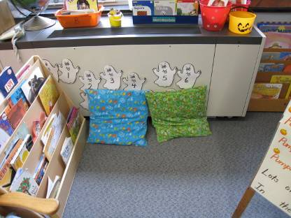

Large Pillows in Classroom, Also Note Pillows Obstructing Airflow
Into Univent Return Vent (Front Bottom)

Picture 13

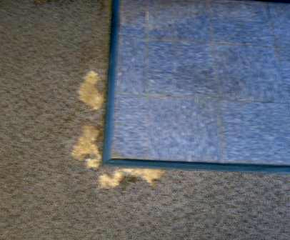

Worn/Damaged Carpeting

Picture 14

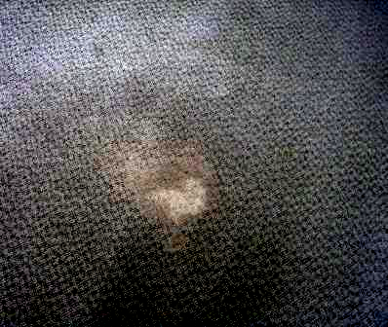

Worn/Damaged Carpeting
Location/ Room | Occupants  in Room | Temp  (°F) | Relative  Humidity  (%) | Carbon  Dioxide  (ppm) | Carbon Monoxide  (ppm) | PM2.5  (µg/m³) | Windows  Openable | Ventilation |  | Remarks
 |  |  |  |  |  |  |  | Supply | Exhaust | Remarks
background |  | 54 | 53 | 375 | ND-2.0 | 15 |  |  |  | Cool, cloudy, idling cars, light traffic
Main office | 3 | 73 | 42 | 900 | ND | 14 | Y open | N | N
13 | 20 | 71 | 38 | 780 | ND | 11 | Y | Y | Y | WD CP-dry low moisture measurement
11 | 20 | 71 | 37 | 790 | ND | 12 | Y | Y | Y | Exhaust obstructed by furniture, DO, CP
14 | 0 | 71 | 37 | 616 | ND | 10 | Y | Y | Y | Room used occasionally, worn carpeting
15 | 22 | 72 | 40 | 768 | ND | 13 | Y | Y | Y | UV and exhaust partially obstructed, DO, PF, accumulated items
10 | 17 | 71 | 36 | 657 | ND | 10 | Y open | Y | Y | Pillows blocking UV return vent, DO blocking exhaust vent, WD CP – moist elevated moisture measurement, carpet dry low moisture measurement
16 | 25 | 72 | 41 | 823 | ND | 9 | Y | Y | Y | 23 occupants gone 20 mins, DO, CF, PF, heat complaints
Work room | 2 | 74 | 39 | 836 | ND | 9 | Y | N | N | No local exhaust for PCs, printers
Gym equip. room | 0 | 71 | 34 | 533 | ND | 9 | Y | Y | Y | Dislodged CT
17 | 21 | 72 | 41 | 820 | ND | 9 | Y open | Y | Y | Plant
Gym | ~50 | 71 | 41 | 985 | ND | 16 | Y open | Y | Y off | Four UVs, exhaust off
18 | 22 | 73 | 42 | 771 | ND | 8 | Y open | Y | Y | Exhaust dusty, items on/front of UV, DO, PF
19 | 1 | 73 | 71 | 961 | ND | 10 | Y | Y | Y | Exhaust near door, plant, occupants gone ~ 5 mins
20 | 8 | 73 | 40 | 744 | ND | 11 | Y | Y | Y | Exhaust vent dusty, UV obstructed, DO, PF
21 | 0 | 74 | 39 | 883 | ND | 10 | Y | Y off | Y | 2 UVs off, DO
22 | 18 | 75 | 40 | 1100 | ND | 10 | Y | Y off | Y | 2 UV off, DO
23 Library | 22 | 73 | 37 | 766 | ND | 9 | Y | Y | Y
12 | 0 | 72 | 34 | 533 | ND | 9 | Y | Y | Y | 24 computers
4 | 18 | 72 | 39 | 798 | ND | 9 | Y | Y | Y | Exhaust dusty
5 | 19 | 73 | 38 | 662 | ND | 10 | Y open | Y | Y | DO, PF
3 | 13 | 71 | 37 | 584 | ND | 10 | Y | Y | Y | Cold complaints, desk near UV, recommend relocating
6 | 0 | 71 | 37 | 569 | ND | 8 | Y open | Y | Y | Exhaust dusty, DO, PF, occupants at lunch
2 | 0 | 72 | 36 | 492 | ND | 9 | Y | Y | Y | 17 occupants gone 10-15 mins, DO
7 | 0 | 72 | 35 | 550 | ND | 9 | Y | Y | Y | Occupants gone 10-15 mins, cushions
8 | 0 | 72 | 35 | 551 | ND | 9 | Y | Y | Y | Occupants gone 10-15 mins, DO
1 | 2 | 72 | 37 | 574 | ND | 10 | Y | Y | Y | DO, PF occupants gone 10-15 mins, WD CP—leak repaired-carpet dried
Cafeteria | ~100 | 71 | 38 | 853 | ND | 12 | Y | Y | Y | 2/4 univents on, exhaust off, exterior door open
Teacher’s Room | 2 | 73 | 40 | 820 | ND | 9 | N | Y | Y | Sump pump, PC, DO, abandoned sink
28 | 10 | 74 | 39 | 673 | ND | 9 | N | Y | Y
29-A | 0 | 74 | 37 | 623 | ND | 10 | N | Y | Y | Plug-in air freshener
29-B | 0 | 74 | 37 | 633 | ND | 10 | N | Y | Y
30-A | 0 | 74 | 37 | 560 | ND | 10 | N | Y | Y | PF
30-B | 0 | 74 | 36 | 546 | ND | 8 | N | Y | Y
31 | 0 | 73 | 37 | 585 | ND | 10 | N | Y | Y
24 | 17 | 73 | 37 | 694 | ND | 8 | Y | Y | Y | TB
25 | 18 | 73 | 37 | 780 | ND | 9 | Y | Y | Y | Cold complaints
26 Music | 17 | 71 | 33 | 482 | ND | 10 | Y | Y | Y | DO
27 Art | 23 | 72 | 36 | 588 | ND | 12 | Y | Y | Y
Office A | 0 | 71 | 38 | 593 | ND | 9 | N | Y | Y
Office B | 1 | 72 | 37 | 602 | ND | 9 | N | Y | Y | Supply weak
Office C | 1 | 72 | 37 | 581 | ND | 8 | N | Y | Y | Supply weak, DO

