INDOOR AIR QUALITY/WATER DAMAGE INVESTIGATION

Memorial Elementary School
12 West Walnut Street
Milford, Massachusetts

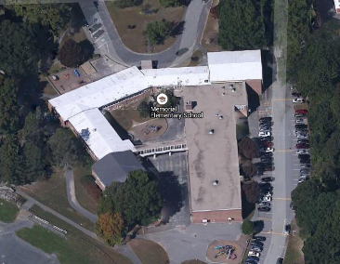

Prepared by:
Massachusetts Department of Public Health
Bureau of Environmental Health
Indoor Air Quality Program
March 2016

BACKGROUND
Building: | Memorial Elementary School (MES)
Address: | 12 West Walnut Street, Milford, MA
Assessment Requested by: | Milford School Department, Milford Health Department
Reason for Request: | Water damage concerns, exacerbation of asthma/allergies
Date of Assessment: | March 1, 2016
Massachusetts Department of Public Health/Bureau of Environmental Health (MDPH/BEH) Staff Conducting Assessment: | Cory Holmes, Environmental Analyst/Inspector, Indoor Air Quality (IAQ) Program
Date of Building Construction: | 1950s, addition 1996
Building/Site Description: | Elementary school grades K-2 near downtown Milford
Windows: | Openable

IAQ Testing Results
Please refer to the IAQ Manual for methods, sampling procedures, and interpretation of results (MDPH, 2015). The following is a summary of indoor air testing results (Table 1).
- Carbon dioxide levels were above 800 parts per million (ppm) in two of the three areas surveyed, indicating a lack of air exchange at the time of assessment.
- Temperature was within the recommended range of 70°F to 78°F in all areas tested.
- Relative humidity was below the recommended range of 40 to 60% in all areas tested.
- Carbon monoxide levels were non-detectable in all areas tested.
- PM2.5 concentrations measured were below the National Ambient Air Quality Standard (NAAQS) limit of 35 μg/m³ in all areas tested.

RESULTS AND DISCUSSION
Due to the severe cold weather experienced the weekend prior to February vacation (February 13 & 14) heating pipes had frozen and burst in classroom 6 along the exterior wall. Water leaked from these broken pipes and moistened carpeting, furniture and classroom items in classroom 6, as well as adjacent areas (classrooms 5 and 7). It was reported by Principal Lisa Burns, that she discovered the water damage at approximately 11:00 AM on Monday, February 15th and by 3:00-4:00 PM that afternoon, a professional flooding/restoration firm was on-site removing all wet items from classrooms and conducting drying/remediation efforts.
The US Environmental Protection Agency (US EPA) and the American Conference of Governmental Industrial Hygienists (ACGIH) recommends that porous materials (e.g., wallboard, carpeting) be dried with fans and heating within 24 to 48 hours of becoming wet (US EPA, 2008; ACGIH, 1989). If porous materials are not dried within this time frame, mold growth may occur.
At the time of the BEH/IAQ assessment, remediation had been completed and school was in session. BEH/IAQ staff performed a visual inspection of building materials for any residual water damage and/or microbial growth. All moisture testing results of carpeting in affected areas was normal (i.e., dry) at the time of assessment and no residual water damage, mold growth or associated odors were observed/detected.
As previously mentioned, the assessment was requested due to exacerbation of asthma/allergies. Although no residual water damage/mold growth was observed, a number of other potential environmental issues and/or potential allergy/asthma triggers were observed, including:
- Accumulated items on flat surfaces throughout the classroom, making dust control/wet wiping difficult (Pictures 1 through 3);
- The classroom unit ventilator (univent) was partially obstructed, which can limit air circulation and put added stress on machinery (Picture 3);
- The classroom exhaust vent (Picture 4) was not operating, therefore any normally-occurring pollutants (e.g., airborne dust, odors, carbon dioxide) can build up and lead to IAQ/comfort complaints;
- Exhaust vent grills/ducts were occluded with dust/debris (Pictures 5 and 6), which can become airborne if exhaust vents are not drawing air and backdrafting;
- A hole was noted in the cinderblock (Picture 7), which can provide a pathway for odors, dust/debris from the wall cavity;
- Ripped upholstery on furniture (Picture 8) which makes the furniture hard to clean and can be a place for mold colonization;
- The pencil sharpener was missing its cover, leaving piles of shavings on flat surfaces and carpeting (Picture 9), where they can become reareosolized; and
- Classroom doors were open to both hallways and adjacent classrooms, which decrease the ability of the classroom mechanical ventilation system to exchange air when both univents/exhaust vents are operating as designed.
It is also important to note that both portable dehumidifiers and air purifiers were in use in classrooms. These devices contain filters that should be cleaned/changed as the manufacturers’ instructions. In addition, dehumidifiers hold standing water and should be emptied/cleaned regularly to prevent scale, odors and mold growth.

CONCLUSIONS AND RECOMMENDATIONS
Based on observations made at the time of the visit, the flood remediation appears to be complete. The following other recommendations were made at the time of the assessment to improve IAQ and are reiterated below:
- Remove all items from top/front of classroom univents.
- Ensure all classroom exhaust vents are operating as designed, make repairs as needed.
- Close classroom doors to facilitate air exchange.
- Operate all supply and exhaust ventilation systems throughout the building continuously during periods of occupancy to maximize air exchange.
- Clean exhaust vents, as well as personal fans and univent air diffusers periodically of accumulated dust, including the interior of exhaust vent grills/louvers. This will require removal of the sheet metal screws.
- Seal hole in concrete wall in classroom 6 (Picture 7), as well as any other penetrations/utility holes that can allow pathways of odor/dust migration into occupied areas from floors/wall cavities, with an appropriate fire-rated sealant.
- Discard damaged chairs with exposed upholstery.
- Replace missing cover on the pencil sharpener and clean shavings regularly.
- Clean/change filters to air purifiers and dehumidifiers as per the manufacturers’ instructions. Empty/clean dehumidifier reservoir as required.
- For buildings in New England, periods of low relative humidity during the winter are often unavoidable. Therefore, scrupulous cleaning practices should be adopted to minimize common indoor air contaminants whose irritant effects can be enhanced when the relative humidity is low. To control for dusts, a high efficiency particulate arrestance (HEPA) filter equipped vacuum cleaner in conjunction with wet wiping of all surfaces is recommended. Avoid the use of feather dusters. Drinking water during the day can help ease some symptoms associated with a dry environment (throat and sinus irritations).
- Consider conducting school-wide clutter reduction/cleaning of flat surfaces quarterly, with faculty working in conjunction with maintenance staff to relocate/remove items to facilitate cleaning.
- For more information about mold/remediation consult Mold Remediation in Schools and Commercial Buildings” published by the US Environmental Protection Agency (US EPA, 2008).
- It was reported that carpet was slated for replacement within the next few years; consideration should be made to installing non-porous flooring, particularly in those areas prone to flooding.
- Refer to resource manual and other related indoor air quality documents located on the MDPH’s website for further building-wide evaluations and advice on maintaining public buildings. These documents are available at http://mass.gov/dph/iaq.

REFERENCES
ACGIH. 1989. Guidelines for the Assessment of Bioaerosols in the Indoor Environment. American Conference of Governmental Industrial Hygienists, Cincinnati, OH.
MDPH. 2015. Massachusetts Department of Public Health. Indoor Air Quality Manual: Chapters I-III. Available at: http://www.mass.gov/eohhs/gov/departments/dph/programs/environmental-health/exposure-topics/iaq/iaq-manual/.
US EPA. 2008. Mold Remediation in Schools and Commercial Buildings. US Environmental Protection Agency, Office of Air and Radiation, Indoor Environments Division, Washington, D.C. EPA 402-K-01-001. http://www.epa.gov/mold/mold-remediation-schools-and-commercial-buildings-guide.
Picture 1
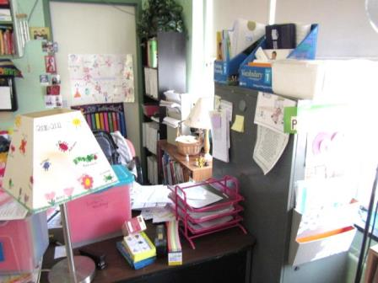
Accumulated items on flat surfaces in classroom
Picture 2
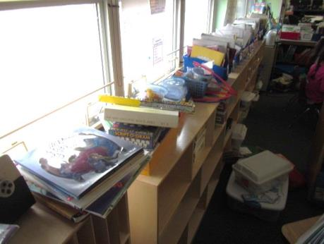
Accumulated items on flat surfaces in classroom
Picture 3
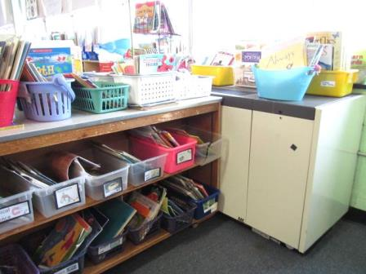
Accumulated items on flat surfaces in classroom, note shelving unit obstructing univent return vent (arrow)
Picture 4
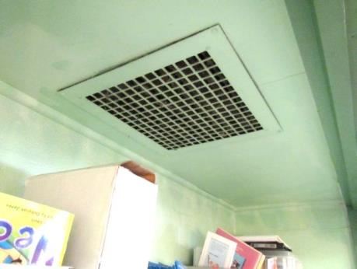
Classroom exhaust vent in coat closet
Picture 5
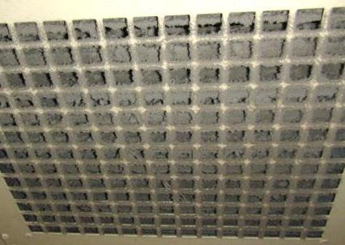
Accumulated dust/debris on/in classroom exhaust vent
Picture 6
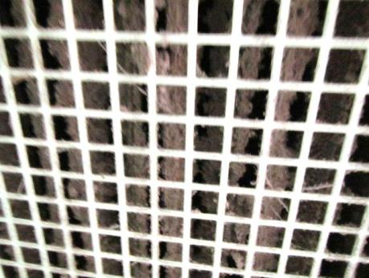
Accumulated dust/debris on louvers inside classroom exhaust vent
Picture 7
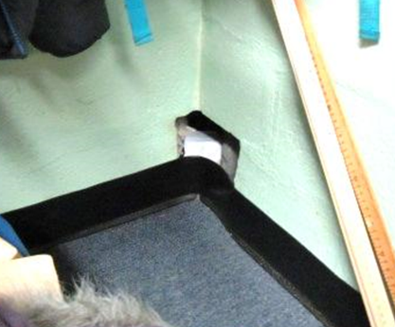
Hole in cinderblock wall classroom 5
Picture 8
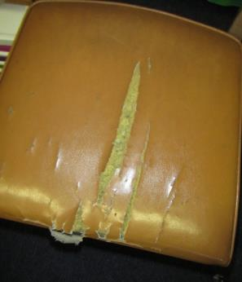
Ripped upholstery
Picture 9
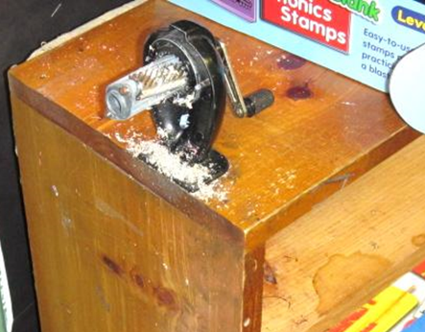
Pencil sharpener missing cover and pencil shavings

Location | Carbon  Dioxide  (ppm) | Carbon Monoxide  (ppm) | Temp  (°F) | Relative  Humidity  (%) | PM2.5  (µg/m³) | Occupants  in Room | Windows  Openable | Ventilation |  |  | Remarks
 |  |  |  |  |  |  |  | Intake | Exhaust
Background (outside) | 389 | ND | 39 | 28 | 10 |  |  |  |  |  | SW wind 8-22 mph, gusts up to 31 mph
Classroom 5 | 1147 | ND | 71 | 23 | 1 | 15 | Y | Y |  | Y | Dehumidifier, AP, DO, carpet moisture testing-normal/dry
Classroom 6 | 933 | ND | 71 | 27 | 2 | 2 | Y | Y |  | Y | Exhaust vent not operating, UV partially obstructed, carpet moisture testing-normal/dry, DO, pencil sharpener missing cover, hole in wall
Classroom 7 | 729 | ND | 71 | 24 | 1 | 1 | Y | Y |  | Y | DO, dehumidifier, AP, carpet moisture testing-normal/dry, AP

