Mold/Water Damage Investigation

Memorial Elementary School
12 Walnut Street
Milford, Massachusetts

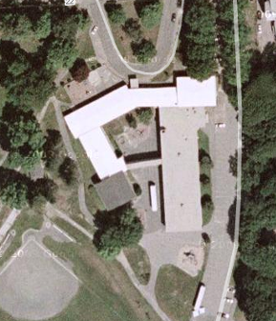

Prepared by:
Massachusetts Department of Public Health
Bureau of Environmental Health
Indoor Air Quality Program
October 2009

Background/Introduction
At the request of Paul Mazzuchelli, Director, Milford Board of Health, the Massachusetts Department of Public Health (MDPH), Bureau of Environmental Health (BEH) provided assistance and consultation regarding indoor air quality at the Memorial Elementary School (MES), 12 Walnut Street, Milford, Massachusetts. On August 22, 2009, Cory Holmes, Environmental Analyst/Inspector in BEH’s Indoor Air Quality (IAQ) Program made a visit to the MES to conduct an assessment. Mr. Holmes was accompanied by Robert Quinn, Facilities Director, Milford Public Schools (MPS), Francis Anderson, Principal, MES, and Mr. Mazzuchelli during the assessment. The request was prompted by mold growth reported to be growing on the surface of the carpeting as well as some non-porous surfaces (e.g., desks, bookcases) in classroom 30.

Methods
BEH staff performed a visual inspection of building materials for water damage and/or microbial growth. Moisture content of porous building materials was measured with a Delmhorst, BD-2000 Model, Moisture Detector equipped with a Delmhorst Standard Probe.

Results and Discussion
As previously mentioned, the assessment was prompted by concerns of mold growth observed by school staff on several surfaces in classroom 30. Shortly after its discovery, the mold was reportedly removed/cleaned from the carpeting (Picture 1) and other surfaces by MPS maintenance staff using bleach and water. BEH staff did not observe/detect visible mold or associated odors on these surfaces at the time of the assessment.
In order for building materials to support mold growth, a source of water exposure is necessary. Identification and elimination of the source of water moistening building materials is necessary to control mold growth. Mr. Quinn reported that the computerized heating, ventilating and air conditioning (HVAC) system is programmed to deactivate during the night cycle. AC systems are designed to cool air, in part by removing moisture from the air and reducing indoor relative humidity. During the month of August 2009, the Northeast experienced a period of sustained elevated relative humidity (> 70%). Relative humidity in excess of 70 percent for extended periods of time can provide an environment for mold and fungal growth on building materials (ASHRAE, 1989). It was likely that the mold growth occurred on the surface of carpeting due to the elevated relative humidity.
In order to determine if porous building materials in classroom 30 were wet at the time of the assessment, BEH staff conducted moisture measurements of carpeting, gypsum wall board (GW) walls and ceilings. Materials with increased moisture content over normal concentrations may indicate the possible presence of mold growth. All materials tested during the assessment were found to have low (i.e., normal) moisture content. Moisture content of materials measured is a real-time measurement of the conditions present at the time of the assessment.
BEH staff obtained a sample of the carpeting and noted that the backing of the carpet was made of an impermeable plastic/vinyl material (Picture 2). The impermeable plastic/vinyl material prevents moisture (i.e., from the top) to move downwards; similarly, water could not penetrate from the slab through to the carpet. Carpeting at the MES was thin (approximately ¹/₂-inch thick) and adhered directly on slab with no carpet pad. Often times, when carpeting gets wet (e.g., a flooding event), attempts to dry are successful; however the padding can retain moisture, grow mold and give off unpleasant odors. The carpet in the MES has a water-impervious backing that is adhered directly to the floor slab. Any mold growth, if present, would be limited to the pile above the backing and could be readily cleaned using a high temperature, steam/water extracting cleaning process. Since this carpeting has been repeatedly subjected to mold growth, BEH staff recommends that the carpeting be replaced with a non-porous material since this floor appears to be prone to condensation which will wet the carpet pile, producing future mold growth. Until the carpeting is replaced, BEH staff recommends regular vacuuming with a high efficiency particulate arrestance (HEPA) filter equipped vacuum cleaner, which filters out 99.97% of fine particles 0.3 micrometers (µm) in diameter that can exacerbate asthma and allergy symptoms (US EPA, 2001).
Some visible mold was observed on the surface of the GW ceiling around a metal light fixture and a return vent (Pictures 3 and 4). As with the carpeting, these surfaces appear to be chronically prone to condensation generation, which may likely require some removal of GW and insulation around the exhaust ductwork. As an interim measure, BEH staff recommended sealing the vent and removing the mold by cleaning, followed by vacuuming the surface of the GW as well as surfaces around and below these areas, with a HEPA filtered vacuum cleaner. As discussed, the HVAC system had been deactivated overnight during periods of elevated relative humidity. When warm, moist air passes over a surface that is colder than the air; condensation can collect on the cool surface of the metal fixtures. Over time, water droplets can form, and lead to mold growth on porous materials (i.e., GW).

Conclusions/Recommendations
Several recommendations to address mold concerns at the MES were given at the time of the assessment, and are reiterated below along with other recommendations to improve air quality. In addition, MDPH guidance on mold remediation and preventing mold growth during summer months are attached as Appendix A and Appendix B. The MDPH has prepared these guidance documents in order to reduce or minimize exposure opportunities to mold in buildings and to prevent/reduce the migration of remediation-generated pollutants into occupied areas.
- Ensure mold is cleaned from the metal light fixture. An examination of the GW surface in the ceiling plenum side is advised to ascertain whether mold colonization exists. This examination would likely require removal of the light fixture and removal of some GW.
- Consideration should be given to replacing carpeting with a non-porous flooring surface during the next school vacation.
- Remove the exhaust vent and examine whether wall cavity surface of the GW in mold colonized. If mold colonized, remove in a manner consistent with recommendations made in “Mold Remediation in Schools and Commercial Buildings” published by the US Environmental Protection Agency (US EPA, 2001). This document can be downloaded from the US EPA website at: http://www.epa.gov/mold/mold_remediation.html.
- Consideration should be given to extending the ductwork so that the exhaust vent is not in direct contact with the ceiling GW. Consideration should also be given to installing an insulation material between the exhaust vent duct and the ceiling GW.
- Monitor conditions in classrooms as needed to adjust the HVAC system to avoid elevated relative humidity (>70%) conditions that would be prone to condensation and/or mold growth.
- Examine areas prone to condensation/mold growth periodically during spring/summer months and address as needed.
- Consider supplementing the HVAC system in below grade areas with portable dehumidifiers as needed during humid, spring/summer months. Ensure dehumidifiers are cleaned and maintained as per the manufacturer’s instructions to prevent standing water and mold growth.
- Keep classroom doors shut for proper operation of HVAC system and to maintain comfort.

References
US EPA. 2001. “Mold Remediation in Schools and Commercial Buildings”. Office of Air and Radiation, Indoor Environments Division, Washington, DC. EPA 402-K-01-001. March 2001. Available at: http://www.epa.gov/mold/mold_remediation.html.
ASHRAE. 1989. Ventilation for Acceptable Indoor Air Quality. American Society of Heating, Refrigeration and Air Conditioning Engineers. ANSI/ASHRAE 62-1989.
Picture 1

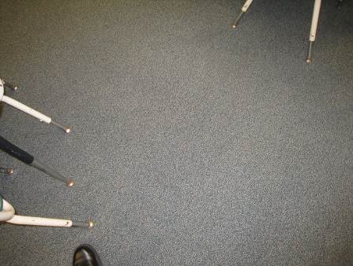

Carpeting in Classroom 30, No Visible Mold/Moisture Damage

Picture 2

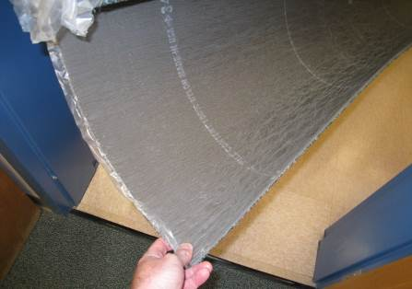

Impermeable Plastic/Vinyl Backing of Carpeting Sample Similar to that Installed in Classroom 30

Picture 3

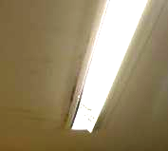

Light Mold Growth on Surface of GW along Metal Light Fixture in Classroom 30

Picture 4

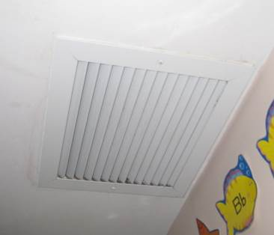

Light Mold Growth on Surface of GW along Metal Return Vent in Classroom 30
Location/ Room | Occupants  in Room | Temp  (°F) | Relative  Humidity  (%) | Carbon  Dioxide  (ppm) | Carbon Monoxide  (ppm) | PM2.5  (µg/m³) | Windows  Openable | Ventilation |  | Remarks
 |  |  |  |  |  |  |  | Supply | Exhaust | Remarks
background |  | 54 | 53 | 375 | ND-2.0 | 15 |  |  |  | Cool, cloudy, idling cars, light traffic
Main office | 3 | 73 | 42 | 900 | ND | 14 | Y open | N | N
13 | 20 | 71 | 38 | 780 | ND | 11 | Y | Y | Y | WD CP-dry low moisture measurement
11 | 20 | 71 | 37 | 790 | ND | 12 | Y | Y | Y | Exhaust obstructed by furniture, DO, CP
14 | 0 | 71 | 37 | 616 | ND | 10 | Y | Y | Y | Room used occasionally, worn carpeting
15 | 22 | 72 | 40 | 768 | ND | 13 | Y | Y | Y | UV and exhaust partially obstructed, DO, PF, accumulated items
10 | 17 | 71 | 36 | 657 | ND | 10 | Y open | Y | Y | Pillows blocking UV return vent, DO blocking exhaust vent, WD CP – moist elevated moisture measurement, carpet dry low moisture measurement
16 | 25 | 72 | 41 | 823 | ND | 9 | Y | Y | Y | 23 occupants gone 20 mins, DO, CF, PF, heat complaints
Work room | 2 | 74 | 39 | 836 | ND | 9 | Y | N | N | No local exhaust for PCs, printers
Gym equip. room | 0 | 71 | 34 | 533 | ND | 9 | Y | Y | Y | Dislodged CT
17 | 21 | 72 | 41 | 820 | ND | 9 | Y open | Y | Y | Plant
Gym | ~50 | 71 | 41 | 985 | ND | 16 | Y open | Y | Y off | Four UVs, exhaust off
18 | 22 | 73 | 42 | 771 | ND | 8 | Y open | Y | Y | Exhaust dusty, items on/front of UV, DO, PF
19 | 1 | 73 | 71 | 961 | ND | 10 | Y | Y | Y | Exhaust near door, plant, occupants gone ~ 5 mins
20 | 8 | 73 | 40 | 744 | ND | 11 | Y | Y | Y | Exhaust vent dusty, UV obstructed, DO, PF
21 | 0 | 74 | 39 | 883 | ND | 10 | Y | Y off | Y | 2 UVs off, DO
22 | 18 | 75 | 40 | 1100 | ND | 10 | Y | Y off | Y | 2 UV off, DO
23 Library | 22 | 73 | 37 | 766 | ND | 9 | Y | Y | Y
12 | 0 | 72 | 34 | 533 | ND | 9 | Y | Y | Y | 24 computers
4 | 18 | 72 | 39 | 798 | ND | 9 | Y | Y | Y | Exhaust dusty
5 | 19 | 73 | 38 | 662 | ND | 10 | Y open | Y | Y | DO, PF
3 | 13 | 71 | 37 | 584 | ND | 10 | Y | Y | Y | Cold complaints, desk near UV, recommend relocating
6 | 0 | 71 | 37 | 569 | ND | 8 | Y open | Y | Y | Exhaust dusty, DO, PF, occupants at lunch
2 | 0 | 72 | 36 | 492 | ND | 9 | Y | Y | Y | 17 occupants gone 10-15 mins, DO
7 | 0 | 72 | 35 | 550 | ND | 9 | Y | Y | Y | Occupants gone 10-15 mins, cushions
8 | 0 | 72 | 35 | 551 | ND | 9 | Y | Y | Y | Occupants gone 10-15 mins, DO
1 | 2 | 72 | 37 | 574 | ND | 10 | Y | Y | Y | DO, PF occupants gone 10-15 mins, WD CP—leak repaired-carpet dried
Cafeteria | ~100 | 71 | 38 | 853 | ND | 12 | Y | Y | Y | 2/4 univents on, exhaust off, exterior door open
Teacher’s Room | 2 | 73 | 40 | 820 | ND | 9 | N | Y | Y | Sump pump, PC, DO, abandoned sink
28 | 10 | 74 | 39 | 673 | ND | 9 | N | Y | Y
29-A | 0 | 74 | 37 | 623 | ND | 10 | N | Y | Y | Plug-in air freshener
29-B | 0 | 74 | 37 | 633 | ND | 10 | N | Y | Y
30-A | 0 | 74 | 37 | 560 | ND | 10 | N | Y | Y | PF
30-B | 0 | 74 | 36 | 546 | ND | 8 | N | Y | Y
31 | 0 | 73 | 37 | 585 | ND | 10 | N | Y | Y
24 | 17 | 73 | 37 | 694 | ND | 8 | Y | Y | Y | TB
25 | 18 | 73 | 37 | 780 | ND | 9 | Y | Y | Y | Cold complaints
26 Music | 17 | 71 | 33 | 482 | ND | 10 | Y | Y | Y | DO
27 Art | 23 | 72 | 36 | 588 | ND | 12 | Y | Y | Y
Office A | 0 | 71 | 38 | 593 | ND | 9 | N | Y | Y
Office B | 1 | 72 | 37 | 602 | ND | 9 | N | Y | Y | Supply weak
Office C | 1 | 72 | 37 | 581 | ND | 8 | N | Y | Y | Supply weak, DO

